LCBB4001
Silvia Mihaela Tanache
2122649
TABLE OF CONTENTS
Introduction 3
Question one 3
Income Statement for Wales Plc 3
Why does the statement of financial position balance? 4
Question Two 5
Calculate the following ratios for Sweets plc for 2021 and 2020 5
Financial performance and position of Sweet’s plc. 11
Conclusion 12
Reference 14

Introduction
Data input, collecting, summarizing, evaluating, and publishing are all steps in the accounting process that pertain to the monetary operations of a business or institution. Accounting fundamentals serve as a guide for carrying out these activities. Financial statements are prepared using the activities of a company entity throughout an accountancy term, which is typically a year. Accounting is a tool used by businesses to assess their financial position. They support cost budgeting, cost evaluation, and judgment. Because a company's financial status is summarized in its financial report, it is crucial to analyze the financial statement before making any decisions that may enhance the company's finances. On the contrary hand, it gets simple to distinguish between the records of creditors and debtors. They must adhere to all of these finance summary principles in order to create a financial statement that is effective. Corporations could properly characterize their economic state by applying those ideas.

Question one

Income Statement for Wales Plc
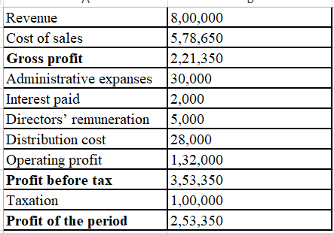
The report of Wales Plc's economic status as of the 31st of December, 2021 will include a penalty in the amount of £3,000 for commissions that are owing to salesmen. The economic report for 2021 would reflect the fact that, on December 31 of that year, clients received shipments with a total value of £980. (Sutton, 2018).
A statement of the profit and loss up until that point in time.
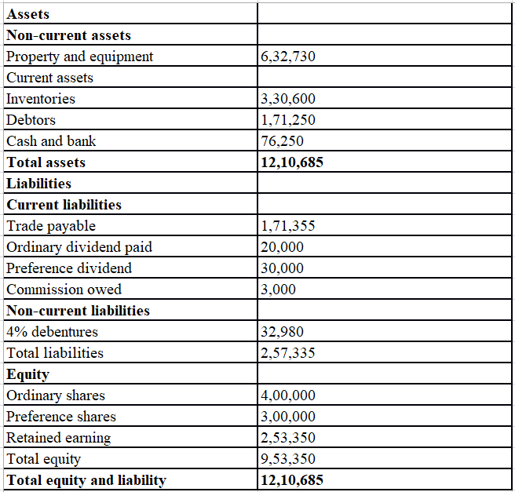

Why does the statement of financial position balance?
The Balance Sheet is a financial statement that outlines the assets, liabilities, and shareholders' equity of a corporation as of a specific date. You may learn a lot about the company's financial stability from this report. An essential part of every company's financial records, it provides a snapshot of the company's financial health as of a certain date. In these additional uses, it serves as a historical record of a company's financial standing. The three key components are explained in more detail below. The financial statements of a certain industry include estimates of the value of its assets, liabilities, and ownership. When a group owns property, it means that they have access to resources that may be used to make money. Whether or not an asset is classified as a current or non-recurring asset depends on the amount of money it is expected to make over its useful life. Inventory and accounts receivable are two examples of preexisting commodities that may often be converted to cash within a year of acquisition (Sutton, 2018). First of a balance sheet's three major divisions, assets account for the vast majority of the total. All of the company's assets that can be turned into cold, hard cash within a year are considered existing property, and may be used to cover normal operating costs immediately. An obligation is a debt that a company owes as a result of a previous transaction, the payment of which would lower the value of the company. In addition, there is the possibility of classifying liabilities as either "current" or "future." Accounts payable is an example of a current obligation since it represents the company's short-term debt to its suppliers (Sutton, 2018). Total debt on the balance sheet is comprised of both current and noncurrent obligations. In contrast to current liabilities, which are due within a year after incurrence, noncurrent liabilities are long-term obligations or commitments that are not expected to be repaid in full within one year. Due to the dual entry idea of accounting, the first financial report shows a healthy situation, and the company's owners retain thorough records of cash flow and invoiced inputs that verify the accuracy of the books. The financial situation report demonstrates the company's expertise in handling funds, which is helpful in maintaining healthy connections with consumers and suppliers. Position statements should be honest and compatible with the dual-entry accounting technique so that they may be understood by their readers (Sutton, 2018).

Question Two

Calculate the following ratios for Sweets plc for 2021 and 2020
ROCE: The return on investment may be a very helpful metric to use when determining the level of profitability of businesses operating in equity-based industries such as the energy and telecommunications sectors. It is essential that ROCE take into account both capital and debt, in contrast to other needs such as return on equity (ROE), which solely measures performance in relation to an investor's shares. If corporations carrying considerable amounts of debt did this, it may potentially enhance the appraisal of the economic impact (Sutton, 2018).
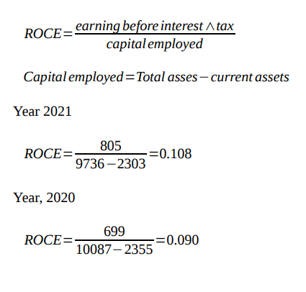
ROE: Calculating returns on equity is as simple as dividing net income by the entire amount of capital held by shareholders and multiplying the result by 100. After deducting the value of the company's entire liabilities from its total assets, return on equity (ROE) is sometimes referred to as yields on net resources. This is due to the fact that ROE assesses the profitability of a company based on the returns that the company creates for its investors. It is generally accepted that a lucrative company strategy and effective revenue generation are both associated with a high return on equity. Return on equity is a measure of a company's capacity to fuel expansion with new investment while also generating revenue, and it reflects management's ability to do both (Swieringa, 2018).

Year 2021,
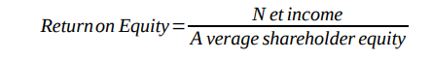
431 =0.1369
3088

Year 2020,


Earnings per share: To calculate earnings per share, take and divide it by the total number of shares of ordinary stock that are currently in circulation. The results numbers may be used to make a calculation about the prospective earnings of a firm. After taking into account unexpected expenditures and the possibility of share dilution, companies often announce their earnings per share, also known as EPS. Earnings, which are often referred to as revenues, are calculated by multiplying the company's net profit by the total number of shares that are currently in circulation. Adjusting the denominator and the population in order to take into account the possibility of additional units being produced as a result of borrowing, borrowing obligations, or individual choice is required in complex computations. If the rest of the formula is changed to take into account the actions that are happening right now, it takes on a far more vital role (Swieringa, 2018).
Year 2021,
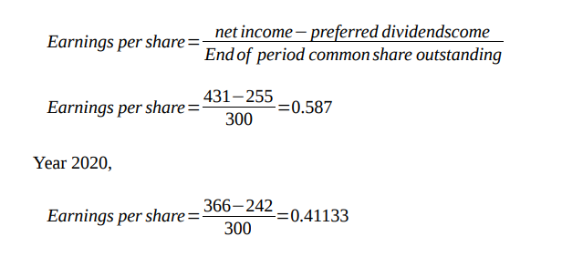
Net profit margin: Net profit margin is a financial indicator used to determine the extent to which a company's revenues exceed its expenditures; it is also known as the earning percentage or revenue growth ratio. As a result, it is the single most important factor in establishing a company's profit margins. The term "gross income margin" refers to the proportion of revenue that is retained as income before expenses (Swieringa, 2018).
Year 2021,
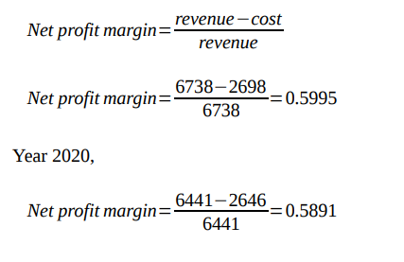

Asset turnover: The asset turnover ratio assesses a company's ability to generate revenue from its assets. Institutional effectiveness is commonly evaluated by looking at how sales compare to the overall sales of the industry. The ratio is often chosen to reflect the performance of the company in generating sales or profits, with a greater ratio being preferred. A lower ratio indicates that resources are being underutilized inside the business. Given the wide variation in asset turnover rates between industries, it is essential that only comparable businesses be compared. Any time frame can be used to compute the ratio, but annually-based plans are most common (Turtle & Wang, 2017).
Year 2021,
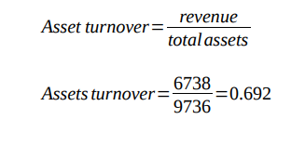
Year 2020,
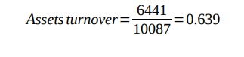
Stock holding days: The period of time between the purchase and sale of an asset is referred to as "keeping time" in the world of investing. Whether or not a property owner will be liable to long-term capital gains tax rates upon selling a property for a profit depends on the length of time the owner has held ownership of the property (Turtle & Wang, 2017).
Year 2021,
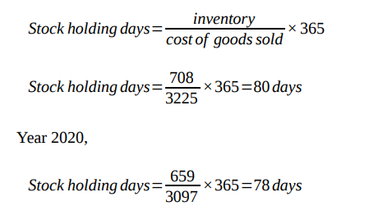
Debtor’s collection period: Experts agree that a company's grace period of 90 days or fewer is appropriate if it offers two months of interest-free credit. This example illustrates the time required to generate and acquire a credits payment after payment has been made. For companies that have had significant revenue growth, a shorter borrowing period may be favored over a lengthier one. The short payback earnings ratio is found by taking the loan amount for the year multiplied by 365 and dividing it by the company's yearly selling on contract (Turtle & Wang, 2017).
Year 2021,
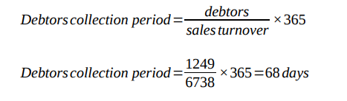
Year 2020,

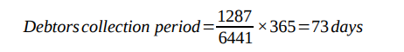
Current ratio: Existing ratios are commonly employed as a measure of liquidity when determining a company's ability to satisfy its short-term or ongoing financial commitments. It serves as an example to both investors and academics of how a company might make the most of its liquid assets to meet its immediate financial obligations. An acceptable current ratio is about or slightly over the norm for the business sector. Problems or breakdowns may become more likely if the frequency percentage is smaller than typical. Further, if a company's current ratio is significantly higher than the average of similar companies, it suggests that its management isn't making the best use of its resources (Sutton, 2018). "(Sutton, 2018)"
Year 2021,

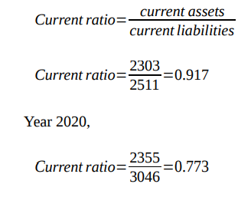
Gearing ratio: Financial analysts frequently use "economic gearing ratios" to compare a company's mortgage debt to its other assets, such as its stock market value and its real estate. Gearing ratios are a type of financial leverage metric that shows what percentage of a company's activities are financed by the sale of stock to shareholders as opposed to by taking on debt from lenders. Gear ratios can be used to simplify complex mechanisms. A company's reliability and its capacity to weather financial storms may be gleaned through an examination of its gearing ratios, which reveal the sources of the company's operational cash. Acquire a deeper understanding of the fundamentals of organizational measurement (Sutton, 2018).
Year 2021,
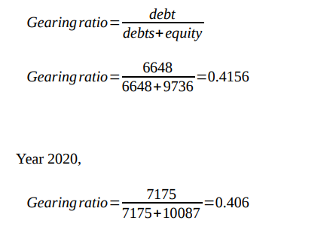
Interest cover: A financial indicator known as the Payment Covering Ratios is used to evaluate a company's ability to repay its existing debt. The ICR is used by many types of potential lenders, investors, and lenders to decide whether or not to extend credit to a business. Similar to the cover ratio is the "double income obtained" percentage. It has a few different names, but they all refer to a tool that helps you estimate the likelihood of a loss on your loan's principal. Increases in ICR reduce vulnerability. Loans are preferred by both purchasers and borrowers when the ratio is high since it indicates that the company can easily pay back the interest when the loan comes due (Sutton, 2018).
Year 2020,
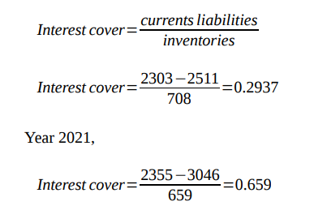

Financial performance and position of Sweet’s plc.
There are numerous different groups involved in an industry, including consumers, suppliers, financiers, traders, employees, and upper-level management. The financial health of firms in every industry is closely monitored. A company's financial efficiency may be gauged by how successfully it earns income, maintains its assets, keeps its word, and defends the interests of its investors, customers, and creditors. It is recommended that while analyzing finances, many measures be employed concurrently (Richardson et al., 2019). More specific indicators, such as Operational Earnings, Operating Cash Flows, and Process Earnings, may be derived from Total Units Sold. If the investigator or the shareholders are interested in finding proof of decreasing expenditures or increasing percentages of pennies, they may find it helpful to check over the financial records more thoroughly. As a methodology, Six Sigma excels in this area (Richardson et al., 2019).
The financial report for Sweets PLC Organization shows that it is still doing strong, both in terms of market share and financial flexibility. A greater number of options would be made available in 2021 than in 2020. This proves that the company's profits have been rising at a constant rate. The ratio of an industry's equity or capital to its debt is measured using a gear reduction ratio in a balanced scorecard. A high degree of gearing does not appear to be impeding the company's ability to satisfy its financial commitments. Since it shows how much money was produced after deducting all the costs associated with manufacturing, the net income margins ratio is often employed by businesses as a measure of profitability. One of the most telling metrics of how well a company's financial management team is doing their job is the return on equity (ROE). There was an undeniable quickening of the industry's expansion rate between 2020 and 2021. The company's financial status has been stabilizing recently. The present value of the asset in 2021 is also considerably higher than in 2020. (Richardson et al., 2019)

Conclusion
This study concludes that every enterprise has to have a basic accounting system in place. It aids firms in keeping tabs on their finances so that they can make educated decisions that will increase their bottom line. Accountants collect and evaluate financial data using a wide range of tools and methods before providing insights, recommendations, and feedback to the company's staff and management. In order to assess their economic capacity or position, businesses must first ascertain their financial standing. All decisions should start with the company's capabilities, thus it makes sense to evaluate and implement plans based on the financial accounts.

Reference
“Chapter 6: Composition of Central Bank Balance Sheet Assets” 2018 Central Bank Balance Sheet and Real Business Cycles, pp. 87–120. Available at: https://doi.org/10.1515/9781547400577-006.
“Financial statement reporting: The balance sheet” 2019 The Complete CPA Reference, pp. 33– 90. Available at: https://doi.org/10.1002/9781119204121.ch2.
“Financial statement reporting: The income statement” 2015 The Complete CPA Reference, pp. 1–31. Available at: https://doi.org/10.1002/9781119204121.ch1.
“Fundamental accounting concepts” 2019 Financial Accounting, pp. 37–80. Available at: https://doi.org/10.4324/9781315728445-11.
“The income statement/statement of comprehensive income” 2016 UK GAAP Financial Statement Disclosures Manual, pp. 67–82. Available at: https://doi.org/10.1002/9781119283393.ch4.
Richardson, S., Tuna, İ. and Wysocki, P. 2019 “Accounting anomalies and fundamental analysis: A review of recent research advances,” Journal of Accounting and Economics, 50(2-3), pp. 410–
454. Available at: https://doi.org/10.1016/j.jacceco.2010.09.008.

“Statement of financial position” 2019 Wiley 2016: Interpretation and Application of International Financial Reporting Standards, pp. 61–75. Available at: https://doi.org/10.1002/9781119254447.ch04.
Sutton, S.G. 2018 “The fundamental role of Technology in Accounting: Researching Reality,” Advances in Accounting Behavioral Research, pp. 1–11. Available at: https://doi.org/10.1108/s1475-1488(2010)0000013004.
Swieringa, R.J. 2018 “Robert T. Sprouse and fundamental concepts of financial accounting,” Accounting Horizons, 25(1), pp. 207–220. Available at: https://doi.org/10.2308/acch.2011.25.1.207.
Turtle, H.J. and Wang, K. 2017 “The value in fundamental accounting information,” Journal of Financial Research, 40(1), pp. 113–140. Available at: https://doi.org/10.1111/jfir.12119.

