Introduction

The aim of this research is, in essence, a manifestation of my desire to experience enchantment with the mystical cosmos. I often find myself often struggling with the ‘disenchantment of the world’, a product of the extreme rationalisation and industrialisation of the contemporary Western society in which I live and have been raised in, and searching for experiences of the transcendent or enchanting within my own life. Max Weber describes enchantment as an experience of union, something both spiritual and material. As such, I decided to discuss the findings from my sky journal in relation to the statement by Vincent Van Gogh, who advises: ‘Be clearly aware of the stars and infinity on high. Then life seems almost enchanted after all.’ Consequently, the aim of this essay is to step away from rationale, to explore enchantment and a mystical engagement with the cosmos, in order to understand what Van Gogh meant in his statement, and to satisfy my spiritual, personal and academic exploration to discover enchantment within my own life.

Academic Rationale

In line with the Vincent Van Gogh quote, I decided to focus my sky journal observations on experiencing enchantment through the practice of daily awareness of, and engagement with, the cosmos. J. R.R. Tolkien describes the phenomenon of enchantment as “the realization, independent of the conceiving mind, of imagined wonder’…’a fleeting glimpse of Joy, Joy beyond the walls of the world, poignant as grief’. Indeed, it could be said that I was in search of my own ‘concrete magic’, an attempt to produce practical results of enchantment through my own phenomenological research and engagement with the heavens. In other words, I attempted a practice of divination, setting out to experience the cosmos as animus, as living and capable of engaging with me in return, as opposed to objective observation of an inanimate and lifeless night’s sky.

Methodology

I began my sky journal in October and carried it on through to early November. My focus was on the stars that were visible to me, specifically the noticeable pattern of stars referred to as the Big Dipper asterism of the Ursa Major constellation, otherwise known as the Great Bear. Below is a painting I came across which I felt symbolises my own perspective of the asterism, and similarly represents my view of it from where I had been observing it. Both the painting and my observations took place in the Northern Hemisphere, where the Dipper is largely visible through the winter months. Interestingly, upon researching the artist, Natalia Shchipakina, it also became clear that her artworks are heavily inspired by Vincent Van Gogh, something I may have subconsciously picked up on when selecting this image specifically to include in this text.
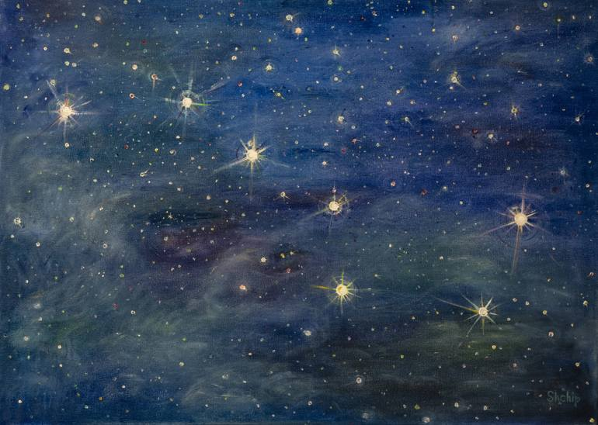

I chose to observe the asterism from the patch of sky that is visible from my partner’s back garden, where I had been living. This section of sky is wide and largely unobstructed. I began to note the times and dates of my observations, and soon realised that the best observation period for the Big Dipper was between 8 and 9pm. Any later than 10.30pm, the constellation would disappear behind the tree on the right-hand side, showing me its perceived migration from left, to right from my vantage point.

The methodological framework for my sky journal observations was undertaken in line with Christopher Tilley’s phenomenological approach, through using experiential evidence and my own subjective, lived experience to analyse a landscape. I applied Tim Ingold’s perspective to my research, that ‘Real landscapes…have to be inhabited’ in order to fully experience them. In my research, the landscape was the night’s sky. Indeed, Ruth M. Van Dyke states that the value of using human spatial perceptions in research can allow for ‘insights into the ways in which prehistoric peoples experienced, perceived and represented the spatial world’. Consequently, I kept a daily diary in which I not only recorded the quantitative data of my observations such as dates and times, but also focused on which stars of the asterism were the most visible, therefore incorporating my visual senses. Qualitatively, I detailed my emotional reactions, my intellectual wonderings, how the weather impacted my physical body and other physical sensations that occurred throughout my daily observation. I took several images alongside my written observations.

My Phenomenological Experience

Upon visiting and revisiting this section of the sky I began to enjoy the feeling of constancy, in knowing that the constellation would be there, it brought a sense comfort in an otherwise unstable and unpredictable time in my life. This is evident in the entry from 19th October, 2022: ‘I may feel unsettled, but night after night the stars have made themselves available to me’. It was in this way my repeated observations became a sacred ritual for me, a moment for reflection and to connect with the mystical beyond. Even after completing the month-long sky journal observations, I found myself missing this element of my new daily routine, and when the stars were obscured by mist or cloud I noted in my journal ‘a sense of sadness, a disconnection from my newfound friendship with the cosmos’. William James describes a transcendent experience as ‘union with something larger than ourselves’, something I evidently felt and experienced, and noticed a sense of longing for on the nights the Big Dipper was covered by mist or clouds.

Additionally, throughout my observations I continued to experience:
‘A longing, and a kind of homesickness. I find myself wondering what life is like beyond the realms of Earth-based consciousness, whether loved ones who has passed are among the stars and planets, watching and standing alongside me.’
It could be argued that this quote demonstrates another experience of enchantment, as John R. Peteet recognises four main components in experiences of enchantment or transcendence: ‘1) suspending disbelief, 2) being inspired or moved, 3) surrendering oneself and 4) identifying one’s place within a larger context’. The quote from my journal suggests my experience of observing the sky did indeed trigger inspiration and emotional movement, as well as placing myself within a much wider context.

Whilst looking at the dark spaces between the stars, I then became intrigued by the idea of their interconnectedness, how although these celestial bodies were lightyears apart in distance, they appeared to me only a couple of meters away from one another.
As noted in my journal:
“I find a strange sense of peace in linking together the visible stars in triangles, and it makes me think of Pythagorean triangles. Was his theorem an attempt to understand the distance of the universe through mapping the stars? I.e., by continually working out the hypotenuse of each tringle as it was linked or attached to the one next to it.”
Whether there is any truth in that might be near impossible to know, yet I personally found it an illuminating and enchanting thought, even just to be seeing the same sky, the same patterns that the brilliant theoretical and philosophical minds have questioned and wondered about since time began, much like how Van Dyke argues a phenomenological methodology can connect us with the past. Evidently, I had begun to uncover the sense that ‘life seems enchanted after all’.

Furthermore, I was consciously engaging with my senses throughout my journal observations. I also, somewhat subconsciously, found myself detailing the emotions I was experiencing whilst partaking in my observations. Such entries included “feeling vulnerable and isolated”. The phenomenological perspective demands awareness of the affective and bodily sensations that arise through engagement with a landscape, therefore the importance of noting my embodied sensations became increasingly evident, not just the incorporation of my tactile senses. This led me to question whether my emotional state was capable of influencing my observations, or whether the reflective state I found myself during my observations was a product of engaging with the cosmos in such a way. Or, as Van Dyke suggests, was it indicative of what previous generations had too experienced whilst observing the Big Dipper from the Northern Hemisphere?

An Unexpected Experience of Enchantment

Despite my daily observations and experiences of intellectual and conscious wonderings whilst focusing on the Big Dipper, I found my most affective, powerful and embodied experience of enchantment originated entirely outside of my planned methodological observations. This experience of enchantment did not occur through watching the night’s sky at all, in fact it happened through an incredible sunset visible through striking, bulbous clouds in an entirely different area of Swansea.

‘I found myself called to the sunset in a quiet and subtle way, and stood in the garden observing the movement of the clouds and the gently shifting, pink-orange light as though it was speaking to me in a way I understood more deeply than language, more embodied than words or phrases. I felt immediately that this experience had found me, and not the other way around.’
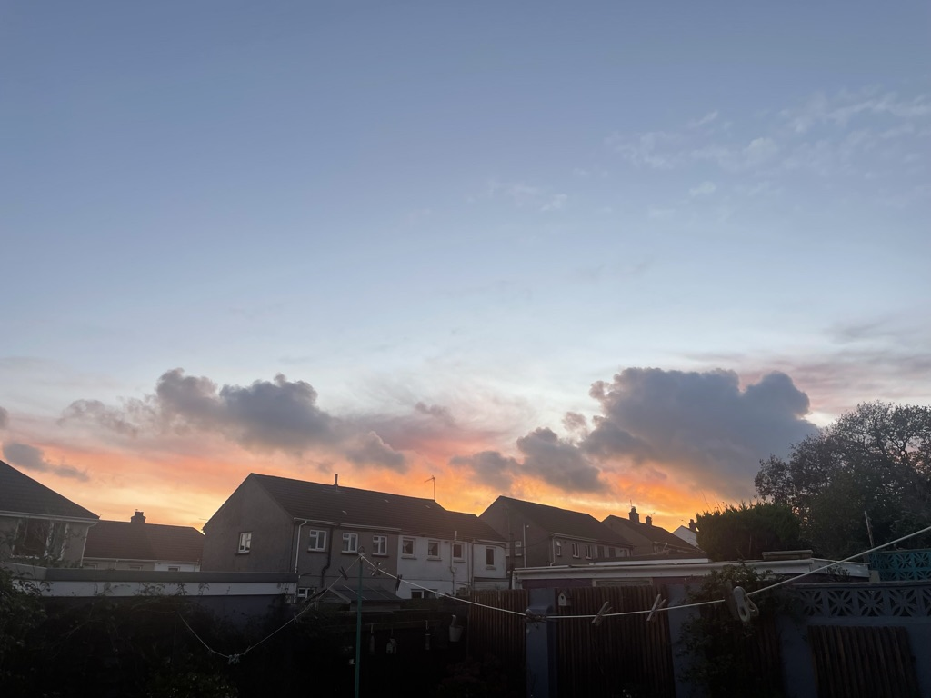
Image taken 17/11/22 by myself.

Here I would like to compare to another primary source about enchantment from Sally MacLaine, who said ‘I found new levels of meaning in the simplest act. If a bird sang outside my window, I longed to know the hidden message of its song’. As such, these two primary sources surrounding personal experiences of transcendence and enchantment suggest that such experiences possess a form of agency, a way of engaging or communicating with those who seek it out, but rarely in the way we expect. As I pondered on how enchantment appeared to come to me as opposed to being hidden waiting for me to discover, I reflected upon previous experiences of enchantment, finding that they have without exception, found me. I understood, then, that one can seek out such meanings and experiences, yet the experience must first be willing to reveal itself.

Conclusion

In conclusion, the aim I set out to achieve with regards to seeking out enchantment appears to both have been successful, and to have failed. Throughout my sky journal observations, I began to pay more attention to the sky and its teachings, however my search for enchantment ultimately did not arise out of my methodological framework and instead rather surprised me, taking form and appearing somewhat of its own desire and intention. However, I believe my methodology and examination of my emotions and embodied experiences allowed me to engage with the experience of enchantment when it ultimately revealed itself to me. The animism of the cosmos had absolutely been demonstrated, presenting itself to me with an expression of agency, its own intention and desires. Consequently, the academic and personal conclusion of my sky journal observation is indeed to agree with Van Gogh’s contention that when you engage with the heavens, life does become enchanted, only not in the ways one might expect.

Weber, Max., cited in Patrick Curry “Divination, Enchantment and Platonism”, in Jean H. Lall and Angela Voss (eds.), The Imaginal Cosmos (Canterbury: University of Kent, 2006) pp.3
Curry, Patrick., “Divination, Enchantment and Platonism” (2006), pp.3
Gogh, Vincent van, and Ronald de Leeuw. The Letters of Vincent Van Gogh. London: Penguin Books, (1997), p.392
Tolkien, J. R. R.(On Fairy Stories pp.35), cited in in: Rosegrant, John. “Tolkien’s Dialogue Between Enchantment and Loss.” Mythlore 33, no. 2 (126) (2015): 127–38. http://www.jstor.org/stable/26815993.
Curry, Patrick., “Divination, Enchantment and Platonism” (2006)
https://www.saatchiart.com/print/Painting-Big-Dipper/1547819/7530169/view
Tilley, Phenomenology of Landscape
Tim Ingold (2005) Comments on Christopher Tilley: The Materiality of Stone: Explorations in Landscape Phenomenology. Oxford: Berg, 2004., Norwegian Archaeological Review, 38:2, 122-129, DOI: 10.1080/00293650500359078
Van Dyke, R.M. (2014). Phenomenology in Archaeology. In: Smith, C. (eds) Encyclopedia of Global Archaeology. Springer, New York, NY. https://doi.org/10.1007/978-1-4419-0465-2_295
Nicol, Amelia., 2022, ‘Sky Journal’, 19th October, pp.2
Nicol, Amelia., 2022, ‘Sky Journal’, 22nd November, pp.14
James, William., 1902, "The Varieties of Religious Experience", Lecture XX, Conclusions, pp.134
Nicol, Amelia., 2022, ‘Sky Journal’, 2nd November, pp.6
Peteet, John R., 2018, ‘A Closer Look at Transcendence and Its Relationship to Mental Health.’ Journal of Religion and Health, 57, no. 2: 717–24. http://www.jstor.org/stable/26749403.
Nicol, Amelia., 2022, ‘Sky Journal’, 17th October, pp.2
Van Dyke, Ruth M., ‘Phenomenology in Archaeology’ (2014)
Gogh, Vincent van, and Ronald de Leeuw. ‘The Letters of Vincent Van Gogh’.
Nicol, Amelia., 2022, ‘Sky Journal’, 25th October, pp.7
Nicol, Amelia., 2022, ‘Sky Journal’, 17th November, pp.12
MacLaine, Shirley., 1983, ‘Out on a Limb’, pp.87, cited in in Sire, James W., 2014, “I Am God: Transcendence as Immanent in the Self.” In Echoes of a Voice: We Are Not Alone, 1st ed., 183–99. The Lutterworth Press, https://doi.org/10.2307/j.ctt1cg4m8v.14.

