
APPENDIX GA36c

LEVEL 6 ASSESSMENT SPECIFICATION

Student name: |  | Student ID number:
Programme: | BEng Manufacturing Systems Engineering, BEng Materials Engineering, BEng Advanced Manufacturing Operations, BSc Engineering Management
Module: | Manufacturing Systems and Simulation
Module code: | ACEA 6002 | Contribution to Overall Module Assessment (%): | 50%
Lecturer: | Andrew Thorn | Internal Verifier: | Kelvin Lake
Assignment Title: | Applying Lean Techniques | Word count (or equivalent): | 2,500
Submission deadline: | 21/07/2023 | Return date of provisional marks & written feedback: | 22/09/2023
Submission method: | All written assessments, where practical and possible, must be submitted via Turnitin unless otherwise instructed by the Lecturer. (Please DO NOT put this assessment specification into Turnitin or it will match many similarities with other students’ submissions.)  Alternative submission method (if applicable):  Late submission of the assessment will result in a late penalty mark. Penalties for late submission: Up to one week late, maximum mark of 40%. Over one week late, 0%. Only the Extenuating Circumstances Panel may approve a change to submission dates.
Academic honesty / referencing: | Academic honesty is required. In the main body of your submission you must give credit to authors on whose research and ideas your work is based. Append to your submission a reference list that indicates the books, articles, etc. that you have used, cited or quoted in order to complete this assessment.

Module Learning Outcomes
(from module syllabus)
Upon the successful completion of this module, the student should be able to:
- Interpret and evaluate the material and information flows in the manufacturing process using simulation and analytical techniques
- Evaluate a range of strategies for the improvement and management of production operations

TASK DESCRIPTION

You are required to analyse a particular part of the manufacturing or service operations and make recommendations as to how the process/service could be made leaner.

Your report should address the following issues:-

- The types of waste that are currently occurring in the process or service.
- An analysis of what creates value from the customer’s perspective in relation to process or service being considered.
- An evaluation of how the process/service can be made leaner.
- A consideration of potential problems associated with implementing the improvements, costs of the improvements where possible and how these problems could be overcome.

Report

Introduction
The purpose of this report is to analyse the operating practices and procedures of the CDS1 Thermal Spraying Booth in Bodycote Newport LLC to determine where losses in the system are being incurred and what can be done to eliminate or mitigate them in an attempt to improve the cost effectiveness of the process.

The Process
The manufacturing process of CDS1 utilises a pair of oxy-acetylene torches to add two coatings, a thin nickel-aluminium bond coat and a thick aluminium top coat, to a premanufactured core. These parts are used as blanks and later milled to produce bearing bushings for jet engine fuel pumps, and as such they are a high specification part despite the relative simplicity of the CDS1 process; this will need to be taken forwards when discussing how the process can be improved, as no significant change can be affected upon the part itself.

The complete process occurs as follows:
- A pair of bearing blank halves are collected from the delivery box.
- The bearing blank halves are fixed onto a blasting mandrel and taken to the surface preparation cell.
- The halves are grit blasted with #20 grade alumina grit at 55psi.
- The halves are taken back to CDS1 spraying booth.
- The halves are sprayed with a compressed air line to remove any remaining grit and visually inspected under a 1000 lumen light to ensure that the blasting has been thorough enough and that no blistering of the part surface has occurred.
- The halves are part marked and the diameter of the neck of the lower half is measured and recorded.
- The halves are transferred to a coating mandrel selected from the preheating oven which is then placed in the mandrel holder inside the booth.
- The part is tested using a temperature probe to ensure it has reached the target temperature of 80°C.
- The 6P II bond coat gun is lit, and the booth door is closed.
- All errors messages are cleared from the robot control console and the program is selected and started.
- The halves receive one preheat cycle.
- Nickel-Aluminium Powder feed is manually engaged to the bond coat gun and the program is continued.
- The halves receive 9 to 17 coating cycles. After the first two cycles the cooling air engages.
- Powder feed is disengaged, the booth is opened, and the parts removed.
- The lower half neck diameter is remeasured to ensure that the coating thickness is sufficient.
- The joined part is removed from the mandrel and placed in a heatproof box to await top coating.
- The process is repeated until the full batch is bond coated.
- Changeover process for top coat is enacted.
- The bond coated part is removed from the box, fitted to a coating mandrel selected from the preheating oven which is then placed in the mandrel holder inside the booth.
- The part is tested using a temperature probe to ensure it has reached the target temperature of 80°C.
- The 12E top coat gun is lit and the booth door is closed.
- All errors messages are cleared from the robot control console and the program is selected and started.
- The bonded part receives two preheat cycles.
- 3mm Aluminium Wire feed is manually engaged to the top coat gun and the program is continued.
- The bonded part receives 115 to 250 coating cycles. After the first two cycles the cooling air engages.
- Wire feed is disengaged, and the booth is opened.
- The minimum diameter is measured to ensure that the coating thickness is sufficient. If it is not, the coating thickness can be topped up.
- The joined part is removed from the mandrel, part marked and immersed in vermiculite to cool.

Study of this process indicates that it produces two primary forms of waste; time and material. The system is reliable when the process is adhered to correctly and will not produce scrap material, however deviations outside of the expected parameters can result in the coating thickness being excessive or insufficient which, for bond coat, cannot be corrected. The process is also at the risk of a phenomenon known as Lead Sweat, which is caused by the part becoming too hot during spraying and the lead content of the part’s core leeching out and sticking the part to the model (Figure 1)
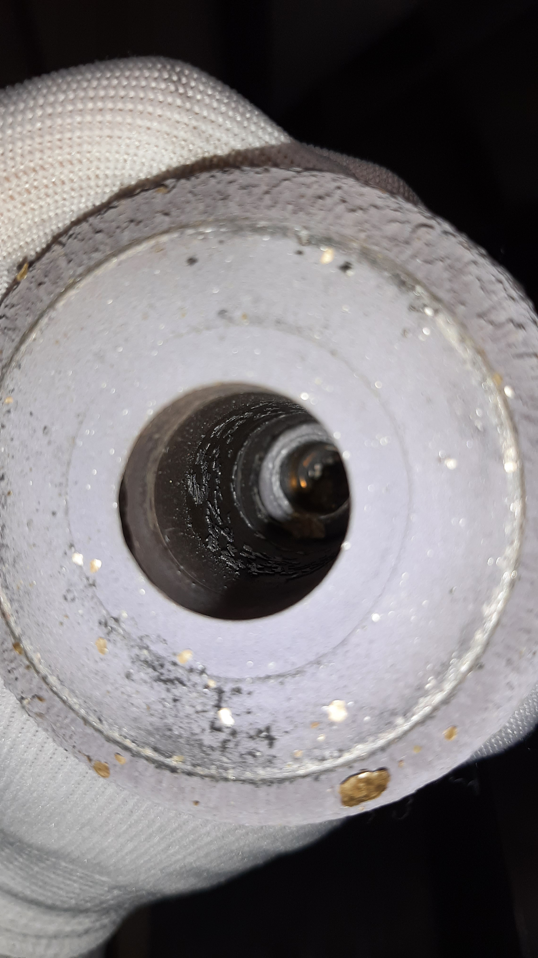
Figure 1: Lead Sweat
Lead Sweat represents a complete failure state of the part and creates significant waste; the part is rendered unusable because the material structure of the core of the part has been altered in a way that renders it no longer fit for purpose, and the introduction of lead between the part and the mandrel causes them to stick and require the use of a hydraulic press to separate the two followed by cleaning the lead from the mandrel for it to be reused, creating in most cases approximately 30 minutes of time waste. However, adjusting the part to eliminate this risk is also not an option, as this is a desired behaviour of the part; it is an intentional part of the design to stop the finished bushing from spinning and cease operation of the fuel pump in the event of an engine fire. Therefore, this behaviour must be both maintained and worked around when redesigning the production process.

Time Waste
The first stage of investigating the production process was to determine where activities were being undertaken that could be performed faster.

Handling - Grit Blasting Cell
The first and most obvious example of this is the requirement to take the two halves to and from a separate cell to be grit blasted, requiring two walks of 40 metres per part. This could be eliminated simply by relocating the grit blaster to the main CDS1 cell, reducing the time to produce each part on bond coat by roughly one minute per part (assuming an 80m distance and an average walking speed of 1.42m/s (Browning, Baker, Herron, & Kram, 2006)).

However, this would require the grit blasting booth to be fully sealed when in use to minimise escape of alumina dust to the main floor of the factory, to be fitted with an extraction unit to prevent buildup of dust inside the booth, and to have a means of removing used grit from the booth (presently it simply drops into a bin below the booth, but the open hole would prevent it being sealed against dust escape). While these issues can certainly be circumvented (and indeed have been for some other grit blasting operations in other cells), the expected increase in throughput likely does not justify the expense of moving the booth and acquiring a new extraction unit for it. It would also introduce a new level of noise hazard to the factory floor.

Waiting Time - Changeover Process
The second most obvious place to look for time wastage is in the changeover process between parts being produced. However, a time saving measure is already in place, in that steps 6-7 and 19 of a following part will be performed between steps 14-15 and 27-28 of a preceding part respectively. This allows the following part to come up to temperature while the preceding part is being verified and stored, eliminating some waiting time.

To determine how effective the changeover process is, time and motion studies were conducted in order to measure the difference between value adding time (a part is currently being sprayed) versus non-value adding time for a variety of part types during the top coating process (Figure 2).

Figure 2: Time and Motion Studies
As can be seen, the process has an efficiency in excess of 70% throughout. This is good, but there is certainly room for improvement. The following step was to study the temperature traceback graphs to see where the most time was being lost between coatings. Analysis was done based on the bond coat process.

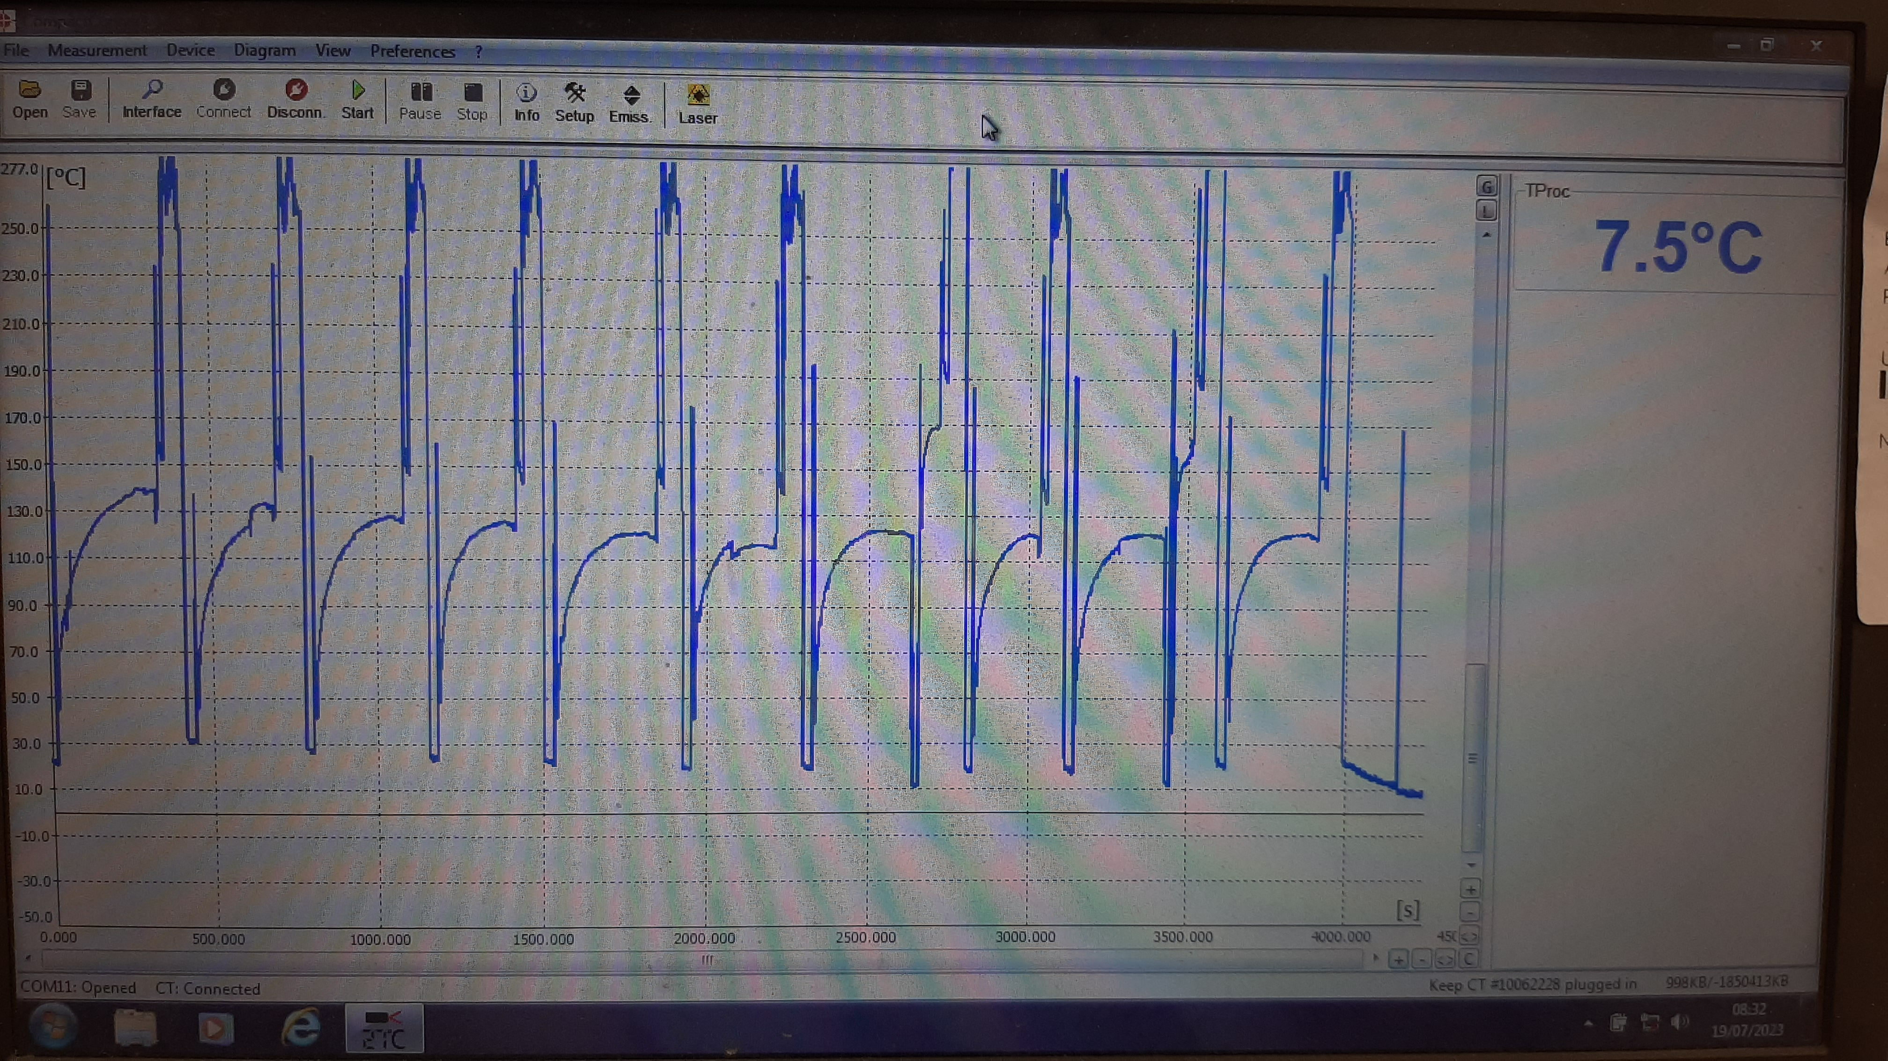
Figure 3: Temperature Traceback of Bond Coat Process
The traceback (Figure 3) shows a curving line when the part is coming up to temperature, followed by a sharp spike in temperature when the preheat cycle is applied followed by a series of fluctuations as the bond coat is applied. There is then a brief gape as the changeover occurs before the cycle starts again. The graph immediately makes clear that the primary cost of time in this process is the wait while the part comes up to temperature, so this must be considerred first when determining how the process can be made quicker.

Suggestions have included increasing the initial temperature of the coating mandrels to shorten the preheat time, but as the mandrels are in direct contact with the core of the part this solution runs a high risk of inducing lead sweat. Another suggested solution is to lower the oven temperature, but to preheat the part itself; this procedure is currently in use on the CDS2 booth, and its effectiveness in reducing changeover times is currently being studied there. However, CDS2 is currently not cleared for regular production work and so its operational processes are still in flux, and the exact effectiveness of this method on CDS1 cannot be easily determined. It would also require the investment of a bigger preheating oven, but this expense is minimal and would certainly be paid off by production time reduction quickly enough.

Material Waste
The second stage of investigation was to determine where activities were wasting material, and where this could be eliminated. The first example of this found was overspray; on both bond and top coats, the gun will travel off of the part and spray material onto the mandrel holder and onto a backing sheet behind the part. This necessitates foil-and-wire shrouds to cover the mandrel holder to prevent damage and allow buildup of material to be easily removed, as well as wasting bond coat powder and top coat wire directly. Shrouds are used at a rate of one large and one small for a whole bond coat batch (Figure 4), and one large for a whole top coat batch plus one small per top coat part (Figure 5). The cost of the wire to hold the foil in place is functionally zero as these are recovered from unusable lengths of top coat wire following wire spool changes.

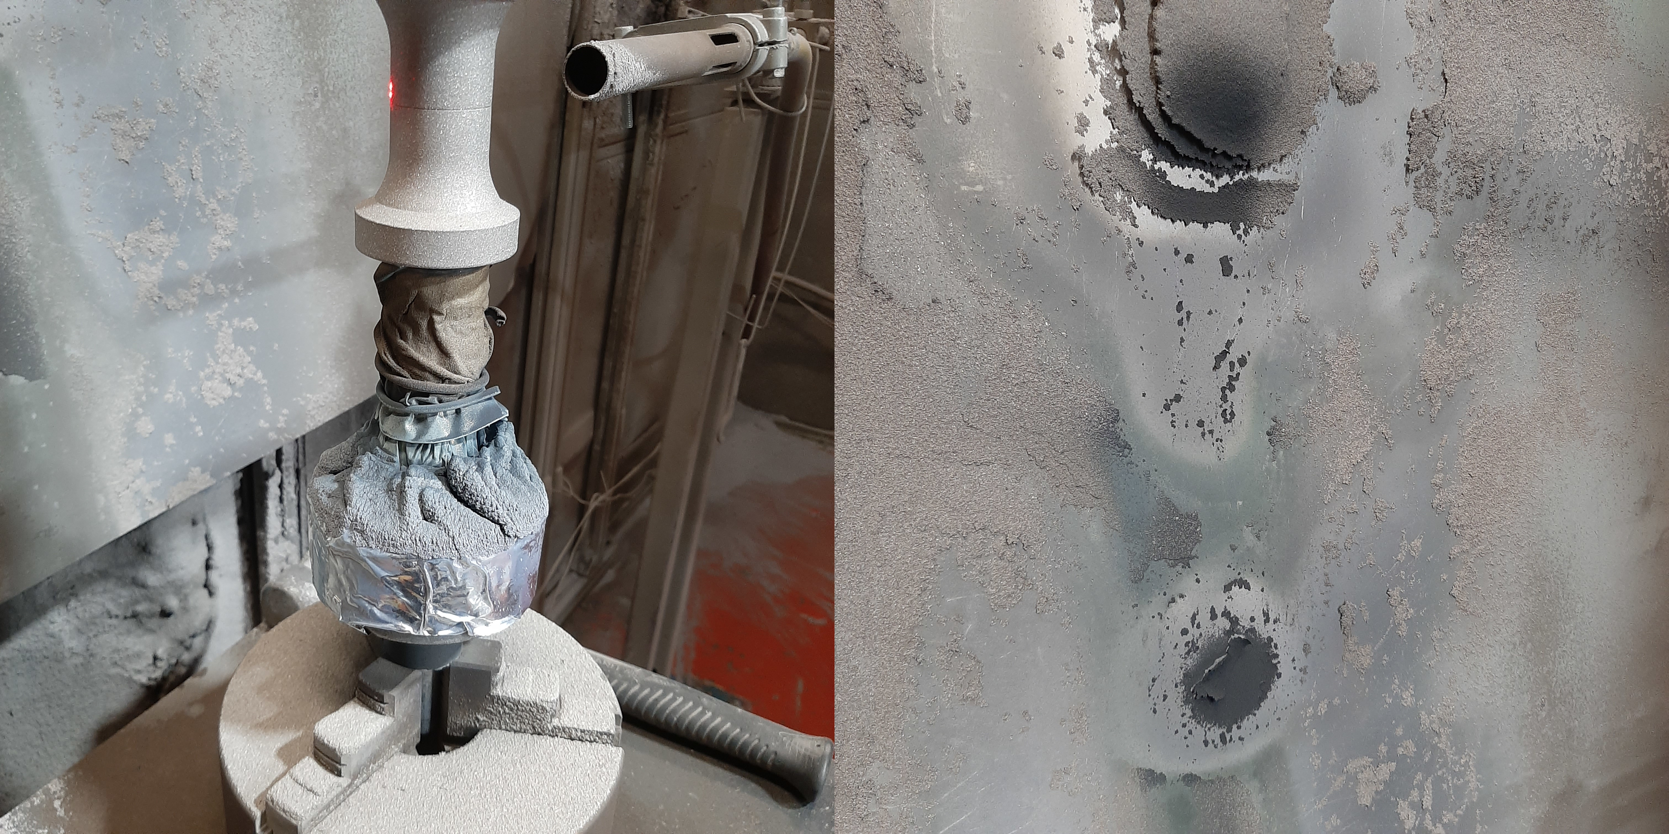
Figure 4: Overspray on Bond Coat
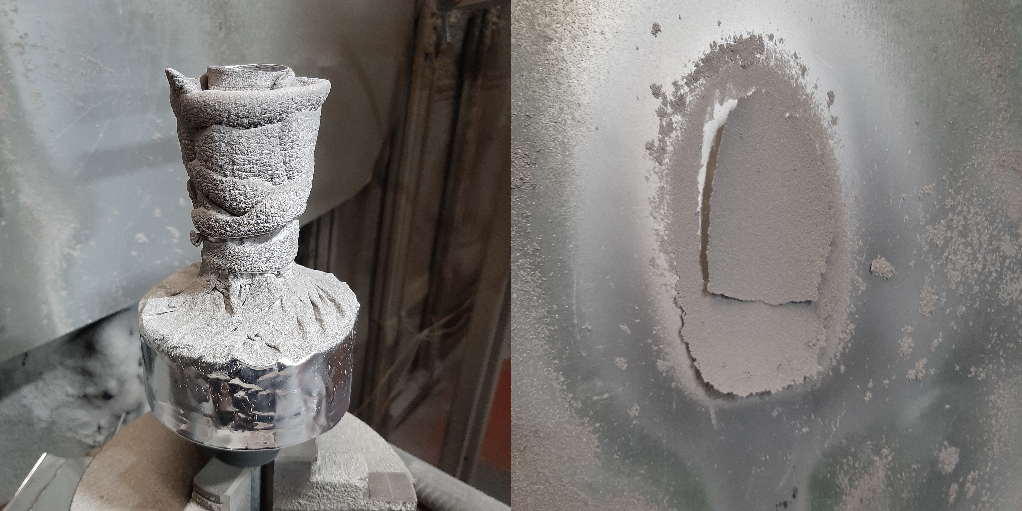
Figure 5: Overspray on Top Coat
The bond coat excess spray for a batch of 22 parts was found to be equal to 124.7g of powder. Considering the target spraying rate is 35g/min, this indicates a total of roughly 214 seconds of time off part per bond coated part. Unfortunately a direct cost-by-weight could not be established prior to the publishing of this report.

Figure 6: Top Coat Overspray Weight
Figure 6 demonstrated the weight of excess top coat wire overspray in grams for a batch of 12 290 parts. As can be seen, nearly half a kilogram of aluminium is wasted per part. A two-kilogram spool of wire costs £26.85, which when compared to the average weight of aluminium wasted gives us an average wasted aluminium wire cost of £6 per part.

Unfortunately, eliminating these waste costs has proven difficult: the reason for the gun travelling off of the part while spraying is to create cooling time for the part mid-production and manage the buildup of heat, which has proven to be key in preventing lead sweat in parts. The issue has been severe enough that even the newer CDS2 booth, which has a better cooling air and extraction system to give further assistance to part cooling, still must include this behaviour in its gun position programming.

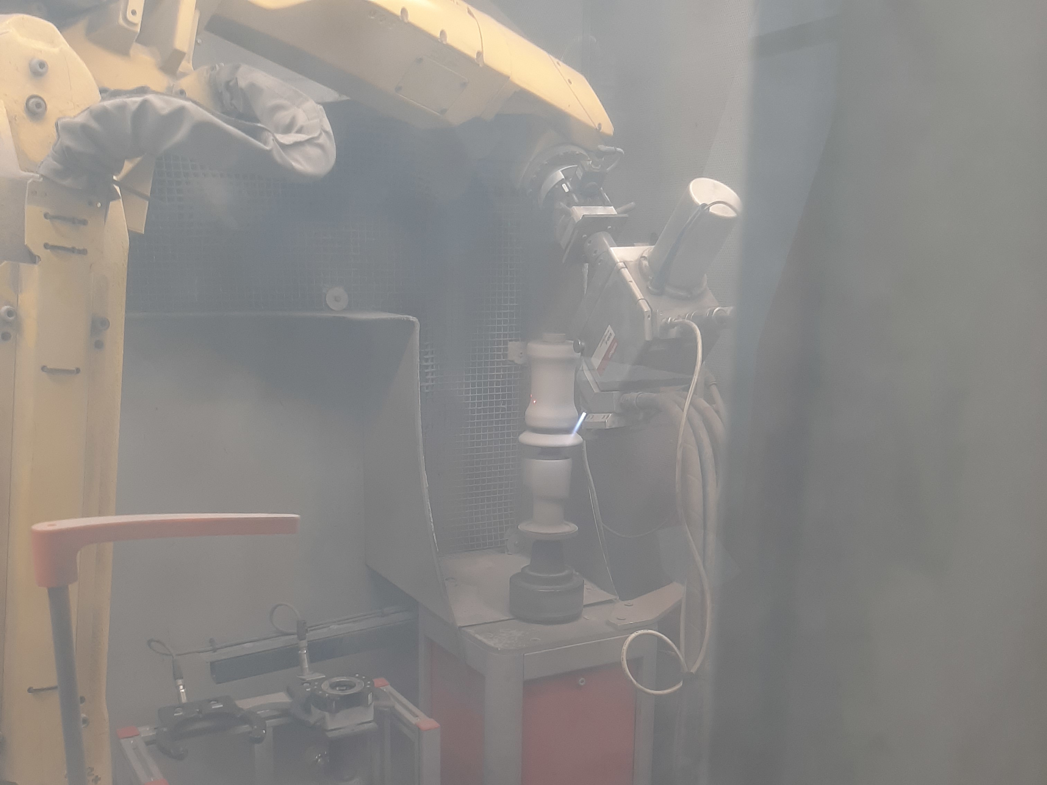
Figure 7: CDS2 Overspray
However, CDS2 does implement some features that could also be used on CDS1; its mandrels are fitted with a reusable silicon splash guard rather than requiring a disposable foil shroud. This would remove a marginal cost from the process. The improved cooling air system could also be implemented, allowing the overspray time to be reduced.

GUIDANCE FOR Students IN THE COMPLETION OF TASKS

NOTE: The guidance offered below is linked to the five generic assessment criteria overleaf.

- Engagement with Literature Skills
Your work must be informed and supported by scholarly material that is relevant to and focused on the task(s) set; you should make use of scholarly reviews and primary sources, where appropriate (for example, refereed research articles and/or original materials appropriate to the discipline). You should provide evidence that you have accessed a wide range of sources, which may be academic, governmental and industrial; these sources may include academic journal articles, textbooks, current news articles, organisational documents, and websites. You should consider the credibility of your sources; academic journals are normally highly credible sources while websites require careful consideration/selection and should be used sparingly. Any sources you use should be current and up-to-date, mostly published within the last five years or so, though seminal/important works in the field may be older. You must provide evidence of your research/own reading throughout your work, using a suitable referencing system, including in-text citations in the main body of your work and a reference list at the end of your work.

Guidance specific to this assessment:
Try to ensure there is a good blend of references, do not rely solely on Internet sources.

- Knowledge and Understanding Skills
At level 6, you should be able to demonstrate coherent and detailed knowledge and a systematic understanding of the subject area, at least some of which is informed by the latest research and/or advanced scholarship within the discipline. You should be aware of the uncertainty, ambiguity and limits of knowledge. Your work must demonstrate the growing extent of your knowledge and systematic understanding of concepts and underlying principles associated with the subject area. Knowledge relates to the facts, information and skills you have acquired through your learning. You demonstrate your understanding by interpreting the meaning of the facts and information (knowledge). This means that you need to select and include in your work the concepts, techniques, models, theories, etc. appropriate to the task(s) set. You should be able to explain the theories, concepts, etc. meaningfully to show your understanding. Your mark/grade will also depend upon the extent to which you demonstrate your knowledge and understanding; ideally each should be complete and detailed, with comprehensive coverage.

Guidance specific to this assessment:
Make sure the area you choose for your lean exercise has sufficient wastes in it and that there is room for improvements to be made.

- Cognitive and Intellectual Skills
You should be able to: critically evaluate evidence, arguments, assumptions, abstract concepts and data some of which are at the forefront of a discipline (and that may be incomplete) to devise and sustain arguments, to make judgements and/or solve problems; describe and comment upon particular aspects of current research, or equivalent advanced scholarship, in the discipline Your work must contain evidence of logical, analytical thinking, evaluation and synthesis. For example, to examine and break information down into parts, make inferences, compile, compare and contrast information. This means not just describing what! But also justifying: Why? How? When? Who? Where? At what cost? At all times, you must provide justification for your arguments and judgements. Evidence that you have reflected upon the ideas of others within the subject area is crucial to you providing a reasoned and informed debate within your work. Furthermore, you should provide evidence that you are able to make sound judgements and convincing arguments using data and concepts. Sound, valid conclusions are necessary and must be derived from the content of your work. Where relevant, alternative solutions and recommendations may be proposed.

Guidance specific to this assessment:

- Practical Skills
At level 6, you should be able to apply the methods and techniques that you have learned to review, consolidate, extend and apply your knowledge and understanding, and to initiate and carry out projects. You will deploy accurately established techniques of analysis and enquiry relevant to the discipline, and apply them in complex and unpredictable contexts, to devise and sustain arguments and/or to solve problems. You should be able to frame appropriate questions to achieve a solution - or identify a range of solutions. You should be able to demonstrate how the subject-related concepts and ideas relate to real world situations and/or a particular context. How do they work in practice? You will deploy models, methods, techniques, and/or theories, in that context or circumstances, to assess current situations, perhaps to formulate plans or solutions to solve problems, or to create artefacts, some of which may be innovative and creative. This is likely to involve, for instance, the use of real world artefacts, examples and cases, the application of a model within an organisation and/or benchmarking one theory or organisation against others based on stated criteria. You should show awareness of the limitations of concepts and theories when applied in particular contexts.

Guidance specific to this assessment:
Try to think about the problems encountered implementing new ideas or changes.

- Transferable Skills for Life and Professional Practice
Your work must provide evidence of the qualities and transferable skills necessary for graduate-level employment requiring the exercise of initiative and personal responsibility and decision-making in complex and unpredictable circumstances. This includes demonstrating: the learning ability for professional development to advance existing skills and acquire new competences of a professional nature that will enable you to assume significant responsibility within organisations; that you can initiate and complete tasks and procedures, whether individually and/or collaboratively; that you can use appropriate media to effectively communicate information, arguments and analysis in a variety of forms to specialist and non-specialist audiences; fluency of expression; clarity and effectiveness in presentation and organisation. Work should be coherent and well-structured in presentation and organisation.

Guidance specific to this assessment:
Ensure your work is well referenced, reads well and figures and tables are referred to in the text

Student FEEDBACK FORM

This section details the extent to which the assessment criteria are demonstrated by you, which in turn determines your mark. The marks available for each category of skill are shown. Lecturers will use the space provided to comment on the achievement of the task(s), including those areas in which you have performed well and areas that would benefit from development/improvement.

Generic Assessment Criteria | Marks available | Marks  awarded
1. Engagement with Literature Skills
.
 | 10
2. Knowledge and Understanding Skills

 | 20
3. Cognitive and Intellectual Skills

 | 30
4. Practical Application Skills

 | 30
5. Transferable Skills for Life and Professional Practice

 | 10

Assessment Mark (Assessment marks are subject to ratification at the Exam Board. These comments and marks are to give feedback on module work and are for guidance only until they are confirmed. ) | Late Submission Penalties (tick if appropriate) |  | %
 | Up to 1 week late (40% Max) |  | %
 | Over 1 week late (0%) |  | %

GENERIC ASSESSMENT CRITERIA

Level 6
In accordance with the Framework for Higher Education Qualifications, at the end of Level 6 students should have coherent and detailed knowledge and a systematic understanding of their subject area, at least some of which is informed by the latest research and/or advanced scholarship within the discipline. They will be able to accurately deploy established techniques of analysis and enquiry within a discipline, using their conceptual understanding to devise and sustain arguments and/or to solve problems. They should be aware of the uncertainty, ambiguity and limits of knowledge. They should be able to critically evaluate evidence, arguments, assumptions, abstract concepts and data (that may be incomplete), to make judgements, and to frame appropriate questions to achieve a solution - or identify a range of solutions. They will apply the methods and techniques that they have learned to review, consolidate, extend and apply their knowledge and understanding, and to initiate and carry out projects. They will have the ability to manage their own learning, and to make use of scholarly reviews and primary sources (for example, refereed research articles and/or original materials appropriate to the discipline). They will demonstrate the qualities and transferable skills necessary for employment requiring: the exercise of initiative and personal responsibility; decision-making in complex and unpredictable contexts; the learning ability needed to undertake appropriate further training of a professional or equivalent nature.

Level 6 | FAIL | MARGINAL FAIL | SATISFACTORY  (3rd / Pass) | GOOD  (2.2 / Pass) | VERY GOOD  (2.1 / Merit) | EXCELLENT  (1st / Distinction) | EXCEPTIONAL  (1st / Distinction)
Category | 0-29% | 30-39% | 40-49% | 50-59% | 60-69% | 70-84% | 85-100%
Engagement with literature (including reading, referencing,  academic conventions and  academic honesty) | Little or no evidence of reading and/or reliance on inappropriate sources.  Views and findings mostly unsupported and non-authoritative.  Referencing conventions used incoherently or largely absent. | Poor engagement with essential reading. No evidence of wider reading. Reliance on inappropriate sources, and/or indiscriminate use of sources. Heavily reliant on information gained through class contact. Inconsistent and weak use of referencing. | Engagement with a limited range of mostly relevant and credible sources. Some omissions and minor errors.  Referencing conventions evident though not always applied accurately or consistently. | Engagement with an appropriate range of research-informed literature, including sources retrieved independently. Some over-reliance on texts. Referencing may show minor inaccuracies or inconsistencies. | Engagement with a wide range of research-informed literature, including sources retrieved independently.  Selection of relevant and credible sources. Very good use of referencing, with no/very few inaccuracies or inconsistencies. | Engagement with an extensive range of relevant and credible literature, informed by the latest research. Consistently accurate application of referencing. | Exceptional engagement with an extensive range of relevant and credible literature, informed by the latest research. High-level referencing skills consistently and professionally applied.
Knowledge and understanding (Coherent and detailed knowledge and systematic understanding of the subject area, at least some of which is informed by the latest research and/or advanced scholarship within the discipline.) | Major gaps in knowledge and systematic understanding of the subject matter. Substantial inaccuracies. No awareness of knowledge of the latest research and/or advanced scholarship within the discipline. | Gaps in knowledge, with only superficial systematic understanding. Some significant inaccuracies and/or irrelevant material. No awareness of knowledge of the latest research and/or advanced scholarship within the discipline. | Limited knowledge and systematic understanding of the relevant concepts and principles within the subject area which to some limited extent, is informed by current research and scholarship. | Knowledge is reasonably detailed, accurate with a good systematic understanding of the field of study and to some extent, current research and scholarship. | Knowledge is reasonably extensive coherent and detailed. Exhibits very good understanding of the breadth and depth of established views, and the work is, at least in part, well-informed by current research and scholarship. | Excellent coherent and detailed knowledge and systematic understanding of the principles and theories of current research and scholarship. Clear awareness of challenges to established views and the limitations of the knowledge base. | Exceptionally coherent and detailed knowledge and systematic understanding of the principles and theories of the subject, well-informed by current research and scholarship. A critical, sophisticated and nuanced awareness of the ambiguities and limitations of knowledge.
Cognitive and intellectual skills  (Conceptual and critical thinking, analysis, synthesis and evaluation of research, assumptions, abstract concepts and data (that may be incomplete); logic, argument and judgement.) | Wholly or almost wholly descriptive work. Little or no analysis, synthesis or evaluation.  Failure to develop arguments, leading to illogical or invalid judgements. Unsubstantiated generalisations, made without use of any credible evidence. | Largely descriptive work, with superficial use of critical evaluation. Weak development of arguments and judgements. Information accepted uncritically, uses generalised statements made with scant evidence and unsubstantiated opinions. Ideas sometimes illogical and contradictory. | Limited attempt at critical thinking, analysis, synthesis and evaluation, tending towards description.  Some evidence to support emerging arguments and judgements but these may be underdeveloped or with a little inconsistency / mis-interpretation.  Asserts rather than argues a case. | Some critical thinking, analysis, synthesis and evaluation. Can analyse new and/or abstract concepts and data without guidance.  An emerging awareness of different stances and ability to use evidence (that may be incomplete) to support the argument.  Mostly valid arguments and logical judgements. Some tendency to assert/state opinion rather than argue on the basis of reason and evidence. | Sound critical thinking, analysis, synthesis and evaluation demonstrating critical thinking. Ability to devise and sustain persuasive arguments, and to review the reliability, validity and significance of evidence (that may be incomplete) to make mostly appropriate and valid judgements. | Excellent critical thinking, analysis, synthesis and evaluation. Ability to investigate contradictory or incomplete information and make strong, persuasive, arguments and sophisticated judgements. Some evidence of independent thought and ability to ‘see beyond the question’, suggesting a grasp of the broader field and wider concepts. | Exceptional critical thinking, analysis, synthesis and evaluation based on judiciously selected evidence.  Ability to investigate contradictory or incomplete information and make strong, persuasive, arguments and sophisticated, nuanced, judgements. Evidence of independent thought and ability to ‘see beyond the question’, suggesting an outstanding grasp of the broader field and wider concepts.
Practical skills  (Apply/deploy accurately established tools and techniques; initiate and carry out projects; formulate solutions to solve problems in complex and unpredictable contexts.) | Limited or no use of methods, materials, tools and/or techniques.  Little or no appreciation of the context of the application.  Limited understanding of the application of theory to practice or making appropriate links between the two.  Very weak problem-solving skills in complex and unpredictable contexts. | Rudimentary application of methods, materials, tools and/or techniques but without consideration and competence. Flawed appreciation of the context of the application.  Weak understanding of the application of theory to practice, with only occasional evidence of making appropriate links between the two. Weak problem-solving skills in complex and unpredictable contexts. | An adequate awareness and mostly appropriate application of well-established methods, materials, tools and/or techniques.  Basic appreciation of the context of the application. Theoretical knowledge and understanding applied in practice, but not always making logical links between the two.  Can identify problems and propose basic solutions in complex and unpredictable contexts without fully appreciating the complexity. | A good and appropriate application of standard methods, materials, tools and/or techniques.  Clear appreciation of the context of the application. Mainly consistent, accurate and logical application of theory to practice, making appropriate links between the two  Can identify problems and propose mostly appropriate solutions in complex and unpredictable contexts. | A very good application of a range of methods, materials, tools and/or techniques.  Very good consideration of the context of the application, with perceptive insights. Can identify problems and propose appropriate solutions in complex and unpredictable contexts.  Evidence of some innovation and creativity. | An advanced application of a range of methods, materials, tools and/or techniques.  The context of the application is well considered, and insightful.  Application and deployment extend beyond established conventions. Can identify complex problems and propose excellent solutions. Innovation and creativity evident. | Exceptional levels of application and deployment skills in unpredictable, practical contexts, drawing skilfully on the latest research within the discipline. Can identify complex problems and propose sophisticated solutions. Assimilation and development of cutting edge processes and techniques.
Transferable skills for life and professional practice  (Exercise of initiative and personal responsibility; professional development; initiate and complete tasks and procedures: individually and/or collaboratively; use appropriate media to communicate effectively; fluency of expression; clarity and effectiveness in presentation and organisation.) | Communication medium is inappropriate or misapplied.  Work is poorly structured, disorganised and/or confusingly expressed. Very weak use of language and/or very inappropriate style. Little or no evidence of autonomy (or collaboration, where relevant) in the completion of tasks. Little or no evidence of the skills required in graduate employment. | Communication medium is poorly designed and/or not suitable for the audience.  Work is poorly presented in a disjointed manner. It is loosely, and at times incoherently, structured, with information and ideas often poorly expressed. Weak use of language and/or inappropriate style. Weak independent initiative (or collaboration, if relevant). Limited evidence of the skills required in graduate employment. | Can communicate in a suitable medium but with some room for improvement.  Mostly ordered presentation and structure in which relevant ideas / concepts are reasonably expressed. Work may lack coherence in places. Can work as part of a team, but with limited involvement in group activities.  Demonstrates the basic skills required in graduate employment, with some areas of minor weakness. | Can communicate effectively in a suitable format, but may have minor errors.  Mostly coherent, organised work, in a suitable structure and is for the most part clearly expressed. Can work effectively independently and/or as part of a team, with clear contribution to group activities.  Demonstrates the skills required in graduate employment, with some areas of strength and some of minor weakness. | Can communicate well, confidently and consistently in a suitable format.  Work is coherent, fluent, well-structured and organised. Can work very well autonomously and/or as part of a team, with very good contribution to group activities.  Demonstrates very good graduate employment skills, with just occasional minor weakness. | Can communicate professionally confidently and consistently in a suitable format.  Work is coherent, very fluent and is presented professionally. Can work autonomously with initiative. Where relevant can work professionally within a team, showing leadership skills as appropriate, managing conflict and meeting obligations. Demonstrates excellent graduate employment skills and an appetite for further development. | Can communicate with an exceptionally high level of professionalism.  Work is exceptionally coherent, very fluent and is presented professionally. Can work exceptionally well and professionally within a team, showing advanced leadership skills. Demonstrates exceptional graduate employment skills and an appetite for further development.

THIS DOCUMENT IS ALSO AVAILABLE IN WELSH

