BMIH4003
Hospitality & Guest Services

  - Assessment-1

Student ID:

Slide 1


Slide 2
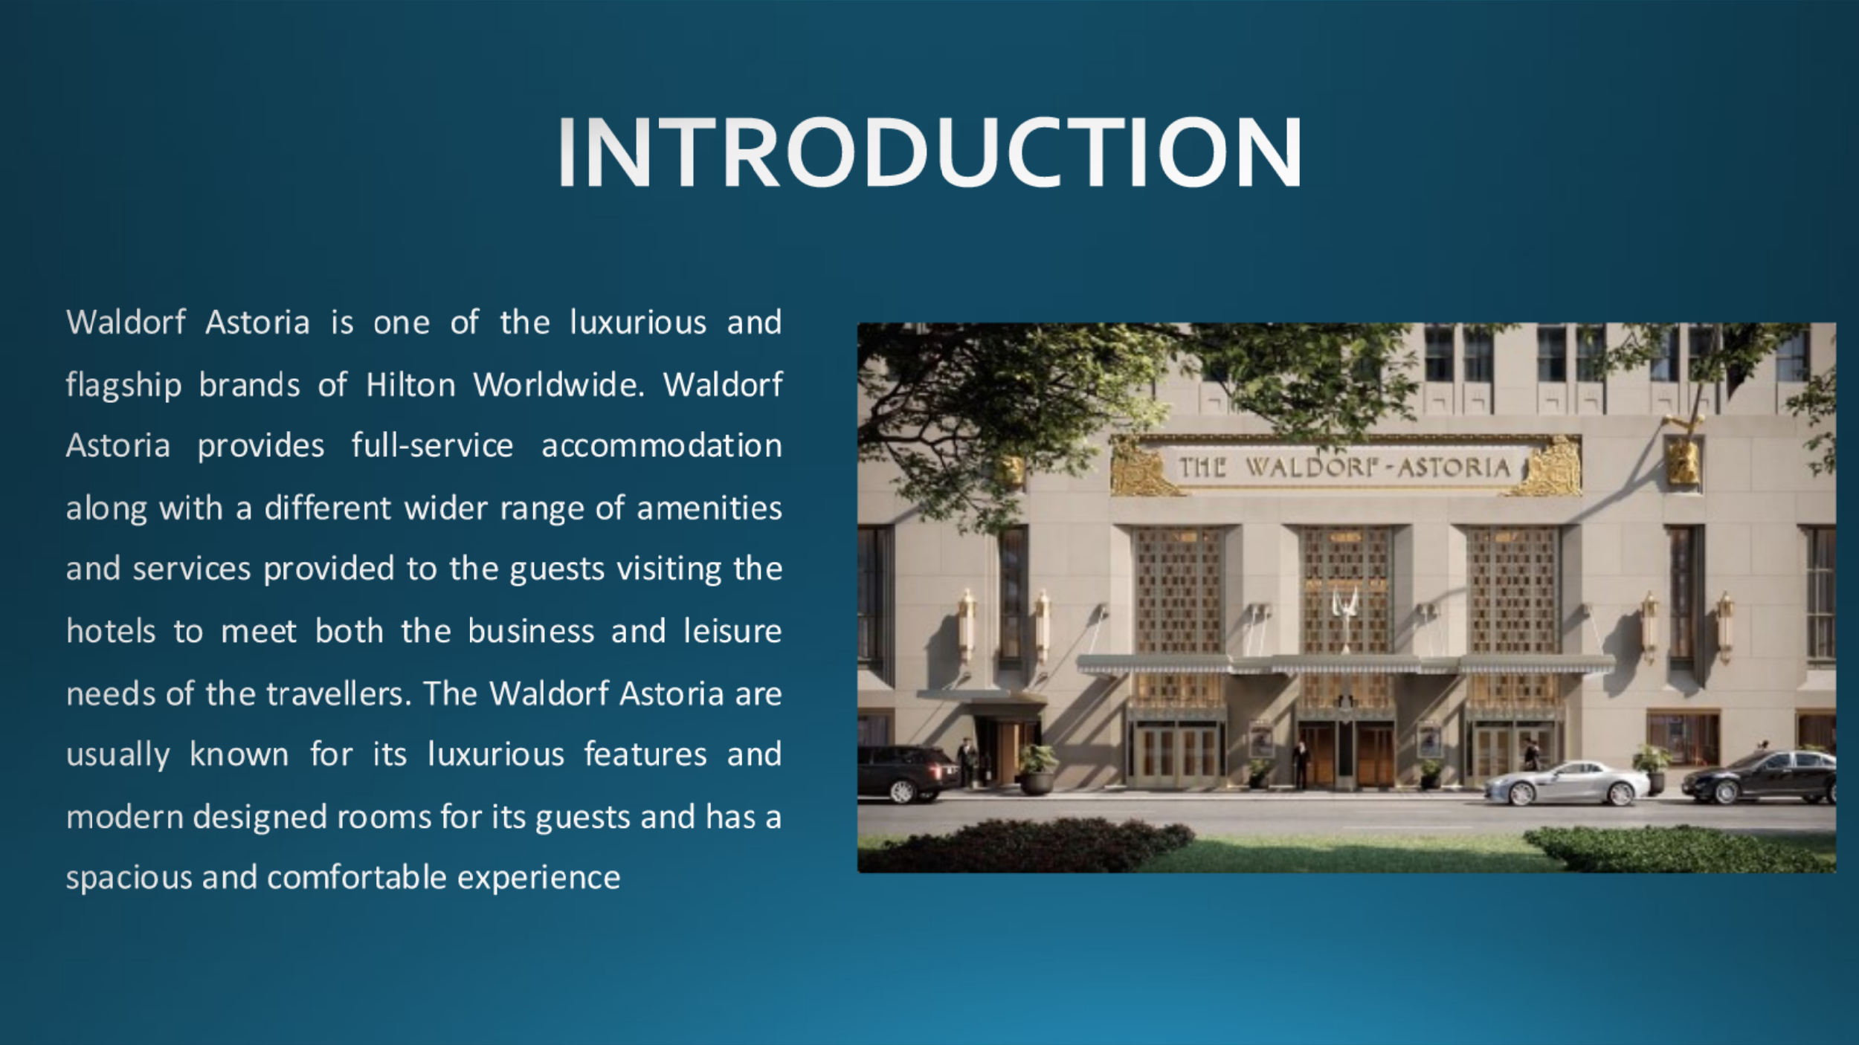
Introduction
Waldorf Astoria is one of the luxurious and flagship brands of Hilton Worldwide. Waldorf Astoria provides full-service accommodation along with a different wider range of amenities and services provided to the guests visiting the hotels to meet both the business and leisure needs of the travellers. The Waldorf Astoria are usually known for its luxurious features and modern designed rooms for its guests and has a spacious and comfortable experience. Waldorf Astoria has a very strong focus on customer service and providing high-quality and luxury experiences to the guests visiting the hotel.

Slide 3
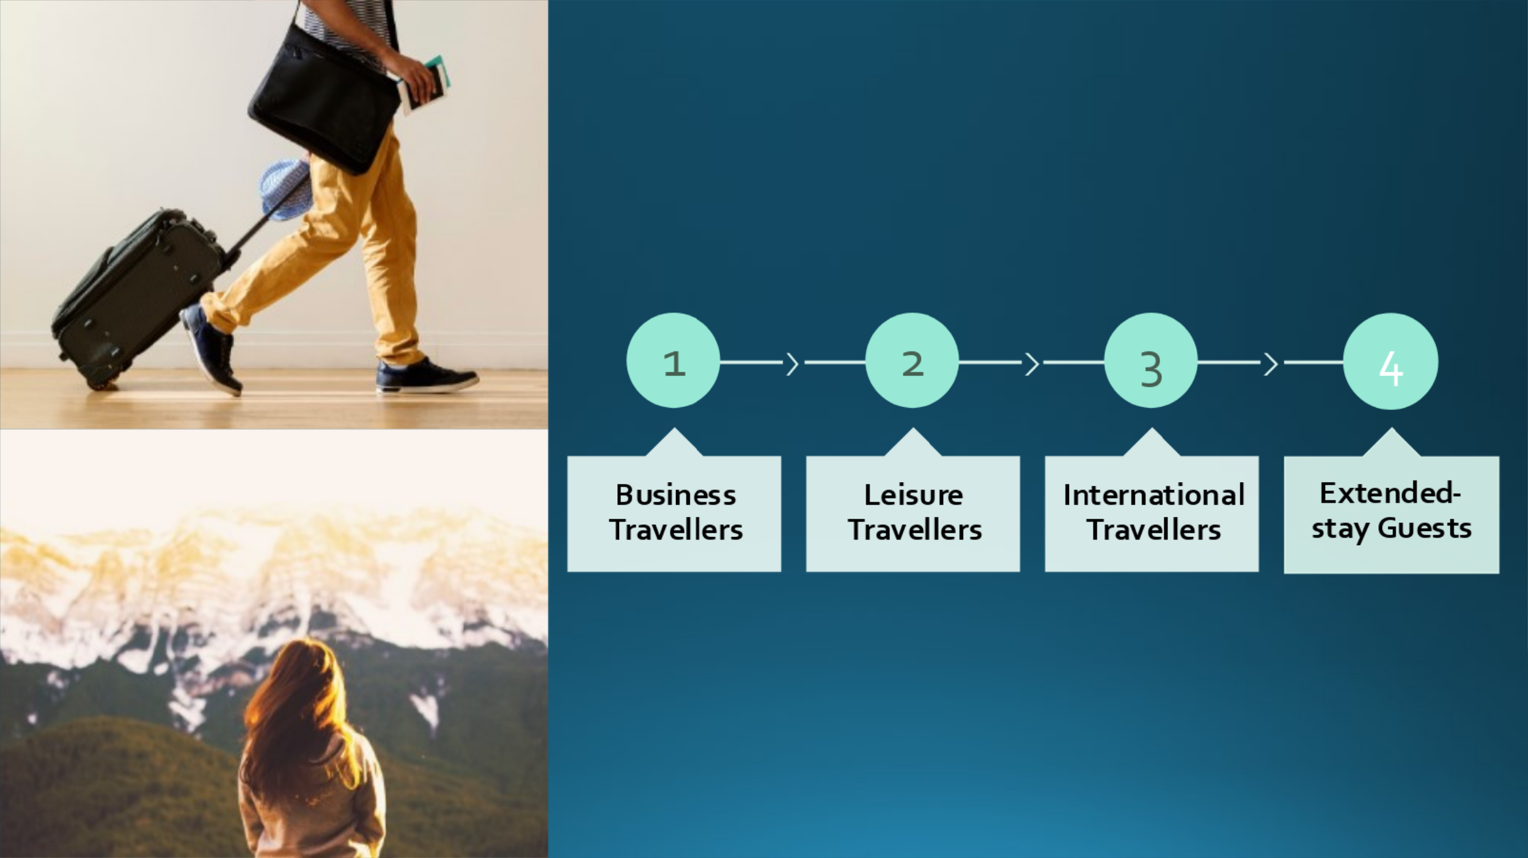
Main Consumers of Waldorf Astoria
Waldorf Astoria have different types of guests and visitors.
Business Travellers: Business travellers add up to a significant portion of the visitors the years visiting Waldorf Astoria (Cho and Lee, 2020). The hotels provide different business-class facilities such as business centres, meeting and seminar rooms, and meeting spaces to meet the business needs of the travellers.
Leisure Travellers: The Hilton Worldwide customer base also includes a significant portion of leisure tourists. The hotels owned by this corporation provide guests with a variety of facilities and services, such as spas, dining establishments, gymnasiums, and entertainment venues, to entice vacationers and business travellers who are looking for ways to relax and have fun (Kim and Park, 2020).
International Travellers: The Waldorf Astoria brand has a significant worldwide presence, with locations located in more than 130 countries throughout the globe (Smith and Johnson, 2019). Because of this, they are a common option for those who are travelling internationally and are looking for a recognisable and trustworthy brand when they are in a new location.
Extended-stay Guests: Extended-stay Guests Waldorf Astorias may also provide services to guests that are expecting to remain in the area for an extended period. These visitors may be travelling to work or moving to a new city. The lengthened-stay homes owned by the brand give completely furnished kitchens in addition to other facilities that are intended to make guests feel as if they are staying in a pleasant and easily accessible home away from home.

Slide 4
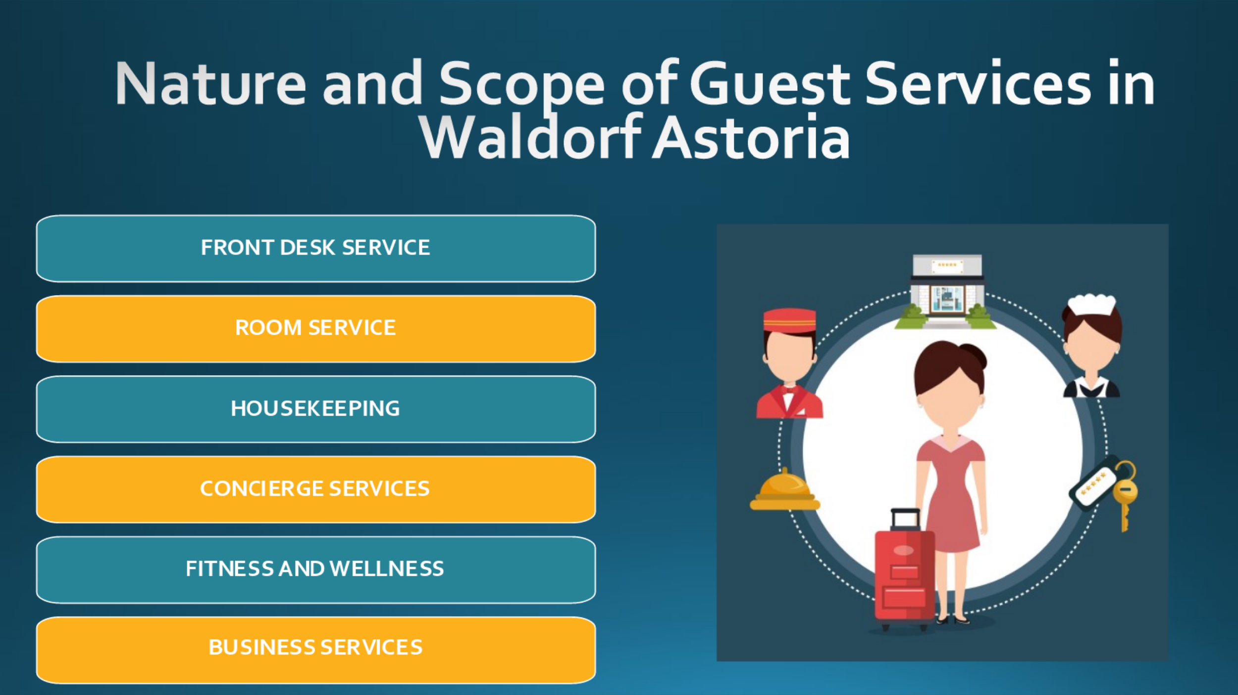
Nature and Scope of Guest Services in Waldorf Astoria
During their stay, guests of Waldorf Astorias can expect an exceptional level of convenience, comfort, and personalised attention as a result of the nature and scope of the hotel's services that are provided at these hotels. The personnel at the front desk receives extensive training to ensure that they are polite, competent, and efficient while fulfilling the requirements of guests (Kim and Park, 2020). The personnel at the front desk receives extensive training to ensure that they are polite, competent, and efficient while fulfilling the requirements of guests. The guest rooms of Waldorf Astorias are serviced daily by housekeeping staff to ensure that guests have a clean and pleasant environment throughout their stay. The accommodation will be cleaned and tidied up by the maintenance crew, who will also prepare the beds and replace the linens and toiletries (Hwang and Kim, 2021). Concierge services are available at all Waldorf Astorias and may assist visitors with making dinner reservations, arranging transportation and attending to other travel-related issues.

Slide 5
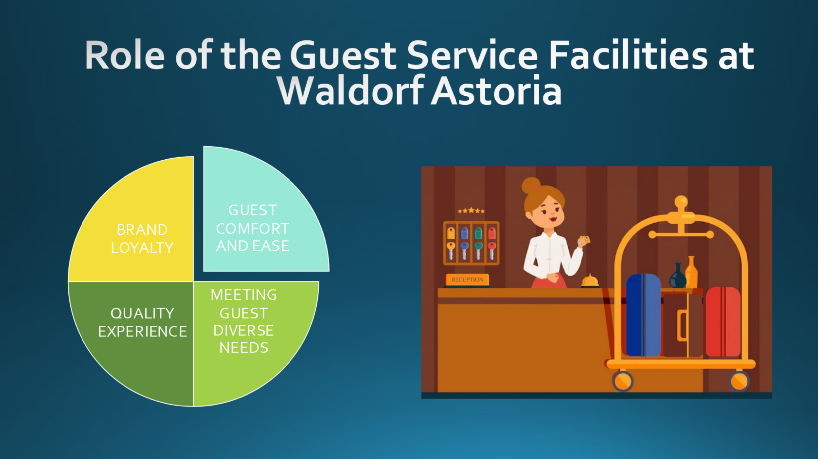
Role of the Guest Service Facilities at Waldorf Astoria
At Waldorf Astorias, the guest service facilities play an essential part in making sure that visitors enjoy a comfortable and pleasant experience throughout their stay at the hotel. The quality of the guest service facilities of Waldorf Astorias has a considerable bearing on the whole experience that a visitor has at one of these hotels. These establishments boost client comfort and pleasure by providing services and facilities that accommodate the varied requirements of customers (Wei et al., 2020). This, in turn, increases the likelihood that guests will leave favourable reviews, return, and recommend others to the establishment. Favourable impressions can be made on visitors via guest service facilities through the provision of personalised care as well as effective service, which increases the possibility of guests being loyal to the brand.

Slide 6
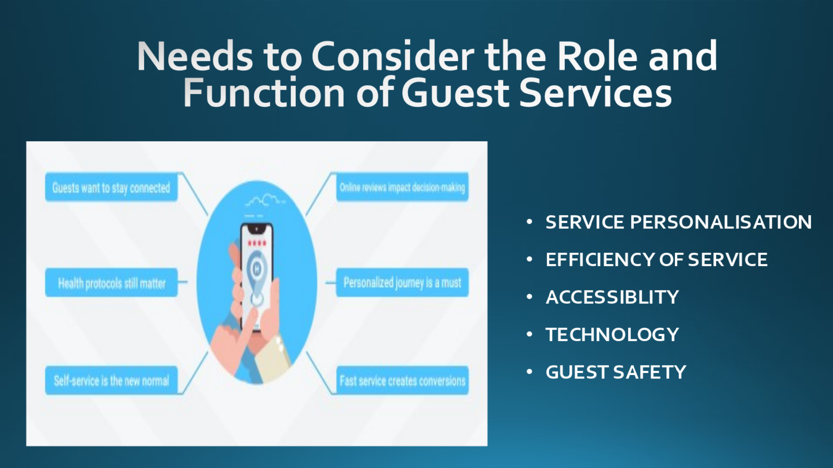
Needs to Consider the Role and Function of Guest Services
At Waldorf Astorias, it is the responsibility of the guest services department to provide exceptional customer service that goes above and beyond what the guest anticipates. The contribution that guest services make to the development of a favourable visitor experience, the cultivation of brand loyalty, and the promotion of returning customers and referrals are of the utmost importance. The provision of efficient services to visitors may also result in excellent evaluations, which can encourage future visitors to choose Waldorf Astorias above those of the company's competitors (Park and Kim, 2022). In the end, the purpose of providing visitors with a stay that is hassle-free, pleasurable, and memorable while also catering to their specific requirements and inclinations lies at the very core of the job and the role of guest services.

Slide 7
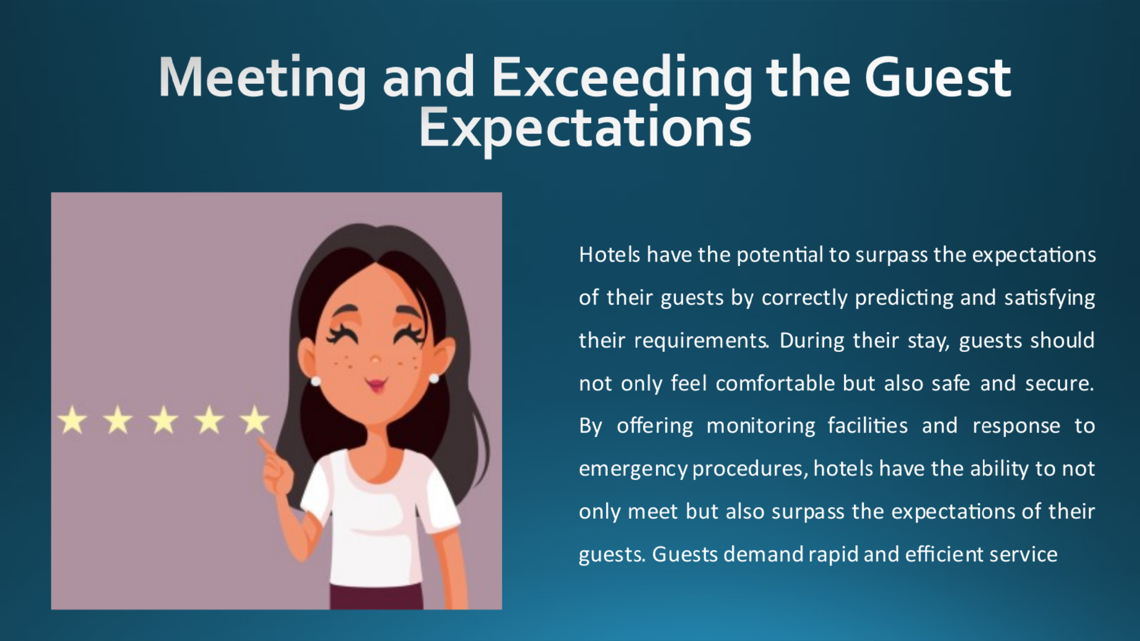
Meeting and Exceeding the Guest Expectations
Hotels can satisfy the expectations of their guests by delivering individualised service that is tailored to the specific requirements and inclinations of each client. Hotels have the potential to surpass the expectations of their guests by correctly predicting and satisfying their requirements. During their stay, guests should not only feel comfortable but also safe and secure. By offering monitoring facilities and response to emergency procedures, hotels have the ability to not only meet but also surpass the expectations of their guests. Guests demand rapid and efficient service (Liu et al., 2021). By expediting operations like check-in and check-out, hotels can not only meet but even surpass the expectations of their guests. Services and amenities of a high standard are expected by the guests. By providing a variety of amenities, hotels can surpass the expectations of their guests.

Slide 8
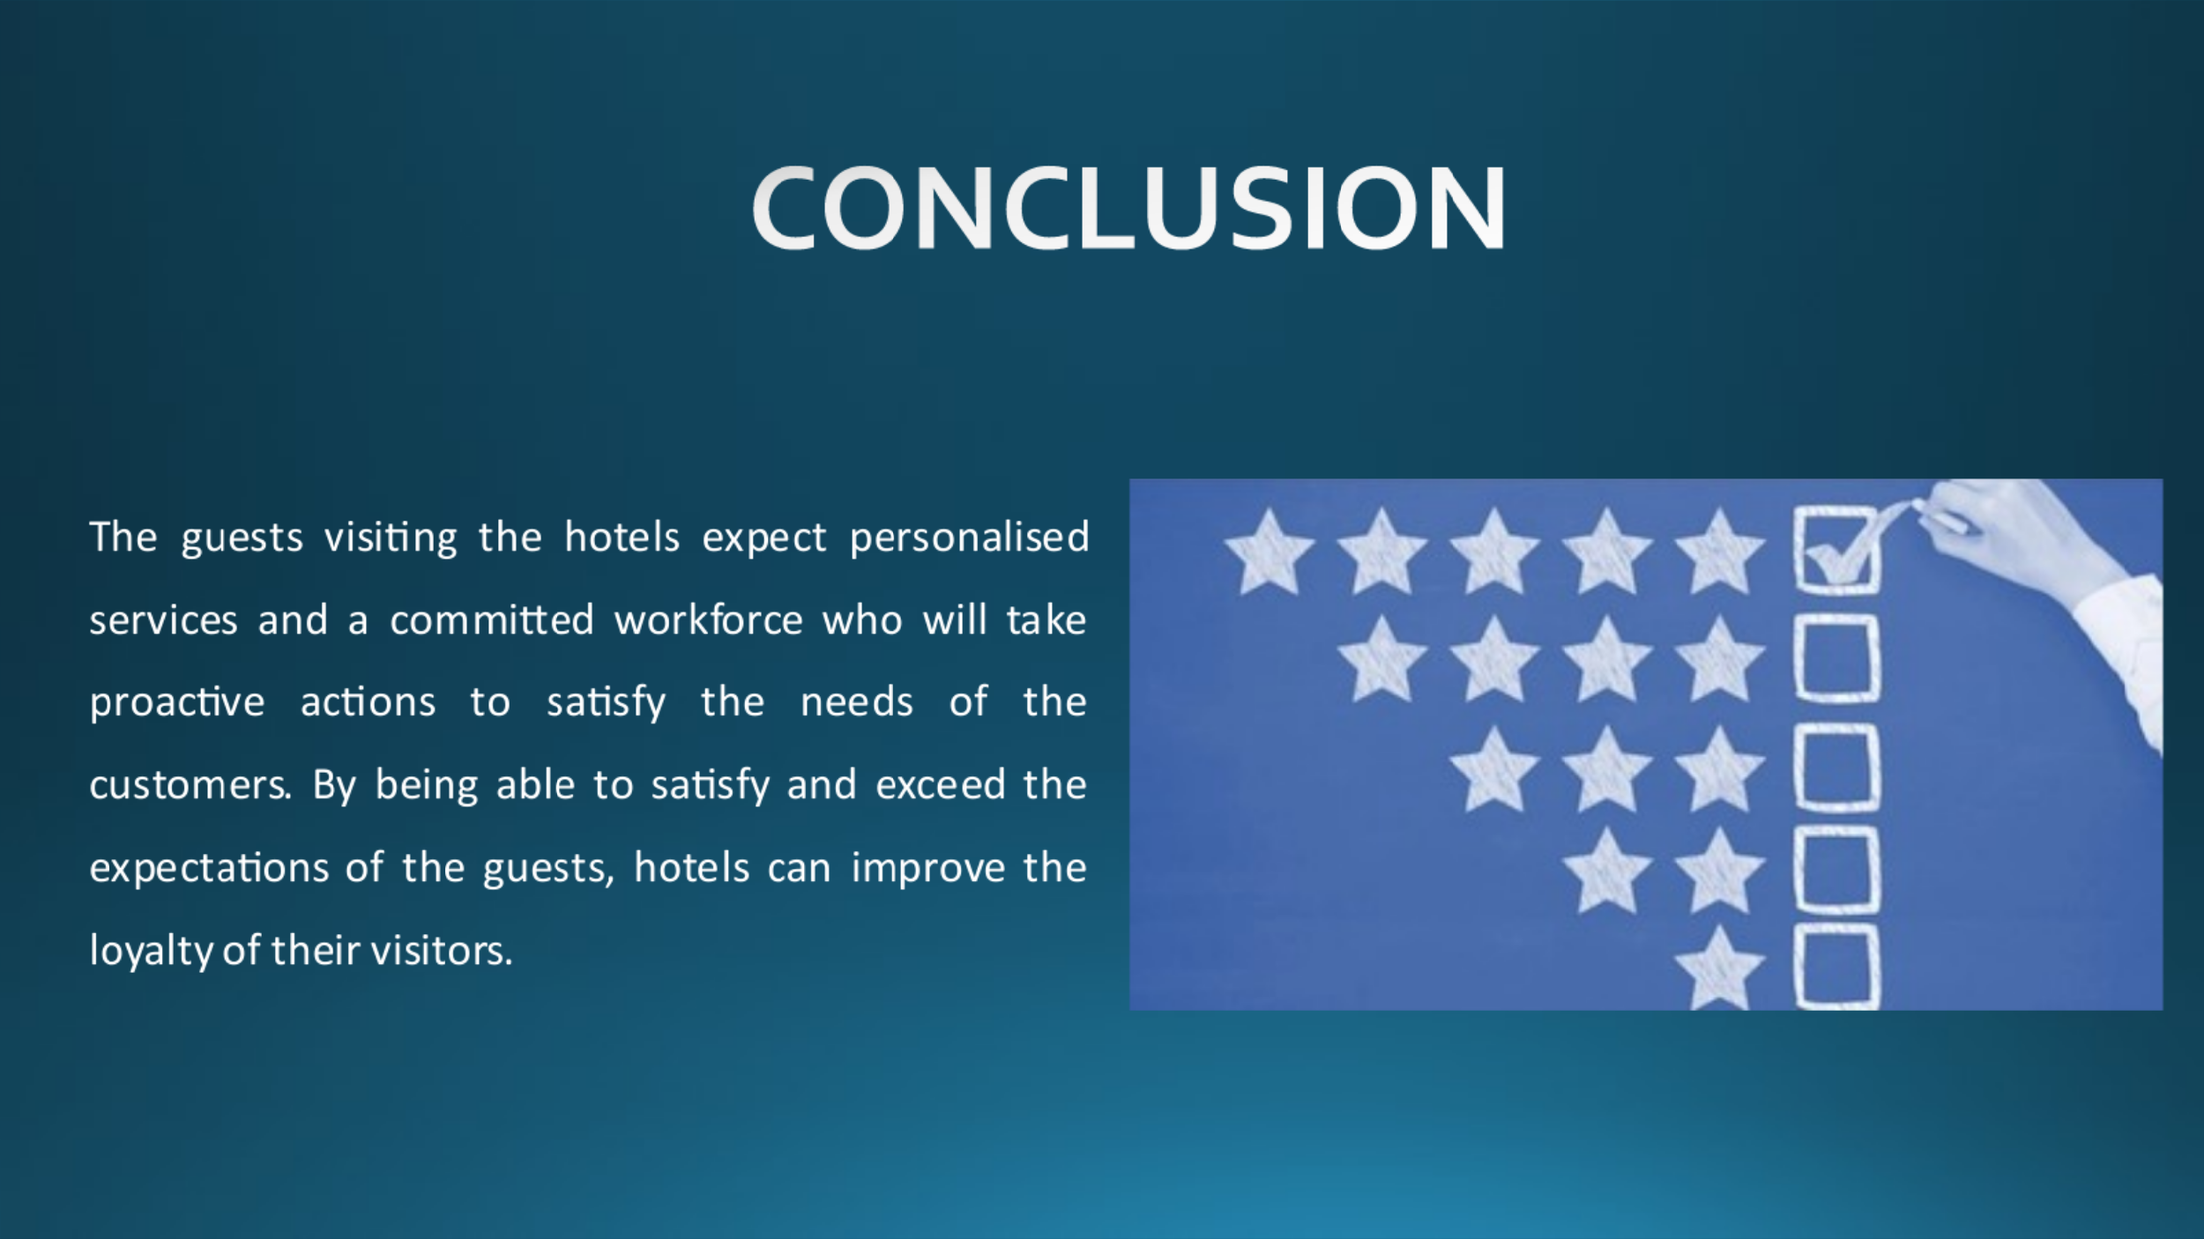
Conclusion
Waldorf Astoria have been highly successful in the hospitality sector because of its dedication and commitment to the customer service. The guests visiting the hotels expect personalised services and a committed workforce who will take proactive actions to satisfy the needs of the customers. By being able to satisfy and exceed the expectations of the guests, hotels can improve the loyalty of their visitors.

Slide 9


