
NAME: Hakim Senoga

STUDENT NUMBER: 2430688

MODULE: Changemakers: Creativity and Value Creation Professions (BMHP5014).

LECTURER: Brian mashumba
A designed poster presents clearly innovative health and social care solution accompanied by a pitch focused
On a relevant health and social care is campaign on stop drug abuse.
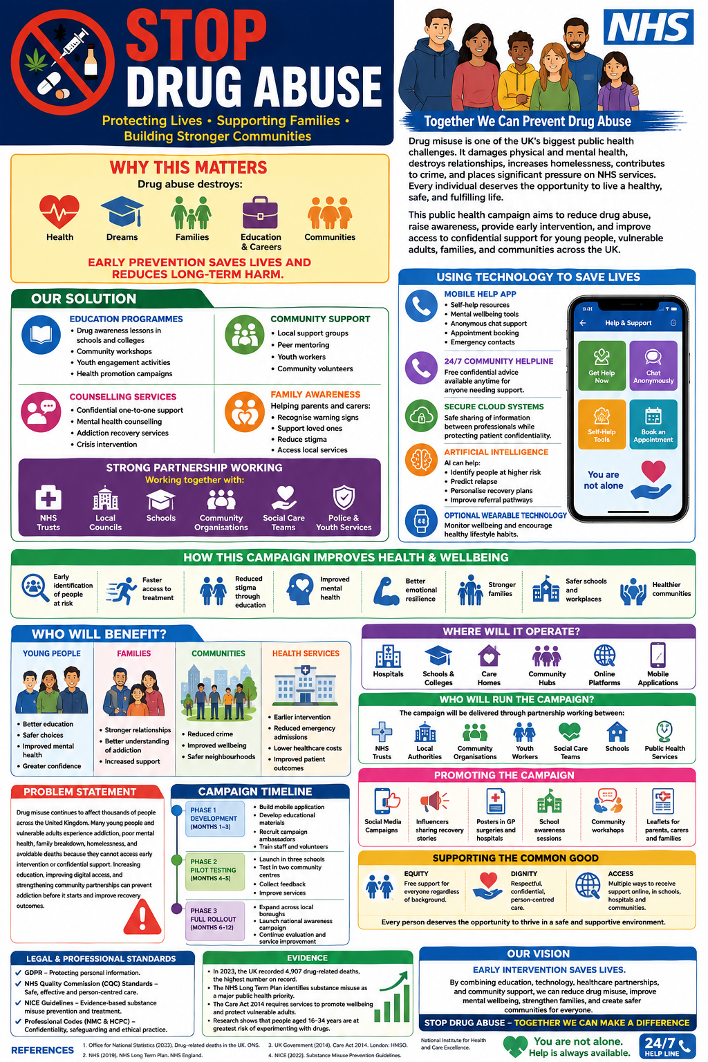

STOP DRUG ABUSE (written pitch)

Introduction.
Stop Drug Abuse – is a public health campaign designed to reduce drug misuse and improve access to support services for people at risk of addiction. Drug misuse remains a major public health issue in the UK, affecting individuals, families, and communities. Many young people and vulnerable adults do not receive support until their problems become serious, leading to poor mental health, homelessness, family breakdown, and increased pressure on health services.

The campaign combines education programmes, community support, counselling services, and digital technology to provide early intervention and prevention. A mobile app, community hotlines, and awareness campaigns will help people access confidential support quickly. The main beneficiaries are young people, vulnerable adults, families, schools, workplaces, and local communities. By promoting healthy lifestyles and early support, the campaign aims to reduce harm and improve wellbeing.
Background.
Drug misuse is a growing public health concern across the United Kingdom. According to the Office for National Statistics (ONS), 5,448 deaths related to drug poisoning were registered in England and Wales in 2023, the highest number since records began. In 2022, there were 4,907 registered deaths. These figures highlight the urgent need for effective prevention and intervention services.
Drug misuse can lead to addiction, poor physical health, mental health problems, unemployment, family breakdown, and homelessness. Young adults are particularly vulnerable because they may face peer pressure, social difficulties, and lack information about the long-term consequences of drug use.
The NHS Long Term Plan places a strong emphasis on prevention and early intervention to improve health outcomes and reduce pressure on services. The Care Act 2014 also highlights the responsibility of health and social care organisations to promote wellbeing and protect vulnerable individuals. NICE guidelines recommend targeted interventions for people who are at risk of drug misuse and encourage support through existing health, social care, and community services.
Many people affected by substance misuse experience stigma and fear asking for help. As a result, treatment is often delayed. This campaign addresses these barriers by providing accessible, confidential, and community-based support that focuses on prevention as well as recovery.
Innovation Description.
The Stop Drug Abuse – campaign is an innovative approach because it combines technology, education, healthcare services, and community engagement within one support system.
A key feature is a mobile application that provides self-help resources, information about drugs, mental health support, appointment booking, and access to confidential chat services. The app will allow users to find local support services quickly and receive guidance without fear of judgement.
The campaign will also establish a 24-hour community hotline where trained professionals and volunteers can provide advice, emotional support, and referrals to specialist services. Educational workshops will be delivered in schools, colleges, workplaces, and community centres to increase awareness of the risks associated with drug use.
Artificial intelligence tools could be used within the app to identify patterns that may suggest an increased risk of relapse and recommend appropriate support options. Secure cloud-based systems will enable safe sharing of information between health professionals while remaining compliant with GDPR requirements.
Unlike traditional awareness campaigns, this innovation focuses on both prevention and ongoing support. It is accessible through multiple channels, including online platforms, healthcare services, schools, and community organisations. This integrated approach makes support easier to access, encourages earlier intervention, and helps people receive the right help before problems become severe.
Impact on Health and Social Care.
This campaign will have a positive impact on both health and social care services. The primary beneficiaries are young people, vulnerable adults, individuals experiencing substance misuse, and their families. Communities with higher levels of deprivation may particularly benefit because barriers to accessing support are often greater in these areas.
The campaign improves access to services by providing multiple routes to support. People can access help through the mobile app, community hotlines, schools, GP surgeries, hospitals, and local community centres. This flexibility makes it more likely that people will seek assistance at an earlier stage.
The initiative also supports healthcare professionals by improving referral pathways and reducing delays in accessing treatment. Early intervention may reduce emergency hospital admissions and the long-term health consequences associated with drug misuse. The campaign also helps social care services by preventing issues such as homelessness, safeguarding concerns, unemployment, and family breakdown.
The campaign contributes to the common good by promoting fairness, dignity, and inclusion. Support services will be free and accessible regardless of age, background, ethnicity, or income level. Reducing stigma through education encourages more people to seek help and creates safer communities. Ultimately, improved physical health, better mental wellbeing, stronger families, and healthier communities are likely outcomes of this innovation.
Public and Stakeholder Involvement.
Public involvement is essential to the success of this campaign. People with lived experience of substance misuse will be involved in designing educational materials, developing app features, and evaluating services. Their experiences will help ensure that support remains relevant, practical, and user centred.
Public engagement activities will include surveys, focus groups, workshops, and community events. Schools, youth organisations, charities, family support groups, and residents will be encouraged to contribute their views. Advocacy campaigns on social media will also raise awareness and reduce stigma surrounding addiction.
Healthcare professionals, community leaders, and voluntary organisations will work together to co-produce services. This collaborative approach will help build trust, improve participation, and ensure that the campaign reflects the needs of local communities.
Policies, Services, and Professional Links.
This innovation aligns with several important policies and legal frameworks. The Care Act 2014 supports the promotion of wellbeing and the protection of vulnerable adults. The Equality Act 2010 promotes fair access to services and protects people from discrimination. GDPR regulations will ensure that personal information collected through the mobile app is securely stored and managed.
The campaign also follows NICE guidance on drug misuse prevention and supports NHS priorities relating to prevention and early intervention.
Key partners will include GP practices, NHS Trusts, local councils, schools, social care teams, community organisations, and voluntary sector services. Nurses, social workers, youth workers, counsellors, psychologists, and support workers will all play important roles in identifying risks, supporting individuals, and making referrals to appropriate services.
Conclusion.
Drug misuse continues to harm individuals, families, and communities across the UK. The "Stop Drug Abuse Start a Healthy Life" campaign provides a practical and innovative solution through education, technology, community support, and healthcare partnerships. By encouraging early intervention and improving access to support, the campaign can reduce harm, improve wellbeing, and strengthen communities. Its use of existing services and modern digital tools makes implementation realistic and sustainable.

References
Care Act 2014. London: The Stationery Office.
NHS England (2019) The NHS Long Term Plan. London: NHS England.
NICE (2017) Drug Misuse Prevention: Targeted Interventions (NG64). London: National Institute for Health and Care Excellence.
Office for National Statistics (2024) Deaths Related to Drug Poisoning in England and Wales: 2023 Registrations. Newport: ONS.

Equality Act 2010. London: The Stationery Office.
Office for Health Improvement and Disparities (2025) Alcohol and Drug Misuse Prevention, Treatment and Recovery Guidance. London: Department of Health and Social Care.

UK Government (2018) Data Protection Act 2018. London: The Stationery Office.

Nursing and Midwifery Council (2018) The Code: Professional Standards of Practice and Behaviour for Nurses, Midwives and Nursing Associates. London: NMC.

