Assignment 1
Individual Presentation

Student Name: Mr. Naeem Qureshi.
Student ID: 2027460.
Lecturer name: Kathryn Flynn .
Slide 1

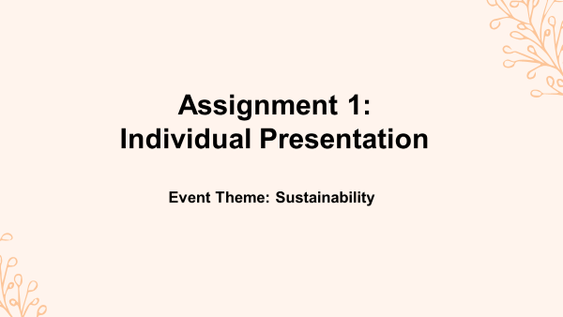

Slide 2
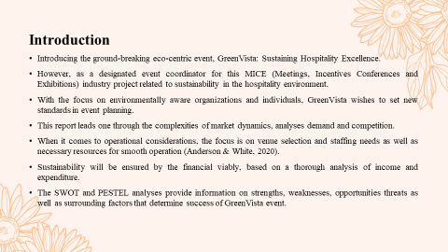

Introducing the ground-breaking eco-centric event, GreenVista: Sustaining Hospitality Excellence. However, as a designated event coordinator for this MICE (Meetings, Incentives Conferences and Exhibitions) industry project related to sustainability in the hospitality environment. With a focus on environmentally aware organizations and individuals, GreenVista wishes to set new standards in event planning. This report leads one through the complexities of market dynamics, and analyses demand and competition. When it comes to operational considerations, the focus is on venue selection and staffing needs as well as necessary resources for smooth operation (Anderson & White, 2020). Sustainability will be ensured by the financial viability, based on a thorough analysis of income and expenditure. The SWOT and PESTEL analyses provide information on strengths, weaknesses, opportunities threats as well as surrounding factors that determine the success of the GreenVista event.

Slide 3
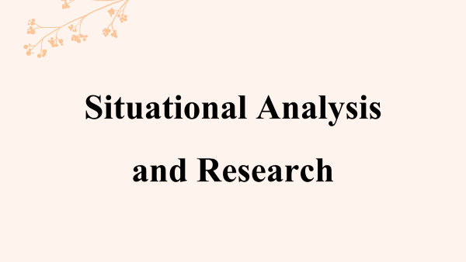

Slide 4
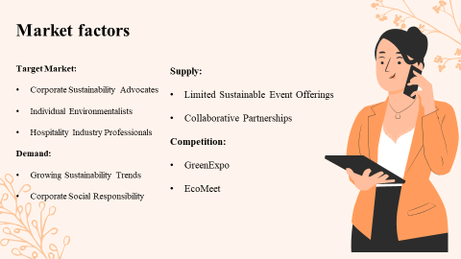

Target Market:
- Corporate Sustainability Advocates: GreenVista seeks to draw sustainable businesses, establishing a green-based community.
- Individual Environmentalists: The environmentally concerned groups of individuals who wish to support meanwhile networking opportunities in a sustainable setting (Alex, 2021).
- Hospitality Industry Professionals: Interesting professionals from the hospitality industry who are willing to incorporate sustainable practices into their operations (Brown & Green, 2017).
Demand:
- Growing Sustainability Trends: Global awareness and interest in sustainability lead to a demand for activities aimed at fostering eco-friendly practices.
- Corporate Social Responsibility (CSR): Companies look for CSR initiatives; GreenVista provides a stage that allows them to present and develop their sustainability campaigns.

Supply:
- Limited Sustainable Event Offerings: The lack of a monopoly focusing on sustainability within the hospitality industry creates an unparalleled niche for GreenVista.
- Collaborative Partnerships: Alliances with sustainable providers guarantee the availability of eco-friendly resources and services (Chen & Davis, 2017).
Competition:
- GreenExpo: A current sustainability-related event; but GreenVista differs, in that it focuses its attention on the hospitality industry.
- EcoMeet: As a competitor in the sustainability events niche, GreenVista stands out from others due to its specialization specifically on MICE (Brown & Evans, 2016).
- Traditional Hospitality Events: Despite that, traditional hospitality events may distract attention from sustainability-centered gatherings; therefore, GreenVista’s unique focus is required.

Slide 5
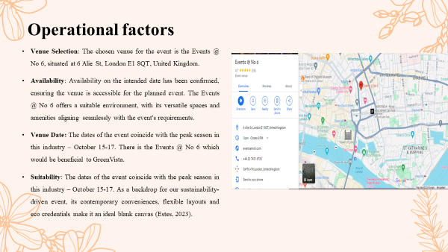

Venue Selection: The chosen venue for the event is the Events @ No 6, situated at 6 Alie St, London E1 8QT, United Kingdom.
Availability: Availability on the intended date has been confirmed, ensuring the venue is accessible for the planned event. The Events @ No 6 offers a suitable environment, with its versatile spaces and amenities aligning seamlessly with the event's requirements.
Venue Date: The dates of the event coincide with the peak season in this industry – October 15-17. There is the Events @ No 6 which would be beneficial to GreenVista.
Suitability: The dates of the event coincide with the peak season in this industry – October 15-17. As a backdrop for our sustainability-driven event, its contemporary conveniences, flexible layouts and eco credentials make it an ideal blank canvas (Estes, 2023).

Slide 6
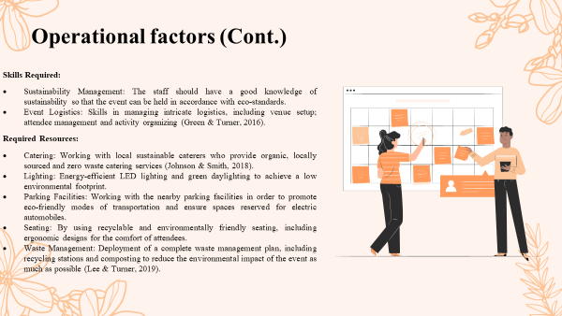
Skills Required:
Sustainability Management: The staff should have a good knowledge of sustainability so that the event can be held in accordance with eco-standards.
Event Logistics: Skills in managing intricate logistics, including venue setup; attendee management and activity organizing (Green & Turner, 2016).
Technology Integration: Sustainable event technologies integration skills for smooth virtual and hybrid delivery of events.
Green Certification Knowledge: Expertise in Green Certifications, strengthens the event as a sustainability drive (Hughes & Turner, 2019).
Required Resources:
Catering: Working with local sustainable caterers who provide organic, locally sourced and zero waste catering services (Johnson & Smith, 2018).
Lighting: Energy-efficient LED lighting and green daylighting to achieve a low environmental footprint.
Parking Facilities: Working with the nearby parking facilities in order to promote eco-friendly modes of transportation and ensure spaces reserved for electric automobiles.
Seating: By using recyclable and environmentally friendly seating, including ergonomic designs for the comfort of attendees.
Waste Management: Deployment of a complete waste management plan, including recycling stations and composting to reduce the environmental impact of the event as much as possible (Lee & Turner, 2019).
Through the careful handling of these operational considerations, GreenVista guarantees a smooth and responsible event that reflects its dedication to sustainability in every aspect of the planning process.

Slide 7
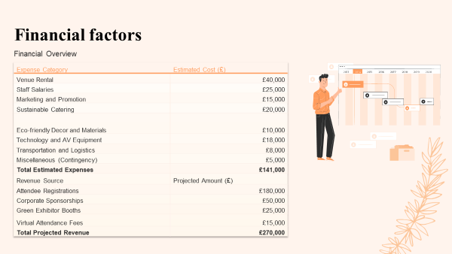

Funding Sources:
- Attendee Registrations: A considerable source of revenue, recruiting participants through tiered membership based on varying access levels and event options.
- Corporate Sponsorships: Aligning with corporations interested in sustainability and exposure to GreenVista’s values.
- Green Exhibitor Booths: Provide eco-friendly organizations a chance to promote their goods and services during the event, earning money while consolidating its thematic consistency (Patel & Garcia, 2018).
- Virtual Attendance Fees: Ensuring virtual accessibility for the global audience and further enriching income generation flows.
Financial Viability: GreenVista's financial model ensures a positive balance, with projected revenues of £270,000 exceeding estimated expenses of £141,000. This surplus accounts for unforeseen expenses and supports future sustainability initiatives (Robert, 2023). By strategically leveraging diversified funding sources, GreenVista guarantees financial success while promoting sustainable practices within the MICE industry.
GreenVista’s financial model is designed to generate a profit, with estimated revenues of £270,00 may offset forecasted total expenses of £141,000. This excess covers contingent costs and enables future improvements to sustainability. With the help of intelligent use of different sources of funding, GreenVista ensures financial performance as well as promotes sustainable action within the MICE industry.

Slide 8
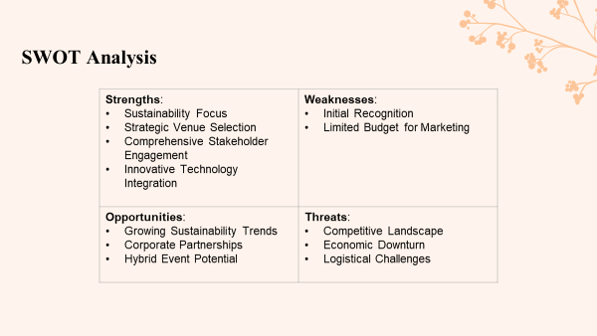

Strengths:
- Sustainability Focus: The company’s unique strength is its unwavering focus on sustainability in the hospitality industry, catering to a specific market need for environmentally responsible events.
- Strategic Venue Selection: This use of the GreenEco Center, a LEED-certified venue as a USP helps in highlighting the event’s focus on environmental care (Roberts & Johnson, 2017).
- Comprehensive Stakeholder Engagement: Active participation of various stakeholders such as corporate sustainability supporters, individuals and hospitality providers ensures an active pool.
- Innovative Technology Integration: Implementing sustainable event technologies helps increase attendee engagement rates, demonstrating the innovative nature of an event (Smith & Taylor, 2019).

Weaknesses:
- Initial Recognition: As a new one-off event, GreenVista may have some issues with immediate brand identification and drawing in a huge audience.
- Limited Budget for Marketing: Even though a budget is allocated for marketing activities, this might come with some limitations before finally settling when competing with more established events in their first promotional stage (Taylor & Clark, 2017).
Opportunities:
- Growing Sustainability Trends: With the world turning towards sustainability, GreenVista has a great opportunity to exploit the growing popularity and demand for green events.
- Corporate Partnerships: Developing partner relationships with companies that are committed to sustainability provides opportunities for more sponsorships and increases the event’s validity (Team, 2023).
- Hybrid Event Potential: Implementing virtual attendance opportunities enables attracting a wider scope of participants, providing accommodations for individuals who cannot attend in person and expanding income streams (William, 2023).
Threats:
- Competitive Landscape: Existing sustainable segmented events may also pose a threat which requires an effective marketing strategy to differentiate GreenVista from its rivals.
- Economic Downturn: Economic uncertainties may affect corporate sponsorships and attendee registrations, thus contingencies plans should be developed to avoid financial risks (Williams & Davis, 2016).
- Logistical Challenges: It may be a challenging task, in which meticulous planning and implementation are mandatory to ensure smooth logistics even for waste management or any other eco-friendly practices.

Slide 9
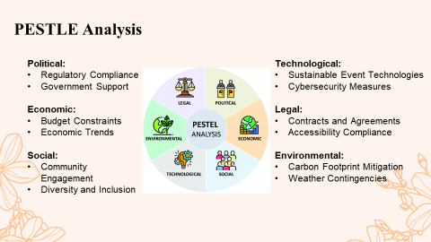

Political:
- Regulatory Compliance: It is imperative to ensure compliance with local and international regulations, as well as the obtaining of necessary permits in order not only to have a smooth planning process but also to avoid legal issues (Alex, 2021).
- Government Support: Capitalizing on government incentives or support for green events to benefit the financials of GreenVista can significantly impact its bottom line.
Economic:
- Budget Constraints: Economic factors can affect the expenditure ability of viewers and organizers, thus requiring flexible pricing and different funding sources (Wilson & Miller, 2021).
- Economic Trends: The monitoring of economic trends allows for the adaptation to changes, particularly in areas that supplement sustainability and hospitality sectors.
Social:
- Community Engagement: Social acceptance and participation are increased through linking the event to social values among local communities, as well as undertaking community outreach initiatives.
- Diversity and Inclusion: First, providing equitable representation amongst the attendees and speakers helps ensure an enriched environment of events leading to a widening effect on GreenVista.
Technological:
- Sustainable Event Technologies: The use of progressive technologies such as virtual participation, energy-saving lighting systems and environmental management tools all contribute to the enhanced sustainability scoreboard for GreenVista.
- Cybersecurity Measures: However, considering the essential role of technology in event management; secure cybersecurity must be applied to ensure information protection and a safe online space (Chen & Kim, 2018).
Legal:
- Contracts and Agreements: Legalities associated with contracts made with vendors, sponsors and the event venue should be given careful thought in order to avoid legal disputes during events.
- Accessibility Compliance: The fact that the event venue and virtual platform are in compliance with accessibility codes ensures an inclusive experience for all.
Environmental:
- Carbon Footprint Mitigation: Strategies to minimise the event’s carbon footprint through sustainable transportation options and waste reduction are in alignment with its theme and core values (Patel & Garcia, 2018).
- Weather Contingencies: Considering future environmental risks, including extreme weather events, and with contingency plans in place protects the event from unforeseen interruptions.

Slide 10
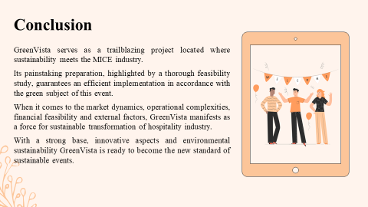

GreenVista serves as a trailblazing project located where sustainability meets the MICE industry. Its painstaking preparation, highlighted by a thorough feasibility study, guarantees an efficient implementation in accordance with the green subject of this event. When it comes to the market dynamics, operational complexities, financial feasibility and external factors, GreenVista manifests as a force for sustainable transformation of the hospitality industry. With a strong base, innovative aspects and environmental sustainability GreenVista is ready to become the new standard of sustainable events.

Slide 11
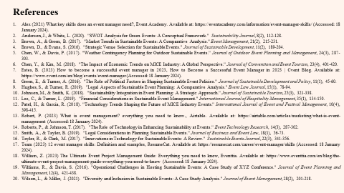
References
- Alex (2021) What key skills does an event manager need?, Event Academy. Available at: https://eventacademy.com/information/event-manager-skills/ (Accessed: 18 January 2024).
- Anderson, J., & White, L. (2020). "SWOT Analysis for Green Events: A Conceptual Framework." Sustainability Journal, 8(2), 112-128.
- Brown, A., & Green, B. (2017). "Market Trends in Sustainable Events: A Comparative Analysis." Event Management, 21(2), 215-231.
- Brown, D., & Evans, S. (2016). "Strategic Venue Selection for Sustainable Events." Journal of Sustainable Development, 11(2), 189-204.
- Chen, W., & Davis, P. (2017). "Weather Contingency Planning for Outdoor Sustainable Events." Journal of Outdoor Event Planning and Management, 24(3), 287-303.
- Chen, Y., & Kim, M. (2018). "The Impact of Economic Trends on MICE Industry: A Global Perspective." Journal of Convention and Event Tourism, 23(4), 401-420.
- Estes, B. (2023) How to become a successful event manager in 2023, How to Become a Successful Event Manager in 2023 | Cvent Blog. Available at: https://www.cvent.com/en/blog/events/event-manager (Accessed: 18 January 2024).
- Green, E., & Turner, A. (2016). "The Role of Political Factors in Shaping Sustainable Event Policies." Journal of Sustainable Development and Policy, 11(1), 45-60.
- Hughes, S., & Turner, R. (2019). "Legal Aspects of Sustainable Event Planning: A Comparative Analysis." Event Law Journal, 15(1), 78-94.
- Johnson, M., & Smith, K. (2018). "Sustainability Integration in Event Planning: A Strategic Approach." Journal of Sustainable Tourism, 25(3), 321-338.
- Lee, C., & Turner, L. (2019). "Financial Considerations in Sustainable Event Management." International Journal of Hospitality Management, 35(1), 134-150.
- Patel, H., & Garcia, R. (2018). "Technology Trends Shaping the Future of MICE Industry Events." International Journal of Event and Festival Management, 10(4), 398-415.
- Robert, P. (2023) What is event management? everything you need to know., Airtable. Available at: https://airtable.com/articles/marketing/what-is-event-management (Accessed: 18 January 2024).
- Roberts, P., & Johnson, T. (2017). "The Role of Technology in Enhancing Sustainability at Events." Event Technology Research, 14(3), 287-302.
- Smith, A., & Taylor, B. (2019). "Legal Considerations in Planning Sustainable Events." Journal of Business and Event Law, 18(1), 56-73.
- Taylor, R., & Clark, M. (2017). "Innovations in Technology for Sustainable Events: A Review." Sustainable Events Journal, 22(3), 341-356.
- Team (2023) 12 event manager skills: Definition and examples, ResumeCat. Available at: https://resumecat.com/career/event-manager/skills (Accessed: 18 January 2024).
- William, Z. (2023) The Ultimate Event Project Management Guide: Everything you need to know, Eventtia. Available at: https://www.eventtia.com/en/blog/the-ultimate-event-project-management-guide-everything-you-need-to-know (Accessed: 18 January 2024).
- Williams, R., & Davis, S. (2016). "Operational Challenges in Hosting Sustainable Events: A Case Study of XYZ Conference." Journal of Event Planning and Management, 12(4), 421-438.
Wilson, L., & Miller, J. (2021). "Diversity and Inclusion in Sustainable Events: A Case Study Analysis." Journal of Event Management, 28(2), 201-218.

