11/4/2019
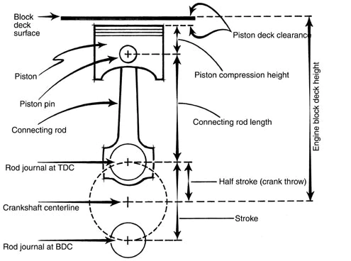
Advanced Engine Design
Thomas Sykes (P147408)
school of engineering
UWTSD
M6X00410

Contents
1. Abstract 3
2. Methodology & Results 3
Task A 3
Task A analysis 4
Task B 5
Task B Analysis 6
Task C & D – Compressive and Tensile Loads 7
Task C – Compressive Force 7
Task D – Tensile Force 8
Task C & D Analysis 9
Task E – compressive and tensile stress 11
Task E analysis 12
Task F 14
Task F Analysis 15
Task G – Compression distance & stretch in the rod 16
Task G Analysis 17
Task H – Titanium Rod 18
Task H Analysis 19
Conclusion 20
Bibliography 22
Appendix 23
Further work 23
First and second order Acceleration 23
Volume- per degree 24
Vertical & horizontal Piston Forces 25
Methodology 25
Frictional force 26
Instant torque 26

Figure 1: Peak Gas Force per Rpm 3
Figure 2 Peak Gas Force per Rpm Graphic 4
Figure 3 Peak Gas Force per Rpm 5
Figure 4 Con-Rod & crank Specifications 5
Figure 5 Reciprocating mass 5
Figure 6 Peak inertia Vs Acceleration 6
Figure 7 inertial Forces per Degree Graphic 6
Figure 8 Peak inertia values 7
Figure 9 Peak inertial forces 7
Figure 10 Bore Specifications 7
Figure 11 Peak Compressive Force per Rpm 8
Figure 12 Highest net compressive force on rod per Rpm 8
Figure 13 Peak Tensile Force 8
Figure 14 Maximum Tensile force on Rod 8
Figure 15 Peak compressive force & Rod Force VS Rpm 9
Figure 16 Rod force, Inertia & Pressure per degree 9
Figure 17 rod force, inertia & Acceleration 10
Figure 18 Peak Tensile force & force on Rod 10
Figure 19 Max Tensile stress 11
Figure 20 Max compressive stress 11
Figure 21 Compressive stress Per degree 12
Figure 22 Tensile stress and rod force per degree 12
Figure 23 Compressive force, stress & rod force 13
Figure 24 maximum Tensile 13
Figure 25 Ford's UTS value 14
Figure 26 Compressive Static safety factor 14
Figure 27 Tensile Static safety factor 14
Figure 28 Compressive static safety factor of powder forged Steel 15
Figure 29 Tensile static safety factor of powder forged steel 15
Figure 30 Tensile Stretch 17
Figure 31 Compressive Distance 17
Figure 32 compressive distance of powder forged steel 17
Figure 33 Tensile Stretch of powder forged steel 18
Figure 34 Titanium Specification 18
Figure 35 comparison of titanium and steel compression & stretch 18
Figure 36 Comparison of Titanium & steel static safety Factors 19
Figure 37 Titanium Compressive safety factor 19
Figure 38 Titanium Tensile safety factor 19
Figure 39 Titanium Tensile stretch under stress 20
Figure 40 Titanium rod compressive distance 20

Abstract

The aim of this study is to carry out an analysis of a Ford 1.6 sigma engine where cylinder pressures and specifications were obtained for further study. This was with the aim of calculating several parameters of the engine to determine the forces & stresses acting on the system. These variables will be demonstrated through 8 tasks that will calculate forces, stresses and tolerances on the sigma connecting Rod with consideration to materials and dimensions across a range of Rpm’s.
A further study of the same engine which is modified at the authors discretion with the aim of testing the engine to higher theoretical limits. In this study the engine was modified to a higher Rpm to determine the additional forces and stresses where the pressure was proportionally increased during combustion

Methodology & Results

Task A

-For this task the author was asked to demonstrate peak gas forces for the production engine as well as a chosen modified engine. This was achieved with a formula of:
$$P*\frac{πD^{2}}{4}$$
(Where pressure (P) is to the unit of M^3 and diameter (D) is measures in meters (0.08m))
This formula used per degree will demonstrate the gas force across the cycle whereas the peak is determined my finding the maximum across the cycle or by using peak pressure in the calculation demonstrated.
Figure 1: Peak Gas Force per Rpm

Figure 2 demonstrates the values for Peak Gas Force per Rpm. As can be seen the author has calculated gas forces for 7000 and 8000 Rpm for the Modified engine. These values of peak gas force for the higher Rpm’s were calculated using a Logarithmic trend line over a peak pressure per Rpm graph (see Figure 2 Peak Gas Force per Rpm Graphic)Figure 3 Peak Gas Force per Rpm.

The Logarithmic trend line in figure 3 generated an interpolation formula also seen in figure 3 where when the X value represents the Rpm at which the force is being generated for and y is representative of the gas force at the specified Rpm.
Figure 2 Peak Gas Force per Rpm Graphic

To determine the Average pressure increase with the Rpm was calculated via:
$$\frac{peak Gas Force @ 7000Rpm}{Peak Gas Force @ 6000Rpm}=1.062763993$$

This value calculated is the increase multiplier between 7000 and 6000 Rpm, the same process needs to be repeated for 5000 Rpm and 6000 rpm to determine the decreasing multiplier between the factory Rpm range $$\frac{peak Gas Force @ 7000Rpm}{Peak Gas Force @ 6000Rpm}=1.003684846$$
The higher rpm multiplier is then divided by the lower to give a closer approximation of the Gas force at 7000 Rpm

Task A analysis
The results found for task A demonstrate that as the Rpm increases the Gas pressure also increase as seen in Figure 3 Peak Gas Force per RpmWhich also demonstrates that as rpm increases the ignition timing and Peak gas pressure gets later before 2500 Rpm and then gradually moves earlier as Rpm increases this demonstrates the risk run of pre- ignition when pushing up the rpm.

The issues with increasing the Rpm in this model is that the cylinder can only induct so much which this model doesn’t consider. This can be seen when looking at the trend of results in Figure 1: Peak Gas Force per Rpmthe force for 7000 spikes unlike in 6000.

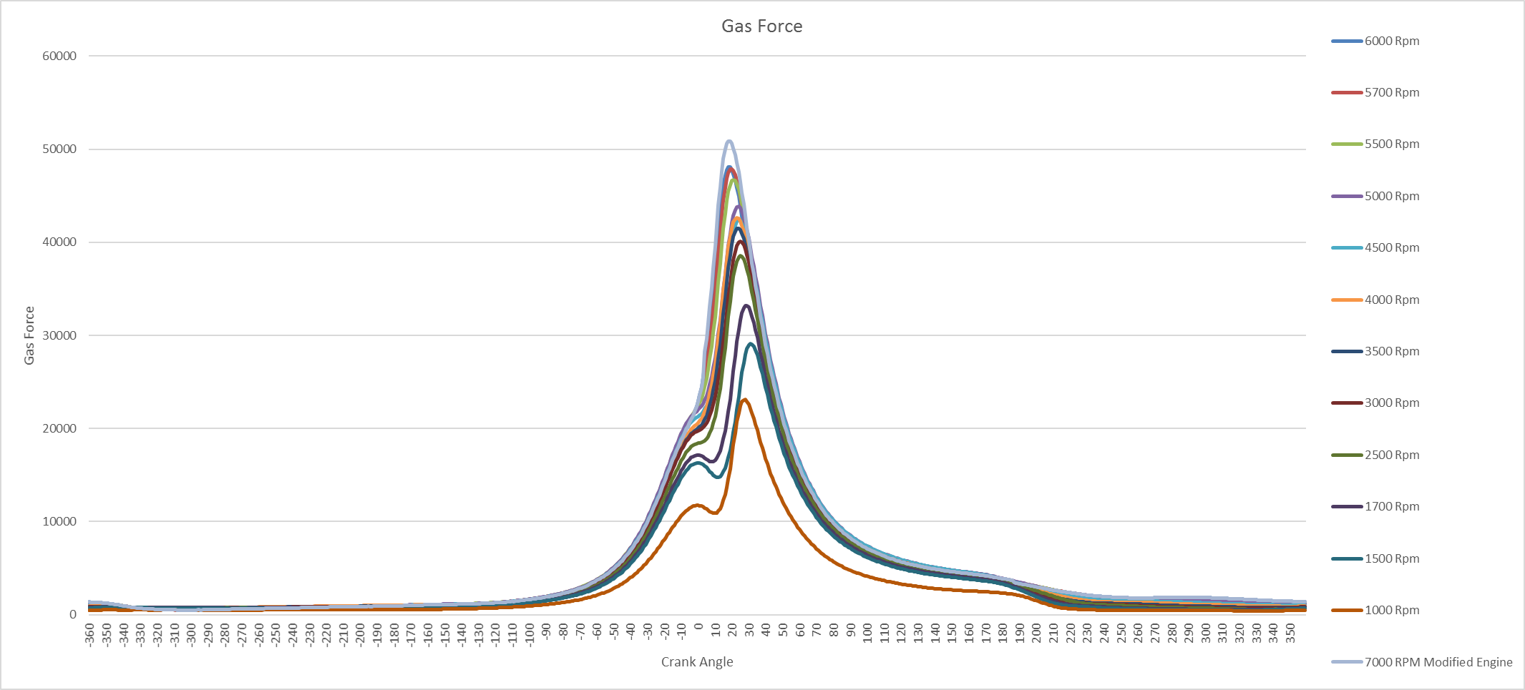
Figure 3 Peak Gas Force per Rpm

Task B

- For task be the inertial loads put on the con-rod as product of rank angle were calculated for both production engine and modified engines.

This was achieved through first calculating angular velocity & piston acceleration calculated via:
Firstly, angular Velocity:
$$ω=2π \frac{RPM}{60}$$
Secondly piston Acceleration (M/s^2):
$$α=Rω^{2}.\cos\left(θ\right)+ \frac{R}{L}.{Rω}^{2}.\cos{2}(θ)$$
Once piston acceleration has been calculated the values for the reciprocating mass such as the piston, Gudgeon Pin, circlip and piston ring are required to calculate the inertia (see Figure 5 Reciprocating mass).
Figure 4 Con-Rod & crank Specifications
Figure 5 Reciprocating mass

Therefore:
$$Inertial Force=Mp*( Rω^{2}.\cos\left(θ\right)+( \frac{R}{L}.{Rω}^{2}.\cos{2}(θ)$$

1st order acceleration
2nd order acceleration

Task B Analysis

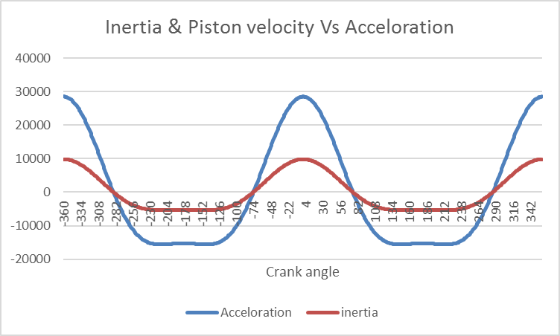
During Task 3 it can be seen that inertia is a product of acceleration as Figure 6 Peak inertia Vs Acceleration demonstrates where in this example inertia is roughly 30% of the acceleration force which is determined by the mass (see Figure 5 Reciprocating mass) and a product of both first and second order acceleration.
Figure 6 Peak inertia Vs Acceleration
Figure 7 shows the inertial forces per degree for each Rpm which shows increasing inertial forces as Rpm increases. This is clearly a product of Rpm, rotational velocity, acceleration to inertia as one increase as douse the rest.
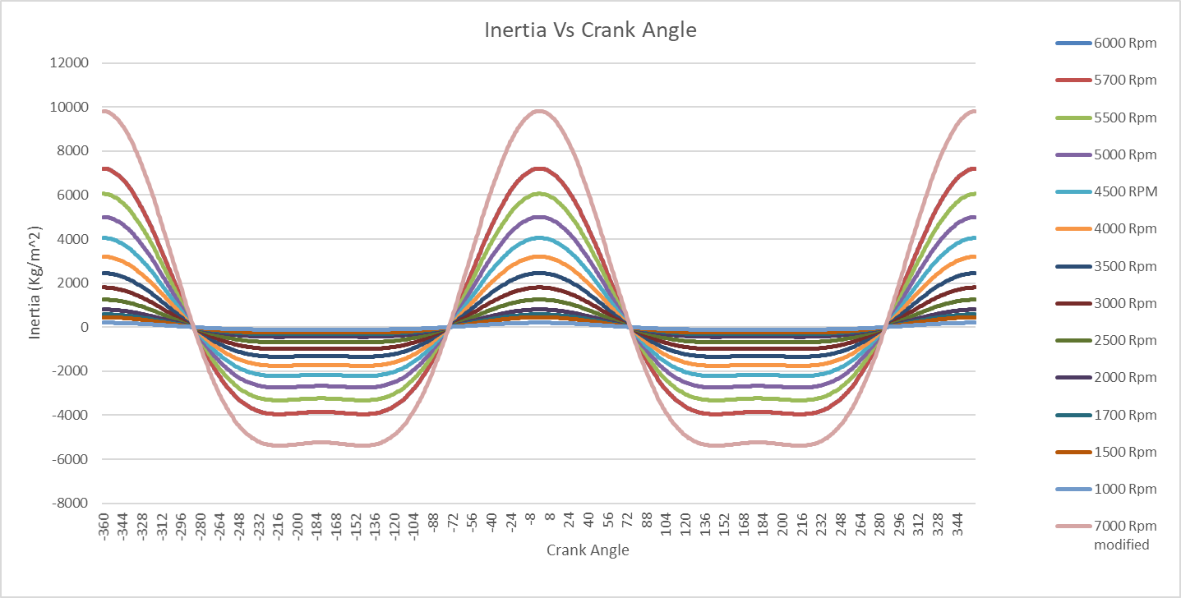
Figure 7 inertial Forces per Degree Graphic

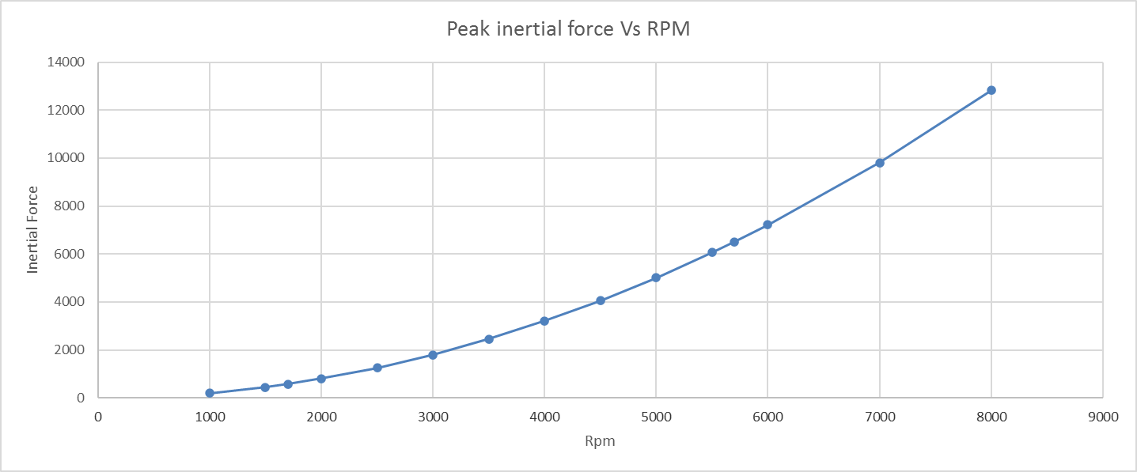
Figure 8 Peak inertia values
Figure 9 Peak inertial forces

Task C & D – Compressive and Tensile Loads

Task C – Compressive Force

Task C required that the author calculate the highest net compressive load on the rod for the production engine and modified Engine.

The net compressive force on the rod is a product of the net downforce applied to the piston with consideration to con-rod angle.
Firstly, calculating con-rod angle:
$$∅= -sin⁡(\frac{R}{L} sinθ)$$

The highest compressive force is expressed as:
$$Peak compressive force=$$
$$Pmax*bore area-inertial force (at the carank angle of Pmax)$$

Where Bore area is equal to:
$$Bore Area=π{\frac{d}{4}}^{2}$$
Figure 10 Bore Specifications

Therefore, once peak compressive force and con-rod angle have been calculated the compressive force through the rod can be calculated:
Figure 11 Peak Compressive Force per Rpm
$$Compressive Rod Force=\frac{peak compressive force }{\cos{∅}}$$
Figure 12 Highest net compressive force on rod per Rpm

Task D – Tensile Force

Task D requires the highest net Tensile Force for the production and modified engine to be calculated
Similarly, to compressive force (see task C) con-rod angle is needed before calculating tensile force as well as the highest net tensile force which Is calculated via:
$$Peak net Tensile force= inertial force-(small)gas force$$

Peak tensile force on the rod is calculated via:
$$Peak Tensile force on Rod= \frac{Peak Tensile force }{\cos{∅}}$$
Figure 13 Peak Tensile Force
Figure 14 Maximum Tensile force on Rod

Task C & D Analysis

Task C Analysis
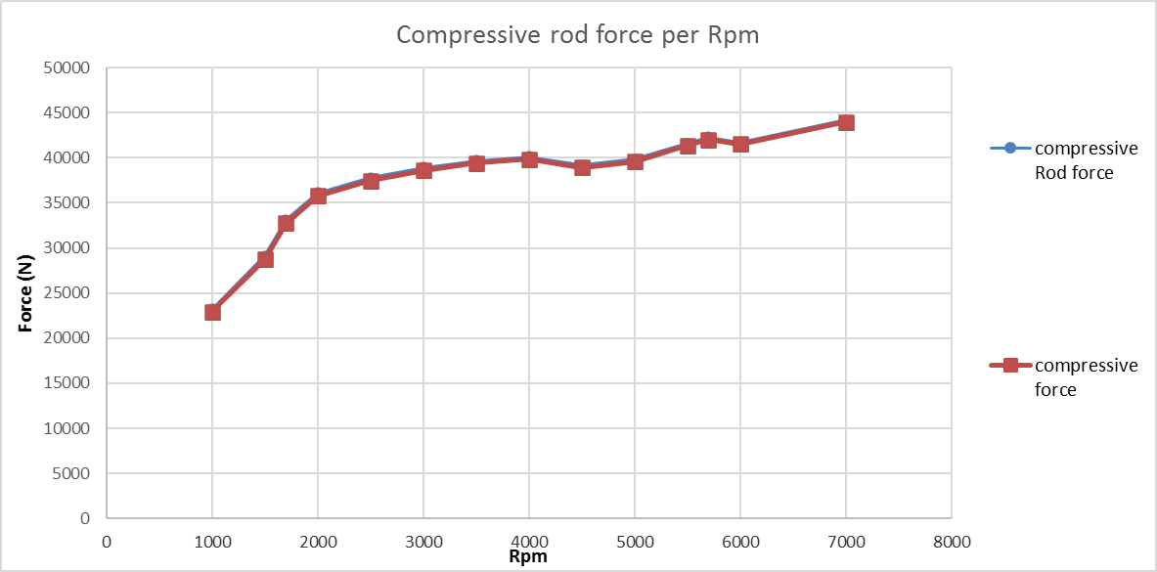
The study of the compressive forces in task C demonstrated that when force is applied to the rod at an angle the resultant force is greater as can be seen in comparing Figure 12 Highest net compressive force on rod per Rpmand Figure 11 Peak Compressive Force per Rpm
Figure 15 Peak compressive force & Rod Force VS Rpm

Figure 16 shows the correlation between Rod force inertia and pressure in each part of the cycle, this demonstrates that the rod force is a result of the pressures effect during the cycle. The inertial forces are Peak at TDC as well as the tensile forces which are shown as negative values, this happens at lower pressure because as can be seen between the exhaust stroke and end of induction where pressure is low tensile force is at its highest.
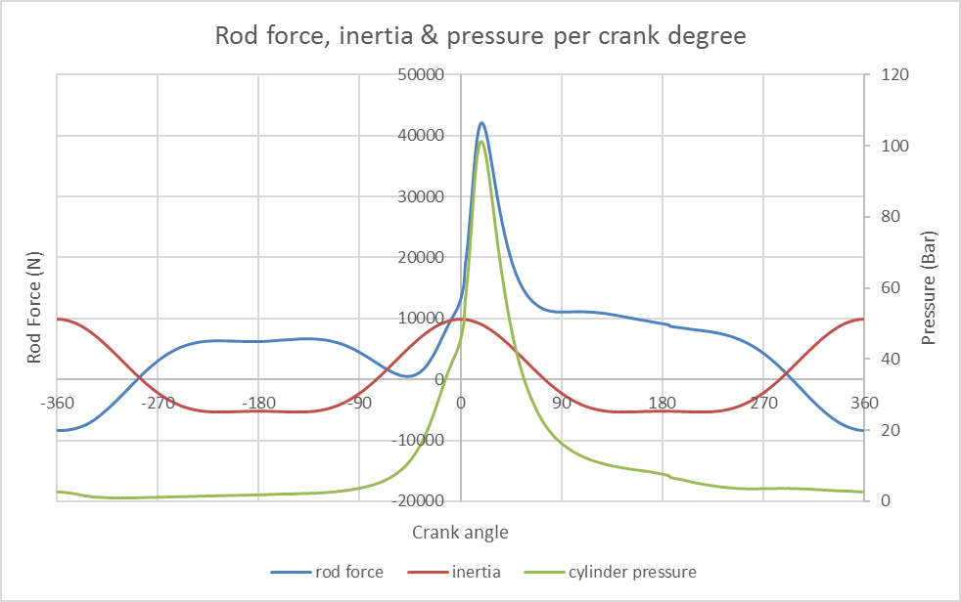
Figure 16 Rod force, Inertia & Pressure per degree
induction
Compression
Spark
combustion
Exhaust

It is also worth noting that at TDC just before combustion and after compression inertia peaks however due to high pressure under compression the larger force acting on the rod is compressive.

Task D Analysis

The highest tensile force on the rod is situated at peak inertial force just after TDC during the an of the exhaust stroke where the smallest pressure value in situated this can be seen in
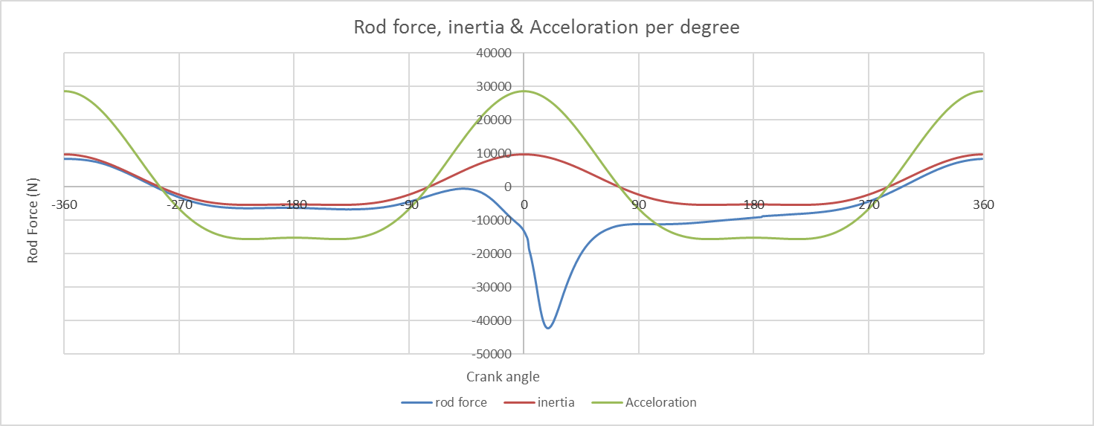
Figure 17 rod force, inertia & Acceleration
Exhaust
compression
induction

Figure 17 demonstrates the inverted values for rod force to show tensile force at a positive value plotted against acceleration and inertia which shows the tensile rod force tightly follow the inertial and acceleration’s trend other than in combustion where it can be seen that these forces are largest at TDC during the end of exhaust.
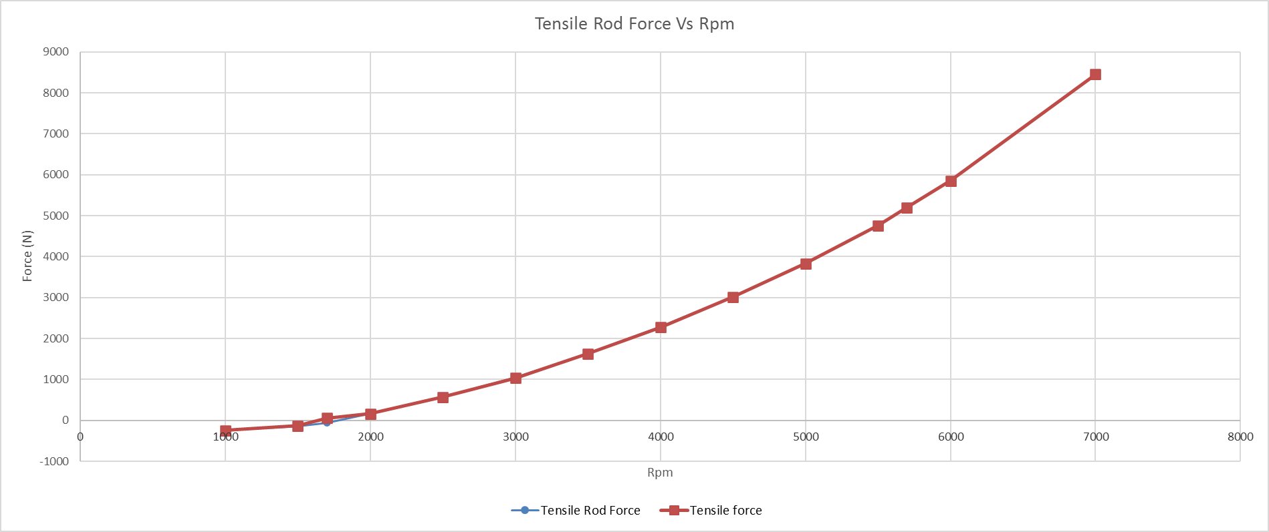
Figure 18 Peak Tensile force & force on Rod

Task E – compressive and tensile stress

In task E the author was tasked with calculating the maximum tensile & compressive stress of a simple rod shanks minimum cross-sectional area for both production and Modified Engine.
This task required the tensile and compressive loads on the rod generated in task C & D as well as the cross-sectional area of the connecting rod. (see Figure 4 Con-Rod & crank Specifications)
This is expressed as:
$$σ= \frac{F}{A}$$
This formula is then used with respect to tensile and compressive force on the rod separately, the data generated from this formula will calculate both tensile and compressive stress regardless of which force you are considering, however the values will be inverted so the positive values will represent the stress values for whichever you are calculating where as the negative will represent the opposite force (see Task E analysis)
Figure 19 Max Tensile stress
Figure 20 Max compressive stress

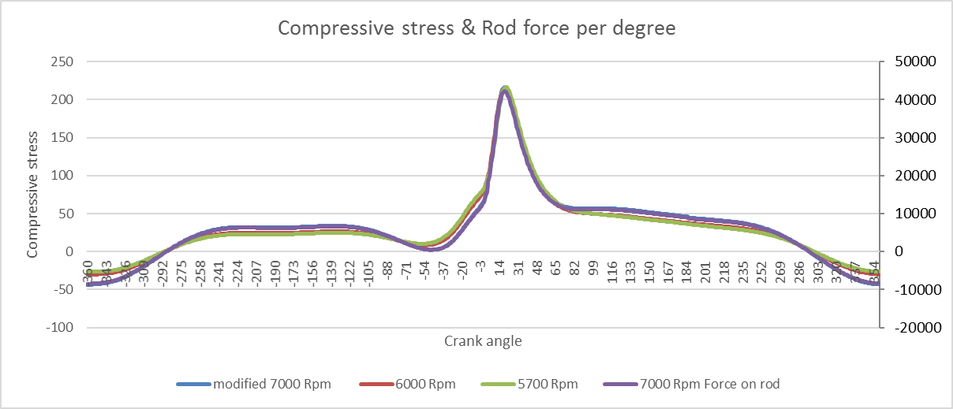
Task E analysis
Figure 21 Compressive stress Per degree

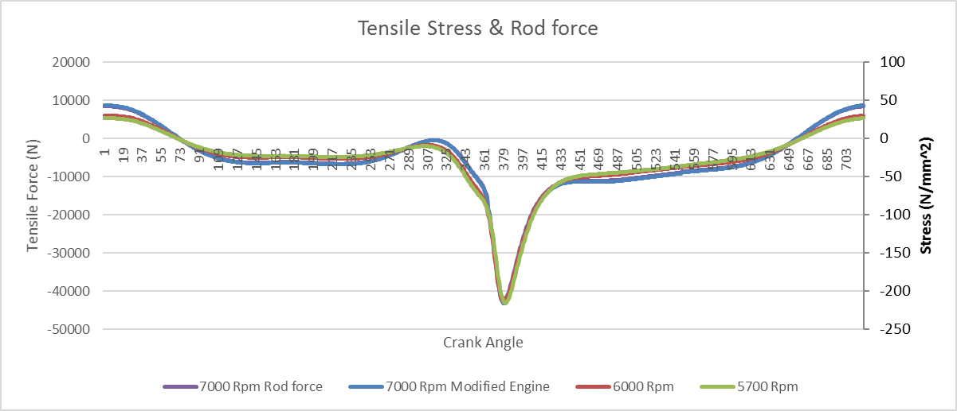
Figure 21 & Figure 22 Tensile stress and rod force per degreeRepresents force plotted against the stress and rod force, this shows that the values for stress are a direct product of the compressive forces on the cross sectional area of the rod.
Figure 22 Tensile stress and rod force per degree

The pints of interests highlighted task C & D such as compression, exhaust etc can also be analysed in these figures to demonstrate that the peak stresses are act in the same position of the cycle as the forces calculated earlier.

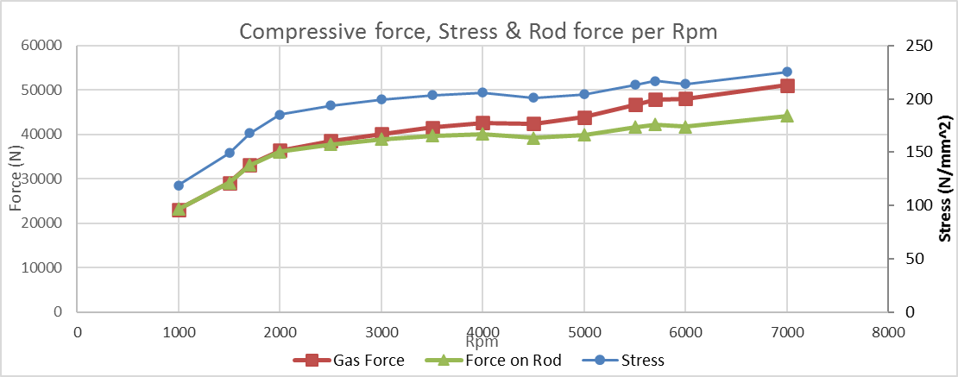
Figure 23 Compressive force, stress & rod force
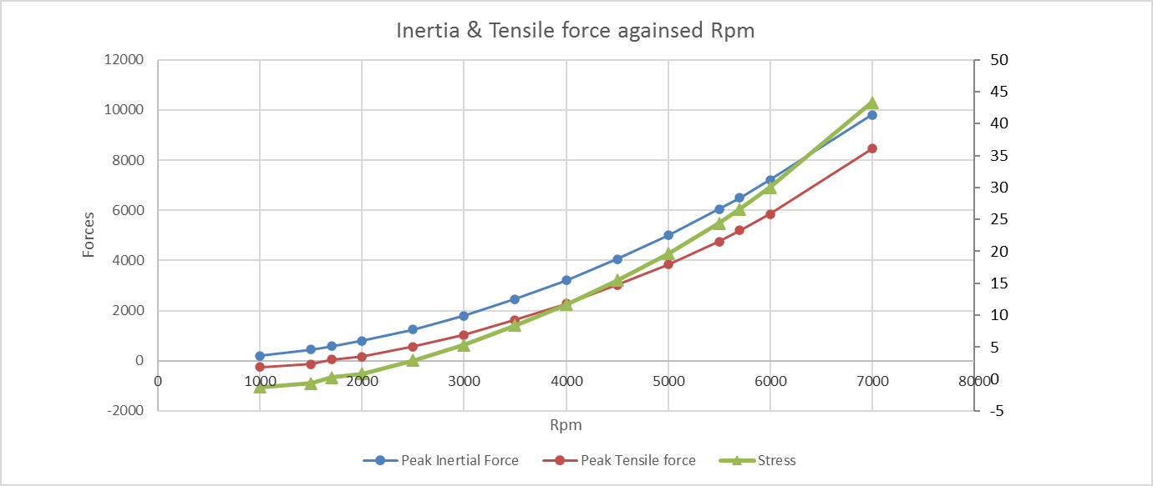
figures 23 & 24 shows that the stress consistently follows the trend of forces as previously explained across the Rpm rang as well as Per degree however the magnitude is far less due to the division of the forces by the cross section.
Figure 24 maximum Tensile
The tensile stress & forces before 2000 Rpm are negligible due to the lack of acceleration and inertial forces at low Rpm, this effect can be seen in figure 23 where rod force separates from gas force and decreases this is due to the inertial forces acting against the compressive forces of the gas

Task F

Task F asks that using the compressive and tensile stress data generated in task E to calculate the static safety factor for both production and modified engines relative to the UTS of the rod.

Ford manufactures their rods to an ultimate Tensile strength UTS of 750N/mm^2 therefore when calculating the safety factor, we express it as:
$$static safety factor= \frac{UTS}{maximum stress}$$

Figure 25 Ford's UTS value

This formula is then used respectively for tensile and compressive stresses to generate the static safety under tensile and compressive stresses (see Figure 26 Compressive Static safety factor& Figure 27 Tensile Static safety factor)
Figure 26 Compressive Static safety factor
Figure 27 Tensile Static safety factor

Task F Analysis

The compressive static safety factor is determined by the UTS of the material in question for example figures 28 & 29 are demonstrating the SSF of powder forged steel which is used for Fords Con-Rods.
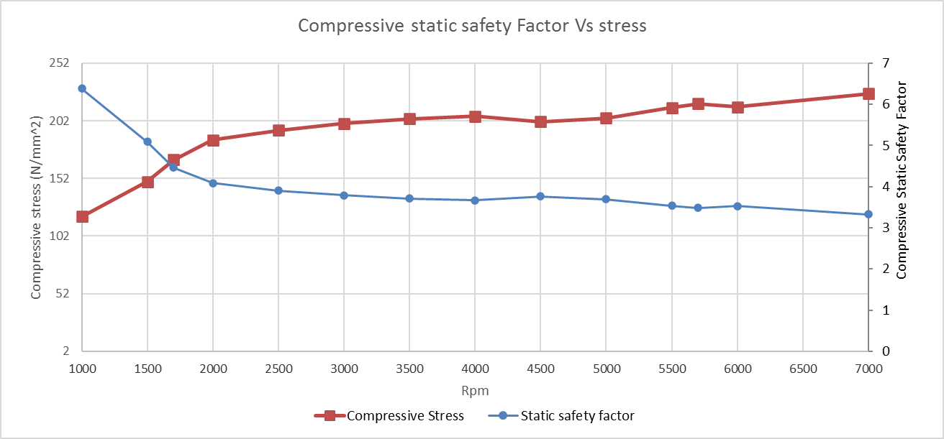
Ford outline a minimum safety factor of 3 to ensure operational clearances while also allowing a margin of error encase of any unpredicted factors.
Figure 28 Compressive static safety factor of powder forged Steel

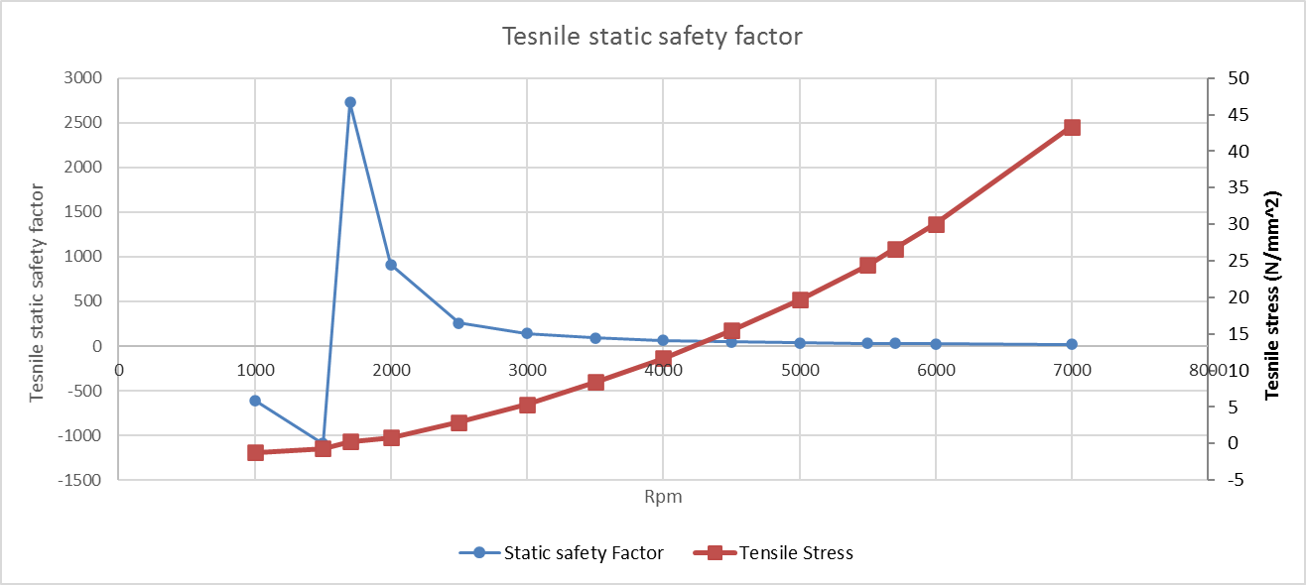
Figure 28 shows that as the rpm increase the safety factor rapidly decreases before resting at 3.3 just over fords margin, as we know as Rpm increases as douse the stresses which in turn will reduce the safety factor.
Figure 29 Tensile static safety factor of powder forged steel

The tensile safety factor before 1700 Rpm begins as a negative due to the lack of tensile stress, as stress increases the SSF decrease but due to significantly less tensile stress the safety factor doesn’t reach lower than 17.3 which Is well within fords safety margin.

Task G – Compression distance & stretch in the rod

Task G requires the calculation of the compression distance and stretch in the rod when under the tensile and compressive stresses calculated in task E for both production and modified engine.

To calculate the compression and stretch the stiffness (K) of the rod was required, stiffness is determined via:
$$E=K.\frac{L}{A}$$
Therefore:
$$K= \frac{EA}{L}$$
Once the stiffness is calculated the compression and stretch due to stress can pe calculated with the young’s modulus for a powder forged Rod and cross section of the Rod via:
$$F= kx$$
Therefore if: $σ= \frac{F}{A}$ then: $σ= \frac{Kx}{A}$

Therefore:
$$X= \frac{σA}{K}$$
This formula is used to calculate compressive distance using compressive stress and stretch via tensile stress.
Figure 30 Tensile Stretch
Figure 31 Compressive Distance

Task G Analysis

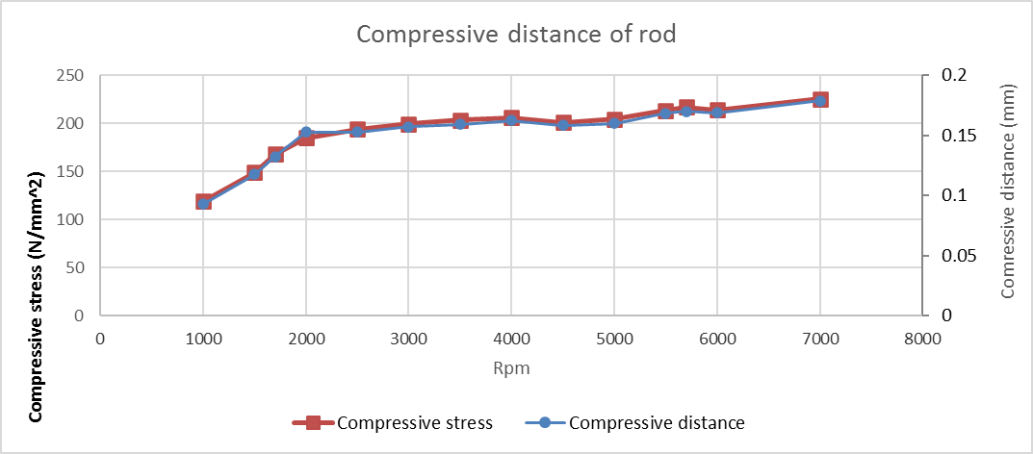
Task G demonstrates the effect of stresses on the length of the rod for example figure 32 & 33 shows the relationship between stress on the rod and distance compressed or stretched at each Rpm , this is a product of the stress & effective area against the stiffness which determines the magnitude of disfiguration in the rod.
Figure 32 compressive distance of powder forged steel

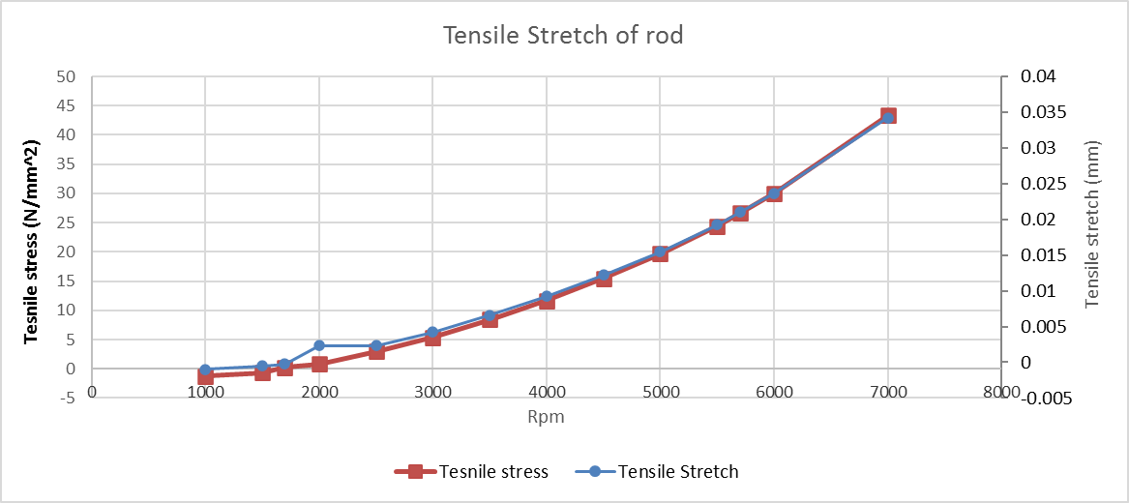
Further study of the con-rods yield strength would determine at which point it passes the elastic range and scums to fatigue, assuming the safety factor accounts for fatigue and elasticity when ford assign a minimum value of 3.
Figure 33 Tensile Stretch of powder forged steel

Task H – Titanium Rod

Task F was repeated for task H however the Rod was replaced from a Powder forged steel Rod to a titanium Rod in the modified engine to determine the effect on operational clearances
To modify the con rod material for the modified engine the lower value of young’s modulus is required to determine the effect of stresses on the rod when under tensile and compressive force. Titanium also has a higher UTS which needs to be considered.

Figure 34 Titanium Specification

Figure 35 comparison of titanium and steel compression & stretch

Figure 36 Comparison of Titanium & steel static safety Factors

Task H Analysis

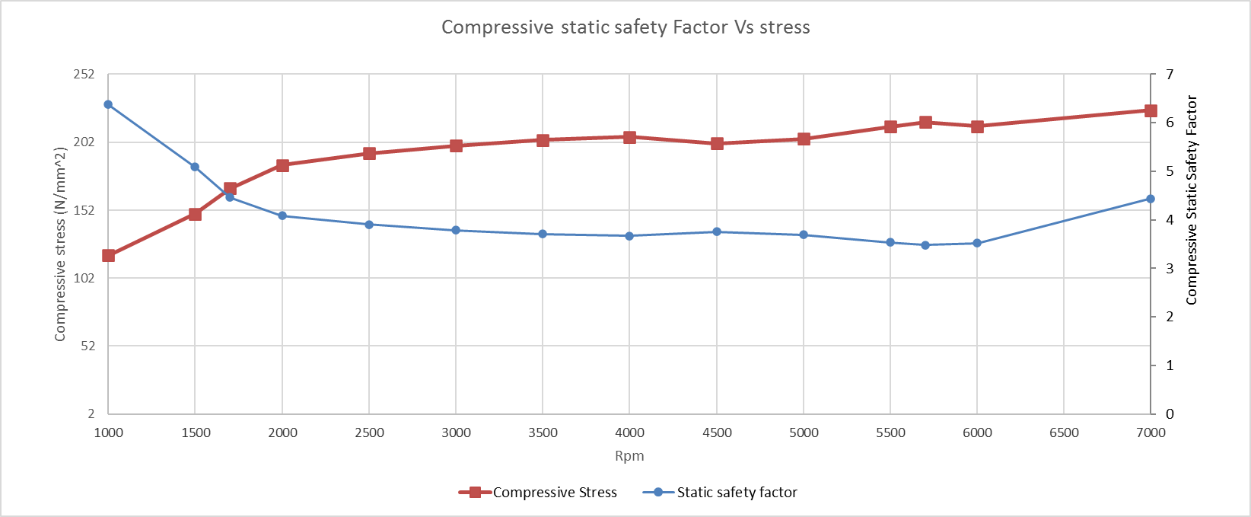
The effects of changing the rod for a titanium rod can be seen in the static safety factors as well as the stretch and compression of the Rod.
Figure 37 Titanium Compressive safety factor
For example it can be seen in Figure 37 Titanium Compressive safety factorthat the safety factor has increased by approximately 0.8 which demonstrates that the titanium rod has a higher elastic tolerance which allows it to stretch or compress further before fatigue damages the rod. This can also be seen more clearly for figure 38 when looking at the results in figure 36.
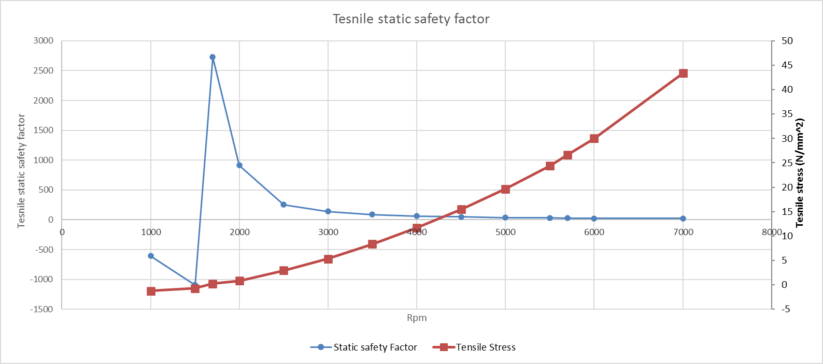
Figure 38 Titanium Tensile safety factor

The other effect on operational clearance can be seen in figure 39 & 40 where the tensile & compressive stress is plotted against tensile stretch, it can be seen that in the modified engine the degree of stretch and compression increases by roughly 25%.
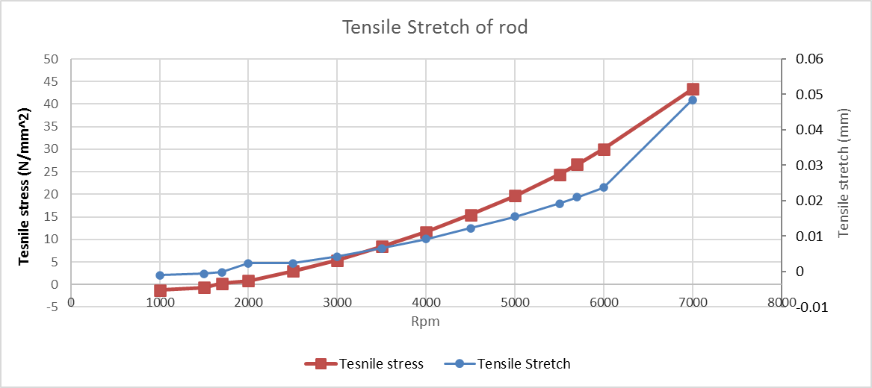
this increase may have negative effects on clearances such as if not considered when determining variables such as dimensional tolerances, compression ratios and knock in the cylinder as an additional 0.1 of a mm can exceed tolerances for engine components.
Figure 39 Titanium Tensile stretch under stress
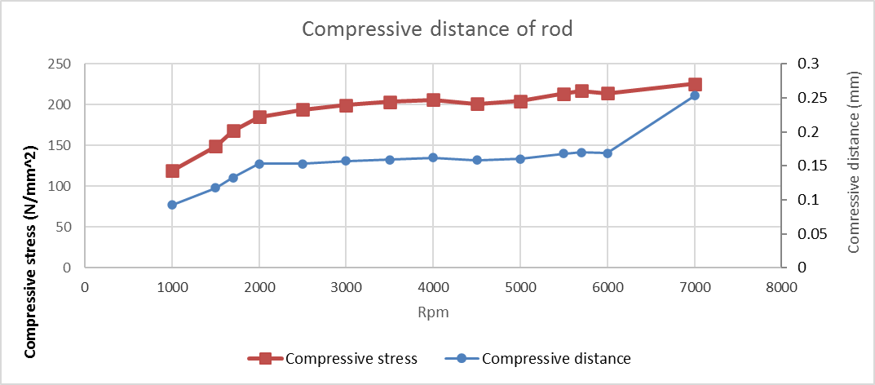
Figure 40 Titanium rod compressive distance

Conclusion

In conclusion this study has demonstrated that the forces acting on the con-rod across the Rpm are a product of pressure, mass and acceleration which have the most effect on the cycle when changed. The most effective Rpm range was also determined as at 5700 Rpm due to the peak output forces being at this Rpm for the production engine however if the Rpm can be increased then the modified engine produces better results.

The use of titanium over steel has its benefits such as its greater ability to deal with more extreme forces however the rate at which it stretches, and compresses may lead to issues in tolerances and clearance during the cycle

Bibliography
Bosch. (1996). Automotive Handbook. Robert Bosh GmbH.
Taylor, c. F. (1985). the internal combustion engine in theory and practice. the MIT Press.

Appendix

Further work

First and second order Acceleration
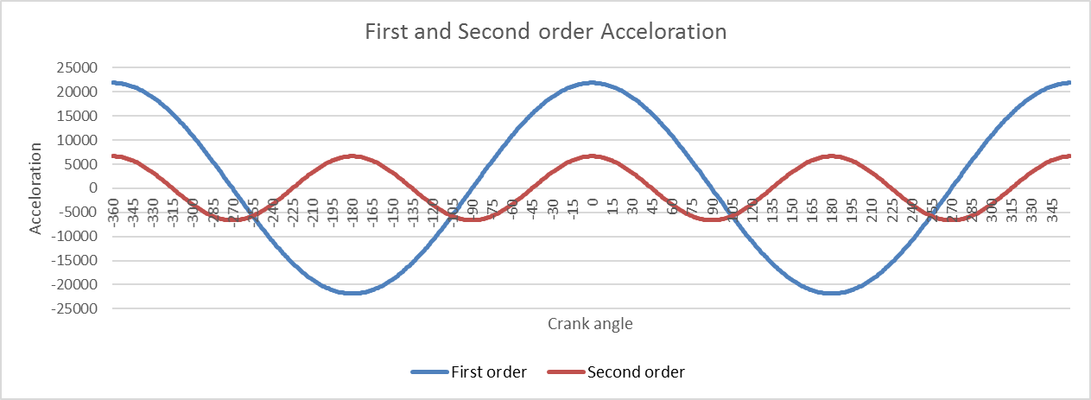
The first order acceleration is a product of the cranks rotation which peaks every 180 degrees whereas the second order acceleration is produced via the rod which rotates 720 degrees for the cranks 360.
First order acceleration is expressed via:
$$( Rω^{2}.\cos\left(θ\right)$$

Second order acceleration is expressed as:
$$( \frac{R}{L}.{Rω}^{2}.\cos{2}(θ)$$
These terms combined when balanced represent the resultant acceleration force in the system

Volume- per degree

To calculate the volume of the cylinders across the cycle the stroke was required and calculated via:

$$stroke =2*crank radus$$
secondly the swept volume
$$sweaped volume =\frac{{ πD}^{2}*stroke}{4}$$
$$displacement=Sweaped volume*4$$

$$Clearance volume=\frac{sv}{(CR-1)}$$

$$Piston position=R+L-\left(Rcosθ\right)-(Lcos(-\sin\left(sinθ\right)*(\frac{R}{L})$$

Once these have been calculated the volume per degree can be calculated via:
$$(Cv+S)*\frac{πD^{2}}{4}$$

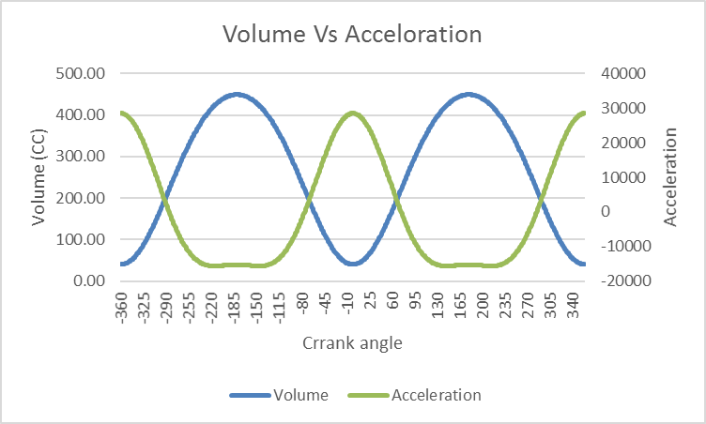
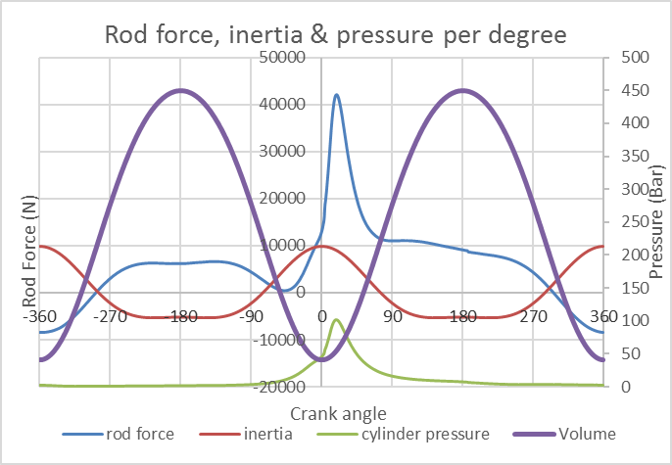

Vertical & horizontal Piston Forces

Methodology

$$Vertical resolution=Frodcos∅=Fnet$$

$$horizontal resolution= Frodsin∅=Fside$$

$$\frac{Frod sin∅}{Fside cos∅}= \frac{Fside}{Fnet}$$
Therefore:

$$\frac{sin∅}{cos∅}= \frac{Fside}{Fnet}=\tan{∅}$$
Therefore:
$$Fside=Frod.tan∅$$
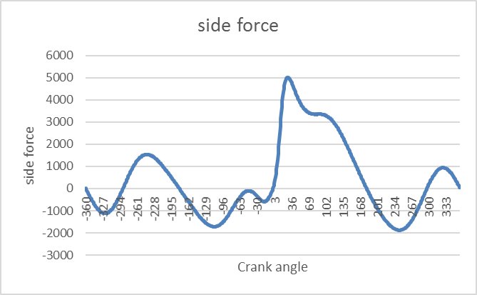

Frictional force

Assuming:
$$μ=0.1$$

Then
$$Ffriction= μ. Fside$$

Instant torque
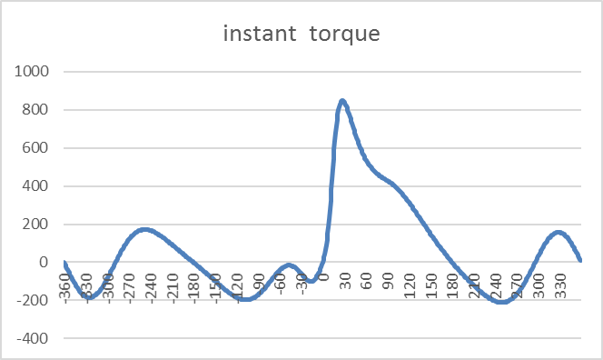
$$Frod . Rsin(θ+∅)$$

Proof of work



