Organizational culture and structure of Total SA
Student: Kaloyan MIlkov Koev
Student Number: 1814704
Subject: IMW
Table of content:
- Introduction
- About the company
- Corporate governance
- Organizational structure
- Organizational culture

1.Introduction
The organizational culture theory, also referred to as the theory of corporate culture, focuses on different concepts of culture that stem from anthropology and sociology. The theory mainly focuses on performance, organizational effectiveness, employee satisfaction, and employee commitments (Miner, 2015). Other areas that this theory focuses on include the strength of organizational culture and culture congruence as well as the type of organizational culture. The theory is comprised of three sections which include artifacts, espoused values, and basic underlying assumptions (Miner, 2015).

2.About the Company
TOTAL S.A. is one of the largest global companies in the oil, natural gas, and specialty chemicals industry. The activities of the company are organized in three distinct main areas which include: upstream, downstream, and chemicals. The company’s upstream sector consists of the exploration for crude oil and natural gas as well as the production of these elements, along with the development activities in the mining operations of coal (referenceforbusiness.com, 2019). TOTAL is also majorly involved in electricity and gas development activities worldwide.
TOTAL’s downstream unit is solely focused on refining, trading, and marketing or petroleum products. The third sector, the chemical sector, includes products such as rubber, resins, inks, paints, and adhesives that are manufactured by its subsidiary Hutchinson. Most of these products are for the automotive industry (referenceforbusiness.com, 2019).
More than one-third of the company’s stake was owned by the French government up until 1996. After that, the government owns less than one percent of the stakes. The company operates in the sectors of renewable power and energy generation and it also has marketing and services segment as well as a corporate segment which deals with sales, management, holdings, operational and financial activities. The company is actively present in more than 130 countries and has an ambition to become the major company in responsible energy production and marketing (referenceforbusiness.com, 2019). Total SA has more than 100,000 employees who are all committed to better and safer energy which is cleaner and accessible to as many people across the planet as possible. To fulfill their ambitions, Total SA is committed to road safety during the transportation of their products, climate and forests through avoiding pollution, youth inclusions and education, and cultural heritage and dialogue. Part of the company is the Total Foundation, which aims to provide effective and tangible solutions, thereby giving fresh impetus to the youth in the heart of the countries where the company is present (referenceforbusiness.com, 2019).
3.Corporate governance
Corporate governance refers to the way a company is organized, controlled, and managed. At Total SA, the responsibility of corporate governance solely lies on the hands of the Board of Directors and the General Management of the company (referenceforbusiness.com, 2019). The Board of Directors is comprised of members who come from a wide range of backgrounds, thus ensuring that the highest standards of corporate governance are applied in the running of the company. Significantly, the Board of Directors and the General Management of the company apply the criteria set out in the AFEP-MEDEF Corporate Governance Code of Listed Corporations as a basic guideline (referenceforbusiness.com, 2019).
The Board of Directors define the Company’s strategic vision, thus ensuring that internal control functions are working as effectively as possible, and oversees the quality of the information that is provided to the company’s shareholders and to the financial markets. The Board of Directors is made up of 12 members, and as of the last financial year, about 10 meetings are convened annually with an attendance rate of beyond 95% every year (referenceforbusiness.com, 2019). These members are tasked with defining the strategic orientations of Total SA and its businesses in all the markets, as well as the implementation of management decisions made during the board meetings and whenever else it is necessary. Part of this mission for the board is to approve the investments that are proposed for the company, or even divestments that involve amounts that exceed 3% of the company’s shareholders’ equity (referenceforbusiness.com, 2019).
The board also addresses any and all issues related to the effective operations of the company. The members affect and monitor the management of both financial and non-financial matters and therefore ensure that the quality of the information the company gives to its shareholders and also convene and set the agenda of interest in Annual Shareholders’ Meetings. The board is supposed to meet at least four times annually, but there can be meetings whenever the situations deem necessary. The board also evaluates its own performances on at least one occasion in three years (Miner, 2015).
The company is very much aware of the need for gender balance in management, and the Board of Directors is equally representative of both members on a 50/50 ratio between men and women. This composition is of vital necessity for the company and should changes be needed in the composition of this board, the Governance and Ethics Committee is tasked with reviewing the annual performances of the board and to propose the desirable changes that the situations may necessitate in the composition of the Board of Directors and the various management Committees basing on the Total SA strategy (Miner, 2015).

4.Organizational Structure (Fatehi)
Organizational structure determines the method a company sort its people and jobs to execute the work, and to attain its target. A small business can manage with less-official form and can take lead of repeated face-to-face disclosure to clear up the issues. Larger company’s however need more particular visibility and mission of work to confirmed leadership and responsibility. The distinct types of organizational structure explain the method in which employee’s duty are allocate and the lines announce to managers. The most suitable form of any organization rely on category of work it does, amount of workers, organization income, geographic placement of equipment and buildings and the level of change of unrelated types of business (J.Woodruff,2018)
According to Fatehi, K. (1996) the organizational structure has 3 main models – Geographic, function and product.
- Geographic structure: Workers are classified according to area. Of the top of each division there is a chief executive who split control of the region with the human resources manager. Main office keep command of “strategic planning” as well as leadership of the action in each company.
- Functional structure: Here, control is on the authority of functional areas: top of each role: marketing, finance, research and development. They communicate straight to the CEO.
- Product structure: The company using this type arrange their workers following to product lines, which are assemble to the product division. All the task is connected to the product being sold and the market being provide is manage by the division. This structure enable a product to be introduce trough building a new devision.
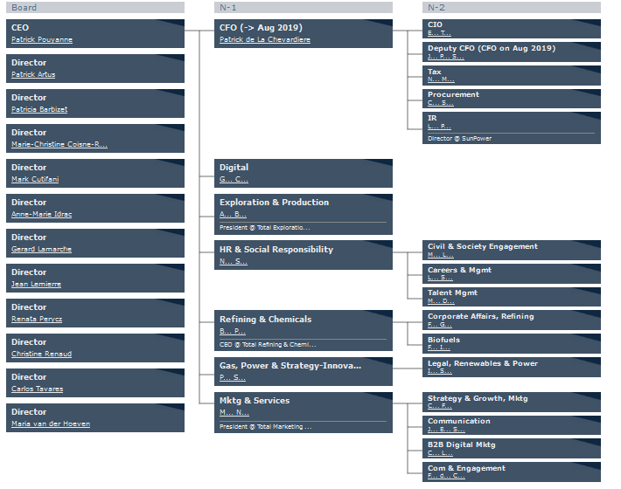(Retrieved from https://www.theofficialboard.com/org-chart/total)
Corporate structure 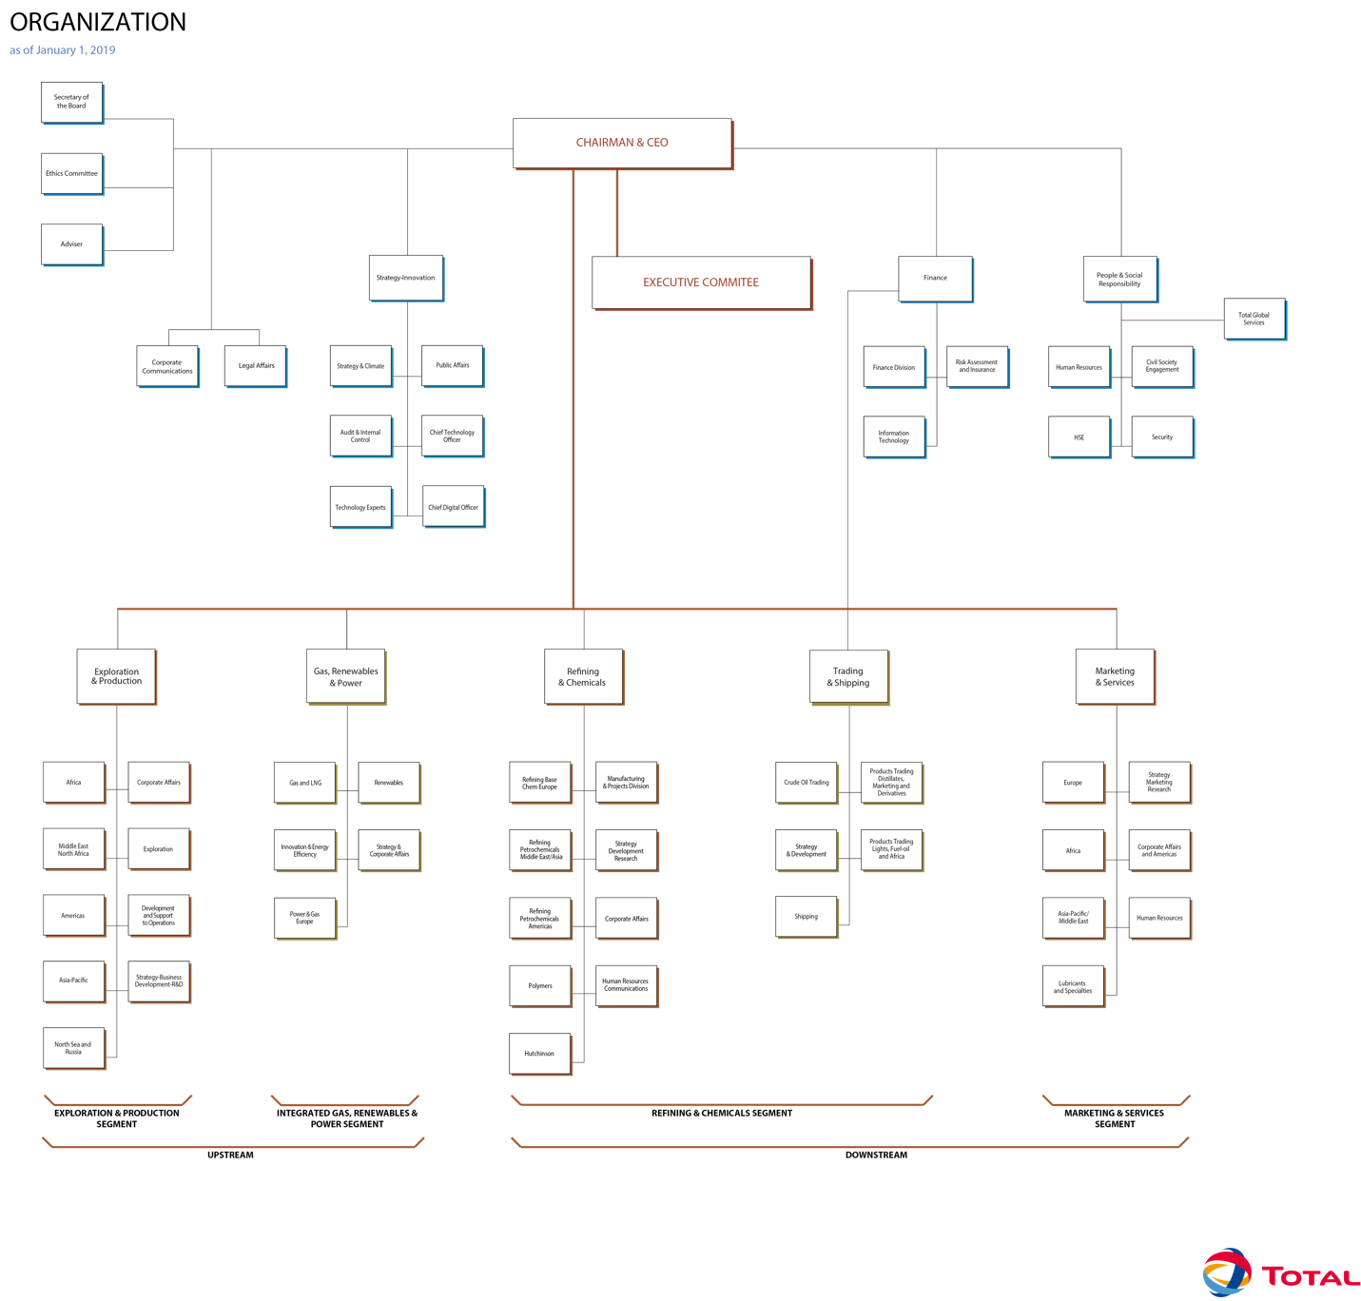

(Retrieved from https://www.total.com/sites/default/files/atoms/files/orga_en_inter.pdf)

6.Organizational culture (Hofstede )
Hofstede’s cultural dimension theory is substructure of cross-cultural communication succeed by Geert Hofstede. It relates the reaction of society culture on the service of its members, and how this service is connected to performance, using a structure obtain from factor study. Hofstede bloom his genuine model as outcome of applying factor analysis to study the consequence of a global overview of employee service by IBM between 1967 and 1973. The authentic theory suggests four dimension which cultural worth could be inspect: individualism-collectivism, uncertainty avoidance, power distance (power of collective hierarchy) and masculinity- femininity. (B.McSweeney, 2002)

Levels of Culture
Artifacts | Visible organizational structures and processes.  (Difficult to measure)
Espoused Values | Espoused justifications  Philosophies, goals, strategies
Basic Underlying Assumptions | Unconscious, perceptions, feelings, thoughts, ignored beliefs

The following is an analysis of the organizational structures and culture of the French multinational corporation TOTAL S.A.

Total achieves its success in market operations mainly due to the culture that it has established within the ranks of corporate governance, but most importantly, doe to the environment that the culture creates when the company operations are underway (Miner, 2015). The ambition of the company is to become a responsible energy major, and this ambition is only achievable if the company receives help from its employees and if these employees are primarily committed to improvement of the company’s operations and products. The company has always had the firm conviction that the men and women of Total SA are the engine on which the company’s errands run (Miner, 2015). As a result of this, Total SA strives to create the best necessary conditions that would allow the flourishing and expression of the employees’ potential. This is done with the objective of offering the employees with working conditions that enhance their capacity to fulfill their individual aspirations through collective rising to the challenges that a responsible energy future poses to the company.
Total SA is aware that for people to get enough motivation when they are going to their places of work every other day, they require to have a goal that drives them and provides them with a meaning for their actions. The most significant ting that the company has managed to do is to establish the culture of responsibility and ownership of the company in the employees, such that whenever they are in operation in the company’s premises, they are likely to give their best efforts to have the best results in their operations (Miner, 2015). This culture enhances the company’s ambition for the production of clean, affordable, and reliable energy for the world, wherever and whenever it is needed. As such, the employees and management of the company are working hard every day to solve the challenges that they face in line with their operations, while at the same time recognizing and solving the new challenges facing them every day (Miner, 2015).
Total SA prides itself as a caring employer looking to the future, which is the basis on which the company builds the culture of letting the employees become a significant part of the company’s daily operations and successes as well. At the company, the employees’ sense of fulfillment s believed to come from the wealth of experiences they received from working in different areas of the company every day. The company’s operations in more than 130 countries and their presence in entire energy; solar, oil, and gas industry chain, offers these employees multiple opportunities to take on new challenges and new jobs where they are able to relocate from one place to the other (Miner, 2015). This culture means that these people continue learning new experiences in the company, and that improves their service delivery which ultimately improves the company’s output. The company also offers numerous training courses for these employees to further develop their skills, further reinstating the statement that the company seeks to grow and achieve its targets by becoming an employer that minds the welfare of the employees (Northouse, 2018).
Safety is a significant concern in the energy and fuel industry. The concerns about safety span from the health of the employees, the working environment, as well as the external environment. Total invests a lot of resources and time on the safety of the employees and their surroundings with the primary goal of ensuring that these employees enjoy a caring and high-quality work environment with as minimal concerns as possible in terms of health, safety, and work-life balance of these individuals. Total SA offers the employees and the management a means to achieve their career fulfillment. The approach of the company has always been underpinned by a strong set of values that is shared among all the individuals and levels working in and for the company. These values range from safety, respect for each other, standing together or team working, fostering a pioneering spirit, and being performance-minded. These five core values guide the proceedings of the company and the relationships that exist between stakeholders, while also offering a solid foundation on which the company builds its collective ambition and vision.
Another aspect of the company’s culture that has significantly defined Total SA and given the company immense success is their culture of promoting and enhancing diversity. Spanning from the core value of respecting each other, the company creates an environment which is inclusive of all the people and every worker is free to express themselves and to develop their potential from the point they are hired throughout their career. In this essence, Total successfully incorporates all people regardless of their gender, origin, sexual orientation, unions, religion, and any other social classification. All people working for Total SA are presented with the same opportunities and the treatment of each of them is the same.
Total is especially strongly committed to enforcing diversity by inclusivity of people with disabilities. As proof of this, the CEO of Total, Patrick Pouyanne, and 50 other corporate leaders at the company signed a pledge that promoted the inclusion of all classes of people with the aim of this pledge being to accelerate inclusivity and diversity in the company as well as outside across the world economy. With a work force of more than 100,000 which includes more than 150 nationalities, Total SA has done a lot in leveraging its international diversity. This inclusivity is enhanced through employment structures that are focused to giving priority to the local populations in whichever country the company and its subsidiaries are operational.
There are not many companies that are as committed to listening to the aspirations of their employees as Total is today (Northouse, 2018). Total has a culture that nurtures social dialogue and enhances the expression of opinions and aspirations by the employees and management as well, thus enhancing the company’s will to share their strategy with the employees and empowering them to play a significant part in the growth and development of the company (Northouse, 2018). Therefore, the company has a communication strategy in place where employees, either directly or through their representatives and departments, are able to send their messages and opinions to the highest ranks in the governance of the company and to ferry the feedback in the converse direction. The employees and their representatives are allowed to raise concerns through the available channels on matters that affect them including issues to do with safety, wages, health, and training and promotions (Northouse, 2018).
One area that has been reinforced over the years in the company’s operational history is safety, and as said earlier, the company takes safety for something that supersedes just a priority as for them this is a core value on which the company’s strategy is built. The company commits itself to having all the stakeholders including employees and managers and external stakeholders share the core principle of upholding safety to the highest possible positions (Northouse, 2018). The necessity for the high-standards of safety in the company is because they operate in an industry where everyone is inherently faced by multiple risks. The company management also recognizes that with safety, the company is guaranteed of sustainable market development and growth of its internal operations. The company benefits a lot from this safety standards as it gets international recognition as one of the companies that have high levels of safety, and thus they are able to foster market trust in many countries (Northouse, 2018).

References
Miner, J. B. (2015). From Edgar Schein’s Organizational-Culture Theory to Organization Development (Particularly Involving Process Consultation). In Organizational Behavior 4 (pp. 334-348). Routledge.
Northouse, P. G. (2018). Leadership: Theory and practice. Sage publications.
referenceforbusiness.com. (2019). TOTAL S.A. - Company Profile, Information, Business Description, History, Background Information on TOTAL S.A. Retrieved 1 August 2019, from https://www.referenceforbusiness.com/history2/16/TOTAL-S-A.html
Schein, E. H. (2010). Organizational culture and leadership (Vol. 2). John Wiley & Sons.
McSweeney, B. (2002). Hofstede’s model of national cultural differences and their consequences ( http://sagepub.com/cgi/content/abstract/55/1/89)
Woodruff J. (2018) (https://smallbusiness.chron.com/models-organizational-structure-3821.html)
Fatehi, K. (1996) International Management: A cross-cultural approach, Upper Saddle River, NJ: Prentice Hall.

