Crisis Management Case Study Review

Joshua Wilson - 2004727
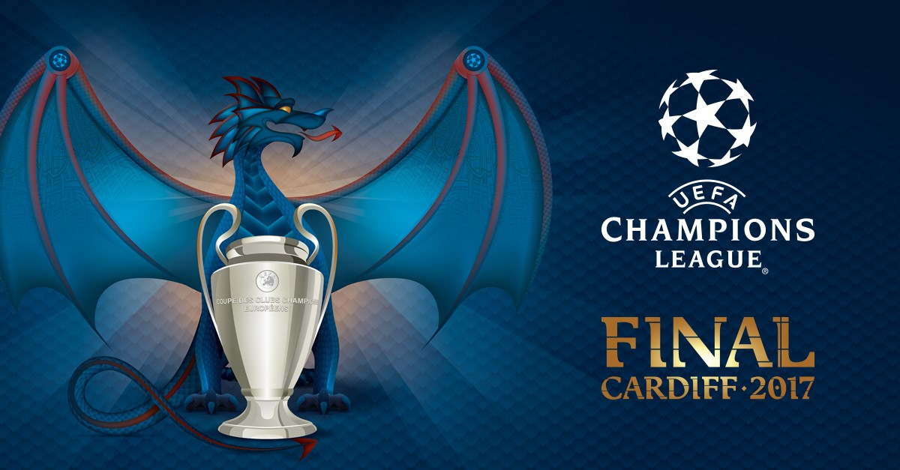
(UEFA, 2016)
Table of Contents
Crisis Notion 3
Background 3
Pre-event planning 4
Principality Stadium policies 4
Aims of crisis management scenario 5
ABTA Terrorism Training 5
Terrorism / Emergency Preparedness 6
Risk Management and Crisis Management models 7
Response to Crisis Scenario 9
Conclusion 10
Recommendations 10
Reference List 11
Image List 13
Appendices 15

Crisis Notion

When it comes to crises across the world, the World Travel and Tourism Council states, “A culture of continual improvement a growth mindset that focuses on learning from crises rather than apportioning blame from failings, and careful knowledge management are all necessary for crisis preparedness and resilience in the tourism sector” (World Travel and Tourism Council, 2022).

Background

The Champion’s League Final was the biggest sporting event to occur in 2017. Whenever Cardiff was announced in 2015, preparation, security and strategies needed to be planned, and implemented for the event to run successfully and to give Wales a great reputation to host events. The Welsh Government stated, “around 170,000 additional visitors are expected in Cardiff and an estimated global TV audience of 200 million across 200 countries and territories, few events can match the Champions League Final for size and scope.” (Welsh Government, 2017).
A crisis scenario analyzed and critically evaluated a disaster that was carried out at the Principality Stadium in Cardiff during the 2017 Champions League Final. Teams were split into gold, silver and bronze command and worked together to determine how extensive the scenario was and to successfully execute the situation. What was a success, what needed work and what was badly handled. Looking below outlines how important crisis strategies are and the steps that are needed to mitigate the risk of attack.

Pre-event planning

For the preparation, teams brought together a map of the stadium, so that research could be conducted to identify emergency exits, refuge points, locality of train stations, bus stations, car parks and gate information. Appendix 6
Additionally, silver command reviewed information, legislation, and analytical statistics from the Green Guide. This ‘is recognised around the world as best practice for the design and planning, and the safety management and operation of sport grounds.’ (Sports Grounds Safety Authority, 2023). Detailed evaluation prompted interest in the following information in accordance with the Guide to Safety at Sports Grounds, 2021:

- extra stewarding
- improved sightlines
- the removal of viewing restrictions in the affected area
- the banning of persistent offenders
- educational programmes
- restricting the capacity of the seated area in question?
(Guide to Safety at Sports Grounds, 2021, p. 10)

Principality Stadium policies

The scenario involved support and work with the stadium. Security was needed to be taken seriously. According to the stadium website, ‘With the recent tragic events in the UK, we are continually reviewing our security procedures at the stadium. We work very closely with South Wales Police, the Wales Extremism & Counter Terrorism Unit and our local partners to ensure that there is a coordinated and appropriate level of security in place for each and every event.’ (Principality Stadium, 2023).
The procedures ensure safety and security for staff and the public. Within silver command, preparation was conducted to understand how the security measures were implemented for the final. Bag searches, and liaising with South Wales Police are examples of this.

Aims of crisis management scenario

With all commands involved, there are key aims that team members want to get out of this exercise.
- To make industry leaders of the future.

- Successfully execute exercise whilst learning more about crisis management for future job roles.

- Incorporate knowledge within every team member and to strengthen teamworking, communication and crisis management skills.

This scenario will be able to make industry leaders of the future, by showing them what is required for an event to be successful, safely handled and executed professionally in an intense setting.
If the scenario is successful, it gives team members a range of experience in crisis management principles, and provides opportunities for job roles in this sector.
This group scenario ensures a degree of teamworking skills. It encourages communication which in turn maximises camaraderie within the team.

ABTA Terrorism Training

In 2021, the ACT Awareness training was conducted. Six different modules were completed.
These modules were able to prepare groups for the crisis scenario, ensuring that knowledge was gained before the scenario took place in 2023.
- Introduction to Terrorism
- Identifying Security Vulnerabilities
- How to Identify and Respond to Suspicious Behaviour
- How to Identify and Deal with a Suspicious Item
- What to do in the Event of a Bomb Threat
- How to Respond to a Firearms or Weapons attack

Appendix 7 – certificate

Terrorism / Emergency Preparedness

Football matches have high standards of safety protocols that protect staff and spectator. The Hillsborough Disaster, 1989 changed the way safety in stadiums is viewed. Football organizations now have safety checks to mitigate accidents and disasters. According to Counter Terrorism Policing, football fans are now urged to
‘Know The Game Plan.’
- Arrive early, allowing more time for security checks.
- Minimise what you carry, fewer bag searches will speed up entry to the ground.
- Be vigilant at all times and if you see anything suspicious, tell a steward right away.
- If you see anything that could pose an immediate threat to safety, call 999.
- In an emergency, listen to the Public Address instructions and follow them.
- If told to evacuate, do so immediately, do not wait around to film events on your mobile.
- Move right away from the stadium as quickly as possible for your safety and to allow clear access for any emergency vehicles.
- Once you are safe, follow the local police force on Twitter for updates.

According to National Police Coordinator for Protective Security, Chief Superintendent Nick Aldworth,

“The chance of being caught up in a terrorist attack is low but we want the public to feel confident to come forward and report any concerns if they see something suspicious to matchday staff or police.”

(Aldworth, 2018).

Crucially, gold, silver, and bronze commands are now implemented in police forces.
This structure looks at key, fundamental principles of keeping everyone safe at large scale events. It provides a framework into delivering a strategic, tactical, and operational response. Gold is in overall command of the operation having the authority to make an overall decision. Silver commands and coordinates the overall tactical response to the incident. They also follow the direction and decisions made by gold and follow it through. Bronze is responsible for a group of resources and focuses primarily on the operational side of the incident. They take direction from gold and silver in implementing their decisions. Roles and responsibilities apply to all areas. They are as follows:
(College of Policing, 2013)

Appendix 1 gives more detail regarding the command structures and their importance to the event.

Risk Management and Crisis Management models

For this event, it is vital that these models are considered for the safety and welfare of all.
Many risk management and crisis management models need reviewed so organisations cover all points. When analysing appendix 2, there are five stages of risk. Firstly, diagnosis. Team members and staff need to identify risks and analyse their severity. Stewards will be situated across the stadium, as well as operational and tactical representatives in the control box who can monitor everything.
Decisions need to be made when a risk is identified. Stewards will need to decide on the severity of the incident. The evaluation of the risk will determine how great the risk is and if it needs to be elevated or lowered. This will be communicated by each stage of command.
Communication between event organisers and staff members is essential. Without this, it would be difficult to make decisions, and execute plans effectively. Stadiums make communication essential if an incident occurs. However, if there was a lack of communication, incidents will become out of control and heighten the risk of attack or injury.

Finally, event organisers must monitor and manage situations as they unfold. It is important that risks are isolated and not develop. This looks unprofessional and makes it difficult to manage the situation.
There are five phases of crisis management. Firstly, signal detection. Event managers and staff are expected to watch for red flags to monitor for danger. This is the SIGHT section. An example of this is seeing someone acting suspiciously looking at CCTV. Potentially, they may be planning something dangerous.
The team need to display preparation and prevention. No one wants to experience a crisis. One way is through staff briefings and training, which strengthens knowledge and understanding.
Professionalism is needed to protect the reputation of the organisation. Any risk or threat needs to be contained. If an accident does occur and there is damage, staff need to limit this.
An essential stage of crisis management is post-crisis evaluation. Departments will need to implement a recovery plan. This should be in place regardless of an attack. An updated plan means venues are prepared for evolving crises. Due to the attack in London, 2017, Cardiff was on high alert and ensured a strong police presence. According to BBC News, “South Wales Police said there would still be a large number of officers in the city following the terror attack in London, as the Champions League festival is still running until 17:00 BST on Sunday.” (BBC News, 2022).
The final stage is the learning element. According to Carley and Harrald 1997, “Learning from crises is vital to develop the capabilities required to prevent their occurrence and limit their implications.” (Carley and Harrald, 1997). This is about evaluation as a team to determine what could be performed better and the key learning elements.
Depending on the seriousness of the situation, refresher or new training modules are needed. This can link to Hillsborough “resulting in the deaths of 97 Liverpool fans attending the club's FA Cup semi-final against Nottingham Forest.” BBC News (2022). This error of misjudgement resulted in a catastrophe, with such incidences not happening again through the effects of training and practice.
The Manchester bombing in 2017, killing 22 people was the worst attack to happen in recent history. Security were not concentrating, making it easy for the assailant to detonate the bomb. This established Martyn’s Law which “aimed at forcing all venues to draw up plans to prevent terrorist attacks and ensure public safety.” (Sabbagh, 2023). Martyn was one of the victims.
The London Bridge Attack resulted in 11 deaths and was confidentially discussed at the scenario. This attack was allegedly prepared for Cardiff during the Champions League Final, but due to heavy police presence, crisis was averted, and London was targeted. What measures were Cardiff able to implement that London could not? According to Piekarz 2015, “in order to achieve the service standards and implement the safe and effective working practices, training is fundamental. In terms of safety, effective training regimes require induction for new employees and a sound ongoing training system that is both realistic and proportionate to maintain competence.” (Piekarz, 2015, p. 94).
In silver command, it was viewed from a tactical perspective what the police did in London and compared it to the scenario in Cardiff. For example, trojan arrival shortly after the attack occurred. However, timings were different. London’s attack was random and not during an event, police were not prepared, which contributed to deaths. However, the Champions League was occurring, the commands were prepared. There were serious injuries, but police were situated around the city. It is difficult to stop terrorism, however, more may be saved if training is undertaken frequently. 2023 is sees a rise in terrorism threats, so the UK must be prepared.
Due to security threats for the final, it was decided the stadium would host the match under a closed roof, to prevent drone attacks. According to Dream Team, “UEFA called for the roof closure at the 74,500 Principality Stadium, renamed National Stadium of Wales for the final, after the Borussia Dortmund bus bombing last month.” (Wilkinson, 2017). Preparedness and planning are vital for success. According to Ritchie 2015, “Crisis events consistently demonstrate how a lack of information and communication has the capacity to significantly affect organizations of all sizes.” (Ritchie, 2015, p. 16). This event was well executed because staff members displayed effective communication of the plans.
According to CNN, “Amid heightened security following the recent terror attack in Manchester, which killed 22 people, 6,000 police officers – 600 armed – have been deployed in the Welsh capital Cardiff over four days. On Saturday, 2,000 police officers will be on patrol.” (CNN, 2017). Richard Lewis (Assistant Chief Commissioner for South Wales Police) said that “the eyes of the world were on Cardiff” which made the city and stadium a higher risk to terrorism or threats. Due to the effectiveness of the police force and staff in the stadium, this prevented an attack.
Appendixes 4 and 5 show how organisations deal with crisis. Their principles need to be implemented for the safety of the venue and everyone there. Both models have a response/recovery section, so that no matter what damage is inflicted, every organisation needs to respond effectively.

Response to Crisis Scenario

Groups were split up and put into different commands. This team was the silver command group. During the preparation stage, silver excelled and were able to identify the spokesperson and map analyst when it came to making decisions. As much as the vocal and teamworking skills were good, there were elements that needed improved. When the scenario started, the threat escalated quickly, and decisions needed to be made fast to prevent deaths. For example, an unidentified van with its engine running which needed to be reported, as well as terrorists who started to wield knives and guns.

Every person that was based in the stadium, Cardiff Castle and on the streets needed to be in communication with each other, so that armed responses could neutralise the target. However, it was found that gold command did not interact much with silver, which meant bronze were not getting the tactical information we needed to assist with. Also, silver was partly to blame, as they did not relay much information to bronze, which impacted the scenario outcome.
Appendix 5 of Fink’s Model, silver command did not fully execute this as well as it should. However, good decisions were made. At the prodromal stage, team members monitored signs at the venue and kept a timed record of what went on. For example, there were stewards in the stadium to monitor fans. Whenever it came to the acute and chronic stages, silver did not perform highly. There was a lack of communication between silver and bronze. It was silver’s responsibility to give information to bronze, though no one engaged with them. As silver was dealing with the tactical approach, they needed to advise bronze on what they needed to do operationally. Without this, the developments would crumble. Regarding the three commands, there were serious communicational errors which need to be corrected for future scenarios. Credit needs to go to gold who gave good information to bronze but failed to give information consistently to silver.
However, when it came to the recovery, the three commands were able to deal with the situation after realising the downfall in communication they encountered during the attack.

Conclusion

This crisis review has shown extensive information on the importance of crisis management and what it takes to avert an attack, looking specifically at the Champions League Final in Cardiff, 2017. Also, by incorporating crisis management models which reflect what needs to occur at events such as this. There was fine attention to the strategic, tactical, and operational plans for each command when dealing with a crisis, as well as reviewing how the scenario played out together. This review has highlighted crisis management in many ways and what it takes for a successful running of events in all venues.

Recommendations

Major recommendations for this review are as follows:
- More effective communication needs to be carried out amongst groups, so that each command is kept updated about the situation, as it can change quickly.

- Ensuring that any personal role in the event is improved by showing enthusiasm in the scenario and making it a responsibility to speak more professionally with other group members.

- By improving these points, applying the knowledge and expertise would be heightened if there was a real-life crisis, combined with the analysis of crisis management models, thus excelling those in crisis management positions further.

- Make sure training for crisis situations is undertaken on a routine basis for any organisation in which you find future employment.

Reference List

- BBC News (2017) Champions League: Fans head home after Cardiff final. Available at: https://www.bbc.co.uk/news/uk-wales-south-east-wales-40144714 (Accessed: 16 May 2023).

- BBC News (2022) Hillsborough: Timeline of the 1989 stadium disaster. Available at: https://www.bbc.co.uk/news/uk-england-merseyside-47697569 (Accessed: 19 May 2023).

- Counter Terrorism Policing (2018) Football Fans Urged To Know The Game Plan. Available at: https://www.counterterrorism.police.uk/football-fans-urged-to-know-the-game-plan/ (Accessed: 27 April 2023).

- Eismann, K. Posegga, O. Fischbach, K. (2021) ‘Opening organizational learning in crisis management: On the affordances of social media’, Journal of Strategic Information Systems, p. 3

- Guide to Safety at Sports Grounds (2021) London: Sports Grounds Safety Authority.

- Piekarz, M. (2015) Risk and Safety Management in the Leisure, Events, Tourism and Sports Industries. CABI. Wallingford, Oxfordshire.

- Principality Stadium (2023) SECURITY. Available at: https://www.principalitystadium.wales/safety-and-security/ (Accessed: 20 May 2023).

- Ritchie, B. (2015) Tourism Crisis and Disaster Management in the Asia-Pacific. Queensland, Australia.

- Sabbagh, D. (2023) ‘Martyn’s law’ anti-terrorism bill to be published this spring, says Braverman’, The Guardian.

- Sports Grounds Safety Authority (2023) Guide to Safety at Sports Grounds ‘Green Guide’. Available at: https://sgsa.org.uk/greenguide/ (Accessed: 20 May 2023).
- Welsh Government (2017) Selling Wales to the world during the Champions League Final. Available at: https://www.gov.wales/selling-wales-world-during-champions-league-final#:~:text=With%20around%20170%2C000%20additional%20visitors,Final%20for%20size%20and%20scope. (Accessed: 19 May 2023).

- Wilkinson, M. (2017) SECURITY MEASURES UEFA Champions League final to be played under roof amid fears of terrorist drone attack. Available at: https://www.dreamteamfc.com/c/news-gossip/220941/uefa-champions-league-final-to-be-played-under-roof-amid-fears-of-terrorist-drone-attack/#:~:text=Welsh%20FA%20chiefs%20have%20decided,protect%20against%20an%20aerial%20attack. (Accessed: 16 May 2023).

Image List

- ABTA Knowledge Zone (2023) Action Counters Terrorism [Image]. Available at: https://www.abtaknowledgezone.com/get-certificate/ (Accessed: 20/05/2023).

- College of Policing (2013) Command structures [Image]. Available at: https://www.college.police.uk/app/operations/command-and-control/command-structures (Accessed: 29/04/2023).

- CQ Net (2020) Leadership in times of the coronavirus crisis: A management guide for professionals [Image]. Available at: https://www.ckju.net/en/blog/leadership-times-coronavirus-crisis-management-guide-professionals/98221 (Accessed: 02/05/2023).

- Genially (2019) Risk Management Model [Image]. Available at: https://view.genial.ly/5ca61eeae4401c23df7fee1f/horizontal-infographic-diagrams-risk-management-model (Accessed: 30/04/2023).

- Smartsheet (2020) Models and Theories to Improve Crisis Management [Image]. Available at: https://www.smartsheet.com/content/crisis-management-model-theories (Accessed: 16/05/2023).

- Smartsheet (2020) Models and Theories to Improve Crisis Management [Image]. Available at: https://www.smartsheet.com/content/crisis-management-model-theories#:~:text=The%20prodromal%20stage%20covers%20the,it%20or%20limit%20its%20scope. (Accessed: 18/05/2023).

- Stadium Guide (2022) Cardiff Principality Stadium Seating Plan Rows, Parking Map, Ticket Prices [Image]. Available at: https://stadiumsguide.com/united-kingdom/cardiff-principality-stadium/ (Accessed: 20/05/2023).

- UEFA (2016) Cardiff 2017 final identity launched [Image]. Available at: https://www.uefa.com/uefachampionsleague/news/0230-0e94cab78cd6-3e902dfc0305-1000--cardiff-2017-final-identity-launched/ (Accessed: 13/05/2023).
- UEFA (2017) UEFA Champions League final: Guide to Cardiff [Image]. Available at: https://www.uefa.com/uefachampionsleague/news/0239-0e972c0435bd-8d289209b813-1000--uefa-champions-league-final-guide-to-cardiff/ (Accessed: 27/04/2023).

Appendices
(College of Policing, 2013)
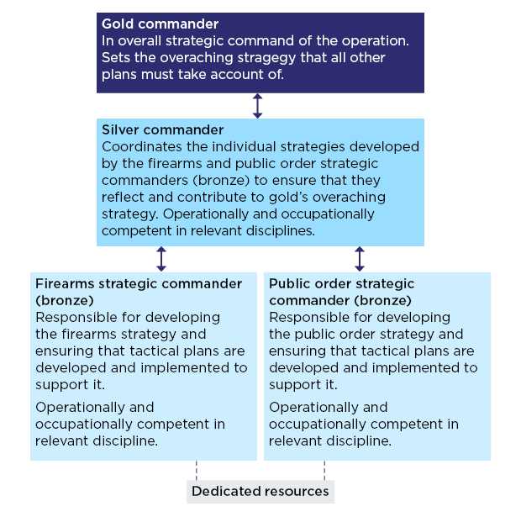

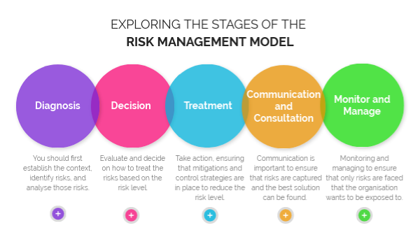
(Genially, 2019)

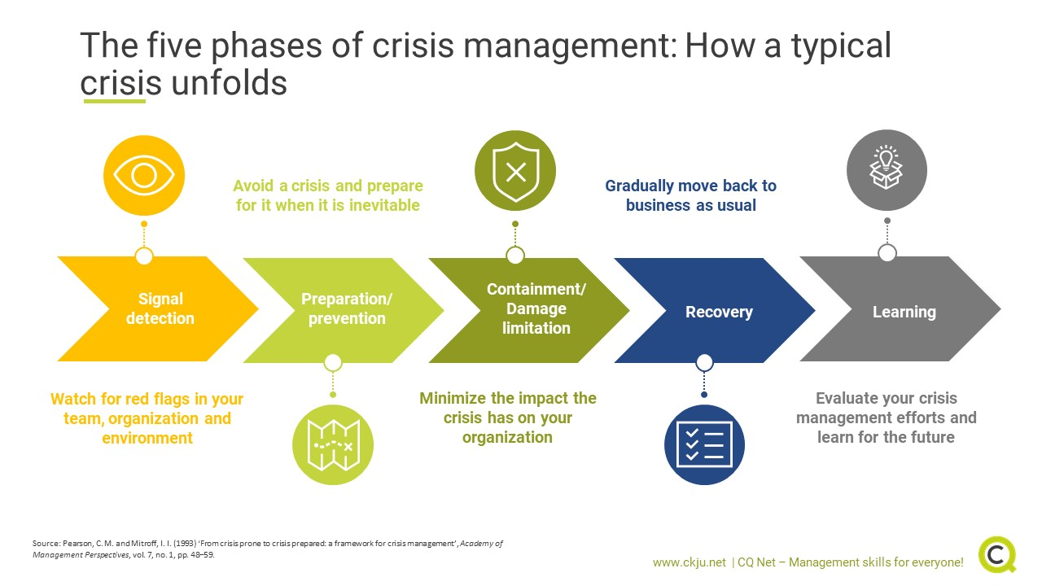
(CQ Net, 2020)

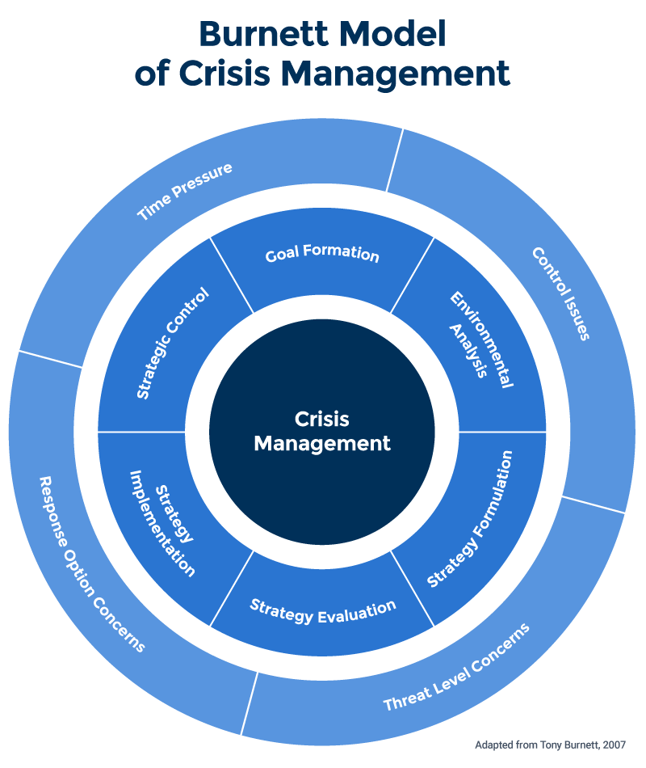

(Smartsheet, 2020)

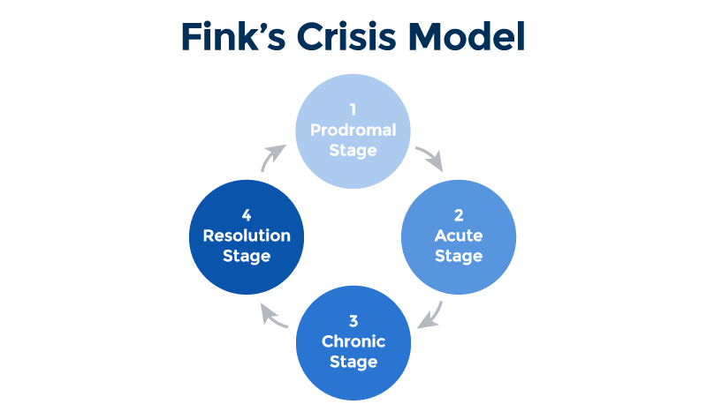
(Smartsheet, 2020)

(Stadium Guide, 2022)
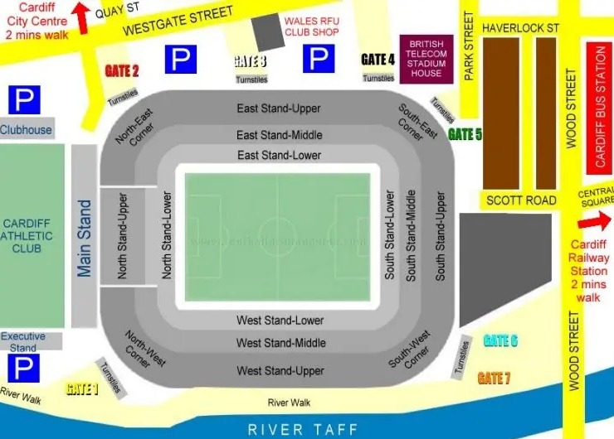
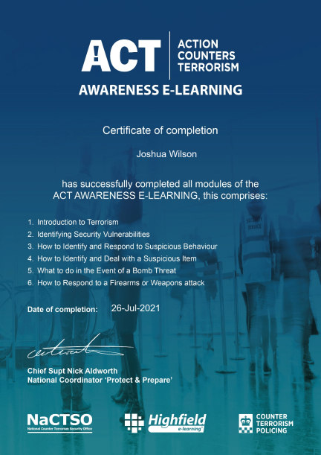
ABTA Knowledge Zone (2023)

