Destination Management: Positano

SUSTAINABLE HOSPITALITY & TOURISM MANAGEMENT

BMIH5006

Student’s Name: OTILIA GHINET
Student’s ID: 1922158
Lecturer’s Name: RUTH TAYLOR-DAVIES

Table of Contents
Introduction 3
Sustainability – Positano 4
Social Sustainability 4
Environmental Sustainability 5
Economic Sustainability 6
Butler’s Lifecycle Model 7
Doxey’s iridex model 11
Conclusion 13
References 14

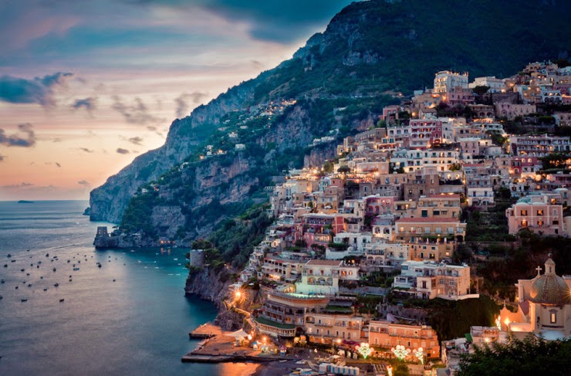
This Photo by Unknown Author is licensed under CC BY

Introduction

Positano is a town on the Amalfi Coast in the south of Italy and it is a popular place for tourists to visit because of its beautiful scenery. The town was built on steep rocks that look out over the calm Tyrrhenian Sea and give stunning views of the Mediterranean coast below and Positano is a well-known tourist destination where people come from all over the world. A lot of people are drawn to it because of the complicated network of streets and stairs that wind their way down to the water's edge and because there are so many bright homes in the municipality and bougainvillea and other colorful plants decorate the outsides of these homes, the municipality is a great place for people who like to take pictures. (Roberts, 2020)

Positano has a lot of fun things to do besides what tourists do. Some of these things to do are to soak up the sun on the beach, swim in the ocean, and try the food from the area and travelers who want to see the coast and nearby islands can do so on boat tours. Positano is known all over the world for having the best fashion and style. Since there are a lot of boutiques and shops in the area that sell expensive Italian clothes and accessories, it is a great place to go if you want to buy some high-end brand items. (De Luca & Zavarrone, 2014)
The following report is about the sustainability in Positano and destination management which will include the three pillars of sustainability related to the subject, the Doxey’s iridex model as well as Butler’s Lifecycle model applied on Positano as a travel destination.

Sustainability – Positano

The social, environmental, and economic facets of sustainability comprise the three legs of the sustainability tripartite framework, which, when considered as a whole, serves as the basis for establishing a sustainable location. (Weaver & Lawton, 2014)

Social Sustainability

Social sustainability refers to a society's ability to meet the needs of its members over time while preserving social harmony and equality and it encompasses participation in decision-making processes, access to education and career opportunities, and access to food, shelter, and healthcare. In addition, it includes having access to food, shelter, and healthcare. (Gossling et Al., 2020)

The concept of social sustainability refers to the process of increasing the standard of living not only of Positano's residents, but also of tourists who visit the city and this particular concept pertains to the importance of preserving cultural and social heritage while also prioritizing the health and safety of both the local population and visitors. (Pimentel & De Abreu, 2020)

Positano has implemented several initiatives designed to promote social sustainability and this strategy is embodied within the Towns Tourism Plan. It priorities the preservation of local traditions and the encouragement of cultural exchange between tourists and locals and the community's frequent and well-organized cultural events at the local level, such as musical festivals and parades, provide windows into the intricate cultural fibre of the town. (Gheorghiloaia & Storbacka, 2018)

In addition, Positano strives to promote inclusiveness by providing amenities and services that are adapted to satisfy the needs of individuals with a range of disabilities and accessibility is prioritized in the design of numerous building types, including those that house people and serve sustenance. (Segui-Amortegui et Al., 2018)

Environmental Sustainability

Environmental sustainability, the second essential component of sustainability, encompasses both the preservation of the natural environment and the promotion of environmental conservation and as Positano is in a particularly advantageous position to benefit substantially from the significance of this topic due to its unique geographical location and the presence of a sensitive marine ecosystem. (Tosun, 2018)

Positano is dedicated to the reduction of carbon emissions and the preservation of the natural environment and among other environmentally sustainable, the municipality promotes the use of eco-friendly construction materials and the development of recycling initiatives. In addition, visitors are actively encouraged to participate in tourism activities that have a minimal impact on the local environment, such as helping to clean up the coastline or hiking through nearby natural areas. (De Carlo & Perano, 2015)

Economic Sustainability

Economic sustainability refers to the capacity of an economy to maintain its productivity and development over time while ensuring that its resources are utilized in a responsible and equitable manner and in order to promote the long-term prosperity and well-being of all members of society, it is necessary to strike a balance between the pursuance of economic development and the consideration of social and environmental concerns. A sustainable economy requires meticulous planning, efficient resource management, and a commitment to sustainable business practices and public policy. (Andereck et al., 2015)

Positano's tourism industry contributes significantly to the city's economy, and a sizable portion of the population relies on hotel and tourism employment as their primary source of income and the municipality is committed to promoting sustainable tourism practices that promote economic growth while minimizing the potential negative impacts of tourism and this commitment will assist the city in promoting sustainable tourism. In addition, the municipality works to promote sustainable development by enhancing its infrastructure and fostering cordial relationships with local manufacturers and businesses and this contributes to the municipality's aim of sustainable development. (Cucco & Baggio, 2017)

Positano's continued economic success is primarily contingent on adhering to the three fundamental principles of sustainability described in the previous sentence and combining social activities, environmental preservation, and the promotion of economic development, the municipality has achieved remarkable success in advancing sustainability. Positano can ensure that this picture-perfect location remains for future generations if it priorities sustainable practices while the destination’s success must serve as a model for other global tourist destinations in order to nurture a more sustainable future. Positano is a model of how to accomplish this. (Graci & Dodds, 2015)

Butler’s Lifecycle Model
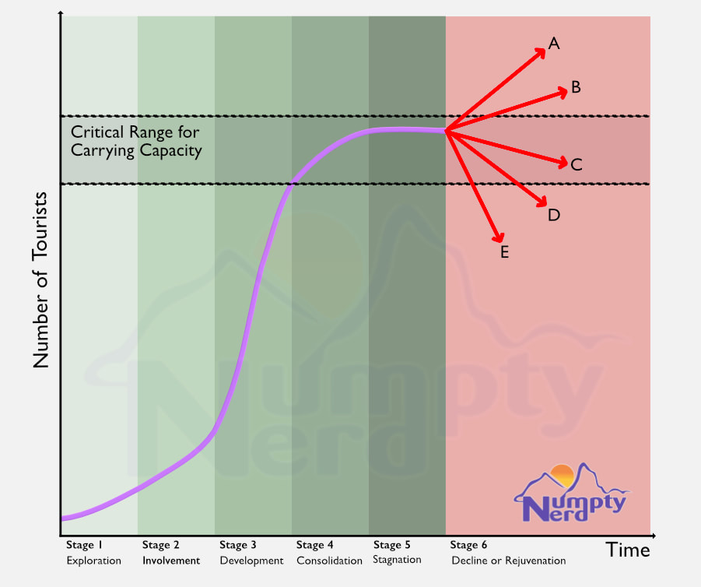
Butler's Lifecycle model is a popular tool for evaluating the efficacy of tourist destinations. Under this concept, a comprehensive examination of all phases of a location's evolution as a tourism destination is conducted and the paradigm consists of a total of six distinct phases, which are exploration, involvement, development, consolidation, stagnation, and rejuvenation, respectively. Positano's viability as a tourist destination and the city's ongoing development as a tourist destination are both amenable to analysis using the methodology outlined previously, and this analysis can be conducted effectively. (Butler, 1980)

Exploration
The Butler model begins with what is commonly referred to as the exploration phase and this is the model's initial phase and during this time, the number of tourists visiting Positano was practically nonexistent, and the town had not yet established itself as a prominent tourist destination. Positano was once a small fishing village known only to a select group of visitors who came to visit acquaintances and family. Today, however, Positano is well-known worldwide. (Kim et al., 2008)

Involvement
According to the Butler model, the second phase of a tourism destination's life cycle is the involvement phase and during this period, the tourism industry experienced a period of constant expansion, which was primarily driven by informal verbal promotion and communication. Positano rose to prominence among the affluent and eminent, who were drawn to the area by its unique appeal and picturesque terrain And also, Positano acquired notoriety. (Cole & Scott, 2016)

Development
The third phase of the Butler model emphasizes on the developmental phase of an organization and there has been a significant increase in the quantity of money invested in the infrastructure of the tourism industry due to the rise in tourism demand. The local government area witnessed the emergence of innovative lodging and dining establishments geared towards meeting the demands of the travel and tourism industry and the municipality's reputation began to grow, and as a consequence, it became a major travel destination. (Sharifzadeh & Khalifeh, 2017)

Consolidation
According to the Butler model, after the development phase has concluded, the destination will enter the consolidation phase and the destination has now reached its maximum potential in terms of tourism development, and it has firmly established itself as a major player in the global tourism industry. Positano's tourism industry has experienced tremendous growth, which has resulted in the region's transformation into a popular destination for a variety of tourists pursuing recreational activities. (Klijn & Koppenjan, 2016)

Stagnation
The fifth stage of tourist development, according to the Butler model, is characterized by stagnation, which marks the beginning of a decline in tourism activity and this phase commences when tourism activity reaches its maximum level. Positano's strategic geographical location, which is renowned for its exceptional attractiveness and regarded as a symbol of both Italy and the Mediterranean, is likely the reason why this particular phase has not yet been implemented in the town. (Want et al., 2019)

Rejuvenation
The final phase of the Butler model is the revitalization phase, which entails the implementation of strategies designed to revitalize the destination and this is the final phase of the model. Positano has demonstrated a proactive approach to maintaining the destination's appeal to visitors by implementing sustainable environmental practices, economic stimulation measures, and social sustainability initiatives and this has enabled Positano to demonstrate its dedication to preserving the destination's charm. Positano is actively working to improve its sustainability in order to restore the town to its former glory while simultaneously preserving the area's ecological integrity and fostering the development of tourism practices that are less damaging to the environment over time. (Weaver, 2017)

The application of the Butler model to Positano's sustainability indicates that the town has become a prominent and well-known tourist destination, with the tourism industry functioning as the primary economic growth driver and this was discovered after applying the model to the situation in Positano. Positano has effectively developed a sustainability strategy with the objectives of preserving the destination's appeal to tourists and minimizing any negative effects that may have resulted from previous tourism activity but also, Positano is committed to preserving both its cultural and natural heritages, and it achieves this objective in part by developing meticulously detailed plans for each of these purposes. This strategy ensures that the town will remain an inviting, aesthetically pleasing, and environmentally responsible destination. (Ozdemir & Uysal, 2019)

Doxey’s iridex model
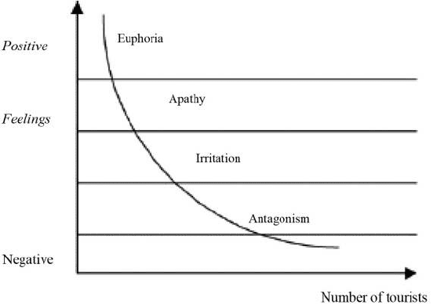

For a comprehensive theoretical account of how visitors and locals alike take in the tourism phenomena, consider the Doxey Iridex model. The concept consists of four stages: initial excitement, gradual disinterest, mild anger, and extreme animosity. (Doxey, 1976)

The Enthusiasm Stage describes a person's early period of enthusiasm and excitement towards a topic or activity and at this point, the learner is highly motivated and interested in actively engaging with the material. The excitement phase of the tourism sector is characterized by elevated levels of anticipation and expectation on the part of both locals and visitors and because of its natural beauty, attractiveness, and rich cultural heritage, Positano has seen a period of substantial expansion in recent years. It is worth noting that this phase has been significantly strengthened by the introduction of modern comforts and technical breakthroughs, leading to a rise in tourism's corresponding economic benefits. (Romao et al., 2021)

After the initial excitement wears off, locals and visitors alike may experience indifference, which can be defined as a lack of motivation in continuing to explore the destination and by launching creative initiatives that highlight the destination's continued sustainability as a key selling point, Positano has managed to avoid becoming stagnant. This method has encouraged creativity, leading to the introduction of novel, one-of-a-kind offerings. The annoyance stage occurs when travelers start questioning the destination's authenticity because of the overwhelming presence of typical tourists and Positano's luxurious reputation and stunning natural surroundings make a visit here an experience you will not forget any time soon. The only problem the location is currently facing is that it is too popular among tourists. (Buhalis & Law, 2008)

The Doxey Iridex model culminates in an aggressive condition and this issue emerges when a destination's tourism industry begins to experience unintended consequences as growth in the industry continues. Positano's administration and companies are aware of the risks that come with tourism and as a result, they have launched a number of sustainability programs aimed at balancing the region's natural resources, cultural traditions, and economic systems. (Nunkoo, Ramikssoon, 2012)

Conclusion
Positano exemplifies a location that places a premium on sustainability across various dimensions, including social, environmental, and economic aspects and the town's steadfast dedication to sustainable practices has effectively safeguarded its longevity, thereby engendering long-term economic and communal advantages for future generations.

References

- Andereck, K. L., Valentine, K. M., Knopf, R. C., & Vogt, C. A. (2015). Residents' perceptions of community tourism impacts. Annals of tourism research, 50, 105-120.
- Buhalis, D., & Law, R. (2008). Progress in information technology and tourism management: 20 years on and 10 years after the Internet-The state of eTourism research. Tourism management, 29(4), 609-623.
- Butler, R. W. (1980). The concept of a tourist area cycle of evolution: Implications for management of resources. Canadian Geographer/Le Géographe canadien, 24(1), 5-12.
- Cole, S., & Scott, D. (2016). Tourism in the city: Towards an integrative agenda on urban tourism. Tourism Geographies, 18(4), 385-404.
- Cucco, M. V. F., & Baggio, R. (2017). Does destination governance impact satisfaction and loyalty of tourists? Journal of Destination Marketing & Management, 6(2), 143-155.
- de Carlo, M., & Perano, M. (2015). Social networking and tourism destinations: TripAdvisor case study. Journal of Destination Marketing & Management, 4(3), 151-161.
- De Luca, I. B., & Zavarrone, E. (2014). Authenticity and tourism experience: An ethical inquiry. Journal of Business Ethics, 124(1), 1-14.
- Doxey, G. (1976). Perception of tourism as a positive and negative impact. In Travel, Tourism, and Hospitality Research: A Handbook for Managers and Researchers (pp. 43-67). John Wiley & Sons.
- Gheorghiloaia, D., & Storbacka, K. (2018). The role of brand in the tourism experience economy. Journal of Service Management, 29(5), 827-839.
- Gössling, S., Scott, D., & Hall, C. M. (2020). Tourism and water: Interactions, impacts, and challenges. Channel View Publications.
- Graci, S., & Dodds, R. (2015). Exploring the impact of social media practices on tourist experience. Journal of Hospitality and Tourism Technology, 6(2), 119-136.
- Kim, H., Lee, T. J., & Law, R. (2008). An empirical examination of the acceptance behavior of hotel front office systems: An extended technology acceptance model. Tourism management, 29(3), 500-513.
- Klijn, E. H., & Koppenjan, J. F. (2016). Governance network theory: Past, present and future. Policy and Politics, 44(2), 247-265.
- Nunkoo, R., & Ramkissoon, H. (2012). Power, trust, social exchange and community support. Annals of tourism research, 39(2), 997-1023.
- Özdemir, A. I., & Uysal, M. (2019). Tourism as a tool for peacekeeping: Exploring the concept and prospects. Journal of Travel Research, 0047287518823458.
- Pimentel, R., & De Abreu, K. N. d. C. (2020). The role of stakeholder collaboration in sustainable tourism development in Brazil. International Journal of Tourism Cities, 6(1), 1-18.
- Roberts, L. (2020). Ethical considerations in wildlife tourism. In Animal Tourism (pp. 191-212). Channel View Publications.
- Romão, J., da Costa Mendes, J., & Machado, J. A. T. (2021). Integrating Destination Management and Marketing toward Sustainable Tourism Development: The Case Study of Azores as a Nature-Based Tourism Destination. In Sustainable Tourism (pp. 167-190). Apple Academic Press.
- Seguí-Amortegui, F. J., García-Sastre, M. A., & Fernández-Morales, A. (2018). Tourist destinations 3.0: An analysis of leading research directions. Journal of Destination Marketing & Management, 9, 36-46.
- Sharifzadeh, A., & Khalifeh, M. S. (2017). Heritage tourism and stakeholders’ involvement: A case of Isfahan, Iran. Journal of heritage tourism, 12(5), 420-432.
- Tosun, C. (2018). An overview and analysis of research on sustainable tourism and sustainable tourism development. Journal of Sustainable Tourism, 26(1), 1-27.
- Wang, D., Li, X. R., Huang, S., & Xiang, Z. (2019). Tourism and mobile technology. Journal of Travel Research, 0047287519828164.
- Weaver, D. B. (2017). Sustainable tourism and the environment: Roles and constraints. Routledge.
- Weaver, D. B., & Lawton, L. J. (2014). Twenty years on: The state of contemporary ecotourism research. Tourism Management, 45, 116-127.

