Critically discuss the Enquiry Based Learning (EBL) approach that can be used as part of a range of teaching and learning approaches in the primary school. In your discussion, refer to examples of EBL strategies and techniques that you would use to develop learners’ knowledge, understanding and skills in aspects of the humanities and science in the primary school.
Roberts (2003, p.50) informs that there are ‘four essential characteristics’ of Enquiry Based Learning (EBL), which include the following: driven by questioning, study of data and sources of information, deriving meaning for study, and reflecting on learning. Pike (2016, p.1) states that EBL is a process of the learner ‘thinking about their learning, asking questions’, and using a collection of research to conclude the enquiry. Furthermore, Dahlgreen and Dahlgreen (2002, quoted in Palmer, 2002, p.82) describes how the aim of EBL is for the learner to ‘take charge of their own learning’ through the teacher providing them with the ‘freedom’ to research topics in which they are highly interested in. Roberts (2003), Pike (2016), and Dahlgreen and Dahlgreen (2002, quoted in Palmer, 2002) highlight that, although definitions may vary, EBL encourages learners to ask questions about topics they are personally interest in and lead their own learning through researching, collecting data, and reflecting upon their learning.

Pike (2016) informs that there are many ways to implement EBL in the Humanities, to which the following models may be used: the ‘S’ model, the ‘Enquiry and Questioning’ model, the 4 stage model ‘The Investigative Cycle’, the 5 stages of enquiry model, Michael Storm 5 Questions Model and, the 6 Stage Enquiry Framework. Grigg and Hughes (2013, p.115) inform that the ‘S’ model is a ‘simplified planning tool for local enquiries’, which includes the following steps: select, search, sift and synthesise, and share. Pickford, Garner, and Jackson (2013) inform that the ‘Enquiry and Questioning’ model includes the teacher presenting an overarching question and the learners asking subsidiary questions in order to come to a conclusion. The 4 Stage Model ‘The Investigative Cycle’ includes the following stages: Generate, do, analyse, and reflect (Samuel, 2009). The Office for Standards in Education, Children’s Services and Skills (Ofsted) (2010) suggest the use of the 5 stages of enquiry model within religious education, which includes learners creating questions, planning, conducting research, presenting findings, and reflecting upon the enquiry. Storm (1989, p.4) states that, within the Michael Storm 5 Question Model, a number of questions are asked to learners about specific environments, such as ‘How is this place changing?’. Finally, Scoffham (2010) suggests the use of the 6 Stage Enquiry Framework in geography which includes six structured stages of enquiry. Harlen (2009) describes how enquiry skills are used within science to gather evidence, though conducting experiments, to explain and support things that happen in the world. Furthermore, Turner et al. (2011, p.123) supports EBL within science as a structure to develop subject specific skills, develop questioning, and providing ‘rich assessment evidence’ of learners’ knowledge, understanding and skills. Zion and Mendelovici (2012, p.384) state that EBL can be used to conduct science enquiries via ‘structured’, ‘guided’ and, ‘open’ enquiries. These EBL models, as explained by Banchi and Bell (2008), differentiate in the information given to the learners and the guidance given by the teacher, in an aim to allow learners to independently lead their own learning in open enquiries. The Department for Children, Education, Lifelong Learning skills (DCELLS) (2008a, p.13) describe how the cycle, plan, develop, reflect, can be used to structure scientific enquiries to ensure key skills, such as activating prior knowledge, logical thinking, and ‘forming opinions and making decisions’, are developed. These sources show that EBL is present within scientific enquiries and allow the development of a number of key skills and subject specific skills.

Donaldson (2015, p.29) describes how learning should be underpinned by four purposes, to which one purpose states that learners should be ‘ambitious, capable learners’ who challenge their learning and are ‘questioning and enjoy solving problems’. This exemplifies that conducting EBL supports the suggestions for Wales’ new curriculum. Within the Science and Technology Area of Learning and Experience, Donaldson (2015) suggests that learners should be given opportunities to investigate, gather evidence, communicate, and form an understanding and provide explanations of findings. Within the Humanities Area of Learning and Experience, Donaldson (2015) suggests that learners should be given opportunities to conduct discussions, engage with the community around them, and gain an understanding of themselves and others through conducting research. These statements about the Science and Technology and Humanities Areas of Learning and Experience highlights the opportunities within Wales’ new curriculum to engage with EBL and shows that the statements made in the Areas of Learning and Experience are closely related to the characteristics of EBL.
The characteristics of EBL are supported by constructivism and the work of John Dewey, as he theorised that learners must have an ‘absorbed interest’ in the topics they are learning in order to enhance their engagement and learning, and reduce adverse behaviour (Bates, 2016, p.42). Additionally, Robinson (2015, p.88) describes how learners should be given opportunities to ‘pursue their individual interests’ in order to gain greater personalised learning. Both Bates (2016) and Robinson (2015) suggests that conducting EBL can enhance learners’ engagement and develop their learning, as one characteristic of EBL is that learners have control over their learning and the ability to research topics in which they are interested in (Dahlgreen and Dahlgreen, 2002, quoted in Palmer, 2002). Conversely, Tolman (1961) theorised that learning should always be goal orientated to ensure that learners are applying their knowledge and developing skills in specific contexts planned by the teacher. Furthermore, Rodriguez (2018) states that when learners are playing an active role in their learning, they may become distracted by topics which are not relevant to the main task, resulting in a negative impact on their learning. Tolman (1961) and Rodriguez (2018) contrast the theories of Bates (2016) and Robinson (2015) and suggest that allowing learners to focus and lead their learning on personal interests may result in distraction as they are not working towards specific goals set by the teacher. Ültanır (2012) also supports the characteristics of EBL and describes how encouraging learners to create their own understanding of information, for example interacting with an array of stimuli in order to form their own understanding, is an effective teaching and learning strategy. Ültanır (2012, p.195) continues to state that teachers must be a ‘guide, facilitator, and co-explorer’ to encourage learning, and use effective questioning strategies to challenge learners and provide them with opportunities to share their own ideas. The excellent practice shared by Ültanır (2012) reflects the characteristic of EBL that teachers must facilitate the pupils’ learning in order for the pupil to derive meaning from their research and drive the learning through asking and answering questions (Roberts, 2003). Additionally, Donaldson (2015, p.20) describes how one purpose of Wales’ new curriculum is to provide learners with the skills to work ‘as independently as they can’. Ültanır (2012) and Donaldson (2015) highlight that EBL develops independence within learners through the facilitation of the teacher. However, Dewey (1963, p.25) stated that not all learning experiences created by teachers are ‘genuinely or equally educational’, which implies the skills and knowledge of the teacher are vital when creating effective learning environments that develop learners’ independence and skills, such as EBL. Similarly, Zion and Mendelovici (2012) highlight the importance of the teacher’s ability to facilitate the pupil’s learning by having effective questioning strategies, and implies that if teachers are not knowledgeable of ways to implement and support EBL then it may have a negative impact on the pupils’ learning. Therefore, Dewey (1963) and Zion and Mendelovici (2012) show that teachers’ knowledge of EBL and effective strategies to facilitate pupils’ learning is essential to enhance their learning. Black and Wiliam (1998) also support the characteristics of EBL as they theorise that teachers should provide learners with opportunities to reflect on their learning and understanding, through meaningful teacher-pupil dialogue, in order to furthermore develop learners’ skills. Additionally, Donaldson (2015, p.42) suggests that learners’ ‘personal effectiveness’ must be developed within education through reflecting on their own work and the work of others, to which DCELLS (2008b) suggests can be achieved through self-assessment. Black and Wiliam (1998) and Donaldson (2015) support that learners should reflect on their learning, a characteristic of EBL stated by Roberts (2003).

An advantage of EBL is that it encourages pupils to work with a group of learners, to which Vygotsky (1987, cited in Kozulin, 2003, p.40) theorised that ‘collaboration with more capable peers’, which can be obtained through group work, can result in learners benefiting from the interaction and gaining a greater knowledge and understanding of the topic of work, compare to working independently. Additionally, DCELLS (2008a) highlight that the use of group work can develop thinking, communication and oracy skills. Both Vygotsky (1987, cited in Kozulin, 2003) and DCELLS (2008a) show that encouraging learners to conduct group work within EBL can increase their knowledge and understanding of the topic as well as essential transferable skills. Roberts (2003) states that a main challenge of EBL is that learners require an understanding of the structure of an EBL model in order to understand how to conduct the enquiry. Additionally, Dumont, Istance, and Benavides (2010, p.212) state that learners may have difficulty ‘generating meaningful questions or evaluating their questions’ due to their lack of knowledge and experiences of EBL. Roberts (2003) and Dumont, Istance, and Benavides (2010) show that pupil understanding of the structure of an EBL model is imperative to the successfulness of the enquiry. However, Banchi and Bell (2008) inform that when an EBL model is first introduced to the learner, the amount of information and the level of facilitation provided to the learner by the teacher may be increased to allow the learner to gain an understanding of the structure of the model. This shows that the teacher may introduce an EBL model through a gradual release of information and facilitation. Another advantage of conducting EBL is, as previously discussed, learners develop their independence as they are given the opportunity to lead their own learning and investigate topics in which they are personally interested (Ültanır, 2012, and Donaldson, 2015). However, allowing learners to lead their own learning can result in difficulty in time managing as Abrams, Southerland, and Silva (2008) states that it is difficult for teachers to predict the time needed to conduct and complete an enquiry. Furthermore, Jones (2005, p.7) highlights that time must be allocated to ‘specific learning goals’ within sessions to ensure that learners do not waste time without anything ‘specific being achieved’. Both sources of information show that time management of EBL is a challenge for the teacher to ensure that appropriate time is given to learners to conduct an effective enquiry.

The question ‘How can citizens of Wales stop climate change?’ will drive the enquiry and will develop the skills of learners in year 5 who have previously experienced and conducted EBL. DCELLS (2008d, p.12) states that learners should be given opportunities to investigate ‘topical events and issues in the local area and the wider world’, to which appendixes 1 and 2 exemplify that climate change is extremely relevant in the news, and discover how people have affected the environment and the ways in which we can protect it. Furthermore, Donaldson (2015, p.30) states that a purpose of the new curriculum is for learners to develop as ‘ethical, informed citizens’ who ‘show their commitment to the sustainability of the planet’. These statements by DCELLS (2008d) and Donaldson (2015) highlight the importance of developing learners’ knowledge and understanding of climate change within education in Wales. The enquiry will require learners to define climate change, identify the impacts climate change has in Wales, investigate the solutions to climate change, and conclude a strategy they believe is the most effective to stop climate change. The EBL models that will be utilised to develop learners’ enquiry skills with the assignment will be the 4 stage ‘Investigation cycle’ and the ‘Enquiry and Questioning’ model (Samuel, 2009, and Pickford, Garner, and Jackson, 2013). The ‘Investigation cycle’ EBL model is suggested by Samuel (2009) to be used to develop geographical skills however, the model will be used to develop a range of skills through a cross-curricular manner. The ‘Enquiry and Questioning’ model will be used within the ‘Investigation cycle’ to furthermore promote question driven learning (Pickford, Garner, and Jackson, 2013).

Generate
A video and news article, shown in appendixes 1 and 2 respectively, will be used as a stimulus to engage the learners, as Yates and Eames (2018, p.47) state that ‘Newspaper articles and children’s news programmes stimulate debate’. Furthermore, Estyn (2018) informs that engaging learners through the use of stimuli is a quality of excellent practice. After observing the stimulus, learners will be asked to suggest the theme of the enquiry, demonstrating their understanding of the stimulus, and evidencing their prior knowledge of climate change. Schmidt et al. (1989, p.617) conclude from their research that activating prior knowledge during problem-based activities, such as determining the theme of EBL, can be successful in ‘bridging the gap’ between information that is already known and information that can be learned. This implies that using the stimulus can prepare and encourage learners to develop their knowledge and understanding of climate change. However, Mayer (2014, p.243) states that the ‘Split-Attention effect’ occurs when, in order to ‘derive meaning’, information must be process ‘simultaneously’, resulting in a negative impact on understanding. This suggests that learners may not gain an understanding of the information from the stimulus due to learners processing information and using prior knowledge to determine the theme of the enquiry.

Within the ‘Enquiry and Questioning’ model, Pickford, Garner, and Jackson (2013) suggest the use of an overarching question for an enquiry, to which learners must ask subsidiary questions to conclude the overarching question. Additionally, allowing learners to formulate subsidiary questions reinforces child-lead learning, a characteristic of EBL (Dahlgreen and Dahlgreen, 2002, quoted in Palmer, 2002). Therefore, following learners determining the theme of the enquiry, the teacher will introduce the following overarching question: How can citizens of Wales stop climate change? DCELLS (2008d, p.13) state that learners should ask questions about geographical issues, such as ‘how have people affected this place\environment?’, therefore learners will be encouraged to discuss, with their partner, the subsidiary questions they have about the overarching question. Vygotsky (1987, cited in Kozulin, 2003) highlighted the importance of learner interaction as it develops both learner’s understanding and knowledge of the topic. Additionally, Long and Porter (1985, p.208) state that group work can improve the ‘quality of student talk’ and encourages learners to establish roles within discussion. Vygotsky (1987, cited in Kozulin, 2003) and Long and Porter (1985) imply that learners engaging in discussion can result in the creation of a higher quality of subsidiary questions. Conversely, Long and Porter (1985) inform that learners’ attention may deter during discussion. Therefore, the role of the teacher will be to observe learners’ discussions and question learners to further develop their answers. This strategy is closely related to Socrates theory that the role of the teacher is to question and guide the learner to ‘discovery’ (Bates, 2016, p,8). After discussing, learners will feedback their subsidiary questions to the teacher who will create a graphic organiser, an example is shown in appendix 3. The Institute for the Advancement of Research in Education (2003) inform that graphic organisers, due to their structure, have a large impact on learners’ development of higher order thinking skills. However, Hall and Strangman (2008) describe how, without instruction from the teacher, graphic organisers may not be effective as learners lack experience using them to support their learning. Therefore, when the teacher is creating the graphic organiser, they will model the main aspects of creating an effective graphic organiser which can be used as a tool to develop higher order thinking skills. Eggen and Kauchak (2001) describe modelling as an instructional strategy that entails learners observing the teacher conducing a specific skill to which they can conduct and apply within their learning.

Learners will record their prior knowledge of climate change and subsidiary questions using a Know-Want-Learn (KWL) grid. By conducting this activity, it will ensure that all learners access and record their prior knowledge. Mihardi, Harahap, and Sani (2013) describes the KWL grid is a framework that connects a learners’ prior knowledge to their active learning. Furthermore, DCELLS (2008c) state that, in order for memorable learning to occur, the brain must make connections between the different cells. Therefore, Mihardi, Harahap, and Sani (2013) and DCELLS (2008c) show that, through the use of KWL grids, learners make connections between prior knowledge and current learning, resulting in more memorable learning. Previously, the teacher modelled the creation of an effective graphic organiser, according to the recommendations of Hall and Strangman (2008). Learners will be divided into four groups and provided with the following questions: Where can we get information from? Who can we interview and where can we visit to receive information? What websites can we get reliable information from? How can we share our findings? Using these questions, the groups will create a graphic organiser suggesting ways in which they could conduct the enquiry. Conducting this activity will develop thinking, communication, collaboration, and planning skills, to which DCELLS (2008a, p.8) state are ‘crucial’ for learners to ‘refine their ideas’ and to ‘deepen their understanding’. Additionally, it ensures that learners lead an enquiry they are interested in, which are characteristics of EBL stated by Roberts (2003) and Dahlgreen and Dahlgreen (2002, quoted in Palmer, 2002). An example of a graphic organiser is shown in appendix 4.

Do
Donaldson (2015, p.66) states that ‘rich, stimulating environments’ allow learners to fully engage with learning and promotes exploration and experimentation. Additionally, Neil Fleming promoted four styles of learning: ‘Visual, Auditory, Reading, and Kinaesthetic’ (Bates, 2016, p.120). Fleming suggested a number of styles should be used to ensure effective teaching (Bates, 2016). Donaldson (2015) and Bates (2016) exemplify that environments have an impact on pupils’ learning. Thus, an educational visit will be conducted to create an environment that promotes exploration and experimentation and includes aspects of the four learning styles. The educational visit will take place at the materials recycling facility in Carmarthen, where learners will conduct two activities. The first activity will include learners exploring the facility, with the guidance of a member of the facility, to visualise, observe and ask questions about the recycling process, as DCELLS (2008d, p.13) state that learners should ‘observe and ask questions’ about geographical issues. Learners will experience sorting materials and gain an understanding of what materials can be recycled and why, creating a kinaesthetic learning experience. Mayer (2004, p.14) describes that, for optimum learning to occur, learning should be an ‘active process’ whereby learners conduct ‘hands-on’ activities. Providing learners with these experiences ensure effective and memorable learning (Bates, 2016). However, Broadbent (1987) theorised that the brain cannon effectively process information when it encounters a number of stimuli simultaneously, resulting in aspects of the stimuli not be processed. Broadbent (1987) contrasts the statements by Donaldson (2015) and Bates (2016) and implies the educational visit may overwhelm the learners, resulting in a lack of understanding of the information being received. Therefore, learners will be encouraged to take photographs, video, and make notes of key information of the facility to support the discovery of their subsidiary question.

The second activity will entail learners conducting an interview with the manager of the recycling facility, as DCELLS (2008d, p.13) states that learners should ‘collect and record data’ via secondary sources. The learners will use their subsidiary questions to interview the manager and record the findings by noting key information. The following topics may be discussed: climate change, recycling, renewable energy, and fossil fuels. This activity will develop the following skills: speaking skills, as they will be speaking clearly and using formal language, and listening skills, as learners must listen intently and use ‘techniques to remember the main points’ (DCELLS, 2016, p.4). Donaldson (2015) highlights the importance of literacy skills and states that it is a cross-curricular responsibility that should be developed throughout the curriculum. Additionally, Laever (2005, p.9) states that an aim of education is for learners to become ‘adults who are self-confident’ which can be obtained through developing literacy skills. Both Donaldson (2015) and Laever (2005) identify the importance of literacy within the curriculum and show the use of literacy within this activity benefits the learners.

When conducting an investigation, DCELLS (2008d, p.13) state that learners should analyse evidence and sources of information allow learners to ‘develop ideas and find answers’. Therefore, learners will use their previously created graphic organised, depicting suggestions of reliable website, to research information and strategies to stop climate change. Donaldson (2015) states that digital competence is a cross-curricular skills and should be developed throughout the curriculum. However, Estyn (2018) highlight that learners are not given enough opportunities to apply their ICT skills through a cross-curricular approach. Therefore, learners will use ICT to research the previously mentioned information, and will be asked to ‘consider’ if the websites used are ‘reliable’ by using their prior knowledge and information gained from the educational visit, as suggested within the digital competence framework (Learning Wales, 2016). Learners may use website such as WWF (2019) and Greenpeace (2019) to identify the effects of climate change and strategies to stop climate change. Learners will work in small groups and individually research a strategy to stop climate change. For example, a learner could research the impact electric cars have on climate change. Learners will use software, such as Microsoft Word, to record their findings. Donaldson (2015, p.29) would agree with this activity as he describes that learners should be ‘ambitious, capable learners’ who are able to ‘use digital technologies’ to ‘communicate, find and analyse information’. Learners will be asked to include positive and negative aspects of the strategy to ensure that the learners critically analyse and evaluate their findings, to which Donaldson (2015) states in an essential aspect of conducting research. Additionally, Halpern (2002) describes how encouraging learning to use critical thinking develops their thinking skills as learners are considering different viewpoints and evaluating the information. As previously stated, Zion and Mendelovici (2012) highlight the importance of the use of questioning strategies to facilitate the pupils’ learning. Therefore, the teacher will monitor the learners during the task and facilitate and extend their learning by asking the following questions: ‘Why do you think this website is reliable?’, ‘How do you know this website is reliable?’, and ‘What information do you need to research next and why?’.

Analyse
DCELLS (2008d, p.13) describes how learners should be given opportunities to ‘analyse evidence, develop ideas’ and form conclusions. Therefore, after conducting individual research, learners will return to their groups to share their findings of strategies to stop climate change. In order to develop learners’ ‘critical, analytical thinking’, ‘team productivity’ and to form a focused discussion, the teacher will facilitate and scaffold the learning through the use of de Bono’s ‘Six Thinking Hats’ (The de Bono Group, 2019). De Bono (2009, p.3) describes how confusion can occur when thinking due to overwhelming thoughts of ‘emotions, information, logic, hope and creativity’. Similarly, Broadbent (1987) stated that the brain cannot effectively process information when encountered with a number of stimuli simultaneously. De Bono (2009) and Broadbent (1987) show that thinking, without the use of scaffolding, can be ineffective, suggesting that the use of de Bono’s thinking hats will develop focused thinking and discussion. Furthermore, Bates (2016, p.46) describes scaffolding as a way to break a large ‘task into smaller sub-tasks’, which is evident with de Bono’s thinking hats. In turn learners will introduce their findings using the white hat, sharing the factual information they have researched. The learners will then use the yellow and black hats to share the positives and negative of their researched strategies. Learners will share their personal ideas of how to implement their researched strategy in Wales through the use of the green hat. Finally, the red hat will be utilised for all learners to share their feelings of the strategies discussed, and conclude, as a group, the strategy they feel will be the most effective to stop climate change. This activity allows learners to ‘express their own opinions’ and acknowledge different viewpoints (DCELLS, 2008d, p.13). Additionally, it develops learners’ oracy skills as they are building upon and developing the ‘ideas of others in group discussions’ (DCELLS, 2016, p.4).

The teacher will show learners the stimuli that introduced the enquiry again, shown in appendixes 1 and 2 respectively. This will remind learners of the purpose of the enquiry and allow learners to reflect on the information they have discovered, to which Ebbinghaus (1885) states that recalling and repeating information in different contexts results in an effective, memorable learning experience. Based on the learners’ suggestions of ways to present their findings, recorded via graphic organiser, the teacher will state that learners must present their strategy to stop climate change to their local Member of Parliament (MP). The teacher will explain that the MP wishes to hear from the learners how Welsh citizens can contribute to stopping climate change. Learners will be given five learning targets that must be included and developed within their presentation, as Black and Wiliam (1998) state that learners must understand the purpose of their learning and how to achieve it. Furthermore, Jones (2005) describes that sharing aims and criteria of learning is a form of effective teaching and assessment for learning. The learning targets will include the following: explanation of strategy, positives and negative aspects of the strategy, suggestions of how to implement the strategy in Wales, clearly spoken, and use of appropriate, formal language. These targets will also ensure the development of learners’ ability to ‘explain information and ideas’ and project their voice to large audiences through a ‘presentation to visitors’ (DCELLS, 2016, p.3). The groups will decide how they wish to present their strategy, which may include a physical model, a PowerPoint presentation, or a drawing. Appendix 5 shows a way in which a strategy could be presented. Donaldson (2015, p.29) highlights that levels of creativity must be increased within learners in Wales and proposes that learning should be based upon learners developing as ‘creative contributors’ who use creative thinking to solve problems. Furthermore, Smith (2013, p.6) describes how creativity will ‘shape our world like no other force imaginable’, implying that creativity is an essential skill that will drive learners’ future. Donaldson (2015) and Smith (2013) show that importance and value of developing creativity within learners in Wales through thinking creatively along with problem solving, to which this activity includes the development of. Furthermore, allowing the learners to decide how to present their strategy will also encourage creativity and allow the learners to lead their own learning, a characteristic of EBL. A challenge, highlighted by Abrams, Southerland, and Silva (2008), of providing learners with time to create a presentation is the difficulty of allotting an amount of time that ensures learners have sufficient time to complete the task. Therefore, the role of the teacher will be to support the learners and question the learners to further develop their ideas, to which Zion and Mendelovici (2012) state are elements of effective facilitation, and encourage and observe the progress the learners make within a lesson to ensure they complete their presentations within a reasonable amount of time.

Learners will then be given the opportunity to present their strategy to stop climate change in Wales to their local MP. Wyse and Dowson (2009, p.39) stated that ‘greater satisfaction and further motivation are gained when the resulting work can be shared with others’, which implies that learners will have greater motivation and satisfaction when creating their presentations due to their work being shared with the MP. Conversely, Abraham Maslow theorised that, in order for learners to develop higher-order needs such as self-confidence, learners must have their lower-order needs met such as comfort (Bates, 2016). This implies that learners must be in a comfortable learning environment in order to learn, and if not achieved it may deprive the development of other important skills.

Reflect
Black and Wiliam (1998, p.10) highlight the importance of peer- and self-reflection and inform that learners must be ‘trained in self-assessment’ in order to understand the purpose of their learning. DCELLS (2008b, p.11) describes how self-assessment ‘fosters reflective learning’, which is supported by Donaldson (2015, p.42) as he states that ‘personal effectiveness’ should be developed within learners via reflecting on their own work and the work of other. These sources highlight the importance of the learners reflecting on the presentations they conducted. However, Black and Wiliam (1998) emphasis that learners can only effectively conduct peer- and self-assessment when they have a clear understanding of the learning targets. Therefore, the learners will reflect on their presentations using the previously explained learning targets. This will allow the learners to conduct effective self-assessment, as stated by Black and Wiliam (1998). Learners will note the aspects of the presentations they feel were good, and the aspects they feel they could have improved. Additionally, learners will set themselves a target for the next time they conduct a presentation to ensure they lead their future learning. At the start of the enquire, learners used a KWL grid to record their prior knowledge of climate change and subsidiary questions. Therefore, learners will now complete the KWL grid, including the knowledge they have gained from the enquiry. This will allow the teacher to understand what each pupil has learned as Mihardi, Harahap, and Sani (2013) describe how KWL grids exemplify and prove the knowledge and skills learners have developed. This will also provide learners to reflect on the overarching question of the enquiry using the information they have gained. Samuel (2009) describes within the ‘Investigation cycle’ it is essential to conclude the enquiry by learners reflecting on the enquiry as a whole. Therefore, the teacher will lead a class discussion asking learners to identify aspects of the enquiry that were good, and aspects that could be improved. The teacher will scaffold the discussion through the use of de Bono’s ‘Six Thinking Hats’ (The de Bono Group, 2019). The teacher will ask learners to use the yellow and black hats to discuss the positive and negative aspects of the enquiry. Furthermore, the red hat will be used for learners to share their final feelings of the enquiry and suggest ways in which they would improve the enquiry if they were to conduct it again.

Conclusion
The ‘Investigation cycle’ and ‘Enquiry and Questioning’ EBL models were used within this assignment to create immersive learning environments, include a range of teaching methods, and to support effective teaching and learning (Samuel, 2009, and Pickford, Garner, and Jackson, 2013). The ‘Generate’ stage promoted a learner-lead enquiry by pupils asking question about climate change and suggesting ways, via group discussion, to conduct and present their findings. This related to the characteristic of EBL that learners should ‘take charge of their own learning’ (Dahlgreen and Dahlgreen, 2002, quoted in Palmer, 2002, p.82). The ‘Do’ stage developed learners’ knowledge of climate change through collecting and recording data on an educational visit (DCELLS, 2008d). The materials recycling facility fostered questioning and enquiry skills within learners as it provided them with the opportunity to experience the recycling process and interview a manager of the facility. Also, in this stage, learners conducted their own research of strategies to stop climate change and developed their geographical and ICT skills through a cross-curricular manner, to which Barnes (2015) states that hierarchical cross-curricular learning uses a subject to enhance the learning of another subject. The ‘Analyse’ stage utilised de Bono’s ‘Six Thinking Hats’ to scaffold learners’ thinking to create more focused and effective discussions, allowing learners to critically analyse their research, and come to a unanimous conclusion (De Bono, 2009). Additionally, creativity was promoted through learners creating a presentation and presenting a strategy to stop climate change to their local MP, developing essential skills, such as oracy and team work. The ‘Reflect’ stage encouraged learners to reflect on their learning throughout the enquiry, highlighting positive elements and suggest ways to improve the enquiry, to which Black and Wiliam (1998) and Donaldson (2015) highlight the importance of learners conducting self-assessment. However, the assignment also highlighted the challenges of conducting EBL, such as difficulty in allotting sufficient time to conduct aspects of the enquiry and ensuring that learners were actively progressing during the enquiry and not becoming distracted when researching personal interests.

Reference list
Abrams, E. Southerland, S. and Silva, P. (2008) Inquiry in the Classroom: Realities and Opportunities. Charlotte: Information Age Publishing. Available at: https://books.google.co.uk/books?id=VvknDwAAQBAJ&printsec=frontcover&dq=disadvantages+of+inquiry+based+learning&hl=en&sa=X&ved=0ahUKEwjhj-H4h-7hAhWBVBUIHVQ7BC4Q6AEIKjAA#v=onepage&q&f=true (Accessed: 26th April 2019).
Banchi, B. and Bell, R. (2008) ‘The Many Levels of Inquiry’, Science and Children, 46(2), pp. 26-29.
Barnes, J. (2015) ‘The Creative Primary Curriculum’, Edition: Second, Chapter: Thirteen, Publisher Sage, Editors: Driscoll, P, Lambirth, A and Roden, J.
Bates, B. (2016) Learning theories simplified. London: SAGE Publications Ltd.
Black, P. and William, D. (1998) Inside the black box: Raising standards through classroom assessment. London: GL Assessment.
De Bono, E. (2009) Six Thinking Hats. London: Penguin. Available at: https://books.google.co.uk/books?hl=en&lr=&id=Q1grDwAAQBAJ&oi=fnd&pg=PT6&dq=de+Bono+thinking+hats&ots=Wh6KjFMxcH&sig=sfV2QlageC5b7vs0exVdT6C0d60#v=onepage&q=de%20Bono%20thinking%20hats&f=false (Accessed: 3rd May 2019).
Department for Children, Education, Lifelong Learning Skills. (2008a) Skills framework for 3 to 19-year-olds in Wales. Cardiff: Welsh Assembly Government.
Department for Children, Education, Lifelong Learning Skills. (2008b) Why develop thinking and assessment for learning in the classroom? Cardiff: Welsh Assembly Government.
Department for Children, Education, Lifelong Learning Skills. (2008c) Learning and Teaching Pedagogy. Cardiff: Welsh Assembly Government.
Department for Children, Education, Lifelong Learning Skills. (2008d) Geography in the National Curriculum for Wales. Cardiff: Welsh Assembly Government.
Department for Children, Education, Lifelong Learning Skills. (2016) Curriculum for Wales: Program of Study for English, Key Stages 2-4. Cardiff: Welsh Government.
Dewey, J. (1963) Experience and Education. New York: Collier Books. Available at: https://books.google.co.uk/books?hl=en&lr=&id=JhjPK4FKpCcC&oi=fnd&pg=PA17&dq=Dewey,+J.&ots=DavJ2qFAEa&sig=LCUcncsp6Fcac31XlJ2-fn3Thsg#v=onepage&q=Dewey%2C%20J.&f=false (Accessed: 25th April 2019).
Donaldson, G. (2015) Successful Futures. Crown copyright. Available at: http://gov.wales/docs/dcells/publications/150317-successful-futures-en.pdf (Accessed: 26th April 2019).
Dumont, H. Istance, D. and Benavides, F. (2010) The Nature of Learning: Using Research to Inspire Practice. Unknown: OECD. Available at: https://books.google.co.uk/books?hl=en&lr=&id=306PApBeLTwC&oi=fnd&pg=PA199&dq=challenges+of+inquiry+based+learning&ots=-JChBJPIpS&sig=yArRByTtoZO-lFk3121mnK3sYH8#v=onepage&q=challenges%20of%20inquiry%20based%20learning&f=false (Accessed: 26th April 2019).
Ebbinghaus, H. (1885) Memory: A Contribution to Experimental Psychology. New York: Teachers College, Columbia University. Available at: https://pdfs.semanticscholar.org/8501/b17d47d1b365fc75c0acb949a04e2d1aae88.pdf (Accessed: 3rd May 2019).
Eggen, P. and Kauchak, D. (2001) Educational Psychology: Classroom Connections. 5th ed. New York: Macmillan.
Estyn (2018) The Annual Report of Her Majesty’s Chief Inspector of Education and Training in Wales 2016-2017. Cardiff: Crown.
Greenpeace. (2019) ‘Stop climate change’. Available at: https://www.greenpeace.org.uk/what-we-do/climate/ (Accessed: 2nd May 2019).
Grigg, R. and Hughes, S. (2013) Teaching Primary Humanities. Harlow: Pearson.
Hall, T. and Strangman, N. (2008) Graphic Organizers. Wakefield: CAST. Available at: https://www.northernhighlands.org/cms/lib5/nj01000179/centricity/domain/18/graphic_organizers_2008.pdf (Accessed: 30th April 2019).
Halpern, D. (2002) ‘Teaching for Critical Thinking: Helping College Students Develop the Skills and Dispositions of a Critical Thinker’, New Directions for Teaching & Learning, 80(1), pp. 69-74. Available at: http://pages.wustl.edu/files/pages/imce/writing1/teaching_for_critical_thinking_halpern_wood_pairing.pdf (Accessed: 2nd May 2019).
Harlen, W. (2009) ‘Enquiry and good science teaching’, Primary Science, 106, p. 5-8.
Institute for the Advancement of Research in Education (2003) Graphic Organizers: A Review of Scientifically Based Research. Portland: Inspiration Software. Available at: http://www.inspiration.com/sites/default/files/documents/Detailed-Summary.pdf (Accessed: 30th April 2019).
Jones, C. (2005) Assessment for learning. London: Learning and Skills Development Agency.
Kozulin, A. et al. (2003) Vygotsky’s Educational Theory in Cultural Context. New York: Cambridge University Press.
Laever, F. (2005) ‘Deep-level-learning and the Experiential Approach in Early Childhood and Primary Education’. Leuven: Leuven University Press. Available at: http://www.speelsleren.nl/wp-content/uploads/2015/05/Deep-level-learning-Ferre-Laevers.pdf (Accessed on 1st May 2019).
Learning Wales. (2016) ‘Digital Competence Framework’. Available at: https://learning.gov.wales/resources/browse-all/digital-competence-framework/framework?lang=en&year=year_5&selectedYear=col_11&lang=en (Accessed: 2nd May 2019).
Long, M. and Porter, P. (1985) ‘Group Work, Interlanguage Talk, and Second Language Acquisition’, TESOL Quarterly, 19(2), pp. 207-228.
Mayer, R. (2014) The Cambridge Handbook of Multimedia Learning. 2nd Ed. New York: Cambridge University Press. Available at: https://books.google.co.uk/books?hl=en&lr=&id=Cvw6BAAAQBAJ&oi=fnd&pg=PA227&dq=the+modality+principle&ots=HvV7SfxY0U&sig=gDqhHm58M3o1d63tfGA2gscl06Q#v=onepage&q=the%20modality%20principle&f=false (Accessed: 30th April 2019).
Mayer, R. E. (2004). ‘Should There Be a Three-Strikes Rule Against Pure Discovery Learning?’, American Psychologist, 59(1), pp.14-19.
Mihardi, S. Harahap, M. and Sani, R. (2013) ‘The Effect of Project Based Learning Model with KWL Worksheet on Student Creative Thinking Process in Physics Problems’, Journal of Economics and Sustainable Development, 4(18), pp.93-107.
Office for Standards in Education, Children’s Services and Skills (2010) Transforming religious education. Manchester: Crown. Available at: https://dera.ioe.ac.uk/1121/1/Transforming%20religious%20education.pdf (Accessed: 26th April 2019).
Palmer, S. (2002) ‘Enquiry-based learning can maximise a student’s potential’, Psychology Learning and Teaching, 2(2), pp. 82-86. Available at: https://journals.sagepub.com/doi/pdf/10.2304/plat.2002.2.2.82 (Accessed: 24th April 2019).
Pickford, T. Garner, W. and Jackson, E. (2013) Primary Humanities: Learning through Enquiry. London: Sage.
Pike, S. (2016) Learning Primary Geography. London: SAGE.
Roberts, M. (2003) The challenge of enquiry-based learning. Sheffield: The Geographical Association. Available at: https://www.google.com/url?sa=t&rct=j&q=&esrc=s&source=web&cd=1&ved=2ahUKEwivnJj87-3hAhVCzqQKHWM3CPAQFjAAegQIBRAC&url=https%3A%2F%2Fbirmingham.instructure.com%2Fcourses%2F462%2Ffiles%2F522570%2Fdownload%3Fverifier%3DqQFNxtJYzcA1aE1Xf9YSpbdBtihYocU42XXvFHmb%26wrap%3D1&usg=AOvVaw3eOMMS80eXWsKF6KSEG9TS (Accessed: 26th April 2019).
Robinson, K. (2015) Creative Schools: Revolutionizing Education form the Ground Up. UK: Penguin Random House.
Rodriguez, B. (2018) Active learning vs. passive learning: What’s the best way to learn? Available at: https://www.classcraft.com/blog/features/active-learning-vs-passive-learning/ (Accessed: 25th April 2019).
Samuel, E. (2009) Investigating our World: Developing investigation skills in KS2 Geography. Caerphilly: G.Ap. Publishers.
Schmidt, H. et al. (1989) ‘Explanatory Models in the Processing of Science Text: The Role of Prior Knowledge Activation Through Small-Group Discussion’, Journal of Education Psychology, 81(4), p. 610-619. Available at: https://repub.eur.nl/pub/2727/JournEducationPsychology1989.pdf (Accessed: 30th April 2019).
Scoffham, S. (2010) Primary Geography Handbook. Sheffield: Geographical Association.
Smith, D. (2013) An independent report for the Welsh Government into Arts in Education in the Schools of Wales. Arts Council of Wales.
Storm, M. (1989) 'The five basic questions for primary geography', Primary Geography 2: 4.5. Sheffield: Geographical Association.
The de Bono Group. (2019) ‘Six Thinking Hats’. Available at: http://www.debonogroup.com/six_thinking_hats.php (Accessed: 3rd May 2019).
Tolman, E. (1961) Behaviour and Psychological Man: Essays in Motivation and Learning. Los Angeles: University of California Press. Available at: https://books.google.co.uk/books?hl=en&lr=&id=96TYuXvWEIgC&oi=fnd&pg=PA1&dq=tolman+behavior+and+psychological+man&ots=xEsNpvjh6d&sig=e4ytq7MnlecHw6u5Ir7McUz_bWY#v=onepage&q&f=false (Accessed: 25th April 2019).
Turner, J. et al. (2011) It’s not fair or is it? Sandbach: MHE.
Ültanır, E. (2012) ‘An epistemological glance at the constructivist approach: constructivist learning in Dewey, Piaget, and Montessori’, International Journal of Instruction, 5(2), pp.195-212. Available at: http://disde.minedu.gob.pe/bitstream/handle/MINEDU/5415/An%20Epistemologic%20Glance%20at%20the%20Constructivist%20Approach%20Constructivist%20Learning%20in%20Dewey,%20Piaget,%20and%20Montessori.pdf?sequence=1&isAllowed=y (Accessed: 26th April 2019).
WWF. (2019) ‘The Effects of Climate Change’. Available at: https://www.wwf.org.uk/effectsofclimatechange (Accessed: 2nd May 2019).
Wyse, D. and Dowson, P. (2009) The Really Useful Creativity Book. Abingdon: Routledge.
Zion, M. and Mendelovici, R. (2012) ‘Moving from structured to open inquiry: Challenges and limits’, Science Education International, 23(4), pp. 383-399.

Appendix 1 – Video stimulus
https://www.youtube.com/watch?v=cMZwTawkqYg&list=WL&index=19&t=0s\

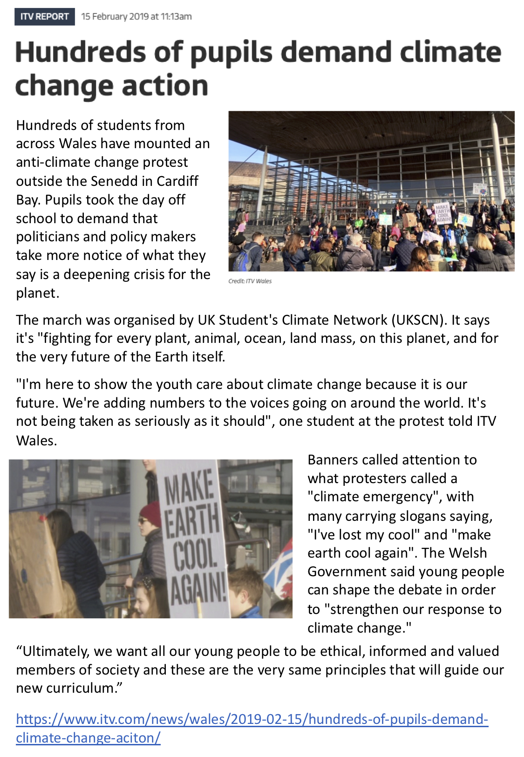
Appendix 2 – News article stimulus
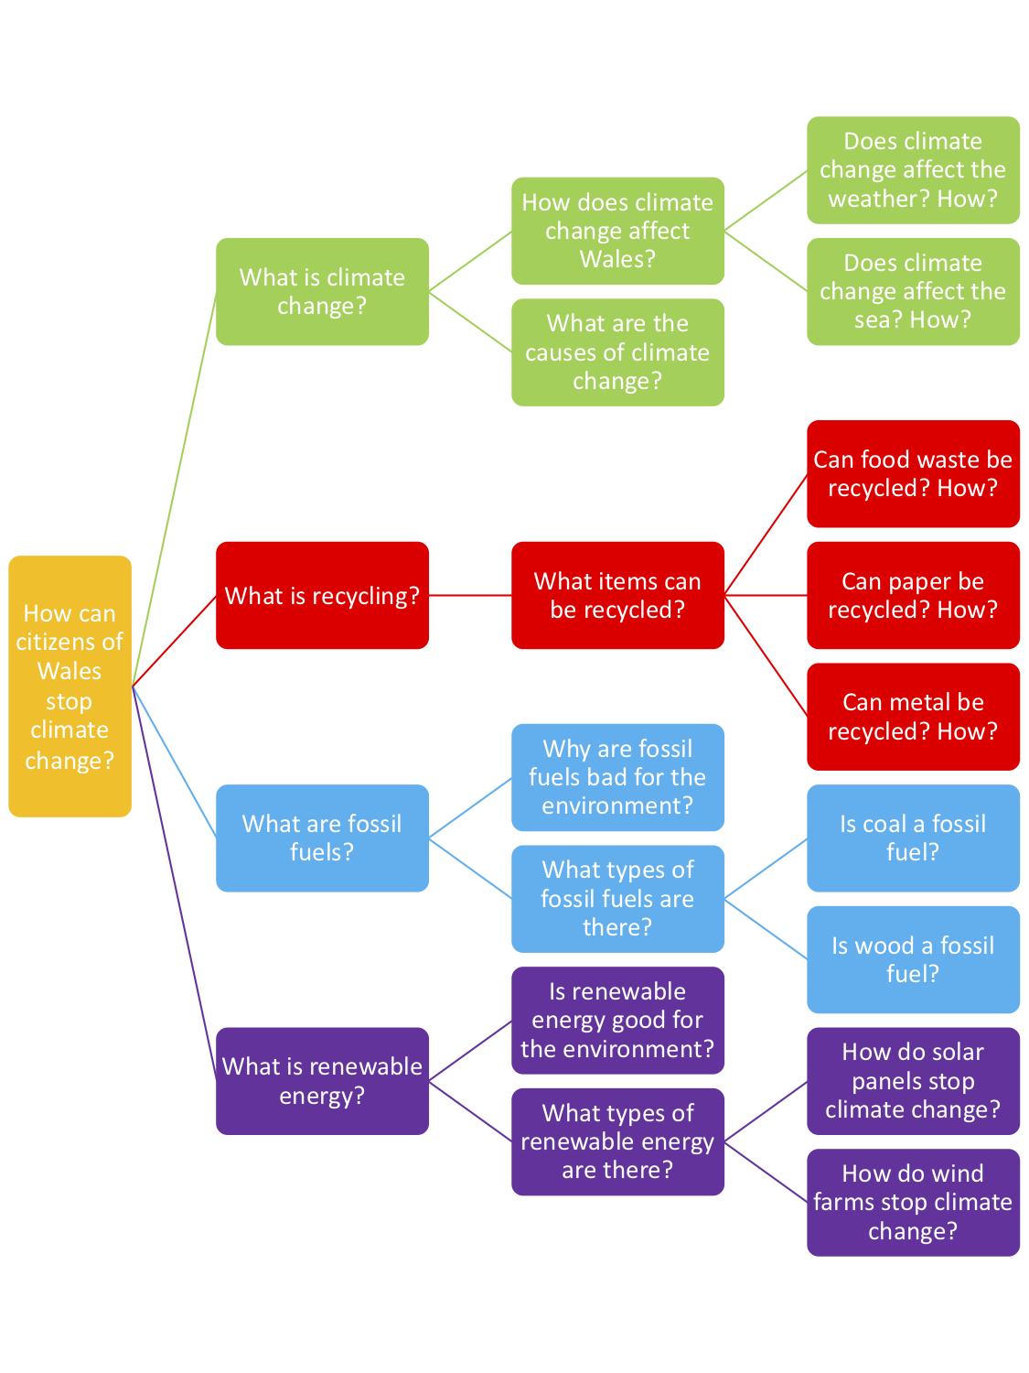
Appendix 3 – Graphic organiser: Subsidiary questions

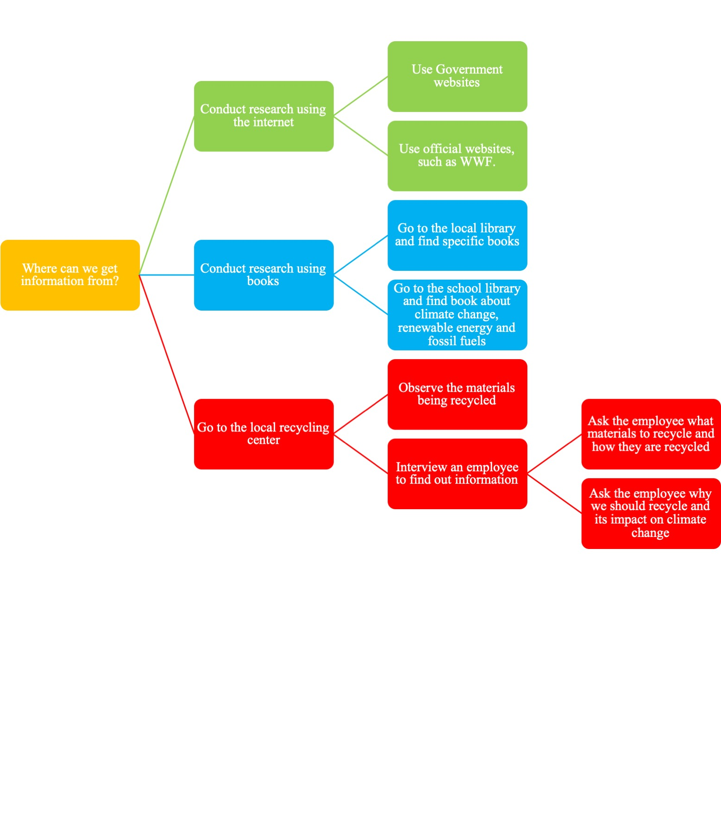
Appendix 4 – Graphic organiser: Enquiry planning

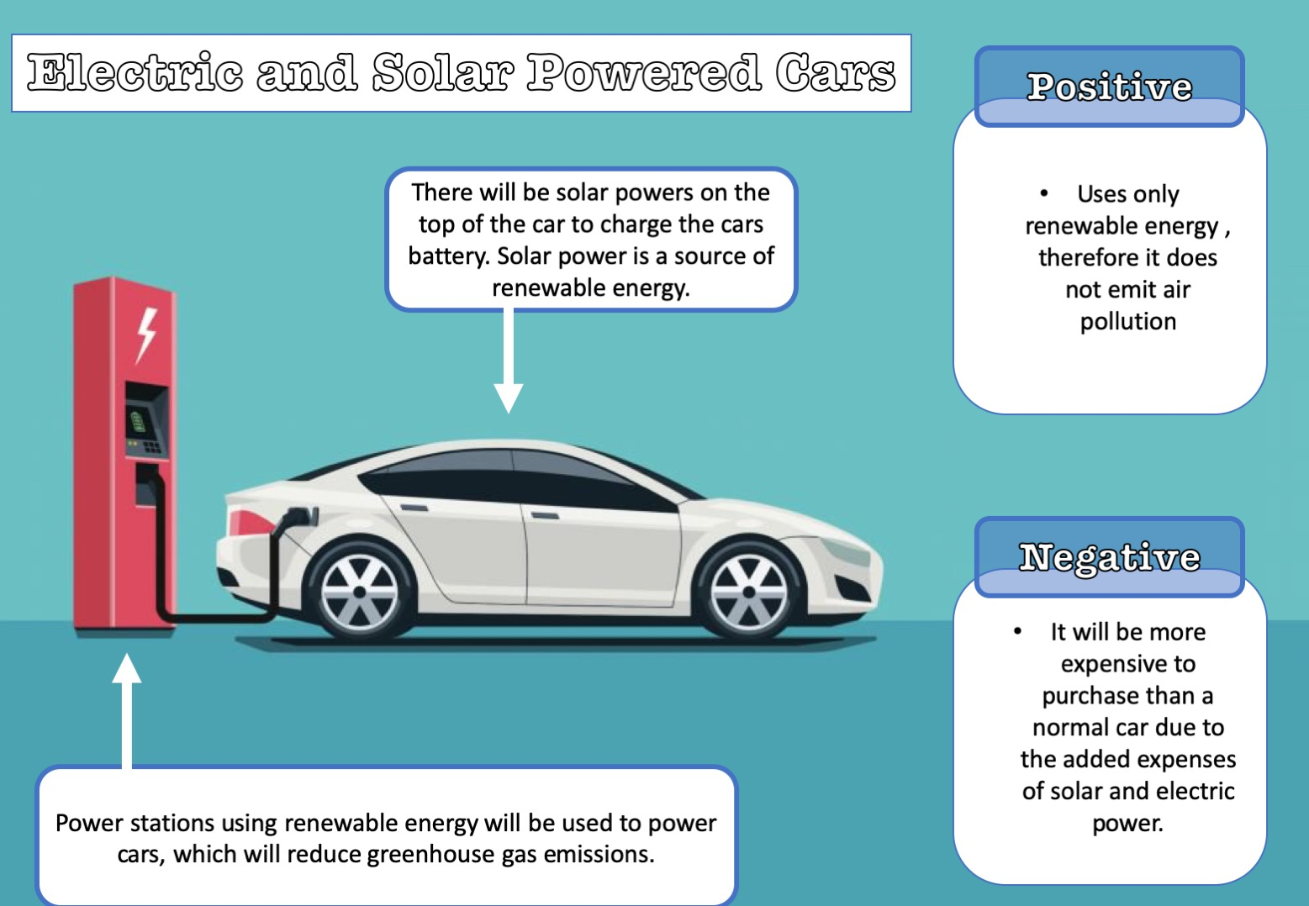
Appendix 5 – Example of presentation of strategy to stop climate

