Networking Programmability
Implementation
By Alexander Tzafos

Lecturer: Dr. Nitheesh Kaliyamurthy
Module Code: ACCB5029

Table of Contents
Introduction 3
Part A 4
Part B 6
Stage 1 6
Stage 2 6
Stage 3 7
Stage 4 9

Introduction
This assignment was based around a group project in which we needed to set up in groups no less than 3 and create a project using python or a similar application if needs be. Furthermore, we were then given a few tasks in were we needed to break down what we had, and which member of our team had done what task. Finally, we then had a reflection task which was needed to do at the end about our own performance in the team and how the team performed on the whole.

Part A

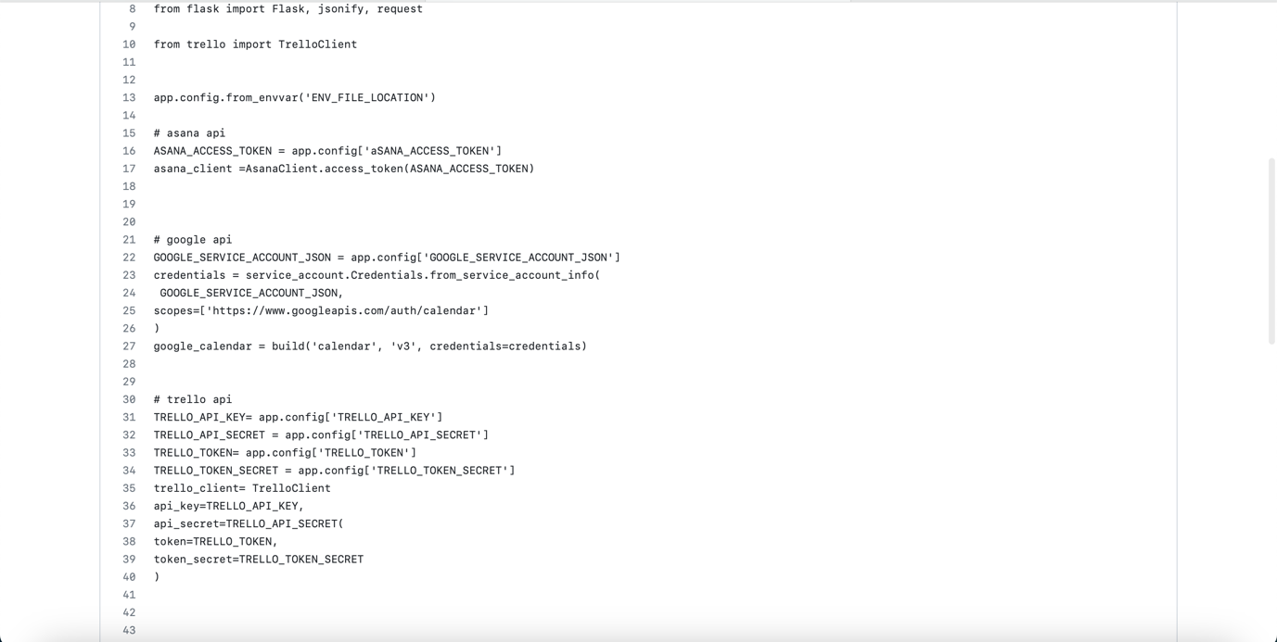
This screenshot shows the API that is making the whole application.
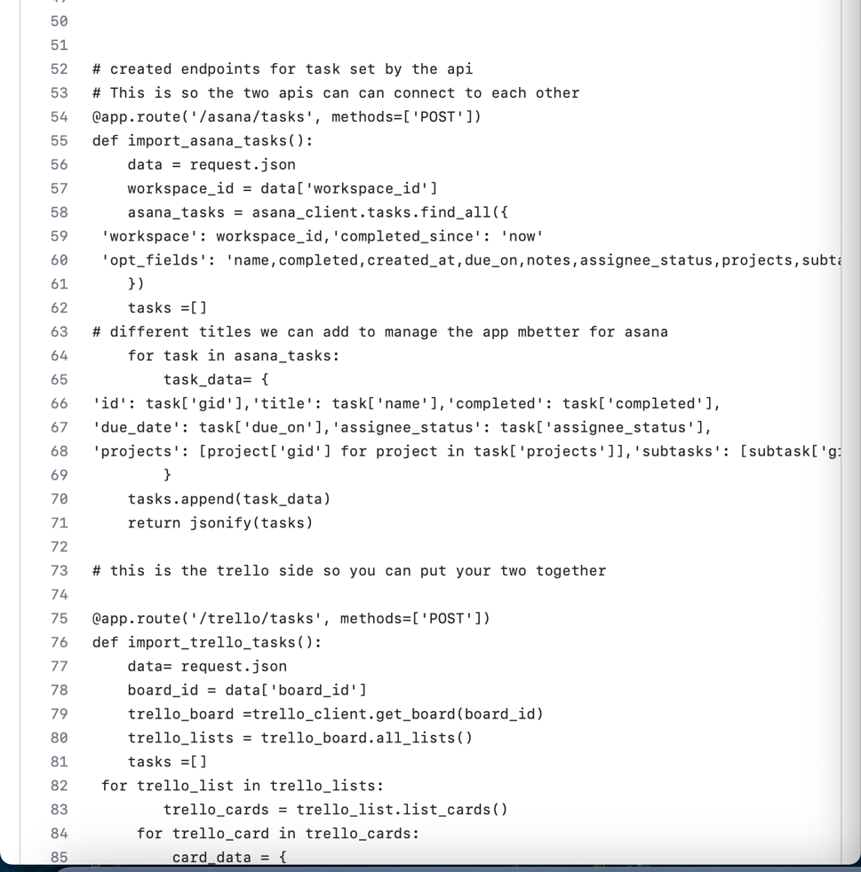
This screenshot showcases the code that links the asana API and the Trello API together.

Part B

Stage 1

 | Name | Skillsets, Interests
Facilitator | Alex | Coding
Recorder | Josh | Research
Team Member | Daniels | Research
Team Member

Stage 2

How did your team select the scrum leader?

As a group we had decided that I would be the team leader as I am better suited to the tasks we had to face when compared to the rest of the group. As a team leader I tried my best to help my teammates when they became stuck with the code.

Did you define any other agile team roles? If yes, give details. If no, why?

We all decided on the roles as we went along, as everyone did a bit of everything we found this was a much easier way to complete the tasks as we didn’t take time to discuss the roles and jobs of each team member.

Which communication tools did your team decide to use and for what purpose?

Tools | Purpose
Outlook | We used outlook ad it was the best option to use for transferring files
Teams | We used it to meet up with each other for commutation
In person | We would meet up in class and outside of class to make the project

Stage 3

What were the reason your team selected this option? (Option 1 or Option2)

As a group we went for option 2 as we found that is what we were much better suited for as we manged to get the code working much better with GitHub, also the use of this application allowed us to create a much better-looking code which worked very well. Another reason this option was chosen is because of what we were capable with as none of us have the greatest knowledge when it comes to coding, so we went with the easiest choice. Due to the lack of time, we had as a group this option also proved great dividends and we believe we did a good job.

Describe your team's application and its deliverables. What are the specific objectives of this application?

This was a great productivity tool that helped us manage the tasks properly, due to the number of tasks it was stressful, but this application really helped us keep it under control. The application allowed us to connect asana and Trello which is what we used for the APIs and then it allowed us to import the projects from both of the platforms, alongside this it allowed us to connect this to google calendar. This allowed us to assign the teams members to the different tasks and you can then set due dates for the tasks. The whole delivery side of it is that we could have a place where the work was kept.

Record your team member roles and skillsets

Team Member | Role/ Knowledge/ Skillset
Alex | He has knowledge of the understanding of code
Josh | He knows how to use work as a team
Daniels | Know how to research

Provide a brief description of your team’s strategy for completing this project

We came up with a brief plan on what was needed to be done before the project was starts as we all wanted to make it easier for ourselves. The team worked on different parts, this allowed Josh on one part, myself to do another part and Daniels to do something different, but we would mostly work together so the code would be the same as one another. We tried and tried but we struggled to get the APIs to link up, we tried for quite a while but instead removed parts of the code. We didn’t really have an overall pan as we just did parts of work on the side and then decided to meet up a few times to get parts done together.

What is the link to your GitHub repository?

https://github.com/joshnaylor10/assignment-work2.git

This link is Josh’s as mine wasn’t working.

Describe how GitHub was used in your project?

We used GitHub a lot during this project as it helped us develop the code and look for ideas which we could of used. I do believe that it was very helpful in the overall decision that we made during this process as we had used the code review which allowed us to further improve our code for the project. We also used the code merge function which proved great help as ut allowed us to combine different developments together when making the main bulk of the project. We weren’t able to add anymore team members as there wasn’t enough people available to choose as a large majority of the class are DDS.

List of future enhancements

If we were to carry this on down the line we could add even more APIs for the task management as we could of made sure that different apps were available, this would make it much more useable. We could also add different task options that if you weren’t on time when completing a task then you could explain why and how long extra you will need as an extension. Another future enhancement might be to add a function where if you are on a break like a holiday or something like that then a message would appear if you were to try access the site.

Stage 4

Personally, I believe that if I would of started this assignment a little earlier I think that my project would have been leaps and bounds better than what it came out like as I would pressed for time towards the end. As I completed this assignment on my MacBook instead of my PC it was difficult to find programs which run python smoothly. As a team we did find a software eventually which was one we used last year during a separate module, however it was pretty temperamental and did crash quite a lot. I do think that on the whole we worked really well as a team and had a decent understanding about the project we were tasked with, as all 3 of us have had plenty of different classes together it did help as there was no awkwardness at the start which allowed to get straight into the work and get it done. As a team leader I would say I did a decent job in keeping everyone on track and motived in order to get the work done, as I did have a better understanding of python than the other 2 it did allow me to help when one of them got stuck or confused. I’d say Josh and Danials contributed equally and did a good job when given their tasks that they needed to complete.

