

Certificate of Higher Education Skills for the Workplace (Health & Social Care)
Introduction to Health and Social Care
LCHS4003


Community Mental Health Services Poster
and
Ambulance Services Essay

Student name: Katherine Elizabeth Montero Coello
Student ID: 2512506
Lecturer name: Eleni Koutsogeorgou
Due Date: 23/03/2026

Table of Contents
Task 1: Community Mental Health Services Poster 2
Task 2: Ambulance Services in the UK 4
References 6

Task 1: Community Mental Health Services Poster

5.0 Current Functioning of CMHS

a) Assessment and care planning
Most service users are referred by GPs, hospitals, crisis teams, etc. The multidisciplinary assessment team carry out a full assessment exploring all a service user’s needs, including mental health, physical health, housing needs, social issues, employment issues, substance misuse issues, and risk and safeguarding (NICE, 2022; NHS England, 2019).

b) Treatment and therapeutic support
The Centre for Mental Health Services (CMHS) will offer a variety of proven interventions, including medication review, talking therapies such as cognitive behaviour therapy (CBT) and counselling, psychoeducation and relapse prevention (NICE, 2022; NHS Digital, 2024).

c) Risk management and crisis support
CQC (2024) highlights the roles that CMHS will play in relation to a few risks, including self-harm, suicide risk, neglect and vulnerability.

d) social support and recovery work
CMHS also cover some of the social determinants of mental health, including housing, employment, money and managing money and social isolation (King’s Fund, 2024).

Figure 2: NHS illustrating workforce capacity constraints affecting
community and mental health services (The King’s Fund, 2025)
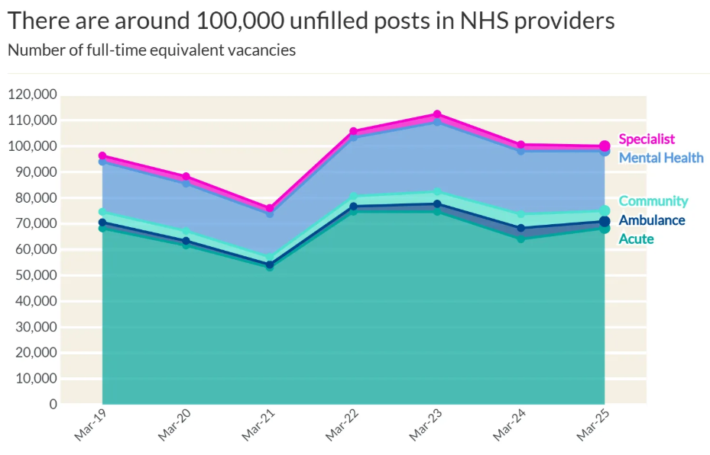
- Introduction

Community Mental Health Services are a prominent part of the UK's health and social care system, designed to support people with mental health problems towards independent living. Community Mental Health Services (CMHS) involve multidisciplinary teams of health professionals who assess, diagnose, and intervene to help clients manage their mental health problems in their homes and communities rather than in hospitals (NHS England, 2019; NICE, 2022). In essence, CMHS are services that foster the recovery of people with mental health issues and promote a greater quality of life (NCCMH, 2021).

Figure 3: Mental health: 10 charts on the scale of the problem (BBC, 2018)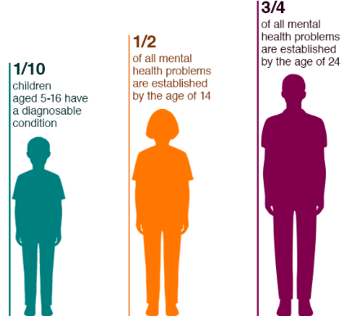
Figure 1: Community mental health framework (NCCMH/Royal College of Psychiatrists, 2023)
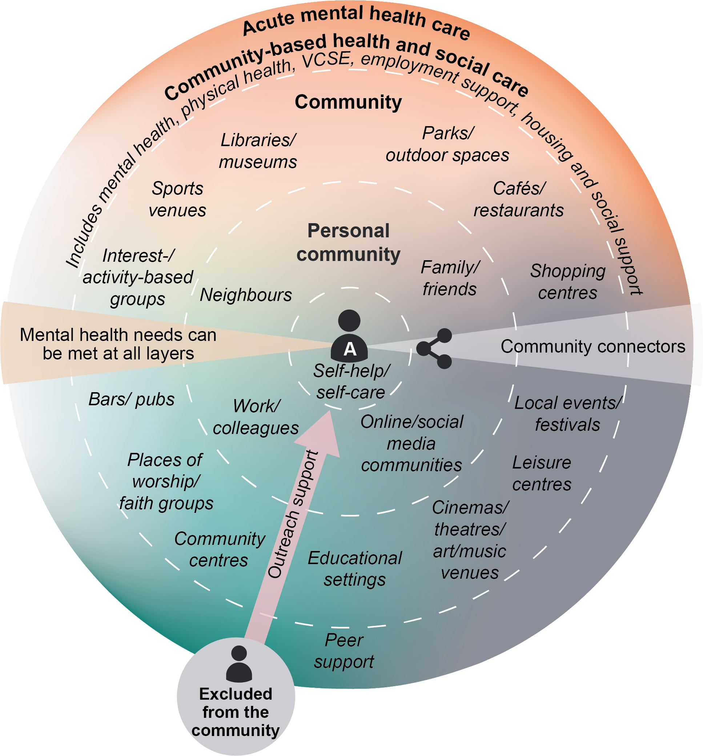
2.0 Definition of Community Mental Health Services
CMHS are community-based facilities that offer mental health care and support services as an alternative to emergency care within a general hospital (NHS England, 2019; NICE, 2022). CMHS provide a range of services. These psychiatrists and therapists are the best options for adults facing the darkest symptoms, such as major depressive disorders, panic and anxiety disorders (NICE, 2022).
A multidisciplinary team (MDT) is made up of interprofessional practitioners who work across different capacities, helping others make assessments, plan, and provide treatment. A CMHS-MDT is likely to include a mix of professionals, including mental health nurses, psychiatrists, clinical psychologists, social workers, and occupational therapists (NCCMH, 2021; NHS Digital, 2024).
3.0 Explanation of Community Mental Health Services
An individual with mental health issues may have a range of additional needs that they will require support with at the same time. These may include medication review, counselling, benefits advice, housing issues, and risk management (NICE, 2022; The King's Fund, 2024). CMHS will be an individual-centred service, verified against the service user's needs, preferences and aspirations. Recovery in a mental health context is a process of people who have mental health problems living full lives with both the desire and skills to attain a full and meaningful life without struggle, through encouragement, hope and experiences that they will need to proceed along their desired pathways, aware of and ready to adjust to health severity (Mind 2022; NCCMH 2021).

4.0 Brief History of the Service
Before 1959: Institutional care
Mental health care was provided in large psychiatric hospitals and asylums. Such institutions had been the subject of considerable criticism regarding their spatial form, social reputation, and the lack of a treatment-oriented rehabilitative focus (Rogers and Pilgrim, 2014).

Mental Health Act 1959
The Mental Health Act 1959 was concerned with less restrictive provision and treatment in the community and marked a shift away from long-term hospitalisation (Department of Health, 1959).

1980s–1990s: Care in the Community
Dr Emily Bennett of The University of Manchester investigated the impact of a government initiative to modernise mental health services, which led to a reduction in the number of long-term psychiatric hospital beds and an increase in community care in the 1980s.

1990s onwards: Community Mental Health Teams (CMHTs)
CMHTs are increasingly common in the NHS, facilitating multidisciplinary working and continuity of care, and providing access to a range of interventions.

2000s to present: Recovery-focused and integrated care
Current policy priorities in practice include person-centred care, early intervention, recovery and integrated working across services (NHS England, 2019; NCCMH, 2021).

6.0 Two Key Challenges Facing CMHS
Challenge 1-Workforce shortages and increasing demand: Mental health services for children, young people, and families in CMHS are under extreme pressure, and indeed are grossly understaffed in terms of mental health personnel, including mental health nurses, psychiatrists, and psychologists. A substantial concern arises, particularly when workplace stress is high, as this increases waiting times for clinical assessment and reduces time spent with families (King's Fund 2025).
Challenge 2-Funding pressures and unequal access: Mental health services for children, young people, and families in CMHS are under extreme pressure, and indeed are grossly understaffed in terms of mental health personnel, including mental health nurses, psychiatrists, and psychologists. A substantial concern arises, particularly when workplace stress is high, as this increases waiting times for clinical assessment and reduces time spent with families (King's Fund 2025).

7.0 References
Care Quality Commission (CQC) (2024) The state of health care and adult social care in England 2023/24. Newcastle upon Tyne: Care Quality Commission. Available at: https://www.cqc.org.uk/publications/major-report/state-care/2023-2024 (Accessed: 17 February 2026).
NHS Digital (2025) Mental Health Services Monthly Statistics. Leeds: NHS Digital. Available at: https://digital.nhs.uk/data-and-information/publications/statistical/mental-health-services-monthly-statistics (Accessed: 15 February 2026).
NHS England (2019) The community mental health framework for adults and older adults. London: NHS England. Available at: https://www.england.nhs.uk/wp-content/uploads/2019/09/community-mental-health-framework-for-adults-and-older-adults.pdf (Accessed: 16 February 2026).
Royal College of Psychiatrists (RCPsych) (2021) The Community Mental Health Framework for Adults and Older Adults: support, care and treatment (service design and development resources). London: RCPsych/NCCMH. Available at: https://www.rcpsych.ac.uk/improving-care/nccmh/service-design-and-development/community-framework (Accessed: 16 February 2026).

l

Task 2: Ambulance Services in the UK

Ambulances are such a blessing because they give people a fair chance of experiencing health and social care in the UK more effectively. Ambulances represent health care in a hidden context, as the top defensive medical and clinical procedures essential for the well-being of society, while the third largest, widely spread form of care relates to ambulance care and the pressing demand for immediate relief. This real focus on health and social care can be broader and affected by frontline issues, including emergency departments, community services, and social services (not under the direct control of the ambulance trust) (NHS England 2026a; NAO 2023; CQC 2025).

Historical analysis concerning the NHS ambulance service has, in the past, mainly centred on patient transport. Looking solely from the perspective of history offers an inadequate examination; one guided by the perspective of more recent policy, practice, and professional literature of contemporary pre-hospital care may support the assertion that ambulances do not transport patients much for clinical purposes but are now expected to provide clinical care outside the hospital antecedent to patient admission (NHS England, 2026b; Eaton et al., 2023).

The Ambulance Response Program of NHS England introduced national changes to implement a system to determine priority concerning every call, with a pre-triage series of questions. The performance of the model, with the four priorities of paediatric and adult services it offers to the public, is now being discussed within policy circles (House of Commons Library, 2025; Nuffield Trust, 2025). The four-category response model is arguable but is more acceptable than time-based models because the latter equates greatly differing care requirements with the same procedural goals and so might pose a problem for strategic resource allocation and patient prioritisation (NAO, 2017; NHS England, 2026b).

The frontline has not felt the long-term effects of reforms in the ambulance service. It seems that actions being taken as part of the Ambulance Response Programme and in other urgent and unplanned care sector improvements may never be operationalised at the frontline on a long-term basis. The PACES pathways are one of the radical changes introduced by the reforms to direct GP out-of-hours triage, but triage accounts for only a small part of the overall urgent and unplanned care system. Moreover, the National Audit Office (NAO) and others have identified other components in the care pathway, which NAO believes are, in fact, interdependencies with ambulance performance and are key in the accountability stakes.
Delays in transferring patients into the health economy could result in ambulances being tied up with a single patient for virtually the same time period. The Care Quality Commission, in its report on ambulance demand in England, observed that demand has continued to spiral up and that there has remained considerably high demand for urgent and emergency care in 2024/25 (CQC, 2025). Thus, the outcomes of ambulance events occurring in the wider health-and-social-care-system outside the ambulance system, such as patient flow, hospital capacity, and hospital discharge speeds (NAO, 2023; CQC, 2025).

This concern is supported by handover standards and field evidence. Once again, AACE is using 15 minutes as the point of ambulatory national aspirations. Handover of patients to the A&E is not supposed to take more than 30 minutes. This scenario paints a picture of fewer than 15 minutes of handovers, on the employer side, with 30 or 60 minutes, bad leadership, and diversion (AACE, 2026; NHS Providers, 2025).

This Policy Aspiring Items stresses the importance of maintaining the speed and quality of pre-hospital health care and treatments during the sudden onset of acute or traumatic conditions to prevent effects requiring subsequent specialist care after an event. One of the priority areas put forward by NHS England is Category 2 performance improvement across a wide variety of circumstances, including stroke, heart attack, sepsis, and trauma for that time (NHS England, 2025; NHS England, 2026c).

In conclusion, ambulance services are vital in the UK, providing urgent care before hospital, but rising demand and handover delays strain performance.

References
AACE (Association of Ambulance Chief Executives) (2021) Delayed hospital handovers: Impact assessment of patient harm. Available at: https://aace.org.uk/wp-content/uploads/2021/11/AACE-Delayed-hospital-handovers-Impact-assessment-of-patient-harm-FINAL-Nov-2021.pdf (Accessed: 24 February 2026).
AACE (Association of Ambulance Chief Executives) (2026) Hospital handovers. Available at: https://aace.org.uk/hospital-handovers/ (Accessed: 20 February 2026).
Care Quality Commission (CQC) (2024) Urgent and emergency care survey 2024. Available at: https://www.cqc.org.uk/publications/surveys/urgent-emergency-care-survey (Accessed: 24 February 2026).
Care Quality Commission (CQC) (2025) The state of health care and adult social care in England 2024/25: Summary. Available at: https://www.cqc.org.uk/publications/major-report/state-care/2024-2025/summary (Accessed: 24 February 2026).
Eaton, G. (2023) ‘Addressing the challenges facing the paramedic profession in the United Kingdom’, British Medical Bulletin, 148(1), pp. 70–78. Available at: https://pubmed.ncbi.nlm.nih.gov/37681285/ (Accessed: 21 February 2026). (PubMed)
House of Commons Library (2025) Ambulance service response times. Available at: https://commonslibrary.parliament.uk/research-briefings/cdp-2025-0042/ (Accessed: 24 February 2026). (House of Commons Library)
National Audit Office (NAO) (2017) NHS ambulance services. London: National Audit Office. Available at: https://www.nao.org.uk/wp-content/uploads/2017/01/NHS-Ambulance-Services.pdf (Accessed: 24 February 2026). (National Audit Office (NAO))
National Audit Office (NAO) (2023) Access to unplanned or urgent care. London: National Audit Office. Available at: https://www.nao.org.uk/wp-content/uploads/2023/06/access-to-unplanned-or-urgent-care.pdf (Accessed: 24 February 2026).
NHS England (2025a) 2025/26 priorities and operational planning guidance. Available at: https://www.england.nhs.uk/long-read/2025-26-priorities-and-operational-planning-guidance/ (Accessed: 19 February 2026).
NHS England (2025b) Urgent and emergency care plan 2025/26. Available at: https://www.england.nhs.uk/long-read/urgent-and-emergency-care-plan-2025-26/ (Accessed: 24 February 2026).
NHS England (2025c) Monthly operational statistics – May 2025. Available at: https://www.england.nhs.uk/long-read/monthly-operational-statistics-may-2025/ (Accessed: 19 February 2026).
NHS England (2026a) Ambulance Response Programme (ARP). Available at: https://www.england.nhs.uk/urgent-emergency-care/improving-ambulance-services/arp/ (Accessed: 24 February 2026).
NHS England (2026b) 2026/27 ambulance emergency and urgent care service specification. Available at: https://www.england.nhs.uk/urgent-emergency-care/improving-ambulance-services/service-specification/ (Accessed: 24 February 2026).
NHS England (2026c) Ambulance Quality Indicators (AQI). Available at: https://www.england.nhs.uk/statistics/statistical-work-areas/ambulance-quality-indicators/ (Accessed: 24 February 2026).
NHS Providers (2025) NHS activity tracker 2025/26: Ambulance sector (May 2025). Available at: https://nhsproviders.org/resources/nhs-activity-tracker-202526/may-2025/ambulance-sector/ (Accessed: 24 February 2026).
Nuffield Trust (2025) Ambulance response times. Available at: https://www.nuffieldtrust.org.uk/resource/ambulance-response-times (Accessed: 24 February 2026).
UK Parliament (1946) National Health Service Act 1946. Available at: https://www.legislation.gov.uk/ukpga/1946/81/pdfs/ukpga_19460081_en.pdf (Accessed: 20 February 2026).
UK Parliament (n.d.) 1946 National Health Service Act (Living Heritage). Available at: https://www.parliament.uk/about/living-heritage/transformingsociety/livinglearning/coll-9-health1/health-01/ (Accessed: 20 February 2026).

