Name Daniela Ciornea
Student number / Rhif myfyiwr 1907166
E-portfolio report
ADRODDIAD E-BORTFFOLIO
Learning in the Digital Era / Dysgu yn yr Oes Digidol – BMPL4007/BMPS4009
Table of Contents
Task 1 – Written summary / Tasg 1 - Crynodeb Ysgrifenedig 0
Task 2 – Mind map / Tasg 2 – Map meddwl 0
Task 3 – Presentation / Tasg 3 - Cyflwyniad 0
Task 4 – Reflection / Tasg 4 - Myfyrdod 0
Task 5– Personal Development Plan 0
Reference list / Rhestr Cyfeirnodi 0

Task 1 – Written summary / Tasg 1 - Crynodeb Ysgrifenedig

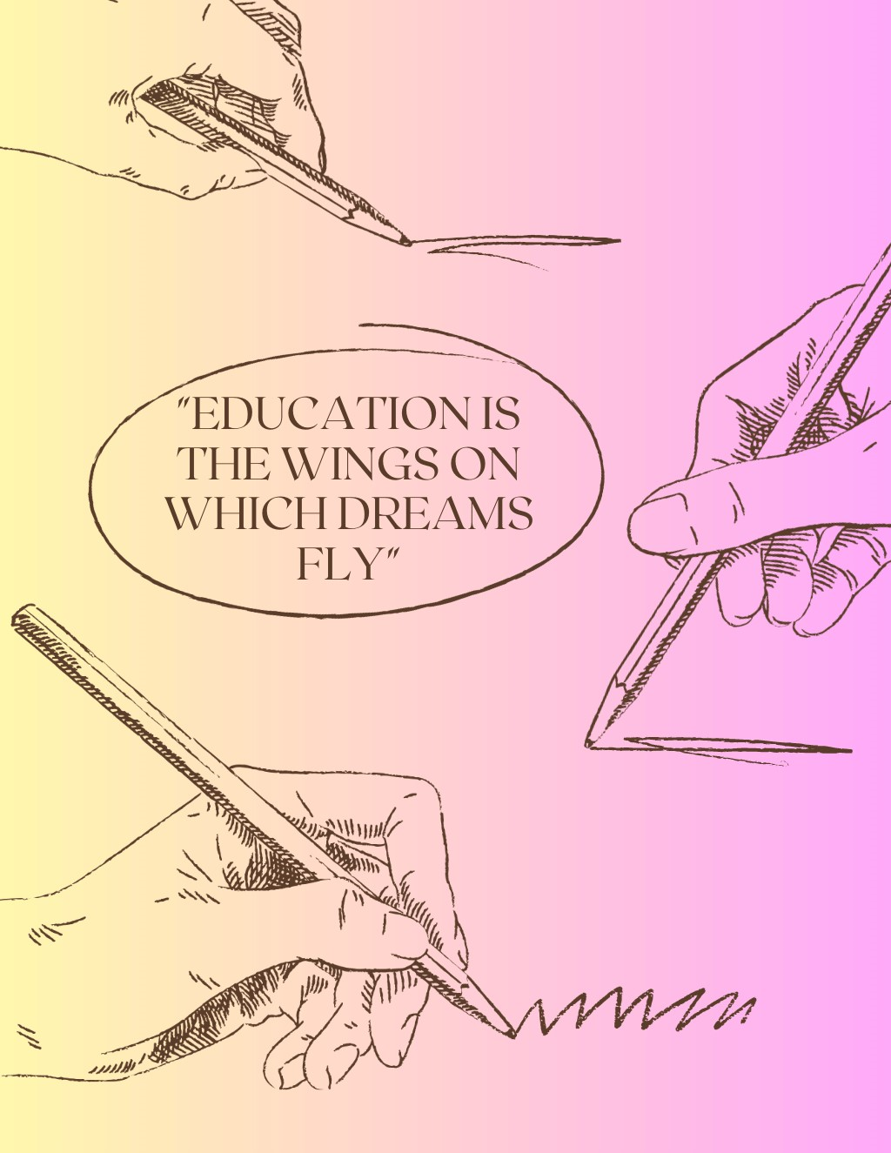Preparing for Higher Education

To be proactive and succeed in life one always must search for knowledge. Information is power, it opens doors to a successful future and creates connections with bright minded individuals. We live in a fast-moving era where information is available with a click of a button, but one must be careful not everything on the internet is true and useful, so then again one must turn back to the old-fashioned way, education in an institution. Living in the UK comes with several advantages in terms of education: regardless your age you can always apply to enrol, for those who do not have a good financial situation there is always Student Finance and of course, the prestige that comes with being an UK student.
One must always research his options. Explore different colleges and universities and learn about their academic programs, courses and admission requirements. At this stage it is crucial that an individual should take into consideration his personal schedule, work hours and family commitments. As an example, a single mother must check with the nursery/school for their availability to accommodate the child during the courses as paying attention it is decisive in retaining the information.
Another step to be mindful of it is choosing the right course, consider your interests and goals and choose a field of study that aligns with your passion and career aspirations. To be admitted to your desired course you must work on a strong personal statement which will describe your personality and why you deserve a place in the University. “Chaos is mater, origin, source, mother; materia, the substance from which all things are made (J. Peterson, 2018 p2), one must always strive to succeed even though sometimes life is getting tougher, you must remain dedicated, disciplined and committed to finish your task. It can be a smooth process complying to the changing requirements of study, work, and new people when you are framing on a sturdy base (S. Cottrell, 2015 p25).

Task 2 – Mind map / Tasg 2 – Map meddwl

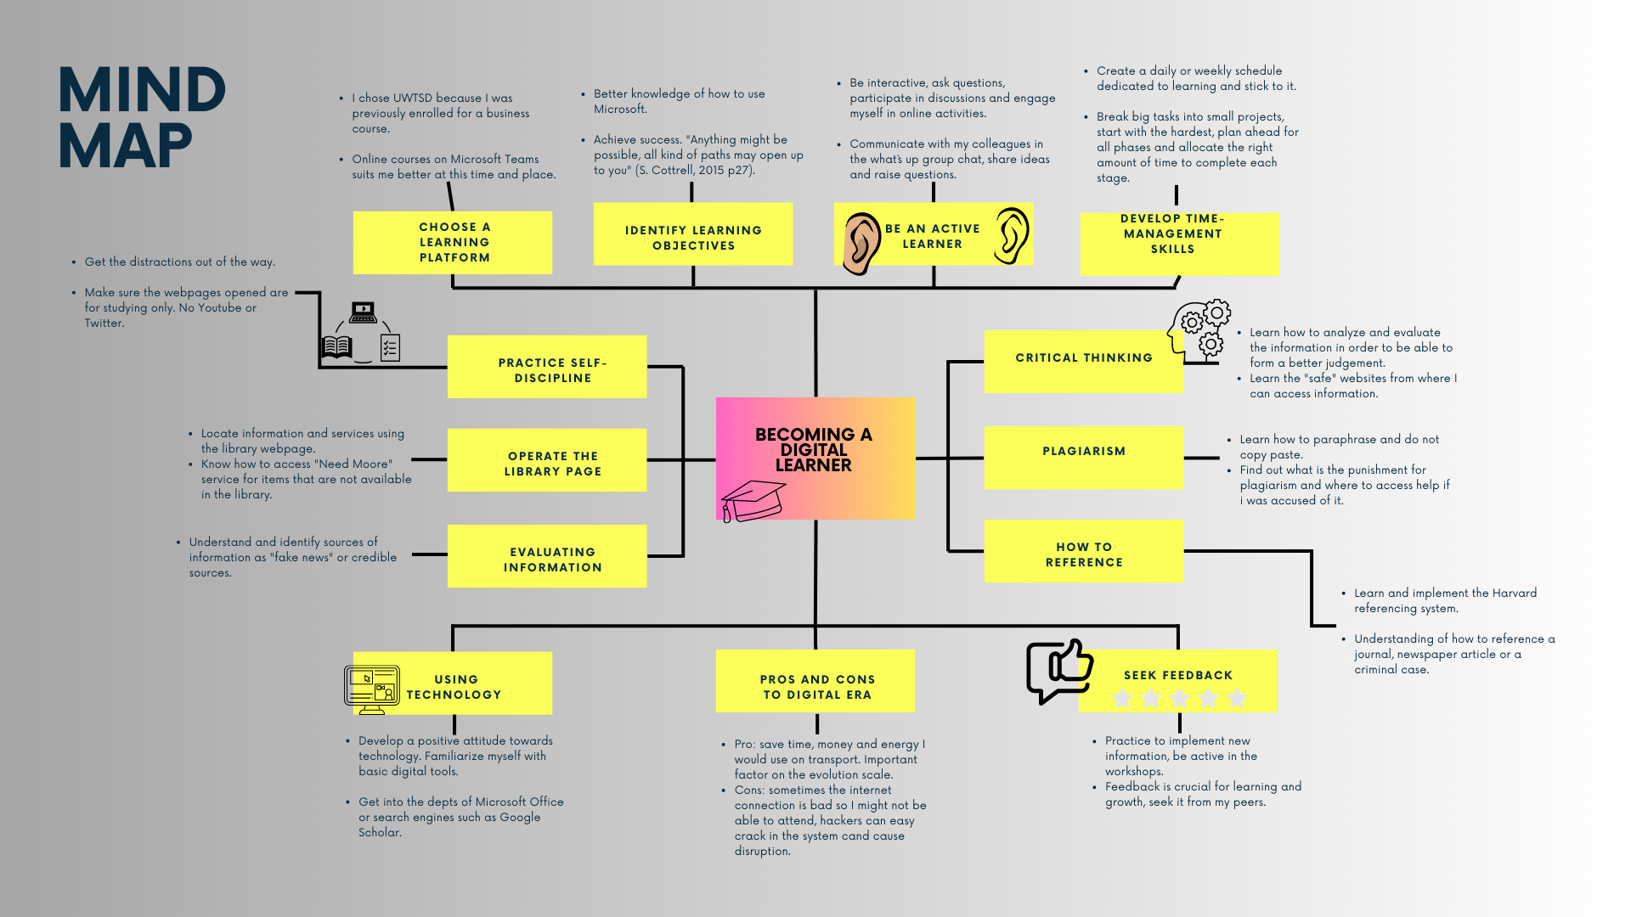

Task 3 – Presentation / Tasg 3 - Cyflwyniad
Please follow this link to view my presentation: / Dilynwch y cyswllt isod i wylio fy nghyflwyniad
https://www.youtube.com/watch?v=aoVFI4-lSNU

Task 4 – Reflection / Tasg 4 - Myfyrdod

How do I feel so far as a student – using Gibbs reflective cycle
Description. I am a single mother determined to offer a bright future to my little girl. I came across the Law and legal practice degree, something I always wanted to study, especially now since it can be done online so I can fit it better within my daily schedule. Enrolment process was straightforward, the learning material accessible and my colleagues a gem so far. The classes are interactive, we are broken down into groups most of the times which facilitates brainstorming and learning how to be part of a team. Obviously, the outcome desired is to graduate, therefore, to gain necessary knowledge to succeed in a law career. So far, I have managed to learn time-management and how to adapt to a new mode of learning which has presented its own set of challenges.
Feelings. Before I started, I felt a bit anxious as I didn`t know if I would be capable of integrating this course in my life, since I managed to do so, I am relieved and excited to learn new things every Monday. Being part of my class, it came as a blessing as I formed good friendships and interaction between us was always in a polite manner. However, we are different characters, so I had a bit of a clash with one of my colleagues, but the fire has been put down. Looking back at the time I started I feel really happy I have done so and I am looking forward with much excitement and curiosity.
Evaluation. What really went good so far is the duration of the classes and how they are structured, whenever I am assigned to a team we put our brains together, research and come with a good outcome. However, what I consider to be of a negative impact is that not all my colleagues contribute when assigned to a team and that sometimes seems to bring frustration amongst the team members.
Analysis. As I think about it now, enrolling in this course I consider to be one of my best decisions so far. Learning in the digital era is a must for the future workplace and I have managed so far to come to terms with a lot of digital knowledge. Being in such diverse class has helped me understand other people`s culture, it did indeed help me compete and bring out the best of me by making sure I am present and involved in the class activities.
I must mention once again that most of my colleagues are extremely helpful, we have set up a What`s up group chat where we share ideas and help the ones that are stuck behind with the learning material, where to find useful information, such as making use of the Student Services help and opportunities. I have formed a strong bond with some of them as we talk outside the class interest and help each other diminish procrastination so at the end of this course we can get the best results according to the work we put in.
I am more active daily, I have learned how to manage my time and how to better focus on my work, therefore my future. I have adapted different themes and focal point for reflection such as: behaviours, interaction with or between others, feelings, knowledge, theories, system and structures or policies, procedures and rules (S. Cottrell 2015, p234).
The challenges this course presented with were not so many, but important to help me get more disciplined and aware of the continuously changing work-environment. Challenges such as being present on time in body and mind or making use of the technology we are surrounded by daily.
Conclusion. I have learned how to be more considerate of other`s feelings and their schedule, as well as be aware that we all come with limitations and strengths which shape us into the individuals we are. I have discovered the implementation of Belbin`s team roles theory to be efficient and beneficial for the wellbeing of the group. At last, I have determined that mutual respect and respecting each other’s boundaries it is what helps people succeed and create strong future workforce.
Action plan. The possible areas which I identified as needed to work on are the ability to act when matters arise, especially important tasks such as assignments so procrastination will not be a steppingstone in my future career, as well as my capability to work in a team and to come to terms with the strengths and the limitations of my team members. I have found a great mechanism which can help me cope and lead perhaps within my designed team in Belbin`s team roles tool which has given me a great insight into the role I can fulfil in an organisation based on my behaviour or how can individuals fit within a team according to their behaviour, strengths, and limitations.
In the nearest future I will put accent on respecting other people`s opinion and in case I do not agree, or I feel offended, I will try to make my point and bring arguments in a civilised manner, with a positive attitude as I have understood that my actions and words can affect the wellbeing of us as a team. I will work towards fulfilling my potential and bringing value to my team by listening more, being more disciplined and attentive to details. I will take into consideration other`s feelings, strengths, and limitations.

Task 5– Personal Development Plan

Student Name |  | Student Number |  | Module |  | Code
Daniela Ciornea |  | 1907166 |  | Learning in the Digital Era |  | BMPL4007  BMPS4009
What goals do I want to achieve? | How will I measure my progress? |  | What resources or support will I need? |  | How is the objective relevant to my personal aspirations? | What is the timeframe for the achievement of my goals?
Specific | Measurable |  | Achievable |  | Relevant | Timebound
Developing self-awareness.  Being opened to possibilities.  Being flexible, adaptable and resilient in the face of changing circumstances (Cottrell S, p5).  Achieving well academically.  Enhance communication skills.  Develop team-working skills.  Complete tasks more effective.  Be more appropriate at giving and receiving criticism.  Analyse how well my values and behaviours match what employers seek.  Enhancing my career prospects.  Develop critical thinking and problem-solving skills.  Time management.  Build up my physical appearance.  Do acts of charity.  Socialize more. Go back into the dating scene. | Keep a reflective journal.  Make up a list with pros and cons for opportunities when may arise.  Set goals and learn from experience.  Create a timetable for the hours I can dedicate to studying and stick to it.  Be mindful of my body language and avoid being vulgar.  Create or download a Belbin team roles chart.  Create a priority to-do list.  Relax more, release the tension in my body, do yoga.  Write in a daily journal. Write down my values, search what employers look for and what can I offer.  Create an outstanding CV and personal letter.  Be mindful of other points of view and do vast research before taking a decision.  Create a weekly schedule. Set up a goal to achieve for the end of every day.  Pay for a gym membership.  Set up a monthly amount of cash I can dispose of for a noble cause.  Find a reliable nanny. Join my friends on date nights more often. Join a dating website. |  | Plan a personal S.W.O.T analysis.  Trust your instinct and intuition. Create and keep in touch with new contacts.  Remain hopeful and spend more time in nature.  Establish 1 hour a day minimum for studying.  Proofread everything before I hit “send”.  Define separate responsibilities and roles.  Start with small tasks.  Focus on the behaviour not the person. Be mindful of emotions.  Improve my behaviour, consider the people I most admire. Write what I admire most about them and how can I have the same qualities.  Assimilate information through the course duration. Have ambition, determination and discipline.  Learn how to be an active listener. Understand my mental process.  Restrict the screen time. Try and spend as les stime as you can scrolling on videos. Spend very limited time on social media.  Attend gym at least 3 times a week. Cook with less oil.  Search online for charities and choose one that shares my values. Set up a direct debit.  Organise a meet-up with my university colleagues to get to know each oter better. Use open body language and non-verbal communication. |  | Seek feedback from tutors.  Practice gratitude. Reduce judgement of myself or others.  Keep good physical and mental health.  Avoid missing deadlines or procrastination.  Avoid being misunderstood and secure a desired place in any team.  Develop awareness.  Satisfactory grades and no time wasting.  I can better integrate within my class or in a work-place environment.  I can confidently apply for the job that is suitable to me and as well, I can better integrate in a new environment.  I will achieve success and it would help me grow in the future.  I will gain respect and consideration from my team or workplace.  I will be able to finish my tasks on time, I will be more proactive and I will not lose time.  A healthy body will boost up my confidence and further my mental  health.  It will humble me and I will attract positive energy.  Create and solidify new connections, which might help in my future career.  It will help with my mental health. | Monthly breakthrough.  Quarterly revision.  Preferably every end of a month.  Every time I have an assignment to submit.  Every two weeks I shall reflect on my behaviour.  Preferably before I finish my course.  Weekly milestones.  Daily steps.  Every six months.  At the end of this course.  Every six months.  Every day or every beginning of a week.  Every end of the month I shall go on a scale and keep track of my body weight.  Monthly task.  Weekly revision.

Reference list / Rhestr Cyfeirnodi
Belbin, R. Meredith (2003), Management teams: Why they succeed or fail. 2nd edn. Butterworth Heinemann, Oxford.
Cottrell, S. (2015) Skills for success. 3rd edn. London. Macmillan Publishers Ltd.
Cottrell, S (2009) The Study Skills Handbook. 5th edn. London. Macmillan Education UK.
Cottrell, S (2017) Critical Thinking Skills. 3rd edn. London. Palgrave Macmilan.
Godfrey, J (2018) How to use your readings in your essays. 3rd edn. London. Palgrave.
Peterson, J. (2018) 12 Rules for Life: An Antidote to Chaos. Random House Canada.
https://www.canva.com/design/DAFlCi8ff7k/fI9zGDqGFLOy0HkwclfMdQ/edit?utm_content=DAFlCi8ff7k&utm_campaign=designshare&utm_medium=link2&utm_source=sharebutton
https://www.canva.com/design/DAFlDBe6EZY/z6cN9z_64QfSovlXDGf2Rg/edit?utm_source=shareButton&utm_medium=email&utm_campaign=designshare
Maund, A., Schriek, M., Tinkler, P. K. (2017). Certificate in Higher Education: Skills for the Workplace Student Yearbook. London: 1st ed. SAGE Publications Ltd.

