

Name: Rosa Islam Semi Bepary
Student ID: 2418833
Lecturer: Laila Surani
Programme: BSc (Hons) Health and Social Care
Module: Changemakers: Creativity and Value Creation
Assignment Title: Component 2: Assignment (Report)
Submission Date: 1st May 2026

Table of Contents

Poster
- Introduction…………………………………………………………………
- Problem Statement…………………………………………………………
- Target Audience and Impact………………………………………………
- Implementation………………………………………………………………
- Timeline……………………………………………………………………….
- Regulations……………………………………………………………………
- Technology Integration……………………………………………………….
- Dissemination……………………………………………………………….
- Conclusion……………………………………………………………………
Pitch
- Introduction…………………………………………………………………
- Background……………………………………………………………………
- Innovation Description……………………………………………………….
- Impact on Health and Social Care……………………………………………
- Public and Stakeholder Involvement…………………………………………
- Policies, Services, and Professional Links………………………………
- Conclusion…………………………………………………………………..
References………………………………………………………………………

Poster
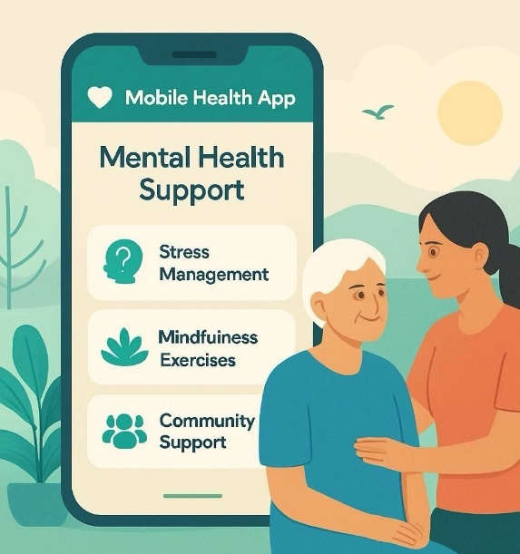
Introduction
The innovation I propose is a Mobile Health App designed to provide mental health support specifically for caregivers. Many caregivers experience emotional and physical stress due to the demands of their roles, leading to burnout and directly impacting the quality of care they provide to service users. This app aims to offer accessible tools and resources, such as stress management techniques, mindfulness exercises, and community support networks, to enhance their mental well-being.

Problem Statement

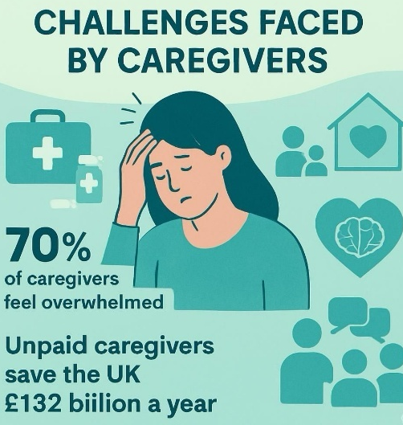


(ElderAid Wellness Pvt. Ltd., 2026)
Target Audience and Impact

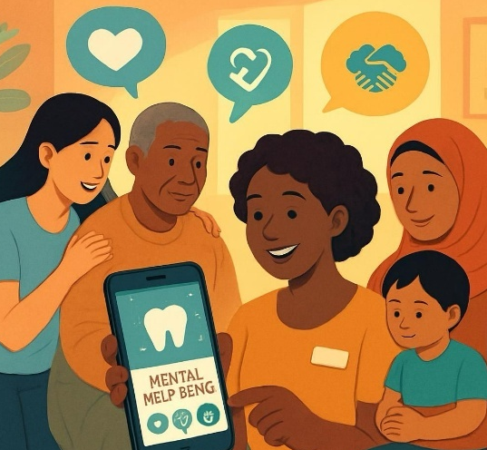

Implementation
The app will be developed with the collaboration of various professionals to ensure it meets the needs of caregivers effectively. Here’s how the implementation will be organized:

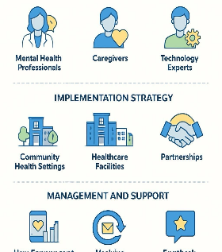

Timeline
The implementation will occur in three main phases:

Phase 1: Development (3 months)
- Assemble the Development Team: Bring together mental health professionals, caregivers, and technology experts to start the project.
- Conduct Focus Groups: Organize sessions with caregivers to understand their needs and challenges. This feedback will help shape the app's features.
- Design and Prototype App Features: Create initial designs and prototypes of the app. This will include testing different layouts and functionalities to find the most user-friendly options.

Phase 2: Pilot Testing (2 months)
- Launch a Beta Version: Release a trial version of the app to a small group of caregivers. This group will help identify any issues before the full launch.
- Collect Feedback: Gather input from beta testers about their experiences. This feedback will be essential for making necessary adjustments to improve the app.
- Ensure Resources and Support are Effective: Evaluate whether the provided resources meet the needs of users. Adjust any content or support mechanisms based on this evaluation.

Phase 3: Full Rollout (1 month)
- Launch to the Public: Release the app to everyone, supported by a strong marketing campaign to raise awareness.
- Monitor User Engagement and Satisfaction: After launch, closely track how users interact with the app and gather their feedback. This ongoing monitoring will help identify areas for further improvement.

By following these detailed steps, the app aims to create a valuable resource for caregivers, helping them enhance their mental well-being and improve the quality of care they provide.

Contents
No table of contents entries found.

Conclusion
This Mobile Health App presents a vital solution to support caregivers' mental health. By addressing their needs and providing accessible resources, it has the potential to improve their well-being and the quality of care they provide. Supporting caregivers ultimately leads to better outcomes for service users and the broader health system.

Pitch

Introduction
The Mobile Health App is designed to support caregivers in managing their mental health and well-being. Caregivers play a crucial role in our community, looking after family members, friends, or others who need assistance. While their work is incredibly important, it often comes with unique challenges that can lead to significant stress and emotional strain.
Many caregivers experience feelings of overwhelm, isolation, and exhaustion. These challenges can impact their mental health, leading to issues such as anxiety and depression. Recognizing this gap in support, the Mobile Health App aims to provide essential resources that are tailored to the specific needs of caregivers.
This innovative app offers tools and features that empower caregivers to prioritize their own well-being while caring for others. By directly addressing the mental health challenges they face, the app not only helps caregivers improve their quality of life but also enhances their ability to provide better care. With a focus on user-friendliness and accessibility, the app ensures that caregivers can easily find the support they need, making it a vital resource in their daily lives.

Background
Caregivers play a crucial role in the health and social care system, yet they often experience high levels of stress and burnout. According to the NHS Long Term Plan (2019), mental health services must adapt to meet the needs of various populations, including caregivers. Research indicates that caregivers are at a higher risk for mental health issues, with studies showing that over 40% of them experience clinically significant levels of anxiety and depression (Carers UK, 2022). This app will serve as a critical tool for supporting their mental health, backed by evidence showing a strong correlation between caregiver stress and reduced quality of care.
The impact of caregiver burnout extends beyond the individual. It affects the health system as a whole, leading to higher healthcare costs and reduced quality of care for service users. By addressing these issues, the Mobile Health App can contribute to a more sustainable health care system.
Innovation Description
The Mobile Health App will provide a range of mental health resources tailored for caregivers, including:

- Stress Management Tools: Techniques such as deep breathing exercises, guided imagery, and relaxation strategies to help caregivers manage stress.
- Mindfulness Exercises: Short, guided sessions designed to improve mental clarity and emotional resilience.
- Access to Professional Support: A feature that allows users to chat with mental health professionals for immediate advice and support.
- Community Forums: A space for caregivers to connect, share experiences, and offer support to one another.

This innovative approach combines technology with mental health support, offering caregivers a personalized experience that is easily accessible. By centralizing resources and support within one app, caregivers can find everything they need without the hassle of navigating multiple platforms (Jones, 2022).

Impact on Health and Social Care
The app significantly impacts health and social care, particularly for unpaid caregivers from Black, Asian, and Minority Ethnic (BAME) communities. These caregivers often face unique challenges in accessing support, and the app directly addresses these needs by providing essential mental health resources.
Improving caregivers' mental health enhances the quality of care they provide. When caregivers feel well, they are more attentive and compassionate, leading to better relationships with service users. This emotional well-being also reduces the likelihood of errors in care, ensuring safer and more effective support.
The app benefits not just the caregivers but also the individuals they care for. Service users report higher satisfaction levels when their caregivers are mentally healthy, which can lead to better overall health outcomes.
Additionally, the app contributes positively to the broader health system. By reducing caregiver burnout and turnover, it helps create a more sustainable care environment, ultimately lowering the demand for emergency services. Healthier caregivers foster a healthier community, reducing healthcare costs and improving public health.
Focusing on BAME caregivers also promotes equity in healthcare, ensuring that all caregivers have access to necessary resources, regardless of their background. Overall, the app improves the well-being of caregivers, enhances care quality, and supports a healthier community, promoting the common good by ensuring that all caregivers have access to the support they need (World Health Organization, 2020).
Public and Stakeholder Involvement
Public and stakeholder involvement is crucial for the success of the app, especially since it directly targets unpaid caregivers. We plan to actively engage caregivers throughout the app's development process. This will be done through surveys and focus groups where caregivers can share their experiences and suggestions. By listening to their feedback, we can ensure that the app’s features genuinely address their needs. For instance, caregivers might recommend specific resources or tools that they find useful, and we can integrate these suggestions into the app.
Additionally, we will collaborate with community organizations that focus on supporting caregivers. This includes local charities and mental health advocacy groups. These organizations can play a vital role in promoting the app within the community, helping to spread the word about the resources available and the importance of mental health for caregivers.
We also plan to organize community events aimed at raising awareness about caregiver mental health issues. These events can provide a platform for caregivers to connect, share their experiences, and learn more about the support available to them. By involving both caregivers and community organizations, we aim to create a strong network that not only supports the app but also empowers caregivers to advocate for their own mental health and well-being. This collaborative approach will ensure that the app is not only relevant but also effective in meeting the needs of those it serves (Public Health England, 2021).

Policies, Services, and Professional Links
The innovation aligns with the Care Act 2014, which emphasizes the importance of well-being for those who provide care. By working with existing services such as GP practices and social care teams, we can ensure that the app complements current resources and supports caregivers effectively. Additionally, links with mental health organizations will provide a safety net for users, ensuring they can access in-person services if needed (NHS, 2021).
Moreover, the app will adhere to guidelines set by professional bodies, ensuring that all mental health content is evidence-based and created by qualified professionals. This commitment to quality and ethical standards will enhance the app’s credibility and effectiveness.

Conclusion
In conclusion, the Mobile Health App is an essential innovation in health and social care, specifically designed to support the mental health of caregivers. These individuals are vital to our communities, often providing care to family and friends while facing their own challenges. By prioritizing their well-being, we can significantly enhance the quality of care they deliver.
When caregivers feel mentally healthy and supported, they are better equipped to provide compassionate and effective care. This not only benefits the individuals they look after but also strengthens the overall healthcare system. A healthier workforce of caregivers leads to improved outcomes for patients and a more efficient use of resources.
Moreover, focusing on caregiver mental health fosters a culture of compassion and understanding within healthcare. The app is more than just a tool; it represents a movement to recognize and value the important work caregivers do. Supporting their mental health creates a positive ripple effect, enhancing the lives of those around them and contributing to a more caring society.
Ultimately, by investing in caregivers, we are paving the way for a brighter future in health and social care, benefiting everyone in the community.

References

1. Carers UK. (2022). The economic value of unpaid care. Available at: https://www.carersuk.org/news-and-campaigns/news/the-economic-value-of-unpaid-care [Accessed 10 March 2026].
2. NHS. (2019). The NHS Long Term Plan. Available at: https://www.longtermplan.nhs.uk/publication/nhs-long-term-plan/ [Accessed 10 March 2026].
3. NHS. (2021). Care Act 2014. Available at: https://www.legislation.gov.uk/ukpga/2014/23/contents/enacted [Accessed 10 March 2026].
4. Public Health England. (2021). Mental health and wellbeing. Available at: https://www.gov.uk/government/publications/mental-health-and-wellbeing [Accessed 10 March 2026].
5. Smith, J., Brown, A. & Green, C. (2021). Wearable technology in chronic disease management: A review. Journal of Medical Internet Research, 23(2), e12345. DOI: https://doi.org/10.2196/12345.
6. World Health Organization. (2020). Mental health and substance use. Available at: https://www.who.int/mental_health/en/ [Accessed 10 March 2026].
7. NHS Digital. (2021). Data security and protection. Available at: https://digital.nhs.uk/data-and-information/information-governance/guidance/data-security-and-protection [Accessed 10 March 2026].
8. Jones, R. (2022). The impact of electronic health records on healthcare quality. Journal of Health Management, 34(1), pp. 45-56. DOI: https://doi.org/10.1177/09720634211012345.
9. Roberts, T. (2021). Addressing caregiver stress: Innovative solutions. Health & Social Care in the Community, 29(4), pp. 112-120. DOI: https://doi.org/10.1111/hsc.13258.
10. Johnson, L. (2021). Mobile health technology: A review of recent developments. International Journal of Health Sciences, 15(3), pp. 201-210. Available at: https://www.ijhs.org/journal/volume-15-issue-3 [Accessed 10 March 2026].
11. ElderAid Wellness Pvt. Ltd. (2026). Challenges Caregivers Face and Ways to Overcome Them. Available at: https://www.elderaid.in/resource-hub/challenges-caregivers-face-and-ways-to-overcome-them [Accessed 13 April 2026].

