
Programme: Master of Business Administration
Module: Business Development proposal
Module code:LCMB7037

Title: BDP Outline

Student Name:Mohmedkaif Hamidail Mansuri
Student ID:2321459

SEASONAL FRUIT DRINK TO MANUFACTURED PRODUCT
Table of Contents
1. Introduction 3
1.1 Problem and Opportunity Statement 3
1.2 Background and Context 3
1.3 Scope 4
1.4 Objective 4
2. Literature Review 4
2.1 PESTLE Framework 4
2.2 Jobs-to-Be-Done (JTBD) Theory 5
2.3 Justification for Framework Selection 5
3. Methodology 5
3.1 Overall Approach 5
3.2 Rationale for Secondary Qualitative Method 6
3.3 Data Sources 6
3.4 Analytical Approach 6
3.5 Ethical Considerations and Limitations 6
4. Initial Market Opportunity Analysis 7
4.1 Market Size and Structure 7
4.2 PESTLE Analysis 7
4.3 Jobs-to-Be-Done Analysis 9
4.4 Segmentation and Demand Signals 9
5. Limitations 10
6. Timeframe 10
7. Conclusion 10
Reference List 11

1. Introduction

1.1 Problem and Opportunity Statement
It is projected that the sales of non-alcoholic beverages in the UK is going to be at a projected revenue of US 65.4 million by 2033. A compound annual growth rate of 7.9% is expected for the UK non-alcoholic beverages market from 2026 to 2033. Fruits like mango, elderflower, pomegranate and tamarind are also short shelf artisans that localise to the season (Grand View Research, 2025). The possibility is transforming them into mainstream UK retail shelf-stable, factory-manufactured products.

1.2 Background and Context
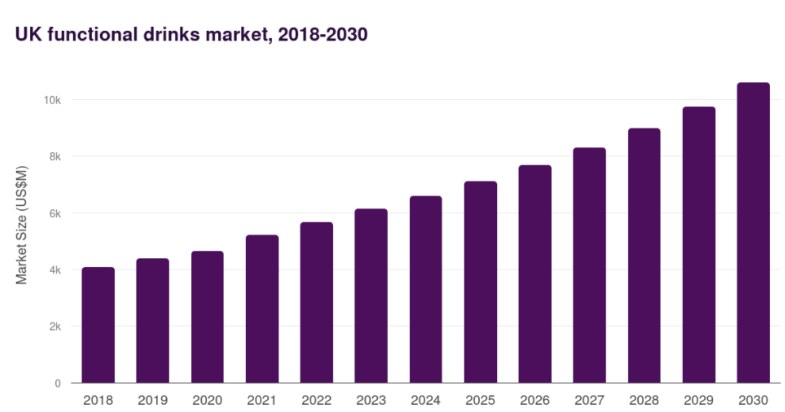
Figure 1: UK Functional Drinks Market Size
(Source: Grand View Research, 2025a)
By the year 2033, the functional drinks market in the UK is projected to have a revenue of US$ 13,235.2 million. A compound annual growth rate of 7.9% is expected for the UK functional drinks market from 2026 to 2033. Approximately 49 percent of adults aged in the UK said that they consumed a functional drink in the last three months, and food and non-alcoholic beverage prices increased by 4.5 percent in the 12 months up to December 2025, pushing consumers to trade to products perceived to have some nutritional benefit. Regulatory pressure to product formulation, such as the Soft Drinks Industry Levy, and the HFSS advertisement restrictions of October 2025, are simultaneously changing the nature of product formulation (Grand View Research, 2025a).

1.3 Scope
The present BDP is restricted to the UK off-trade retail channel (ca 85% of commerce in the juice-category) and to non-carbonated seasonal-fruits formulations. The task is to evaluate feasibility of producing seasonal fruit drink into a marketable product (year-round) and to determine the customer requirements, macro environments, and customer demand indicators that can be used to justify market entry (Albert, 2026).

1.4 Objective
- To analyse the macro-environment in the UK to transform a seasonal fruit drink into an annual product of a manufactured product using PESTLE analysis.
- To determine the functional, emotional, and social consumer jobs that were not met using the Jobs-to-Be-Done theory.
- To determine business feasibility, target markets and positioning at market entry within the UK off-trade retail channel.

2. Literature Review

2.1 PESTLE Framework
PESTEL framework- Political, Economic, Social, Technological, Legal, and Environmental - As per Yitbarek et al. (2025) the origin of the PESTEL framework can be found in the strategic analysis literature, where it is deemed one of the most thorough external macro-environmental scanning tools in the literature. It has an advantage in that it is a structured, systematic way of mapping macro-drivers that impact the business feasibility, especially within regulated types of FMCGs, like beverages. Critics like Afshar and Hussain (2025) however, suggest that without being connected with strategic implications, PESTLE may turn out to be descriptive, as opposed to analytical. PESTLE, as applied to this BDP, will be an evaluative process, linking each factor directly to the product design, sourcing, pricing, and go-to-market factors.

2.2 Jobs-to-Be-Done (JTBD) Theory
JTBD was created by Christensen et al. (2016) and posits that customers do not buy en masse, but when hired by the products to complete particular functional, emotional, and social jobs. Villaumbrosia (2024) also operationalised JTBD as a means of determining outcomes that are under-serviced and unmet needs. JTBD is especially effective in beverage innovation, as purchase reasons often go beyond the product itself, and hydration, refreshment, mood uplifting, cultural nostalgia, and the functional health benefits often coincide on a single occasion. As per Marrone et al. (2025), its limitation is that it relies on interpretive insight which is subject to subjectivity unless it is triangulated with market data. This suggestion thus combines JTBD and PESTLE to offset the customer-level analysis and system-level analysis.

2.3 Justification for Framework Selection
PESTLE and Jobs-to-Be-Done are chosen due to the overlapping of the macro-environment which is highly regulated with a very personalized moment of consumption and no single framework can define either of them. Walker (2026) stated that the PESTLE is critical, due to forward-influences affecting the UK beverage sector. The Soft Drinks Industry Levy, limitations on HFSS advertising, price sensitivity on inflation and volatility of sourcing of fruits depending on the climate the factors of which directly impact the formulation, prices and route to market. Garg (2024) pointed out that JTBD is also very important since the ability to turn seasonal drink into a product requires that the reasons behind consumer hiring such drinks must be known i.e. refreshing, nostalgia, cultural identity and functional cues regarding health reasons. Other tools such as Porters 5 Forces or Value proposition Canvas were looked at but dismissed due to being either too competitive oriented or too design oriented to use at an opportunity identifying phase. PESTLE and JTBD complement each other as neither is overlapping.

3. Methodology

3.1 Overall Approach
A secondary qualitative research design will be used in this BDP. The method is interpretive and exploration, suited to a business development background where the goal is to discover, situate and exonerate an opportunity as opposed to testing hypotheses statistically.

3.2 Rationale for Secondary Qualitative Method
There are three reasons why a secondary qualitative approach is selected. To start with, the UK beverage market has a substantial amount of quality published intelligence - IBISWorld industry reports, Mintel category reports, Statista data, ONS inflation statistics and trade press sources like BeverageDaily and FoodNavigator - which provides valid, up-to-date and commercially-based evidence (Mintel Group Ltd, 2026). Second, the time frame and resource envelope of the BDP is not allowing the large scale primary field work. Third, qualitative interpretation would be more effective when the focus is on the uncovering of the emotional and social jobs, upon which the consumption of seasonal fruit drinks is anchored which is not normally captured in quantitative surveys (Wallnoefer, Riefler and Meixner, 2021).

3.3 Data Sources
The sources will be: (i) industry and market research reports about fruit drinks, juices and category innovation: (ii) product launches, category innovations in fruit drinks and juices: (iii) regulatory measures: (iv) publicly-available consumer-behaviour data and macroeconomic data of the Office for National Statistics.

3.4 Analytical Approach
Three-step analysis will be made. PESTLE will first be used to map the macro-environmental forces that influence the UK seasonal fruit drink opportunity. Second, JTBD analysis will make sense of the functional, emotional, and social jobs that the UK consumers would like to have JTBD hired to perform (Momin, 2023). Third, the two lenses are going to be amalgamated in order to find out how to join macro-conditions and unmet customer jobs together to a feasible commercial opportunity.

3.5 Ethical Considerations and Limitations
There is a limited scope in terms of ethical considerations because the research is a secondary one: there are no human subjects involved. Nevertheless, reliability of sources, and the possible bias of the publisher in industry reports and date freshness will also be discussed in the analysis. Where feasible, every source will be triangulated in at least two publications (White, 2020).

4. Initial Market Opportunity Analysis

4.1 Market Size and Structure
In the UK, the market of Fruit Drink and Functional Beverage Production will have a size of 2.2 billion in 2025 26, 79 active players, and a five-year CAGR is 5.6%. The juice market in the UK in particular was estimated to be USD 4.39 billion in 2025 and it is set to increase to USD 4.73 billion by 2032. The supermarkets, convenience stores and online grocery are already contributing to an estimated 85% of sales in the off-trade channels, and therefore this affirms grocery retail as the dominant channel in the market that a manufactured seasonal fruit drink should take (IBISWorld, 2026).

4.2 PESTLE Analysis
Political: Obesity reduction remains a priority among UK government policy areas with the Soft Drinks Industry Levy (SDIL) still in place until 2025-26, and Treasury consultations in 2025 giving a hint that it may apply to milk-derived and high-sugar functional beverages. A low-sugar, real-fruit formulation has nonexposure to levy and complies with the national health agenda (Scarborough et al., 2020).
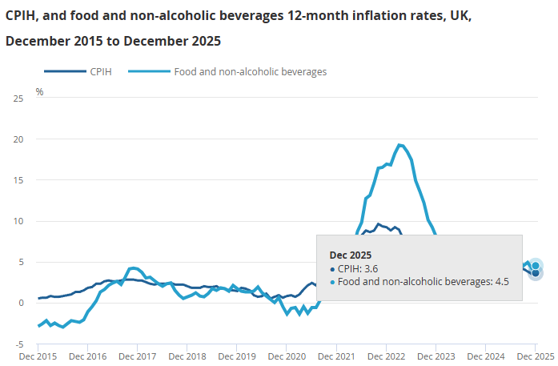
Figure 3: Food and non-alcoholic beverages inflation rate rose in December 2025
(Source: Consumer Price, 2026)
Economic: UK food and non-alcoholic drink prices were up 4.5% in the twelve months to December 2025 and juice has shifted to being a weekend, not a daily purchase, in most families. There is a consumer shift, away from either high-quality 100 per cent juice towards value plus benefit formats, which is providing middle ground between approximately £2.20 to £2.80 per unit (Consumer Price, 2026).
Social: UK adults aged 49% have used a functional drink during the last three months, and a quarter of adults (29% of all) mention the right balance of nutrients as a top choice driver in 2025. Food fervour on exotic, nostalgic and culturally-inspired tastes prefers fruit heritage throughout the season (Statista, 2025).
Technological: Aseptic filling, HP, and cold-fill preservation now provides 6-12 months of ambient shelf life without heavy additives and allows year-round production of a seasonal recipe.
Legal: Both HFSS restrictions which came into effect in October 2025 include prohibitions on paid online advertising and advertising on TV before 9pm as well as volume-promotion prohibitions on high-sugar beverages. Compliant formulation maintains all marketing freedom (GOV.UK, 2023).
Environmental: The variability in harvests due to environmental factors, especially climate, increased the input costs in citrus and berries and made them sky-high in 2025. Cost and ESG risk is reduced by blended sourcing and recyclable packaging made of PET or alumina.

4.3 Jobs-to-Be-Done Analysis
Applying JTBD, three primary customer jobs emerge:
- Functional job: Assistance with feeling energized and hydrated with something that is also able to provide a health vibe like vitamin C, antioxidants or pro-gut foods. This is in line with the most rapidly expanding sub-category of fruit juices and smoothies of out-of-home consumption in the UK (Diaz, 2025).
- Emotional job: A flavor that is reminiscent of a season, a home, or a memory. Fruit beverages are associated with intense cultural and sensorial connotations, which can hardly be matched by manufactured mainstream soft drinks (Barker, Moss and McSweeney, 2021).
- Social job: "Let me signal that I care about my health, my heritage, and the environment when I share this drink with family or friends." This positioning is backed up by clean-label, low-sugar, real-fruit credentials operating under the marketing regulations governed by HFSS.

4.4 Segmentation and Demand Signals
Health-conscious, urban 25-44-year-old consumers have the greatest potential, and specifically, Millennials and Gen z share the same functional-beverages adoption levels. In 202526, demand cues encompass the development of high-end British sparkling products incorporating real fruit and botanicals, the diversification of categories into functional shots and cold-pressed products, and the active search of "functional drinks" in terms of moving to the mainstream market. These indicators, combined, will validate an attentive consumer base and also a market structure receptive towards an entrant at a differentiated seasonal fruit drink (Cording, 2025).

5. Limitations
A number of restrictions are recognised. One, secondary sources require the analysis to adopt the assumptions and sampling frames, and sides to publication biases of the original authors; the results obtained using paywalled reports like Mintel and IBISWorld are not verifiable line-by-line (Baldwin et al., 2022). Second, only published behavioural data are used to infer JTBD outcomes, instead of validated in an interview or focus group. Third, very recent changes in consumer sentiment in 2026, may not be accurately reflected in market data. Fourth, macroeconomic uncertainty (mainly inflation, tariffs and fruit input prices) injects uncertainty in forecasting. In an effort to overcome these dangers, sources will be triangulated and findings will be presented as signs of opportunity, instead of his confident forecasts.

6. Timeframe
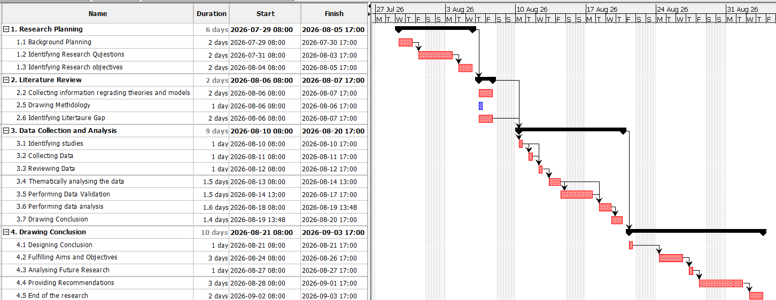
Figure 4: Gantt Chart
(Source: Self Created using Project Libre)

7. Conclusion
This analysis has given a clear analytical baseline to transform a seasonal fruit beverage into a produced, all year long product to the UK market. The PESTLE and Jobs-to-Be-Done are complementary lenses of one macro-environmental one customer-focused, the methodology has established a plausible secondary-qualitative design with high-quality industry, regulatory, and trade-press sources. The first market opportunity report establishes a rising category of £2.2 billion, positive regulatory trend to low sugar and functional formulations, and identifiably functional, emotional and social work which a seasonal fruit beverage uniquely fits. Under realistic time and resource constraints, the opportunity is a realistic and commercially viable idea which warrants advancement to the full Business Development Proposal.

Reference List
Afshar, M.Z. and Hussain, M. (2025) “Strategic Evaluation Using PESTLE and SWOT Frameworks: Public Sector Perspective,” Vol- III(Issue- I), pp. 108–114. Available at: https://doi.org/10.5281/zenodo.14854362.
Albert, J. (2026) The UK Juice Market Navigates Health Trends, Inflation Pressures, and Premium Innovation, Global Risk Community. Available at: https://globalriskcommunity.com/notes/the-uk-juice-market-navigates-health-trends-inflation-pressures-a
Baldwin, J.R., Pingault, J.-B., Schoeler, T., Sallis, H.M. and Munafò, M.R. (2022) “Protecting against Researcher Bias in Secondary Data analysis: Challenges and Potential Solutions,” European Journal of Epidemiology, 37(1), pp. 1–10. Available at: https://doi.org/https://doi.org/10.1007%2Fs10654-021-00839-0.
Barker, S., Moss, R. and McSweeney, M.B. (2021) “Carbonated emotions: Consumers’ sensory perception and emotional response to carbonated and still fruit juices,” Food Research International, 147, p. 110534. Available at: https://doi.org/10.1016/j.foodres.2021.110534.
Christensen, C. (2016) Jobs to Be Done Theory, Christensen Institute. Available at: https://www.christenseninstitute.org/theory/jobs-to-be-done/
Consumer Price (2026) Consumer price inflation, UK, Ons.gov.uk. Office for National Statistics. Available at: https://www.ons.gov.uk/economy/inflationandpriceindices/bulletins/consumerpriceinflation/december2025
Cording, J. (2025) The Rise Of Functional Beverages Among Millennials And Gen Z, Forbes. Available at: https://www.forbes.com/sites/jesscording/2025/04/13/the-rise-of-functional-beverages-among-millennials-and-gen-z/
Diaz, V. (2025) Foods That Beat Fatigue, Healthline. Healthline Media. Available at: https://www.healthline.com/health/food-nutrition/foods-that-beat-fatigue
Garg, J. (2024) Jobs to be Done Framework, Medium. Available at: https://juhigarg.medium.com/jobs-to-be-done-framework-973c580a5833
GOV.UK (2023) Restricting Promotions of Products High in fat, Sugar or Salt by Location and by Volume price: Implementation Guidance, GOV.UK. Available at: https://www.gov.uk/government/publications/restricting-promotions-of-products-high-in-fat-sugar-or-salt-by-location-and-by-volume-price/restricting-promotions-of-products-high-in-fat-sugar-or-salt-by-location-and-by-volume-price-implementation-guidance
Grand View Research (2025a) UK Functional Drinks Market Size & Outlook, 2030, Grandviewresearch.com. Available at: https://www.grandviewresearch.com/horizon/outlook/functional-drinks-market/uk
Grand View Research (2025b) UK Non-alcoholic Beverages Market Size & Outlook, 2030, Grandviewresearch.com. Available at: https://www.grandviewresearch.com/horizon/outlook/non-alcoholic-beverages-market/uk
IBISWorld (2026) Fruit Drink & Functional Beverage Production in the UK - Market Research Report (2016-2031), Ibisworld. Available at: https://www.ibisworld.com/united-kingdom/industry/fruit-drink-functional-beverage-production/692/#testimonials
Marrone, T., Cantone, L., Basile, V., Testa, P. and Cantone, G.F. (2025) “Beyond Promotions Business Model Innovation in Everyday Low Pricing Grocery,” MANAGEMENT DECISION [Preprint]. Available at: https://doi.org/10.1108/MD-01-2025-0196.
Mintel Group Ltd (2026) Global Drinks Industry Forecast: Trends, Challenges & Innovations | Mintel, Mintel. Available at: https://www.mintel.com/insights/global-drinks-industry-now-and-next/
Momin, A. (2023) PESTLE Analysis of The United Kingdom: 6 Factors Affecting the UK, Pestleanalysis.com. Available at: https://pestleanalysis.com/united-kingdom-pestle-analysis/
Nikolaidis, N. (2025) Fueled up: How energy became the must-have benefit in functional beverages | Attest, Attest. Available at: https://www.askattest.com/blog/research/fueled-up-how-energy-became-the-must-have-benefit-in-functional-beverages
Scarborough, P., Adhikari, V., Harrington, R.A., Elhussein, A., Briggs, A., Rayner, M., Adams, J., Cummins, S., Penney, T. and White, M. (2020) “Impact of the Announcement and Implementation of the UK Soft Drinks Industry Levy on Sugar content, price, Product Size and Number of Available Soft Drinks in the UK, 2015-19: A controlled Interrupted Time Series Analysis,” PLOS Medicine. Edited by B.M. Popkin, 17(2), p. e1003025. Available at: https://doi.org/10.1371/journal.pmed.1003025.
Statista (2025) Regular consumption of functional drinks in the United Kingdom 2025, by age group, Statista. Available at: https://www.statista.com/statistics/1560019/functional-drink-consumption-by-age-group-uk/?srsltid=afmboopql43xebnyughrsq2bwrk2paiv4ekyri1w2ag5ctw1qje-heaz
Villaumbrosia, G. de (2024) Jobs to Be Done Framework: A Guide for Product Teams, Productschool.com. Available at: https://productschool.com/blog/product-fundamentals/jtbd-framework
Walker, A. (2026) How regulation will reshape the UK food and drink sector in 2026, Lexology. Morton Fraser MacRoberts LLP. Available at: https://www.lexology.com/library/detail.aspx?g=1f9c8ca5-20c3-4cef-961a-4f9ba8115880
Wallnoefer, L.M., Riefler, P. and Meixner, O. (2021) “What Drives the Choice of Local Seasonal Food? Analysis of the Importance of Different Key Motives,” Foods, 10(11), p. 2715. Available at: https://doi.org/10.3390/foods10112715.
White, M. (2020) “Why Human Subjects Research Protection Is Important,” The Ochsner Journal, 20(1), pp. 16–33. Available at: https://doi.org/10.31486/toj.20.5012.
Yitbarek, T.W., Wilson, J.R.U., Evans, A. and Dehnen-Schmutz, K. (2025) “An analysis of macro-environment factors influencing the governance of tree planting schemes in Africa,” Current Research in Environmental Sustainability, 10, p. 100302. Available at: https://doi.org/10.1016/j.crsust.2025.100302.

