Data Mining
Svetoslav Anastasov Ivanov (2322727)
ACCA6026 - Data Warehousing & Data Mining
22.07.2026

Table of Contents
Introduction 2
1.1 Purpose and Practice of Data Mining 2
1.2 Dataset Description and Exploration 3
1.3 Data Pre-processing and Post-processing 5
1.4 Sample Runs and Analysis Methods 6
Logistic Regression 6
Decision Tree 7
Random Forest 8
Comparison of Classification Models 9
1.5 Business Recommendations 9
1.6 Reflective Commentary 9
Conclusion 10
References: 11

Customer Churn Prediction and Segmentation Using Weka

Introduction
Customer retention has become a major challenge for organisations as acquiring new customers is generally more expensive than retaining existing ones. Customer churn, which occurs when customers stop using a company's products or services, can significantly reduce revenue and long-term profitability. As a result, organisations increasingly rely on data mining techniques to identify customers at risk of leaving and develop effective retention strategies.
This report analyses the Customer Churn dataset using data mining techniques to predict customer churn and identify customer behaviour patterns. The dataset is explored through data preparation, visualisation and statistical analysis before applying classification and clustering methods in Weka. Several machine learning algorithms are evaluated and compared using appropriate performance metrics to determine their effectiveness in predicting customer churn. Finally, the report presents business recommendations based on the findings and reflects on the strengths and limitations of the analysis.

1.1 Purpose and Practice of Data Mining
Data mining is the process of examining large datasets to discover useful patterns, relationships and trends that may not be immediately visible through traditional reporting [1]. It combines methods from statistics, machine learning, database systems and data visualisation. The purpose is not simply to describe what has happened, but also to explain why it happened and predict what may happen in the future. Data mining therefore supports evidence-based decision-making within organisations [2].
In a retail, telecommunications or e-commerce context, data mining can be used to analyse customer purchases, spending behaviour, service usage, complaints, demographic characteristics and levels of engagement [3]. For example, clustering techniques can divide customers into groups with similar behaviours, while association analysis can reveal services or products that are frequently selected together. Classification techniques can predict an outcome such as whether a customer is likely to leave the company.
Customer churn prediction is an important application because losing an existing customer may lead to reduced revenue and increased marketing costs. A churn model learns patterns from historical customers whose outcomes are already known [4]. The trained model can then estimate the likelihood that a current customer will cancel their service. Managers can use these predictions to target retention offers, improve customer service or recommend more suitable contracts.
Data mining also supports decision-making by converting operational data into actionable information. However, model results should not replace managerial judgement. Predictions may be affected by incomplete data, class imbalance, outdated records or variables that do not fully explain customer behaviour. Consequently, data mining should be treated as a structured decision-support process involving business understanding, data preparation, modelling, evaluation, interpretation and continued monitoring.

1.2 Dataset Description and Exploration
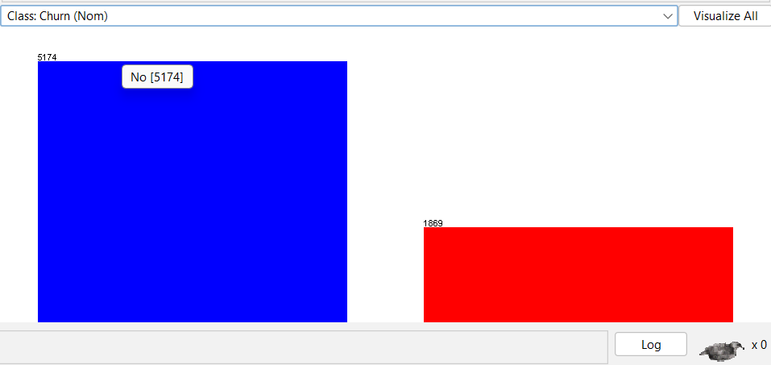
The dataset we've uploaded features 7,043 customer records, each with 21 different attributes. Every record represents a telecommunications customer. The main focus is on the Churn variable, which shows whether a customer has left the company, indicated by the values Yes or No (Figure 1).
Figure 1- Churn (Yes/No)
The dataset contains customer information such as demographics (gender, senior citizen status, partner presence, and dependents), account details (tenure, contract type, paperless billing, and payment methods), and service features (phone service, multiple lines, internet, online security, backup options, device protection, tech support, and streaming services). It also includes financial data like monthly and total charges. Note that customerID is just a unique identifier and offers no predictive value. Figures 2 and 3 display the churn rate based on contract type and monthly charges.
Most variables are nominal categorical attributes. SeniorCitizen is stored numerically as 0 or 1, even though it represents a binary category. Tenure is an integer ranging from 0 to 72 months. MonthlyCharges is a numeric value that varies from £18.25 to £118.75. TotalCharges should also be numeric, but it was imported as text because 11 records contained blank strings.
On average, customers stay for about 32.37 months, with many lasting around 29 months. Typically, monthly charges are about £64.76, though there's quite a bit of variation with a standard deviation of £30.09. The middle point for monthly charges is slightly higher at £70.35. When we treated blank entries as missing data, the overall total charges averaged around £2,283.30, with a median of approximately £1,397.48. The noticeable gap between the average and median suggests that some long-term customers have made significantly higher total payments, pulling the average upward.
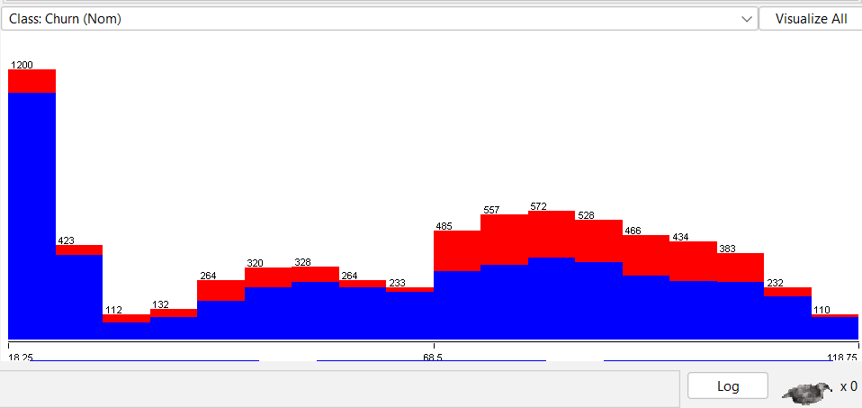
Figure 2 - Churn by monthly payment
The target variable was somewhat imbalanced. There were 5,174 non-churners, making up about 73.5% of the customers, and 1,869 churners, accounting for 26.5%. A simple model that predicts every customer as a non-churner would achieve around 73.5% accuracy. This highlights why relying on accuracy alone can be misleading.
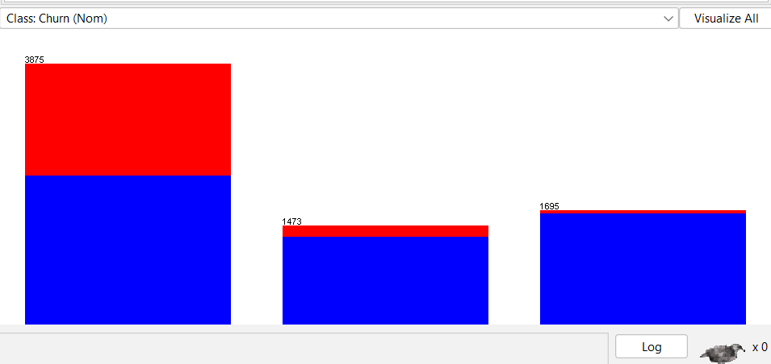
The type of contract an individual chooses can really influence their likelihood of leaving. Month-to-month plans see a higher churn rate of about 42.7%, while those with a one-year contract have a much lower rate of 11.3%, and two-year contracts are even more stable at just 2.8% (Figure 3). Customers who pay by electronic cheque tend to have a churn rate of around 45.3%. When it comes to technology, fibre-optic users are slightly more likely to stay, with a churn rate of 41.9%, whereas those without access to technical support or online security experience churn rates of approximately 41.6% and 41.8% respectively.
Figure 3 - Churn (Month-to-Month, One Year, Two Years)

These findings indicate that customers who opt for flexible contracts, certain payment options, more expensive internet plans, and limited support services tend to experience higher churn rates. Understanding these factors can help us find better ways to improve customer retention and create more satisfying experiences.

1.3 Data Pre-processing and Post-processing
Before analysing the dataset in Weka, data preparation was necessary. The initial step involved reviewing the structure, attribute types, missing values, and potential duplicates. The dataset comprised 7,043 records and lacked standard null values. However, closer inspection revealed that 11 entries in TotalCharges were blank spaces, which led to the attribute being interpreted as text instead of numeric.
Blank values mainly appeared among customers with zero months of tenure, indicating they are newly registered and haven't accumulated charges yet. One option is to replace these blanks with zero, but this assumes that a blank means no charges rather than a possible data entry error. A more cautious approach is to treat blanks as missing and fill them using median imputation. Since TotalCharges is heavily skewed by long-term, high-spending customers, the median is a better choice than the mean. This process can be carried out using Weka’s ReplaceMissingValues filter.
The customerID attribute was removed because it uniquely identifies individual customers but does not describe their behaviour. Including it could introduce noise and cause the model to learn accidental patterns that are unlikely to generalise to new customers.
Categorical variables were transformed into nominal attributes. Weka can handle these directly for algorithms like J48 and Random Forest. For Logistic Regression, Weka automatically converts nominal categories into indicator variables. If preparing data outside Weka, binary categories can be encoded as 0 and 1, and attributes with multiple categories can be represented with one-hot encoding. It's important to avoid treating unordered categories, such as payment method, as continuous numbers, as this could lead to artificial ranking relationships.
The dataset was also checked for class imbalance. About 26.5% of records represented churners. While this imbalance isn't too severe, it might encourage classifiers to favour the larger non-churn group. It's a good idea to start by training models with the original class distribution, which reflects the real business population. Afterwards, you can compare their performance with balanced alternatives to see what works best.
In Weka, class balancing can be achieved with ClassBalancer, Resample, or SMOTE, which creates synthetic minority class examples instead of duplicating existing ones. It's important to apply oversampling only to training data; applying SMOTE before cross-validation risks data leakage, leading to overly optimistic results. In Weka, this can be managed with a filtered classifier.
Feature selection helps reduce noise and discover the most meaningful customer traits. You can use the AttributeSelection filter with InfoGainAttributeEval and Ranker to achieve this. From our initial analysis, some of the most valuable attributes seem to be Contract, tenure, InternetService, MonthlyCharges, TotalCharges, OnlineSecurity, TechSupport, PaymentMethod, and PaperlessBilling, which can provide great insights.
Enhancing feature engineering can really boost understanding. For instance, you might combine service attributes into a single ServiceCount, showing how many active services a customer has. Tenure could be categorised into new, developing, or established customers. Additionally, a customer value score might be built from factors like monthly charges, total charges, and tenure. Just remember, it’s important to carefully justify and test these engineered features, as they might sometimes repeat information already captured by the original variables.
The main evaluation method was stratified ten-fold cross-validation, which helps ensure each divided group has roughly the same number of churners and non-churners. This approach gives a more dependable assessment than testing the model on the same data it trained on. Afterwards, we looked at confusion matrices, class-level precision, recall, F-measure, and ROC area, turning these results into percentages and comparison tables for easier understanding. We also examined decision-tree rules and Random Forest importance scores to pinpoint the key factors influencing churn.
For segmentation, we used K-Means clustering on standardised variables like tenure, monthly charges, total charges, number of services, and contract length. Standardisation was important because total charges had a much larger numerical scale than the other measures, and without it, they would unfairly influence the clustering. We then profiled the resulting clusters by analysing their average characteristics and churn rates.

1.4 Sample Runs and Analysis Methods
Three classification approaches were selected: Logistic Regression, a decision tree and Random Forest. These algorithms provide a useful comparison between a statistical linear model, an interpretable rule-based model and an ensemble learning method.

Logistic Regression
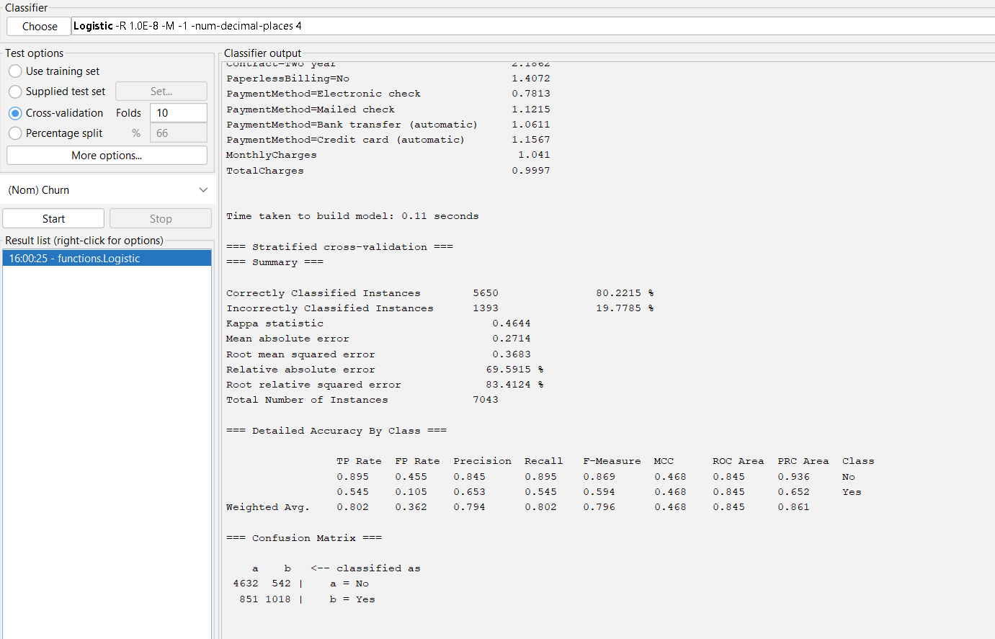
Logistic Regression estimates the probability that a customer belongs to the churn class. It was selected because the target contains two possible outcomes and because the model provides a strong, understandable baseline. Its coefficients can indicate whether particular customer characteristics increase or decrease churn likelihood.
Figure 4 - Logistic Regression
The confusion matrix was:
 | Predicted No | Predicted Yes
Actual No | 4,632 | 542
Actual Yes | 851 | 1,018
The model correctly identified 1,018 churners but missed 851. Its AUC of 0.845 indicates good ability to rank higher-risk customers above lower-risk customers. However, the recall of 54.5% means that almost half of actual churners were not identified at the default classification threshold (Figure 4).

Decision Tree
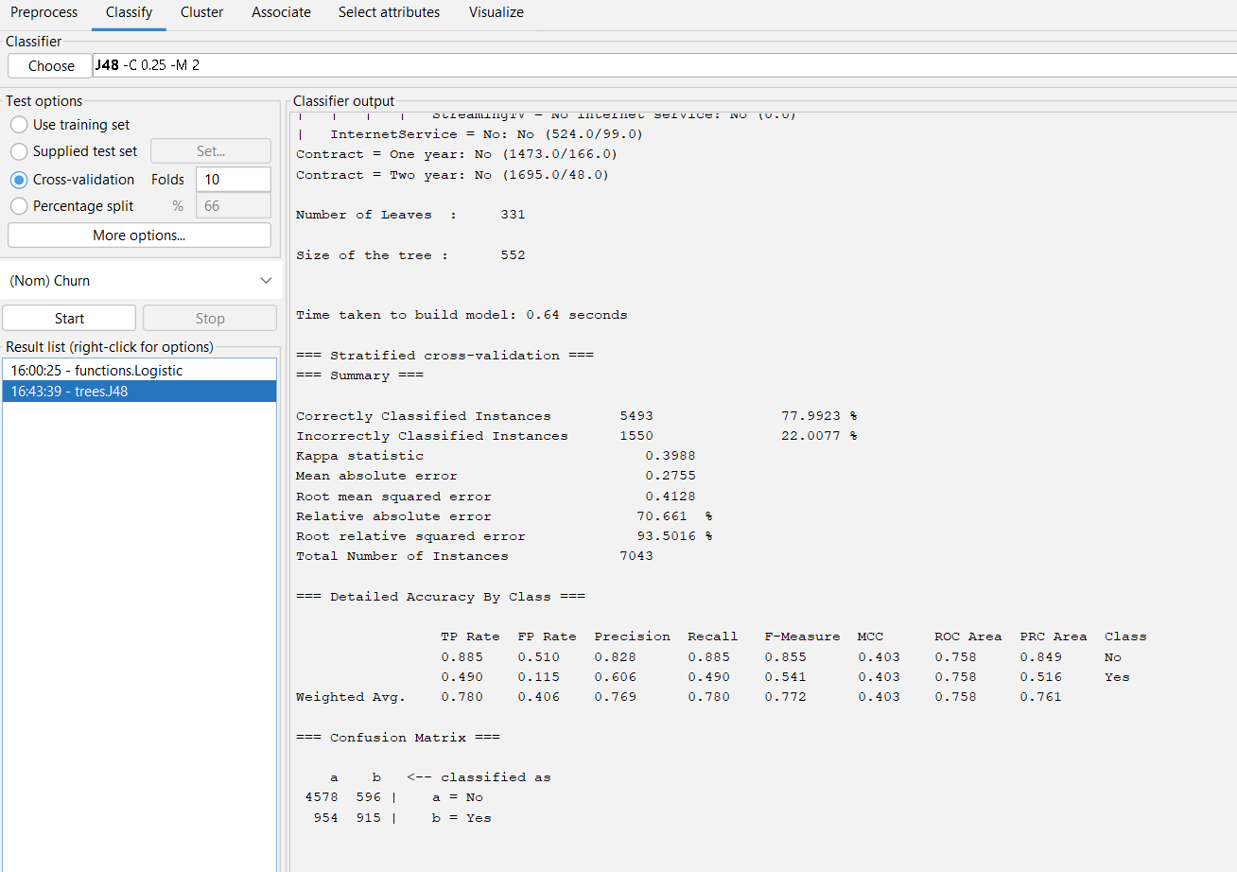
A decision tree was selected because its structure can be explained to business users. Weka’s J48 algorithm implements the C4.5 decision-tree method. It repeatedly selects attributes that create useful divisions between the churn and non-churn classes.
Figure 5 - Decision Tree (J48)

A pruned decision-tree benchmark produced approximately:
Metric | Result
Accuracy | 77.99%
Precision for churn | 60.60%
Recall for churn | 49.00%
ROC AUC | 0.758
The confusion matrix was:
 | Predicted No | Predicted Yes
Actual No | 4,578 | 596
Actual Yes | 954 | 915
The decision tree achieved slightly lower accuracy, AUC and churn recall (Figure 5) than Logistic Regression. This means it detected fewer customers who actually churned, although it also created more false-positive retention alerts. For a business where missing a churner is expensive, this trade-off may be acceptable.
The tree is also very helpful for interpretation. It likely begins by splitting data based on factors like contract type, how long the customer has been with the service, internet service type, technical support availability, and monthly charges. For example, a common high-risk profile might include customers with a month-to-month contract, short service tenure, fibre-optic internet, and no technical support. On the other hand, customers who have two-year contracts and a longer tenure are usually seen as less likely to churn, or leave, the service.

Random Forest
Random Forest builds numerous decision trees from various customer samples and randomly chosen attributes. The final result depends on the collective votes of these trees. This method was selected because ensemble models tend to minimise the instability and overfitting that can occur with a single decision tree.
The confusion matrix was:
 | Predicted No | Predicted Yes
Actual No | 4,688 | 486
Actual Yes | 921 | 948
Random Forest achieved strong accuracy and precision but the lowest churn recall among the three benchmark models. It produced fewer false-positive churn predictions, but it missed more actual churners. The model may be adjusted using class weights, cost-sensitive learning, probability thresholds or balanced training data.

Comparison of Classification Models
Logistic Regression was the strongest overall model, achieving the highest accuracy and AUC. However, the decision tree had the highest recall and F-measure for churn, so the best model depends on the organisation’s goal.
Accuracy measures correct predictions but can be misleading with imbalanced classes. Precision shows the proportion of predicted churners who actually churned. Recall shows actual churners correctly identified, important when missing high-risk customers is costly. The F-measure balances precision and recall. AUC assesses model ranking performance across thresholds.
A cost-sensitive approach could assign higher costs to false negatives, as missing a churner can lose future revenue. Managers might also use predicted probabilities instead of fixed Yes/No outcomes, dividing customers into risk groups based on retention capacity.

1.5 Business Recommendations
The organisation might find it helpful to focus on customers with month-to-month contracts, short tenure, fibre-optic internet, electronic cheque payments, and those without technical support or online-security services, as these traits were often linked to higher churn rates. Consider offering personalised deals, like temporary discounts, price guarantees, free upgrades, or loyalty rewards, especially to high-cost flexible segment customers, to encourage them to switch to one-year contracts. It’s best to target these incentives carefully, focusing on customers who are more likely to leave but also have significant long-term value.
The first months of the customer relationship appear especially important. New customers should receive structured onboarding, service checks and clear explanations of bills and contract options. Contacting customers shortly after activation may identify technical or billing problems before cancellation occurs.
The high churn rate among fibre-optic customers may indicate dissatisfaction with price, reliability or perceived value. Management should investigate complaints, service quality, regional network performance and competitor pricing rather than assuming that the technology itself causes churn.
Customers without technical support or online security could receive trial access or bundled service packages. Automatic payment methods may also be promoted as alternatives to electronic cheques.
The selected model should be integrated into a retention dashboard and refreshed regularly. Managers should monitor churn recall, campaign response, revenue saved and the cost of incentives. Retention actions should also be tested through controlled experiments so the company can distinguish genuine campaign effects from customers who would have remained anyway.

1.6 Reflective Commentary
The analysis produced effective models, all surpassing the 73.5% baseline with AUCs over 0.82, showing they could distinguish high- and low-risk customers. Logistic Regression had the best AUC, while the decision tree had the strongest churn recall and was more interpretable. Comparing multiple algorithms and using stratified ten-fold cross-validation offered more reliable results, combining individual predictions with customer profiles. However, the models missed many churners and were based on a snapshot lacking detailed customer data like complaints or reasons for churn, making relationships predictive rather than causal. The dataset was moderately imbalanced, and the probability threshold might not reflect true costs. Future work includes class weighting, tuning models systematically, and setting aside a final test set. Exploring algorithms like Gradient Boosting, adding temporal data, and working with managers to cost false positives, false negatives, and retention efforts will improve the model's financial relevance.

Conclusion
This analysis shows how data mining techniques can help predict customer churn and identify important customer groups. The results indicate that classification models like Logistic Regression and Decision Trees are quite effective for predicting churn, and customer segmentation offers helpful insights into how customers behave. Overall, the findings emphasize the valuable role of data mining as a supportive tool that can assist organizations in improving customer retention and making smarter business decisions.

References:
[1] M. K. Gupta and P. Chandra, “A comprehensive survey of data mining,” International journal of information technology (Singapore. Online), vol. 12, no. 4, pp. 1243–1257, Dec. 2020, doi: 10.1007/s41870-020-00427-7.
[2] S. M. Birjandi and S. H. Khasteh, “A survey on data mining techniques used in medicine,” Journal of diabetes and metabolic disorders, vol. 20, no. 2, pp. 2055–2071, Dec. 2021, doi: 10.1007/s40200-021-00884-2.
[3] H. N.-A. Mettle, E. H. Ayerko, and P. Appiahene, “Machine Learning–Based Customer Churn Prediction in Telecommunication Industry,” Applied computational intelligence and soft computing, vol. 2026, no. 1, Jan. 2026, doi: 10.1155/acis/8496186.
[4] I. Ullah, B. Raza, A. K. Malik, M. Imran, S. U. Islam, and S. W. Kim, “A Churn Prediction Model Using Random Forest: Analysis of Machine Learning Techniques for Churn Prediction and Factor Identification in Telecom Sector,” IEEE access, vol. 7, pp. 60134–60149, 2019, doi: 10.1109/ACCESS.2019.2914999.

