

Student Name : HARDIK SAI GADDIPATI
Student Number : 2215797
Module Name : Data base systems (ACCA7002)

Abstract

Creating a database in SQL for Abertawe Leisure Centre (ALC) to manage bookings made by their customers. Proposing a database schema using entity relationship diagram. Creating appropriate tables to store data regarding their members, instructors, classes and bookings in PostgreSQL database. Filling the database with realistic records and test the functionality of the database using stored procedures along with auditing features.

Table of Contents

1. Proposal of Database 4
2. Importance Concepts 4
2.1. Rollback 4
2.2. Commit 4
2.3. Functions 4
2.4. Triggers 4
2.5. Procedures 5
2.6. Transactions 5
2.7. Indexing 5
3. Creation of Database 5
3.1. Entity Relationship Diagram 5
3.2. Creating database and schemas 6
3.3. Creating table 6
3.4. Creating triggers 7
3.5. Creating functions 8
3.6. Features of database 9
3.6.1. Normalized to 3NF 9
3.6.2. Referral Constraints 9
3.6.3. Composite keys 9
3.6.4. Auditing feature 9
4. Performance tuning 10
5. Transactions 10

Proposal of Database
I propose a database which consists of two schemas, and they are ALC and audit. In ALC there will be 6 tables and they are a table which contains the details of the member along with a member ID, the table which contains the details of an instructor, details of the class, details of membership plan, a booking stable which contains the details of which member takes which class along with the date and the assigned instructor and a table to keep track of viable classes. In audit schema we have audit logs which store the details of a particular table whenever any modification occurs.

Importance Concepts

Rollback
Rollback is a tool used to undo any changes made to a database. It can be helpful when someone has accidentally deleted or changed the data, as it allows them to restore the database to what it was before. This is especially important because some changes are irreversible, like when data is deleted. It also helps protect the security and accuracy of the data, as it can undo any malicious actions taken. Additionally, it can help to identify issues or errors in the database.

Commit
Commit in SQL is a command used to make sure that our changes are saved and implemented in the database. Once the changes are committed, the database is updated with the changes so that the changes are permanent. Without commit, the database would not be updated, and the changes would not be saved this only works in a transaction. Without commit, we would have no way to know if the changes have been successfully applied or not.

Functions
Function in SQL are used because it allows us to perform actions on database instantaneously. It can be used to perform complex operations such as calculations, sorting and complex. We can use functions to access data across any table in the database which makes it important in certain cases.

Triggers
As the name suggests triggers are like functions but in order to activate the commands inside a trigger block, we need to satisfy the trigger condition that may include a specify type of query by a specific user. Triggers make auditing very easy; they can also be used as complex integrity constraints too.

Procedures
procedure is a group of SQL statements which are stored in the database so that they can be executed all at once. They can be used to restrict access to sensitive data, and they can be reused without slowing the database as they are already compiled and stored inside the database.

Transactions
Transactions are used to enable multiple users to access the database at the same time without complications like concurrency issues. The transaction is read onto the database only after commit is called which reduces number of disk reads and writes therefore increasing performance.

Indexing
Indexing is a method used to enable faster searching operations on a column. This is done by creating a index file which contains list of keys and pointers to the actual data records in table. This can significantly improve the performance of a query as it reduces the time to retrieve the data from an indexed data

Creation of Database

Entity Relationship Diagram
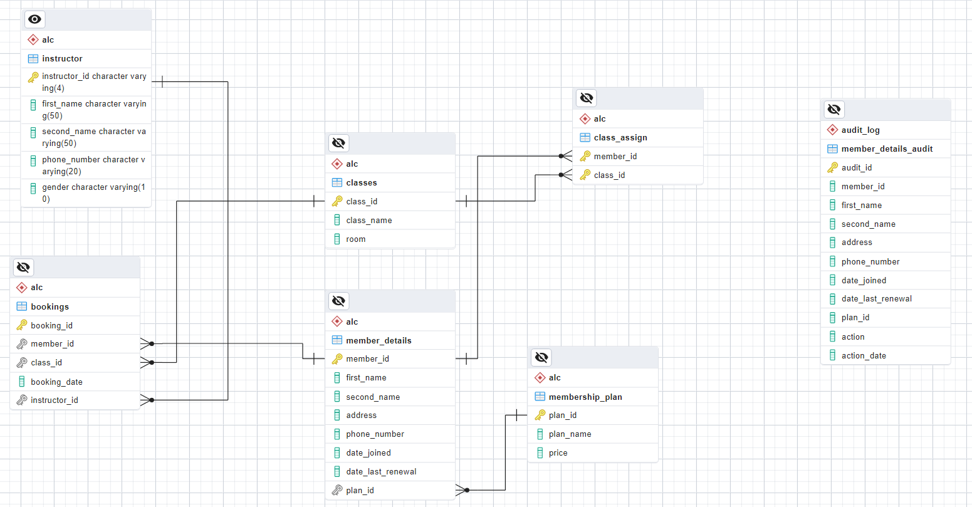

Creating database and schemas
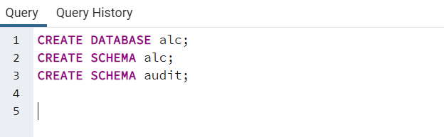

Above query creates the database ‘alc’ and two schemas ‘alc’ and ‘audit’. This is done using PGadmin4 in PostgreSQL.

Creating table
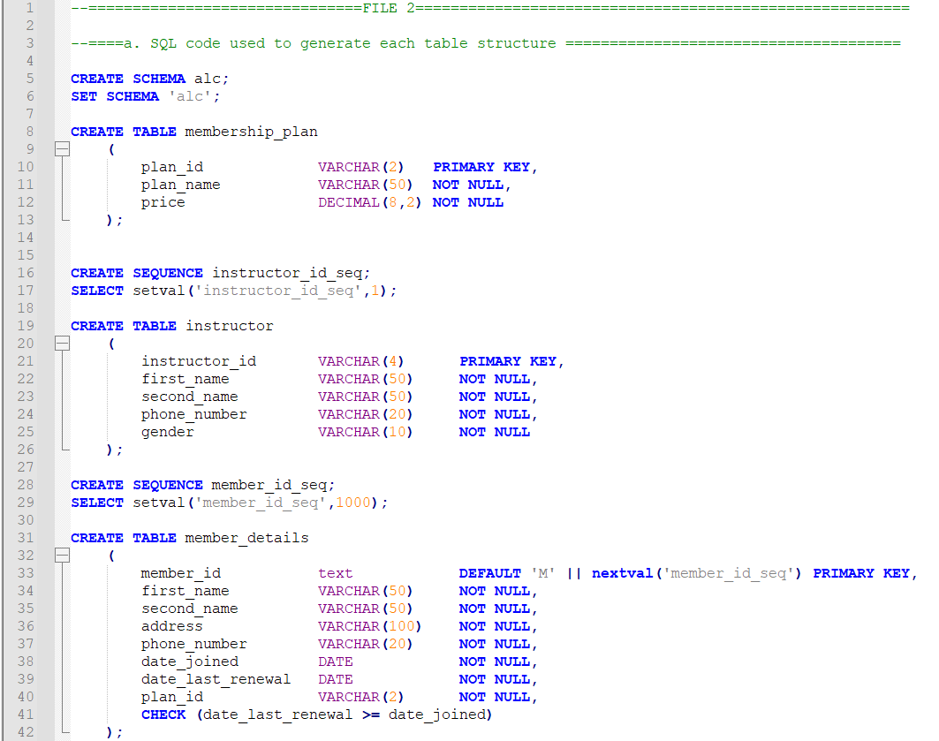

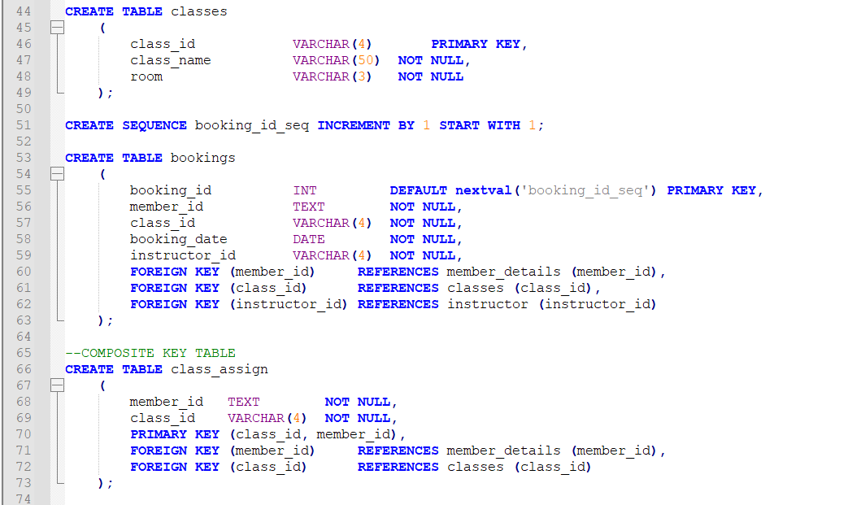

In figures we have SQL commands to create the schema ‘alc’ and tables inside that schema. All the tables have at least on primary key and there are 3 sequences which are “instructor_id_seq”, “member_id_seq” and “booking_id_seq”.

Creating triggers
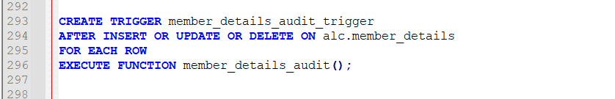

The commands used in the above figure are used to create a trigger named member_details_audit_trigger which s set to activate upon using insert delete and update commands o the member_details table and for each row created in this table member_details_audit function is executed.

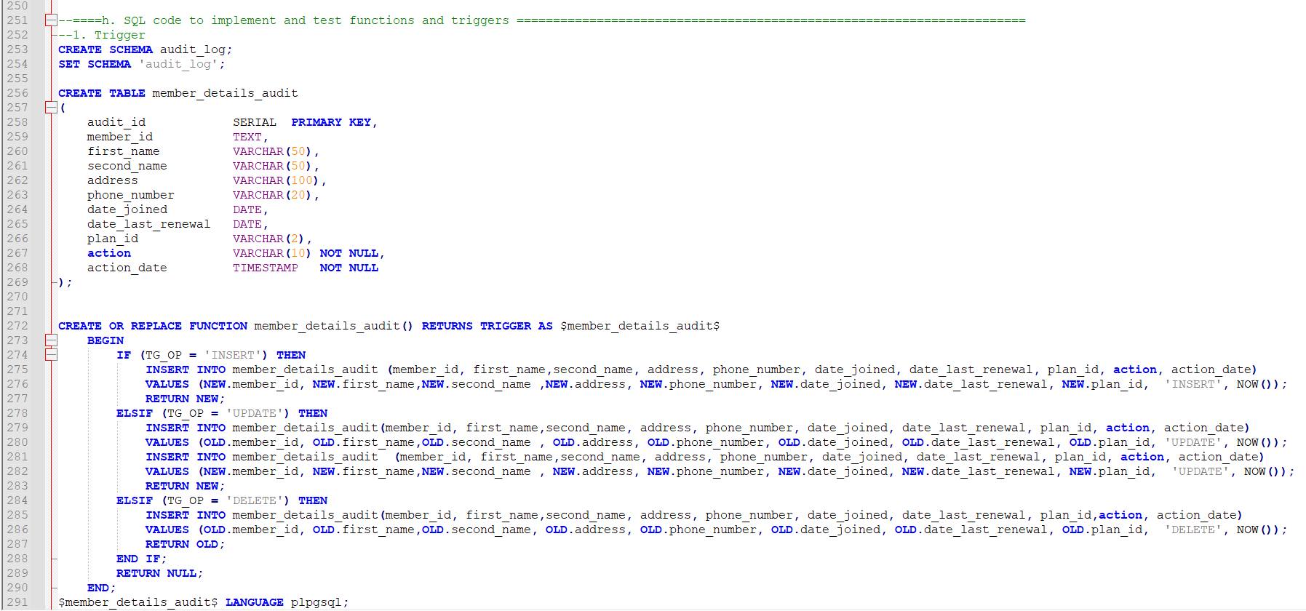

The figure shows that a new table member_detailks_audit is created in audit schema. This table has same columns and datatypes as input with 2 additional columns which store the action taken along with timestamp. The function member_details_audit has if else statements with insert, update and delete as conditions. When rows inserted or deleted to member_details table will be copied into the members_details_audit table and upon updating both the new and old rows will be added to the audit table.

Creating functions
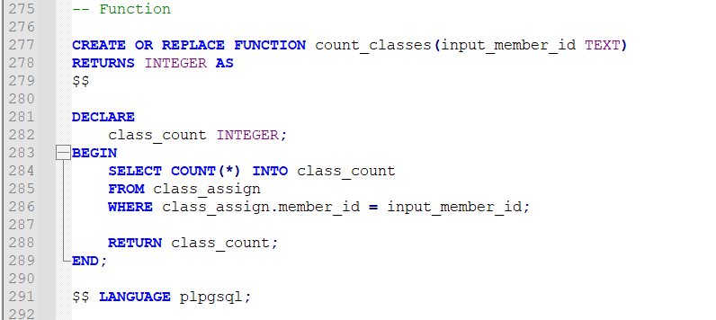

In above figure we create a function named count_classes using create function and the input is the member id from member_details table. The function counts number of times the id is repeated in that table since it the class id and member id are a composite key, they only exist in a unique combination so counting the member id is enough.

Features of database

Normalized to 3NF
        - To achieve first normal form, we ne need to make sure a single cell must contain only a single value also known as atomicity and every table must contain at least a single primary key. There should not be any duplicate rows or columns and no two rows should be same (primary key constraint does not allow this to happen).
        - In second normal form we must make sure all non-key attributes are totally dependent on the primary key.
        - In third normal form transitive dependency should not occur i.e. every non key attribute value should only be dependent on the primary key of that table

Referral Constraints
        - Foreign key, it is a referral constraint which checks the value inserted into the foreign key, exist inside referred table as a primary key. This vastly improves the integrity of data.
        - Check constraint, this is used to impose rules as to which type of values are to be inserted into the table. We can avoid SQL injection attacks in most cases by using a check constraint.
        - Not Null, this command is used when the value cannot be null in a table.

Composite keys
Composite keys are used to maintain unique rows when individual columns may repeat the values. The table class_assign is made of two columns, both member_id and class_id together make a composite key. By making them a composite key we can make sure that combination of these columns remains unique.

Auditing feature
As mentioned in 3.4 this feature is created using triggers and functions to create and automatically update the audit table. The audit table stroes the changes made on the member details.

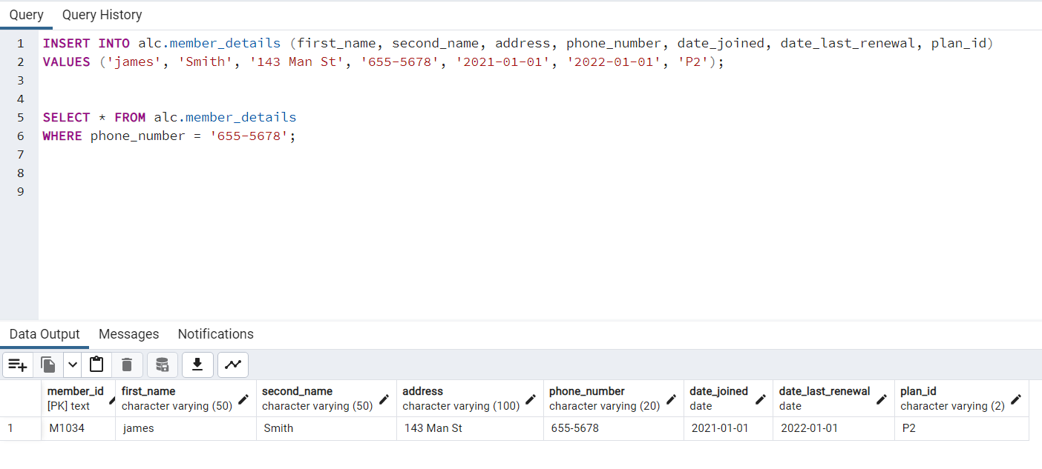
The above query inserts a new row in member details activating the audit function the figure below shows that the action is recorded in the audit table
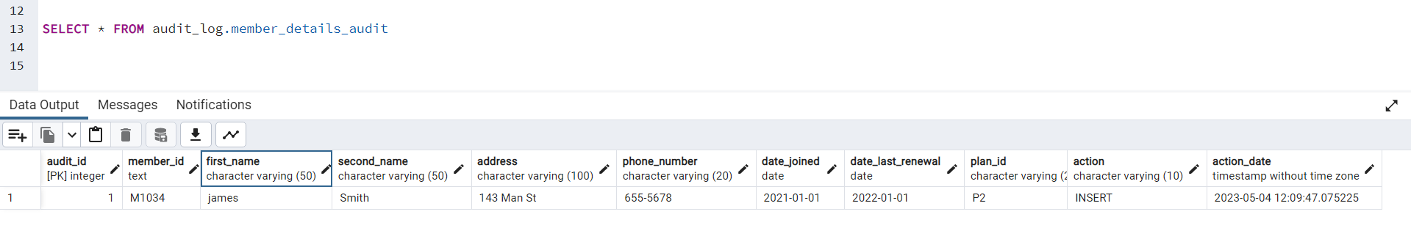

Performance tuning
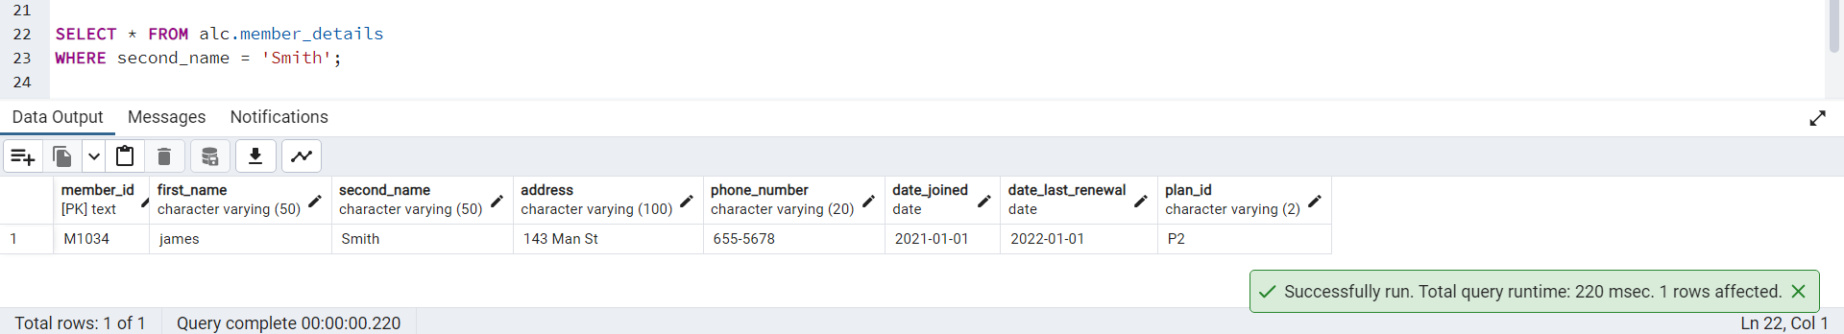
The query took 220 milli seconds and after adding an index to the second name column the query time is reduced to 118 milliseconds.
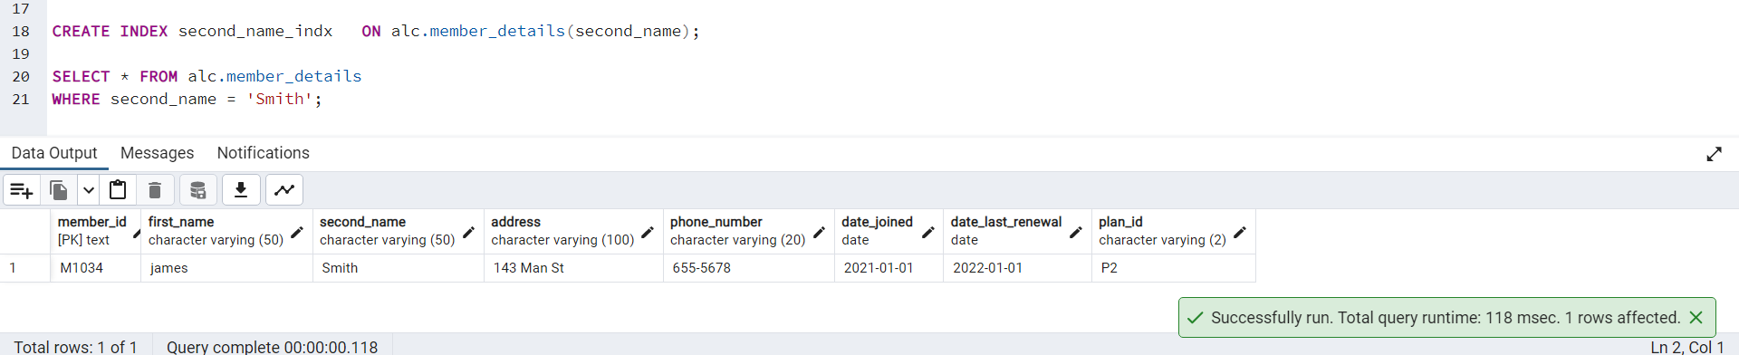

Transactions


