

Institute of Inner-City Learning Birmingham Campus

BSc (Hons) Health and Social Care
DISSERTATION

Disclaimer
This document was correct at the time of publication. The Module Coordinator reserves the right to modify any statement, if necessary, make variations to the content or methods of delivery of programmes of study, to discontinue programmes, or merge or combine programmes if such actions are reasonably considered to be necessary by UWTSD. Every effort will be made to keep disruption to a minimum, and to give as much notice as possible. An electronic copy of this handbook can be found on the Moodle page for the module.

DECLARATION
This work has not previously been accepted in substance for any degree and is not being concurrently submitted in candidature for any degree.
Signed……
………Francis.Annor……………………………
Date……25/07/2025…………………………………………
STATEMENT 1
This dissertation is being submitted in partial fulfilment of the requirements for the degree of BSc.
Signed……Francis.Annor……………………………………….
Date…………25/07/2025……………………………………
STATEMENT 2
This dissertation is the result of my own independent work/investigation, except where otherwise stated. Other sources are acknowledged by footnotes giving explicit references. A bibliography is appended.
Signed………Francis.Annor……………………………………
Date……………25/07/2025…………………………………
STATEMENT 3
I hereby give consent for my dissertation, if accepted, to be available for photocopying and for interlibrary loan, and for the title and summary to be made available to outside organisations.
Signed…………Francis.Annor……………………………………
Date………………25/07/2025…………………………………
STATEMENT 4
I hereby give consent for my dissertation, if accepted, to be available on the university’s IT system to those who have consent to use the system.
Signed………Francis.Annor………………………………………
Date……………25/07/2025……………………………………
Title
What are the Barriers to Physical Activity and Healthy Eating in BAME Individuals with Type 2 Diabetes?
Your Full Name: Francis Annor
Student Number: 2213838
Dissertation submitted as part of the requirements for the award BSc (Hons) Health and Social Care

ACKNOWLEDGEMENTS
I offer my sincerest thanks to God Almighty, whose divine grace, mercy, and guidance have been instrumental to my success over these past three years. It is through His strength and favour that I have attained this significant milestone.
I extend my heartfelt appreciation to my cherished family. To my wife, Adonoh Beatrice Alloua, your unwavering love, patience, and support have been the foundation of my resilience. To my daughter, Whitney Annor, and my son, Egya Nyanzu Blaychie Annor, your encouragement and joyful presence have served as a formidable source of motivation, propelling me forward even amidst challenges.
Special thanks are due to my project manager, Harries Chloe. Your astute guidance, constructive feedback, and steadfast encouragement have rendered my work on this project not only fruitful but also immensely enjoyable. I also extend my heartfelt appreciation to all my lecturers who have supported me throughout this academic journey, with recognition to Joanne Davies and Parese Ahmed. I was continually impressed by the professionalism, patience, and dedication that both of you exhibited, making my final year at the University of Wales Trinity Saint David a truly enriching experience.
I am equally grateful to my workplace manager, Lauren Burgin, and her deputy, Molly Ellis-Scafe, for their understanding and flexibility. Your support in permitting me to adjust my working hours has played a crucial role in harmonising my academic and professional obligations.
Lastly, I acknowledge my fellow course mates, whose companionship and collective spirit have fostered a nurturing environment that significantly enhanced our learning experience. I celebrate and congratulate each of you as we collectively reach this academic milestone.

ABSTRACT
This research explored the cultural, socioeconomic, and environmental obstacles impacting physical activity and nutrition in BAME individuals with type 2 diabetes to inform the development of culturally competent healthcare policies and practices in the UK. The research employed a thematic literature review as its methodological framework, concentrating on published peer-reviewed studies pertinent to the subject matter. Articles were meticulously selected utilising structured Boolean search strategies and assessed for credibility through the CRAAP test. A thematic analysis was subsequently performed to discern and interpret recurring patterns and salient themes within the literature. The analysis unveiled three predominant themes that significantly influence lifestyle behaviours: Access and Structural Barriers, Cultural Identity and Values, and Knowledge and Education. These themes summarised a spectrum of challenges, including unsafe or inaccessible environments, culturally incongruous healthcare services, a deficiency of culturally competent professionals, and insufficient health literacy. The research concluded that these barriers contribute to substandard disease management, thereby underscoring the urgent necessity for more inclusive and culturally attuned interventions. While the study yielded valuable insights, its dependence on secondary data posed limitations, notably the absence of primary, lived-experience data from BAME individuals. This may curtail the depth of cultural nuance captured and restrict the generalisability of the conclusions drawn. Furthermore, systemic issues such as underfunding and institutional resistance were identified as persistent barriers to effective implementation. Considering the findings, the study advocates for culturally tailored, community-centric interventions that engage faith leaders, utilise peer educators, and co-design health education initiatives with BAME communities, alongside structural adaptations to existing services such as the NDPP. These recommendations bear significant practical implications for health and social care policy, practice, and education. They accentuate the imperative to integrate cultural competence and community collaboration into diabetes prevention and care strategies, ensuring that future interventions are more equitable, effective, and responsive to the diverse needs of ethnic minority populations.

Table of Contents
Disclaimer 1
Table of Contents 5
CHAPTER 1 8
Introduction 8
1.1a Overview of the Topic 8
1.1b Aim of the Dissertation 8
Definitions and Terminology 9
1.2a Key Definitions: 9
1.2b Acronyms and Abbreviations 9
Rationale for Research 10
1.3 Purpose of the Research 10
1.3b Identified Problems and Research Gaps: 10
1.3c Detailing research’s contribution to solving these problems. 11
1.4 Aim and Objectives 11
1.4a Research Aim: 11
1.4b Research Objectives: 11
Conclusion 12
CHAPTER 2 13
Introduction 13
2.1a Purpose of the Chapter: 13
Historical Background 13
2.2b Development of the Topic: 13
2.2c Significant Historical Figures and Contributions: 14
Theoretical Background 15
2.3a Key Theories and Concepts 15
2.3b Application of Theories 15
2.3c Critical Evaluation 16
2.3d Debates and Controversies 16
International Context 17
2.4a Global Perspective 17
2.4b Comparative Analysis: 17
2.4c Case Studies: 18
National/Local UK Context 18
2.5a UK Perspective 18
2.5b Policy and Regulation 19
2.5c Local Context 19
Conclusion 20
CHAPTER 3 21
Methods and Search Strategy 21
3.1 Introduction 21
3.2 Search Strategy 21
Searching for Information 21
Research Validation 22
Inclusion and Exclusion Criteria 22
Analysing Research 23
Ethical Considerations 23
3.8 Chapter Conclusion 23
CHAPTER 4 25
Findings and Discussion 25
4.1 Introduction 25
4.2 Thematic Analysis 25
4.3 Theme 1 26
Access and Structural Barriers to support 26
Definition 26
Background Information 26
Impact on Research Question 27
Statistical Information 27
Theories, Policies, and Legislation 28
Implications 29
Examples from my Articles 29
Connections to Other Themes 30
4.4 Theme 2 30
Definition 30
Background Information 31
Impact on Research Question 31
Statistical Information 32
Theories, Policies, and Legislation 32
Policy and Legislation: 33
Implications 33
Examples from my Articles 34
Connections to Other Themes 34
4.5 Theme 3 35
Knowledge and Education 35
Definition 35
Background Information 35
Impact on Research Question 36
Statistical Information 36
Theories, Policies, and Legislation 37
Policy and Legislation: 37
Implications 38
Examples from my Articles 38
Connections to Other Themes: 38
4.6 Chapter Conclusion 39
CHAPTER 5 40
Conclusion and Recommendations 40
5.1 Overall Conclusion 40
5.2 Recommendations 40
5.2.1 Community-Led, Culturally Tailored Health Initiatives for BAME Individuals with Type 2 Diabetes (1). 40
5.2.2 Develop Culturally Tailored Community-Based Interventions (2): 41
5.2.3 Co-Design Culturally Tailored Health Education with BAME Communities (3): 42
6.0 CHAPTER 6 43
References and Appendices 43
6.1 References 43
6.2 Appendices 53
Figure 1 53
Figure 2 55
Figure 3a 59
Figure 3b 60

CHAPTER 1

Introduction

1.1a Overview of the Topic
The barriers to physical activity and healthy eating for Black, Asian, and Minority Ethnic (BAME) individuals with type 2 diabetes are a major public health issue needing further research. People from BAME backgrounds experience disproportionately high rates of type 2 diabetes and face specific difficulties managing the condition. Understanding and overcoming these obstacles is crucial for improving health in this population.
The world is facing a diabetes epidemic (Please, reference appendix Figure 1 for further information). In the UK, over 4.3 million people have diabetes (mostly type 2), and another 2.4 million are at considerable risk (Diabetes UK, 2023b). This illness is related to poor lifestyle choices, according to researcher Spruijt-Metz et al. (2014). BAME individuals develop type 2 diabetes younger and at lower BMIs than White British people (Goff, 2019). Harrison (2014) indicates that South Asians and Black Africans/Caribbeans face a greater risk due to socioeconomic and healthcare disparities. Diabetes diagnosis and management are suboptimal for historically marginalised groups due to healthcare barriers.
Modern public health challenges remain, notwithstanding cultural considerations (Resnicow et al., 1999). Raleigh (2023) noted health disparities, particularly lower physical activity among BAME populations. COVID-19 highlighted minority health disparities, requiring focused healthcare that addresses lifestyle barriers (Kerschbaumer et al., 2023).

1.1b Aim of the Dissertation

This research seeks to understand why BAME people with type 2 diabetes do not engage in physical activity and healthy eating to improve interventions for better health.
The attainment of healthy living is hindered for ethnic minority populations with type 2 diabetes by socioeconomic inequalities, cultural variables, and constrained resources. This study will explore these challenges, suggest solutions, and emphasis culturally sensitive interventions to improve health outcomes. Ultimately, I hope this work will lead to better health outcomes and reduced health inequalities in diabetes care for BAME groups.

Definitions and Terminology

1.2a Key Definitions:
Barriers are hindering access to necessary healthcare and support, including physical, economic, social, cultural, systemic, psychological, and technological aspects (Care Learning, 2024). Physical Activity: is any bodily movement produced by skeletal muscles that results in energy expenditure (World Health Organisation, 2024). Healthy Eating: Means eating a variety of foods in the right proportions and consuming the right amount of food and drink to achieve a healthy body weight (NHS, 2022; NHS Wales, 2024). Type 2 Diabetes: is where the body’s insulin either does not work properly or is not producing in-sufficient amounts (NHS, 2023).
Research on health outcomes focuses on physical activity, healthy eating, barriers, and type 2 diabetes. Obstacles to physical activity and healthy eating are barriers. To reduce the risk of chronic diseases, including type 2 diabetes, physical activity is crucial. A healthy diet is crucial for blood sugar control and preventing insulin resistance. Type 2 diabetes is characterised by high blood sugar levels. Investigation of these factors assists in developing programs for health promotion and disease prevention.

1.2b Acronyms and Abbreviations

BAME: Black, Asian, and Minority Ethnic
BMI: Body Mass Index
COM-B: Capability, Opportunity, Motivation = Behaviour
HBM: Health Belief Model
HEAL-D: Healthy Eating and Active Lifestyles for Diabetes
HFFI: Healthy Food Financing Initiative
NDPP: National Diabetes Prevention Programme
NHS: National Health Service
SEM: Social Ecological Model
UK: United Kingdom
WHO: World Health Organisation
AIHW: Australian Institute of Health and Welfare
CASP: Critical Appraisal Skills Programme

Rationale for Research

1.3a Purpose of the Research
The effective management of type 2 diabetes among BAME individuals is significantly hampered by factors such as inadequate access to affordable, culturally relevant, nutritious food, as well as language and cultural barriers (Zeh et al., 2014). The presence of these impediments may contribute to less-than-optimal glycaemic control, decreased adherence to prescribed treatments, and reduced engagement in health-promoting behaviours, ultimately leading to a worsening of diabetes-related complications. The socioeconomic impact of suboptimal diabetes management within Black, Asian, and minority ethnic groups is substantial, including direct healthcare costs and indirect costs from reduced workforce participation. The purpose of this study is to analyse the obstacles hindering the management of type 2 diabetes among Black, Asian, and minority ethnic populations to lessen health inequities and economic strain.
A culturally sensitive approach to healthcare, integrating behavioural change models within intervention design to encourage physical activity and healthy eating, is advocated by Katangwe-Chigamba et al. (2024). The implementation of targeted strategies is essential to optimise health outcomes, mitigate financial burdens on healthcare systems, and promote socioeconomic equity.

1.3b Identified Problems and Research Gaps:

Maintaining consistent exercise and healthy eating habits is frequently challenging for those of BAME origin with type 2 diabetes (Huffman and Vaccaro, 2012). A study found that 53% of South Asian participants with diabetes did not follow a diabetic diet (Kasturia et al., 2018). Disease management challenges may arise from cultural norms, socioeconomic inequalities, and resource scarcity (Caballero, 2018; Gumber and Gumber, 2017). Lee, Cardel and Donahoo (2019) report that 27% of low socioeconomic groups, disproportionately from ethnic minorities, had insufficient physical activity and poor diabetes control.

1.3c Detailing research’s contribution to solving these problems.

Prioritising support for BAME individuals with type 2 diabetes to adopt active lifestyles and healthy diets is crucial for their health and well-being within health and social care (Huffman and Vaccaro, 2012). By confronting these challenges, healthcare providers and policymakers can develop effective interventions to promote healthier behaviours and mitigate the effects of diabetic complications within these communities (Gumber and Gumber, 2017). This research addresses a gap in the current body of research by investigating the distinctive hurdles encountered by minority ethnic communities with type 2 diabetes and proposing tailored interventions to improve their health outcomes (Lirussi, 2010).

1.4 Aim and Objectives

1.4a Research Aim:

This research aims to determine and explain the obstacles to physical activity and nutritious eating habits in BAME individuals with type 2 diabetes, guiding the creation and implementation of interventions that enhance wellness and disease management within these communities.

1.4b Research Objectives:

The present study will analyse the impediments to exercise, and healthy eating experienced by BAME populations affected by type 2 diabetes. Cultural, socioeconomic, and environmental considerations limit the extent of their engagement. This study will examine existing literature concerning the effect of stumbling block on BAME individuals with type 2 diabetes, including but not limited to food insecurity, restricted physical activity, and other relevant health determinants. A thematic literature review will critically evaluate interventions aimed at improving physical activity and diet among type 2 diabetic patients within BAME populations, focusing on efficacy and potential improvements. Future research and intervention may explore these possibilities. Recommendations emphasis enhanced food access, increased physical activity among BAME individuals, and improved diabetes management within this population.

Conclusion

This research examines the cultural, socioeconomic, and environmental factors hindering physical activity and healthy eating among BAME individuals with type 2 diabetes. These difficulties contribute to poor disease management and health disparities. The study aims to identify these obstacles and propose culturally sensitive interventions to enhance health outcomes. A thematic literature review will assess existing strategies and recommend improvements. The research addresses gaps in understanding the unique challenges faced by BAME communities, emphasising the need for tailored, effective interventions to reduce health inequalities and improve diabetes management.
The next chapter will introduce the groundwork for this dissertation by providing background information and analysis. First, it introduces the subject; then; it provides historical context on type 2 diabetes management within BAME communities. Understanding health behaviours requires examining behavioural and social factors through theoretical frameworks. International and national contexts are examined in this chapter, revealing global and UK-specific hurdles and solutions.

CHAPTER 2

Introduction

2.1a Purpose of the Chapter:

The upcoming chapter seeks to explore the specific difficulties to physical activity and nutritious eating encountered by BAME individuals with Type 2 diabetes. It will employ theoretical frameworks to delve into behavioural and social determinants, scrutinise global and UK-specific hurdles, and assess the efficacy of interventions. This groundwork will pave the way for identifying pragmatic solutions in the subsequent chapters.
This chapter establishes the foundation for the research by scrutinising historical, theoretical, and contextual elements impacting physical activity and nutritious dietary habits in BAME individuals with type 2 diabetes. It digs into behavioural and societal determinants using established theoretical frameworks and furnishes a comprehensive comprehension of the obstacles encountered. Through an exploration of global and UK-specific concerns, interventions, and existing deficiencies, this chapter sets the stage for an intricate analysis of impediments and prospective resolutions in subsequent chapters.

Historical Background

2.2b Development of the Topic:
The research topic concerning impediments to physical activity and nutritious eating among BAME individuals with type 2 diabetes stems from the worldwide prevalence of type 2 diabetes, which disproportionately impacts ethnic minority cohorts due to genetic, environmental, and socioeconomic determinants (Patel et al., 2016).
Public health studies underscore the significance of social determinants, such as income, education, and cultural ideologies, in shaping health-related behaviours (Braveman and Gottlieb, 2014). The SEM and HBM frameworks elucidate the numerous factors that influence lifestyle decisions (Glanz, 2022). Research conducted in the United Kingdom unveils systemic challenges, underscoring the necessity of customised interventions tailored to BAME communities (Katangwe-Chigamba et al.,2024).
Pivotal milestones incorporate the acknowledgment of health inequalities in the 1970s to1980s, the proclamation of the St Vincent Declaration in 1991, the accentuation on frameworks focusing on social determinants of health during the 2000s, and the implementation of evidence-based diabetes prevention programs from 2018 to 2020 (Ariel-Donges et al., 2019; Braveman and Gottlieb, 2014; Leese, 1995). The emergence of the COVID-19 pandemic has laid bare health inequities prevalent in BAME populations, underscoring the imperative to address hindrances to adopting healthy lifestyles (Keys et al., 2021). These advancements characterise a transition towards comprehending the sociocultural and environmental factors in managing diabetes, with ongoing research concentrating on interventions customised to diverse cultural contexts (Wit et al., 2020).

2.2c Significant Historical Figures and Contributions:
Researchers studying physical activity and healthy eating barriers in BAME type 2 diabetics include leading experts such as Sir Michael Marmot, whose work focuses on health disparities. His 2010 Marmot Review highlighted the critical importance of social factors in influencing health (Local Government Association, 2010; Marmot, 2010). Reducing diabetes in BAME groups requires addressing systemic inequalities (Gumber and Gumber, 2017). Professor Kamlesh Khunti, a top scholar in diabetes and primary care, focuses his work on enhancing diabetes prevention and management within ethnic minority populations (Gumber and Gumber, 2017). His academic investigations guided the development of clinical guidelines and individualised interventions that cater to the distinct needs of BAME populations (Gumber and Gumber, 2017). Diabetes UK strongly supports awareness, prevention, and comprehensive care for diabetes (Diabetes UK, 2017).
These groundbreaking reports raise awareness and shape national diabetes management strategies for diverse populations (NHS England, 2016a). Their deep understanding of how social factors affect diabetes risk stimulated focused public health programs and influenced the NHS Diabetes Prevention Program (NHS England, 2016a). Leading figures and organisations have greatly advanced our knowledge of the cultural, social, and economic barriers BAME individuals with type 2 diabetes face in adopting healthy habits (Goff, 2019). Their work resulted in new policies, enhanced public health, and community programs. The focus of research on BAME populations has evolved; it is now holistic, examining the intricate web of factors shaping health behaviours, and not just clinical ones (Ajayi, 2021).

Theoretical Background

2.3a Key Theories and Concepts

Bronfenbrenner’s SEM illustrates how interconnected individuals, and their surroundings are at different levels, influencing behaviour. Culture, family, social networks, healthcare, and government regulations all play a role in shaping the physical activity and eating habits of BAME communities (Campbell, 2025). The HBM clarifies health behaviour influences by examining perceived risks and benefits, highlighting challenges faced by BAME individuals (Vazini and Barati, 2014).
Addressing cultural differences is crucial for effective diabetes management; culturally competent and equitable healthcare ensures all communities receive fair and appropriate care. This research is based on SEM and HBM (Wilkinson et al., 2016). Unlike HBMs, which emphasis on internal drives, SEM analyses external influences on actions. Combining these theories provides a complete picture of the factors influencing physical activity and diet in BAME people with type 2 diabetes (Alyafei and Easton-Carr, 2024). To better assist BAME communities in making healthy choices, we must tailor our strategies to their cultural contexts.

2.3b Application of Theories
The SEM examines individual-environment interactions across various levels. It will help overcome obstacles faced by BAME people with type 2 diabetes. Using the SEM, patients, leaders, and professionals developed the UK’s African and Caribbean communities HEAL-D program to pinpoint diabetes self-management obstacles (Moore et al., 2019). Behaviour changes techniques within the program facilitated healthful behaviour changes (MacPherson et al., 2020).
Individual perceptions of health risks and benefits drive health behaviours, which are central to the HBM (Gunhu, 2025). It helps explain the challenges different ethnic groups face in managing diabetes (Gunhu, 2025). Using the HBM, researchers in Zimbabwe investigated barriers to type 2 diabetes management within the Karanga ethnic group. Peer pressure, diet, cultural norms, and insufficient family support negatively impacted glucose management and self-care (Gunhu, 2025).
Interventions focused on UK minority ethnic groups can utilise the COM-B and SEM models. Culturally, specific programs promoting better health, consider each community’s social circumstances, beliefs, and tradition which show SEM and HBM can successfully address the causes of inadequate physical activity and diet in BAME individuals who have type 2 diabetes (Katangwe-Chigamba et al.,2024). To effectively help these populations, interventions need to account for their cultural norms, family dynamics, social support, and healthcare access (Hechanova, Ellis, and Bunagan, 2021).

2.3c Critical Evaluation
SEM analyses the complex interplay between individuals and their environments at multiple levels: individual, interpersonal, organisational, community, and policies to identify obstacles and how to overcome them (Campbell, 2025). Furthermore, SEM cultivates lasting, systemic shifts by tackling underlying structural and environmental issues, not just individual behaviours (Caperon, Saville and Ahern, 2022). In short, diverse populations are better served by culturally inclusive models that reflect community values, norms, and beliefs (Watson-Thompson et al., 2022).
Turning the SEM’s wide-ranging ideas into real-world actions is surprisingly difficult. Widespread change implementation demands substantial resources and teamwork (Costa et al., 2023). Furthermore, the model may downplay individual preferences in favour of environmental considerations. The strategy for changing individual behaviour is unclear, according to commentators (Gumber and Gumber, 2017). In contrast with the HBM, the SEM’s narrow focus ignores the essential cognitive and emotional dimensions of behaviour (Preissner, Oenema, and de Vries, 2022).

2.3d Debates and Controversies
Critics argue that the HBM overlooks social factors. People are criticising SEM for its failure to provide actionable steps (Kurzman et al., 2023). In contrast with the communal health decisions in collective cultures, HBM prioritises individual cognitive factors. Ignoring cultural nuances, a universal SEM approach may be incomplete (Omodara, Gibson and Bowpitt, 2021). HBM is more effective for short-term prevention (e.g., vaccines) than chronic care (e.g., diabetes). While SEM targets systemic change for chronic conditions, individual behaviour change remains difficult (Alyafei and Easton-Carr, 2024).
Although SEM and HBM help us understand health behaviours, their success varies depending on the situation. Integrating SEM’s multi-level strategy with HBM’s emphasis on individual perceptions offers a holistic approach to managing type 2 diabetes within BAME communities. To promote long-term behaviour change, interventions need to be adjusted to suit cultural, social, and environmental factors (Alyafei and Easton-Carr, 2024).

International Context

2.4a Global Perspective
Around the world, access to nutritious food, affordable healthcare, and culturally relevant diabetes education are limited in certain regions (Matheson, Patterson and Neilson, 2020). Moreover, the stigma and discrimination surrounding diabetes in BAME communities prevents people from seeking adequate care (Ayers et al., 2001). Globally, there is growing recognition of the need for culturally sensitive diabetes care for minority ethnic groups (Coughlin, Smith and Fernandez, 2017). To encourage healthy diets and activity, some nations have implemented initiatives including subsidising fresh food and community education (Kevany and Prosperi, 2023; Roberto and Moran, 2021).
The UK’s NHS and similar organisations support health interventions adapted to cultural preferences, including diet and exercise plans (NHS England, 2016a). In the US, programs focus on community initiatives that are culturally sensitive. Although the Affordable Care Act tried to improve access to preventive care, health disparities remain (Brach and Fraser, 2022; Edberg, 2013) Programs in Africa and Caribbean regions frequently involve grassroots education and collaborations with community leaders, although resources may be constrained (Hands, 2013).

2.4b Comparative Analysis:

Management of type 2 diabetes in BAME people varies across the globe. The UK’s NHS adapts interventions to cultural needs, while the US prioritises community-based, culturally sensitive programs. However, disparities remain due to socioeconomic and insurance barriers (Barry et al., 2023; Coughlin, Smith, and Fernandez, 2017). Limited resources hamper the advancement of grassroots educational initiatives in Africa and the Caribbean (Hands, 2013).
Indigenous Australians experience disproportionately elevated rates of type 2 diabetes. Initiatives such as Deadly Choices provide culturally appropriate health education, physical activity programs, and nutritional counselling through esteemed community representatives. These endeavours seek to address systemic racism, food insecurity, and geographic isolation, which impede access to healthy lifestyles (AIHW, 2023).
The WHO, the International Diabetes Federation, and other international partners strive to increase access to diabetes care, prevention, and education, fostering global collaboration to overcome disparities in diabetes management (WHO, 2021).

2.4c Case Studies:

In the US, access to affordable, healthy food varies greatly, especially for minority communities in predominantly minority neighbourhoods, often lacking full-service grocery stores and being categorised as "food deserts" (Ver Ploeg, 2010). To improve fresh produce access, community gardens and farmers' markets have been implemented. Programs like the HFFI and urban farmers' markets have demonstrably improved fruit and vegetable intake, food accessibility perceptions, and community involvement in low-income areas (Singleton et al., 2018). However, these advantages have often been geographically limited and unsustainable without ongoing financial and administrative support. While boosting food access, critics argue these programs neglect core issues like poverty and cultural food preferences, limiting long-term dietary improvements (Zenk et al., 2011).
In the UK, health workers have introduced diabetes education programs that are culturally sensitive to people from Black, Asian, and minority ethnic groups. Initiatives such as culturally relevant cooking classes, using multilingual resources to boost health literacy and promote dietary changes, are included (Hood et al., 2015); Multiple programs demonstrate enhanced participant engagement, improved comprehension of diabetes risk factors, and superior dietary selections.
However, some limitations still exist. Goff et al. (2021) show that consistent funding, community collaboration, and cultural mediators are needed to address disparities in language access and trust. Moreover, the inconsistent outcome measures used to assess these programs impede the evaluation of long-term behavioural changes and blood glucose control. Future work should centre on culturally sensitive assessment methods to ensure educational programs suit the diverse backgrounds of BAME groups (Hawthorne et al., 2010).

National/Local UK Context

2.5a UK Perspective
Within the UK, this research area is increasingly acknowledged as a pressing public health issue, prompting initiatives to address these obstacles through various policies and practices (Public Health England, 2018). Key national strategies involve the promotion of culturally tailored diabetes management programmes, the expansion of access to diabetes education and support services in diverse communities, and the advocacy for policies that encourage healthy eating and physical exercise (Public Health England, 2018). Overall, there is a growing awareness of the necessity to tackle these barriers effectively to enhance the health outcomes of BAME individuals with type 2 diabetes in the UK (Gumber and Gumber, 2017).

2.5b Policy and Regulation
Many factors influence the capacity of individuals from BAME communities with type 2 diabetes to engage in physical activity and maintain a healthy diet. The United Kingdom has implemented numerous policies, regulations, and legislation to address barriers and encourage healthy lifestyles among individuals with diabetes (Bednarska, 2022). An essential initiative, the NDPP specifically targets those at risk of developing type 2 diabetes, particularly within BAME demographics (NHS England, 2023). By taking a proactive approach to diabetes prevention, the NDPP offers lifestyle interventions such as education on nutritious eating and physical exercise (Bednarska, 2022).
Moreover, the government’s Sugar Reduction Programme is designed to reduce sugar content in food and beverages, promoting healthier dietary choices. This program holds great promise for BAME individuals with type 2 diabetes by providing access to low-sugar alternatives, thereby enhancing their ability to manage their condition effectively (NHS, 2019).
In essence, nationwide policies and initiatives play a crucial role in addressing the challenges faced by BAME individuals with type 2 diabetes in maintaining healthy lifestyles to offer indispensable resources, support, and guidance to assist individuals in leading healthier lives and effectively managing their diabetes (Public Health England, 2018).

2.5c Local Context
Focusing on type 2 diabetes in BAME communities requires national policies, yet local implementation remains critical. Leicester and similar urban areas face significant type 2 diabetes challenges within their BAME communities, requiring local authorities to develop community-led solutions (Stone et al., 2005).
A tailored Desmond program, providing culturally sensitive dietary guidance and language assistance, has been embraced by Leicester’s South Asian population for diabetes education (Dallosso et al., 2022). While structured education doesn’t generally improve outcomes for diabetics, South Asian participants showed better self-management (Khunti et al., 2012).
Desmond’s cultural adaptation significantly improved participant retention and engagement, highlighting the importance of addressing community-specific needs (Dallosso et al., 2022). To improve access to health food in BAME communities, some local councils are funding projects, such as community gardens and nutrition education programs (Sanchez et al., 2024) The UK’s diabetes care varies regionally, with customised programs significantly helping ethnic minorities (BAME) with type 2 diabetes (Gumber and Gumber, 2017).

Conclusion

This chapter summarised the historical, theoretical, international, and UK-specific factors hindering physical activity and healthy eating among BAME individuals with type 2 diabetes. The work details key public health policy advancements, profiles leaders such as Sir Michael Marmot and Professor Kamlesh Khunti analyse the SEM and HBM. Globally, diabetes care is shaped by diverse cultural and systemic factors; nationally and locally, programs such as the NDPP and Desmond exemplify customised strategies. These insights build a strong base for exploring interventions and practical solutions in later chapters.
The next chapter details the study’s methodology, building on this chapter’s theoretical, historical, and contextual analysis. Chapter 3 details the research design, data collection methods, and ethical considerations used to study barriers to physical activity and healthy eating among BAME individuals with type 2 diabetes. Chapter 2’s historical context and theoretical perspectives (especially SEM and HBM) shaped the study’s methodology, research questions, participant recruitment, and choice of culturally sensitive tools.

CHAPTER 3

Methods and Search Strategy

(Please refer to Figure 2 in the appendix section for the academic methodology poster, which includes the cover slide, a two-page poster, a references list, and the result tracking table that examines the methods and research strategy).

3.1 Introduction

This chapter details a literature review examining barriers to physical activity and healthy eating among BAME individuals with type 2 diabetes. Using only secondary sources, it allows for the exploration and analysis of relevant academic literature.
A visual summary of the academic methodology poster illustrated the process; this chapter elaborates on each section, explaining the search strategy, evaluation techniques, and thematic analysis. This structured approach, directly supporting the dissertation, guides literature identification, selection, and analysis for Chapter 4's thematic findings, ensuring robust, systematic research aligned with the study's objectives.

3.2 Search Strategy

This research focuses on barriers to physical activity and healthy eating among BAME individuals with type 2 diabetes. Using terminology like impediments, exercise, nutrition, and T2D. Boolean operators improve search precision by combining terms in databases and search engines (Ryan, 2022). They helped me find results with specific keywords and refine my search to address all aspects, answering my academic research question. When planning, I identify key terms, develop a search strategy with Boolean operators and keywords, and track search terms in a list or table to monitor and refine the approach for easier documentation of the search process.

Searching for Information

In writing this research work, I used PubMed and Google Scholar because they host reputable articles from scholarly journals and academic institutions. PubMed focuses on medical research, making it ideal for finding information on topics like barriers to physical activity and healthy eating among BAME individuals with type 2 diabetes. Google Scholar, on the other hands offers a broader selection of scholarly articles across disciplines.
When seeking information, various filters, such as publication date, type of study, and language, were employed to refine search results and concentrate on specific criteria. As the search process unfolded, supplementary keywords or Boolean operators were incorporated to further narrow the results and uncover more pertinent information.
A source tracking table squarely monitored the reviewed articles and sources, including details such as author, publication date, key findings, and pertinence to the research question. This methodology assists in organising and synthesising the information amassed from various sources, thereby facilitating the referencing and citation of these sources in the final research paper. (Please refer to the appendix Figure 2 for the source tracking table).

Research Validation

Secondary research, utilising existing data, allows for the exploration of new questions and resultant findings (Hmielowski, 2017). Secondary research validation carefully assesses how existing data applies to new research. This procedure is crucial for obtaining precise and fair results (Emanuelson and Egenvall, 2014; Wickham, 2019).
To assess an article's significance and grasp its purpose, I first read the title, abstract and then the introduction. Finally, I check the conclusion for the relevant details. This process allows for rapid evaluation of the source. I determine credibility by skimming and applying the CRAAP test. I assess information sources' quality using the CRAAP test, evaluating currency, relevance, authority, accuracy, and purpose (Lasky, 2024; Manchester Metropolitan University, 2023).
I organise and analyse Chapter 4 using colour coding and result tables for visual categorisation and information connection (Please refer to Figure 3a and 3b). Despite not fully meeting all requirements, four moderately valuable articles provided useful information. These techniques and tools help with effective source and data assessment in Chapter Four.

Inclusion and Exclusion Criteria

This research incorporates peer-reviewed journal articles published within the last decade and directly relevant to the research topic; UK-based sources were selectively included to ensure alignment with national healthcare policies. Contrary, the exclusion criteria involve sources that are over ten years old, non-academic references, and inaccessible articles. By adhering to these inclusion and exclusion criteria, I ensure that the research is grounded in contemporary, high-quality, and substantial sources that will enhance the overall quality and validity of this study.

Analysing Research

Qualitative research uses thematic coding, a systematic analytical method, to organise and examine data. This involves a detailed review of scholarly articles and other sources to identify common themes and keywords. These common themes then help create initial codes used to organise and understand the data (Clarke and Braun, 2016).
This work grouped similar codes to build themes from the collected data. These themes are consistent with the research questions and objectives. By categorising and analysing data, I was able to extract meaningful patterns in the research topic. This method effectively connects ideas, reveals trends, and answers research questions.
My research analysis is efficiently managed using tables and colour coding. These tools simplify data organisation and analysis by tracking coding processes and theme development. By using colour coding, codes and themes are visually separated, making it easier to spot patterns and connections (kindly refer to Appendix Figure 3b). Chapter 4 uses tables to present and organise data systematically, guiding the research process and analysis preparation.

Ethical Considerations

Ethical guidelines for secondary research promote responsible data analysis and interpretation, preventing errors and fostering a positive research environment. Guidelines for research integrity are available for individuals and organisations (BHBIA, 2025; UK Research Integrity Office, 2023). This research relied entirely on existing sources; no new data was gathered.
Ethical writing requires proper citation of all sources. This cites original authors, enabling readers to verify information. Maintaining clarity and organisation is achieved through consistent citation styles, such as Harvard referencing. My literature selections are fair and unbiased, using credible sources and accurate representations. I provided information objectively, avoiding bias, distortion, or misrepresentation. These principles help ensure my writing's integrity and foster trust with my audience.

3.8 Chapter Conclusion

To summarise, I strategically searched for relevant journal articles on BAME type 2 diabetes patients' struggles with physical activity and healthy eating using Boolean operators and keywords. The study rigorously vetted sources with the CRAAP test, ensuring only the most credible and relevant information was used. Thematic coding systematically identified patterns in the findings by organising them into coherent themes. This procedure offered a complete and methodical review of the secondary data. Chapter 4 provides a thematically structured analysis, connecting the findings to the core research question.

CHAPTER 4

Findings and Discussion

4.1 Introduction

This chapter will elucidate the findings by articulating the process of thematic analysis, accompanied by a diagram that illustrates the derivation of codes and themes. Subsequently, it will proceed to elaborate on Chapters 1 through 3 by delineating the themes, offering contextual and historical insights, examining their implications on the research question, presenting statistical data, discussing relevant theories and policies, and exploring their broader implications. Additionally, it will incorporate examples from my articles, establish connections to other themes, and complete with a comprehensive conclusion to the chapter.

4.2 Thematic Analysis

Thematic analysis, as articulated by Clarke and Braun (2016), constitutes a methodological approach for identifying, analysing, and elucidating patterns (themes) within qualitative data. This process entails the systematic coding and categorisation of data to unveil pivotal themes that condense the essence of the material. Thematic analysis is prevalently employed in research to investigate and interpret intricate, multifaceted data in a structured and transparent manner.
I commenced my research by meticulously reviewing and analysing the data in my results table. (Refer to Appendix Figures 3a and 3b for the results and coding). Key concepts and themes from the literature were then summarised into initial codes. These preliminary codes are then refined and synthesised into more comprehensive themes through a rigorous process of coding.
I interpreted and articulated the findings by elucidating the principal themes that emerged from the analysis. This methodology facilitated a structured and profound exploration of the literature, yielding insights into the predominant ideas and concepts present in the text.
My research in this chapter is guided by themes from my coding: access and structure barriers to support, cultural identity and values, knowledge and education. A summary table is provided below, illustrating the derivation of my themes from the coding.

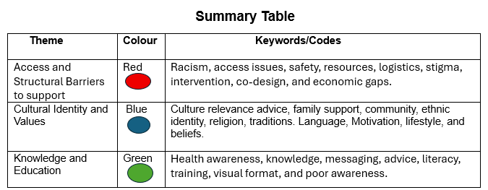

4.3 Theme 1

Access and Structural Barriers to support

Definition

Access and structural barriers, as they relate to my discussion, limit individuals’ ability to engage with health resources. Among Black, Asian, and minority ethnic individuals with type 2 diabetes, these barriers limit access to physical activity, nutrition, and healthcare services. Access barriers, structural barriers, BAME, cultural competence, socioeconomic deprivation, and health inequalities constitute some of the key terms within this theme. It is crucial to understand structural and access-related factors impacting the inadequate management of diabetes within BAME communities.

Background Information

Access and structural barriers have long been the focus of understanding health disparities in managing chronic conditions such as type 2 diabetes within BAME communities. BAME individuals face healthcare, socio-economic, linguistic, and cultural barriers to physical activity and healthy eating (Katangwe-Chigamba et al., 2024).
The UK, and similar nations, has historically relied on a uniform healthcare system, frequently ignoring the distinct requirements of ethnic minorities. Studies, including that by Moore et al. (2019), suggest ethnic minorities have less access to lifestyle services like exercise and dietary advice. Iqbal (2023) notes that implicit bias, poor cultural awareness in healthcare, and limited community outreach often lead to disparities in referrals.
These structural barriers are exacerbated by socioeconomic deprivation. BAME groups experience higher rates of poverty, substandard housing, and limited access to safe recreational activities, which restricts their physical activity (Gafari et al., 2024). The food environment restricts access to healthy, culturally relevant food because of inaccessibility (Patel et al., 2016).
Moreover, insufficient ethnicity-specific healthcare data has hindered the creation of effective, targeted interventions. Despite the rise in equality, diversity, and inclusion policies since the early 2000s, significant structural inequalities persist (Goff et al., 2021).
In short, BAME individuals with type 2 diabetes face structural barriers to lifestyle changes due to historical health service design, socioeconomic disparities, and institutional neglect.

Impact on Research Question

Access and structural support are key research areas. Overlooking these barriers will probably hinder BAME community health initiatives. Public health programs for type 2 diabetes need equitable, culturally aware, and inclusive methods.
Access and structure affect BAME type 2 diabetes patients' health choices. Healthcare, language, and finances hinder healthy lifestyles for many BAME individuals’ post-diagnosis. Systemic issues exclude BAME individuals from public health programs.
To effectively address these barriers, entrenched in institutions and poor policy, systemic reform is required (Moore et al, 2019; Katangwe-Chigamba et al., 2024). To address health disparities in BAME communities, it’s key to understand these barriers and how systemic disadvantages shape health behaviours. Members of BAME groups frequently reside in underserved communities lacking sufficient access to safe recreational spaces and reasonably priced fitness resources (Goff et al., 2016).
Access, language, and relevance barriers limit the use of preventive services such as diabetes education (Iqbal, 2023). Poverty, unstable housing, and structural barriers combine to influence health outcomes (Gafari et al., 2024). Policy interventions failing to address access barriers will worsen health disparities among BAME individuals. Improving physical activity and healthy eating in BAME groups requires tackling access barriers. Public health interventions to manage type 2 diabetes must be equitable and culturally appropriate.

Statistical Information

From 2018 to 2023, analysis of 108,514 Birmingham NHS Health Checks showed socioeconomic deprivation and ethnicity correlated with 64% of type 2 diabetes cases. Diabetes prevalence odds ratios were 5.43 for Asians and 3.15 for Black individuals, indicating significant interaction effects. Diabetes prevention is hampered for BAME groups by socioeconomic barriers that impede lifestyle modifications (Au-Yeung et al., 2024).
Furthermore, only 3.3% of the 83,598 Welsh Exercise Referral Scheme participants (2008-2017) were sedentary referrals. Despite a 67.3% uptake rate, higher costs caused enrolment to drop among the most disadvantaged groups. The utilisation of referral services is significantly influenced by financial burden and socioeconomic status, resulting in the marginalisation of BAME and economically disadvantaged individuals from receiving physical activity support (Morgan, Ogden and Helliwell, 2021).
Regardless of ethnicity or class, insufficient park amenities and incivility in Bradford's diverse areas correlated with lower park usage. Roberts et al. (2019) found that safety and facility quality are major obstacles to physical activity within BAME communities.
To summarise, socioeconomic deprivation is a more significant diabetes risk factor than ethnicity for BAME populations, highlighting crucial structural considerations. Uneven participation and completion of prevention programs highlight systemic failures to reach BAME groups effectively.

Theories, Policies, and Legislation

BAME individuals with type 2 diabetes face systemic and accessibility barriers to healthy eating and exercise. Lack of knowledge and cultural influences pose personal barriers to better health (Moore et al. 2019; Vazini and Barati, 2014).
Poor support for healthy behaviour can create interpersonal barriers. Positive lifestyle changes are unattainable without access to healthy food and safe spaces (Gafari et al. 2024). Discrimination, inequality, and low self-efficacy, stemming from environmental and cultural factors, restrict BAME individuals' access to resources (Moore et al. 2019; Patel et al. 2016). Addressing these challenges may produce better, culturally sensitive diabetes care for BAME individuals.
UK policies combat type 2 diabetes obstacles for BAME people. The NDPP, a core policy, promotes exercise and healthy eating (Bednarska, 2022). The NHS Long-Term Plan pledges enhanced diabetes care with a focus on better support for people from BAME communities. The initiatives consider cultural preferences and limited resources for physical activity (NHS England, 2023a). These policies improve the health outcomes of BAME individuals with type 2 diabetes. Targeted strategies can reduce health inequalities and enhance health results.

Implications

Access and structural barriers significantly impact research on physical activity and healthy eating among BAME individuals with type 2 diabetes.
Policies and laws removing barriers may positively affect awareness and funding for programs promoting better access to physical activity and healthy food choices in BAME communities (Gafari et al. 2024). Improved health and a lower risk of type 2 diabetes complications may result (NHS, 2023b).
Stigma and discrimination against BAME individuals in healthcare and society could result from negative effects (Iqbal, 2023). Inefficient policies and laws might mean little change in access to support. Policy and law analysis concerning physical activity and healthy eating barriers for BAME individuals with type 2 diabetes must consider both positive and negative effects (Teitelbaum et al., 2021). To be effective, solutions must address these issues comprehensively and inclusively (Scottish Government, 2022).

Examples from my Articles

My theme of access and structural barriers is directly supported by Gafari et al. (2024), Kime et al. (2020), and Patel et al. (2016). Gafari et al.'s 2024 study pinpointed racism, safety, transport, and food access as barriers to healthy lifestyles among BAME individuals, proposing a values-based toolkit for intervention programs.
This data indicates that the obstacles to healthy living for ethnic minorities are systemic, not individual. Their contribution underscores the crucial role of access in making believable, available, and safe lifestyle advice actionable.
Kime et al. (2020) showed inadequate training, limited clinic time, and referral limitations affect physical activity advice for BAME patients. The healthcare structure influences patient behaviour. This article backs Gafari's structured method but highlights access challenges for providers. Insufficient clinician training and time constraints lead to unequal BAME support.
Patel et al. (2016) reviewed barriers to healthy behaviours in South Asian communities, including unsafe areas, absence of women-only fitness centres, and limited dietary advice. The lack of gender-equitable and culturally sensitive infrastructure necessitates safe and private exercise spaces for women.
Patel highlights the frequently ignored roles of gender and environment-specific factors in broader studies. Their findings reveal complex, overlapping access barriers, with safety and cultural norms disproportionately affecting particular groups.
According to all scholars, structural issues, rather than individual knowledge or drive, obstruct healthy habit formation in BAME adults with Type 2 diabetes. Gafari and colleagues concentrate on community issues such as racism and cultural invisibility. Kime et al. underscore the constraints of the healthcare system. Patel and colleagues examine issues of gendered access. These studies show structural racism and poverty reduce access. Limited healthcare access hinders behaviour modification. The impact of gender and culture creates barriers. Solutions should consider infrastructure, healthcare, and cultural factors affecting BAME individuals with type 2 diabetes.

Connections to Other Themes

This work highlights the interconnectedness of these themes, with a focus on cultural aspects. Patel et al. (2016) found that exercise facilities can be under-used due to cultural issues, even when easily accessible. Cultural insensitivity in healthcare systems could explain why Black, Asian, and minority ethnic individuals avoid healthcare (Gafari et al., 2024). Access isn't limited to the physical; culture heavily influences it.
Additionally, a lack of educational resources tailored to Black, Asian, and minority ethnic groups may hinder their comprehension of, and confidence in, health advice (Kime et al., 2020). Shortages of translated training materials and short consultation times are major structural barriers to effective healthcare professional training, preventing better practices. The structure limits how effective and far-reaching educational programs can be.
Differences between traditional/religious diets and biomedical recommendations can create knowledge gaps and distrust (Gumber and Gumber, 2017). Ignoring cultural beliefs in health education is dismissive and ineffective. Culturally competent education is needed to translate knowledge into action.
Studying intersections demonstrates obstacles possess a non-individual nature. Intervention needs to address infrastructure, healthcare, and social inclusion.

4.4 Theme 2
Cultural Identity and Value’s

Definition

Cultural identity refers to the sense of belonging to a particular cultural group, shaped by shared traditions, beliefs, language, customs, values, religion, and social norms. It influences how individuals perceive the world, including health, illness, and appropriate behaviour. Cultural values are the guiding principles and norms rooted in this identity, affecting dietary habits, physical activity, and healthcare engagement.
In the context of BAME individuals with type 2 diabetes, cultural identity and values may dictate traditional food choices, religious practices (e.g. fasting), gender roles, and attitudes toward illness and healthcare providers. For example, modesty norms can discourage women from attending mixed-gender exercise classes, while a preference for traditional, high-carbohydrate meals may conflict with medical dietary advice.
Terms such as cultural competence and culturally tailored are centred on the theme. Recognising these elements is essential for overcoming barriers to healthy behaviours and improving diabetes outcomes among BAME communities.

Background Information

Health behaviours for chronic illnesses, like type 2 diabetes, are influenced by cultural identity and values, especially for people from BAME backgrounds. The UK health system has historically been Eurocentric, neglecting the diversity of minority ethnic groups, leading to a disconnect with mainstream health advice (Patel et al., 2016).
This cultural gap results in lower engagement with preventative health services and a lack of trust in healthcare providers (Moore et al., 2019). The demand for culturally sensitive healthcare is rising, with a shift towards tailored education and community-based programs. Understanding cultural identity is crucial for addressing health in BAME communities, given the historical oversight of cultural differences in healthcare.

Impact on Research Question

The theme of cultural identity and values affects my research question on barriers to physical activity and healthy eating in BAME individuals with type 2 diabetes. Cultural beliefs heavily influence health behaviours in ethnic minority communities.
For many BAME individuals, cultural values determine food preferences, gender roles, perceptions of health, and attitudes towards physical activity. Traditional diets may conflict with dietary advice due to cultural or religious significance (Gumber and Gumber, 2017).
Cultural expectations can prevent women from participating in exercise settings. Religious practices like fasting during Ramadan may impact diabetes management. Health professionals should consider these practices for effective advice (Patel et al., 2016).
Cultural stigma can discourage seeking help, affecting engagement with public health interventions (Iqbal, 2023). Ignoring cultural identity risks reinforcing health inequalities. Understanding cultural identity is essential for inclusive interventions supporting physical activity and healthy eating in BAME individuals with type 2 diabetes.

Statistical Information

There exist a multitude of statistics that underscore the significance of cultural identity and values in relation to physical activity and nutritional practices among BAME individuals grappling with type 2 diabetes. In a study, Iqbal (2023) found that South Asian individuals with type 2 diabetes stick to high-carb traditional diets due to cultural attachment to certain foods and lack of tailored advice. These habits clash with standard dietary guidelines, causing resistance or confusion.
Additionally, Patel et al. (2016) found South Asian women less likely to attend physical activity classes due to cultural barriers like lack of women-only spaces, modest concerns, and household roles. Gender roles deeply rooted in cultural identity must be considered in intervention design for inclusivity.
The implications of these statistics suggest that interventions for promoting physical activity and healthy eating among BAME individuals with type 2 diabetes should consider cultural beliefs and values. This may involve culturally tailored education programs, community-based interventions, and collaborations with cultural and religious organisations.

Theories, Policies, and Legislation

Several theories explain how cultural identity and values affect barriers to physical activity and healthy eating in BAME individuals with type 2 diabetes. Theories show how culturally rooted behaviours shape lifestyle choices and health intervention engagement. Some theories, like the HBM, connect health behaviours to perceived risks and benefits. Cultural values influence illness and treatment perceptions (Vazini and Barati, 2014).
For instance, a BAME individual’s fatalistic view of diabetes based on family history could reduce their likelihood of preventive actions. Likewise, the incompatibility of culturally valued foods with healthy eating advice raises barriers.
The six G’s framework offers a multifaceted cultural perspective. This theory elucidates how intersecting identities such as race, ethnicity, gender and class profoundly influence individuals’ experiences of marginalisation.
This implies that a South Asian woman with type 2 diabetes may face obstacles due to ethnicity and gender norms, such as caregiving expectations and modesty, limiting her time for public exercise. Understanding identity is crucial to grasping the challenges for individuals from BAME backgrounds (Goff et al. 2021).
People’s engagement with health advice is shaped by their cultural background. These frameworks strengthen the research by identifying and addressing cultural barriers.

Policy and Legislation:

UK policies on cultural identity affect research on BAME diabetes patients' activity and diet. These policies aim at equitable healthcare access and at reducing health inequalities.
The 2010 Equality Act prohibits discrimination based on protected characteristics, which ensures equal access to public services, such as the NHS, for all (GOV. UK, 2010). Notwithstanding the legal framework established for equitable treatment, its practical application remains uneven. Reports of culturally insensitive care from a substantial portion of BAME patients with type 2 diabetes underscore the inadequacy of legal protection in guaranteeing culturally competent healthcare services (Goff et al. 2021). The integration of cultural understanding within healthcare practices necessitates a commitment exceeding legal compliance.
Moreover, to prevent type 2 diabetes and address ethnic disparities, the NDPP offers structured education and lifestyle support. BAME underrepresentation in NDPP support is linked to linguistic, cultural, and trust issues (Bednarska, 2022). Regional programs (e.g., South Asian diets) show cultural sensitivity, but national consistency is lacking. The program's reach is limited by cultural diversity.
These policies acknowledge culture's role in health. Implementation remains incomplete. Culturally sensitive services must support legal protections and inclusive policies for BAME individuals. Lack of this perpetuates barriers to healthy habits, especially for type 2 diabetics.

Implications

The theme of cultural identity and values has profound implications for the research question. Positively, recognising cultural values enables the design of culturally tailored interventions, such as women-only fitness classes or dietary advice aligned with traditional cuisines, which can improve engagement and adherence (Patel et al., 2016). It also encourages trust and communication between healthcare professionals and BAME patients, enhancing the effectiveness of health advice (Kime et al., 2020).
However, negative impacts arise when cultural factors are misunderstood or ignored. Cultural stigmas around illness, gender norms, or fasting practices can discourage participation in physical activity or dietary changes (Gafari et al., 2024). Additionally, many healthcare services lack the cultural competence or resources to deliver appropriate support, creating further disengagement (Harrison et al., 2019). A balanced approach that respects cultural identity while addressing barriers is essential. Without this, interventions risk being ineffective or even alienating, reinforcing inequalities in diabetes outcomes for BAME individuals (Moore et al., 2019).

Examples from my Articles

In my Results Summary Table, these two articles underpin the Cultural Identity and Values theme. Gafari et al. (2024) qualitative research emphasises the significant impact of cultural values (community, food, family) on physical activity and diet. Participants said that uncaring services and environments, which ignore cultural values, reduce participation. To design interventions, the authors suggest a values-based toolkit that respects cultural norms and builds trust. These highlight that culturally appropriate services are needed to address identity and belonging barriers.
In a narrative review of South Asian communities by Patel et al. (2016) modesty, gender roles, and traditional food preferences emerged as significant barriers to healthy living. Improved participation is noted with women-only exercise spaces and culturally tailored dietary advice.
Connection: Shows how culture and social structures affect whether people can be healthy.

Both articles highlight cultural identity in intervention design. In contrast to Patel et al. (2017) focus on specific cultural practices, such as gender norms, Gafari et al. (2024) stress adaptation at the system level. Collaboratively, they address the research question of how culturally tailored strategies can overcome barriers to physical activity and healthy eating among BAME individuals with type 2 diabetes.

Connections to Other Themes

The themes of cultural identity and values, access and structural barriers, knowledge and education are intertwined in this dissertation. BAME individuals' health advice perceptions are influenced by cultural beliefs, affecting their use of health services. Unsuitable resources can decrease participation in physical activity or dietary programmes, showing a direct link between identity and access.
Language barriers and a lack of culturally sensitive facilities hinder educational content delivery. Insufficient culturally sensitive health education leads to confusion and distrust regarding dietary and exercise advice. Inadequate culturally informed education and access show health interventions don't reach BAME communities. To promote physical activity and healthy eating in people with type 2 diabetes, address all three themes simultaneously to break the cycle of exclusion.

4.5 Theme 3

Knowledge and Education

Definition

Providing individuals with information, skills, and understanding to make sound health decisions is what health knowledge and education encompass. Understanding type 2 diabetes requires knowledge of the condition, its management, and the importance of diet and exercise. For BAME individuals, this theme includes culturally and linguistically relevant learning materials, community-based education, and awareness campaigns that honour cultural beliefs and practices.
My theme includes terminology such as health literacy, which refers to an individual's ability to obtain and comprehend health information. Many people from ethnic minority backgrounds have trouble understanding health information, especially if there are language barriers or complex medical jargon.
Secondly, culturally sensitive education tailors teaching methods and materials to suit diverse cultural values, food preferences, and communication styles, thus improving the acceptance and effectiveness of health advice.

Background Information

Managing chronic illnesses like type 2 diabetes requires knowledge and education. However, the UK’s health education system has historically focused on European perspectives, overlooking the unique cultural, linguistic, and educational requirements of BAME communities (Patel et al., 2016). This has created a gap between medical advice and patients’ comprehension and application of it.
Many BAME individuals face systemic barriers, such as poor access to relevant health information, low health literacy, and language barriers, hindering their ability to make healthy choices (Goff et al., 2021). These disparities were frequently ignored in earlier public health efforts, causing distrust and disengagement.
Community programs, customised dietary advice, and translated resources show a recent increase in inclusive health education. However, consistently implementing it remains difficult. Effective education is crucial for BAME individuals to manage type 2 diabetes confidently and to improve health outcomes.

Impact on Research Question

Understanding the barriers to exercise and healthy eating for minority ethnic groups with type 2 diabetes needs knowledge and education. Poor understanding of diabetes care, healthy eating, and exercise limits people’s ability to make good health decisions. Linguistic barriers, low health literacy, and a lack of culturally appropriate resources worsen these challenges among Black, Asian, and minority ethnic groups (Gumber and Gumber, 2017; Goff et al., 2021).

Numerous standard health promotion schemes are based on Western ideals, which might not suit BAME individuals’ cultural or social backgrounds. Dietary advice lacking traditional foodways can confuse patients and make following the plan hard. Moreover, mistrust in healthcare, often due to past negative experiences or poor communication, can reduce engagement in educational initiatives (Patel et al., 2016).
The importance of this theme is its demonstration of how poor or culturally insensitive education leads to ongoing health disparities. Tackling this problem is key to creating accessible and effective diabetes self-management programs for Black, Asian, and minority ethnic groups.

Statistical Information

Several statistics highlight the vital importance of knowledge and education in managing type 2 diabetes among BAME groups. A 2017 study by Gumber and Gumber showed significantly lower structured education program attendance among South Asian (36%) than White British (70%) type 2 diabetes patients in the UK. The difference reveals major shortcomings in health education's reach and impact.
Furthermore, a (2023a) Diabetes UK report revealed that BAME individuals have a 2-4 times higher risk of type 2 diabetes, yet often lack awareness of lifestyle management due to language, cultural, or outreach limitations. A concerning discovery is the NDPP's low BAME participant rate (9.3% in 2021), despite increased funding, highlighting worries about equal access and culturally appropriate education (Bednarska, 2022).
As these statistics reveal, inadequate education and knowledge about health create obstacles to proper diet and exercise within BAME communities.

Theories, Policies, and Legislation

There are multiple theories about how culture impacts exercise and healthy eating in BAME people with type 2 diabetes.
According to the HBM, perceived susceptibility, severity, benefits, and barriers to illness all affect the probability of health-promoting behaviours (Vazini and Barati, 2014). Among BAME individuals, limited diabetes knowledge and poor health communication can cause an underestimation of risk and low perceived benefits from lifestyle changes, thus affecting their physical activity and healthy eating habits.
In addition, Social Cognitive Theory (SCT) posits that learning happens through observing, reinforcing, and building self-efficacy (Bandura, 1986). Exposure to healthy role models within one's culture improves understanding of healthy behaviours. A lack of culturally sensitive educational resources could limit this model's effectiveness and reduce the chance of adopting healthier habits. These theories stress that culturally sensitive and accessible education is key to overcoming barriers to healthy habits for BAME individuals with type 2 diabetes.

Policy and Legislation:

The distribution of health information and education to BAME type 2 diabetes patients in the UK is largely determined by various policies and frameworks.
The NDPP is among the policies and legislation. The NDPP's proactive diabetes prevention strategy uses lifestyle interventions, such as nutrition and exercise programs (Bednarska, 2022). NDPP's structured educational programs for at-risk groups have struggled to engage people from BAME communities. Research (Bednarska, 2022) shows that insufficient engagement stems from linguistic barriers, cultural mismatches, and ineffective outreach.
Furthermore, the 2010 Equality Act is significant. This law guarantees equal access to public services like health and education, while banning discrimination based on race, ethnicity, or language (GOV.UK, 2010). By law, education must be culturally inclusive and accessible to all diverse groups.
Despite aiming to reduce inequality, inconsistent implementation undermines these policies' effectiveness. The cultural and linguistic needs of BAME groups are frequently ignored in educational resources, thereby hindering their understanding and the adoption of healthy lifestyles. Overlooking cultural aspects when designing interventions can lead to ineffective and misinterpreted programs for improving diet and physical activity.

Implications

The research question is significantly impacted by the themes of knowledge and education. Looking on the bright side, customised diabetes education improves awareness and promotes better habits. Accessible, culturally relevant information improves BAME participation in health initiatives focused on diet and exercise (Patel et al., 2016).
However, if education is generic or Eurocentric, and fails to account for cultural beliefs and literacy levels, then negative implications follow. This leads to confusion, mistrust, or rejection of advice, worsening health inequalities (Iqbal, 2023). Misunderstandings between healthcare providers and BAME patients can result in inadequate self-management and lack of engagement.
A culturally competent and balanced education is essential. Ineffective educational interventions are a risk without it. To overcome physical activity and healthy eating barriers in BAME type 2 diabetes communities, culturally relevant knowledge delivery is key.

Examples from my Articles

The Results Summary Table's theme of Knowledge and Education is strongly supported by two articles. Standard diabetes education frequently overlooks cultural factors, causing issues for South Asian patients, according to Patel et al. (2016). Participant response improved with community-led education that was culturally tailored and sensitive to traditional diets and language.
Gafari et al. (2024) similarly emphasise the importance of culturally sensitive education, arguing that generic health advice is often ineffective for BAME individuals. Study participants found interventions led by peers and similar messengers valuable and trustworthy.
According to both articles, culturally appropriate education leads to better health literacy and healthier behaviours. This research shows that insufficient and inappropriate education significantly hinders healthy eating and physical activity, thereby answering our research question. Closing the diabetes care gap for BAME communities requires prioritising inclusive education.

Connections to Other Themes:

My dissertation explores the significant connections between knowledge and education, access and structural barriers, and cultural identity and values. Insufficient culturally appropriate health education and limited access to relevant services disproportionately affect BAME individuals with type 2 diabetes. Untranslated or culturally insensitive educational materials, for example, can create misunderstandings and disengagement, reflecting both structural and cultural barriers.
Cultural beliefs can affect how we understand and prioritise knowledge; for example, traditional medicine might be favoured over biomedical approaches. In addition, unequal access to quality education is frequently caused by socio-economic differences and language barriers, thus strengthening existing structural inequalities.
The interplay of insufficient knowledge, inaccessible resources, and cultural gaps results in a cycle of low engagement with healthy eating and physical activity. To design inclusive, effective interventions for BAME communities, we must understand these intersections.

4.6 Chapter Conclusion

In conclusion, the chapter elaborated on the preceding section by referencing thematic analysis, which concentrated on the acquisition of codes that elucidated themes for examination and discourse regarding the obstacles to physical activity and nutritious eating among BAME individuals diagnosed with type 2 diabetes. This study meticulously analysed and deliberated upon the three themes derived from the thematic codes presented in the results summary, categorised into three distinct themes.
The forthcoming chapter, Chapter 5, will furnish a comprehensive conclusion to this project, addressing the impediments to physical activity and healthy eating in BAME individuals with type 2 diabetes. Additionally, it will propose recommendations and potential future solutions to the research challenges identified.

CHAPTER 5

Conclusion and Recommendations

5.1 Overall Conclusion

This dissertation scrutinised the cultural, socioeconomic, and environmental impediments to physical activity and nutritious eating among BAME individuals afflicted with type 2 diabetes. These challenges, influenced by the intricate interplay of identity, access, and knowledge, contribute to suboptimal disease outcomes and enduring health disparities. The research sought to identify and analyse these barriers, evaluate existing strategies, and propose culturally attuned interventions to enhance diabetes management.
Chapter 1 delineated the rationale and objectives, emphasising the imperative for customised public health initiatives. Chapter 2 provided a historical and theoretical framework, leveraging the Social Ecological Model and Health Belief Model to elucidate behavioural influences. It also examined national and international responses, including the National Diabetes Prevention Programme (NDPP) and the Diabetes Education and Self-Management for Ongoing and Newly Diagnosed (DESMOND) initiative. Chapter 3 elucidated the methodology, encompassing a meticulous literature selection process employing Boolean searches and the CRAAP test, as well as a thematic analysis approach. Chapter 4 articulated the findings, categorised into three principal themes: access and structural barriers, cultural and identity values, and knowledge and education.
Overall, the research fulfilled its objectives by identifying fundamental barriers and assessing existing interventions. The findings highlight the necessity of culturally informed, community-specific strategies to foster healthier lifestyles among BAME individuals. This work contributes to broader endeavours aimed at mitigating health disparities and enhancing long-term diabetes outcomes through inclusive, evidence-based public health practices.

5.2 Recommendations

5.2.1 Community-Led, Culturally Tailored Health Initiatives for BAME Individuals with Type 2 Diabetes (1).

A pragmatic and attainable recommendation is the establishment of community-driven, culturally attuned physical activity and nutrition initiatives, co-designed with BAME individuals living with type 2 diabetes. This is in alignment with Gafari et al. (2024), who advocate for a values-based toolkit that addresses community-specific challenges such as racism, safety, and food accessibility. Integrating cultural competence into programme design and implementation, such as offering women-only fitness environments (Patel et al., 2016) or utilising multilingual resources (Kime et al., 2020) ensures inclusivity and relevance. Collaborating with local faith organisations, community centres, and culturally congruent service providers can enhance trust and participation, particularly in contexts where healthcare systems have historically fallen short in outreach efforts (Iqbal, 2023; Moore et al., 2019).
This strategy also tackles health infrastructure deficits by harnessing existing community networks to deliver support in the absence of traditional services or where they are inadequate. By training culturally competent local health ambassadors, barriers related to language, cultural norms, and mistrust may be alleviated (Kime et al., 2020).
Nevertheless, funding constraints, insufficient cultural training for healthcare professionals, and institutional inertia may impede the scalability of such initiatives. Furthermore, socio-political resistance to targeted interventions may obstruct policy endorsement (Teitelbaum et al., 2021). These challenges can be surmounted by embedding such initiatives within national frameworks like the NDPP (Bednarska, 2022) and the NHS Long-Term Plan (NHS England, 2023a), which already champion tailored diabetes care. Evidence derived from local pilot programs should be leveraged to advocate for broader systemic reform and sustained investment in culturally sensitive community health infrastructure.

5.2.2 Develop Culturally Tailored Community-Based Interventions (2):

To help BAME individuals with type 2 diabetes overcome cultural barriers to physical activity and healthy eating, we should use community-based interventions that are culturally tailored and created with local leaders. This corroborates the work of Patel et al. (2016) and Gafari et al. (2024), which identified cultural values, gender norms, and traditional diets as major barriers.
Obstacles to participation include culturally inappropriate dietary guidance, women's modesty concerns, healthcare system distrust, and inadequate representation in programs such as the NDPP (Bednarska, 2022). Addressing these barriers involves practical steps like providing women-only exercise programs, engaging faith and community leaders, and incorporating traditional foods into dietary recommendations while respecting medical advice.
This approach is supported by the Health Belief Model, which recognises how cultural beliefs influence perceived barriers and benefits, affecting behaviour (Vazini and Barati, 2014). To ensure interventions respect community identities, build trust, and improve engagement, values-based toolkits, as proposed by Gafari et al. (2024), are recommended.
In practical terms, this could involve tailored NDPP sessions in community spaces such as mosques or community centres, using local languages and respecting religious observances such as Ramadan. The research successfully identified barriers to physical activity and healthy eating among BAME individuals with type 2 diabetes. This recommendation promotes inclusive, effective diabetes care by addressing cultural identity, values, structural, and educational barriers.

5.2.3 Co-Design Culturally Tailored Health Education with BAME Communities (3):

To enhance physical activity and diet in BAME individuals with type 2 diabetes, healthcare systems must partner with the community to develop culturally relevant educational resources. Studies by Patel et al. (2016) and Gafari et al. (2024) indicate that community-based, culturally sensitive health education substantially boosts health literacy, trust, and engagement.
A major obstacle is inadequate health literacy stemming from language difficulties, medical jargon, and educational materials that fail to reflect cultural norms (Goff et al., 2021). By including cultural mediators and community leaders in the development and delivery of content that respects traditional values, food preferences, and religious practices, these challenges can be addressed.
Social Cognitive Theory (Bandura, 1986) suggests that same-ethnicity peer role models can effectively demonstrate healthy behaviours, using relatable examples to reinforce the message. Similarly, the Health Belief Model suggests that people are more inclined towards healthy behaviours if they see them as relevant and beneficial, a concept that culturally tailored education promotes (Vazini and Barati, 2014).
Real-world applications might include delivering diabetes education in mosques, temples, or community centres, using visual aids and local languages. These efforts will increase inclusivity and engagement. This recommendation aligns with the research goal of exploring barriers to healthy habits among ethnic minorities with type 2 diabetes, and it achieves the objective of pinpointing practical, culturally appropriate interventions for better results.

6.0 CHAPTER 6

References and Appendices

6.1 References

Ajayi, O. (2021) ‘A Perspective on Health Inequalities in BAME Communities and How to Improve Access to Primary Care’, Future Healthcare Journal, 8(1), pp. 36-39. Available at: https://pmc.ncbi.nlm.nih.gov/articles/PMC8004339/ (Accessed: 05 April 2025).
Alyafei, A. and Easton-Carr, R. (2024) The Health Belief Model of Behaviour Change. Treasure Island (FL): Stat Pearls Publishing.
Ariel-Donges, A. H., Gordon, E. L., Dixon, B. N., Eastman, A. J., Bauman, V., Ross, K. M. and Perri, M. G. (2019) ‘Rural/urban Disparities in Access to the National Diabetes Prevention Program’, Translational Behavioural Medicine, 10(6), pp. 1554-1558. Available at: https://doi.org/10.1093/tbm/ibz098
Australian Institute of Health and Welfare (2024). Australian Burden of Disease Study Available at: https://www.aihw.gov.au (Accessed: 09 April 2025).
Au-Yeung, C. H, Ellis, D., Dallaway, A., Riley, J., Varney, J. and Howell-Jones, R. (2024) 'Socioeconomic and Ethnic Inequalities Increase the Risk of Type 2 Diabetes: an Analysis of NHS Health Check Attendees in Birmingham', Frontiers in Public Health, 12. Available at: https://doi.org/10.3389/fpubh.2024.1477418
Ayers, S., Baum, A., McManus, C., Newman, S., Wallston, K., Weinman, J. and West, R. (2001) Cambridge Handbook of Psychology, Health and Medicine.2nd edn. Cambridge: Cambridge University Press.
Bandura, A. (1986) Social Foundation of Thought and Action. New Jersey: Prentice-Hall.
Barry, E., Greenhalgh, T., Shaw, S. and Papoutsi, C. (2023) ‘Explaining the UK’s ‘high-risk’ Approach to Type 2 Diabetes prevention: Findings from a Qualitative Interview Study with policymakers in England’, BMJ Open, 13(2), p. e066301. Available at: https://doi.org/10.1136/bmjopen-2022-066301
Bednarska, N. G. (2022) ‘Critical Assessment of Current Health Policies Used for Managing Diabetes in the United Kingdom.’, Journal of Community Medicine & Public Health, 6(2), p. 260. Available at: https://doi.org/10.29011/2577-2228.100260
BHBIA (2020) Keeping You Informed about Changes in the UK Legal and Ethical Environment BHBIA Data Analytics Guidelines Secondary Data -Ethical Principles. Available at: https://www.bhbia.org.uk/assets/Downloads/Guidelines/4_secondary_data_ethical_principles_aug2020_fv.PDF (Accessed: 23 May 2025).
Brach, C. and Fraser, I. (2022) ‘Reducing Disparities through Culturally Competent Health Care’, Quality Management in Health Care, 10(4), pp. 15-28, Quality Management in Health Care. Available at: https://doi.org/10.1097/00019514-200210040-00005
Braveman, P. and Gottlieb, L. (2014) ‘The Social Determinants of Health: It’s Time to Consider the Causes of the Causes’, Public Health Reports, 129(2), pp. 19-31. Available at: https://doi.org/10.1177/00333549141291s206
Caballero, A. E. (2018) ‘The A to Z of Managing Type 2 Diabetes in Culturally Diverse Populations', Frontiers in Endocrinology, 9(1). Available at: https://doi.org/10.3389/fendo.2018.00479
Campbell, J. (2025) Social Ecological Model. Available at: https://www.ebsco.com/research-starters/environmental-sciences/social-ecological-model (Accessed: 04 April 2025).
Caperon, L., Saville, F. and Ahern, S. (2022). ‘Developing a socio-ecological Model for Community Engagement in a Health Programme in an Underserved Urban Area’. PLOS ONE, 17(9). Available at: https://doi.org/10.1371/journal.pone.0275092
Care Learning (2024) What Are Barriers in Health and Social Care? Available at: https://carelearning.org.uk/blog/accessibility/what-are-barriers-in-health-and-social-care/ (Accessed: 24 March 2025).
Clarke, V. and Braun, V. (2016) ‘Thematic Analysis’. The Journal of Positive Psychology, 12(3), pp.297–298. Available at: https://doi.org/10.1080/17439760.2016.1262613
Costa, A., Crupi, A., De Marco, C. E. and Di Minin, A. (2023) ‘SMEs and Open innovation: Challenges and Costs of Engagement’, Technological Forecasting and Social Change, 194, p. 122731. Available at: https://doi.org/10.1016/j.techfore.2023.122731
Coughlin, S.S., Smith, S.A. and Fernandez, M.E. (2017) Handbook of Community-Based Participatory Research. 1st edn. United Kingdom: Oxford University Press.
Dallosso, H., Mandalia, P., Gray, L. J., Cxhudasama, Y. V., Choudhury, S., Taheri,, S., Patel, N., Khunti, K. and Davies, M. J. (2022) ‘The Effectiveness of a Structured Group Education Programme for People with Established Type 2 Diabetes in a multi-ethnic Population in Primary care: a Cluster Randomised Trial’, Nutrition, Metabolism and Cardiovascular Diseases, 32(6), pp. 1549-1559. Available at: https://doi.org/10.1016/j.numecd.2022.03.017
Diabetes UK (2017) Our Prevention Work. Available at: https://www.diabetes.org.uk/about-diabetes/type-2-diabetes/preventing/prevention-work (Accessed: 04 April 2025).
Diabetes UK (2023a) How Many People in the UK Have Diabetes? Available at: https://www.diabetes.org.uk/about-us/about-the-charity/our-strategy/statistics (Accessed: 15 July 2025).
Diabetes UK (2023b) Number of People Living with Diabetes in the UK Tops 5 million for the First Time. Available at: https://www.diabetes.org.uk/about-us/news-and-views/number-people-living-diabetes-uk-tops-5-million-first-time (Accessed: 26 March 2025).
Edberg, M. (2013) Essentials of Health, Culture, And Diversity. 1st edn. Jones and Bartlett Learning.
Emanuelson, U. and Egenvall, A. (2014). ‘The Data – Sources and Validation.’ Preventive Veterinary Medicine, 113(3), pp.298–303. Available at: https://doi.org/10.1016/j.prevetmed.2013.10.002
Gafari, O., Stokes, M., Agyapong-Badu, S., Alwan, N. A., Calder, P. C., McDonough, S., Tully, M. A. and Barker, M. (2024) 'Including the Values of UK Ethnic Minority Communities in Policies to Improve Physical Activity and Healthy Eating', Discover Public Health, 21(1). Available at: https://doi.org/10.1186/s12982-024-00163-4
Glanz, K. (2022) Social and Behavioural Theories. Available at: https://obssr.od.nih.gov/sites/obssr/files/Social-and-Behavioral-Theories.pdf (Accessed: 06 April 2025).
Goff, L. M. (2019) ‘Ethnicity and Type 2 Diabetes in the UK’, Diabetic Medicine, 36(8), pp. 927-938. Available at: https://doi.org/10.1111/dme.13895
Goff, L. M., Moore, A. P., Harding, S. and Rivas, C. (2021) 'Development of Healthy Eating and Active Lifestyles for Diabetes (HEAL‐D), a Culturally tailored Diabetes Self‐management Education and Support Programme for black‐British adults: a Participatory Research Approach', Diabetic Medicine, 38(11). Available at: https://doi.org/10.1111/dme.14594
GOV.UK (2010). Equality Act 2010. Available at: https://www.legislation.gov.uk/ukpga/2010/15 (Accessed 14 Jul. 2025).
Gumber, A. and Gumber, L. (2017) 'Improving prevention, Monitoring and Management of Diabetes among Ethnic minorities: Contextualising the Six G’s Approach', BMC Research Notes, article number 774. Available at: https://doi.org/10.1186/s13104-017-3104-9
Gunhu, R. (2025) Using the Health Belief Model to Understand Barriers to Effective Type 2 Diabetes Management among Ethnic Karanga Diabetic Patients in Masvingo Urban. Available at: https://www.longdom.org/proceedings/using-the-health-belief-model-to-understand-barriers-to-effective-type-2-diabetes-management-among-ethnic-karanga-diabet-37076.html?utm_source (Accessed: 01 April 2025).
Hands, C.M. (2013) Pathways to Community Engagement in Education: Collaboration in Diverse, Urban Neighbourhoods. Palgrave Macmillan.
Harrison, G. (2014) Health Beliefs of Black and Minority Ethnic Groups and the Implications for Diabetes Care. Available at: https://diabetesonthenet.com/journal-diabetes-nursing/health-beliefs-of-black-and-minority-ethnic-groups-and-the-implications-for-diabetes-care/ (Accessed: 26 March 2025).
Harrison, R., Walton, M., Chauhan, A., Manias, E., Chitkara, U., Chitkara, M. and Leone, D. (2019) 'What Is the Role of Cultural Competence in Ethnic Minority Consumer Engagement? An Analysis in Community Healthcare', International Journal for Equity in Health, 18(1), p. 191. Available at: https://doi.org/10.1186/s12939-019-1104-1
Hawthorne, K., Robles, Y., Cannings-John, R. Edwards, A. G. K. (2010) 'Culturally Appropriate Health Education for Type 2 Diabetes in Ethnic Minority Groups: A Systematic and Narrative Review of Randomized Controlled Trials', Diabetic Medicine, 27(6), pp. 613-623. Available at: https://doi.org/10.1111/j.1464-5491.2010.02954.x
Hechanova, R.M., Ellis, C. and Bunagan, K. (2021). Cultural Diversity and Family-Based Interventions. Cambridge University Press eBooks.
Hmielowski, J. D. (2017) 'Secondary Research/Analysis', The International Encyclopaedia of Communication Research Methods, pp. 1-5. Available at: https://doi.org/10.1002/9781118901731.iecrm0232
Hood, K. K., Hilliard, M., Piatt, G. and Ievers-Landis, C. E. (2015) ‘Effective Strategies for Encouraging Behaviour Change in People with Diabetes’, Diabetes Management, 5(6), pp. 499-510. Available at: https://doi.org/10.2217/dmt.15.43
Huffman, F. G. and Vaccaro, J.A. (2012) 'Physical Activity, Type 2 Diabetes, and Ethnicity', American Journal of Lifestyle Medicine, 7(2), pp. 104-114. Available at: https://doi.org/10.1177/1559827612469337
Iqbal, S. (2023) 'Cultural Factors Influencing the Eating Behaviours of Type 2 Diabetes in the British South-Asian population: a Scoping Review of the Literature', Journal of Global Health Reports, 7(7), p. e2023050. Available at: https://doi.org/10.29392/001c.84191
Kasturia, S., Ali, M. K., Ali, M., Narayan, K., Tandon, N., Shivashankar, R., Garg , V., Kapoor, D., Mohana Sundaram, A., Mohan, D., Kadir, M., Prabhakaran, D., Mohan, V. and Jaacks, L. (2018) ‘Diets for South Asians with diabetes: recommendations, adherence, and Outcomes’, Asia Pac J Clin Nutri, 27(4), pp. 823-831. Available at: https://doi.org/10.6133/apjcn.112017.03
Katangwe-Chigamba, T., Kantilal, K., Hartley-Palmer, J., Salisu-Olatunji, S. O., Seeley, C., Naughton, F. and Chester, R. (2024) ‘Diet and Physical Activity Interventions for People from Minority Ethnic Backgrounds in the UK: a Scoping Review Exploring Barriers, Enablers and Cultural Adaptations’, Journal of Racial and Ethnic Health Disparities. Available at: https://doi.org/10.1007/s40615-024-02112-y
Kerschbaumer, L., Crossett, L., Holaus, M. and Costa, U. (2023) ‘COVID-19 and Health Inequalities: the Impact of Social Determinants of Health on Individuals Affected by Poverty’, Health Policy and Technology, 13(1), pp. 100803-100803. Available at: https://doi.org/10.1016/j.hlpt.2023.100803
Kevany, K. and Prosperi, P. (2023) Routledge handbook of sustainable diets. Routledge.
Keys, C., Nanayakkara, G., Onyejekwe, C., Sah, R. K. and Wright, T. (2021) ‘Health Inequalities and Ethnic Vulnerabilities during COVID-19 in the UK: A Reflection on the PHE Reports’, Feminist Legal Studies,29(1), pp. 107–118. Available at: https://doi.org/10.1007/s10691-020-09446-y
Khunti, K., Gray, L. J., Skinner, T., Carey, M. E., Realf, K., Dallosso, H., Fisher, H., Campbell, M., Heller, S. Davies, M. J. (2012) ‘Effectiveness of a Diabetes Education and Self-Management Programme (DESMOND) for People with Newly Diagnosed Type 2 Diabetes mellitus: Three Year follow-up of a Cluster Randomised Controlled Trial in Primary Care’, BMJ, 344(262), pp. e2333-e2333. Available at: https://doi.org/10.1136/bmj.e2333
Kime, N., Pringle, A., Zwolinsky, S. and Vishnubala, D. (2020) 'How Prepared Are Healthcare Professionals for Delivering Physical Activity Guidance to Those with diabetes? A Formative Evaluation', BMC Health Services Research, 20(1). Available at: https://doi.org/10.1186/s12913-019-4852-0
Kurzman, A., Londono, M., Truong, V., Morales‐Haro, O., Lam, A., Kaleem, H., Ritt‐Olson, A and Boden‐Albala, B. (2023) ‘Reducing Risk of ADRDs: Innovative Framework to Inform Behaviour Change’, Alzheimer’s & Dementia, 19(S23), p. e071755. Available at: https://doi.org/10.1002/alz.071755
Lasky, J. (2024) CRAAP Test | EBSCO. Available at: https://www.ebsco.com/research-starters/social-sciences-and-humanities/craap-test (Accessed: 21 June 2025).
Lee, A., Cardel, M. and Donahoo, W. T. (2019) 'Social and Environmental Factors Influencing Obesity', NIH.GOV. Available at: https://www.ncbi.nlm.nih.gov/books/NBK278977/ (Accessed: 20 July 2025).
Leese, B. (1995) ‘Diabetes Mellitus and the St Vincent Declaration’, Pharmacoeconomics, 7(4), pp. 292-307. Available at: https://doi.org/10.2165/00019053-199507040-00004
Lirussi, F. (2010) 'The Global Challenge of Type 2 Diabetes and the Strategies for Response in Ethnic Minority Groups', Diabetes/Metabolism Research and Reviews, 26(6), pp. 421-432. Available at: https://doi.org/10.1002/dmrr.1105
MacPherson, M. M., Dineen, T. E., Cranston, K. D. and Jung, M E. (2020) ‘Identifying Behaviour Change Techniques and Motivational Interviewing Techniques in a Diabetes Prevention Program Situated in a Community Site’, Canadian Journal of Diabetes, 44(8), pp. 719-726. Available at: https://doi.org/10.1016/j.jcjd.2020.09.011
Manchester Metropolitan University (2023) Evaluating Sources of Information. Available at: https://www.mmu.ac.uk/library/referencing-and-study-support/evaluating-information (Accessed 28 Jun. 2025).
Marmot, M. (2010) Fair society, Healthy Lives the Marmot Review. Available at: https://www.parliament.uk/globalassets/documents/fair-society-healthy-lives-full-report.pdf (Accessed: 01 April 2025).
Matheson, J., Patterson, J. and Neilson, L. (2020) Tackling Causes and Consequences of Health Inequalities: 1st edn. Milton: CRC Press.
Moore, A. P., Rivas, C. A., Stanton-Fay, S., Harding, S. and Goff, L. M. (2019) 'Designing the Healthy Eating and Active Lifestyles for Diabetes (HEAL-D) self-management and Support Programme for UK African and Caribbean communities: a Culturally tailored, Complex Intervention under-pinned by Behaviour Change Theory', BMC Public Health, 19(1), article number 1146. Available at: https://doi.org/10.1186/s12889-019-7411-z
Morgan, K., Ogden, M. and Helliwell A. (2021) 'People in the Most Deprived Groups Were Least Likely to Take Part in the Exercise Referral Scheme, Study Finds', NHIR- National Institute for Health and Care Research. Available at: https://doi.org/10.3310/alert_44022
NHS (2019) Obesity. Available at: https://www.longtermplan.nhs.uk/online-version/chapter-2-more-nhs-action-on-prevention-and-health-inequalities/obesity/ (Accessed: 08 April 2025).
NHS (2022) Eating a Balanced Diet. Available at: https://www.nhs.uk/live-well/eat-well/how-to-eat-a-balanced-diet/eating-a-balanced-diet/ (Accessed: 25 March 2025).
NHS (2023) What is Diabetes? Available at: https://www.nhs.uk/conditions/diabetes/ (Accessed: 11 July 2025).
NHS England (2016a) NHS Diabetes Prevention Programme – Digital Stream. Available at: https://www.england.nhs.uk/diabetes/digital-innovations-to-support-diabetes-outcomes/nhs-diabetes-prevention-programme-digital-stream/ (Accessed: 08 April 2025).
NHS England (2016b) NHS England Impact Analysis of Implementing NHS Diabetes Prevention Programme, 2016 to 2021. Available at: https://www.england.nhs.uk/wp-content/uploads/2016/08/impact-assessment-ndpp.pdf (Accessed: 04 April 2025).
NHS England (2023) NHS Diabetes Prevention Programme (NHS DPP). Available at: https://www.england.nhs.uk/diabetes/diabetes-prevention/ (Accessed: 05 April 2025).
NHS Wales (2024) Healthy Eating. Available at: https://thepracticeofhealth.nhs.wales/health-advice-support/healthy-eating/ (Accessed: 25 March 2025).
Nur, H. A., Atoloye, A. T., Wengreen, H., Archuleta, M., Savoie-Roskos, M. R., Wille, C. and Jewkes, M. (2021) ‘A Scoping Review and Assessing the Evidence for Nutrition Education Delivery Strategies for Refugees in High-Income Countries’, 12(6), pp. 2508-2524. Available at: https://doi.org/10.1093/advances/nmab080
Omodara, D. A., Gibson, L. and Bowpitt, G. (2021) ‘Exploring the Impact of Cultural Beliefs in the Self-Management of Type 2 Diabetes Among Black sub-Saharan Africans in the UK – A Qualitative Study Informed by the PEN-3 Cultural Model’, Ethnicity & Health, 27(6) pp.1358-1376. Available at: https://doi.org/10.1080/13557858.2021.1881764
Patel, N., Ferrer, H. B., Tyrer, F., Wray, P., Farooqi, A., Davies, M. J. and Khunti, K. (2016) 'Barriers and Facilitators to Healthy Lifestyle Changes in Minority Ethnic Populations in the UK: A Narrative Review', Journal of Racial and Ethnic Health Disparities, 4(6), pp. 1107-1119. Available at: https://doi.org/10.1007/s40615-016-0316-y
Preissner, C. E., Oenema, A. and de Vries, H. (2022) ‘Examining Socio-Cognitive Factors and Beliefs about Mindful Eating in Healthy Adults with Differing Practice experience: A cross-sectional Study’, BMC Psychology, 10(1), pp. 1-15. Available at: https://doi.org/10.1186/s40359-022-00977-4
Public Health England (2018) Health matters: Preventing Type 2 Diabetes. Available at: https://www.gov.uk/government/publications/health-matters-preventing-type-2-diabetes/health-matters-preventing-type-2-diabetes (Accessed: 08 April 2025).
Raleigh, V. (2023) The Health of People from Ethnic Minority Groups in England. Available at: https://www.kingsfund.org.uk/insight-and-analysis/long-reads/health-people-ethnic-minority-groups-england (Accessed: 25 March 2025).
Resnicow, K., Baranowski, T., Ahluwalia, J. S. and Braithwaite, R. L. (1999) ‘Cultural Sensitivity in Public health: Defined and Demystified’, Ethnicity & Disease, 9(1), pp. 10–21. Available at: https://pubmed.ncbi.nlm.nih.gov/10355471/
Roberto, C. and, Moran, A. (2021) Retail Strategies to Support Healthy Eating. Basel, Switzerland: Multidisciplinary Digital Publishing Instituter.
Roberts, H., Kellar, I., Conner, M., Gidlow, C., Kelly, B., Nieuwenhuijsen, M. and McEachan, R. (2019) 'Associations Between Park features, Park Satisfaction and Park Use in a Multi-Ethnic Deprived Urban Area', Urban Forestry & Urban Greening, 46, p. 126485. Available at: https://doi.org/10.1016/j.ufug.2019.126485
Ryan, E. (2022) Boolean Operators | Quick Guide, Examples & Tips. Available at: https://www.scribbr.co.uk/working-sources/boolean-operator/ (Accessed: 27 June 2025).
Sanchez, S. O., Funderburk, K., Reznicek, E., Parmer, S. M. and Hinnant, J. B. (2024) ‘Impact of School Gardens on Nutrition Education among Limited‐Income Communities in Alabama’, Journal of School Health, 95(2), pp. 153-161. Available at: https://www.mybib.com/#/projects/qk896g/citations/new/article_journal:~:text=https%3A//doi.org/10.1111/josh.13513 (Accessed: 25 March 2025).
Scottish Government (2022) Minority Ethnic Groups - Understanding Diet, Weight and Type 2 Diabetes: Scoping Review. Available at: https://www.gov.scot/publications/understanding-diet-weight-type-2-diabetes-minority-ethnic-groups-scotland-access-experiences-services-support-weight-management-type-2-diabetes-recommendations-change/ (Accessed: 12 July 2025).
Singleton, C. R., Li, Y., Odoms-Young, A., Zenk, S. N. and Powell, L. M. (2018) 'Change in Food and Beverage Availability and Marketing Following the Introduction of a Healthy Food Financing Initiative–Supported Supermarket', American Journal of Health Promotion, 33(4), pp. 525-533. Available at: https://doi.org/10.1177/0890117118801744
Spruijt-Metz, D., O’Reilly, G. A., Cook, L., Page, K. A. and Quinn, C. (2014) ‘Behavioural Contributions to the Pathogenesis of Type 2 Diabetes’, Current Diabetes Reports, 14(4), p. 475. Available at: https://doi.org/10.1007/s11892-014-0475-3
Stone, M., Pound, E., Pancholi, A., Farooqi, A. and Khunti, K. (2005) ‘Empowering Patients with diabetes: a Qualitative Primary Care Study Focusing on South Asians in Leicester, UK’, Family Practice, 22(6), pp. 647-652. Available at: https://doi.org/10.1093/fampra/cmi069
Teitelbaum, J., McGowan, A. K., Richmond, T. S., Kleinman, D. V., Pronk, N., Ochiai, E., Blakey, C. and Brewer, K. H. (2021) 'Law and Policy as Tools in Healthy People 2030', Journal of Public Health Management and Practice, 27(6), pp. S265–S273. Available at: https://doi.org/10.1097/phh.0000000000001358
UK Research Integrity Office (2023) Code of Practice for Research. Available at: https://ukrio.org/wp-content/uploads/UKRIO-Code-of-Practice-for-Research.pdf (Accessed: 06 May 2025).
Vazini, H. and Barati, M. (2014) ‘The Health Belief Model and Self-Care Behaviours among Type 2 Diabetic Patients’, Iranian Journal of Diabetes and Obesity, 6(3). Available at: https://ijdo.ssu.ac.ir/article-1-195-fa.pdf (Accessed: 06 April 2025).
Ver Ploeg, M. (2010) Access to Affordable, Nutritious Food Is Limited in “Food Deserts”. Available at: https://www.ers.usda.gov/amber-waves/2010/march/access-to-affordable-nutritious-food-is-limited-in-food-deserts (Accessed: 08 Aprile 2025).
Watson-Thompson, J., Hassaballa, R. H., Valentini, S. H., Schulz, J. A., Kadavasal, P. V., Harsin, J. D., Thompson, V. M., Hassaballa, I. H., Esiaka, C. C. and Thompson, E. C. (2022) ‘Actively Addressing Systemic Racism Using a Behavioural Community Approach', Behaviour and Social Issues, 31(1), pp. 297–326. Available at: https://doi.org/10.1007/s42822-022-00101-6
WHO (2021) The WHO Global Diabetes Compact. Available at: https://www.who.int/initiatives/the-who-global-diabetes-compact (Accessed: 08 April 2025).
Wickham, R. (2019) 'Secondary Analysis Research', Journal of the Advanced Practitioner in Oncology, 10(4), pp. 395-400. Available at: https://pmc.ncbi.nlm.nih.gov/articles/PMC7520737/ (Accessed: 08 May 2025).
Wilkinson, E., Waqar, M., Sinclair, A. and Randhawa, G. (2016) ‘Meeting the Challenge of Diabetes in Ageing and Diverse Populations: A Review of the Literature from the UK’, Journal of Diabetes Research, 2016, Article number 8030627. Available at: https://doi.org/10.1155/2016/8030627
Wit, M., Trief, P. M., Huber, J. W. and Willaing, I. (2020) ‘State of the art: Understanding and Integration of the Social Context in Diabetes Care’, Diabetic Medicine, 37(3). Available at: https://doi.org/10.1111/dme.14226
World Health Organization (2024) Physical Activity. Available at: https://www.who.int/news-room/fact-sheets/detail/physical-activity (Accessed: 25 March 2025).
Zeh, P., Sandhu, H. K., Cannaby, A. M. and Sturt, J. A. (2014) ‘Cultural Barriers Impeding Ethnic Minority Groups from Accessing Effective Diabetes Care services: a Systematic Review of Observational Studies’, Diversity & Equality in Health and Care, 11(1), pp. 9-33. Available at: https://doi.org/10.21767/2049-5471.100001
Zenk, S. N., Schulz, A. J., Israel, B. A., James, S. A., Bao, S. and Wilson, M. L. (2005) 'Neighbourhood Racial Composition, Neighbourhood Poverty, and the Spatial Accessibility of Supermarkets in Metropolitan Detroit', American Journal of Public Health, 95(4), pp. 660-667. Available at: https://doi.org/10.2105/ajph.2004.042150

6.2 Appendices

Figure 1
Further figures and statistics to support background context of the research topic.

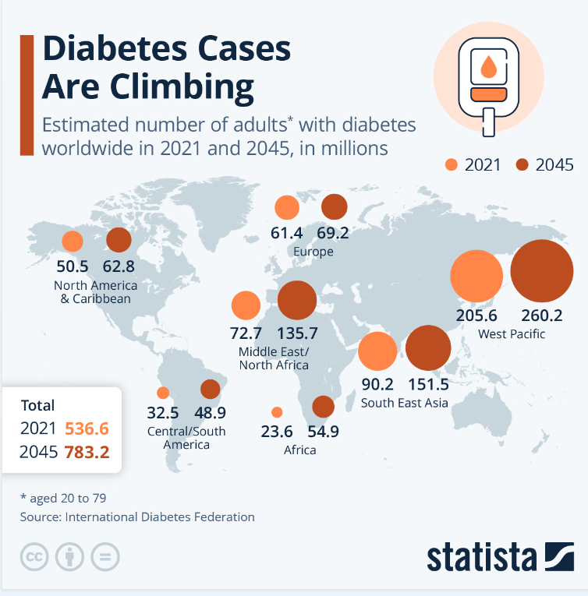

(Fleck, 2024)

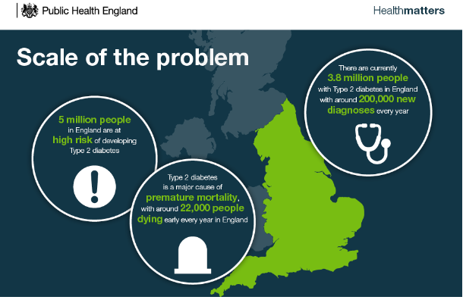

(Public Health England, 2018) 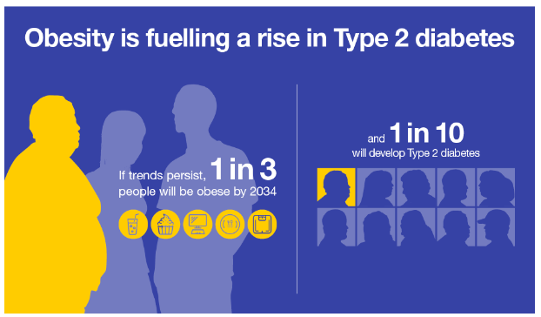
(Public Health England, 2018)

Figure 2


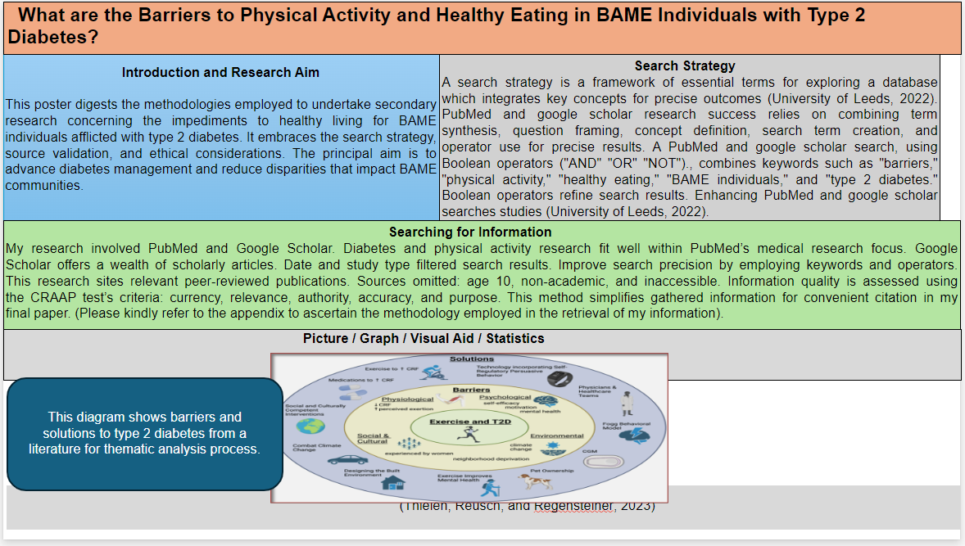
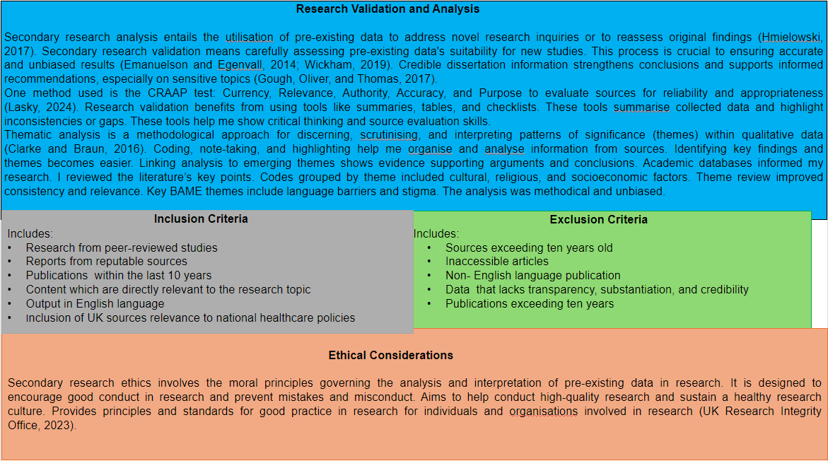
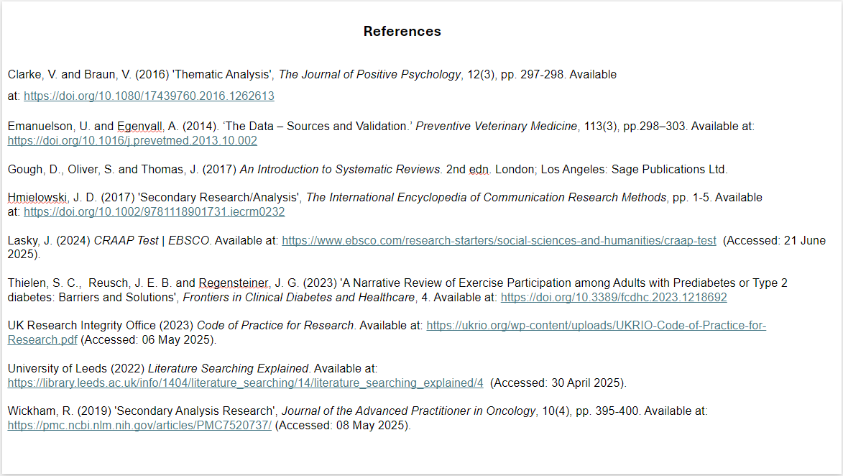

BMHP6020 Independent Project Source Tracking Table
✅ Saved? | Author & Year | Title | Summary | CRAAP Notes | File Name / Link to Source
Yes | Gafari  et al. (2024) | Including the Values of UK Ethnic Minority Communities in Policies to Improve Physical Activity and Healthy Eating. | Including UK Ethnic Minority Communities in Policies for Physical Activity and Healthy Eating. | Current, Relevant, Authority, Accurate, and Purpose. | https://doi.org/10.1186/s12982-024-00163-4
Yes | Goff et al. (2021) | Development of Healthy Eating and Active Lifestyles for Diabetes (HEAL‐D), a Culturally tailored Diabetes Self‐management Education and Support Program for black‐British adults: a Participatory Research Approach. | Development of HEAL-D, a Culturally tailored Diabetes Self-management Program for black-British adults: a Participatory Research Approach. | Current (Medium), Relevant, Authority, Accurate, and Purpose. | https://doi.org/10.1111/dme.14594
Yes | Gumber and Gumber, (2017) | Improving prevention, Monitoring and Management of Diabetes among Ethnic minorities: Contextualizing the Six G’s Approach. | Contextualizing the Six G’s Approach. | Current (Medium), Relevant, Authority, Accurate, and Purpose | https://doi.org/10.1186/s13104-017-3104-9
Yes | Iqbal, (2023) | Cultural Factors Influencing the Eating Behaviours of Type 2 Diabetes in the British South-Asian population: a Scoping Review of the Literature. | Cultural impacts on Type 2 Diabetes diets in British South Asians. | Current, Relevant, Authority, Accuracy, and Purpose. | https://doi.org/10.29392/001c.84191
Yes | Katangwe-Chigamba et al. (2024) | Diet and Physical Activity Interventions for People from Minority Ethnic Backgrounds in the UK: A Scoping Review Exploring Barriers, Enablers and Cultural Adaptations. | Improving diet and exercise for UK minorities: a scoping review. | Current, Relevant, Authority, Accurate, and Purpose. | https://doi.org/10.1007/s40615-024-02112-y
Yes | Kime et al. (2020) | How Prepared Are Healthcare Professionals for Delivering Physical Activity Guidance to Those with diabetes? A Formative Evaluation. | Healthcare professionals' preparedness to counsel diabetes patients on exercise. | Current (Medium), Relevant, Authority, Accurate, and Purpose. | https://doi.org/10.1186/s12913-019-4852-0
Yes | Moore et al. (2019) | Designing Healthy Eating and Active Lifestyles for Diabetes (HEAL-D) self  management and Support Program for UK African and Caribbean communities: A Culturally tailored, Complex Intervention under-pinned by Behaviour Change Theory. | Developing a behaviour change-based HEAL-D program for UK's African and Caribbean populations. | Current, Relevant, Authority, Accurate, and Purpose. | https://doi.org/10.1186/s12889-019-7411-z
Yes | Patel et al. (2016) | Barriers and Facilitators to Healthy Lifestyle Changes in Minority Ethnic Populations in the UK: A Narrative Review' | Barriers and facilitators to healthy lifestyles among UK ethnic minorities. | Current (Medium), Relevant, Authority, Accurate, and Purpose. | https://doi.org/10.1007/s40615-016-0316-y

Figure 3a
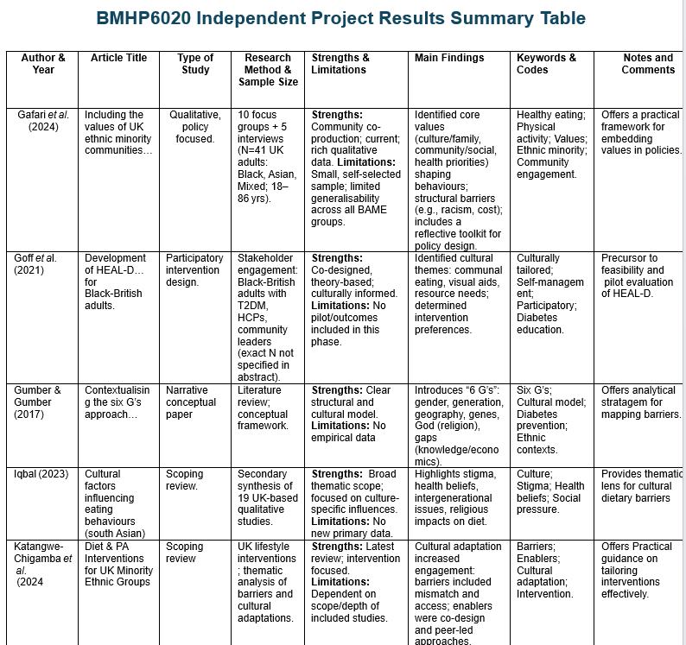
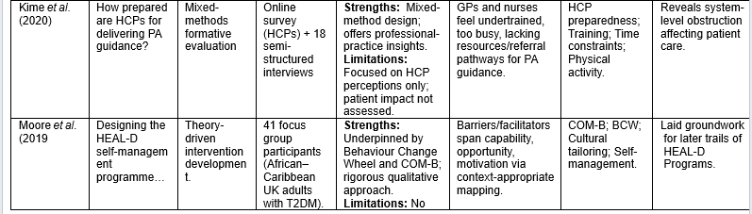
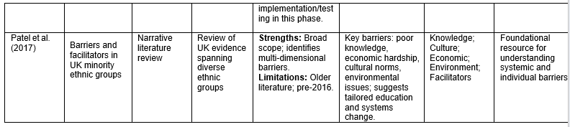

Figure 3b


