
HTML & CSS Web development
ACCA4023

22 July 2026
Anna Leontieva (2509324)
LECTURER: DR. SADHANA JHA

Contents
Introduction-----------------------------------------------------------------------------------------------2
Requirements--------------------------------------------------------------------------------------------3
Purpose------------------------------------------------------------------------------------------------3
Subject matter----------------------------------------------------------------------------------------3
Intended audience-----------------------------------------------------------------------------------3
Implementation------------------------------------------------------------------------------------------4
Screenshots of the Webpages-------------------------------------------------------------------4
Validation----------------------------------------------------------------------------------------------7
HTML Validation-----------------------------------------------------------------------------------8
CSS Validation-------------------------------------------------------------------------------------9
Evaluation ----------------------------------------------------------------------------------------------15
Part A--------------------------------------------------------------------------------------------------15
Website usability---------------------------------------------------------------------------------15
Website accessibility----------------------------------------------------------------------------15
Search engine optimisation-------------------------------------------------------------------16
Part B-------------------------------------------------------------------------------------------------16
Usefulness (Usability and Utility) -----------------------------------------------------------16
Search Engine Optimisation (SEO)---------------------------------------------------------17
Accessibility---------------------------------------------------------------------------------------18
Part C-------------------------------------------------------------------------------------------------19
References----------------------------------------------------------------------------------------------20
Appendix-------------------------------------------------------------------------------------------------21

Introduction
This report documents the design, development, implementation, and evaluation of a responsive website created as part of the Web Development module. It outlines the complete development process, beginning with the identification of the website requirements and target audience, followed by the design decisions and implementation of the website using HTML and CSS.
The report also includes screenshots of the completed website, together with the results of HTML and CSS validation to demonstrate compliance with web standards. Any validation errors encountered during development are discussed, along with the methods used to resolve them.
In addition, the report evaluates the completed website by examining key aspects of modern web development, including usability, accessibility, search engine optimisation (SEO), and mobile responsiveness. The report also assesses the strengths and limitations of the website, identifies areas for future improvement, and compares two existing websites that provide similar services.
The report concludes with a list of references formatted using the IEEE referencing style and includes appendices containing the HTML and CSS source code used to create the website.

Requirements

Purpose:
The purpose of this website is to introduce visitors to the beauty and attractions of the Peak District National Park. It aims to provide useful information about its landscapes, famous landmarks, and outdoor activities while encouraging people to explore one of the UK's most popular natural destinations. The website also helps users plan visits by highlighting some of the best places to see.

Subject matter
This website showcases the main attractions and features of the Peak District. It includes information about the history of the national park, its scenic landscapes, walking trails, historic villages, and popular tourist destinations such as Mam Tor, Chatsworth House, and Stanage Edge. There are different activities for visitors, such as hiking, cycling, rock climbing, photography, and sightseeing, giving visitors an overview of what the Peak District has to offer.

Intended audience
The website is intended for people who are interested in nature, outdoor activities, and travel. It is suitable for tourists planning a visit to the Peak District, families looking for a day out, hikers and cyclists searching for scenic routes, photographers wanting beautiful landscapes, and students or anyone wishing to learn more about the UK's first National Park.

Implementation

Screenshots of the Webpages

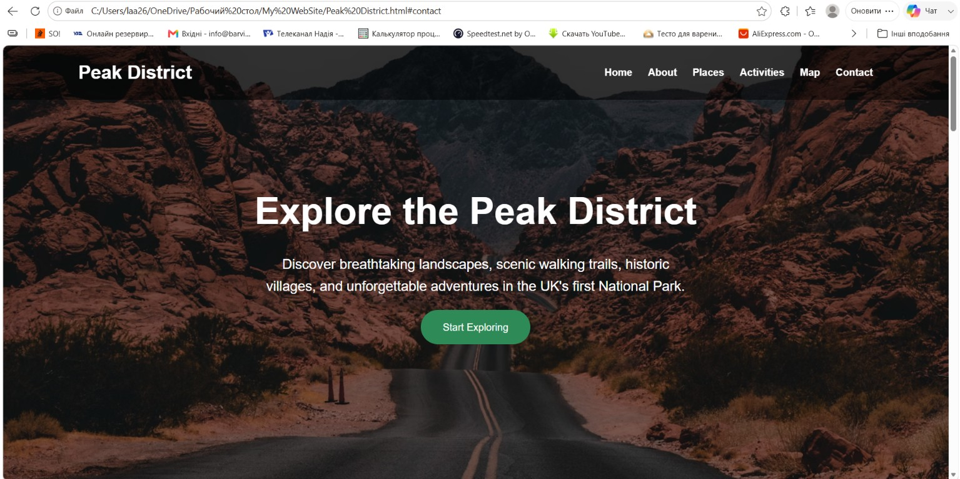

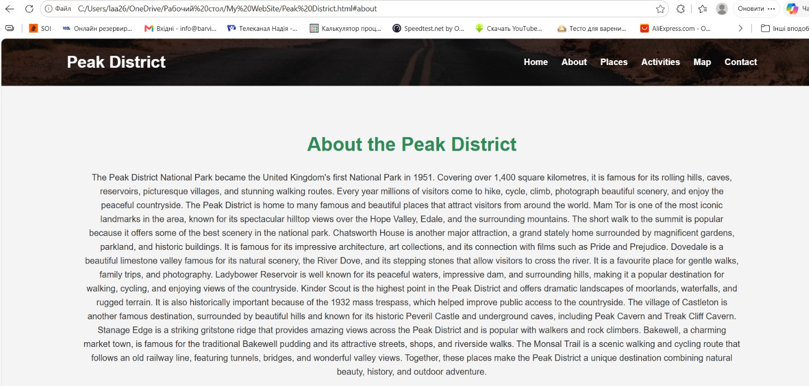

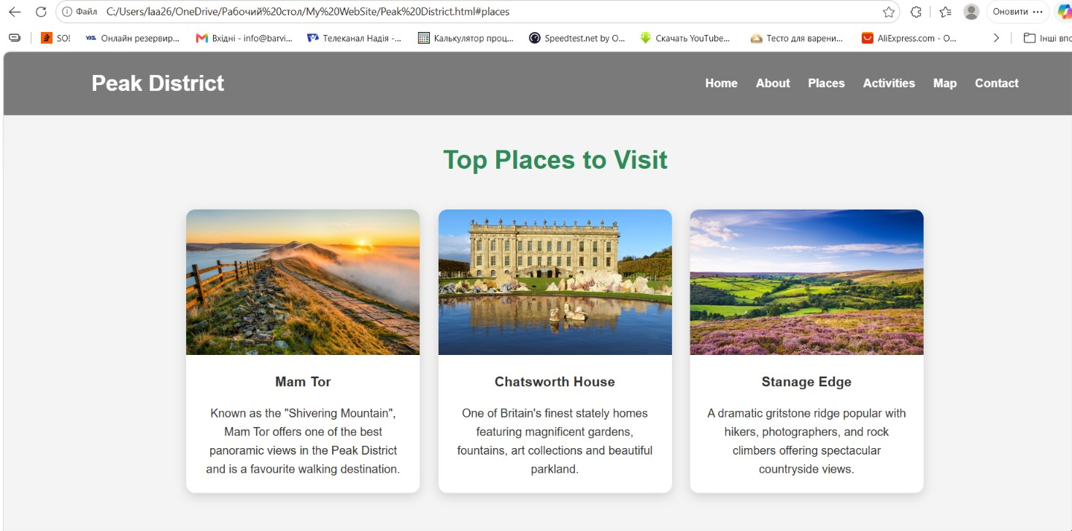

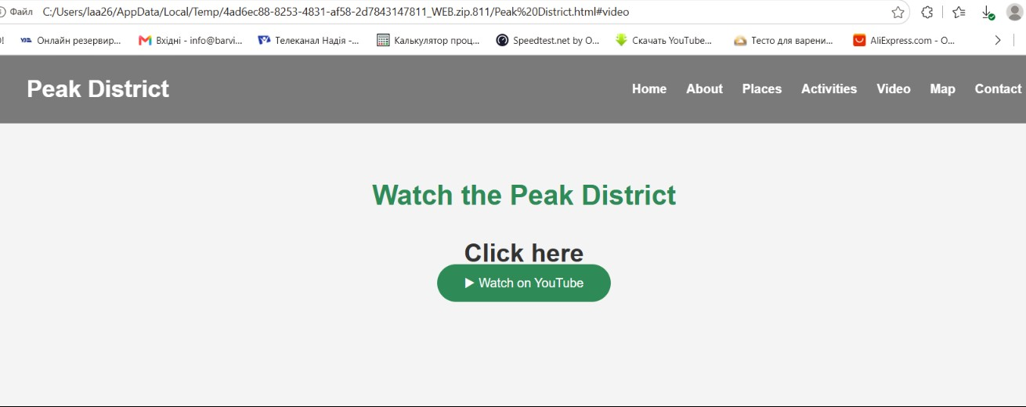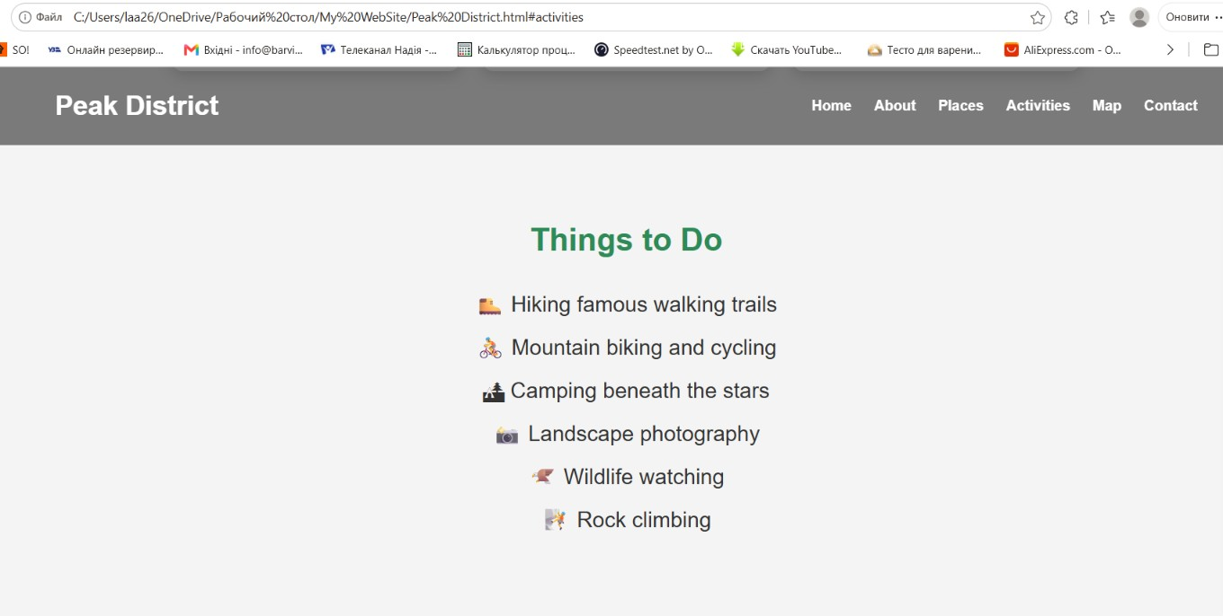

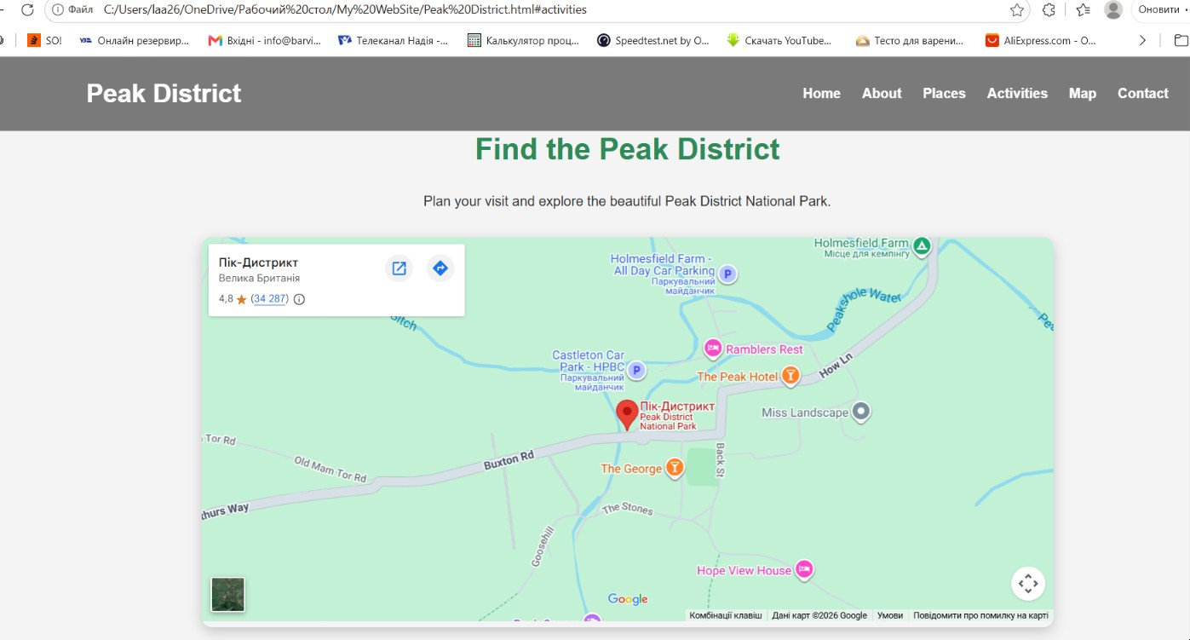

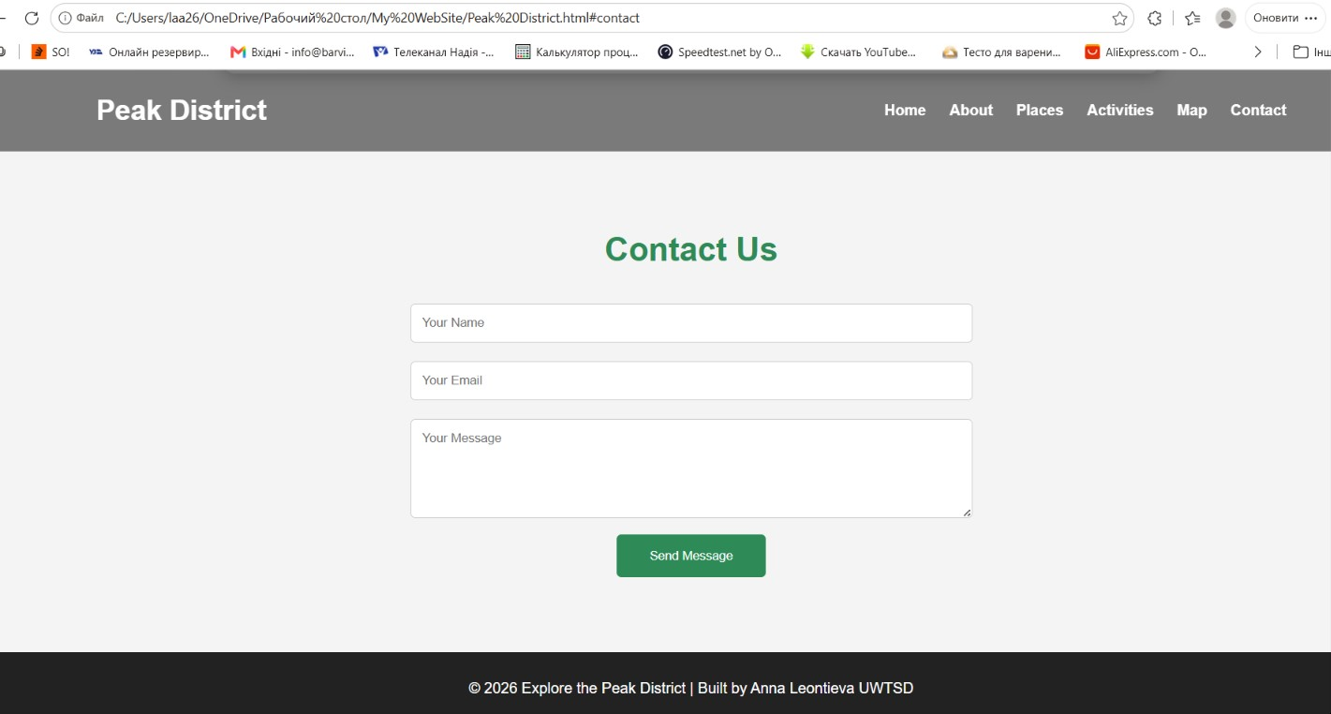

Validation HTML and CSS
HTML and CSS validation is the process of checking web code for errors and ensuring it follows official web standards. HTML validation verifies the structure and syntax of a webpage, while CSS validation checks the correctness of styles and formatting. Validating code helps improve browser compatibility, accessibility, and overall website quality [1].
The website was validated using the W3C HTML Validator for the home page and the W3C CSS Validator for the main stylesheet. The validation process identified a small number of minor HTML and CSS errors, including syntax mistakes, missing closing tags, and formatting issues. These were corrected by reviewing the code and ensuring it followed HTML5 and CSS standards. After making the necessary changes, the website validated successfully. Any remaining warnings are related to browser-specific or modern CSS properties that do not affect the website's appearance or functionality.

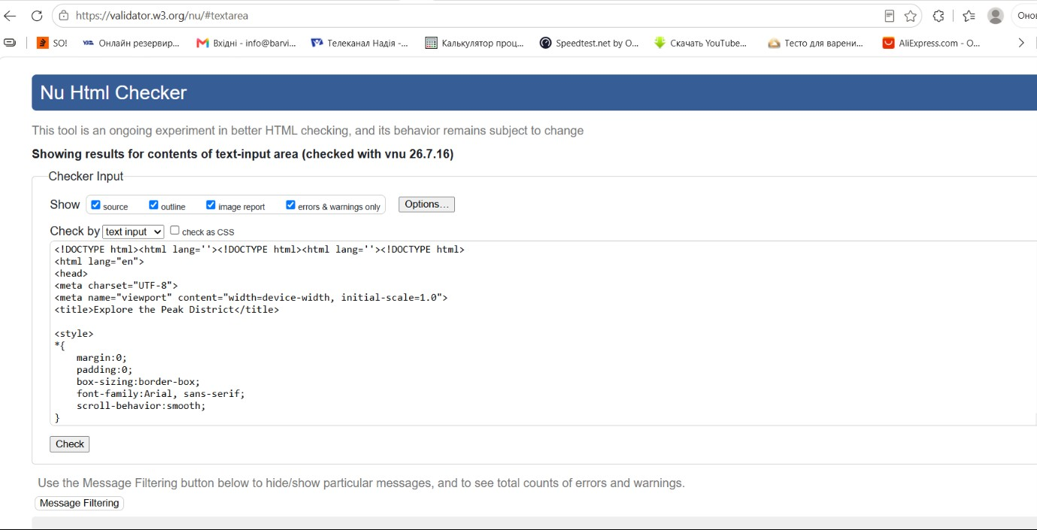
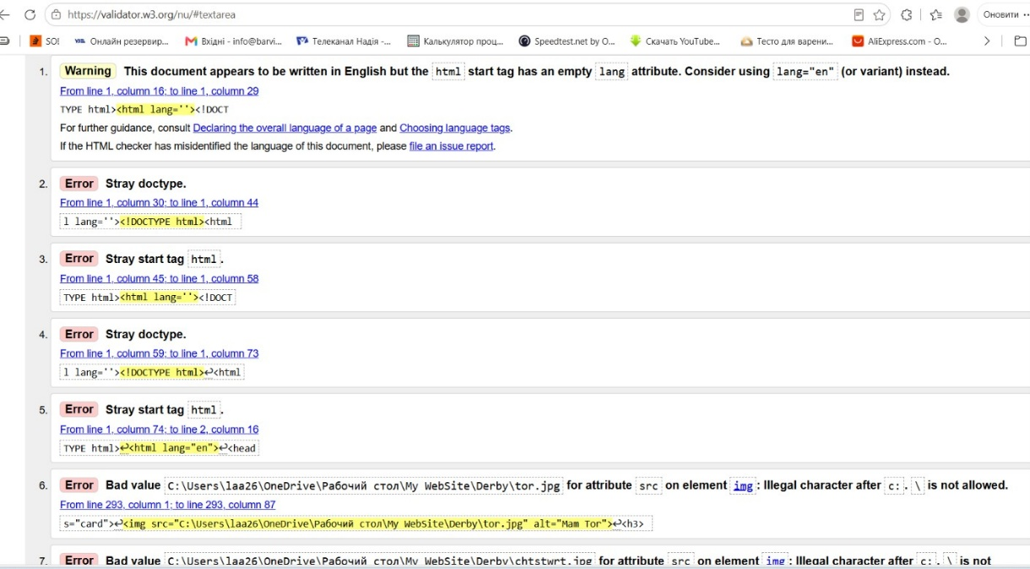
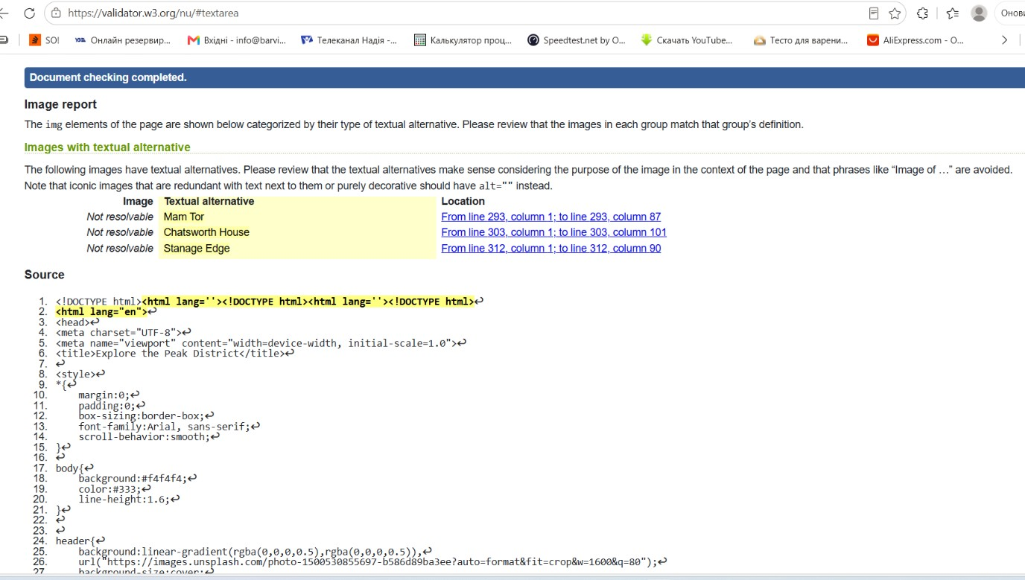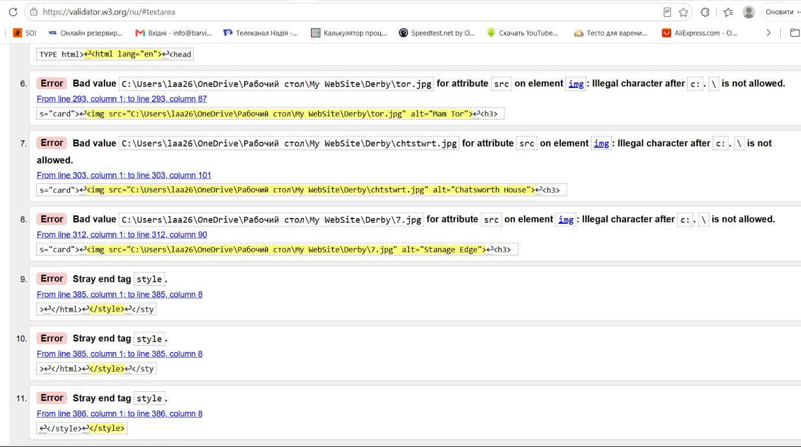
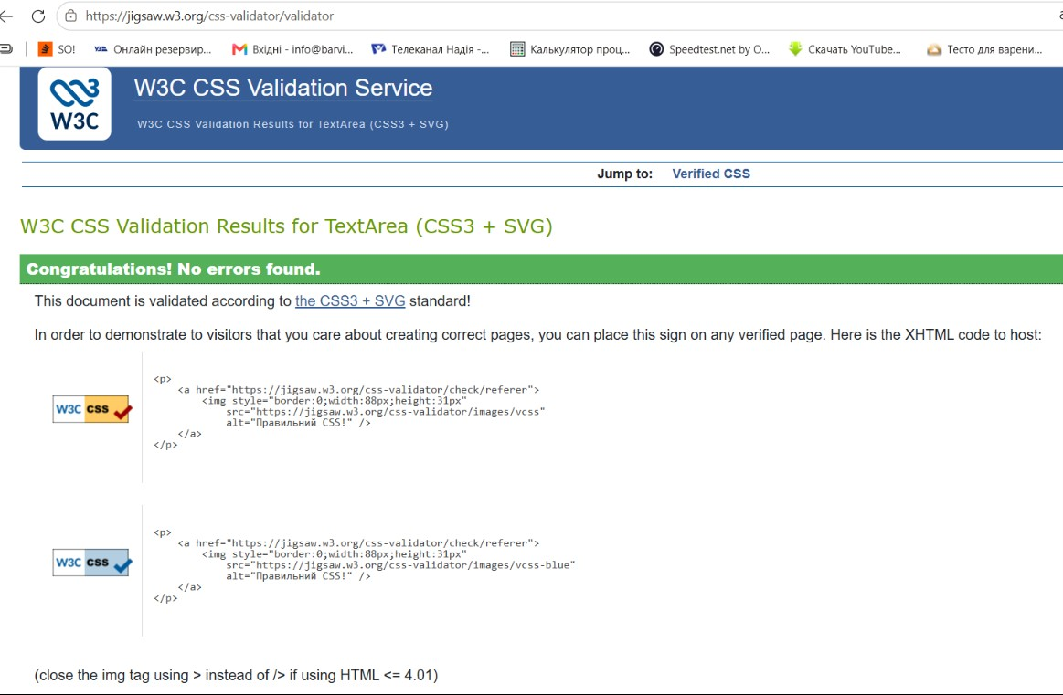

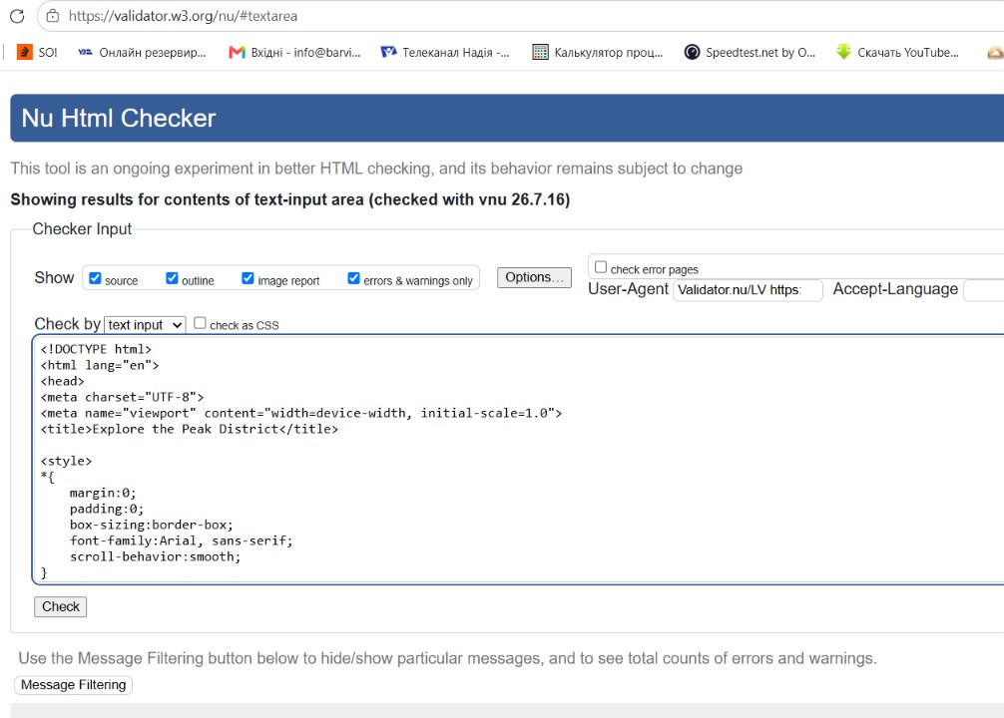
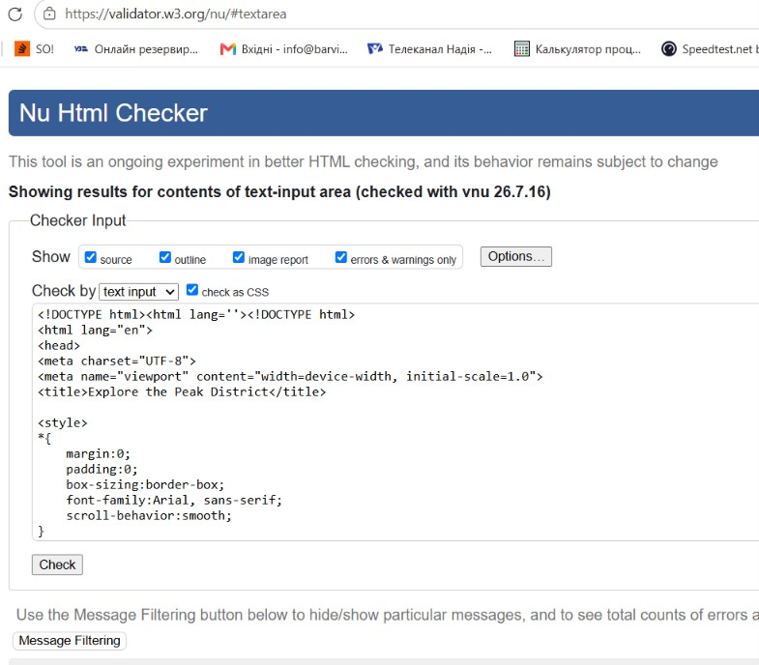
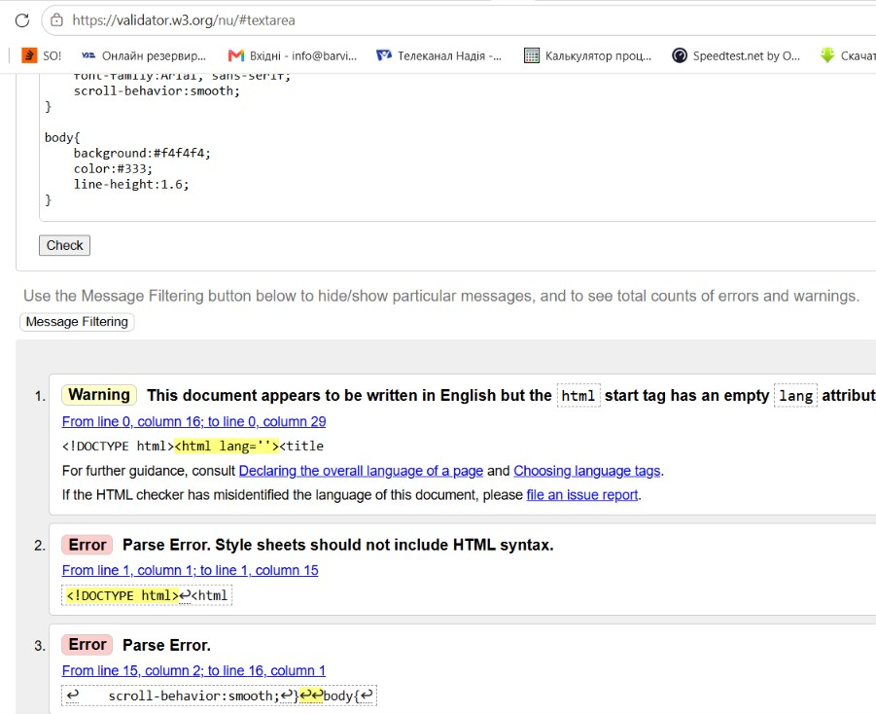

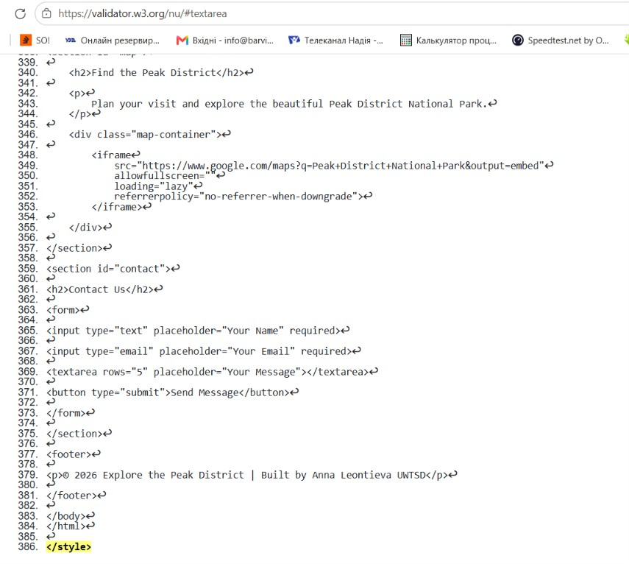

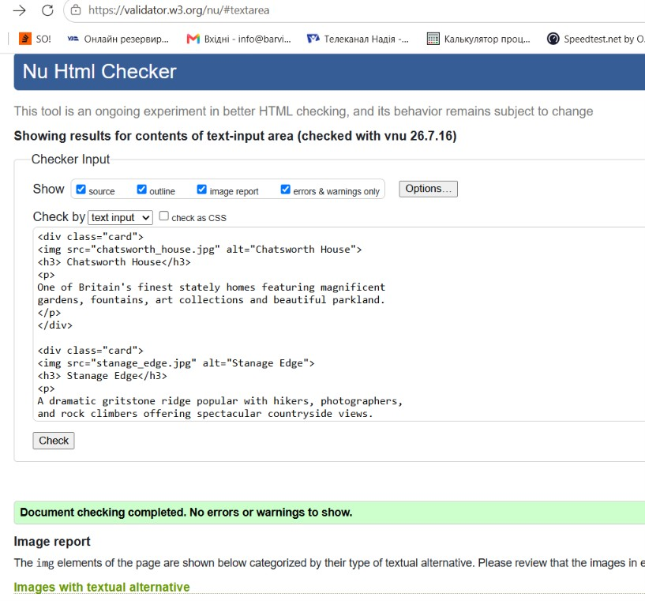

Evaluation

Part A

Website usability
Website usability refers to how easy, efficient, and satisfying it is for users to interact with a website and achieve their goals. A website with good usability allows visitors to find information quickly, navigate pages without confusion, and complete tasks with minimal effort, resulting in a positive user experience. Key principles of website usability include intuitive navigation, a clear and consistent layout, fast loading times, readable content, logical organisation of information, responsive design for different devices, and simple, user-friendly forms and interactive elements [2].
Website usability plays a vital role in web development because it directly influences user satisfaction and the overall success of a website. A well-designed, usable website helps improve the customer experience by making information easy to access and tasks straightforward to complete [3].

Website accessibility
Website accessibility refers to the practice of designing and developing websites so that they can be used by everyone, including people with disabilities. An accessible website enables users with visual, hearing, motor, cognitive, or neurological impairments to access information and complete tasks using assistive technologies such as screen readers, voice recognition software, keyboard navigation, screen magnifiers, and alternative input devices. The internationally recognised standard for web accessibility is the Web Content Accessibility Guidelines (WCAG), developed by the World Wide Web Consortium (W3C). WCAG is based on four core principles: websites should be Perceivable, Operable, Understandable, and Robust (POUR). Common accessibility features include providing alternative text (alt text) for images, ensuring keyboard-accessible navigation, adding captions to videos, maintaining sufficient colour contrast, allowing text to be resized, and using a clear heading structure. These features ensure that website content can be accessed and understood by a wider range of users [4].
Website accessibility plays an essential role in web development because it ensures that digital content is available to the widest possible audience, regardless of ability. By incorporating accessibility into the design and development process, organisations can provide equal access to information and services, comply with accessibility legislation, and improve the overall user experience [5].

Search engine optimisation
Search Engine Optimisation (SEO) is the process of improving a website so that it ranks higher in search engine results pages (SERPs), increasing the amount of organic (non-paid) traffic it receives. Search engines such as Google use complex algorithms to evaluate hundreds of ranking factors when determining the order of search results. SEO is generally divided into three main categories: on-page SEO, technical SEO, and off-page SEO. On-page SEO focuses on optimising the content and structure of individual web pages through elements such as page titles, meta descriptions, headings, keywords, internal links, high-quality content, and image optimisation. Technical SEO ensures that a website is easy for search engines to crawl and index by improving factors such as page loading speed, mobile responsiveness, secure HTTPS connections, XML sitemaps, structured data, and crawlability. Off-page SEO involves activities that improve a website's authority and reputation, including earning quality backlinks, maintaining a strong social media presence, and building domain authority. Together, these techniques help improve a website's visibility and make it easier for users to find relevant information through search engines. SEO plays a vital role in web development because it helps websites reach a larger audience and improves their overall online performance [6].

Part B

Usefulness (Usability and Utility)
The purpose of my website is to provide visitors with useful information about the Peak District National Park and encourage them to explore its attractions. The website is designed with a simple and consistent layout that makes it easy for users to navigate between sections using the fixed navigation bar. The navigation menu contains clear links to the Home, About, Places, Activities, Map, and Contact sections, allowing users to quickly access the information they need. The hero section immediately introduces the website with an attractive background image, a clear heading, a short description, and a call-to-action button labelled "Start Exploring", helping users understand the purpose of the website as soon as they arrive.
The website has good usability because it uses a consistent colour scheme of green, white, and grey, which reflects the natural environment of the Peak District. The typography is simple and easy to read using the Arial font, while headings and content are organised into clearly separated sections. The cards used to display popular attractions provide a clean visual layout, making information easier to understand. Responsive design has also been implemented using CSS media queries so that the website adapts to smaller screens such as tablets and smartphones. The embedded Google Map allows visitors to easily locate the Peak District, while the contact form provides a simple way for users to send enquiries.
The website also has good utility because it provides practical information about the Peak District, including descriptions of famous attractions, popular outdoor activities, an interactive map, and contact details. Visitors can quickly find information about destinations such as Mam Tor, Chatsworth House, and Stanage Edge without needing to search elsewhere.
Although the website performs well overall, several improvements could be made in future versions. Additional features such as a search function, weather information, accommodation recommendations, visitor reviews, social media links, and online booking links could further improve the usefulness of the website.

Search Engine Optimisation (SEO)
Several on-page SEO techniques have been applied during the development of my website to improve its visibility in search engine results.
Firstly, the webpage includes a descriptive title tag, this clearly describes the content of the page and includes the primary keyword "Peak District", helping search engines understand the topic of the website.
Secondly, the website uses a logical heading structure and several headings for different sections, including About, Top Places to Visit, Things to Do, Find the Peak District, and Contact Us. This creates a clear content hierarchy that benefits both users and search engines.
Relevant keywords such as Peak District, National Park, Mam Tor, Chatsworth House, Stanage Edge, walking trails, cycling, and hiking appear naturally throughout the website content. These keywords help search engines identify the subject of the page while maintaining readable, informative text.
The website also includes a responsive viewport meta tag, this ensures the website displays correctly on mobile devices, which is an important ranking factor for Google.
Although several SEO techniques have been implemented, further improvements could be made. A meta description should be added to improve search result snippets, descriptive file names should be used for all images, local image paths should be replaced with relative paths, and structured data (Schema.org markup) could be added to help search engines better understand the content. Additional internal pages, faster image optimisation, and external links to official Peak District tourism websites would also strengthen the website's SEO performance.

Accessibility
The website was evaluated against the four WCAG 2.1 principles: Perceivable, Operable, Understandable, and Robust. It is generally accessible because it uses clear fonts, readable text, headings, image alt text, semantic HTML, and a responsive layout that supports keyboard and mobile navigation. However, improvements could include testing colour contrast to meet WCAG AA standards, adding a "Skip to Content" link, improving keyboard focus indicators, using form labels instead of placeholders, providing confirmation and error messages, validating the HTML, and adding ARIA attributes where appropriate. Overall, the website provides a clean, user-friendly experience while meeting many accessibility requirements, although further testing with tools such as WAVE or aXe would help improve accessibility and overall quality.

Part C
Comparison of Two Live Websites - GOV.UK and BBC News

For this comparison, the two live websites selected are GOV.UK (https://www.gov.uk) and BBC News (https://www.bbc.co.uk/news). Both websites provide information to the public and are designed to serve a wide range of users. GOV.UK offers government services and official information, while BBC News delivers news and current affairs. Although they have different purposes, both websites prioritise usability, accessibility, search engine optimisation (SEO), and mobile responsiveness.

Area | Website 1 | Website 2
Weblink of the Website | GOV.UK  www.gov.uk | BBC News  www.bbc.co.uk/news
Usability | Simple navigation, clear layout, task-focused design | Well-organised content but more visually complex
Accessibility | Excellent WCAG compliance, keyboard navigation, screen reader support | Strong accessibility with captions, transcripts, and keyboard support
SEO | Clear URLs, structured headings, descriptive page titles | High-quality content, keyword optimisation, frequent updates
Mobile Friendliness | Fully responsive with fast loading and simple interface | Fully responsive with adaptive multimedia and navigation
Conclusion | Best for accessibility and ease of use | Best for content discovery and SEO

References:
[1] B. Frain, Responsive Web Design with HTML5 and CSS : Develop future-proof responsive websites using the latest HTML5 and CSS techniques, Third edition. Warsaw ; Packt Publishing Limited, 2020. doi: 10.0000/9781839219795.
[2] J. Nielsen, Designing web usability : [the practice of simplicity]. Indianapolis, Inu: New Riders, 2000.
[3] J. Nielsen and K. Pernice, Eyetracking web usability. Berkeley, Calif: New Riders, 2010.
[4] J. Thatcher, Web accessibility : web standards and regulatory compliance, 1st ed. 2006. Berkeley: FriendsofED, 2006. doi: 10.1007/978-1-4302-0188-5.
[5] Lazar, J., Dudley-Sponaugle, A. and Greenidge, K.D. (2004) ‘Improving web accessibility: A study of webmaster perceptions’, Computers in Human Behavior
[6] Beel, J. and Gipp, B. (2010) ‘Academic Search Engine Optimization (ASEO): Optimizing Scholarly Literature for Google Scholar’, Journal of Scholarly Publishing

Appendix


