Assessment for Learning (AfL) is one of the twelve Pedagogical Principles as discussed in Professor Graham Donaldson’s Successful Futures (2015) where he identifies that in order for good teaching, AfL needs to be successfully implemented in order to provide effectiveness for pupil’s learning and progression. The purpose for assessment within the Welsh Curriculum is to ensure that every pupil makes progress in their own timeframe. It plays a fundamental role in creating a supportive yet challenging environment for each individual learner by assessing them holistically such as where they are in their understanding and producing ideas for progression in teaching and learning (Curriculum for Wales, 2022). There are four key elements for AfL and these can be used as effective ways to create strategies within the learning environment, these include, sharing criteria with learners, quality of questioning and quality of talk, use and quality of feedback and peer and self-assessment all of which involve asking questions and being able to adapt learning strategies for all ages, key stages and subjects. Assessment for Learning is distinctively different to normal assessment and test strategies as it focusses on a broader view which develops the idea of observing, giving feedback and reflecting on learners work to enable them to become more independent in their own learning (Welsh Government, 2013).
Discussion around effective Assessment for Learning strategies outlines the powerful outcomes which can be achieved when learners are given correct feedback which supports their decision making and also provides them with feedback to move forward (Donaldson, 2015). Successful AfL strategies used in classroom environments can create a raise in the effectiveness of pupil learning and also create evolution for effective teaching by providing discussions using quality of questions or talk, sharing criteria with learners, the use and quality of feedback given or providing pupils with opportunities for peer and self-assessment (Black and Wiliam, 1998). The Welsh Government (2010) also identifies within their guidance that by using successful Assessment for Learning strategies such as providing feedback to learners through oral feedback, it helps pupils focus on the issues within their learning instead of interpreting a specific grade within their work. This may also increase learning opportunities and increase pupil improvement throughout the lesson without the learners realising that they are making regular improvements (Welsh Government, 2010).
This assignment will discuss the effectiveness of AfL strategies within a learning environment and also outline the importance of effective Assessment for Learning strategies and how they support learners' development and independence. It will also outline possible effects which it may have on pupils and the positives and negatives from other sources and discussions while critically evaluating how AfL can be utilised within learning opportunities through chosen areas of learning.
The class I will be basing my lesson plans on is my Year five class of twenty-nine pupils. These pupils have a range of needs and capabilities within the classroom, ranging from an intellectual capability of year two to year six, all of which has been taken into consideration when designing the aid of progression within their learning. Within the classroom their current topic is Alchemy Island which explores the reality and questions the fiction of an island which they have created. Within this group there are around nine children with Additional Learning Needs (ALN) such as autism, ADD and ADHD which work closely with a member of staff such as the teacher or teaching assistant to produce their work. When creating their learning experience, it was important to understand what they could already do and also the type of support which they needed such as providing closer one to one support or a separate lesson plan for them to follow. Within my progression steps in my lesson plans I decided to create a poem and they worked closely with the teaching assistant during their first lesson. However, within my second lesson I ensured that I created an experience for them to support their progression by using whiteboards instead of writing in their books as this gave them the opportunity for me to share criteria with them and also provide effective feedback for them to consider when doing their second draft. The pupils have created their own cinquain poem on crystals we found in our island which they have not done before so it was important for me to share the success criteria with them and discuss what they did and did not know. This included a consensogram for them to complete before we begun so I was aware of if they knew what type of poem it was. I was then able to build upon this knowledge and provide the correct quality of questioning throughout the three lessons to continually build upon their previous knowledge. I provided different learning experiences within the three lessons as many pupils learnt differently to the others, some were more visual, and some were very practical in their approach to learning. As the pupils had no previous learning experiences with cinquain poems it was important for them to research this and find out for themselves what it could be which supports one of the pedagogical principles of promoting their problem solving, creative and critical thinking while also supporting the four purposes for them to become ambitious, capable learners.
The three areas of Learning and Experience (AoLEs) I have chosen are Science and Technology, Languages, Literacy and Communication and Expressive Arts and these lessons will provide a continuous progression for their learning by building upon their previous knowledge and scaffolding their learning by firstly researching what a cinquain poem is, to then create a word bank and produce their poems to finish by performing their poems in front of the class. By doing this it gives the learners a constant learning experience with an exciting outcome to see what all their learning produced.

Many discussions have been made involving Assessment for Learning strategies and the overall effect they have on pupil progression one being how it improves teaching in order to support the pupils further (Coe, Aloisi, Higgins, Elliot Major, 2014). Within this it discusses the importance of effective practice in the classroom environment which can lead to positive progression such as peer observations and effective use of assessment and questioning. Furthermore, another report taken from James Ko and Pam Symmons (2013) support this view and discuss how effective teaching is key for school improvement and, in conjunction with this, the use of effective AfL are both key means of instigating effective improvement for both the school and the learners within. With effective AfL implementation it defers the comparison between pupils and enables them to improve their own work using advice and other methods to support their own individual progression (Black and Wiliam, 1998). Additionally, by creating experiences for learners to engage in formative assessment such as peer and self-assessment it provides the opportunity to improve classroom practice and also shows alignment with better learning outcomes for students (Browne, 2016). In addition to this, Professor John Hattie (2019) argues that by successfully employing AfL strategies, such as sharing criteria with the learners, it enables them to see what success looks like for them to then create their own work to reach that level.
Bloom’s Revised Taxonomy (2023) states that the cognitive process of a learner begins with a lower order of thinking skills such as remembering and thinking, to a higher order of thinking skills by creating, evaluating and analysing. This taxonomy provides a framework to clarify learning objectives and within this it determines that sharing specific and measurable criteria with the learners enables them to know what they will be judged on (Gilbert, 2010). Research around formative assessment has also shown that by sharing success criteria equipped with simple learning intentions and suggestions to achieve the learning objective, enables pupils to self and peer assess the outcome (Sadler, 1998). However, in contrast to this Crichton and McDaid (2016) believe that there has not been enough research into the implementation and the perception of the use of learning intentions and success criteria which, when discussed with teachers, showed frustration towards the way they have been implemented. Pollard (2019) also believes that pupils should be engaged in the process for AfL to be successful and he identifies that by sharing learning objectives and goals it defers from the actual learning (Pollard, 2019). These findings may show that although sharing success criteria with learners can be a positive step towards pupil progression it may also have a negative effect on the way in which they are displayed (BERA, 2016).
Studies suggest that implementing effective questioning and talk within the setting can further aid learner progression. Professor David Hopkins discussed this in The Instructional Core by explaining how it begins with the content of student and teacher. By creating a powerful learning environment, it raises the students’ engagement and also creates supportive teaching and learning strategies (Hopkins, 2000). AfL strategies such as using questioning strategies can support pupil progression by creating an environment in which they can fully be aware of what they are learning and also further their learning by delving deeper into their own questions (Cambridge International Education, 2024). However, there can be some misconceptions when raising their quality of questioning due to learners misinterpreting questions (Royal Society of Chemistry, 2008). Trevor Kerry (1982) identified common mistakes that people use when employing effective questioning techniques and considered that questions may be too complex for the learners and also there may be a lack of positive reinforcement when discussing the answers. Likewise, Wiliam (1998) recommends at least two seconds of wait time for learners before discussing or asking for answers to give the opportunity for extended answers when using effective questioning techniques. If this is not achieved then pupils will not engage within the session and be unable to produce acceptable answers (Black and Wiliam, 2010). Giving supportive questioning further benefits another element of AfL by ensuring there is effective feedback given from the answers. Wiliam argues that research has shown if learners are not exposed to regular feedback they will not benefit and further their learning. If a pupil has low grades and is not given feedback they will not understand where they are currently and how they can improve, so it is important to give measurable and specific guidance to each individual person (Black and William, 1998) to aid pupil progression.
Peer and self-assessment are another element of AfL which can be seen as an aid to support pupil progression. Black and William (1998) discussed that pupils are more honest when assessing themselves and one-another, however this can only be achieved if the pupils have a clear understanding of the aims and targets within the learning, so it is important to provide clear and correct success criteria (Black and William, 1998). Studies also show that effective learning achievements can be attained when pupils are engaged in their own learning, it makes them responsible for the outcomes and also develop their collaborative learning skills (Ndoye, 2017). This in time, creates a supportive and collaborative environment for learning strategies, however pupil’s temperaments may impact the benefits of peer and self-assessment due to their own views (Ndoye, 2017). If a pupil can identify their learning progress through specific self-assessment strategies it will aid their engagement and further their learning while also accommodating a range the individuals’ experiences and backgrounds (Spiller, 2012). Spiller (2012) also identifies how peer assessment can help each other make sense of their learning and understanding while lessening the imbalance between teachers and students' statuses. However, there are some limitations when discussing Self-assessment as an Assessment for Learning strategy as the pupils have to fully be aware of the requirements within the success criteria which may lead them to believe they have achieved more than they have (One Education, 2024). Learners may also be subjective when peer assessing, and it must be managed carefully to ensure there are no personal conflicts or comments within this formal assessment (One Education, 2024).

Within my learning opportunities I have decided to focus on Science and Technology (S&T), Language, Literacy and Communication (LLC) and also Expressive Arts (EA) as this focuses on the Digital Competency Framework (DCF) and the Language Competency Framework (LCF). One ESTYN report stated that it is important to take the DCF into consideration as it is essential for children and young people to become aware of the future digital demands (Edwards, 2019). Furthermore, this has been supported by Professor Graham Donaldson and his Successful Futures review (2015) as he highlights the importance of developing learners’ digital skills as a means to adapt to the technological World we live in today.
Due to these views I believe that by introducing a S&T lesson it prepared the pupils for further learning to begin scaffolding their knowledge on the topic, Alchemy Island, and the lesson involving Cinquain Poems. Within my first lesson (see appendix .1) the pupils researched the method to creating a cinquain poem and I believe that by involving the learners in the discussion and methodology for a successful poem it begun to identify the success criteria in preparation for the next lesson. As discussed previously, Black and William (1998) identify the importance of sharing success criteria with learners and by introducing elements from the DCF the pupils’ will be able to lead their own learning with interactive research methods. Within the DCF, the data and computational thinking progression steps provide opportunities for problem solving and thinking skills while also supporting them in their understanding of the methods to their problem solving (Welsh Government, 2023). As the pupils had no previous learning based on cinquain poems, I felt that it was important for them to research this to scaffold their knowledge and begin to build an idea on the expected outcome of the three lessons. This was also used as an opportunity for them to ask questions and solve problems while using technology to analyse and collect relevant information supporting one of the four purposes for ambitious, capable learners (Welsh Government, 2022). Within this lesson I hoped to see the pupils create their own success criteria for a correct cinquain poem while also being able to research further into the topic on their own terms. Before beginning the lesson, I displayed a consensogram with the question “What do you know about cinquain poems?” where learners had the opportunity to place a sticker on one of the three columns showing ‘a lot’, ‘a little bit’ or ‘nothing’. I then used this to use this to check for pupil understanding and I will re-visit this at the end of the lesson to see what the learners had understood. One other method of AfL used in the first lesson to support pupil understanding was to do a simple thumbs up or down after our introduction to determine if the pupils understood the task presented. Rosenshine’s Principles of Instruction (2012) discusses the importance of checking for understanding and identified that it can alert the teacher of any parts that need to be retaught. This also established that the more time that was taken asking questions and checking for understanding ensured that all errors were corrected early on. Furthermore, utilising AfL strategies within my lesson included sharing criteria with learners and the quality of talk used. Within the plenary at the end, as a whole group, we discussed the findings and created a shared criteria to scaffold the learning for the next lesson which included the objective to support the learners understanding. John Hattie’s (2005) rationale supports this decision as he believes that pupils should negotiate the success criteria to engage better in their learning and also it can be used as a basis for feedback and self-assessment.
Leading on from this, after scaffolding the basic success criteria from the first lesson we then created our cinquain poems as part of their LLC learning (see appendix .2). LLC is one of the main AoLEs within the Welsh Curriculum and it discusses the importance of supporting learners using LLC as this enables them to communicate effectively and encourage the transfer of skills through other areas of learning (Welsh Government, 2022). This lesson plan closely links with the Literacy Framework (LF) as part of the cross-curricular frameworks within the curriculum which is another reason why I used this for the second part of the learning experiences. The main focus within the LLC was to develop the learners’ expression through a range of different writing formats and styles by increasing the depth of their own knowledge through writing (Welsh Government, 2022). Professor Graham Donaldson (2015) discussed in his Successful Futures Review the necessity for Cross-Curriculum Responsibilities to ensure the development of high competence levels and through the LF this can support rich content which can be extended when applied. Within my second lesson plan, we firstly recapped over the success criteria which they researched independently in order to revisit their prior knowledge before discussing possible poem strategies. Before beginning to create their own poem, I made sure to discuss with them the need to use their previous work to complete their cinquain poems while continuously displaying the success criteria on the board. Keith Taber (2018) highlights the importance of scaffolding lessons and building on previous knowledge and support learning for student development. Following this, the learners then completed their cinquain poems on whiteboards using the word bank and success criteria which were created previously. In doing this, I was able to live mark the pupils’ work and give effective feedback, as part of the main AfL strategy, for them to correct their poems before doing their final draft in their book. As discussed previously I was then able to explain any misconceptions or grammatical errors which had arisen which supported my decision as it was effectively used for the teaching and learning within this episode. Reasoning behind using effective feedback can support learners understanding as when I was discussing errors or their own work it gave an opportunity to use effective questioning to promote a deeper level of thinking (Coe, 2020). I chose to use the whiteboard strategy during this lesson as it enabled me to live mark their work and give effective and useful feedback to everyone individually for them to correct their work promptly. However, Van Der Kleij (2020) investigated the effectiveness of feedback from teachers to students and discovered that the perception of the given feedback was not as prominent or understood which led to the effectiveness being very subject and individual-dependent. This in turn may lead to less understanding in the classroom or overall, within this subject so it was important to give context-dependent visual work to each individual student, rather than a whole class. This also supported one of the Pedagogical Principles of encouraging the learners to become responsible for their own learning whilst giving them the opportunity to creatively express their thoughts through a given theme.
For my final AoLE (see appendix .3) I focused on Expressive arts (EA) and the learners had the opportunity to perform their cinquain poems to the class. Within the Expressive Arts AoLE, responding and reflecting as the audience and artist is highlighted within the What Matters Statements, due to this I believe this lesson was a successful opportunity to go deeper into this and engage the students by responding to the idea as to why creative work is developed and produced (Welsh Government, 2022). This also provided an opportunity for the learners to consider a range of creative work styles and media forms whilst focussing on assessing their peers as part of the AfL strategy. The main AfL strategy in this lesson was to peer and self-assess and also provide the opportunity for the students to create a success criteria for what they believed would make a successful performance. As part of sharing the success criteria with the learners I did a show + elicit method in which the children were asked for the success criteria which enabled them to think creatively whilst still being within their parameter. During the performances the learners stood in front of the whiteboard, which displayed the criteria, so the other pupils could use this as a guide to peer assess the performance. I decided to encourage the learners to peer assess each other using their independent criteria as I believe this gave them the freedom to express themselves creatively and further benefit from other people’s opinions. Although the pupils used the ‘two stars and a wish method’ there was also the risk of the students becoming too critical or subjective when they carried out their assessing. However, Keith J. Topping (2009) identified that peer feedback can be more available and has a greater volume of immediacy than teacher feedback which further supports my view. Although peer assessment can be seen as a challenge during formative assessment strategies due to the lack of critical evaluation from students or pupils' difficulty in being objective towards fellow peers (Grob, Holmeier and Labudde, 2015), Black and Wiliam (1998) contrast this opinion by discussing how pupils are more honest when assessing each other. I also ensured to use a range of different questions and enabled a class discussion with open ended questioning in order to aid the pupils thinking by using a ‘Basketball’ method to enable active participation throughout the peer assessment process. By doing this I discovered that the learners were more likely to answer and begin discussing with each other their views and opinions of their peers performances.

During my planning it was important for me to use specific AfL strategies in order to support and develop each individual’s learning. I found that by doing this, although some pupils accelerated at a greater speed, I was able to assess each individual throughout the learning process and support them successfully in creating and performing their own cinquain poem on crystals which came from Alchemy Island. During this process all learners achieved the desired outcome and when questioned, they were able to recall information and criteria. However, during this process if I was to complete this activity again, I would try to implement different methods of sharing success criteria with the learners as I feel this was a large area of my AfL strategies which I covered. Also, I would try to include more methods for targeting strategies for more in-depth methods of questioning. When taking into consideration the literature which was discussed I believe that I understood the main discussion of theorists and ideologies which further supported my decisions and ideas when creating the lessons to target successful AfL strategies.

Appendices
Appendix 1.

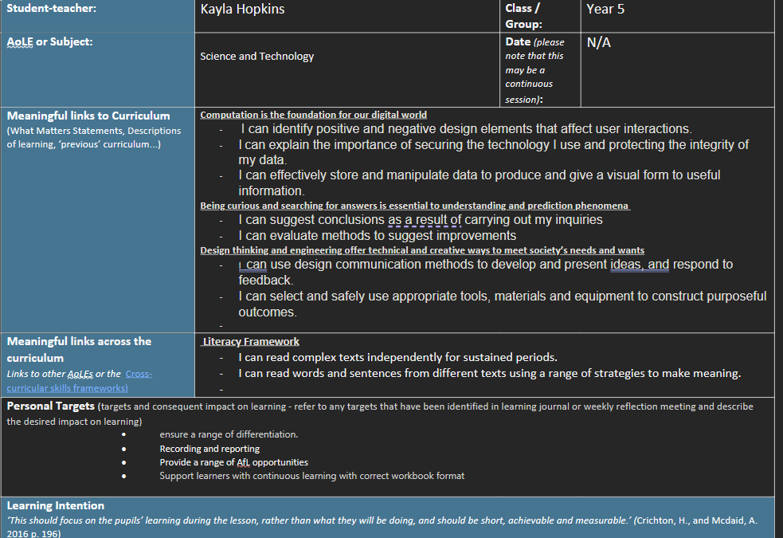
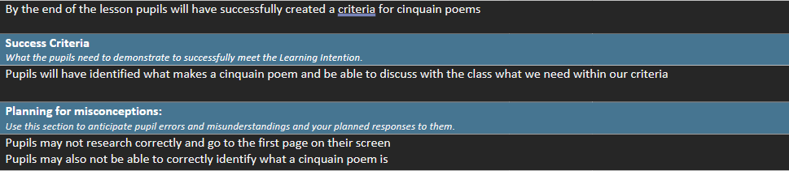
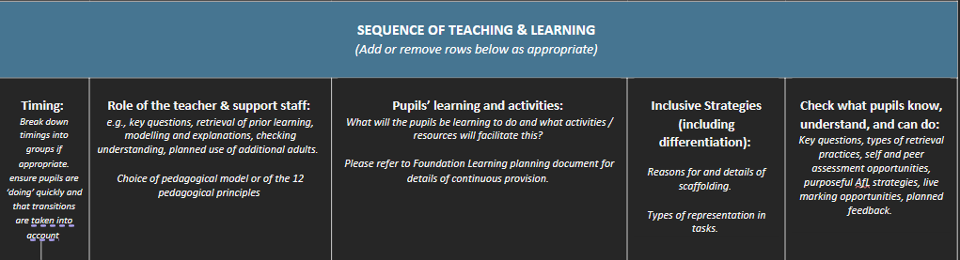
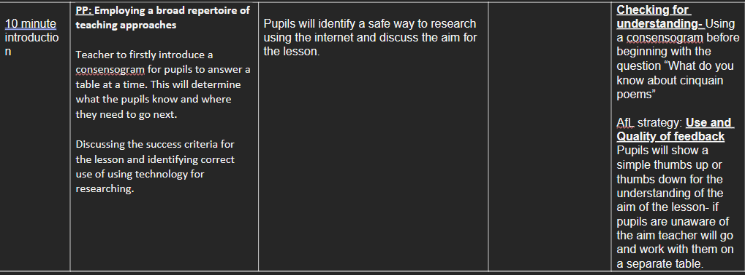
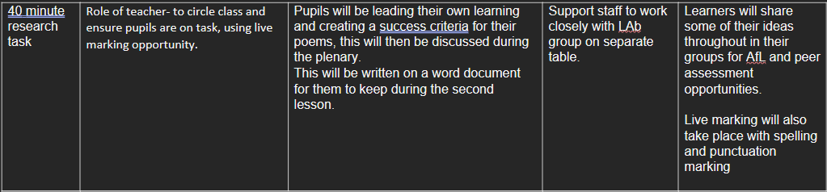
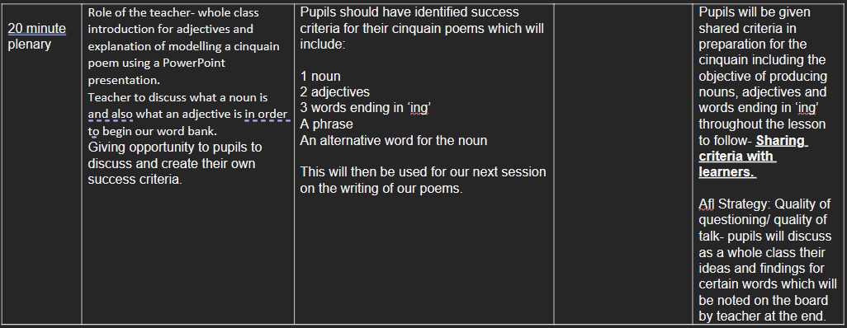

Appendix 2.

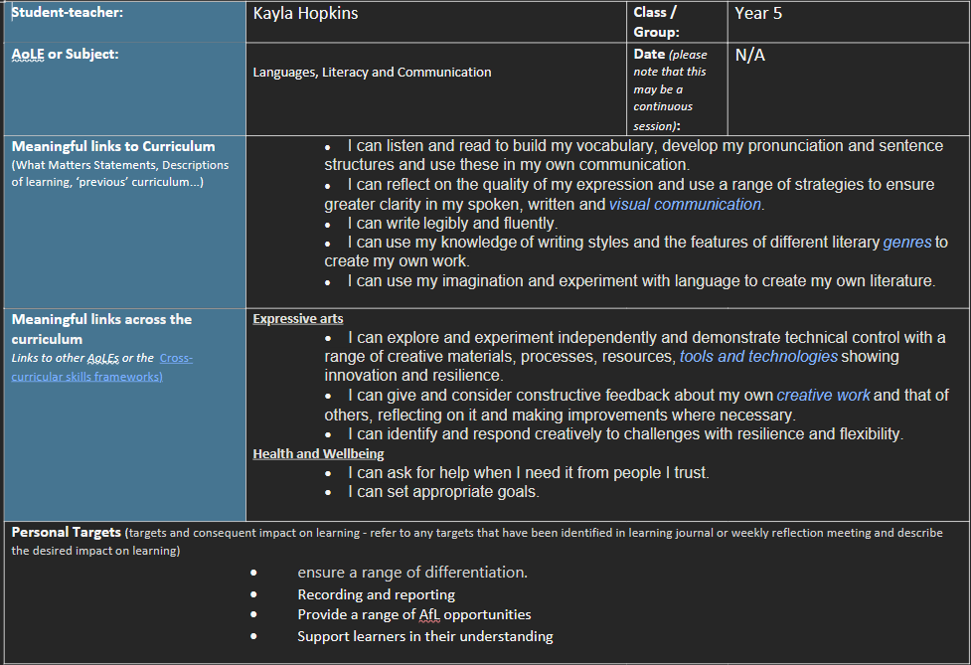
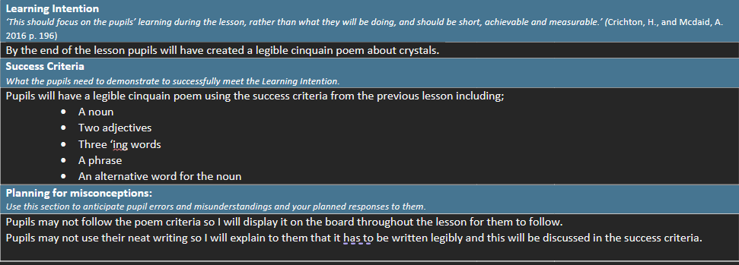
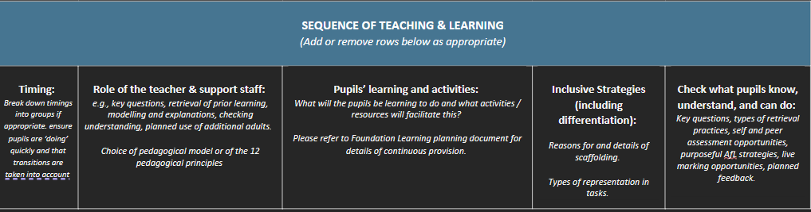
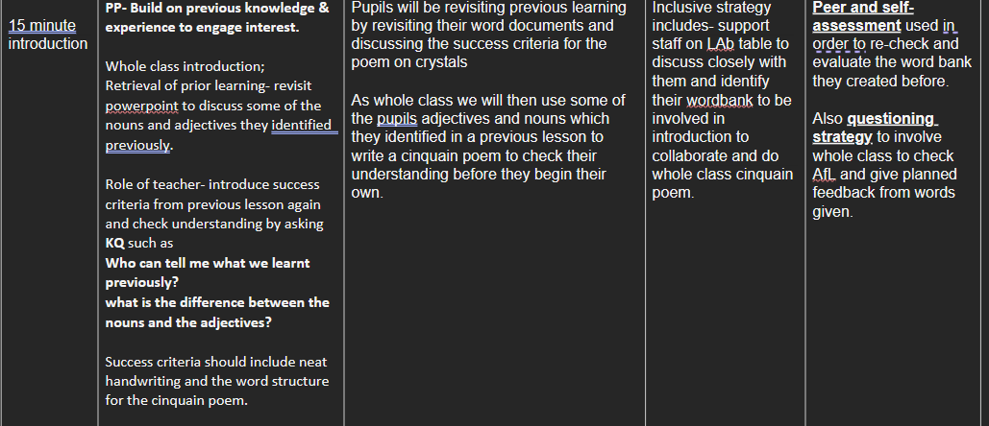
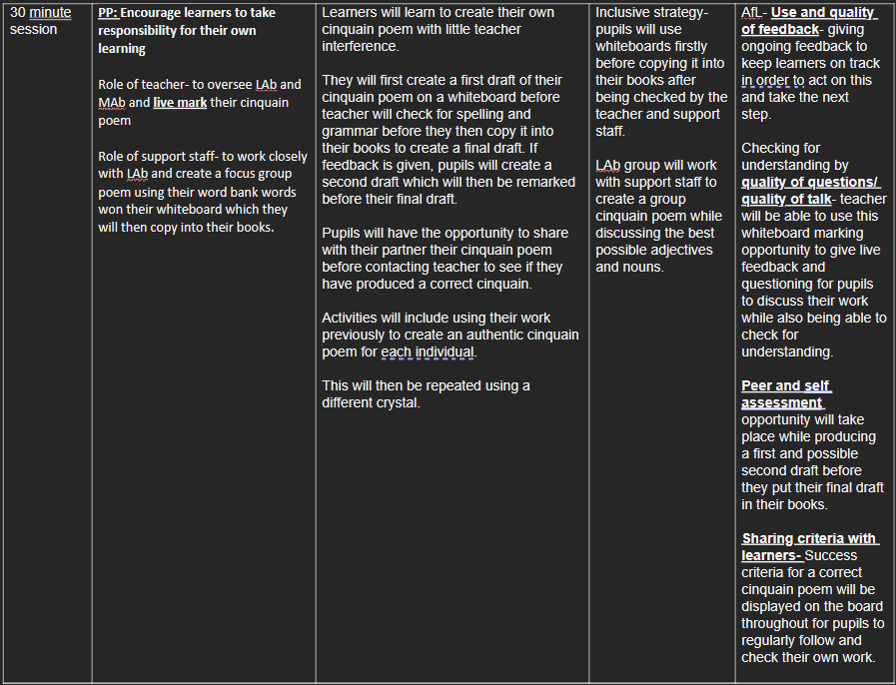
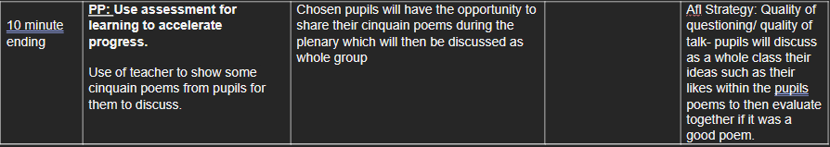

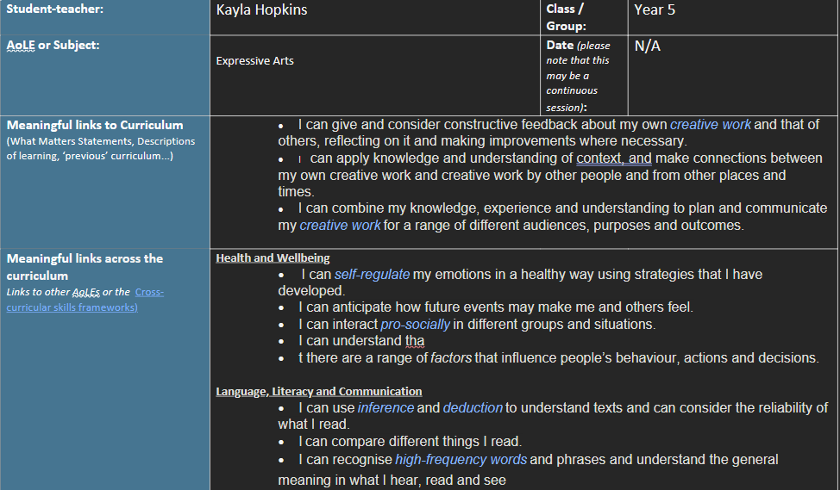
Appendix 3.
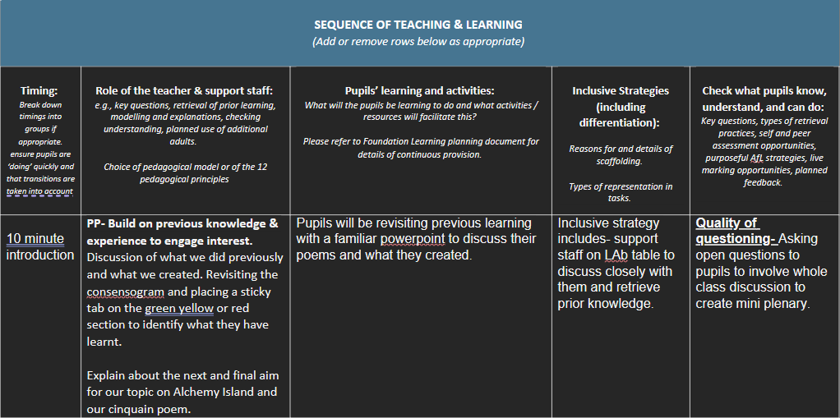

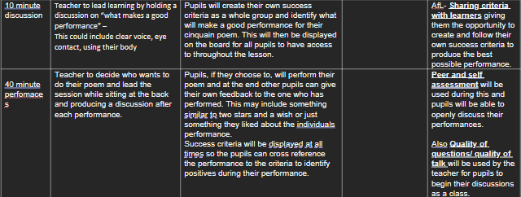
eferences

Black, P., Wiliam, D., & King's College London. (1998). Department of Education Professional Studies. Inside the black box: Raising standards through classroom assessment. Llundain: NferNelson

Browne, E. (2016). Evidence on formative classroom assessment for learning. K4D Helpdesk Report. Brighton, UK: Institute of Development Studies. (online). Available at: 003_Classroom_Assessments_v3.pdf (publishing.service.gov.uk) (Accessed 29th December 2023).

Cambridge International Education Teaching and Learning Team, (2024). Getting started with Assessment for Learning. Available at: Getting started with Assessment for Learning (cambridge-community.org.uk). (Accessed 29th December 2023).

Coe, R., Rauch, C.J., Kime, S., Singleton, D, (2020). Great Teaching Toolkit. Evidence Review. Available at: 584543-great-teaching-toolkit-evidence-review.pdf (cambridgeinternational.org)

Crichton, H., McDaid, A. (2016) Learning intentions and success criteria: learners’ and theachers’ views. BERA. The Curriculum Journal. 2(12). Pp. 190-203. (online). Available at: Learning intentions and success criteria: learners' and teachers' views - Crichton - 2016 - The Curriculum Journal - Wiley Online Library (Accessed 29th December 2023).

Curriculum for Wales, (2022). Supporting learner progression: assessment guidance.
Available at: Supporting learner progression assessment guidance - Hwb (gov.wales)
(Accessed 20th December 2023)

Donaldson, G. (2015). Successful Futures. Wales: Welsh Government. Available at: successful-futures.pdf (gov.wales) (Accessed 2nd January 2024).
Edwards, A. (2019). Digital Competence: Improving pupils’ digital skills. Available at: Digital competence: Improving pupils’ digital skills | Estyn (gov.wales) (Accessed 2nd January 2024).
Glowscotland, (2024). Clarifying and Sharing Learning Intentions and Success Criteria. Available at: LI & SC (glowscotland.org.uk). (Accessed 2nd January 2024).
Grob, R., Holmeier, M., Labudde, P. (2015). Advantages and challenges of formative peer assessment in inquiry-based education at primary school level. Annual conference in Belval. pp. 61-71. Available at: Advantages-and-challenges-of-formative-peer-assessment-in-inquiry-based-education-at-primary-school-level.pdf (researchgate.net)
Hattie, J., Clarke, S. (2018). Visible Learning insights. Routledge, Taylor & Francis Group. (Online) Available at: ProQuest Ebook Central - Reader (Accessed 29th December 2023).
Hattie, J. (2005). What is the nature of evidence that makes a difference to learning? Available at: What is the nature of evidence that makes a difference to learning? (acer.edu.au) (Accessed 2nd December 2024).
Hopkins, D., (2000). Powerful learning, teaching and powerful schools. Journal of Educational Change. 1(2), pp. 135-154.
Kerry. T. (1982). A Question of Stimulation. Gifted Education International. 1(1). pp. 10-13. (online). Available at: A Question of Stimulation - Trevor Kerry, 1982 (sagepub.com) (accessed 29th December 2023).
Ko, J., Sammons P. (2013) Effective Teaching: A Review of Research and Evidence. Reading: CfBT Education Trust. (online). Available at: (PDF) Effective teaching: A review of research and evidence (researchgate.net) (Accessed 29th December 2023)
Major, L. E., & Higgins, S. (2016). What is great teaching and how can I achieve it? In The Times Educational Supplement (Issue 5225, pp. 40-). Times Supplements Ltd. (online) Available at: What is great teaching and how can I achieve it? - ProQuest (Accessed 29th December 2023).
Ndoye, A. (2017). Peer/Self Assessment and Student Learning. Available at: ERIC - EJ1146193 - Peer/Self Assessment and Student Learning, International Journal of Teaching and Learning in Higher Education, 2017 (Accessed 29th December 2023).
One Education. (2023). Involving Learners and Others in the Assessment Process. Available at: Slide 1 (oneeducation.org.uk) (Accessed 29th December 2023).
Pollard, A. (2019). Reflective Teaching in Schools. London. Bloomsbury.
Rosenshine, B. (2012). Principles of instruction: Research-based strategies that all teachers should know. American Educator. 36(1). pp. 1-9.
Royal Society of Chemistry, (2008). Questioning. Available at: Questioning | Principles of assessment for learning | Resource | RSC Education (Accessed 29th December 2023).
Sadler, D.R. (1989). Formative Assessment and the Design of Instructional Systems. InstrSci, 18. (pp. 119-144). (online). Available at: Formative assessment and the design of instructional systems | Instructional Science (springer.com) (Accessed 29th December 2023).
Spiller, D. (2012). Assessment Matters: Self-Assessment and Peer Assessment. The University of Waikato. 13. pp. 2-18. (online). Available at: assessment_matters_self-assessment_peer_assessment.pdf (sdu.dk) (Accessed 29th December 2023).
Taber, K.S, (2018). Scaffolding learning: Principles for effective teaching and the design of classroom resources. pp. 1-43. Nova Science Publishers. Available at: (PDF) Scaffolding learning: Principles for effective teaching and the design of classroom resources (researchgate.net)
Topping, K.J, (2009). Peer Assessment. pp. 20-27. Available at: Peer Assessment: Theory Into Practice: Vol 48, No 1 (tandfonline.com)
Van Der Kleij, F. (2020). Towards effective feedback. Available at: Towards effective feedback: an investigation of teachers’ and students’ perceptions of oral feedback in classroom practice: Assessment in Education: Principles, Policy & Practice: Vol 27, No 3 (tandfonline.com)
Welsh Government, (2010). How to develop thinking and assessment for learning in the classroom.
Available at: untitled (gov.wales)
(Accessed 20th December 2023)

Welsh Government, (2013). Assessment for learning and the National Literacy and Numeracy Framework.
Available at: assessment-for-learning-and-the-national-literacy-and-numeracy-framework.pdf (gov.wales) (Accessed 20th December 2023)

Welsh Government, (2022). The four purposes of the curriculum for Wales. Available at: the-four-purposes-of-the-curriculum-for-wales.pdf (gov.wales) (Accessed 2nd January 2024).

Welsh Government, (2022). Languages, Literacy and Communication. Available at: Languages, Literacy and Communication: Introduction - Hwb (gov.wales) (Accessed 5th January 2024).

Welsh Government, (2023). Digital Competence Framework. Available at: Digital Competence Framework - Hwb (gov.wales). (Accessed 2nd January 2024).

Widiana, I. W., Triyono, S., Sudirtha, I. G., Adijaya, M. A., & Wulandari, I. G. A. A. M. (2023). Bloom’s revised taxonomy-oriented learning activity to improve reading interest and creative thinking skills. Cogent Education, 10(2). (online). Available at: Bloom’s revised taxonomy-oriented learning activity to improve reading interest and creative thinking skills - ProQuest (Accessed 29th December 2023).

