
Module Code: BMHP5023
Module Title: Introduction to Physiology

Assignment Title: Component 1: Written Assignment (Case Study Report)
Module Lecturer: G1 and G2 Shaila Hussain

Student Name: Faridah Namukasa
Student ID: 2429800

Table of Contents
1. Introduction 3
2. Structure of the respiratory system and mechanical respiration 4
3. Gaseous exchange in lungs 5
4. Effect of irritants in the respiratory system and impact on respiration 6
5. Recording and tracking respiratory functions to help individuals with asthma monitor and safely manage their condition 7
6. Evidence-based recommendations 8
7. Conclusion 9
Reference list 10

1. Introduction
Asthma (also known as bronchial asthma) is a chronic respiratory condition characterised by airway swelling and narrowing with mucus, typically leading to breathing difficulties. Based on the clinical evidence, asthma can be specified through recurrent episodes like wheezing, coughing, tightening of the chest and uneven breathing patterns (Clevelandclinic, 2022). Importantly, the symptoms worsen during exercise as well as at night time. In the UK, asthma is a common respiratory condition among all ages, with statistics showing an estimated 7.2 million individuals suffering from the condition in recent decades (Gov.uk, 2025).
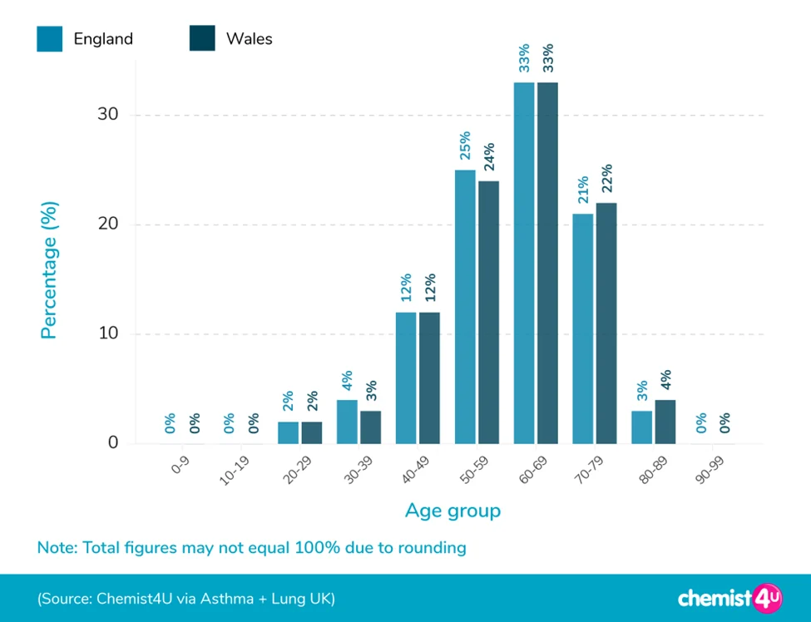
Figure 1: Statistical report of asthma in the UK
(Source: Chemist4U, 2025)
While emphasising the rising statistics of the condition, potential risk factors, which are inherent based on lifestyle patterns, have been established. According to the evidence, in the UK, 10-20% of individuals are pet fur sensitive, 6% show allergic reactions to fungi, and 1-2% to dust particles (Gov.uk, 2025). These risks are further worsened under viral infections, when exposed to air pollution and allergens. Koppelman et al., (2025) further informed that genetics has been a crucial factor that increases the risk of asthma significantly. From a UK-based focus, it has been established that environmental exposures and allergens are critical factors increasing the risk of asthma. Additionally, childhood history of asthma or other respiratory infections, as well as obesity, are strongly contributing to the relapse or worsening of the situation (di Palmo et al., 2021). Thus, prevention, followed by effective management, is essential.

2. Structure of the respiratory system and mechanical respiration
According to the information from NHLBI (2022), the respiratory system comprises specific organs that contribute to breathing. These organs are involved in mechanical respiration, which is also referred to as the physical exchange of gases within and outside of the lungs under the dynamic nature of internal pressure.
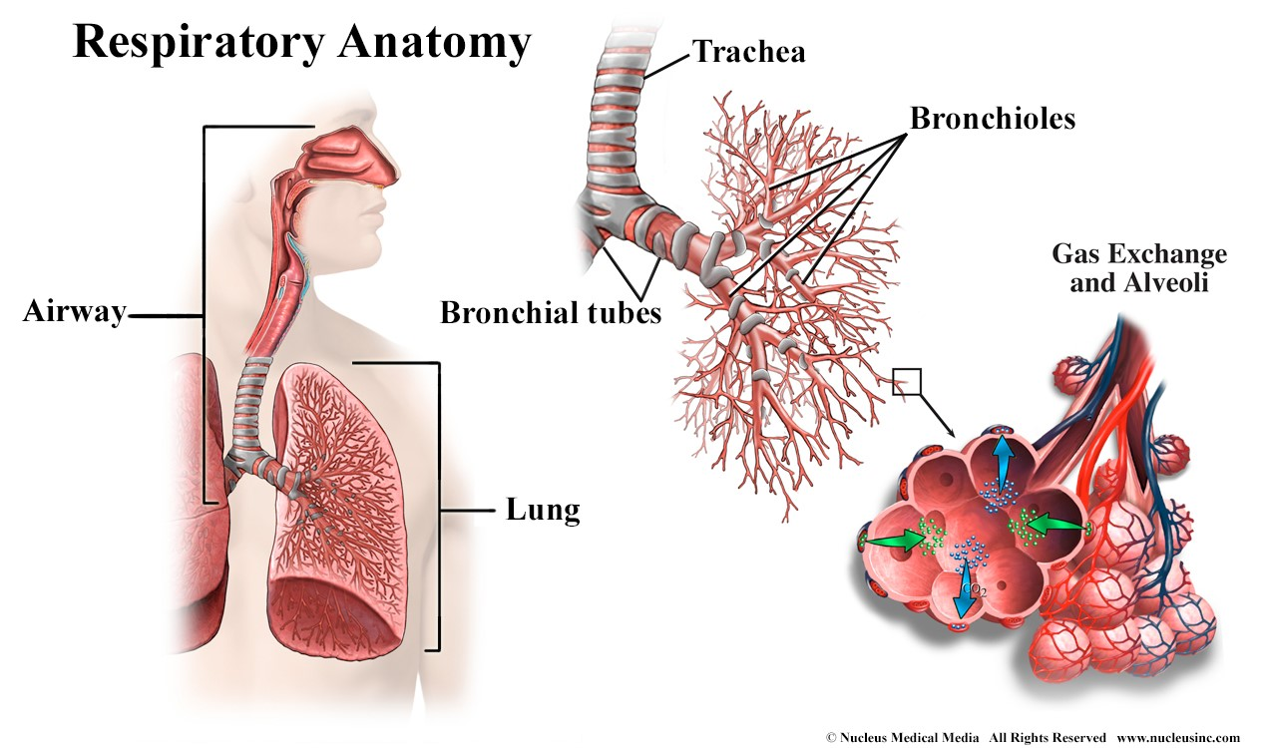
Figure 2: The anatomical structure of the respiratory system
(Source: Nhlbi, 2022)
- Upper respiratory tract (URT) - The URT is the largest part of the respiratory system, which includes the nasal passage (including the nose), nasal cavity, sinuses, pharynx & larynx. According to Clevelandclinic (2024), the URT structure filters, warms and humidifies the external air within the lungs.
- Lower respiratory tract (LRT) - This structure comprises four organs, including the trachea, bronchioles and bronchi as well as alveoli. Anatomically, the trachea (or the windpipe) branched into bronchi, which are further segmented into bronchioles (NCI, 2020). This finally ends in alveoli, small air sacs, via which gaseous exchange occurs.
- Lungs - These are the main organs of respiration, which are categorised as the right and left lungs. While the right lung contains 3 lobes, the left lung contains 2 lobes, which accommodate the cardiac organ (heart) (Clevelandclinic, 2024). Each lung is composed of multiple alveoli, which expand the surface area to exchange oxygen & carbon dioxide as required.
- Supporting muscles - The dome-shaped muscle, or diaphragm, just beneath both lungs, as well as the intercostal muscle structure, contribute to proper breathing.
Mechanical respiration (or breathing) is a physical process of inhalation and exhalation through the lungs and other respiratory structures. The two phases executing this process involve:
- Inspiration - This is also known as inhalation, where the diaphragm contracts, while moving downward, and the intercostal muscles typically widen the rib cage. The process, as informed by Nhlbi (2022), expands the thoracic capacity and lowers the alveolar pressure (<atm pressure). This overall process leads to the inflow of air within the lungs.
- Expiration - This is also referred to as exhalation. In contrast to inspiration, expiration involves relaxation of the diaphragm, which further moves upward (Bains et al., 2023). The ribs fall back, and the thoracic capacity deflates. Further, the pressure builds within alveoli increases (>atm pressure), thus promoting outflow of the air from the lungs.
The process is a continuous cycle, which ensures adequate oxygen flow into the bloodstream and eliminates carbon dioxide. Additionally, as Nhlbi (2022), explained, mechanical respiration maintains homeostasis and supports cellular respiration.

3. Gaseous exchange in lungs
The gaseous exchange in the respiratory system typically starts from the tiny air sacs (alveoli), which are surrounded by capillary networks providing space necessary for diffusion. Based on the evidence by Jana et al., (2023) during inspiration, oxygen travels along the upper and lower respiratory tracts into alveolar sacs. Herein, a higher O2 concentration can be recorded due to oxygenation, when compared with the deoxygenated blood (containing CO2) released through pulmonary arteries. The change in partial pressure plays a vital role in diffusing oxygen across the thin alveolar membrane into the blood capillaries (Powers and Dhamoon, 2023). Jana et al., (2023), mentioned that herein, oxygen molecules bind to haemoglobin (Hb) in RBCs. This enables efficient transport of oxygen within tissues across the body system.
On the other hand, carbon dioxide (CO2) is released as a by-product of cellular respiration. This forms a higher concentration within the bloodstream compared to the air in the alveolar sac. As explained by Jolley (2025), the higher CO2 gradient releases the gas from the pulmonary artery into the alveolar sac. When performing exhalation, CO2 is released (expelled) from the lungs.
The overall process of gaseous exchange in the lungs is facilitated through a thin membrane layer with a thickness of about 0.5µm, followed by a dense capillary network and the cycle of ventilation-perfusion. These structures keep a pace between the blood and air flow. Amid the focus, it is essential to consider that gas exchange regulates homeostasis through O2 regulation and removes CO2 to eliminate the risk of acidosis.

4. Effect of irritants in the respiratory system and impact on respiration
From the previous information, it has been established that individuals with asthma are affected by various factors. Herein, the effect is medium to severe on the respiratory system, considering the triggering factors. Considering the focus, when irritants, for example, cigarette smoking, dust mites, air pollution and vaping aerosols, pass through the respiratory system, they cause a triggering impact, which is identified as an inflammatory response against external substances in the airway (Lira et al., 2024). Based on the information by Hall and Agrawal (2024), the immune system of the body releases key mediators such as histamine or cytokines that cause swelling of bronchial walls as well as the contraction of smooth muscles. The swelling is pivotal in narrowing the airway passage (lumen), and mucus production creates a barrier to airflow.
With continuous swelling of the bronchial walls and alveoli, both organs show limited functioning during gaseous exchanges. As previously mentioned, while the narrowed airway passage restricts the passage of irritants, the delivery of oxygen is simultaneously reduced. It is because of this reason that limited O2 molecules pass into the bloodstream, thus depleting the oxygen content in haemoglobin, a common situation in respiratory infection. O’Donnell et al., (2020) explained that the imbalance between O2 and CO2 leads to critical symptoms like wheezing, coughing and chest tightness. Over the period, continuous exposure to external particles (or irritants) causes airway remodelling, which increases tissue thickness and reduces elasticity. The remodelling causes breathing difficulties, thus increasing “chronic obstructive pulmonary disorder” (COPD) risks, such as asthma and other respiratory tract infections (Mălăescu et al., 2025).
The overall impact of irritants on respiration, as has been understood from the mechanism, is concerning. For instance, individuals experience a declining lung capacity with impaired oxygenation. This causes laboured breathing. Thus, proper management is necessary to prevent exposure to irritants by using inhalers that can reduce inflammation and enable proper monitoring of lung functions.

5. Recording and tracking respiratory functions to help individuals with asthma monitor and safely manage their condition
In clinical practice, the monitoring & tracking of organ functions are critical to assess any deviation from the actual performance. When focusing on respiratory functions, DeVrieze and Giwa (2024), explained that obtaining readings for peak flow is pivotal in effective management of conditions like asthma. According to the evidence provided by Clevelandclinic (2025), a peak flow meter, typically used for measuring the oxygen flow, estimates the exhalation speed at maximum, thus emphasising the rate of airway obstruction. With properly recorded daily values, the subtle changes in patients’ lung function can be noted that is crucial to prevent severity or fatal consequences. Considering the case scenario, empowering patients with asthma to take necessary actions at the earliest, for example, adjusting medications and preventing triggers, can reduce the acute exacerbation risk.
From a critical perspective, monitoring peak flow can provide objective data, which complements the reporting of subjective symptoms. This can be illustrated with asthmatic conditions, the symptoms of which frequently fluctuate and can be underestimated by patients. This is particularly evident among the adult population with asthma, who normalise their breathing during physical exercise. Therefore, regular tracking shows uneven patterns, for example, morning dips, when exposed to irritants, thus informing individuals with tailored interventions (Mah et al., 2022). Kaplan et al., (2023) mention that in healthcare, HCPs use these records for adjusting treatment plans, while providing evidence-based proactive care.
While the above information highlights the importance of monitoring and tracking respiratory functions, the critical emphasis has revealed key limitations. Based on the information provided by Barnes et al., (2020) peak flow readings, for instance, vary based on the tool, indicating possible inaccuracy, which may mislead observation results. Secondly, the adolescent population with asthma often faces a dilemma with adherence, thus undermining the significance. Hence, effective empowerment and education regarding correct effort-dependent technique are important to increase reliability as well as engagement.
Overall, it can be stated that both recording & tracking are fundamental in monitoring respiratory functions, since it provides a structured and evidence-based clinical practice for asthma management. Despite the limitations identified in the process, a combined focus with modification in health education and lifestyle changes can promote patient empowerment and improved clinical decision-making, which reduces exacerbation risk.

6. Evidence-based recommendations
For asthma management, improvement in lifestyle factors is crucial to control repeated exposure to irritants, allergens and other triggers. This not only enhances lung function but also supports overall health conditions. Upon understanding the situation, evidence-based recommendations are established to improve lifestyle conditions of asthma patients.
Environmental adjustments
From the above evaluation, the information highlights that continuous exposure ot irritants/allergens in the environment leads to chronic remodelling of respiratory structures. Thus, reducing exposure, such as quitting cigarette smoking, vaping aerosols and avoiding air pollution, can restrict airway inflammation (ALA, 2021). In the home environment, managing allergens, for example dust mites and pet fur with regular cleaning, can prevent flare-ups.
Dietary improvement and adequate nutrition
The next recommendation involves adjustments in regular food intake. According to You et al., (2021) changes in dietary intake, like adding potassium to the diet, can improve lung health. The consumption of anti-inflammatory foods like fruits and vegetables, as well as omega-3 fatty acid-rich foods, for example, fish, can improve asthmatic conditions with adequate control. Apart from this, the adequate intake of vitamin D through food and sunlight reduces asthma attacks.
Physical exercise and weight management
Managing obesity and performing regular breathing exercises are important considerations to improve the contraction and relaxation of respiratory muscles. Sukadiono et al., (2022) mentioned that key activities like swimming, running and yoga can ensure body control and strengthen lung capacity. Moreover, moderate weight loss promotes improvements.
In essence, it can be stated that lifestyle modifications are vital for effective management of asthma. Herein, combining appropriate medication administration with improved lifestyle changes can ensure a holistic and evidence-based intervention to improve respiratory health.

7. Conclusion
Overall, the report provides comprehensive clinical evidence and anatomical facts on respiratory structures and functions as well as asthma management. Evidence suggests that it is important for individuals suffering from asthma to manage their condition carefully, as it can significantly affect their respiratory health. With the information established on the structure and functions of the respiratory system, it is important to note that managing airway integrity is essential to properly manage gaseous exchange as well as irritants. Further, the demonstration of the importance of peak flow readings as a technique for recording and tracking respiratory functions identifies its significance in early detection of changes and taking prompt actions. Finally, the recommendations provided aim for an overall lifestyle modification that ensures a holistic practice toward asthma management, while reducing exacerbations and improving long-term respiratory health.

Reference list
ALA (2021) Tips to keep your lungs healthy. [online] www.lung.org. Available at: https://www.lung.org/lung-health-diseases/wellness/protecting-your-lungs [Accessed 28 July 2026].
Bains, K.N.S., Kashyap, S. and Lappin, S.L. (2023) ‘Anatomy, thorax: diaphragm.’ In StatPearls [Internet]. StatPearls Publishing. Available at: https://www.ncbi.nlm.nih.gov/books/NBK519558/ [Accessed 28 July 2026]
Barnes, C.N., Mahler, D.A., Ohar, J.A., Lombardi, D.A. and Crater, G.D. (2020) ‘Peak inspiratory flows.’ Chest, [online] 158(4), pp.1413–1419. DOI:10.1016/j.chest.2020.03.072.
Chemist4U (2025) Asthma statistics report. [online] Guides. Available at: https://www.chemist-4-u.com/guides/research-insights/asthma-statistics/ [Accessed 28 July 2026].
Clevelandclinic (2022) Asthma. [online] Cleveland Clinic. Available at: https://my.clevelandclinic.org/health/diseases/6424-asthma [Accessed 28 July 2026]
Clevelandclinic (2024) Respiratory system: Functions, facts, organs & anatomy. [online] Cleveland Clinic. Cleveland Clinic. Available at: https://my.clevelandclinic.org/health/body/21205-respiratory-system [Accessed 28 July 2026]
Clevelandclinic (2025) What is a peak flow meter? [online] Cleveland Clinic. Available at: https://my.clevelandclinic.org/health/treatments/peak-flow-meter [Accessed 28 July 2026]
DeVrieze, B.W. and Giwa, A.O. (2024) Peak flow rate measurement. [online] PubMed. Treasure Island (FL): StatPearls Publishing. Available at: https://www.ncbi.nlm.nih.gov/books/NBK459325/ [Accessed 28 July 2026]
di Palmo, E., Filice, E., Cavallo, A., Caffarelli, C., Maltoni, G., Miniaci, A., Ricci, G. and Pession, A. (2021) ‘Childhood obesity and respiratory diseases: Which link?’ Children, 8(3), pp.177-180. DOI:10.3390/children8030177
Gov.uk (2025) Asthma and airborne allergens. [online] GOV.UK. Available at: https://www.gov.uk/guidance/asthma-and-airborne-allergens [Accessed 28 July 2026]
Hall, S. and Agrawal, D.K. (2024) ‘Key mediators in the immunopathogenesis of Allergic asthma.’ International immunopharmacology, [online] 23(1), pp.316–329. DOI:10.1016/j.intimp.2014.05.034.
Jana, S., Manjari, P. and Hyder, I. (2023) ‘Physiology of respiration.’ pp.171–192. DOI:10.1007/978-981-19-9410-4_7
Jolley, C. (2025) ‘Respiratory physiology.’ CRC press eBooks, pp.28–47. DOI:10.1201/9781003033882-4.
Kaplan, A., Boivin, M., Bouchard, J., Kim, J., Hayes, S.W. and Licskai, C. (2023) ‘The emerging role of digital health in the management of asthma.’ Therapeutic advances in Chronic disease, 14(1). DOI:10.1177/20406223231209329.
Koppelman, G.H., Pino-Yanes, M., Melén, E., Powell, P., Bracke, K.R., Celedón, J.C. and Brusselle, G.G. (2025) ‘Genetic and environmental risk factors for asthma: Towards prevention.’ The lancet. Respiratory medicine, [online] pp.S2213–2600(25)00256–5. DOI:10.1016/S2213-2600(25)00256-5
Lira, G., Silva, G., Bezerra, P. and Sarinho, E. (2024) ‘Avoidance of Inhaled pollutants and irritants in Asthma from a salutogenic perspective.’ Journal of Asthma and allergy, [online] Volume 17, pp.237–250. DOI:10.2147/jaa.s445864.
Mah, A.J., Nguyen, T., Ghazi Zadeh, L., Shadgan, A., Khaksari, K., Nourizadeh, M., Zaidi, A., Park, S., Gandjbakhche, A.H. and Shadgan, B. (2022) ‘Optical monitoring of Breathing patterns and tissue oxygenation: A potential application in Covid-19 screening and monitoring.’ Sensors, [online] 22(19), p.7274. DOI:10.3390/s22197274.
Mălăescu, A.-N., Mihălțan, F.-D. and Constantin, A.-A. (2025) ‘Chronic obstructive pulmonary disease in Never-Smokers—A distinct entity within the COPD spectrum.’ Life, [online] 16(1), pp.43–43. DOI: 10.3390/life16010043.
NCI (2020) Bronchi, bronchial tree, & lungs | SEER training. [online] National Cancer Institute. Available at: https://training.seer.cancer.gov/anatomy/respiratory/passages/bronchi.html [Accessed 28 July 2026]
Nhlbi (2022) How the lungs work - the respiratory system . [online] www.nhlbi.nih.gov. National Heart, Lung, and Blood Institute. Available at: https://www.nhlbi.nih.gov/health/lungs/respiratory-system [Accessed 28 July 2026]
O’Donnell, D.E., Milne, K.M., James, M.D., de Torres, J.P. and Neder, J.A. (2020) ‘Dyspnea in COPD: New mechanistic insights and management implications.’ Advances in Therapy, [online] 37(1), pp.41–60. DOI: 10.1007/s12325-019-01128-9.
Powers, K.A. and Dhamoon, A.S. (2023) Physiology, pulmonary ventilation and perfusion. [online] Nih.gov. StatPearls Publishing. Available at: https://www.ncbi.nlm.nih.gov/sites/books/NBK539907/ [Accessed 28 July 2026]
Sukadiono, S., Zahrah, S.F., Nasrullah, D., Supatmi, S. and Fitriyani, V.R. (2022) ‘The effect of physical exercise on vital lung capacity in Tapak suci athletes.’ Jurnal keolahragaan, [online] 10(2), pp.166–174. DOI:10.21831/jk.v10i2.52392.
You, D., Zhang, M., He, W., Wang, D., Yu, Y., Yu, Z., Lange, T., Yang, S., Wei, Y., Ma, H., Hu, Z., Shen, H., Chen, F. and Zhao, Y. (2021) ‘Association between dietary sodium, potassium intake and lung cancer risk: Evidence from the prostate, lung, colorectal and ovarian cancer screening trial and the Women’s health initiative.’ Translational lung cancer research, 10(1), pp.45–56. DOI: 10.21037/tlcr-20-870.

