Strategic Redirection of IKEA approach innovation
Agile Business Management, Innovation in Customer Care, and Sustainable Competitive Advantage

Sandra Boscaneanu 2016826
University of Wales Trinity Saint David
Strategic and Agile Business Management BMMB7027

Executive Summary

This paper analyses IKEA's strategic position utilising major frameworks: PESTLE, SWOT, Porter’s Five Forces, Porter’s Generic Strategies, Market Trends, and the Value Chain. These tools offer insights into the external and internal elements influencing IKEA's business strategy and assist in formulating future recommendations. The PESTLE analysis delineates external influences influencing IKEA, including governmental regulations, economic trends, technical innovations, and escalating environmental issues. The SWOT analysis underscores IKEA's strengths in brand recognition and cost efficiency, while pinpointing weaknesses like supply chain difficulties. Opportunities encompass the enhancement of sustainability initiatives and digital services, but risks stem from fierce rivalry and escalating expenses. Porter’s Five Forces indicates that IKEA encounters significant rivalry and supplier power, which it alleviates through cost leadership and a robust brand presence. The Porter’s Generic Strategies framework illustrates IKEA’s hybrid strategy of cost leadership and differentiation, allowing it to offer both affordable and innovative items. Market trends highlight a growing demand for sustainability, digital services, and e-commerce. The Value Chain analysis demonstrates IKEA's proficient supply chain management, which underpins its competitive pricing and operational efficacy. The paper advocates for augmenting digital interaction, amplifying sustainability measures, refining customer service, and diversifying products via strategic alliances to preserve IKEA's competitive advantage and foster long-term growth.

Table of Contents
1.Introduction 3
2. Main Findings 4
3.0 Strategy and Strategic Management 5
3.1 Strategic Analysis 5
3.2 Porter’s Five Forces Analysis 8
3.3 Stakeholder analysis 12
3.4 Market Analysis 15
4.0 Internal Analysis 16
4.1 Resource-Based View 16
4.2 SWOT Analysis 17
4.3 Value Chain Analysis 18
5.0 Critical Evaluation of Strategic Options 19
6.0 Conclusion 23
Recommendations 24
References 27

1.Introduction
In today’s rapidly evolving business environment, the pursuit of customer care and sustainable competitive advantage has become critically important for organisations of all sizes. With increasing concerns about environmental and social issues, companies are adopting innovative strategies that not only enhance cost efficiency but also foster value creation and improve customer care. This investigation aims to examine IKEA's strategic orientation, its reactions to global instability, and its sustainable growth methods focusing on customer care. This analysis will use a combination of Porter’s Generic Strategies, Ansoff’s Matrix, SWOT Analysis, PESTLE, and Bowman’s Strategy Clock, underpinned by pertinent theoretical insights. For this report various credible sources of information have been used, such as, books, ebooks, journals, websites, and peer reviewed articles.
Organisation Background
IKEA is a subsidiary of Inter-IKEA Holding BV, providing home furnishing products, solutions, and services. The company's divisions include franchising, variety of products, supply chain, and industry. It offers products in several categories, including textiles, living and workspace, bedroom and bathroom, kitchen and dining, lighting and smart home, cooking, dining, décor and food, among others. The headquarters is in Zuid Holland, Netherlands. IKEA's vision and values are "to create a better everyday life for the many people." The company aims to positively influence the globe by sourcing raw materials from local communities. The IKEA business model aims to provide a diverse selection of aesthetically pleasing and practical home furnishings at costs that are accessible to a broad audience.(IKEA , 2023)

2. Main Findings
Organisational Culture and Strategic Management
According to (Nel, 2024) IKEA foster a culture characterised by flat organisational structures and concise communication. Furthermore, IKEA’s flat culture, channels, egalitarian values, and focus on collaboration play a pivotal role in shaping its strategic direction and ensuring alignment with its mission of “creating a better everyday life for the many people.”
A flat organisational structure is an organisational design characterised by a diminished hierarchy and a decentralised decision-making process. (Schooley, 2023). Furthermore Schooley (2023) asserts that this type of culture is increasingly prevalent among organisations as they pursue cost-cutting measures through worker reductions. Consequently, few advantages of flat organisational culture, according to Schooley(2023) are as follow:
- Enhance communication – as the communication between employees and superiors is more open and direct.
- Increase employee engagement - Employees in flat organisations tend to exhibit greater engagement, motivation, and empowerment to make significant contributions to the firm due to increased responsibility and autonomy. According to Forsdick(2024) IKEA's recent data indicates that voluntary employee turnover was 21.0% in the 2023 fiscal year. This figure was significantly below the retail sector average of 50%, as reported by the British Retail Consortium.
- Reduce costs - A flat organisational culture features minimal management tiers between senior executives and entry-level personnel.
Nonetheless, the flat organisational culture has certain limitations. According to Reitzig (2022), one limitation is that dismissing middle-level hierarchy may result in a doubled or tripled workload for remaining managers, and if the company does not ease some managerial responsibilities, the organisation may become unstable. Another drawback according to (Schooley, 2023) of flat culture is that limits career progression. The reduction of middle management levels may restrict employees' advancement options within the organisational hierarchy. Furthermore, Origanimi (2024) contends that employees may lack clarity regarding their reporting structure and the individuals responsible for final decisions, thereby resulting in decision paralysis and diminished productivity.

3.0 Strategy and Strategic Management

According to Thompson(2024) the word "strategic management" is occasionally employed interchangeably with "strategy," however the two concepts are not identical. A company's strategy is its blueprint for success in competing against other firms. Strategic management is a procedure for designing and executing a strategy. According to Lynch (2018), strategic management is the process of identifying an organisation's purpose and formulating plans and actions to achieve it. Nonetheless, Lynch(2018) argues that it is possible to plan strategy in advance and then conduct that strategy over time.
Furthermore, Lynch (2018) identifies five essential characteristics of strategic decision-making that are fundamentally linked to an organisation's capacity to create value and compete for customers in the marketplace.

3.1 Strategic Analysis
External Analysis - PESTLE
According to (Battista, 2024) to be effective PESTLE analysis, needs to be done regularly so can help organisations to spot trends early, and provide a competitive advantage. One advantage of this tool is that helps organisations to identify opportunities and threats that affects the business in its macro environment. On the other hand, (Sujan, 2023) states that a limitation of PESTLE is that the ever-changing nature of external factors could cause PESTLE analysis conclusions to become outdated quickly. Rapid shifts in areas like politics, technology, or regulations may take businesses by surprise, making it difficult to predict and respond effectively. IKEA operates in more than 60 countries, necessitating adherence to various regulatory frameworks.
According to Hivelr Business Review (2023a), partnering with business-friendly governments can streamline operations, reduce bureaucratic obstacles, and cut costs. Nonetheless, the company confronts significant challenges, such as geopolitical tensions (e.g., the Russia-Ukraine conflict), global supply chain disruptions, and fluctuations in energy prices. These challenges also present opportunities, particularly in advancing decarbonization initiatives. Table 1 highlights PESTLE factors influencing IKEA, including political stability, inflation rates, climate-focused regulations, consumer changes, AI.

These complex dynamics emphasize the necessity for ongoing PESTLE analyses to detect early trends and maintain a competitive advantage (Battista, 2024). Additionally, (Sujan, 2023) argue that PESTLE analysis is not without its drawbacks; it may yield outdated insights in fast-evolving environments. On the other hand, (CIPD, 2021) states that PESTLE analysis evaluates the external environment to identify and interpret extensive, long-term patterns. This understanding is beneficial in multiple business planning scenarios, including:
Strategic Business Planning
PESTLE analysis provides critical context for formulating corporate plans, encompassing the company's trajectory, brand positioning, growth ambitions, and potential hazards, including the repercussions of another pandemic on productivity. It assists in evaluating the pertinence of existing products and services while directing the creation of new offerings.
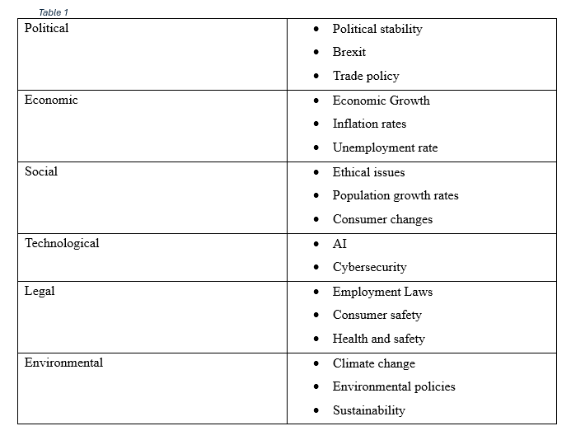

An economic factor that may affects IKEA is supply chain disruption, according to Oladipo and Shepardson (2024) disruptions in the supply chain could affect IKEA's capacity to sustain product availability and fulfil consumer demand. IKEA, as a global retailer, depends on an intricate network of suppliers and logistics to convey goods from manufacturers to shops globally. Port strikes, shipping delays, natural disasters, and geopolitical conflicts can result in delays, elevated costs, or shortages of essential resources and products. These disruptions impair IKEA's capacity to deliver goods punctually and may lead to increased prices for consumers or diminished sales. However, Ingka Group(2024a) recently reported its portion of IKEA retail sales at EUR 39.6 billion for the fiscal year 2024, reflecting a 5% decline from the previous year (EUR 41.7 billion in FY23. The corporation has prioritised reducing prices for clients by spending over EUR 2.1 billion in thousands of items across all markets. This resulted in a more than 3% increase in store visits and a 28% rise in internet visits, while online orders increased by 9%. (Ingka Group, 2024b)
Additionally, (Ludmir, 2023) states that growing consumer demand for sustainable furniture has prompted IKEA to focus on expanding its circular economy initiatives, including product repair and resale programs.

3.2 Porter’s Five Forces Analysis
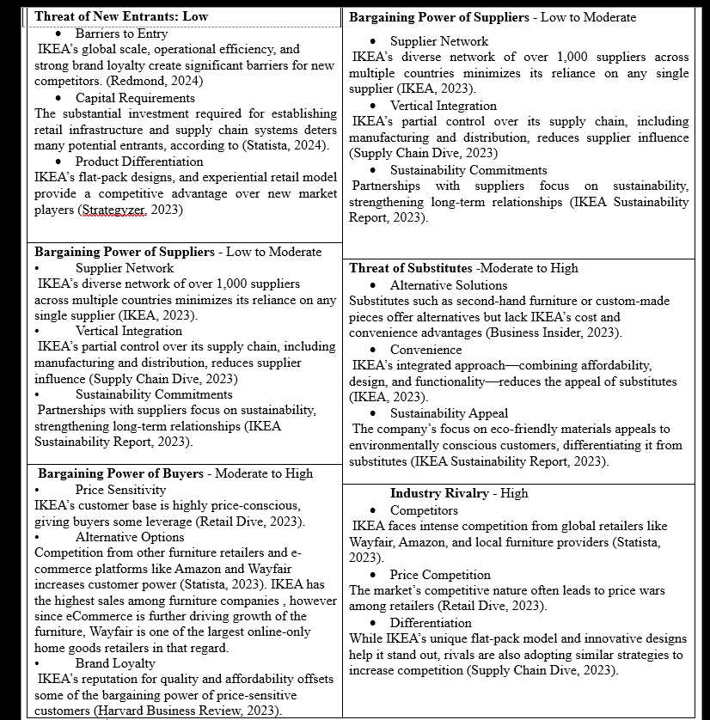
Porter (2008) asserts that this model is commonly utilised to analyse organisational structure for the purpose of developing a company strategy. A comprehensive description is provided below. Furthermore, Whittington, R. et al. (2020) states that the objective of the five forces analysis is to examine the industry's appeal and explore ways to adapt strategies to these forces, ensuring long-term survival and securing a competitive edge. According to Porter (2017), the Five Forces analysis, it is a framework for assessing the competitive dynamics within an industry and for developing company strategies. A detailed analysis in in Figure 1 below.
Figure 1 Porter's Five Forces IKEA

- The power of suppliers is minimal due to IKEA's extensive network of thousands of global suppliers, hence diminishing reliance on any individual provider. This diversification provides IKEA with considerable bargaining power. If a supplier raises pricing, IKEA may often switch to a different provider. However, suppliers may wield moderate power due to external factors such as geopolitical instability, raw material shortages, or disruptions; for example, during the pandemic, suppliers experienced enhanced power.
Furthermore, Porter (1998) contends that governmental regulations might restrict the activities of firms in their roles as suppliers or buyers. Additionally, Porter (1998) declares that the government functions as a customer or supplier and can influence industry competitiveness through its implemented policies. As a result, (Hivelr Business Review, 2023b)states that IKEA's goods necessitate distinctive raw materials or skilled craftsmanship, complicating the rapid replacement of suppliers, hence giving them more power.
- The bargaining power of buyers at IKEA is high due to numerous factors. IKEA caters to a varied, international consumers with differing interests and financial capacities. Consumers possess numerous choices in the furniture market, allowing them to assess prices, quality, and features. The expansion of e-commerce increases consumer autonomy by providing access to information, reviews, and price comparisons, thus allowing for educated decision-making. Furthermore, the low switching costs in the furniture industry encourage consumers to seek alternatives. According to (Hivelr Business Review, 2023c)since people do not buy that often furniture, they research more , therefore giving them more power.
- The threat of substitutes for IKEA is moderate to high, given the plethora of alternatives available in the furniture and home accessories sector. Owing to the proliferation of stores offering same products, all of which present comparable items at varying prices, quality, and styles. The rise of e-commerce has enhanced the accessibility of these alternatives, while an increasing interest in second-hand furniture, driven by environmental considerations, has broadened the options available through thrift stores, online marketplaces, and local advertisements. Flat-pack packaging, self-service techniques, and immersive in-store experiences collectively enhance the convenience and enjoyment of the shopping experience. Moreover, IKEA's formidable reputation for quality, durability, and design cultivates consumer loyalty, reducing the likelihood of brand switching to competitors. Customers return due to the company's varied product range, innovative and cost-effective designs, and robust brand recognition.
- The industry rivalry presents substantial competition for IKEA, marked by numerous competitors, modest product differentiation, price sensitivity, and low barriers to market access. Competitors encompass multinational firms and local retailers, offering analogous products and engaging in price competition, such as Amazon, Wayfair. Nonetheless, IKEA differentiates itself with economies of scale, unique designs, sustainability, strong branding, and cost leadership. IKEA emphasises innovation, operational efficiency, and customer-focused strategies to maintain its competitive edge in a fluctuating market.
IKEA’s strategy primarily revolves around cost leadership and differentiation, offering functional and stylish furniture at competitive prices. This aligns with Porter’s Generic Strategies (2017), which advocates for low-cost leadership as a competitive advantage while differentiating the brand through unique design and in-store experiences. Figure 2 show how IKEA’S applying it. Additionally, IKEA’s self-service model, flat-pack furniture, and vast supply chain allow it to achieve economies of scale, reinforcing its cost leadership.
Consequently, (Sloan, 2024) states that IKEA's strategic position is shaped by its capacity to control external forces. The enterprise mitigates supplier power by global diversification. Substantial buyer power necessitates ongoing innovation, cost efficiency, and customer-centric strategies. The significant threat from substitutes highlights the necessity for differentiation via design and sustainability.
After conducting the Five forces analysis emerges that the industry structure type of IKEA is the perfect competition. According to, Whittington, R. et al. (2020) perfect competition occurs when entry barriers are minimal, numerous equal competitors offer identical products or services, and information about prices, products, and competitors is fully accessible. Price becomes the primary focus of competition, as the similarity of products and limited resources often prevent rivals from investing in significant innovations or marketing efforts to differentiate themselves.
Figure 2 Porter's Generic Strategy
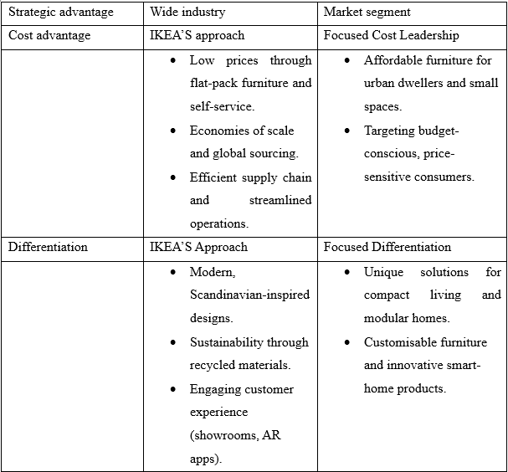
Broad Cost Leadership
IKEA attains cost leadership across the industry by providing aesthetically pleasing, usable furniture at competitive costs, attracting a diverse worldwide clientele.
Focused Differentiation
IKEA strategically targets specific demographics, including urban residents and environmentally friendly consumers, through customised product lines and innovative solutions. (IKEA, 2024)
Focused Strategy
Operating at the intersection of cost leadership and differentiation, IKEA successfully implements a hybrid strategy, capturing a large market share while maintaining its competitive edge.
Stanke (2024) states that Porter's Generic Strategies serve as an effective framework for enterprises seeking to achieve a competitive edge in their marketplaces. By comprehending the three primary strategies (cost leadership, differentiation, and focus) and executing them proficiently, enterprises can get long-term success. On the other hand, Stanke(2024) argues that implementing the strategy can be challenging in highly competitive market. Additionally, for some companies could be inappropriate if they lack the resources to attain economies of scale or to engage in product differentiation.

3.3 Stakeholder analysis
According to Harrison et al. (2019), stakeholders are defined as a group whose support is essential for the organisation's continued existence. On the other hand, Walters and Helman (2019) assert that an organisation must ensure its customer value initiatives effectively generate revenues that surpass its cost of capital, hence constantly enhancing shareholder wealth.
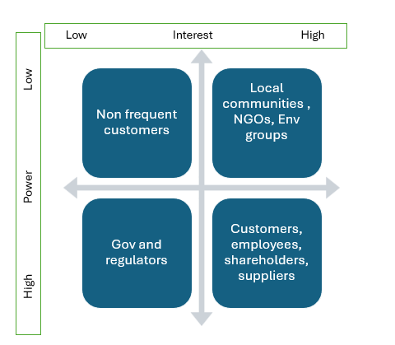
Figure 3 Stakeholder Mapping
IKEA stakeholders are categorised as follows:
High power and high interest
- Customers, employees, shareholders, and suppliers.
Ikea should prioritise regular communication with the stakeholder who have high power and interest.
- Customers impact IKEA directly on sales, brand, loyalty and market reputation.
- Employees drive operations and customer satisfaction.
- Suppliers are critical for maintaining cost leadership and delivering sustainable products.
- Shareholders influence long-term decision-making and investment strategies.
High power and Low Interest
- Governments and regulators which ensure operational continuity and avoid legal penalties. Maintain compliance and build long-term relationships.
Low Power and High Interest
- Local communities, NGOs, and environmental groups these influence public perception and IKEA’s alignment with sustainability goals.
Low power and Low Interest
- Non frequent costumers they have limited influence but potential for conversion into loyal customers.

According to Graham (2019), the interests of various stakeholders may be complementary or conflicting; for example, the shareholders' pursuit of long-term value creation may conflict with the suppliers' and distributors' demands for continuity, security, and satisfactory margins. Furthermore, Graham (2019) contends that each organisation will exhibit a combination of orientations towards distinct stakeholders.
On the other hand, Singh and Singh(2023) states that mapping stakeholders on their level of power and interest helps organisations prioritise them and understand their potential impact on the organisation’s objectives and success. Additionally, Singh and Singh(2023) states that stakeholder analysis offers organisations insights into the requirements, expectations, and concerns of various stakeholder groups, facilitating effective engagement, relationship management, and decision-making that accounts for the larger stakeholder impact. By comprehending the dynamics of stakeholders, businesses may improve collaboration, mitigate risks, foster trust, and attain mutually advantageous results. Figure 4 below shows the stakeholders of IKEA.
Figure 4 Stakeholder Analysis
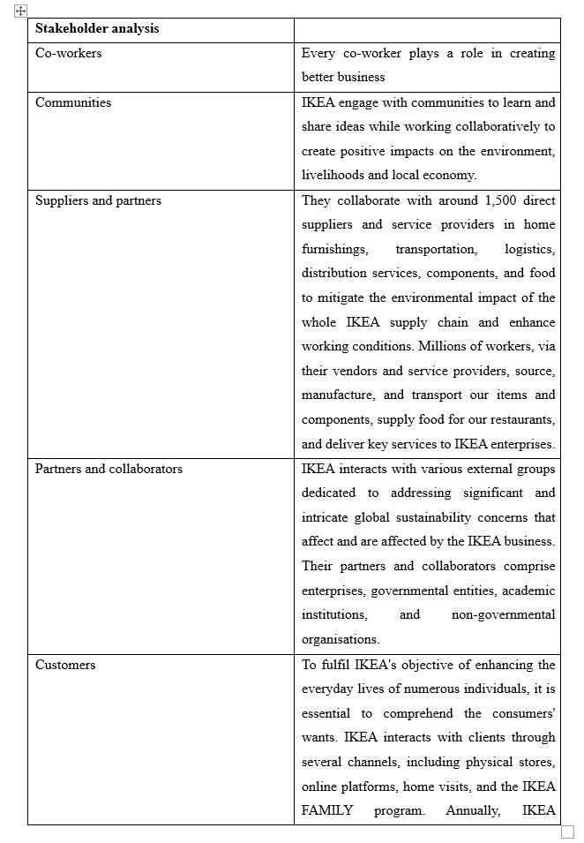

3.4 Market Analysis
Currently, developing and implementing a solid marketing plan requires an awareness of the evolving marketing landscape. Singh and Singh (2023) define market analysis as the evaluation of the market in which an organisation operates or intends to enter, encompassing the assessment of many aspects that affect demand, supply, and competitive dynamics.
Moreover, Singh and Singh (2023) assert that market analysis enables firms to comprehend market size, trends, client requirements, rivalry, and growth prospects.
- Sustainability Demands
According to, Birch (2024) IKEA's commitment to sustainability is evident in its use of renewable materials and efforts to make products more recyclable and repairable, including the renowned Billy bookshelf, to maintain low manufacturing costs while ensuring profitability.
According to, (Ross,2023) by 2030, IKEA aims to transition entirely to renewable or recycled materials across its product range, reinforcing its leadership in sustainable retail practices​.
- Consumer Behaviour shift
According to Birch(2024), IKEA continues to adapt to changes in consumer priorities, particularly the growing demand for sustainability. Its second-hand furniture services, online options for pre-loved furniture, and supply chain innovations emphasize repair, reuse, and recycling. These strategies align with modern consumer preferences for affordability and eco-conscious living​.
- Technology
IKEA leverages technology, such as AI-powered tools and e-commerce platforms, to optimize its operations and enhance customer experience. For example, (Zornes, 2022) states IKEA’s , AI-driven waste management tool “Winnow” has been implemented across hundreds of stores to minimize food waste. Digital tools also help streamline IKEA’s circular economy initiatives, such as its Buyback & Resell service (Sillitoe, 2023), allowing customers to trade in used furniture​. (IKEA, 2024)
Thus, IKEA is adjusting to major market shifts in the UK by emphasising sustainability, digitisation, and changing customer habits. In 2023, IKEA announced significant growth, with 38.5% of its sales conducted online. The corporation prioritise sustainability by using renewable energy and augmenting its fleet of electric delivery vans. As per J. and E. Stead (2024), following the analysis and observation of macro - environmental trends and changes, strategists subsequently formulate predictions of expected outcomes and evaluate the significance of the predicted environmental changes on their plans. They assert that forecasts are essential since they influence strategic managers' perceptions of the future.

4.0 Internal Analysis

4.1 Resource-Based View
The resource-based view examines how managers use business resources and competencies to develop products that better satisfy customers compared to competitors(Cazurra et al. 2021). It delineates the methods that facilitate resource development and safeguard them against rivals.
On the other hand, Martins and Rodrigues (2021) states RBV explains how organisations attain competitive advantage and revenue by the ownership and administration of assets, capabilities, knowledge, and other internal resources.
- Innovation ability
According to (IKEA, 2023), IKEA revolutionised furniture design with flat-pack solutions, enabling customers to transport and assemble furniture easily. This not only reduced logistical costs but also enhanced customer accessibility and satisfaction. The model reinforces its cost leadership strategy and differentiates the brand from competitors. The customer's involvement in certain tasks is crucial for maintaining IKEA's low prices. According to (Faster capital, 2024) this type of distribution and inventory management further decrease expenses. Flat, densely packed, stackable packages are more environmentally friendly, as they allow for greater product capacity in trucks, containers, railway carriages, warehouses, and IKEA shops. This results in a reduced number of lorries on the roads and diminished environmental effect.
- Sustainability Focus
Thus, according to Ross(2023) IKEA integrates sustainability into its operations, aiming for carbon neutrality and environmentally friendly practices. The company emphasizes renewable materials, energy-efficient designs, and innovations like the ÅBÄCKEN water-saving nozzle. These efforts resonate with growing consumer and regulatory demands for sustainability.
- Cost-efficient supply chain
Therefore, IKEA’s supply chain is highly optimised, reducing costs and ensuring operational efficiency. By maintaining a vast network of global suppliers and employing practices like flat-pack packaging and in-store logistics, IKEA minimizes shipping costs and enhances inventory management. According to, (Ross, 2023) sustainability is integrated into its supply chain through initiatives like IWAY, its supplier code of conduct, and circular supply chain strategies, which align with modern consumer values and regulatory demands.
- Brand Reputation and Customer-Focus
According to, (Hivelr Business Review, 2023), IKEA’s global brand is synonymous with affordability, quality, and innovative designs. Its customer-centric approach is demonstrated through efficient in-store experiences, robust e-commerce platforms, and sustainability-focused product offerings, contributing to customer loyalty.

4.2 SWOT Analysis
Graham (2019, p. 40) states that the purpose of SWOT is twofold: it aims to identify the most critical internal and external elements impacting the company and its markets. It offers a concise executive summary of the principal problems. Secondly, analysing the alignment of strengths and weaknesses with opportunities and challenges can facilitate strategy formulation. Conversely, Palazzo and Micozzi (2024) emphasise that a primary weakness of SWOT analysis is in its decision-making methodology. The issue is in managers or practitioners selecting elements based on personal judgement after a brainstorming session, leading to a perceived inconsistency in the classification of contingent external and internal factors.
Strengths  - Global brand recognition  - Innovative business model  - Sustainability leadership  - Efficient supply chain | Weaknesses  - Complex assembly process  - Dependence on suppliers  - Environmental challenges
Opportunities  - Technology transformation  - Sustainability trends  - Expansion  - Innovative product lines | Threats  - Intense competition  - Economic instability  - Regulatory challenges  - Shifts in consumer behaviour
Table 2 SWOT IKEA
- Strengths
IKEA’s innovative flat-pack model, global brand recognition, and sustainability leadership underscore its competitive advantage. Its cost-efficient supply chain and customer-centric approach further enhance resilience (Ross, 2023).
- Weaknesses
IKEA faces challenges in entering markets with differing cultural preferences or logistical barriers, impacting its global reach. (IKEA, 2023a)
- Opportunities
Leveraging digital transformation and expanding into emerging markets are key growth areas. Sustainability trends and circular economy initiatives present avenues for differentiation (Statista, 2023).
- Threats
Intense competition, economic instability, and regulatory challenges, such as labour laws and environmental compliance, could constrain growth. IKEA faces high industry rivalry from both global chains and local retailers offering related products, often at competitive prices (Jurevicius, 2023)

4.3 Value Chain Analysis
Furthermore, (Stobierski, 2020) states that using value chain analysis helps organisation to optimise budget and establish competitive advantages, additionally businesses can use value chain analysis(VCA), for
- Supply chain management.
- Strategic decision making
- Improving customer satisfaction
- Innovation and development
- Environmental and social impact.
On the other hand ,(Maplesden, 2023) argues that while a company executives may have obtained internal buy-in, obtaining it from external stakeholders, such as vendors and partners, might prove more challenging. Company executives must cultivate robust relationships with owners of various segments of the supply chain to effectively persuade them to commit to enhancements. Third-party agreements could potentially facilitate this process.
IKEA’S VALUES CHAIN ANALYSIS
Primary Activities
- Ikea’s unique value chain approach start with people, according to (IKEA, 2023b), IKEA begins by listening to customer needs and understanding their “dreams”, ensuring every product is aligned with customer desires. This reflects a customer-centric approach, making customers active participants in the value chain process.
Design Innovation
- Democratic Design principles (form, function, quality, sustainability, and low price) ensure products balance customer satisfaction and cost-effectiveness. According to, (Margarita, 2024) building solid relationships with customers based on openness and trust is a top priority for IKEA. This is accomplished by providing comprehensive product details, simple assembly instructions, and several auxiliary services including home delivery and assembly help. Constantly improving design ensures both affordability and enhanced customer experience.
Production and supplier collaboration
- Additionally collaborating closely with suppliers, IKEA identifies ways to improve quality and sustainability. This benefits customers by providing durable, eco-friendly products at competitive prices.
Packaging and distribution
- Efficient flat-pack designs lower costs for both IKEA and customers, making furniture easier to transport and assemble. This empowers customers to "co-create" value, participating in the assembly process to save costs.
Circular Value chain
- The value chain is circular, continuously learning from customer feedback, IKEA adapts and innovates its products and services. This reinforces a cycle of improvement, ensuring customer needs remain central.
(IKEA, 2023b)

5.0 Critical Evaluation of Strategic Options
Research indicates that IKEA's business model integrates cost leadership and differentiation strategies, forming a hybrid approach that enables the company to provide affordable, high-quality products while meeting customer expectations.
According to, Abubakar, A. et al. (2024) cost leadership, a core strategy aimed at reducing expenses while preserving product or service quality, continues to be a persistent objective for numerous organisations. As facilitates the reduction of operational expenses while simultaneously generating actual value and improving overall performance.
Consequently, (Patov, 2024)states that IKEA use digital technologies to enhance customer care, such as.
- Augmented Reality (AR) - IKEA has launched the IKEA Place App, enabling customers to virtually organise furniture within their residences with augmented reality technology. The application has surpassed 8 million downloads and boasts a 98% accuracy rate in product sizing and dimensions. (Patov, 2024)
- IKEA has incorporated digital tools throughout its stores to enhance consumer involvement and the shopping experience. Self-service kiosks and digital catalogues enable users to swiftly obtain product information, stock availability, and location details. This has resulted in a 15% enhancement in customer satisfaction ratings.
The Impact of technology on the Customer Experience
IKEA has use virtual reality to enhance its shopping experience and engage customers(Fox, 2024). The Virtual Reality Kitchen Experience allows customers to build and explore kitchen layouts in a virtual environment, influencing purchasing decisions. VR also aids in employee training and development, with studies showing 30% efficiency improvement. (Patov, 2024) believes VR is a powerful tool for customer engagement and employee training, as it enhances understanding of products and customer relationships.
On the other hand, (Murphy, 2024)argues that customer interactions can be negatively impacted by reliance on technology, as automated responses and chatbots may struggle to accurately represent emotions or oversee complex situations, leading to dissatisfaction for customers dealing with sensitive issues. Furthermore, (Murphy, 2024) states that overdependence on automated systems may diminish opportunities for substantial human interactions, thereby undermining consumer engagement and loyalty. Customers who favour human interaction may experience isolation or a sense of undervaluation if they cannot readily access a real representative.
Sustainability and resilience
IKEA introduced circular economy initiatives like the Buyback & Resell service and transitioning to 100% renewable materials by 2030 align with consumer expectations and regulatory demands (Ross, 2023).
According to Graham (2019), economies of scale are the most significant factor in numerous businesses. Economies of scale arise from performing tasks more efficiently or differently at a larger volume. Furthermore, substantial scale can facilitate purchasing leverage to obtain more affordable and/or higher-quality raw materials, especially during periods of scarcity. Conversely, Graham (2019) contends that there are limitations to economies of scale, as increased size may introduce additional complexity that might result in diseconomies.
Furthermore, IKEA has a vertical integration strategy, as stated by Whittington, R. et al. (2020) vertical integration means that IKEA owns and controls multiple stages of its supply chain. The objective is to optimise operations and establish a competitive edge by minimising reliance on external suppliers. However, there are some limitations. Whittington, R. et al. (2020)argues that vertical integration involves investment. Expensive investments in operations that are less successful than the original core business will be undesirable to shareholders since they are diminishing their average or overall rate of return on investment. Second, even if there is a degree of relatedness across the value network, vertical integration is likely to involve diverse resources and competencies.
Furthermore, another strategy that IKEA could use is Business Model Canvas which will help the business to differentiate itself in the market and achieve long-term success. The company aspires to achieve climate positivity and complete circularity by 2030, emphasising renewable energy, sustainable products, and closed-loop manufacturing systems. IKEA will augment services such as home delivery and furniture rental to address increasing demand. The corporation may pursue new alliances to broaden its product portfolio and capitalise on rising trends. This modifies IKEA's business model to address customer requirements and societal issues.
The following table 3 shows a description of the model approach. 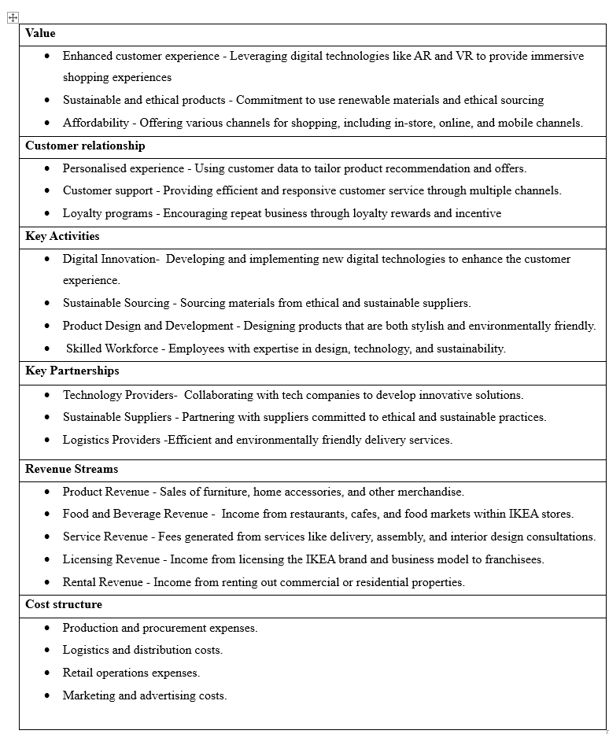
Table 3 Business Model Canvas

6.0 Conclusion

This report emphasizes IKEA's competitive advantages, including its creative business strategy, leadership in sustainability, and customer-centric practices. Mitigating vulnerabilities, including supplier dependency and environmental issues, while capitalising on digital transformation and circular economy trends, strategically positions IKEA for sustained growth. In conclusion, IKEA's hybrid business model, which combines cost leadership and differentiation, has positioned the company as a global leader in affordable and high-quality home furnishings. However, in the face of evolving consumer expectations and market trends, it is crucial for IKEA to adapt its strategies to sustain its competitive advantage.

Recommendations
IKEA is a global leader in the home furnishings sector, known for offering affordable and high-quality products. The company combines cost leadership and differentiation strategies in its business model, which allows it to maintain a strong position in the competitive market. However, as consumer expectations evolve, particularly in the realms of technology, sustainability, and customer experience, IKEA must adapt its strategies to retain its competitive edge.
- Human Interaction in Customer Service
Although digital tools like chatbots and self-service kiosks have improved convenience, IKEA must provide additional possibilities for human connection in customer support, especially for intricate issues. Integrating live video consultations with customer service agents or providing in-store specialists to assist consumers with both digital and physical purchases might improve the experience for individuals who favour personal interaction.
- Justification
Murphy (2024) indicates that an overdependence on technology may estrange clients who favour human interaction, particularly in the context of intricate or sensitive matters. This advice harmonises the practicality of digital technologies with the nuanced approach that numerous clients continue to desire. Providing more human-driven interactions guarantees that clients perceive their worth, fostering deeper emotional ties with the brand. Facilitating direct access for consumers to informed and compassionate personnel can improve satisfaction and boost retention. Emphasising human interaction fosters trust, enabling IKEA to sustain consumer loyalty in a competitive marketplace.
- Limitation
Increasing personnel elevates operational expenses. It necessitates investments in educating customer service professionals and sustaining the infrastructure for live interactions. Moreover, logistical obstacles may arise in providing live video consultations or in-store specialists at scale, particularly during busy periods, thereby impacting the overall efficacy of customer service operations.
- Strengthening Circular Economy and Sustainability
IKEA ought to enhance its circular economy initiatives by pledging to utilise 100% renewable materials in all items by 2030 and by broadening its Buyback & Resell service. IKEA should consider adopting closed-loop production processes to minimise waste. The corporation may also invest in sustainable transportation solutions to further diminish its carbon footprint.
- Justification
According to Ross (2023), sustainability is a significant concern for contemporary customers. IKEA's dedication to renewable materials and sustainability corresponds with the increasing consumer demand for environmentally friendly products. The Buyback & Resell program represents a substantial advancement in this regard, promoting the recycling and reutilization of products by customers. This technique enables IKEA to satisfy legal requirements and consumer expectations while bolstering its environmental reputation. Consumers are progressively selecting brands that resonate with their environmental principles, and IKEA's sustainability initiatives can foster enhanced brand loyalty. Exemplifying sustainability can distinguish IKEA from its competitors and elevate its brand image in a saturated market.
- Limitation
Realising a fully circular economy and attaining 100% renewable materials by 2030 will necessitate substantial investments in advanced technology and production methodologies. (Manutan, 2024) argues that the primary challenge a corporation seeking to adopt the circular economy may encounter is insufficient employee support. Any change, by definition, necessitates experiencing a "grieving" phase. This frequently evokes emotions inside teams, including fear, wrath, or sadness, which may evolve into resistance.
These obstacles pertain to both operational personnel and management. It is imperative that all individuals comprehend the significance of the circular economy, adopt the company's vision, and contribute to shared objectives.
- Vertical Integration to Streamline Operation
IKEA ought to persist in investing in vertical integration by overseeing further phases of its supply chain, especially in manufacturing and logistics. It should prioritise the automation of operations to diminish the intricacy of integration. By investing in automated technologies for production and logistics, IKEA can sustain cost leadership while guaranteeing high-quality items and expedited delivery times.
- Justification
Whittington, R. et al. (2020) assert that vertical integration enables firms to optimise operations and diminish dependence on external suppliers. Although this may facilitate cost management, the intricacy of overseeing multiple phases of the supply chain can lead to inefficiencies. Automation can mitigate these problems, enhancing operational efficiency and bolstering IKEA's cost leadership approach. Automation can reduce operational expenses, sustaining IKEA's status as a cost leader while enhancing supply chain efficiency.
- Limitation
Vertical integration and automation necessitate substantial initial capital expenditure. Whittington, R. et al. (2020) indicate that the intricacy of overseeing distinct phases of manufacturing may present unexpected difficulties.
- Expanding Strategic Alliances and Product Diversification
IKEA should pursue strategic alliances to diversify its product portfolio, focusing on new service areas such as furniture rental and home delivery. The company could also look to partner with tech companies to enhance its digital tools and explore new alliances in fashion or home design to broaden its product range.
- Justification
The Business Model Canvas posits that establishing relationships is essential for enhancing a company's capabilities. The current partnerships between IKEA and technology firms have facilitated the creation of products such as the IKEA Place app. Establishing new alliances can grant access to additional markets, technology, and resources, enabling IKEA to address changing customer demands and trends. By broadening its offers, IKEA may access new revenue streams, including furniture leasing and more product categories. Strategic alliances can enable IKEA to expand its audience, drawing in customers who may not have previously contemplated IKEA's products. By augmenting digital engagement, improving human interaction in customer service, bolstering sustainability initiatives, investing in vertical integration, and pursuing new strategic partnerships, IKEA can elevate its customer experience, maintain competitive advantages, and secure long-term success in a swiftly changing market.
- Limitation
Expanding into new product categories or forming new alliances can strain IKEA’s current operational capacity and resources. It may require investments in areas were IKEA lacks expertise, such as fashion or high-tech products. Additionally, new strategic partnerships could pose risks related to brand alignment, as collaborations with incompatible companies might dilute IKEA's core identity.

References

Lynch, R 2018, Strategic Management, Pearson Education, Limited, Harlow, United Kingdom. Available from: ProQuest Ebook Central.
(Accessed on: 10 December 2024).
Abubakar, A. et al. (2024) ‘The Role of Environmental and Social Innovations in the Cost Leadership Strategy, Value Creation, and Business Performance: A Comparative Analysis of SMEs and Large Manufacturing Companies’, Human Behavior & Emerging Technologies, 2024, pp. 1–14.
Available at: https://doi:10.1155/2024/7078016
(Accessed on: 4 December 2024)
Whittington, R. et al. (2020) Exploring strategy : text and cases. Twelfth edition. Harlow, England: Pearson Education Limited.
(Accessed on: 22 November 2025)
Porter, M.E. (1998) Competitive strategy : techniques for analysing industries and competitors. 1st ed. New York: Free Press.
Walters, D, & Helman, D 2019, Strategic Capability Response Analysis : The Convergence of Industrié 4. 0, Value Chain Network Management 2. 0 and Stakeholder Value-Led Management, Springer International Publishing AG, Cham.
Available from: ProQuest Ebook Central.
(Accessed on: 13 December 2024)
Birch, K. (2024). Interview: IKEA’s Ingka Group on Becoming a Circular Business. [online] sustainabilitymag.com.
Available at: https://sustainabilitymag.com/sustainability/interview-ingka-groups-connor-hill-on-becoming-circular.
(Accessed on: 21 November 2024)
Cazurra, et al. (2021). Multinationals’ misbehavior. Journal of World Business, Volume 56, Issue 5(ISSN 1090-9516).
https://doi.org/10.1016/j.jwb.2021.101244
(Accessed on: 10 December 2024)
CIPD (2021). PESTLE analysis. [online] CIPD.
Available at: https://www.cipd.org/globalassets/media/knowledge/knowledge-hub/factsheets/pestle-analysis-factsheet_20221230T092611.pdf.
(Accessed on: 20 November 2024)
Dabo, M. (2023). IKEA UK reports strong growth in FY23. [online] Retail Insight Network.
Available at: https://www.retail-insight-network.com/news/ikea-uk-reports-strong-growth-in-fy23/.
(Accessed on: 20 November 2024)
Ethical Trading Initiative (2023). Our impact 2023-24 | Ethical Trading Initiative. [online] Ethicaltrade.org.
Available at: https://www.ethicaltrade.org/our-impact-2023-24
(Accessed on: 20 November 2024)

Faster capital (2024). Distribution costs: Reducing Distribution Costs: A Key Strategy for Business Growth - FasterCapital. [online]
Available at: https://fastercapital.com/content/Distribution-costs--Reducing-Distribution-Costs--A-Key-Strategy-for-Business-Growth.html
(Accessed 7 December 2024)
Forsdick, S. (2024). Ikea’s CHRO on why culture is the company’s ‘superpower’. [online] Raconteur.
Available at: https://www.raconteur.net/talent-culture/ikeas-chro-culture-companys-superpower.
(Accessed on: 20 November 2024)
Fox, G. (2024). Ikea Business Model: Repositioning the Point of Production. [online] Dr. Gary Fox.
Available at: https://www.garyfox.co/ikea-business-model/
(Accessed on10 December 2024)
Harrison, J.S. (2019). The Cambridge handbook of stakeholder theory. Cambridge, United Kingdom: Cambridge University Press.
(Accessed on8 December 2024)
Hivelr Business Review (2023a). IKEA: PESTEL and Macro-Environmental Analysis. [online] Hivelr.
Available at: https://www.hivelr.com/2023/12/ikea-pestel-and-macro-environmental-analysis-2/.
(Accessed on8 December 2024)
Hivelr Business Review (2023b). IKEA: Porter’s Five Forces Industry and Competition Analysis. [online] Hivelr.
Available at: https://www.hivelr.com/2023/06/ikea-porters-five-forces-industry-and-competition-analysis/.
(Accessed on8 December 2024)
Hivelr Business Review (2023c). IKEA: Porter’s Five Forces Industry and Competition Analysis. [online] Hivelr. Available at: https://www.hivelr.com/2023/06/ikea-porters-five-forces-industry-and-competition-analysis/.
(Accessed on8 December 2024)
Hivelr Business Review (2023d). IKEA: Porter’s Five Forces Industry and Competition Analysis. [online] Hivelr. Available at: https://www.hivelr.com/2023/06/ikea-porters-five-forces-industry-and-competition-analysis/.
(Accessed on8 December 2024)
IKEA (2023a). Breaking down the IKEA value chain – IKEA Global. [online] IKEA. Available at: https://www.ikea.com/global/en/our-business/how-we-work/the-ikea-value-chain/.
(Accessed on7 Decemeber 2024)
IKEA (2023b). The Challenges of Entering a New Market – IKEA Global. [online] IKEA.
Available at: https://www.ikea.com/global/en/our-business/how-we-work/learning-as-we-go-the-challenges-of-entering-a-new-market/
(Accessed on: 7 December 2024)
IKEA (2023c). Where are your products manufactured? - IKEA United Kingdom. [online]
Available at: https://www.ikea.com/gb/en/customer-service/knowledge/articles/54146145-c9d3-4502-b958-4e285g577d40.html.
(Accessed on7 December 2024)
IKEA (2024). IKEA Buyback & Resell. [online] Ikea.com.
Available at: https://www.ikea.com/gb/en/circular/buy-back/
(Accessed on: 7 December 2024)
IKEA (2023). Stakeholder engagement - IKEA Global. [online] Ikea.com.
Available at: https://www.ikea.com/global/en/our-business/sustainability/stakeholder-engagement/.
(Accessed on10 December 2024)
IKEA Museum (2023). How IKEA Took Flatpacks to a Whole New Level - IKEA Museum. [online] WordPress på Azure.
Available at: https://ikeamuseum.com/en/explore/the-story-of-ikea/flatpacks/
(Accessed on 7 November 2024)
Ingka Group (2024a). IKEA sides with its customers in an exceptional year, investing more than EUR 2.1 billion in lowering prices | Ingka Group. [online] Ingka Group.
Available at: https://www.ingka.com/newsroom/ikea-sides-with-customers-in-an-exceptional-year-investing-more-than-eur-2-1-billion-in-lowering-prices/
(Accessed on7 December 2024)
Ingka Group (2024b). Ingka Group prioritises affordability and long-term business resilience, recording EUR 41.8 billion in revenue | Ingka Group. [online] Ingka Group.
Available at: https://www.ingka.com/newsroom/ingka-group-prioritises-affordability-and-long-term-business-resilience-recording-eur-41-8-billion-in-revenue/
(Accessed on: 7 December 2024).
Jurevicius, O. (2023). SWOT Analysis of IKEA 2023. [online] Strategic Management Insight.
Available at: https://strategicmanagementinsight.com/swot-analyses/ikea-swot-analysis/
(Accessed on20 November 2024)
Ludmir, C. (2023). How Sustainability and Affordability Can Go Hand-In-Hand: The Case of Ikea. [online] Forbes.
Available at: https://www.forbes.com/sites/claraludmir/2023/11/24/how-sustainability-and-affordability-can-go-hand-in-hand-the-case-of-ikea/
(Accessed on23 November 2024)
Lynch, R., Barish, O., Chau, V.S., Thornton, C. and Warner, K.S.R. (2024). Strategic Management. SAGE Publications Limited.
(Accessed on: 18 November 2024)
Magarita (2024). Decoding the IKEA Business Model: From Flat-Pack Furniture to Global Giant - Unilever Edu. [online] Nhà Phân Phối Unilever Pureit Hạnh Phúc.
Available at: https://unilever.edu.vn/how-tencents-business-model-disrupts-the-industry-a-detailed-analysis/
(Accessed on: 8 December 2024].
Maplesden, P. (2023). 6 advantages and disadvantages of value chain analysis | TechTarget. [online] ERP.
Available at: https://www.techtarget.com/searchERP/tip/advantages-and-disadvantages-of-value-chain-analysis.
(Accessed on8 December 2024)
Martins, C. and Rodrigues, P. (2021). Competitive drivers for improving future business performance. Hershey, PA: IGI Global, Business Science Reference.
(Accessed on8 December 2024)
Michelle Battista (2024). PESTLE Analysis. [online] CIPD. Available at: https://www.cipd.org/uk/knowledge/factsheets/pestle-analysis-factsheet/
(Accessed on 8 Decemmber 2024)
Murphy, N. (2024). Technology’s Role in Modern Customer Service: Pros and Cons. [online] CPD Online College.
Available at: https://cpdonline.co.uk/knowledge-base/business/technologys-role-modern-customer-service-pros-cons/
(Accessed on8 December 2024)
Nel, R. (2024). 4 Secrets of IKEA’s Innovation Culture. [online] Itonics-innovation.com.
Available at: https://www.itonics-innovation.com/blog/ikea-innovation-culture.
(Accessed on22 November 2024)
Oladipo, D. and Shepardson, D. (2024). The US port strike ends leaving cargo backlog. [online] Reuters.
Available at: https://www.reuters.com/world/us/us-port-strike-ends-clearing-long-ship-queues-will-take-time-2024-10-04/.
(Accessed on10 December 2024)
Origanimi (2024). What Is a Flat Organizational Structure? Definition & Examples. [online] Organimi.
Available at: https://www.organimi.com/what-is-a-flat-organizational-structure/
(Accessed on22 November 2024)
Patov, A. (2024). How IKEA Uses Technology to Improve Customer Experience (CX) in Retail. [online] Renascence.io.
Available at: https://www.renascence.io/journal/how-ikea-uses-technology-to-improve-customer-experience-cx-in-retail
(Accessed on: 23 November 2024)
Porter, M.E. (2008). On competition. United States: Harvard Business School Press
. (Accessed on18 November 2024)
Porter, M.E. (2017). Competitive Strategy. Createspace Independent Publishing Platform.
(Accessed on: 18 November 2024)
Redmond, N. (2024). Shoppers are buying like it’s 2008, Ikea CEO tells BI. [online] Business Insider.
Available at: https://www.businessinsider.com/ikea-exec-on-cutting-prices-affordability-consumer-spending-2024-11
(Accessed: 22 November 2024)
Reitzig, M. (2022). Get Better at Flatter: A Guide to Shaping and Leading Organizations with Less Hierarchy. Cham: Springer International Publishing, Imprint Palgrave Macmillan.
(Accessed on10 December 2024)
Ross, L. (2023). Behind the Scenes of the Strategic Ikea Supply Chain. [online]
Available at: https://www.thomasnet.com/insights/ikea-supply-chain/
(Accessed on18 November 2024)
S&P Global (2024). Top Geopolitical Risks of 2024. [online] S&P Global.
Available at: https://www.spglobal.com/en/research-insights/market-insights/geopolitical-risk.
(Accessed on18 November 2024)
Schooley, S. (2023). Flat Organizations: Advantages of Eliminating Managers. [online] business.com.
Available at: https://www.business.com/articles/flat-organization/
(Accessed on23 November 2024)
Sillitoe, B. (2023). ‘Keep good things going’: Ikea focuses on prolonging the life of products in the new campaign. [online] Green Retail World.
Available at: https://greenretail.world/2023/04/26/keep-good-things-going-ikea-focuses-on-prolonging-life-of-products-in-new-campaign/
(Accessed: 22 November 2024)
Singh, G. and Singh, S. (2023). Strategic Management: For B.com, BBA, MBA, State Assistant Professor and other c. Ink of Knowledge.
(Accessed: 22 November 2024)
Sloan, M. (2024). IKEA CEO: 3 ways to gain competitive advantage with sustainability | MIT Sloan. [online] MIT Sloan.
Available at: https://mitsloan.mit.edu/ideas-made-to-matter/ikea-ceo-3-ways-to-gain-competitive-advantage-sustainability.
(Accessed: 22 November 2024)
Stanke, B. (2024). Porter’s Five Forces vs. Porter’s Generic Strategies: Understanding the Difference — Helping Companies Deliver More Value Through Better Process Management. [online] BOB STANKE.
Available at: https://www.bobstanke.com/blog/porters-five-forces-vs-porters-generic-strategies
(Accessed on8 December 2024)
Statista (2024). Furniture: market data & analysis. [online] Statista.
Available at: https://www.statista.com/study/55490/furniture-market-data-and-analysis/
(Accessed on: 7 December 2024)
Stead, J.G. and Stead, E.W. (2024). Sustainable Strategic Management. [online]
Available at: https://books.google.co.uk/books/publisher/content?id=fKk0DwAAQBAJ&pg=PA1929&img=1&zoom=3&hl=en&bul=1&sig=ACfU3U3rmvXfqrP2YFnjTIhiFWYIWSkduQ&w=1280 (Accessed on: 7 December 2024)
Stobierski, T. (2020). What Is a Value Chain Analysis? [online] Harvard Business School.
Available at: https://online.hbs.edu/blog/post/what-is-value-chain-analysis
(Accessed on: 7 December 2024)
Deloitte (2023). Sustainable Consumer 2023 - Sustainable Products. [online] Deloitte United Kingdom.
Available at: https://www2.deloitte.com/uk/en/pages/consumer-business/articles/sustainable-consumer-what-consumers-care-about.html
(Accessed: 10 December 2024)
Strategyzer (2023). IKEA Business Model. [online] www.strategyzer.com.
Available at: https://www.strategyzer.com/library/ikea-business-model.
Sujan (2023). 10 Pros and 7 Cons of PESTLE Analysis for Business. [online] TheMBAins. Available at: https://thembains.com/pros-and-cons-of-pestle-analysis/
(Accessed on: 8 December 2024)
Wells, T. (2024). IKEA Pricing Strategy and Product Development Deep Analysis [Online] Pricing recruitment I Am pricing jobs I Revenue Management Jobs.
Available at: https://taylorwells.com.au/ikea-pricing-strategy/
(Accessed on: 8 December 2024)
Zornes, M. (2022). How IKEA co-workers teamed up with Winnow to halve their global food waste. [online] blog.winnowsolutions.com. Available at: https://blog.winnowsolutions.com/ikea-winnow-halve-their-global-food-waste
(Accessed on: 8 December 2024)
Palazzo, M. and Micozzi, A. (2024). Rethinking Decision-Making Strategies and Tools. Emerald Group Publishing.
(Accessed on: 12 December 2024)
Manutan (2024). What are the circular economy limitations for companies and how to overcome them? [online] Manutan.
Available at: https://www.manutan.com/blog/en/circular-economy/circular-economy-limitations-how-to-overcome-them
(Accesssed: 13 December 2024)
Thompson, S. (2024). Strategic Management Vs. Strategy. [online] Chron.com.
Available at: https://smallbusiness.chron.com/strategic-management-vs-strategy-66207.html
(Accessed on: 13 December 2024)

