ACADEMIC AND EMPLOYABILITY SKILLS

Student Name: Doina Cojan

Student ID Number:1816176

Lecturer: Timothy Hopkins

Through my Academic studies, work experience and other activities I am looking forward to develop my employability skills. According to this subject, firstly I have to define my further job study, secondly I have to identify myself and analyse what skills I have already and what skills are required, then I will have to think about how am I going to demonstrate my ability and develop my weakness. Based on those points as a final point I will talk about how am I going to get this progress of academically draft done .
When you are defining your further job you have to think about your strengths and weakness, how can you improve it. If you looking to apply for a new position you have to be able to identify yourself and also to be able to talk about your weakness and straights.
My strengths are : good communicator, Responsible, organised, positive, team-working, sociable, creative and reflective. This are the strengths which can define myself not just as a employee but also as a person.
Being a good communicator especially at the workplace means to interpret your message clear and prompt as to be understood for your co-workers. Using the communication skills could help you to create your message and send it in proper way to the receiver.
The communication skills are:
- Using Non-Verbal communication (body language)
- Being clear and prompt
- Listening (helps you to communicate efficiently)
- Understanding the message
- Interpreting the message
- Writing skill is also part of communication as many of us using social media.
- Feedback (giving and receiving feedback is very important communication skill)
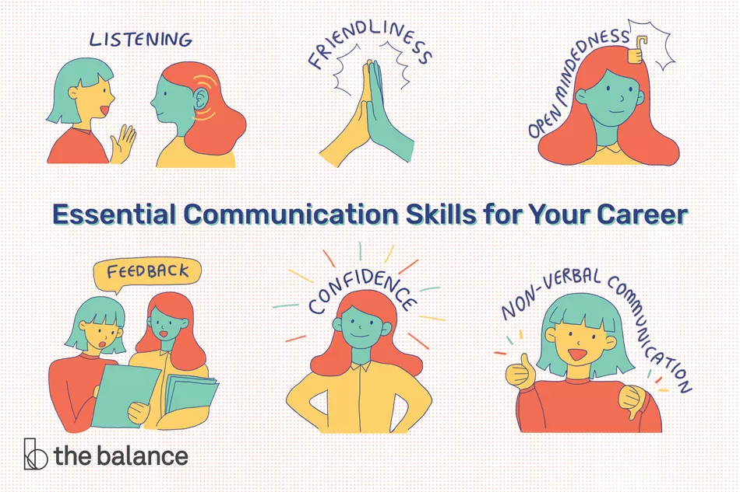
https://www.thebalancecareers.com/communication-skills-list-2063779

Responsible means being able to take decisions and assume it, also helping your group colleges to achieve the group objectives.
Being organise in a team as a leader it has a huge impact to inspire your team to become reflective and more attentive to the subject which you have to develop.
Being positive it is a big advantage for the group as in this way you can bring more useful ideas for the group work.
Being reflective is also part of my straights, I always liked to show up a good impression, by reading books or watching videos about
As a very important skill with a huge impact in our life is problem solving which gives us the knowledge to resolve the problem and also being able to find solutions in any circumstances.
As we all have strengths we also hold weakness, to improve our strengths we have to focus on our weakness : being nervous when I have to do a presentation, hard skill (financial analysis) which I am looking forward to develop, patience ( based on this skill I am looking to use my strengths to improve my patience) time management ( I have a problem with the time management as always can not finish my purposes) but I looking to inspire myself from the successful people to help myself to become more punctual.
Based on information I had, how actually I can demonstrate my strengths and develop my weakness? Think about an Academic Presentation how I am going to interpret the massage and reflected to others?
In a presentation project you have to know your facts, you have to believe (the information which you talk about and also make it believable for audience), By knowing your facts makes you fell more confident.
Setting the goals is also part of improving the weakness, think about the time management. Creating the diary you can write it down what is priority to be done and what things can be placed on the waiting list as is not Priority.
Taking extra training is the most important part of improving and developing the weakness and strengths as well, by taking more training is always a step up in your professional development strategy.
Thinking about next step by keeping in touch with social media and news you can deciding your next strategy.
Using the communication skills it can have a big impact in your professional career, by speaking and listening to others and also receiving feedback from others it helps you to grow and develop your ideas.
Professionalism is another truly wide ability to succeed, when it comes to this skill, it dose not really matter what you have got in your mind, but the way how you organise to bring it out and reflected to others makes the difference and this is what it can define you as a person. This ability can decided your professional career job. The important traits which can define your professionalism once you have a job are your physical and verbal reaction. Once you decided to join to one group you have to take this chance as a challenge to find out and more about your group and also deciding on your strategy.
The other way to reflected your professionalism is an interview for work or for university admission it is listing to them and make sure you take every advance in a very serios way. Give them reasons to believe in your professional and academic skills.
As my dream is to become a manager in the future I also have to develop some managing skills, as my idea in managing a team is to create a team who can with me not for me. According to my work place I can say that a organisation it dose not exist without a team who you can work with to bring the success to the company.
As a employability skill it is also life-long learning, this skill it help us to be in a continue learning process, improving the knowledge.
Life-long learning is characteristic skill for those companies which has as a priority to evolve their business from focus on the productivity and also makes priority the solving of new and old problems. Even while we studying, we can achieve some knowledge by speaking with our colleges who came from different countries with different culture, we can add some new skills by inspired from others, you never know when this information could be useful.
Life-long learning can be easily accomplished by reading every newspaper we have it or we find it, TV News, Discovery, and many others useful papers or Tv Programs. In this way you can grow on the professional plan and there are thousand jobs waiting for this kind of people. Investing in yourself and placing yourself on the first place will help you to grow and being more then you think you can be.
Problem solving and decision making skills, according to academic and employability strategy, as an employer who wants to step up in his career, he should not just identify the problem but in the same time bring solutions and Ideas to solving the issue. To be able to bring ideas for solving the problems and also take decisions, not just at the workplace but even in personal life you need some knowledge and skills as:
- Active listening
- Analysis
- Creativity
- Research
- Communication
- Decisions making
- Team-building
By using this skills you can improve your knowledge and manage your team as to bring a big success to the company.
Taking notes from the case studied could be also an action which can help you to increase and develop your abilities in solving the problem easily. Seeking the opportunity to solve the problems is part of learning process, being involved in a new project which it does not have any relation with your professional job it is a challenge to learn new opportunities of how can you do your job better.
When you taking notes, by using paraphrasing you can avoid plagiarism, even when you inspire yourself from other persons you can still create your own work by avoiding plagiarism. As everyone is different, we have different feelings, different tasty about what we like it and about what we can do with our abilities , so everyone.
Reflected to my work place I can say that we learning from each other how to solve the issue, as I have colleagues which are skilled in this domain so I always pay attention when they are solving the problems and I add as a new skill in my work experience. Being part of the team helps me to develop my communication skills by speaking to my colleagues and advising them in different work situations.
Using the RAC Process (Recoding, Analysing, Changing), by focusing on this three easy steps for a great implication and organisation in a team we can accomplish new skills. RAC process is more likely for Leadership position, this could be part of the work place and also part of the personal life as relationship. By using the RAC process we can recording the information which comes from others people, taking through of the analysing process and deciding what is good, what is bad and what could be better if we using different ways to create the situation or to organise your time. At the end think about the change you could do it to progress to bring the value to the team or to the personal relationship.
If you focus on those skills which you looking to achieve in the future there is not doubt that you will be successful and you will not develop your professional career. Keep being positive and believe in yourself.

  - CONCLUSION
According to the academic and employability skills you can achieve your purposes just if you believe in yourself by focusing on the hard skills and also deciding your strategy of how can you do it. Reading, Writing and using the verbal and non-verbal communication can have a huge impact in your professional and personal life. By knowing your further job you wanted and also your ability can give you more confidence to go forward.
You can be successful by inspired yourself from other people how was using their mind and their skills to create things.
By using your employability and communication skills could be reflection of how respectful you are and also it will be a reflection of your strengths. By using your strengths you can develop your weakness as this could be a reflection of professionalism.
Leadership is a very complex work position which include a positive attitude, hard skills, good relationship with the team work, being involved in group meeting also show up professionalism, using the life learning skill is the most important step to improve and rise your knowledge, feeling free to express yourself could be a way to receive some feedback form other leaders. Involving yourself in different projects activities can help you to rise your experience by learning how can you create strategies of cash flow.
Leader can be that personae who focus on problem solving and decision making, by knowing your strategy they can identify the problem and finding solution to avoid the crash of cash flow.
Managing a team is a strategy of leadership by including good communication skills to identify the work situation, SWAT Analysis to analysing what is priority to be done and what can be placed on waiting list, by being able to create new things which can bring a new value for the team, by researching new ideas can be an advantage to stepping up and succeed in your purpose and at the end I am going to mention that without a team it dose not exist a company, it is not exist a project, it dose not exist support, it dose not exist value and also it dose not exist potential of rising performance.
To build a team is not hard, the hardest thing is to maintain the value of the team by invest your time, knowledge and experience you can have the best team
The academic and employability skills program it dose not prepare us just for a job position, but as a human being it gives us education which is the most important thing to grow and to achieve our goals.

References
Mound.A, Schriek.M, Tinkles.P.K, (2017), Certificate of Higher Education For The Workplace Student Yearbook.
Doyle.A, (2019), Communication Skills For Your Workplace Success, available at: https://www.thebalancecareers.com/communication-skills-list-2063779
Manoor.S.R (2011), Effect Of Teamwork On Employees Performance, available at: http://citeseerx.ist.psu.edu/viewdoc/download?doi=10.1.1.682.1135&rep=rep1&type=pdf
Finch.E, Fafinschi.S (2014) Employability Skills For Law Students, available at: https://books.google.co.uk/books?id=A9TQAgAAQBAJ&printsec=frontcover&dq=academic+and+employability+skills&hl=en&sa=X&ved=0ahUKEwjD6NTY6pvkAhWynVwKHb0pCfUQ6AEIKDAA#v=onepage&q=academic%20and%20employability%20skills&f=false

Appendix


