University of Wales Trinity Saint David
Construction
Professional Skills and Health and Safety

The Relevance of Professional Skills In The Work Environment

Prepared for:

R. Thomas

By:

Thomas Caddell (2217174)

Contents

 | Content | Description | Page
1) | Summary | A brief summary of the report. | 2
2) | Introduction | A quick introduction to the topic at hand. | 3
3) | My Findings  (3.1)  (3.2) | My overall findings and information on the specific skill I have chosen. | 4-7
4) | Conclusion/Evaluation | My thoughts and feelings on my findings. | 8
5) | References | List of all references used within the report. | 9-10
6) | Appendices | Graphs, photographs, info graphs of data researched. ect | 11-13

(1.) Summary

1.1)

This is a report on how and why professional skills (in this case communication) are desired within a work environment. The report will look at why communication is a personal skill needed in the industry in my opinion and how it can affect workmanship, while gathering various bits of information and data to support my judgement. I will then conclude my findings and give my personal views and feelings on the information and data I have gathered throughout.

(2) Introduction

2.1)

Workplace skills are essential when providing high quality work for the employer. These skills can allow employees to resolve problems or issues that arise and come in many forms, to list a few:

- Leadership
- Team work
- Communication
- Time management
- Adaptability
- Initiative

When employees use skills like these they can have a big impact on meeting deadlines, efficiency, workmanship and economics.
(Swain.R, 2021)

Each employee has abilities that provide them with the chance to succeed at work. These personal skills that you hold will often be an indicator to match your skill set with the career path you want to take. By considering which skills can be advantageous to the industry you are intending to work in or working for, you can determine if you have the skills for the job or what skills to work on for the job.
(CIPD, 2022) and (Indeed, 2021)

This report will be focusing on communication as a workplace skill, how it can affect the industry, benefits of the skill and types of communication.

Figure 1-
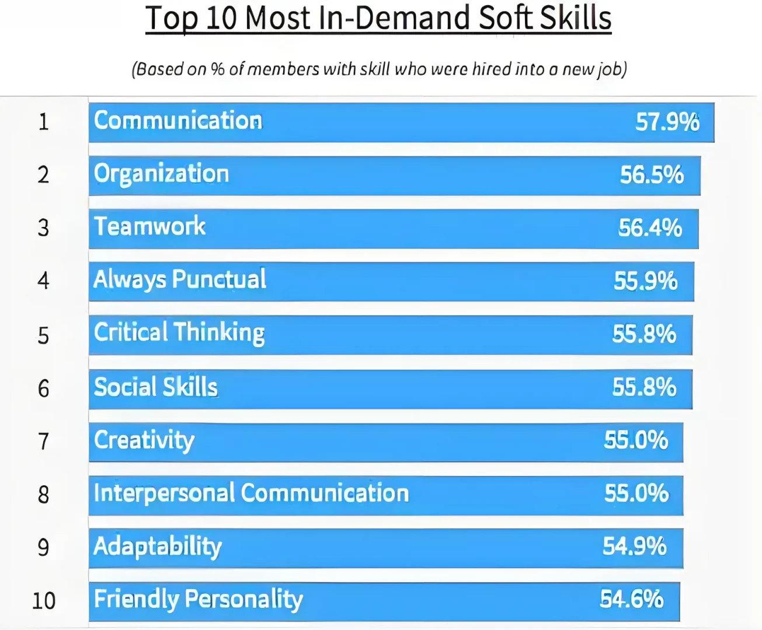

(3) My Findings

3.1) The effects of communication and how it is used in the industry-

Within the construction industry communication is the backbone of the works. The skill itself is crucial within the industry mainly due to speed of project completion and the understanding of the information presented to the workforce. Generally communication is the sharing of information to send a message, and effective communication entails being able to communicate your message in a way that workmates, colleagues or managers can process and understand the information given. (Jones.K, 2021)

Within the industry there are many forms of communication that are used to convey information or issues, bellow are forms used in the industry and the effects of using them;

- Verbal Communication- The main form of communication across the industry whether it be in the office, contacting clients/contractors or out on site. Information should be clear and concise for listeners to understand, this can be used in briefs, toolbox talks and idea bouncing. (Duncan.C, 2022)

- E-mails- Normally used to share information as quickly as possible with a particular recipient or many at the same time, this allows for messages to travel to clients or businesses thousands of miles away in minutes. You can include important documents such as photographs, spreadsheets or presentations; this allows the recipient to edit the information if needed and to help explain your point in an email. This form of communication is also a hard copy of the information that is provided and can be used as evidence if a problem occurs. (Root.N.G, 2019)

- Drawings/Plans- Drawings normally hold the technical information for the work on site. Drawings give a visual representation of the information and provide detail for the user to interpret. In terms of project management and time management technical drawings play a major part in transferring information from paper to a physical structure as quickly but accurately as possible. As we can see below in figure2, this type of communication works its way from the client to the build and then to the final product meaning it is essential that the information given is followed exactly as it can have a great effect on the outcome if the information is not interpreted correctly.
(Greenway Hirst Page Ltd, 2021)

Figure 2-
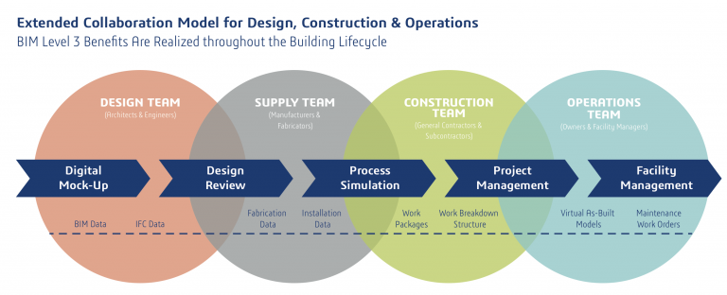

- Hand signals- Used more often than not on site, this form of communication is mainly when directing heavy machinery. This allows a form of communication to take place when written or verbal forms cannot be used, this has a great effect on the accidents and injuries on sites world wide as signals can be interpreted by anyone as there is no language barrier. Correct training must be provided in order for both parties to understand the signals.
(Safety by Design, 2021)

3.2) How communication can benefit the workplace/employer

Within the construction industry communication has a major role in many areas, many different communication types benefit companies, clients, workforce and management throughout the process of a project. Bellow are what I consider the three best benefits of communication to a construction project:

Productivity-
The first benefit is the increase in work productivity; effective communication can increase speed of the digestion information, this means deadlines can be hit and can reduce unseen costs as issues are solved as efficiently as possible. Types of communication that increase productivity are emails, verbal and drawings.

Health and Safety Issues-
The second benefit is a decrease in health and safety issues; being able to communicate in various ways such as RAMS, briefs and toolbox talks can play a big part in reducing health and safety accidents and risks as they provide the necessary information for the user/employee to understand the risks involved.

Morale and friendship within employees-
The last benefit on the list is morale and friendship within employees; when communication levels are high from all members of the project it means stress levels are at their lowest due to the workforce understanding their work before starting the job. When all parties are on the same wavelength it minimises the likelihood of confrontation and also keeps the workforce motivated.
(Martinelli.K, 2022) (Jouany.V, Martic.K, 2022)

As we can see below in figure 3, good communication skills can have an increase in productivity and performance by over 25%. While poor communication skills can cause a failure to complete projects, loss in sales and missed performance goals.

Figure 3-
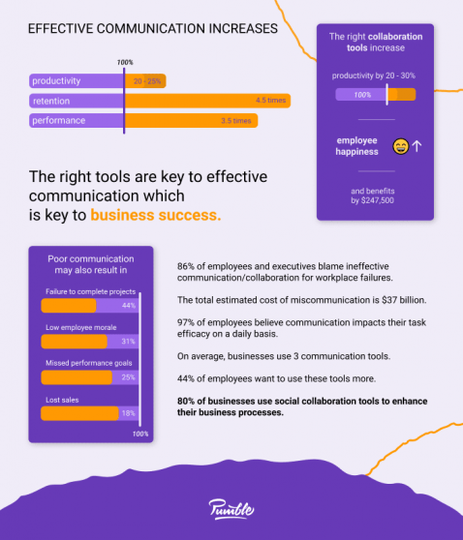

(4) Conclusion/Evaluation

4.1)

In my opinion from the information I have gathered I believe that communication is truly the most advantageous skill to hold. Although there are thoughts and theories out there regarding how communication can over complicate the job at hand especially through emails, excessive phone calls and the stress of thousands of questions at one time. (Tumlin.G, 2013)

I can see both sides of the argument but I think that you need to find the balance between overcommunication and lack of communication, in this case for the construction industry I think communication is valued at a greater degree due to the efficiency and speed work can be carried out at; with that efficiency and speed comes an increase in production keeping employers happy. This can then boost morale of the workforce, lowering unseen costs and can have a very positive effect on time/project management.

(5) References

CIPD, (2022) ‘Skills development in the UK workplace’ Available at-
https://www.cipd.co.uk/knowledge/work/skills/skills-factsheet#gref [Accessed on 04/01/23]

Duncan.C, (2022) ‘Сonstruction Сommunication: Full Guide For Managers’ Available at-
https://www.alert-software.com/blog/effective-communication-in-construction-industry [Accessed on 06/01/23]

Greenway Hirst Page Ltd, (2021) ‘The Importance of Construction Drawings in Every Building Design’ Available at- https://ghp.biz/the-importance-of-construction-drawings-in-every-building-design/ [Accessed on 07/01/23]

Indeed, (2021) ‘Workplace Skills: Definition and Examples’ Available at-
https://www.indeed.com/career-advice/career-development/workplace-skills [Accessed on 04/01/23]

Jones.K, (2021) ‘6 Keys to Better Construction Communication’ Available at-
https://www.constructconnect.com/blog/6-keys-better-construction-communication [Accessed on 06/01/23]

Jouany.V, Martic.K, (2022) ‘Top 5 Communication Skills and How to Improve Them’ Available from-
https://haiilo.com/blog/top-5-communication-skills-and-how-to-improve-them/ [Accessed on 10/01/2023]

Martinelli.K, (2022) ‘What is Effective Communication in Construction?’ Available at- https://www.highspeedtraining.co.uk/hub/communication-in-construction/ [Accessed on 10/01/23]

Root.N.G, (2019) ‘Advantages & Disadvantages of the Use of Email as a Business Communications Tool’ Available at-
https://smallbusiness.chron.com/advantages-disadvantages-use-email-business-communications-tool-21193.html
[Accessed on 06/01/23]

Safety by Design, (2021) ‘Heavy Equipment and Construction Hand Signals’ Available at- https://www.safetybydesigninc.com/heavy-equipment-and-construction-hand-signals/ [Accessed on 07/01/23]

Swain.R, (2021) ‘What skills do employers want?’ Available at-
https://www.prospects.ac.uk/careers-advice/applying-for-jobs/what-skills-do-employers-want [Accessed on 04/01/23]

Tumlin.G, (2013) ‘5 Reasons More Communication Isn’t Better’ Available at- https://www.govexec.com/management/2013/09/5-reasons-more-communication-isnt-better/70092/ [Accessed on 11/01/23]

(6) Appendices

Figure 1) Jouany.V, Martic.K, (2022) ‘Top 5 Communication Skills and How to Improve Them’ Available from-
https://haiilo.com/blog/top-5-communication-skills-and-how-to-improve-them/ [Accessed on 04/01/2023]

Most in demand soft skills:

Figure 2) Nway Technologies, (ND) ‘Construction project Management’ Available from-
https://www.nwayerp.com/construction-project-management/
[Accessed on 07/01/23]

Planning processes and who communication passes through for the final result:

Figure 3) Pumble, (2022) ‘Workplace communication statistics’ Available from- https://pumble.com/learn/communication/communication-statistics/#:~:text=Workplace%20communication%20statistics%20show%20that,by%20as%20much%20as%2025%25.
[Accessed on 11/01/23]

How communication can affect business and workforce:

