Module Name: Digital Skills and Research Methods
Module Number: BMSW4003

Student Name: Zafar Ahammad

Student Number: 2121303

Research Title
An international study on LinkedIn's recruitment efficacy.

Table of Contents
Abstract: 4
Introduction: 4
Research Design: 5
Ethical Considerations: 7
Results: 7
Discussion: 9
References: 13

Abstract:

Because so many firms compete for the same talent, it is vital to use the most effective tactics to locate and acquire the best candidates. This research aims to examine how LinkedIn influences the recruitment process on a worldwide level. The investigation was prompted by a need to discover where to direct scarce resources to attract the best and brightest. It seems that social media usage is becoming more prevalent every day, and this is also true in the recruitment process. Semi-structured interviews were conducted to determine the study's main topics and subthemes. If a recruiter is not addressed intelligently, using LinkedIn may be overwhelming. The usage of social media sites such as LinkedIn is essential for successful hiring. However, social media training is essential. According to the findings of this study, LinkedIn has a significant impact on recruitment around the globe.

Introduction:

As a society, we rely heavily on online social media platforms to exchange knowledge and resources (Muller, 2019). Using social media in the office is an excellent example of incorporating new technology and digital skills into the workplace. LinkedIn has become a vital source of information and a forum for job searchers to showcase their skills (Edward, 2021). Over 300 million people across the globe have joined LinkedIn since it was founded in 2003 (Hayden, 2016). LinkedIn aids recruiters and hiring managers by screening applicants (Patil, 2019). LinkedIn is the most popular SNS for recruitment (Koch, 2018). The research focuses on LinkedIn's ability to help companies acquire new workers. Several methods have been used to identify the problem. Our goal is to perform a poll, together with an in-depth historical and factual investigation, so that we can arrive at an answer. We will use a "mixed strategy" of data collection to ensure accurate as well as reliable results. According to this study, LinkedIn's capacity to link companies and job seekers may benefit both sides. With LinkedIn, job searchers and recruiters use the platform's fundamental function to connect with professionals, conduct commercial transactions or inquire about employment prospects through connections with people they already know. Professional and careful behaviour on LinkedIn, on the other hand, is what will bring the highest rewards (Andy, 2020).

Research Design:

The design of the research is essential since it aids in developing a research foundation. Developing a solid research foundation begins with a well-thought-out study plan. Researchers' thoughts, viewpoints, and goals make up the research methodology.

Research Question
How effective has LinkedIn been in recent years in speeding up the hiring process for both the public and commercial sectors when considered globally?

Research Strategies:
Research strategies serve as an overarching framework for the study, and it proposes an alternative method for addressing problems caused by it. Exploratory and survey research, including case studies, is an example of a research methodology. Other forms of research methods include historical and documentary analysis (Badke, 2021). An online poll and an archival and documentary technique will be used to acquire data for this investigation. Documentary and archive strategies use documents and other sources of information to get information from respondents, while the survey approach relies on questionnaires to collect data (Koch, 2018).
Types of Research:
Based on the purpose of the project, there are two categories of research: fundamental and applied (Badke, 2021). As a consequence of our effort, we are creating new theories considered basic research. This has no financial value and is not being done for a specific individual or business. Rather than starting with a hypothesis and working backwards, we use an inductive approach in our investigation (Patil, 2019). We will assess to discover the answer to our research question. An assessment study aims to evaluate the impact of different actions on the investigation's subject matter. Since we will only collect data from the same sample once, we will perform a cross-sectional study.
Research Method:
We will use a mix of quantitative and qualitative data gathering approaches in our research, i.e., a mixed method. Questioning individuals about their life is one way to obtain information for qualitative research, which does not rely on numerical data. An idea will be produced based on replies from individuals who took the survey, and it will be in public soon afterwards. Mathematical methods and data processing processes are used in quantitative research, and these discoveries are then merged with statistical representations to obtain the final results. Analytical diagrams and charts will be utilised to analyse the quantitative data collected and analysed throughout the project. We will provide numerical and statistical analysis to our customers using quantitative research approaches.

Participants:
Vodafone, Compass Group, Proctor & Gamble, and other public sector employees will be invited to participate. There will be a total of 25 participants, 70% of whom will come from the private sector, which has been focusing on contemporary recruitment tactics in recent years. Due to time and money restrictions, we will use the non-probability sampling approach to pick our participants. Another benefit of using this approach is that we will be able to meet the new HR employees who have been recommended to us and who have shown an interest in participating in our research.

Ethical Considerations:

Ethical issues are an essential part of any research, and this is the case here. Human resources professionals have always undertaken a variety of background checks as part of the interview process (Clarke, 2021). A company's policy on online recruiting should state that no demographic data is used in the recruitment process and that LinkedIn is only used for recruitment (Jhonty, 2019). All of this will be considered in conducting a thorough evaluation and developing an implementation plan. We will use a consent form to make sure participants are aware of the study's purpose, how their data will be used, and, most importantly, whether or not they want to participate. We will only allow HR specialists to participate if they desire to do so independently and not due to a mandate. In addition, we will make sure that our evaluation procedures do not endanger them. We will not publish any reports or records that reveal who the responders are out of respect for their privacy. For our last phase, we will work on improving our moral character characteristics like honesty and integrity and our capacity to resist prejudice and behave in line with the law while also honouring the dignity, privacy, and autonomy of other people.

Results:

Social media was shown to be widely used in recruitment operations, with a considerable number of participants doing so. Additionally, participants in this survey reported using LinkedIn significantly more often than either Twitter or Facebook (Muller, 2019). Almost all of the 25 participants said that they utilise LinkedIn for recruitment purposes. It is possible that, despite the fact that this study only had a limited sample size, there are still substantial differences in the way people utilise LinkedIn.

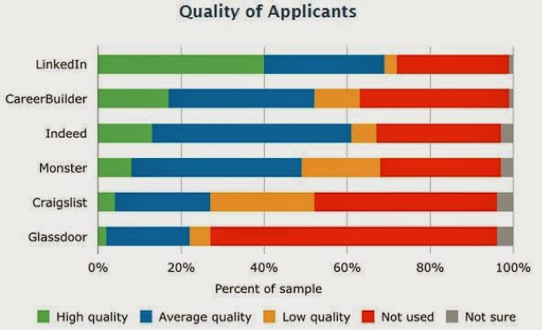

Figure: Quality of applicants in the different social networking sites (Andy, 2020)
LinkedIn has got the most talented and quality applicants so far. This means LinkedIn is not simply for seeking new workers but also for identifying them. Once a possible candidate is discovered on LinkedIn, various websites are consulted to verify their contact information. It is impossible to avoid the risk of candidate profile inflation while utilising LinkedIn to search for headhunting candidates (Patil, 2019). Recruiters in this sample seem unconcerned with the possibility of application profile inflation, which was not addressed by any of the interviewees. According to Koch (2018), LinkedIn has one of the highest success rates of any social networking site.
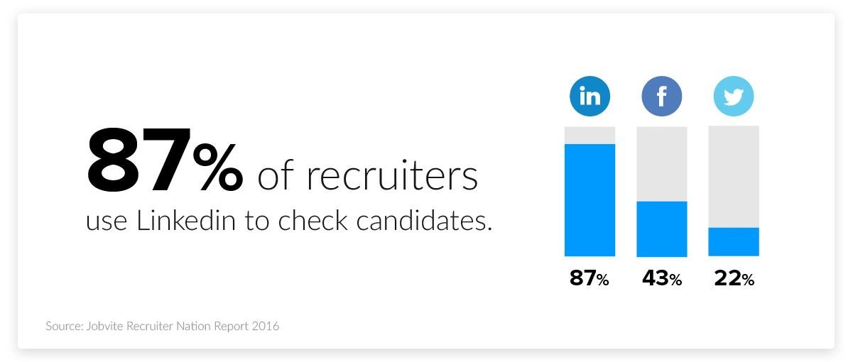
Figure: Checking candidates via different social media (Jobvite, 2016).

After reading and hearing about the importance of employment websites and portals in the recruitment process, it is clear that LinkedIn is a crucial recruiting tool. A significant indication that some recruiters do not use LinkedIn is that they continue to use more traditional recruitment methods, particularly advertising. In another way, this approach is by the view that social media should not be used as a stand-alone recruiting tool but rather as part of a comprehensive, well-planned strategy (Patil, 2019).

Discussion:

This study's outcomes show that recruiters worldwide utilise LinkedIn extensively as part of their sourcing strategy. According to Muller (2019), the usage of LinkedIn in recruitment grows as the day passes by with the increasing number of candidates. Recruiters are aware of the potential of social media to attract both active and passive and semi-active applicants. The usage of LinkedIn is substantially greater than that of Twitter and Facebook, much as in other countries. Employer branding is a critical component of attracting top talent, as shown by the results showing that LinkedIn's recruitment tools are optimised to help recruiters locate and connect with applicants online. LinkedIn seems to have overtaken enterprise databases when it comes to finding new employees. In the past, recruiters would have used their database to look for suitable applicants, but today they utilise LinkedIn as their new tool.
However, in contrast to the database, LinkedIn is not employed as a stand-alone tool. The candidate's contact information and other relevant information are sourced from various online resources once located on LinkedIn (Badke, 2021). LinkedIn makes it easier for recruiters to find passive and semi-passive job seekers, but it also creates a data glut. The number of candidates generated by employing it limits the pool's usefulness and efficiency. There are two sides to the recruitment process: recruiters who "blow" their time and focus on looking through LinkedIn profiles and job searchers who "splatter" their resumes to recruiters via social media. This time around, the procedure seems to be a little simpler and more refined than in the past. This is because it is mechanised electronically, yet the overflow occurs here (Patil, 2019).

LinkedIn Recruitment in UK:
As of September 2019, LinkedIn has 10 million UK members, a more than 100% increase in membership from the previous month. From Net-A-Porter to Travis Perkins, employers in the UK rely on LinkedIn's Talent Solutions offerings to find and hire top-notch employee (Andy, 2020). More than 22,000 firms throughout the globe, including 75 of the FTSE 100, have signed up for the programme. Due to the COVID-19 outbreak, many businesses had to allow their employees to work from home, but many companies may not have been as prepared as they believed. Companies in the United Kingdom have taken advantage of this opportunity, and LinkedIn has emerged as their go-to resource for all recruitment needs (Jhonty, 2019). In the United Kingdom, more than 15,000 businesses pay a fee to utilise LinkedIn Recruiter. Unilever, Tesco, and P&G are just a few of the many major, medium, and small businesses and recruitment organisations that make up this list. By 2023, it is expected that the recruiting sector in the United Kingdom would have risen by 10% as a result of the use of social media platforms like LinkedIn (Muller, 2019).

Conclusion:

To sum up, both theoretically and practically, the findings of this research provide a substantial scientific and practical contribution to the understanding of effective recruitment techniques. As shown by the fact that LinkedIn is significant in hiring on a global scale, at the very least as a complementary process to more traditional recruitment approaches, it is crucial in recruiting on a global scale. The research also reveals that LinkedIn is becoming more vital and relevant in the world's talent management framework. Under the study results, recruiting via the use of LinkedIn is unique from recruiting through the use of other social networking platforms. Employers, recruiters, and job seekers should pay attention to a recent study that found LinkedIn to be the most influential social media platform in the hiring process. This is a significant result that should be taken into consideration by researchers, recruiters, and job seekers in the future.

.

References:

Andy, H., 2020. Social media recruitment. London: Kogan Page.
Badke, W., 2021. RESEARCH STRATEGIES. [S.l.]: IUNIVERSE COM.
Clarke, N., 2021. The responsibility to protect. Oxford: International Development Research Centre
Edward, J., 2021. The social media marketing book. Sebastopol, Calif.: O'neill.
Hayden, D., 2016. Social media marketing all-in-one. s.l.:s.n.
Jhonty, X., 2019. Handbook research for competitive strategy. Cheltenham, UK: Elgar Publications.
Jobvite.com. 2016. Jobvite. [online] Available at: <https://www.jobvite.com/> [Accessed 9 April 2022].
Koch, T., 2018. The impact of social media on recruitment: Are you LinkedIn?. UK Journal of Human Resource Management, 16.
Muller, J., 2019. Recruitment via LinkedIn. Birmingham: Reed Business.
Patil, P., 2019. LinkedIn an Effective Source of Recruitment in the Corporate World. KRSCMS Journal of Management, 4(4), p.40.

