.
Network operating systems and security-ACCC5003
Terry Walcott | UWTSD
Assessment 1- observational task
Kamen Todorov (1818166)
2020
Contents
Task 1. 2
Task 2. 3
Task 3. 3
Task 4. 3
Task 5. 5
Bibliography and References 6

Task 1.
The most obvious benefit is the need of only one physical computer also because the guest operating systems work in sandbox software; there is no possibility of damaging the main operating system or the physical hardware. VirtualBox platform is a great tool it enables quick and easy access to the alternate OS, and this enables users to access different OS-specific tools and applications. The downside is because the VM access the computer resources true the main OS a latency is introduced, which affects the VMs performance. On "Diagram 1" we can observe Active directory forest, it's comprised of two trees one forest root two-parent domains and three child domains. Active Directory forest is used in a company usually spanning large geographical areas; in this case, different continents. It is the topmost logical container of Active Directory, and it's comprised of domains, users, computers, and group policies. A child domain is created when users want a domain that shares contiguous namespace whit other domains, example of that can be seen on fig.1. Another characteristic of parent-child domain, parent domains can administer child domains but not the other way around.
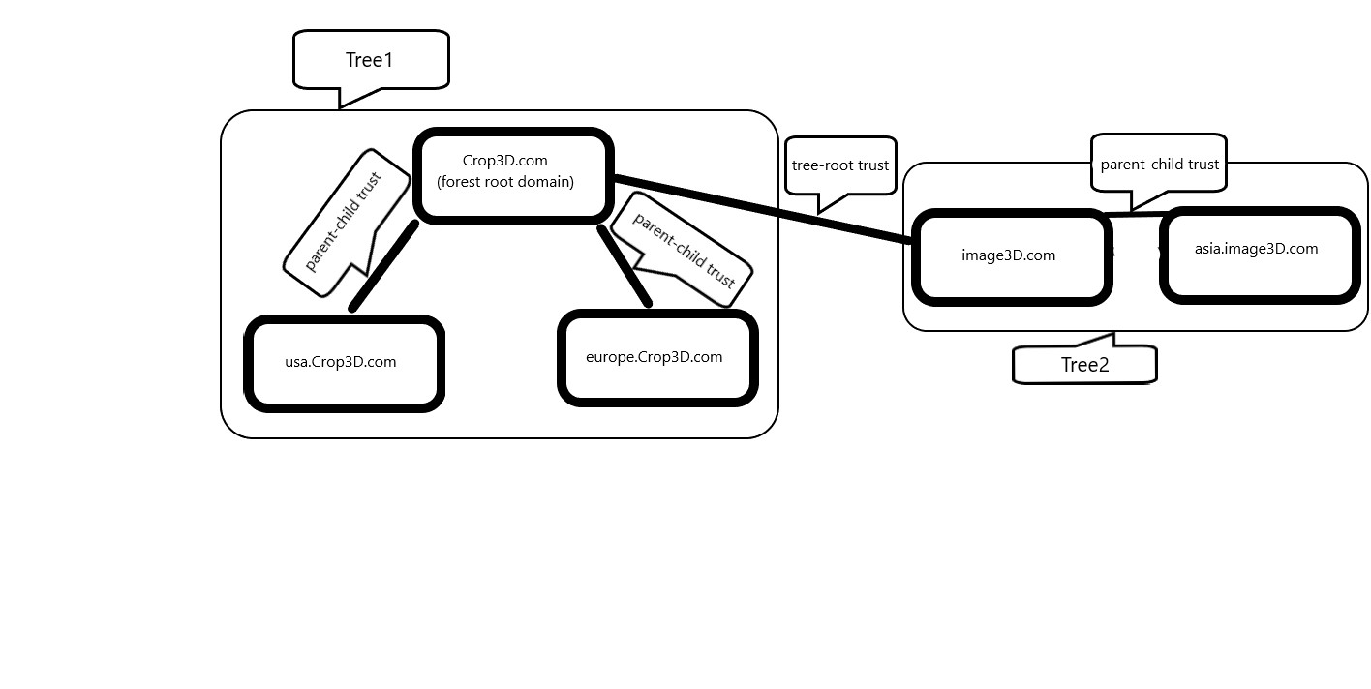Diagram 1. Active Directory forest
Active Directory (AD) is a server in which all enterprise objects are stored; its multi-master enabled hierarchical database capable of storing large quantities of data. The primary role of an AD domain controller is to organize company computer and user hierarchy. It contains the data that validates and determines access to a network. A most important tool for a troubleshooting domain controller is the built-in logs enabled and configured by default. In case there are issues not covered by the built-in logs there are several tools used as starting points like "Dcdiag.exe", "Repadmin.exe, "MSInfo32.exe". All these errors are very important to examine the error codes carefully. It provides crucial information about the error that can be used to resolve it. The general methodology for troubleshooting is as follows:
- Syntaxis issues check.
- Prerequisite failure check.
- Promotional error check.

Task 2.
There are several "ground rules" for password complexity, such as password length, content, age, and encryption type. Most commonly, passwords are required to be at least eight characters long, and any additional characters increase complexity greatly. The content of the password is the most important requirement; some of the best practices are as follows:
1. Password must not contain the account name or full display name.
2. No repetitive characters like "aaaaa", "3333", etc.
3. Must contain uppercase and lowercase letters.
4. Nonalphanumeric characters: "$, #, !"

Task 3.
Shared permissions and NTFS permission are independent in the sense that neither changes the other. When determining access permissions on a shared folder, both are taken into consideration. The more restrictive permissions are applied in the final decision. NTFS permission affects access remotely and locally, and shared permissions do not restrict access to any local or terminal server user. This means shared permissions does not provide privacy between users using the same device or terminal server used again by more than one user. New technology file system or NTFS is the standard file system of Microsoft Windows, and this file system was created to replace the old FAT file system. The NTFS supports meta-data and uses advance data structures to improve performance and reliability, in addition, incorporates extensions such as access control list and system journaling. Systems employing the NFTS file system are known to have improved reliability and improved performance on large drives. Because NFTS can use a small cluster, it reduces the amount of wasted drive space, and the "hotfix" support means that "bad sector" are automatically detected and mark so they won't be used. There are several benefits of using groups to managing users. First, all the settings are applied automatically on login whit out the need of admin intervention which means fewer technicians needed. Next is easily managing a large number of users or devices, when a restriction is applied to a group, it applies to all users or devices in the group. Group policy (GPO) and Organizational units (OU) are crucial design factor that impacts the security, policies, and the cost of administration of windows network. OU is commonly used to contain group accounts, user accounts, and computer accounts. One of the main benefits of OU is that it can accomplish domain functions, therefore reduces the number of domains needed. Another big benefit is when OU and group policies have combined all files and folders of a user successfully can be accessed on different devices. Users are no longer confined to e single computer, which increases users' productivity. Group policy objects (GPO) have many benefits and uses like user data management, software installation and maintenance, users settings management, and remote operating system installation. When designed correctly, GPOs can also reduce the total cost associated with windows network ownership, and the administrators' responsibilities can be reduced with GPO automatically managing software and users setting across the domain.

Task 4.
The main goal of DHCP is to simplify network management; some of its advantages are:
- Easy management of large and medium networks.
- Automatic propagation of network configuration settings.
- Conservation of IP addresses.
- Automatic network configuration for new client devices.
On Diagram 2, the four stages of the DHCP process can be seen.
Stage 1: Client sends "DHCP discover" broadcast packet to the server.
Stage 2: Server sends "DHCP offer" unicast packet to the client.
Stage 3: Client sends "DHCP request" unicast packet to the server.
Stage 4: Server sends "DHCP acknowledgement" unicast packet to the client.
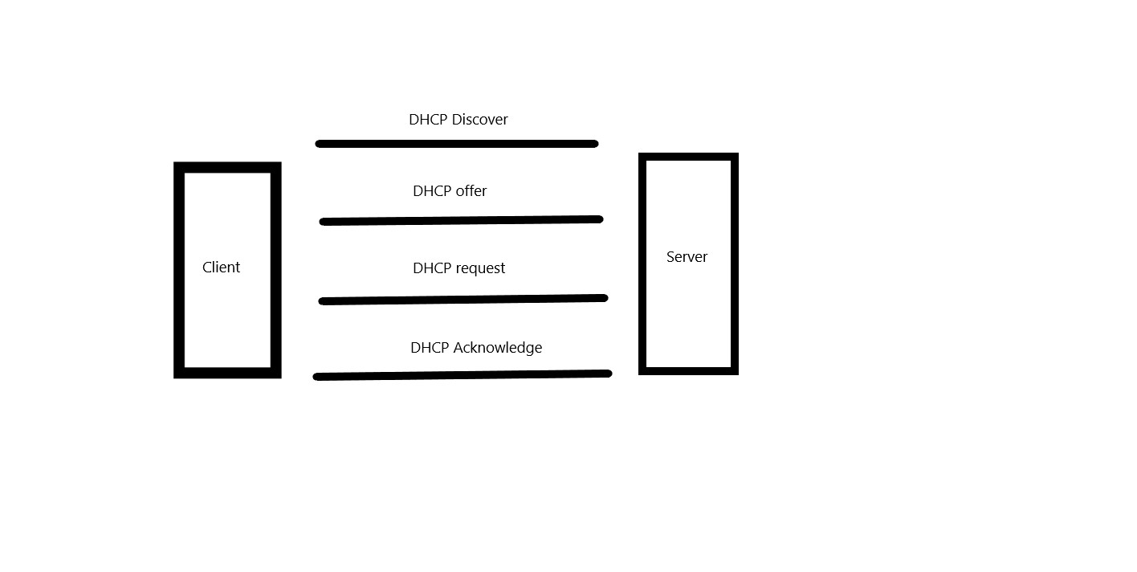
Diagram 2. DHCP process
Some of the threats of using DHCP server are:
- DHCP can be a single point of failure.
- If there are incorrect network configuration, it will propagate automatically to all clients.
- DHCP has no client authentication.
- The main target of cyber-attacks.

Task 5.
When a client sends name resolution query to DNS server if the DNS server does not have the information it can query another DNS server on behalf of the client this is called "Recursive query". An iterative query is a process in which DNS server makes repeated name resolution queries to different DNS servers. DNS data stored in the DNS server is called root hints, it provides list preliminary resource records used to locate other DNS server which authoritative for domain namespace tree. FQDN for the host is "subcontA.nwtraders.msft".

Bibliography and References
[1] D. Francis, "Mastering Active Directory", Google Books, 2019. [Online]. Available: https://books.google.co.uk/books?hl=bg&lr=&id=ybaoDwAAQBAJ&oi=fnd&pg=PP2&dq=mastering+active+directory&ots=zJ7yEF0T15&sig=1NUGCsRihvhW8l3EfXgT06cOAmo&redir_esc=y#v=onepage&q=mastering%20active%20directory&f=false. [Accessed: 17- Dec- 2020].

