The Global Business Environment
Written Examination
LCBB4005_BIRM

Student Name: Cristina Valentina Solomon
Student ID: 2025748
Module Coordinator: Dr. Eric Osei
Lecturer: Uwaoma Ochonogor
Explaining the importance of international trade.
International trade is the exchange of goods and services between countries. Global trade gives consumers and countries exposure to goods and services that are unavailable at the national level, or more expensive at the national level. International trade has played a key role in the recovery of the global economy. In the global economy, supply and demand, and hence prices, impact and impacted by global events. However, some argue that international trade can actually be harmful to small nations, putting them at an even greater disadvantage on the world stage.
About PepsiCo.
PepsiCo is one of the world's largest food and beverage companies with 2015 net sales of over $63 billion. She has a diverse portfolio of internationally renowned brands. PepsiCo has a food and beverage portfolio that includes 22 brands. Pepsi's flagship brand. Beverages, Frito-ray Snacks, Gatorade Sports Drink Line, Quaker Nutritious and Delicious Foods and Snacks, Tropicana Fruit Juice.

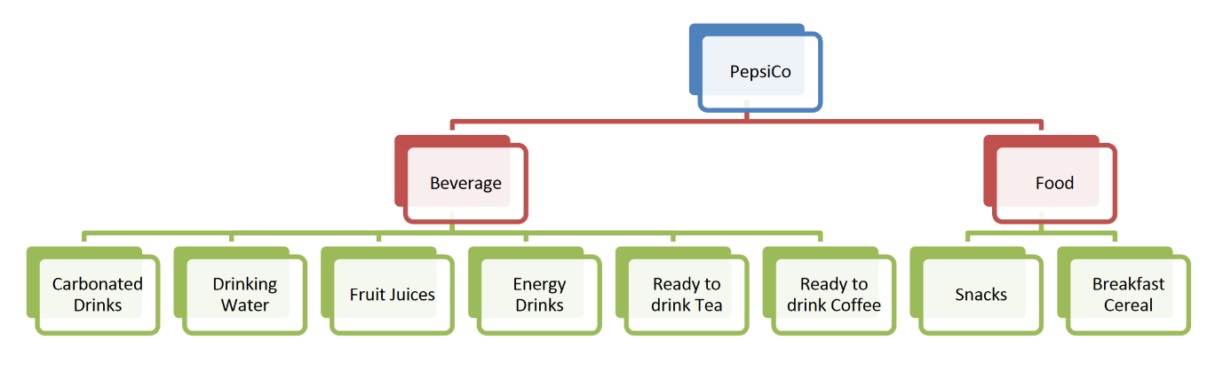
PepsiCo Product Diversity

PepsiCo is a globally widespread company, has six global divisions operating in business.
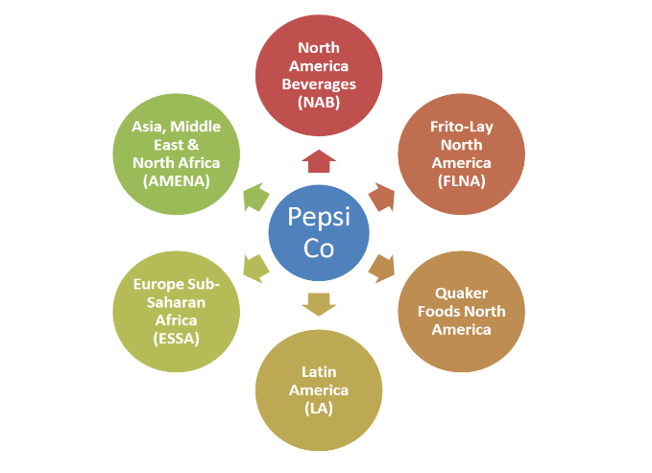
Global Operating Divisions of PepsiCo
PepsiCo Inc is one of several global strategies to increase value and increase market share in the international market. PepsiCo Inc. Headquarters are located in Purchase, Harrison, New York, USA. The company is engaged in the production, marketing and sales of grain-based beverages and snacks. The company was first founded in Delaware in the 1890s and has since grown into a multinational corporation. Expansion was primarily through mergers and acquisitions.
Project Blue, Pepsi's marketing strategy, was launched in 1996 in various international markets. It was a campaign to commemorate the 100th anniversary of the founding. Several publicity stunts have been performed to support this strategy. A banner was hung on the Mir space station, and the Concorde aircraft were painted blue above all else. It also marked the launch of the Pepsi Globe logo. Branding is very important and aggressive, young companies like Pepsi are innovators. In 2008, he announced that he would change his logo again. By 2009, Pepsi, Pepsi Max, and Diet Pepsi had started using lowercase letters in their Pepsi Globe logos, with white stripes mimicking an angle-shifting "smile" depending on the product. From 2009 to 2010, the updated logo was first introduced to the Pepsi market in Canada and then introduced to Latin America, Australia, the Philippines and other countries.
The SWOT synopsis of PepsiCo is presented below:
- Strengths: Consistently strong financials and dividend pay-out; Large, diversified and unique product portfolio; Innovative marketing campaigns; World Class Partnerships.
- Weaknesses: Largely Dependent on US Market and unhealthy perception of consumers.
- Opportunities: Venezuela Impairment charges; Pursue inorganic growth with focus on healthier offerings; Winning the MSG contract.
- Threats: Intense Competition; Impact of Brexit; Frequent product recalls.
The PESTLE and analysis is presented below:
- Political: Contribution made in compliance with laws and regulation; Changes in political scenario of a country
- Economical: Impact of economic crisis
- Social: Cultural shift from carbonated drinks to healthy beverages.
- Technological: Leveraging big data for optimisation of supply chain.
- Legal: Laws and Government regulations on food and beverages; Regulations and taxes on the ingredients of products.
- Environmental: Addressing sustainability and climate change; adopting of environmental friendly practices through “ Sustainable Farming Program”

Supply and Demand.
PepsiCo's supply and demand conditions are governed by availability, product price and consistency of flavour (Hubbard, R. & Brien, A., p. 70). An increase in demand for goods is the growth of a middle-class economy. Product demand is negatively affected by changes in consumer needs, and failure to innovate to meet consumer preferences and needs means we cannot satisfy them, and we lose them as potential customers (Zott, 2008). . The growth of the retail landscape means that the one-stop retail landscape has undergone significant changes over the years, during which there has been an understanding to serve small stores better while supporting important partners for large retail customers. In addition, the drop-in store system provides excellent service to both large and small retailers while maintaining lower shipping costs.
The price elasticity of demand is the quantity of a good required when the price of the same good changes. The price elasticity of a product is determined by five factors. Substitutes, time course, and market and consumer budgets if the product is a commodity (Hubbard, R. & Brien, A. page 170178). There are several alternatives for the PepsiCo brand, such as Coke for Pepsi or Tropicana Orange juice for Sunkist orange juice. If PepsiCo raises its price, consumers will buy alternative products in return. Also, if the price rises sharply, you can stop buying it immediately as it is unnecessary, but most PepsiCo products are cheap. PepsiCo is a company with an oligopolistic market structure and has a large economy of scale, so manufacturing costs are relatively low. Demand is elastic, so when PepsiCo changes its price, the amount of product sold changes, which changes its gross profit (Hubbard, R. & Brien, A.). If PepsiCo wants to increase its total revenue, PepsiCo must lower its price, which will increase demand.

What is market failure?
In an economy, market failure is a situation determined by an inefficient distribution of goods and services in a free market. In the case of market failure, an individual's incentive to act rationally does not lead to a rational outcome for the group. That is, each made the right decision for himself, but it was the wrong decision for the group. In traditional microeconomics, it can appear as a persistent imbalance in which supply does not match quantity demanded. Key Consequences Market failures occur when those who act for their rational self-interest result in suboptimal or economically inefficient outcomes. Market failures can occur in public markets where goods and services are bought and sold directly, which we consider to be typical markets. Market failure can occur even in an implicit market when a preference or preference such as an election or a legislative process is exchanged. Market failures can be addressed through private market solutions, government proposed solutions, or voluntary collective action.
Understanding Market Failure
Market failure occurs whenever individuals in a group are worse off than if they did not act according to their perfectly rational self-interest. Such groups incur too much cost or receive too little benefit. The economic consequences of market failure are not what economists usually consider optimal, and they are usually not cost-effective. Although the concept seems simple, it is misleading and easy to go wrong. As the name suggests, market failures do not account for the inherent flaws of a market economy. Market failures can also occur in government activities. One notable example is the pursuit of rent by special interest groups. Special interest groups can benefit greatly by lobbying for less for everyone else, like tariffs. When each small group charges its own cost, the whole group is in a worse position than without the lobby. Also, not all bad outcomes of market activity are considered market failures. Market failure also does not mean that private market actors cannot solve the problem. On the other hand, not all market failures have potential solutions, even with careful regulation or increased public awareness.

Defining Market Failure
Market failure occurs when the price mechanism fails to account for all of the costs and benefits necessary to provide and consume a good.
Market failure occurs when pricing mechanisms fail to account for all the costs and benefits required to offer and consume a product. The market will fail by failing to provide socially optimal products. Prior to market failure, market supply and demand failed to produce a quantity of goods whose prices reflected the marginal benefit of consumption. Imbalance leads to inefficiencies in distribution, i.e. excessive or insufficient consumption of goods. The structure of the market system contributes to market failure. In the real world, markets cannot be perfect due to inefficient producers, externalities, environmental problems, and lack of public goods. Externality is the effect on a third party due to the production or consumption of goods or services.
During market failures, governments typically respond in different ways. Possible government responses include:
- Legislation - adoption of specific laws. For example, smoking ban in restaurants or compulsory high school attendance.
- Taxation - The levy of a tax on certain goods in order to curb their use and compensate for external costs. For example, the introduction of "phrases" for tobacco products and the subsequent increase in the cost of tobacco consumption.
- A tradable - permits that allows a business to produce a certain amount of something that normally pollutes the environment. Businesses can trade permits with other businesses to increase or decrease what they can produce. This is the basis of cap-and-trade, an effort to reduce environmental pollution.

Causes of Market Failure
Market failure occurs due to inefficiency in the allocation of goods and services.
Market failure is caused by inefficient distribution of goods and services. A pricing mechanism does not account for all the costs and benefits of providing or consuming a particular good. When this happens, the market will not produce a socially optimal supply of goods. It will be over or under-produced. To fully understand market failures, it is important to recognize why markets may fail. It may not be perfect due to market structure. As a result, most markets fail and require various interventions.
Reasons for market failure include:
- Positive and negative externalities: Externalities are the effects on a third party due to the consumption or production of goods or services. Positive externalities are positive side effects that occur in the consumption or production of goods or services. For example, public education can have a direct impact only on students and schools, but an educated population can have a positive impact on society as a whole. Negative externality is a negative side effect to third parties. For example, second-hand smoke can adversely affect people's health, even if they do not smoke directly.
- Lack of public good: A public good is a good for which the total cost of production does not increase with the number of consumers. As an example of a public good, a lighthouse has a fixed cost of production that is the same whether one ship or one hundred ships use its light. Public goods can be by-products; From a privacy perspective, there is little incentive to provide a lighthouse as you can wait for someone else to provide it and then use your lights without incurring any costs. This problem - someone getting resources or goods and services at no cost to the benefit - is known as the free problem.
- Overprovision of demerit goods: Incapacitated goods are private goods that society considers to be over-consumed, often with negative externalities. For example, tobacco, alcohol and prostitution are considered secondary property.
- Underproduction of merit goods: a merit goods are private goods that society considers underconsumption, often with positive externalities. For example, educational, healthcare and sports centers are considered meritorious goods.

References
https://www.swotandpestle.com/pepsico/
https://courses.lumenlearning.com/boundless-economics/chapter/introducing-market-failure/
https://www.sweetstudy.com/sites/default/files/qx/16/01/08/02/pepsico-_draft.docx
https://www.investopedia.com/terms/m/marketfailure.asp
https://www.investopedia.com/insights/what-is-international-trade/
https://www.daytranslations.com/blog/how-pepsi-expands/

