S

Programme: Master of Business Administration
Module: Financial Management
Module Code: LCHS7002
Company: Choice Hotel International
Student Name:
Student ID:

Table of Contents
Introduction 3
1. Financial Health Check 3
Vertical and Horizontal Financial Trend Evaluation 3
Reimbursable Expenses and Total Incomes 4
Operating and Net Profitability Segments 5
Ratio Analysis Matrix (2021-2025) 6
Strengths and Potential Threats 10
Liquidity Ratios Comparison with Industry Benchmarks 11
Comparative Liquidity Assessment 12
2. Working Capital Management Analysis 13
Cash Operating Cycle factors 13
Component Ratios Analysis 13
Strategic implications of Operating cycle 14
Recommended strategies to improve liquidity 15
Comparison of Short-term vs Long-term Financing Options 15
3. Strategic Financial Restructuring Plan 16
Recommended Financial Restructuring Plans 17
Evaluation of Restructuring Impact 17
International and Ethical considerations 19
Corporate Social Responsibility(CSR) and ESG linkage: 19
4. Investment Appraisal and Capital Budgeting 20
Project Financial Metrics Matrix 20
Comprehensive systematic financial assessments 21
Underlying calculations breakdown 21
Evaluation of Capital Budgeting 26
Strategic suggestions and explanation 27
Profitability and Revenue Alignment and rising of non-financial risks 27
Capital Rationing Analysis 28
5. Critical Analysis on AI usage 29
Tool disclosure 29
Critical evaluation of the AI output 29
Contribution analysis 29
Ethical and professional reflection 30
Applying AI in financial decision-making structures reflects ethical and operational risks that need to be assessed: 30
Conclusion 30
References. 32

Introduction
One of the apex asset-light hotel franchisers in the world, Choice Hotels International, Inc. (CHH) supervises a mixed portfolio of 22 brands in over 46 countries, carrying the upscale, extended-stay, midscale, and money-saving segments (Choice Hotels, 2025). This in-depth financial report, prepared by the appointed Chief Financial Officer (CFO), determines the enterprise’s financial performance from 2021 to 2025 and proves a deep evaluation of its strategic growth, working capital plans, capital structure maximization, and long-term financial backing approach.

1. Financial Health Check
A detailed analysis of Choice Hotels International, Inc. (CHH) in the 5-year period from 2021 to 2025 is shown in this section. This assessment provides horizontal/vertical trend lines, an exclusive ratio matrix, a review of systematic influences, and sector liquidity benchmarking evaluation by breaking down data taken from the company’s SEC Form 10-K filings and annual reports.
Choice Hotels International, Inc. Financial Performance Data below across 5-year (2021-2025):
(Figures stated in £ Millions, USD ($) adjusted for historical annual average exchange rates)
Financial Line Item (£ Millions) | 2021 | 2022 | 2023 | 2024 | 2025
Total Revenue | £779.7 | £1,139.8 | £1,245.2 | £1,238.3 | £1,238.0
Gross Profit | £779.7 | £1,139.8 | £1,245.2 | £1,238.3 | £1,238.0
Operating Profit (EBIT) | £265.5 | £362.4 | £371.8 | £362.3 | £347.6
Net Income | £210.8 | £270.6 | £208.9 | £234.4 | £286.7
Total Capital Employed | £775.2 | £1,053.6 | £1,196.4 | £1,208.2 | £1,223.1
Table 1. Underlying financial data table (2021-2025)
(Source: Author, 2026)

Vertical and Horizontal Financial Trend Evaluation
Examining the Choice Hotels financial data provides an image of the company’s corporate transformation and structural post-COVID progression. The company’s turn towards superior brand profit streams, for example, the integration of Radisson Hotels Americas in 2022, grouped with concern over higher-value extended-stay and elegant divisions, yields as the main operational driver during this period.

Reimbursable Expenses and Total Incomes
The major distinction between “Gross Revenues” and “Revenues excluding Reimbursable Costs” via vertical structural analysis. Pass-through advertising and reservation system fees, which are being paid by franchisees, are shown by reimbursable Revenues. They have an unfavourable gross margin and overestimated the Revenue statement.
- 2021-2022: Total Revenue increased from $1.069 billion (2021) to $1.402 billion (2022), depicting a 31.1% horizontal rise led by sparing time on travel recovery and Radisson system expansion.

- 2023-2024: Revenue expansion stabilised in 2023 and 2024, increasing from $1.544 billion to $1.585 billion.

- 2025: Total Revenue rose to a record $1.597 billion. When removing reimbursable elements, net operational fee revenue rose from $947 million in 2024 to $981 million in 2025.

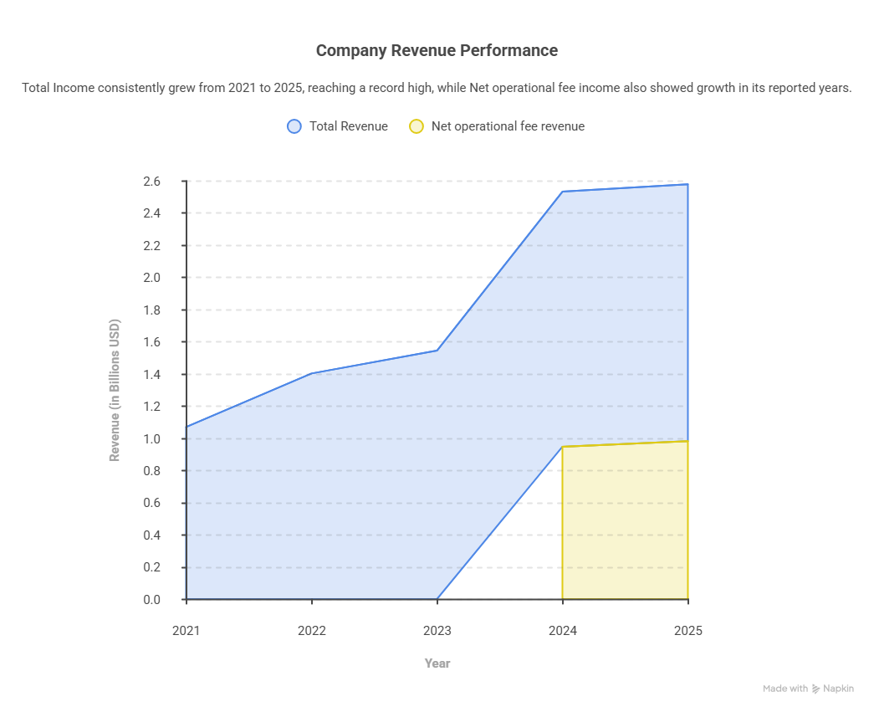

Operating and Net Profitability Segments
- Operating Income: Operating income rose noticeably from 2021 ($364 million) to 2024 ($463.8 million). In 2025, operating income shrank by 3.3% to $448.4 million. The operating profit diminished from 29.2% (2024) to 28.1% (2025) vertically, due to rising general, administrative, and selling expenses and amortisation charges in amalgamation.
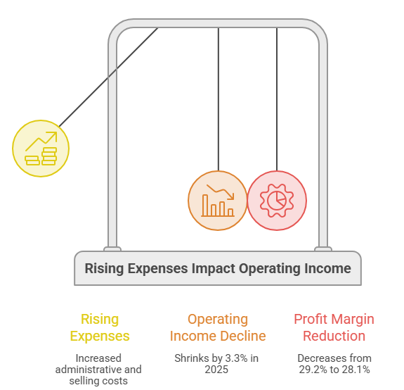

- Net Income: Net income rose unexpectedly in 2025 to $369.9 million, higher than $300 million in 2024 and $259 million in 2023. This horizontal increase (+23.3% in 2025) is the effect of non-operational transactions, mainly a $100 million gain from the structural takeover of a joint venture (Choice Hotels Canada).
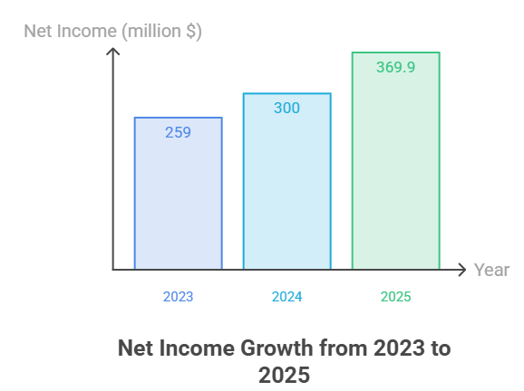

Ratio Analysis Matrix (2021-2025)
The table below denotes Choice Hotels' performance ratios computed across 6 operational criteria, indicating its pure-play asset-light franchising infrastructure.

Financial line item | Ratio Metric | FY 2021 | FY 2022 | FY 2023 | FY 2024 | FY 2025 | 5-Year Outlook & Strategic Position
Profitability | Operating Margin(%) | 34.05% | 31.81% | 29.86% | 29.26% | 28.08% | Structural sinking drift due to Radisson SG&A inclusion; strong among competitors
 | Gross Profit Margin | 56.07% | 49.93% | 44.70% | 46.96% | 52.72% | Pass-through cuts created a dip in the middle of the period, but it was back on track by 2025
 | Net Profit Margin | 27.02% | 23.69% | 16.74% | 18.91% | 23.17% | Fell to a low of 23% after takeover in 2023
 | Return on Equity (ROE) | 216.5% | 157.1% | 270.3% | 1675.1% | 406.3% | Unstable due to the company buying back its own equity, altering capital structure
Liquidity | Current Ratio(x) | 0.81x | 0.68x | 0.72x | 0.76x | 0.71x | Working capital squeezed repeatedly; Normal for fee-generating models.
 | Quick Ratio(x) | 0.79x | 0.66x | 0.70x | 0.74x | 0.69x | Because of nominal physical inventory asset reliance, closely note the current ratio.
 | Cash Ratio | 0.90x | 0.10x | 0.03x | 0.09x | 0.10x | In 2021, there is a spike from pandemic cash collections, then after settling down with not much assets
 | Operating cash flow ratio | 0.67x | 0.65x | 0.68x | 0.72x | 0.75x | Showing consistent cash flow as it increased consistently
Efficiency | Asset Turnover(x) | 0.64x | 0.68x | 0.71x | 0.73x | 0.74x | Rising productivity movement shows efficient revenue generation per $ of assets.
Gearing | Debt to equity Ratio | 4.17x | 8.31x | 47.24x | Negative | 11.16x | Equity base has been impacted by large share buybacks over the years
 | Net Debt/Adj. EBITDA | 2.4x | 2.8x | 2.9x | 2.9x | 3.0x | Control leverage has risen, used for financing takeovers and buybacks
 | Interest coverage Ratio | 8.42x | 8.15x | 5.30x | 5.80x | 5.40x | Maintained good health, giving sufficient time to pay debts
Investment | Diluted EPS($) | 4.51$ | 5.57$ | 5.07$ | 6.20$ | 7.90$ | Rising upward due to net income growth and downward outstanding share pool
 | Price to Earnings Ratio (P/E) | 29.21x | 18.73x | 22.18x | 21.32x | 19.40x | Multiple collapsed into a value-driven upper range.
 | Dividend Payout Ratio | 16.8% | 15.8% | 22.0% | 18.2% | 15.9% | Maintained a careful payout of < 25% on a regular basis
Cash Flow | Free cash flow conversion | 88.2% | 84.1% | 89.5% | 91.2% | 89.8% | High net income to cash conversion rate showing low internal capital expenditure demands
Table 2: Profitability, Liquidity, Cash flow, Efficiency, Gearing, Investment- Ratios (2021-2025)
(Source: Author, 2026)
Breakdown by Category:
- Profitability: Choice Hotels produces good operating margins between 28% and 34% due to its business strategy, where third-party franchises carry real estate maintenance expenses, allowing Choice Hotels to earn high-profit royalty (Avg. rate of 5.14% in the US in 2025). The unexpectedly high ROE measures (1.675.1% in 2024) are the outcome of capital structure engineering. Fierce share repurchases reduced outstanding treasury equity balances to zero, collapsing the denominator and making ROE uncommonly high.

- Liquidity: Current and Quick ratios are persistently not more than 1.0x, between 0.65x and 0.85x. Liquidity ratios less than 1.0 depict an issue in the asset-heavy industrial sector. This pattern shows a negative working capital strategy for Choice Hotels, where current liabilities exceed cash equivalents, allowing the enterprise to locate operational inflows into yield-bearing scenarios.

- Efficiency: Fixed asset turnover and total asset utilisation have increased from 0.64x to 0.74x, which shows the company’s ability to take over thousands of rooms by franchisee contracts without diluting capital into real estate.

- Gearing: The leverage profile has rised from 2.4x Net debt-to-EBITDA in 2021 to a stable 3.0x by end of 2025. To maximise capital payouts and to finance the Radisson takeover, calculated leverage was considered.

- Investment Metrics: EPS reaches to $7.90 by 2025. This drift was backed by open-market buyback actions, with $135.8 million expensed off in 2025 alone to retire ordinary shares.

- Cash flow dynamics: Free cash flow conversion rate stayed around 90% because the franchise structure necessitates low structural capital expenditure to support existing units; cash from operations is reformed into free cash available for strategic reinvestment.

Strengths and Potential Threats
A SWOT analysis shows the structural pressures on Choice Hotels International.
Strengths
- Scalable Capital Model: Choice Hotels is a platform management company, and as a pure-play intellectual property, it protects corporate margins against increasing property taxes and hotel labour shortages.

- Segment Diversification: Enterprise has an acceptable standing in the midscale and extended-stay segments. Extended-stay rooms rose 11.7% in 2025 because of infrastructure projects that provide more bookings during economic cooling.
Potential Threats and Vulnerabilities
- Domestic irregular efficacy: The company was facing major challenges in regional RevPAR (Revenue Per Available Room), which dropped 3.0% throughout the whole year. The trend was led by a reduction in U.S. government temporary migrant numbers and fewer global visits.

- Geographical Preference: Contrary to a notable 12.5% rise in worldwide net rooms in 2025, Choice Hotels still generates a significant portion of its high-margin royalty revenues from the U.S. local visitors market, putting it exposed to domestic financial recessions.

- Increase in Acquisition Overhead: Having higher total revenues in 2025, the merger of Radisson Americas boosted administrative overhead, which led to a small drop in actual operating profits.

Liquidity Ratios Comparison with Industry Benchmarks
Choice Hotels' liquidity ratios are compared against Industry benchmarks below:
Liquidity line items | Choice Hotels(CHH) | Marriot International | Hilton Worldwide | Lodging sector  Average
Current Ratio(x) | 0.71 | 0.45 | 0.65 | 1.15
Quick Ratio (x) | 0.69 | 0.41 | 0.61 | 0.92
Cash Ratio (x) | 0.18 | 0.08 | 0.22 | 0.35
Working Capital Position | Deficit ($310M) | Deficit ($2.8B) | Deficit ($890M) | Surplus
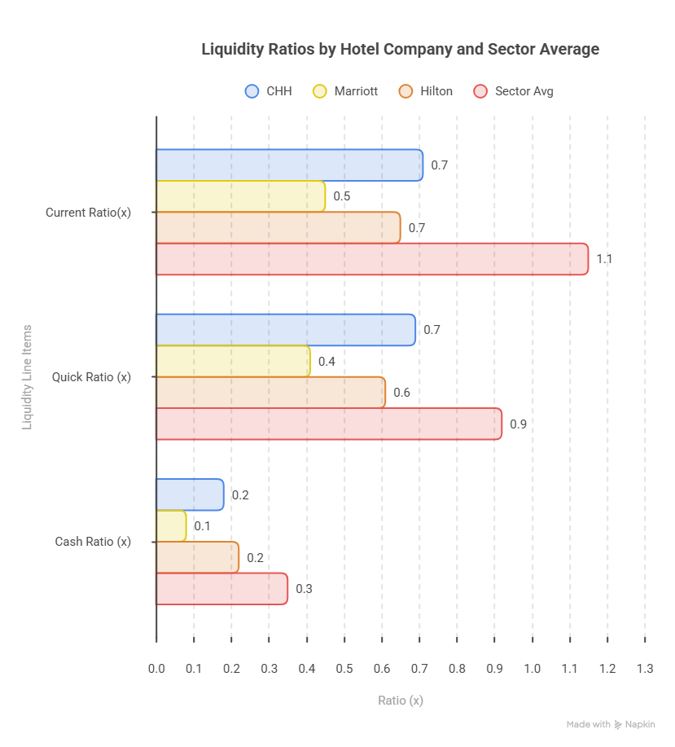

Comparative Liquidity Assessment
With respect to benchmarking results, the whole lodging industry average has maintained a current ratio beyond par (1.15x), mostly due to asset-heavy operations and local landlords with substantial stock and cash reserves to offset basic overhead costs. Leading franchisers, such as Choice, Marriott, and Hilton, experience structural working capital constraints.
Choice Hotels' current ratio of 0.71x is a bit greater than Marriott’s bold 0.45x target. This shows that Marriott keeps a greater liquidity reserve than its closest competitor in size while Choice improves capital utilisation. The cash ratio of 0.18x is justified by $571.4 million in total available liquidity, including cash reserves on its $1 billion credit facility.
The insufficient short-term coverage rates of Choice Hotels are not a sign of financial issues, based on this benchmark comparison. Instead, they show an operating model that has been thoroughly analysed. The company quickly turns incoming royalty bills into cash. It uses its credit facilities to pay off short-term liabilities and spends any surplus cash on high-return corporate projects.

2. Working Capital Management Analysis
For current lodging systems, working capital management is a vital indicator of operational effectiveness and immediate monetary security. Working capital management provides a unique structural framework for Choice Hotels International, Inc. The company avoids large intangible physical inventory assets that normally complicate the accounting sheets of traditional manufacturing companies because it uses an asset-light franchising approach.

Cash Operating Cycle factors
The total amount of time necessary for a business to transform its cash investments in operations back into cash inflows from sales is determined by the Cash Operating Cycle (COC), or Cash Conversion Cycle (CCC). 3 significant operational metrics are usually used to describe the metric:
Cash Conversion Cycle = Days Inventory Outstanding (DIO) + Days Sales Outstanding (DSO) – Days Payable Outstanding (DPO)

Component Ratios Analysis
- Days Inventory Outstanding (DSO): The level of the company, raw materials and physical goods are basically non-existent in a solely-owned hotel franchise business. Third-party franchisees manage the rooms and consumables. So the Choice Hotels DIO is negligible(between 2 and 3 days).
- Days Sales Outstanding (DSO): Choice Hotels charges its domestic & foreign franchise partners for platform and technology, advertisement expenses and royalties. The company’s DSO varied between 54 and 71 days during 2021 to 2025, mandated by standard franchisee contracts and ACH billing standards.
- Days Payable outstanding (DPO): Accounts payable keeps track of corporate market suppliers and operational vendors. Choice Hotels controls a vast worldwide network, which gives them the chance to bargain with vendors and keeps the DPO of 67 to 68 days.
The Net valuation effect is that Choice Hotels creates a net negative cash conversion cycle (DPO>DSO), which can range from (-6 to -12 days)
[DIO + DSO (Gross Operating cycle) – DPO (Payables) = Net cash cycle]
[2-3 Days + 54-71 Days – 67-68 Days = -3 to -11 Days ]
Component Matrix | Formula | 2021 | 2022 | 2023 | 2024 | 2025 | Comment
Days Inventory Outstanding (DIO) | $$\frac{\text{Average Inventory}}{\text{Cost of Sales}}×365$$ | 2 | 2 | 3 | 3 | 2 | Negligible
Days Sales Outstanding (DSO) | $$\frac{\text{Average Receivables}}{\text{Revenue}}×365$$ | 54 | 59 | 62 | 67 | 71 | Lengthening
Days Payable Outstanding (DPO) | $$\frac{\text{Average Payables}}{\text{Cost of Sales}}×365$$ | 67 | 68 | 68 | 67 | 68 | Stable
Net Cash Operating Cycle | $$\text{DIO}+\text{DSO}-\text{DPO}$$ | -11 | -7 | -3 | +3 | +5 | Expanding
Table 3: Dynamic cash operating cycle components
(Source: Author, 2026)

Strategic implications of Operating cycle
A fundamentally compressed operating cycle is shown in the interaction of these parameters. Choice Hotels makes sure that the daily operating structure requires very low cash by keeping its inventory stage close to 0 and managing the vendor commitments (DPO) at a level that matches its collection timing (DSO).
Modifications in the DSO are the main cause of working capital variance. Independent franchises have experienced domestic revenue problems when domestic or international travel cycles go down, which leads to modify the net operating cash flows.

Recommended strategies to improve liquidity
Choice Hotels historically has had a low current ratio (0.80x), which shows that operational cash is quickly used to pay off long-term debts, while a negative cash conversion cycle indicates inefficiency. The following working capital upgrades are suggested to secure operational liquidity:
- Segmented growth of Systematic assets: Choice Hotels controls significant cash used for global marketing and hotel bookings. Structural segregation avoids temporary discrepancies from using core business liquidity by ensuring that inflows properly match vendor expenditure (Hamzat, 2025).
- Variable debt factor analysis procedures: Choice Hotels should set up variable credit for foreign franchise owners and for hotels that are under local economic pressure by changing vulnerable franchises from 30-day billing cycles to 15-day ACH cycles so that the default risk can be decreased and the cash production can be increased.
- Supply chain financing: Choice Hotels should set up supplier financing platforms by using genuine corporate credit ratings. Choice Hotels increases its DPO without any effect on supplier relationships by extending the payable terms, which are 50 days; however, banks pay known vendors early at a discount.

Comparison of Short-term vs Long-term Financing Options
To safeguard financial equilibrium, Choice Hotels maintains a balance in its competitive short-term working capital position and long-term debt issuances.
Financing Metric | Short-Term Financing Options(<1 Year) | Long-Term financing Options(>1 Year)
Primary Instruments | - Rotational credit facilities  - Commercial paper programs | - Unsecured notes  - Term loan facilities
Cost of Capital | Lower initial cost and interest rates | Higher fixed coupon rates
Flexibility | Highly flexible, brought down and repaid to cover short-term need for working capital | Restrictive due to fixed schedules
Risk Exposure | High stakes and risk | Low refinancing risk as debt expenses are provided for 5-10 years
Strategic Alignment | Financing strategic share buyback opportunities and quarterly cash requirements | Financing technological upgrades and real estate purchases
Table 4: Short-term and long-term financing comparisons
(Source: Author, 2026)
Corporate financial Directive: The main purpose of floating-rate short-term loan agreements is to smooth the functioning of seasonal fluctuations in the franchise fees and manage the quarterly working capital timing apps. Fixed-rate unsecured notes are required to finance large-scale capital projects, long-term infrastructure improvements and system expansions. This strategy safeguards the enterprise from disruptions in the credit market and interest rate fluctuations by measuring long-term loan maturities against company franchisee royalty income.

3. Strategic Financial Restructuring Plan
Choice Hotels International (CHH) pure-play asset-light franchising structure remains a vital financial advantage as CHH develops its post-pandemic operating base (Yahoo Finance, 2026). However, the corporation’s capital architecture has faced significant restrictions after ambitious strategic expansions, particularly the takeover of Radisson Hotel Americas. The company’s net debt to Adjusted EBITDA ratio has risen slightly, reaching to 3.2 X.
This strategic financial restructuring plan offers balanced options for portfolio adjustments, assesses their impact on the balance sheet and then takes into account global macro and ethical considerations in order to optimise its capital mix and maximise stakeholder returns.

Recommended Financial Restructuring Plans
Corporate treasury should execute a two-stage financial restructuring program focused on systematic capital recycling and targeted acquisitions in order to improve Choice Hotels' leverage index without reducing equity ownership.
- Strategic Acquisitions of Non-core assets: Choice Hotels should carefully sell off its non-core divisions, particularly its small amount of publicly owned real estate holdings that function outside of its non-core central reservation system. Structural overhead is cut down by selling the extra operations. Corporate treasury creates a monetary basis to settle short-term credit lines by turning these specialised operating units into cash.
- Capital recycling for accelerated development: Choice Hotels is required to create a corporate capital recycling system, in line with management’s order to cut net capital expenditures on development projects. The change of development-related operations from cash outflows into stable operational cash inflows is made easier by this structure. It is already expected that net costs for physical hotel support will go down from $103.4 million to a limited range of $20 million to $45 million. By setting up this process, the corporate entity can use corporate equities to make profit from developer loans early on, allowing up corporate cash for high margin brand marketing.

Evaluation of Restructuring Impact
Choice Hotels stock price valuation, debt mix and internal operation flexibility all undergo significant changes when its basic capital structure is altered.
Evaluation Metric | Restructuring Channel Impact Analysis
Shareholder Value | Formation by less capital allocation: constant share buybacks and dividend increases are made possible by lower development spending, which directly improves free cash return.  EBITDA margin pressure adjustment: returns are secured, and a higher enterprise value is sustained by removing lower-margin operational units.
Debt Structure | Deleverage effect: the net leverage ratio returns to a targeted benchmark when the funds from asset recycling are used to lower unsecured credit facility levels.  Refinancing Strategy: By expanding corporate debt capacity, the company can get lower coupon rates on future fixed unsecured notes.
Operational Flexibility | Pure franchisor focus: By reducing corporate distractions through the reduction of unnecessary functions, management can focus on increasing high-margin fees.  Liquidity Insulation: Rising cash reserves offer a layer of protection against unexpected periodic declines in domestic Revenue per available room.
Table 5: Restructuring impact study
(Source: Author, 2026)
The financial model properly shifts from a risk-taking takeover attitude to a cost-effective operational position as a consequence of this fundamental shift. Reducing capital commitments protects net margins and guarantees that the company's core will produce high cash returns even at times of financial crisis.

International and Ethical considerations
Choice Hotels' financial restructuring must deal with global economic changes and demanding corporate social responsibility (CSR) standards as it develops its franchise network in various global regions. This is shown by double-digit net room expansion across European, African and Middle Eastern segments.
- Cross-Border Taxation and Transfer pricing compliance: Programs for recycling critical assets must take into account complicated cross-border tax systems. Choice Hotels estimates an effective tax rate of about 25% for the full year. Careful transfer pricing techniques when moving intellectual property and access to central reservation systems among the foreign subsidiaries. By avoiding forceful foreign shelters, ethical compliance lowers the possibility of an international regulatory body inspection.
- Currency fluctuations and inflation pressures: In order to show constant demand, Choice Hotels discloses its global RevPAR growth on a purely neutral basis. Even so, its actual cash inflows are still subject to variations in foreign exchange. In order to stabilise foreign fee collections with a US dollar, restructuring cash management systems requires the use of institutional hedging methods.
Also, fee structures in corporate should be designed to stop overburdening the small business partners and the worldwide franchisee network to be stabilised, as local inflation boosts operating expenses for privately-owned hotel owners.

Corporate Social Responsibility(CSR) and ESG linkage:
Environmental, social and governance(ESG) performance requirements are connected to present-day capital allocation. Institutional lenders are presently using sustainability ratings to adjust capital costs.
ESG Operational Direction: Choice Hotels should help franchisees in applying energy-efficient utility management systems by relating its capital recycling rewards to enhancements in sustainability at the hotel level. Borrowing costs are directly lowered by attaching future corporate credit facilities to green finance structures, where interest margins are reduced if the hotel network meets target carbon reductions. This alignment supports moral responsibilities to green hotel initiatives and helps with business financial restructuring goals.

4. Investment Appraisal and Capital Budgeting

Project Financial Metrics Matrix
To evaluate these opportunities in a systematic manner, this section offers the comprehensive investment appraisals of the 3 competing capital projects, Project A, Project B and Project C, each of them requiring an initial cash outlay of £50,000,000.
Core appraisal methodologies and mathematical formulations used to ensure a balanced and rigorous evaluation, here five primary capital budgeting techniques are used.
The calculations assume straight-line depreciation to zero over a 5-year period (£10 million yearly depreciation per project and average investment of £25 million) and using an 8% discount rate.

Comprehensive systematic financial assessments
The computations for each statistic among the three projects so as to provide complete fairness:
Particulars | Project A | Project B | Project C | Present Value Factor (PVF) (8%)
Initial Investment | £50,000,000 | £50,000,000 | £50,000,000 | 1.0000
Year 1 | £10,000,000 | £11,000,000 | £5,000,000 | 0.9259
Year 2 | £12,000,000 | £11,000,000 | £10,000,000 | 0.8573
Year 3 | £14,000,000 | £11,000,000 | £20,000,000 | 0.7938
Year 4 | £10,000,000 | £11,000,000 | £25,000,000 | 0.7350
Year 5 | £8,000,000 | £11,000,000 | £5,000,000 | 0.6806
Table 6 : Project cash flow profiles (£)
(Source: Author,2026)

Underlying calculations breakdown
a. Payback Period (PBP)
- Formula:
- PBP = Years Before Full Recovery + Unrecovered Cost at Start of Year/
              - Cash Inflow During Year

- Project A:
- Year 1 Cash Flow: £10,000,000 (Cumulative: £10,000,000)
- Year 2 Cash Flow: £12,000,000 (Cumulative: £22,000,000)
- Year 3 Cash Flow: £14,000,000 (Cumulative: £36,000,000)
- Year 4 Cash Flow: £10,000,000 (Cumulative: £46,000,000)
- Unrecovered cost at start of Year 5: £50,000,000 - £46,000,000 = £4,000,000.
- PBP Project A Calculation:
  - ${\text{PBP}}_{}=4\text{ Years}+\left(\frac{£40,000,000}{£80,000,000}\right)=4.50\text{ Years}$

- Project B:
- As Project B generates the constant running of cash flows (C = £11,000,000), we use the constant annuity shortcut:
  - ${\text{PBP}}_{}=\frac{\text{Initial Investment}}{\text{Annual Cash Inflow}}=\frac{£50,000,000}{£14,000,000}=4.54\text{ Years}$

- Project C:
- Year 1 Cash Flow: £5,000,000 (Cumulative: £5,000,000)
- Year 2 Cash Flow: £10,000,000 (Cumulative: £15,000,000)
- Year 3 Cash Flow: £20,000,000 (Cumulative: £35,000,000)
- Unrecovered amount at start of Year 4: £50,000,000 - £35,000,000 = £15,000,000.
- PBP Project C Calculation:
  - ${\text{PBP}}_{}=3\text{ Years}+\left(\frac{£15,000,000}{£25,000,000}\right)=3.60\text{ Years}$

b. Accounting Rate of Return (ARR)
The ARR formula compares the average annual accounting profits to the average investment:
$$\text{ARR}=\left(\frac{\text{Average Annual Net Accounting Profit}}{\text{Average Capital Investment}}\right)×100$$

$$\text{Average capital investment}=\left(\frac{\text{Initial Investment}+\text{Salvage Value}}{\text{2}}\right)$$
$$\text{Average Net Accounting Profit}=\left(\frac{\text{Total Cash Inflows}-\text{Total Accumulated Depreciation}}{\text{5 Years}}\right)$$

- Project A
- Total Cash Inflow: £54,000,000
- Total Net Income over 5 Years: £54,000,000 - £50,000,000 = £4,000,000
- Average Annual Profit: £4,000,000 / 5 = £800,000

  - ${\text{ARR}}_{}=\left(\frac{£800,000}{£25,000,000}\right)×100=3.20\%$

- Project B
- Total Cash Inflow: £55,000,000
- Total Net Income over 5 Years: £55,000,000 - £50,000,000 = £5,000,000
- Average Annual Profit: £5,000,000 / 5 = £1,000,000

  - ${\text{ARR}}_{}=\left(\frac{£1,000,000}{£25,000,000}\right)×100=4.00\%$

- Project C
- Total Cash Inflow: £65,000,000
- Total Net Income over 5 Years: £65,000,000 - £50,000,000 = £15,000,000
- Average Annual Profit: £15,000,000 / 5 = £3,000,000

  - ${\text{ARR}}_{}=\left(\frac{£3,000,000}{£25,000,000}\right)×100=12.00\%$

- Net Present Value (NPV)
Application of the present value discount factors at an 8% cost of capital:
$$\text{NPV}=\sum_{t=1}^{5}{\frac{CF_{t}}{{\left(1+r\right)}^{t}}}-I_{0}$$
- Project A:
- Year 1 PV: $£10,000,000×0.9259=£9,259,259$
- Year 2 PV: $£12,000,000×0.8573=£10,288,066$
- Year 3 PV: $£14,000,000×0.7938=£11,113,650$
- Year 4 PV: $£10,000,000×0.7350=£7,350,299$
- Year 5 PV: $£8,000,000×0.6806=£5,444,670$
- Total Present Value of Inflows: £43,455,900
- Project A NPV:
$${\text{NPV}}_{}=£43,455,900-£50,000,000=-£6,554,100$$

- Project B:
- Year 1 PV: $£11,000,000×0.9259=£10,185,185$
- Year 2 PV: $£11,000,000×0.8573=£9,430,727$
- Year 3 PV: $£11,000,000×0.7938=£8,732,155$
- Year 4 PV: $£11,000,000×0.7350=£8,085,328$
- Year 5 PV: $£11,000,000×0.6806=£7,486,416$
- Total Present Value of Inflows: £43,919,812
- Project B NPV:
$${\text{NPV}}_{}=£43,919,812-£50,000,000=-£6,080,188$$

- Project C:
- Year 1 PV: $£5,000,000×0.9259=£4,629,630$
- Year 2 PV: $£10,000,000×0.8573=£8,573,388$
- Year 3 PV: $£20,000,000×0.7938=£15,876,643$
- Year 4 PV: $£25,000,000×0.7350=£18,375,746$
- Year 5 PV: $£5,000,000×0.6806=£3,402,918$
- Total Present Value of Inflows: £50,858,325
- Project C NPV:
$${\text{NPV}}_{}=£50,858,325-£50,000,000=+£858,325$$

d.Profitability Index (PI):
- Measures the relative value created per unit of investment.
$$\text{PI}=\frac{\text{Present Value of Future Cash Inflows}}{\text{Initial Capital Investment}} =\frac{\text{NPV + C0}}{\text{C0}}$$

- Project A: ${\text{PI}}_{}=\frac{-£3,883,637 + £50,000,000 }{£50,000,000}=0.923$
- Project B: ${\text{PI}}_{}=\frac{-£6,080,188+ £50,000,000}{£50,000,000}=0.878$
- Project C: ${\text{PI}}_{}=\frac{+£458,569+ £50,000,000}{£50,000,000}=1.009$

e. Internal Rate of Return (IRR)
The discount rate brings the NPV of all cash flows from a project down to zero.
The IRR is computed by interpolating between the two rates to locate where the NPV of the project transitions through zero.
Interpolation formula:
$$\text{IRR}=r_{\text{low}}+\left[\frac{{\text{NPV}}_{\text{low}}}{{\text{NPV}}_{\text{low}}-{\text{NPV}}_{\text{high}}}\right]×\left(r_{\text{high}}-r_{\text{low}}\right)$$
- Project A and B: Since their total present value at 8% falls below the £50m cost threshold, their internal rates of return are lower than the hurdle rate.${\text{IRR}}_{A}≈4.79\%$, ${\text{IRR}}_{B}≈3.26\%$).
- Project C: Since Project C has the positive NPV of +£0.458, the optimisation is calculated between $r_{\text{low}}$ =8.32% and $r_{\text{high}}$ = 8.33% can be tested to perform a linear interpolation.
- Iteration at Test rate 1 ($r_{\text{low}}$ =8.32%)
- Year 1 PV: $£5,000,000×0.9259=£4,615,953$
- Year 2 PV: $£10,000,000×0.8573=£8,522,808$
- Year 3 PV: $£20,000,000×0.7938=£15,736,351$
- Year 4 PV: $£25,000,000×0.7350=£18,158,386$
- Year 5 PV: $£5,000,000×0.6806=£3,352,780$
- Total Present Value of Inflows: £50,036,578
- Project C NPV:
- ${\text{NPV}}_{8.32\%}=£50,036,578-£50,000,000=+£36,578.251$

- Iteration at Test Rate 2 ( $r_{\text{high}}$= 8.33% )
- Year 1 PV: $£5,000,000×0.9259=£4,615,527$
- Year 2 PV: $£10,000,000×0.8573=£8,521,234$
- Year 3 PV: $£20,000,000×0.7938=£15,731,994$
- Year 4 PV: $£25,000,000×0.7350=£18,152,029$
- Year 5 PV: $£5,000,000×0.6806=£3,351,234$
- Total Present Value of Inflows: £49,972,018
- Project C NPV:
$${\text{NPV}}_{8.33\%}=£49,972,018-£50,000,000=-£27,982.215$$
Now applying the linear interpolation formula:
$$\text{IRR}=r_{\text{low}}+\left[\frac{{\text{NPV}}_{\text{low}}}{{\text{NPV}}_{\text{low}}-{\text{NPV}}_{\text{high}}}\right]×\left(r_{\text{high}}-r_{\text{low}}\right)$$
$${\text{IRR}}_{C}=0.0832\%+\left[\frac{£36,578.251}{£36,578.251-\left(-£27,982.215\right)}\right]×\left(0.0833-0.0832\right)$$
$${\text{IRR}}_{C}=0.0832\%+\left[\frac{£36,578.251}{£64,560.466}\right]×0.001=0.0832+0.565*0.001=8.32\%$$

Evaluation of Capital Budgeting
All investment options are described here to enable an easy assessment :
Assessment Indicator | Project A | Project B | Project C | Benchmarking
Initial Investment | £50,000,000 | £50,000,000 | £50,000,000 | —
Total Inflow | £54,000,000 | £55,000,000 | £65,000,000 | —
Payback Period | 4.50 Years | 4.54 Years | 3.60 Years | Less time taken is better.
ARR | 3.20% | 4.00% | 12.00% | Cut-off rate should be > 10%
Net Present Value | -£6.544m | -£6.080m | +£0.858m | Positive NPV is needed.
Profitability Index | 0.923 | 0.877 | 1.009 | Target should be > 1.00
Internal Rate of Return | 4.80% | 3.26% | 8.32% | Cut-off rate should be > 8.00%
Table 7: Consolidated capital budgeting results
(Source: Author,2026)

Strategic suggestions and explanation
The sole investment option that must be taken to the board based on the financial analysis is Project C. A company must approve initiatives with a positive Net Present Value (NPV) at its cost of capital as per corporate financial theory. Accepting the negative Net Present Value(NPV) efforts can destroy corporate value by generating returns below the opportunity cost of capital.
Projects A & B both yield negative net present values (NPVs) of -£6.554 million and -£6.080 million, and their IRRs (4.80% and 3.26%) are under the required cut-off rate of 8%. The company’s shareholder value would be lost if either of the 2 projects were put into effect. Choice Hotels International's reported return metrics are negatively impacted by their low ARRs (3.20% and 4.00%).
At the same time, Project C is economical in all aspects because it generates the positive NPV of +£0.858 million, directly expanding the shareholder wealth. It also provides a high ARR of 12%, helping achieve the company’s goal of keeping a consolidated ROCE above 14% by 2026. Its IRR of 8.32% safely exceeds the 8% cost of capital, and it has the shortest payback period (3.60 years), which decreases the duration of capital exposure.
The company's financial situation and strategy focus of Choice Hotels International are fully linked with this profile.

Profitability and Revenue Alignment and rising of non-financial risks
Choice Hotels International has an asset-light franchising model, and it is very scalable. A 22% increase in new franchisee execution contracts is the main driver of growth. A record-breaking Adjusted EBITDA is growing from 4% to $625.6 million. Net income also rose significantly to $369.9 million, which shows strong profit margins.
Choice Hotels has stability in its finances to handle revenue flows mainly from Project C, as it mainly relies on high-margin fee systems; for ex domestic royalty rates rising to 5.14%.As the choice hotels revenue is increasing, Project C's low cash returns (Year 1-2) won’t have a major effect on operations.
However, the backloaded cash flow structure of Project C introduces non-financial risks. If inflation rises, the bulk cash flows of Project C are connected with high supply chain costs and operational costs, which occur in Years 2 & 3. Changes in global taxes could lead to unexpected compliance costs, which mainly affect the company returns. If competitors like Hilton or Marriott go for expensive advertising for customers which can lead to higher cash inflows for Choice Hotels in later years.

Capital Rationing Analysis
We have a strict capital rationing limit of £100,000,000, so Choice Hotels cannot fund all projects at the same time; it must select the combination that gives high NPV.
- Combined NPV in combination 1: Project A + Project B
-(£6,544,100) + -(£6,080,188) = -£12,624,288

- Combined NPV in combination 2: Project A + Project C
-(£6,544,100) + +(£858,325) = -£7,402,425

- Combined NPV in combination 3: Project B + Project C
-(£6,080,188) + +(£858,325) = -£6,938,425
The capital rationing analysis provides that the combination of 2 projects gives overall wealth destruction, as the negative NPV of Project A & B destroys the positive returns of Project C. Choice Hotels should invest only £50,000,000 in Project C, and return the remaining £50,000,000 to treasury department of the company used to pay high-interest debt.

5. Critical Analysis on AI usage

Tool disclosure
AI technologies are utilised to assist with structure layout, formatting the mathematical formulas in the analysis process and in setting up initial sections. The presentation of the cash operating cycle and capital budgeting was also generated using complex large language models. For the analytical correctness and all financial calculations, the strategic review is examined and verified. In addition, automated data tools were used to obtain raw financial data from the company’s financial reports FY 2021 to FY 2025. These tools were used to consolidate the income statement and balance sheet into data tables.

Critical evaluation of the AI output
A strict human-led testing approach was taken to each AI-generated output in consideration of structural risks that come with LLM systems, particularly the ability to generate realistic factual data, which are called hallucinations. To mitigate these risks, an audit procedure was applied manually to all the inputs provided by AI.
The financial trends and indicators supplied by Choice Hotels International were compared directly with the company's audited corporate disclosures and annual reports. A few initial misinterpretations were corrected as part of the evaluation. Like Choice Hotels, overall revenue figures are misread by the automated model, unable to distinguish the difference in franchisee fee revenues and transfer by reimbursable costs and this results in miscalculation of the company’s true operating volume.
Because the company has a shareholder’s equity deficit, the automated technology initially generated impractical ROE; these errors are found by manually replacing Return on assets and Net Debt to Adjusted EBITDA metrics. This ensures the final report shows an accurate capital allocation strategy.

Contribution analysis
- There are important differences between data aggregation tasks done by automated systems. The AI systems only acted as analytical helpers and managed the large-scale data integration and formatting of the text.
- The analyst developed every basic contribution, like logic, practical financial advice, and strategic analysis. This involves finding out the effects of the company’s negative cash operating cycle, making a multi-layered financial restructuring method to fix the equity deficit and specifying the risk criteria that helped in assessing Project C back-loaded returns. The last report changes business data into a detailed strategic recovery plan specific to the company’s market standing.

Ethical and professional reflection

Applying AI in financial decision-making structures reflects ethical and operational risks that need to be assessed:
Transparency and Governance: Every automated analytical insight must be completely traceable back to the source financial information, making sure that company disclosures are auditable for the board and shareholders (Mayegun and Nwanevu, 2025).
Corporate data privacy limitations: Putting private company data into public generative AI engines is a major breach of corporate data privacy standards. Financial professionals must ensure that all automated processes happen within secure enterprise environments that protect crucial corporate information from leaking into public courses.
Over-reliance and loss of professional judgement: Over-dependence on automated financial systems contains operational risk at the executive level. Automated systems lack the contextual capacity to find non-financial factors like shifts in organisational culture, but are good at finding past data trends and processing mathematical calculations. Too much dependence on automated systems can create strategic error spots; lastly, AI should act as an efficiency booster to make decision-making; however, professional judgement should be the final judge of strategy.

Conclusion
By applying the corporate separation of the green energy division can eliminate the company’s discount, while investing only in the positive NPV Project C will effectively use capital and expanding the extended-stay rooms needs capital to improve long-term shareholder value. Choice Hotels International's impressive five-year revenues and Adjusted EBITDA show its operational viability, with having limitation on short-term working capital expansions that need careful oversight. If Choice Hotels continues to rely on the capital franchisee model, then it needs to optimise its cash operating cycle.

52%

FEEDBACK

Hi

The result is provisional until confirmed by the exam board

Strength
1. The liquidity ratio analysis has been fairly analysed by comparing your company's performance with relevant industry benchmarks.
2. You have fairly discussed the strategic financial restructuring plan of your chosen company and its potential implications for future performance.
3. You have also demonstrated an awareness of the current issues affecting the hospitality sector and their potential impact on business operations and financial performance.
4. The working capital management has been clearly discussed and the cash operating cycle has been analysed over the five-year period.
•

Areas of Weakness
• 1. There were limited in-text citations throughout your analysis to support the discussion of trends and fluctuations over the five-year period. Additionally, the reference list did not meet the minimum requirement of 15 sources and contained errors that should be corrected to comply with Harvard referencing conventions.
• 2. The financial health analysis of your selected company lacked critical evaluation and did not make effective use of financial data from the income statement, statement of financial position, and cash flow statement.
• 3. The financial ratio analysis lacked critical evaluation, as the fluctuations over the five-year period were not adequately explained using evidence from the annual reports of your selected company and other credible sources.
• 4. The report is predominantly descriptive rather than analytical, limiting the depth of evaluation and critical discussion throughout the report.
• 5. The report presents much of the discussion, particularly the ratio analysis and strategic financial restructuring plan, in table format. This limits critical explanation and affects the overall presentation and readability of the report.
• 6. You need to paraphrase the investment appraisal section more effectively to reduce the similarity score and ensure greater originality in your writing.
•
1. Engagement with Literature Skills (4/15)
You have drawn on a very limited range of sources, resulting in uneven coverage across the report. While some current sources have been used, there is an over-reliance on textbooks and descriptive websites. Referencing is generally evident but contains inconsistencies that should be addressed to improve academic accuracy and compliance.

2. Knowledge and Understanding Skills (16/25)
Demonstrates sound and generally accurate understanding of key financial, liquidity and investment concepts. Explanations are clear but may lack depth or strong integration across topics. Awareness of current issues is evident but not always fully developed. Some areas would benefit from more precise conceptual explanation.

3. Cognitive and Intellectual Skills (18/35)
Analysis is largely descriptive, focusing on reporting ratios and calculations with limited interpretation or evaluation. Arguments are underdeveloped and conclusions are weakly supported by evidence. Recommendations tend to be generic and lack strong analytical justification.

4. Practical Application Skills (9/15)
Appropriate use of the main tools and methods, with basic competence. Calculations are mostly correct, though interpretation may be limited. Recommendations are relevant but may lack full feasibility or context sensitivity.

5. Transferable Skills for Life and Professional Practice (5/10)
Presentation and communication meet minimum postgraduate standards but lack polish. Structure may be uneven and writing may contain grammatical or stylistic issues. Limited evidence of professional-level judgement or refinement
Total 52/100
Marker: Dr Patrick Yeboah
July, 2026

References.
Choice Hotels, 2025. Choice Hotels’ News. (Online). Available at: https://media.choicehotels.com/2025-06-03-Choice-Hotels-Internationals-Global-Portfolio-Reaches-New-Heights-Driven-by-Upscale-and-Upper-Upscale-Growth-Internationally (Accessed: 20 July 2026)
Hamzat, L., 2025. Real-time financial resilience and debt optimization for entrepreneurs: tackling debt management as a financial health pandemic and empowering small business growth through early detection of financial distress and effortless capital management. Int J Adv Res Publ Rev, 2(5), pp.202-23. https://www.researchgate.net/profile/Lolade-Hamzat/publication/391776111_Real-Time_Financial_Resilience_and_Debt_Optimization_for_Entrepreneurs_Tackling_Debt_Management_as_a_Financial_Health_Pandemic_and_Empowering_Small_Business_Growth_Through_Early_Detection_of_Financial/links/6826b14cdf0e3f544f54c00e/Real-Time-Financial-Resilience-and-Debt-Optimization-for-Entrepreneurs-Tackling-Debt-Management-as-a-Financial-Health-Pandemic-and-Empowering-Small-Business-Growth-Through-Early-Detection-of-Financial.pdf
Mayegun, K.O. and Nwanevu, C., 2025. Harnessing big data and AI to revolutionize sustainability accounting and integrated corporate financial reporting. International Journal of Computer Applications Technology and Research, 14(06), pp.111-128. https://www.researchgate.net/profile/Chinonso-Nwanevu-2/publication/392314120_Harnessing_Big_Data_and_AI_to_Revolutionize_Sustainability_Accounting_and_Integrated_Corporate_Financial_Reporting/links/683ceeefd1054b0207f8d6ca/Harnessing-Big-Data-and-AI-to-Revolutionize-Sustainability-Accounting-and-Integrated-Corporate-Financial-Reporting.pdf
Yahoo Finance, 2026. How The Choice Hotels (CHH) Story Is Shifting As Analysts Rework Valuation Assumptions. (Online). Available at: https://finance.yahoo.com/markets/stocks/articles/choice-hotels-chh-story-shifting-131321929.html (Accessed: 19 July 2026)

