

Certificate of Higher Education in Skills for the Workplace

Task 2
Professional career development

Student name: Khalilur Rahman
Student ID: 2112662
Module code: (BMSW4005)
Lecturer name: Bianca Sanfilippo
Submission date: 06/09/2022

Table of Contents
Cover page 1
Table of Contents 2
Introduction 3
Role play reflection 4 - 6
Skills and knowledge & other skills at work 7-8
Knowledge of rules of workplace……………………………………………………………………………………………………….9
Equality Act 2010………………………………………………………………………………………………………………………………9
Human Rights Act 1998………………………………….………………………………………………………………………………. 10
Data Protection Act 1988 and Health and Safety Act 1974 ………………………………………………………………11
Knowledge of rules of workplace …………………………………………………………………………………………………….12
My personal Strength and areas for further development………………………………………12

SWOT Analysis in Personal Development Helps Build Self-Confidence………………….….13
My employment goals and my personal career action plan/development plan…………14 - 15
My short, medium, long term targets for the development of my professional career plan…… 16 - 17
Conclusion…………………………………………………………………………………………………………………………………… …18
References……………………………………………………………………………………………………………………………………...19
Appendices………………………………………………………………………………………………………………………………20 - 23

Introduction
I am Khalilur Rahman, a student of this university of Wales Trinity Saint David. I have acquired some set of employment and personal skills to stay focused to achieve my desired goal. I have studied business administration level 2 as workplace vocational course while ago, which helped me to decide to study at this University. I am currently working for Ministry of Justice as a team leader. I have targeted a better employment opportunity with a university degree. For this reason, I have joined this university to pursue higher education to achieve skills for the workplace (Wickwire, 2014). I have been able to enhance my knowledge and skills in the professional world while studying at this university.

Role play
During a role-play interview, candidates act out a scenario to demonstrate their suitability for a particular position.
Role-playing exercises evaluate candidates' potential responses to challenging circumstances that regularly arise in the business world. (Role Play Interviews, 2022).
I participated in a role paly interview first as an interviewer and then an interviewee, the role duration was about 20 minutes.
First, I interviewed Violeta, for the role of a Chef at the Bistro Restaurant - London. Then I was interviewed by Violeta, for the role of the Administration Manager at Global International Ltd - London
Around 500 words self-reflection review on the role play has been included in this report and a personal development plan provided using SWOT analysis and SMART objectives.

Reflection on the Role Play

In this section I have provided my personal reflection of the role play by using Gibb’s model of reflection:

Gibbs Reflective Cycle

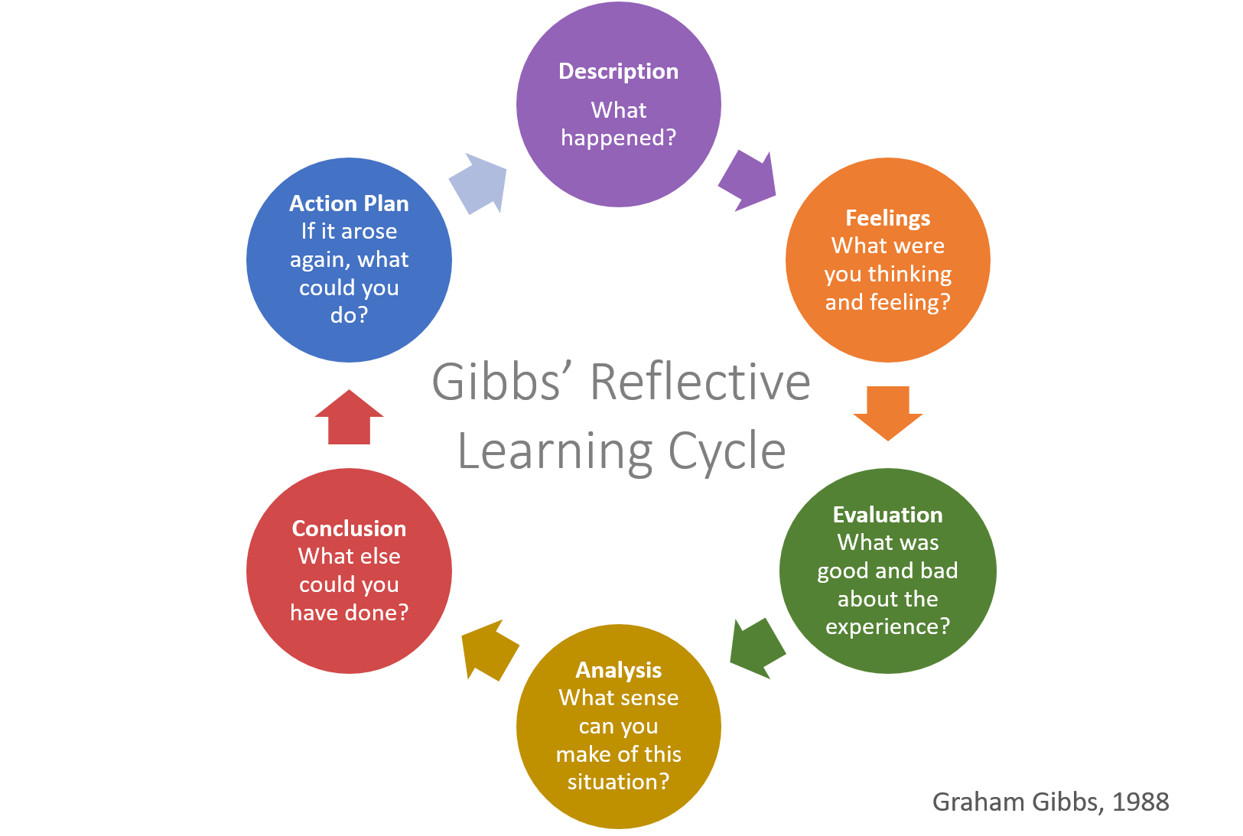
Figure 1 Gibbs Reflective Cycle Gibbs (1988)

Gibbs model is divided into to 6 steps:
- Description - of what happened.
- Feelings – what I was thinking and feeling.
- Evaluation – what was my experiences, the good and the bad.
- Analysis – what sense I can make from this situation.
- Conclusion – What else could I have done.
- Action plan – how I can do better, If I had to do this again.

Description: In this state, I have taken an interview with my partner for the role of a chef of a restaurant. I asked 5 different questions and showed a composed behaviour toward my partner. I have finished the interview according to the duration given by my lecturer.

Feelings: During the interview process, I was quite happy with most my performances. I found that it is easier to ask questions rather than to answer them, I can remember the tense and butterfly feeling that I had when I was interviewed for my job position. My mouth felt dry, I was struggling to find the right words and at a time I repeated my answers, I was a little nervous before the time of my interview. On the other hand, I was calmer, and it was easier, I was more relaxed while was taking the interview.

Evaluation: I have found many positive aspects in this role play, it is important to keep calm to provide good answer, I remember taking a sip of water and took my time before answering a specific answer, I was relaxed and think better to answer that question. The role-play went well but at a time I felt anxious in during the interview, yet my friend was calm and comfortable. However, I did not like the interruption caused by the noises of (burst out laughing) by other students when I stated that I was 22 years of age at the start of the interview. (Okay I am not really 22 years old and much older, but I did not expect that reaction from the students which through me off a little bit.

Analysis: As this was time sensitive activity, I was conscious of the time slot for the interview and did not want to over-run the prescribed time limit set by the lecturer. I had to use the time effectively and cover all the questions and answers within that time, in the end we managed to finish all our questions and answers within the time limit, which was a relief for me.

Conclusion: Maybe I could have had some practice interviews before hand to get used to giving my answers, I could have ironed out some of the mistakes I did for example: I took a little longer to answer questions than I would have liked. I am sure I would have been more relaxed and more confident answering some of the questions if I had some practice interviews prior.

Action Plan: I have now realised my weaknesses after the reflection on the role play. I will be conducting practice interview, before I go to an actual interview in the future. I will conduct more research to become more effective at interviews by watch videos of interview for tips for what to and not to do at interviews for example, body language, eye contact etc.

Skills and Knowledge which contribute towards working effectively.
My goal is to become an Administration Manager, the skills required are as follows according to (Monster.com 2022)
- Leadership skills – i will need to make decision as and when necessary, collecting and analysing data and make balance decision. I will need to plan and make strategic decision of how best to use companies’ resources. Nurture and develop talent, tolerate mistakes and be innovative. Strong decision making that favours the company as well as the workforce.
Advantage
I will be able to lead the team I am in charge effectively, guiding and supporting them, helping them achieve goals and objectives.

Disadvantage
If I did not possess the skills, then I would not be able to lead my team effectively and could not provide the above support.

- Communications (written and verbal), this skill is going to be crucial skill for me as a manager, I will need to communicate effectively, not only verbally and written but also body language as well.
Advantage

- I will be able to communicate effectively with parties such as: customers when dealing with enquiries, complaints and business transactions, and with colleagues regarding work and work related as and when necessary.
Disadvantage
I will not be able to communicate effectively, and therefore will not be able to carry out my job properly.

- Supervising – As a manager I will be responsible to provide necessary direction to staff to achieve goal, I will have to motivate them when they lose focus by praising and rewarding them as and when necessary. Watch over the staff and provide direction as an when necessary to reach goals. I will need to set example when doing things, i will need to nature and develop colleagues with necessary training and education. I will need to be creative and innovative and discover new ways to improve productivity. Create sense Diversity within staff at all level, using excellent interpersonal skills when dealing with staff and people in general, be empathetic, actively listening and emotional intelligent.

Advantage
I could supervise my team in effective manner, nurturing and developing their skills to increase productivity, listen to team members effectively.

Disadvantage
I will not be able to supervise my team effectively and will not be addressing my team’s need effectively.

- Problem Solving – I often come across problems at work and when I do, I use my skills and knowledge developed over the years at work and from this course to solve problems. As a manager I will be solving problems using the following steps:

- Defining the problems to get to the root cause
- Exploring solution – what are the available solutions
- Selecting the best solution to apply
- Implement the best solution
- Evaluate and review
Advantage
I will be able to deal with problems systematically and effectively if I possess this skill.
Disadvantage
I will not be able to solve problems effectively if I did not possess these skills.
Other skills:
Honesty – This is vital is it creates Loyalty, Trust and Respect amongst customers and colleagues (Quain, 2019)
Integrity – This increases trust and respect amongst colleagues, it also increases production of work (Integrity in the Workplace: Definition, Examples and Tips, 2021)
Professionalism – This creates positive impression, enhances image and strengthens working relationship and improves efficiency (Importance of Professionalism in a Workplace, 2021)
Knowledge of Rules and Regulations at workplace.
As I am going to be working as an admin manager in the office environment, I will need to have basic knowledge for me to work effectively, in the following Laws and Regulations for workplace:
Workplace legislation – (What legislation covers the employment relationship? | Informi, 2022)

Equality Act 2010
The Equality Act 2010 legally protects people from discrimination in the workplace and in wider society. It replaced previous anti-discrimination laws with a single Act, making the law easier to understand and strengthening protection in some situations. For example, not to discriminate on the grounds of following:
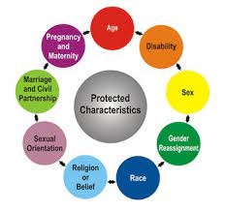
https://working-within-safe-environment.weebly.com/equality-act-2010.html
- Age
- Disability
- Gender Reassignment
- Race
- Religion or belief
- Sex (Gender)
- Sexual Orientation
- Pregnancy and Maternity
- Marriage and Civil Partnership

Human Rights Act 1998
This act protects following basic needs of human:
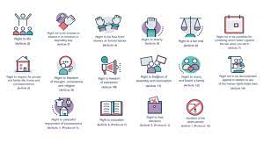
https://www.bihr.org.uk/thehumanrightsact
- Right to Life
- Not to be tortured, and treat in a human way
- Right to Liberty
- Right to be free from Slavery
- Right to have a fair trial
- Not to be punished for something which was not against the law
- Respect for private life, home and correspondence
- Freedom of thought, conscience and Religion
- Freedom of expression
- Freedom of Assembly and Association – (joining a Union to become a member)
- Right to marry and found a family
- Right to peaceful enjoyment and possession
- Not to discriminate any Human Rights listed here
- And other more

Data Protection Act 1998
The Data Protection Act 1998 was an act of Parliament designed to protect personal data stored on computers or in organized paper filing systems.
However, details can be passed to relevant agencies if there is health and safety issues, to protect the person in question and the society.
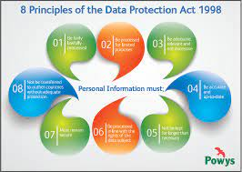
https://powys.moderngov.co.uk/documents/s17784/Data Protection Act 1998.pdf
- Sharing personal information of people can put people at risk,
- The information can be used for identity theft.
- Risk of data harm.

Health and Safety at work act 1974:
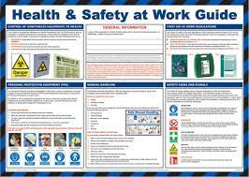
http://pjbhse.com/health-and-safety-at-work-act-1974/
- The employer provides a safe environment for work and any visitors.
- making workplace a safe place to work,
- prevent any danger to health and make sure that all the machinery is safe to use for everyone involved.
Knowledge of rules of workplace:
- Handling confidential information safely
- Fraud prevention
- Theft from employee
- Good behaviour at work

My personal Strength and areas for further development
In my current job i have developed various skills such as:
Communication skills, I communicate in various ways – In writing via emails to various agencies as well as judges, enquiring availability of Judges, also via a text and on the phone. I communicate with colleague’s face to face and in writing via email, I also communicate with customers face to face at the enquiry counter as well as in writing and on the phone.
Teamwork, I work in a team consists of 12 members, our tasks are split in various parts with a time frame to achieve it by. I must cooperate and coordinate my tasks with my colleagues to ensure that we complete our tasks on time and meet the deadline.
Problems solving, often we as a team have to sit down and work on solving problems that may arise, I will look at the problems and analyse it to find out the root cause and then come up with possible solution and apply and monitor, I will solve problems in that fashion when needed.

SWOT Analysis

SWOT Analysis in Personal Development Helps Build Self-Confidence
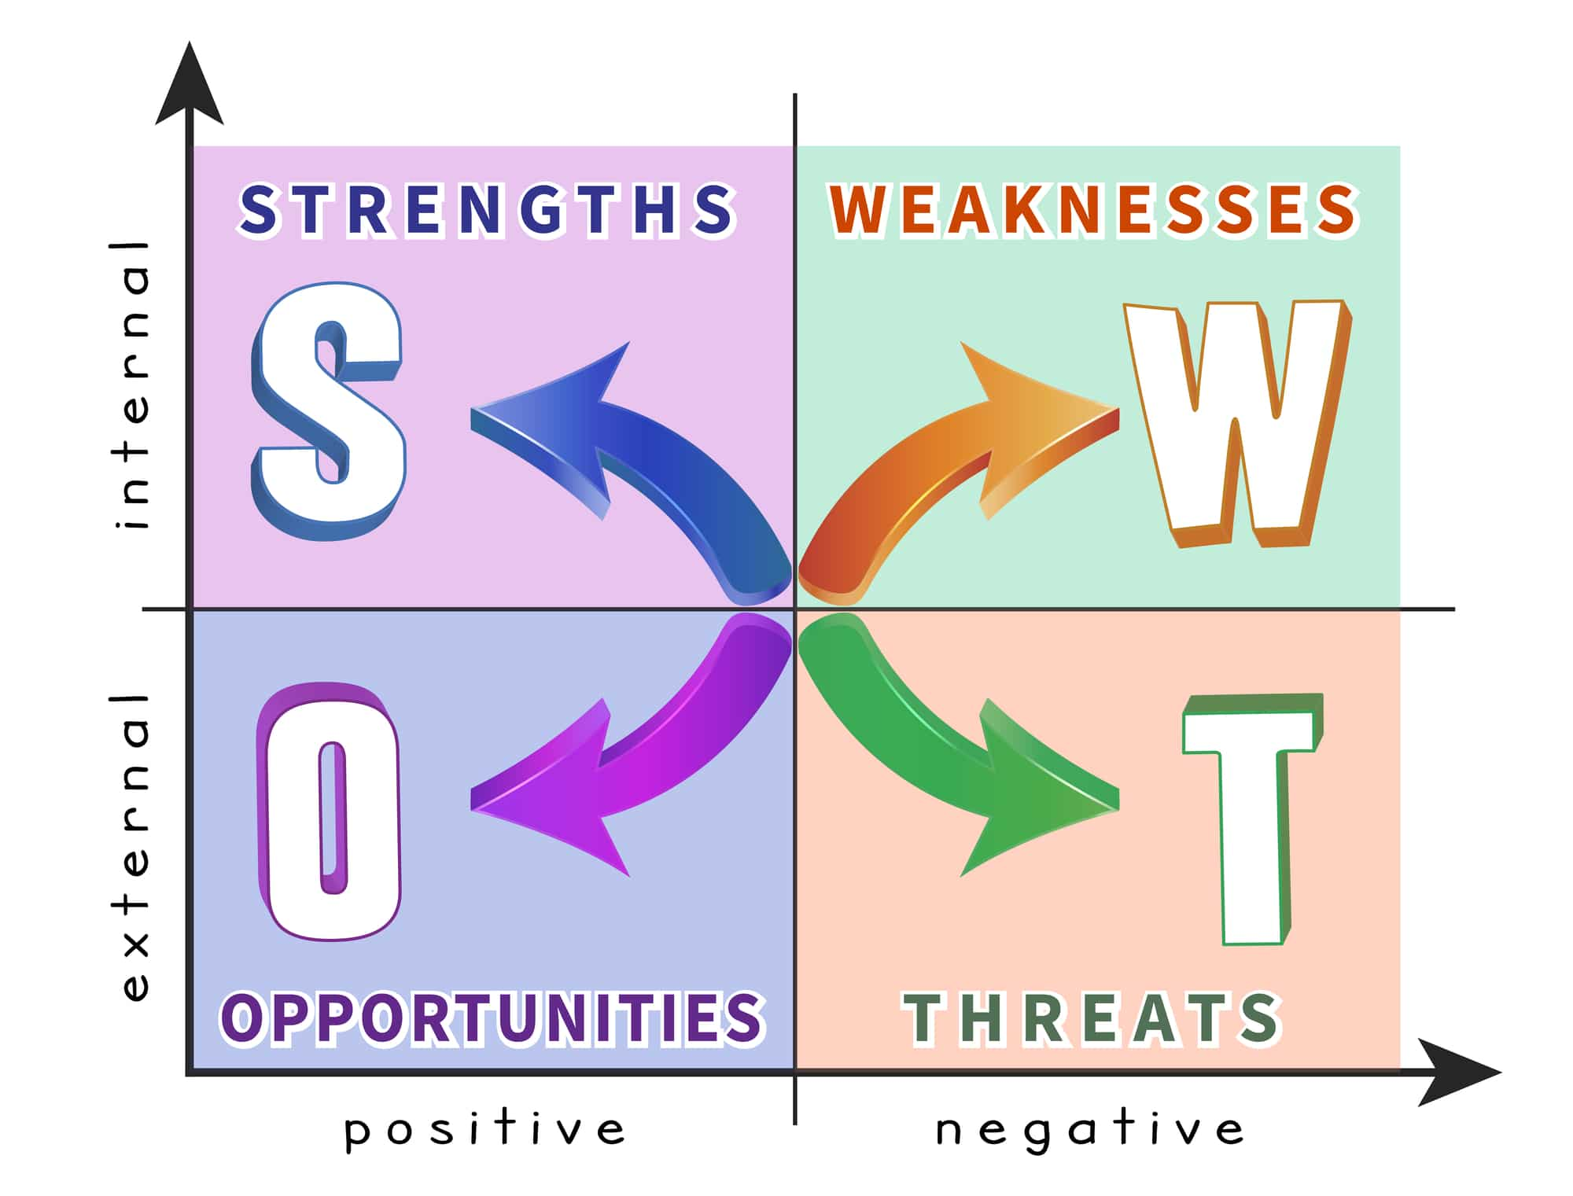
Figure 2 SWOT Analysis Source: (Contributor, 2022)

STRENGHTS  Communication skill  Team working  Time management  Problem solving | WEAKNESSES  Digital skills with Morden technologies  Developing ideas  Attention to details  Man-management skills
OPPORTUNITIES  Attending university  Attending different courses  Attending online courses  Attending training at work | THREATS  Resources (money)  Time  Family commitments  Work commitments

- My employment goals and my personal career action plan/development plan
My professional career pathway is:
To become administration manager

What are my current strengths?
- Communication
- Team working
- Time management
- Problem solving

What are my achievements and areas of success since the beginning of the module/programme?
I am now able to complete a job application properly; I have learned about interview questions and technique.

In what areas do I need to develop?
- Writing skills, in different styles
- Digital skills using modern technology
- Effective man management skills (interpersonal)

Why is it important to improve in these areas?
- I will gain more confidence to write intricate and academic writing to express myself, I can write more clearly and concisely and without mistakes.

- I will be more confident using modern technology, help me use technology at work more confidently.

- Be more confident when dealing with people at work and generally.

Who will help me? What resources will I need?
- The current level 4 course I am doing.
- The lecturer from my class in the university.
- I can attend some online courses.
- Learning at home.
- Student loan

What are the constraints/ barriers to achieving this key are and how I will manage these – eg time, resources,
- Time and money
- Work commitment
- Family commitment

What further action do I need to take now?
Actions to be taken – things to do, people to see.
- Need to talk to my family.
- Talk to line manager – to see if I can have time off

Time scale – by when
October 2022

- My short - medium – long term targets for the development of my own professional career plan (using Specific, Measurable, Agreed, Realistic, Time-bound –SMART targets)

Short-term plan (3 -6 months)
Specific | Start level 5
Measurable | Enrol for Level 5, Submit all assignments and complete level 5.
Agreed | With family  Line manager  Time
Realistic | Yes, it is realistic as I have proved by completing level 4.
Time-Bound | October 2022
Medium-term plan (1-2 years)
Specific | Complete BA, finish level 6 and graduate
Measurable | Submitting all assignment modules or dissertation
Agreed | Dissertation supervisor  The family  Line manager  Time
Realistic | Yes, it is realistic
Time-Bound | 10th September 2024
Long-term plan (2-5 years)
Specific | Start MBA
Agreed | Family  Line manager  Time  Course supervisor
Realistic | Yes, hopefully I would have completed my degree by then.
Time-Bound | 10th October 2024

Conclusion

I can conclude that it is vital to know oneself in terms of skills and capabilities and discover ways to develop themselves. I outlined above what I have to work on to build my skills and character to achieve all my goals. Moreover, the role-play of an interviewer and an interviewee allowed me to recognise my weaknesses and strengths. I hope I have finally recognised what I must do to fulfil my full potential.

References:

Contributor, P. (2022) How SWOT Analysis in Personal Development Helps You Build Self-Confidence. [online] PESTLE Analysis. Available at: <https://pestleanalysis.com/swot-analysis-in-personal-development/> [Accessed 3 August 2022].
Gibbs, G. (1988) Learning by Doing: A guide to teaching and learning methods. Further Education Unit. Oxford Polytechnic: Oxford.
IMPOFF (2021) Importance of Professionalism in a Workplace. [online] Available at: <https://impoff.com/importance-of-professionalism/> [Accessed 24 July 2022].
Indeed Career Guide (2021) Integrity in the Workplace: Definition, Examples and Tips. [online] Available at: <https://uk.indeed.com/career-advice/career-development/integrity> [Accessed 24 July 2022].
Informi (2022) What legislation covers the employment relationship? | Informi. [online] Available at: <https://informi.co.uk/legal/what-legislation-covers-employment-relationship> [Accessed 10 July 2022].
Monster.com (2022) Administrative Manager Job Description Template. [online] Available at: <https://hiring.monster.com/resources/job-descriptions/administrative/adminstrative-manager/> [Accessed 10 July 2022].
Quain, S. (2019) Before you continue to Google Search. [online] Google.com. Available at: <https://www.google.com/search?client=firefox-b-e&q=why+honesty+is+important+in+work> [Accessed 24 July 2022].
Wickwire, P. (2014) Career Education and the Professional Association. Journal of Career Development, 13(3), pp.63-70.
Wikijob.co.uk (2022) Role Play Interviews. [online] Available at: <https://www.wikijob.co.uk/interview-advice/interview-types/role-play> [Accessed 24 July 2022].

Appendices

Job application form

Application for [Administration Manager] -

Your details

Name: Mr. Khalilur Rahman

Education and training
Please give details:
2021 – 2022 University of Wales Trinity Saint David – London Campus.
2004 – 2005 – At work
1995 – 1996 – Tower Hamlet College

Qualifications
Please give details:

Level 4, Certificate of Higher Education in skills for workplace.

GNVQ – Business and Administration – level 2

GCSE: English C, Mathematic C, Psychology C, Geography B, History C.

Information Technology clait level 2.

Employment history

Your current or most recent employer

Name of employer: Ministry of Justice

Job title: Team leader

Length of time with employer: 7 years

Reason for leaving:

Duties: Current

2015 – Current, leading a team of 8 members, my duties involve:
Designing duty rota, monitoring and managing staff and management dairies, arranging and participating in team and cross departmental meetings. Dealing with staff leave, monitoring staff development and training, deputing section manager as and when necessary. Attending management meeting and taking minutes. Participating in new projects etc.

Previous employers
Please tell us about other jobs you have done and about the skills you used or learned in those jobs.

2000 - 2015 Receptionist / Admin officer.

Greeting visitors, answering telephone, monitoring emails, arranging meetings for Managements with customer, control access to premises, monitor and manage various logbooks such as: Visitors, Contractors, Keys and Incident.

1994 to 1998 City Estate Agents – showing properties to prospective buyers, surveying new properties and Preparing reports of properties for the manager, dealing with office duties etc.

Supporting statement
Please tell us why you applied for this job and why you think you are the best person for the job.

I am applying for this job because I believe this job will give me a chance to learn new skills that I do not have and therefore expand my knowledge and skills.

Communication Skills
I have excellent communications skills face to face, on the phone and in writing; I currently communicate with various people from various agencies such as: District and High Court Judges, Solicitors, Barristers and Lawyers, Embassies, the probations and the Prison service and the Police etc.

Teamwork
I believe teamwork is vital in order to achieve goals and always willing to help and assist colleges to meet the deadline and also I keep my colleague informed of my position so that if I encounter problems my colleagues can help me.

Flexible and effective working to meet deadline
I am flexible always willing to take extra responsibilities and can work late and extra hours to meet deadlines. I also use time management tool in order to manage my time effectively and meet deadline.

Learning new skills:
I am always willing to learn new skills; I adapt well to new tasks and ways of working to meet business needs of the organisation. I take part in new projects to learn new skills.

Right to work in the UK
Do you need a work permit to work in the UK? No

References
Please give the names and contact details of 2 people who we can ask to give you a reference. We may ask them before an employment offer is made. We will not ask your current employer until we get your permission.

Mr. Joe Bloggs, 24 Mission House, Aim Street, Target 5. (manager of current job)

Mr. El Nino, Dream House, Fantasy Road, Nightmare 10. (manager from previous job)

Declaration
I confirm that to the best of my knowledge the information I have provided on this form is correct and I accept that providing deliberately false information could result in my dismissal.

Name: Khalilur Rahman

Signature: Khalilur Rahman

Date: 26/06/22

Roleplay interview questions:

- Please tell me the qualities that makes you the right candidate for this position of manager at Global International - London
- Tell me about some of the skills that an administration manager requires?
- Please tell me about your weaknesses.
- tell me a situation when you had to deal with a difficult customer?
- Please tell me how you organize your work?

Questions for the Interviewer:
- What are the chances of promotion and progression?
- Do you have flexible working system here?

