
PROJECT (2)-Individual-reflective submission



Contents
1 Introduction 2
2 Concrete experience 3
3 Reflective observation 4
4 Abstract conceptualization 5
5 Active experimentation 6
6 Conclusion 8
7 References 9

Introduction
The holistic purpose of the reflective writing is to present and summarize the skills applied to complete the pathway project two. The paper will take into consideration myself, knowledge, and experience. It will also reflect upon my knowledge, learning, and experience obtained from completing the pathway project two. Moreover, it will reflect upon my set of skills applied to complete the project activities. In order to reflect these issues, I have selected an important methodology which is Kolb’s learning cycle. Many scholars and academicians stated that Kolb’s learning cycle is one of the best method to reflect upon previous learning, experience, and knowledge (Kolb, 2014).
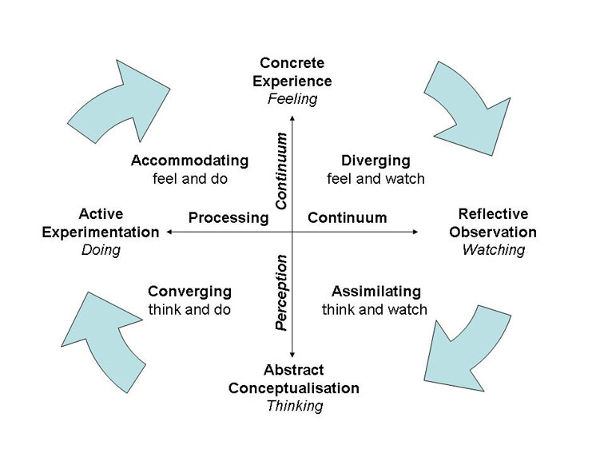
Figure 1 Kolb's learning cycle (Source: Kolb, 2014)

Concrete experience
I was assigned to write a business plan which was the core part of the pathway project one. During our class, the tutor asked us to form a group because the pathway project two was a group based activities. Ultimately, I formed a group with four people who were Irene Kauzeni, Mwadi Mvita Kalonga, Diasis Biembongo, and Aphie Mongombe. In order to form a group, we applied the Belbin team role model. This is due to the fact that the model clearly articulates the roles and responsibilities of group member. In this case, Arends (2014) argued that the goals and objectives of a group or team are accomplished if the group members clearly understand their roles and responsibilities properly.
Therefore, it was required to apply the Belbin team model in terms of accomplishing the objectives of the project (Eubanks et al., 2016). However, we set up timescale to complete the project activities. It is to be mentioned here that we worked on preparing a business plan on Travel plus. This mean that we attempted to prepare a business plan on travel agency who serves for travelers and tourists who intend to visit one place to another place (Mathieu et al., 2014).
The key objective of creating a timescale is to finish the project activities in relation to the timescale (Walker, 2015). We established a group on 16th November 2017. Then we arranged a group discussion on 20th November 2017. Then we got permission to discuss about the business plan to our tutor (Anita Nan). She suggested us to prepare a business plan on travel agency. According to her suggestion, we took decision to distribute our project activities on 23th November 2017. Ultimately, we delegated tasks to our group members. I was responsible for establishing the aim and objectives of our business.
I was also responsible for summarizing the overall business plan while finishing all project activities. In terms of generating innovative ideas and concepts, we met together on 25th November 2017. The holistic purpose of brain storming session was to generate innovative ideas and concepts. Then we prepared the slide on 28th November 2017 and submitted to group leader. Finally, we completed our whole job on 1th December 2017. Then we presented our business plan to our honorable tutor (Anita Nan).

Reflective observation
When I started to write down the presentation slide, I faced some challenges. For example, I was confused to set up the objectives and purposes of the business. This is because the whole business plan is developed to accomplish the aim and objectives of the business (McKeever, 2014). This was an integral part of business plan. Besides, I had poor research skills. This created barrier to get the actual information for setting up the objectives of the business. For example, I searched for gathering information on setting up the objectives of Travel plus (Travel agency). I found a lot of information available on the internet (Finch, 2016).
But I did not understand what information was actually required to me. In addition to this, I was not good at writing presentation slide. This was another key drawback to me. I found difficulties to enrich the content of the presentation. On the other hand, I found some opportunities while completing the project. For example, the project was a great opportunity to improve presentation skills, group working skill, networking skill, delegation skill, management skills, and leadership skills and so on (Polanyi, 2015).
At the very beginning of the project, I found too much difficulties to complete the project. But my excellent networking and interpersonal communication skills allowed me to resolve the problem. For example, I regularly communicated with my group members with an aim of knowing the status of their work. Furthermore, I shared my problems to my group members. I started to notice that other group members also faced difficulties like me. Therefore, we decided to further consult with our tutor. After getting consultation with her, we got the actual path to complete the project activities.

Abstract conceptualization
Our tutor motivated us to prepare the business plan on Travel Plus. She provided some fruitful and productive ideas. She motivated us to apply our group working, inter-personal, project management, leadership, management, delegation and networking skills to complete the project (Cottrell, 2015).
The brain storming session allowed us to learn how to apply a set of personal and professional skills. Initially, we started to initiate the project. At initiation stage, we prepared the business case. This mean that we created a strong business case on Travel agency. In this case, I applied my research skills. This mean that we collected secondary information from some important website such as travel agency, and annual statistics for the demand and supply of the travel business. Then, I analyzed the information to set up the objectives of our business.
In this case, Mulder (2014) stated that research skill allows an individual to resolve a particular problem by collecting, analyzing, and assessing information. Then I applied my project management skills to prepare the Gantt chart, project schedule and work breakdown structure. In this case, Hepworth et al., (2016) noted that project management skills allow to complete a project by accomplishing the objectives and minimizing the potential risks. The Gantt chart helped us to distribute tasks in relation to the stipulated time.
On the other hand, the project schedule assisted every group member to finish their activities within deadline. I applied my networking and interpersonal communication skills to create a strong relationship with our group members. For example, I used mobile phone, e-mail. Facebook and face to face communication to create a good relationship with group members. My networking skills allowed to create a both personal and professional relationship. Even I attempted to apply my technical skills. This mean that I applied my theoretical knowledge on project management into creating a good business plan on Travel plus. I had poor group working skills. But I realized that the supportive behavior of my group members facilitated the development of my group working skills. However a set of integration of my personal and professional skills allowed me to complete the project activities. Walther et al., (2017) argued that employability skills include both personal and professional skills required to accomplish the project activities.

Active experimentation
I collected required information from quality secondary sources such as author’s publication, journal article, relevant website and available internet sources. I had been assigned to set up the aim, objectives, and purpose of the business namely Travel Plus. I got suggestions from my tutor. I noted down some important points by browsing real world business setting on travel agency. This mean that I collected all required information and resources (Wihlborg et al., 2017). My computer was okay. The PowerPoint option was available. Therefore, I started to write presentation slide. Before developing the aim and objective of the business, I creates a business case.

- The tourism sector in the UK has become one of the most prominent sector. WTO (2014) specified that the UK is world’s 8^{the} largest tourist destination. There were more than 36.115 million visiting in the UK in 2015. There are different types of local and foreign visitors who come to enjoy the beauty of tourist destination. Therefore, the Travel Plus is going to provide custom travel agreement and packages and consulting services.

Based on the business case, I approached to setting up the aim and objective of the business. In this case, I considered the current and future demand of the travel agency business. The size and scope of our business. Even, I considered the forecasted cash flow and financial indicators. Then, I summarized the information and put it down to the PowerPoint slide.
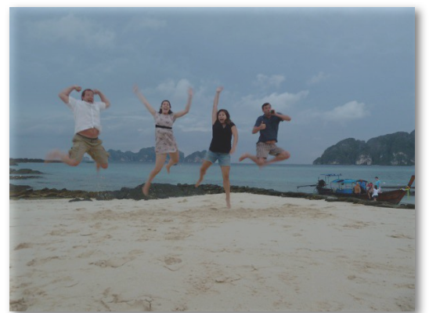
After setting up the aim and objective of the business, it was turned next to establish the purpose of the business. The key purpose of our business was to ensure custom travel agreement and packages and consulting services. After creating the aim, objective, purpose and legal status of the business, I sent the file to other group members through using E-mail. They found it quite interesting to complete their own project activities.
In order to complete the project, I applied my own set of personal and professional skills. For example, I applied my project management skills to create a good business plan. I applied my group working skill to manage my contribution to group. My interpersonal communication and networking skills were applied to facilitate strong communication with group members. In this context, Molina et al., (2018) argued that strong communication skill is prerequisite to accomplish project activities. Furthermore, I applied my writing skill to prepare presentation slide. Finally, I used my presentation skill to deliver a good presentation before the audience.

Conclusion
The pathway project two created a great opportunity to improve my personal and professional skills. Although I faced numerous challenges to complete the project activities. I overcome these challenges by turning them into opportunity. This project allowed me to identify my strengths and weaknesses. At the end of the project, I found that my weaknesses had been converted into strengths. This indicated that I learned numerous important issues from the project. How to create an excellent business plan through the application of personal set of skills was great learning to me. This project allowed me to improve my interpersonal communication skills, group working skills, networking skills, delegation skills, project management skills, technical skills and so on. Moreover, the project improved both of my soft and hard skills. In order to resolve my previous mistakes, I intend to take numerous steps such as reading problem related books and journal articles, attending training and development program, participating group activities and so on.

References
Arends, R. (2014). Learning to teach. McGraw-Hill Higher Education.
Cottrell, S. (2015). Skills for success: Personal development and employability. Palgrave Macmillan.
Eubanks, D. L., Palanski, M., Olabisi, J., Joinson, A., & Dove, J. (2016). Team dynamics in virtual, partially distributed teams: Optimal role fulfillment. Computers in Human Behavior, 61, 556-568.
Finch, B. (2016). How to write a business plan. Kogan Page Publishers.
Hepworth, D. H., Rooney, R. H., Rooney, G. D., & Strom-Gottfried, K. (2016). Empowerment Series: Direct Social Work Practice: Theory and Skills. Nelson Education.
Kolb, D. A. (2014). Experiential learning: Experience as the source of learning and development. FT press.
Mathieu, J. E., Tannenbaum, S. I., Donsbach, J. S., & Alliger, G. M. (2014). A review and integration of team composition models: Moving toward a dynamic and temporal framework. Journal of Management, 40(1), 130-160.
McKeever, M. (2016). How to write a business plan. Nolo
Molina, G., Musy, M., & Lefranc, M. (2018). The Characteristics of the Pioneers: Trajectories, Construction, and the Advancement of Their Skills. Building Professionals Facing the Energy Efficiency Challenge, 61-96.
Mulder, M. (2014). Conceptions of professional competence. In International handbook of research in professional and practice-based learning (pp. 107-137). Springer Netherlands.
Polanyi, M. (2015). Personal knowledge: Towards a post-critical philosophy. University of Chicago Press.
Walker, A. (2015). Project management in construction. John Wiley & Sons.

