Mariusz Kalasz (1805456)

Abstract
This report includes information about the BYOT network framework and comparison between different mobile management software. The report also includes a DFD of the framework, a configuration of the framework and analysis of the BYOT structure in general.
The solution
Task: Synthesize a solution to a potential real-life scenario

Table of Contents
1 Introduction…………………………………………………………………………............2
2 Research…………………………………………………………………………….............2
2.1 Research on BYOT Framework…………………………………………………..2
2.2 Research on Mobile Management Software………………………………………4
2.2.1 Cisco Meraki…………………………………………………………….4
2.2.2 Microsoft Intune…………………………………………………………6
2.2.3 Comparison and Choice…………………………………………………8
3 Implementation…………………………………………………………………………….8
3.1 The Explanation of the DFD………………………………………………………9
3.2 The System……………………………………………………………………….10
3.3 The BYOT Policy………………………………………………………………...11
4 Conclusion…………………………………………………………………………………13
Bibliography………………………………………………………………………………...14
Appendix…………………………………………………………………………………….14

1 Introduction
It has been tasked to create a BYOT framework for the company called Hyper-fort who is a consultancy company specializing in the energy sector. The framework needs to cover all aspects of the company’s enterprise network. It also has been tasked to create a working simulation of the network, research have been made about the BYOT framework and any potential mobile management software.

2 Research
The research for this is from multiple sources, so the sources will be integrated with each other. This section will go through the needed research of the BYOT framework and any potential software needed for the whole framework.

  - 2.1 Research on the BYOT framework
Firstly, it is important to establish what a BYOT framework is. “It stands for Bring Your Own Device and what it means is a business policy where employees bring in personally owned mobile devices such as smartphones and tablets and allow them to access privileged business data such as databases and email on their own device.” [1]. The policy can also allow the employees to access the files outside the office, however it is believed that this can be changed depending on the company. This policy is becoming more popular now days as it gives more of a freedom to the employees as they can use their own devices to do their work on.
The policy of course has its advantages and disadvantages:
Advantages:
- Reduced Costs: Not every organisation will see this benefit but many of them will save money as “they don’t have to purchase devices for each employee. Plus, employees are generally more likely to take better care of their own devices, which saves money on repairs” [2], this will save on any potential repair costs. This is more noticeable with companies who provide their employees with devices and any data plans that they include.
- Technology Familiarity: “Most people tend to be familiar with their own devices. Apple fans are good with Apple technology and Windows fans are better with devices with Windows operating systems.” [1] This basically will allow the employees to be much more efficient at their work as they are more familiar with that technology. “Plus, employees are more likely to check their email and work at night if they are on their own devices.” [2]
- Flexibility: The BYOT framework offers “new mobile workforce opportunities, as employees can work anywhere at any time. With increased flexibility, organisations are more likely to attract more top-performing employees.” [2]
The thoughts on the sources used are that they are very familiar on the advantages front, the sources have a difference in around 5 years, this could mean that the BYOT framework hasn’t change much between the years, the only changes which could have is in technology. By having 2 sources which agree with each other it can be safely assumed that this information is correct.
Disadvantages:
- Cost for the Employee: One of the problems of BYOT is that the employee must pay for their own devices. Not everyone has those devices, and some do not see the use in one therefore never wanting one. “Therefore, being told by your company you then need to get one for work is likely to leave them feeling fairly hard done by. Factor in the increased usage and transportation of the device likely leading to quicker depreciation of the device and possible accidents – repairs could also prove to be costly for the employee.” [1] This could reduce the satisfaction of new employees straight away as they must pay for the devices and any repairs for them. Making them work less effectively.
- Security: This is the main reason the report is written, this is the biggest challenge of this framework. As the employees will have access to sensitive data from their own devices, and this can be proved difficult to keep them secured. “When a company owns the device, they can dictate how the device will be used by blocking certain websites and monitoring activity if necessary.” [2] Also, the company spent a lot of money and resources to create their security system.” Employees, however, are unlikely to have this level of security. Whilst the everyday security software for home use can cover all day to day activities, you might not trust them to be up to the job of protecting your valuable customer data.” [1] In addition, the company needs to think about how to prevent employees from leaving with the company’s sensitive data. If the data is leaked or lost it can hurt the trust in the company and the work done might be lost as well, decreasing the efficiency.
- Supporting various devices: “When companies own their devices, they have the benefit of selecting a small number of devices to support. This makes it significantly easier on the IT department because they can become familiar with the devices.” [2] However, with BYOT it is different, as employees bring a variety of devices running on different hardware and software the IT department has to create a system which can support all of them making it more difficult to do and requires a bigger IT department. Furthermore, on the hardware side the different devices will run the required software differently, “all with different capabilities and operating systems that run different programmes at different levels of quality. It is hard to get programmes that are of high quality but are also able to cover all platforms and realistic quality of devices, so this could cause issues.” [1]
- Scalability: There is also the issue of scalability. “Many employees use multiple personal devices, and many organizations simply don’t have the network infrastructure required to handle all of the extra traffic.” [2] If not done the network will be slow due to possible data collisions.

The comparison between the sources on the disadvantage side is more different than with the advantages, one of the sources provided with one extra disadvantage which the other source didn’t, this could show the difference in age of the sources, however this provided with vital information to continue with.

  - 2.2 Research on Mobile Management Software
Part of this research will show 2 main mobile management software, Cisco Meraki and Microsoft Intune. This will be a comparison between these 2 pieces of software and the results will be the choice for the company.
  - 2.2.1 Cisco Meraki
Cisco Meraki is regarded as one of the powerful mobile device management software, with its “robust logic checking capability, Cisco Meraki Systems Manager is a cloud-based enterprise mobility management software that offers multiple solutions which include mobile device management, mobile application management, mobile content management, and mobile identity management solutions.” [3] The software can manage from medium to large companies with providing “seamless functionalities” [3] for large mobile networks.
This software is compatible with Android 4 and above, Chrome OS, iOS, tvOS, Mac, Windows and Windows Phone. “With the ability to adapt to the changing environment of network of mobile devices, it treats every mobile device as unique hence enhancing the manner of tracking device posture and configuring security policies to maintain a network which is responsive to ever changing mobile devices.” [3] This makes it highly adaptable to the network making it easier to set it up.
Overview of Benefits
One of the main features of Cisco Meraki is that it allows users to “implement tight control, restrictions, and security policies across networks of mobile devices.” [3] Its security and geofencing policy functionalities allow the user to add or remove profiles of employees or members of the organisation, this depends on their compliance with both policies.
For example, if the administrator set up the security in a way that the employee is required to check into the dashboard every 30 minutes, the software would track mobile devices that went offline for 30 minutes, so the system will either tag them as complying with the policy or violating it, this depends on how it was set up. This is also the case for georeferencing policies, when the device leaves the set area boundary on the dashboard, this will also tag the device and the user as violating the policy. “This feature allows users to assert and enforce security controls over their network to ensure that mobile devices are used for the purpose they are intended for.” [3]
“This enterprise mobility management solution also offers automated and systematic ways of enrolling mobile devices into its system.” [3] So, for example, when enrolling a Android OS devices, the users can either enrol their own devices or the company owned ones, if a company owned Android device is enrolled, “the device full storage is utilized as the work container allowing the implementation of maximum security controls and restriction on those devices.” [3]
This is however different for enrolment of BYOT devices as personal and work data are separated from each other through containerisation. However, for iOS devices, users have a selection of enrolment programs for example like Apple Value Purchasing Program by which the users can purchase apps in bulk and receiving ownership for their usage. “With this feature, sharing of data among apps becomes more secured and provisioning runs dynamic.” [3]
Another distinct feature of this software is its tagging of devices. “Through this feature, users can tag devices using any tag names. These tag names can also be applied to apps and profiles. Hence, it connects different profiles, devices, and apps and differentiates the devices and apps used by different sets of employees.” [3] This feature is very useful as tagging devices can make the life of system administrators much easier, making it easier in creating pollicises for group of end users. For example, the policies implemented for students are different compared to employees.
Features
- Robust Security Policy Enforcement.
- Enforce Restrictions and Deploy Network Settings.
- Rapid Provision Devices.
- Tagging Mobile Devices.
- Remotely Deploy Apps and Software.
- Scalable Endpoint Configuration.
- Analyse Network Activity.
- Unified Multi-Platform Device Management.
- Asset and Inventory Management.
- Enterprise Connectivity.
Technical Details
Devices Supported
- Windows
- Android
- iPhone/iPad
- Mac
- Web-Based
Language support
- English
Pricing Model
- Quote-based - therefore there is not set price for this software.
Customer Types
- Large Enterprises
- Medium Businesses
Deployment
- Cloud Hosted
- Open API
  - 2.2.2 Microsoft Intune
“Intune is an integrated console for the advanced management of mobile devices and enterprise apps.” [4] It is part of the Azure portal and can be acquired as its own solution or as an inclusion with enterprise mobile and security packages, due to this Intune is a cost-effective platform as price per user is not prohibitive.
“As an HTML-based console, Intune is accessible from the cloud through any up-to-date browser. Tools are seamlessly accessible from its uncluttered and user-friendly dashboard; thus, allowing users to swiftly find or generate the information they need.” [4]
Intune also has support for the Microsoft Graph API, which enables the company to put most redundant and even essential tasks into an auto-pilot.
Overview of Benefits
Security Productivity
“Security protocols have a way of disrupting employee productivity.” [4] However, with Intune the company can allow their personnel to go about their task efficiently while being assured that their data is secure and safe from any potential cyber security threats.
Flexible Data Control
The company can “secure important information in devices provided for by the management, employee devices enrolled into the network, and those owned by partners and third-parties.” [4] This way, the company can enable different user levels which have different responsibilities to complete and go through the workflow easily, while ensuring that access t sensitive data is kept to minimum and only to certain set of groups.
Diverse Platform Support
Intune supports wide variety of devices “including macOS, iOS, and Android. Thus, organizations have a unified management solution that enables the rigorous handling of the mobile ecosystem.” [4]
Cloud Efficiency
As Intune is deployed in the cloud the company doesn’t have to build up servers to hold it which in turn saves them on costs. “Therefore, they can focus more on their core business procedures and requirements which they can scale globally with the aid of a cloud architecture that is well-maintained and updated.” [4]

Features
- Device Enrolment
- Device Compliance
- Device Management
- Mobile Apps Deployment
- Mobile Apps Configuration and Monitoring
- Conditional Access Settings
- Users and Groups Management
- User Roles Controls
Technical Details
Devices supported
- Windows
- Android
- iPhone/iPad
- Mac
- Web-based
- Windows Mobile
Language support
- English
- Chinese
- German
- Hindi
- Japanese
- Spanish
- French
- Russian
- Italian
- Dutch
- Portuguese
- Polish
- Turkish
- Swedish
Pricing model
- Monthly Payment – of $6 per user per month
Customer types
- Small Business
- Large Enterprise
- Medium Business

Deployment
- Cloud Hosted
- Open API

  - 2.2.3 Comparison and Choice
Both software is a good choice for the frame work, Intune is more accessible for smaller companies and easier to use with its auto-pilot function, as it makes tedious task less tedious plus it can also make more important tasks automatically as well. However, Meraki has much more unique functions for example the tagging function, which allows to differentiate the devices easier, it also treats each device separately. It is also much more secure with setting up polices which can affect the employees if they violate them.
So the final choice will be Cisco Meraki as it has the same features as Intune but plus more, the only downside of it is its unknown price range as Intune’s price is $6 per device per month. However due to its better security and more features Cisco Meraki is the choice for the solution.

3 Implementation
This section of the report will go through the design of the system, this section will also include all diagrams associated with it and the policy. First, it is important to outline the problem and list off any assumptions made for the company.
So, the problem was to create the network which supports the BYOT framework, with this a new security policy needs to be written as well. Most of the investigation has been done in the research section of the report the rest will be shown in this section.
The assumptions that were made:
- The company has a fully working IT department which can support the network
- The company has the needed budget for this network
- All the other policies are in good order
- The devices brought by the users are supported
- All other areas of the network are fully functional
- The IP addresses are all set up

  - 3.1 The Explanation of the DFD
The DFD shown below is the for the system designed. It is a basic diagram which shows the simple works of the system.
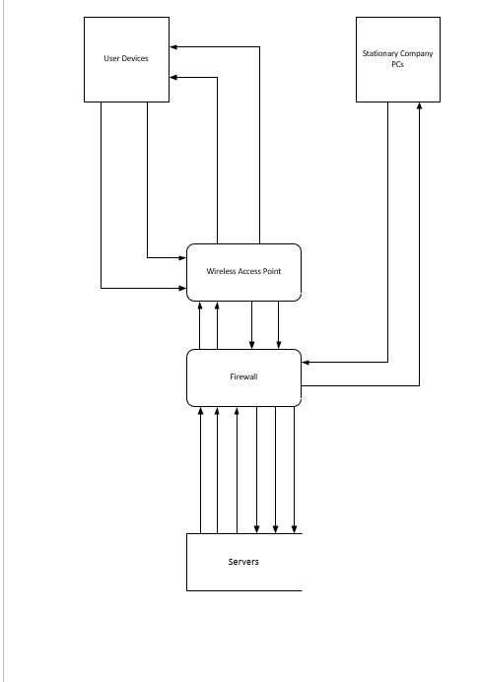
Basically, the user devices connect to the wireless access point which goes though the firewall, the firewall will detect any unauthorised access and block it. For the stationary PCs they go straight through to the firewall.
All devices can request data form the servers when they go through the firewall, customers of course will have less access to the data than compared to the employees, the employees will also have their own levels of access as their work differ from other, this will make it more efficient for the employees to do their work.
The system will also have the Cisco Meraki software on it this will be more in detail in the section.

  - 3.2 The System
The simulation of the system has been created in packet tracer, the screenshot below shows the topology of the network.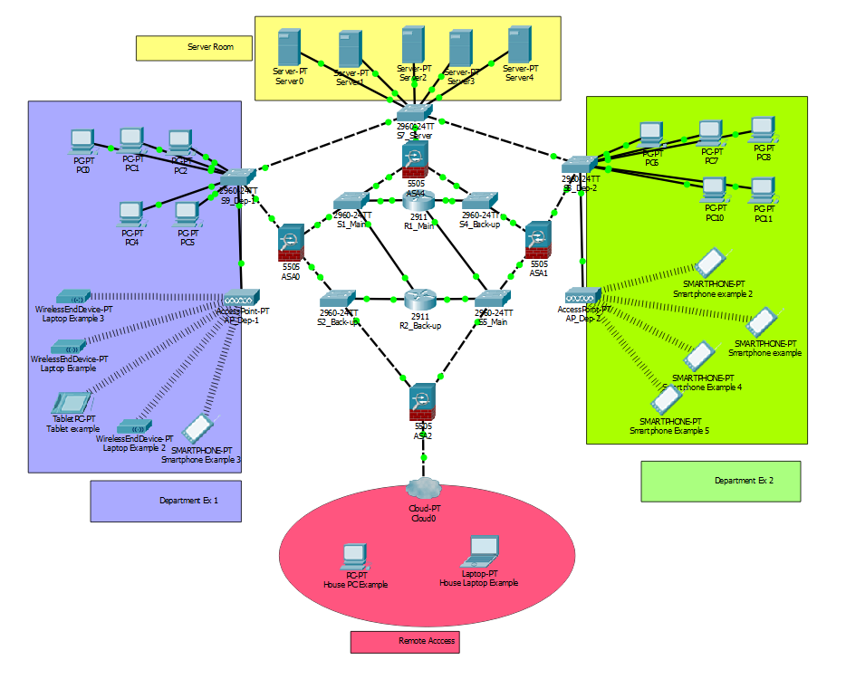
First, the centre area of the topology is the access to the internet, as shown there are 2 separate routers, this is because one of the routers is the main one and the other is the backup. So, if the main router fails the backup will replace it, preventing the network from going down, it serves as redundancy. This can be said for all the switches in the centre 2 are main and the rest are backups.
In the purple rectangle is an example of one the departments, as it can be seen it has been decided to do a hybrid version of the BYOT framework, however this is still in majority wireless but there are also stationary PCs in the topology. The stationary PCs are connected to the switch which is connected to the firewall and to the server switch, the reason its connected directly to it, is that it won’t slow down the network. If it wasn’t connected directly then it would have to go through the centre which would make it much slower, due to potential data collision plus going through the firewall will slow it down as well.
The other device can access the network via a wireless access point, the access point is connected to the switch which is connected to the whole network. There is a prevention from groups of people not accessing the data which is not meant for them, using the Cisco Meraki tagging feature the enrolled customers and employees will be tagged with different names so only the data which they can access will show, for example the customer will only be able to see adverts on the company’s offer, and an employee will be able to see the work which correspond to the department which they work in.
The green rectangle is basically the same as the purple one, but it represents the different department of the company.
The yellow rectangle represents the server room where the company’s data is stored, they are all connected to the server switch which is then connected to the rest of the network. This room will be locked off to any unauthorised personnel using either a keypad or an id card, this is to prevent any tampering with the servers.
And the final point is the red oval area. This represents the cloud where employees and customers can connect to from their home, the data is taken from the servers, the connection goes through 2 firewalls so the connection of it could be a slower than in the company. The reason it goes through 2 firewalls it to be safe that any potential malicious activity, so the system isn’t affected. Furthermore, the system does have antivirus protection, so it is protected from any malware. Any other potential security issues are covered by Cisco Meraki with all its features.

  - 3.3 The BYOT Policy
The company Hyper-fort grants its employees the privilege of purchasing and using smartphones and tablets of their choosing at work for their convenience. Hyper-fort reserves the right to revoke this privilege if users do not abide by the policies and procedures outlined below.
This policy is intended to protect the security and integrity of Hyper-fort’s data and technology infrastructure. Limited exceptions to the policy may occur due to variations in devices and platforms.
Hyper-fort employees must agree to the terms and conditions set forth in this policy in order to be able to connect their devices to the company network.
Acceptable Use
- The company defines acceptable business use as activities that directly or indirectly support the business of Hyper-fort.
- The company defines acceptable personal use on company time as reasonable and limited personal communication or recreation, such as reading or game playing.
- Employees are blocked from accessing certain websites during work hours/while connected to the corporate network at the discretion of the company. Such websites include, but are not limited to…
- Devices’ camera and/or video capabilities are disabled while on-site.
- Devices may not be used at any time to:
- Store or transmit illicit materials
- Store or transmit proprietary information belonging to another company
- Harass others
- Engage in outside business activities
- The following apps are allowed: Gmail, Messenger, Outlook, Google Drive, any other email app, Facebook (only in breaks).
- The following apps are not allowed: any potential apps which could cause harm to the company and its data.
- Employees may use their mobile device to access the following company-owned resources: email, calendars, contacts, documents, etc.
- Hyper-fort has a zero-tolerance policy for texting or emailing while driving and only hands-free talking while driving is permitted.
Devices and Support
- Smartphones including iPhone, Android and Windows phones are allowed. Any model of these phone is allowed and any version of the OS except of Android as it has to be Android 4 or above
- Tablets including iPad and Android are allowed Any model of these phone is allowed and any version of the OS except of Android as it has to be Android 4 or above.
- Connectivity issues are supported by IT; employees should/should not contact the device manufacturer or their carrier for operating system or hardware-related issues.
- Devices must be presented to IT for proper job provisioning and configuration of standard apps, such as browsers, office productivity software and security tools, before they can access the network.
Reimbursement
- The company will reimburse the employee for a percentage of the cost of the device which will be 30% of the initial cost.
- The company will pay half of the data plan.
- The company will not reimburse the employee for the following charges: roaming, plan overages, etc.
Security
- In order to prevent unauthorized access, devices must be password protected using the features of the device and a strong password is required to access the company network.
- The company’s strong password policy is: Passwords must be at least six characters and a combination of upper- and lower-case letters, numbers and symbols. Passwords will be rotated every 90 days and the new password can’t be one of 15 previous passwords.
- The device must lock itself with a password or PIN if it’s idle for five minutes.
- After five failed login attempts, the device will lock. Contact IT to regain access.
- Rooted (Android) or jailbroken (iOS) devices are strictly forbidden from accessing the network.
- Employees are automatically prevented from downloading, installing and using any app that does not appear on the company’s list of approved apps.
- Smartphones and tablets that are not on the company’s list of supported devices are/are not allowed to connect to the network.
- Smartphones and tablets belonging to employees that are for personal use only are/are not allowed to connect to the network.
- Employees’ access to company data is limited based on user profiles defined by IT and automatically enforced.
- The employee’s device may be remotely wiped if 1) the device is lost, 2) the employee terminates his or her employment, 3) IT detects a data or policy breach, a virus or similar threat to the security of the company’s data and technology infrastructure.
Risks/Liabilities/Disclaimers
- While IT will take every precaution to prevent the employee’s personal data from being lost in the event it must remote wipe a device, it is the employee’s responsibility to take additional precautions, such as backing up email, contacts, etc.
- The company reserves the right to disconnect devices or disable services without notification.
- Lost or stolen devices must be reported to the company within 24 hours. Employees are responsible for notifying their mobile carrier immediately upon loss of a device.
- The employee is expected to use his or her devices in an ethical manner at all times and adhere to the company’s acceptable use policy as outlined above.
- The employee is personally liable for all costs associated with his or her device.
- The employee assumes full liability for risks including, but not limited to, the partial or complete loss of company and personal data due to an operating system crash, errors, bugs, viruses, malware, and/or other software or hardware failures, or programming errors that render the device unusable.
- Hyper-fort reserves the right to take appropriate disciplinary action up to and including termination for noncompliance with this policy.

4 Conclusion
In conclusion, the whole report has its own recommendations throughout. But for future work and any other possible recommendations, it is recommended to follow this report and the choice of software, the policy is a simple and basic one, so it can furthermore be improved and made less general. The future work would be in perfecting the topology of the system and thinking about more of how the data is transferred and any security risks associated with that.

Bibliography

[1] | Optimus Learning, “The Advantages and Disadvantages of BYOD,” 4 September 2013. [Online]. Available: https://www.optimuslearningservices.com/practical-ld/advantages-disadvantages-byod-in-learning/. [Accessed 6 January 2019].
[2] | RTI Team, “The Advantages & Disadvantages of BYOD,” 26 July 2018. [Online]. Available: https://www.1rti.com/the-advantages-disadvantages-of-byod/. [Accessed 6 January 2019].
[3] | Finances Online, “Cisco Meraki Review,” [Online]. Available: https://reviews.financesonline.com/p/cisco-meraki-systems-manager/. [Accessed 6 January 2019].
[4] | Finance Online, “Intune Review,” [Online]. Available: https://reviews.financesonline.com/p/intune/. [Accessed 6 January 2019].
[5] | M. Berry, “BYOD Policy Template,” [Online]. Available: http://www.itmanagerdaily.com/byod-policy-template/. [Accessed 6 January 2019].

Appendix
[5] | M. Berry, “BYOD Policy Template,” [Online]. Available: http://www.itmanagerdaily.com/byod-policy-template/. [Accessed 6 January 2019].  Company XYZ: BYOD Policy  Company XYZ grants its employees the privilege of purchasing and using smartphones and tablets of their choosing at work for their convenience. Company XYZ reserves the right to revoke this privilege if users do not abide by the policies and procedures outlined below.  This policy is intended to protect the security and integrity of Company XYZ’s data and technology infrastructure. Limited exceptions to the policy may occur due to variations in devices and platforms.  XYZ employees must agree to the terms and conditions set forth in this policy in order to be able to connect their devices to the company network.  Acceptable Use  - The company defines acceptable business use as activities that directly or indirectly support the business of Company XYZ.  - The company defines acceptable personal use on company time as reasonable and limited personal communication or recreation, such as reading or game playing.  - Employees are blocked from accessing certain websites during work hours/while connected to the corporate network at the discretion of the company. Such websites include, but are not limited to…  - Devices’ camera and/or video capabilities are/are not disabled while on-site.  - Devices may not be used at any time to:  - Store or transmit illicit materials  - Store or transmit proprietary information belonging to another company  - Harass others  - Engage in outside business activities  - Etc.  - The following apps are allowed: (include a detailed list of apps, such as weather, productivity apps, Facebook, etc., which will be permitted)  - The following apps are not allowed: (apps not downloaded through iTunes or Google Play, etc.)  - Employees may use their mobile device to access the following company-owned resources: email, calendars, contacts, documents, etc.  - Company XYZ has a zero-tolerance policy for texting or emailing while driving and only hands-free talking while driving is permitted.  Devices and Support  - Smartphones including iPhone, Android, Blackberry and Windows phones are allowed (the list should be as detailed as necessary including models, operating systems, versions, etc.).  - Tablets including iPad and Android are allowed (the list should be as detailed as necessary including models, operating systems, versions, etc.).  - Connectivity issues are supported by IT; employees should/should not contact the device manufacturer or their carrier for operating system or hardware-related issues.  - Devices must be presented to IT for proper job provisioning and configuration of standard apps, such as browsers, office productivity software and security tools, before they can access the network.  Reimbursement  - The company will/will not reimburse the employee for a percentage of the cost of the device (include the amount of the company’s contribution), or The company will contribute X amount of money toward the cost of the device.  - The company will a) pay the employee an allowance, b) cover the cost of the entire phone/data plan, c) pay half of the phone/data plan, etc.  - The company will/will not reimburse the employee for the following charges: roaming, plan overages, etc.  Security  - In order to prevent unauthorized access, devices must be password protected using the features of the device and a strong password is required to access the company network.  - The company’s strong password policy is: Passwords must be at least six characters and a combination of upper- and lower-case letters, numbers and symbols. Passwords will be rotated every 90 days and the new password can’t be one of 15 previous passwords.  - The device must lock itself with a password or PIN if it’s idle for five minutes.  - After five failed login attempts, the device will lock. Contact IT to regain access.  - Rooted (Android) or jailbroken (iOS) devices are strictly forbidden from accessing the network.  - Employees are automatically prevented from downloading, installing and using any app that does not appear on the company’s list of approved apps.  - Smartphones and tablets that are not on the company’s list of supported devices are/are not allowed to connect to the network.  - Smartphones and tablets belonging to employees that are for personal use only are/are not allowed to connect to the network.  - Employees’ access to company data is limited based on user profiles defined by IT and automatically enforced.  - The employee’s device may be remotely wiped if 1) the device is lost, 2) the employee terminates his or her employment, 3) IT detects a data or policy breach, a virus or similar threat to the security of the company’s data and technology infrastructure.  Risks/Liabilities/Disclaimers  - While IT will take every precaution to prevent the employee’s personal data from being lost in the event it must remote wipe a device, it is the employee’s responsibility to take additional precautions, such as backing up email, contacts, etc.  - The company reserves the right to disconnect devices or disable services without notification.  - Lost or stolen devices must be reported to the company within 24 hours. Employees are responsible for notifying their mobile carrier immediately upon loss of a device.  - The employee is expected to use his or her devices in an ethical manner at all times and adhere to the company’s acceptable use policy as outlined above.  - The employee is personally liable for all costs associated with his or her device.  - The employee assumes full liability for risks including, but not limited to, the partial or complete loss of company and personal data due to an operating system crash, errors, bugs, viruses, malware, and/or other software or hardware failures, or programming errors that render the device unusable.  - Company XYZ reserves the right to take appropriate disciplinary action up to and including termination for noncompliance with this policy.

This source was the used to create the policy for the Hyper-fort company, inspiration has been taken from this source.

