Name: Andreea Madalina Gheorghiu
Student ID: 1813703
Module code: BMSK4005_LON
Assignment Name: Professional Career Development

.

Introduction
In my point of you Academic and Employability skills play a big part in our day to day life, as employers look for different skills in a future employee. Studying this module has helped me to discover my strengths and find out my weaknesses, it has also taught me new skills and how the ideal employee should be. In this report I am going to be talking about what my strong and weak academic and employability skills are, how I can work on improving my weaknesses and what I have achieved during the time I have studied this module. In this module the academic concepts that have been presented to us are: academic writing, research methods and skills in academic referencing.
I am going to talk about each academic concepts so we can get a better view of what each of them do and how they help for the future.

Academic writing

Academic writing is a skill that everyone should have. This style of writing is first of all a way to communicate just like any other styles of writing. When creating a written piece of work we should concentrate in using our own words and write in such a way that you can convince the reader that you know what you are writing about. Also when using this style it is ideal to use quotations and paraphrase as the reader cannot tell clear what you are thinking when using other people’s words (Cormack, 2013) .

Research Methods

Research methods is a strategy that we use to collect different data that could make our understanding more clear about a certain topic. This is a really good skill to have as it can help at the work place and also in general it can help us develop our knowledge (University of Newcastle, 2019).

Academic Referencing

This academic concept talks about acknowledging other person’s work. It is important to have this skills as within the workplace and not only will you have to use citations or references in order to first of all give the author full credit for his ideas, make the piece of work weather is a report for work or an assignment for university more clear to the audience where if they have any misunderstanding they can follow the source and read more about it. On the other hand what you write can actually show your understanding about that specific topic (Skills you need, n.d.).

Main Body

When I say ‘’Academic and Employability skills’’ I think about ‘’future’’. When I say ‘’future’’ I mean my career. Those skills are vital as without them it can be almost impossible to get a job and have a great career. This module helped me discover my strengths and weaknesses and taught me certain things that I never knew would count in getting a job. First of all the CV is very important. This document is your reflection. It only takes five seconds for the employer to decide whether you are possibly suitable for the position applied for or not. One thing I did not know was that there could be different types of CV’s. For example there is a general CV that talks about the qualifications you might have, personal statement describing what kind of person you are and what your strengths and weaknesses you consider to have and some contact details. On the other hand there could be a CV for the specific position you apply for. Let’s say that I apply for a position in the Marketing field. In this CV I should only outline my experience in this field and the qualifications I have in regards to Marketing. A thing I did not know that can be vital in a job application/interview is the cover letter. A cover letter should be different for each job. In the cover letter you should talk about why you deserve the job and give enough evidence and information as to why they should chose you and what you can bring into the job so that you and the company have benefits.
However, during this module I have discovered more about myself as an individual. I have discovered that I have great communication skills and that I can work well in a team and also in managing my time when it comes to getting somewhere on time but on the other hand I am not so good in managing my time in meeting deadlines and being organized . For example for my last assignment at University I have started my research late and I hardly managed to get it done on time but it was obviously not up to the standard I would have liked it to be, In order for me to improve my time management skills I should learn how to prioritize my work, I should also stop myself from getting distracted by things going on around me, I can also try to make a schedule and try to be very strict about it and respect every step. Also if something is unclear to me for example regarding an assignment I can always find time and go to my lecturer and ask for advice which can help me in getting my work done quicker and up to a better standard. Although I said above that I am good in working in a team I think that I could improve this field as well because sometimes I have the tendency to take lead of everything that is going on and not to really listen to what my colleagues would have to say. To improve this I would have to gain some self-control and take into consideration other people’s opinion in order to work better as a team member. As I have mentioned above about CV and Cover letters, doing this module has also taught me what I should have and should not necessarily have on my CV, things such as address, marital status etc. The CV should be short and precise talking about the relevant experience for the job, well formatted, not including any unnecessary information and not lying about any qualifications or work experiences you might have as that might put you down if getting the job and not being able to put in practice what you have said you have already done.
On the other hand, talking about academic skills, I have developed my vocabulary by learning new words and expressions, my writing and reading skills and research skills. I have also learned the importance of formal writing and the importance of starting the research from time so it can be more efficient. Also in a recent lecture I understood more about creating a presentation. What it should include, who is it aimed for, self-appearance, tone of voice, short and clear for the audience to understand it, also before starting to present you need to verify your equipment such as speakers. If needed, projector, remote, computer etc. and the key point is rehearsing. Why do I say that ‘’rehearsing’’ is the key point? In my opinion when you rehears it builds your confidence as when you are in front of the crowd you are confident in what you are saying, you also can summarize what is in your presentation in order to keep the crowd engaged and interested. Depending on the circumstances, such as audience, topic, size of the audience and place the presentations could be formal or less formal. However, it does not matter whether the presentation is formal or informal or how many people you are presenting in from of, make sure at the end of the presentation ask them if they have any questions as not everyone may be clear of what you have said during your presentation and to avoid any misunderstandings. Being able to create a presentation and delivering this to others it is a very important and vital skills to have as you might come across this in university, work, etc. In this module I have also developed my analytical thinking skills. According to an article from ‘’ (IQDoodle, n.d.) Analytical skills are very important in our day to day life as it gives us the ability to solve problems more efficiently. This skills involves a step by step progress of breaking down a problem into an easy manageable components. Also in order to do this it requires you to get information about a problem and identify the key issues and compare sets of information from different sources also identify the main reason why that certain problem occurred and its effect and take the appropriate conclusion in order to come to a good solution in solving the problem.
Gathering information it is also crucial because if we do not gather the correct information in regards to the problem we are trying to solve we are not going to draw the right conclusion. We also have to identify what type of information we need and after we need to ask the appropriate questions in order to get necessary insights that will help you make the right decision in regards to the problem. Least but not last we also have to consider the authenticity and relevance of the source we take our information from (IQDoodle, n.d.).
Once we gather all the right information from our sources we now must put everything together in an organized way and put all the pieces together in order to get better insights of the problem and take out the key points and draw the right conclusion.
I personally think that I still have to work on my analytical thinking skills, so according to (Terrel, 2019) there are few easy ways to improve those. Some of them are:
- Play mind games
This way of improving our analytical thinking skills is an easy and fun way that gets you thinking of strategies and ways to play that certain game and it only takes 15 minutes a day.
- Learn one new thing everyday
Try to learn one new things every day in regards to anything. If there is a field that interests you, you can go online and research in more depth or speak to a specialist that will tell you more about the field you are passionate about.
- Join a book club
Joining a book club could be interesting as you are not just reading, but getting to meet new people that you can analyse and debate on the books you’re reading which gives you the opportunity to improve your analytical thinking.
- Volunteer for new projects
If there is a specific analytical skills we are interested in we should volunteer for a project that involves that skill in order to give us a little boost into what we like to do and develop into something/ someone better.

Name: Andreea Madalina Gheorghiu
Student ID: 1813703
Module code: BMSK4001_LON
Assignment Name: Academic and Employability Skills
Lecturer’s Name: Sylvia Hoffmann

Introduction
As an individual is very beneficial to possess different academic and employability skills to be able to obtain their career goals. There are a lot of types of skills such as multitasking, teamwork and communication. The skills that every single one of us have depend on our background, qualifications or other factors that may influence this and it also depends on our capability to learn or develop new skills. The main reason to have and develop those skills is for our future career as in being able to have our dream job or work in that specific field that we have our qualifications in.

Definition of employability skills
The term of ‘’employability skills’’ describes a group of strengths that an individual has after coming out of an academic curriculum or course applicable at a workplace and also the strength to engage in lifelong learning . Those strengths could be very beneficial in their day to day life and also for the employer (Duszyński, 2019)

Analyze the relevant employability skills

Problem solving
Being able to solve a problem within the business environment involves sometimes analyzing figures and fact, confronting with a new challenge and manage to get to the end of it, coming up with new ideas and putting them into practice at the work place (Duszyński, 2019).

Communication
In our days it is very important to be able to communicate effectively at the work place. If an individual is able to listen effectively, emphasize and pull rational conclusions after receiving the information shows that they have really strong communication skills (Duszyński, 2019).

Adaptability
This skills is one of the most important skills that a candidate could have. In our days things can change by the day such as: technology, business ideas, new competition etc. being able to adapt also show that you are ready and want to learn new things to develop your knowledge and after making few mistakes you could come up with new efficient ideas for the business (Duszyński, 2019).

Being able to use technology effectively
In the 21st century technology runs our lives. It does not matter what field you work in you will always need to have knowledge about the technologies that are relevant to your work place. That is why being able to use technology effectively became one of the top skills when it comes to employment (Duszyński, 2019).

Time management
Time management is essential at the work place. Not being able to manage your time effectively at work can affect your results. Sometimes if you find it hard to prioritize your tasks can create a really bad contrast between the professional and personal life (Duszyński, 2019).

Why should we identify our employability skills?
The reason we should identify our employability skills is because it makes us more conscious of what our strengths and weaknesses are. Nevertheless it also helps us in our face to face job interviews, writing effective job applications and building our self-confidence. As an individual you will feel very confident and comfortable to speak openly about your strengths and weaknesses and the employer could see this as a very strong and essential skill (The University of Sydney , n.d.).

Importance of employability skills for the employers
In our days, employers consider employability skills vital for their business. They no longer go just for candidates that have good qualifications, if they do not have the key employability skills they risking no to get the job. Some of the key skills employers look for are: team working, time management, punctuality, problem solving, adaptability, strong communication skills, strong IT Skills etc. Some of them I have mentioned and explained above but for example, being able to work effectively in a team is beneficial for the business as you could get projects or presentations to work on together and you should definitely be able to listen and cooperate with others, this could also create a nice and peaceful environment within the workplace. Those skills play a strong role in your professional life. If those skills are non-existent the employer will be able to see if from your performance. From a manager’s point of you those aptitudes are more of a service that the employee brings in the organization. With the help of those skills the worker can help with the development of the business. Another reason why employers look for those competences in a candidate is that they can assist and help the business to combat all or any challenges that might come along (studentingera, 2018)

Models of employability skills
Employability skills are more important to an employer on today’s market as they prefer those abilities over any educational qualifications. When the candidate has those skills they help the company develop and gain better results. There are a lot of concepts of employability explained through various methods. Some of the models I am going to discuss down below.

USEM employability model (2004)
The USEM model gives an idea of what a graduate should gain after finishing their degree and make use of them in their work lives. U stands for Understanding, S for Skills, E for Efficacy beliefs and M for Metacognition. This model was proposed by Knight and York in 2004. This model creates a relationship between personal qualities with the skills and knowledge needed to give wider personal efficacy and employability (Martin & Sara, n.d.).
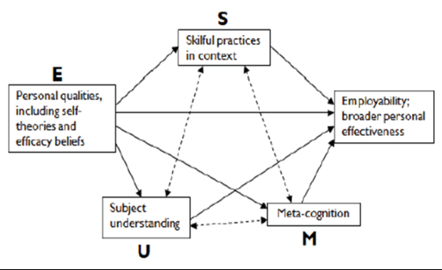

Figure 1. USEM Employability Model (2004)
Source: https://www.heacademy.ac.uk/system/files/downloads/khechara-development_of_employability_skills.pdf

Bridgstock employability model (2009)
This model was established in 2009 and it offers a different perspective of what a graduate’s skills for employability should be. In this model one of the most important skills is career management. Bridgstock thinks that employability takes more than just possessing general skills listed by employers. She is highlighting that things in business change fast and there is a competitive economy, so the graduates should also be able to explore the world of work and manage their career business themselves (Doug Cole and Maureen Tibby, n.d.).

Her model shows that:
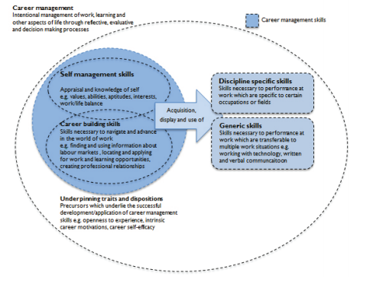

Figure 2. Bridgstock’s Employability Model (2009)
Source: https://www.heacademy.ac.uk/system/files/resources/Employability_framework.pdf

The CBI/NUS (2011)
The CBI/NUS proposed in 2011, concentrates more on how to get students engaged in employability and encourage them to take responsibility of the way they are developing in their employability career from the start of their journey in university. They created a source which focuses on the importance of employability and practical ways in which students can improve their employability. They have agreed that employability falls under an umbrella which includes a range of skills, characteristics and knowledge. They have also established that positive attitude is very important and it is considered to be the heart of employability (Doug Cole and Maureen Tibby, n.d.)

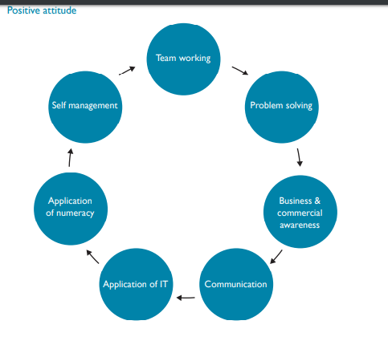

Figure 3. CBI/NUS (2011)
Source: https://www.heacademy.ac.uk/system/files/resources/Employability_framework.pdf

Personal SWOT Analysis
Down below, I have created a personal SWOT Analysis in order to determine my strengths and weaknesses and to have a clearer view on how it can affect me in the future. From this table I can see some of the opportunists I might have in regards to my strengths and how my weaknesses affect me in my professional life.

STRENGHTS  - Fast learner  - Strong communication skills  - Strong IT / Technology skills | WEAKNESSES  - Time management  - Team work  - Not enough employment experience
OPPORTUNITIES  - I could find a job that will help me improve my weaknesses and build a better CV  - Get a job within the IT sector and develop my knowledge | THREATS  - Not finding a job easily as I find it quite hard to work with people  - Not being able to prioritize my tasks and not attending interviews on time

Table 1. Personal SWOT Analysis
Source: (Personal experience)

Plan of action to improve my skills to meet employer’s need (SMART)

Above I have analyzed my strengths, weaknesses and what I need to improve on. Here I am going to create a table and set some SMART objectives in order to help me work on my flaws.
SPECIFIC ACTIONS | MEASURABLE | ACHIEVABLE | RESOURCES | TIME-BOUND
Managing my time better | I will set up deadlines, avoid doing more things at the same time and prioritizing my tasks. | I will watch videos and read articles on how to manage your time | Internet | End of my academic year
Working more efficiently as part of a team | I will listen more effectively to the other team members, engage more in socializing | I will engage in more group activities/meetings, socialize more , work on my patience | Internet  Parks  Restaurants | Summer Holiday
Gain more experience in employability | Make some changes on my CV, working on my skills, being more confident | Apply to jobs on a regular basis | Internet  Volunteering work | End of my academic year

Table 2. Plan of action to improve my skills
Source: (Created by Andreea Madalina Gheorghiu)

Employability skills that need to develop in the future
After taking a close look at my ‘’Personal SWOT Analysis’’, I came to the conclusion that I have to work a lot more on my employability skills in order to get my dream job. For example I could start working on my patience in order to be able to work in a team more effectively. I could also start taking into consideration more ideas and opinions coming from my co-workers. In regards to time management I could watch some videos or read some articles on how to make the difference between the things that ‘’ I HAVE TO DO’ and the things that ‘’I MUST DO’’. Things that ‘’I have to do’’ are important but not as important as the one ‘’ I must do’’. Learning how to manage my time would be very beneficial for my professional life and future career. However, lack of employability experience plays a big role in my CV as in our days employers want to see some sort of experience rather than educational qualifications. In my opinion if I work on my weaknesses such as team working and time management I will definitely be able to get a job where I can gain experience and learn new skills.

Conclusion
In conclusion I think that having employability skills plays a vital role in everyone’s life. If you acknowledge that you lack in some fields you could always go and research for tips on how to improve, engage in group activities, ask for feedbacks from employers, friends, teachers and take into consideration their opinion. I have also came to the conclusion that employability experience plays a big part in getting a job as the employer looks for experience as well as a degree. In some jobs experience might be more important than the degree. During my research for this assignment I found three very important models of employability, I have also created my personal SWOT analysis and created my Plan of action on how to improve my flaws in order to be suitable to get a good job, in a big organization and have a better career prospect. I also think that by working on those weaknesses I will expand my horizon after I finish my university year and get my degree.

References

(n.d.). Retrieved from IQDoodle: https://school.iqdoodle.com/framework/competencies/analytical-think/
Cormack, S. (2013, October 22). University of Sunderland . Retrieved from https://my.sunderland.ac.uk/pages/viewpage.action?pageId=56688664
Doug Cole and Maureen Tibby. (n.d.). Retrieved from https://www.heacademy.ac.uk/system/files/resources/Employability_framework.pdf
Duszyński, M. (2019, March 20). Zety . Retrieved from https://zety.com/blog/employability-skills
Martin, S., & Sara, K. (n.d.). University of Wolverhampton. Retrieved from https://www.heacademy.ac.uk/system/files/downloads/khechara-development_of_employability_skills.pdf
Skills you need. (n.d.). Retrieved from https://www.skillsyouneed.com/learn/academic-referencing.html
studentingera. (2018, June 25). Studenting Era . Retrieved from http://studentingera.com/blog/importance-of-employability-skills-from-employers-perspective/
Terrel, S. (2019, January). MindValley. Retrieved from https://blog.mindvalley.com/analytical-thinking-skills/
The University of Sydney . (n.d.). Retrieved from https://sydney.edu.au/careers/students/career-advice-and-development/employability-skills.html
University of Newcastle. (2019, April 15). Retrieved from https://libguides.newcastle.edu.au/researchmethods

