Step 1
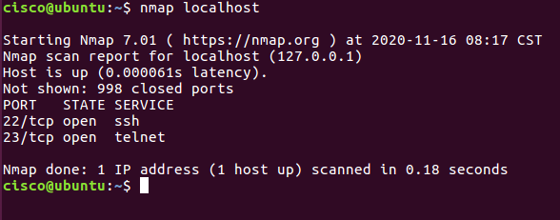

Step 2

Type the command you used to find out your host IP Address
Ifconfig

Type the command you used to scan after finding your host IP Address
Nmap 10.0.2.15
Record the outcomes of the above command here

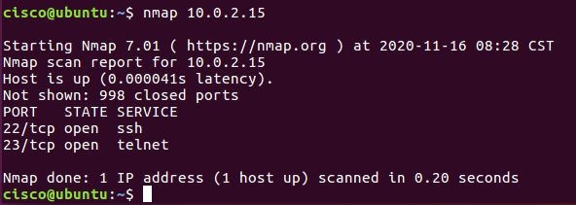

Step 3: Analyse the outputs/outcomes from Step 1 and 2 and record your reflections. (Hint: Analyse what is the difference between local host and ip address of the host, If ports displayed are different, Why is it different? etc (not limited to the hints))

The local host scans the loopback IP whilst nmap 10.0.2.15 scans the IP given. The localhost has a shorter scan time by .02 seconds and they both have 22 and 23 (SSH and Telnet) open. The Nmap IP has a lower latency.

Step 4: Why is the nmap scan only scans the first 1000 ports? What will be the command to scan all the ports?
The first 1000 most common ports for each protocol are scanned, for any other ranges the nmap -p must be used specifying the port ranges to scan.

Step 5: Scan the UDP Ports
nmap –sU localhost
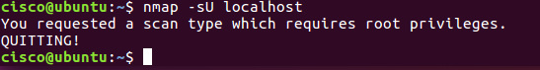
sudo nmap –sU localhost
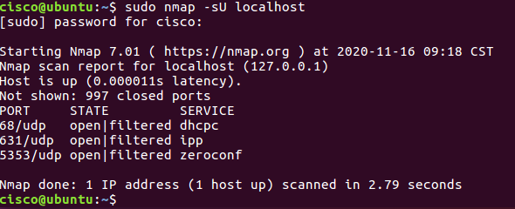
Record the outcomes of the above command here (Hint: what UDP ports could you find open through your scan)
The -sU must refer to the Super user as the first command without sudo would not run due to insufficient privileges.
On the second command ports 68, 631 and 5353 were identified as being open.

Step 6: From the above outcomes select any ports which is open ▪ sudo nmap –p137 localhost

Record the outcomes of the above command here (Hint: Is the port open or closed? Why? Also, record the use of –p command)

The port chosen was 631 and the port is open
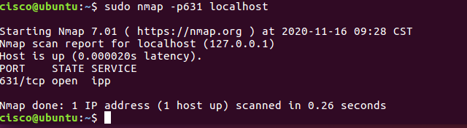

Step 7: Try other port related commands and record its purpose. ▪ sudo nmap –pportnumber host_ip
▪ sudo nmap –pportnumber_startrange-portnumber_endrange host_ip
▪ sudo nmap –pportnumber,portnumber host_ip
▪ not limited to the above (Do a google search, refine your search and find out other port related commands, Hint:nmap.org)

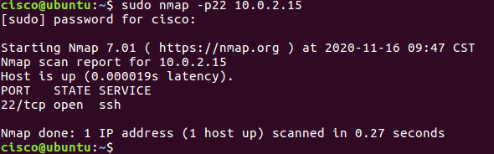

Step 8: Detecting the version is a very important part of information gathering. Try to find out the version. ▪ nmap –sV localhost

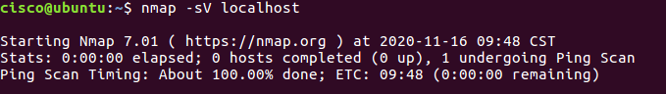

Step 9: Try other commands to detect other versions and record its purpose. ▪ Command to identify the Operating System version

Command to identify the Service Version



