Gareth Collett

Flixborough disaster – ellie martin

Table of Contents
1 Introduction 1
2 Evaluation 1
3 Conclusion 2
4 Bibliography 3

Table of Figures
Figure 1- Swiss cheese model 2

Introduction
The Nypro chemical plant, which was situated in flixborough was primarily involved in the production of caprolactam, this is a key ingredient that is used to make nylon [1]. On June 1, 1974, the site experienced one of the most catastrophic peacetime industrial explosions in British history. The explosion was caused by the failure of a temporary bypass pipe that had been installed after a vertical crack was discovered in Reactor No. 5, which was leaking cyclohexane [1].
The incident involved a fuel air explosion, this is a highly destructive blast which consumes all the oxygen from the surrounding environment- generating extreme temperatures and pressures which subsequently cause an explosion. These are often referred to as a ‘thermobaric’ or vacuum bomb [2]. Following an investigation and the site being shut down, the installation of the temporary bypass assembly was used to connect reactor No.4 to No.6 to allow for production to resume- However, the temporary pipe which was installed was not designed to with stand great amounts of pressure and was also not adequately tested to support the operation capacity of the plant. Upon operation, the pipe failed under pressure releasing a substantial amount of cyclohexane. This flammable liquid formed a large vapour cloud that subsequently combusted.
All eighteen people which were in the control room were killed due to the glass shattering and the structural damage sustained to the roof [1]. The fire that occurred from the explosion continued to burn for several days after the initial incident. In total, 28 people were killed and 36 of the 76 people which were on-site sustained serious injuries [3].

Evaluation
There were numerous causes of this disaster the main technical cause of failure of this disaster were the poor design and insufficient pressure testing on the temporary bypass pipe that was implemented. The temporary fix was not capable of processing such large quantities of cyclohexane it was subjected to. The technical issues were not the only cause as there were also significant organisational failures surrounding safety management of the modification particularly the lack of risk assessment and relevant supporting documentation
The empirical findings in this study provide an understanding on the effects that a lack of comprehensive safety protocols to manage the operation of the chemical plant with one of the reactors being offline. There was also insufficient testing to support the use of the system with the temporary pipe being in operation.
Another contributing factor are the ‘Dirty dozen’- these are twelve common human factors that typically contribute to accidents and errors which occur within high-risk industries [4]. Reason introduced the idea that the implementations of a sophisticated safety culture opposed to fixating on blaming individuals for accidents which occur can have substantial impact on reducing the risk of unsafe actions from taking place. He explored the idea that error can only be applied if an error has occurred based on an intentional action [5]. This understanding of intention allows us to begin to understand how actions with intention can result in errors due to inadequate documentation and communication breakdown. Reason’s Swiss cheese model is one of the most widely referenced models providing a visual demonstration on the impact of human error [figure 1] and how the implementation of multiple layers of defence still has the potential to fail if all their respective weakness aligns at the same time.
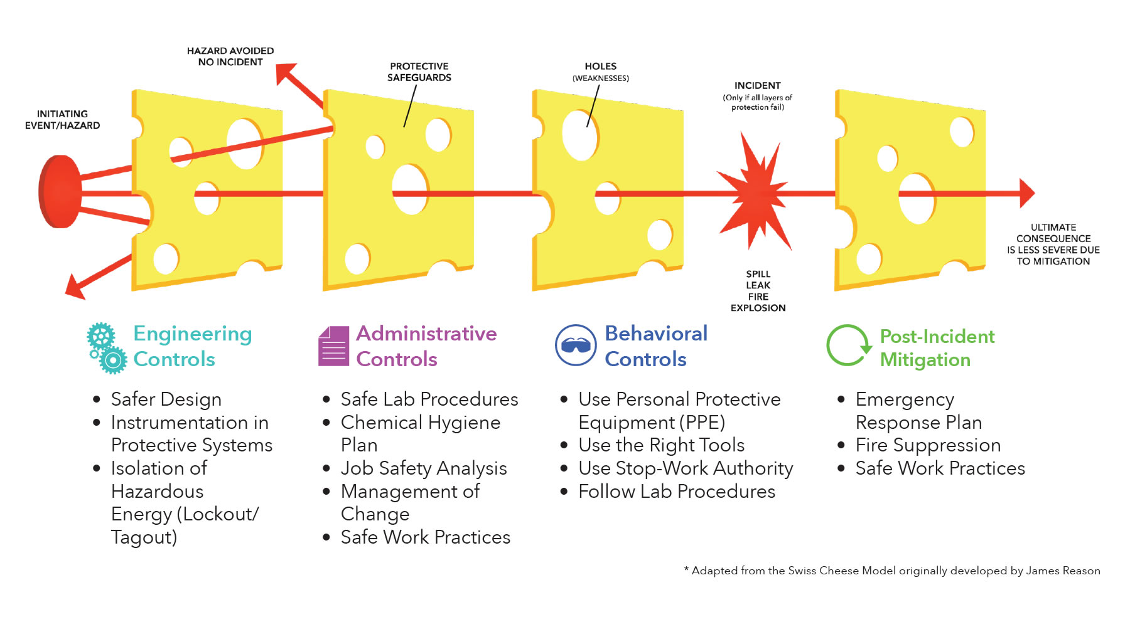
Figure 1- Swiss cheese model

Having considered all the organisational and individual factors many of which are overlapping, the research shows that all the ‘dirty dozen’ were present in varying degrees in the Flixborough disaster. However, it has become apparent that the three main contributing ones were;
- Lack of communication
Due to the extensive blame culture instilled to the work force at the time research suggests that the staff didn’t voice concerns of pressures which they were being subject to resulting in critical safety concerns not being reported. This meant there was inadequate documentation to reflect the potential risks which resulted in limited knowledge around the the temporary pipe and the constraints to the rate of production was overlooked. This had a knock-on effect as there was no clear communication regarding the safety protocols which should be in place, and this knowledge was not passed on to other departments.

- Lack of teamwork
The installation of the bypass pipe was done without the subject matter experts and the mechanical engineers being involved. This resulted in the modification not being qualified to ensure it would adhere to the requirement if production and a lack of coloration to ensure necessary safety checks were being conducted to ensure the performance of the pipe was within the acceptable tolerances.

- Complacency
The plant had a long-standing history of safe operations thus leading to the misplaced confidence and a under estimation of the surrounding risks of the modifications. Due to this staff did not question the reliability of the bypass pipe and how this would impact the effectiveness of the plant as there was an assumption that nothing could go wrong because it hasn’t for years. It is apparent that this human factor can be caused by organisational factors such as peer pressure [6] which could prevent individuals from voicing concerns that they had regarding the lack of report or risk assessments for example.
From research the lack of the communication is the top causality of tis accident as it is clear that it has a cascading effect of the other factors due to the organisational blame culture which was present. If staff had the confidence in communicating concerns with management and also colleagues, it would have highlighted that the temporary modification did not have the capacity to handle the amount of cyclohexane which is being produced in the plant. The learner identified the lack of teamwork as the second most important causality it was apparent that there was not sufficient oversight from subject matter experts who had the knowledge to understand the risks of the temporary bypass pipe and the collaboration between departments would have ensured that the appropriate safety checks were being completed however this was not the case. Complacency is also a closely linked factor as there was an overconfidence in the reliability of the temporary fix and there was not appropriate pressure testing to ensure that the pipe had been certified for use. It was also apparent that there was a lack of urgency about ensuring that these modifications were appropriate even though they plant handled extremely flammable chemicals.
The HSE was created following on from the health and safety at work act 1974- the majority of this enforced in 1975 following the Flixborough disaster [2] which reinforced the need to have a regulator to investigate incidents as well as ensure compliance is being adhered to and develop the safety standard to minimise risk. Following the Flixborough disaster industries became more aware of the outcomes when accidents happen which meant the development of a systemic approach to process safety [8]. In 1976 the Sevesco disaster occurred resulting in the control of major accident hazard regulations (COMAH) 1999 being introduced in the UK which required industries which handled dangerous substances to identify these associated risks and implement appropriate control measures to manage these risks and report and incidents which took place.

Conclusion
The explosion which occurs in Flixborough influenced a lot of key changes within high-risk environment of work following from the catastrophic outcomes. The disaster highlighted the need for comprehensive risk assessments to be in place which would need updating following any modifications which occurred and to be reviewed on a regularly scheduled basis to ensure any near misses or accidents where documented to ensure appropriate training was being provided to all staff ensuring a proactive positive safety culture. This would ensure that any modifications made were reviewed by multiple individuals and undergo vigorous safety testing prior to implementation- this would mean that the modification which was required is in line with any regulations enforced by the governing bodies.
All the ‘Dirty dozen’ were present in different degrees in this disaster however the lack of communication, poor teamwork and complacency were the central human factors. This alongside multiple organisational and technical errors were detrimental in an accident which could have been prevented. The application of an overarching safety management protocol which ensures that all documentation is updated and understood by all staff would have minimised the potential misuse of the equipment and prevented the oversight of modifications. Upon the reflection of the incident the people which were on site at the time of the explosion were at minimum due to it being a weekend and the plant only having the minimum required personnel on site for it to be operational which meant that less people were killed/ injured- this highlighted that even though this was a catastrophic accident more people could have been involved.
This disaster emphasized the importance of instilling a positive safety culture shifting away from the top-down blame-orientated culture in high risk working environments which discouraged staff from voicing their concerns or reporting potential near misses. Flixborough supported the formation of governing bodies which are responsible for the development of the HSE COMAH regulations and which requires industries which handle dangerous substances to ensure the appropriate control measure are in place to ensure the risk are as low are reasonably practicable. It also highlighted how human factors can have a large impact on accidents within the workplace which allowed for more training to be implements within a safety-critical environment.

References
[1]
Health and Safety Executive, “Flixborough (Nypro UK) Explosion 1st June 1974,” Hse.gov.uk, 2015. https://www.hse.gov.uk/comah/sragtech/caseflixboroug74.htm (accessed May 31, 2025).
[2]
“What is a thermobaric or vacuum bomb?,” BBC News, Mar. 10, 2022. Accessed: Jun. 14, 2025. [Online]. Available: https://www.bbc.co.uk/news/business-60571395
[3]
“Flixborough disaster,” Wikipedia, Oct. 30, 2020. https://en.wikipedia.org/wiki/Flixborough_disaster (accessed Jun. 23, 2025).
[4]
Skybrary, “The Human Factors ‘Dirty Dozen,’” SKYbrary Aviation Safety, 2021. https://skybrary.aero/articles/human-factors-dirty-dozen (accessed Jun. 23, 2025).
[5]
J. Reason, Human Error. Cambridge: Cambridge University Press, 1990, p. 5.
[6]
M. S. Patankar and J. C. Taylor, “Analyses of Organizational and Individual Factors Leading to Maintenance Errors,” 2001. doi: 10.4271/2001-01-3005.
[7]
“Our History Timeline,” solutions.hse.gov.uk. https://solutions.hse.gov.uk/about-us/our-history-timeline (accessed Jul. 11, 2025).
[8]
Wikipedia Contributors, “Flixborough disaster,” Wikipedia, Apr. 13, 2025.

