

Assessment 2
2.500 words essay
By Shumana Begum

Student Name: Shumana Begum
Student number: 1913892
Children, Young People and Families
BMHP5004-LON
Assessment Component 2
Lecturer Name: Bianca Sanfilippo
Submission Date: 24th November 2022
Word Count:2510
Introduction
In this 2,500-word essay I will be conducting a well-structured essay that will be focussing on the meaning of childhood and I will also be demonstrating the understanding of key elements of social construction.
I will be explaining the meaning of social construction of childhood and will be included by changes in childhood from present to historical times. This will be followed by the concept and the changes within families in the UK.
Childhood is defined as a person whose is an infant until they reach puberty. It is important that a child should be nurtured by parental figure and a good role model. (Jay W. Marks, 2021)
A person who is under the age of 18 is known as to be vulnerable person and needs protection. (Kehily, 2013)
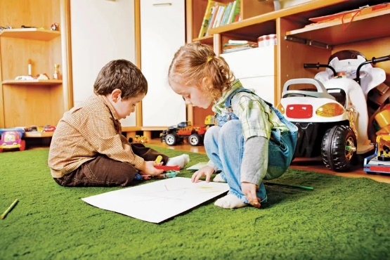

By Amy Tikkanen

Social Constructionism Definition and Examples
Social constructionism is a theory of knowledge in sociology that examines how individuals develop their knowledge and understanding of the world. There is no one precise definition of social constructionism, nor of the theories of the sociologists in the field.
The History
The first sociologist writing in the tradition of social constructionism was Mead (1930), in her book, Mind, Self, and Society. Mead created the concept of “symbolic interactionism,” which argues that humans construct their own and each other's identities through their everyday encounters with each other. In other words, the self is created through social interaction.
The Social Construction of Reality argues that humans create and sustain all social phenomena through their social practices. People “externalize” their thoughts on the world, such as writing down or creating a story about an idea they have. As other people tell this story or read the book, this idea becomes an “object” of consciousness for the people the idea spreads to.

The idea to these people becomes an objective truth. And in the last stage, the idea becomes “internalized” in the consciousness of the society, and future generations more or less take the idea for granted as an objective truth, as the idea already exists in the world they were born into (Burr 2015).
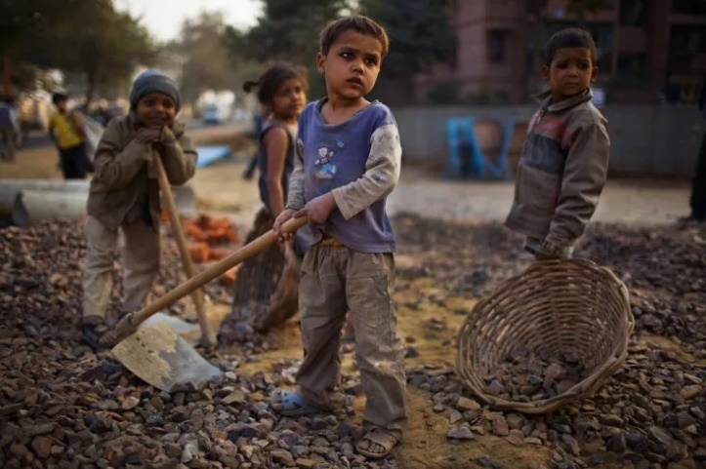

(Lydia Smith,2022)

The History of Childhood as Social construction
As it is mentioned by sociologist childhood as socially constructed means the ideas about childhood are produced by society.
There are many factors which are influenced by the society of childhood which involves:
- The moment a child becomes an adult
- The rights and responsibility of a child.
- The importance of children whether if they are innocent and in need of protection.
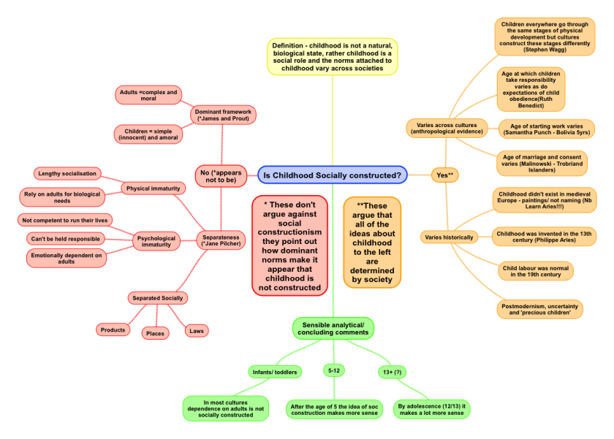

This diagram shows a mixture of the evidence about social construction in childhood

(Karl Thompson,2015)

Examples of the Social Construction of Childhood

There can be many examples that explains the meaning and definitions of social construction on children that would benefit them in early life, These involves:

The general idea that children are in need of care and stability.

The fact that they have the right of freedom in order to express.

The right that children should be educated.

Childhood is a one of the examples of social constructionism as this give a a clear understanding on the historical t]and present times of social construction.

Changes of Childhood from Historical to Present Times
During the 19th century there have been several changes to the lives of children including:
- Work: The policies that were produced was restricted on child labour which meant the process of removing children from paid work.

- Education: Getting education is important for the welfare of a child as these increases funding of education.

- Childbirth & Early Childcare: According to the mortality rates of childbirth the NHS staffs are required to provide early childcare to mothers and children.

- The legislation has been appeared in order to remove young people from many harmful and dangerous substances.

- Children have money spent on them such as a range of specialist products and services have emerged and increased which are aimed at children and child development.

- Parents are spending more time with their children actively focusing with parenting.

- The recent growth of the idea of rights of the child has given children more of a voice in society.

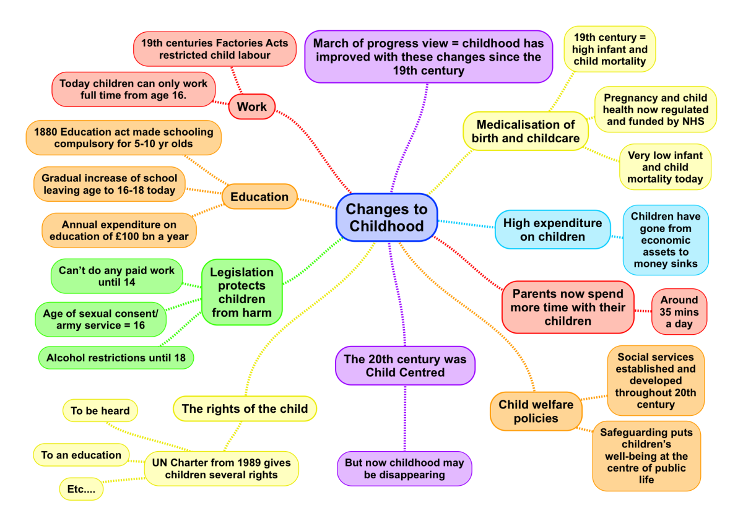

Childhood in Victorian Times

Victorian Children aims to bring together information and facts from the Victorian times which focuses on children and how things impacted on their lives.
During the Victorian times in 19th century children are faced with working in factories as they are often found working in poor conditions which may be leading to negative impact on their health which can result in children suffering at work during unpleasant environment.

As the children are at home they are also expected to take on adult duties by which are involved by doing housework and taking care of sick relatives. These circumstances are reflected by many social policies related to work and education as this impacts on the child’s mental health and wellbeing.
However, the changes happened over a very long period of time from the 1830s with the first factor acts restricting child labour right up to the present day with the emergence of the ‘rights of the child spearheaded by the United Nations.
Factors
There are several factors that may affect the social development of children depending on the safety and welfare of a child needs.
Home Atmosphere
It is important to have a safe home environment and is a place for children learn and play. A child should be feel happy and have a positive home atmosphere as this is a safe place for a child to grow in.
Affection
Affection is the type of love you that give to a child that shows affection and to nurture them in order to feel safe.
The amount and quality of affection a child is receiving by their parents shows love and car. This also builds up the their social interactions towards other people.
According to WHO since 1990 the progress of children’s death has been reducing.
The total number of under-5 deaths worldwide has declined from 12.6 million in 1990 to 5.2 million in 2019. Since 1990 the global under-5 mortality rate has dropped by 59% from 93 deaths per 1000 live births in 1990 to 38 in 2019. This is equivalent to 1 in 11 children dying before reaching age 5 in 1990 compared to 1 in 27 in 2019.
the world as a whole has been accelerating progress in reducing the under-5 mortality rate, difference exist in under-5 mortality across regions and countries. Sub-Saharan Africa remains the region with the highest under-5 mortality rate in the world, with 1 child in 13 dying before his or her fifth birthday, 20 years behind the world average which achieved a 1 in 13 rate in 1999. Two regions, sub-Saharan Africa and central and southern Asia, account for more than 80 per cent of the 5.2 million under-5 deaths in 2019, while they only account for 52 per cent of the global under-5 population.

According to Worlds Health Organization the mortality rates for children aged between 0.2 to 16.8 deaths per 1000 children aged 5 years.
As for children under 5 the highest mortality countries are concentrated in sub-Saharan Africa. Countries who have the highest number of deaths between 5-9 year olds including India, Nigeria, Democratic Republic of the Congo, Pakistan and China. (World Health Organization,2020)

Legislation
There are many age restrictions on certain activities on childhood according to the policies of children which are:
- In England the Department for Education is responsible for child protection
- Children who are aged 10 have the responsibility for their own actions

Children who are under the age of 14 cannot work however at age 14 they can still do light work.

When someone is 16 years of age, this is where they start to get more rights and be a responsible adult .

At the age of 18 this is when a person has reached the age of entitlement which means you are an adult so you have the responsibility for your own actions.. (Karl Thompson, 2020)

Child labour
Child labour is exploiting children by giving them any form of work that deprives them of their childhood and education. Child labour is very harmful to a child’s mental, physical, social, and moral development.
In the census of 2011, the total number of child labour between the age group 5-14 were 10.1 million out of total 259.64 million children in India. Child labour is not only an Indian problem around 217 million children work as child labour worldwide and many of them worked as full-time laborers. According to the world bank, Child labour has been decreased to 10% from 25% between year 1960 and 2003. The UNICEF and ILO concluded that about 168 million children work as child labor between the age groups 5-17 in 200
Figure:1 shows the estimated percentage of the population in poverty, 2019-20 to 2021-22)
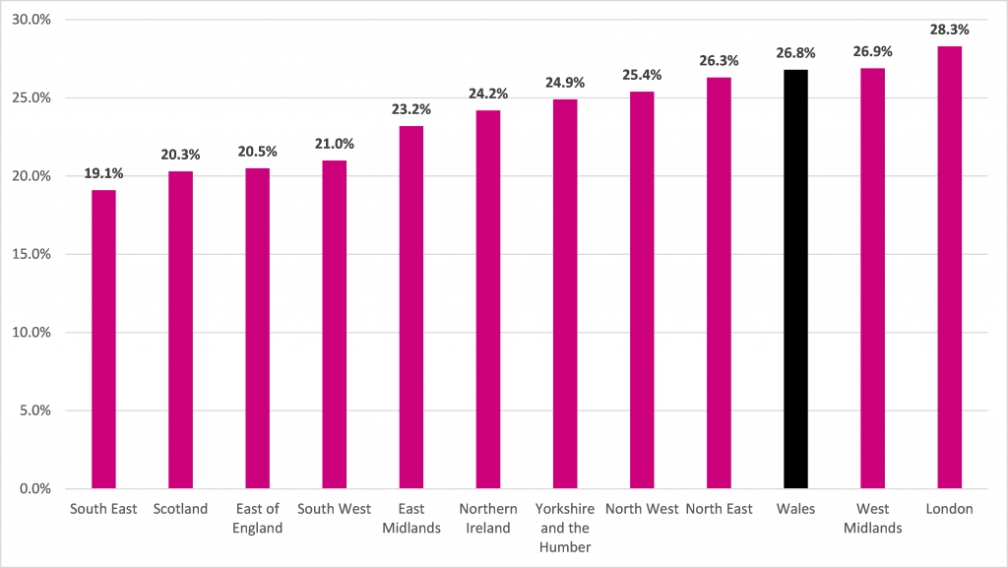

Figure 2 shows estimated percentage of children in poverty 2019-20 to 2021-22

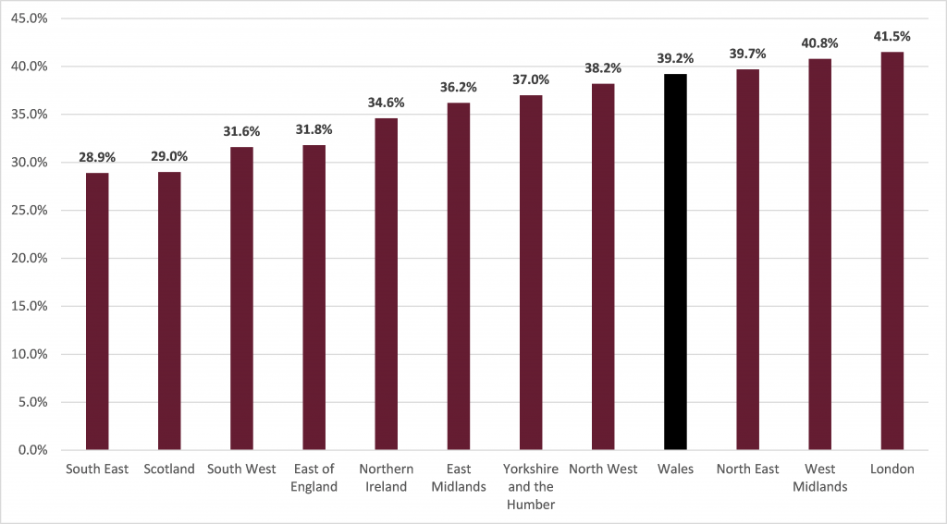

The definition of child marriage refers to any type of marriage between a child who is under the age of 18
Child brides can still become pregnant but there’s a chance of the risk of complications during pregnancy which can lead to childbirth increasing for themselves and their baby.
The practice of child marriage can also isolate girls from social interactions family and friends and remove them from participating in their social communities taking a heavy roles on their physical and psychological well-being.
As child marriage can impact on the health because this can put an effect on the emotional and mental state. This also puts the economic costs at the national level with the implications for their development. (Unicef,2020)
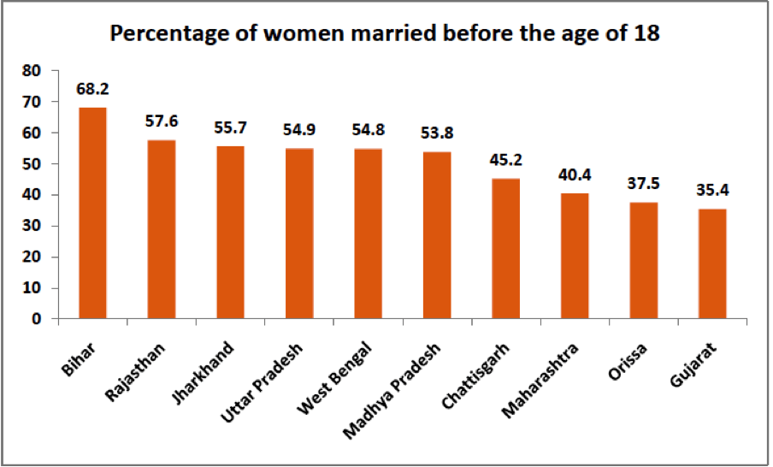

Child Slavery
Modern slavery is an umbrella term for all forms of slavery, human trafficking, and exploitation. It is a hidden crime with victims often unable to come forward due to fear or shame, or because they are unable to leave their situation. Consequently, reporting is partial and quantifying the number of victims is challenging.
There is no one data source that accurately quantifies the number of child victims in the UK. The National Referral Mechanism (NRM) currently provides the best measure of potential victims, although is known to be an undercount. Data for the UK NRM for the year ending December 2021 shows
The are many forms that refers to child slavery which includes:
- Children who are encouraged in prostitution, pornography or other forms of sexual exploitation
- Children who are forced into crimes such as drug trade
- Forced labour exploitation
- Children who is forced to marry anyone under 18 who doesn’t consent to a marriage or doesn’t fully understand consent is exploited within their marriage, or is not able to leave is living in slavery

The highest proportion of children who are in forced marriage (nearly 9 million) and the children in forced labour (3.3 million) half are in commercial sexual exploitation, and just under 40% are in forced labour exploitation in the private economy.

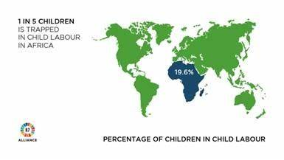

Research analysis of approaches and Interventions

The focus of this review was on early intervention with children and young people who are vulnerable to either child sexual exploitation or child sexual abuse.

Reviews of the child protection system have suggested that children who experience abuse lack a designated adult outside of the family system who is able to provide consistent support – or a ‘trusted relationship’. EIF was commissioned to provide a rapid overview of the evidence on which features of trusted relationships are critical to improving outcomes for vulnerable children and young people, and to provide policy advice on how more of these relationships could be enabled in public services.

EIF’s research included a rapid strategic evidence overview; consultation with practitioners and leaders from services working with children and young people; and testing and refining of our conclusions and recommendations with key stakeholders, including the Association of Directors of Children’s Services, Local Government Association, NSPCC, Office of the Children’s Commissioner.

There is a strong logic for thinking that trusted relationships between a practitioner and a child can protect vulnerable young people from child sexual exploitation.

There is a lack of high-quality research evidence on the risk and protective factors for becoming a victim of CSE or CSA.

There is broad consensus between research and practice on the features which allow trusted practitioner–child relationships to develop.

The ability of public services to build trusted relationships with vulnerable children and young people appears to be influenced by the characteristics of the child or young person, the practitioner, and the organisational context.

There is good evidence for the effectiveness of high-quality mentoring approaches.

EIF’s research is intended to inform Home Office policy aimed at increasing trusted practitioner–child relationships available to vulnerable children.

The issue of how to enable a greater emphasis on trusted relationships in public services is complex, given the range of interdependent factors, rather than merely technically complicated. This means that interventions which focus on single factors are unlikely to address the system relationships and interdependencies, and therefore are unlikely to lead to sustainable change.
(Early intervention Foundation,2018)

Recommendations
Childhood is based on vulnerability and the state of mind. I believe that social construction in childhood is very important as you can gain a lot of knowledge through this. As you are aware of there are many factors that can impact on children behaviour so there are many strategies and organizations to prevent this.
It is important to have a safe environment in order to have a clean environment where children can learn and play.
It is also important to be aware of on the history social constructions of childhood, so I highly recommend this for future reference.

Conclusion
In conclusion to my essay this research has been 100% successful due to the lack of information I have found along with the many policies and regulations.
I believe this essay has given me the knowledge and perspective in order gain an understanding on the perspective of the historical concept of childhood.

- Crown Prosecution Service (CPS) (2019) Prostitution and Exploitation of prostitution. (online). Available at: https://www.cps.gov.uk/legal-guidance/prostitution-and-exploitation-prostitution {Accessed: 06/08/2021}

- Education summary, (2022) Factors Affecting Social Development of the Children. Avalable at: https://educationsummary.com/lesson/factors-affecting-social-development-of-the-children/ {Assessed date: 23/10/2022]

- Early intervention Foundation,(2015) Building trusted relationships for vulnerable children and young people with public services. Available at: https://www.eif.org.uk/report/building-trusted-relationships-for-vulnerable-children-and-young-people-with-public-services. {Acsessed dae: 23/10/2022}

- Nickerson, C (2021) Social Constructionism Definition and Examples, Available at: https://www.simplypsychology.org/social-constructionism.html [Accessed date: 23/10.2022}

- Office for National Statistics, (2022) Child victims of modern slavery in the UK: Available at https://www.ons.gov.uk/peoplepopulationandcommunity/crimeandjustice/bulletins/childvictimsofmodernslaveryintheuk/ {Assessed 23/10.2022}

- Revise Sociology, (2015)The Social Construction of Childhood. Available at: https://revisesociology.com/tag/childhood-as-a-social-construction/ {Access date: 22/10/2022}

- Revise Sociology, (2020) Changes to childhood since Victorian Times, Available at:https://revisesociology.com/2020/06/30/changes-childhood-since-victorian-times/ {Accessed date:23/10/2022}

- Study Smarter, (2022) Childhood As A Social Construct, Available at: https://www.studysmarter.us/explanations/social-studies/families-and-households/childhood-as-a-social-construct/ {Accessed date: 23/10/2022}

- UNICEF, (2020) Child marriage, Available at: https://www.unicef.org/protection/child-marriage {Assessed date:23/10/2022}

- WHO, (2020) Children: improving survival and well-being. Available at: https://www.who.int/news-room/fact-sheets/detail/children-reducing-mortality {Accessed date: 23/10/2022}

