University of Wales Trinity Saint David
Wales Institute of Science and Art


A Report Analysing the Effect of Introducing a Kinetic Energy Recovery System to a Subaru Impreza WRX STI
Alternative Propulsion Systems (ACHA5010)

Aeddan Senior
2205394
21st December 2023

Contents
Introduction

- Chosen vehicle

- Dynamic Characteristics of vehicle

- Worldwide harmonised light vehicle test procedure for selected vehicle

- Mathematical calculations

- KERS power input and energy storage requirements

- Chosen KERS system

- Recovered energy used

- How the system operates and a comparison to a conventional ICE

Introduction
This report is looking at the effect of adding an energy recovery system to a vehicle. By recovering and using kinetic energy, fuel consumption is reduced. This means that the cost of travel is reduced, and fewer harmful emissions are produced.

1. Chosen Vehicle

The vehicle that I have chosen to look at is the Subaru Impreza WRX STi. I have chosen to look at this vehicle because I have been interested in this car for a while. Unfortunately, the fuel consumption for this vehicle is high. The Autoevolution website (https://www.autoevolution.com/cars/subaru-impreza-wrx-sti-2008.html#aeng_subaru-impreza-wrx-sti-2008-25-turbo)states that the fuel economy of the Impreza is 28.6 mpg on a motorway, 17 mpg in a city which results is an average of 22.8 mpg. As shown, data for in a city is significantly lower than on a motorway, this id due to the constant braking and accelerating that goes on. This makes a KERS suitable for city driving.

2. Dynamic Characteristics of vehicle

Test Mass
This is the mass of the vehicle that will be tested.
The unladen mass is 1505kg and the gross mass is 1980kg.
For the purpose of this report, I will be using the gross mass as the test mass because it is likely to be more representative of real driving conditions.
Data from https://www.autoevolution.com/cars/subaru-impreza-wrx-sti-2008.html#aeng_subaru-impreza-wrx-sti-2008-25-turbo
Frontal Area
The frontal area is the area of the car that can be seen from a distance that can be seen by someone standing directly in front of the car. According to homework.study.com an estimation of the frontal area can be calculated by multiplying 0.85 times the width of the car with the height of the car.


Frontal Area = 0.85*width*height
0.85*1798*1478
=2258827.4mm^2
=2.26m^2
(Zenlea, 2012 Subaru Impreza WRX - editors' notebook - automobile magazine 2016)
Frontal area of Subaru Impreza WRX STi

Rolling Resistance Coefficient
The rolling resistance coefficient for the Subaru Impreza that will be used is the value for the tarmacadam. The value for tarmacadam is 0.025.

Coefficient of Aerodynamic Drag
The coefficient of drag for the Impreza is 0.36.

Coast down testing
Clean fleet report (https://cleanfleetreport.com/tech-coastdown-testing) states that ‘A coast down test is often used to measure the mechanical and aerodynamic resistance that acts on a vehicle’.
Coasting is the when the clutch is disengaged, and the car slowly reduces speed. The mechanical resistance(friction) and aerodynamic resistance(drag) are the forces that cause the car to slow down when the car is coasting. If you know the mass of the car and the rate of deceleration it is possible to calculate the total force on the car.
Faero + Fmech = m*a
The following equation can also be used to calculate the coefficient of drag or the coefficient of rolling resistance:
(ρv²CdA)/2 + CrrN = m * a

3. Worldwide harmonised light vehicle test procedure for selected vehicle
Evans Halshaw (https://www.evanshalshaw.com/blog/what-is-wltp/) states that the WLTP ‘is the most recent testing process for measuring new car fuel economy, electric driving range and emissions’.
During a usual journey that could take place the WLTP looks at different phases of the journey, such as:
- Acceleration
- Braking
- When the vehicle is stationary
Areas which are considered while the car is being assessed include:
- Rolling resistance
- Air resistance
- Different engine and gearbox combinations
- Optional equipment
The class 3 test cycle includes vehicles with a high power to mass ratio and vehicles with a greater top speed that 120km/h are in class 3b. The Subaru Impreza is in this class.

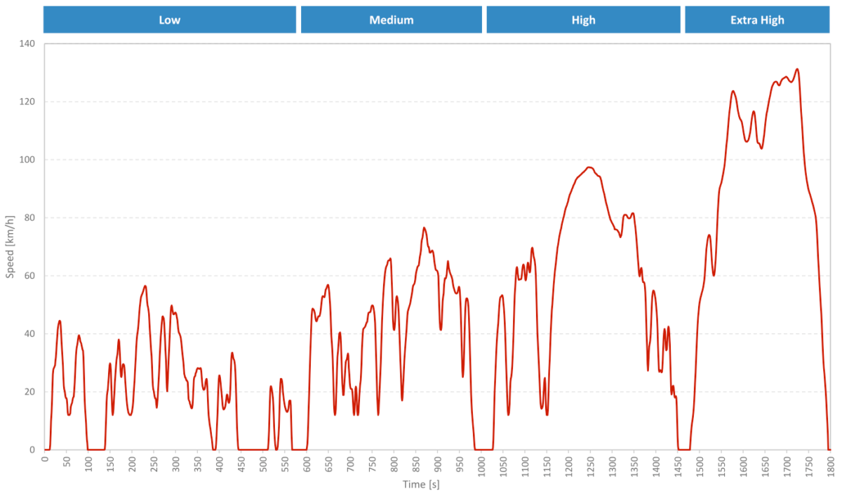
WLTP Cycle for Class 3b Vehicles
Evdb (2023) WLTP explained: Simplifying range and efficiency, EVDB. Available at: https://evdb.nz/wltp (Accessed: 02 January 2024).

The WLTP is being used to test whether it is beneficial to use KERS systems in cars and how the real-life conditions would affect the they the car is driven. The WLTP Is split in to cycles that represent real life driving and measures the fuel consumption and CO2 emissions.
‘The WLTP driving cycle is divided into four parts with different average speeds: low, medium, high and extra high. Each part contains a variety of driving phases, stops, acceleration and braking phases.’ (https://www.wltpfacts.eu/what-is-wltp-how-will-it-work/)
The four parts that are used for the WLTP are urban, suburban, main road and motorway. The parts that a KERS system will be most beneficial are urban and suburban. This is because of there are multiple acceleration and deceleration phases where the energy is used and recovered. A KERS system would be useful for the Impreza because of its poor fuel consumption in urban and suburban areas.

4 Mathematical calculations
Where the velocity decreases, there is an opportunity for the KERS system to recover kinetic energy. There are 20 opportunities for this to happen in phase 1. There was 1 deceleration that resulted in no energy being available. This is because of the change in speed was negligible.
There are 16 opportunities for energy to be recovered in phase 2. There were 2 deceleration that resulted in no energy being available.

WLTP Data
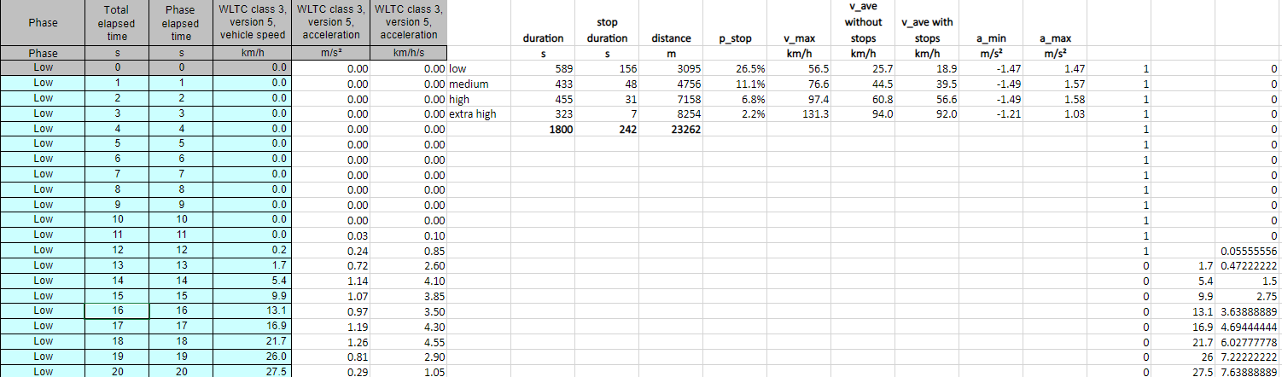
Below is the data for the first 20 seconds of the WLTP driving cycle. This data will be used to help calculate the energy available for KERS.

Data for acceleration resistance, rolling resistance, aero resistance, total resistance and power for the Subaru Impreza based on the WLTP driving cycle

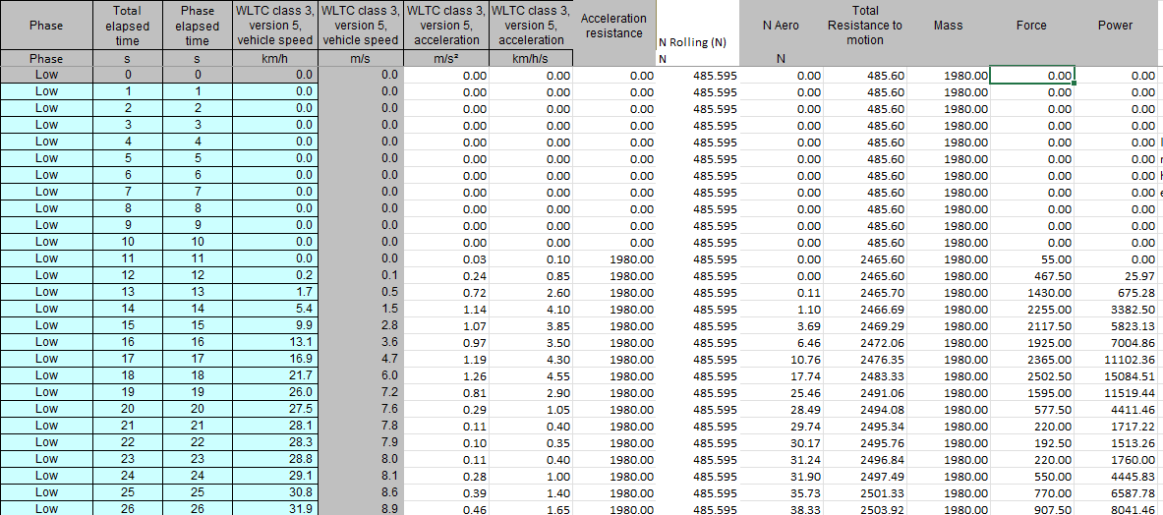
Phase 1

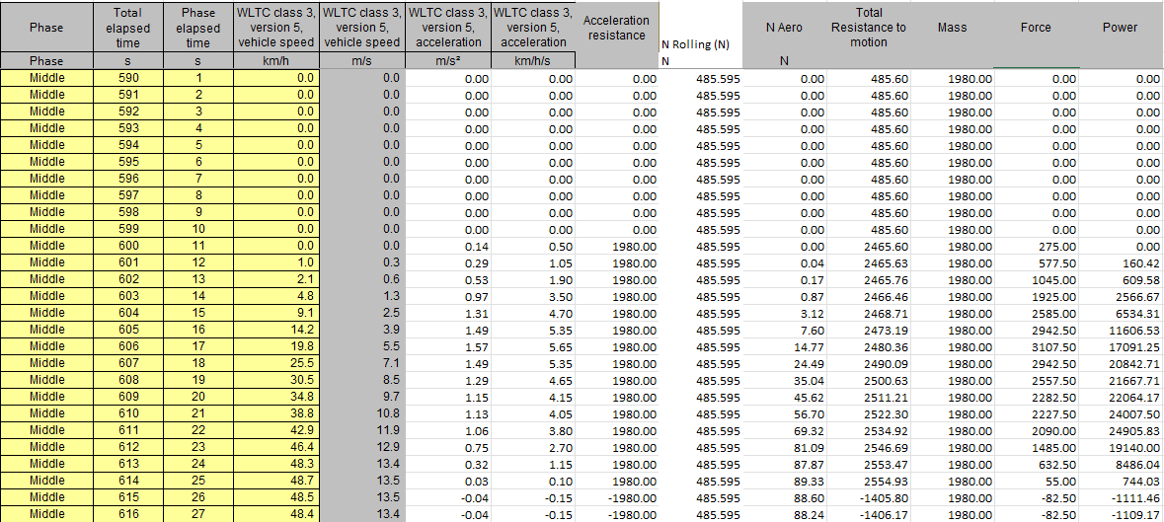
Phase 2

A spreadsheet of calculations to identify energy available for KERS for a Subaru Impreza

5. KERS power input and energy storage requirements
The time that the KERS system will be used more will be in towns and cities when the accelerating and braking is more frequent. The KERS system will also be effective when on country roads which also have a lot of accelerating and braking. This gives a lot of opportunity for the kinetic energy to be recovered and used. With the KERS system being more effective in the low and medium phases of the WLTP the data chosen to decide the capacity of the KERS system should come from these phases.

From the graphs above it is clear that having a KERS system with a capacity considerably over 200KJ would be inefficient as there are only 2 decelerations points that make available above 200KJ for KERS. Most of the deceleration points are well below that. In phase 4 there was 1 deceleration point that was over 1000KJ, but this was exceptional. And would be unlikely to compensate for the size of the energy store required to harvest it.
An appropriate minimum size energy store would be 250KJ, because a reasonable number of deceleration points are closed to 200. It would be best to leave some extra capacity to take account of different driving styles and the conditions that might be faced by different drivers.

6. Chosen KERS System and
The KERS system I have chosen to look at is a flywheel KERS system. Volvo uses the system in their vehicles

The Green Car Guide have examined a Fly wheel system being developed by Volvo for use in road cars.
https://www.greencarguide.co.uk/features/volvos-flywheel-kers-puts-a-new-spin-on-hybrid-cars/
‘Volvo has fitted its experimental KERS module to the rear axle of an S60 T5 saloon car, which retains its original five-cylinder petrol engine driving the front axle.’ The system used is a fly wheel.
‘The KERS module improved fuel economy results under the NEDC test regime by an impressive 25 per cent. As the Subaru Impreza is quite fuel inefficient this would make a significant difference to fuel consumption.
‘Volvo’s KERS unit can store up 150Wh.’ This a relatively small capacity compared to other KERS systems but is more than adequate for the Subaru Impreza as the capacity that is needed is only 250KJ for urban and suburban driving. 150Wh is equivalent to 540KJ
‘Due to its purely mechanical nature, KERS can flip from storing to releasing energy extremely quickly and efficiently, making it ideally suited to real-world situations like stop-start urban traffic or twisting country roads, where there are short and frequent switches between braking and accelerating. Round-trip energy efficiency is around 70%, almost twice the level for a battery-based equivalent.’ This would make a similar system on a Impreza very effective at reducing fuel consumption in towns and cities where the Impreza is particularly poor.
‘The KERS module itself weighs around 60kg and uses a 6kg, 20cm in diameter Fly wheel, which is very small easy to fit within the car.’
The size of the KERS will be the same size as the Volvo designed system, because Volvo has done their research with the Volvo 60 which a similar size to the Impreza. This means that it makes sense to use a similar capacity KERS for the Impreza.

Components
The KERS is made up of a flywheel module, CVT module and output gear train connected to the rear axle. Set up as in the diagram below.

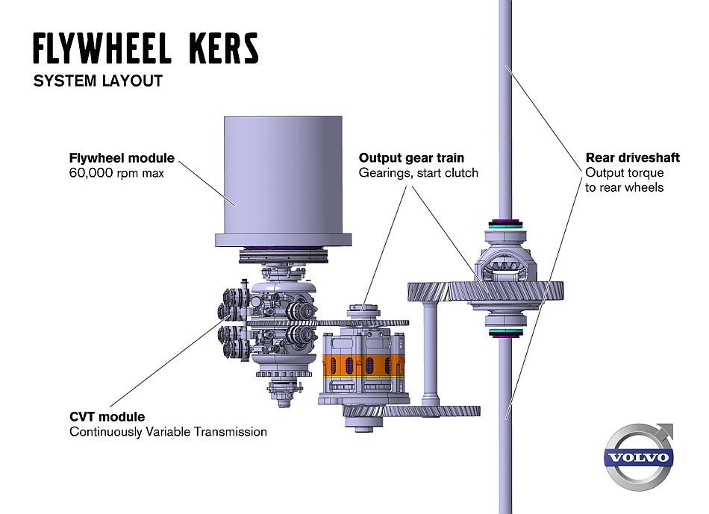

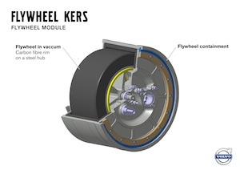
The fly wheel stores the energy by spinning. The fly wheel can store more energy by being larger or spinning faster. The fly wheel would need to fit in the car without taking up too much space and not be to heavy otherwise the increase weight would make fuel consumption less efficient. Volvo’s Flywheel is 20cm in diameter 6kg. This means it needs to spin extremely fast to store energy.

KHK Stock Gears says that ‘a mechanism with two or more gears meshed in series and its axes interlocked by a proper link to transmit power and to increase/decrease rotary speed is called a gear train.’ In this case the gear chain is increasing the rotary speed of the flywheel relative to the rear axle when the car is braking, and transmitting the momentum back to the axle when accelerating
Green Car Guide state that ‘kinetic energy is fed into and out of the flywheel via a compact continuously variable transmission (CVT), built by Torotrak – another UK company that part-owns Flybrid Automotive. A CVT coupling is needed to allow a slowing rear axle to smoothly feed power into an increasingly quick-spinning flywheel during energy capture, and vice versa when providing boost.’

System operation
The system is fairly simple, with a gear train and CVT that transfer Kinetic energy from the rear axle to the fly wheel when braking and from fly wheel to the rear axle when accelerating. The CVT allows the energy to be transferred efficiently and smoothly. The CVT acts as an automatic gear box meaning that the gear ratio between the axel and the flywheel is constantly adjusted to the appropriate ratio.

Variations the driver may feel
When the vehicle is moving the driver should not feel any difference when braking, when accelerating the KERS system will kick in resulting in faster acceleration, or reduced fuel usage and a reduction in emissions. This would be particularly pronounced in towns and cities where the driver would be braking and accelerating frequently.
There would not be any great benefit on dual carriageways and motorways because the vehicle speed would be fairly constant with very few braking and acceleration points.
In summary the driver would benefit from faster acceleration, better fuel consumption (Cheaper to drive), lower car tax bills and, less pollution than when driving a conventional ICE and friction-based vehicle.

Assumptions made
All the data is based on the WLTP Cycle. The assumption was made that all cars are driven in a way that matches the WLTP Cycle. This is not true, because some drivers will have a different driving style. They could be more aggressive in their use of the throttle brake and clutch, they could be driving in different areas where the road conditions are different. For example, someone living in Swansea (urban) will experience different road conditions to someone living in Powys (rural)

References
(Tan, Subaru's UK sales fell 68% in 2020, sold below 1K cars - new boss describes performance as 'embarrassing' 2021)
Profir, F. and Serban, T. (2021) Subaru Impreza WRX STI Specs & Photos - 2008, 2009, 2010, 2011, 2012, 2013, 2014, autoevolution. Available at: https://www.autoevolution.com/cars/subaru-impreza-wrx-sti-2008.html#aeng_subaru-impreza-wrx-sti-2008-25-turbo (Accessed: 10 January 2024).
The frontal area a represents the frontal projection of the car’s area . Available at: https://homework.study.com/explanation/the-frontal-area-a-represents-the-frontal-projection-of-the-car-s-area-and-could-be-approximated-simply-by-multiplying-0-85-times-the-width-and-the-height-of-a-rectangle-that-outlines-the-front-of-a-c.html
Kevin (no date) How to calculate rolling resistance. Available at: https://x-engineer.org/rolling-resistance/ (Accessed: 02 January 2024).
Printable version - specifications - 2018 WRX & WRX STI - Subaru Canada. Available at: https://www.subaru.ca/Print/Specifications.aspx?WebSiteID=282&+WRX+STI&CarIds=1025&GroupID=5&t=1499990550002 (Accessed: 02 January 2024).
(Zenlea, 2012 Subaru Impreza WRX - editors' notebook - automobile magazine 2016)
Evdb (2023) WLTP explained: Simplifying range and efficiency, EVDB. Available at: https://evdb.nz/wltp (Accessed: 02 January 2024).
How To Use Coastdown Testing for Drag Measurement (no date) Cleanfleetreport.com. Available at: https://cleanfleetreport.com/tech-coastdown-testing/ (Accessed: 10 January 2024).
Dale, N. (2021) What is WLTP and what does it mean? WLTP explained, Evans Halshaw. Available at: https://www.evanshalshaw.com/blog/what-is-wltp/ (Accessed: 10 January 2024).
Rooke, N. (2011) Volvo Car Corporation, flywheel KERS, component details., Volvo Cars Global Media Newsroom. Available at: https://www.media.volvocars.com/global/en-gb/media/photos/38469 (Accessed: 14 January 2024).
Gear trains (no date) KHK Gears. Available at: https://khkgears.net/new/gear_knowledge/gear_technical_reference/gear-trains.html (Accessed: 14 January 2024).

