Student name
Velko Chakalov
Student ID
1917352
Lecturer name
miss Rula Alousi
Module title
LCBB4004
Marketing Fundamentals
Assignment 1
Blogging Community
“Blog on ZARA”

Introduction
Zara is a fashion chain stores convinced in 1975. Spanish group named Inditex owned by a Spanish, Amancio Ortega, founded the famous lifestyle brand. Zara has been one of the leading fashion retail brands worldwide and has the best fast-fashion concept. Zara has an extensive product line, including clothing’s, shoes, beauty, perfumes and other fashion products (Zara.com, 2020). The headquarter of Zara is in Spain, and it has over 2270 stores worldwide. Zara is a million-dollar company in the retail industry and is pacing up with all the competitors. Its innovative and unique business approach and robust use of effective supply chain. The supply chain and customer-oriented service of Zara make the brand highly trustable and acceptable globally. After opening the first shop in Spain, Zara now has almost 3000 stores worldwide and is prevailing in the fashion industry with the highest rankings. After the Covid-19 pandemic, the fashion industry has declined, but Zara somehow managed to get a good year because of its supply chain.

History of Zara and It’s Success
Zara was ranked 29th best global brand in 2019. I was ranked as one of the best brands because the core values of faith are beauty sustainability functionality and clarity. Zara has got success because of the innovative approaches and smart and effective supply chain, which prevented the waste of raw materials and excessive production. The production of Zara is roughly 20000 pet year even, and sometimes it comes down to 12000 as well (Zara.com, 2020).
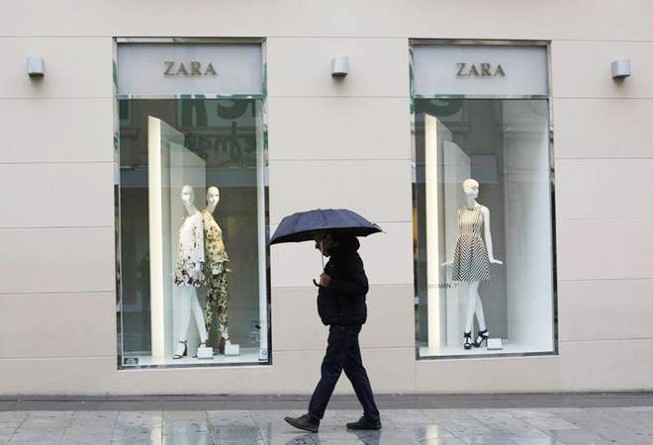
So after this statement, it is clear that Zara is more focused on quality than quantity. The main statement that made Zara successful is differentiation, innovation, and cost leadership. Cost leadership is when a brand reduces the cost of production and then increases their profit margin. Zara produces limited edition fashion clothing, and the demand for its products is mitigated with the production of its unique products.
Also, Zara husband ability to introduce new fashion and new products to the market and customers believe in the brand and its innovative approaches. The lifestyle brand Zara has now become a unique attribute in the customer's life. Whenever any customer wants to become unique and unmatched with the world, Zara serves them with the service they want.

Zara “Fast or First?”
Is Zara a kind of brand that innovates new fashion and promotes it? Is it fast to adapt to the ongoing fashion and make the innovation take another step further? Well, the answer is "Zara is Fast to adopt the new trends". Zara is no exception to the retail industry; Zara does the same things and produces the same products that other brands associate. But still, Zara stands out to be one of the best and earns more profit than other retail brands. The reason behind this secret is that Zara has a stimulating process and customer-oriented brand.
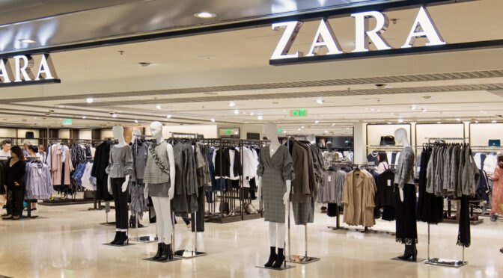
The most important thing to Zara is customer satisfaction and customers feedback. When customers give good reviews and say good things about their products, they note the strategies and procedures they need to follow. On the other hand, when customers feel like they do not like the products and wants to complain about it, Zara takes the criticism positively and instantly works on the problem.
The fact that makes Zara great is because it is a brand that thinks of the satisfaction and experience of customers and works on their feedbacks. Nowadays, the main motto of business is customer satisfaction, which is provided by Zara appropriately and adequately. Zara can be addressed as “What is new, is Zara”. The fastest brand to adapt to the changes and stimulate the fashion industry to a great level is none other than Zara, which is why it is one of the most leading brands in the fashion industry.

Innovative and Zara
Fashion is the industry that changes with a glance of the moment. Fashion is a stimulus fact that changes for every day in every single different country. It is diverse and is not the same in all corners of the world but still sticks to the timeline. Zara is a brand that adapts innovative ideas fast and turns them into their product. Java is considered the most fast-moving brand that introduces new and innovative fashion sense (Parma et al., 2020).
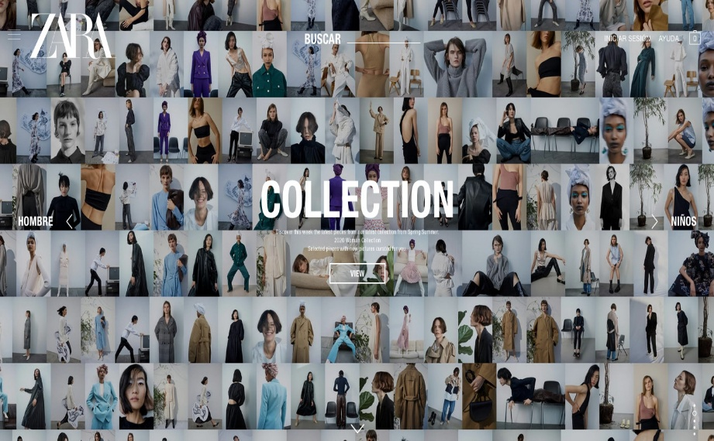
The thing that makes Zara unique is the Zara designing team. The theme ideas and inspiration from all over the world and producers new fashion trends. Zara has a team of 350 people who are in charge to look for fashion trends that are happening all over the world. The team produces almost 20000 unique products a year and design every product at it’s best. The get the ideas and inspiration from books and magazines or blogs. They are all over in the internet or fashion rules to get to know what is trending now or what make range in the current situation.
Generating ideas and new concepts is not all. The most unique and innovative things that Zara does is that bit takes feedback from each customer and monitors customers' feedback in the head headquarters. The customers tell them their genuine opinion about the products and ask the customer what should Zara change so that they can like the product better than now. This type of customer service is the most innovative way that Zara has adapted and has been continuously used to satisfy customers and build a strong customer base (Viardot and Nylund, 2017).

Zara Price strategy
Zara is a high rated brand with a strong and effective pricing model of the portfolio. It uses two types of pricing method to sell the products. Being a luxury brand, Zara should adopt the high Pricing model and ensure its profitability. Even after being a luxury brand Zara sells its products to the customers at a significant moderate rate.
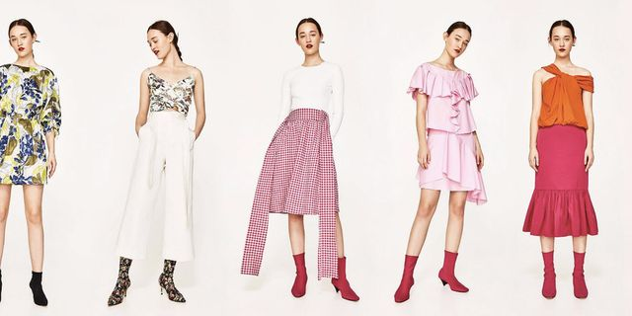
Their products and services are not that high then the other brands, but they still manage to make more profit than H&M in the last few decades. Is there any specific reason for such events? Yes. Zara uses cost-leadership methods to reduce production costs and make sure their products are of good quality and are available at reasonable prices. In the pricing method of Zara, it cuts the extra costs and adds on the value proposition to the price. It is affordable, unique, modern, different and most trusted by the customers all over the world. The increment in the labour cost may lead Zara towards a high Pricing model, and competitive pricing model is used when the market starts to penetrate rapidly (Caro, Babio and Peña, 2019).

Zara supply chain management
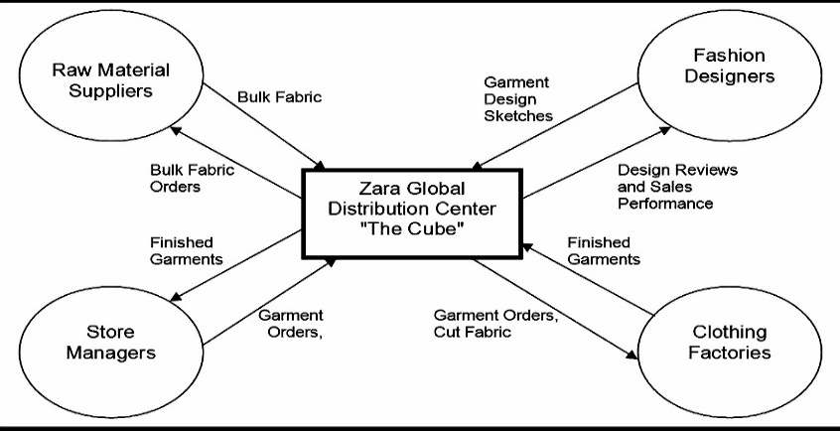
The supply chain of Zara is robust and well organised. Zara has one of the best and most influential supply chain management style by far. The manufacturing of almost 50% of its products is done in their stores in Spain. Though the products' manufacturing is done within their stores, they do the sewing work from outside suppliers. The supply chain management is flexible and very robust that the fast-changing fashion industry does not affect the supply chain of Zara that easily.
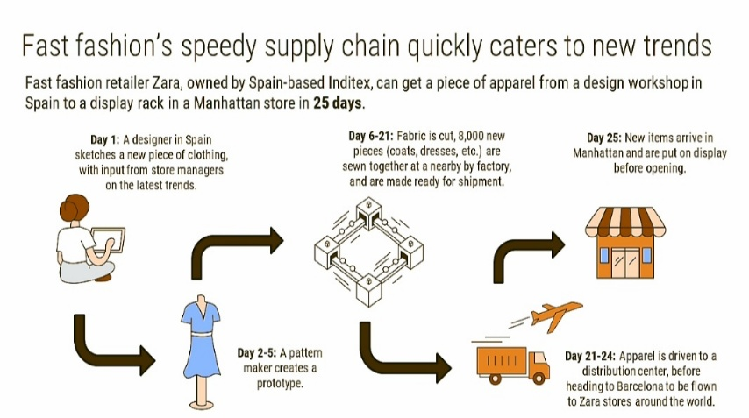
In supply chain management, the fact that it is essential to Zara is the fast supply of products. Speed is the most concerning component of their supply chain and ensures that they have established a very flexible and Fast-tracking supply chain that works more efficiently. This type of diverse supply chain adds up to their profit margin. The inventory optimisation is a significant fact that plays a great role in the supply chain of Zara. As the inventory optimisation helps estimate the required demand of products in the market, Zara happens to know the exact amount of product they need to produce. They know which product will be in demand, when the timeline will be and how they will produce the products according to their customer needs and give them the priority. This is the central aspect that has brought Zara this far in this throat cutting industry, and the robust supply chain has made the brand channel its operations (Xuejie, Chang and GuangHao, 2019).

Zara marketing strategies
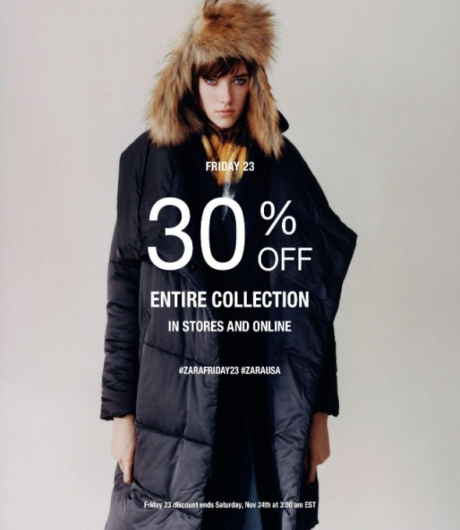

In terms of marketing strategies, Zara has a different approach than the other retail brands that are famous and globally renowned for its services and products. Zara spends the least cost in marketing, and that is why their profit margin is higher than many other companies in the retail industry. Some brands spend more than three percent of their capital in marketing purposes and marketing strategies. Instead, it does not cost even one percent of its marketing budget when it comes to Zara.
Zara follows the anti-marketing process. It spends less than .5% of its money on advertising. They hardly use any major marketing strategies for their promotion. They focus on discounts, ending inventory vacancy sales and the main thing that is their marketing strategy is the word of mouth or (WOM). The service and fast feedback that Zara gives speak tor itself. And their products and services are unusual enough to hold into their position and bring new target market into the loyal customer base. Zara is now a lifestyle brand, and it does impact the lives of their customers. That's why Zara's after purchase services are an intense form of unpaid marketing that they get to have. Also, the main thing that attracts customers towards Zara purchase is that all Zara products are unique and not replaceable. Customers can feel the differentiation and unique feel, and this is the prominent unpaid marketing or anti-marketing that Zara is following. Also, the placement of shops and outlet's is an excellent way followed by Zara to attract the impulsive buyers to purchase from them (Martimroll.com, 2020).

Conclusion
Zara is one of the leading fashion brands globally, and customers love to buy here. It is affordable, unique, modern, different and most trusted by the customers all over the world. It has become the 29th best brand all over the world and is continuing to stay at the best of its own (Martimroll.com, 2020). Zara uses the best supply chain and best innovative team to create new trends and become a unique brand. The brand has faced a slight decline in sales owing to the Covid-19 situation, but it has taken some initiatives and sales to buckle up and become as profitable as before. Zara will always remain to be the most unique and up-to-date brand and a form of differentiation for customers.

References
Caro, F., Babio, F. and Peña, F., 2019. Coordination of Inventory Distribution and Price Markdowns for Clearance Sales at Zara. In Operations in an Omnichannel World (pp. 311-339). Springer, Cham.
Martimroll.com (2020) The Secret of Zara’s Success: A Culture of Customer Co-creation Available at: https://martinroll.com/resources/articles/strategy/the-secret-of-zaras-success-a-culture-of-customer-co-creation/ [Online] [Accessed in 25 September 2020].
Parma, V., Ohla, K., Veldhuizen, M.G., Niv, M.Y., Kelly, C.E., Bakke, A.J., Cooper, K.W., Bouysset, C., Pirastu, N., Dibattista, M. And Kaur, R., 2020. More than smell—COVID-19 is associated with severe impairment of smell, taste, and chemesthesis. Chemical Senses, 45(7), pp.609-622.
Viardot, E. and Nylund, P.A., 2017. Conquering the Digital Customer: How Zara Is Confronting the Digital Innovation Revolution. In Socio-Economic Perspectives on Consumer Engagement and Buying Behavior (pp. 334-354). IGI Global.
Xuejie, C., Chang, Q. And GuangHao, Z., 2019, August. Research on Innovation supply chain Management in Fast Fashion Industry——A comparative analysis of ZARA and H&M. In 2019 3rd International Conference on Education, Culture and Social Development (ICECSD 2019). Atlantis Press.
Zara.com (2020) Welcome to Zara, Available at: https://m.zara.com/ [Online] [Accessed in 25 September 2020].

