

Student name: Janat Kiconco

Student ID: 2426595

Module name: Introduction to Pysiology

Module code: BMHP5023

Lecturer name: Dr. Soban Sadiq

Assessment: ONE

Table of Contents
1. Introduction 3
2. Blood Sugar Regulation 3
3. Cellular Metabolism 5
4. Recording and tracking blood sugar levels for type 2 diabetes 7
5. Recommendations 7
6. Conclusion 8
References 9

1. Introduction
Diabetes is a metabolic disease which is chronic and impacts the body in terms of failure to regulate the quantity of sugar in the blood. It results when the body fails to produce insulin effectively or fails to utilise insulin effectively. Diabetes has two major categories, Type 1 diabetes, which is autoimmune and Type 2 diabetes which is in large part, lifestyle-related and genetically related. The most prevalent form of diabetes is Type 2 which is becoming more common among adults because of the current lifestyle trends.
There are a number of risk factors that lead to development of diabetes and some of these include obesity, poor diet, physical inactivity, smoking and family history. These components affect the way the body utilises glucose and the insulin reactions. Diabetes is directly associated with the endocrine system, specifically, the pancreas that secretes hormones like insulin, glucagon, which control the level of blood sugar (Jwad and Al-Fatlawi 2022).
The purpose of this report is to give a clear insight on the mechanism of keeping blood glucose level within a normal range, producing energy at cellular level and the reasons that necessitate patients with Type 2 diabetes to monitor blood sugar. It also provides evidence-based suggestions on lifestyle changes that can be used by people who may control their condition and would achieve better health outcomes.

2. Blood Sugar Regulation
Blood glucose control is a vital physiological activity that keeps blood glucose within the normal limits in order to have a healthy body. The control of this process is the homeostasis and it is mainly being controlled by the pancreas that has special cells that are called the Islets of Langerhans. In these islands, there are beta cells that produce insulin and alpha cells that produce glucagon. These two hormones act in combination to help the body to stabilise the level of glucose in the blood according to the body requirements (Aldhalemi and Lahhob 2024).
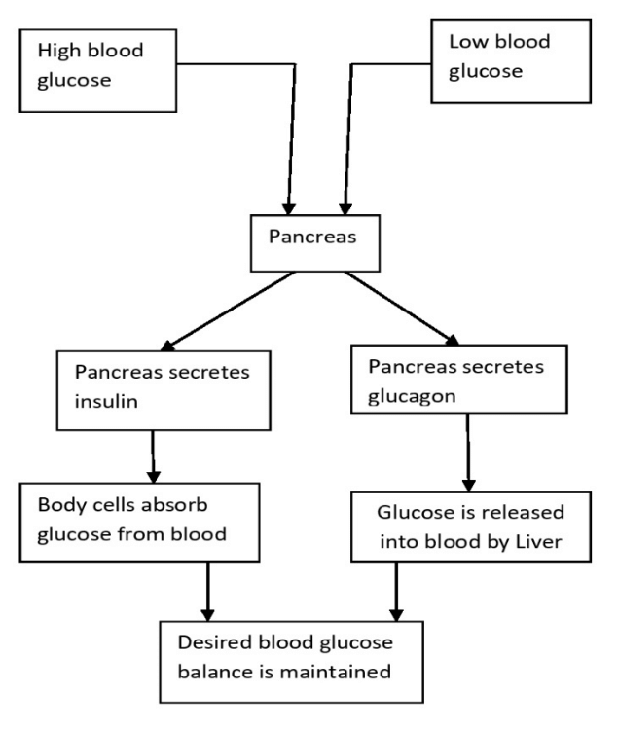
Figure 1: Mechanisms of maintaining desired blood glucose levels
(Source: Swapna et al. 2019)
Glucose is taken across the small intestines into the bloodstream following feeding on food especially carbohydrates and this increases the blood glucose levels (Hantzidiamantis et al. 2024). The insulin secreted by the beta cells of the pancreas is in response to this upsurge. Insulin attaches to the insulin receptors on body cells, especially the muscle and adipose (fat) cells and thereby the glucose is able to gain access to the cells and is used in producing energy. Any surplus glucose is introduced into the liver which converts them into glycogen and stores them in the liver via a process called glycogenesis. This action reduces the level of blood glucose and brings them to a normal level. Globally, an estimated 537 million persons between the ages of 20 and 79 (10.5% of all adults in this age range) have diabetes (Magliano and Boyko 2021).
Conversely, a decrease in blood glucose levels such as in the state of fasting, sleep, or between meals, results in the release of glucagon by the pancreas, in the alpha cells. The liver is stimulated by glucagon to break down glycogen stored in the liver to form glucose in a process known as glycogenolysis. Non-carbohydrate gluconeogenesis may also take place in the liver to generate new glucose. This glucose is then deported to the blood stream providing a boost of blood sugar and continuous source of energy and in particular the brain which is very dependent on glucose.
The liver is therefore vital towards the sustenance of blood glucose through storing and releasing glucose when it is needed (Mohajan, 2025). This is not the case in Type 2 diabetics where this system gets disturbed owing to insulin resistance. This is such that the body cells fail to respond to insulin effectively and the glucose uptake decreases making the amount of glucose in the blood to increase a condition referred to as hyperglycaemia. With time, the pancreas can also become incapable of producing adequate amounts of insulin, which also deteriorates the control of blood glucose (Fazeli and Ahanjan 2022).
Permanent hyperglycaemia may harm the blood vessels, nerves, kidney and cardiovascular system. Consequently, such complications can be prevented and overall health can be maintained by means of monitoring blood glucose homeostasis, medication, and lifestyle modifications.

3. Cellular Metabolism
The biochemical processes which go on in cells to supply energy necessary to maintain survival, growth, repair and normal body operation are referred to as cellular metabolism. Cellular respiration is one of the most significant metabolism processes that utilises glucose and oxygen to produce energy in the form of adenosine triphosphate (ATP) (Popolizio, 2024). ATP is the universal currency of the cell and it is needed in muscle contraction, transmitting nerves, active transportation, and body temperature. Cellular respiration takes place in three primary phases, which are glycolysis, Krebs cycle and the electron transport chain. Glycolysis is the initial step that occurs in cytoplasm of the cell. In the glycolysis process, a single molecule of glucose reacts to two molecules of pyruvate and a few moles of ATP are produced. This step does not utilise oxygen thus is classified as an anaerobic respiration (Zhu et al. 2024).
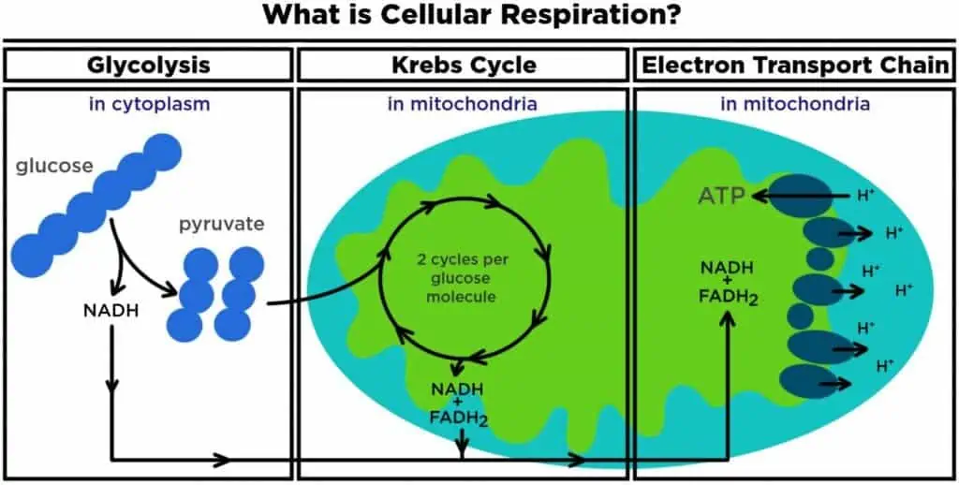
Figure 2: Cellular metabolism
(Source:
Those molecules of pyruvate get into the mitochondria and further react in the Krebs cycle also referred to as citric acid cycle. Carbon dioxide forms a waste product and the electron carriers of high energy (energy) are generated during this stage. These carriers are responsible to carry the electrons to the last process of cell respiration.
The last step is the electron transport chain that takes place in the inner membrane of mitochondria. Oxygen is also very important at this process because this is the ultimate electron donor. Large quantities of ATP are produced in this process making it the most efficient process of cellular respiration. The stage may not be effective in case of lack of oxygen, leading to low ATP production and causes fatigue and decreased cellular functioning.
The cellular metabolism is disturbed in Type 2 diabetes in individuals because of resistance to insulin (Blagov et al. 2024). After glucose is in the bloodstream, insulin is required to help the glucose come into the cell but in cases where cells are insulin resistant, the glucose will not be used to generate energy but will stay in the bloodstream. This causes the cells to lack adequate glucose to generate enough ATP to result in fatigue and poor physical performance.
Inability to use glucose may cause the body to start decomposing fats to provide energy releasing ketones as a by-product. Although ketones may be utilised as alternative energy, if the amount of ketones produced is too high, metabolic complications will be developed. Thus, effective cellular respiration relies on the effective intake of glucose and the presence of oxygen, which denotes the relevance of blood glucose regulation in diabetic patients.

4. Recording and tracking blood sugar levels for type 2 diabetes
Blood sugar level testing and subsequent glycaemic monitoring are necessary ingredients in Type 2 diabetes management. Close monitoring helps one to know the influence of factors including consumption of food, exercise, medications, stress, and daily activities on blood glucose levels. It helps to uphold homeostasis and prevents hazardous swings in the levels of blood sugar. Based on their blood sugar levels, an estimated 6.3 million people in the UK are at higher risk of developing type 2 diabetes, according to Diabetes UK (Chase lodge hospital 2026).
One of the most common techniques in self-monitoring is a glucometer which measures a small blood sample (finger-pick) of blood, as glucose. This gives instant outcomes and enables people to test their levels at various times of the day such as before and after meals or when they are sleeping. Moreover, continuous glucose monitoring (CGM) systems are also becoming more popular. These monitors apply a tiny sensor beneath the skin to scan the amount of glucose, and convey real-time information about patterns and trends.
The problem of blood glucose level monitoring is relevant in the prevention of hyperglycaemia and hypoglycaemia. Hyperglycaemia is a complication of insulin resistance or the lack of the insulin hormone that can result in cardiovascular disease, neuropathy, retinopathy, and kidney damage (Islam et al. 2025). Hypoglycaemia, though, could give way to symptoms which include dizziness, confusion, excessive sweating and worst still lapse of consciousness in severe circumstances.
It is also important to measure the level of blood sugar to show people the tendency and to comprehend how lifestyle variables contribute to their status. Healthcare professionals can also rely on such information to make changes to their treatment plans (DiMatteo et al. 2025). Consequently, the consistent monitoring would help in the efficient management of diabetes, decrease the complications, and enhance quality of life.

5. Recommendations
Treatment of Type 2 diabetes can only be implemented through lifestyle changes and evidence-based health interventions. The objectives of these strategies are better control of blood glucose, a lower risk of complications, and a healthy person with good health and well-being.
A healthy balanced diet is one of the greatest lifestyle changes that have been recommended. The persons with Type 2 diabetes ought to eat the low-refined sugar food and food that is rich in fibre including whole grains, vegetables, fruits, and legumes (Machado et al. 2023). Foods rich in fibre reduce the absorption rate of glucose into the blood stream and therefore, do not lead to fast rise in blood sugar. Portions and timing of meals also have to be taken into account because irregular eating habits may result in the rise and fall of blood glucose.
Another aspect in diabetes control is regular body exercise. A minimum dose of moderate exercise of 150 minutes per week such as fast walking, swimming, or cycling can also increase insulin sensitivity (Alabdul Razzak et al. 2025). This will enable glucose to be utilised efficiently by body cells thus lowering levels of blood sugar. Workout is also useful in maintaining weight and enhancing heart health since diabetics are more susceptible to heart diseases.
Proper weight management is especially relevant in people with overweight and obesity because, as a result of having body fat, they become insulin-resistant. A slight decrease of the body weight may considerably enhance the functioning of insulin and blood sugar.
It is much preferable that smoking should be stopped since smoking causes harm to the blood vessels, lack of oxygen in the tissues and predisposes a person to the occurrence of cardiovascular disease and other complications of diabetes. The alcohol intake should be monitored as well because over drinking alcohol intake may impair the level of blood sugar management and metabolic well-being.
Lastly, frequent medical examinations, stress reduction and proper sleep are some of the lifestyle factors that support blood sugar regulation (John et al. 2023). In general, by implementing healthy lifestyle behaviours, diabetes Type 2 can be managed and the number of long-term complications can be mitigated to a considerable degree.

6. Conclusion
In conclusion, type 2 diabetes is a chronic metabolic disease which entails insulin resistance and the body capacity to control the level of sugar in the blood. The levels of blood glucose are regulated using homeostasis of the hormones insulin and glucagon released into the blood by the pancreas. The consequence of disruption of this regulatory system is high level of blood glucose and may result in severe complications that may be related to heart, kidney, nerves, and eyes. The cellular respiration process needs glucose and oxygen to generate energy as ATP and the decreased consumption of glucose in Type 2 diabetes may lead to fatigue and impaired body functions. Thus, effective management of diabetes requires glucose monitoring and lifestyle changes that include healthy diet, exercise, weight control and cessation of smoking.

References
Alabdul Razzak, I., Fares, A., Stine, J.G. and Trivedi, H.D., (2025). The role of exercise in steatotic liver diseases: an updated perspective. Liver International, 45(1), p.e16220.
Aldhalemi, A.A. and Lahhob, Q.R., (2024). The study of chemical reactions in the human body through the use of hormones. International Journal of Advanced Biochemistry Research, 8(5), pp.01-09.
Blagov, A., Nedosugova, L., Kirichenko, T., Sukhorukov, V., Melnichenko, A. and Orekhov, A., (2024). Mitochondrial dysfunction as a factor of energy metabolism disorders in type 2 diabetes mellitus. Front Biosci (Schol Ed), 16(1), p.5.
Chase lodge hospital (2026). Prediabetes Symptoms: Early Warning Signs and How Diet Can Help. [online] Chaselodgehospital.com. Available at: https://chaselodgehospital.com/blog/prediabetes-symptoms/ [Accessed 29 Mar. 2026].
DiMatteo, M.R., Martin, L.R. and Haskard-Zolnierek, K.B., (2025). Health behavior change and treatment adherence: Evidence-based guidelines for improving healthcare. Oxford University Press.
Fazeli, F. and Ahanjan, M., (2022). The capacity of stem cells in treatment of diabetes. Cell Mol Biomed Rep, 2(4), pp.230-244.
Hantzidiamantis, P.J., Awosika, A.O. and Lappin, S.L., (2024). Physiology, glucose. In StatPearls [Internet]. StatPearls Publishing.
Islam, K., Islam, R., Nguyen, I., Malik, H., Pirzadah, H., Shrestha, B., Lentz, I.B., Shekoohi, S. and Kaye, A.D., (2025). Diabetes mellitus and associated vascular disease: pathogenesis, complications, and evolving treatments. Advances in therapy, 42(6), pp.2659-2678.
John, N.A., John, J., Tarnikanti, M., Kalpana, M., Kamble, P., Singhal, A., Ganji, V., Gaur, A., Umesh, M., Katta, R. and Saktivadivel, V., (2023). Implications of lifestyle medicine in medical practice. Journal of family medicine and primary care, 12(2), pp.208-212.
Jwad, S.M. and Al-Fatlawi, H.Y., (2022). Types of diabetes and their effect on the immune system. J Adv Pharm Pract, 4(1), pp.21-30.
Machado, D., Brás, M.A., Almeida, A. and Lourenço, A.C.G., (2023). Eating habits of undergraduate health graduates.
Magliano, D.J. and Boyko, E.J. (2021). IDF Diabetes Atlas. [online] www.ncbi.nlm.nih.gov. International Diabetes Federation. Available at: https://www.ncbi.nlm.nih.gov/books/NBK581940/. [Accessed 29 Mar. 2026].
Mohajan, H.K., (2025). A study on functions of liver to sustain a healthy liver. Innov Sci Technol, 4(1), pp.77-87.
Popolizio, T., (2024). Energy and Metabolism. Understanding Organisms: An Evolutionary, Ecological and Comparative Approach.
Puiu, T. (2020). What is cellular respiration: from food to ATP. [online] ZME Science. Available at: https://www.zmescience.com/feature-post/natural-sciences/biology-reference/biochemistry/what-is-cellular-respiration-052533/ [Accessed 1 Apr. 2026]. [Accessed 29 Mar. 2026].
Swapna, G., Soman, K.P. and Vinayakumar, R., (2019). Diabetes detection using ecg signals: An overview. Deep Learning Techniques for Biomedical and Health Informatics, pp.299-327.
Zhu, L., Li, W., Liu, Y., Li, J., Xu, L., Gu, L., Chen, C., Cao, Y. and He, Q., (2024). Metaproteomics analysis of anaerobic digestion of food waste by the addition of calcium peroxide and magnetite. Applied and Environmental Microbiology, 90(2), pp.e01451-23.

