

ACCA7031 - Digital Forensics Analysis

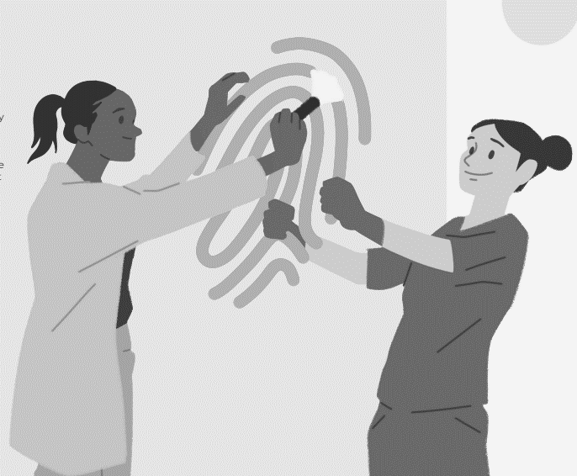



Cybercrime Incident and Digital Forensic Assessment

2231139 – Jenishkumar Paghadar

Table of Contents

Abstract 2
1. Introduction 3
List of Figures 4
List of Tables 4
2. Forensics Aspects Analysis (Task-1) 5
2.1 Current State of the Field 5
2.2 Intersection of Digital Forensics and Cybersecurity 6
2.3 Emerging Trends 7
2.3.1 Cloud Forensics: 7
2.3.2 Mobile device forensics: 7
2.4 Key Challenges 8
2.5 Job Scopes in The Market 9
3. State of The Digital Forensics Tools (Task-2) 9
4. Hard Disk Investigation (Task – 3) 15
4.1 Understanding about investigation of hard-disk: 26
5. Mobile Forensics Investigation (Task – 4) 27
5.1 Case Information: 27
5.3 Data Acquisition 28
5.4 Summary of Analysis 35
5.4 Forensic Artifacts 36
5.5 Findings 38
5.6 Understanding about investigation of Mobile phone: 39
References 40

Abstract

People all over the world have moved to the digital world because technology changes so quickly. However, this change additionally led to more cybercrimes and vulnerabilities that put people's privacy and safety at risk. This report primarily focused on how digital forensics can address cybercrime, representing a significant advancement in cybersecurity. Within the scope of this report, we will examine the most recent developments in the field of digital forensics.[1] Cloud forensics, social media forensics, and Internet of Things forensics are some examples of digital forensics emerging trends. With the assistance of this technologies, individuals working in cybersecurity can utilize the digital footprints left behind by data storage and processing to protect data and identify criminals. Several factors, including the high complexity of these systems, the vast volume of data, the chain of custody, the integrity of employees, and the accuracy and reliability of digital forensics, cause significant challenges to the widespread application of this technology.[2]

1. Introduction

The rapid expansion of technology in recent years has not only transformed the way we communicate and stay connected, but it has also opened up new opportunities for criminal behaviour. The general accessibility of digital devices and the widespread utilisation of digital platforms has led to a rise in the frequency of online criminal activities and digital misconduct. As a result, there has been a significant increase in the need for highly educated individuals who are knowledgeable in the field of digital forensics.
The Investigator in a Digital Forensics company is a combination of demanding and ever-changing responsibilities.[3] It requires a deep comprehension of several elements such as computer forensics, mobile phone forensics, and digital media investigations. It requires not just keeping up to date with the most recent technology achievements, but also understanding the legal implications and ethical concerns related to the analysis of digital evidence.[4]
This research seeks to define the extent of digital forensics, emphasizing its importance in contemporary investigative techniques. Moreover, it will go deep into current innovations in the industry, technical breakthroughs, and strategies utilized in simulated investigations. Simulated exercises are crucial for providing pathway investigators with the necessary skills and expertise needed to analyze digital evidence.
Within the constantly changing digital landscape, digital forensics serves as a fundamental pillar of investigative methodologies. The present work intends to comprehensively explore several aspects of digital forensics, encompassing its present condition, its relationship with cybersecurity, growing trends, significant obstacles, and an overview of the domestic and global employment market.

List of Figures

Figure 1: Procedure Steps of Digital Forensic Investigation 5
Figure 2: Tools Key Aspects 11
Figure 3: Tools Platform and File Formats 12
Figure 4: Operating System Files Features in Tools 13
Figure 5: Web Supported Features 13
Figure 6: Chain of Custody Form HDD 14
Figure 7: Hard Disk Partition 15
Figure 8: PowerShell Commands 15
Figure 9: Bitlocker Drives 16
Figure 10: Directory Analysis 16
Figure 11: Disk Partition Analysis 17
Figure 12: Directory List Recovery 17
Figure 13: Evidence of Credit Card Details 18
Figure 14: Evidence of Email Accounts Recovered 18
Figure 15: Evidence of Phone Numbers Recovered 19
Figure 16: Size of Data 20
Figure 17: Imaging of Hidden Partition 20
Figure 18: Evidence of Unallocated Spaces 21
Figure 19: Company Data Base 22
Figure 20: Evidence Bank Statement 23
Figure 21: Suspects List 24
Figure 22: Chain of Custody Form Mobile Device 27
Figure 23: Device Information 27
Figure 24: Summery of Evidence Analysis 28
Figure 25: Evidence Audio Files 33
Figure 26: Recovery of Data 35

List of Tables

Table 1: Forensics Tools Summery 10
Table 2: Files of Evidence 21

2. Forensics Aspects Analysis (Task-1)

In recent years, digital forensics has undergone substantial development, expanding its scope to include a variety of subfields such as computer forensics, mobile device forensics, network forensics, and others. The gathering, storage, and examination of digital evidence, which is an essential component of investigations, are all included in this process.[5] Advances in technology have made it possible for forensic investigations to gain advantages from the invention of sophisticated instruments and procedures.

2.1 Current State of the Field

A digital forensics framework, often called a digital forensics operation model, consists of processes that are designed to facilitate an effective analytics investigation, including the inputs, outputs, and requirements for each step. Utilising digital forensic frameworks not only involves a series of specific procedures for each investigation phase but also facilitates the quick and accurate reconstruction of the timeline of events and their corresponding data.[6] One of the most crucial elements of a digital investigation is ensuring the appropriate protection of the evidence chain of custody.[7] The process of digital forensics involves multiple stages, beginning with the identification of digital media found at a crime scene that could potentially serve as evidence. It concludes with the presentation of this evidence by a professional witness in the courtroom. The steps of process shown in below figure.
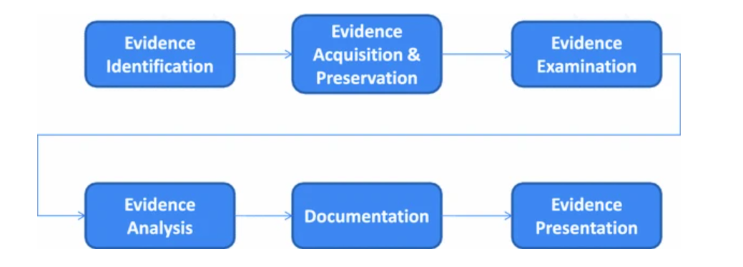
Figure 1: Procedure Steps of Digital Forensic Investigation

- The first step in digital forensics is finding relevant digital evidence. This entails identifying one or more digital storage sources that can store investigation-related data.

- Acquisition involves obtaining a binary bitwise copy of all identifiable digital media. Standard hash signatures like MD5 or SHA1 are used to certify digital-proof authenticity.

- Evidence examination, Evidence Examination: User data consists of information directly created, modified, or received by one or more individuals involved in an investigation. Metadata provides information about data, including how, when, by whom, and in what form the user data was made, changed, or accessed.[8]

2.2 Intersection of Digital Forensics and Cybersecurity

The consolidation of digital forensics and cybersecurity signifies a mutually beneficial association that is crucial for recognizing, preventing, and reducing cyber hazards. The convergence of these two aspects occurs at different points during cyber incidents, starting with preventative measures to analyze problems after they occur.[9]
- Incident Response and Forensic Investigation: Forensic investigators gather and examine digital evidence from hacked systems, networks, or devices.[10] This analysis aids in reconstructing the historical sequence of events, identifying the extent of the security breach, and attributing the occurrence to particular attackers or malware.
- Threat Intelligence and Proactive Forensics: Digital forensics uses data from past cyber events to improve our understanding of threats. Cybersecurity experts can make defences stronger against similar threats by looking at past events, behavioural trends, and attack vectors.
- Cybercrime Investigations and Law Enforcement: Digital analysis and law enforcement working together are very important for finding cybercriminals. Digital forensic experts help gather, store, and examine digital proof that is relevant to the law.
- Forensic Techniques in Cybersecurity Operations: Cybersecurity operations depend on the use of forensic techniques to actively monitor and analyze security occurrences in real-time. Forensic tools and procedures aid in the analysis of system logs, network traffic, and other digital artefacts to detect irregularities and potential security breaches.

2.3 Emerging Trends

2.3.1 Cloud Forensics:

Cloud computing is a rapidly evolving technology that has been used globally by both the public and private sectors. Cloud computing offers services tailored to the user's requirements, including Software as a Service (SaaS), Platform as a Service (PaaS), and Infrastructure as a Service (IaaS). DFaaS (Digital Forensics as a Service) is highly influential in the present state of forensic science. However, there is a need to enhance the current procedures of the model.[11] It includes addressing possible interruptions while accessing the internet-based service and the reliance on internet connection speeds for submitting investigational documents.
Replicating evidence on cloud servers introduces redundancy, which in turn increases the time complexity of retrieving a file from the storage. Furthermore, having two different investigational files with similar names affects the index-searching technique.
However, technological development requires more attention. Digital forensics and cyber forensics investigations need better assistance for users. Cloud services have the potential to provide greater computational power, which can assist investigators in cybercrime and other related activities.

2.3.2 Mobile device forensics:

Mobile devices are subject to forensic science. Forensics is currently the most popular field of research all around the world. The recovery of digital evidence from a mobile device is the subject of this scientific discipline. In order to provide an in-depth look into mobile technologies and their involvement in forensic procedures, you need to establish guidelines. The worldwide rise of social networking programmes used on smartphones makes a cell phone a valuable resource for investigation.
Android phones and iPhones contain significant amounts of valuable data that may be retrieved for forensic examination. However, BlackBerry devices are unable to restore or track any data.
In addition, space is not only accessible in the social networking sector but also in the well-known open research fields of mobile device forensics, such as mobile file carving, mobile forgery, restoration of compressed and hidden data quality, live mobile forensics analysis, and several others.

2.4 Key Challenges

The field of digital forensics encounters various obstacles, such as the encryption of data blocking access, the swift advancement of technology rendering forensic techniques outdated, the widespread use of mobile devices complicating investigations, and the necessity for legal frameworks to guarantee the acceptance of electronic proof.[12] There are different key challenges described below.

- Encryption is the process of hiding data that can only be decoded and read by someone possessing the appropriate decryption key. Encryption is employed to conceal or obfuscate the evidence on the compromised system. Adversaries implement diverse encryption techniques, making it necessary for experts to crack the encrypted data to render it usable.[13] Cracking the encrypted data is a time-consuming process, and there are instances where the mixed data cannot be decrypted.

- An undercover communication channel, typically referred to as a secret channel, enables attackers to hide information from the organization and potentially bypass detection mechanisms. Attackers employ these underground techniques to establish an indirect connection between themselves and the compromised system. It is a bit more difficult to identify.

- Wiping residual data is sometimes called data clean-up. Some hidden cycles operate without the attacker's knowledge when using a computer to achieve a purpose. A skilled attacker can mitigate this danger by deleting machine tracks and making the structure appear unutilized.

2.5 Job Scopes in The Market

The estimated size of the Digital Forensics Market in 2024 is USD 6.65 billion, and it is projected to reach USD 12.21 billion by 2029. During the forecast period from 2024 to 2029, the market is projected to grow at a compound annual growth rate (CAGR) of 12.92%.
The increasing prevalence of IoT devices, along with the developments in traditional crime lab infrastructure, the expanding penetration in corporate sectors, and the growth in cyber-attacks and crimes, have led to a surge in the usage of digital forensics.[9] According to the Internet Crime Complaint Centre (ICC) and the Federal Bureau of Investigation (FBI),[14] the IC3 received reports of 43,300 instances of online identity theft. The category of phishing and similar fraudulent activities received the highest number of complaints, totalling 241,342. Due to growing number of cyber threats and attacks by organization and individuals is increasing in the world. Current Job Vacancies in the U.K 494 post open for various designation in the digital forensics field.[15]

3. State of The Digital Forensics Tools (Task-2)

Generally, digital forensics entails preservation, the extraction process, recognition, examination of data, and the provision of a report. Currently, there are a wide range of digital investigative tools that could significantly simplify the work of a forensic investigator. These tools have a limited range of functions. For example, some tools are appropriate for performing such task. There are different types of tools listed below.
- Autopsy Sleuthkit: The Sleuth Kit can analyze disc images to bring back deleted data. It lets a detective look at data from the disc and file systems. It is used a lot by the military, law enforcement, and business examiners. Autopsy is a digital forensics platform and graphical interface for The Sleuth Kit and others.[16]

- Redline: It provides host investigation capabilities to users to find sign of spying activities through memory files and create threat assessment profile. Redline has the capability to conduct an audit and get all active processes and drivers from memory, metadata of the file system, registry data, event logs, network information, services, tasks, and web browsing history.[17]

- Belkasoft Evidence Centre: Belkasoft Evidence Centre (BEC) is a commercially available forensic instrument that offers a trial version. Belkasoft Evidence Centre (BEC) facilitates the process of obtaining, examining, evaluating, storing, and disseminating digital evidence discovered within the computer, mobile devices, RAM, and cloud.[18]

- ProDiscover Basic: Forensic investigators use ProDiscover, a comprehensive tool. It streamlines the management of computer forensics cases. Investigators can gather time zone data, web surfing activities, and device information using a report, if necessary.[19]

- Xways Forensics: Computer forensic examiners operate in an advanced environment at X-Ways Forensics. X-Ways Forensics operates significantly faster, identifies deleted files and search results that rivals will overlook, requires no specialized hardware, and does not require the creation of a complex database.[20]

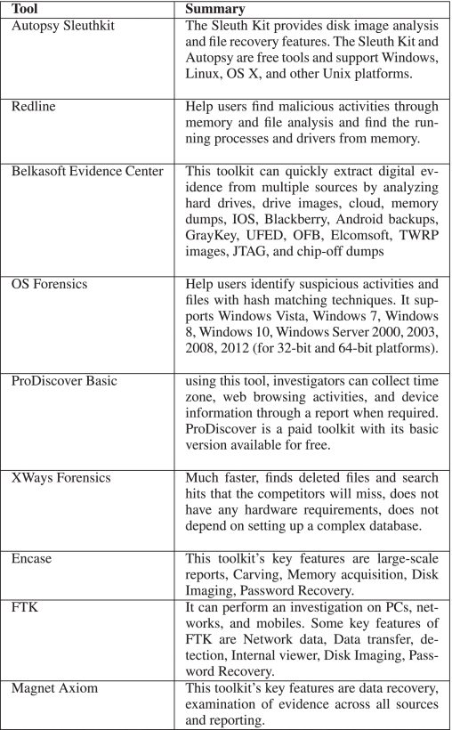
Table 1: Forensics Tools Summery

- Encase: Encase is a popular forensic tool worldwide. Possibly, 90% of the investigators make use of this technology. The main characteristics of this toolset are extensive reporting, Carving, Memory acquisition, Disc Imaging, and Password Recovery.[21]

- FTK: The company credited with developing FTK is Access Data Group. They offer instruction and accreditation for forensic tools. Over 130,000 governing bodies and legal firms utilize FTK. FTK offers several essential functions, including network data analysis, data transfer capabilities, detection capabilities, an internal viewer, disc imaging functionality, and password recovery capabilities.[22]

- Magnet Axiom: Magnet Axiom possesses the capability to retrieve data from smartphones, computers, and the cloud. Magnet Axiom additionally offers the capability to analyze evidence from all sources within a single case file. Additionally, it offers and communicates insights using robust analytics and reporting capabilities.[23]

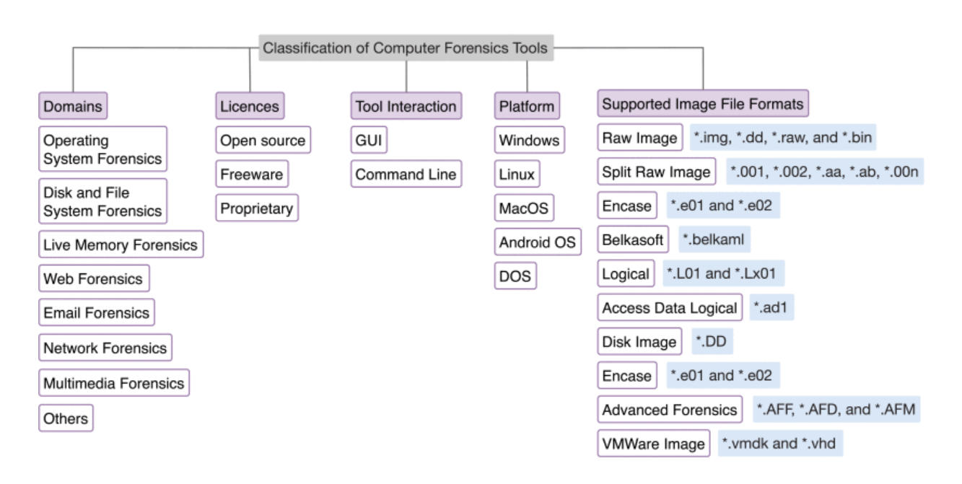
Figure 2: Tools Key Aspects

There are also a number of new tools that have been developed by the forensic community for the purpose of analysing digital evidence. These tools include hard disc photographs, networks, memory dumps, phones, logs, and many more. Corporate tools like Guidance application and AccessData came up with proprietary evidence storage formats and announced FTK Forensic tool and Guidance Encase for investigate digital evidence. Pyflag, log2timeline, volatility and Sleuthkit, Wireshark are publicly available tools.

In most cases, the proof is supplied in the form of a huge number of binary metadata.[24] Additionally, the tools offer read-only interfaces to the data at both the textual and hexadecimal levels of abstraction. There are some tools described with supported platforms and filesystem types in figure below.

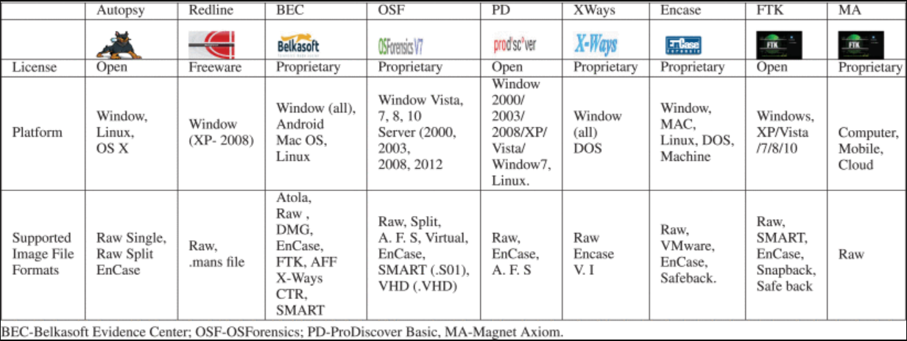
Figure 3: Tools Platform and File Formats

Deep analysis: Forensic investigators carry out forensic investigations during the investigation process for various reasons. Depending on the nature of the crime that was committed, the investigation that is required will follow a particular pattern. As one example, proof discovered in the Messenger Chat app might be more useful, and for another, audio recordings might be more interesting when examined.

It analysed the prominent attributes offered by forensic tools in each field and conducted a comparative assessment of the tools with each other. We have selected tools that are particular to the area and conducted a thorough analysis of their features to make comparisons. A few examples of such tools include Volatility, Network, and Miner.

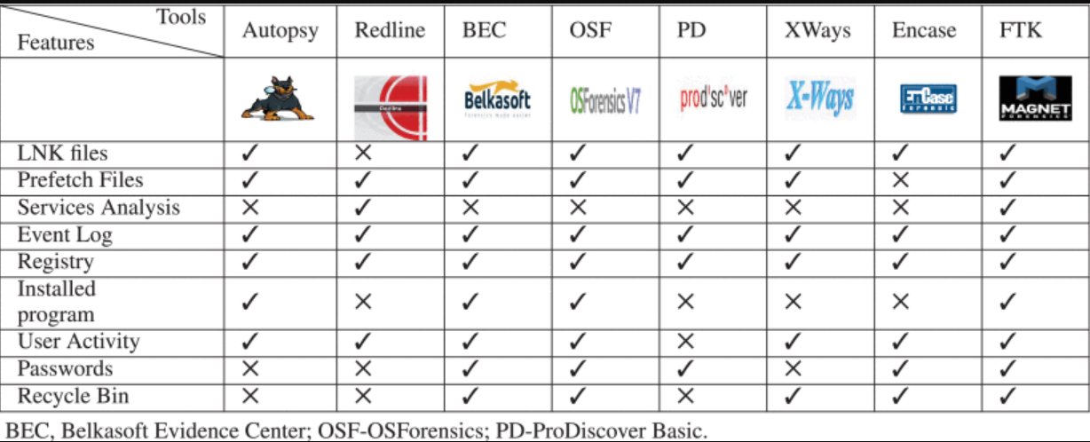
Figure 4: Operating System Files Features in Tools

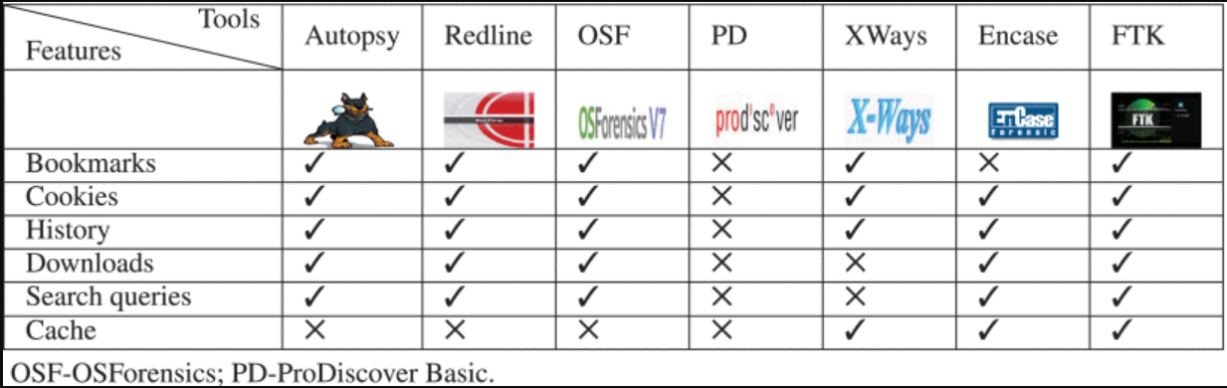
Figure 5: Web Supported Features

Belkasoft Evidence Centre, Windows Scope, and Redline tools are working based on Graphical user interface but Encase and Volatility tools can use by command-line interface. While F-Response tool can be utilised by both Graphical and command-line interface.

4. Hard Disk Investigation (Task – 3)

HDD GROUP REPORT

Scenario: corporate crime

An online dating company called Red Hot Passion has received veiled threats that confidential information such as (Payment information, Names, Addresses, Job positions, and Photographs) stored in database documentation and other communications via text messages emails, and videos could be leaked by unknown sources.

This information is more so sensitive due to the nature of the website which provides a platform for married members to engage in infidelity. This is an invasion of the user’s privacy who trusted that website would confidentially retain their information. A lot of the users of the website work in high positions of importance such as at Fortune 500 companies and in high-end managerial positions and could be under pressure of firing if this information was leaked as well as affecting the security of their marriages.

It is believed that several employees/employees of administration staff could have potentially had access to this sensitive information and have left the company recently. These employees could have potentially been disgruntled and could have had reasons to want to take revenge against the company due to previous payment disputes.
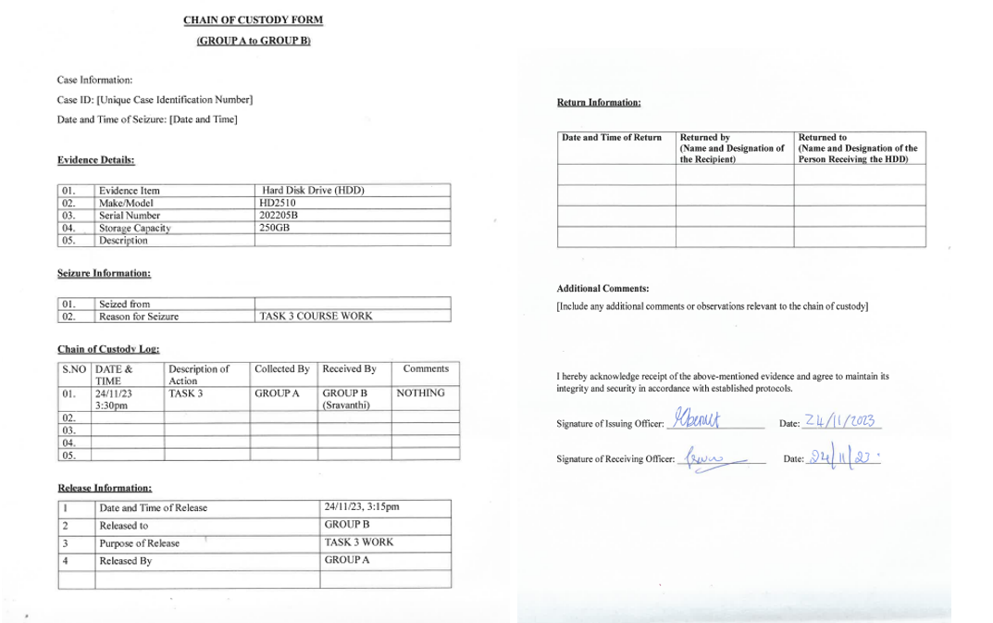
Figure 6: Chain of Custody Form HDD

The HDD came with about 4 different partitions, lettered E, F, G, and H. Part. F and G have BitLocker password encryption without a password given.
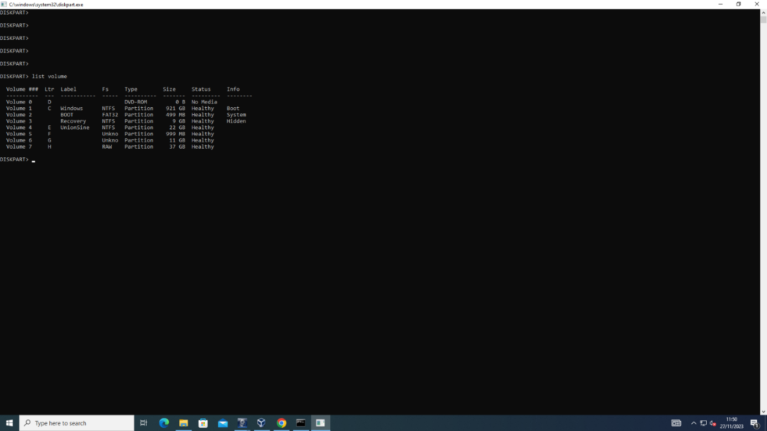
Figure 7: Hard Disk Partition
We tried to disable the BitLocker using a PowerShell command “disable-BitLocker”, but it didn’t work. Except we use the system that was used to add the BitLocker on the HDD.
The screenshots below are proof of the PowerShell command.

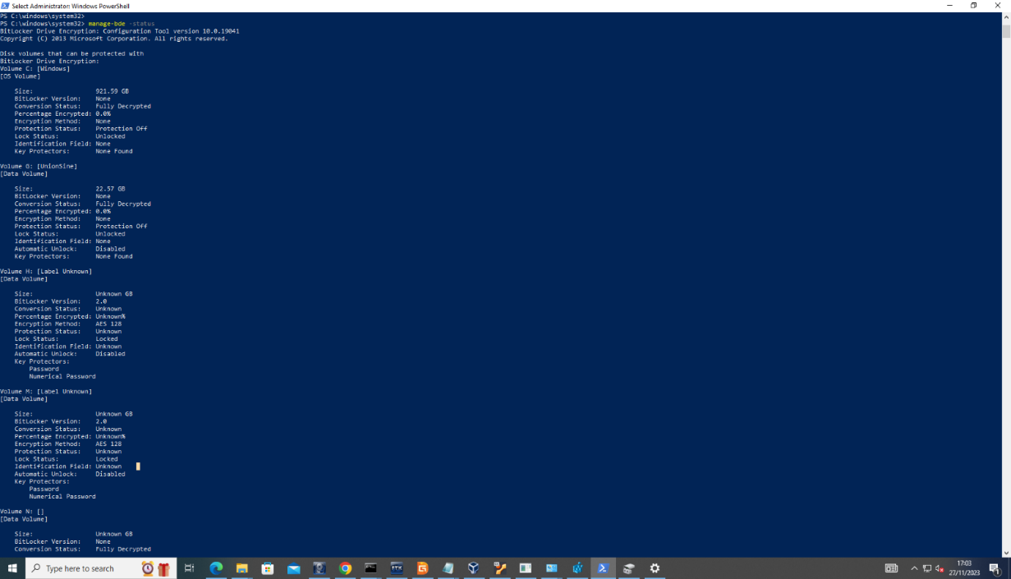
Figure 8: PowerShell Commands
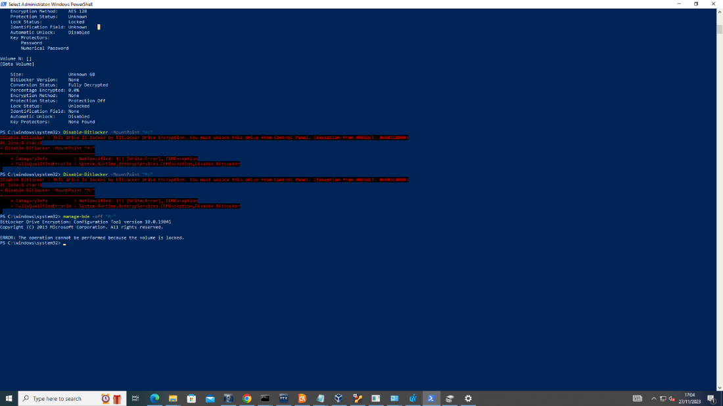
Figure 9: Bitlocker Drives
After several attempts to unlock the BitLocker drives, we reached out to Team A concerning the difficulties we encountered trying to unlock the BitLocker, we were informed that the BitLocker drives don’t contain any files and that we should ignore it.
We took an Image of all visible partitions on the HDD using FTKImager, we tried to analyze the image using the Autopsy tool, and we could recover previously stored and deleted files from the HDD.
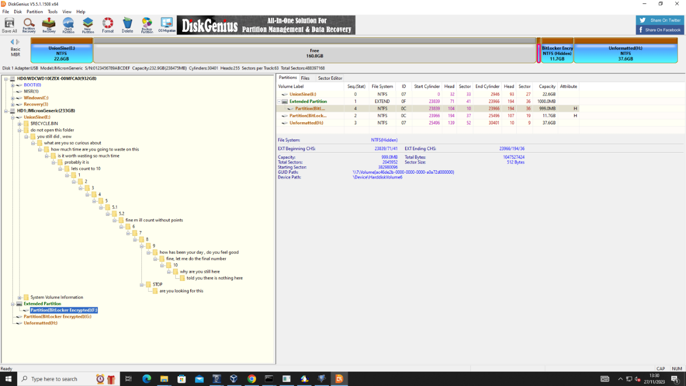
Figure 10: Directory Analysis
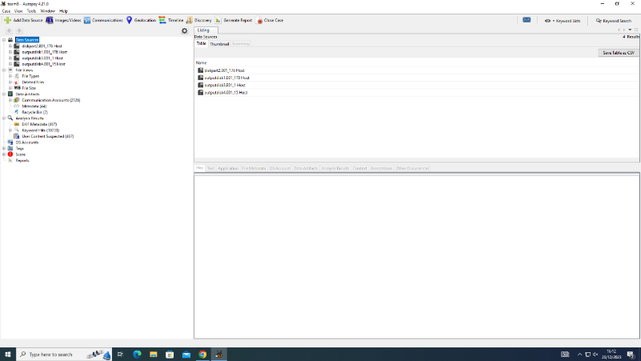
Figure 11: Disk Partition Analysis

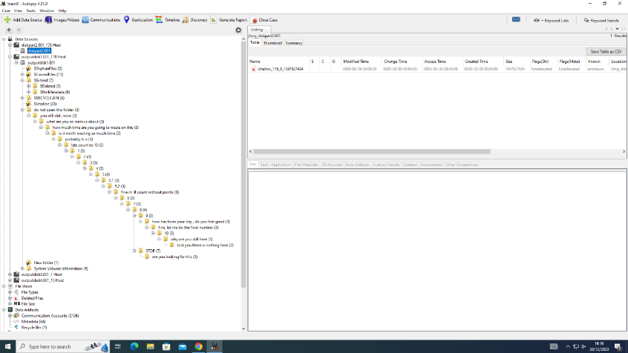
Figure 12: Directory List Recovery

Evidence of recovered files and folders found on the image taken of the HDD.
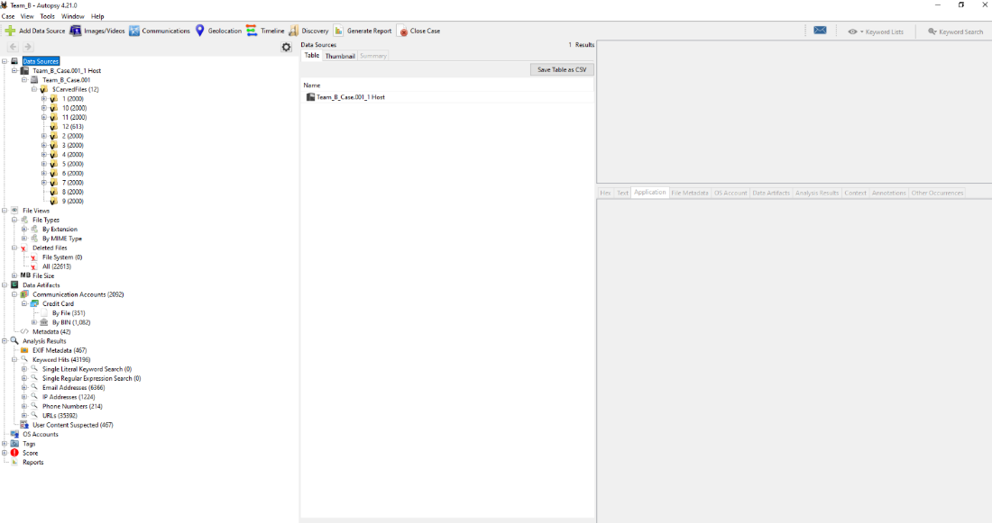
Figure 13: Evidence of Credit Card Details

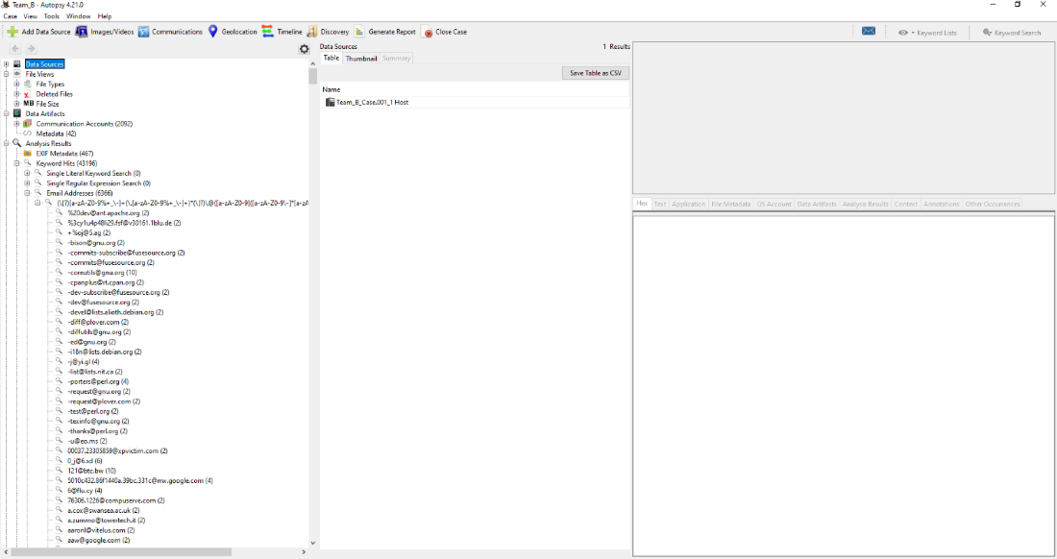
Figure 14: Evidence of Email Accounts Recovered

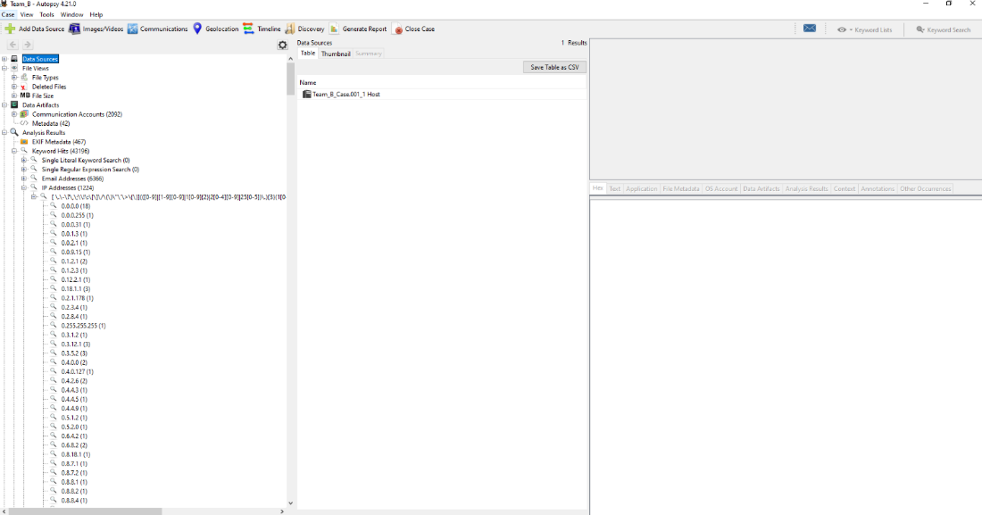
Figure 15: Evidence of Phone Numbers Recovered

After recovering all these files, we started analyzing the files one after another, and we noticed that the evidence didn’t corollate with the given scenario, so we had to reach out to the team to confirm if the files we recovered were the actual evidence they copied into the HDD, they confirm it wasn’t their files.
Team A informed us that there was a hidden drive partition on the HDD, and their actual evidence files are likely saved on that hidden drive partition.
After several attempts in trying to find the hidden partitions failed, we did some research and found a tool called VeraCrypt, this tool was used to encrypt the drive.

This is the drives partitions that were visible before we used the VeraCrypt.
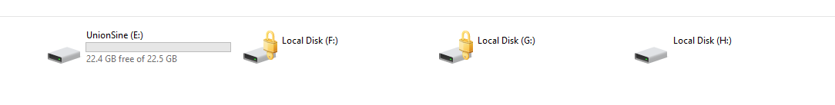

We used the VeraCrypt to dismount all drives in the HDD after which we mounted a new drive with a different drive letter, it requested for a password, which we collected from Team A. The next shot below shows the new mounted drive, lettered “J”.
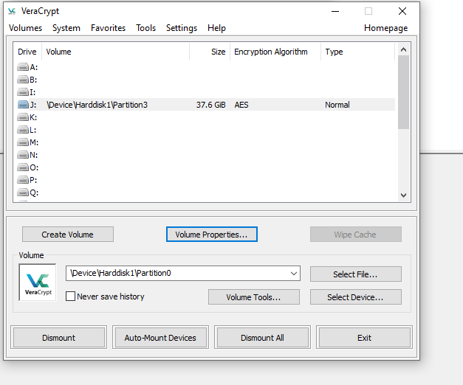
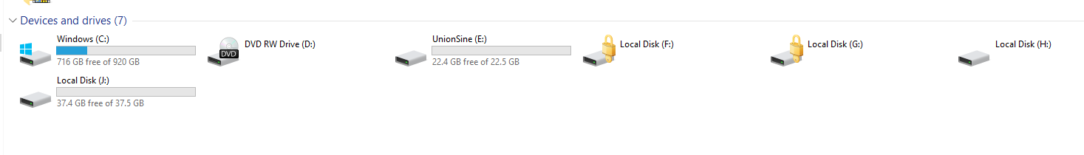
We now have five drives partitions. Drive J is the hidden drive which contains evidence files from Team A. We took a new image of the un-hidden drive partition (drive J).
Size of Data: The total size of an image taken of Local disk J is 925MB
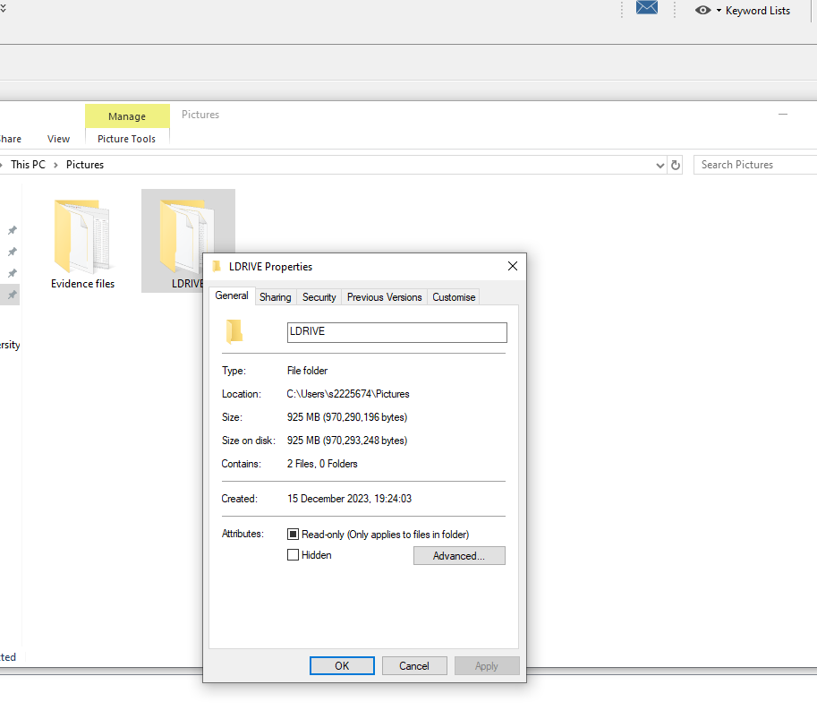
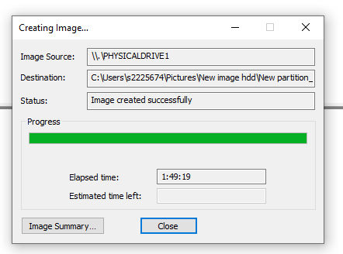
Figure 16: Size of Data
Figure 17: Imaging of Hidden Partition

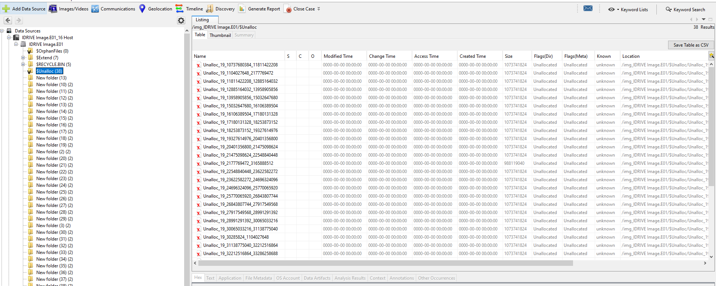
Figure 18: Evidence of Unallocated Spaces

Evidence Title | Format | Extension
- 20231113151155_5869 | Excel sheet document | XLS
- Barclays Statement | Image | jpeg
- customer data | MySQL Database | Sql
- mail-conversation | Image screenshot | Jpeg
- Nitheesh_Corporation | Notepad text file | txt
- meeting2 | Video | Mp4
Table 2: Files of Evidence

- Analysis Report Based on Evidence Analysed
From the given scenario above, the customer database of a dating company (Red Hot Passion), with patronisers who are top executives at a 500 Fortune company was hacked and their user details were leaked, exposing names of different customers including top employees with managerial roles at (Nitheesh Corporation).

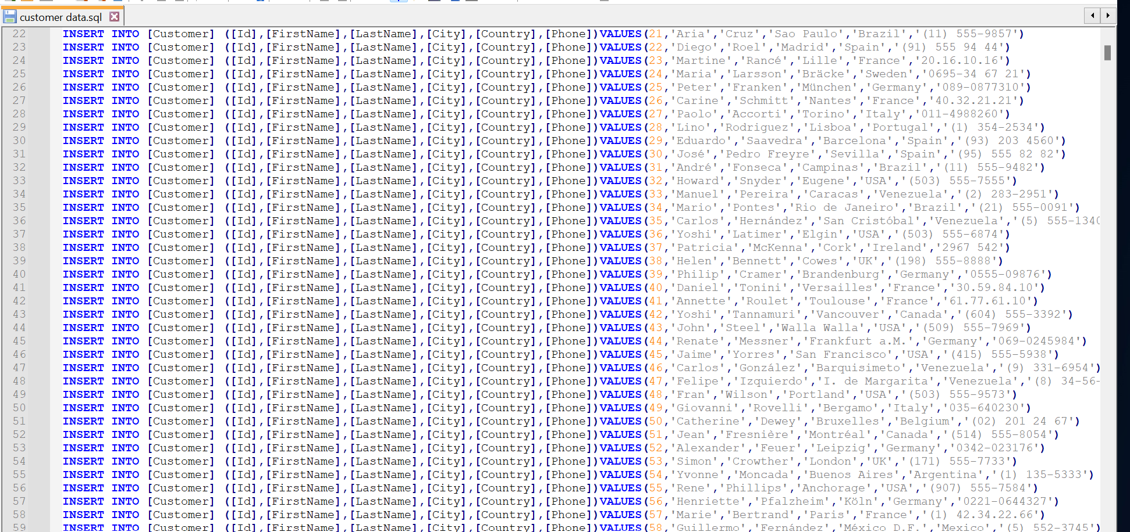
Figure 19: Company Data Base
A sender known as Josh sends a mail to Nitheesh's email (nithesh@gmail.com), but we can't tell who Josh is because there's no record of him in the database that was leaked, or why is he sending a mail to Nitheesh, asking him to verify his bank details. Nitheesh cooperation is possibly owned by Nitheesh. The sender of this email could be a hacker who is claiming the identity of someone very close to Nitheesh. He sends a verification form, for Nitheesh to verify his account details.

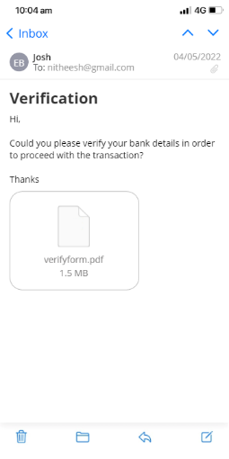

Database containing confidential details and bank card details of employees' of Nitheesh's cooperation, possibly leaked by former staff of Nithesh corporation, who left the company due to issues. As administrative staff, these employees had access to almost every record and data of the cooperation, it is also possible that they leaked the bank card details of the employees.
The reason is they want to take revenge against the company due to previous payment disputes.
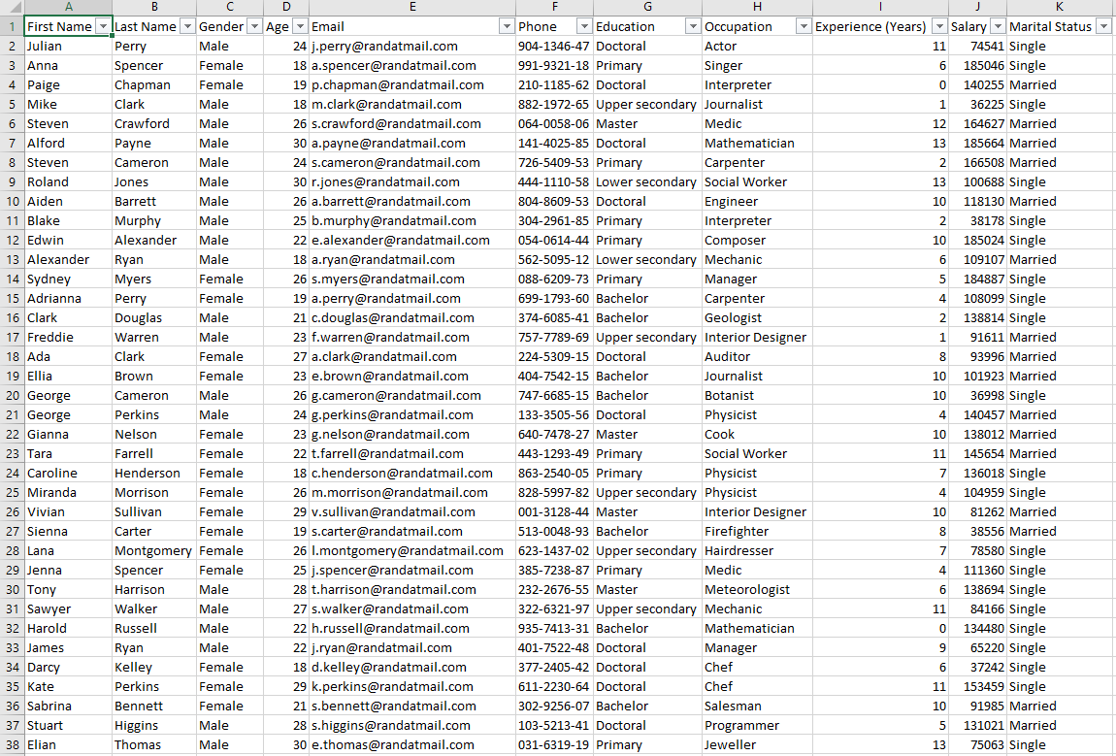
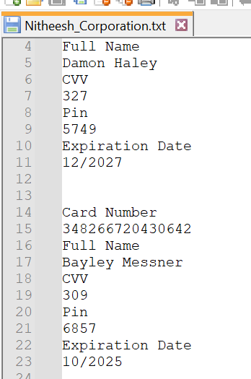

An account statement having the name John Doe Lee, there's no record of John Doe among the list of either customer data of Red-Hot Passion or the database of Nitheesh Corporation. He may be the hacker, who was paid by the suspects who leaked confidential data of Nitheesh's cooperation. From his bank statement, there was a deposit of £540 into John Doe's account on 12 Jan. On 19 Jan. he paid £39 for transport to London.

Figure 20: Evidence Bank Statement

we can't say for sure, but from the bank statement, John Doe made a card payment to London on 19 Jan. 2022. From the SQL database, about seven names appeared to live in London, I suspect that John could've possibly travelled to meet with these people. Those names have been highlighted below from the SQL file.
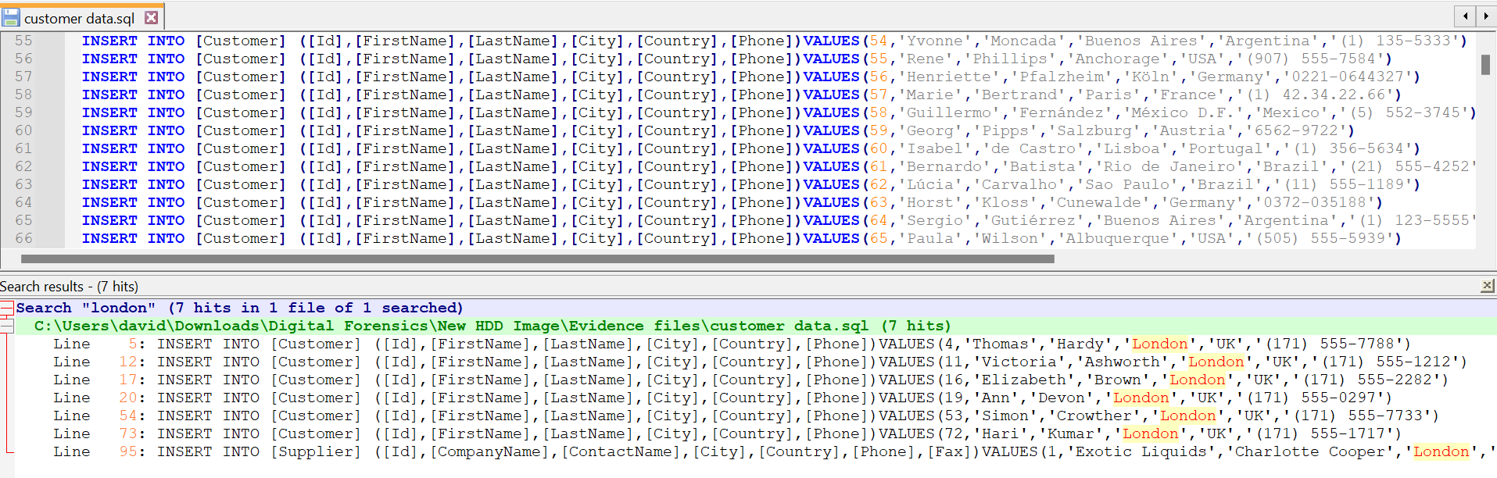
Figure 21: Suspects List
- Challenges
- Not able to ascertain the actual size of HDD and size data on the HDD, because it contained hidden partitions and unallocated spaces.
- HDD contains 2 BitLocker encryption partitions, and no password was given.
- The HDD Contains malware, that automatically displays multiple windows, which causes a disruption of operations on the PC.
- In trying to recover hidden partitions using autopsy tools, the autopsy tools recovered previously deleted files on the HDD, these files amount to over 160GB. Below is a screenshot of the files recovered.

Video Link:- Meeting in _General_-20240111_173046-Meeting Recording.mp4

4.1 Understanding about investigation of hard-disk:

Creation of crime scene is about cyberbullying, and based on that scenario I understood that how crime have been happened on the social engineering platform. I learned that which type of challenges could be phase for collect evidence. We need to maintain and ensure data integrity as per geographical location law and with the following law we need to submit our investigation in the court. In the crime creation scenario, I learnt about using various techniques and tools, which can enumerate filesystem type and made them unreadable. I did steganography method using stegano tool in kali Linux machine and hide file into the different file. Using this method, we can hide our data and it will not show in the directory list. Even if anyone find data, no one can access the file because it is protected by particular password. I learned about different technique which is encryption. We used that method for hiding the evidence as part of our activity.
Investigating as a digital forensics analysis, I am being part of the team and we got case of financial fraud. As beginning of the investigation, I learned about procedure of siege and taking custody of proof. Ensure data integrity and preserve it in safe place. By the law if we have to prove any evidence in the court we have to processed and analysis under the rules and policies. Considering rule, I learnt that timestamp and chain of custody is help and provide point to point information of evidence. I had gathered deep understanding of different file formats, various tools like DD command line tool. FTK and more. I had tried hash cracking of bit-locker decryption with help of hashcat tool and John the Ripper tool. HDD contained specious files script code and analysing it found out it has loop back, which can run and make system restarting. Analysis of HDD and find that different filesystem methods and understanding about unallocated space.

5. Mobile Forensics Investigation (Task – 4)

Group Report
Scenario:
Our client is a car manufacturing company working on a new model of AI self-driving cars. They have competitors in several Countries, and they want to maintain the privacy of this project. However, they suspect that one of their technical officers might be selling the research data to their competitors.

5.1 Case Information:

- Case Details: Case ID: MP-0140124
- Date of Request:18/12/2023
- Requesting Authority: Team B
- Case Investigator: Team B
- Device Information: ulefone
- Manufacturer: China
- Model: Note 14 (16)
- Serial Number: S/N:3102SH1010027469
- IMEI/MEID: IMEI-1:355617730545789

Explain the methods and techniques used during the mobile forensics analysis, including tools, procedures, and any challenges encountered. The mobile phone was handed to us by the company, and every authorization process was sorted by the company. We ensured to maintain a chain of custody after receiving it.
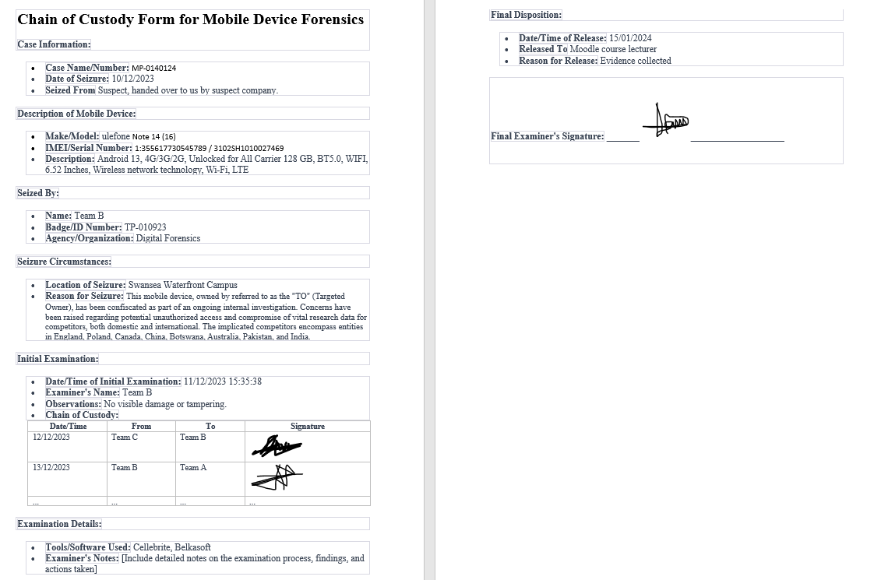
Figure 22: Chain of Custody Form Mobile Device

5.3 Data Acquisition

- Device Identification: The phone was handed to us by the company where the suspect works, due to an ongoing investigation involving a breach of data. Every verification was done by the company before the phone was handed to us.
- Data Extraction: We extracted a logical filesystem using the Cellebrite forensics toolkit. Due to the model of the phone, we could not perform a physical extraction.
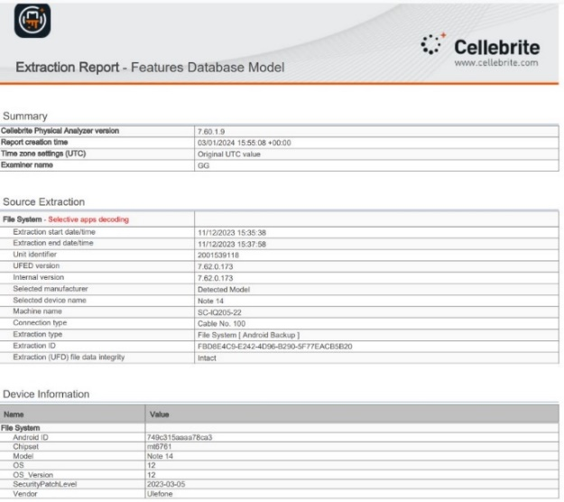
Figure 23: Device Information
- Data Preservation: Detail the steps taken to preserve the integrity of the evidence throughout the analysis. To maintain data integrity, we set up a forensics lab in the Cisco lab, using virtual machines with operating systems installed on them. All digital extraction and analysis took place in this environment. Every piece of evidence collected and analysed was stored on OneDrive.

- Data Analysis:
We used the Cellebrite Physical Analyzer and Belkasoft forensics tool in analyzing the data.
The analyzed data contain images of different locations and places the suspect visited; we trailed his journey based on the position of images extracted from his device. We found audio recordings with details of events happening within the suspect. Some of the audio was not audible enough, but we were able to transcribe the audio to the best of our ability.
Below are screenshots of the evidence, with timestamps, location, and details about each piece of evidence discovered.

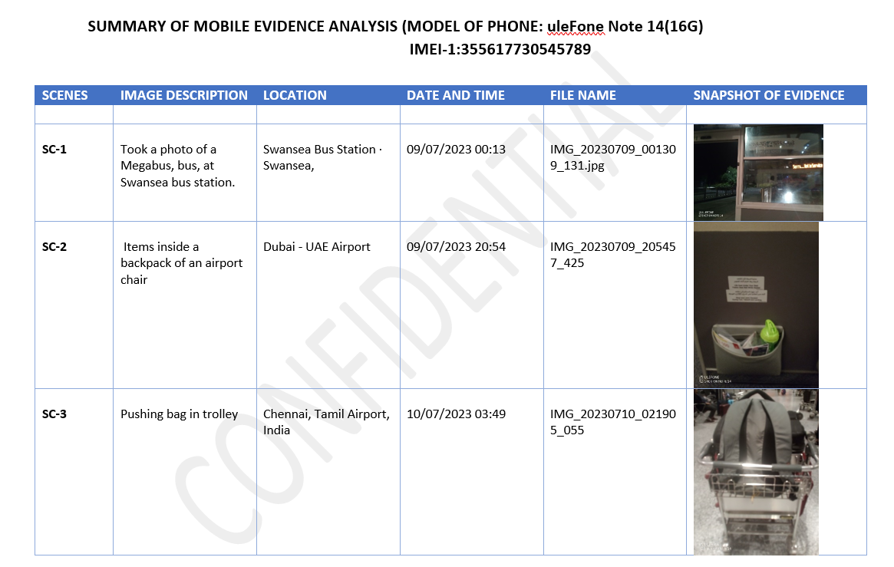
Figure 24: Summery of Evidence Analysis

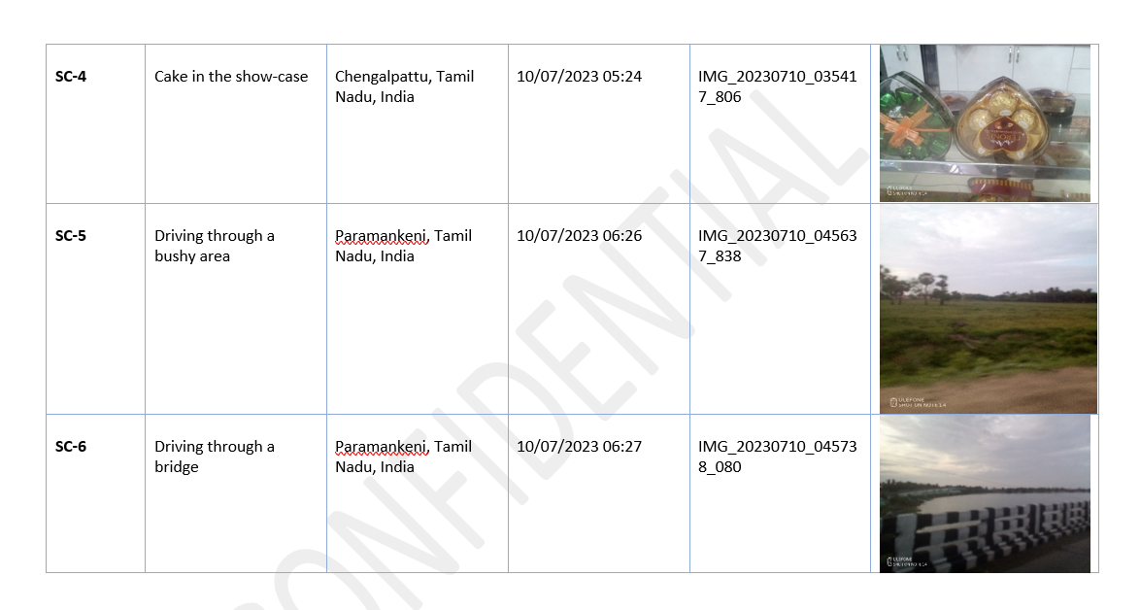
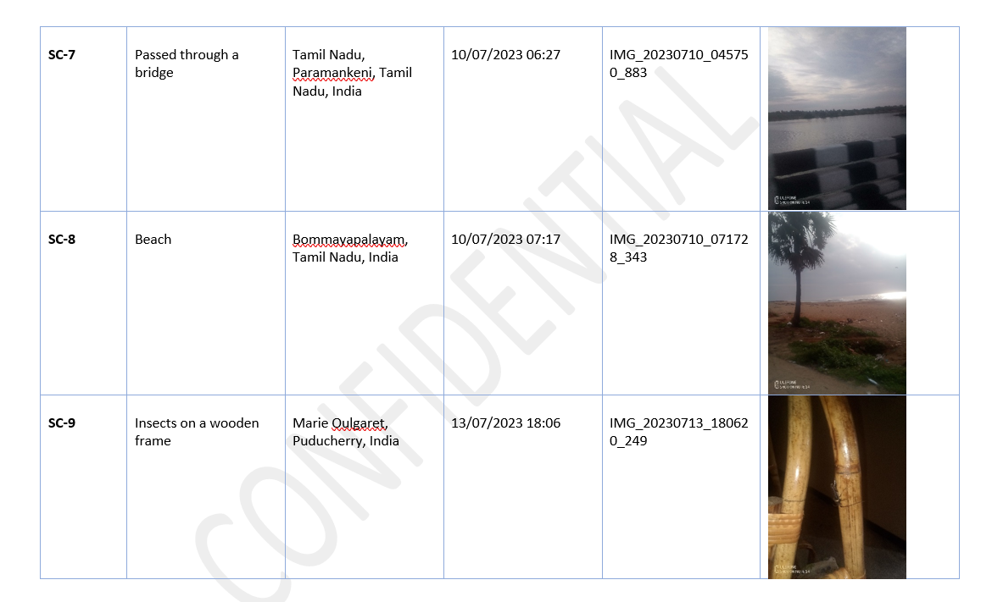
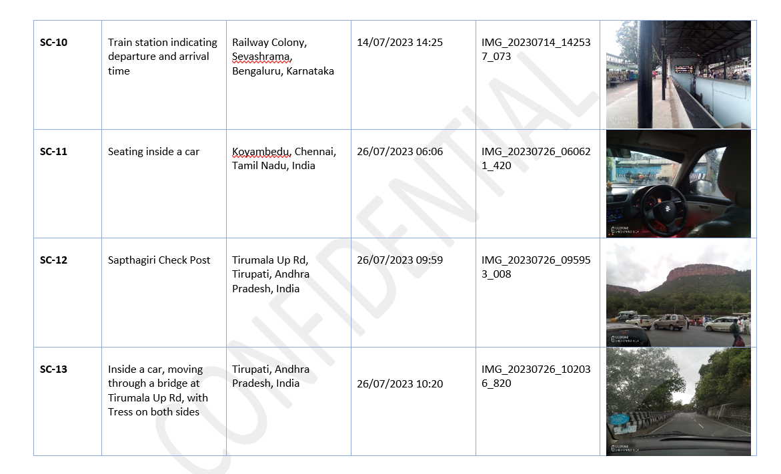
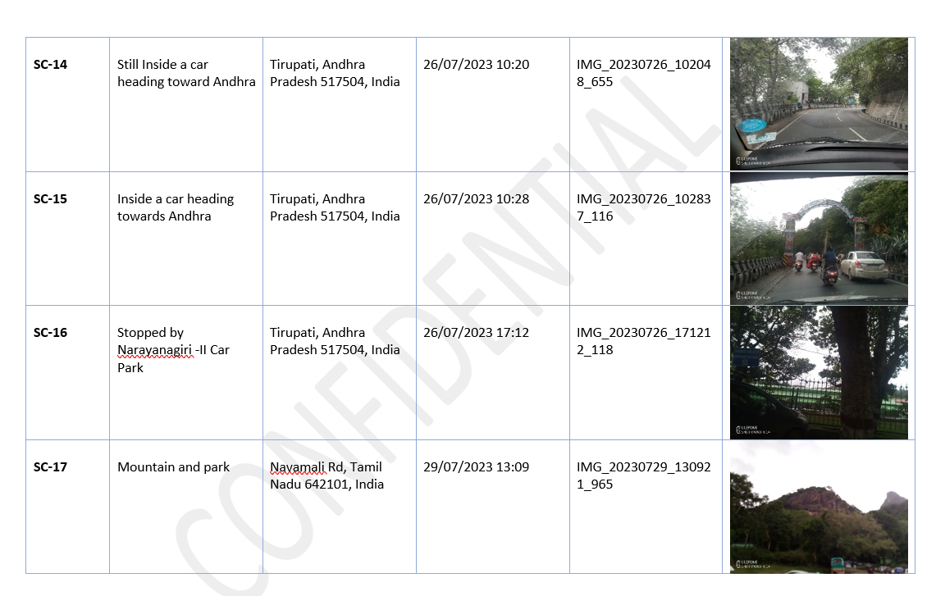
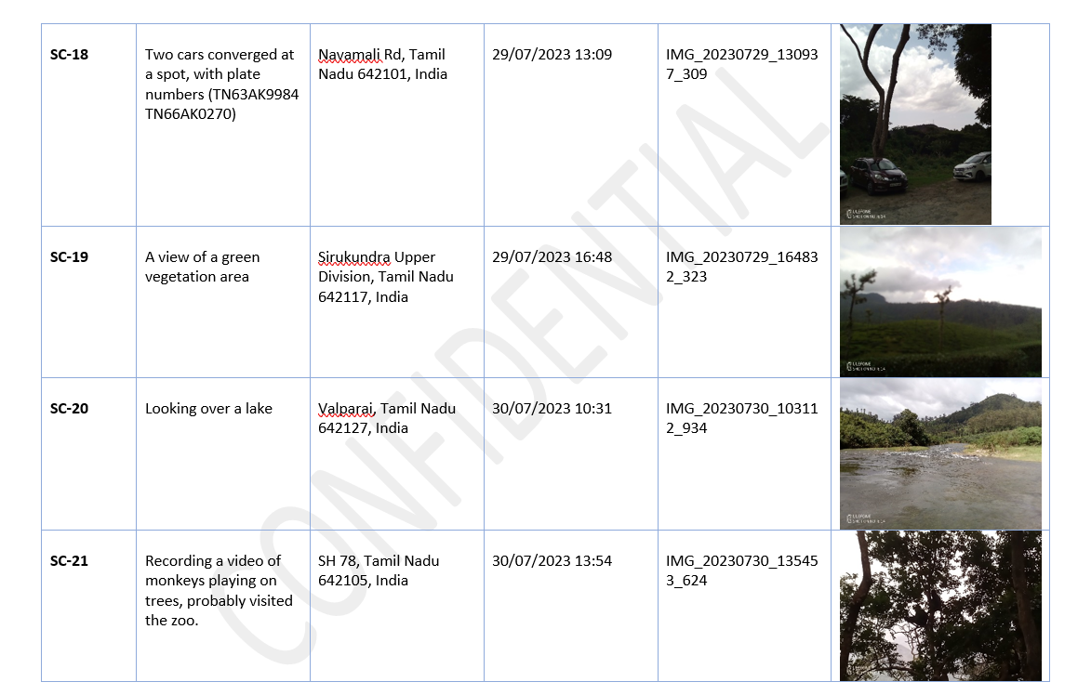
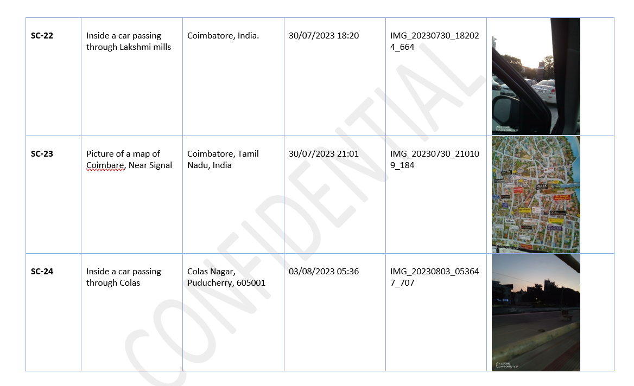
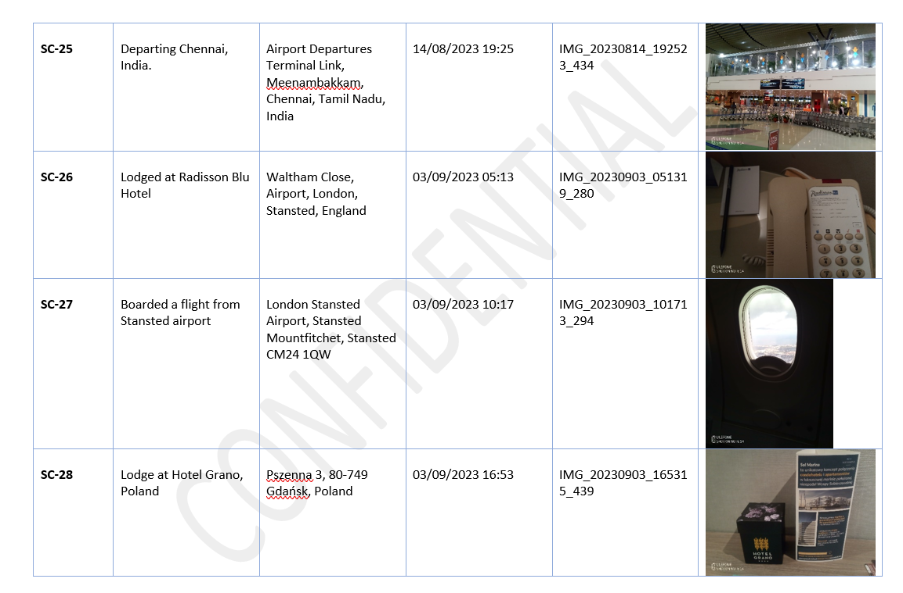
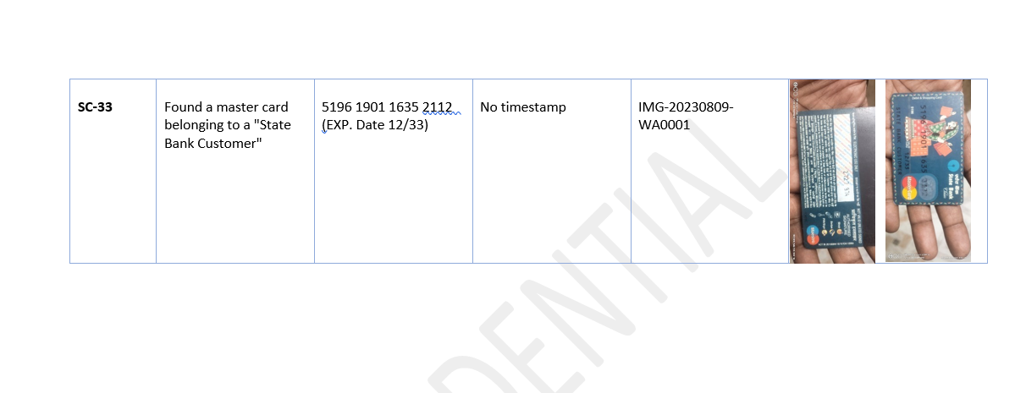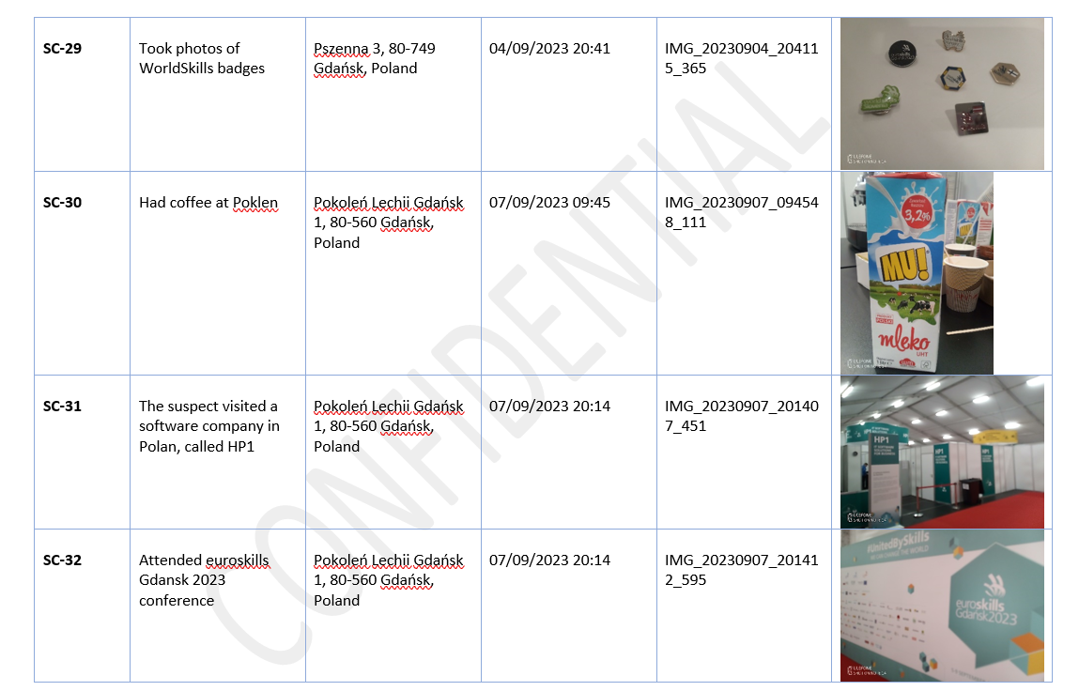

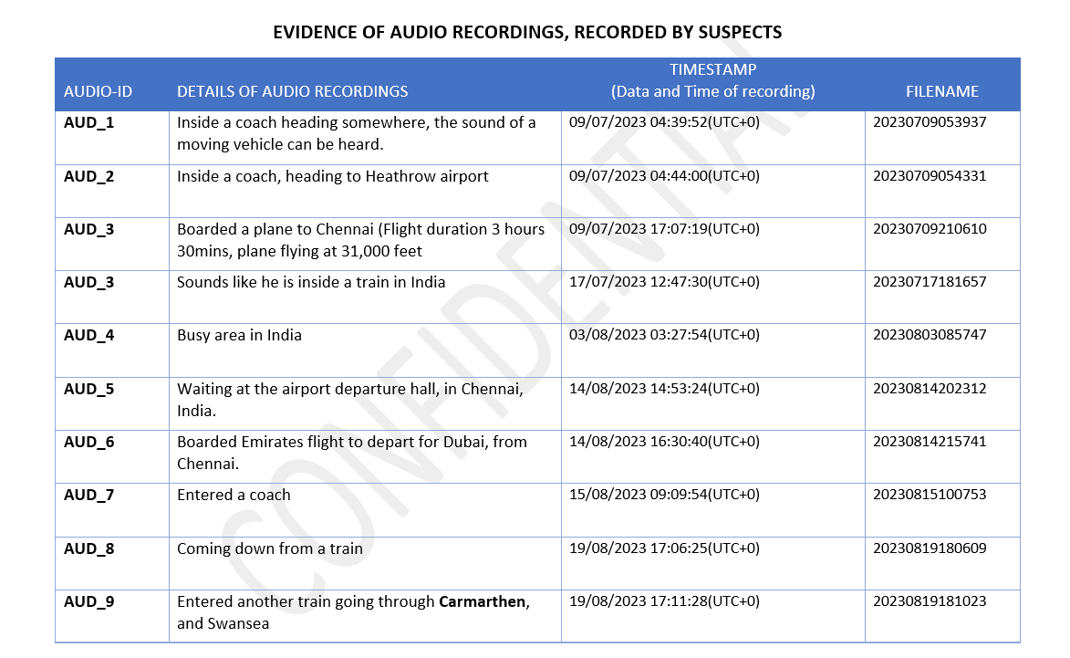
Figure 25: Evidence Audio Files
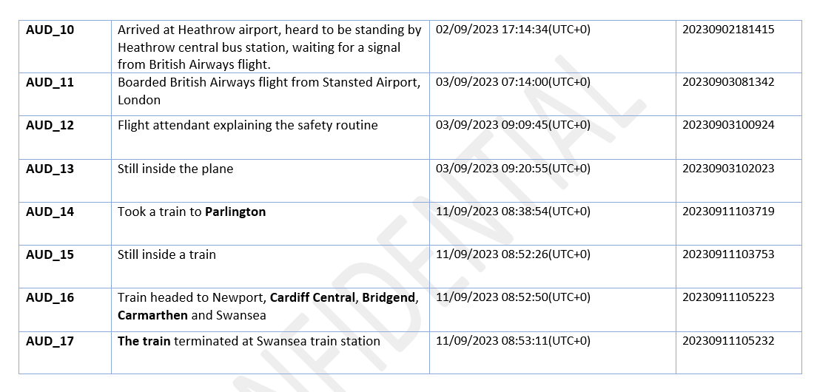

5.4 Summary of Analysis

The evidence provided contains a detailed analysis of the suspect's activities and locations throughout his journey.

The suspect embarked on two different trips.
- He began his first trip from Swansea to London, where he boarded a flight from Heathrow Airport, stopped at Dubai Airport, and took a reconnecting flight to Chennai, India, as indicated in Sc-1 and Sc-3.
- While in India, he met with an unknown person, as seen in SC-18, two vehicles are seen to converge in Navamali Road, Tamil, Nadu. One of the vehicles was probably used in transporting the suspect. The plate numbers of these vehicles have been captured for further investigation.
- He was in India for about 35 days starting from 10/07/2023 to 14/08/2023, Sc-1 to sc-25, AUD_1 to AUD_9.
- His first trip ended when he returned to Swansea on 19/08/2023.

His second trip started on 02/09/2023, as indicated in AUD_10.
- He arrived at Heathrow Airport and waited for a flight signal from British Airways.
- He was next spotted at the Radisson Blu Hotel, Stansted Airport, England on 03/09/2023, Sc-26.
- He boarded a flight that same day to Poland, at about 10:17, SC-27, AUD_11 to AUD_13.
- At about 16:53 of that same day, he lodged at Hotel Grano, Gdansk, Poland, Sc-28.
- While in Poland, he visited an IT company called HP1, located at Pokenlen Lechoo, Gdansk 1, Sc-31.
- He also attended euro skill Gdansk 2023 Conference, Sc-32. A payment card was also found in the suspect phone, but we can't confirm who the owner is, Sc-33.
- He returned to the UK on the 11/09/2023, AUD_14 to AUD_17.
- He spent about 8 days in Poland, and about 4 days in the UK.

- Recovered Data
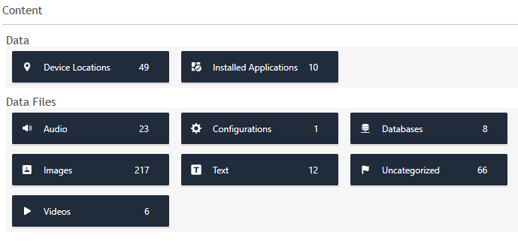
Figure 26: Recovery of Data

5.4 Forensic Artifacts

Below is the file system structure of the mobile device and the data structure contained in the phone.

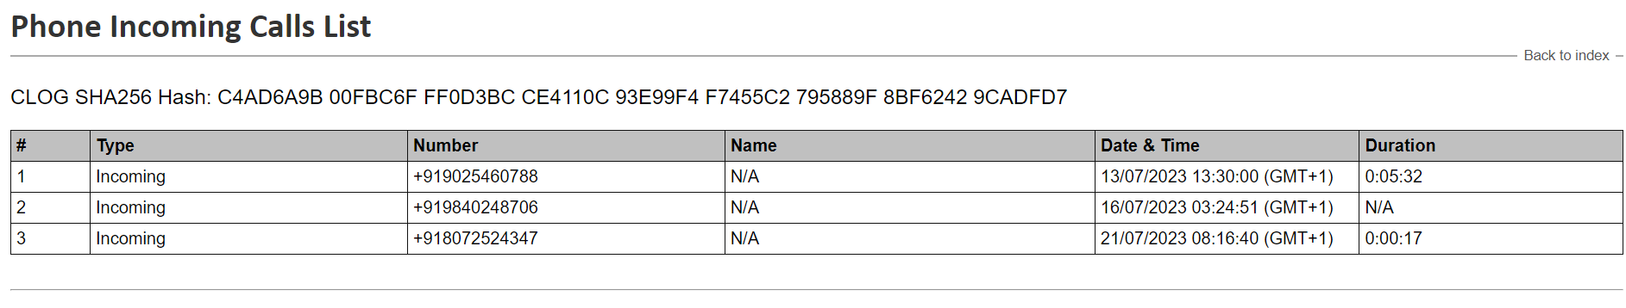
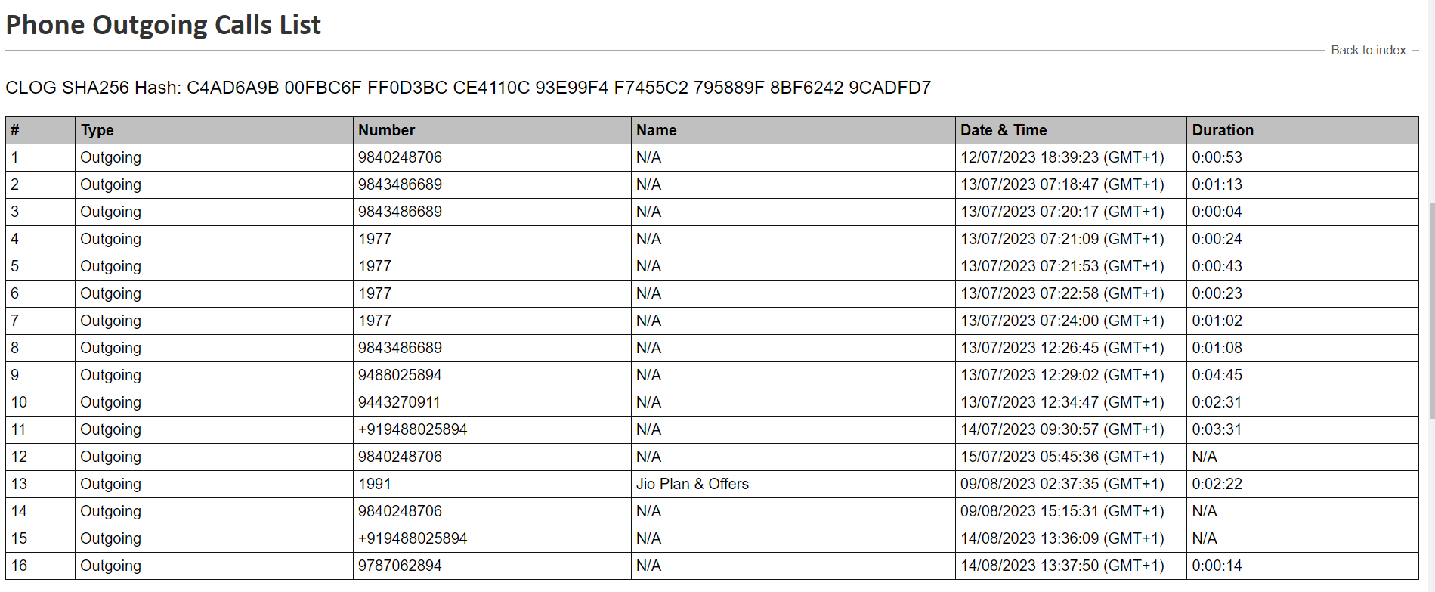

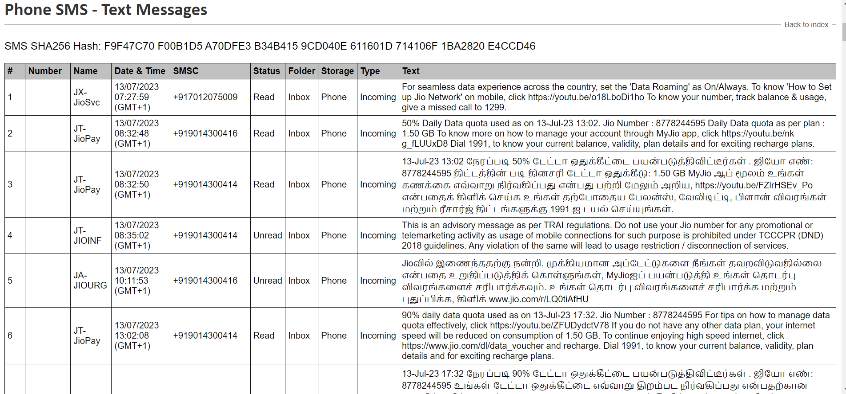
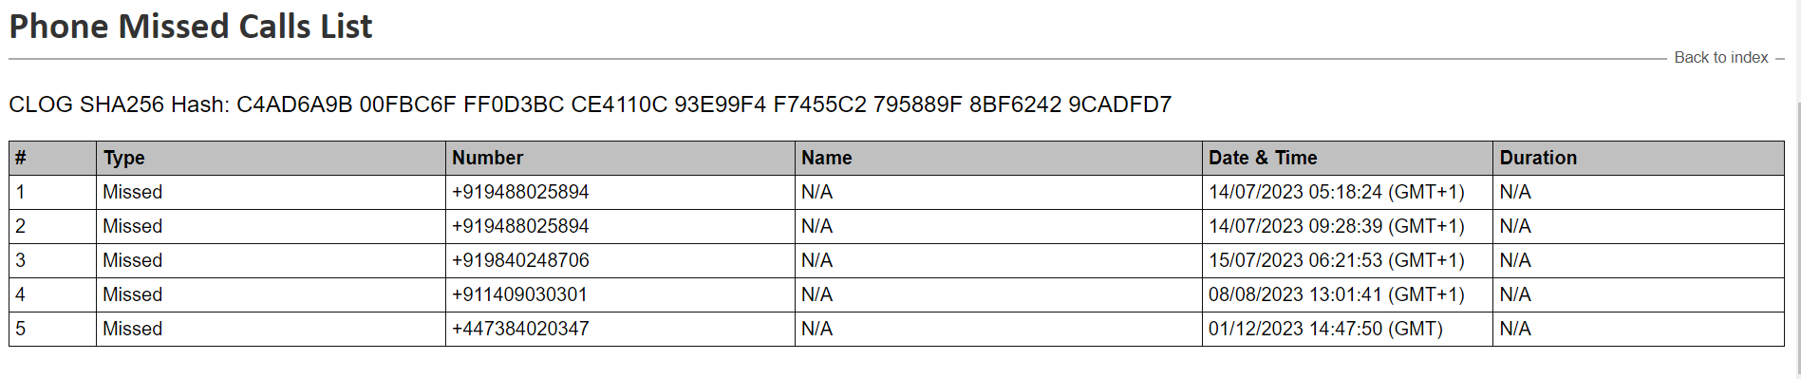

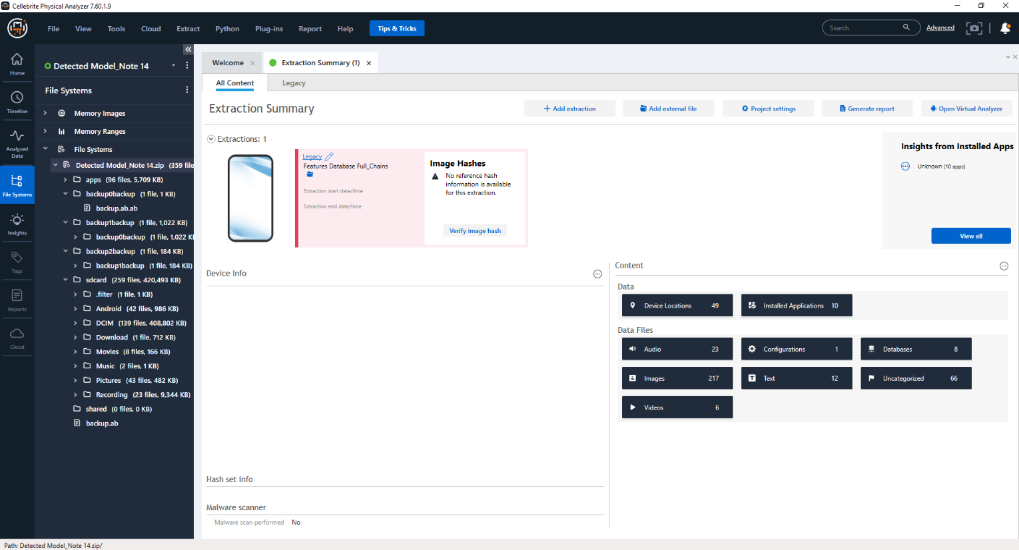
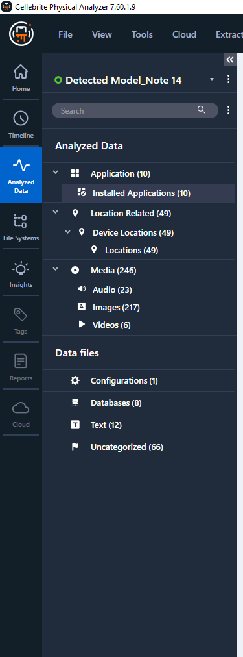

5.5 Findings

From our analysis, we discovered that the suspects:

- Visited 4 different Countries, the United Kingdom, United Arab Emirates, India, and Poland.
- Spent more time in India than the other 3 Countries.
- Met with someone in India.
- Visited an IT company in Poland.
- Was careful not to leave any trace of the leaked research data on his mobile device.

- Conclusions

From our analysis, we have been able to point out key convincing points to prove that the suspects visited some of the Countries. He visited 3 Countries from the list of suspected Countries (England, Poland, Canada, China, Botswana, Australia, Pakistan, and India).
This is proof that he compromised the research data of his company.

- Recommendations
We recommend that further investigations be conducted to discover who he met with in India, based on the car plate numbers captured.
The IT company he visited should also be investigated to confirm this claim.

- Limitations
Not enough evidence to establish a convincing case of stolen research data. There was no chat, text, or email of any conversation between the suspect and his accomplice.
Some features on the Cellebrite UFED and Physical analyzer didn’t effectively. If we had more sophisticated proprietary forensic tools Magnet AXIOM, Oxygen Forensics Detective, and others.

- Acknowledgments

The report is based on a group discussion. Each team member played a different role in ensuring the integrity of every evidence and analysis performed. Every fact and assumptions made were based on the team agreement.

5.6 Understanding about investigation of Mobile phone:

Digital forensics most trending part is mobile phone as because globally use of mobile phone and internet dramatically increased. Therefore, number of users are using online platforms for banking, social media for their day-to-day routine. Highly use of mobile many criminal activities organize through the phone and that’s why mobile forensics is being more complicated to find criminals. Based on our investigation I deeply understood about hand on experience of real-life scenario. What kind of criminal actives are happenings, how can ensure the mobile phone data integrity and what could be the procedure. Scenario investigation gives more comprehensive and gain deep understanding about digital forensics.

Part of digital forensics team I learned different kind of challenges, which could be phase in real life scenario. First challenge is found out the password of mobile phone using various techniques like guessing, brute force etc. second challenge and procedure is after collecting evidence need to preserve in secure location and covering signal blocker specially in mobile phone case. Third is if criminal have been wiped phone, data recovery is quite challenging. Due to lack of evidences criminals are not being cache.

Sophisticated and industry deign mobile forensics tools are very helpful for finding criminals and provide data report, which can help us to prove evidence in the court. Using different industrial tools, I gain knowledge about various tools and their capabilities. Evolution of various tools can help to find criminal activities in more accurate way.

References

[1] C. Neale, I. Kennedy, B. Price, Y. Yu, and B. Nuseibeh, “The case for Zero Trust Digital Forensics,” Forensic Science International: Digital Investigation, vol. 40, p. 301352, Mar. 2022, doi: 10.1016/j.fsidi.2022.301352.
[2] W. A. Bhat, A. AlZahrani, and M. A. Wani, “Can computer forensic tools be trusted in digital investigations?,” Science & Justice, vol. 61, no. 2, pp. 198–203, Mar. 2021, doi: 10.1016/j.scijus.2020.10.002.
[3] N. Hughes and U. Karabiyik, “Towards reliable digital forensics investigations through measurement science,” Wiley Interdisciplinary Reviews: Forensic Science, vol. 2, no. 4, p. e1367, 2020.
[4] A. R. Javed et al., “Future smart cities: requirements, emerging technologies, applications, challenges, and future aspects,” Cities, vol. 129, p. 103794, Oct. 2022, doi: 10.1016/j.cities.2022.103794.
[5] “https://niccs.cisa.gov/education-training/catalog/mile2/certified-digital-forensics-examiner-cdfe.”
[6] G. Horsman, “Digital evidence and the crime scene,” Science & Justice, vol. 61, no. 6, pp. 761–770, Nov. 2021, doi: 10.1016/j.scijus.2021.10.003.
[7] P. B. Ladkin, B. Littlewood, H. Thimbleby, and M. Thomas, “The Law Commission presumption concerning the dependability of computer evidence,” Digital Evidence & Elec. Signature L. Rev., vol. 17, p. 1, 2020.
[8] C. Neale, “Fool me once: A systematic review of techniques to authenticate digital artefacts,” Forensic Science International: Digital Investigation, vol. 45, p. 301516, Jun. 2023, doi: 10.1016/j.fsidi.2023.301516.
[9] T. J. Holt, A. M. Bossler, and K. C. Seigfried-Spellar, Cybercrime and Digital Forensics. London: Routledge, 2022. doi: 10.4324/9780429343223.
[10] S. A. L. Mary, N. Mukilan, and A. U. Ruby, “A Zero-Trust Approach in Digital Forensics,” Ann Rom Soc Cell Biol, vol. 25, no. 6, pp. 1263–1266, 2021.
[11] “https://www.researchgate.net/profile/Ali-Mansour-2/publication/371399058_A_Comparative_Review_of_ISO_Standards_for_Digital_Forensics_Laboratory_Accreditation/links/6481e063d702370600dc2344/A-Comparative-Review-of-ISO-Standards-for-Digital-Forensics-Laboratory-Accreditation.pdf.”
[12] A. Nisioti, G. Loukas, A. Laszka, and E. Panaousis, “Data-Driven Decision Support for Optimizing Cyber Forensic Investigations,” IEEE Transactions on Information Forensics and Security, vol. 16, pp. 2397–2412, 2021, doi: 10.1109/TIFS.2021.3054966.
[13] A. R. Javed, W. Ahmed, M. Alazab, Z. Jalil, K. Kifayat, and T. R. Gadekallu, “A Comprehensive Survey on Computer Forensics: State-of-the-Art, Tools, Techniques, Challenges, and Future Directions,” IEEE Access, vol. 10, pp. 11065–11089, 2022, doi: 10.1109/ACCESS.2022.3142508.
[14] FBI, “https://www.fbi.gov/services/laboratory/scientific-analysis/trace-evidence#: ∼:text=The%20Trace%20Evidence%20Unit%20(TEU,%2C%20glass%2C%20and%20building%20materials.”
[15] “https://www.linkedin.com/jobs/computer-forensic-analyst-jobs/?currentJobId=3773379382&originalSubdomain=uk.”
[16] “https://www.autopsy.com/?__hstc=51627318.adec18b47296903e7dab753c1685f18d.1704679476609.1704679476609.1704679476609.1&__hssc=51627318.2.1704679476609&__hsfp=1749141717.”
[17] “https://fireeye.market/assets/apps/211364/documents/877936_en.pdf.”
[18] “https://belkasoft.com/x#:~:text=Powerful%20analytical%20features%20such%20as,you%20to%20uncover%20facts%20rapidly.&text=Belkasoft%20X%20automates%20search%20tasks,investigation%20at%20a%20quick%20pace.”
[19] “https://prodiscover.com/#:~:text=ProDiscover%20helps%20in%20efficiently%20uncovering,artifacts%20relevant%20to%20the%20investigation.”
[20] “https://www.x-ways.net/forensics/.”
[21] “https://www.opentext.com/products/encase-forensic.”
[22] “https://www.exterro.com/forensic-toolkit.”
[23] “https://www.magnetforensics.com/free-tools/.”
[24] G. Horsman and J. R. Lyle, “Dataset construction challenges for digital forensics,” Forensic Science International: Digital Investigation, vol. 38, p. 301264, Sep. 2021, doi: 10.1016/j.fsidi.2021.301264.

