Health and social care
Student ID: 2020625
Lectures name: Dr Azora Hurd
Module code: BMHP5014
E-portfolio

Autism spectrum disorder

Introduction
To create an e-portfolio, task 1 and type 2 is chosen. In task 1, the gap in the services related to ASD is identified and a mind map is created accordingly. To accomplish task 2, ADHD is chosen to develop a blog containing the mission and campaign to approach a potential audience. The detail of these tasks is provided hereby:
Task Ⅰ:
Mind map of Sleep problem in ASD:

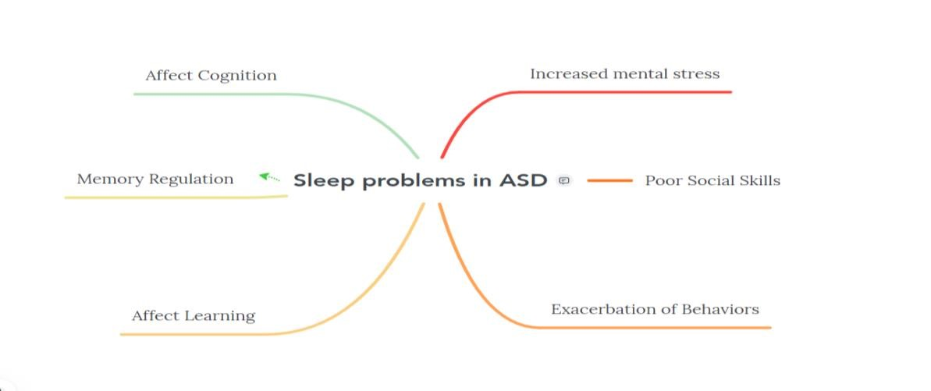

The above-mentioned mind map indicates that the sleep problem in Autism spectrum disorder can lead to several other coexisting problems including mental stress, hyperactivity, poor social skills, and an effect on memory Regulation and cognition. Evidence has suggested that most settings significantly focus on the diagnosis of ASD and put less concentration on the treatment and services that can be provided to the children affected by this condition. There are several coexisting problems in ASD which are not focused including sleep problems, hyperactivity, sensor problem, and feeding issues. There is a significant advancement in the tool that is used to diagnose this disorder; however, there is less focus on the coexisting conditions. In this report, sleep problem is highlighted which is one of the existing issues in patients with ASD. during my research, the gap is found related to the treatment protocol of coexisting problems in ASD which requires a solution and significant method so that people living in local areas could have knowledge regarding the treatment protocol and focus significantly on treating these coexisting issues.
What is Autism?
Autism spectrum disorder or ASD can be defined as a
“Developmental disability that leads a child towards significant behavior, social as well as communication challenges”.

This disorder affects the way people interact with each other, communicate with others, and their learning as well. It is possible to diagnose the condition at any age as this disorder is described as a developmental disorder because of its symptoms that may appear in the initial years of life. American Psychiatric Association created a guide for the care providers for mental disorders and they explained that people who have this disorder open face difficulties wave interacting two other people and they show consistent and repetitive behaviors and their interest in socialization is restricted. Their symptoms are certainly associated with their daily living functions and can affect their capability to function effectively in school right place as well as in other areas of their life. Autism is described as a spectrum disorder as the type and severity of the system in every individual varies and there is a wide variety of symptoms as well. It is also interesting to know that people of all age, ethnicity, and gender can suffer from this disorder (Fombonne, 2018).
Signs and Symptoms:
Autistic people usually have difficulty and challenges with social communication and their interaction with other people. Moreover, they show certain common behavior and there is a list of common types of behaviors in individuals that are diagnosed with Autism spectrum disorder. Although every individual has different symptoms and their behavior varies, however, the list below illustrates some of the common behavior of individuals with ASD.
People with ASD make little or inconsistent eye-contact with the people around them and they appear not to pay attention to the people talking to them (Lyall et al., 2017).
Individuals with ASD will show infrequent sharing interest in certain activities including social interaction and communication.
Another common feature of ASD is Dyslexia which indicates speech difficulties in which the individual is unable to pronounce or say words. Sometimes the word is not clear and sometimes individuals with autism do not have words.
Individuals with Autism usually have different vocal tones and voices. They may sound robotic. Individuals with autism may have learning disabilities and they find it difficult to communicate and learn new things easily (Lord et al., 2018).
Individuals with Autism may show repeating behavior are repeating phrases which is called echolalia and they show an intense interest in certain topics including numbers or details and they might show obsessive behavior towards certain colors or activities. These individuals usually do not like changes around them and they become upset and irritating when their routine or things around them are changed (Grabrucker, 2013).
The gap in services:
Most of the settings are significantly focusing on the diagnosis of ASD in early childhood so that parents should be aware of their child's behavior and initiate the relevant therapy for their children. However, it is also seen that the focus is more on the diagnosis instead of the services that can provide treatment to the coexisting conditions of Autism spectrum disorder.
Solution:
As people are certainly aware of autism in certain areas, most class is aware of this condition and they significantly focus on the diagnosis of the condition. Health and social care providers also focus on the diagnosis of this condition in several settings however that treatment protocols are not focused significantly. The solution to this problem is to aware people of the treatment plan for coexisting conditions in autism such as feeding problems, sensory issues, and sleep disorders as well. Sleep issues are usually neglected and the Healthcare provider should not only focus on the diagnosis of autism but also on the treatment and therapies required for sleep issues. Inadequate and insufficient sleep of autistic children main illustrates exacerbated behavior for example irritability anger issues and cognitive abilities as well. Although there are cognitive issues in people with autism, however, if there is sleep issue is not addressed it can exaggerate their cognitive issues and may cause their behavior to be aggressive which ultimately leads them to learning issues, etc (Rosenberg, Patterson and Angelaki, 2015). The solution to this problem is to provide a guideline to the parents or care provider regarding the therapies required for the treatment protocol to manage the sleep Problem of an autistic child. There should be an online program and health awareness program regarding the management of sleep issues in autistic children. Online campaigns should run regarding the importance of treatment protocols for autistic.
Mission:
My mission as a leader is to promote and be aware of the people regarding the significance of treatment of coexisting symptoms of Autism so that people and health care providers can focus on the treatment of these people.
Campaign:
Healthcare providers should campaign for the rights of autistic people as well as their families and ensure that national policy is reflecting their needs significantly. ND Health Care providers should campaign for the treatment of autistic people so that the clinical settings can focus on not only the diagnosis but the treatment as well. The campaign that I would like to run to accomplish my mission will be “Fight Discrimination and Find a place for Autistic people to flourish”. This campaign will highlight the significance of treatment for autistic people so that they can also flourish in society.

Task Ⅱ:
Blog: https://theautismworld.blogspot.com/2022/07/autism-what-is-autism-autism-is.html
As discusses earlier, there are several coexisting problems in ASD which are not focused including sleep problems, hyperactivity, sensor problem, and feeding issues. There is a significant advancement in the tool that is used to diagnose this disorder; however, there is less focus on the coexisting conditions. In this report, sleep problem is highlighted which is one of the existing issues in patients with ASD. during my research, the gap is found related to the treatment protocol of coexisting problems in ASD which requires a solution and significant method so that people living in local areas could have knowledge regarding the treatment protocol and focus significantly on treating these coexisting issues (Pascuzzo, Moss and Cyr, 2015).

Save Autism
It is mentioned in task 1 and blog that it is important to save autism by ensuring that Healthcare services are focusing on the treatment for the management of autistic people. for this purpose, people should the brand campaigns on your social media companies in support of treatments of autism. this campaign is important as it not only signifies the treatment of autism but also indicates that the people on the Autism spectrum should reach their full potential as an individual in society and they should be provided a voice so that they can speak up for themselves and can utilize their potential to flourish in the society and stay as independent as possible.
Although there is no significant treatment for autistic individuals, however, their areas could be managed and by utilizing their potential in a direction their cognitive abilities could be improved and they could work as a significant individual in society (Fombonne, 2018). The Blog illustrates the features of autism and it also elaborates that is why it is important to save autism. There is an important feature that is in autistic people which is OCD. If this behavior is managed appropriately, autistic people will be the most organized and disciplined people with managed behavior and acts as independent individuals supporting their families as well.

strategies to support the family of autistic individuals and provide them significant awareness regarding the management protocol so that they can act as efficient individuals in society.
There are individuals with Autism spectrum disorder that illustrate higher brain function and if their abilities are fully utilized and reach their maximum potential, they can master any skill which is required for an individual to work independent in the society (Bargiela, Steward and Mandy, 2016).

Gap & Solution

Autism is a neurodevelopment disorder which means that it the features of this disorder can appears in the first 2 years of life. The health and social care provider significantly focus on the diagnosis of the disorder as early as possible. However, the gap creates in the services when the treatment or management programs are not provided to these individuals. The solution to this problem is to provide a guideline to the parents or care provider regarding the therapies required for the treatment protocol to manage the sleep Problem of an autistic child. As the social services are ensuring that autistic children should be diagnosed at early age so that early management could be initiated, so they should also work on the surety of provision of management programs to these children.
E
-
portfolio

Jul. 14

The health care providers and social service providers should focus on developing different

Importance of Raising Awareness
If the people are aware of the management program, it can help individual autism and make the life of care giver and service provider easier. Early interventions are not easy for autistic individuals; however it can improve the holistic development of a child and reduce the challenging behaviors of the individual. By providing strong public awareness regarding the management of autistic children, the individuals of the society could be more informed on symptoms and interventions or therapies which will be useful and beneficial for the child. Public members are responsible to do their part and share the awareness campaigns regarding the therapies or interventions of autism and enable the public regarding the management of these children.

According to the previous studies and data collected from several clinical settings, it is observed that most of the people are focusing on diagnosing ASD, however they are not focusing on treatment or manaegemnt programs which are comaprateively necessary for care giver and the child as well. there are several online platforms available that enable the local population to be aware regarding the manegemnt of autistic child and to “Save Autism”, there should be campaign all over social media to spread awareness and focus the attention of social service provider towards the significance of treatment of autism spectrum disorder.
E
-
portfolio

Jul. 14

References:
Bargiela, S., Steward, R. and Mandy, W. (2016) ‘The Experiences of Late-diagnosed Women with
Autism Spectrum Conditions: An Investigation of the Female Autism Phenotype’, Journal of Autism and Developmental Disorders, 46(10), pp. 3281–3294. doi: 10.1007/s10803-016-2872-8.
Fombonne, E. (2018) ‘Editorial: The rising prevalence of autism’, Journal of Child Psychology and Psychiatry and Allied Disciplines, 59(7), pp. 717–720. doi: 10.1111/jcpp.12941.
Grabrucker, A. M. (2013) ‘Environmental factors in autism’, Frontiers in Psychiatry, 3(JAN), pp. 1–13. doi: 10.3389/fpsyt.2012.00118.
Lord, C. et al. (2018) ‘Autism spectrum disorder’, The Lancet, 392(10146), pp. 508–520. doi: 10.1016/S0140-6736(18)31129-2.
Lyall, K. et al. (2017) ‘The Changing Epidemiology of Autism Spectrum Disorders’, Annual Review of Public Health, 38, pp. 81–102. doi: 10.1146/annurev-publhealth-031816-044318.
Pascuzzo, K., Moss, E. and Cyr, C. (2015) ‘Attachment and Emotion Regulation Strategies in
Predicting Adult Psychopathology’, SAGE Open, 5(3), pp. 1–15. doi:
10.1177/2158244015604695.
Rosenberg, A., Patterson, J. S. and Angelaki, D. E. (2015) ‘A computational perspective on autism’, Proceedings of the National Academy of Sciences of the United States of America, 112(30), pp. 9158–9165. doi: 10.1073/pnas.1510583112.

