NEELAM ASHRAF: 2126021

Module Code: - LCHS4004

Module Name: - Introduction to Public Health

Assignment Title: - Component 1- Incidence of disease in communities

Lecturer: - Dr Aishat Bakre

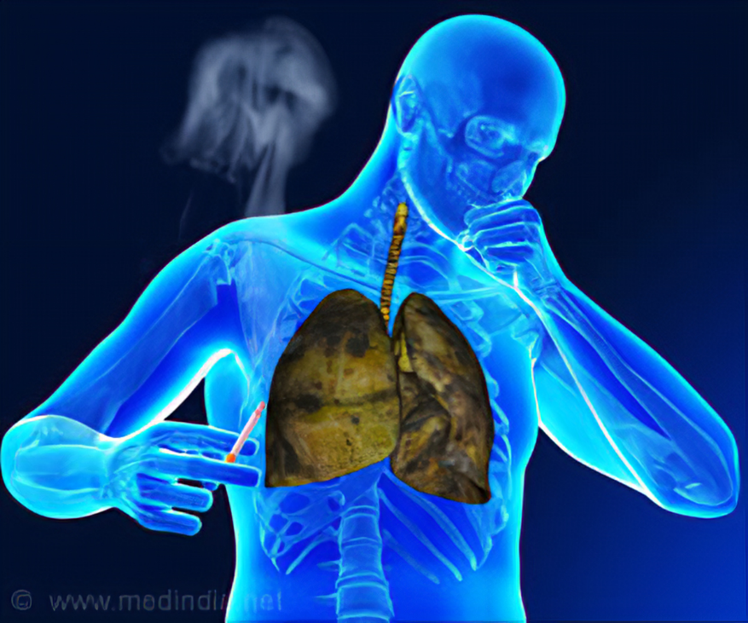
Gadgetsng.com (available 2022

Introduction ……………………………………………………………………….3

Strategies to measure, monitor and control incidence of Mumps………….3-5

Conclusion…………………………………………………………………………5

References…………………………………………………………………………6

Introduction book
A sickness is an unusual condition that harmed the capability or construction of all or part of a Creature and isn't brought about by a prompt injury from an external perspective (L'OPEZ _Otin and Kroemer, 2021). there are two kinds of illnesses for example. Irresistible and non. Irresistible illness.
An irresistible sickness called tuberculosis (TB) ordinarily influences individuals' lungs. A possibly risky problem can stretch out to the stomach (midsection), organs, bones, and sensory system. A constant hack that endures longer than three weeks and much of the time produces mucus that might be horrendous, weight reduction, night-time sweats, a high internal heat level, weariness and weakness, a deficiency of hunger, and neck swellings are commonplace side effects of TB. over three weeks of hacking. chest torment TB is a bacterial contamination that is shrunk by breathing tiny beads from a tainted individual's hack or wheeze. (NHS,2022)
The aim of this report is to explain the strategies used to measure, monitor and control mumps in the UK.
MEASURE
The strategies for measuring tuberculosis incidence in the U K refer to the number of new cases occurring in a population at a given time. Tuberculosis is a dangerous disease, and it is a legal requirement that health professionals inform their local health protection team of all new suspected cases (Health Protection Report, 2017)..
The most common ways to measure the incidence of tuberculosis are mortality, which is the number of deaths due to the disease, and morbidity, which is being infected or in an unhealthy state (morbidity vs. mortality - no date). The other way of measuring is incidence, which gives information about new cases, and prevalence, which gives the number of new and old cases. To measure the incidence of tuberculosis, it is essential to conduct an epidemiological survey. These measures are linked to understand the impact of mumps in the community and how to manage the burden (Health Knowledge, 2022
Predominance: new and old paces of sickness: how more extensive spread illness is.General wellbeing sign's notices have constantly diminished, until 2019, when a 2.4% increment was accounted for at a pace of 7.3 per 100,000 individuals. 2022 imprints the fourth back-to-back year that the rate is beneath this level. Who characterizes a low occurrence country as. As in past reports, TB rates are as yet higher among people who were brought into the world beyond the UK, in the people who have social gamble factors, and in the people who come from our less prosperous country. (Tuberculosis in Uk :2021 report)
Public Health England also works with partners across the health system to ensure that the public receives the right information at the right time and that decisions and actions are taken to protect, promote and prevent mumps (Public Health England 2022)
MONITOR
Screen: Infections can be checked with the assistance of general wellbeing reconnaissance frameworks. General wellbeing reconnaissance is the "General wellbeing independent direction and activity are helped by the continuous assortment, examination, understanding, and spread of wellbeing information. Observing and keep the recurrence of disease in the area is significant "identical t. (CDC, 2012).
the dispersal of these information to chiefs in illness anticipation and general wellbeing, as well as their understanding (CDC2012). To follow the illness, for this situation the tuber cluses from the beginning and to distinguish any likely solutions for stop further transmission, General Wellbeing Britain (PHE) utilizes a global positioning framework. This approach supports following the pervasiveness of mumps in the area (General Wellbeing Britain, 2022)
Lab checking and a chest radiograph. Inside the initial fourteen days, the run of the mill TB side effects — hack, sputum result, fever, and weight reduction — generally improve
The data on the surveillance system is available to the following:
- Directors of public health, local authorities, health and wellbeing boards
- Public health England staff
- Commissioning bodies
- notifications and a rate of 15.6 per 100,000 reported). Since 2011, the number and rate of
- Clinicians and NHS managers
- Government departments
- Academic bodies
- International organisations e.g., WHO, ECDC
- Industry, pharmaceutical companies
- Local public
(Public Health Surveillance, 2022)
If leadership and management do not use the surveillance plan, the public's health in the UK will be at risk.
Control the incidence of tuberculosis:
But tuberculises can be cured if it is treated with the right antibiotics. You must take medication for at least 6 to 9 months. increasing communal immunity also protects others The cornerstone of limiting infectious illnesses has been herd immunity. Antimicrobial drugs can occasionally also be used to stop infections before or after exposure to a disease (pre and post exposure prophylaxis). These drugs either destroy the germs or prevent them from multiplying. In the fight against pathogens, antimicrobial resistance, which can happen when bacteria acquire resistance to drugs that were earlier successful against them, is a major issue. The technological advancements have exacerbated antimicrobial resistance.
England's cooperative tuberculosis approach (2019)
1: expanding service accessibility and ensuring early diagnosis.
2: enhance care and treatment offerings.
3: making sure that contact tracking is thorough.
4. Giving everyone access to quantity diagnostics is step four.
5: enhancing BCG
In order to eliminate TB, the World Health Organization (who) established the
the dispersal of these information to chiefs in illness anticipation and general wellbeing, as well as their understanding (CDC2012). To follow the illness, for this situation the tuber cluses from the beginning and to distinguish any likely solutions for stop further transmission, General Wellbeing Britain (PHE) utilizes a global positioning framework. This approach supports following the pervasiveness of mumps in the area (General Wellbeing Britain, 2022)
Lab checking and a chest radiograph. Inside the initial fourteen days, the run of the mill TB side effects — hack, sputum result, fever, and weight reduction — generally improve
The data on the surveillance system is available to the following:
- Directors of public health, local authorities, health and wellbeing boards
- Public health England staff
- Commissioning bodies
- notifications and a rate of 15.6 per 100,000 reported). Since 2011, the number and rate of
- Clinicians and NHS managers
- Government departments
- Academic bodies
- International organisations e.g., WHO, ECDC
- Industry, pharmaceutical companies
- Local public
(Public Health Surveillance, 2022)
If leadership and management do not use the surveillance plan, the public's health in the UK will be at risk.
Conclusion.
TB is complicated and difficult to manage in people and animals over the last century research has shed light on the illness and its management, and future research will help England control and eradicate TB flexible mechanisms and needed to effectively integrate surveillance and research findings into policy and implementation.
Unfortunately, Disease Control demands sacrifice. that the disease's intricacy and numerous epidemiological, economic, and social effects necessitated a full set of laws and regulations. This promotes living with the condition and regulation rather than Disease Control. England's livestock TB rates in cattle and probably beggars remain Contants, but this cannot continue. epidemic control is Difficult. All sectors must redouble their efforts.
References
- 1.WP-Content: A Beginner's Guide To WordPress' Most Important Directory (November 26, 2022)
https://www.malcare.com/blog/wp-content-uploads/(Accessed 2022).
- (Beers, Mark H., MD, and Robert Berkow, MD., editors. "Infectious Diseases Caused by Mycobacteria." In The Merck Manual of Diagnosis and Therapy. Whitehouse Station, NJ: Merck Research Laboratories, 2004
- LOPEZ_OTIN, c. Kroemer., 2021.Hallmarks of health .cell,184(1) pp.33_63.
- ‘Health Protection Report’ (2017), 11(42), p. 8.
- 2.lic Health Surveillance: Towards a Public Health Surveillance Strategy for England’ (no date), p. 64 1: Gadgetsng.com (available 2022)2: Lopez-Orinocan Kroemer, G., (2021). Hallmarks of health. Cell, 184(1), pp.33-63.
- Morbidity vs Mortality - Difference and Comparison (no date). Available at: https://www.diffen.com/difference/Morbidity_vs_Mortality (Accessed: 29 October 2022)
- public Health Surveillance: Towards a Public Health Surveillance Strategy for England’ (no date), p. 64.
- Public Health England: approach to surveillance (no date) GOV.UK. Available at: https://www.gov.uk/government/publications/public-health-england-approach-to-surveillance/public-health-england-approach-to-surveillance (Accessed: 25 October 2022).

