Counselling Skills and Approaches
Portfolio and Reflective Commentary of Voluntary Experience

Table of Contents

- BPM Cymru Homepage
- Reflective Commentary
- References
- BPM Cymru Background Information
- BPM Cymru Services
- BPM Cymru Statements for Volunteers
- Reflective Logs
- Appendix

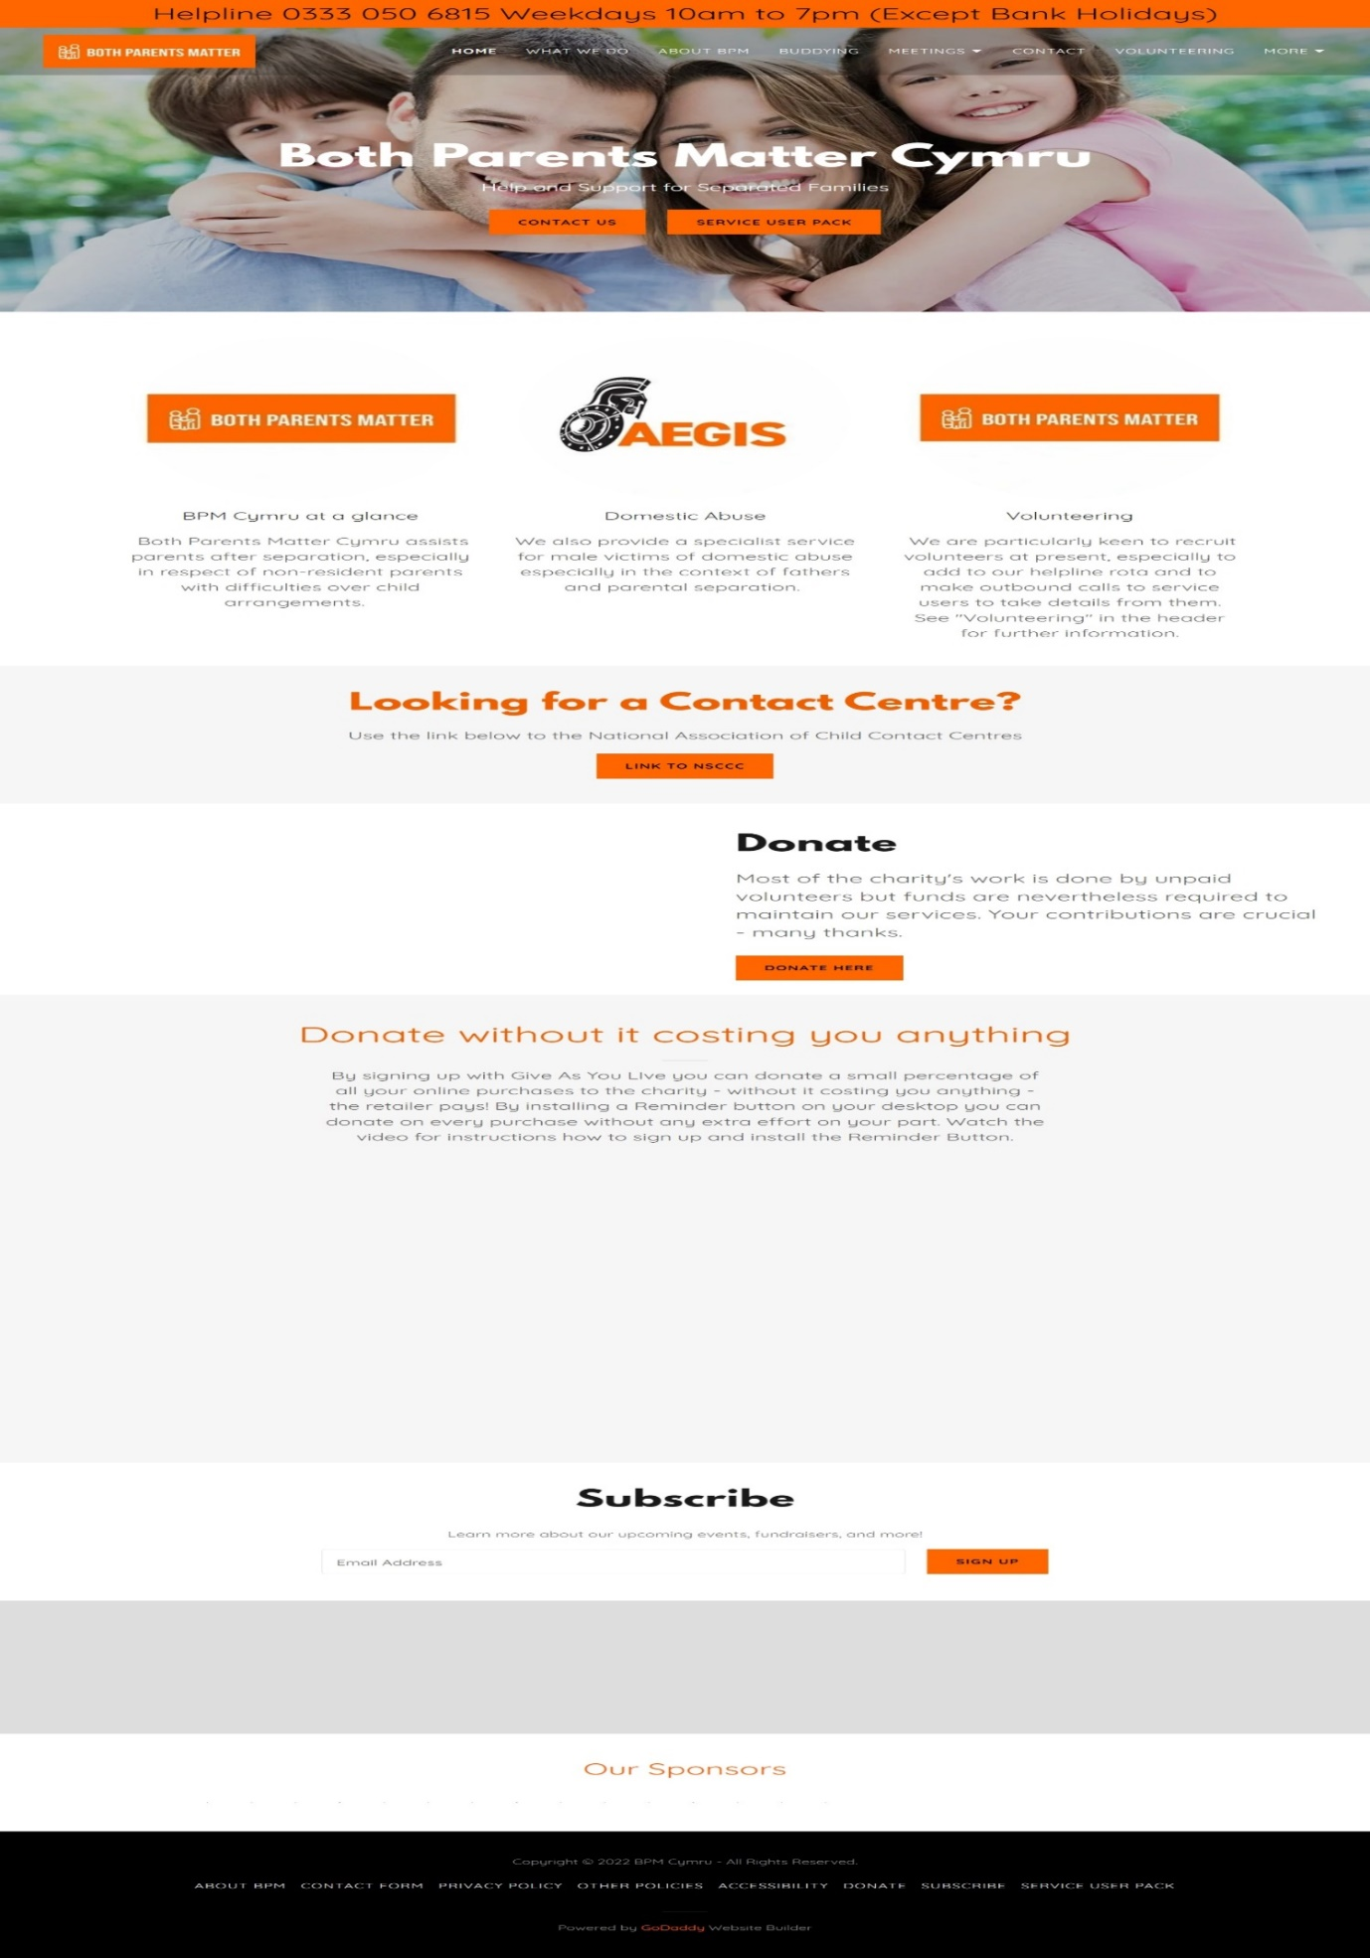

Reflective Commentary
My reflective commentary will reflect my time spent volunteering at my chosen organisation Both Parents Matter Cymru and I will be using the Gibbs Reflective Cycle (1988). My commentary will be based of my volunteering postion within the organisation and the opportunities that it has provided myself to develop upon my core counselling skills that I have spent my time working on as part of my Psychology and Counselling Course.
We were told that we had to try and secure a volunteering placement that would allow me to learn and develop on my counselling skills and that would help me gain the valuable learning experience in using these skills. I was excited at the prospect of working in a placement and gaining new skills that would help me to further my learning and experience in counselling and started to research some opportunities that meant something to myself. At this time, we were still in a Covid-19 Pandemic, and I found this to be rather stressful as there weren’t many opportunities that I could help with due to the suspension of new volunteers as the organisations were following the strict guidelines and safety measures put in place in majority of places. This was upsetting as I would have liked to go into an organisation and been present to learn the skills, such as my body language, being present in the situation and active listening. I really wanted to learn to fulfil my passion of working in the counselling field. After much research and talks with my counselling skills tutor, I found an organisation that I truly believed in their mission statement and emailed them to find out if they were looking for volunteers and I was lucky enough to find out they were, but it was an online postion. After giving it much thought and despite this not being a in person postion, I decided to give this a go and do it online. The organisation I choose was Both Parents Matter Cymru (BPM Cymru, 2022). Unfortunately, at the time of doing the reflective commentary, I had a bare minimum of experience due to the helpline not receiving the calls sufficient enough for me to learn and use the skills required in counselling. While I did take a number of calls, these were just a basic questionnaire calls that would then be picked up by the more experienced volunteers. This was at times frustrating for myself, but I understood that this was at no fault of anyone, and it was just down to unfortunate circumstances of the pandemic times. My role in the organisation was as a helpline advisor and my duties included answering the online helpline phone software that I had to download and put onto my laptop in order for me to sufficiently take the phone calls. As a helpline advisor, I would answer the phone and take down the service users name and contact details and then inform them of the confidentiality form that had to be read before a call took place. If the service user agreed to this, I would then proceed to ask a number of questions that would be marked on a questionnaire form to gather the first initial details and information needed, when this was done, I would then inform the user that they would receive a call back from another department. When the call was finished, I would put the answered and filled out questionnaire into the system and that would be passed on to a outbound caller who would call back the service user. In this phone call, the skills I would use would be contracting with the service user to initiate the start of the process, so everyone was safe , respected and bound by the contracting. I would also use my active listening skills as this was a crucial part of the call to help get the correct information from the service user, I would also use paraphrasing to confirm details and to make sure what I had heard was correct and also showed I was present and listening to the service user. Also, I would ask questions and summarise the key information. These are some of the skills that are used in counselling. Hough, M. (2006).
During my time in placement, I found it quite surprising the lack of quantity of calls that I had received, I found this surprising due to the fact that the statistics that BPM quote of the amount of people who need help especially during these pandemic times are soaring and this did not reflect on the helpline when I weas on it. I found this to be challenging as I was my expectations were that I would gain lots of experience and be able to demonstrate some of the skills I have learnt but due to the helpline not being busy, this was not the case and I feel I did not really gain any new skills. I want to improve on my skills and also learn new skills, so this was disappointing. My main responsibility during the helpline role was to make sure I took the information that was given to me and correctly entered into the database. While I did enjoy helping when I could, due to the nature of the helpline I was not allowed to give any information or help, and the main priority was to just capture the important details and to inform the service user of the next steps. BPM have a number of opportunity’s to move on from the helpline which I am hoping to be able to do and move into a more proactive role that will allow me to demonstrate some of the skills I have already and expand on these. They also have a buddy role that involves meeting held once a month that is in person and I am hoping to move onto this in the near future.

References

Both Parents Matter. (2022). BPM Cymru - Non-Resident Fathers, Domestic Abuse, Charity (bpmuk.org).
Gibbs, G. (1998). Learning by Doing: A guide to teaching and learning methods. Oxford Polytechnic.
Hough, M. (2006). Counselling skills and theory. Hodder Arnold.


What We Do in brief

- Assist with family court applications
- Assist with applications for legal aid
- Provide access to free legal advice from solicitors
- Support male victims of domestic abuse
- Provide emotional support via our Buddy Group
- Research and campaigning on associated issues

Children First
BPM is a Child’s Rights charity working under the UN Convention on the Rights of the Child. The community we work with in our core business consists of non-resident parents and grandparents seeking to maintain a constructive and beneficial relationship with their children/grandchildren after parental separation. Parents who have recently separated, both resident and non-resident, face enormous practical and emotional problems. Our focus is on helping prevent these difficulties adversely affecting the children’s best interests, which generally means facilitating an ongoing meaningful relationship between both parents, and all grandparents, and the children. Non-resident parents need particular support because of the nature of their position. These are mostly, but not invariably, fathers. .

How We Help
Our core service provides two distinct types of support: assistance with practicalities and emotional support. In respect of the former, we emphasise the need for our service users to devise a clear plan and constructive proposals to put forward to the other parent, avoiding destructive confrontation. We also provide assistance in completing paperwork, which can be daunting for the uninitiated. This includes applications for Legal Aid, where appropriate. It also includes access to pro bono solicitors for an initial consultation.

(BPM Cymru,2022)
BPM offer a range of services that they can help assist with to help the service user. Their main mission is that they are a children’s rights charity first and foremost and their focus is to help families in difficulties and to prevent more upset for children. The best interest of the child is the main priority.

Men as Victims of Domestic Abuse
The other part of our service is to act as a specialist service provider to male victims of domestic abuse, which we carry out under a distinct name “Aegis”. This became a natural extension of our core business as nearly two-thirds of our service users are victims of domestic abuse. This service has been provided via weekly male DV drop-in centres in Neath and Swansea, started in the first half of 2019. However, we also take male DV clients from our core business (monthly support meetings, helpline, and referrals). This has been funded in 2019/20 by NPT county council and the Big Lottery Awards for All, and we have recently won another Awards for All grant to continue the service in 2020/21.
(BPM Cymru, 2022)

The Buddy Scheme
Last but not least is the Buddy Scheme. The purpose of this scheme is to address the very challenging issues presented by the poor mental wellbeing and severe isolation (and often domestic abuse) which is typical within our client base. The role of the Buddies is strictly confined to emotional support. The giving of advice is not part of their remit. The idea is to promote two things: firstly, a community of service users who will become self-supporting, encouraged by the active involvement of the charity’s volunteer “Buddies”. The intention is that any service user is free to join this self-help group.
(BPM Cymru, 2022)

BPM Cymru offer a range of service for men that are suffering domestic abuse in any form. They do this by offering the buddy scheme which is a great initiative that can be life changing for some men that feel they have nowhere to turn or go.

Induction
After you have had time to absorb the contents of the documents/videos we will arrange an online chat with you to answer your questions about the role(s). This is the Induction process. Assuming you remain keen to become involved, the outcome will be approving you to start in a probationary capacity in a specific role. Sometimes we approve in two roles. Assuming all goes well, you will be formally approved in the role(s) after 3 months working with the charity.
Supervision
All volunteers are assigned a supervisor, as defined in the Role Specification.
ID
Volunteers who attend meetings will be required to supply a passport style photo which will be used to provide you with photo ID identifying you as an FNF BPM Cymru volunteer.
Feedback
We will ask you for your feedback on your volunteering experience with us, (a) at the end of your initial 3 month probationary period, (b) when you decide to end volunteering with us, and (c) every year as routine.
Confidentiality
By signing the Agreement, below, you agree to abide by our confidentiality policy. In the course of your volunteering with the charity you will come across confidential information about the organisation, its staff, trustees, volunteers and its service users, and possibly third parties. You must respect this confidentiality, noting that we assure others, especially our service users, that their confidential disclosures to us will be treated in the strictest confidence. You agree not to disclose any such information unless directed to do so by the charity’s management team (who will approve disclosure only when there is a child protection issue that legally requires such disclosure or to protect some other party).
Policies
By signing the Agreement, below, you agree to abide by the charity’s various policies and procedures, e.g., our data protection, equal opportunities and safeguarding policies and other policies available on our website, Other Policies | BPM Cymru.
Termination
Either you or the charity can terminate this agreement with or without notice at any time.

Training
Essential Pre-Deployment
All new volunteers who are to be assigned designated roles (as listed in the Volunteer Roles document) must be given an Induction prior to being deployed. This generic Induction can be carried out by any member of the Management Team. A common set of briefing material exists for this Induction, regardless of role.
For volunteers to be newly assigned to the Helpline Operative role, training in the requirements of the role, consistent with the above description, must be provided prior to being deployed in that role. This will include, (a) use of the Circle Loop VOIP system, (b) use of the Teams file system (via membership of the team “Secure SUP Completion”), (c) training in completing the first two pages of a Service User Pack, and (d) the elements of effective helpline-style interactions.
A set of briefing notes (the Induction for Helpline Operatives) exists to provide the required scope of this training. The written training brief shall be augmented by an online “interview” with the Helpline Coordinator or with a similarly experienced member of the management team. This will provide the candidate with an opportunity to ask questions to ensure the nature of the role is understood and to clarify any aspects of the written training brief. In practice this training may be carried out at the same time as the General Induction.
Desirable Within Deployment
External or online training is desirable to enhance all volunteers’ skills. For Helpline Operatives the most relevant will be helpline training, essentially amplifying and reinforcing the messages in the Induction for Helpline Operatives. This would include such things as active listening, open questions, accurate listening, feedback, paraphrasing, empathic responding and observing boundaries in dealing with the service users.

Logbook Experience
Student Name: | James Vidler
Name of Host Employer: | Both Parents Matter Cymru

Record of project work carried out (add more entries as needed)
Date: | 28th September 2021
Tasks completed: | Emailed BPM Cymru about volunteering.
Reflection: | I was very happy and positive that I had found an organisation that meant something to myself and was looking forward to hopefully getting started with them.

Date: | 3rd October 2021
Tasks completed: | Had an email back from the volunteer Co-ordinator with the volunteering form and confirmation that I can help with their services.
Reflection: | I was thrilled that I was able to join this organisation and was excited at the prospect of learning new skills that will able me to further my knowledge and skills in the helping and counselling sector.

Date: | 14th October 2021
Tasks completed: | Had an invitation to have an interview with the co-ordinators of the charity over a team meeting page due to the pandemic.
Reflection: | I really enjoyed this meeting; the co-ordinators were great at explaining and showing me how the operation system they use work and stopped through every process to let me ask questions or go over anything I didn’t understand.

Appendix
- Email of confirmation with Both Parents Matter Cymru
- Completed Placement Information
- Email from Module Leader confirming placement
- Email of timekeeping for placement from Co-ordinator



