Module Title: Contemporary Themes in the Hotel and Hospitality Sector
Module Code: BMIH6001
Lecturers: Dr Ernest Balutie Wavei, Natalie Brailsford, Jessica Newport
Assignment Two: Presentation
Mental Health Stigma and Help Seeking Barriers among Hospitality Employees
Student Name: Cristina Maria Petrache
Student ID: 2234360

AI Declaration
“I confirm that I have not used any AI tools in the research and creation or this assignment. I confirm that I have not presented any AI generated materials as my own work. I confirm I have copies of my drafts, notes, and other resources I used, which may be asked to provide in evidence”

Slide 1: Title
Mental Health Stigma and Help Seeking Barriers among Hospitality Employees
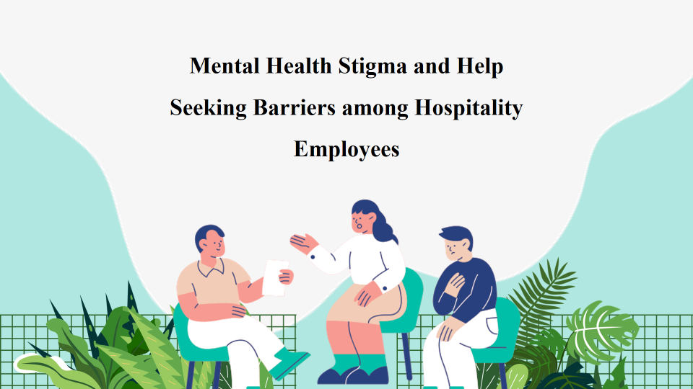
Slide 2: Introduction to the Topic
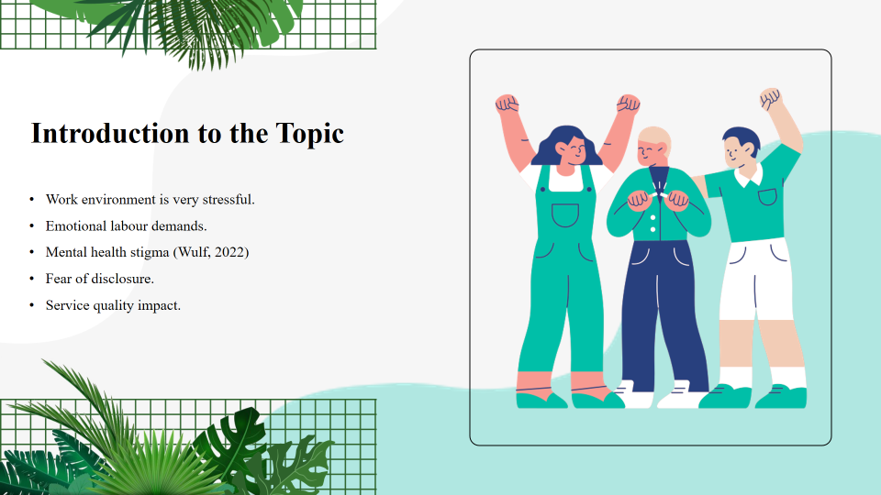
The problem of mental health has become a burning concern in the field of hospitality because of the extended working hours, emotional labour, and regular contact with the guests. It is common to find stress, anxiety and burnout among the employees. Stigma has been identified as a major obstacle that does not allow staff to seek help even despite the growing level of awareness (Wulf, 2022; Roche et al., 2024). Such a problem does not only have a direct impact on the wellbeing of employees, but also on organisational performance and quality of service.
Slide 3: Hospitality Mental Health Problems
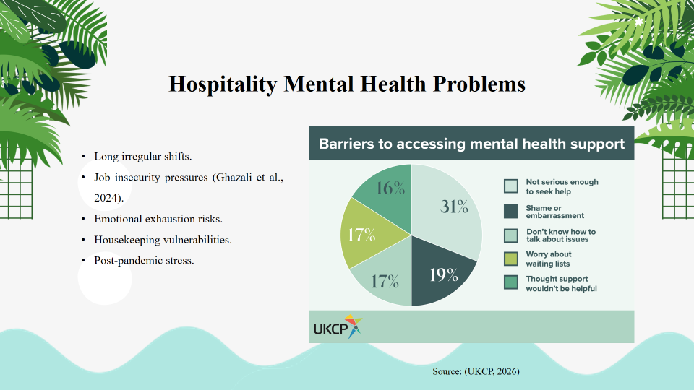
The employees of the hospitality industry are exposed to special psychological stressors such as irregular work shifts, work overload, and stress because of their interface with customers. COVID-19 enhanced the experience of job insecurity and emotional pressure (Ghazali et al., 2024). Physical strain and the lack of organisational support in particular makes housekeeping staff vulnerable (Iing et al., 2025). These contribute to the development of anxiety, depression, and burnouts.
Slide 4: Knowledge of Stigmatisation in the Workplace
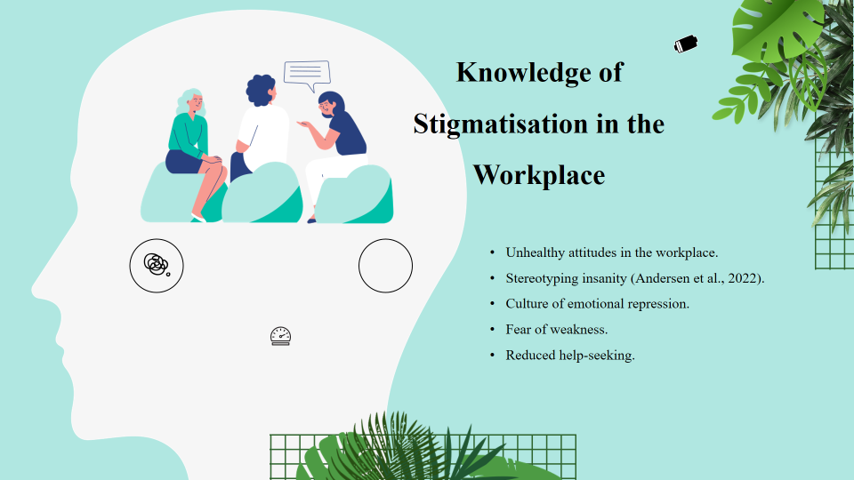
Stigma is described as having negative attitudes, stereotypes, and discrimination against people living with mental health conditions (Andersen et al., 2022). Employees in the service-based sector such as hospitality are supposed to be positive and resilient. The culture does not encourage free conversations on psychological distress. It has been found out that stigma lessens the desire to seek professional assistance (Cilek and Akkaya, 2022).
Slide 5: Barriers of Help-seeking behaviour
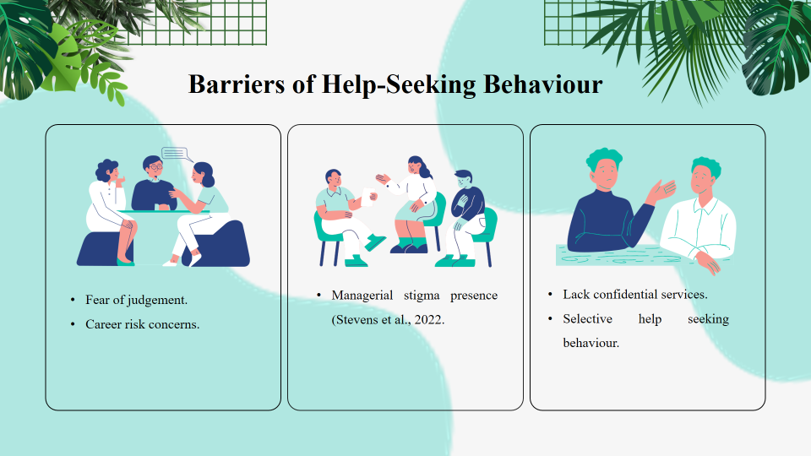
Even though most employees acknowledge the need to have mental health support, they are usually reluctant to use it. Disclosure is restricted by fear of judgement, consequences on their career, and managers bias (Stevens et al., 2022). Help-seeking is also discouraged by organisational systems and vague mental health policies (Pagnozzi and Antonelli, 2025).
Slide 6: Stigmatising Organisational Effects
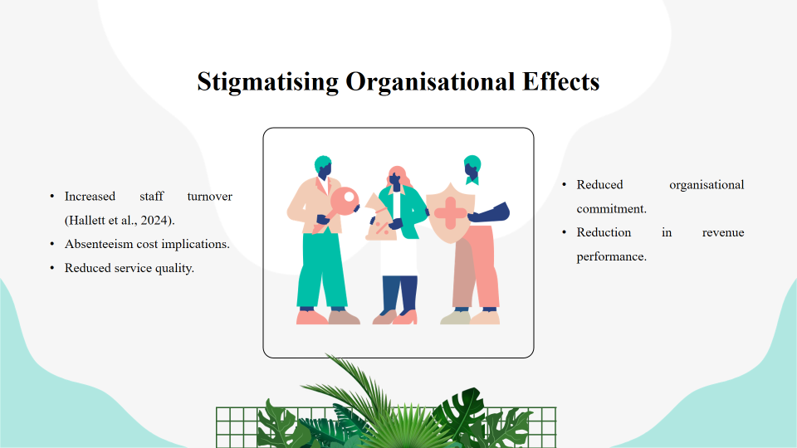
Mental health problems that are not treated lead to absenteeism, high turnover, and decreased productivity (Hallett et al., 2024). Employee wellbeing in hospitality has a direct contribution to guest satisfaction. Research indicates that workplace stigma causes a decrease in organisational commitment and an increase in turnover intention (Callado et al., 2023). Hence, the issue of mental health is a human and business one.
Slide 7: Research Methodology
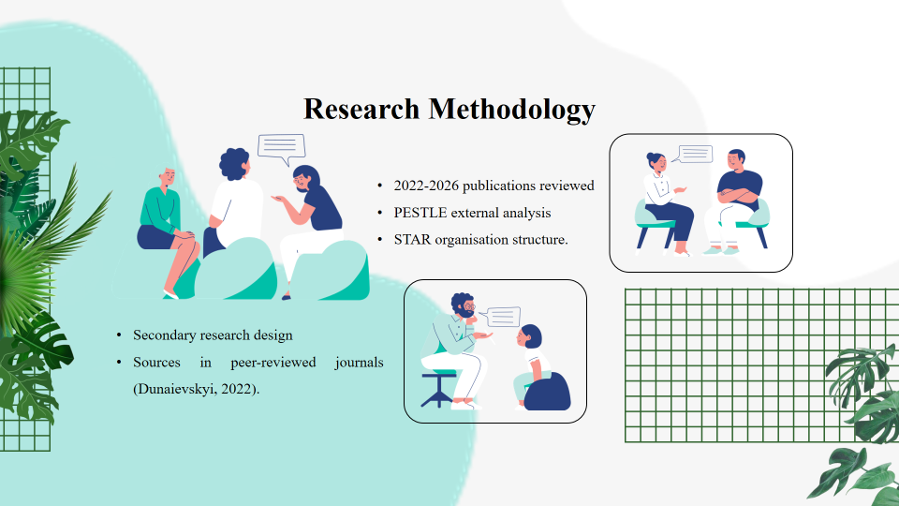
The present research took a peer-reviewed scholarly literature, industry reports, and credible web sources as the secondary research design. PubMed, Scopus, and Google Scholar were used to gather sources because they were considered the most relevant and reliable ones and included studies published in 2022-2026. PESTLE framework was used to examine the macro-environmental factors that affect mental health in the hospitality industry (Dunaievskyi, 2022), and the STAR model was employed to assess internal organisational reactions (Wu et al., 2024). The integrated analytical methodology made the linked structural, cultural, and management factors contributing to stigma and help-seeking behaviour comprehensible.
Slide 8: Findings of the PESTLE Analysis
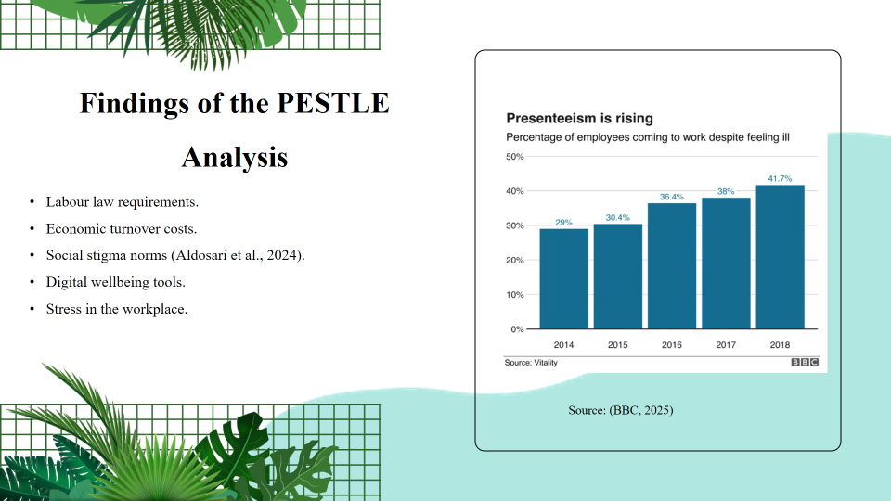
PESTLE model brings out the influence of external factors on mental health at work. Environmental safety is demanded by labour laws and rules against discrimination (Malik and Rai, 2022). Turnover costs are more expensive due to economic pressure (Hallett et al., 2024). Disclosure is not encouraged by social norms (Aldosari et al., 2024), and technology, including wellbeing apps, can be used to enhance access to support.
Slide 9: Application of STAR Framework
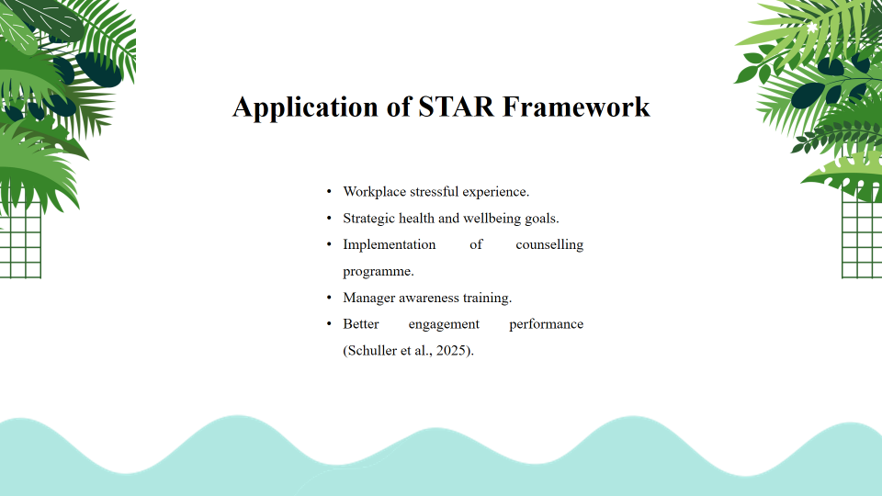
The responses of organisations are assessed using the STAR model (Situation, Task, Action, Result). It is a case of stress and burnout; stigma reduction tactics are needed in the task. Measures involve counselling and training of mental health. The outcomes demonstrate a higher level of engagement in cases of a successful implementation of interventions (Schuller et al., 2025).
Slide 10: Interventions and Best Practice in the Industry
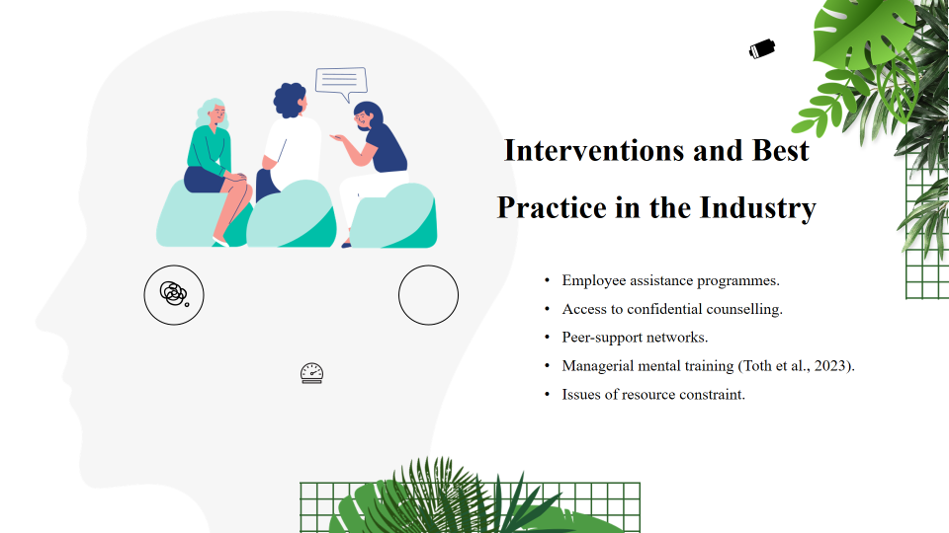
Huge international brands like Hilton and Accor have also launched EAPs (Employee Assistance Programs), confidential counseling, and peer-support (Fleming, 2024). Systematic reviews affirm the reduced stigma caused by interventions in the workplace which can be reduced through structural application (Toth et al., 2023). Nevertheless, small hotels do not always have enough resources (Johnson et al., 2022).
Slide 11: Change of Structure and Culture Requirement
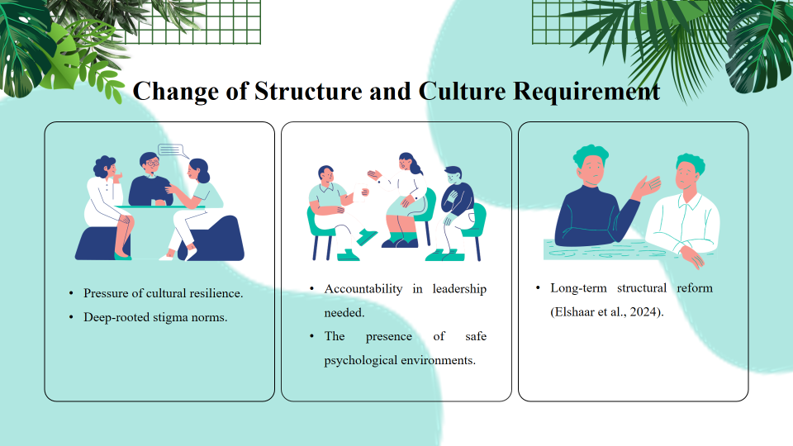
Although there are interventions, most organisations dwell on symptoms as opposed to underlying causes of stigma. The vulnerability is also suppressed by cultural demands of resilience (Elshaar et al., 2024). To achieve sustainable change, the mental health awareness will have to be enshrined in leadership, operations, and workplace culture.
Slide 12: Conclusion and Recommendations
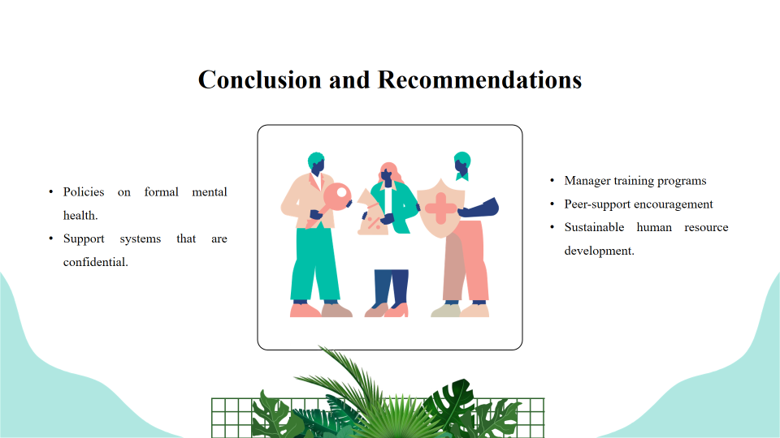
Mental health stigma is one of the key problems in hospitality. To solve it, it is necessary to implement formal policies, management training, peer networks, and available digital tools. Stigmatisation reduction enhances retention, productivity and satisfaction of guests. To create sustainable and conducive working environments, organisations need to invest in a long-term cultural change.
Slide 13: References
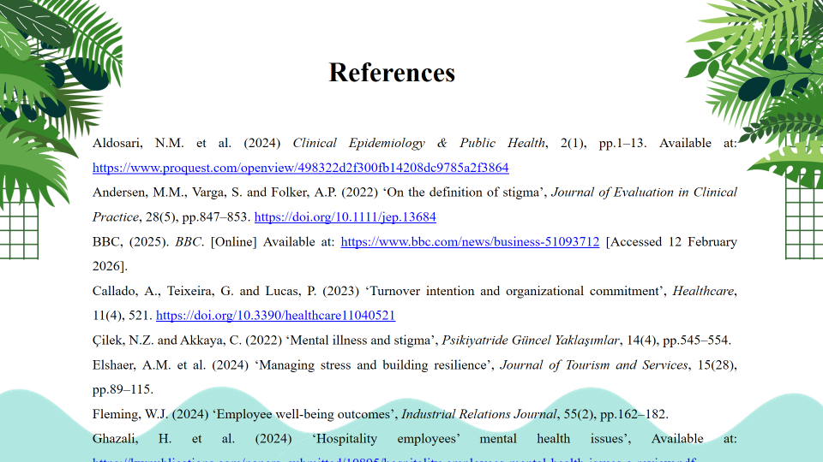
Aldosari, N.M. et al. (2024) Clinical Epidemiology & Public Health, 2(1), pp.1–13. Available at: https://www.proquest.com/openview/498322d2f300fb14208dc9785a2f3864
Andersen, M.M., Varga, S. and Folker, A.P. (2022) ‘On the definition of stigma’, Journal of Evaluation in Clinical Practice, 28(5), pp.847–853. https://doi.org/10.1111/jep.13684
BBC, (2025). BBC. [Online] Available at: https://www.bbc.com/news/business-51093712 [Accessed 12 February 2026].
Callado, A., Teixeira, G. and Lucas, P. (2023) ‘Turnover intention and organizational commitment’, Healthcare, 11(4), 521. https://doi.org/10.3390/healthcare11040521
Çilek, N.Z. and Akkaya, C. (2022) ‘Mental illness and stigma’, Psikiyatride Güncel Yaklaşımlar, 14(4), pp.545–554.
Elshaer, A.M. et al. (2024) ‘Managing stress and building resilience’, Journal of Tourism and Services, 15(28), pp.89–115.
Fleming, W.J. (2024) ‘Employee well-being outcomes’, Industrial Relations Journal, 55(2), pp.162–182.
Ghazali, H. et al. (2024) ‘Hospitality employees’ mental health issues’, Available at: https://kwpublications.com/papers_submitted/10895/hospitality-employees-mental-health-issues-a-review.pdf
Slide 14: References
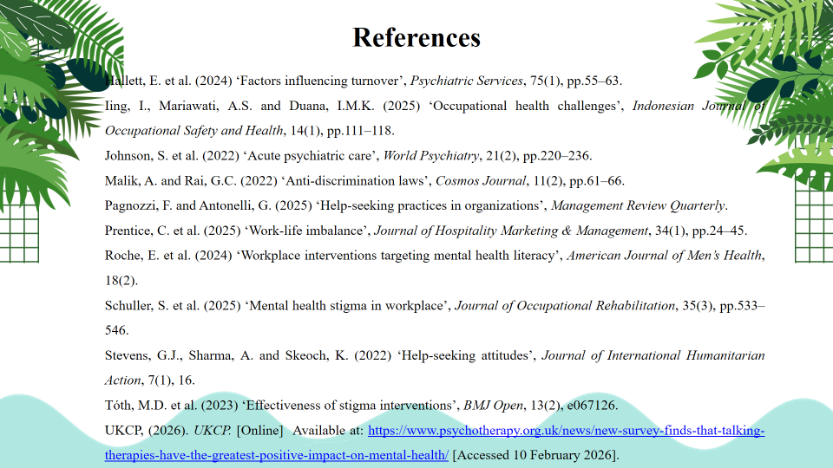
Hallett, E. et al. (2024) ‘Factors influencing turnover’, Psychiatric Services, 75(1), pp.55–63.
Iing, I., Mariawati, A.S. and Duana, I.M.K. (2025) ‘Occupational health challenges’, Indonesian Journal of Occupational Safety and Health, 14(1), pp.111–118.
Johnson, S. et al. (2022) ‘Acute psychiatric care’, World Psychiatry, 21(2), pp.220–236.
Malik, A. and Rai, G.C. (2022) ‘Anti-discrimination laws’, Cosmos Journal, 11(2), pp.61–66.
Pagnozzi, F. and Antonelli, G. (2025) ‘Help-seeking practices in organizations’, Management Review Quarterly.
Prentice, C. et al. (2025) ‘Work-life imbalance’, Journal of Hospitality Marketing & Management, 34(1), pp.24–45.
Roche, E. et al. (2024) ‘Workplace interventions targeting mental health literacy’, American Journal of Men’s Health, 18(2).
Schuller, S. et al. (2025) ‘Mental health stigma in workplace’, Journal of Occupational Rehabilitation, 35(3), pp.533–546.
Stevens, G.J., Sharma, A. and Skeoch, K. (2022) ‘Help-seeking attitudes’, Journal of International Humanitarian Action, 7(1), 16.
Tóth, M.D. et al. (2023) ‘Effectiveness of stigma interventions’, BMJ Open, 13(2), e067126.
UKCP, (2026). UKCP. [Online] Available at: https://www.psychotherapy.org.uk/news/new-survey-finds-that-talking-therapies-have-the-greatest-positive-impact-on-mental-health/ [Accessed 10 February 2026].
Wulf, I.C. (2022) ‘Help-seeking intentions’, Frontiers in Education, 7, 856458. https://doi.org/10.3389/feduc.2022.856458
Slide 15: Thank You


