Level four – Quality and Business Improvement Assignment 2

Intro
The main purpose of this report is to investigate problems, assess risk and analyse areas for improvement. I will be using the role of a consultant Process Improvement Engineer to utilize an improvement plan for a specific manufacturing process. In this scenario I will be using the process which is used to create a sliding jaw for a vice.
For the first operation, two separate machinists (A&B) work autonomously to carry out the sand casting. Two other machinists (C&D) will also work independently from each other to machine the dimensions stated in order to finish the component.
In this scenario, I am assuming that CNC machines have been used for this purpose. I am also assuming that each machinist varies in skill and experience. An assumption has also been made that there is a customer who wants the product made to a specific specification. With the defect data and appropriate quality tools, I will be creating a prioritised correction action plan.

Main body
To create the action plan, I believe that the six-sigma methodology should be used due to the fact that its main purpose may be the most appropriate for the underlying project. Six Sigma may be carried out from a variety of methods. The text states “DMAIC (pronounced “Duh-MAY-ick”) is a structured problem-solving methodology widely used in business.”, George. Et al (2004). This implies that six sigma has a specific process used in order to achieve its main goal. Also, that it seems to be very a very effective process in assessing underlying causes due to the fact that it is used a lot to solve problems in all types of industries.
There is a specific approach to this type of tool. An article states “Sigma represents the approach of population standard deviation, which is a measure of the variation in a data set collected about the work process”, Bhasin (2019). This implies that six-sigma is a methodology used in industry to try and improve the quality of products produced. This may be achieved through reducing the amount of discrepancies in a specific process. Explain further

1.1
The first step in the ‘DMAIC’ process is the letter ‘D’ which stands for ‘define’. The purpose of this is “To have the team and its sponsor reach agreement on the scope, goals and financial and performance targets”, George. Et al (2004). This suggests that the first step of ‘DMAIC’ is to establish goals in terms of what we as a team would like to achieve. In this scenario, I would like to create an action plan to improve the manufacturing process for a sliding jaw.

In summary the ‘Define’ for this project would be to reduce the amount of discrepancies involved in the process of manufacturing. This could be done through a tool called a ‘SIPOC diagram’. A ‘SIPOC’ diagram is used to help verify the ’scope’ of the project. It helps to give an outline of the full course of action, relating to ‘Suppliers, Inputs, Processes, Outputs and Customers’.
The first box that is completed in a SIPOC diagram is ‘P’ which stands for ‘Process’. In this section the collection of activities is noted to show the team what is being reviewed. It is defined as a collection of activities with the purpose of creating a product for a customer.
The second step for this technique is ‘O’ which represents ‘Output’. This is simply just a product created by the company for the customer.
The ‘Customer’ is the third part of the ‘SIPOC’ diagram. This could be one person, a team or a company who receives the product created in the previous step.
Next, the ‘Supplier’ box is filled. This could also be one person, a team or a company. The difference to the last step is that the ‘Supplier’ provides an ‘Input’ in order to be able to carry out the ‘Process’. Depending on the workplace, the ‘Supplier’ and ‘Customer’ could be the same. An example of this is in my company (FSG Tool and Die) where a customer will supply a specific material with a drawing.
Finally, the ‘Input’ section is filled in. This consists of everything used to make the ‘Process’ workable. This most likely consists of material type, information, energy and manpower.

This is what a SIPOC diagram would look like for this scenario.
Supplier | Input | Process | Output | Customer
Who supplies inputs? | What inputs? | Major steps? | What comes from the process? | Who receives the output?
Customer | - Employees  - Material  - Energy  - CNC machine  - Engineer drawing | Sand casting | Semi-finished sliding jaw | Customer
Customer |  | Machining | Finished sliding jaw | Customer

1.2
The second step relating to ‘DMAIC’ is ‘M’. This refers to ‘Measure’. This is implemented “To understand the current state of process and collect reliable data”, George et al (2004). I believe that doing this will involve a data collection plan. This could help the team expose any underlying problems relating to speed, quality and cost. This may involve the team breaking down the processes to see where things may be going wrong. Once identified, it may well help to summarise the team’s findings in a statement. This will help by informing the team what has been found.
Throughout each manufacturing operation of the sliding jaw, each workpiece was put through a quality check to see if any discrepancies were present. This was completed over the period of one week, over days and nights for each machinist.
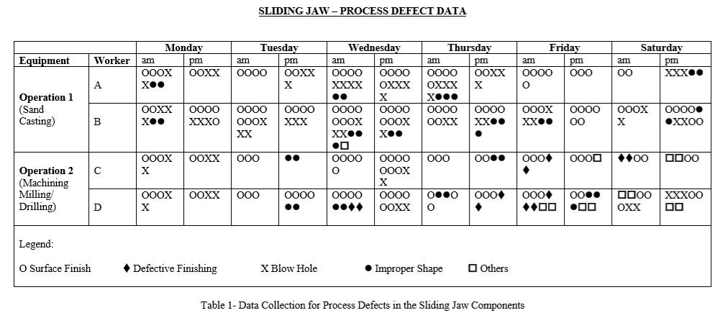
For the second step, a data summary was required to bring all the found data together. This was completed in the form of a table using different symbols to represent different discrepancies noticed. To keep everything as simple as possible I only used individual symbols for recurrent errors and for the very inconsistent issues I placed under ‘others’. This form was used due to it being a quick and easy method to present the information found.
Using this data, I may be able to define the results even further. This could be done through a PARETO analysis. This tool uses a statute referred to as ‘80/20’. This means that, for many events that occur roughly 80% of the effects come from roughly 20% of the causes. An example of this could be 80% of the results coming from 20% of the effort.
The first step of this process involves how the information is collected. In this scenario I have used a tally chart to gather information over the period of one week. Other ways to extract information could be questionnaires, complaint records and observation. As there were two processes involved, I found a large amount of results.
The next step is to order the information in a more detailed matter. This requires another table, however this will also include the cumulative percentage as well as the cumulative number. This is calculated through the following equation:
Cumulative percentage = (Cumulative number/ total) * 100
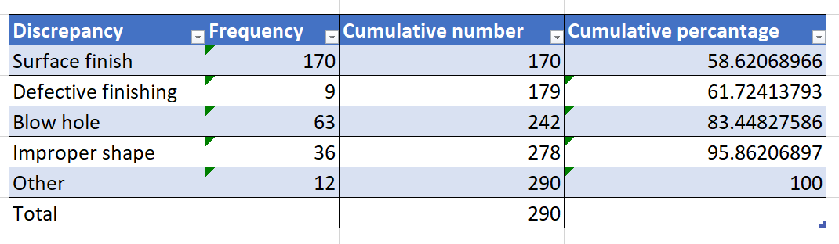

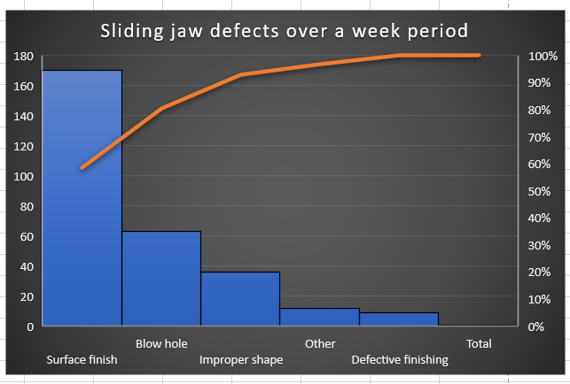
Finally, a graph is plotted based on the findings of the last step. It should contain bars to represent the frequency of occurrence. A line should also be present to signify the cumulative percentage.

There was a total of 290 discrepancies throughout the week. What I found was the most commonly occurring was ‘surface finish’ which could have happened for a number of reasons. This will be studied in the next step of the ‘DMAIC’ process.

1.3
The third phase of ‘DMAIC’ is ‘A’, which stands for ‘analysis’. This is applied to “Pinpoint and verify causes affecting the key input and output variables tied to project goals.”, George et al (2004). I deem that this will involve the data collected from the most recent phase, moreover, to determine where the quality is potentially worst affected.
The most vital assets should be discussed first. The text states “Determine critical inputs.”, George et al (2004). This implies that the information found from the ‘measure phase’ needs to be looked over for all of the most affected areas of the process. From my results from the ‘measure’ phase, I can see that ‘surface finish’ was the most common factor towards creating discrepancies. Also ‘blow hole’ being the second most common, furthermore ‘improper shape’ being the third most common.
I believe that further analysis needs to be done in relation to my results. The text states “Perform process analysis.”, George et al (2004). This infers that the whole process needs to be looked at, at various points to determine where the main constraints are. Analysing the process flow helps with finding ‘bottlenecks’ and rework points, which will show the team where time is being wasted and also where the quality is potentially not up to standard. I imagine this could be completed through a root cause analysis.
There are many ways to carry out a root cause analysis. The most appropriate method for this scenario may be the ‘Ishakawa’ method. This consists of placing all the incongruities into a ‘fishbone diagram’. Next, each error will be considered in terms of how it has happened. An example of this could be the surface finish being incorrect due to incorrect speeds and feeds.
- Use ishakawa method to produce diagram
- Explain findings

1.4
- Improve phase
- Determine what needs to be done in this phase
- How can it be done?

1.5

- Control phase
- Purpose of phase?
- Why is it important?
- How can it be achieved?
- Carry out for current investigation

Conclusion
- What has been found?
- Benefits?

References (Complete properly, more needed)
- https://www.marketing91.com/what-is-six-sigma/
- George, et al (2004) Lean six sigma pocket tool book. (pages 1,

