Tesco´s Strategic report

Table of Contents
Introduction 3
2. PESTEL 4
2.1 Political Factors 5
2.2 Economic Factors 7
2.3 Social Factors 10
2.4 Technological Factors 12
2.5 Environmental Factors 13
2.6 Legal Factors 15
3. Porter’s Five Forces Analysis of Tesco 16
3.1 Threat of New Entrants 16
3.2 Bargaining Power of Suppliers 17
3.3 Bargaining Power of Buyers 17
3.4 Threat of Substitutes 18
3.5 Industry Rivalry 18
4. SWOT 19
4.1 Strengths 19
4.2 Weaknesses 21
4.3 Opportunities 22
4.4 Threats 22
5. Porter’s Generic Strategies 24
Conclusion 25
Recommendations 26
References 27

Introduction

Strategic management is vital in today’s retail industry, where companies must constantly adjust to disruptions, new technologies, and fast-changing customer needs. According to Chandler (1963), strategy is about setting long-term goals and deciding how to use resources to reach them. Porter (1980; 1996) argues that a company’s lasting advantage comes from having a unique position in the market—either by being the lowest cost provider, offering something different, or focusing on a specific segment.
Because the retail world is so unpredictable and complex, many experts now recommend using more flexible and mixed approaches. This means combining traditional strategy models with agile, data-driven decision-making (Kim, Nam & Stimpert, 2004; Mintzberg, 2007).
Analytical tools like PESTEL, Porter’s Five Forces, and SWOT help organisations look at both external and internal factors, giving a complete foundation for making strategic decisions (Thakur, 2021). In retail, these frameworks are especially useful for dealing with challenges such as economic instability, supply chain issues, digital change, and shifting customer preferences.
Recent research also points out the growing importance of putting the customer at the centre and using hyperpersonalisation. The “Care of One” approach (McKinsey, 2020) is now seen as a key way to build loyalty and resilience, especially in a market where customers can easily switch brands and expect a lot.
This report uses these strategic management ideas to analyse Tesco PLC, the UK’s top grocery retailer, which is facing stronger competition from discount stores, economic pressures after the pandemic, and rapidly changing consumer demands. As of 2024, Tesco has 4,506 stores worldwide, including 3,786 in the United Kingdom, 170 in the Republic of Ireland, 197 in Hungary, 184 in the Czech Republic, and 169 in Slovakia (Tesco PLC, 2024). By using well-known strategic analysis tools, this report carefully examines Tesco’s current situation and looks at how innovative, flexible strategies—especially in personalised customer care—can help Tesco stay strong and keep its competitive edge in a fast-changing retail environment.

2. PESTEL

PESTEL analysis is widely regarded as a fundamental framework for systematically examining and organising the broad environmental factors that influence strategic decisions (Aguilar, 1967; Thakur, 2021; Belsare, 2025). Academics highlight its usefulness in both stable and uncertain contexts, as it enables organisations to identify and evaluate external opportunities and threats (Andersen, 2025; Vino Ocho et al., 2024; Karadzhov & Patarchanova, 2025). By categorising complex influences into distinct groups, PESTEL supports comprehensive and informed strategy development. For Tesco, applying PESTEL is essential due to the company’s exposure to significant political, economic, social, technological, environmental, and legal challenges in the modern retail sector.

2.1 Political Factors

Political developments continue to shape Tesco’s operations, particularly in areas such as trade, labour legislation, and public health policy. Brexit remains a major factor, impacting supply chains through increased customs checks and regulatory changes. The UK relies heavily on imported food, with only about 60% of domestically produced food consumed locally, and the EU remains its largest trading partner (Wunsch, 2024). This dependence means that post-Brexit procedures have led to higher import costs and delays, especially for perishable goods, increasing the risk of stock shortages and making price stability more difficult in a competitive market.
Labour policy is another significant consideration. As shown in Figure 1, the National Living Wage has risen sharply over the past decade, reaching £12.21 in 2025. For a retailer like Tesco, which employs a large workforce, higher wage floors directly increase operational costs.
The company’s agreement with USDAW (the Union of Shop Distributive and Allied Workers) further adds to these pressures, with pay rates rising from £12.02 to £12.45 in March 2025, and then to £12.64 in August (Tesco PLC, 2025). While these increases support employee wellbeing and job retention, they also reduce operating margins and heighten the need for productivity improvements.

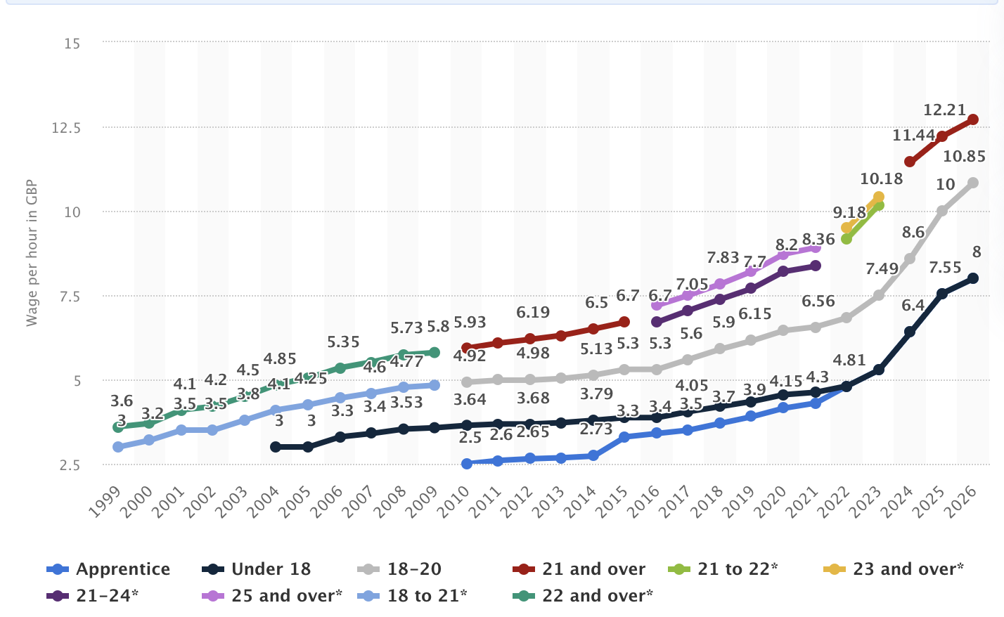
Figure 1: UK National Minimum Wage Rates, 1999–2026
Source: Low Pay Commission (2024).

Public health regulations also influence Tesco’s product strategy. The Soft Drinks Industry Levy will be extended to include sugary milk-based drinks from 2028, requiring manufacturers and retailers to reformulate products or face higher costs (Department of Health and Social Care, 2024). The aim is to reduce national calorie intake, but this may affect product pricing and demand. Consequently, retailers must balance regulatory compliance with competitive pricing and adapt their product ranges to meet evolving health expectations.
Overall, political pressures—ranging from trade and labour costs to public health rules—create significant challenges for Tesco. These factors affect pricing, sourcing, and operational efficiency, all of which influence customer experience and the company’s ability to deliver personalised and reliable services.
Major political events, such as Brexit, continue to shape Tesco’s strategic landscape. The UK’s departure from the EU has complicated trade with European countries, introducing new customs checks, tariffs, and delivery delays, particularly for fresh produce. These changes have increased operational costs and made inventory management more complex (Baldwin & Evenett, 2020; Wunsch, 2024). Brexit has also reduced the availability of EU workers in logistics and warehousing, further challenging Tesco’s supply chain (Dhingra & Sampson, 2019).
Labour regulations remain a key issue. Ongoing increases in the national minimum and living wage directly affect Tesco’s labour costs. As illustrated in Figure 1, the minimum wage for workers aged 21 and over has risen from £3.60 per hour in 1999 to £12.21 per hour in 2025, with similar trends for other age groups (Machin, 2024). Additionally, union agreements, such as those with USDAW, often exceed statutory requirements, further increasing payroll expenses (Tesco PLC, 2024).
Public health policies also impact pricing and product strategies. From 2028, sugary milk-based drinks will be subject to the Soft Drinks Industry Levy, potentially requiring retailers to reformulate products or absorb higher costs, which could influence both pricing and consumer demand (Department of Health and Social Care, 2024). Changes in corporate tax rates and regulatory requirements may also affect profitability (HM Revenue & Customs, 2021).

2.2 Economic Factors

Persistent inflation and ongoing macroeconomic uncertainty continue to shape the UK economy (Chadha,2021), significantly affecting both consumer behaviour and Tesco’s strategic priorities. For instance, the UK’s annual inflation rate (CPIH) surged to nearly 10% in 2022 (Figure 2), and although it has since moderated, it remains above pre-pandemic levels. This has eroded household purchasing power, prompting many consumers to favour discount retailers and intensifying competition in the market (Office for National Statistics, 2024).

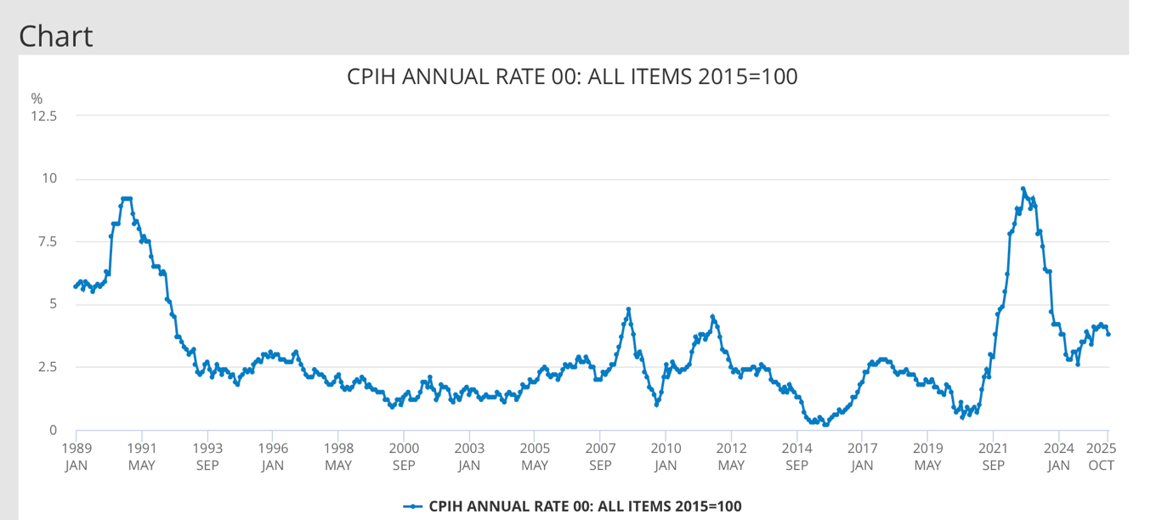

Figure 2: UK Annual Inflation Rate (CPIH)
Source: Office for National Statistics (2024).

Despite these challenges, Tesco continues to play a major role in the UK economy, with a market value of £55.5 billion and employing approximately 1% of the UK’s adult workforce across a diverse demographic (Figure 3). However, the company’s total workforce has gradually declined over the past decade, reflecting efforts to improve efficiency in response to rising costs, technological progress, and changing consumer expectations (Statista, 2024).
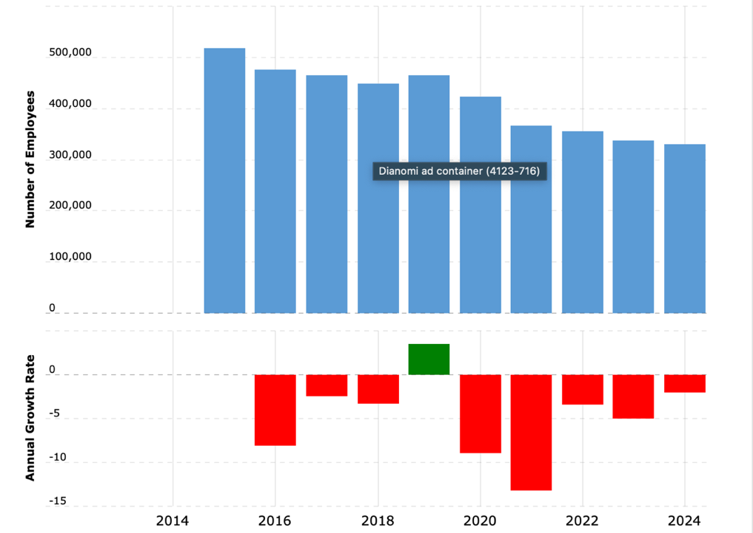
Figure 3: Tesco Group Employment Numbers and Annual Growth Rate, 2014–2024
Source: Statista (2024)

To address these macroeconomic pressures and increased price sensitivity among shoppers, Tesco has implemented a multi-layered value strategy. As shown in Figure 4, this includes Aldi Price Match (covering over 700 products), Low Everyday Prices (over 1,000 products), and Clubcard Prices (exceeding 8,000 products). These initiatives have enabled Tesco to maintain its position as the UK’s most affordable full-line grocer for more than two years. Notably, Clubcard holders receive over £350 of additional value annually, underscoring Tesco’s commitment to delivering economic benefits and fostering customer loyalty. By leveraging its scale, operational efficiencies, and data-driven insights, Tesco has sustained customer retention and remained resilient despite ongoing inflation and uncertainty.

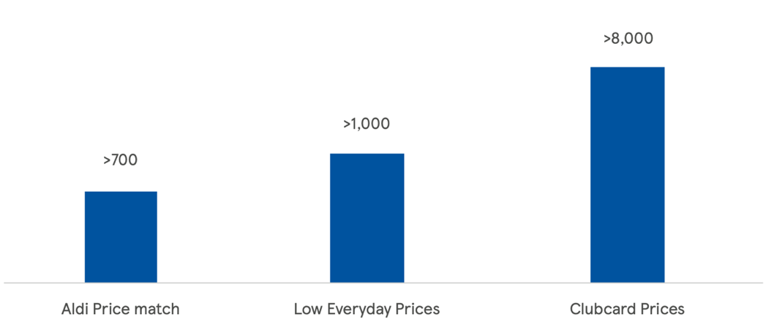

Figure 4: Tesco’s Value Proposition Initiatives
Source: Tesco PLC (2024).
At the same time, broader economic instability—including global volatility, post-Brexit currency fluctuations, and the lingering effects of the COVID-19 pandemic—continues to influence consumer spending patterns, with many households prioritising essential goods over discretionary purchases (Stojanovic, 2020)

2.3 Social Factors

Tesco operates within a dynamic social environment shaped by increasing health awareness, economic pressures, and evolving customer expectations. Approximately half of UK grocery shoppers are now classified as ‘post-family’, with older adults—who tend to make healthier purchasing choices—forming a significant customer segment for Tesco, especially regarding healthy ageing and supportive retail services (Tesco PLC, 2025). Many of the company’s most loyal customers are older individuals or carers, making effective service for this group increasingly important (Gordon, 2018).
In response to these social changes, Tesco has engaged in health-focused community initiatives. For example, the company participated in the Healthy Ageing innovation event in Newcastle, collaborating with academic, public sector, and business partners to improve the quality of life for older people (Gordon, 2018). With projections indicating that one in four people in the UK will be aged 65 or above by 2046, Tesco’s involvement aligns with broader social priorities and demonstrates its commitment to supporting healthy ageing (Tesco PLC, 2025).
To address changing customer expectations, Tesco has set a target for 65% of its total sales in the UK and Republic of Ireland to come from products classified as “healthy” under the UK Government’s Nutrient Profiling Model (NPM) by the end of 2025. As of 2025, the company had already achieved 64%, reflecting strong progress (Tesco PLC, 2025). The use of Clubcard data helps guide product reformulation and encourages suppliers to innovate healthier alternatives.
In-store initiatives such as Better Baskets, restrictions on promotions of high fat, sugar, and salt (HFSS) products, and clearer nutritional signposting have led to over half a million shopping baskets becoming healthier since 2021. In 2022, 3.3 million customers increased their healthy purchasing by at least 10%, and 71 billion calories were removed from own-brand ranges (Tesco PLC, 2025).
Social expectations regarding quality are also shifting. Customer perception of Tesco’s product quality has improved, with premium shoppers increasingly switching from higher-end retailers. Sales of the Tesco Finest range now exceed £2 billion, indicating strong confidence in the company’s ability to deliver high-quality products at competitive prices (Tesco PLC, 2024).
At the same time, trends continue to favour convenience and digital shopping. Tesco has invested heavily in online and rapid-delivery services, notably expanding its Whoosh service, which now offers delivery within as little as 30 minutes in many locations. This increases accessibility for time-pressed customers and those with mobility limitations, including older adults and busy families (Tesco PLC, 2025).
The company’s social responsibility extends to community support. Recognising financial pressures on households, especially during school holidays, Tesco provided over 450,000 free children’s meals in 2023 to families using an adult Clubcard purchase in Tesco cafés. Initiatives such as free EU roaming through Tesco Mobile and freezes on Clubcard Price contracts further demonstrate support for affordability and wellbeing, enhancing Tesco’s reputation as a community-centred retailer.

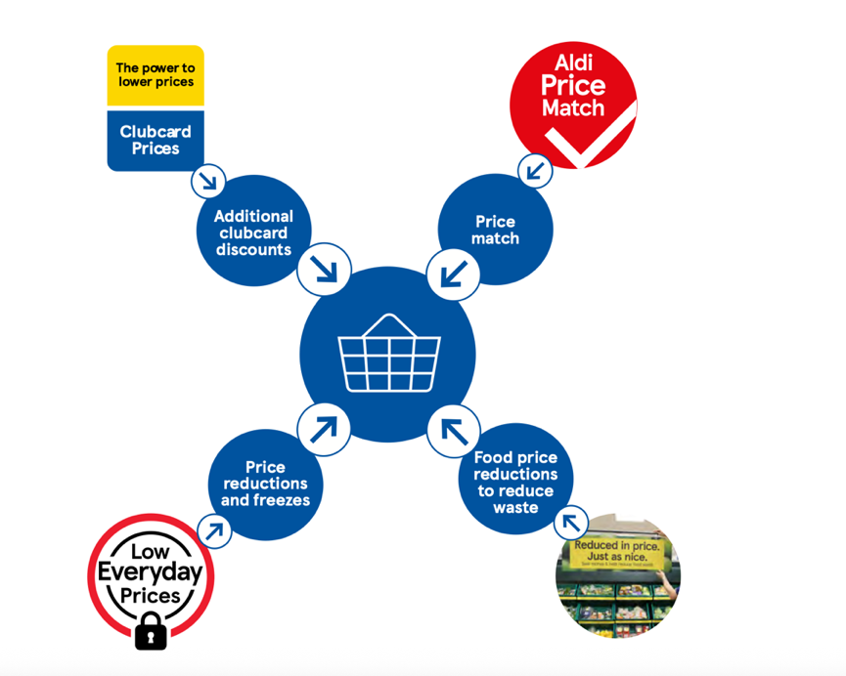
Figure 5: Tesco’s Holistic Value and Customer Care Model
Source: Tesco PLC (2024).

2.4 Technological Factors

Tesco is at the forefront of technological innovation in retail, adopting digital solutions to improve both customer experience and operational efficiency. The emergence of “phygital” retailing—integrating physical and digital shopping—has transformed customer expectations, with retailers increasingly focusing on experiential and personalised services (Alexander and Varley, 2025).
The adoption of Supply Chain 4.0 principles, including automation, advanced analytics, and real-time data sharing, has enabled Tesco to respond more dynamically to consumer demand while improving efficiency and reducing costs (Alicke and Rachor, 2016; Rogers, Semeijn and Magali, 2016). Notably, the company has leveraged artificial intelligence (AI) to enhance supply chain visibility, streamline inventory management, and predict demand more accurately (Food Digital, 2024). These technological advancements have been crucial in maintaining high service levels, especially during disruptions such as the COVID-19 pandemic.
Tesco has also used data-driven insights to personalise marketing, tailor promotions, and improve customer engagement through its Clubcard programme and digital channels (Harvard Digital Data Lab, 2024). The company continues to lead in technological innovation, increasingly harnessing AI and advanced analytics to deliver personalised customer experiences. A significant recent development is the launch of “Clubcard Challenges,” which uses AI-driven insights to tailor offers and rewards to individual shopping habits. As Lizzie Reynolds, Group Membership and Loyalty Director at Tesco, has stated:
“We are constantly looking for ways to make Clubcard work harder for our customers. With Clubcard Prices on around 8,000 products, it is saving customers up to £360 off the annual cost of their groceries. Personalisation is about using what we know about customers to make their experience better and our rewards more helpful and we’re very excited to see how our customers respond to Clubcard Challenges” (Tesco PLC, 2024).

This initiative reflects Tesco’s strategic focus on using technology not only to improve operational efficiency but also to increase customer loyalty and satisfaction by providing more meaningful, relevant rewards.

2.5 Environmental Factors

Tesco continues to make significant progress towards its ambitious environmental goals and remains firmly committed to becoming carbon neutral in its own operations by 2035 (Tesco PLC, 2025). A notable achievement is the expansion of Tesco’s rail freight services, now including a tenth rail service serving the north west of England. This enables the company to move over 300 million cases per year by rail, significantly reducing its carbon footprint.
Additionally, Tesco has made substantial investments in renewable energy. A new power purchase agreement with Cleve Hill solar park will allow the company to source enough solar energy to power the equivalent of 144 large stores annually—about a tenth of its total electricity needs. Another agreement with the Stranoch windfarm will provide clean energy for the equivalent of 80 average-sized supermarkets (Tesco PLC, 2025).
Tesco has also intensified efforts to reduce plastic usage throughout its operations. Millions of pieces of plastic have been eliminated from stores and the supply chain. For example, the company transitioned its Finest pasta line from plastic to paper packaging and trialled innovative solutions such as laser etching on avocados to avoid plastic stickers.
These environmental efforts are complemented by ongoing commitments to health and supplier relations. Tesco has made strong progress towards achieving 65% healthy sales in the UK and Republic of Ireland by 2025 and has been recognised as the number one retailer by suppliers in the Advantage supplier survey for the ninth consecutive year (Tesco PLC, 2025). Collectively, these initiatives demonstrate leadership in sustainability, renewable energy adoption, and responsible retailing, supporting both environmental and social priorities as part of Tesco’s broader business strategy.
To support these sustainability goals, Tesco has also introduced specific animal welfare and environmental sourcing commitments, as shown in Figure 7.
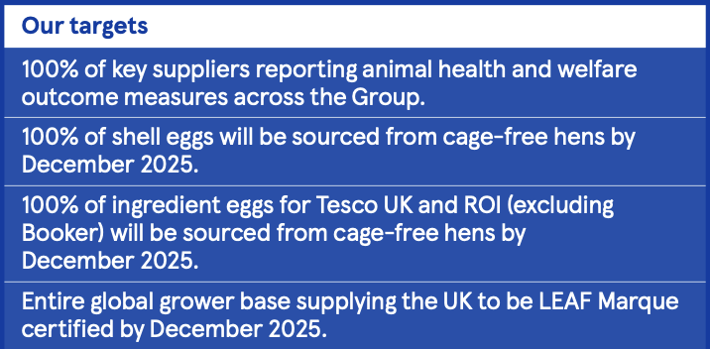
Figure 7: Tesco’s Animal Welfare and Sustainable Sourcing Targets
Source: Tesco PLC (2025).

In addition to these targets, Tesco outlines detailed commodity-specific sourcing expectations and progress measures across its global supply chain. These are presented in Table 1, which highlights Tesco’s commitments to deforestation-free sourcing, responsible certification, and enhanced supplier standards across key categories including soy, palm oil, cocoa, timber, beef, coffee, and seafood.

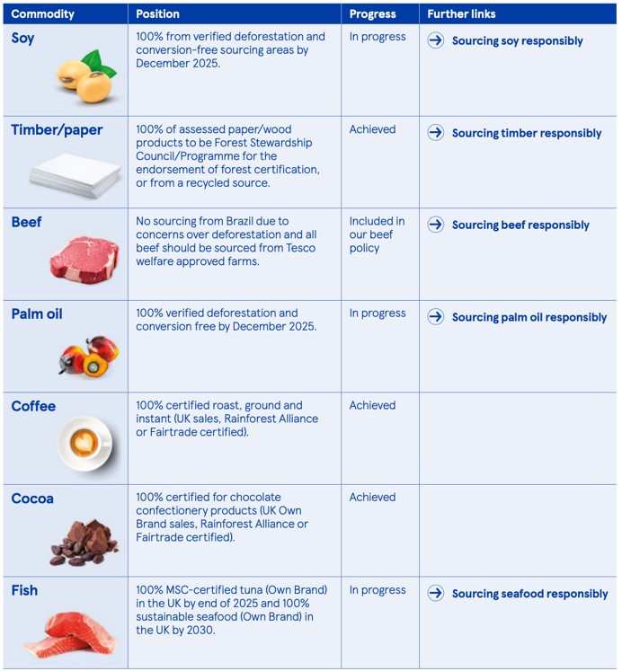
Table 1: Tesco’s Sustainable Commodity Sourcing Commitments and Progress
Source: Tesco PLC (2025).

2.6 Legal Factors

Tesco operates in a highly regulated sector and maintains robust compliance with a wide range of legal requirements, including food safety, employment law, advertising, health and safety, and environmental regulations (Tesco PLC, 2025). The company invests in stringent systems to ensure product safety and quality, as well as ethical sourcing throughout its supply chain.
A critical aspect of Tesco’s legal obligations involves the management and protection of personal data. As a major retailer operating both online and offline, Tesco must navigate the complexities of data protection laws such as the General Data Protection Regulation (GDPR) in the EU and UK. The company is committed to processing personal data lawfully, fairly, and transparently in accordance with GDPR principles (Tesco, 2024; Tesco PLC, 2025).
Tesco’s comprehensive Privacy and Cookies Policy details how customer information is collected, used, and safeguarded. Measures include strong data security protocols, regular audits, and staff training to prevent unauthorised access or misuse of data. Customers are informed about their data rights—such as access, correction, and erasure—and receive clear information about the use of cookies and similar technologies on the company’s website and applications (Tesco, 2024).
All third-party partners handling personal data are required to comply with the same high standards of data protection. By prioritising GDPR compliance and maintaining transparency, Tesco builds and maintains customer trust while reducing legal and reputational risk. Furthermore, the company proactively engages with regulators and policymakers to anticipate and adapt to legislative changes, ensuring continued compliance and ethical business practices across all areas of operation (Tesco PLC, 2025). This proactive approach supports Tesco’s long-term resilience and reinforces its reputation as a responsible market leader.

3. Porter’s Five Forces Analysis of Tesco

Porter’s Five Forces framework remains a cornerstone for analysing the competitive dynamics within the grocery retail sector (Porter, 1979; Porter, 2008). Applying this model to Tesco, which operates both in the UK and internationally, provides valuable insights into the structural challenges and opportunities the company faces (Allio and Fahey, 2012; Crowther, 2008).

3.1 Threat of New Entrants

The likelihood of new competitors entering the UK and European grocery market is low. Tesco and other established retailers, such as Sainsbury’s, Asda, Morrisons, Aldi, and Lidl, benefit from significant economies of scale, strong brand loyalty, and extensive logistics networks (Porter, 1979; Tesco, 2024). New entrants encounter substantial barriers, including the need for large capital investments to develop retail networks and supply chains (Dobbs, 2014). While some online-only and niche retailers focus on specific product segments, such as organic or international foods, they have not yet significantly impacted the market share of major brands (Dias, Espadinha-Cruz and Matos, 2023). Even Aldi and Lidl, now prominent competitors, achieved their positions only after years of sustained investment and expansion in both the UK and Central Europe (Aldi, 2024; Lidl, 2024).

3.2 Bargaining Power of Suppliers

Tesco’s scale and international presence provide considerable leverage in negotiations with suppliers (Dobbs, 2014; Tesco, 2024). Like other major retailers, Tesco typically secures favourable terms due to the high volume and consistency of its orders (Dias, Espadinha-Cruz and Matos, 2023). However, suppliers offering unique, high-demand, or environmentally sustainable products may sometimes negotiate better terms, especially as sustainability and product provenance become more important to consumers (Crowther, 2008). The prevalence of private label products across retailers—including Tesco, Aldi, and Lidl—intensifies competition among suppliers, encouraging improvements in quality and value (Aldi, 2024; Lidl, 2024).

3.3 Bargaining Power of Buyers

Consumers in the UK and Tesco’s international markets have access to a wide range of choices, which significantly increases their bargaining power (Statista, 2024). Shoppers can easily compare prices, switch between supermarkets, or opt for alternatives such as discount retailers and online platforms (Sainsbury’s, 2024).

Aldi and Lidl, both strong in the UK and expanding rapidly in Central European countries, are particularly appealing to price-sensitive customers (Aldi, 2024; Lidl, 2024; Tesco, 2024). Digital providers like Amazon Fresh have also raised expectations for convenience and speed (Crowther, 2008). In response, Tesco invests in loyalty programmes, frequent promotions, and ongoing product innovation (Tesco, 2024), but maintaining customer loyalty requires a continuous focus on delivering value and high-quality service (Allio and Fahey, 2012).

3.4 Threat of Substitutes

The variety of substitutes available to grocery shoppers continues to grow (Dobbs, 2014). Online grocery shopping, rapid delivery services, meal kits, convenience stores, and specialist retailers offering organic, international, or health-focused products all compete with traditional supermarkets (Crowther, 2008). Discount grocers like Aldi and Lidl provide a strong alternative, especially for cost-conscious consumers, and their presence in several of Tesco’s core international markets makes them a particularly significant threat (Aldi, 2024; Lidl, 2024; Tesco, 2024). Tesco addresses these challenges by enhancing its digital offerings, expanding healthy and speciality product ranges, and streamlining the overall shopping experience (Tesco, 2024).

3.5 Industry Rivalry

Competition in the UK and across Tesco’s international markets is intense (Porter, 2008; Tesco, 2024). Tesco faces ongoing rivalry from established competitors such as Sainsbury’s, Asda, and Morrisons, as well as discounters like Lidl and Aldi, both of which have a significant and growing presence not only in the UK but also in the Czech Republic, Hungary, and Slovakia (Aldi, 2024; Lidl, 2024; Tesco, 2024).

The increasing influence of Amazon in the online grocery segment further intensifies the competitive landscape (Crowther, 2008). To maintain its market leadership, Tesco must continually optimise pricing, product selection, and customer experience, while investing in technology, loyalty schemes, and service improvements across all markets (Allio and Fahey, 2012; Tesco, 2024).

4. SWOT

As Phadermrod et al. (2019, p. 194) state, “SWOT analysis is one of many tools that can be used in an organisation’s strategic planning process.” The SWOT framework—strengths, weaknesses, opportunities, and threats—enables organisations to identify and evaluate key internal and external factors that can affect their current performance and future direction (Dyson, 2004; Ayub et al., 2013). This structured approach helps companies like Tesco to systematically assess what they do well, where improvements are needed, and how to respond to changes in their environment (Phadermrod, Crowder and Wills, 2019).

4.1 Strengths

Tesco is recognised as the largest grocery retailer in the UK, consistently securing the highest market share and revenue among its competitors (Statista, 2024). The company’s operational scale is clearly illustrated in Figure 9, which shows Tesco’s number of stores worldwide from 2008 to 2025. The chart indicates that after peaking at over 7,300 stores in 2014, Tesco now maintains a stable network of just above 5,000 stores globally (Statista, 2024). This demonstrates Tesco’s ability to strategically adapt its store portfolio. The business also benefits from a wide range of store formats, ongoing investment in digital services such as advanced online shopping, and a well-established Clubcard loyalty programme. Tesco’s commitment to competitive pricing, including direct price matching with discounters like Aldi, further supports its strong market position (Vizard, 2020).

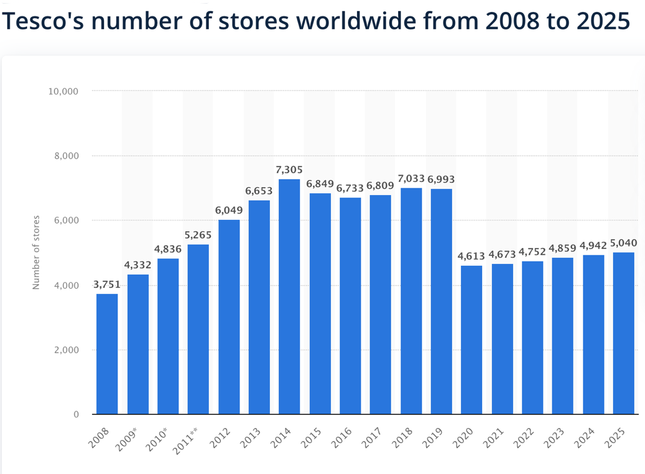
Figure 9: Tesco’s Number of Stores Worldwide from 2008 to 2025
Source: Statista (2024).

4.2 Weaknesses

Despite its extensive reach, Tesco remains highly dependent on the UK market, making it particularly susceptible to changes in local economic conditions and regulations (Statista, 2024). The chart also reflects Tesco’s partial withdrawal from international markets over recent years, pointing to challenges in maintaining global growth. Additionally, the company has faced reputational challenges, such as disputes over executive pay (Jahshan, 2020) and negative reactions to changes in its loyalty scheme, both of which can impact customer perception and loyalty.
Tesco’s expansion into China ended abruptly when it sold 80% of its shares to China Resources in 2022, highlighting the company’s difficulties in achieving sustainable international growth (Li, Wang and Zhang, 2007; ResearchGate, 2023).
Furthermore, Tesco’s reputation has faced additional strain due to legal penalties. The company was fined £7.56 million at Birmingham Magistrates' Court and ordered to pay prosecution costs of £95,500 for food safety violations, an incident which has the potential to damage its public reputation (BBC News, 2021). Given that a good corporate reputation signals trustworthiness and reliability to stakeholders, damage in this area can increase behavioural uncertainty and weaken customer loyalty (Raimondo, Miceli and Costabile, 2008; Walsh, Beatty and Shiu, 2009).

4.3 Opportunities
Tesco has several opportunities to strengthen its competitive position following recent strategic changes in its international footprint. Since the company is no longer operating in a number of overseas markets, Tesco can now place greater emphasis on consolidating and expanding its presence within the UK.
According to Schmid and Morschett (2023), retailers often experience strategic advantages after foreign market exits because they can redirect resources, managerial attention and investment toward core markets where they already hold strong competitive positions. This provides Tesco with an opportunity to refine its domestic strategy, improve store formats and enhance service delivery within the UK.
Another key opportunity lies in the continued expansion of Tesco’s private-label product range. Private labels allow retailers to differentiate themselves while offering strong value propositions, and research suggests that private-label products can significantly influence customer preferences and loyalty (Samdani, 2020). By investing in exclusive, high-quality private-label lines, Tesco can strengthen customer attachment to its brand and improve profitability through higher margins.
The company can also capitalise on shifts in consumer behaviour, particularly those accelerated by global disruptions. Changes in purchasing patterns, such as greater demand for convenience, value, and hybrid online-offline shopping, create opportunities for retailers to innovate and adapt their offerings.
O’Connor (2020) highlights that significant changes in consumer behaviour can open avenues for retailers to develop new service models, enhance digital engagement and tailor products more effectively to evolving customer expectations. For Tesco, this presents opportunities to strengthen its online services, upgrade its convenience store formats and offer more flexible shopping experiences.

4.4 Threats

Tesco faces strong competition from both traditional supermarkets and fast-growing discounters like Aldi and Lidl, who are expanding in the UK and Europe (Vizard, 2020). Another significant threat comes from Amazon, which has established itself as a powerful player in the online grocery market.
Inflationary pressures also represent a significant threat to Tesco, as rising costs can reduce consumer spending power, increase operational expenses, and intensify price competition across the grocery sector. When inflation is high, customers tend to become more price sensitive and may switch to discount retailers, which heightens the competitive environment for full-range supermarkets such as Tesco (Office for National Statistics, 2024). Sustained inflation can therefore undermine profit margins and disrupt strategic planning.

In addition, retail trends are evolving rapidly, requiring Tesco to continuously update and adapt its commercial practices. Campo and Gijsbrechts (2004) emphasise that retailers must regularly adjust their micromarketing strategies and store-level decisions to remain aligned with consumer expectations. This constant need for adaptation presents an ongoing challenge, particularly in a diverse and competitive market where customer behaviours and local conditions vary widely.
Technological disruption also poses a strategic threat. The rapid development of artificial intelligence is transforming marketing, sales, and customer experience across the retail sector, and failure to adopt new technologies quickly enough may put Tesco at a disadvantage compared to more agile competitors (Kaur, 2024). As AI-driven personalisation and automation become standard in competitive retail, Tesco must invest heavily in innovation to maintain its position. Other threats include regulatory pressures, supply chain disruptions, and reputational risks such as shareholder disputes over executive compensation (Jahshan, 2020).

5. Porter’s Generic Strategies

Porter’s Generic Strategies framework outlines three principal routes to achieving competitive advantage: cost leadership, differentiation, and focus (Porter, 1980; Ali and Anwar, 2021). Cost leadership is centred on attaining the lowest operational costs; differentiation involves offering unique value; and focus targets a specific market segment. Traditionally, organisations are advised to select one strategy, as attempting to pursue multiple approaches simultaneously can result in being “stuck in the middle.”
However, in rapidly evolving industries such as retail, research indicates that successful firms often blend cost leadership and differentiation to meet shifting customer expectations (Kim, Nam and Stimpert, 2004; Ali and Anwar, 2021). This is particularly relevant for Tesco, which must balance intense price competition from discounters like Aldi and Lidl with increasing consumer demand for convenience and personalisation.
A pure cost-leadership strategy would enable Tesco to maintain low prices but might restrict its capacity to invest in personalised services and advanced technologies. Conversely, a pure differentiation strategy—emphasising personalised offers, exclusive product lines, or AI-driven loyalty features—could enhance customer loyalty but would entail higher costs and may not appeal to price-sensitive shoppers (Ali and Anwar, 2021).
Given these considerations, a hybrid strategy is the most suitable option. Tesco can continue to offer competitive pricing through initiatives such as Aldi Price Match and Clubcard Prices, while simultaneously differentiating itself through digital personalisation, data analytics, and programmes like Clubcard Challenges (Kim, Nam and Stimpert, 2004). This dual approach enables Tesco to cater to both value-oriented and experience-driven customers.
A comparison with Amazon highlights further opportunities for Tesco. Amazon leverages advanced analytics, dynamic pricing, and an agile innovation culture to deliver highly personalised shopping experiences (About Amazon, 2024; Denning, 2019; Omnia Retail, 2024).

Conclusion
In summary, this report has used established strategic management frameworks to assess Tesco’s current position and future strategic options. Tesco operates in a rapidly changing environment shaped by economic pressures, evolving customer expectations, and strong competition from both discounters and digital-first retailers such as Amazon. The analysis indicates that a hybrid strategy—combining cost leadership with targeted differentiation through digital personalisation—offers the most effective path for strengthening Tesco’s resilience and long-term competitive advantage. To achieve this, Tesco must continue investing in technology, staff capabilities, and customer-focused practices while maintaining strong data governance. By adopting this balanced approach, Tesco can enhance personalised customer care, reinforce customer loyalty, and sustain its leadership within a highly competitive retail sector.

Recommendations

Based on the strategic analysis conducted, three interconnected recommendations are proposed to strengthen Tesco’s competitive position and advance its hybrid strategy of cost leadership and differentiated personalisation.
1. Deepen AI-enabled personalisation to enhance customer loyalty and differentiation.
The analysis indicates that Tesco should intensify its focus on artificial intelligence and advanced analytics to deliver a more personalised customer experience. With the increasing influence of digital-first competitors and empowered consumers, it is essential for Tesco to invest in technologies that enable real-time tailored pricing, predictive recommendations, and highly targeted promotions. Building on initiatives such as Clubcard Challenges, these actions would reinforce Tesco’s differentiation advantage, increase switching costs, and support the “Care of One” personalised care model, while remaining consistent with the company’s established digital strengths (Teece, 2007).
2. Leverage data-driven efficiencies to reinforce cost leadership in response to inflationary pressures.
The economic analysis demonstrates that persistent inflation and rising labour costs continue to compress retail margins. To maintain its position as the UK’s cheapest full-line grocer, it is recommended that Tesco expand the use of automation, demand-forecasting systems, and Supply Chain 4.0 technologies across fulfilment centres and logistics. Porter emphasises that cost leadership is achieved through scale efficiencies and operational optimisation; therefore, deeper integration of AI into supply chain decision-making can reduce waste, improve inventory accuracy, and support lower shelf prices without undermining profitability. This approach strengthens the cost-leadership component of Tesco’s hybrid strategy and addresses the threat posed by discounters such as Aldi and Lidl (Porter, 1980).
3. Strengthen the strategic development of private-label and health-focused ranges to capture emerging market opportunities.
The SWOT analysis identifies strong growth potential in private-label expansion and the rising demand for healthier, sustainable products. Research shows that private labels enhance retailer differentiation, margin control, and brand loyalty (Samdani, 2020). It is therefore recommended that Tesco prioritise premium and value-tier private-label innovation, supported by supplier partnerships aligned with its environmental and sourcing commitments. Expanding these ranges also complements social trends towards healthier lifestyles and reinforces Tesco’s brand reputation. This recommendation aligns with hybrid strategy logic by enabling Tesco to differentiate through quality and innovation while sustaining value pricing relative to competitors.

Taken together, these recommendations support a coherent strategic direction: a strengthened hybrid strategy enabled by digital transformation, operational efficiency, and targeted differentiation. This integrated approach positions Tesco to respond effectively to competitive pressures, evolving consumer expectations, and long-term market uncertainty.

References

About Amazon (2024) ‘About Us’. Available at: https://www.aboutamazon.com/about-us(Accessed: 10 December 2025).

Aldi (2024) About Us. Available at: https://corporate.aldi.us/about-us/aldi-101 (Accessed: 9 December 2025).

Aguilar, F.J. (1967) Scanning the Business Environment. New York: Macmillan.

Alicke, K. and Rachor, J. (2016) ‘Supply Chain 4.0 – the next-generation digital supply chain’, McKinsey & Company. Available at: https://www.mckinsey.com/ (Accessed: 10 December 2025).

Alexander, B. and Varley, R. (2025) ‘Retail futures: Customer experience, phygital retailing, and the Experiential Retail Territories perspective’, Journal of Retailing and Consumer Services, 82. Available at: https://doi.org/10.1016/j.jretconser.2024.104108 (Accessed: 7 December 2025).

Allio, R.J. and Fahey, L. (2012) ‘Joan Magretta: what executives can learn from revisiting Michael Porter’, Strategy & Leadership, 40(2), pp. 5–10.

Andersen, M.S. (2025) ‘From PEST to STEEPLE: Variants of external environment analysis frameworks’, SSRN. Available at: https://doi.org/10.2139/ssrn.5266562 (Accessed: 8 December 2025).

Ayub, A., Razzaq, A., Aslam, M.S. and Iftekhar, H. (2013) ‘A conceptual framework on evaluating SWOT analysis’, Journal of Marketing and Management, 4(1), pp. 23–34.

Baldwin, R. and Evenett, S. (2020) COVID-19 and Trade Policy: Why Turning Inward Won’t Work. London: CEPR Press.

BBC News (2021) ‘Tesco fined £7.56m for food safety breaches’. Available at: https://www.bbc.com/news/uk-england-birmingham-56806641 (Accessed: 11 December 2025).

Belsare, H.V. (2025) ‘PESTLE analysis’, International Journal of Advanced Research, 13(2), pp. 608–612. Available at: https://doi.org/10.21474/IJAR01/20411 (Accessed: 7 December 2025).

Chadha, J. (2021) ‘Inflation and retail: Challenges for the UK grocery sector’, Journal of Economic Perspectives, 35(1), pp. 12–19.

Chandler, A.D. (1963) Strategy and Structure. MIT Press.

CIPD (2023) ‘PESTLE analysis factsheet’. Available at: https://www.cipd.org/en/knowledge/factsheets/pestle-analysis-factsheet/ (Accessed: 8 December 2025).

Clark, D. (2024) United Kingdom: balance of trade in goods and services Q1 2024. Statista. Available at: https://www.statista.com/statistics/282273/balance-of-trade-in-goods-and-services-in-the-uk/ (Accessed: 10 December 2025).

Coyne, K.P. and Subramaniam, S. (1996) ‘Bringing discipline to strategy’, McKinsey Quarterly, 33(4), pp. 14–25.

Crowther, P. (2008) ‘The five competitive forces that shape strategy’, Harvard Business Review, 86(1), pp. 78–93.
Department of Health & Social Care (2024) Soft drink levy extended to protect children and improve health. Available at: https://www.gov.uk/government/news/soft-drink-levy-extended-to-protect-children-and-improve-health (Accessed: 10 December 2025).

Denning, S. (2019) ‘How Amazon became Agile’, Forbes. Available at: https://www.forbes.com/sites/stevedenning/2019/06/02/how-amazon-became-agile/ (Accessed: 9 December 2025).

Dess, G.G. and Davis, P.S. (1984) ‘Porter’s (1980) generic strategies as determinants of strategic group membership and performance’, Academy of Management Journal, 27(3), pp. 467–488.

Dias, S., Espadinha-Cruz, P. and Matos, F. (2023) ‘A Porter’s Five Forces model proposal for additive manufacturing’, Procedia Computer Science, 217, pp. 165–176. Available at: https://doi.org/10.1016/j.procs.2022.12.212 (Accessed: 8 December 2025).

Dhingra, S. and Sampson, T. (2019) ‘Brexit and the UK labour market’, British Journal of Industrial Relations, 57(3), pp. 463–482.

Dobbs, M.E. (2014) ‘Guidelines for applying Porter’s five forces framework’, Competitiveness Review, 24(1), pp. 32–45. Available at: https://doi.org/10.1108/CR-06-2013-0059 (Accessed: 8 December 2025).

Drucker, P.F. (1994) ‘The theory of business’, Harvard Business Review, September–October, pp. 95–106.

Dyson, R.G. (2004) ‘Strategic development and SWOT analysis’, European Journal of Operational Research, 152(3), pp. 631–640.

Emarketer (2023) Global Online Sales Statistics 2023. Available at: https://www.emarketer.com/ (Accessed: 7 December 2025).

Food Digital (2024) ‘How Tesco enhanced supply chain visibility using AI’. Available at: https://fooddigital.com/retail/tesco-enhanced-supply-chain-visibility-using-ai (Accessed: 9 December 2025).

FoodNavigator (2021) ‘Tesco sets new healthy food sales target’. Available at: https://www.foodnavigator.com/(Accessed: 7 December 2025).

Gordon, G. (2018) ‘Supporting healthy ageing – the Snowball effect’. Available at: https://www.tescoplc.com/news/2018/supporting-healthy-ageing-the-snowball-effect/ (Accessed: 7 December 2025).

Gospel, H. et al. (2020) ‘Minimum wage and supermarket employment’, Labour Market Review, 6(4), pp. 77–89.

Grocery Trader (2025) ‘New data shows supermarket interventions including HFSS changes…’. Available at: https://grocerytrader.co.uk/ (Accessed: 11 December 2025).

Grocery Trader (2025) ‘Tesco’s Healthy Eating Initiatives Deliver Results’. Available at: https://www.grocerytrader.co.uk/ (Accessed: 9 December 2025).

Harvard Digital Data Lab (2024) ‘Tesco: A digital transformation’. Available at: https://d3.harvard.edu/platform-rctom/submission/tesco-a-digital-transformation/ (Accessed: 9 December 2025).
HM Revenue & Customs (2021) Corporation Tax Statistics 2021. Available at: https://www.gov.uk/government/statistics/corporation-tax-statistics-2021 (Accessed: 8 December 2025).

Jahshan, E. (2020) ‘Tesco faces shareholder revolt over CEO’s bonus hike’, Retail Gazette, 31 May. Available at: https://www.retailgazette.co.uk/ (Accessed: 10 December 2025).

Kantar (2024) UK grocery market share and inflation trends. Available at: https://www.kantarworldpanel.com/(Accessed: 12 December 2025).

Karadzhov, V. and Patarchanova, E. (2025) ‘How to Create the Best PESTEL Analysis’, International Journal of Digital Research, 1(3), pp. 8–20.

Kim, E., Nam, D. and Stimpert, J.L. (2004) ‘The Applicability of Porter’s Generic Strategies’, Journal of Management, 30(5), pp. 569–589.

Li, F., Wang, X. and Zhang, L.Q. (2007) An introduction to retail internationalisation in China. Available at: https://www.researchgate.net/ (Accessed: 12 December 2025).

Lidl (2024) About Us. Available at: https://info.lidl/en (Accessed: 8 December 2025).

Low Pay Commission (2024) National Minimum Wage Uprating Report 2025. Available at: https://assets.publishing.service.gov.uk/ (Accessed: 10 December 2025).

Low Pay Commission (2025) National Minimum Wage Report. Available at: https://www.gov.uk/government/collections/national-minimum-wage (Accessed: 8 December 2025).

Machin, S. (2024) ‘Minimum wage trends in the UK’, Labour Economics, 41(2), pp. 123–134.
Mason, L. (2018) ‘Amazon Culture: Staying Agile’. Available
at: https://www.youtube.com/watch?v=ESBJoxNCY(Accessed: 9 December 2025).

McKinsey & Company (2020) ‘Hyperpersonalisation and “The Care of One”’. (Accessed: 9 December 2025).

Mintzberg, H. (2007) Tracking Strategies: Towards a General Theory. Oxford: Oxford University Press.

Murray, A.I. (1988) ‘A contingency view of Porter’s generic strategies’, Academy of Management Review, 13, pp. 390–400.

Murphy, K. (2021) ‘Tesco’s economic and social contribution’, Tesco PLC Annual Report. Available at: https://www.tescoplc.com/ (Accessed: 12 December 2025).

O’Connor, K. (2020) The challenges and opportunities created by a global pandemic’s effects on consumer shopping behaviour. Available at: https://esource.dbs.ie/ (Accessed: 10 December 2025).
Office for National Statistics (2024) Consumer price inflation, UK: March 2024. Available at: https://www.ons.gov.uk/(Accessed: 8 December 2025).

Omnia Retail (2024) ‘The strategies behind Amazon’s success’. Available at: https://www.omniaretail.com/blog/the-strategies-behind-amazons-success (Accessed: 9 December 2025).

Phadermrod, B., Crowder, R.M. and Wills, G.B. (2019) ‘Importance–performance analysis based SWOT’, International Journal of Information Management, 44, pp. 194–203.
Porter, M.E. (1979) ‘How competitive forces shape strategy’, Harvard Business Review, 57(2), pp. 137–145.

Porter, M.E. (1980) Competitive Strategy. New York: Free Press.

Porter, M.E. (1996) ‘What is strategy?’, Harvard Business Review, November–December, p. 60.
Porter, M.E. (2008) ‘The Five Competitive Forces That Shape Strategy’, Harvard Business Review, 86(1), pp. 78–93, 137.

Raimondo, M.A., Miceli, G. and Costabile, M. (2008) ‘How relationship age moderates loyalty formation’, Journal of Service Research, 11, pp. 142–160.

Retail Times (2023) ‘Tesco data shows supermarket interventions improving shopping baskets’. Available at: https://retailtimes.co.uk/ (Accessed: 11 December 2025).

Retail Times (2023) ‘Tesco’s health push sees millions buying healthier food’. Available at: https://www.retailtimes.co.uk/ (Accessed: 7 December 2025).

Rogers, D., Semeijn, J. and Magali, C. (2016) ‘The digital industrial revolution’, Journal of Supply Chain Management, 52(4), pp. 45–60.

Sainsburys (2024) Our Strategy. Available at: https://corporate.sainsburys.co.uk/about-us/our-strategy/ (Accessed: 9 December 2025).

Samdani, T. (2020) Impact of Tesco's private label brands on buying behaviour of millennials. Available at: https://norma.ncirl.ie/ (Accessed: 10 December 2025).

Schmid, D. and Morschett, D. (2023) ‘Retailers’ foreign market exits over time’, International Business Review, 32(5). Available at: https://doi.org/10.1016/j.ibusrev.2023.102164 (Accessed: 10 December 2025).

Slater, D. (2022) ‘Leading and innovating with leadership principles’. Available at: https://aws.amazon.com/executive-insights/ (Accessed: 9 December 2025).

Stojanovic, A. (2020) ‘Consumer behaviour in uncertain times’, Retail Insights Quarterly, 13(4), pp. 22–31.

Statista (2024) Grocery market share in the United Kingdom (UK). Available at: https://www.statista.com/ (Accessed: 9 December 2025).

Statista (2024) ‘Tesco PLC: number of outlets worldwide’. Available at: https://www.statista.com/ (Accessed: 9 December 2025).

Statista (2024) ‘Number of Tesco Group employees worldwide 2014–2024’. Available at: https://www.statista.com/(Accessed: 25 April 2024).

Teece, D.J. (2007) ‘Explicating dynamic capabilities: The nature and microfoundations of (sustainable) enterprise performance’, Strategic Management Journal, 28(13), pp. 1319–1350.

Tesco (2023) Annual Report and Financial Statements 2023. Available at: https://www.tescoplc.com/ (Accessed: 9 December 2025).

Tesco (2024) About Us. Available at: https://www.tesco.com (Accessed: 8 December 2025).
Tesco PLC (2023) Healthy Ageing at Tesco. Available at: https://www.tescoplc.com/healthy-ageing-tesco/ (Accessed: 7 December 2025).

Tesco PLC (2024) About Tesco. Available at: https://www.tescoplc.com/about (Accessed: 10 December 2025).
Tesco PLC (2024) 2025 Economic and Social Impact Report. Available at: https://www.tescoplc.com/media/vtbj2jpt/20250218-tesi-report.pdf (Accessed: 12 December 2025).

Tesco PLC (2024) Privacy and Cookies Policy. Available at: https://digitalcontent.api.tesco.com/... (Accessed: 7 December 2025).

Tesco PLC (2024) ‘Tesco brings its AI game to new Clubcard Challenges’. Available at: https://www.tescoplc.com/(Accessed: 10 December 2025).

Tesco PLC (2025) Annual Report and Financial Statements 2025. Available at: https://www.tescoplc.com/media/ky0bfwpo/tescoar25interactive.pdf (Accessed: 7 December 2025).

Tesco PLC (2025) Sustainability: Health. Available at: https://www.tescoplc.com/sustainability/health (Accessed: 11 December 2025).

Thakur, V. (2021) ‘Framework for PESTEL dimensions of sustainable healthcare waste management’, Journal of Cleaner Production, 287, 125562. Available at: https://doi.org/10.1016/j.jclepro.2020.125562 (Accessed: 7 December 2025).

Vino Ocho, N.V. et al. (2024) ‘Neutrosophic evaluation through the PESTEL method’, Neutrosophic Sets and Systems, 74, pp. 480–488. Available at: https://doi.org/10.5281/zenodo.14420384 (Accessed: 7 December 2025).

Vizard, S. (2020) ‘Tesco becomes the first supermarket to price match Aldi’, Marketing Week, 5 March. Available at: https://www.marketingweek.com/ (Accessed: 9 December 2025).

Walsh, G., Beatty, S.E. and Shiu, E.M. (2009) ‘The customer-based corporate reputation scale’, Journal of Business Research, 62, pp. 924–930.

Wunsch, N. (2024) ‘Supply chain challenges post-Brexit’, European Business Review, 18(1), pp. 33–41.

Wunsch, N.-G. (2024) Brexit and the UK food and beverage industry: Key figures. Statista. Available at: https://www.statista.com/ (Accessed: 10 December 2025).

