

Candice Ellis
(2205980)

‘Exploring the Relationship Between Parental Nutritional Knowledge, Cooking Skills, and Dietary Behaviour in Physically Active Adolescents’

Sports and Exercise Nutrition MSc

Supervised by Dr Chris Cashin

Word count: 15418

Contents
Declaration Form 4
Abstract 6
Acknowledgements 7
List of Abbreviations 8
Glossary of terms 9
List of Tables 10
List of Figures 11
1 Introduction 12
1.1 Aim of the Study 14
1.2 Research Objectives 14
2 Literature Review 16
2.1 Search Strategy 16
2.2 Study Selection 16
2.3 Inclusion and exclusion materials 17
2.4 Nutritional requirements 17
2.5 Food Literacy 18
2.6 Nutritional Knowledge and Dietary Behaviours in Adolescents 19
2.7 Eating Patterns 21
2.8 Diet Quality 23
2.9 Cooking Skills 25
2.10 Energy Availability 26
2.11 Low Energy 28
2.12 RED-s 29
2.13 Psychology and Social Influence 30
2.14 Theoretical Framework 31
2.15 Social Media Influences 31
2.16 Methodological Challenges 32
2.17 Research Gap 33
2.18 Conclusion 34
3 Methodology 35
3.1 Conceptual framework 35
3.2 Research Methods 35
3.3 Participants and Recruitment 36
3.4 Method 1 – Questionnaires 38
3.4.1 Procedure 38
3.4.2 Cooking skills questionnaire 38
3.4.3 Data analysis 39
3.4.4 Statistical Analysis 39
3.5 Method 2 - Food diaries 39
3.5.1 Procedure 39
3.5.2 Data Analysis 40
3.5.3 Statistical Analysis 41
3.6 Timescale for research 41
3.7 Limitations 41
3.8 Informed Consent and Anonymity 42
3.9 Ethical consideration 42
3.10 Conclusion 42
4 Results 43
4.1 Data Analysis 43
4.2 Food diaries analysis 44
4.2.1 Carbohydrates 44
4.2.2 Protein 45
4.2.3 2 Fats 45
4.2.4 Fibre 45
4.2.5 Free Sugars 45
4.5.6 Fluid intake 46
4.2.7 Fruits and Vegetables 46
4.2.8 Supplements 48
4.3 Sports Nutritional Knowledge Questionnaire 48
4.4 Cooking skills questionnaire 52
4.5 Conclusion 56
5 Discussion 57
5. 1 Nutritional Knowledge Questionnaire 57
5.2 Socioeconomic Factor and Information Access 58
5.3 Cooking Skills 59
5.4 Food Diaries 60
5.4.1 Energy 60
5.4.2 Carbohydrates 62
5.4.3 Proteins 62
5.4.5 Free sugars 63
5.4.7 Fibre 64
5.4.8 Fruits and Vegetables 64
5.5 Supplements 65
5.5.1 Vitamin D 66
5.6 Water Intake 66
5.7 Knowledge vs Behaviour 67
5.8 Strengths and Weaknesses 67
5.9 Future research 68
5.10 Conclusion 69
6 Conclusion 70
References 72
List of Appendices 83
Appendix 1 - Ethical approval for research 83
Appendix 2 – Flyer 93
93
Appendix 3 - Consent forms 94
94
Appendix 4 – Sport nutritional knowledge questionnaire abridged version 95
Appendix 5 – Cooking skills questionnaire 97
97
Appendix 6 – Food diary template 99
Appendix 7 – Timeline 100
Appendix 8 – Food Literacy Framework 101

Declaration Form

Master’s Degrees by Examination and Dissertation Declaration Form

- This work has not previously been accepted in substance for any degree and is not being concurrently submitted in candidature for any degree.

Signed: C.Ellis

Date: 29/04/2026

- This dissertation is being submitted in partial fulfilment of the requirements for the degree of MA in Outdoor Education.

Signed: C.Ellis

Date: 29/04/2026

- This dissertation is the result of my own independent work / investigation, except where otherwise stated.

Other sources are acknowledged by explicit references. A bibliography is appended.

Signed (candidate): C.Ellis

Date: 29/04/2026

- I hereby give consent for my dissertation, if accepted, to be available for photocopying, inter-library loan, and for deposit in the University’s digital repository.

Signed (Candidate): C.Ellis

Date: 29/04/2026

Supervisor’s Declaration.

I am satisfied that this work is the result of the student’s own efforts.

Signed: ………………………………………

Dated: ………………………………………….

Abstract
AIM: The aim of this research project was to examine parental nutritional knowledge and cooking skills and explore how these factors influence the dietary intake of adolescents who engage in regular physical activity.
METHODS: This study adopted a quantitative, cross-sectional design grounded in Social Cognitive Theory (Bandura,1986) and food literacy frameworks. Parents of adolescents aged 8–17 years completed a validated sports nutrition knowledge questionnaire and a cooking skills questionnaire. A sub-sample of participants (n=20) also completed three-day food diaries for their child, which were analysed using Nutritics (Nutritics, 2019) and compared to UK dietary recommendations. Descriptive statistics and inferential analyses were conducted using SPSS.
RESULTS: The findings demonstrated that parental nutritional knowledge scores were significantly lower than the established benchmark (49), indicating limited understanding of both general and sport-specific nutrition. In contrast, self-reported cooking skills and confidence were moderate, with most parents reporting regular preparation of meals using basic ingredients. Analysis of food diaries revealed suboptimal energy, carbohydrate, fibre, and fluid intake among adolescents, despite adequate protein intake. These findings highlight a gap between nutritional knowledge and practical dietary behaviours.
CONCLUSION: This study demonstrates that parental involvement in cooking does not necessarily equate to adequate nutritional knowledge or optimal adolescent fuelling practices. The findings support the need for accessible, practical, and context-specific nutrition education interventions for families involved in grassroots sport, aiming to bridge the gap between knowledge and real-world application and improve long-term health and performance outcomes for adolescent athletes.
Keywords: Adolescents, Parental Nutritional Knowledge, Cooking Skills, Dietary Intake, Grassroots Sport, Food Literacy

Acknowledgements
This journey has been testing with a pregnancy, managing two under two, and one wedding. It has been an experience, but one I will truly miss the experience.
Firstly, I would like to thank Dr Chris Cashin for the support throughout this process.
Secondly, I would like to thank my dyslexia support tutor, Melanie, for believing in me, making me take a rest during pregnancy and giving me the drive to the end and Karl, for the encouragement throughout, especially when I was ready to give up.
A massive thank you to the families who took part. Without you, this would not have been possible. Naheed for the help distributed the flyers.
Last but not least, my husband Nathan, for holding the fort in the house and helping me to manage my many emotions throughout this. My mum for looking after the children, house and me to allow me the time to conduct the research and finally my brother for the late-night and last-minute IT support, encouraging with your no-nonsense attitude.

Dedicated to my children:
Sol and Ottalies

List of Abbreviations

DRV – Dietary Reference Values
EDNP – energy dense nutrient poor
FD – food diary
g – grams
Kcals – kilocalories
M - mean
mg – milligrams
NHS – National Health Service
NMES – non milk extrinsic sugars
RED-s – Relative Energy Deficiency in sport
SACN – Scientific Advisory Committee on Nutrition
SCT – Social Cognitive Theory
SD – standard deviation
SFA – saturated fatty acids
SNKQ-A – Sports Nutritional Knowledge Questionnaire Abridged version
SPSS – statical package for the social sciences
TEE – total energy Expenditure
ųg - micrograms
UWTSD – University of Wales Trinity Said David
WHO – World Health Organisation

Glossary of terms
Glossary Terms | Definition
Adolescents | An individual in the transitional phase of physical and psychological development between childhood and adulthood (World Health Organisation, 2025)
Dietary Reference Values | These values are quantified estimates for dietary energy and nutritional intake for groups of healthy people. (Department of Health, 1991)
Food literacy | The proficiency to combine food-related knowledge, skills and behaviours to plan, manage, select, prepare and eat food required to meet their needs and determine intake. (Vidgen and Gallegos, 2014)
Grassroot sports | Amateur, non-professional participation in sport and recreation where participants are not compensated for their participation (Parliament UK, 2021)
Nutrition Literacy | An individual's ability to find, understand and use nutrition-related information and skills necessary to make appropriate nutritional decisions. (Silk et al.. 2008)
Nutritional Knowledge | The ability to understand healthy nutrition concepts and the influence of food behaviour and eating habits that can affect health. (Rosi et al.. 2020)

List of Tables

Table 1 | Inclusion criteria in the literature review | 17
Table 2 | Energy Requirements | 17
Table 3 | Age-Specific Requirements | 18
Table 4 | Participant data for questionnaires | 43
Table 5 | Participants' data for food diaries | 43
Table 6 | A comparison of estimated TEE and DRV energy | 44
Table 7 | A comparison of absolute energy, macronutrient and micronutrient intake from the food diary of a participant and the daily recommended values for 8 – 10-year-olds. | 45-46
Table 8 | Average Nutritional Knowledge Scores | 48
Table 9 | A comparison of nutritional knowledge scores and the test value. | 48
Table 10 | A one-sample effect size of the nutritional knowledge data. | 49
Table 11 | Post – HOC Turkey multiple comparisons | 51
Table 12 | Descriptives of score and income | 52
Table 13 | ANOVA effect sizes of different groups | 52

List of Figures

Figure 1 | Comparison of absolute totals and DRV | 47
Figure 2 | Nutritional knowledge scores vs household income | 49
Figure 3 | A comparison of knowledge scores vs governing body nutritional information | 50
Figure 4 | Do you cook meals from basic ingredients | 52
Figure 5 | How many times a week do you use basic ingredients | 54
Figure 6 | How many portions of fruit and vegetables should be consumed per day | 55
Figure 7 | Amount of fruit and vegetables consumed | 56

1 Introduction
Adolescence represents a critical period of rapid physical growth, psychological development, and behavioural change, during which nutritional requirements are heightened, and long-term health behaviours begin to form (Vidgen and Gallegos, 2014). During this life stage, increased energy demands associated with growth and puberty coincide with a transition toward greater autonomy over food choices. When nutritional intake fails to meet these demands, adolescents may be placed at increased risk of poor health outcomes, compromised physical performance, and the development of unhealthy dietary patterns that track into adulthood (Thomas et al.. 2016). Recent evidence indicates that the prevalence of overweight and obesity among adolescents continues to rise in the United Kingdom, highlighting adolescence as a key window for prevention and intervention.

For adolescents who participate in regular physical activity or organised sport, nutritional adequacy becomes particularly important (Physically active and grassroots sports will be used interchangeably). Energy and nutrient requirements increase further in response to training demands, growth, and recovery needs (WHO, 2026). However, research consistently shows that physically active adolescents frequently fail to meet dietary recommendations, particularly for total energy intake, carbohydrates, fibre, and micronutrients. Inadequate nutrition in this population may contribute not only to suboptimal performance and recovery, but also to increased risk of injury, fatigue, and longer-term consequences such as impaired bone health and relative energy deficiency in sport (RED-S) (Mountjoy et al.. 2014). Despite this, much of the existing sport nutrition literature focuses on elite or professional athletes, with comparatively little attention paid to adolescents participating in grassroots or community sport.

Parents and carers play a central role in shaping adolescents’ dietary intake, particularly in the home environment. They are typically responsible for food purchasing, meal planning, preparation, and the transmission of nutrition-related beliefs and behaviours. As such, parental nutritional knowledge and practical cooking skills are likely to have a significant influence on adolescents’ food choices, dietary quality, and energy availability. Social Cognitive Theory suggests that behaviours are learned through observation and modelling, positioning parents as key role models for adolescents’ eating behaviours (Bandura, 1986). Likewise, food literacy frameworks emphasise that knowledge alone is insufficient for behaviour change; individuals must also possess the skills, confidence, and environmental support required to put knowledge into practice.

Despite the recognised importance of the family environment, research investigating parental nutritional knowledge has been limited. Existing studies have largely focused on adolescents themselves or on parents of elite athletes who may have access to professional nutrition support. Evidence relating to parents supporting adolescents in grassroots sport remains scarce. Furthermore, studies rarely integrate assessments of parental nutritional knowledge with practical cooking skills and objective measures of adolescents’ dietary intake, such as food diary analysis. This represents a significant gap in the literature, particularly given that grassroots sport participants are unlikely to receive structured nutritional guidance and may rely almost exclusively on parental decision-making.

Socioeconomic and environmental factors further complicate the relationship between nutritional knowledge and dietary behaviour. Rising food costs, time constraints, and the increased availability of ultra-processed convenience foods may limit families’ ability to translate nutritional knowledge into healthy meals, even when awareness is present. In addition, adolescents are increasingly exposed to nutrition-related content through social media and marketing, where misinformation is common and credibility is difficult to assess. These influences may undermine evidence-based dietary guidance and contribute to confusion around appropriate nutrition for growth and sport participation.

Another challenge within adolescent nutrition research relates to methodological limitations. Self-reported dietary assessment methods, such as food diaries, are prone to misreporting and social desirability bias, particularly in younger populations. Nevertheless, three-day food diaries remain one of the most feasible and widely used methods for obtaining detailed dietary intake data in community-based research. When combined with validated questionnaires assessing parental knowledge and cooking skills, they offer a valuable approach to exploring the relationship between knowledge, behaviour, and actual intake.

Given these considerations, there is a clear need for research that examines parental nutritional knowledge and cooking skills in relation to adolescents’ dietary intake within a grassroots sporting context. Understanding whether parental knowledge translates into appropriate adolescent fuelling practices is essential for informing future education and intervention strategies aimed at improving both sporting performance and long-term health outcomes.

1.1 Aim of the Study
The aim of this study is to examine parental nutritional knowledge and cooking skills and explore how these factors influence the dietary intake of adolescents who participate in regular physical activity at a grassroots level.

1.2 Research Objectives
- To assess parents’ general and sport-specific nutritional knowledge.
- To evaluate parents’ self-reported cooking skills and confidence.
- To analyse adolescents’ dietary intake using three-day food diaries in relation to dietary reference values.
- To explore the relationship between parental knowledge, cooking skills, and adolescents’ dietary behaviours.
By adopting a quantitative, cross-sectional design grounded in Social Cognitive Theory (Bandura, 1986) and food literacy frameworks (Vidgen and Gallegos, 2014), this study seeks to address an important gap in sport and public health nutrition literature (see appendix 8). The findings aim to contribute to a greater understanding of how parental factors influence adolescent nutrition within real-world sporting environments, and to inform the development of accessible, practical nutrition education initiatives for families involved in grassroots sport.

The literature review synthesises evidence on nutritional requirements, dietary quality, energy availability, and behavioural and social influences

2 Literature Review
This literature review aims to critically examine existing research related to the nutritional knowledge of parents of adolescents who participate in regular physical activity. However, there is limited research exploring parental nutritional knowledge among grassroots adolescents. As a result, evidence from government guidelines and elite or performing sports populations will be contextualised to understand. The review will focus on nutritional requirements and the psychology of both parents and adolescents.

2.1 Search Strategy
This literature review was conducted between September 2024 and January 2026, which allowed for newer research to be incorporated throughout the duration of the research. The research timeframe was between 1986 and 2026. This was chosen as it includes the publication of The Social Cognitive Theory (Bandura, 1986) and the Dietary Reference Values in 1991 (Department of Health, 1991). Literature was sources from databases available via the University of Wales Trinity Saint David library, as well as online nutrition and adolescent sport journals and books published. The search terms incorporated were parental nutritional knowledge, nutritional knowledge, adolescent nutrition, dietary intakes of adolescents, food literacy, cooking skills. Boolean operators were used in addition to keywords (i.e., ‘AND’ and ‘OR’), enhancing necessary results as advised by Rao and moon (2021).

2.2 Study Selection
The literature review considered studies that reviewed nutritional knowledge and cooking skills and dietary intakes of adolescents aged 8 – 18 years and 3-day food diaries all data collection methods were included. There were 2 stages to the review process. Initially, titles and abstracts were reviewed to ensure they were suitable. Subsequently, the full text of the relevant studies were obtained and assessed.

2.3 Inclusion and exclusion materials
Table 1 - Inclusion criteria in the literature review
Published Studies
Studies that include nutritional knowledge
Studies on cooking skills
Studies investigated food literacy
Studies of parent and adolescent psychology in sport
Social Cognitive Theory
Studies of dietary intake of adolescents
All primary research published between 1986 and 2026 that examined nutritional knowledge of adolescents and parents were included. Research that included medical condition of participants were excluded.

2.4 Nutritional requirements
In 1991, the Dietary Recommended Values (DRVs) were introduced for the UK population. These values were devised for the general population. For each individual, the amounts of energy and nutrients required would vary from person to person. DRV are to be applied to a healthy person who engages in physical activity. However, there is no allowances for energy differences or diseases that could affect eating habits (Department of Health, 1991).
Estimated average requirements for energy are based on their lifestyles and activity levels.
Table 2 - Energy Requirements
 | EAR Kcal/d
Age | Males | Females
7-10 yr | 1970 | 1740
11-14 yr | 2220 | 1845
15-18 yr | 2755 | 2110
(Department of Health, 1991)
Based on general energy expenditure, specific measurements of each nutrient are displayed in Table 2.
Table 3: Age-Specific Requirements
 | Protein g/d | Carbohydrates g/d |  | Fats g/d (less than) |  | Fibre g/d | Salt g/d (less than)
Age |  | Males | Females | Males | Females | Males | Females
7-10 | 22.8 | 242 | 227 | 71 | 66 | 5.0 | 20
11-14 | 33.8 | 333 | 267 | 97 | 78 | 6.0 | 25
15-18 | 42.6 | 333 | 267 | 97 | 78 | 6.0 | 30
(Department of health, 1991)

The prevalence of obesity is increasing among adolescents (Agha et al.. 2017). During this life stage, adolescents face a higher nutritional risk. As they go through puberty and growth, their bodies require more energy and often need a higher-calorie diet than they expend due to bodily development (Jebeile et al.. 2022). At this stage, many experience greater anxieties as they navigate these changes, and eating more can become a coping mechanism (Jeyakumar et al.. 2011). However, this is not the sole cause of obesity and therefore a contributing factor. Improving nutritional knowledge can improve dietary habits and reduce the prevalence of obesity (López-Hernández et al.. 2020).

Health-related behaviour, such as physical activity and dietary habits are important for the determinants of adulthood behaviours and plays an important role in preventing adolescents from becoming overweight early on Simmonds et al. 2016).

2.5 Food Literacy
Food is important for healthy growth and development (WHO, 2006). For the prevention of chronic diseases, healthy habits and food selection need to be appropriate and sustained over the long term. Maintaining consistent diet quality can be difficult due to daily changes within households and the community. Food intake is a complex system that requires regular adaptation to the constant changes in everyday life, while remaining healthy and meeting the individual’s needs. Strengthening food literacy will significantly improve dietary resilience, thereby reducing vulnerability to environmental risks and optimising health. There are 4 components to the food literacy framework (refer to fig.). These conceptualise the practical and cognitive skills required to meet nutritional needs. Overall, this is more than nutritional knowledge; it incorporates behaviours within real-world environments (Vidgen and Gallegos, 2014).

2.6 Nutritional Knowledge and Dietary Behaviours in Adolescents
Nutritional knowledge is an important factor for an overall healthy lifestyle. Callis et al.. (2023) stated that parents did not have an adequate amount of nutritional knowledge for those children playing football. This knowledge can help their children to limit injury by fuelling their bodies correctly. This will change from sport to sport and the position they play within their sport. Ultimately, despite parents being the main caregivers responsible for food quality and structure within the home, their level of knowledge, particularly regarding adolescents participating in sports at the grassroots level, remains under-researched. Wasink and Sobel (2007) state that throughout the week, on average, 220 decisions on food are made. By improving the choices of the parents, the children are likely to be more informed about the correct choice to make (Bandura, 1986). Although during the cost-of-living crisis, many food choices were based on price, convenience, culture, religious beliefs or taste (Gallagher et al. 2024).

Smith and Jeukendrup (2013) suggest that the knowledge gap in adolescents for dietary recommendations within sport is limited, as this is due to a minimal amount of research being conducted in the area. Moreover, this area for research is unwise as restricting children's and adolescents' diets for research can be restrictive and can have adverse effects on their developing bodies (Jenkins et al. 2015).
A study amongst elite football athletes was conducted to ascertain whether being an athlete provided them with more nutritional knowledge within the programme..Capra et al. (2024) concluded that the elite athletes within the programme had lower nutrient knowledge scores, as opposed to athlete and non-athlete counterparts. Furthermore, Sygo et al. (2018) indicated that among the elite recreation and competitive athletes, their knowledge was comparable. Although findings from these elite sporting population studies provide useful insight into their practices, their applicability may not transfer to those who are at grassroots level, perhaps lacking access to professional nutrition support and primarily relying on parents' decision-making.

Chawner, Blundekk-Britrill and Hetherington (2020) state that the data collected from the National Diet and Nutrition Survey (NHS England, 2025) food diaries show that adolescents tend to eat vegetables during evening meals, served at home. However, there was little evidence indicating that vegetables were being consumed when alone, during breakfast or as part of casual snacking. Whilst the NHS (n.d.) recommends the consumption of five fruits and vegetables per day, the research conducted in 2018 concluded that up to 10 portions per day are required to incur the desired health benefits. Moreover, over <18% of adolescents consume the recommended 5 a day, the bar would be set as unachievable given that most adolescents are likely to consume 3 or fewer portions of fruit and vegetables per day. The bar would be set unachievable, as most will have 3 per day (Page et al. 2025). Those with a lower socioeconomic status had reduced intake of vegetables. Evidence suggests a correlation between adolescents’ fruit and vegetable intake and lower levels of physical activity. These assumed different risk factors include height, weight, lack of physical activity and sedentary behaviour. Pearson et al.. (2009) concluded that the prevalence of health behaviours was high, with almost 54% of adolescents displaying one or more risk behaviours. 6% of those achieving all the health behaviours, which include skipping breakfast, lack of physical activity and minimal intake of fruit and vegetables. It was demonstrated that the promotion of healthy lifestyle behaviours was necessary. Therefore, the need for this research is to ascertain whether “knowledge” is the key factor underpinning adolescents' patterns of consumption. It was also reported that the data provided in food diaries by adolescents showed that they were consuming more than their needs. However, findings within the NHS England (2022) demonstrated that adolescents each consume far less fruit and veg than recommended by (Public Health England, 2015).

Daly et al. (2022) suggest that adolescents face additional barriers to changing their eating habits, including the time required for preparation and the discipline needed to choose healthier options. Spronk et al. (2014) highlight that the relationship between nutritional knowledge and food diary analysis has been under-researched and not explored in community settings. Governmental schemes suggest that 5 portions of fruit and veg must be consumed, and most people spend less than 30 minutes preparing their evening meal (NHS England, 2026). However, Vidgen and Gallegos (2014) state that for a healthy and balanced diet to be achieved, this requires skills and knowledge. Knowledge of how to make a healthy meal from scratch that does not take long, and the desired skills to be able to prepare this meal. Wolfson et al. 2020) state that homemade food is linked to ‘better diet quality’.

While the existing research has explored nutritional knowledge in adolescents, many studies focus on elite sport or on adolescents themselves, reporting with limited attention paid to the nutritional knowledge of parents of adolescents in grassroots sports. This presents an accessibility issue for those in grassroots sport, as they would not have professional nutritional input; they’re therefore heavily reliant on parental decision-making. As such, there is a clear lack of research focusing on the nutritional knowledge of parents when supporting their children engaged in grassroots sport. This represents a significant gap in the literature and warrants further investigation.

2.7 Eating Patterns
Research has demonstrated that individuals with greater nutrition knowledge often make healthier food choices and participate in more health-conscious purchasing behaviours (Ball et al.. 2006; McLeod et al.. 2011; Turrell & Kavanagh, 2006; Wardle et al.. 2000). This contrast finding from Long and Stevens (2004) states that this relationship is not always consistent, as other studies have identified a weak link between nutrition knowledge and dietary behaviour. More importantly, these inconsistencies suggest that although individuals may be able to distinguish between healthy and unhealthy foods, they may lack the cooking skills needed to transform this knowledge into nutritious meals (Contento et al.. 1992; Dickson-Spillmann & Siegrist, 2011; Long & Stevens, 2004; Story et al.. 2002). By drawing on these ideas, McCloud et al.. (2011) and Story et al.. (2002) identify that having a greater knowledge of nutrition does not necessarily result in the behaviours to complete the action. These inconsistencies may reflect differences in populations studied, such as parental control of food consumption. Particularly, those living at home will have a stronger influence of food availability and affordability than nutritional knowledge alone.

Several studies have indicated that underdeveloped cooking skills can serve as a significant barrier to healthy cooking and eating choices (Larson et al.. 2006; Lichtenstein & Ludwig, 2010; Reicks et al.. 2014). This suggests that parental cooking competence and confidence will play a role in shaping eating patterns, particularly when adolescents have limited autonomy over meal preparation. As reported by Albani et al.. (2017), fruit and vegetable consumption decreases from primary (10) to secondary school (12). Improving fruit and vegetable consumption should be considered. This observed decline may coincide with reduced parental oversight of meal preparation, resulting in increased reliance on convenience foods.

The growing prevalence of dual-career families and single-parent households engaged in paid employment (ABS, 2011) has led to a scarcity of time, resulting in a greater reliance on convenience foods, requiring less time on meal preparation (Monteiro et al.. 2013). As a result of this, in 2019, adolescent athletes’ eating habits were observed, which showed that they were consuming more “fast food,” a diet that lacked the essential micronutrients for good health (Berg, 2019). Dobrowolski and Wlodarek (2020) state that improving nutritional knowledge could have a significant impact on eating habits and body health.

In the context of adolescent athletes, the existing literature on sport nutrition knowledge, behaviours, and attitudes remains limited. Few studies have explored the influence of variables such as sex, race/ethnicity, and socioeconomic status (Manore et al.. 2017). Existing research predominantly focuses on elite athletic populations, with a primary emphasis on energy and nutrient intake, yet little attention has been given to subgroup analyses based on demographic factors (Nascimento et al.. 2016., Spronk et al.. 2015). Moreover, both family food environments and socioeconomic status are recognised as influential determinants of dietary behaviours within the household context (Buscemi et al.. 2011).

2.8 Diet Quality
Children's eating patterns are strongly associated with their preference for food (Domel et al. 1996; Drewnowski 1997; Resricow et al. 1997; Gibson et al.. 1998). According to Cooke and Wardle (2005), children's diets are unfortunately of low or poor nutritional value. Surveys have suggested that children between the ages of 4-16 have a high rate of sugary and fatty foods. The children's gender or age gaps were considered to show little difference in eating vegetables. Bellisle et al. (2000) reported that 9 to 11-year-olds in France were surveyed for their top ten foods. To name a few, pizzas, ice cream, chocolate and fries were included. Furthermore, this was a similar finding in 1996, with older children reporting the consumption of the same types of food. British 4 to 5-year-olds, (Wardle et al. 2001) and 10 -14-year-olds in Germany (Diehl, 1999). American 2-8-year-olds (Skinner et al. 2002); identifying that across different cultural backgrounds children dislike vegetables (Perez-Rodrigo et al.. 2003). In 2005, Cooke and Wardle (2005) conducted a survey which found children prefer foods that have been tried and tested. Therefore, Warde et al. (2001) conclude that ‘children knowing what they like as they like what they know’. Suggesting that children’s food preferences are shaped by familiarity: they tend to prefer foods they have already been exposed to, and repeated exposure reinforces those preferences.

Summerbell et al. (2005) stated that a quarter of children's daily energy intake was from snacking. Sheehy et al. (2008) survey in Scotland showed that Non-Milk Extrinsic Sugars (NMES) made up 17.4% of food energy and Saturated Fatty Acids (SFA) made up 13.8% of food energy thus exceeding the recommended amount set by the Department of Health, (1991) which equates to 11% for both NMES and SFA. Over the years family lifestyles have evolved, leaving less time spent preparing food. In 2007 the Scottish government (2008) undertook a survey to see if result were comparable to those initial observed. Food preparation time has been reduced from 60 minutes to 18 minutes per day. However, Drummond et al. (1996) state that monitoring trends for snacking can be difficult as it’s difficult to define what constitutes “snacking”. Definitions over the years have been based on the time-of-day food is eaten (Kerr et al. 2008), the energy density of foods (Phillips et al.. 2004), and self-reporting of participants (Skinner et al.. 2004). Relying on participants’ self-reporting assumes a shared understanding of what constitutes “snacking”, yet individuals may differ in how they define a snack versus a meal Chamontin et al.. 2003).

Convenience food products are typically highly processed, characterised by high energy and sodium content (Remnant & Adams, 2015), raising significant concerns about public health. Such reliance on Energy-Dense Nutrient-Poor (EDNP) foods is associated with the rising incidence of obesity (Rathi, Worsley and Bruening, 2025) and other chronic diet-related diseases (Biltoft-Jenson et al.. 2022). In households where convenience foods are the norm, children are less likely to acquire essential cooking skills, potentially leading to a continued cycle where future generations remain dependent on EDNP convenience foods rather than fresh ingredients.

European studies have demonstrated that only 30% of total household food expenditure is allocated to "scratch" ingredients, with the remainder being spent on convenience foods and meals consumed outside the home (Daniels & Glorieux, 2015). A separate study indicated that merely 20% of Belgian families prioritise raw or fresh ingredients for most of their food budget, with the remainder comprising a combination of fresh ingredients and varying degrees of convenience foods (Daniels et al.. 2015). Convenience foods sit in a marketplace where competitiveness and shelf-life are key factors in processing these products. Therefore, these foods are generally characterised by high levels of saturated fats, sugars, sodium, and additives (Kesaite et al. 2025). The consumption of these foods has consistently been linked to an increased prevalence of obesity and other ailments like high blood pressure and diabetes (Mescoloto et al.. 2024). Moreover, the additives present in these products have been implicated in the rising incidence of autoimmune diseases, which can lead to additional health determinants (Lerner & Matthias, 2015).

2.9 Cooking Skills
In response to these shifts in dietary behaviours, the concept of 'food literacy' has emerged. Vidgen and Gallegos (2014) defines food literacy as the knowledge, skills, and behaviours necessary for making informed decisions about food. Based on qualitative research with food experts and young people, Vidgen and Gallegos (2014) identified four interconnected domains within food literacy: planning and management, selection, preparation, and eating. This study focuses on the domains of nutrition knowledge and cooking skills. According to Vidgen’s framework (2016), cooking skills are part of the preparation domain, while nutrition knowledge spans the selection and eating domains.

In the context of food preparation terminology, promoting home-cooking may unintentionally encourage reliance on convenience products. As evidenced by Wolfson et al.. (2016b), some individuals perceive the act of heating a ready-made meal as synonymous with home-cooking, thereby perpetuating a potentially misleading interpretation of what constitutes home-prepared food. This highlights the need for a more nuanced understanding of cooking practices in contemporary society. The evidence suggests that time limitations and cost affect the time practice using different ingredients. Therefore, the need for meals to be prepared with fewer time constraints. It is thought that food marketing often advertises products and perpetuates misinformation.

It is well-established that in households where the parents responsible for meal preparation demonstrate greater confidence in cooking vegetables, the frequency of vegetable purchases tends to be higher (Winkler & Turrell, 2009). Moreover, when parents engage in cooking more regularly, there is a notable improvement in the quality of the food consumed (Wolfson, Leung, & Richardson, 2020), and they report greater ease in avoiding ultra-processed foods (Machín et al.. 2018). In fact, when parents possess stronger culinary skills and frequently apply these abilities, their reliance on ultra-processed foods decreases (Lam & Adams, 2008). Additionally, Martins et al. (2020) explain that adolescents tend to consume fewer ultra-processed foods when their parents exhibit greater confidence in their cooking skills, reducing access to unhealthy food as less processed food is readily available (Mahmood et al. 2021). Thereby, impacting the quality of food, which in turn, increases energy available for the training demands when taking part in physical activity.

However, this evidence demonstrates the reliance on self-reporting cooking confidence, which may overestimate the actual skill level, therefore failing to account for socioeconomic or time constraints that could influence parents. Despite the growing evidence of cooking skill improving diet quality, there is limited literature examining how cooking skills interact with nutritional knowledge and adolescents who participate in physical activity (Scott et al 2020).

2.10 Energy Availability
Adequate energy availability is essential for health development and performance of adolescent athletes (Jenkendruo et al. 2024). Energy availability is defined as the amount of energy remaining and accessible for the functions of everyday life after subtracting the calories expended during exercise (Thomas et al.. 2016).

Everett (2025) suggests that female adolescent athletes often fail to meet the recommended nutritional requirements for their chosen sport, which can have a detrimental impact on their energy levels. Jeukendrup (2024) raise concerns that having a consistently low energy availability could result in menstrual, cardiovascular, and gastrointestinal dysfunction. Additionally, there was concern over compromised overall bone health, all of which led to a decrease in performance and ability over time. Logue et al. (2020) and Moss et al. (2021) suggest that low energy availability among athletes varies depending on the sport, with reports estimating between 20%- 60%. There are many contributing factors resulting in this, especially in females. These can be body image, levels of nutritional knowledge, understanding and their participation in a weight-classed sport (Burke et al.. 2018). Livingstone et al. (2011) argue that children before the age of 12 are unable to reliably recall what they have consumed throughout the day, and they have poor knowledge of appropriate portion sizes. Therefore, assistance from parents when self-reporting is important (Haraldsdóttir and Hermansen, 1995). Moreover, one must be careful as mismanaging increased portion sizes may contribute to the prevalence of obesity within the United Kingdom. Office for Health Improvement and Disparities (OHID) (2025) states that higher energy-dense foods are being consumed, leading to higher Body Mass Index in adolescents (Albar et al.. 2014). It was observed that many misreported their Energy intake as the increase in energy-dense foods and their body mass index would not correlate (National Diet and Nutrition Survey, 2025).

Research indicates that low energy availability is frequently under recognised, particularly in adolescent populations. One contributing factor is the well-documented issue of dietary misreporting. Bandini et al.. (2014) highlight that 20 – 30% of dietary data for energy intake is underreported. Data from the Health Survey for England (2024) presented that 29-31% of those aged 2-15 years are overweight and 15-17% of those aged 2-15 years are obese (Craig, Mindell and Hirani, 2009). These results highlight the evidence of a discrepancy in adolescent self-reporting food diaries and the actual intake (Rumbold et al.. 2011). Research suggests that parents often report their child’s food diaries consistently in the home environment (Burrows et al. 2013; Baranowski et al.. 1999). Outside of the home, there is less opportunity to monitor the details of what is consumed each day. Wardle and Beales (1986) argue that adolescents are becoming dissatisfied with their body weight, especially if it does not fit into their perceptions of what a sports body should look like. As a result, this can lead to dietary restrictive eating and constraints (Livingstone et al.. 2004).

If the nutrient requirement for the athlete is not met, this can reduce the natural development of their bodies. With obesity in children on the rise, research has increasingly turned their attention to general youth nutrition, often overlooking the specific dietary needs of adolescent athletes. Nutrition plays a vital role not only for the demand of the sport, but it is also pivotal for growth and development. Adolescent athletes and parents may not understand the importance nutrition can have on the impact of health and performance. This does not consider the impact of skipping a meal or not fuelling for an upcoming practice or competition. Overall, whether child or adult, there is no ‘one size fits all’; the energy levels of the physical activity need to be met by the nutrition intake. Adaptation needs to be met to provide an adequate energy level. Ultimately, providing adequate nutrients to maintain the demand of the activity, plus the demand of the growth and development of their bodies (Smith and Jeukendrup, 2013).

2.11 Low Energy
Fleming et al. (2022) imply that high-overloaded training during an activity result in a loss of rest and recovery. This can, therefore, lead to an incomplete recovery, especially when coupled alongside other pressures. (Nugent, Comyns and Warrington, 2018). This can result in stress exacerbation and increased risk of injury, or an increased exposure to “overtraining syndrome” (Hamlin et al.. 2019).

Consuming the correct amount of nutrients with restful sleep is critical in aiding recovery, and is balanced with training demands (Thomas et al.. 2016). Coaches, parents, and trainers need to be aware of energy deficiency and how nutrition can impact the ability to accumulate energy storage. If the athlete achieves optimal energy levels, they are more likely to have a reduced rate of fatigue, risk of injuries, improvement in health and recovery enhancement (Thomas et al.. 2016). Furthermore, improving the energy levels with nutrition growth and their physiological development will increase sufficiently, which should be the primary concern (Desbrow et al.. 2014). Mountjoy et al. (2014) state that failure to meet these physiological demands of the body can increase the athlete's vulnerability to relative energy deficiency in sport (RED-S) syndrome, which can have negative effects on bone health, menstrual cycle, cardiovascular and psychological health, immunity and protein synthesis.

Injuries occur throughout adolescents' lifestyles, normally occurring during training or other sub-level competition. This is a combination of not enough rest between training and nutritional intake. Moreover, nutrition plays an important role in recovery. Carbohydrate helps to minimise fatigue by providing the main source of energy to the body. Fatigue is a high injury risk factor. Many 15-16-year-old girls drop out of sports not only due to the high stress factor that could be the sports requirements, but also due to injuries. The rest period is not provided, and their eating habits do not change. Many, when injured, reduce the amount they eat due to not playing, but they do not eat the required amount to aid the recovery period. They therefore come back too soon and incur a recurring injury or injure another part of their bodies (Crane and Temple, 2015).

2.12 RED-s
In 1992, the female athlete triad was discovered after female participation increased over the years. However, not all females fell into all the categories, and it excluded male participants (Matzki, Curry and Whitlock, 2015). The International Olympic Committee produced a definition of RED-S. More research has been conducted (Mountjoy et al.. 2014). The lack of male accommodation, high rates of under-reporting, but not without higher training levels, with competition level becoming more important than before (Sawai et al.. 2018). Sports that require high amounts of energy expenditure or those in weight class sports are at increased risk of low energy availability (Mountjoy et al.. 2018; Lee et al..2020). Research supports that health and performance declines often go unrecognised, thus can have short- and long-term effects on different parts of the body systems, impairing the function (Nattiv et al.. 2007; Mountjoy et al.. 2018). Carbohydrate deficiency can result in hormone and metabolic disorders (Loucks and Thuma, 2003).

Despite the growing recognition of RED-s and its development as not just a female trait, much of the existing research is on the elite population. Adolescents participating in grassroots sport may be subject to similar risk due to increasing training load and the lack of professional support and guidance. Within these settings, parents are responsible for the key elements involving food that would influence their child's energy availability. Overall, the literature indicates that training demands, misreporting and inadequate dietary intake have complex interactions. While research has been conducted into the physiological consequences, limited attention has been placed on the parents' nutritional knowledge. Similarly, the effect of preventing deficiencies within the grassroots sporting population has had only partial consideration.

2.13 Psychology and Social Influence
Alshehri et al. (2023) highlights that sports psychology plays an important role when influencing the behaviours, preferences and habits of food consumption. Therefore, it provides the foundation for their child’s formative years. Moreover, encompassing not only food choices and portion sizes but also the nuances of flavour. The nutritional foundation is found at home with the family. With the parents passing on their influences through dietary preferences and behaviours, Story et al. (2008). Story et al. (2002) confirm that food choices are ingrained from childhood, and the food that is available to eat influences dietary choices. Therefore, the parents' beliefs and preferences in nutritional knowledge influence the adolescents (Alshehri et al. 2023)
.
Adolescence represents a critical developmental stage characterised by profound physiological, psychological, and social transitions, during which individuals begin to establish enduring patterns of dietary intake and physical activity (Alshehri et al.. 2023). This period is frequently associated with a decline in physical activity levels and an increase in autonomy over food choices (Nader et al.. 2008). Given the accelerated growth experienced during this life stage, the importance of adequate nutritional intake becomes increasingly pronounced (Das et al.. 2017). The behaviours and habits cultivated during this formative period often persist into adulthood, exerting a lasting influence on overall health and the risk of developing chronic conditions (Rasmussen and Yaktine, 2009). Nevertheless, observed investigations into the association between family meal frequency and adolescent body weight have produced inconsistent findings. While some studies suggest no significant relationship between family meals and overweight status among adolescents, others report an inverse correlation. Conversely, reduced family meal frequency is linked to an elevated risk of becoming overweight or obese (Sen, 2006; Gable et al.. 2007).

2.14 Theoretical Framework
Bandura's Social Cognitive Theory (SCT) provides a useful framework for understanding how adolescents develop nutritional knowledge by highlighting the interaction between personal factors, behaviour, and the environment. According to SCT, adolescents learn about nutrition not only through their own experiences, such as choosing foods or preparing meals. Additionally, they also learn by observing and imitating the behaviours of role models in their environment, such as parents, peers, and media figures. These role models influence adolescents' knowledge and attitudes toward food and nutrition (Bandura, 1986). A key element of SCT is self-efficacy, or an individual’s confidence in their ability to make healthy food choices. Adolescents with higher self-efficacy are more likely to adopt healthier eating habits and seek out nutritional information (Bandura, 1997). Additionally, SCT suggests that behaviour, personal factors, and environmental influences are interconnected. This suggests that an adolescent’s food choices are shaped not only by their knowledge of nutrition but also by the context surrounding them, including family habits, school programs, and media messages about food (Schunk, 2012). Overall, Bandura’s theory emphasises that both individual actions and social influences play a key role in shaping adolescents' nutritional knowledge and behaviours. Food literacy frameworks complement SCT by highlighting that knowledge alone is insufficient; effective dietary behaviours also require planning skills, practical competence, and supportive environments. Together, these frameworks facilitate an understanding of how parental knowledge manifests behaviourally and why gaps between knowledge and practice persist (Vidgen and Gallesop, 2014).

2.15 Social Media Influences
Research suggests that food content created that has higher-density nutrients is more likely to receive higher positive engagement (Tubular, 2020). Higher saturated fatty foods were highly popular and had been bookmarked by consumers as they appeal to the sensory element (Teicholz, 2014). As Kreft et al. (2023) states 69% of the participants used social media as a platform to gain their nutrition information. However, 17% of those actively search for this information; therefore, the 54% engaged if it appeared on their feed. Importantly, 83% of the participants favoured ‘What to eat in a day’ content. This information was portrayed by claimed trusted health influencers, nutritionists and registered dietitians, 16% trusted the nutrition information provided. Consumers are more likely to trust the information provided without concern for qualification and credibility but would doubt information if an explanation is lacking. Therefore, this brings an abundance of misinformation, and with the abundance of information on social media, it becomes difficult to determine what is correct and what is not. Consumers are more likely to follow the diet of an influencer who has a high volume of followers, even if their information is incorrect. If they have an aesthetic they are interested in, they are more likely to follow their meal plans and nutrition beliefs. Equally, consumers were found to believe that the claim ‘Natural’ meant that the recipe was healthy. Therefore, food styling can result in misleading information about how healthy a product/ meal is (Hagen, 2020).

2.16 Methodological Challenges
Similarly, Saravia et al. (2022) present that choosing an appropriate method for assessing dietary habits can be challenging. This can be due to the different daily timetables and the person's ability to accurately measure the amount of food consumed. Saravia et al. (2022) also suggest that there are two ways of collecting the data, subjectively and objectively. Subjectively, relies on memory and a self-reporting method. Objectively, biomarkers are used regardless of the client's memory. This method is often expensive and invasive. Subjectively, they have problems that occur, which are misreporting, whether over- or under-reporting. Different collection methods have been devised over the years to minimise this, but data inaccuracy will still occur.

Meanwhile, in 2020, Ravelli and Schoeller (2020) summarised that the subjective methods of self-reporting are prone to many inaccuracies and that alternative methods should be used. Although misreporting through self-reporting is high in most data collected, the exact areas of misreporting has not been identified. Some areas' data presented similar levels to those of the biomarkers. Due to these findings, it is concluded that due to the cost and the time constraints for participants and expenses for projects, the subjective methods are the best way to measure for a large study. Although this study will not be large, the expenses would not be feasible to facilitate (Cahapay, 2021).

Studies have suggested that children become adolescents between 8 and 10 years old. This study is gathering information on those 8 to 17, which allows for a wider range of parental answers to be gathered.

According to Livingstone and Robson (2000) certain cognitive ability is required to be able to self-report food intake. It has been observed that by the time a child is 8 years of age, they could name foods, have a good attention span and a good memory. However, other considerations need to be considered. How motivated they are to complete, and their perception of their body image. Studies suggest that there is misreporting. This study is requesting the parents to fill in the food diary, although this does not eliminate under reporting provides a coherent recording.

2.17 Research Gap
There is a clear lack of research examining parental nutritional knowledge and cooking skills and how these factors influence the actual dietary intake of adolescents participating in grassroots physical activity. Existing literature disproportionately focuses on elite athletes or adolescents themselves, with limited application of behavioural theory and insufficient use of food diary analysis in community settings. This gap highlights the need for research that integrates parental knowledge, practical skills, and adolescent dietary behaviours within a real-world sporting context

2.18 Conclusion
In conclusion, the literature demonstrates that adolescents' dietary behaviours are shaped by more than nutritional knowledge. Social Cognitive theory and food literacy frameworks highlight the importance of parental role modelling. Despite this, existing knowledge rarely examines parental nutritional knowledge alongside cooking skills and adolescents within grassroots sports. Therefore, to address this gap, the present study adopts a quantitative methodology designed to measure parental nutritional knowledge, cooking skills, and adolescents’ dietary intake concurrently.

3 Methodology
This section outlines the methodological framework adopted to attain the aims of this study. A quantitative design was employed to enable comparison of variables.

3.1 Conceptual framework
This study is situated within a post-positivist epistemological approach with a critical realist ontology. This post-positivist paradigm works when assuming that reality can be investigated through observation and measurement. This is an appropriate paradigm as the study seeks to examine the relationship between parental nutritional knowledge and adolescents' food consumption. The quantitative design enabled the researcher to objectively assess levels of nutritional knowledge, perceived cooking skills, and dietary intake, supporting the study’s aim to generate measurable and generalisable findings.

3.2 Research Methods
A quantitative cross-sectional research design to examine the association between parental nutritional knowledge, cooking skills and dietary consumption among adolescents who participate in physical activity within Greater Manchester. This approach was selected because it is the best method to adopt for this investigation. A cross-sectional approach was considered appropriate as it allows for the collection of data from multiple participants at a single point in time and the identification of different patterns and relationships between variables. This approach aligns with the use of standardised questionnaires and dietary assessment tools, allowing for numerical scoring, statistical analysis, and comparison with existing normative data. This addresses the research aims of examining associations between the questionnaires and food diaries.

3.3 Participants and Recruitment
Participants were expected to be recruited from the local sports centre, Football clubs' advertisements on community notice boards, LinkedIn and posters sent to schools. However, most of the food diary participants were collated by word of mouth and not by the leaflets handed out. Recruitment criteria stated that you must be the parent/carer of a child aged between 8 and 18 years old who regularly takes part in physical activity within the UK. Participants regularly participated in physical activity, including Physical Education lessons, due to the study’s particular interest in grassroots sports participants.

Each participant completed 2 questionnaires, approximately 15 minutes about general nutritional knowledge, sport nutritional knowledge, hydration and cooking skills (see appendix 4 and 5). Parent could either fill out the food diary for their adolescent, or they could get the adolescent to complete it.

All data collection of this study was conducted face-to-face and online. Online collection was through Microsoft Forms and Nutritics. Face-to-face data was collected on paper with secure boxes placed in the community sport centre, where participants could post their questionnaires and /or food diaries.

Recruitment was advertised through email, social media (Facebook, Instagram, LinkedIn), schools and in-person posters at sports centres and community centres (see appendix 2). The personal laptop of the researcher was used throughout the study.

Initially, parents who completed in the questionnaires had a child between 8 and 18. Due to low initial response rates, the inclusion criteria were subsequently broadened. The criteria were changed to include those who have a child under the age of 18, as this widens the range. Recruitment for participants became a challenge. Over 100 questionnaires were sent electronically, handed out many decided to take it home to fill out and bring it back. There were 10 participants who returned the questionnaires at a later date, whilst the rest filled it in on-site.

Club organisers were contacted via email and provided with information sheets for their knowledge. This was for permission for the researcher to come down to speak to the parents of the children who were training at the club. Corresponding emails were not received therefore, the researcher would not be able to collect from that club. This made it difficult to collect the data initially. The researcher decided to attend the club in person and speak to the coach to get permission that way. This allowed access to parents instantly. Information sheets were printed and given to the parents. Thus, allowing them to take part straight away. The research provided them with the equipment needed to fill in the questionnaires and gave them an hour before returning to them to collect filled in form.

The researcher approached the sports centres in person and the football playing field and asked the parents there on match days and training sessions to complete the two questionnaires. The questionnaires were printed out so that they could be completed on-site. Once they were collected, the answers were then input online for an easier data collection process.

All participants were verbally informed of the details prior to handing them the questionnaire. They were also required to tick the box to provide informed consent.

Once the questionnaires were completed, parents were invited to participate in the food diary section by providing a 3-day food diary for their child/ren between the required ages. All participant who opted to take part in the study had their results were used.

3.4 Method 1 – Questionnaires

3.4.1 Procedure
Participants were given an SNKQ-A and a cooking skills questionnaire; these were provided to ascertain whether parents have the required nutritional knowledge and cooking skills to put this knowledge into practice. Raza et al. 2020: Martins, et al.. (2020) suggest that parents who do not have the necessary skills to prepare home-cooked food will cook more ultra-processed meals. Before the questionnaire, optional demographic questions were answered placed. The SNKQ-A is composed of 45 questions covering a range of topics related to general nutrition to sport nutrition-specific questions. The questionnaire scores are then categorised into different levels of knowledge from the points, “poor” (0-4 “Average” (50-65), “good” (66-75%), “excellent” (75-100%).

This questionnaire has been selected as it has undergone and proved content validity and reliability for all its sections (Trakman et al. 2016). The participants will be using their prior knowledge, which will determine whether they had prior knowledge through experiences, beliefs, or influence. According to (Collins and Stockton 2018) this approach allows for not just a reflection of what has been eaten but the construction of their food knowledge and habits, which could be influenced by any different factors.

3.4.2 Cooking skills questionnaire
The questionnaire used was composed by the National Health Service Scotland for an intervention programme on cooking skills. The questionnaire is composed of closed questions where the answers were on the Likert-style scale. All the questionnaires were completed by the parents of adolescents. The questionnaires took on average 7 minutes to complete. The answers to the questions resulted in a certain number, which was rated depending on which part of the questionnaire was being answered. There were different sections laid out in the questionnaire.
How confident do you feel? Which was rated 1-7, 1 being not very confident, 7 being very confident. To recognise consumption patterns, participants were asked how often a particular food group was eaten. This was rated 1 = never to 7 = more than once a day. This questionnaire was chosen as it provides the self-perception of their skills.

3.4.3 Data analysis
The questionnaire results for all participants were saved on Microsoft Forms. Scores were converted into percentages, which could then be compared to the normative data. The use of statistical analysis was used. All nutritional knowledge and cooking skills questionnaires were compared to each other.

3.4.4 Statistical Analysis
The main focus area for this analysis were the nutritional knowledge sections. The answers are analysed vjavascript:void(0)ia points, if a question is answered correctly, 1 point is received. If it is incorrect or unsure, this response is 0 points (Trakman et al. 2018). The higher the score, the greater the participants' nutritional knowledge.
Both questionnaires were analysed using SPSS version 29.0, a statistical software package. All data inputted (descriptive statistics, one-way on, Tukey’s post-hoc, t-test) were conducted. The ANOVA test was used to compare nutritional knowledge scores across different groups collected in the demographic questions. Statistical analysis data levels for significance were at p<0.05 (Bryman and Cramer, 2012).

3.5 Method 2 - Food diaries

3.5.1 Procedure
The food diaries were designed in a simple format that could be completed on paper or online. A link was also provided for those to complete their food diary on Libro (Libro, 2019). An example of how to complete a day was provided to the participant so they understood what was required of them. A three-day food diary template was provided. When collected, if it was submitted via Libro, it was then analysed. Before commencing, participants were told to provide details of all food, drink and supplements consumed. Quantities were also expressed using household measurements, if possible or the packaging size. If the participant decided to complete the diary by hand, once collected, it was input into Nutritics, and analysis could take place. Only the age of the participant was requested for the person in the food diary, no other personal data was requested or needed to be provided. For those who input their data through the Libro (Libro, 2019), all email addresses once the data had been collected were removed from the system to ensure personal information privacy. Following this, food diaries were initially assessed, and if required, the researcher checked for any missing data and discussed with participants for clarification to ensure everything was gathered.

Participants will be asked to record a 3-day food diary for their child on specific days, one weekend, one physical activity day, and one other day where participants match/physical activity day falls on a weekend, participants will be requested to choose a weekend one of the help analyse what they are consuming (Crawford et al. 1994). Participants were asked to record all consumed foods for a 3-day food diary, which was used to obtain information about the adolescents' diets. The process involved an application that the parent could just put their details into the online diary, which saved the researchers time inputting the information again. However, some participants preferred to take part paper based as they felt they were less confident using digital platforms. The information would then be put on the digital platform. Parents were asked to complete this on a physical activity day, weekend and one other day.

3.5.2 Data Analysis
All food diaries are to be input into Nutritics. The data gathered from this will be summarised and used to answer the questions to gain valuable information for comparison. The data will then be compared to the dietary reference values for adolescents. 3-day food diaries have undergone scrutiny to ensure that the amount of days recorded will provide enough data for analysis, which would be sufficient, Singh, Verest and Salathe (2025), determining validity and reliability.

3.5.3 Statistical Analysis
Statistical analyses were not conducted on the food diaries due to the limited number of participants providing dietary data. Mean values were calculated to summarise dietary intake and to characterise overall intake patterns within the study sample.

3.6 Timescale for research
The timeline has been placed in appendix 7 below. This needed to be changed frequently due to the lack of responses in the questionnaires. This subsequently delayed the write-up stages.

3.7 Limitations
Recruitment for participants took eight months, with 75% of the data being submitted within the last 2 months. This slowed the process down considerably as the research could not continue with the process until this information was gathered. Many of the sports teams that originally confirmed interest to take part did not respond to the invitation emails, which could only be taken as them withdrawing their consent to approach their parents. Of the 100 participants initially approached, only 20 returned three-day food diaries of sufficient completeness for inclusion in the analysis. This limits the analysis process as the group cannot be scrutinised through SPSS, as the data set is too small. Thus, reducing the generalisation of the dietary findings.

Questionnaire length should be revised and shortened for the population, although these questionnaires have gone through a pilot testing with Trakman et al. (2016), it took the population longer to complete the questionnaire than originally thought. Only having the essential question from both questionnaires may have brought the time down and increased the participation overall. Although self-reporting questionnaires are widely used, they may be subject to self – reporting bias, and participants may feel they will be judged.

3.8 Informed Consent and Anonymity
Privacy and anonymity were considered during the collection process to protect participants' identities. Information provided could not have identified anyone from the questionnaire and food diaries. All information collected was stored by the researcher in a secure location. Consent forms were required, which included a signature (see appendix 3). These forms were received via an online form or paper copies and stored on the researcher's university OneDrive. The only people who were able to access the data will be the researcher and specialist staff at the University of Wales Trinity Saint David, if any investigation is required.

3.9 Ethical consideration
The researcher has maintained high ethical standards to protect the participants. This study was approved, and permissions were given by the University of Wales Trinity Saint David Research Ethics Committee. The researcher has made sure to follow the guidelines set by UWTSD and Sport and Exercise Nutrition register (Ethics form attached appendix 1). An introduction about the research was given to the schools and head of facilities before gathering the data. This was to obtain permission from the relevant parties to conduct the study on time.

3.10 Conclusion
This chapter has outlined the methodological framework adopted to investigate the relationship between parental nutritional knowledge, cooking skills, and adolescents' dietary habits within a physically active population. A quantitative, cross-sectional design was employed using validated questionnaires and three-day food diaries to ensure a structured and objective approach to data collection.

4 Results
The chosen methods were appropriate for addressing the study aims, allowing for the comparison of nutritional knowledge, self-reported cooking skills, and dietary intake patterns. Ethical considerations, including informed consent, anonymity, and secure data handling, were adhered to throughout the research process. Despite challenges in recruitment and dietary data completeness, the methodology provided sufficient data to address the research objectives. The following chapter presents the results derived from the questionnaire data and dietary analysis.

4.1 Data Analysis
The following section will review the results of the sports nutritional knowledge questionnaire, cooking skills questionnaire and food diaries of the participants in the study. Statistical analysis was used to identify the preliminary analysis of the participants' answers.
Table 4 - Participant data for questionnaires
 | Nutritional Knowledge |  | Cooking Skills
Gender | Frequency | % | Frequency | %
Male | 13 | 25 | 12 | 23
Female | 39 | 74 | 37 | 71
Other | 1 | 2 | 3 | 5

Table 5 - Participants data for food diaries
 | Frequency | Age | Frequency
Male | 10 | 8-10 | 7
Female | 10 | 11-14 | 7
 |  | 15-18 | 6

4.2 Food diaries analysis
The response rate to the food diaries was 37% after 6 months of data collections. This sub section total 20 participants who completed 3-day food diaries, all of which were included in the final analysis (N = 20). Participants were aged between 8 and 17 years. Dietary intake data from the three recorded days were entered into nutritional analysis software Nutritics. Subsequently, the mean daily intakes were calculated for energy, macronutrients, fibre, free sugars, water, and fruit and vegetable consumption. The results presented below reflect three-day averages across the sub-sample.

The mean daily energy intake across participants was 1,716 ± 640 kilocalories (kcal). Energy measured in Kcals was calculated in age categories. Energy levels reported are lower when compared to their estimated TEE. Energy deficit estimates were as follows: 8-10s = 1592 ±620 11-14s = 1763 ± 650 and 15-18s = 1805 ± 253. See table 6 and figure 1 (a).
Table 6 – A comparison of estimated TEE and DRV energy
 | 7-10 | 11-14 | 15-18
Estimated TEE  (Kcals) | 1592 ±620 | 1763 ± 650 | 1805 ± 253
DRV  (Kcals) | 1760 ± 57 | 2250 ±250 | 2250± 250

4.2.1 Carbohydrates
Carbohydrate intake was 209 grams (g) per day, where intake on average was lower than the DRV as shown in Figure (b). The average taken from the absolute carbohydrate is 40% lower than the DRV. With 20% of participants consuming just over 50g of carbohydrates see table 7.

4.2.2 Protein
Protein intake averaged 77 ±49g per day across the sample, which is higher than 40g of the daily requirement as shown in Figure (c). A wide variety of standard deviations suggests participants consume a higher amount of protein than what is required for an essential day see table76.

4.2.3 2 Fats
Participants reported a mean fat intake of 64 ± 29g, which is lower than the recommended reference value of 81g as shown in Figure 1 (d). There is a relatively large standard deviation among participants.

4.2.4 Fibre
Mean daily fibre intake were 16 ± 10g, falling short of the recommended intake of 25g, indicating that, on average. (see Table 7 and see figure 1(f)).

4.2.5 Free Sugars
The average intake of free sugars was 32± 113g per day, exceeding the maximum of 27g. see table 7. Free sugars were derived from foods and beverages containing added sugars, honey, syrups, and fruit juice.

Table 7 - A comparison of absolute energy, macronutrient and micronutrient intake from the food diary of a participant and the daily recommended values for 8 – 10-year-olds.
 | Participants average | DRV
Age | 13 ± 5
Energy  (Kcals) | 1716 ± 640 Kcals | 2087
Carbohydrates  (g) | 209 ± 86g | 279
Protein  (g) | 77 ± 49 | 40
Fat  (g) | 64 ± 29 | 81
Fibre | 16 ± 10g | 25
Water  (ml) | 1068 ± 876ml | 2000
Fruit and Vegetables | 7 ± 8 | 5
Free Sugars | 32 ± 113g | 27

4.5.6 Fluid intake
Fluid intake was noted in addition to nutrient intake. The average amount of water consumed per day was 1068 ± 876millilitres(ml) see table 7. This figure 1 (g) presents the amount of fluid in the food. The daily recommended amount for fluid is 2000 ml, the participant's result indicates 54% consume less than the recommended amount.

4.2.7 Fruits and Vegetables
Participants consumed a mean of 7 ±7 portions of fruit and vegetables per day, based on the three-day average see table 7.
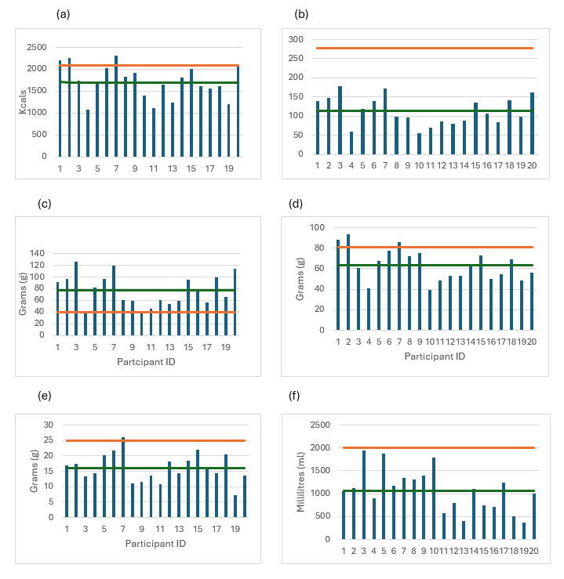
Figure 1 - Comparison of absolute totals and DRV.
The orange line represents the DRV set by the government, and the green line represents the average scores for the participants. .38/74+9,
- Energy individual levels
- Carbohydrate individual levels
- Protein individual levels
- Fats individual levels
- Fibre individual levels
- Water individual levels

4.2.8 Supplements
No statistical analysis was performed on supplements, as the amount within the subgroup was negligible (n=1).

4.3 Sports Nutritional Knowledge Questionnaire
Overall, 54 parents completed the questionnaires. As shown in Table 8, 1 other, 13 males and 39 females were included. A one-sample t-test was conducted to determine whether the average nutritional knowledge score among parents (M = 39.4, SD = 14.2)
Table 8 - Average Nutritional Knowledge Scores.
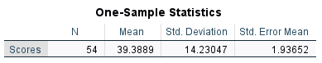

Table (9) shows a statistically significant difference, t(53) = -4.963, P < .001. Indicating that participants’ nutritional knowledge was significantly lower than the expected value. The mean difference was -9.61 with a 95% confidence interval ranging between -13.50 and 5.73.

Table 9– A comparison of nutritional knowledge scores and the test value.

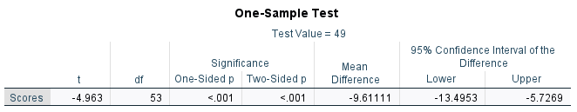

The practical significance of the t-test and effect sizes were calculated. The standardised effect size using Cohen’s D was -.675, and a bias-corrected Hedges’ g was -.666. Both values represent moderate to large effect sizes. The 95% confidence intervals for both values (Cohen’s D: [-0.969, -0.377]; Hedges’ g: [-0.955, -0.371]).

Table 10 – A one-sample effect size of the nutritional knowledge data.
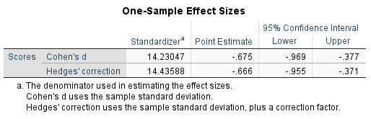
Figure 2 explores the correlation between household income and the scores on the nutritional knowledge questionnaire. Participants in the highest income group (£100,000 and above) ranged in the middle, with noticeable peaks at 43.00 and 46.00. There was a widespread score within the middle range income, (£25,000-£49,999 and £50,000-£74,999). Meanwhile, the lowest income group (under 24,999) had a sparse representation across the chart with fewer high scores
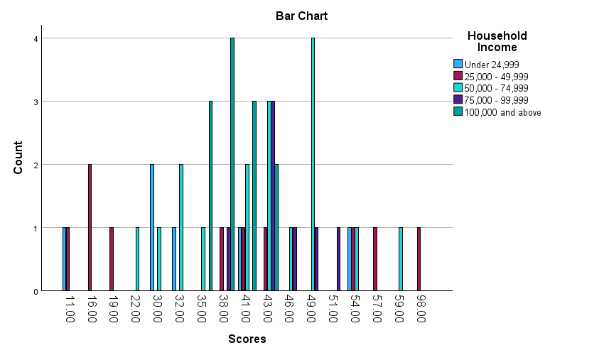
Figure 2 – Nutritional knowledge scores vs household income
Figure 3 shows the distribution of whether parents knew if their governing body provided nutritional information. Among those who stated that their governing body provided nutritional information has an even spread of scores ranging from high to low with minor peaks at 38 and 46. With the highest peak at 5 participants with a score of 38.

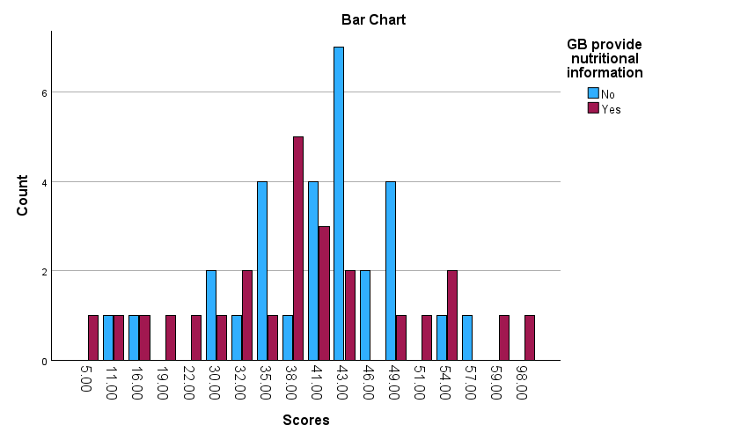
Figure 3 – A comparison of knowledge scores vs Governing Body nutritional information

When looking at the average Scores across the different household income groups, the numbers were all fairly similar. The lowest-income group (under £24,999) had an average score of 33, while the highest mean was 44.7 in the £75,000–£99,999 group. Some groups showed more variation than others for example, the £25,000–£49,999 group had a wide range of scores, while the £100,000+ group was much more consistent. See table 12 Overall, the averages and confidence intervals overlapped a lot, suggesting no clear pattern based on income.
A one-way ANOVA was used to check whether income made a difference to Scores, and the results showed no significant effect. The effect sizes were also very small, meaning income explained little to none of the differences in Scores. Even the more accurate, bias-corrected effect size measures were close to zero, which reinforces that income did not play a meaningful role see table 13.

To explore this further, Tukey HSD post-hoc tests compared each income group with every other group see table 11. Again, none of the comparisons were significant. The differences between groups were small, and all the confidence intervals crossed zero, which means the differences could easily be due to chance. For example, the difference between the lowest-income group and the £25,000–£49,999 group was –6.30, but this was not statistically meaningful.
Overall, all parts of the analysis the descriptive statistics, ANOVA, effect sizes, and post-hoc tests to the same conclusion: household income did not meaningfully affect Scores in this sample
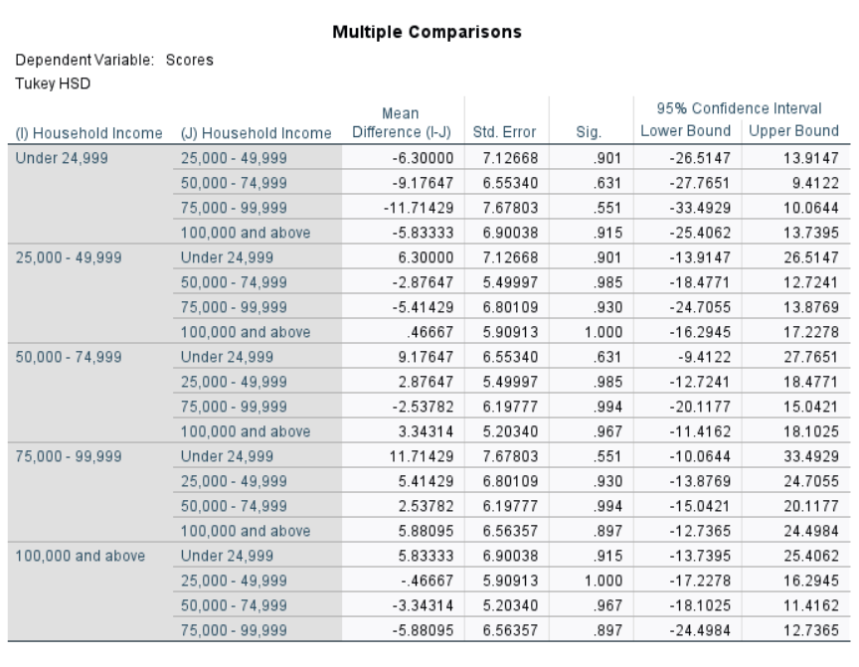
Table 11 – Post-HOC turkey multiple comparisons

Table 12 – Descriptives of score and income
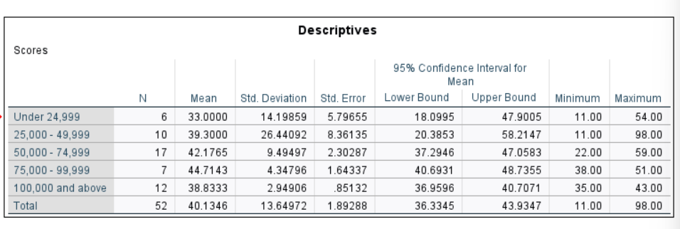

Table 13 – ANOVA effect sizes of different groups
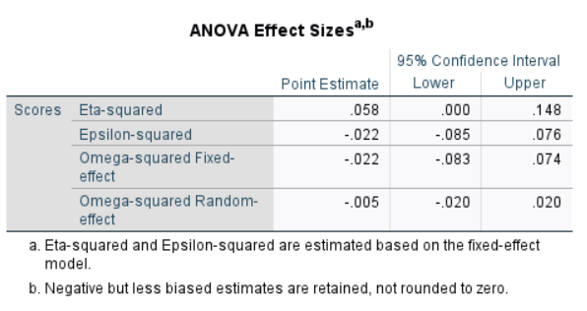

4.4 Cooking skills questionnaire
Participants completed a 20-question questionnaire to assess the cooking skills knowledge of the parents.
Statistical analysis was used to determine the current cooking skills of the participants. Figure (4) provides an overview of how parents are preparing their meals. The chart above shows the breakdown of the different cooking methods. It can be seen that ‘preparing dishes from basic ingredients' has the highest-ranked score, with 81% using this method. The second-ranked option was ‘put together ready-made ingredients to make a complete meal (e.g., use ready-made sauces) with 57%. The lowest result at 1% being do not cook at all’.

Figure 4 - Do you cook meal from basic ingredients

The results, as shown in the figure (5), that 43% cook with basic ingredients 2-3 times per week, 26% of participants use this method 4-6 times per week, and 4 % never use basic ingredients.

Figure 5 – How many times a week do you use basic ingredients

Interestingly, the confidence questions reveal that parents who cook from basic ingredients are 26% extremely confident and 17% not at all confident. comparatively when preparing and cooking with new foods and recipes, the results are 22% extremely confident and 11% not at all confident. There is no significant difference. The confidence levels are more distributed when rating confidence in cooking.

Participants were asked to specify how many pieces of fruit and vegetables are recommended to be consumed in a day. 85% stated five or more, 7% four times, 6% three times, and 2% two times per day.

Figure 6 - How many portions of fruit and vegetables should be consumed per day

The results show 30% eat vegetables 2-4 times per week, 19% twice a day, with both 3 times per day and once a day at 17%. The consumption of fruit: 33% eat a piece of fruit once a day, 22% 2-4 times per week, 4% never eat a piece of fruit shown in figure 7.

Figure 7 – Amount of fruit and vegetables are consumed

The response rate was 41% for once a week, 35% for less than once a week, 11% for 2-3 times per week, 6% for 5-6 times per week, and 7% never eat fish.

4.5 Conclusion
The results section indicates that the data presented reflect suboptimal intake over the short recording period of three days and provides a quantitative summary of reported dietary consumption within this sample of adolescents. These descriptive findings form the basis for subsequent analysis in the next chapter; therefore, it moves on to discuss the results from the nutritional knowledge questionnaire, cooking skills questionnaire and the food diaries in comparison.

5 Discussion
This chapter discusses the findings and the interpretation of the results displayed in the previous chapter.

5. 1 Nutritional Knowledge Questionnaire
As mentioned in the literature review, nutritional knowledge between elite athletes and non-athletes were similar. From this, the benchmark value from Trackman et al. (2016) will be used. A one-sample t-test was conducted to demonstrate the nutritional knowledge. The results from this study indicated that the nutritional knowledge of parents were significantly lower than the benchmark value (49) with a mean difference of -9.61. The statistical significance (p < .001) confirms that this is unlikely to be due to chance. This is reported in numerous studies (Trackman, 2016). This shows a meaningful gap between the observed parental knowledge and the expectations presented in the literature. These findings align with previous research illustrating that nutritional knowledge is limited within this segment of the sporting population engaging in sporting activities. Reed et al. (2013) indicate that having a sporting background does not mean that parents automatically have a superior knowledge of nutrition. Similarly, Smith and Jeukendrup (2013) highlight that sport-specific focused research for adolescents is scarce, which could contribute to the knowledge gap among parents. Another possible explanation for the lack of knowledge is the amount of questions in the questionnaire, therefore making the process tedious. However, Trackman et al. (2016) designed this version after the initial pilot.

One of the issues that comes from these findings is that, from a theoretical viewpoint, this result is concerning when interpreting Bandura’s (1986) Social Cognitive Theory. SCT demonstrates that behaviours are shaped by personal factors, as well as environment and behaviour modelling. As such, parents are the primary role models in the home; therefore, limited parental knowledge on nutrition may directly influence adolescents' dietary habits, particularly within the context of a sporting environment. Furthermore, this could impact the choices the adolescents make in later life.

5.2 Socioeconomic Factor and Information Access
In reviewing the literature, the evidence implies that lower socioeconomic status shows a reduced intake of fruit and vegetables. However, these results did not show this with adolescents consuming above the recommended amount. Income-related patterns suggest a tentative shift toward higher nutritional knowledge among higher-income parents, although the middle-income groups showed variability. Implying that this indicates that income alone cannot predict a high nutritional knowledge score. Meanwhile, the lowest income group (under 24,999) had a sparse representation across the chart with fewer high scores. Although this may suggest that the less income, the less nutritional information or education. However, the numbers that are represented in the category is significant smaller than the others.
This aligns with evidence that socioeconomic status shapes dietary environments and access to resources; this is not a singular determinant of nutritional knowledge (Ball et al. 2006). The observed inconsistency within the income brackets can be interpreted as an advantage, thereby facilitating but not necessarily guaranteeing understanding. In comparison to earlier literature, when parents were asked how many fruits and vegetables they ate, it was below average. This supports the notion for improved health promotion, to improve the influences on adolescents (Chawner, Blundekk-Britrill and Hetherington,2020).

A notable finding was that higher knowledge scores were not associated with governing body nutrition advice. For those who suggested the governing body did not provide them with nutritional information, the range of scores from low to middle range, 35.00 to 49.00, with a peak at 43, with 7 people scoring that rate. A wide range of results were displayed across parents who reported having access to information, showing that exposure alone is insufficient for comprehension and application. This pattern is reflected by Kreft et al. (2023), where participants engaged with nutrition content, particularly through social media, but the knowledge to assess its validity and reliability was absent. Kreft et al. (2026) conclude that with the increasing amount of misinformation, credible sources are being overlooked due to conflicting guidance, which complicates parents' understanding and decision-making. According to current findings, it suggests that effective knowledge transfer requires structured context-specific educational strategies rather than passive messaging (Hagen, 2020).

5.3 Cooking Skills
Despite lower-than-expected nutritional knowledge, 81% of parents reported preparing meals from basic ingredients, and only 2% reported not cooking at all. This suggests that parents feel they are not lacking the skills to prepare food from basic ingredients (Adams et al. 2015). A substantial proportion (41%) cooked from basic ingredients 2–3 times per week. These findings indicate engagement in meal preparation behaviours. This suggests behavioural engagement with meal preparation, which is typically associated with improvements in the quality of dietary intake (Wolfson et al. 2020). However, 80 per cent of the meals are cooked from basic ingredients. It can be said that the meal days selected were those when preparation with basic ingredients was used. Thus, confirming Vidgen and Gallegos, (2014) theory of different domains to knowledge, skills and behaviours.

It was observed that 87% of meals were prepared within the home. According to Helen Vidgen’s food literacy framework, effective dietary behaviour requires integration of planning, selection and preparation. While preparation behaviours appear relatively strong in this sample, confidence levels were irregular, particularly when cooking unfamiliar foods. This suggests that procedural cooking competence may exist without comprehensive nutritional understanding (Vidgen and Gallegos, 2014).

Previous literature has consistently shown that frequent home cooking is associated with improved diet quality and reduced reliance on ultra-processed foods (Wolfson et al. 2020; Lam & Adams, 2008). However, the present findings suggest that cooking frequency alone may not compensate for limited sport-specific knowledge, particularly in households supporting adolescent athletes. This distinction may explain the observed knowledge–behaviour disconnect (Vidgen and Gallegos, 2014). Cooking frequency alone does not guarantee nutritionally optimal meals, particularly in athletic contexts where macronutrient distribution, timing, and recovery strategies are critical. Therefore, food literacy interventions must integrate practical cooking skills with applied sport nutrition education (Wolfson et al. 2020; Lam & Adams, 2008).

Cooking confidence was observed, which suggests that over 50 % of participants were confident at preparing meals from basic ingredients, 65 % following a basic recipe and 56 % tasting new foods. There were no significant differences in which socio-economic groups were confident due to a smaller sub-sample. Adams et a.. (2015) suggest that there is a window of opportunity to implement intervention in lower socio-economic communities. Further work is required to explore the implementation of cooking skills in school curricula.

5.4 Food Diaries
An initial objective was to identify if parental factors influence diet, and whether sport participation is enough to ensure good nutrition. This study examines whether parental behavioural capability (nutritional knowledge and cooking skills) is associated with dietary quality among physically active children.

The results of this study indicated that income amounts do not determine higher amounts of nutritional knowledge. The participants have access to nutritional information from governing bodies, but do not know how to translate it into practice. However, parents were aware of how many fruits and vegetables are recommended to be consumed within a day. We also report an average of underconsumption.

5.4.1 Energy
The value reported for total energy intake Kcals compares well to those of a similar age (Vaiteviciute, Ball and Harris 2014). A consistent theme that appears throughout the literature for adolescence is the reporting or consumption of daily energy intake. Unsurprisingly, participants' average scores fell below the DRV set by the UK government. These findings do not support the clinical findings reported by the national health survey (NHS England, 2026) 15% of children are obese, and 27% were overweight. However, there was 1 participant, 53% under the DRV.

The results show that the participants' energy levels are below the recommended amount, and a deficiency can result in poor recovery rates, low training quality and impact their development. From the total energy intake of the participant, it was estimated that they have lower energy levels than what is required, suggesting that their diet does not provide enough calories for what is being expended. The calculated TEE has not been determined with anthropometric measurements; these are based on the average population. Therefore, when considering sporting activities as an addition, only 40% reach or exceed the recommendations.

The study's data shows 7–10-year-olds = 1592 ±620, 11-14-year-olds = 1763 ± 650, 15 – 18-year-olds = 1805 ± 253 and Total average = 1716 ± 640 Kcals p/d. This data is concerning as having consistently inadequate low energy intake can impair performance, bone density and disrupt hormonal function (Skarakis et al. 2021). Therefore, asking the question is the participant at risk of Relative Energy Deficiency in Sport RED-s or has there been a case of underreporting 75% of participants did not reach the requirement. Inadequate energy availability can lead to an increase of injury and stunted growth and development (Thomas, et al. 2016) If RED-s occurs, performance decreases, but the pressure continues; therefore, this could lead to participants dropping out. As many of the constraints are factors that lead to different consequences contrary to beliefs, those of all weights can develop RED-s (Crane and Temple, 2014). As 20-30% of food diaries are underreported (Bailey, 2021), after analysis of the FD, a sample of how the FD inconsistencies were recognised within them. An example was provided of how the food diary should be filled in as a guide. It can be seen in the appendices (6) that many of the measurements were missing.

A key period for bone growth and development is during adolescence, with over 90% of peak bone mass attained by 20 years of age (Chevalley and Rizzoli 2022). A delay in the timing of puberty is associated with lower bone density (Gordon et al. 2017). This, in turn, can lead to future complications for the participant. There would be a greater risk of fractures whilst young, and later in life they become prone to Osteoporosis (Hereford et al. 2024). A potential reason for the difference in estimated total energy is the validity of the recorded data. Participants may have forgotten to input data, or by not reporting certain foods, i.e chocolate, they would be seen as healthy or even changed their eating habits over the course of completing the FD.

5.4.2 Carbohydrates
According to Burke et al. (2001b) 50% of a person's calories should come from carbohydrates. If a retrospective look is taken of one food diary, we can see that the majority of the calories come from protein sources. Therefore, resulting from this participant may not be extracting sufficient nutrients and may exhibit low energy levels (Mountjoy et al. 2018). Contrary to popular belief, the higher than carbohydrates are important for the body to maintain normal function. These are often considered to be ‘unhealthy within the diet and will make you ‘fat’, (Pasalic et al. 2022) and often instilled into the participant by their coach. Carbohydrate overall total = 209 ± 86g compared with the DRV = 279g. This data suggests that these participants are not achieving the required amounts of carbohydrates due to a lack of consumption (Pasalic et al. 2022). This could result in hormone and metabolic disorder (Loucks and Thuma, 2003).

5.4.3 Proteins
This study examined the protein intake across different age categories, as determined by body weight. The classifications are as follows: 7-10 years old, 11-14 years old, and 15-17 years old, according to the Department of Health (1991). According to Kersick and Fox (2016), protein requirements for individuals aged 13-15 range between 1.2 and 1.8 grams per kilogram per day. Protein plays a vital role in muscle repair. Whilst 80% of participants believe that protein is the most important dietary change when building muscle. Having looked at the results, participants consumed 90% more protein than required. There exists a popular misconception that protein is the sole source of macronutrients needed during physical activity. It is important to consider the distribution of daily protein intake, rather than merely increasing protein consumption in the evening meal. A recommended intake is approximately 30 grams of protein per meal on days designated for training and performance. It is apparent from the result that parents were unsure of what constitutes a recovery meal option, as there were limited options (Beelen et al. 2010).

Amawi et al. (2024) state that those who participate in sports with weight-specific categories or emphasise a certain aesthetic image, such as boxing, dance and gymnastics, are found to consume larger amounts of protein. 20% of participants are below or just above the recommended amount. Those who take part in these types of sports. However, when researchers have investigated, they have not found enough protein markers. These findings highlight a significant need for nutritionists in the early stages of sport participation and for increased knowledge among parents and coaches. Recognising the signs of inadequate protein levels in adolescents is crucial for growth and health, for example, symptoms like fatigue, weight loss, loss of strength, and poor recovery. This issue is particularly common among adolescent athletes who may follow restrictive diets, including vegetarian or vegan athletes (Smith et al. 2025).

5.4.5 Free sugars
The results showed 32 ± 113g of free sugars that were consumed within the food data, the DRV for adolescents is 27g. Which coincides to Cooke and Wardle (2005) research of high results of sugary foods. Surprisingly, individually, many of the food diaries contained less than 27g; however, one record indicated 119g, which is over three times the recommended amount of free sugars (Scientific Advisory Committee on Nutrition (SACN), 2015). The values observed covered a wide range, making the reported high levels comparable with extensive research on obesity (Haase et al. 2020) and metabolic diseases (Xu et al. 2024). The distribution of these food choices included juice and cereal, which have a discretionary appeal (Pelly and Thurecht, 2019), although research suggests that these items are chosen due to the accessibility and high energy-dense properties (Burkhart and Pelly, 2013). Unsurprisingly, these foods have been chosen due to the convenience and limited time to prepare (Buckley, Cowen and McCarthy et al. 2007). These findings further support Vidgen's framework (Vidgen and Gallegos, 2014). It is unclear whether the DRV should be strictly followed, as it is designed for the general population. However, the discrepancies in energy intake and free sugars suggest under-reporting, considering these participants all engage in high-intensity activities. Therefore, it remains uncertain whether a higher intake of free sugars is necessary within this population (SACN, 2015).

5.4.7 Fibre
Health benefits of having adequate amounts of fibre are 25 ± 5g/per day for adolescence having been raised in 2015 by SACN (2015). Within this study, the daily dietary fibre intake was 16 ± 10g per day. Fibre helps with better digestion.

5.4.8 Fruits and Vegetables
Participants reported a mean intake of 7 portions of fruit and vegetables per day based on a three-day average calculation using the standard method. This level of consumption exceeds the 5-a-day benchmark and suggests that, within this sample, parents are practising the health advice with this dietary behaviour. Reported items spanned from fresh, frozen, canned and dried produce, reflecting a diverse range of sources consistent with the national guidelines (NHS, 2025).

Although the consumption appears favourable, several considerations should be considered in understanding this finding. Self-reporting bias, short-term recording periods and the high variability within the sample. These factors align with broader research that suggests that while many adults are aware of the fruits and vegetable dietary recommendations, actual adherence is inconsistent. The higher intake observed within this study could therefore reflect the characteristics of the sample rather than a generalised trend (Livingstone et al. 2004). Comparatively, the results from this study showed that 85% of parents have the knowledge that 5 or more fruits and vegetables are to be consumed per day; however, 45% of those parents reported only consuming them on average once a week. These finding identify with evidence suggesting that parents who have a higher interest in health and nutrition demonstrate higher fruit and vegetable intake compared to population averages (Azupogo et al. 2025). However, national surveys consistently show that the 5-a-day recommendation is not met. This raises the question of selection bias and the influence of contextual factors (OHID, 2025).

Multiple studies observe the typical diet of non-athlete adolescents. It has been noted that fruits and vegetables are not consumed at the recommended levels, but there is an overconsumption of energy-dense foods (Albar et al. 2014). Moreover, multiple studies report that adolescents involved in sports are more likely to have a better-quality diet than non-athlete adolescents (Kern, 2006). From this study, the results show that these cross-sectional and participant-phase athletes consume energy-dense foods and not enough fruits and vegetables. Only 10% of the participants consumed the recommended daily amount of fruits and vegetables, with another 10% not consuming any fruits or vegetables.

5.5 Supplements
One of the issues that emerged through these findings is that 43% of parents/carers stated that their child/children took supplements; however, only 10% of responders had supplements recorded in their food diaries. This supplement was in the form of protein powder. Dietary supplements usually contain higher amounts than those found in food; therefore, it is important to take the correct dosage and the amount taken (Bailey, 2021). 59% of responders reported that they were aware that labelling on supplements is not always true. This coincides with Campos and Pena (2025), who state that food labelling rules are different all over the world, with there being different avenues to purchase supplements, the health claims on labelling may not be true. However, only 50% knew that not all supplements are safe, although in this sub-sample of responders, only one responder was taking one additional supplement that was recorded. The question asked is whether this supplement has gone through testing and is on the World Anti-Doping Agency list (O’Mathúna and Larimore, 2022).

Those who reported having cereal and juice did not report whether it was a fortified cereal (Bristow et al.1997). There is less information about the errors of self-reporting of supplements through dietary supplements (Bailey et al. 2019). Moreover, a product inventory for supplements is considered gold standard. This can be an invasive and time-consuming method, such as a home visit or the participant bringing the packets and information that is collected by the researcher.

5.5.1 Vitamin D
The NHS advises that children and adults over the age of four take a vitamin D supplement during the autumn and winter months. The amount of sunlight in the United Kingdom is not enough to maintain the vitamin D levels (NHS n.d.). The recommended daily amount is 10 ug per day, the average amount consumed was 2.8 ug. Concerningly, in the study’s results, none of the food diaries reported supplement use. Cashman (2007) states that lower levels of vitamin D during these months are more likely to result in high levels of vitamin D deficiency, which will contribute to a higher risk of osteoporosis.

5.6 Water Intake
Fluid intake data indicated that adolescents' hydration levels were consistently below the recommended guideline. Mean daily water consumption across the sub-sample was 1068 ± 876 ml, which is substantially lower than the UK recommended intake of approximately 2000 ml per day for this age group. Overall, approximately 54% of participants consumed less than the recommended daily fluid intake, highlighting a widespread pattern of insufficient hydration. In the context of physical activity, inadequate intake of fluids is concerning. Suboptimal hydration can impair exercise performance and negatively impact concentration and recovery. This further reinforces the knowledge behaviour gap.

Food diaries and eating habits in this study reveal a notable gap between parental food-related practices between all the areas explored in this study. Although most parents reported regular home cooking and moderate confidence in food preparation adolescents' diets remain nutritionally inadequate in several key areas. This indicates that home cooked meal alone does not ensure diets align with adolescents growth and sporting demands.

5.7 Knowledge vs Behaviour
Although 85% of parents accurately identified the recommended consumption of five or more portions of fruit and vegetables per day, the results reported by parents indicate significant variation in consumption patterns. Interestingly, the food diaries maintained by adolescents demonstrated an average intake of seven portions daily, exceeding the national average.

This apparent disparity probably reflects well-known limitations in self-reported dietary assessment. Under- and over-reporting rates of 20–30% are commonly seen in adolescent groups (Bandini et al.1990). Livingstone and Robson (2000) also emphasise that social desirability bias might also be increased in research involving health-related behaviours. As well as the knowledge of what constitutes fruit and vegetables, for example, fruit juices.

Spronk et al. (2014) emphasise that the relationship between nutrition knowledge and dietary intake is complex and not always straightforward. The present findings reinforce this complexity, suggesting that acquiring knowledge does not necessarily lead to behaviour change.

Unsurprisingly, 90% of adolescents did not reach the recommended (mean average) 25g of fibre. Although there is not much research on adolescents, the risks of having inadequate amounts of fibre within the diet can lead to cardiovascular diseases and diabetes (Mathers 2023,).

5.8 Strengths and Weaknesses
Several methodological strengths have been highlighted throughout, including the use of validated questionnaires, which enabled comparison with established benchmarks Trackman et al. (2016), suggesting a strong indicator of the nutritional knowledge gap and the integration of quantitative dietary analysis. The inclusion of both parental and adolescent data enhances natural validity by capturing the home-to-sport boundary. Moreover, by focusing on the role parents play in adolescent nutrition, the study contributes to an under-researched area within sport nutrition literature, addressing a gap highlighted (Smith and Jeukendrup, 2013).

However, limitations must be recognised. The cross-sectional design prevents causal conclusions. Reliance on self-reported intake introduces systematic bias in food. Diary reporting is susceptible to social desirability and misreporting (Livingstone and Robson, 2000; Gandy, 2019). Despite these limitations, subjective dietary assessment remains the most feasible method in community-based youth research, given financial and ethical constraints (Saravia et al. 2022). These results need to be interpreted with caution because a sample size of n=54 with a smaller sub-sample size of n=20 for dietary findings should be interpreted with caution and may not be generalisable. Socioeconomic influences were assessed through income only, which did not highlight other variables. Additionally, although parents encountered exposure to nutritional information, the study did not assess the credibility of those sources or the depth of engagement with these sources, despite the concerns of misinformation Kreft et al. 2026).

5.9 Future research
Further investigation into socioeconomic influences beyond income alone would also strengthen the understanding of structural factors affecting parental support for adolescent athletes.

Future studies may need to design a nutritional knowledge questionnaire with fewer questions to determine whether the participants are finding the process monotonous. Explore ways to incorporate cooking skills, food and nutrition literacy into the curriculum, helping to improve nutritional knowledge. Interventions to educate parents to help implement this into everyday life. The need for adolescents to know this so they can pass this information on to the next generation.

5.10 Conclusion
This study highlights a notable lack of parental knowledge about sports nutrition, despite their strong involvement in home cooking habits. The findings emphasise an ongoing gap between knowledge and practice, which could have implications for adolescent energy intake and long-term health.

Established in Social Cognitive Theory, the results emphasise the importance of parental modelling in youth sport nutrition. While methodological limitations require careful interpretation, the evidence indicates that targeted, context-specific educational interventions are justified.

Optimising nutritional knowledge within youth sport environments extends beyond simply increasing knowledge, it requires integrating education, practical skills development, supportive environments, and sensitivity to developmental needs. Addressing these aspects together may improve both athletic performance and long-term health outcomes among adolescent athletes.

6 Conclusion
This study set out to explore the influence of parental nutritional knowledge and cooking skills on the dietary intake of adolescents participating in regular physical activity at a grassroots level. Underpinned by Social Cognitive Theory and food literacy frameworks, the research aimed to address a notable gap in the sport nutrition literature by focusing on parents as key influencers within real-world, community sport environments.

The findings demonstrated that the parental population studied possessed significantly lower nutritional knowledge than the established benchmark score of 49, indicating a clear knowledge deficit. This suggests that many parents may lack a sufficient understanding of general and sport-specific nutrition to adequately support the growth, development, and training demands of their adolescent athletes. In contrast, self-reported cooking skills and confidence were generally moderate, with the majority of parents indicating that they prepare meals using basic ingredients several times per week. These findings highlight an important distinction between knowledge and practice.

Collectively, the results suggest the existence of two overlapping challenges. First, a proportion of parents lack the foundational nutritional knowledge required to make informed dietary decisions for their adolescents. Second, even among those parents who demonstrate reasonable awareness of dietary guidelines, this knowledge does not consistently translate into effective real-world food choices or optimal fuelling practices. This disconnect reinforces existing evidence that knowledge alone is insufficient to drive meaningful dietary behaviour change.

Importantly, these findings can be understood through the lens of Bandura’s Social Cognitive Theory. Parents act as primary role models within the home environment, shaping adolescents’ beliefs, behaviours, and confidence around food through observation and reinforcement. Limited parental nutritional knowledge, therefore, has the potential to negatively influence adolescents’ dietary behaviours, not only in the short term but also as these behaviours track into adulthood. The study further suggests that improving parental self-efficacy and practical understanding may positively impact adolescents’ independent food-related decision-making over time.

From an applied perspective, the results highlight the need for targeted, accessible nutritional interventions for families involved in grassroots sport. While it cannot be assumed that parents who support their children’s sport participation inherently lack the desire to provide appropriate nutrition, the findings indicate that many would benefit from clearer, more practical guidance. Governing bodies and community sport organisations are well-positioned to facilitate this by providing context-specific education that moves beyond theoretical advice and includes realistic meal examples, food timing strategies, and guidance tailored to training and competition demands.

Despite some methodological limitations, including a modest sample size for dietary data and reliance on self-reported measures, this study contributes valuable insights into an under-researched area. It emphasises that optimising adolescent nutrition in grassroots sport requires more than motivation or access to information alone. Instead, it requires integrated approaches that combine nutritional education, practical skill development, supportive environments, and sensitivity to the constraints faced by families.

References

Agha, M. and Agha, R. (2017) 'The rising prevalence of obesity: Part A: Impact on public health', IJS Oncology, 2(7) Available at: https://doi.org/10.1097/ij9.0000000000000017.
Albani, V., Butler, L.T., Traill, W.B. and Kennedy, O.B. (2017) 'Fruit and vegetable intake: Change with age across childhood and adolescence', British Journal of Nutrition, 117(5), pp. 759–765. Available at: https://doi.org/10.1017/s0007114517000599.
Alshehri, A.G., Aljaloud, S.O., Salam Mohamed, A.M.A., Bursais, A.K. and Alshuwaier, G.O. (2023) 'Understanding the influence of family dynamics and sports psychology on youth athlete nutrition', ASEAN Journal of Psychiatry,(10).
Australian Bureau of Statistics. (2011) Australian social trends
Ball, K., Crawford, D. and Mishra, G. (2006) 'Socio-economic inequalities in women's fruit and vegetable intakes: A multilevel study', Public Health Nutrition, 9(5), pp. 623–630. Available at: https://doi.org/10.1079/phn2005897.
Bandini, L.G., Schoeller, D.A., Cyr, H.N. and W H (1990) Dietary reference values for food energy and nutrients for the United Kingdom: report of the panel on dietary reference values DH.
Bandura, A. (1977) 'Self-efficacy: Toward a unifying theory of behavioral change', Psychological Review, 84(2), pp. 191–215. Available at: https://doi.org/10.1037/0033-295x.84.2.191.
Bandura, A. (1986) Government dietary recommendations PDF Department of Health (1991) Dietary reference values for food energy and nutrients for the United Kingdom: A guide HMSO.
Bellisle, F., Rolland-Cachera, M.F., Deheeger, M. and Guilloud-Bataille, M. (2000) 'Obesity and food intake in children: Evidence from a french study', International Journal of Obesity, 24(10), pp. 1312–1317..
Berg, E.K. (2019) 'Performance nutrition for the adolescent athlete: A realistic approach', Clinical Journal of Sport Medicine, 29(5), pp. 345–352. Available at: https://doi.org/10.1097/jsm.0000000000000744.
Biltoft-Jensen, A., Matthiessen, J., Hess Ygil, K. and Christensen, T. (2022) 'Defining energydense, nutrient-poor food and drinks and estimating the amount of discretionary energy', Nutrients, 14(7) Available at: https://doi.org/10.3390/nu14071477.
Bryman, A. and Cramer, D. (2012) Quantitative data analysis with IBM SPSS 17, 18 & 19: A guide for social scientists Routledge.
Burke, L.M., Cox, G.R., Cummings, N.K. and Desbrow, B. (2001b) 'Guidelines for daily carbohydrate intake: Do athletes achieve them?', Sports Medicine, 31(4), pp. 267–299.
Burke, L.M., Lundy, B., Fahrenholtz, I.L. and Melin, A.K. (2018) 'Pitfalls of conducting and interpreting estimates of energy availability in free-living athletes', International Journal of Sport Nutrition and Exercise Metabolism, 28(4), pp. 350–363..
Burrows, T.L., Truby, H., Morgan, P.J., Callister, R., Davies, P.S. and Collins, C.E. (2013) 'A comparison and validation of child versus parent reporting of children's energy intake using food frequency questionnaires versus food records: Who's an accurate reporter?', Clinical Nutrition, 32(4), pp. 613–618..
Cahapay, M. (2021) 'Kirkpatrick model: Its limitations as used in higher education evaluation', International Journal of Assessment Tools in Education, 8(1), pp. 135–144.
Capra, M.E., Stanyevic, B., Giudice, A., Monopoli, D., Decarolis, N.M., Esposito, S. and Biasucci, G., 2024. Nutrition for children and adolescents who practice sport: A narrative review. Nutrients, 16(16), p.2803.
Chamontin, A., Pretzer, G. and Booth, D.A. (1991) 'Dietary reference values for food energy and nutrients for the united kingdom', Appetite, 41(3), pp. 273–281. Available at: https://doi.org/10.1016/s0195-66630300127-5departmentofhealth.
Chawner, L.R., Blundell-Birtill, P. and Hetherington, M.M. (2008) 'Predictors of vegetable consumption in children and adolescents: Analyses of the UK national diet and nutrition survey', British Journal of Nutrition, 126(2), pp. 295–306. Available at: https://doi.org/10.1017/s0007114520004109.
Contento, I.R., Manning, A.D. and Shannon, B. (1992) 'Research perspective on school-based nutrition education', Journal of Nutrition Education, 24(5), pp. 247–260. Available at: https://doi.org/10.1016/s0022-31821281192-8.
Cooke, L.J. and Wardle, J. (2005a) 'Age and gender differences in children's food preferences', British Journal of Nutrition, 93(5), pp. 741–746. Available at: https://doi.org/10.1079/bjn20051389.
Crane, J.&. and Temple, V. (2015) 'A systematic review of dropout from organized sport among children and youth', European Physical Education Review, 21, pp. 114–131. Available at: https://doi.org/10.1177/1356336x14555294.
Crawford, P.B., Obarzanek, E., Morrison, J. and Sabry, Z.I. (1994) 'Comparative advantage of 3-day food records over 24-hour recall and 5-day food frequency validated by observation of 9-and 10-year-old girls', Journal of the American Dietetic Association, 94(6), pp. 626–630..
Daniels, S. and Glorieux, I. (2015) 'Convenience, food and family lives. A socio-typological study of household food expenditures in 21st-century belgium', Appetite, 94, pp. 54–61. Available at: https://doi.org/10.1016/j.appet.2015.04.074.
Daniels, S., Glorieux, I., Minnen, J., Van Tienoven, T.P. and Weenas, D. (2015) 'Convenience on the menu? A typological conceptualization of family food expenditures and food-related time patterns', Social Science Research, 51, pp. 205–218. Available at: https://doi.org/10.1016/j.ssresearch.2014.09.010.
De Vasconcelos, C.M.B. (2019) Fake News vs. Healthy Diet (Master's thesis ISCTE-Instituto Universitario de Lisboa (Portugal).
Dickson-Spillmann, M. and Siegrist, M. (2011) 'Consumers' knowledge of healthy diets and its correlation with dietary behaviour', Journal of Human Nutrition and Dietetics, 24(1), pp. 54–60. Available at: https://doi.org/10.1111/j.1365-277x.2010.01124.x.
Diehl, J.M. (1999) The importance of liking for food choice in adolescence Ernährungs-Umschau.
Dobrowolski, H. and Wlodarek, D. (2020) 'Low energy availability in group of polish female soccer players', Rocz Panstw Zakl Hig, 71(1), pp. 89–96..
Domel, S.B., Thompson, W.O., Davis, H.C., Baranowski, T., Leonard, S.B. and Baranowski, J. (1996) 'Psychosocial predictors of fruit and vegetable consumption among elementary school children', Health Education Research, 11(3), pp. 299–308. Available at: https://doi.org/10.1093/her/11.3.299.
Drewnowski, A. (1997) 'Taste preferences and food intake', Annual Review of Nutrition, 17, pp. 237–253. Available at: https://doi.org/10.1146/annurev.nutr.17.1.237.
Drummond, S.E., Crombie, N.E. and Kirk, T.R. (1996) 'A critique of the effects of snacking on body weight status', European Journal of Clinical Nutrition, 50(12), pp. 779–783..
Everett, S. (2025) 'Optimizing performance nutrition for adolescent athletes: A review of dietary needs, risks, and practical strategies', Nutrients, 17(17).
Fleming, J.A., Naughton, R.J. and Harper, L.D. (2018) 'Investigating the nutritional and recovery habits of tennis players', Nutrients, 10.
Gable, S., Chang, Y. and Krull, J.L. (2007) 'Television watching and frequency of family meals are predictive of overweight onset and persistence in a national sample of school-aged children', Journal of the American Dietetic Association, 107(1), pp. 53–61. Available at: https://doi.org/10.1016/j.jada.2006.10.010.
Gandy, J. (2019a) Manual of dietetic practice. British Dietetic Association ProQuest Ebook Central John Wiley &Sons
Gibson, E.L., Wardle, J. and Watts, C.J. (1998) 'Fruit and vegetable consumption, nutritional knowledge and beliefs in mothers and children', Appetite, 31(2), pp. 205–228..
Gibson, S.A., Wardle, J. and Watts, C.J. (1998) 'Fruit and vegetable consumption, nutritional knowledge and beliefs in mothers and children', Appetite, 31(2), pp. 205–228. Available at: https://doi.org/10.1006/appe.1998.0180.
Gordon, C.M., Zemel, B.S., Wren, T.A.L., Leonard, M.B., Bachrach, L.K., Rauch, F., Gilsanz, V., Rosen, C.J. and Winer, K.K. (2017) The Determinants of Peak Bone Mass Elsevier BV.
Haase, A., Steptoe, A. and Sallis, J.F. (2004) 'Leisure-time physical activity in university students from 23 countries: Associations with health beliefs, risk awareness, and national economic development', Preventive Medicine, 39(1), pp. 182–190..
Hagen, L. (2020) 'Pretty healthy food: How and when aesthetics enhance perceived healthiness', Journal of Marketing, 85(2), pp. 129–145. Available at: https://doi.org/10.1177/0022242920944384.
Hamlin, M.J., Wilkes, D., Elliot, C.A., Lizamore, C.A. and Kathiravel, Y. (2019) 'Monitoring training loads and perceived stress in young elite university athletes', Frontiers in Physiology, 10.
Haraldsdottir, J. and Hermansen, B. (1995) 'Repeated 24-h recalls with young schoolchildren. A feasible alternative to dietary history from parents?', European Journal of Clinical Nutrition, 49(10).
Hartmann, C., Dohle, S. and Siegrist, M. (2013) Importance of cooking skills for balanced food choices Elsevier BV.
Hilary, I.O. and Dumebi, O.O. (2021) 'Social media as a tool for misinformation and disinformation management', Linguistics and Culture Review, pp. 496–505..
Jebeile, H., Kelly, A., O&#39;malley, G., Baur, N.L., Worsley, A. and Bruening, M. (2022) 'Factors that influence snacking behaviors among urban indian adolescents-a qualitative inquiry', Lancet Diabetes Endocrinol, 10 Available at: https://doi.org/10.1016/s2213-85872200047-xrathi.
Jenkins, K.T., Benton, D., Tapper, K., Murphy, S. and Moore, L. (2015) A cross-sectional observational study of the nutritional intake of UK primary school children from deprived and nondeprived backgrounds: implications for school breakfast schemes Springer Science and Business Media LLC.
Jeukendrup, A.E., Areta, J.L., Van Genechten, L., Langan-Evans, C., Pedlar, C.R., Rodas, G., Sale, C. and Walsh, N.P. (2024) 'Untitled', Does Relative Energy Deficiency in Sport (REDs) Syndrome Exist? Asker E. Jeukendrup Et Al. Sports Medicine, 54(11), pp. 2793–2816..
Jeyakumar, S. (2011) 'Eating-related anxiety in individuals with eating disorders', Eat Weight Disord, 16(4), pp. 236. Available at: https://doi.org/10.1007/bf03327466.
Johansson, G., Wikman, Å, Åhren, A.-., Hallmans, G. and Johansson, I. (2001) 'Underreporting of energy intake in repeated 24-hour recalls related to gender, age, weight status, day of interview, educational level, reported food intake, smoking habits and area of living', Public Health Nutrition, 4(4), pp. 919–927..
Johnson, F., Wardle, J. and Griffith, J. (2001) The Adolescent Food Habits Checklist: reliability and validity of a measure of healthy eating behaviour in adolescents.
Kern, M. (2006) Dietary Intake of Adolescent Athletes and Nonathletes Elsevier BV.
Kerr, M.A., Rennie, K.L., Mccaffrey, T.A., Wallace, J.M.W., Hannon-Fletcher, M.P. and Livingstone, M.B.E. (2009) 'Snacking patterns among adolescents: A comparison of methodology', British Journal of Nutrition, 101(4), pp. 619–627. Available at: https://doi.org/10.1017/s0007114508025037.
Kerksick, C. M., & Fox, E. (Eds.). (2016). Sports nutrition needs for child and adolescent athletes. CRC Press.
Kesaite, V., Chavez-Ugalde, Y., White, M. and Adams, J. (2008) 'Overlap between ultra-processed food and food that is high in fat, salt or sugar: Analysis of 11 annual waves of the UK national diet and nutrition survey', BMJ Nutrition, Prevention &Amp; Health, 8(1) Available at: https://doi.org/10.1136/bmjnph-2024-001035.
Kreft, M., Lombard, C. and Koen, N. (2026) 'The self-reported influence of social media on food choices of young adults at a tertiary institution in south africa', South African Journal of Clinical Nutrition, pp. 1–8. Available at: https://doi.org/10.1080/16070658.2026.2617766.
Kreft, M., Smith, B. and Hopwood, D. (2023) 'The use of social media as a source of nutrition information', South Afr J Clin Nutr, 36(4), pp. 162–168. Available at: https://doi.org/10.1080/16070658.2023.2175518.
Lam, M.C.L. and Adams, J. (2008) 'Association between home food preparation skills and behaviour, and consumption of ultra-processed foods: Cross-sectional analysis of the UK national diet and nutrition survey', Int J Behav Nutr Phys Act, 14 Available at: https://doi.org/10.1186/s12966-017-0524-9.
Lee, S., Kuniko, M. and Han S (2020) 'Association of low energy availability and suppressed metabolic status in korean male collegiate soccer players: A pilot study', Am J Mens Health, 14.
Lerner, A. and Matthias, T. (2015) 'Changes in intestinal tight junction permeability associated with industrial food additives explain the rising incidence of autoimmune disease', Autoimmunity Reviews, 14(6), pp. 479–489..
Libro (2024) Dublin: Nutritics.
Lichtenstein, A.H. and Ludwig, D.S. (2010) 'Bring back home economics education', JAMA, 303(18), pp. 1857–1858. Available at: https://doi.org/10.1001/jama.2010.592.
Livingstone, M.B.E. and Robson, P.J. (2000b) 'Measurement of dietary intake in children', Proceedings of the Nutrition Society, 59(2), pp. 279–293. Available at: https://doi.org/10.1017/s0029665100000318.
Livingstone, M.B.E., Robson, P.J. and Wallace, J.M.W. (2004) a) Issues in dietary intake assessment of children and adolescents Cambridge University Press.
Logue, D.M., Madigan, S.M., Melin, A., Delahunt, E., Heinen, M. and Donnell, S.M. (2020) 'Low energy availability in athletes 2020: An updated narrative review of prevalence, risk, within-day energy balance, knowledge, and impact on sports performance', Nutrients, 12(3).
Long, R. and Stevens, C. (2004) 'Managing human resources in small organizations: What do we know?', Human Resource Management Review, 14(3), pp. 295–323. Available at: https://doi.org/10.1016/j.hrmr.2004.06.001.
López-Hernández, L., Martínez-Arnau, F.M., Pérez-Ros, P., Drehmer, E. and Pablos, A. (2020a) 'Improved nutritional knowledge in the obese adult population modifies eating habits and serum and anthropometric markers', Nutrients, 12(11) Available at: https://doi.org/10.3390/nu12113355.
Loucks, A.B. and J R (2003) 'Thuma luteinizing hormone pulsatility is disrupted at a threshold of energy availability in regularly menstruating women', J Clin Endocrinol Metab, 88(1), pp. 297–311..
Mahmood, L., Flores-Barrantes, P., Moreno, L.A., Manios, Y. and Gonzalez-Gil, E.M. (2021) 'The influence of parental dietary behaviors and practices on children's eating habits', Nutrients, 13(4).
Manore, M.M., Patton-Lopez, M.M., Meng, Y. and Wong, S.S. (2017a) 'Sport nutrition knowledge, behaviors and beliefs of high school soccer players', Nutrients, 9(4) Available at: https://doi.org/10.3390/nu9040350.
Manore, M.M., Patton-Lopez, M.M., Meng, Y. and Wong, S.S. (2017b) 'Sport nutrition knowledge, behaviours and beliefs of high school soccer players', Nutrients, 9(4) Available at: https://doi.org/10.3390/nu9040350.
Martins, C.A., Machado, P.P., Da Costa Louzada, M.L., Levy, R.B. and Monteiro, C.A. (2020) 'Parents' cooking skills confidence reduce children's consumption of ultra-processed foods', Appetite, 144.
Martirosyan, D. and Tavva, S. (2025) The science, safety, and policy of dietary supplements: A comprehensive review and future roadmap Functional Food Center.
Mathers, J.C. (2023) 'Dietary fibre and health: The story so far', The Proceedings of the Nutrition Society, 82(2), pp. 120–129. Available at: https://doi.org/10.1017/s0029665123002215.
McLeod, E.R., Campbell, K.J. and Hesketh, K.D. (2011) 'Nutrition knowledge: A mediator between socioeconomic position and diet quality in australian first-time mothers', Journal of the American Dietetic Association, 111(5), pp. 696–704. Available at: https://doi.org/10.1016/j.jada.2011.02.011.
Mescoloto, S.B., Pongiluppi, G. and Domene, S.M.Á (2024) 'Ultra-processed food consumption and children and adolescents' health', Jornal De Pediatria, 100, pp. 18. Available at: https://doi.org/10.1016/j.jped.2023.09.006.
Monteiro, C.A., Moubarac, J.C., Cannon, G., Ng, S.W. and Popkin, B. (2013) 'Ultraprocessed products are becoming dominant in the global food system', Obesity Reviews, 14(S2), pp. 21–28. Available at: https://doi.org/10.1111/obr.12107.
Moss, S.L., Randell, R.K., Burgess, D., Ridley, S., Ócairealláin, C. and Allison, R. (2021) 'Assessment of energy availability and associated risk factors in professional female soccer players', Eur J Sport Sci, 21(6), pp. 861–870..
Mountjoy, M., Sundgot-Borgen, J. and Burke, L. (2014) 'The IOC consensus statement: Beyond the female athlete triad-relative energy deficiency in sport (RED-S)', Br J Sports Med, 48, pp. 491–497..
Mountjoy, M., Sundgot-Borgen, Jk and Burke, L.M. (2018) 'IOC consensus statement on relative energy deficiency in sport (RED-S): 2018 update', Br J Sports Med, 52, pp. 687–697..
Nader, P.R., Bradley, R.H., Houts, R.M., Mcritchie, S.L. and Brien, O. (2008) 'Moderate-tovigorous phys ical activity from ages 9 to 15 years', Jama, 300(3), pp. 295–305. Available at: https://doi.org/10.1001/jama.300.3.295.
Nascimento, M., Silva, D., Ribeiro, S., Nunes, M. and Almeida, M. (2016) 'Effect of a nutritional intervention on athletes' body composition, eating behaviour and nutritional knowledge: A comparison between adults and adolescents', Nutrients, 8(9) Available at: https://doi.org/10.3390/nu8090535.
Nattiv, A., Loucks, A., Manore, M., Sanborn, C. and Sundgot-Borgen, J.A.W.M. (2007) 'The female athlete triad', Med Sci Sports Exerc, 39(11), pp. 1867–1882..
NHS (n.d.) 5 A Day: what counts? Available at: https://www.nhs.uk/live-well/eat-well/5-a-day/5-a-day-what-counts/ (Accessed: 5 February 2026).
NHS (n.d.) Vitamin D. Available at: https://www.nhs.uk/conditions/vitamins-and-minerals/vitamin-d/ (Accessed: 17 February 2026)
NHS England (2026) Health Survey for England, 2024. Available at: https://www.gov.uk/government/statistics/health-survey-for-england-2024 (Accessed: 5 March 2026).
Nugent, F.J., Comyns, T.M. and Warrington, G.D. (2018) 'Strength and conditioning considerations for youth swimmers', Strength &Amp; Conditioning Journal, 40(2), pp. 31–39..
Nutritics (2024) Dublin; Nutritics.
O’mathúna, D. and Larimore, W.L. (2019) 'Office for health improvement & disparities. national diet and nutrition survey', Medical Clinics, 106(5), pp. 881–898..
Office for Health Improvement & Disparities. National diet and nutrition survey 2019 to 2023: Report. Available at: https://www.gov.uk/government/statistics/national-diet-and-nutrition-survey-2019-to-2023/national-diet-and-nutrition-survey-2019-to-2023-report .
Office for Health Improvement and Disparities (OHID) (2025) National Diet and Nutrition Survey 2019 to 2023: report. Available at: National Diet and Nutrition Survey 2019 to 2023 report (Accessed: 5 November 2025)
Page, P., Collins, D., Jones, K., Bates, B., Swan, G. and Nicholas, J. (2019) 'Untitled', National Diet and Nutrition Survey,.
Pancer, E., Philp, M. and Noseworthy, T.J. (2022) 'Boosting engagement with healthy food on social media', European Journal of Marketing, 56(11), pp. 3007–3031..
Parliament, U.K. (2021) House of Lords -A national plan for sport, health and wellbeing -National Plan for Sport and Recreation World Health Organisation.
Pasalic, A., Segalo, S., Brankovic, S., Mahmutovic, J. and Konjo, H. (2022) 'The proportion and type of carbohydrates in the diets of children in early adolescence', Materia Socio-Medica, 34(3), pp. 174–179. Available at: https://doi.org/10.5455/msm.2022.34.174-179.
Pearson, N., Atkin, A.J., Biddle, S.J., Gorely, T. and Edwardson, C. (2009) 'Patterns of adolescent physical activity and dietary behaviours', International Journal of Behavioral Nutrition and Physical Activity, 6(1) Available at: https://doi.org/10.1186/1479-5868-6-45.
Pelly, F.E. and Thurecht, R. (2019) 'Evaluation of athletes' food choices during competition with use of digital images', Nutrients, 11(7).
Perez-Rodrigo, C., Ribas, L., Serra-Majem, L. and Aranceta, J. (2003) 'Food preferences of spanish children and adolescents: The enKid study', European Journal of Clinical Nutrition, 57(S1), pp. 45. Available at: https://doi.org/10.1038/sj.ejcn.1601814.
Phillips, S.M., Bandini, L.G., Naumova, E.N., Cyr, H., Colclough, S., Dietz, W.H. and Must, A. (2004) 'Energy-dense snack food intake in adolescence', Obesity Research, 12(3), pp. 461–472. Available at: https://doi.org/10.1038/oby.2004.52.
Rao, S. and Moon, K. (2021) Principles and Practice of Systematic Reviews and Meta-Analysis Springer.
Rasmussen, K.M. and Yaktine, A.L. (2009) Adolescent health services: Missing opportunities National Academies Press.
Ravelli, M.N. and Schoeller, D.A. (2020) 'Traditional self-reported dietary instruments are prone to inaccuracies and new approaches are needed', Frontiers in Nutrition, 7.
Raza, A., Fox, E.L., Morris, S.S., Kupka, R., Timmer, A., Dalmiya, N. and Fanzo, J. (2020) Conceptual framework of food systems for children and adolescents Global Food Security.
Reed, J.R., Yates, B.C., Houfek, J., Briner, W., Schmid, K.K. and Pullen, C. (2016) 'A review of barriers to healthy eating in rural and urban adults', Online Journal of Rural Nursing and Health Care, 16(1), pp. 122–153..
Reicks, M., Trofholz, A.C., Stang, J. and Laska, M.N. (2014) 'Impact of cooking and home food preparation interventions among adults: Outcomes and implications for future programs', Journal of Nutrition Education and Behavior, 46(4), pp. 259–276. Available at: https://doi.org/10.1016/j.jneb.2014.02.001.
Rosi, A., Ferraris, C., Guglielmetti, M., Meroni, E., Charron, M., Menta, R., Manini, F., Di Gioia, V., Martini, D. and Erba, D. (2020) General and Sports Nutrition Knowledge Questionnaire in Italian Early Adolescents MDPI AG.
Rumbold, P.L.S., Gibson, A.S.C., Stevenson, E. and Dodd-Reynolds, C.J. (2011) 'Agreement between two methods of dietary data collection in female adolescent netball players', Appetite, 57(2), pp. 443–447..
Rumbold, P.L.S., St Clair Gibson, A., Stevenson, E. and Dodd-Reynolds, C.J. (2011) Agreement between two methods of dietary data collection in female adolescent netball players Elsevier BV.
Saravia, L., Moliterno, P., Skapino, E. and Moreno, L.A. (2022) Basic protocols in foods and nutrition Springer US.
Sawai, A., Mathis, B.J. and Natsui, H. (2018) 'Risk of female athlete triad development in japanese collegiate athletes is related to sport type and competitive level', Int J Womens Health, 10, pp. 671–687.
Schunk, D.H. (2012) Social cognitive theory. Routledge
Scientific Advisory Committee on Nutrition (SACN) (2015) Carbohydrates and health. Available at: https://assets.publishing.service.gov.uk/media/5a7f7cc3ed915d74e622ac2a/SACN_Carbohydrates_and_Health.pdf (Accessed: 5 May 2026).
Scott, H.C., Craddock, C. and Craig, L.C.A. (2020) 'What features of a nutrition resource are important to adolescents of a low socioeconomic status?', Public Health Nutrition, 23(10), pp. 1716–1725.
Scottish Government. (2007) Scottish Health Survey Scottish Government.
Sheehy, C., Mcneill, G., Masson, L., Craig, L., Macdiarmid, J., Holmes, B. and Nelson, M. (2008) Survey of sugar intake among children in Scotland. Aberdeen: Food Standards Agency Scotland.
Silk, K.J., Sherry, J., Winn, B., Keesecker, N., Horodynski, M.A. and Sayir, A. (2008) Web site, and Game Modalities Elsevier BV.
Simmonds, M., Llewellyn, A., Owen, C.G. and Woolacott, N. (2016) 'Predicting adult obesity from childhood obesity: A systematic review and meta-analysis', Obesity Reviews, 17, pp. 95–107. Available at: https://doi.org/10.1111/obr.12334.
Singh, R., Verest, M.T.E. and Salathé, M. (2025) 'Minimum days estimation for reliable dietary intake information: Findings from a digital cohort', European Journal of Clinical Nutrition, 79(10), pp. 1007–1017. Available at: https://doi.org/10.1038/s41430-025-01644-8.
Skarakis, N.S., Mastorakos, G. and Georgopoulos, N. (2021) 'Energy deficiency, menstrual disorders, and low bone mineral density in female athletes: A systematic review', Hormones, 20, pp. 439–448. Available at: https://doi.org/10.1007/s42000-021-00288-0.
Skinner, J.D., Carruth, B.R., Bounds, W. and Ziegler, P.J. (2002) 'Children's food preferences: A longitudinal analysis', Journal of the American Dietetic Association, 102(11), pp. 1638–1647. Available at: https://doi.org/10.1016/s0002-82230290349-4.
Skinner, J.D., Ziegler, P. and Ponza, M. (2004) 'Transitions in infants' and toddlers' beverage patterns', Journal of the American Dietetic Association, 104(1), pp. 45. Available at: https://doi.org/10.1016/j.jada.2003.10.022.
Smith, E.W. and Jeukendrup, A. (2007) 'Performance nutrition for young athletes', Nutrition and Enhanced Sports,
Spronk, I. (2014) 'Relationship between nutrition knowledge and dietary intake', British Journal of Nutrition, 111(10), pp. 1713–1726. Available at: https://doi.org/10.1017/s0007114514000087.
Spronk, I., Heaney, S.E., Prvan, T. and Connor, O. (2015) 'Relationship between general nutrition knowledge and dietary quality in elite athletes', International Journal of Sport Nutrition and Exercise Metabolism, 25(3) Available at: https://doi.org/10.1123/ijsnem.2014-0034.
Story, M., Kaphingst, K.M., Brien, R. and Glanz, R. (2008) 'Creating healthy food and eating environments: Policy and environmental approaches', Annual Review of Public Health, 21(29), pp. 253–272. Available at: https://doi.org/10.1146/annurev.publhealth.29.020907.090926.
Story, M., Neumark-Sztainer, D. and French, S. (2002) 'Individual and environmental influences on adolescent eating behaviours', Journal of the American Dietetic Association, 102(3) Available at: https://doi.org/10.1016/s0002-82230290421-9.
Summerbell, C.D., Waters, E., Edmunds, L.D., Kelly, S., Brown, T. and Campbell, K.J. (2005) 'Interventions for preventing obesity in children', Cochrane Database of Systematic Reviews,(3) Available at: https://doi.org/10.1002/14651858.cd001871.pub2.
Sygo, J., Coates, A.M., Sesbreno, E., Mountjoy, M.L. and Burr, J.F. (2018) 'Prevalence of indicators of low energy availability in elite female sprinters', International Journal of Sport Nutrition and Exercise Metabolism, 28(5), pp. 490–496. Available at: https://doi.org/10.1123/ijsnem.2017-0397.
Teicholz, N. (2014) The big fat surprise: Why butter, meat, and cheese belong in a healthy diet Simon and Schuster.
Thomas, D.T., Erdman, K.A. and Burke, L.M. (2016) 'Position of the academy of nutrition and dietetics', And the American College of Sports Medicine: Nutrition and Athletic Performance. J. Acad. Nutr. Diet, 116, pp. 501–528..
Trakman, G.L., Forsyth, A., Devlin, B.L. and Belski, R. (2016) A Systematic Review of Athletes' and Coaches' Nutrition Knowledge and Reflections on the Quality of Current Nutrition Knowledge Measures.
Trakman, G.L., Forsyth, A., Hoye, R. and Belski, R. (2018) 'Development and validation of a brief general and sports nutrition knowledge questionnaire and assessment of athletes' nutrition knowledge', Journal of the International Society of Sports Nutrition, 15(1).
Turrell, G. and Kavanagh, A.M. (2006) 'Socio-economic pathways to diet: Modelling the association between socio-economic position and food purchasing behaviour', Public Health Nutrition, 9(3), pp. 375–383. Available at: https://doi.org/10.1079/phn2005850.
Vaitkeviciute, R., Ball, L.E. and Harris, N. (2014) The relationship between food literacy and dietary intake in adolescents: a systematic review Cambridge University Press.
Vidgen, H.A. and Gallegos, D. (2014) 'Defining food literacy and its components', Appetite, 76, pp. 50–59..
Wardle, J. (1995) 'Parental influences on children's diets', Proceedings of the Nutrition Society, 54(3), pp. 747–758..
Wardle, J. and Beales, S. (1986) 'Restraint, body image and food attitudes in children from 12-18 years', Appetite, 7(3), pp. 209–217..
Wardle, J., Parmenter, K. and Waller, J. (2000) 'Nutrition knowledge and food intake', Appetite, 34(3), pp. 269–275. Available at: https://doi.org/10.1006/appe.1999.0311.
Wardle, J., Sanderson, S., Gibson, E.L. and Rapoport, L. (2001) 'Factor-analytic structure of food preferences in four-year-old children in the UK', Appetite, 37(3), pp. 217–223. Available at: https://doi.org/10.1006/appe.2001.0423.
Winkler, E. and Turrell, G. (2009) 'Confidence to cook vegetables and the buying habits of australian households', Journal of the American Dietetic Association, 109(10), pp. 1759–1768. Available at: https://doi.org/10.1016/j.jada.2009.07.006.
Wolfson, J.A., Bleich, S.N., Smith, K.C. and Frattaroli, S. (2016) 'What does cooking mean to you?: Perceptions of cooking and factors related to cooking behavior', Appetite, 97, pp. 146–154. Available at: https://doi.org/10.1016/j.appet.2015.11.030.
Wolfson, J.A., Leung, C.W. and Richardson, C.R. (2020) 'More frequent cooking at home is associated with higher healthy eating index-2015 score', Public Health Nutr, 23, pp. 2384–2394..
World Health Organization. (2006) Orientation programme on adolescent health for health-care providers Available at: https://platform.who.int/docs/default-source/mca-documents/policy-documents/operational-guidance/gha-cc-10-03-operationalguidance-eng-adolescent-health-training-manual-for-providers.pdf (Accessed: 5 April 2026).
Xu, X., Cai, H., Zhang, J., Xia, T., Ag, Zarnowiecki, D., Sinn, N., Petkov, J. and Dollman, J. (2011) The Effects of Parental Food Education on Children's Food Literacy: The Mediating Role of Parent-Child Relationship and Learning Motivation MDPI Cambridge University Press.
Ziegler, P., Briefel, R., Clusen, N. and Devaney, B. (2006) 'Feeding infants and toddlers study (FITS): Development of the FITS survey in the united states', Pediatrics, 117(4), pp. 75. Available at: https://doi.org/10.1542/peds.2005-1124d.

List of Appendices

Appendix 1 - Ethical approval for research
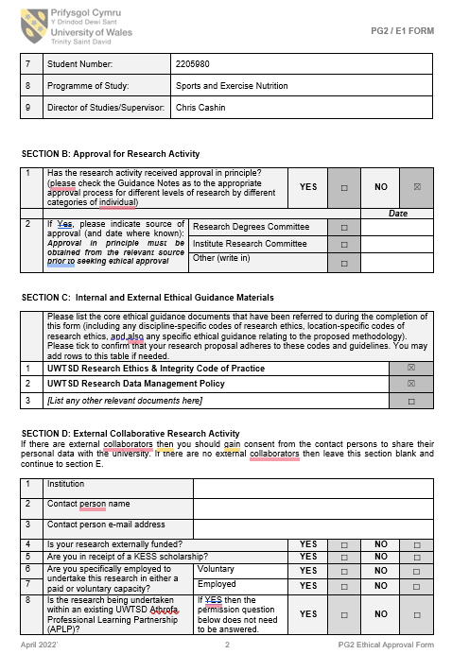
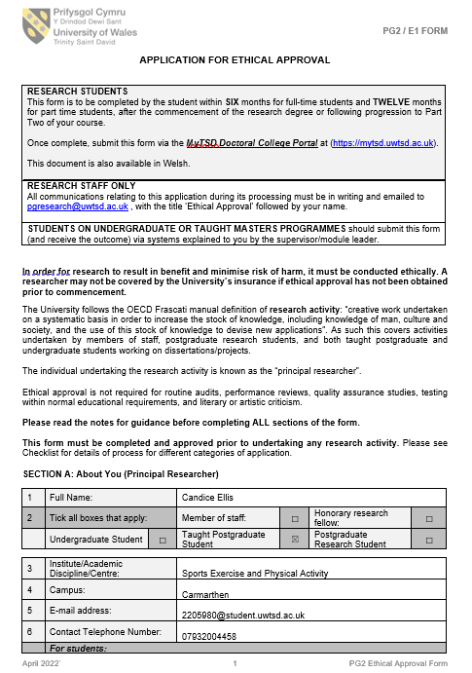
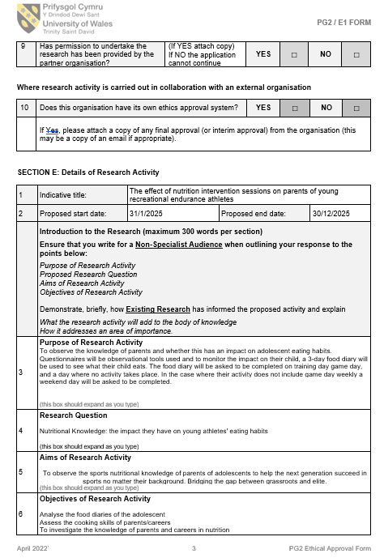
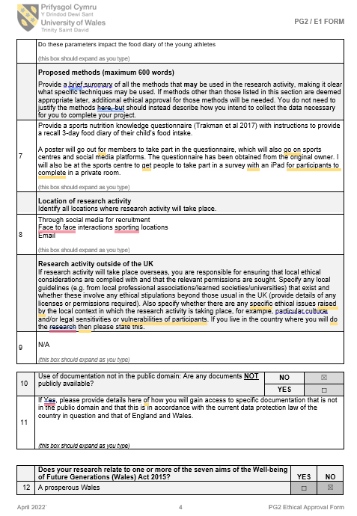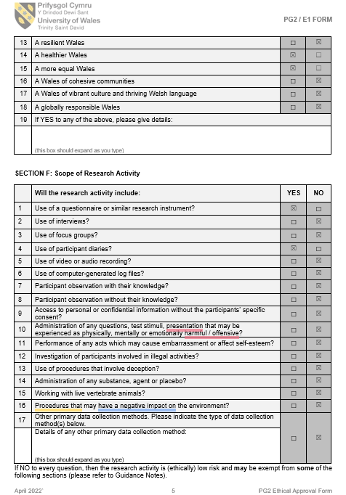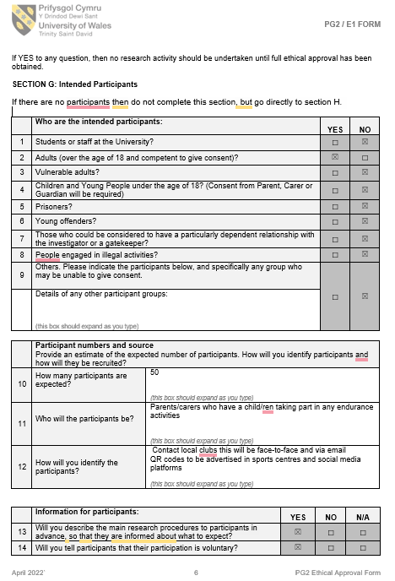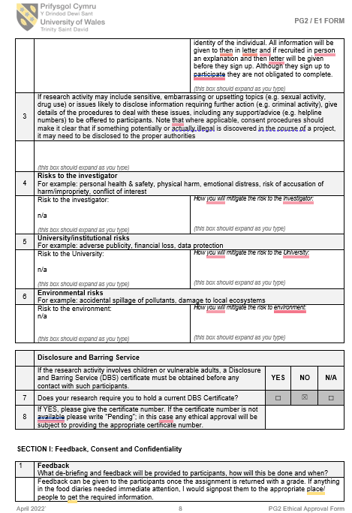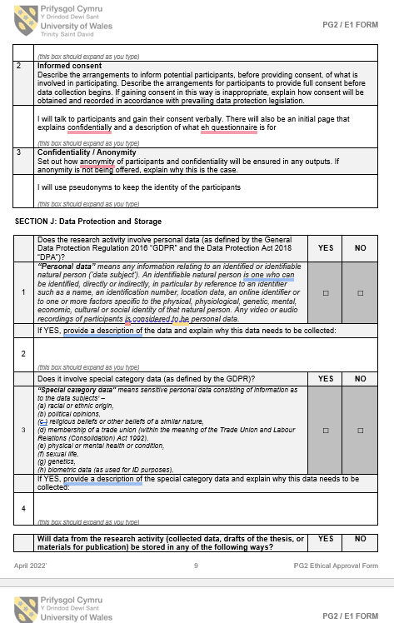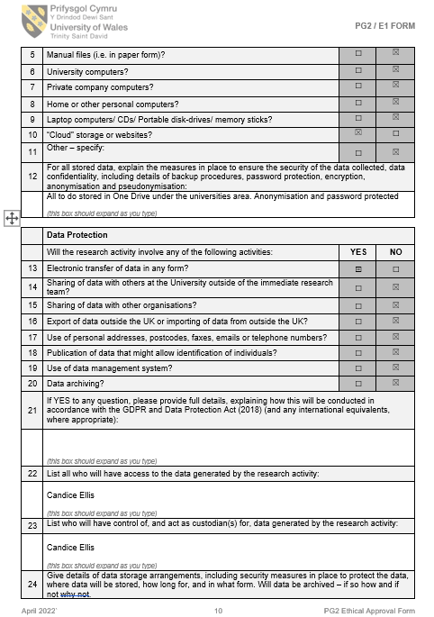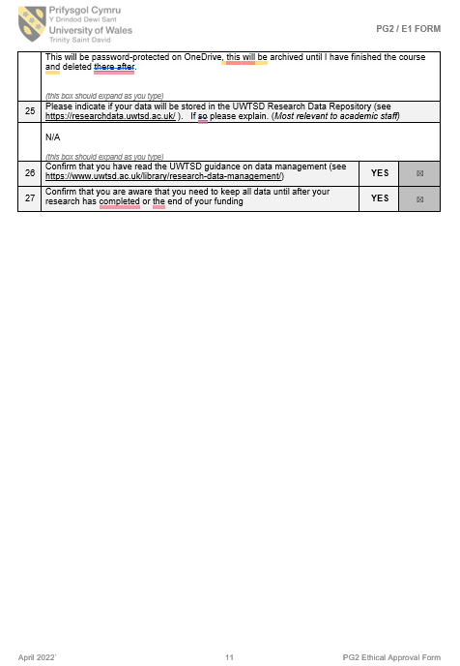

Appendix 2 – Flyer
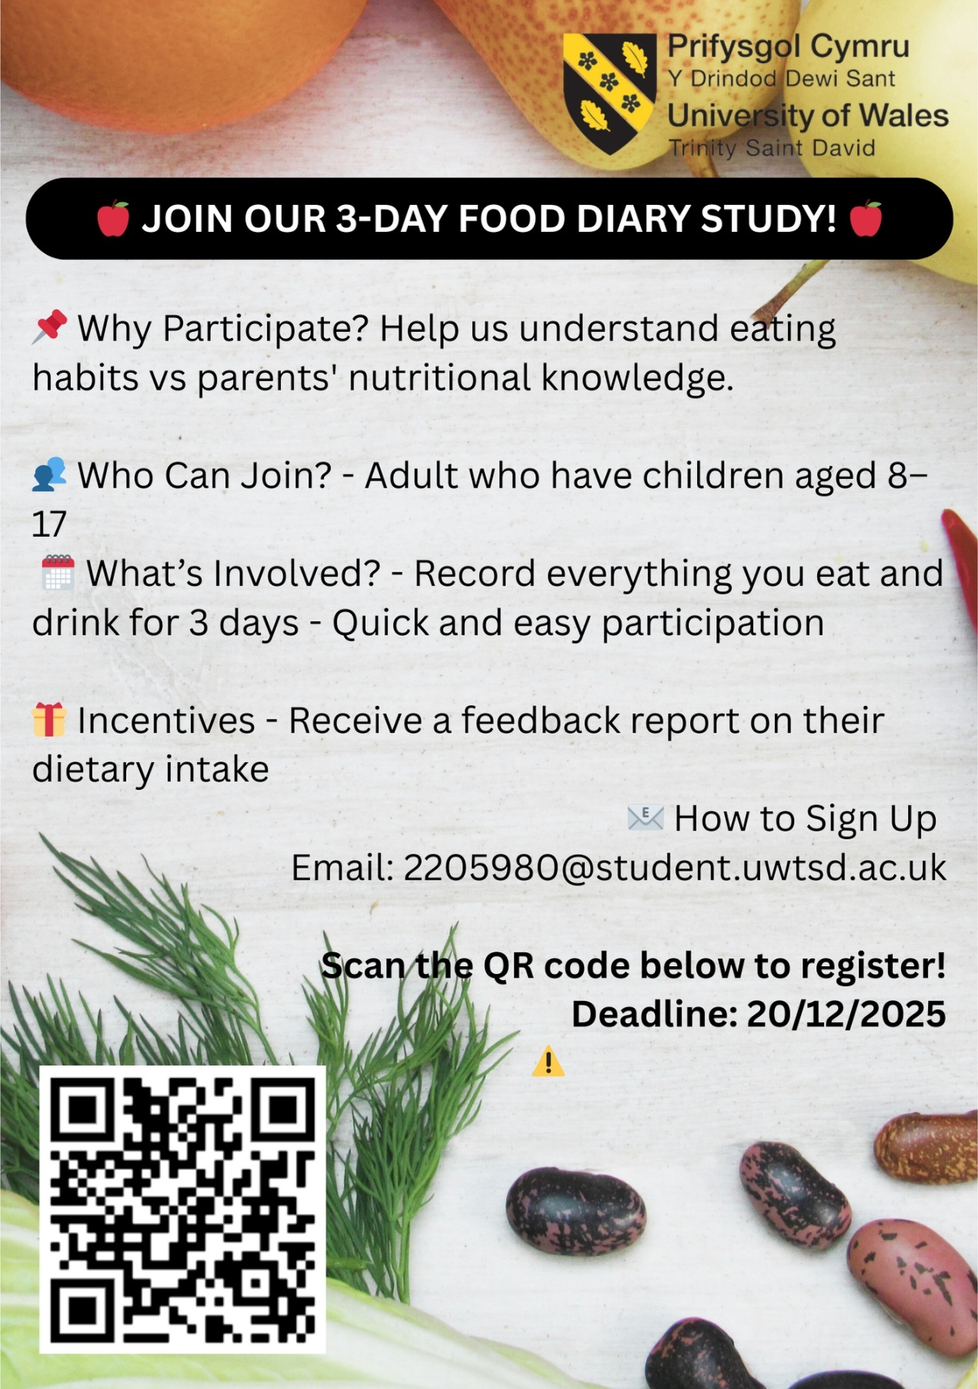

Appendix 3 - Consent forms

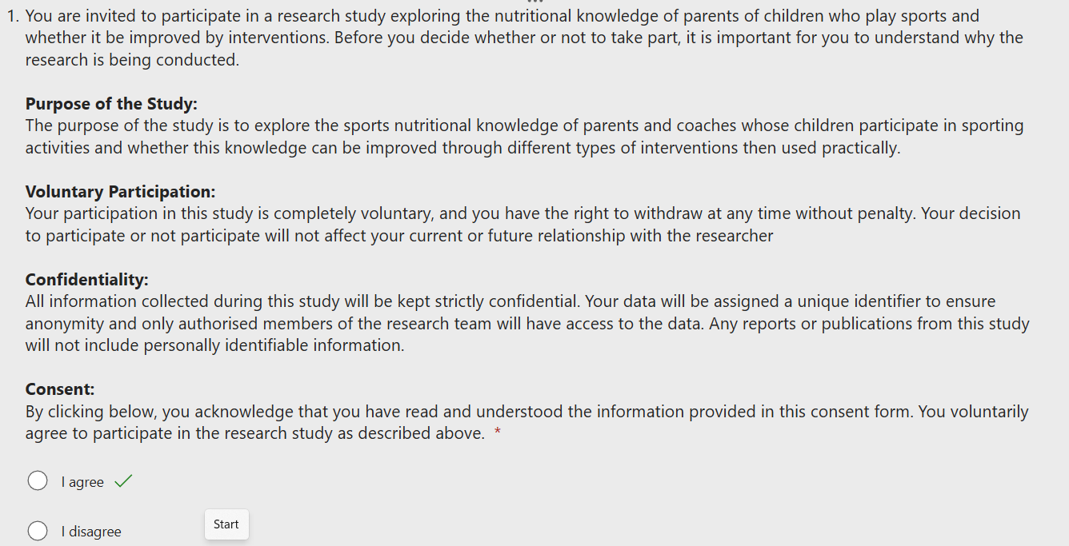

Appendix 4 – Sport nutritional knowledge questionnaire abridged version
E
General Nutrition Knowledge
- Eating more energy from protein than you need can make you put on fat. (agree/disagree/not sure)
- The body needs fat to fight off sickness. (agree/disagree/not sure)
- Do you think cheddar cheese is high or low in fat? (high/low/not sure)
- Do you think margarine is high or low in fat? (high/low/not sure)
- Do you think honey is high or low in fat? (high/low/not sure)
- The body has a limited ability to use protein for muscle protein synthesis. (agree/disagree/not sure)
- Eggs contain all the essential amino acids needed by the body. (agree/disagree/not sure)
- Thiamine (Vitamin B1) is needed to take oxygen to muscles. (agree/disagree/not sure)
- Vitamins contain energy (kilojoules/calories). (agree/disagree/not sure)
- Do you think alcohol can make you put on weight? (yes/no/not sure)
- "Binge drinking" (also referred to as heavy episodic drinking) is generally defined as:
- having two or more standard alcoholic drinks on the same occasion (b) having four to five or more standard alcoholic drinks on the same occasion (c) having seven to eight or more standard alcoholic drinks on the same occasion (d) Not sure

Sport Nutrition Knowledge
- Do you think 1 medium banana has enough carbohydrate for recovery from intense exercise? Assume the athlete weighs about 70 kg and has an important training session again tomorrow. (enough/not enough/not sure)
- Do you think 1 cup of cooked quinoa and 1 tin of tuna has enough carbohydrate for recovery from intense exercise? Assume the athlete weighs about 70 kg and has an important training session again tomorrow. (enough/not enough/not sure)
- Do you think 100 g of chicken breast has enough protein to promote muscle growth after a bout of resistance exercise? (yes/no/not sure)
- Do you think 1 Cup Baked Beans has enough protein to promote muscle growth after a bout of resistance exercise? (yes/no/not sure)
- Do you think 1/2 Cup Cooked Quinoa has enough protein to promote muscle growth after a bout of resistance exercise? (yes/no/not sure)
- Eating more protein is the most important dietary change if you want to have more muscle. (agree/disagree/not sure)
- Which is a better recovery meal option for an athlete who wants to put on muscle? (a) A 'mass gainer' protein shake and 3 - 4 scrambled eggs (b) Pasta with lean beef and vegetable sauce, plus a dessert of fruit, yoghurt and nuts (c) A large piece of grilled chicken with a side salad (lettuce, cucumber, tomato)/ (d) A large steak and fried eggs (e) Not sure
- When we exercise at a low intensity, our body mostly uses fat as a fuel. (agree/disagree/not sure)
- Vegetarian athletes can meet their protein requirements without the use of protein supplement. (agree/disagree/not sure)
- The daily protein needs of a 100 kg (220 lb) well trained resistance athlete are closest to:
- 100g (1g/kg) (b) 150g (1.5g/kg) (c) 500g (5g/kg) (d) They should eat as much protein as possible (e ) Not sure
- The optimal calcium intake for athletes aged 15 to 24 years is 500 mg. (agree/disagree/not sure)
- A fit person eating a balanced diet can improve their athletic performance by eating more vitamins and minerals from food. (agree/disagree/not sure)
- Vitamin C should always be taken by athletes. (agree/disagree/not sure)
- Athletes should drink water to: (a) keep plasma (blood) volume stable (b) stop dry mouth (c) allow proper sweating (d) All of the above (e) Not sure
- Experts think that athletes should: (a) drink 50 - 100 ml (1.7 - 3.3 fluid ounces) every 15 - 20 minutes (b) suck on ice cubes rather than drinking during practice (c) drink sports drinks (e.g. powerade) rather than water during intense sessions (d) drink to a plan, based on body weight changes during training sessions performed in a similar climate (e) Not sure
- Before competition, athletes should eat foods that are high in: (a) fluids, fat and carbohydrate (b) fluids, fibre and carbohydrate (c) fluids and carbohydrate (d) Not sure
- In events last 60 - 90 minutes, 30- 60 g (1.0 - 2.0 ounces) of carbohydrates should be consumed per hour. (agree/disagree/not sure)
- Eating carbohydrates when you exercise will help keep blood sugar levels stable. (agree/disagree/not sure)
- Which is the best snack to have during an intense 90-minute training session? (a) A protein shake (b) A ripe banana (c) 2 Boiled eggs (d) A handful of nuts (e) Not Sure
- How much protein do you think experts say athletes should have after completing a resistance exercise session? (a) 1.5g/kg body weight (~ 150 – 130 g/ 5.3 –10.6 ounces for most athletes) (b) 1.0 g/kg body weight (~ 50 - 100 g /1.9 - 2.3 ounces) for most athletes) (c) 0.3g/kg body weight (~ 15 - 25 g/0.53 - 0.88 ounces) for most athletes) (d) Not sure
- Supplement labels may sometimes say things that are not true. (agree/disagree/not sure)
- All supplements are tested to make sure they are safe and don’t have any contamination. (agree/disagree/not sure)
- Which supplement does not have enough evidence in relation to improving body composition, sporting performance? (a) Caffeine (b) Ferulic acid (c) Bicarbonate (d) Leucine (e) Not Sure
- The WORLD ANTI-DOPING AGENCY ( bans the use of WADA) (a) caffeine (b) bicarbonate (c) carnitine (d) testosterone (e ) Not Sure

Appendix 5 – Cooking skills questionnaire

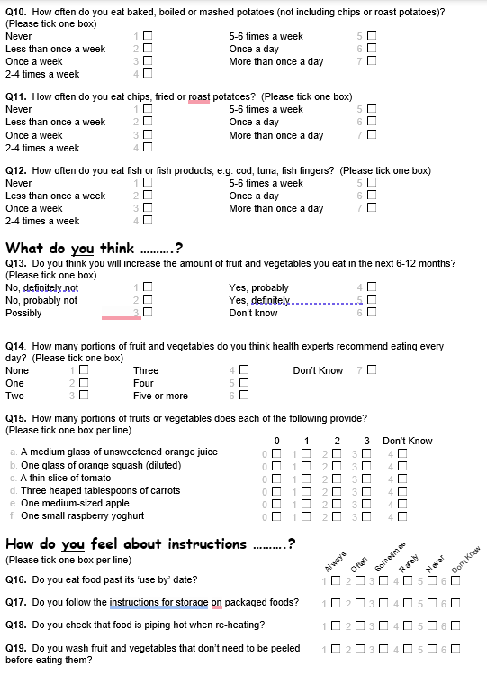

Appendix 6 – Food diary template

Please provide all drinks, snacks and meals.
Example of how to fill in the diary.
Breakfast 7 am 2 Weetabix skimmed milk (125ml) 1 small banana pure orange juice (200ml)
Lunch 12.30 pm 400g tin lentil soup 1 large wholemeal bread roll fruit yoghurt (125g pot) coffee (skimmed milk)
Dinner 6 pm 3 egg -sized new potatoes boiled 1 chicken breast grilled 3 florets broccoli steamed 1 teaspoon low-fat spread
Snacks 11 am 1 medium apple 3 pm 1 packet crisps (25g) 3 coffees (skimmed milk) Water (750ml bottle)

Appendix 7 – Timeline

Appendix 8 – Food Literacy Framework



