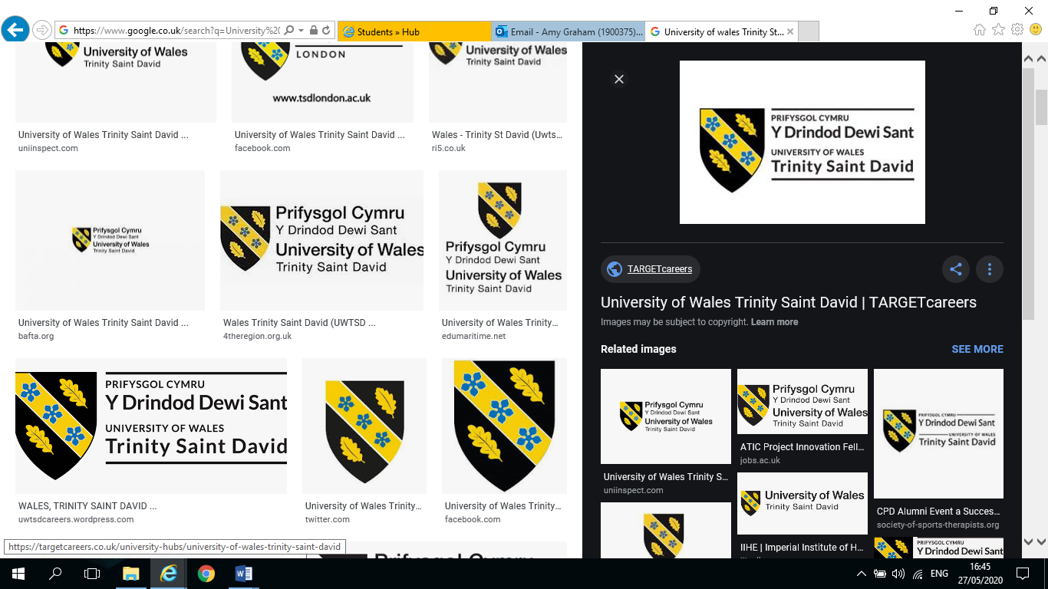

To Critically Evaluate and Identify if the Environment is part of the Motivation for Consumers when choosing a Cruise Holiday

By Amy Graham
1900375

Dissertation submitted as part of the requirements for the award BA (Hons) International Travel and Tourism Management

DECLARATION

This work has not previously been accepted in substance for any degree and is not being concurrently submitted in candidature for any degree
Signed ……………………………………………….
Date ……………………………………………………

STATEMENT 1
This dissertation is being submitted in partial fulfilment of the requirements for the degree of BA.
Signed ………………………………………………….
Date …………………………………………………….

STATEMENT 2
This dissertation is the result of my own independent work/investigation, except where otherwise stated.
Other sources are acknowledged by footnotes giving explicit references. A bibliography is appended.
Signed …………………………………………………
Date ……………………………………………………

STATEMENT 3
I hereby give consent for my dissertation, if accepted, to be available for photocopying and for interlibrary loan, and for the title and summary to be made available to outside organisations.
Signed …………………………………………………
Date ……………………………………………………

STATEMENT 4
I hereby give consent for my dissertation, if accepted, to be available on the university’s IT system to those who have consent to use the system.
Signed ……………………………………………….
Date ……………………………………………………

ACKNOWLEDGEMENTS

I dedicate this dissertation to my Father Glyndwr Parry and my Mum Ruby Parry, who both sadly passed away a few years ago. They always supported me in everything I did and would be so proud to see me completing my third year in university, as they both strongly believed in the education system and that it was important to everyone.

Firstly, I would like to thank Huw Parry, my brother, for his support and encouragement over the last three years and throughout my dissertation. He has always been my guide through difficult times and taught me to persevere and not give up.

I would also like to thank all my tutors at UWTSD, Jacqui Jones, Kathryn Flynn, Caroline Jawad and of course poor old Graham Orr for his patience. Your support and encouragement have made me believe that I could complete my final year.

Finally, I would like to thank my two daughters Lucy and Emma, for their unfaltering support and encouragement and always believing that I would achieve my goal. Also the remainder of my family, along with Gail Pattemore who also never doubted me.

ABSTRACT

The aim of the dissertation was to provide a critical evaluation to identify if the environment is a consideration or motivation for consumers when choosing a cruise holiday. The researcher felt that the study was important to not just the cruise industry but all areas of tourism and therefore, warranted further investigation.
The researcher reviewed a considerable amount of previous literature on the subject, which highlighted both positive and negative impacts on the environment by the cruise industry. The review of literature also considered the motivational aspects of tourists when choosing a holiday, and if the environment was a factor in these motivational choices.
The researcher created an on-line questionnaire and distributed it among various cruise line platforms. The results from the questionnaire coincided with certain themes which were raised in the literature review in chapter two, one of the main themes was that although today people are generally more environmentally aware than ever before, when it comes to their holiday and their own wants and needs it is not their first choice of motivation when choosing a holiday.
The findings of the research suggest that while the cruise industry is trying to counteract the impacts that it causes on the environment, it should also be providing clarity on how well it is doing with regard to its operating procedures so that potential cruise customers can make an informed decision on the choice of cruise holiday.

CONTENTS

CHAPTER 1 – INTRODUCTION …………………………………………………………………..1
  - Background…………………………………………………………………………………..1
  - Rational……………………………………………………………………………………….5
  - Aims and Objectives………………………………………………………………………...6
  - Structure……………………………………………………………………………………...7
  - Conclusion……………………………………………………………………………………7
CHAPTER 2 – LITERATURE REVIEW
2.0 Introduction ………………………………………………………………………………….8
2.1 Historical Developments ………………………………………………………………….. 8
2.1.1 Transport Developments – Historical to Present ………………………………………..9
2.1.2 Tourism Impacts …………………………………………………………………………..10
2.2 Modern Concepts of the Tourism Industry ……………………………………………..11
2.2.1 Niche Tourism Developments …………………………………………………………...11
2.2.2 Developments in the Cruise Industry……………………………………………………15
2.2.3 Cruise Industry as a Niche Product within the Tourism Industry …………………….16
2.2.4 Environmental Ethics and Morals ……………………………………………………….18
2.3 Cruise Industry and Environmental Impacts ……………………………………………20
2.3.1 Environmental Cruise Impacts ..................................................................................20
2.4 Tourists and the Cruise Industry …………………………………………………………26
2.4.1 Motivations of Cruise Tourists ……………………………………………………………26
2.5 Concluding Themes ……………………………………………………………………….28

CHAPTER 3 – METHODOLOGY
3.0 Introduction………………………………………………………………………………… 29
3.1 Research Onion …………………………………………………………………………... 30
3.2 Secondary and Primary Research ……………………………………………………… 31
3.3 Philosophy ………………………………………………………………………………….31
3.4 Qualitative –v- Quantitative ……………………………………………………………….32
3.5 Strategy Approach …………………………………………………………………………33
3.6 Research Design – Questionnaire/Interview ……………………………………………33
3.6.1 Research Design…………………………………………………………………………...33
3.6.2 Questionnaire……………………………………………………………………………….34
3.6.3 Interviews …………………………………………………………………………………...34
3.7 Piloting ………………………………………………………………………………………35
3.8 Sampling ……………………………………………………………………………………36
3.9 Techniques: Data Collection and Analysis ……………………………………………...37
3.9.1 Data Collection ……………………………………………………………………………..37
3.9.1 Analysis ……………………………………………………………………………………..37
3.10 Question and Literature Review Matrix (See Appendix 1) …………………………….38
3.11 Reliability and Validity ……………………………………………………………………..38
3.12 Limitations …………………………………………………………………………………..39
3.13 Ethical Considerations …………………………………………………………………….41
3.14 Conclusion ………………………………………………………………………………….41
CHAPTER 4 – DATA ANALYSIS
4.1 Introduction …………………………………………………………………………………42
4.2 Quantitative Research …………………………………………………………………….44

4.3 Qualitative Research ………………………………………………………………………44
4.4 Profile of respondents ……………………………………………………………………..45
4.4.1 Age………….………………………………………………………………………………..45
4.4.2 Gender ………………………………………………………………………………………46
4.5 Themes ..……………………………………………………………………………………47
4.5.1 Theme 1 - Motivation ……………………………………………………………………..47
4.5.2 Theme 2 - Environmental Awareness …………………………………………………...49
4.5.3 Theme 3 - Cruise Industry Values and Behaviour …………………………………….53
4.5.4 Analysis of Quantitative Data Collected in the on-line survey…………………………58
4.6 Matrix Table for Interview Content Analysis …………………………………………….59
4.7 NVivo ………………………………………………………………………………………..63
4.8 Word Cloud …………………………………………………………………………………64
4.9 Conclusion ………………………………………………………………………………….64
CHAPTER 5 – CONCLUSIONS AND RCOMMENDATIONS
5.1 Introduction …………………………………………………………………………………65
5.2 Meeting the Objectives ……………………………………………………………………65
5.3 Conclusions ………………………………………………………………………………...66
5.4 Recommendations for the Cruise Industry ……………………………………………...67
5.4.1 Objective 3 - Theme 1 – Motivation ……………………………………………………...67
5.4.2 Objective 3 - Theme 2 – Environmental Awareness …………………………………. 68
5.4.3 Objective 3 – Theme 3 – Cruise Industry Values and Behaviour …………………….69
5.5 Final Conclusions Summary ……………………………………………………………...70
5.6 Directions for Future Study ……………………………………………………………… 71
Bibliography …………………………………………………………………………………………73
Appendices ………………………………………………………………………………………….82

LIST OF FIGURES

Figure 2.1 Maslow (1943) “Hierarchy of Needs” model ……………………………………13
Figure 2.2 Richardson, (2005) model of Tourism Activities – Niche Tourism……………14
Figure 3.1 The Research “Onion” (Source: Saunders et.al., 2007)……………………….30
Figure 4.1 Age – Ranges from questionnaire ………………………………………...........45
Figure 4.2 Chart for Gender…………………………………………………………………...46
Figure 4.3 Chart – Respondents main primary motivation when choosing a cruise holiday………………………………………………………………………………………………..48
Figure 4.4 Chart – Awareness of respondents of the environment impacts of cruise ships…………………………………………………………………………………………………..50
Figure 4.5 Cross-tabulation of Gender and Q17, is enough being done to address environmentalism on cruises……………………………………………………………………....51
Figure 4.6 Chart showing result of cross-tabulation on Q17 and Q27……………………52
Figure 4.7 Chart showing whether the environmental rating would result in cruisers changing choice of cruise company……………………………………………………………….57
Figure 4.8 Matrix Table Analysis of Qualitative Data from Interviews/Content Analysis ………………………………………………………………………………………………………...59
Figure 4.9 Word Cloud on associated Themes……………………………………………..63

CHAPTER 1 – INTRODUCTION
The purpose of the dissertation is to provide a critical evaluation to identify if the environment is a consideration or motivation for consumers when choosing a cruise holiday. The subject is an important area of research as it has an effect on not just the cruise sector but all areas of the tourism industry. Chapter one contains the rationale and background of this research to aid the reader in their understanding of the subject matter.

  - BACKGROUND
According to the world Tourism Organisation the definition of tourism can be associated with the movement of people to countries or places that is not their home, and these movements are for either personal, business or professional purposes. These people are generally known as visitors who are either tourists or excursionists. Therefore, because tourism plays some part in their activities, some of their expenditure can be associated with tourism. (UNWTO, 2008)
Travel has grown from experiences that were originally only meant for the wealthy upper classes, the young men of affluent families in the 17th Century were sent around Europe on a “Grand Tour”. (Chaney, 2000) The first known travel agent was Cox and King in 1758, who provided a travel service to the British Armed Forces. (Cox et.al., 2014) This development of the tourism industry continued to 1841 when Thomas Cook opened their first travel agency, which allowed the working classes to travel for short breaks and participate in the temperance movement. (Cook, 2014) The growth of rail travel, along with the birth of the automobile meant that it was possible for anyone to experience or visit different locations around the world.

Along with this according to Kesl (2005) the first cruises across the Atlantic were inspired by the British Medical Journal in 1880 highlighting the health benefits of cruising across the Atlantic and adjacent seas. However, the 1960’s saw the real growth of the cruise industry begin with the development of luxurious ships travelling to exotic destinations for the more affluent customer. (Bosneagu et.al., 2015)
The cruise industry has grown increasingly since the 1960’s and is the fastest growing sector in the tourism industry. (Butler, 1991) It is constantly evolving due to the development of new destinations; increase in passenger numbers and the increase in the size of the ships.
The Seatrade Cruise (2017) states that the global cruise industry has grown dramatically, and now in the twenty first century the mega ships that can accommodate over 6,000 passengers and crew can also provide attractions on board that would match leisure parks or Las Vegas or Broadway theatres. The small cruise ship industry has also had tremendous growth offering a different product that the large ships cannot offer, allowing the passengers to experience a different kind of cruise i.e. (River, expedition and Yacht-style cruises).(Cruise Line International Association, 2018) (CLIA) According to CLIA (2018), the global revenue from cruising was $27,218M, and there were 28.2M passengers, this figure was expected to rise to 30m in 2019, which meant they were expecting another 18 new ships to be in operation in 2019 (the data is not available to confirm this data as yet). Such developments have meant that the cruise sector has grown to be a sector of its own within the travel and tourism industry. (Chanev, C., 2015)
In the last 30 years it has now become a hugely significant contributor to the tourism industry, the Florida-Caribbean Cruise Association revealed that over 27.2 million people took a cruise in 2018. Which according to the latest figures is more than the entire population of Australia (worldpopulationreview.com)

This figure is set to rise to 35M by 2025. (CLIA, 2018) However, it is important to note, that along with this exponential growth, the Cruise Industry has brought with it impacts both positive and negative.
This is particularly the case with respect to environmental impacts. With the increase in popularity comes greater numbers of ships with larger carrying capacities, therefore, putting even more stress on the natural environment. Copeland, (2008) suggests that cruise ship tourism embodies not only the problem of significant transport pollution, but also new pollution phenomena associated with a small mobile city or a tourist destination. Cohen, et.al., (2008) views that this growth is environmentally unsustainable, and that this unsustainability could affect both emerging and established countries. Copeland, (2010) later points out that the new pollution phenomenon from cruise ships and the incredible distances that it can travel, means that it knows no boundaries and is not contained to one nation. Therefore, there is concern for the special marine environments it can affect.
However, it is important to point out the opposing views concerning the potential negative impacts of cruises. One such thought is Hudson. Hudson (2019) questions whether cruise companies are really the villains, supported by, Scott Anderson, General Manager of the Luxury Cruise Company. “Cruise ships are perceived as heavy polluters; however, they comprise far less than 1% of the total global maritime community.” (Hudson, 2019) In further support is the Cruise Lines International Association (CLIA) 2019 Environmental Technologies & Practices Report, who inform that cruise ships are developing new technologies throughout the maritime industry, with $22bn (£17.9bn) invested in energy-efficient technologies and cleaner fuels for ships which did not exist previously. (CLIA, 2019) This growth is due to the amount of ships which are being commissioned.

The Australian based company Aurora Expedition launched a new ship in 2019, which held 120-passengers called the ‘Greg Mortimer’, included in the design was an inverted bow which will reduce drag, travel time and fuel consumption. (Hudson, 2019)
The cruise industry has begun to realise the mistakes of the past with regard to rectifying any environmental damage and are now investing in new technologies to counteract the impacts of the cruise industry. It also acknowledges that cruise tourist’s behaviour and awareness is changing towards the environment, with concerns over protection, therefore, the industry has to be seen to be playing its part in protecting the environment. Ahrens (2011) points out that as cruising becomes more popular and grows, it will inevitably see younger cruise passengers who are more concerned about the environment and are more ecologically aware because of their generation. Ahrens (2011) suggests that these cruisers will expect cruise companies to behave more ethically and responsibly. However, while cruise passengers are prepared to be environmentally friendly at home as part of their day to day actions, they do not want to be “burdened” with having to think about it when they are on holiday. (Miller, et.al., 2010) Paco et.al., (2009) suggested that the industry marketers are paying more attention to cruise customers concern for the environment and their eco-conscious motivations when buying a cruise holiday. The cruise industry impacts and issues with respect to the environment such as ocean pollution; climate change; and the over use of natural resources, has meant that the industry recognises it has to implement practices such as eco-friendly technologies and energy efficiency to satisfy the needs of the ever growing ‘green’ cruisers. (GTG, 2014; IGLU Cruise, 2012)

This research will try to ascertain and analyse the level of impacts cruise ships are having on the environment and whether potential cruisers today are motivated by the environment and the impacts and issues cruise companies are having upon it, and if these motivations are part of their decision making process when choosing a cruise holiday

  - RATIONALE
The impacts of the cruise industry on the environment as mentioned above, underpin the rationale of the research to analyse the motivations and considerations of consumers with regard to environmental cruising.
The motivation choices of tourists when considering a holiday are an important element of the marketing strategy for the cruise industry, therefore, it is essential that the tourism industry develop an awareness of their potential cruise tourist’s needs and wants to provide the appropriate product they require.
The researcher had chosen International Travel and Tourism for their degree, with the hope that from the overall study and specifically the detailed research undertaken as part of the thesis stage, that this would lead to employment within the Tourism Industry. It is felt that the dissertation focusing on Cruise Tourism, an important niche area of the industry, has been valuable to increase background knowledge on the overall industry and will stand the student in good stead to obtain future employment.

  - AIMS AND OBJECTIVES
The aim of this study is to identify if the environment is part of the motivation process of tourists when choosing a cruise holiday.
OBJECTIVES

- Critically analyse previous academic literature that assesses the impacts of the Cruise Industry on the environment, also analyse previous academic literature that probes the motivations and considerations of consumers with regard to the environment and cruising.

- To conduct primary research questionnaires and face to face interviews, to understand if the environment is part of the motivational process when choosing a cruise holiday.

- To synthesise extant literature and primary research to make recommendations for the cruise industry, with regard to changes to consumer attitudes towards cruise holidays and the environment.

  - STRUCTURE
Chapter two will analyse the academic literature that is available to assesses the impacts of the Cruise Industry on the environment, also analysing previous academic literature that analyses the motivations and considerations of consumers with regard to the environment and cruising. This will give the researcher a greater understanding of the subject.
Chapter Three will define the chosen research methods that the researcher used to conduct the primary research data.
Chapter four will define the researcher’s analysis of the data retrieved through mixed methods using a sequential approach. The on-line questionnaire, the interviews and case study focus area, addressed the triangulation method of data collection.
Chapter five will consist of the researcher concluding on the findings of the data and any associated themes. The researcher will then provide the reader with recommendations; limitations of the research and provide opportunities for further directed study on the topic area.

  - CONCLUSION
The aim of this chapter was to outline the rationale and background of the dissertation which led the researcher to the aim and objectives, providing the reader with a deeper understanding of the subject and why the researcher decided to undertake the dissertation.
Chapter two will analyse the relevant academic literature that is available on the tope area.

CHAPTER 2 – LITERATURE REVIEW
2.0 INTRODUCTION
The purpose of this chapter within the dissertation is to carry out a review of literature concerning the Impact of Cruise Tourism on the environment and whether these impacts have any motivations on tourists when choosing cruise ship holidays. This literature review will achieve the first of the three research objectives of the dissertation by:
Critically analysing previous academic literature that assesses the impacts of the Cruise Industry on the environment, also analysing previous academic literature that analyses the motivations and considerations of consumers with regard to the environment and cruising.
The objectives in this chapter will be achieved by using several sources such as academic journals, relevant textbooks, industry publications and websites, and newspaper articles.

2.1 HISTORICAL DEVELOPMENTS
The history of tourism and travel and its importance to the understanding of the industry today, has been widely researched and documented. Vukonic, (2012) writes that by looking at the past it allows us to understand society today. Vukonic, (2012) further suggests the use of tourism models helps to understand the idea of tourism movements from home to another country and the creation of the tourism industry. This human activity of movement from one country to another dates back to the early eighteenth century. However, it has been found that movement and travel has been noted further back in history. Walton (2015) suggests that the birth of travel commenced around 4000 BC with trading at the time of the Sumerians. Trading continued to be a major part of development for travel within the fifteenth and sixteenth centuries particularly with the growth of large trading networks, such as the Silk Roads. (Cooper, 2016)

Along with trade, early tourism was also motivated and linked to military and administrative purposes. In addition, religion (festivals and pilgrimages) also influenced travel motivations. Pilgrims would journey to mountains and rivers to visit their ancestral gods and spirits. (Sofield et.al., 1998) Casson (1994) suggests that the Egyptian period saw many travellers crossing borders for pilgrimages and festivals.
It is evident from this early period that the beginnings of tourism had begun, although, it was very difficult and disjointed to travel due to the distances the pilgrims had to travel and issues of inaccessibility. (Cooper, 2016) At the height of the Roman Empire their construction of roads meant that travel became easier and overtime travel for leisure become popular across Europe. (Cooper, 2016) However, after the collapse of the Roman Empire the roads were no longer maintained, and this became an interruption to travel. (Cooper, 2016)
In the fifteenth century, there was further growth in the area of travel and tourism in the form of the Grand Tour, developed to encourage the sons of the rich to expand their knowledge by touring Europe. The Grand Tour continued through the seventeenth and eighteenth century, and the first modern usage of the term tourist was used in this period. (Cooper, 2016)

2.1.1 TRANSPORT DEVELOPMENTS – HISTORICAL TO PRESENT
Cooper (2011) states that the Industrial Revolution and technology transformed tourism due to the invention of transport which allowed greater numbers to travel more easily and created leisure travel for everyone. Cooper (2011) continues that the development of railways in Britain, and later Europe and America, meant that there was ease of access to new destinations in shorter periods of time. In 1841, Thomas Cook created the first pleasure trip by rail. In the nineteenth century sailing ships were replaced by steam ships which allowed tourists to travel longer distances and access the world for leisure.

According to Bosneagu et.al, (2015) the first ships crossing the Atlantic were mainly merchant ships, however, there were passenger ships but they were lower in number. The “Black Ball Line” in 1818, was the first company to establish a passenger line from Europe to America. (Bosneagu et.al. (2015) The opening of the Suez Canal in 1869 aided this movement around the world. (Cooper, 2011) Cooper (2016) states tourism continued to grow in the nineteenth century up until the first world war. After the war the rise of the car technology meant that tourism entered a new era. The first part of the twentieth century saw the car transform tourism by the emergence of new infrastructure i.e., (roads and hotels) which increased the need for travel. (Cooper, 2011) The popularity of the car affected the dominance of the train, while the introduction of passenger air travel influencing speed and efficiency in the mid-twentieth century affected the dominance of surface transport for long distance travel. (Cooper, 2011) Cooper (2011) states that with the increase in accessibility and new tourist motivation the tourism industry took advantage of this and created the first comprehensive tourism package holiday, which instigated the introduction of “mass tourism” in the second part of the century and hence the tourism industry that is recognised today.

2.1.2 TOURISM IMPACTS
The growth of the tourism industry has grown to such an extent it is one of the biggest industries in the world. However, along with the demand has come impacts on the countries, destinations and oceans it crosses both economically, socially and environmentally. Krippendorf (1998) states:
“Unrestricted tourism growth could lead to the positive economic effects of tourism being outweighed by significant social and environmental disadvantage.”

The pressure to deliver more tourism products has meant that the tourism industry has to look further afield and to more remote destinations for new tourism products. The growth of mass tourism over previous decades has resulted in some destinations becoming overcrowded, leading to adverse effects on the host communities, one case example is Benidorm. The Cruise industry has in the past had a negative reputation for the impacts it has had not only on the destinations it visited but the oceans and the eco systems it affected.
According to Cooper (2011) the concept of sustainability has been growing in strength since the 1960’s, however, for tourism the concept came later growing through the 1980’s, supported by international conventions, declarations and initiatives which were also supported by the general mood of society of the times. Cooper (2011) further states that sustainable tourism has matured and recognised that it is no longer an idealistic pass time but a real problem. Some example companies who lead the way in sustainability are Tui and Accor, however, Buckley (2012) feels that there are still some companies in the sector that have not adapted enough yet to recognise it is important not to just rely on regulations but develop new initiatives having learnt from the market. Cooke (2011) states that the sustainability concept continues to grow not only for the industry but also for society as a whole.

2.2 MODERN CONCEPTS OF THE TOURISM INDUSTRY
2.2.1 NICHE TOURISM DEVELOPMENTS
The travel and tourism industry that is recognised today has developed from mass tourism. The tourist of the past has been happy with travel being packaged by the travel agent, however, with the twenty first century, this has been changing. (Robinson et.al., (2005). Robinson et.al., (2005) further suggests that ‘niche tourism’ has developed in contrast to ‘mass tourism’ and suggests that tourists are becoming more discerning and looking for diversity in their travel choices.

Today, the tourist is looking for something unique, they do not want to follow the crowd; their holiday choice is more specific and suited to their own personal needs or they may even want to be seen to be leading the trends and making a difference in the destinations they visit. The industry has addressed this new interest of the tourist, by developing and marketing niche products within the industry. Robinson et.al., (2005) states that destination managers and planners are looking to benefit from tourism to boost economies within a destination, the niche product offers more sustainable opportunities and has less impact and introduces a higher spending tourist and is therefore supported by industry. Conversely, Cohen (1972) however, disputes the fact that tourists were less discerning in the past and argues that tourists have always been the same in terms of their elementary needs and motivations. It is due to the tourists of the past and their elementary needs and motivations that has aided the growth of the tourism industry.
The growth of the package holiday pointed to two-fold categorisation of the tourist; institutionalised tourist which included individual and organised mass tourists; non-institutionalised tourists which included ‘explorers and drifters.’ This categorisation is associated with segmentation within the tourism industry. Smith (1956) stated that segmentation is a strategy that marketers use to distinguish consumer needs, characteristics or behaviour.
To further investigate the idea of tourist’s motivations, it is important to consider Maslow’s Hierarchy of Needs. Maslow’s hierarchy of needs, theory model, which stated that humans are motivated by needs and once they have achieved their basic needs i.e., (food, water), they strive to achieve higher gratification, namely; self-actualization, with the aim to reach their personal potential, self-fulfilment, and personal growth. (Maslow, 1943) Marketers often use this theory in their demographic segmentation tool i.e. age, education ethnicity, income, religion family, to understand what the needs of these demographics are to determine the tourism product that they want and or need.

The segmentation of these markets further aid the marketer to create Niche products for the more individual needs of tourists. (Weaver, et.al. (2006) McLeod (2018) states:
“Maslow’s hierarchy of needs is a motivational theory in psychology comprising a five-tier model of human needs, often depicted as hierarchical levels within a pyramid.”
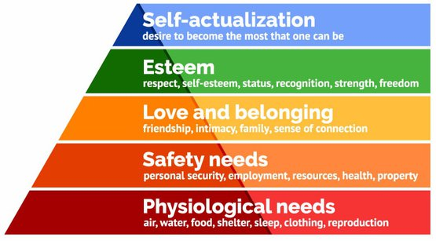
Figure 2.1 – Maslow “Hierarchy of needs” model

The marketers of previous decades used the same segmentation tools, as they also realised that although there was a demand for mass tourism, the demand for Niche products was evident. Cohen (1972) agrees and states that although there was a mass tourism market, these tourists had their own needs to be met. However, was there a product available to them in the 1990’s to allow them flexibility to choose Niche tourism. Robinson et.al., (2005) broadly agrees that this point still holds true today and that mass tourism is still very dominant but includes a more specialised form of tourism (recently developed Niche tourism).
Tourists now wish to appreciate the whole experience of a destination, not just by discovering and experiencing, but also by participating and learning, becoming more discerning. However, although niche tourism is growing steadily in today’s tourism industry, there will always be a need for the mass tourism market for those tourists who are just looking for the beach holiday without any effort.

Robinson et.al., (2005) highlights in his table the differences between mass and niche tourism and the breakdown of the appeal to tourists of the niche products.

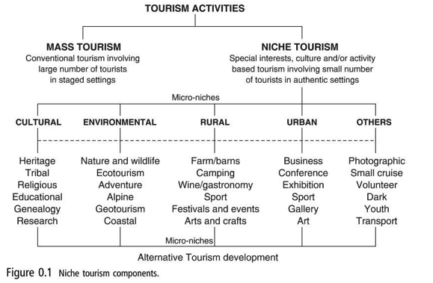
Figure 2.2 – Richardson’s (2005) model of Tourism Activities - Niche Tourism

Robinson et.al., (2005) displays not only Niche tourism but also how it then can be broken down even further into Micro Niches, which highlight the diversity of marketers planning to attract business products into the tourism industry.

In recent years, it is evident however, that niche products are radically evolving and one particular area is Cruising, so much so that it has developed to such a degree, that it is now a sector of its own within the tourism industry.
The Cruise industry developed as a niche product to cater for tourists looking for a different holiday product than the norm, today the industry has grown not just in ship numbers, but in the size of the ships namely; “Mega Ships” to cater for the amount of tourists that want to cruise.

2.2.2 DEVELOPMENTS IN THE CRUISE INDUSTRY
According to Brown (2009) the new cruise ships of the 1960’s offered all the amenities and entertainment that cruisers take for granted today. The passengers on these cruise ships considered that the cruise experience was very important, the luxury cabins along with the restaurants and entertainment were part of their full holiday expectations and not just a means to get to their destinations. In the 1960’s the cruise market was mainly based upon the demographic group of the retired or those whose income was considered to be wealthy enough to afford a cruise ship holidays. It was very much a middle class elitist statement, of who this demographic was and what they could do. The cruise itinerary included various luxury destinations such as Mediterranean, Caribbean and Alaska, and these destinations are still the most popular ports of call for the cruise industry of today. The marketers for the cruise industry created a luxury product for their market, this market catered for this specific demographics element, anticipating their needs to feel special and able to afford the best in life and wanting to dine in luxury restaurants and have luxurious cabins. The aim was to exceed even their expectations, to provide a cruise service that was of paramount quality.

Due to the cruise industry meeting the expectations of their passengers and more, this has resulted in a rise in passenger numbers and the need for new destinations and niche products, which has encouraged the building of not just new ships, but mega ships to support the increased passenger numbers which had risen to 28.2M. (Dowling et.al., 2017) In 2016 it was forecasted that over 24 million passengers would chose a cruise holiday, and 75 new ship builds were on order, the increase in new ships meant that passengers numbers will have an estimated rise to 35 million by 2026. (Seatrade Cruise, 2017).

2.2.3 CRUISE INDUSTRY AS A NICHE PRODUCT WITHIN THE TOURISM INDUSTRY
The cruise industry has grown increasingly since the 1960’s and is the fastest growing sector in the tourism industry. (Butler, 1991) It is constantly evolving due to the development of new destinations; increase in passenger numbers and the increase in the size of the ships, the Seatrade Communication (2012) suggests that 90% of ships are considered to be large and carrying more than 1,250 passengers per ship.
The Seatrade Cruise (2017) states that the global cruise industry has grown dramatically, and now in the twenty first century the mega ships that can accommodate over 6,000 passengers and crew can also provide attractions on board that would match leisure parks or Las Vegas or Broadway theatres. The small ship industry has also had tremendous growth offering a different product that the large ships cannot offer, allowing the passengers to experience a different kind of cruise i.e. (River, expedition and Yacht-style cruises). (Cruise Line International Association, 2018) (CLIA) According to CLIA (2018), the global revenue from cruising was $27,218M, and there were 28.2M passengers and this figure was expected to rise to 30m in 2019, which meant they were expecting another 18 new ships to be in operation in 2019. Such developments have meant that the cruise sector has grown to be a sector of its own within the travel and tourism industry. (Chanev, C., 2015)

Jordan (2019) reports on Cruise Industry Outlook in 2019 and Beyond; that passengers are reaping the benefits of the industries expansion with more choice of destinations and activities on board ship. The age gap of passengers has closed since 2007 to an average of 47 years, however, there is also an increase in millennials requiring active excursions such as kayaking, flightseeing and hiking. The increase in millennials has encouraged the cruise industry to invest in more technology to suit their needs. (Jordan, 2019)
The cruise industry has attempted to provide products for all their consumers expectations, such as the “Luxury” line exceeding cruisers expectations by creating a product that is centred on fine dining and opulent surroundings and travelling to destinations that the larger ships cannot reach while providing a billionaire service. (CLIA, 2018) On the other scale, you have the Disney Cruises that exceed family expectations by providing the family with the same products as Disney land. The Senior cruisers expectations are met by providing them with adult only cruises such as Saga, which cater for their needs, all these companies provide products which are built to exceed their target market expectations. (CLIA, 2018) The marketers for these products closely watch the up and coming trends, especially when it comes to tourist demographics. According to CLIA, (2018) there has been a rise in Generation Z tourists who have a greater wanderlust, which cruising provides with the appeal of multiple destinations and music festivals at sea. Female cruisers are also on the rise, with companies creating female-centred itineraries based on their interests, which creates female empowerment. Going-solo is more popular than ever before, because it allows the solo cruiser to have a once-in-a-lifetime experience in far flung destinations without having to make tons of arrangements but still have the security of being among other tourists. (CLIA, 2018). By following the trends and using the segmentation tool it responds to the market by creating the niche products for it.

The niche cruise tourist is looking for intimate and challenging, even education which challenges them to learn more about destinations they are visiting, this makes them feel different from the usual cruise tourist. (Read, 1980) Douglas et.al (2005) points out that these tourists are the target market for niche product developers. However, it could be asked are the niche product developers going one step too far.
The overwhelming key theme from 2018 is that the cruise ships are continuing to increase in size with large ships reaching 180,000 gross ton parameter, and the deluxe ships reaching 50,000 gross tons. However, Jordan (2019) article highlights the increase in benefits to the passengers and industry, but there is no mention of the impact on the environment and how the industry is developing strategies to combat these impacts to make the ships more environmentally friendly. Today, this is particularly interesting due to the current emphasis being placed on environmental agendas.

2.2.4 ENVIRONMENTAL ETHICS AND MORALS
According to the Stanford Encyclopaedia of Philosophy (2015) Environmental ethics is the philosophy that studies moral relationship between humans and the environment.
In 1987 the United Nations presented a document on sustainability produced by the World Commission on Environmental and Development (WCED, 1987). The commission was chaired by Gro Harlem Brundtland, Prime Minster of Norway, the report was later called the Brundtland report. One of the subjects discussed in the report was the increasing problem of planetary systems vital to supporting life on earth, are beginning to strain. The question raised by the commission was; is it fair to sacrifice options for future well-being to benefit the way of life today, particularly the more affluent and comfortable life, especially for those in richer countries. (WCED, 1987)

Norton, (2005) states that the world is facing global challenges and it is important to see if different human groups with different opinions can take responsibility and adopt a more sustainable use of the environment. To preserve the options for the future, Norton, (2005) feels that the affluence of today cannot dictate and reduce the amount of options and choices that future environments have to face. Therefore, the goals for future sustainability development must be dealt with today, such as the needs of the poor of the world, which should be a priority, by dealing with these goals so that all countries are sustainable in what provides for the future. (Norton, 2005) The report continued that the industrial world had used a good deal of the ecological capital and this was the planets main environmental issue, therefore, it is the main development issue. (WCED, 1987).
It was up to the human race to take the decision to put human wants and needs aside, and act ethically and morally towards the environmental sustainability of the planet and for the future generations. The Brundtland report was only partially successful, as we are still experiencing issues with the environment. The discussions continued between World Leaders and Industry, to try and control emission levels and the Paris Agreement in 2016, was important to strengthen global response to the threat to climate change. The agreement encourages all parties to take action to reduce 45% of emissions by 2030 and a carbon neutral world by 2050. (UNWTO, 2019) However, emissions are still rising, and unless the World Nations take control they will reach tipping point, as this is a human-caused problem, it is up to global nations to prevent these dangerous adverse impacts on the climate to continue, otherwise it will damage our oceans, coral reefs and food supplies for future generations. (UNWTO, 2019)

2.3 CRUISE INDUSTRY AND ENVIRONMENTAL IMPACTS
With the Cruise Industry’s expediential growth this has brought with it impacts both positive and negative.
In the last 30 years it has now become a hugely significant contributor to the tourism industry, the Florida-Caribbean Cruise Association revealed that over 27.2 million people took a cruise in 2018. Which according to the latest figures is more than the entire population of Australia (worldpopulationreview.com) This figure is set to rise to 35M by 2025. (CLIA, 2018) This is particularly the case with respect to environmental impacts. With the increase in popularity comes greater numbers of ships with larger carrying capacities, therefore, putting even more stress on the natural environment. Copeland, (2008) suggests that cruise ship tourism embodies not only the problem of significant transport pollution, but also new pollution phenomena associated with a small mobile city or a tourist destination. Cohen, et.al., (2008) views that this growth is environmentally unsustainable, and that this unsustainability could affect both emerging and established countries. Copeland, (2010) later points out that the new pollution phenomenon from cruise ships and the incredible distances that it can travel, means that it knows no boundaries and is not contained to one nation. Therefore, there is concern for the special marine environments it can affect. Copeland, (2010) further raises the issue of cruise ship emissions, whether the ships are anchored; in dock; or moving at sea, these ships still produce emissions that can have a broad range of impacts on the environment.

2.3.2 ENVIRONMENTAL CRUISE IMPACTS
Dowling (2006) makes the point that the cruise industry has faced many different and complex environmental issues over the years, this is made even more complex because the cruise industry now includes major conservation areas throughout the world within their itinerary.

Dowling (2006) also states that the International Convention for the Prevention of Pollution from 1973 and the Protocol of 1978’, commonly referred to as MARPOL, ruled that records of practices and pollution control equipment should be carried by all ships of waste disposal. These regulations were then amended in 1998 so that cruise ships had the choice to either process and discharge in transit within the MARPOL requirements or store it and discharge in landfill sites in port. Most cruise companies have invested in on-board technologies which consist of environmentally sensitive practices. Timothy (2005) notes that although cruise companies use ‘flags of convenience’ for countries they dock in, ultimately they spend the majority of time in open seas, therefore, are not confined by any government and partially by international regulations. Timothy (2005) states this has allowed them to pay less attention to the environment, which has found to be the case because there is no real accountability. Investigations into cruise lines have found that there is a lack of commitment in the recording of environmental practices upon cruise ships.
However, the increased number of ships and passengers has raised concern for social, economic and environmental sustainability of the cruise industry. (Sheppard, 2010; Hall et.al., 2017) London (2017) highlights that with respect to the environmental aspect, the increase in size and ship numbers has resulted in carrying capacity rising to 5,000-6,000 passengers and 2,500 crew, which has resulted in ports throughout the world having to contemplate how they will accommodate the docking of the ships but also the effect on destinations by passenger numbers. On some occasions some of these ports are having to cope with more than one ship docking or disembarking at a time, which has resulted in the destinations saturation levels reaching capacity or even being breached, and this breach can cause an adverse effect on the host communities who become frustrated and angry with the tourists and cruise companies.

Klein, (2013) research into the management of wastewater on cruise ships found that cruise ships were required to meet treatment standards for gray water as well as 25 other types of incidental vessel discharges. However, Klein (2013) found that on numerous occasions this was not always the case. US authorities found that the most common technology used (Type II Marine Sanitation Device) was found to be ineffective, and new technology (Advanced Wastewater Treatment) was found to be faulty in 70% of samples. Klein (2013) justifies this with a case study example: “in 2008,2009, Royal Caribbean cruise ships were charged three times with illegal discharge of wastewaters in the Chatham Strait, Alaska.” Jeftic et.al., (2005); and Allsop et.al., (2005) previously stated that the United Nations Environment Programme (UNEP) felt that cruise ships were the main polluters of the world marine eco-system. USEPA (2008) estimated that waste from cruise ships was in the region of 2.6 to 3.5 kg/person/day which is monitored by MARPOL. Caric et.al., (2014) makes the point that because cruise ships are mobile, it is difficult to ascertain the source of the pollution, especially in areas such as the Mediterranean where the proximity of neighbouring country jurisdictions run closely together. Caric et.al., (2014) further suggests that although cruise ships must dispose of their organic waste 12 nautical miles (NM) from the Mediterranean coast, there is no way of controlling the way in which waste disposal is carried out upon cruise ships. The various types of problems created from this waste are eutrophication, hypoxia and bio-accumulation of toxins. (Caric, et.al., (2014)
The storage of waste on board ships has always been a problem, however, today’s new ships have new technologies on board such as waste incineration systems. This does create other problems though, because not all ports have the appropriate disposal mechanisms for dealing with the resulting waste from incineration. (Caric et.al., (2014)

Further environmental issues/impacts are related to plastic. Plastics are a growing problem in the marine environment, which make up 60-80% of litter around the world. (Derraik, 2002; Thompson et.al., 2004) Terred’avenir (2010) estimated that within the Mediterranean, there were 250 billion pieces of waste plastic micro-fragments floating in the water column of 10-15 cm depth. It is expected that these figures will have increased tremendously today.
Kershaw et.al., (2011) stated that plastic waste entered the marine ecosystem generally by ocean related activities, such as nautical activities; fishing and aqua-farming. Boucher et.al., (2017) argues that most marine plastics are land sourced. Boucher et.al., (2017) later uses Micro Plastics Pollution (MPs) as an example case, stating that 98% originated from land-based activities, whereas only 2% entered through ocean-based activity.
Joussen, F., (2018), Chief Executive Officer, TUI Group, stated in the Sustainability Report 2018, that the group had launched a plastic reduction programme WASTELESS to support their vision for plastic-free holidays on their cruises by 2020. The reduction of plastic waste is not new for Tui Cruises, they have reverted to glass jugs which passengers can fill at corridor water fountains, which eliminates plastic bottles. All new cruise ships will provide passengers with refillable dispensers in their showers for shampoo and shower gel, saving 370,000 throw-away packs per year for each of its fleets. Joussen, F., (2018) further stated that the fleets bars and restaurant already only provide straws on request and that 1.5M stirrers have been replaced by wooden stirrers. However, to counter-argue plastic waste issues on cruise ships, is the fact that the new cruise ships being built today do have the technologies on board to recycle and incinerate plastic, therefore, it can be assumed that the majority of plastic litter within the marine environment is derived from other sources around the world. According to Carnival Corporation, 2007; Klein, (2003) the incineration of plastics waste may cause ash and the disposal of this ash causes problems itself as there is no enforcement in the Mediterranean as to where it can be released in the sea.

This ash causes various toxic substances and are classed as hazardous waste. Caric et.al., (2014) also points out that there has been little investigation of hazardous waste being released in the Adriatic. This is a particular concern where cruise ships visit sensitive marine regions.
Furthermore Caric et.al., (2014) suggested that engine emissions from cruise ships can detrimentally influence the air. Eyring et.al., (2010) suggests that the estimated global contribution of ship emissions was 15% and 9% of Nitrogen Oxide (NOx) and Sulphur Dioxide (SO2) respectively in 2010, these emissions have increased considerably with the growth of the industry year on year. (Eyring et.al 2010) Cofala et.al., (2000&; EEB 2008) stated that total emissions from international navigation and European seas in 2000, had been estimated at approximately 3.3 million tons of (NOx), 2.3 million tone of (SO2) and 250,000 tons of suspended particles which had been released into the atmosphere. These figures were expected to increase by 50% in 2019, which relates to the growing concern for the effects on the climate change and the environment. Interestingly, it is estimated that 30% of smog comes cruise ships. (Mole, et.al. 2010)
However, Hanses, J., (2018), C.E.O. of Viking cruises, stated in the Sustainability report that Viking Grace, which is a hybrid vessel, had been fitted with a new rotor sail, it is the first of their hybrid to use both wind and propulsion using liquefied natural gas (LNG) for fuel. This innovation will reduce carbon dioxide emissions and fuel consumption. Hansen, J., (2018) further stated that work had begun in China on a larger vessel than Viking Grace but will be expected to consume 10% less fuel, and become the world’s most energy-efficient vessel.

Hudson (2019) National Geographic, reports that the cruise industry has had a bad reputation for years, according to a report in June 2019 by environmental lobby group Transport & Environment. In 2017, Carnival Cruise’s fleet alone emitted nearly 10 times more sulphur oxide in European waters than all of Europe’s 260 million passenger vehicles.
In recent years there has been an increase in cruise tourism to the Antarctica, which is the last part of the globe that has not been overtaken by tourism but is increasingly being marketed as a new niche product. However, Joussen, F., (2018), Chief Executive Officer, TUI Group, stated that by July 2020 Hapag-Lloyd cruise fleet will be using low sulphur marine gas oil (MGO) on all routes. Particularly in sensitive areas such as the Artic and Antarctica, the cruise line was using MGO ahead of legal requirements. The low emission fuel has a sulphur content of only 0.1%. Hapag-Lloyd’s expedition ships also have SCR catalysts, reducing nitrogen oxide emissions by 95%, and to stop engines running while in port, have connectors to power from shore. (Joussen, F., 2018)
It is important to point out the opposing views concerning the potential negative impacts of cruises. One such thought is Hudson. Hudson (2019) questions whether cruise companies are really the villains, supported by, Scott Anderson, General Manager of the Luxury Cruise Company. “Cruise ships are perceived as heavy polluters; however, they comprise far less than 1% of the total global maritime community.” (Hudson, 2019) In further support is the Cruise Lines International Association (CLIA) 2019 Environmental Technologies & Practices Report, who inform that cruise ships are continually developing new technologies throughout the maritime industry, with $22bn (£17.9bn) invested in energy-efficient technologies and cleaner fuels for ships which did not exist previously. (CLIA, 2019) This growth is due to the amount of ships which are being commissioned. However, although these strides in technology are important and badly needed what is also needed is the clarity of the operation policies that cruise companies have in place with regard to their environmental activities to protect the environment.

It is suggested that today’s tourists are more environmentally aware, which includes cruise ship passengers, they expect the cruise industry to be environmentally sustainable and accountable for their policies, therefore, it is important for cruise companies to address this claim within their literature and reports to show how they are making strides to protect the environment. The Cruise Line International Association (2010) celebrating their 35th anniversary released an environmental report which outlined future policies and technologies in use. However, Adams, et.al., (2017) points out that the report did not contain quantifiable scientific figures that researchers could use to assess the industry’s environmental progress. Adams et.al (2017) further goes on to say, though, that there are plenty of press releases to keep the public informed and refer to positive environmental improvements within the industry.

2.5 TOURISTS AND THE CRUISE INDUSTRY
2.5.2 MOTIVATIONS OF CRUISE TOURISTS
As previously noted earlier in the chapter, Ahrens (2011) points out that as cruising becomes more popular and grows, it will inevitably see younger cruise passengers who are more concerned about the environment and are ecologically aware, these cruisers will expect cruise companies to behave more ethically and sustainably. However, this is counter-argued by Miller, who suggests that whilst cruise tourists may be adopting more sustainable principles within their ‘day to day’ lifestyles, they do not necessarily want to be “burdened” with having to think about it when they are on holiday. (Miller, et.al., 2010) Paco et.al., (2009) suggested that the industry marketers are paying more attention to cruise customers concern for the environment and their eco-conscious motivations when buying a cruise holiday, however, in accordance to Miller (2010), this may not necessarily be what the cruise tourist wants, when ‘actually’ participating in the holiday.

The cruise industry impacts and issues with respect to the environment such as ocean pollution; climate change; and the over use of natural resources, has meant that the industry recognises it has to implement practices such as eco-friendly technologies and energy efficiency to satisfy the needs of the ever growing ‘green’ cruisers. (GTG, 2014; IGLU Cruise, 2012) However, Han et.al, (2016) also suggests that the cruise industry should not only make the industry greener to meet ‘green’ customer needs, but also be attempting to understand the motivations of cruisers when purchasing cruise holidays with regard to the environment, as this is becoming a highly competitive market for the cruise industry. Adams (2017) suggests that consumers would take heed of a company’s sustainability policies and procedures as part of the decision making process, if the consumer was given the choice of several companies with a similar product type, and the sustainability information is readily available, to compare and contrast companies against.
Adams (2017) research suggests that cruisers expect some kind of corporate social and environmental responsibility (CSER) with regard to their practices and policies and that some consumers might avoid cruise companies that do not perform ethically and environmentally, and this research agreed with Miller et.al (2010) earlier findings, that consumers felt it was their “right” to go on holiday and it was not their responsibility to make ethical and environmental choices but it was the responsibility of the company to offer them sustainable holiday products. Miller et.al., (2010) also states that consumers felt that there should be government regulation enforced and company ethics developed. In addition, those companies who do not abide with the regulations and who do not operate pro-social and pro-environmentally should not be allowed to operate, therefore, only allowing ethical operators to choose from. Adams et.al., (2017) suggests that the research confirms that (CSER) is important to most consumers today even if it is not the first priority currently in the decision process when choosing a cruise. It would be therefore, important for the cruise industry to be mindful of this.

2.6 CONCLUDING THEMES
It would seem that all the research in to the environmental impacts and issues from cruise ships can be interpreted as quite controversial. There is obviously much for the industry to consider with regard to addressing these impacts and issues, and the way the industry is reacting to them. There should be more accountability by the cruise industry with regard to their practices and procedures, but it is also important to remember that the governments of the countries that these ships dock in have a responsibility to make sure these companies are behaving responsibility and abiding by environmental procedures.
This research will try to ascertain and analyse the level of impacts cruise ships are having on the environment and whether potential cruisers today are motivated by the environment and the impacts and issues cruise companies are having upon it, and if these motivations are part of their decision making process when choosing a cruise holiday.

Chapter 3 – METHODOLOGY
3.1 INTRODUCTION
In the previous chapter focussing on the background of literature, secondary research, the first research objective to understand the development of the cruise industry, adult customer base and how it has achieved its current global status in the tourism industry was addressed. Furthermore, the effects and impacts that the global industry has had on the environment, (which is highly topical due to the poor image the industry has had in the past), and the measures that the cruise industry has recently put into place to combat the impacts on the environment, was also satisfied.
This chapter will now provide a contextual underpinning of the Primary research.
The second objective in the research is to assess and understand the motivations of tourists when choosing a cruise holiday:
“To conduct a primary research questionnaire and conduct face to face interviews, to understand if the environment is part of the motivation process when choosing a cruise holiday.”
To be able to achieve this objective, the researcher used the most suitable methods and methodology.
The researcher will be using Saunders, et.al., (2016) “Research Onion”, to give an understanding of the research methods employed as part of the study.
The basis of research is developing knowledge in a specific field. Burrell, et.al., (1979) Saunders, et.al., (2015) defines research as a ‘system of beliefs and assumptions about the development of knowledge’. Burrell, et.al., (1979) suggests, that unconsciously the researcher will make a number of assumptions during different stages of research.

The assumptions can include such areas as human knowledge (epistemological assumptions); realities that can be encountered in research (ontological assumptions); and how the researcher’s own ways and values can have an impact on the research (axiological assumptions). All of these assumptions form the researcher’s interpretation of the research questions, the methods used and the information gained. (Crotty, 1998) The researcher has been mindful of these approaches in considering the research undertaking.
3.2 RESEARCH ONION
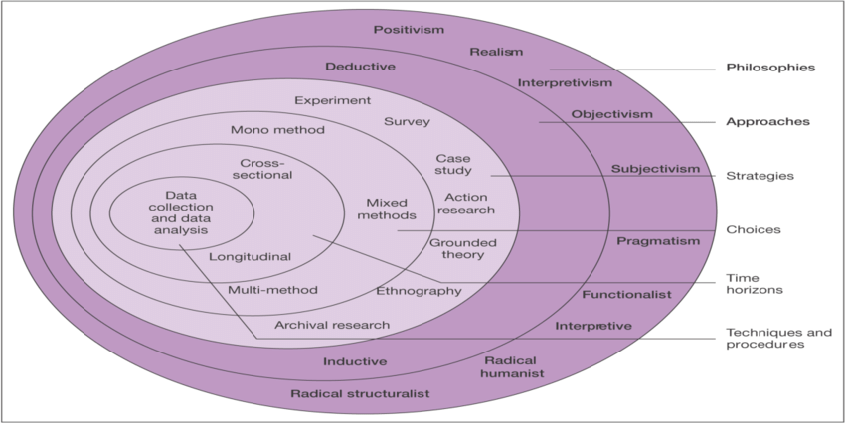
Figure 3.1 - The Research ‘Onion’ (Source: Saunders et.al., 2007)

To efficiently undertake research, Saunders et.al, (2016) created the “Research Onion” model, which allows the researcher to follow specifics for undertaking project pathways, creating appropriate strategies with respect to the current project. The primary data enabled the researcher to have a better understanding of what motivates cruise passengers and if environmental factors influence motivation.

3.3 SECONDARY AND PRIMARY RESEARCH
As noted earlier Secondary research is background/contextual information. In accordance to Bulmer et.al., (2009) can provide the researcher with essential vital knowledge, on the subject, specifically highlighting explanations or deductions that had not been previously considered. Primary data then allows the researcher to ‘build’ on this initial information to investigate the topic further revealing new information. Sapsford et.al., (2006, p109-135) state that ‘primary sources form the basic and original material for providing the researchers raw evidence.’

3.4 PHILOSOPHY
Following on from the initial consideration of secondary and primary research, the researcher further pursued project research philosophy. The researcher used the pragmatism paradigm philosophy because, as Saunders et.al, (2016) comments, pragmatism not only considers theories but concepts, ideas and research findings, which provoke thoughts and actions which produce results for a particular context. Elkader et.al., (2011) states that pragmatists begin with a problem and conduct research to provide solutions to aid future practices. Specifically, the philosophies used by the researcher were centred around Qualitative and Quantitative Research Methods. In addition, a case study focus was also employed namely; the Cruise Industry. By incorporating Qualitative, Quantitative and a case study method, this is referred to as a ‘Triangulated’ approach. (Elkader et.al., 2011)
Triangulation according to Saunders, (2016) consists of using more than one source of data and method of collection, which combine the validity; credibility; authenticity of the research data. Therefore, for the purpose of this research the triangulation was used to compare or combine the on-line questionnaire with the on-line interviews, thus providing the researcher with richer and more in-depth data.

3.5 QUALITATIVE –V- QUANTITATIVE
Upon the outset of the research, it was important to understand the differences between the two research methods Qualitative and Quantitative. One of the simplest ways of understanding the difference between qualitative and quantitative research is that Quantitative is generally used for any data that is collected for example by questionnaire or data analysis using graphs or statistics using numerical data and variables and Qualitative research is generally used for any data collection that is collected for example by interviews; uses non-numerical data. (Saunders et.al., 2016) However, Saunders (2016) goes on to say that although this is an important way to differentiate between the two methods, it can be problematic and narrow. Both quantitative and qualitative research have their advantages and disadvantages and it was important to consider these during the research process. Quantitative research can be used to obtain a large sample of data, and are easy to analyse and reduce the possibility of bias and also have a low cost benefit. However, the design of questionnaires is crucial, to avoid ambiguity and bias, it also requires skill and time and does not allow the researcher to probe important responses. (Saunders, et.al., 2016) In addition response rates can be low. In contrast, Qualitative research is more suitable to achieve open-ended or complex questions. It is more suitable when researching sensitive topics, as it can enable the researcher to create a rapport with the interviewee. However, a disadvantage of the method is that it can be time consuming and expensive. Furthermore, the interviewee may give an answer that they think the researcher wants to hear; and there is also the possibility of bias by the researcher in interpreting the interviewee.
The researcher considered all the advantages and disadvantages before selecting particular methods.

For the purpose of this research, and in line with the Research ‘Onion’, the researcher chose to use a mixed method approach namely both qualitative and quantitative research, with the aim of enhancing and clarifying findings. (Saunders et.al., 2016)

3.6 STRATEGY APPROACH
The researcher collected data from two particular methods 1) an on-line questionnaire which was carried out first and analysed and 2) detailed interviews.
The researcher’s objectives with regard to the questionnaire was to measure the awareness, preferences and motivations with regard to the choices cruise tourists make. (Saunders et.al., 2016) The researcher’s objective with regard to the interview was to understand the perspectives of the Cruise Industry and its development, with particular regard to its environmental impacts.

3.7 RESEARCH DESIGN – QUESTIONNAIRE/INTERVIEW
3.7.1 RESEARCH DESIGN
According to Saunders et.al., (2016) research design is the plan of how the researcher will obtain the information to answer the research question, he also states that it cannot be over emphasised how important it is to define the research question. The researcher followed the ‘Research Onion’ model as a guide. The research contained clean objectives deriving from the research question, where data was retrieved and how the researcher was going to collect and analyse the data. The research also discussed the ethical issues and limitations that were encountered (access to data, time, location and money). Ultimately, it highlighted the thought process the researcher went through in all elements of the research design. (Saunders et.al., 2016)

3.7.2 QUESTIONNAIRE
For the present study the questionnaire was conducted on-line sent via a social media platform. The questionnaire was then submitted electronically back to the researcher. The researcher received 233 responses to the questionnaire.
The on-line questionnaire consisted of twenty-four closed questions and seven open questions. The questionnaire consisted of four section, firstly the motivations of the respondents with respect to cruising, secondly the awareness of the respondents regarding environmentalism, thirdly the respondent’s opinions with regard to the cruise industry and their environmental impacts and behaviour, the fourth entailed the demographic section. The question types were used to try and obtain deeper understanding of the answers received from the data and utilised both open and closed questions. Most questionnaires contain a combination of open and closed questions to enable the researcher to collect both quantitative and qualitative data. (Fink, 2013) Open ended questions allow the respondent to answer the question in their own way and identify themes which could be asked in future interview questions, by the researcher. (Fink, 2013) Closed ended questions provide a number of answers from which the respondent is expected to choose and are relatively quicker and easy to answer. The closed questions consisted of Likert styled questions ranging between five to seven which represented the respondent’s opinions and attitudes. There were also multiple choice questions which allowed the respondents to choose their preference over other items.

3.7.3 INTERVIEWS
Interviews can be structured and formal containing standard questions for each of the respondents or semi-structured or informal with the interviewee conducting informal conversations with the respondent. (Saunders, 2016)

For the purpose of this research there were three Cruise Industry based interviews conducted, this was a limited numbered to what had originally been planned, but had to be scaled back due to the Covid-19 pandemic and all of these needed to be completed via e-mail, due to social distancing measures enforced as a result of the Coronavirus Pandemic. The interview consisted of fifteen questions, which were all open ended to try to retrieve as much information as possible for the research. The questions focussed on a range of areas such as; respondents position in Company, how does your company comply with “Global Legislation” with respect to Cruise Holidays and the environment? What does the future hold for Cruise Tourism? However, due to the global challenges from the Covid-19 Pandemic, the researcher found it incredibly difficult to contact and gain responses from cruise companies due to such companies not operating during these time. Despite numerous attempts to liaise with the cruise companies’ head offices with no avail, the researcher need to amend the research strategy midway through the study and therefore, revert from an interview styled approach to obtaining the information via other means, namely; via Content Analysis. Cruised based Sustainability Report from 2018 were predominantly used to gain a majority of the answers to the interview question.

3.8 PILOTING
Prior to any actual research being conducted (interviews or questionnaires it was important to test the methods, through ‘Piloting’. Piloting is conducted before using questionnaire, interviews. The purpose of the pilot test is to make sure that the questions are appropriate. (Saunders, et.al., 2016) A Pilot Study for the current research took place in March with industry professionals. It highlighted some concerns with the research questions such as the wording and phrasing of questions, which could be construed as being overly biased. These questions were then corrected ahead of the questionnaire going ‘live’ and interviews being planned.

3.9 SAMPLING
A further consideration of the current research was the sample population. The researcher chose a purposive sample because it is non-probability, therefore, the purpose of the sample is to highlight the population that is related to the researcher’s question and objectives. (Saunders, 2016) Becker, (1998) previously suggested that when selecting a sample, it should reflect a full set of cases (population) that can be meaningful and the researcher can justify.
Based on the selected approach, the researcher purposefully sampled tourists who had previously been on a cruise ship holiday. The group was targeted through various social media closed cruise groups, the groups were chosen because it enabled the researcher to gain access to a large number of tourists who had exclusively and recently been on a cruise holiday. Upon the outset, it was important to gain permission from the Cruise Group Admin Members, resulting in non-probability sampling for the research.
Guest et.al., (2006) suggest, that where the focus of the research question is wide ranging and the sample number is low, this could result in insufficient data retrieval for the research. Therefore, for the purpose of the research, the quantitative sample size was 150 participants. The sample of 150 for the research was considered a representative number and was sufficient considering the time constraints feasibility, of the study. The qualitative sample size for the purpose of interviews with Cruise Industry professionals, was three. Ideally, the aim was to obtain higher cruise company numbers, however, due to the Coronavirus pandemic, the remit of the study and the research approach needed to alter slightly. In the light of the circumstances, to include three cruise companies in the study (albeit information obtained via Content Analysis, instead of Interviews), the researcher felt that this number was appropriate.

The original questions drafted for interview were open-ended in style, with the aim to allow the respondents to provide a deeper quality of answer, but which would also allow the researcher, to probe further to obtain a better understanding of the subject matter if needed. However, as noted above, the style of questions was not fully utilised, as the form of data collection for the cruise companies reverted to being centred around Content Analysis for this area.

3.10 TECHNIQUES: DATA COLLECTION AND ANALYSIS
3.10.1 DATA COLLECTION
The gathering of mixed method data collection allows the researcher to gain a wider understanding of the research question. (Saunders, 2016) The questionnaire was conducted by using an on-line questionnaire, and took place over a three-week period. As stated previously above, the interview questions were completed by conducting a Content Analysis from the Cruise Company’s Sustainability Report 2018.

3.10.2 ANALYSIS
The analysis of the quantitative data was conducted using the Statisfied package for social sciences (SPSS), focusing on statistical and thematic analysis. The analysis of the qualitative data was achieved by using the NVEVO package, it is used for the analysis of unstructured text, audio, video, and image data, including interviews, focus groups, surveys, social media. This analysis looked for common themes or trends. The collected qualitative and quantitative data was then analysed and evaluated against one another. Key trends/findings were then discussed as part of the results chapter and compared against the secondary data from Chapter two.

3.11 QUESTION AND LITERATURE REVIEW MATRIX (SEE APPENDIX 1)
Fort the purpose of the study the researcher compiled the Question and Literature Review Matrix. It is a table which contains the questions included in the questionnaire, along-side these questions the researcher provided the references the researcher used to aid construction of the questionnaire. According to Klopper et.al., (2007) a question and literature review matrix is to enable the reader who may not be familiar with the subject matter, to easily locate references that are of either a supportive point or contrary point of view with regard to the same subject, without having to search for the opposing point of view.

3.12 RELIABILITY AND VALIDITY
The significance of reliability within the research was an important factor to consider. In accordance to Saunders et.al., (2016) the researcher should expect to replicate the earlier research design and achieve the same findings, this would mean that the research is reliable. The reliability was gained by using a sample group of respondents who were knowledgeable in the research area. The researcher was satisfied that the results were reliable, because if another researcher repeated the same test with the same respondents, due to the respondent’s knowledge in the subject, the researcher would be able to generate the same results. (Moskal et.al., 2000) Reliability can be a concern when the researcher uses a small sample group, this could result in unreliability due to the drop in protection against the impact of the respondent’s objectivity influencing the data. in the research, it is important to avoid a small percentage of individuals for your sample, as this is not a true representation of the larger community. (Kizlik, 2012) Therefore, for the purpose of the study the quantitative sample size was 150 participants, which was felt a representative number.

According to Saunders (2016) validity refers to whether the researcher used appropriate measures and if the researcher analysed the data results accurately. It was also important for the researcher to use a broad range of sources to ensure the whole subject area is covered and not biased. To ensure validity of these results, it was important to use a large sample size to represent the community as a whole. (Phelan et.al., (2006) If the measures used by the researcher are valid, they could be used by another researcher and the new findings will match the research. Therefore, this would mean that they are appropriate and fit for the purpose of the research. (Saunders, 2016) For the purpose of this research, the researcher felt that the reliability and validity had been confirmed due to the rigorous triangulated methods the qualitative method of interviews and quantitative method of questionnaires and the case study focused on. However, as previously mentioned, above due to the Covid-19 Pandemic, the remit of the study and research approach needed to alter slightly. In light of the circumstances, to include three cruise companies in the study (albeit information obtained via Content Analysis, instead of interviews), the researcher felt that they had done their best and that there was no other outcome and unavoidable.

3.13 LIMITATIONS
As part of any research, there will always be limitations. For the current study, limitations were as follows:
The first limitation of the research was the COVID-19 virus, as a result of the whole country being in isolation, this put significant restrictions on the researcher – attending University, and contacting directly respondents for data collection. In order to address this research needed to be conducted remotely, whilst this was not ideal, it was unavoidable in the circumstances.

The qualitative sample size for the purpose of the interviews with Cruise Industry professionals, was three. Ideally, the aim was to obtain higher cruise company numbers, however due to the Coronavirus pandemic, the remit of the study and the research approach needed to resort to a contingency plan. In light of the circumstances, to include three cruise companies in the study (albeit information obtained via Content Analysis, which had been obtained from the cruise companies Sustainability Report for 2018, instead of Interviews), the researcher felt that this number was appropriate.
The original questions drafted for interview were open-ended in style, with the aim to allow the respondent to provide a deeper quality of answer, but which would also allow the researcher, to probe further to obtain a better understanding of the subject matter if needed. However, as noted above, the style of questions was not fully utilised, as the form of data collection for the cruise companies reverted to being centred around Content Analysis for this area, which was the only option left to the researcher.
The second limitation with regard to the research was the amount of time that the researcher needed to collect primary research and analyse data. Time management needed to be a high priority, and on times this proved difficult due to other academic and personal constraints.
One final limitation of the research related to the questionnaire data collection. This related to some ambiguity/misunderstanding of the research questions. This was despite the questionnaire being piloted.
If additional research was conducted such limitations would be addressed.

3.14 ETHICAL CONSIDERATIONS
Ethical considerations are a very important element of the research, due to the management of sensitive data that the researcher had access to. (Saunders, 2016) For the study, there were also assurances for the respondents that all information collected would remain Confidential and Anonymous. Coinciding with Data Protection Information gained was recorded for academic purposes only. All the respondents were over the age of eighteen and there were no vulnerable adults approached for the questionnaire. A copy of the ethics form which grants approval by the university on the commencement of the research is included in (See Appendix 2)

3.15 CONCLUSION
The purpose of this chapter was to explain the approach that the research took. In the following chapters (chapters four and five) the researcher has analysed and concluded on the research obtained.

CHAPTER 4 – DATA ANALYSIS
4.1 INTRODUCTION
Chapter three’s focus was to define the methodology for the primary research. This chapter will present the findings of the collected primary research from the quantitative and qualitative data which was undertaken by the researcher.
The purpose of this chapter is to present the findings to achieve objective three:
To synthesis extant literature and primary research to make recommendations for the cruise industry with regard to changes to consumer attitudes towards cruise holidays and the environment.

To recap, the following summarises the data sets collected.
1. An on-line questionnaire was conducted – 233 respondents with the majority being from the UK, the remainder were international.
2. It was originally anticipated that three professionals would be contacted from the cruise tourism industry namely; P & O, Tui Group and Viking Cruises, but due to the Covid-19 situation and the pressure the industry was under, the researcher was unable to achieve this. To counteract the challenges, the researcher tried to obtain similar data to what would have been collected through interviews, and it was considered that the best way to achieve this, was via ‘Content Analysis’ namely; researching the cruise company websites and environmental reports. The researcher tried to give a balanced view from the industry by researching their websites to gain answers to the interview questions and compiling a Content Analysis for the qualitative data.

The data was collected sequentially, therefore, the data will be analysed and presented in the order it was collected, firstly from the questionnaire and secondly from the information gained from the Content Analysis, from Cruise Companies Sustainability Reports for 2018.
The questionnaire was distributed over ten private cruise groups, which had members throughout the world. The researcher gained permission from the administration members of the groups, and once they understood the rationale for the research and had read the questionnaire, allowed it to be presented to members of the groups. As previously stated, the interview questions were sent to the tourism industry professionals via email, but no reply could be obtained as all email addresses were either returned “email addressed no longer open” or no response was given to the researcher. These responses were assumed to be because of the Covid-19 pandemic and the challenges the tourism industry was facing at the time.
- OBJECTIVE 1:
To critically analyse previous academic literature that assesses the impact of the cruise industry on the environment, also analysing previous academic literature that probes the motivations and considerations of consumers with regard to the environment and cruising.

The researcher undertook extensive reading into both positive and negative impacts of the cruise industry on the environment, and motivational factors influencing tourist’s decision making process. The reading aided the researcher to gain the background knowledge on the history of the industry and how it has achieved the amount of success it has today. It also aided the researcher to understand the environmental impacts from the cruise industry, while achieving the success it has within the tourism industry, therefore, this achieved the first objective in the dissertation.

4.2 QUANTITATIVE RESEARCH
Quantitative research data was achieved using the mixed method approach for collecting the data, firstly consisting of and on-line questionnaire within specific social platforms, which has been mentioned in chapter three.
There is a list of questions and responses available in appendix three.
The quantitative data was received from the on-line questionnaire and the researcher chose the method of SPSS to statistically analyse some of the data. The method of SPSS is a positivist approach and used a mix of statistical tests. The main test used by the researcher was the cross tabulation test between two variables to see if there were any differences or themes between two groups.

4.3 QUALITATIVE RESEARCH
The qualitative data originally thought to be collected in two parts, to achieve a mixed method approach for collecting the data, this consisted firstly of some data resulting from the questionnaire where respondents were requested to justify their answers (open ended answers), these were part of the quantitative data. However, due to the depth of detail obtained from the questionnaires the researcher decided to review these question types via a qualitative means. As previously mentioned the remainder of the qualitative data was to be achieved via on-line interviews with professionals within the cruise industry, due to challenges within the tourism industry from the Covid-19 pandemic this was not possible. Therefore, the researcher attempted to provide Content Analysis from consulting the companies on-line 2018 Sustainability Reports. The researcher answered the questions to the best of their ability from the organisations websites as this was the only option available in the circumstances.

The researcher appreciated that it was not an ideal situation, however, the researcher felt they had no alternative, because they wanted to achieve as many answers as possible to the interview questions to try to achieve a balanced view point.
A full list of contacts copies of email’s sent and received are available in appendix six.

4.4 PROFILE OF RESPONDENTS
4.4.1 AGE
The respondents were all required to be eighteen and over to participate.
The chart below for question twenty-eight, Age, shows that 227 respondents answered out of a possible total of 233 respondents, and the totals indicate that the largest sample group was the 60-69 age group within the research. However, there are satisfactory responses across all other age groups except 80+ to give satisfactory data. The rationale for the demographic was important to give a balanced view of the motivations of different age groups, as cruising tourism can be associated with a more mature age group.
227 respondents.
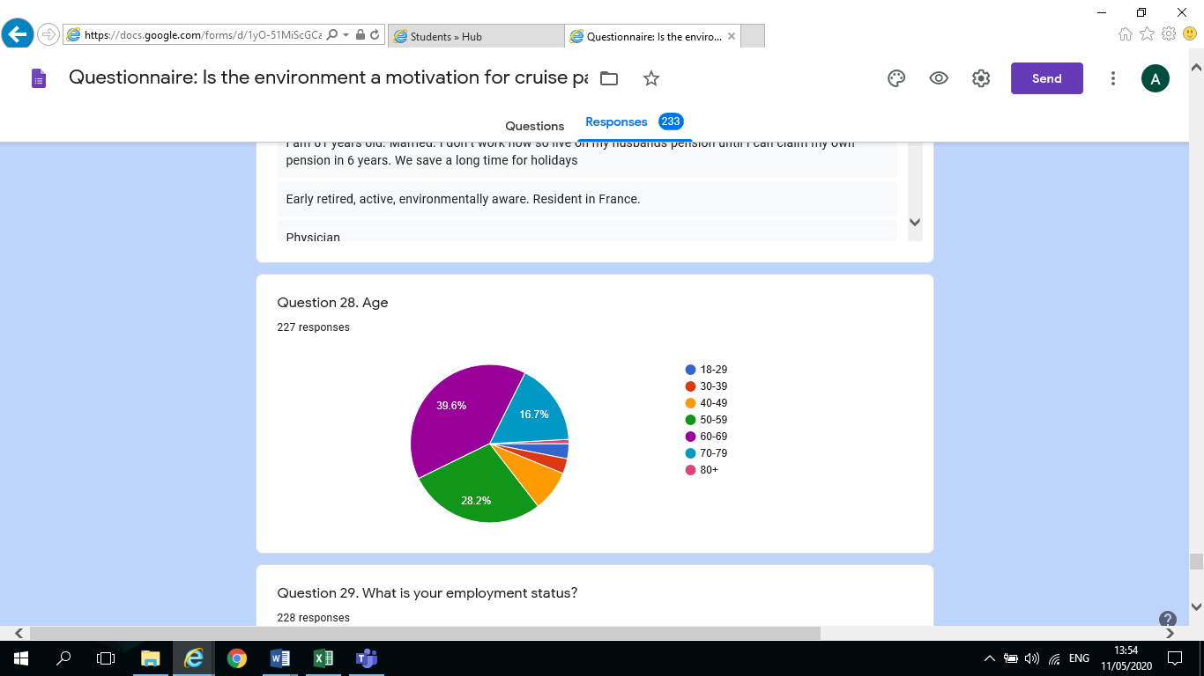Figure 4.1 – Q28 - Range of ages from questionnaire

4.4.2 GENDER
The Chart below shows question twenty-seven, Gender, out of a possible 233 respondents 227 answered the question. The researcher decided to cross reference the charts for gender and age, the rationale was to show not only the male and female samples but also in what age groups they fell.

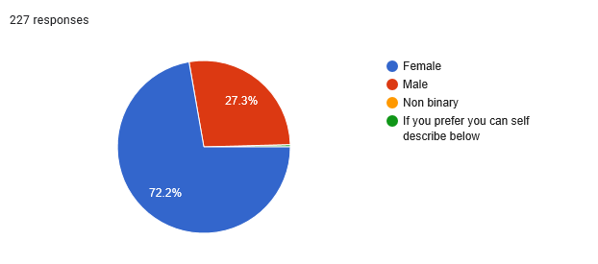
Figure 4.2 – Q27 - Chart for Gender

This rationale for this cross tabulation was to gain an understanding of the demographic sample of the respondents, the researchers count showed that the largest group of females (sixty-four) were in the 60-69 age group and the second highest female group (fifty-one) were in the 50-59 age group, however, the highest amount of males (twenty-five) also fell in the 60-69 age group but the second largest male group (eighteen) fell in the 70-79 age group.

This enabled the researcher to understand that the largest proportion of responses were from females in the 50-69 age groups, but the largest male responses ranged between 60-79. These results had possibly been expected, but did give the respondents more experience in the cruise tourism industry due to their age. The differences between gender and age groups will be considered when drawing on the results and conclusion, as there is an imbalance.

4.5 THEMES
4.5.1 THEME 1 - MOTIVATION
According to Maslow (1943) hierarchy of needs once humans have achieved their basic needs their behaviour is motivated to achieve more until they achieve self-actualisation. As motivation was an important part of the research it was decided to ask questions of the respondents that asked them to think about their motivations and choices.
The researcher asked the respondents in question two, if the cruise company were important to them when choosing a cruise, out of 233 respondents 192 answered, (83.5%) responded yes, they were then asked to justify their answers, out of the 233 respondents 219 gave responses. There was a variety of answers ranging from “luxury, customer service and quality of food” to “destination and price is more important”, however, only one respondent referred to the environment in their response “Environmental issues must be highly considered”. The rationale for this questions was to understand what was the first motivation for respondents when prompted about cruise holidays. The researcher further asked in question seven the main primary motivation when choosing a cruise holiday, the respondents were given numerous options to choose from, and could pick as many as they liked including the Environment, the chart below shows that out of 233 respondents 227 gave responses.

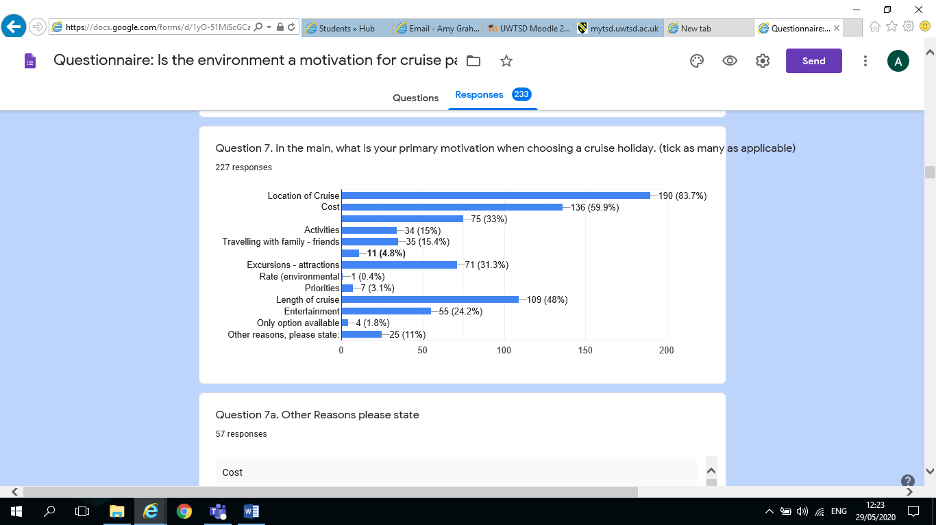
Figure 4.3 – Q7. Respondent’s main primary motivation when choosing a cruise holiday.
As can be seen, the chart shows the three main motivators for choice of cruise are location (83.7%), cost (59.9%) and length of cruise (48%), whereas environment only achieves one response (0.4%). The motivation of cruise tourists would seem to indicate that their basic needs have been met and they were striving for self-actualisation by cruising and visiting different countries. (Maslow, 1954) The environment would not seem to feature as a priority or motivation as part of their desire to explore the world and take a cruise holiday. Miller et.al., (2010) stated that although cruise passengers were prepared to be eco-friendly at home they did not want to be burdened with it on holiday. The cruise passengers felt it was their “right” to go on holiday and it was not their responsibility to make ethical choices with regard to the environment, and felt it was the responsibility of the cruise companies to provide a sustainable holiday. (Miller et.al., 2010) This could well be the case, however, the world has moved on considerably since 2010 environmentally. Most tourists, not all admittedly, have definitely become more environmentally aware, and are more mindful of environmental impacts. Tourists are being exposed to these impacts through events like the Environmental Global Summits where speakers such as Greta Thunberg highlighted that some environmental impacts are nearing tipping point.

Therefore, some tourists could make the environment a part of their decision process when choosing a holiday.
This could have accounted for why the researcher had a sense that as the questionnaire continued and the subject of the environment was more associated with cruising the researcher did feel there was a change in attitudes from some of the respondent’s responses. The respondents began to think about the environment and the responses became more thoughtful and it was evident that some of the respondents were aware of the impacts of cruising and the environment. This will be further developed later in the chapter.

4.5.2 THEME 2 - ENVIRONMENTAL AWARENESS
There has been a tremendous amount of research over the last thirty years with regard to the negative impacts of the cruise industry, however, the cruise industry has made vast improvements over the last two decades to try and combat this negativity. As part of the rationale the researcher designed some questions within the questionnaire to investigate if cruisers felt they were environmentally aware and if they understood the environmental impacts of the cruise industry. The respondents were asked in question ten how important environmental factors were when choosing a cruise, out of 233 respondents 230 answered, (39.1%) stated it was neither important or unimportant with (37%) stating it was important. The respondents were further asked in question twelve if they were aware of the environmental impacts of cruise ships, out of 233 respondents 230 answered, the table below shows the results.

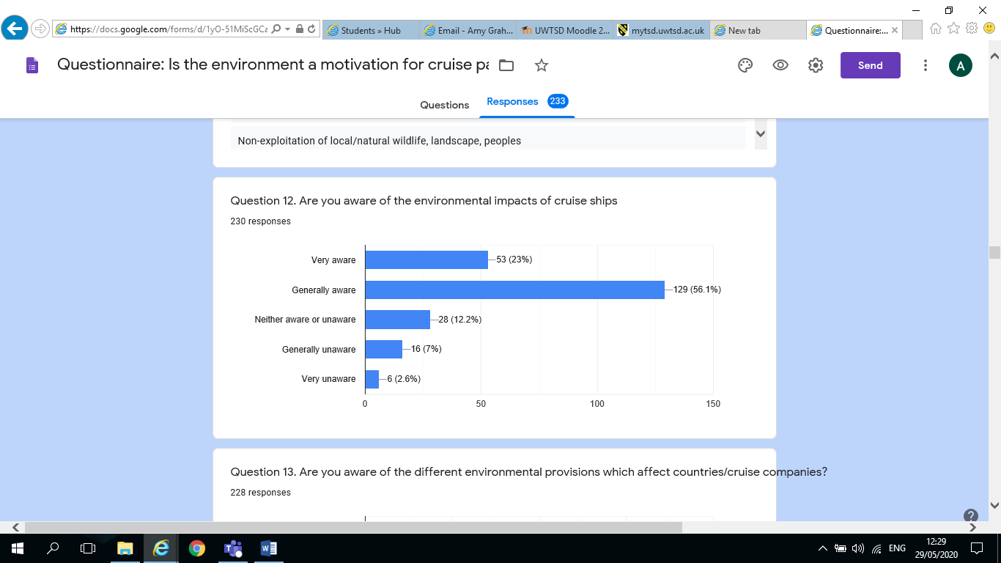
Figure 4.4 – Q12 - Awareness of respondents of the environmental impacts of cruise ships

The chart for question twelve highlights that the majority of respondents had a strong awareness of the impacts of cruise ships on the environment with Generally aware (56.1%) and Very aware (23%). However, the research suggests that even though the results would imply that although they were aware of the impacts by cruise ships on the environment it would not affect their motivation for choosing a cruise holiday. This assumption aligns with Miller et.al., (2010) findings that cruisers felt it was their “right” to go on holiday and not their responsibility to have to worry about the ethical argument of the environment and cruising. However, when the respondents were asked in question seventeen, did they think enough was being done to address the issue, out of 233 respondents 229 answered, the respondents were split (55.5%) Yes there was; and (44.5%) No there was not.

This suggestion by Miller et.al., (2010) may have been accurate to describe some of the tourists of 2010, however, as the results show, the tourists of 2020, would seem to be more environmentally aware than ever before, due to being exposed to Environmental impacts in the media and other platforms such as the Environmental Global summit. The researcher wanted to break this data down further into gender to try and understand which genders response was more empathetic towards the environment, therefore, the researcher created a cross-tabulation in SPSS for question twenty-seven gender and with question seventeen.

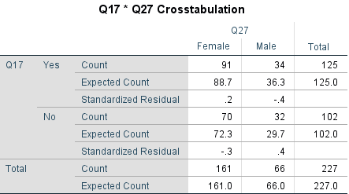
Figure 4.5 – Cross-tabulation of Q27 - Gender and Q17 - Is enough being done to address environmentalism on cruises

Figure 6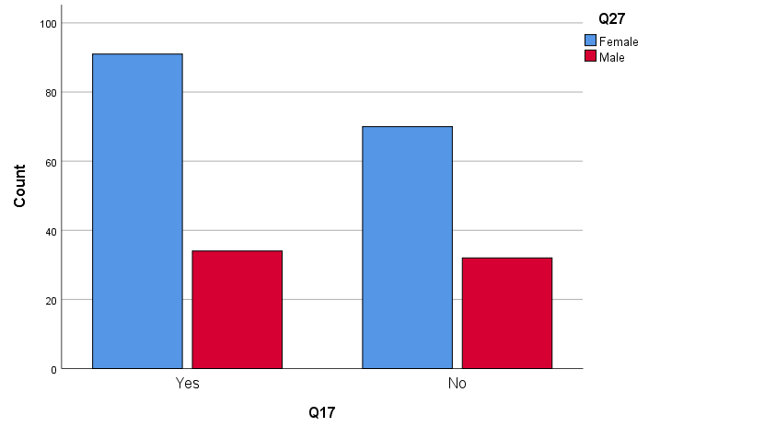 – Figure 4.6 - Q17 and Q27 -Chart showing results of cross-tabulation of Gender and Is enough being done to address environmentalism on cruises

The chart and SPSS table, relating to questions seventeen and twenty-seven clearly shows that woman can seem to be more empathetic to this question. Reasons for this could be linked to instilled nurturing instincts of women or possibly that they are more aware of environmental concerns than men.
The respondents were asked in question seventeen (a) an open ended question, to offer suggestions of what else could be done to protect the environment against impacts from cruising, as would be expected some respondents did not know, but the researcher found that some of the respondents were very knowledgeable on the subject and offered responses such as “eradicate use of bunkering fuel, utilise electric energy supply in port” and “discharge, waste water treatment, fuel burn emissions” and “ISO 14001 discharge of waste”.

As mentioned previously in the chapter the respondent’s responses seemed to change tone as the questionnaire continued, there was a sense of awareness about why the questions were being asked and how much they personally knew about the environment, asking themselves, if they were not aware, why were they not aware, as one respondent stated “I don’t know…but this questionnaire is making me think about it!”. Some respondents were quite knowledgeable, and some were quite loyal to the cruise companies and were perturbed that the questionnaire brought up the subject of environmental impacts by the cruising industry ‘once again’. The respondent made the point that land based tourism had more impact environmentally than cruising. It was quite obvious that some of the respondent felt that the cruise industry received a lot of negativity. The sense of community amongst the regular cruisers was quite evident, and the loyalty to companies was noticed in some of the responses from quite early in the questionnaire. While there is continued loyalty to companies, possibly due to the products and incentives they offer their cruise passengers, this may also account for the lack of motivation from cruisers to put the environment first in their decision making process.

4.5.3 THEME 3 - CRUISE INDUSTRY VALUES AND BEHAVIOUR
Paco et.al., (2009) suggested that the cruise industry marketers are paying more attention to cruise passengers concern for the environment and their eco-conscious motivations, due to the possibility that the number of “green” cruisers could rise in the future. The aim of the rationale for a number of questions was to investigate whether the respondents thought the cruise companies were doing enough to combat the impacts on the environment, also were they conveying the message strongly enough back to them.

The researcher also used some of the content analysis found in the cruise companies Sustainability Reports for 2018, which is part of the qualitative data the researcher collected, this assisted in providing a balanced view of the responses.
The respondents were asked in question fourteen, if they were aware of any new environmental measures that had been introduced by the cruise companies in recent years. Out of 233 respondents there were 178 answers and out of those responses fourteen either said “none, not aware or don’t know” the remainder gave answers such as “recycling and energy saving; fuel type, plastic, less waste, changing towels and bed linen less often”. Upon studying the responses more deeply, the researcher noticed that of the 164 responses remaining, the quality of answers was decidedly different. Twenty-two of the respondents gave a generic response of plastics or recycling, which intimated that their knowledge of the cruise company’s environmental measures was limited or was not important enough to their own needs to consider. However, eighty of the respondents gave a more rigorous and technical answer, showing their appreciation of the cruise industry’s efforts towards combating the impacts on the environment with new technologies regarding such areas as fuel emissions and waste / water pollution. This would seem to imply that environmentalism is definitely growing among cruise passengers today, due to the knowledge they seem to be acquiring, however, marketers within the industry are also seeing this as another opportunity to make their product more attractive. Han et.al., (2016) suggested as much, by stating the industry should not only make their image greener for just ‘green’ customer’s needs, but also try to understand the motivations of cruisers when purchasing holidays with regard to the environment, as this is becoming a more competitive market for the cruise industry.

The researcher also consulted the Content Analysis, which had drawn its information from the 2018 Sustainability Reports for P & O; Tui Group and Viking Cruises. It was originally anticipated that three professionals from the above companies would be contacted, but due to the Covid-19 situation and the pressure the industry was under, the researcher was unable to achieve this. To counteract the challenges, the researcher tried to obtain similar data to what would have been collected through interviews, and it was considered that the best way to achieve this, was via ‘Content Analysis’ namely; researching the cruise company websites and environmental reports, to give a balanced view and qualitative data. The researcher’s aim was to attempt to obtain data demonstrating if and how the three companies complied with “Global Legislation” with respect to cruise holidays and the environment. In this part of the reports the researcher found quite in-depth information listing their strategies and technologies to combat the impacts on the environment such as, in the case of P & O their advance air quality systems to reduce emissions; also Tui Group regarding water pollution; and Viking Cruises and their Norsepower Rotar sail to reduce fuel consumption, and of course plastics and recycling. The information gained from the Sustainability reports would seem to align with the responses the respondents gave in question fourteen, this would suggest that cruisers are possibly obtaining information from the cruise companies about their policies and measures with regard to the environmental impacts. However, Adams et.al (2017) makes the point that there are plenty of press releases to keep the public informed of environmental improvements within the industry, but questions whether they are being freely offered by the cruise industry.
In an attempt to investigate Adam’s (2017) research, both the respondents and cruise companies were asked a similar question. Respondents were asked in question sixteen, if they felt environmental agendas were conveyed to cruise tourists by the cruise companies. Out of the 233 respondents, 229 answered, the highest response was 94 (41%) which was, not conveyed either way.

The researcher, again attempted to obtain data demonstrating that the three cruise companies were aware if cruise tourists had an awareness regarding environmental agendas. This was again achieved by consulting the content analysis from the Sustainability reports. There were two companies, P & O and the Tui Group that mentioned in their Sustainability report for 2018 that all ships had an Environmental Officer on-board the cruisers could talk to, but more importantly, both companies believed that their brand encouraged guests to be aware of their own impacts on the environment and provide environmental awareness information through a range of media. The third company, Viking Cruises did not mention anything on this subject within their Sustainability Report 2018. It would seem from the sustainability reports that most companies have practises in place to provide the information for cruisers, however, there does not seem to be any knowledge of how much of that information is actually being delivered on each cruise to passengers.
If the message regarding environmental impacts, and how the company was dealing with these impacts was reaching cruisers, the question could be asked whether it would influence their decision with regard to which company is more environmentally friendly and if this would be any motivation for their choice of future holidays. Adams (2017) suggest that consumers might consider a company’s sustainability policies as part of their decision making process if the consumer was given a choice of several companies with a similar product type and sustainability information was available to them. The researcher asked respondents a similar question in questions twenty-three which was, would the environmental rating result in you changing your choice of cruise company. The chart below shows the results

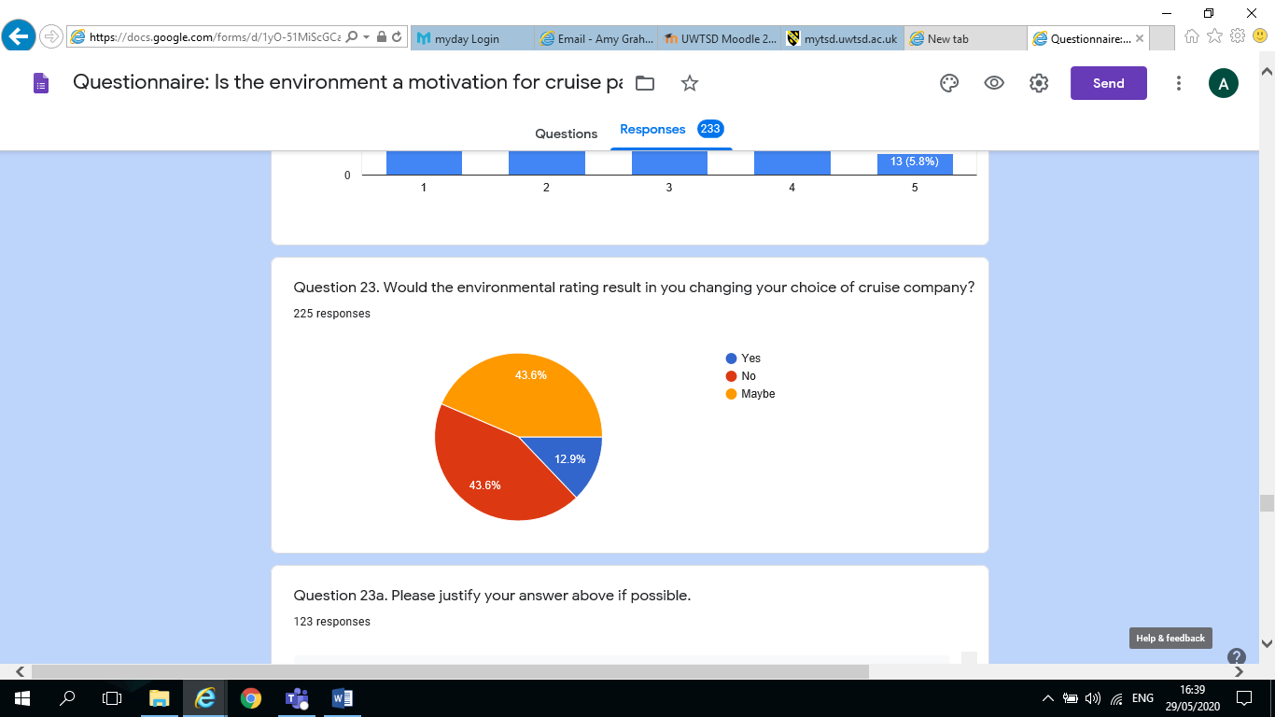
Figure 4.7 – Q23 - Would the environmental rating result in you changing your choice of cruise company?
The results of question 23 were that out of 233 respondents, 225 answered and showed that (43.6%) answered No, and (43.6%) answered Maybe and (12.9%) answered Yes, this would indicate that cruise passenger’s motivations are mixed and that some cruisers were loyal to the companies they cruise with. However, some cruisers may be influenced by an environmental rating if they were provided with the information that warranted this kind of decision making process. The yes respondents obviously felt that the environment was indeed an important motivation in their decision process of choosing a cruise holiday. Therefore, some of the respondent’s answers do aligns with Adams et.al., (2017) suggestions that corporate social and environmental responsibility (CSER) is important to most consumers, even if it is not their first priority in the decision process when choosing their cruise. Most people want or believe they are or can be environmentally aware and behave accordingly, but only until it affects some of their choices, then their own needs and wants come first.

4.5.4 ANALYSIS OF QUALITATIVE DATA COLLECTED IN THE ON-LINE SURVEY
THEME | REASON FOR JUSTIFICATION | RESPONDENT | RESPONDENT | RESPONDENT | RESPONDENT | RESPONDENT
Motivation | Importance of Cruise Company  Choice of Cruise | Luxury, customer service and quality of food  Location of Cruise | Destination and price is more important  Cost | Environmental issues must be highly considered  Length of Cruise | Rate  (Environmental)
Environmental Awareness | Suggestions of what else can be done for environment | Don’t Know | Eradicate use of bunkering fuel, utilise energy supply in port | Discharge, waste water treatment, fuel burn emissions | ISO 14001 Discharge of waste | I don’t know… but this questionnaire is making me think about it!
Cruise Industry Values and Behaviour | Awareness of new Environmental Measures  Would Cruisers be influence by Environmental Rating | None; Not aware; Don’t Know  I Wouldn’t travel with a company that I know is not environmentally aware | Recycling and energy saving  Like cruise lines to be responsible | Fuel type, plastic, less waste, changing towels and bed linen  I trust them to protect it | If the cruise was within my budget | My holiday is my first concern;  Itinerary is my main factor

4.5.5 – Matrix of Qualitative Data from Interview Questions and Content Analysis
Figure 4.8 – Matrix Table Analysis of Qualitative Data from Interviews/Content Analysis
Questions | Q2. How does your company comply with “Global Legislation” with respect to Cruise Holiday and the environment | Q3. What level of emphasis is place on Environmental aspects by your Company | Q4. What is your company’s strategic positioning with regard to tourism and sustainability/environmentalism? (particular policies/strategies Initiatives/measures) | How aware do you believe Cruise Tourists are of Environmental agendas? Do you feel it influences their choice of holiday/cruise?
Interview 1 –  P & O | Very responsible, dedicated to preserving marine environment including reducing emissions, air quality, waste and grey water purifying, recycling, plastics, more efficient fuels, shore power. ISO 14064-1:2006 greenhouse protocol | High level of emphasis on environmental aspects in all areas such Exhaust gas cleaning systems, waste water purification, shore power, water efficiency, waste reduction, carbon footprints, recycling, conservation, responsible sourcing, energy efficiency, clean water, single use plastics | UNESCO partnership – world heritage protection and sustainable tourism, through Seabourn brand continue to partner with UN educational Scientific & cultural organization to foster wider support and understanding in the travel industry. Partnership consists of $1 million financial commitment over a five-year period which started in 2014. (WTTC) members of the organisation which promotes partnerships between the public and private. YUMI project works in economically-challenged South Pacific Islands working with Australian Government. | Their brand encourages guests to be aware of their own impact on the environment. The company provides environmental awareness information to passengers across a range of media. Environmental Officers aboard every ship available to answer questions if requested.
Interview 2-  Tui Group  Marella | More energy efficient ships, improvements in C02, efficient air conditioning, use of engine waste heat, low sulphur emissions due to scrubber technology, recycling, plastic reductions ISO 14001 certification | The report would seem to show that they have a high emphasis on environmental aspects: emissions purification, reduce sulphur emissions by up to 99%, support conservation, dedicated Env.Officer on every ship, operate electric zodiac expedition ships in remote areas – reducing air and noise emissions. | Greener and fairer holidays, 81% of hotels have sustainability certification, 1,177,000 excursions with sustainability at their heart. Destination management companies and excursions meet sustainability standards. Communicate about sustainability throughout the customer journey. Animal welfare and compliance. Reducing plastic throughout business. Creating clean go programme targeting waste in coastal areas. More carbon efficient aircraft, more modern fleet, reducing Co2 per customer on flights. | From survey conducted from Nordic customers: Believe customers show strong willingness to change current travel behaviour to adapt to sustainability priorities. 95% think sustainability important, half say important to act sustainably at home and holiday. Say they will choose sustainable hotels, safe guarding animas rights ensuring local people benefit from tourism. UK: 50% say giving back to destination is important, 27% eliminating hunger important 26% animal welfare important, 22% cultural heritage important, 18% education and lifelong learning opportunities. UK tourist agree travel companies commitment to support local communities impacts their booking decision.
Interview 3  Viking  Cruises | Marpol convention for prevention of pollution award. ISO14001: 2015 certification environmental standards, New ships using Norsepower Rotar Sail reducing fuel consumption and emissions, renewable diesel, recycling bottle glass and plastics, food wastage, carbon dioxide emissions, processed bilge water | The report states that very environmentally aware company been, which has been working on environmental impacts since 1980’s to be leaders in their field. | They are the main sponsors for Turku’s city bikes programme to provide bicycles to tourists and for people use around city to make cities more environmentally friendly and minimise carbon dioxide. | There was no information regarding this question within the report.
Question | Q7. How aware do you believe cruise Tourists are of Environmental Agendas? Do you feel it influences their choice of holiday/cruise? | Q9. At what point in your marketing strategy campaign is our position/policies regarding how effective your initiatives/measures are being dealt with regarding environmentalism to your potential cruise passenger (First point of sale/brochures/on-board ship. | Q10. How has your company’s approach changed in recent years with respect to environmental concern? ( How effective are these employed changed)? | Q14. What/Moral/Social obligation do you feel the cruise industry has in informing/educating the cruise tourist on environmental matters?
Interview 1-  P & O  Cruises | This subject was not identifiable in the report, however, it mentioned that every ship in fleet has an Environmental Officers can talk to and provide in-depth insight to maritime environmental management. The Brand encouraged guests to be aware of their own impact on the environment. Provided environmental awareness information to passengers across a range of media. | The report did not include this information, but the researcher observed that the company provides a lot of on-line information. There is also Environmental  Officer on board every ship for information. The customer could also read the Sustainable report 2018, however, these reports are very long. | Environmental compliance is important for this company because in 2013 an environmental crime was reported by an engineer on one of their ships. Dept. of Justice later found out that multiple ships over several years had same misconduct. Company took responsibility, signed plea agreement 2016 as part of probation includes five- year environmental compliance plan (ECP) began 2017. ECP requires independent audits as well as oversight by Court Appointed Monitor. Therefore, the company’s approach to the environment has changed greatly. | This question was not specifically covered by the Sustainability report, 2018, however as previously stated it provides Environmental Officer that passengers can talk to and the Brand encourages guest to be aware of their own impact on the environment through various forms of media.
Interview 2 – Tui  Group  Marella | This company did not segregate tourists between land and cruise based tourists, however, this company believe that some of their Nordic customers showed strong willingness to change current travel behaviour adapt to sustainability priorities 95% this sustainability is important. The company also said that in UK giving back is big, 50% say giving back to holiday destination is important. 62% of UK tourists say engagement with local is important and they feel better if holiday organised with respect for nature and local communities. | The report did not include this information, but the researcher observed that the company provides a lot of on-line information. There is also Environmental  Officer on board every ship for information. However, companies Sustainable Report 2018 is very informative if customers wish to do so, however, these reports are long. | According to this company’s Sustainability 2018 report the company has realised that sustainability has become a primary ingredient in their customer’ tourism experience. The company would seem to be more accountable for their environmental concerns and approaching it with open book policy, however, this company is also a travel tourism company also. | According to Sustainability 2018 report this would be high in their obligations to their customer, and concerned with educating next generation with regard to sustainable tourism, claims, 60,000 pupils in UK have benefitted from their world detective education programme. Empowering agents in universities. They will help customers to create a positive change.
Interview 3 –  Viking  Cruises | There was no mention of this subject in the Sustainability Report 2018. | Once again no mention of this subject on Sustainability Report 2018, or on their online site. Considered ordering a brochure on line to see if anything in it, however, due to Covid-19 pandemic unable to order brochure. | The Sustainability report 2018, this company has been making strives to improve their environmentalism since 1980 and continue to do so, provided table indicating the different things they have done since 1980. Very little information otherwise. | There was no information regarding this question.

It was originally anticipated that three professionals would be contacted from the cruise tourism industry, namely P & O, Tui Group and Viking Cruises, but due to the Covid-19 situation and the pressure the industry was under, the researcher was unable to achieve this. To counteract the challenges, the researcher tried to obtain similar data to that would have been collected through interviews, and it was considered that the best way to achieve this, was via ‘Content Analysis’ namely; researching the cruise company websites and environmental reports. The researcher tried to give a balanced view and obtain qualitative data.
The data that the researcher obtained from the Sustainability reports for 2018, similarly were very informative. All three companies would seem to be very environmentally aware and attempting to create technologies to counteract the impacts that the cruise industry cause on the environment. However, the emphasis would seem to be at present on the technology, concentrating on who can create the biggest and best in the quickest time. Both P & O and Tui Group would seem to appreciate that they have a responsibility to provide their cruise passengers with information regarding the environment, however, their does not seem to be a system to monitor if the message is actually getting through. Whereas, Viking Cruises did not mention if their cruise passengers were aware of the environmental impacts by the cruise industry or if they informed them of their environmental agendas.

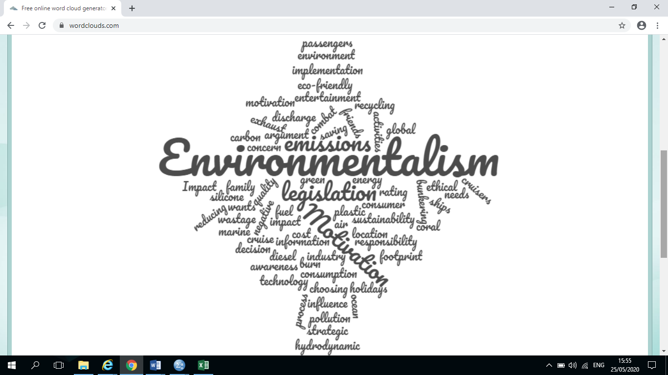

Figure 4.9 – Word Cloud on associated themes.

4.6 NVEVO
The researcher had considered NVEVO, however, later changed their thoughts on using the package (for a variety of reasons – including Covid-19), and have incorporated matrix tables / word clouds as the preferred choice of qualitative data presentation and the best choice of analysis for qualitative data.

4.7 WORD CLOUD
The researcher created the word cloud above (Figure 9), from the main themes highlighted and running through the dissertation. The themes were developed by the researcher during the analysis of the qualitative data from the questionnaire and content analysis. The aim of the dissertation was to understand cruise tourists when they choose their cruise holiday. Motivation was one of the main themes throughout the research, and if this motivation was influenced by the environment and some of the impacts the cruise companies have on the environment. The most common themes are quite prominent and easy to sea within the cloud, such as motivation and environment, however, as the researcher developed the data further, it highlighted other areas such as awareness by the industry and the cruise passengers regarding the environment, implementation of legislation or operating policies by the cruise industry. The researcher asked questions such as were cruisers aware of the impacts by cruise companies; were the impacts affecting the environment important to them. Also, were cruise companies aware of their responsibility not only to the environment but towards the passengers to keep them knowledgeable of what measures the industry had in place, so that these cruisers can make more informed decisions. These themes were an important part of the thought process for the researcher. The word cloud highlights some of the main themes running all through the dissertation

4.8 CONCLUSION
The aim of this chapter was to analyse the data collected from both methods and present the conclusions. The researcher derived three themes from the quantitative and qualitative data. Within the next final Chapter, the researcher presented the findings and recommendations, which met the last objective of the research. Within this chapter the researcher will also discuss any implications and reasons for the research.

CHAPTER 5 – CONCLUSIONS AND RECOMMENDATIONS
5.1 INTRODUCTION
The aim in Chapter four was to analyse the data collected from both methods as outlined in objective number two. Upon analysing the data, it produced three themes which were Motivation, Environment Awareness and Cruise Industry Values and Behaviour. The aim of this chapter is to provide recommendations and conclusions which were outlined in the third objective of the dissertation
To synthesis extant literature and primary research to make recommendations for organisations with regard to changes to consumer attitudes towards cruise holidays and the environment.

5.2 MEETING THE OBJECTIVES
1. To critically analyse previous academic literature that assesses the impact of the cruise industry on the environment, also analysing previous academic literature that probes the motivations and considerations of consumers with regard to the environment and cruising.
In Chapter 2 the researcher analysed a considerable amount of previous academic research to prepare the background for the dissertation.

2. To conduct a primary research questionnaire and face to face interviews, to understand if the environment is part of the motivational process when choosing a cruise holiday.
This was achieved in Chapter Four by analysing the primary data collected in the on-line questionnaire and interviews using SPSS.

5.3 CONCLUSIONS
The researcher’s finding supported the majority of the literature within chapter two. The cruise industry has grown considerably in the last 3 decades but has not always had a good reputation with regard to environmental impacts. The growing number of ships and their size has meant that there has also been an increase in passenger numbers. The growth of the industry has also meant a growth in environmental impacts. (Copeland, 2008) There is also the issue of the industry’s lack of attention to counteract these impacts and their inability to self-regulate in the past. (Timothy, 2005) However, Cruise Companies have in the last decade seen the error of their ways, and are now attempting to correct them. (Hudson, 2019; CLIA 2019) They are constantly striving to combat the impacts of the industry and attempting to be not only more environmentally aware but also accountable for their practices and policies. (CLIA, 2019) Some believe there is still a long way to go but any practices that they put into place now to secure the future of the environment can only be for the better.
The tourists who take cruise ship holidays have always expected the best of their holidays, and the implications that this research has shown, is that this still stands. (CLIA, 2018) Some would say their motivation is selfish, but that is part of human nature; that their first concern is their needs and wants, however, the tourists of the twenty first century are very concerned about the environment, but do not expect to have to be too concerned about it on holiday. These tourists expect the companies that they travel with to be responsible in their behaviour and actions towards the environment, and it is not their responsibility to have to think about it while on holiday. (Adams, 2017)

5.4 RECOMMENDATIONS FOR THE CRUISE INDUSTRY
The following recommendation are being made to the Cruise Industry.
5.4.1 Objective 3 – Theme 1 – Motivation
Firstly, Seatrade Cruise (2017) states that the global cruise industry has grown dramatically, and in the twenty first century the “mega ships” can provide attractions on board that would match leisure parks or Las Vegas. The outlook for the industry, before Covid-19 was looking very bright and passengers would have reaped the benefits of the industry’s expansion with more choice of destinations and activities on board ship. (Jordan, 2019) With the increase in benefits the cruise industry was offering from their new ships and technologies, the motivating factor for the cruise tourist when choosing a cruise holiday, was greatly increased by which benefited them most. This point was proved in question two of the survey when respondents were asked was the cruise company important to them, out of 233 respondents, 192 answered, and (83.5%) said yes, they were then asked to justify their answer, the answers centred around their personal wants and needs, i.e. “luxury, customer service and quality of food to destination and price”. The environment did not seem to feature as a priority or motivation as much as their desire to explore the world and take a cruise holiday. Miller et.al., (2010) stated that although cruise passengers were prepared to b eco-friendly at home they did not want to be burdened with it on holiday. Due to the Covid-19 pandemic causing all cruise holidays to be cancelled at present, this would be an ideal opportunity for marketers to re-think their marketing strategies, and promote the eco-friendly technologies and energy efficiencies of the cruise industry to potential cruise passengers, to motivate them to think about the environment in their decision making process. Han et.al., (2016) suggested that the cruise industry should not only make the industry greener to meet ‘green’ customer needs, but should also be attempting to understand the motivations of cruisers when purchasing cruise holidays with regard to the environment, as this is becoming a highly competitive market for the cruise industry. Due, obviously to the Covid-19 pandemic, this recommendation would have to be considered over the next three to five years, however, as cruise companies are not expected to commence sailing until 2021, this would be a good time and opportunity to assess their promotional advertising and digital platforms with regard to adapting it for the up-coming seasons.
5.4.2 Objective 3 – Theme 2 – Environmental Awareness
Secondly, Over the last 30 years the cruise industry has increasingly developed and grown to such an extent that it has become a hugely significant contributor to the tourism industry. (CLIA, 2018) However, this expediential growth has brought with it both positive and negative impacts. Copeland, (2010) suggested that the new pollution phenomenon from cruise ships and the incredible distances that it can travel, mean that it knows no boundaries and is not contained to one nation. This would suggest that these impacts are not just an issue for one country alone, but a global issue for every nation. Today’s tourists are more environmentally aware, which includes cruise ships passengers, they expect the cruise industry to be more environmentally sustainable and also accountable for their operating policies with regard to environmental impacts such as pollution and emissions. Tourists who travel with the cruise industry should be able to expect clarity on their company’s environmental behaviour. With reference to this subject the researcher consulted the content analysis, where in question nine, it asked at what point in their marketing strategy/campaign is their policies regarding how effective their measures were being dealt with regarding environmentalism to their potential cruise passengers. The researcher noted that two of the cruise companies Sustainability Reports 2018, stated that all ships had an Environmental Officer on-board and that passengers could attend environmental information seminars if they wished to do so, or contact the Environmental officer if they had any questions. However, attendance levels may be expected to be low, as it would be anticipated that passengers might not take time out of their leisure time to attend. These meetings should be designed at a time when they have a captured audience, for example, after the safety drill or included in the welcome meeting. The cruise tourists should be continuously made aware of the company’s policies and strategies, from point of sale to the minute they return home. The company could provide the tourist with an App that is downloaded upon purchase of their holiday, or even before, which would supply all the environmental information they need. Tui already has a mobile App that tourists can use to book holidays, flights, cruises and excursions upon, therefore, in the case of Tui, Environmental information could be added to inform tourists. Another option to inform tourists of the company’s environmental policies may be by email; any contact between the company and customer by email could have a section attached at the end informing the customer of the company’s environmental policies. It is not up to the tourist to have to search for the information it is important the cruise company supply up-to-date information. The researcher suggests that these recommendations could be rolled out over the next five years, due to the possible challenges the industry is under at present due to Covid-19.

5.4.3 Objective 3 – Theme 3 – Cruise Industry Values and Behaviour
Thirdly, at present there is no universal rating of the cruise industry with regard to their performance when dealing with problems such as pollution and emissions. There is, however, a rating system carried out by the (Foe, 2016), as discussed in the literature review. (Miller, 2010; Moodie, 2016; Adams, 2017) The subject of environmental ratings was also raised in chapter four in question twenty-three, when respondents were asked if an environmental rating would result in changing their choice of cruise company, the responses were mixed (43.6%) No; (43.6%) Maybe; and Yes (12.9%), however the result suggested that cruisers may possibly be motivated by a rating system. The system would enable cruise tourists to make an informed decision regarding the environmental policies of cruise companies they choose for their holiday. The rating system could be instigated with the cooperation of the cruise industry and global governments, creating an impartial agency for cruise industry performance levels in pollution and emissions. The system would rate the companies on how well they are performing when dealing with the environmental issues, and could be provided at point of sale to customers. The use of the rating system by cruise customers could act as an incentive for the industry to operate ethically as the industry will be aware that potential cruise customers could possibly be making more informed decisions by using the rating system. The researcher suggests that this rating system be researched further and possibly carried out in the next five to ten years.

5.5 FINAL CONCLUSIONS SUMMARY
The researcher believes the research has achieved the aims and objectives to critically identify if the consumer considers the environment when choosing a cruise holiday. The sample population questioned, has provided positive insight into the topic area, where wider conclusions and recommendations can be drawn from. It has also allowed the researcher to gain a greater understanding of the cruise industry and the issues they face. This researcher believes that the knowledge gained will be of great assistance during their career within the tourism industry.
The dissertation has identified that cruise passengers have an environmental awareness, whether it is at home or on holiday. Cruise passengers are also aware of the impacts of the cruise industry on the environment in the past and are also aware that the cruise industry is striving to make improvements to counteract these impacts. However, the research has identified that even though cruise passengers have an environmental awareness, the first motivations when choosing a cruise holiday is their own needs and wants and the environment comes further down the list of motivations.
In conclusion to this research there is still more to be done with regard to the industry and their responsibilities to the environment. However, importantly is the clarity that the industry must provide about their policies and procedures with respect to their operations with regard to environmental impacts management, such as pollution and emissions. Furthermore, how they intend to make their potential customers aware of their policies so that they can make a more informed decision for their choice of cruise holiday, and taking into consideration environmental factors. The researcher also considered whether it would be possible for some of these measures that had arisen from the research to be rolled out as mandatory via countries / environmental bodies i.e., forcing legally cruise companies to introduce environmental measures in the future, due to some of the current legislation not being effective.
5.6 DIRECTIONS FOR FUTURE STUDY
There was a good response to the on-line survey, the researcher collected 233 questionnaires, which aided the researcher to obtain a sizeable amount of data. The researcher also previously intended to interview three cruise industry professionals, however, due to the Covid-19 pandemic, this was not possible. The researcher attempted to make contact with the three chosen cruise companies, by various email addresses, requesting interviews, however, due to the challenges the industry is facing at present, two out of the three companies did not reply and the third replied but could not participate in the interview due to the aforementioned challenges. (copy of emails available in appendix six) This affected the study, as the qualitative data required by the research was not forthcoming. The researcher tried to do everything they could to overcome the issue, but in the end needed to apply an alternative. Therefore, as previously discussed, the researcher attempted to extract the answers to the interview questions by undertaking a Content Analysis, this information was acquired by researching each of the company’s web sites and Sustainability Report for 2018. Whilst this proved effective for the current study, it is advisable that if the study was done again outside of the issues surrounding Covid-19, ‘face to face’ interviews would be the most appropriate form of collecting qualitative data. The researcher found the dissertation stressful on times, not only due to the Covid-19 pandemic, but also related to the knowledge required for computer analysis, particularly as many of the packages were completely new to the researcher. These issues were particularly compounded by the fact that due to the outbreak of Covid-19, which suspended teaching (lock down), resulting in difficulties in accessing the computer programmes and having access to ‘face to face’ teaching of such packages. Much knowledge was gained independently during the analysis stage of the dissertation on such packages, however, there were limitations due to the remoteness of practical support, which is understandable in the current situation. However, if this study was completed again in the future this would not arise.
There were some questions within the on-line survey that the researcher would have liked to change and replace with other questions which would have given more data, however, this served as a learning curve for the researcher for the future.
The researcher has gained a greater understanding of the cruise industry and its cruise passengers with regard to environmental awareness, but would have liked to have received the professional perspective from the cruise industry in person. This may have given the researcher an even greater understanding of the subject.

BIBLIOGRAPHY
Becker, H.S., (1998) Tricks of the Trade: How to Think About Your Research While You’re Doing It. Chicago IL: Chicago University Press. Bulmer, M., Sturgis, P.J., Allum, N., (2009) ‘Editors’ introduction’, in M.
Bulmer, P.J. Sturgis an N. Allum (eds) Secondary Analysis of Survey Data. Los Angeles: Sage, pp. xviii-xxvi
Buckley, R., (2012), Sustainable Tourism: Research and Reality, Annals of Tourism Research 39(2), 528-546. Book: Cooper, C., (2016) Essentials of Tourism, Second Edition, Pearson Education Limited, Edinburgh Gate, Harlow, CM20 2JE, first published 2012.
Boucher, J., Friot, D., (2017), Primary Micro plastics in the Ocean: A Global Evaluation of Sources. IUCN Gland Switzerland (2017), pp. 1-43, 10.2305/ICUN.CH.2017.ol.en. Elsevier Journal Science of the Total Environment: Peng, L., F. Dongdong, Qi, Huaiyuan, Q.Lan, C., Huaiyuan Qi., Ge., C. (2020). Micro and Nano-plastics in Marine environment: Source distribution and threats – A Review
Burrell, G., Morgan, G. (1979) Sociological Paradigms and Organisational Analysis. London: Heinemann.
Butler, R.W., 1991. Tourism, environment, and sustainable development. Environ Conserv: 18(3), 201-209. Journal of Ocean & Costal Management 102 (2014) 350-363: Cruise Tourism environmental impacts – The perspective from the Adriatic Sea.
Casson, L., (1994) Travel in the Ancient world, JHU press, Baltimore, OH
Chanev, C., (2015), Cruise Mapper, Largest Cruise Ships.
[Online]
(www.cruisemapper.com) [Accessed 28 May 2020]
Chaney, Edward. (2000). The evolution of the grand tour: Anglo-Italian cultural relations since the Renaissance. Portland OR: Routledge.
[Online]
(https://opentextbc.ca/introtourism/chapter/chapter-1-history-and-overview/) [Accessed 10 January 2020]
Cohen, E. (1972) Towards a sociology of international tourism. Social Research, 39(2), 64-82.

Cohen, G., 2008. Overview of Cruise Ships Facts, Threats to Environment, Criminal History. Campaign to Safeguard Americas Waters (C-SAW): Earth Island Institute. Journal of Cleaner Production 111 (2016) 487-498: Challenges and prospects of valuation – cruise ship pollution case
Cooper, C., (2016) Essentials of Tourism, Second Edition, Pearson Education Limited, Edinburgh Gate, Harlow, CM20 2JE, first published 2012.
Cooper, C., (2016) Essentials of Tourism, Second Edition, Pearson Education Limited, Edinburgh Gate, Harlow, CM20 2JE, first published 2012.
Copeland, C., 2008. Cruise Ship Pollution: Background, Laws, Regulations, and Key Issues. Congressional Research Service. CRS Report for Congress. Prepared for members and Committees of Congress, USA. Order Code RL32450. Journal of Ocean & Costal Management 102 (2014) 350-363: Cruise Tourism environmental impacts – The perspective from the Adriatic Sea.
Copeland, C. 2010. Cruise Ship Pollution: Background, Laws, Regulations, and Key Issues. Congressional Research Service. CRS Report for Congress. Prepared for members and Committees of Congress. Journal of Cleaner Production 111 (2016) 487-498: Challenges and prospects of valuation – cruise ship pollution case
Cooper, R., (2011) Tourism, pp. 2519-2524 in The Berkshire Encyclopaedia of World History, Berkshire Publishing, Great Britain, MA
Cooper, C., (2016) Essentials of Tourism, Second Edition, Pearson Education Limited, Edinburgh Gate, Harlow, CM20 2JE, first published 2012.
Cox & Kings. (2014). About us – History. Retrieved from
[Online]
http://www.coxandkings.co.uk/aboutus-history (https://opentextbc.ca/introtourism/chapter/chapter-1-history-and-overview/) [Accessed 29 May 2020]
Creswell, J.W., Plano Clark, V.L., (2011) Designing and Conducting Mixed Methods Research (2nd edn). Thousand Oaks, CA: Sage

Crotty, M. (1998) The Foundations of Social Research London: Sage.
Cruise Lines International Association (CLIA), (2018). Cruise Industry Outlook 2018.
[Online]
https://cruising.org/-/media/research-updates/research/featured/2018-clia-state-of-the-industry.pdf
[Accessed 15 March 2020]
Donald, A.W., (2018), President and CEO of Carnival Corporation, plc., P & O, Sustainability from Ship to Shore, FY2018 Sustainability Report.
[Online]
http://carnivalsustainability.com/download-files/2018-carnival-sustainability-full.pdf
[Accessed 20 April 2020] ttp://carnivalsustainability.com/download-files/2018-carnival-
Dowling, R., K. (2006). Cruise Ship Tourism. CAB International 2006, CABI Head Office, Nosworthy Way, Wallingford, Oxfordshire, OX10 8DE.
Dowling, R. and Weeden, C. (2017), ‘The World of Cruising’, in R. Dowling and C. Weeden (eds), Cruise Ship Tourism, 2nd ed., Wallingford: CABI, pp. 1–39.
Douglas, N., Douglas, N. (2005), Small Ship Cruising, from muddy rivers to blue lagoons. Niche Tourism, Contemporary issues, trends and cases. Edited by Marina Novelli (PhD), Senior Lecture in Tourism Development Management Centre for Tourism Policy Studies, University of Brighton. Elsevier Butterworth-
Elkjaer, B., Simpson, B. (2011) ‘Pragmatism: A lived and living philosophy. What can it offer to contemporary organisation theory?’ in Tsoukas, H., Chia, R., (eds) Philosophy and Organisation Theory. Bradford: Emerald Publishing Ltd., pp. 55-84.
Environment: Peng, L., F. Dongdong, Qi, Huaiyuan, Q.Lan, C., Huaiyuan Qi., Ge., C. (2020). Micro and Nano-plastics in Marine environment: Source distribution and threats – A Review
Fink, A., (2013) How to Conduct Surveys (5th edn). Thousand Oaks, CA: Sage
Foddy, W., (1994) Constructing Questions for interviews and Questionnaire. Cambridge: Cambridge University Press.

Guest, G., Bunce, A., Johnson, L., (2006) ‘How many interviews are enough? An experiment with data saturation and validity’, Field Methods, Vol. 18, No. 1, pp. 59-82.
Heinemann, Linacre House, Jordan Hill, Oxford OX2 8DP, 30 Corporate Drive, Burlington, MA 01803. First published 2005.
Hall, C. M., Wood, H. and Wilson, S. (2017), ‘Environmental reporting in the cruise industry’, in R. Dowling and C. Weeden (eds), Cruise Ship Tourism, 2nd ed., Wallingford: CABI, pp. 441–64
Hanses, J., (2018), CEO of Viking Cruises. Sustainability Report 2018. [Online]
(https://www.vikingline.com/globalassets/documents/market_specific/corporate/environment/hbr2018-vikingline-en.pdf
[Accessed 20 April 2020)
Jordan, A.E., (2019), Cruise Industry Outlook 2019 and Beyond, Trends and Developments. Cruise Travel is property of Lakeside Publishing Company, LLC.
Johnson, P., Clark, M. (2006) ‘Editors’ introduction: mapping the terrain: An overview of business and management research methodologies’, in P. Johnson and M. Clark (eds) Business and Management Research Methodologies. London: Sage, pp. xxv-Iv.
Joussen, F., (2018), Chief Executive Officer, TUI Group, Sustainability Report 2018.[On line]
https://www.tuigroup.com/damfiles/default/tuigroup-15/de/nachhaltigkeit/berichterstattung-downloads/2019/nachhaltigkeitsbericht-de-en/TUI_CSR18_EN.pdf-1e195dc4f0aff3763334c790e5417049.pdf [Accessed 20 April 2020)
Kershaw, P., Saido, K., Sangjin, L., (2011). Plastic deris in the Ocean, IGand, Switzerland, ICUN. CH.2014.03.en. Elsevier Journal Science of the Total
Kizlik, B., (2012), Measurement, Assessment and Evaluation in Education
[Online] :
http://drjj.uitm.edu.my/DRJJ/OBE%20FSG%20Dec07/OBEJan2010/DRJJ-
[Accessed 20 January 2020]

Klein, R., A., 2013. Testimony of Ross a. Klein, PhD before the Senate Committee on Commerce, Science and Transport. Hearings on Cruise Industry.
Klopper, R., Lubbe S. and Rubeer, H (2007) The matrix Method of itrature Review.
[online] available at:
http://alternation.ukzn.ac.za/Files/docs/14.1/12%20Klopper%20.pdf [ Accessed 27 may. 2020].)
Krippendorf, J., (1987), The Holidaymakers: Understanding the impact of Leisure and Travel, Oxford, Butterworth, Heinemann. Book: Cooper, C., (2016) Essentials of Tourism, Second Edition, Pearson Education Limited, Edinburgh Gate, Harlow, CM20 2JE, first published 2012.
London, W. R., Moyle, B. D. and Lohmann, G. (2017), ‘Cruise infrastructure development in Auckland, New Zealand: A media discourse analysis (2008-2016)’, Asia Pacific Journal of Tourism Research, 22:6, pp. 615–33.
Moskal, B.M., Leydens, J.A., (2000), Scoring rubric development validity and reliability., Practical Assessment, Research & Evaluation, ZII(10)
Norton, B.G. (ed.), 2005, Sustainability: A Philosophy of Adaptive Ecosystem Management, Chicago: University of Chicago Press.
Nastasi, B.K., Hitchcock, J.H., Brown, L.M., (2010) ‘An Inclusive framework for conceptualising mixed methods typologies’, in Tashakkori, A., Teddlie (eds) The Sage Handbook of Mixed Methods in social and Behavioural Research (2nd edn). Thousand Oaks, CA: Sage.
Oversight: Recent incidents show Need for Stronger Focus on Consumer Protection, Thursday, July 24, 2013. Russell Senate Office, Building Room no. 2 Washington. Journal of Cleaner Production 111 (2016) 487-498: Challenges and prospects of valuation – cruise ship pollution case
Phelan, C., Julie, W., (2006), EXPLORING RELIABILITY IN ACADEMIC ASSESSEMENT.
(Online):
https://www/uni.edu/chfasoa/reliabilityandvalidity.htm
[Accessed 28 May 2020]
Pen, L., Dongdong Fu, Qi, H., Q.Lan, C., Yu, H., Ge, C., (2020), Micro- and nano-plastics in marine environment: Source, distribution and threats – A review. Science of the Total Environment, Volume 698, 1 January 2020, 134254. Elsevier.
[On line]
https://www.sciencedirect.com/science/article/pii/S0048969719342378
[Accessed 20 February 2020[
Read, S.E., (1980) A prime force in the expansion of tourism in the next decade: special interest travel. In D.E. Hawkins, E.L. Schafer and J.M. Rovestad (ed)
Figure 2.2
Robinson, M., Novelli, M., (2005), Niche Tourism, Contemporary issues, trends and cases. Edited by Marina Novelli (PhD), Senior Lecture in Tourism Development Management Centre for Tourism Policy Studies, University of Brighton. Elsevier Butterworth-Heinemann, Linacre House, Jordan Hill, Oxford OX2 8DP, 30 Corporate Drive, Burlington, MA 01803. First published 2005.https://books.google.co.uk/books?hl=en&lr=&id=hyDej4okNxUC&oi=fnd&pg=PR3&dq=Robinson,+M.,+Novelli,+M.,+(2005),+Niche+Tourism,+Contemporary+issues,+trends+and+cases.+Edited+by+Marina+Novelli&ots=hDZwcn8hfd&sig=14693yL4mQWI5PvBgLRjdXYti0Y#v=onepage&q=Robinson%2C%20M.%2C%20Novelli%2C%20M.%2C%20(2005)%2C%20Niche%20Tourism%2C%20Contemporary%20issues%2C%20trends%20and%20cases.%20Edited%20by%20Marina%20Novelli&f=false [Accessed Dec. 2019]

Sapsford, R. (2007). Putting it into practice. In Sapsford, R. Survey research (pp. 109-135). London: SAGE Publications, Ltd doi: 10.4135/9780857024664
Saunders,mark (n.d.). Research onion.Availableat: https://research-methodology.net/research-philosophy/[Accessed Oct.2019]
Saunders, M., Lewis, P., Thornhill, A., (7th edn) (2016). Research Methods for Business Students. Pearson Education Ltd., Edinburgh Gate, Harlow, England: Pearson.
Seatrade Communications, 2012. Seatrade Cruise Review September 2012. Seatrade Communications Ltd., Seatrade House, 42 North Station Road, Colchester, Essex. UK. Journal of Ocean & Coastal Management 102 (2014) 350-363: Cruise tourism environmental impacts – The perspective from the Adriatic Sea.
Seatrade Cruise (2017), ‘Seatrade Whitepaper on the future of cruise ships’, [Online]
http://ubm.seatradecruiseevents.com/the-future-of-cruise-ships-5/.
[Accessed 10 January 2020]
Sheppard, V. (2010), ‘Exploring the ethical standards of Alaska cruise ship tourists and the role they play inadvertently play in the unsustainable practices of the cruise ship industry’, in M. Lück, P. T. Maher and E. J. Stewart (eds), Cruise Tourism in Polar Regions, London: Earthscan, pp. 75–92.
Sofield, T. and Li, S., (1998) Tourism Development and cultural policies in China. Annals of Tourism Research 25(2), 362-392. Destination Segmentation: A recommended Two-Step Approach, Tkaczynski, A., Rundle-Thiede, S., Baumont, (2010), Journal of Travel Research 49(2): 139-152. Sage Publications
Smith, W., (1956), “Product Differentiation and Market Segmentation as Alternative Marketing Strategies”. Journal of Marketing, 21(1):3-8.
Tashakkori, A., Teddle, C., (eds) (2010) The Sage Handbook of Mixed Methods in Social and Behavioural Research (2nd edn). Thousand Oaks, CA: Sage.
Timothy, D.J., (2005). Arizona State University, School of Community Resources and Development, PO Box 874703, Tempe, AZ 85287-4703, USA, E-mail; dtimothy@asu.edu. Cruise Ship Tourism. CAB International 2006, CABI Head Office, Nosworthy Way, Wallingford, Oxfordshire, OX10 8DE.
Tourism, Marketing and Management Issues, Washington, DC: George Washington University, pp. 193-202
Thomas Cook Group of Companies. (2014)
.[Online]
Thomas Cook history. Retrieved from
http://www.thomascook.com/thomas-cook-history/ (https://opentextbc.ca/introtourism/chapter/chapter-1-history-and-overview/)
[Accessed 29 May 2020) United Nations World Tourism Organisation (UNWTO), (2008), Tourism Highlights 2008 Edition.
[Online]
https://www.e-unwto.org/doi/pdf/10.18111/9789284413560
[Accessed 17 April 2020]

United Nations World Tourism Organisation (UNWTO) (2016), Transforming Tourism for Climate Action. Climate Change. 2016
[Online]
https://www.unwto.org/sustainable-development/climate-change
[Accessed 27 May 2020)
United Nations World Tourism Organisation (UNWTO), (2016), The Paris Agreement (2016)
[Online]
https://unfccc.int/process-and-meetings/the-paris-agreement/the-paris-agreement
[Accessed 26 May 2020]
United Nations World Tourism Organisation (UNWTO), (2019), Tourism’s Carbon Emissions Measured in Landmark Report Launched at COP25. One Planet Sustainable Tourism Programme, UN Climate Summit.
[Online]
https://www.unwto.org/news/tourisms-carbon-emissions-measured-in-landmark-report-launched-at-cop25
[Accessed 27 May 2020]
Vukonic, B. (1995) Tourism and religion. London: Pergamon Press. The Routledge Hand of Tourism Research, edited by Cathy, H.C., Hsu, Gartner, W.C. (2012), published by Routledge, 2 Park Square, Milton Park, Abingdon, Oxon, OZ14 4RN.
WCED 1987. Our Common Future, United Nations General Assembly, Report of the World Commission on Environment and Development. Environmental Ethics, Stanford Encyclopaedia of Philosophy, First published June 3, 2002 substantive revision July 21, 2015.
[Online]
https://sustainabledevelopment.un.org/content/documents/5987our-common-future.pdf [Accessed 13 March 2020]
Walton, J.K., (2015) Tourism and history, pp.31-56 in Cooper, C. (ed.) Contemporary Tourism Reviews, Volume 1, Good fellow, Oxford. A state-of-the-art review of tourism history, specialising in the more recent history of tourism.
Weaver, D., Lawton, L., (2006), Tourism Management 3d Ed. Milton, Queensland, Australia: Wiley. Destination Segmentation: A recommended Two-Step Approach, Tkaczynski, A., Rundle-Thiede, S., Baumont, (2010), Journal of Travel Research 49(2): 139-152. Sage Publications

Figure 2.1
McLeod, S. (2007). Maslow’s Hierarchy of Needs. [online] Simply Psychology. Available at:
https://www.simplypsychology.org/maslow/html
[Accessed 14 January 2020]
Figure 4.8
Hanses, J., (2018), CEO of Viking Cruises. Sustainability Report 2018. [Online]
(https://www.vikingline.com/globalassets/documents/market_specific/corporate/environment/hbr2018-vikingline-en.pdf
[Accessed 20 April 2020)
Joussen, F., (2018), Chief Executive Officer, TUI Group, Sustainability Report 2018.[On line]
https://www.tuigroup.com/damfiles/default/tuigroup-15/de/nachhaltigkeit/berichterstattung-downloads/2019/nachhaltigkeitsbericht-de-en/TUI_CSR18_EN.pdf-1e195dc4f0aff3763334c790e5417049.pdf [Accessed 20 April 2020)
Donald, A.W., (2018), President and CEO of Carnival Corporation, plc., P & O, Sustainability from Ship to Shore, FY2018 Sustainability Report.
[Online]
http://carnivalsustainability.com/download-files/2018-carnival-sustainability-full.pdf
[Accessed 20 April 2020] ttp
APPENDICES

APPENDIX 1
3.12 QUESTION AND LITERATURE REVIEW MATRIX
QUESTIONS IN SURVEY | RELATION TO CHAPTER TWO
Q1. How many times have you been on? | To understand if the tourist is a regular Cruiser
Q2. Is the Cruise Company important to you when choosing a cruise?  Q2a. Please justify answer. | Ahrens (2011), Adam, (2017), Maslow (1987) Miller, et.al., 2010), Paco et.al.,(2009), GTG, (2014); IGLU Cruise, (2012), Han et.al, (2016) Motivation of Cruise Tourists
Q3. Which is your preferred cruise company to book with | Ahrens (2011), Adam, (2017), Maslow (1987), Miller, et.al., 2010), Paco et.al.,(2009), GTG, (2014); IGLU Cruise, (2012), Han et.al, (2016) Motivation of Cruise Tourists
Q4. Of the cruise companies listed below which have you booked with in the past (tick as appropriate). | Ahrens (2011), Adam, (2017), Maslow (1987), Miller, et.al., 2010), Paco et.al.,(2009), GTG, (2014); IGLU Cruise, (2012), Han et.al, (2016) Motivation of Cruise Tourists
Q5. Name the Cruise company that you last booked with. List of cruise companies provided. | Ahrens (2011), Adam, (2017), Maslow (1987), Miller, et.al., 2010), Paco et.al.,(2009), GTG, (2014); IGLU Cruise, (2012), Han et.al, (2016) Motivation of Cruise Tourists
Q6. Why did you choose to book with this company (tick as applicable)?  Q6a. Other reasons please state. | Ahrens (2011), Adam, (2017), Maslow (1987), Miller, et.al., 2010), Paco et.al.,(2009), GTG, (2014); IGLU Cruise, (2012), Han et.al, (2016) Motivation of Cruise Tourists
Q7. In the main, what is your primary motivation when choosing a cruise holiday (tick as many as possible)  Q7a. Other reasons please state. | Ahrens (2011), Adam, (2017), Maslow (1987), Miller, et.al., 2010), Paco et.al.,(2009), GTG, (2014); IGLU Cruise, (2012), Han et.al, (2016) Motivation of Cruise Tourists
Q8. Are there any cruise companies that you are considering booking with in the future and why. | Ahrens (2011), Adam, (2017), Maslow (1987)Miller, et.al., 2010), Paco et.al.,(2009), GTG, (2014); IGLU Cruise, (2012), Han et.al, (2016) Motivation of Cruise Tourists
Q9. How environmentally conscious are you, on a scale of 1-5 with 1 being not very conscious and 5 being very conscious | Adam, et.al., (2017), The Cruise Line International Association (CLIA) (2010), Miller, et.al., (2010). Understanding of Cruisers environmentalism
Q10. When choosing a cruise holiday how important are the environment/environmental factors. | Ahrens (2011), Adam, (2017), Maslow (1987Miller, et.al., 2010), Paco et.al.,(2009), GTG, (2014); IGLU Cruise, (2012), Han et.al, (2016) Motivation of Cruise Tourists
Q11. Is there anything specific that you look for “Environmentally” when booking a cruise holiday.  Q11a. If yes to above what specifics. | Ahrens (2011), Adam, (2017),Maslow (1987), Miller, et.al., 2010), Paco et.al.,(2009), GTG, (2014); IGLU Cruise, (2012), Han et.al, (2016) Motivation of Cruise Tourists
Q12. Are you aware of the environmental impacts of cruise ships. | Allsop et.al (2005), Boucher et.al., (2017), CLIA (2019), Caric et.al. (2014), Carnival Corporation (2007 Derraik et.al (2002; Thompson et.al., (2004) Dowling (2006), Eyring et.al. (2010), Hanson, (2018), Hudson, (2019), Jeftic (2005), Joussen, (2018), Kershaw et.al. (2011), Klein (2003), Mole et.al., (2010), Cofala et.al. (2000, 20008), Terred’avenir (2010) Timothy (2005). Environmental impacts of cruises.
Q13. Are you aware of the different provisions which affect countries/cruise companies?  Q13a. If yes to above, please give examples. | CLIA (2018), World Commission of Environmental and Development (WCED 1987), Norton (2005), Jordan (2019). Provisions that affect cruise companies.
Q14. What measure are you aware of that have been introduced by cruise companies in recent years to address environmental factors. | Allsop et.al (2005), Boucher et.al., (2017), CLIA (2019), Caric et.al. (2014), Carnival Corporation (2007 Derraik et.al (2002; Thompson et.al., (2004) Dowling (2006), Eyring et.al. (2010), Hanson, (2018), Hudson, (2019), Jeftic (2005), Joussen, (2018), Kershaw et.al. (2011), Klein (2003), Mole et.al., (2010), Cofala et.al. (2000, 20008), Terred’avenir (2010) Timothy (2005). Environmental impacts of cruises.
Q15. In your opinion, how well are environmental agendas addressed by cruise companies. | Boucher et.al. (2017), Buckley (2012), Carnival Corporation (2007), Cooper (2011), Dowling (2006), Hanses (2018), Joussen (2018), Kershaw (2011), Krippendorf (1998), Robinson (2005), CLIA (2018), Sea Trade Cruise (2017), Read, 1980), Awareness of developments in environmentalism by Cruise companies.
Q16. In your opinion, how well are the environmental agendas conveyed to cruise tourists.. | Boucher et.al. (2017), Buckley (2012), Carnival Corporation (2007), Cooper (2011), Dowling (2006), Hanses (2018), Joussen (2018), Kershaw (2011), Krippendorf (1998), Robinson (2005), CLIA (2018), Sea Trade Cruise (2017), Read, 1980), Awareness of developments in environmentalism by Cruise companies.
Q17. In your opinion is enough being done to address environmentalism on cruises.  Q17a. If no, what else can be done. | Allsop et.al (2005), Boucher et.al., (2017), CLIA (2019), Caric et.al. (2014), Carnival Corporation (2007 Derraik et.al (2002; Thompson et.al., (2004) Dowling (2006), Eyring et.al. (2010), Hanson, (2018), Hudson, (2019), Jeftic (2005), Joussen, (2018), Kershaw et.al. (2011), Klein (2003), Mole et.al., (2010), Cofala et.al. (2000, 20008), Terred’avenir (2010) Timothy (2005). Environmental impacts of cruises.
Q18. What do you know about the level of impact on marine wildlife on locations by cruise companies. | Boucher et.al. (2017), Buckley (2012), Carnival Corporation (2007), Cooper (2011), Dowling (2006), Hanses (2018), Joussen (2018), Kershaw (2011), Krippendorf (1998), Robinson (2005), CLIA (2018), Sea Trade Cruise (2017), Read, 1980), Awareness of developments in environmentalism by Cruise companies.
Q19. In your opinion, how environmentally friendly are cruise excursions, on a scale of 1-5, 1 being not very friendly and 5 being very friendly. | Boucher et.al. (2017), Buckley (2012), Carnival Corporation (2007), Cooper (2011), Dowling (2006), Hanses (2018), Joussen (2018), Kershaw (2011), Krippendorf (1998), Robinson (2005), CLIA (2018), Sea Trade Cruise (2017), Read, 1980), Awareness of developments in environmentalism by Cruise companies.
Q20. Do you think cruises have more or less impact on the environment than other types of tourism holiday, on a scale of 1-5, with being more impact and 5 being less impact?  Q20a. Please justify your answer above. | Boucher et.al. (2017), Buckley (2012), Carnival Corporation (2007), Cooper (2011), Dowling (2006), Hanses (2018), Joussen (2018), Kershaw (2011), Krippendorf (1998), Robinson (2005), CLIA (2018), Sea Trade Cruise (2017), Read, 1980), Awareness of developments in environmentalism by Cruise companies.
Q21. How mindful are you in your behaviour when considering the environment when on a cruise holiday?  Q21a. Please justify your answer if possible in 21a  Q22. How important is the company’s environmental rating to you when booking a cruise holiday, on a scale of 1-5, with 1 being not very important and 5 being very important. | Boucher et.al. (2017), Buckley (2012), Carnival Corporation (2007), Cooper (2011), Dowling (2006), Hanses (2018), Joussen (2018), Kershaw (2011), Krippendorf (1998), Robinson (2005), CLIA (2018), Sea Trade Cruise (2017), Read, 1980), Awareness of developments in environmentalism by Cruise companies.
Q23. Would the environmental rating result in you changing your choice of cruise company?  Q23a. Please justify your answer above if possible. | Boucher et.al. (2017), Buckley (2012), Carnival Corporation (2007), Cooper (2011), Dowling (2006), Hanses (2018), Joussen (2018), Kershaw (2011), Krippendorf (1998), Robinson (2005), CLIA (2018), Sea Trade Cruise (2017), Read, 1980), Awareness of developments in environmentalism by Cruise companies.
Q24. What changes have you noticed in recent years with respect to environmental provisions on cruise ships / cruise holidays? | Boucher et.al. (2017), Buckley (2012), Carnival Corporation (2007), Cooper (2011), Dowling (2006), Hanses (2018), Joussen (2018), Kershaw (2011), Krippendorf (1998), Robinson (2005), CLIA (2018), Sea Trade Cruise (2017), Read, 1980), Awareness of developments in environmentalism by Cruise companies.
Q25. In your opinion, what improvements should be made to the cruise industry in the future with respect to environmental agendas. | Boucher et.al. (2017), Buckley (2012), Carnival Corporation (2007), Cooper (2011), Dowling (2006), Hanses (2018), Joussen (2018), Kershaw (2011), Krippendorf (1998), Robinson (2005), CLIA (2018), Sea Trade Cruise (2017), Read, 1980), Awareness of developments in environmentalism by Cruise companies.
Q26. In your opinion, what will the future most likely look like for the cruise industry.
Q27. Gender  Q28. Age  Q29. What is your employment status?  Q30. What is your employment status?  Q31. In what region do you live? | Questions 27-31 were all demographic questions, which will allow SPSS to make the relevant tests to gather information on respondents.

APPENDIX 2
Copy of Blank Questionnaire

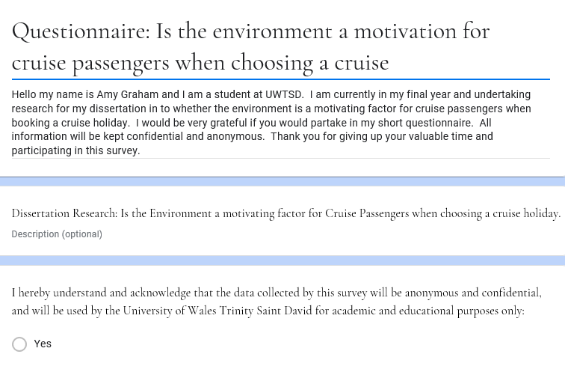
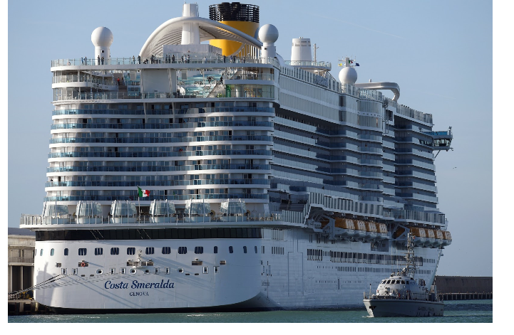

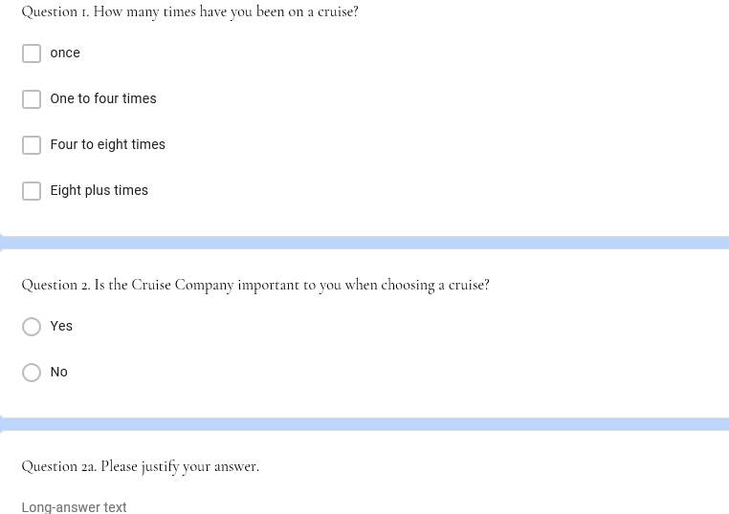

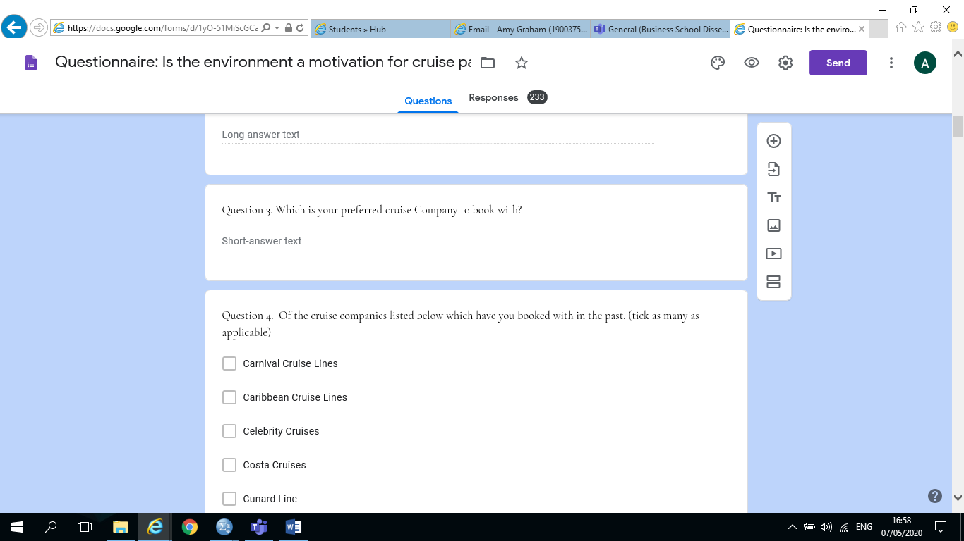

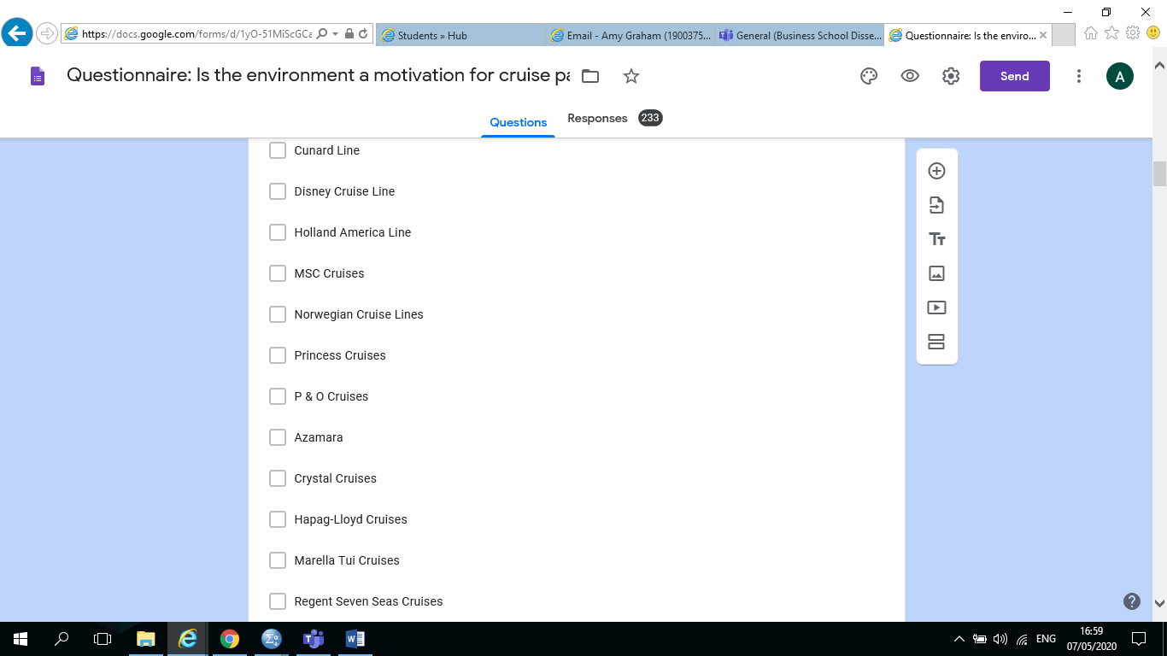

Q4. Continued

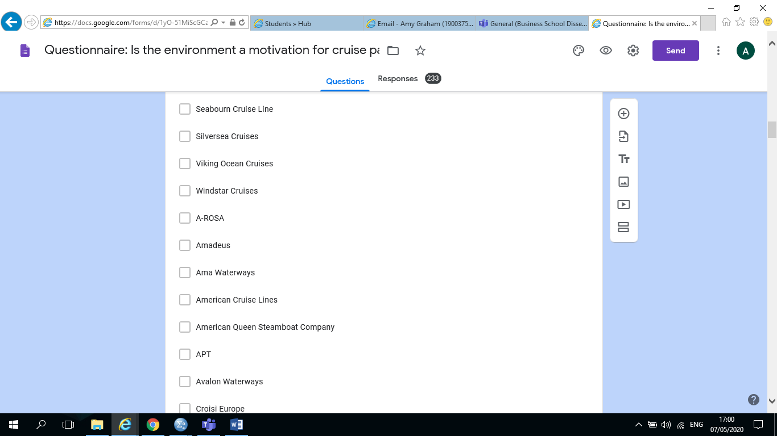

Q4. Continued

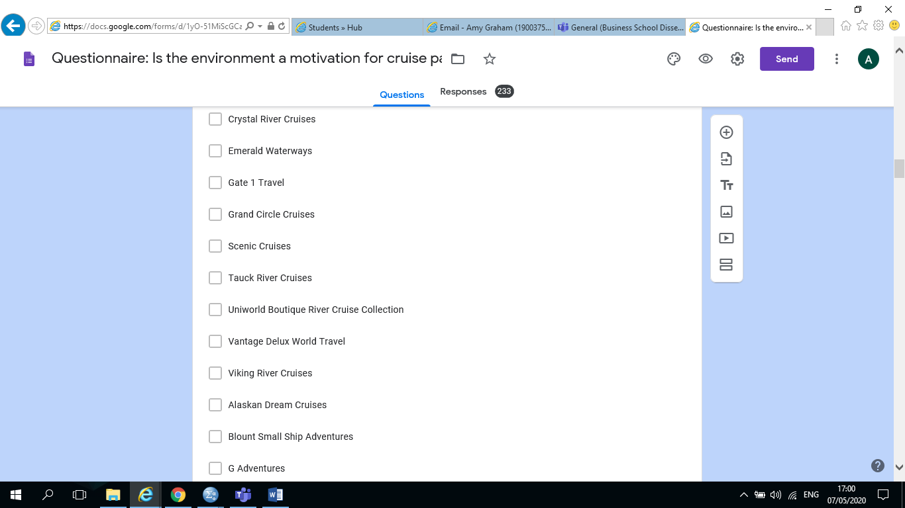
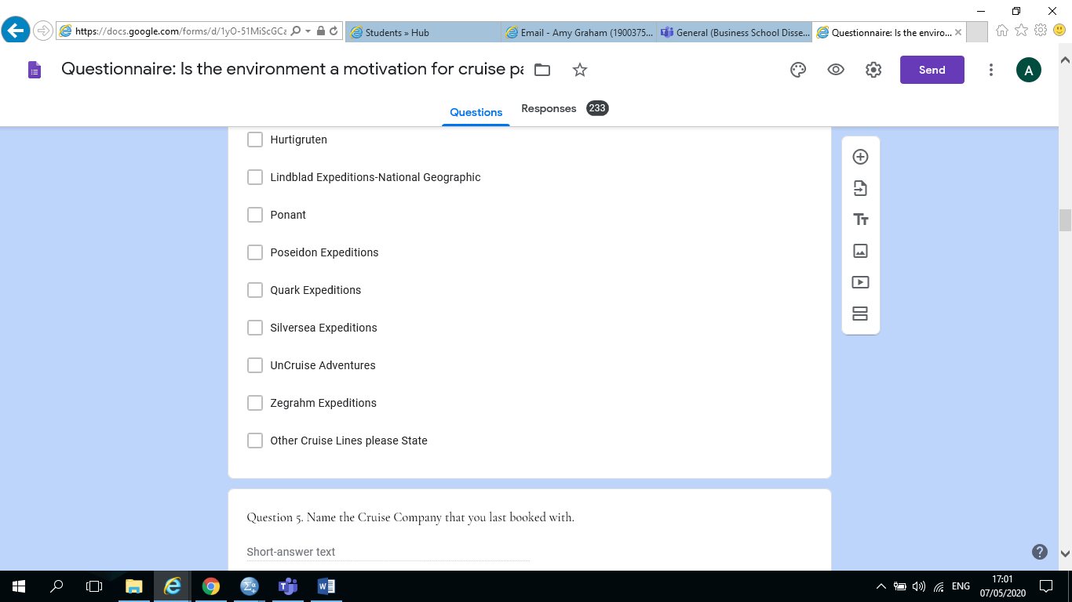

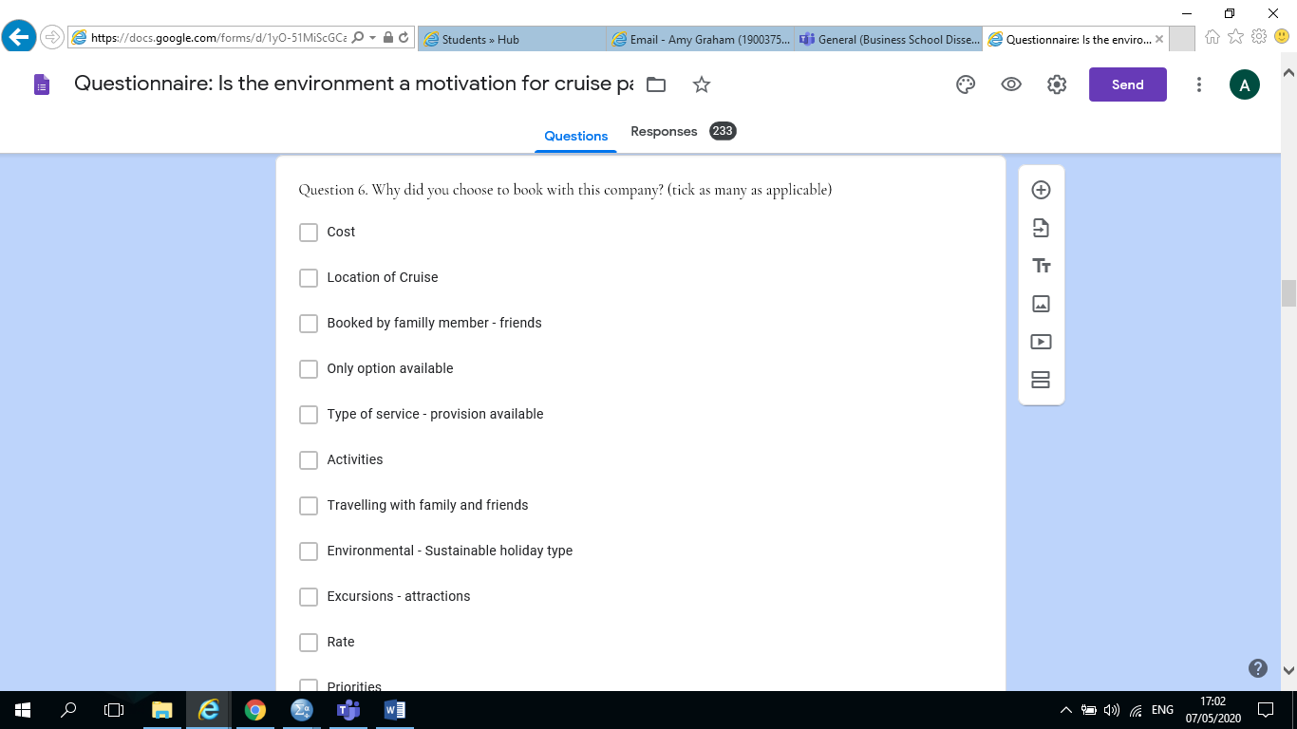
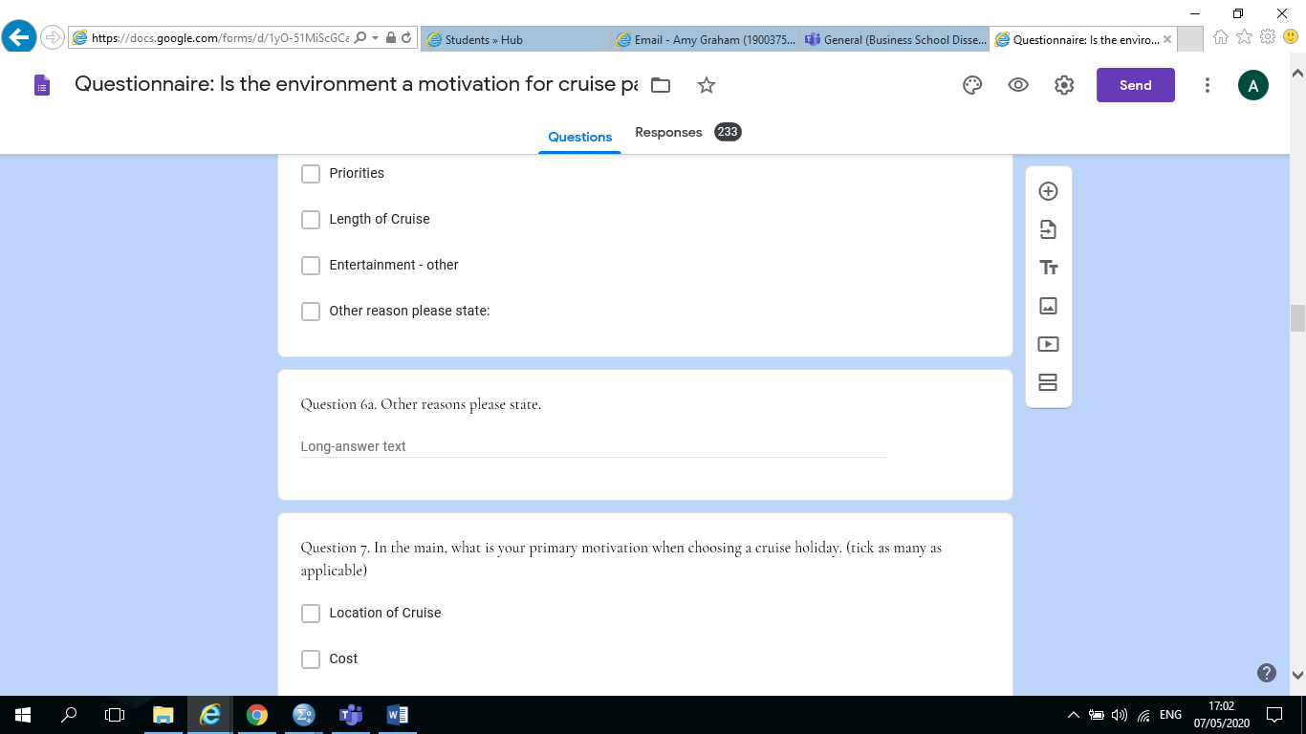

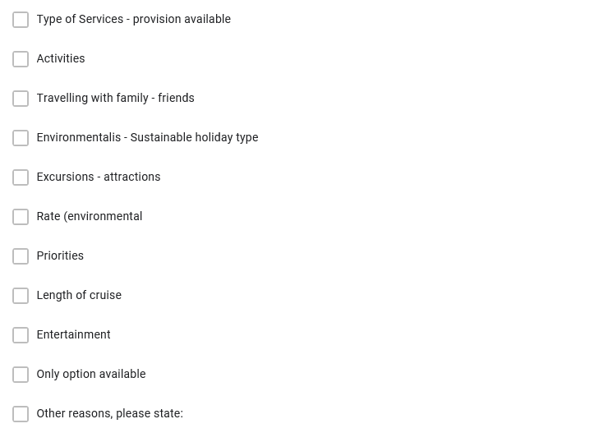

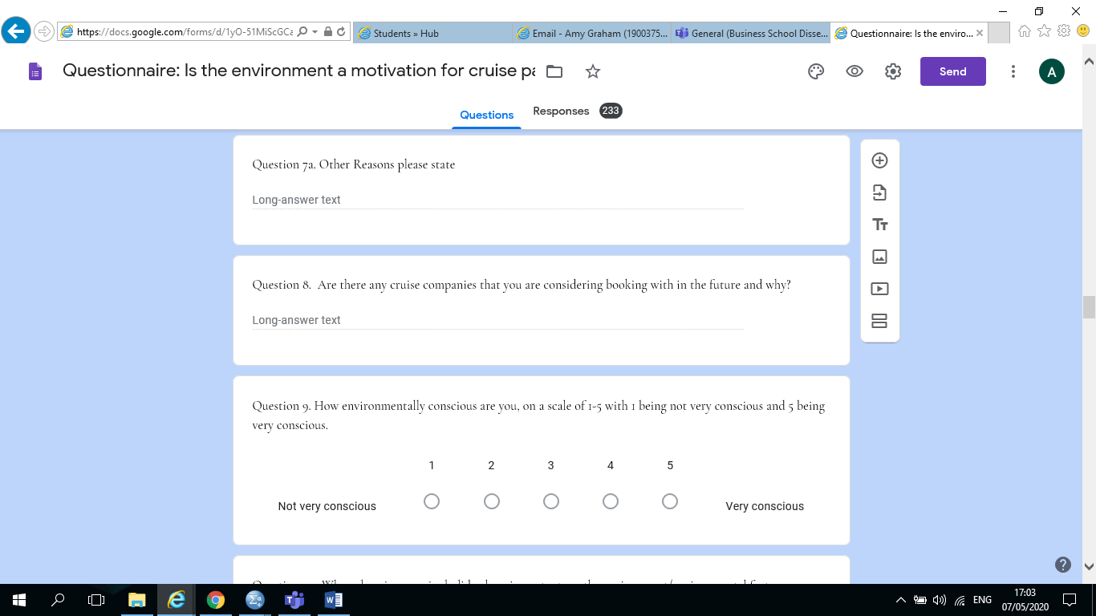
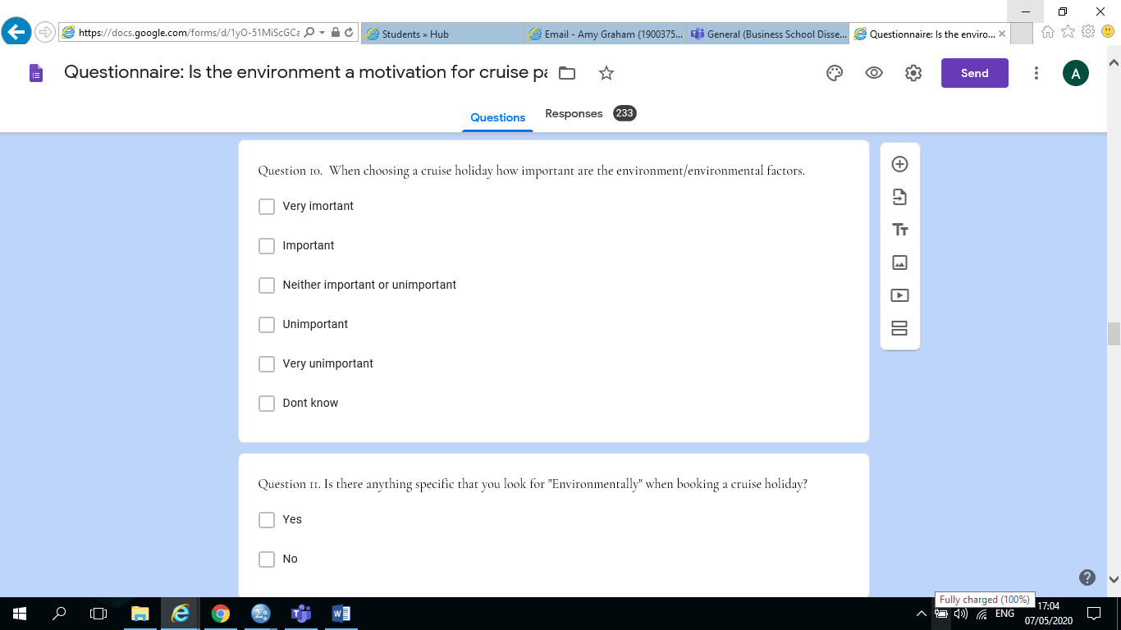

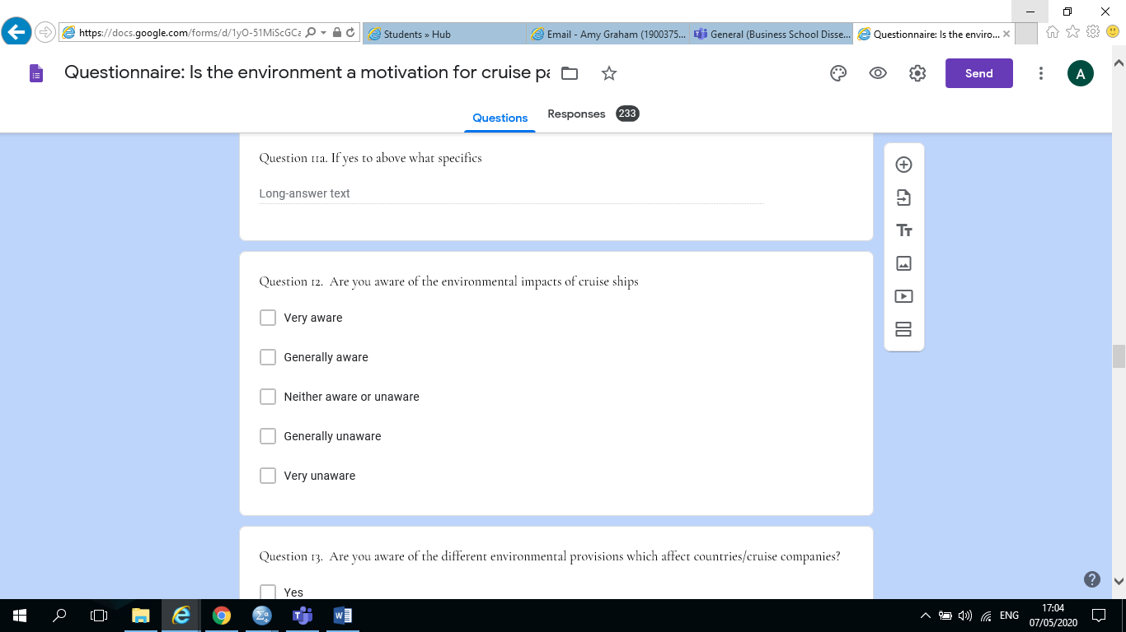

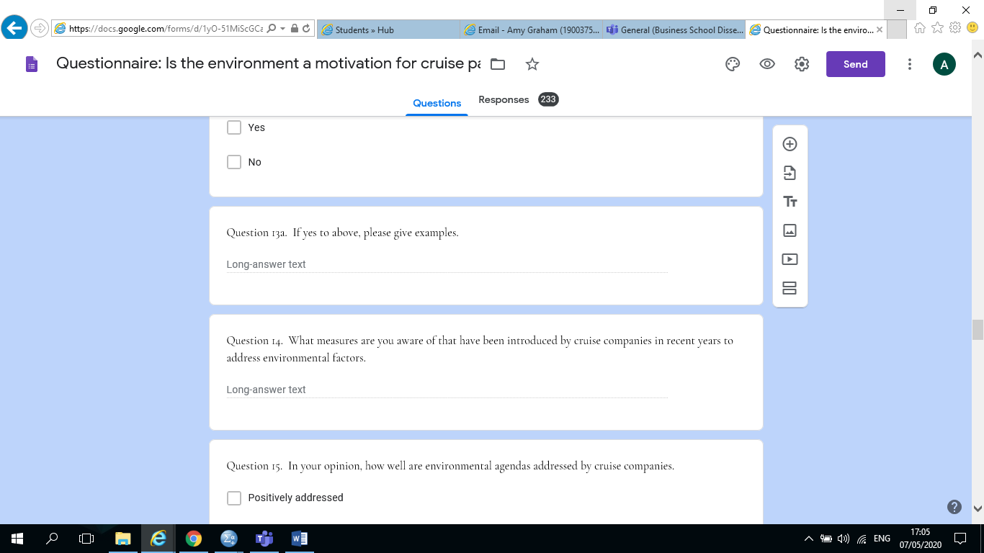
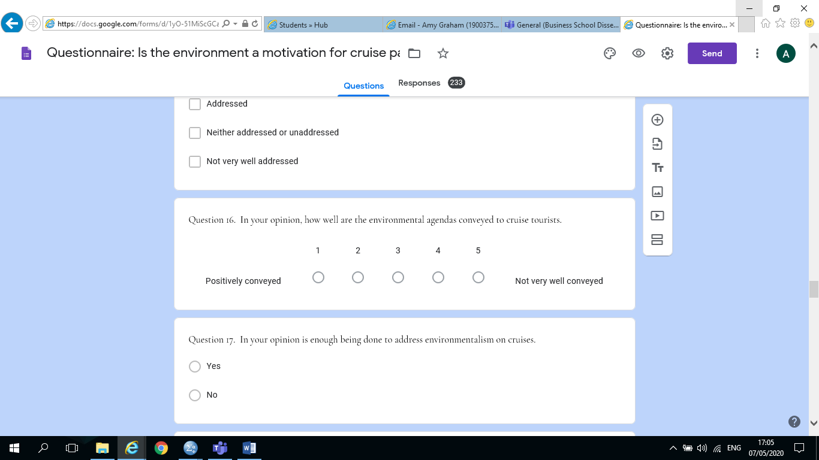

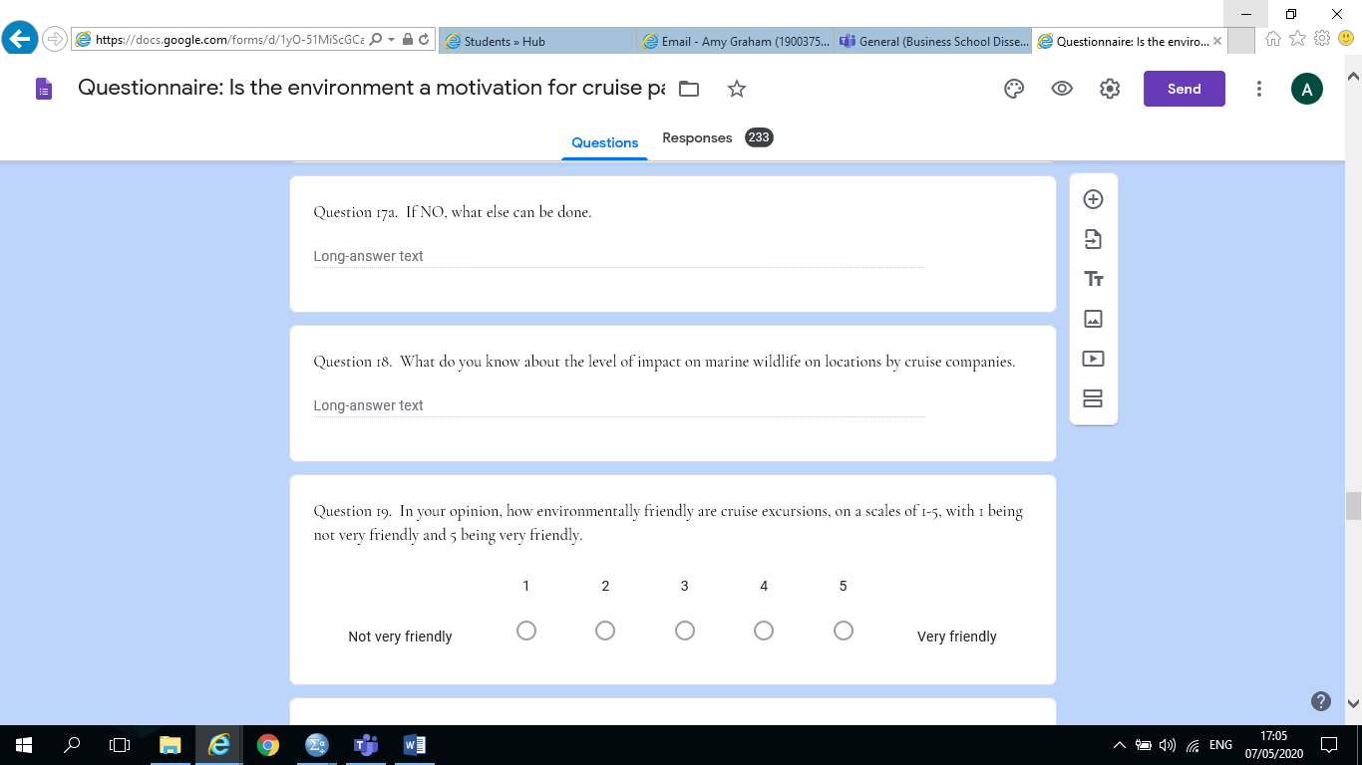
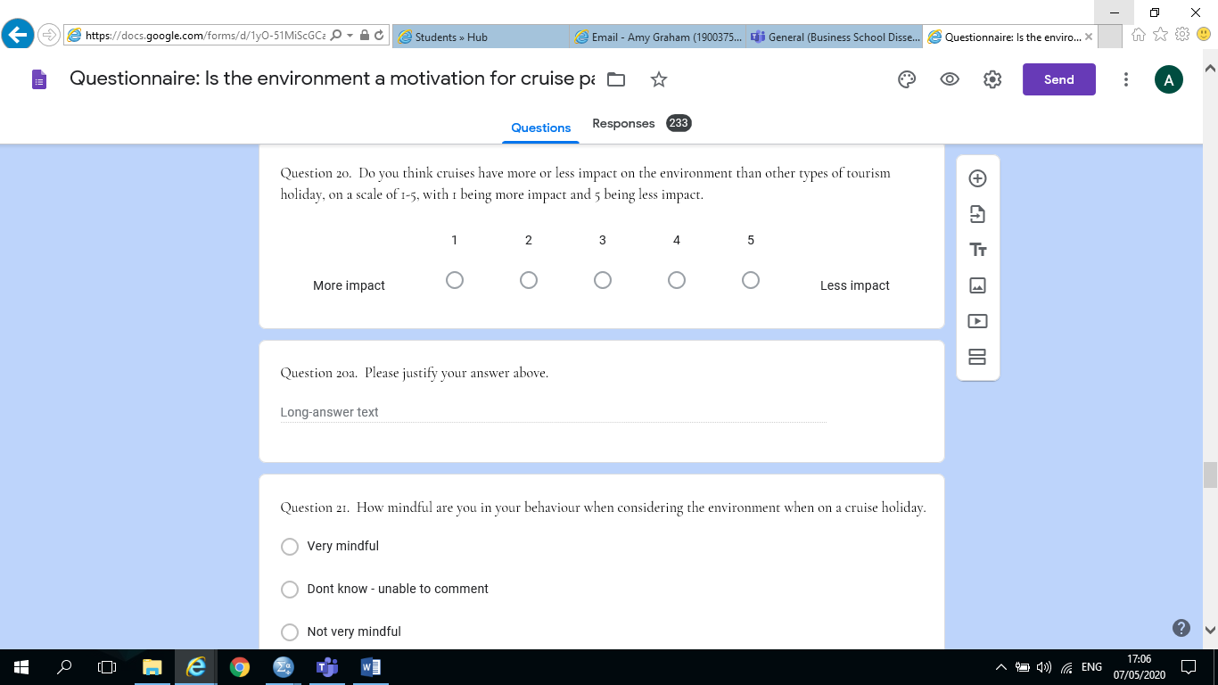
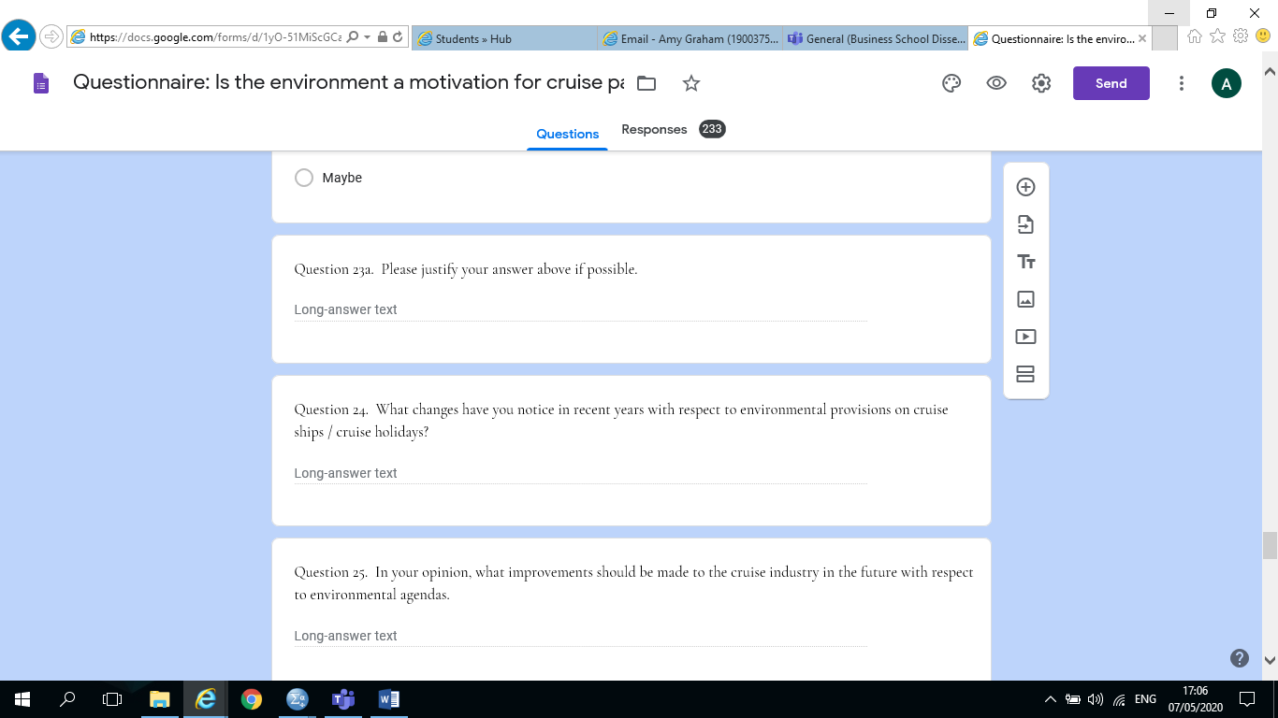

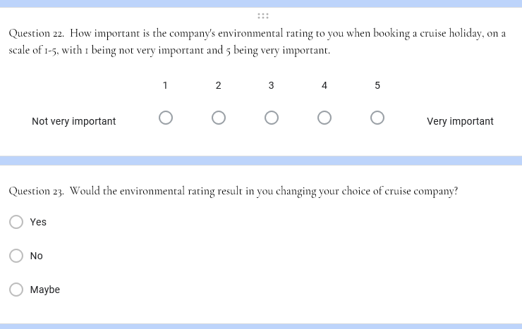

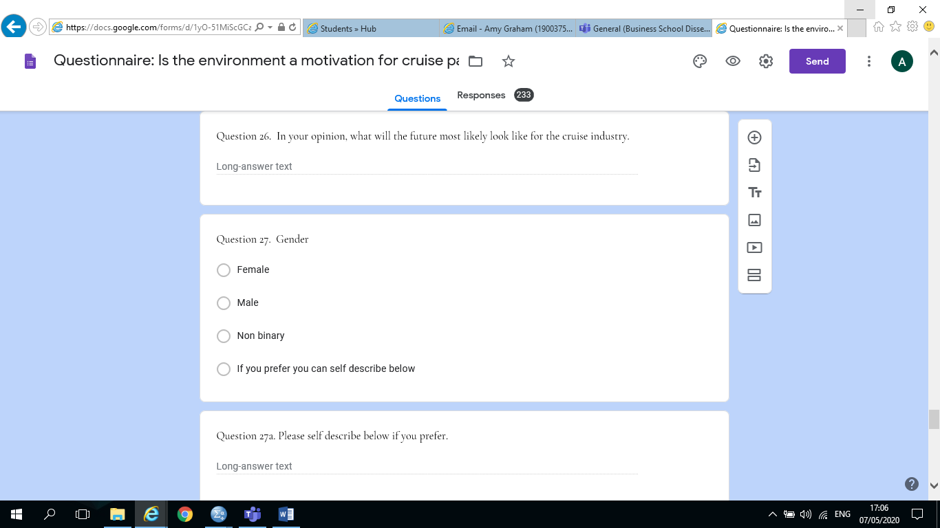

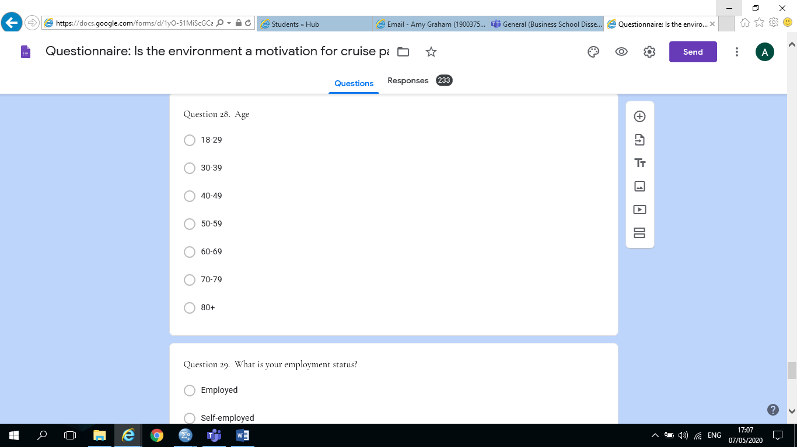
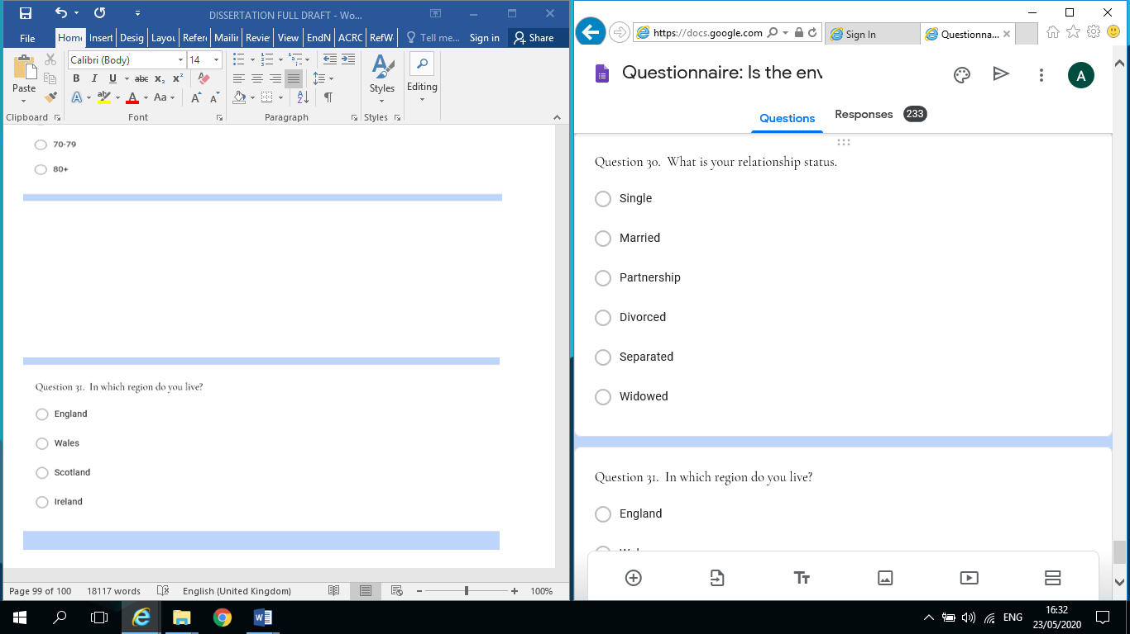

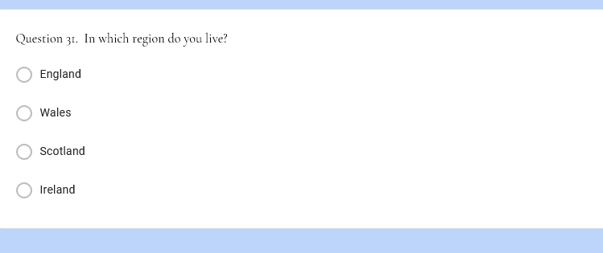

APPENDIX 3: Data from Questionnaire

I hereby understand and acknowledge that the data collected by this survey will be anonymous and confidential, and will be used by the University of wales Trinity Stain David for academic and educational purposes only:
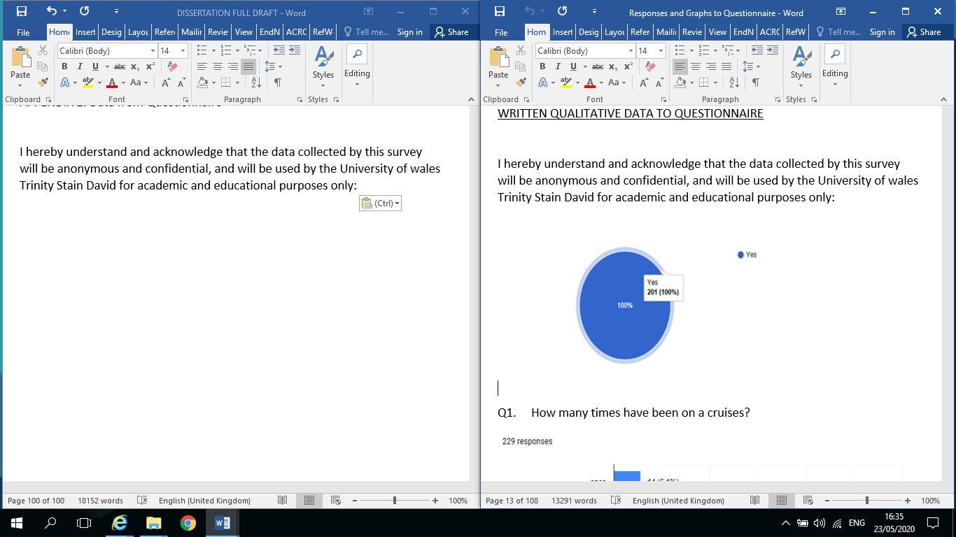
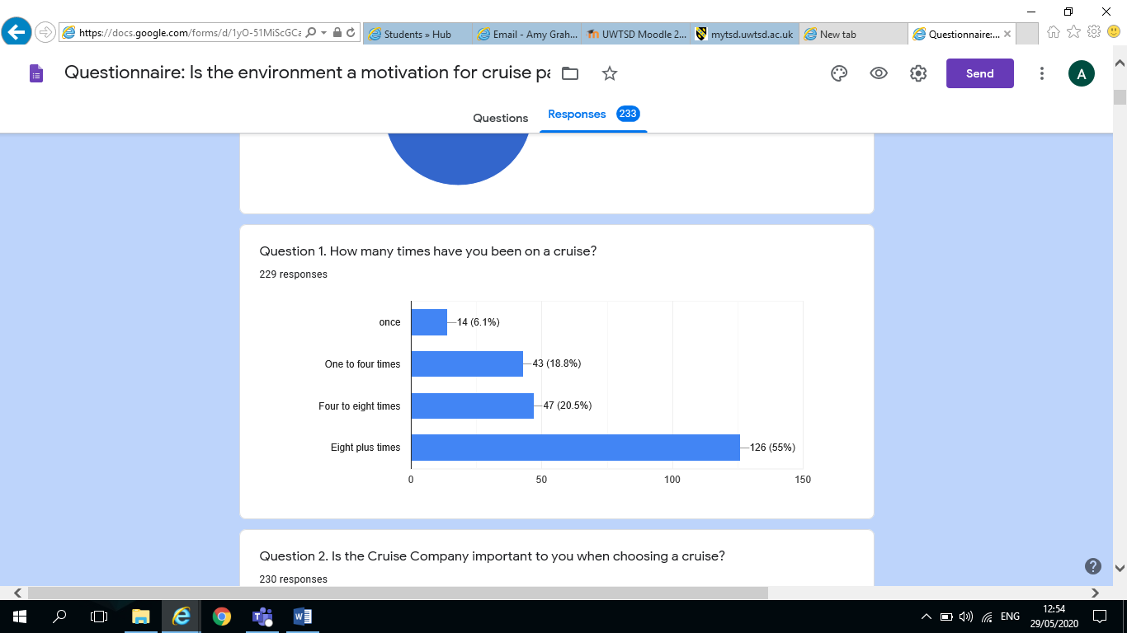

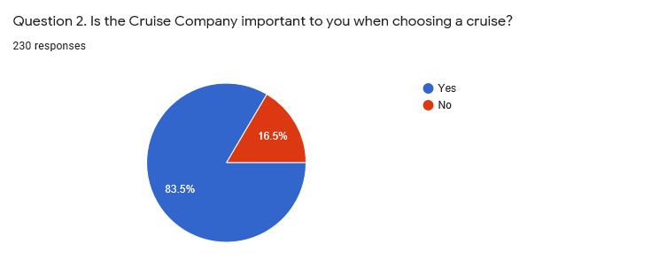

Q2a. Please justify your – 219 responses

P&O
Cunard are very particular with their cleanliness. I was very weary with my cleanliness than normal on Princess line.
I go with the company I know and trust from previous experience.
British, it’s what we know.
The destinations matter the most not which ship or company
Loyalty to one or two cruise brands has valuable benefits and we know that we will have a different cruise experience based on the line due to their ships and demographic. RCL for example being younger and economy passengers and Princess and Cunard being more refined and elegant.
Loyalty to a few companies.
I want to know it’s a reputable company.
Look at reliability, pricing, most bang for my buck. We are a couple in our 50’s and do not want a lot of bells and whistles. Don’t want a bunch of kids.
Their reputation
Different companies offer different experiences
Destination and price more important
The destination is more important
It’s about the destination and timing then cruise line
Rewards for loyalty to one cruise line are a bonus.
For short cruises the company doesn’t really matter but on longer cruises, it does.
I can only cruise during holidays so will choose a cruise during those times with whatever company
I need a package cruise that flies me to port and back so only go with Marella or P&O
Will not cruise on some lines
I have no wish to travel on a floating holiday camp and funfair
I search for best price and itinerary
I cruise with the company that gives me the best value for money
Standard of service
Lie to go with a trusted company which has good reviews
Avoid cruise lines that are known for drinking and hard partying. Usually avoid all-inclusive cruises for this reason
As long as I am on a cruise ship holiday I don’t mind which cruise ship company it is
It’s all about standards and expectations for me. Cunard is my favourite. It offers dress codes and certain standards that are traditional and appeal to me.
Where the cruise goes is more important than the company
Enjoy travelling on Cunard
Only travel from UK ports and return to UK ports so this limited the company I use
Cleaning of ship
Informal and reasonable cost
P&O for British tastes departing from Southampton
Some cruise companies offer that little bit extra
Like companies tailored more to the British market
Not all cruise lines have what we are looking for in a holiday
I think Cunard provide the most luxurious cruises.
Itinerary is more important than cruise company
Bit like which supermarket do you use – Waitrose or Aldi – Waitrose higher end & good solid ethos/ethics
Some Cruise companies run cruises I prefer above others. Not all cruises are the same.
I would like to get my money’s worth
I like to know I can rust the Cruise Company
Itinerary and departure date is the most important
The cruise line is imperative as quality and service varies
I think Cunard does things the right way
Some perks come with loyalty.
Quality and cost
Value for money and ports of call
No of ports covered, itineraries offered, is it a package including flights & transfers.
The itinerary is more important, 70+ cruises
Some cruise lines just feel right, but others don’t
Some companies suit us i.e. food, entertainment, departure port others don’t.
Princess is my choice
I chose who has the best destination route, price and free perks
Looking for high end, mainly adult luxury ship
Different companies cater for different age groups, as we get older princess is our preferred company
We go for itinerary and most cruise company are a similar standard nowadays except for the really expensive ones.
Established company
Needs to sail out of British port.
Different lines cater to different age groups and demographics. We prefer the more traditional style, not floating theme parks.
Money
Ambience on ships differs. Some geared for families for example
They are hugely different in terms of on-ship experience
I choose the itinerary not the cruise company
Cruise has to be affordable
I don’t like massive ships
Environmental issues must be highly considered
Quality of service, ship and crew
Because it depends on what kind of holiday you want, some ships/cruises are party ships. But you may prefer a more gentle cruise/holiday, so kitsn8important to choose the right ship for you
I like the British ships
First cruise was with Tui Marrella and it was amazing staff, ship ethos and was adult only.
We consider ship layout, number of passengers and reviews
I need to know they are reliable and a well-respected company who look after their crews
We prefer the standards adopted by the company we use!
I enjoy cruises that are full of activities and entertainment, this is important for me when booking a cruise
Chose the company by reputation and friends recommendations
I like to know what to expect and if you stay with the same company all the ships are similar
Standards and fellow passengers
I prefer mid-size ships with an emphasis on the over 50’s
Luxury, customer service and quality of food
I book with cruise companies that offer what I am wanting from my holiday.
I enjoy sedate people on a cruise
Loyalty benefits increase with the number of cruises taken
Having trust in the staff and company to give you great service
We use Tui now Marella due to no hidden costs. Also entertainment are UK acts
Just happy with the service and cruises
Prefer to support British companies
Financially secure
You go back to the company that treats you fairly
Some are not as good as others. Would only choose 4 or 5*
Don’t go with American run lines as I have serious doubts their food & environmental safety.
The people they attract and facilities on-board
You expect a certain standard with each cruise line
We’ve only gone our cruises with Cunard-always a wonderful experience!
Not interested in booze cruise type holidays. Adventure and quality of talks at more important
Just love the laid back way they cruise
Standards
You know in advance what the service and programmes on board will be
I prefer a cruise line that caters to older people and is not a party boat line
Q3. Which is your preferred cruise Company to book with? – 220 responses
Cunard
P&O
Princess
Marella
P and O
Cunard
Princess
Tui
Marella
P & O
Celebrity
P and o
Msc
MSC
NCL
P&O Cruises
Carnival
Caribbean
Royal Caribbean
Royall Caribbean
P&O (also princess when they sail out of a British port)
Norwegian cruise liners or P&O
P&O Cruises
P&o
P&O
P and o
The main cruise company we have used Marella cruise line
PO
Royal Caribbean
P&O Cruises
P and O
P&O cruises
P&O or RCI or NCL or HAL… those are our preferred ones though we have cruised with others too many times
P and O, Royal Caribbean
P&O
P&O/Cunard
P & O
Disney and Princess
PO only one I have been with
Princess Cruises
Princess or NCL
Asmara and Princess
P and O
Celebrity
Princess
No preference
No preferred cruise line
CMV
Tui
MSC Cruises
Pullmantuer
Tui Marella
Cruise company signals rating of my experience

Marella cruises
Marella/Tui
Marella and RCL
Tui Marrella Cruises
P and o. & Msc
MSC
Carnival
Marella Tui
(Thomson) Tui Marella
Holland America and CMV
Princess maybe Cunard
Holland America
Holdovers
Undecided
Tui Marella
Princess and Royal Caribbean
Cunard line
RCL
Marella/Tui
See above
P and O or Cunard
No preference really, but MSc is currently our preferred I guess, given the price point for the cabin type we need
Cunard or similar
Carnival, but have cruised with Holland America and liked it more, trying MSc ned
Cunard
As I said for the question above I go for value for money

Q4 Of the cruise companies listed below which have you booked with in the past (tick as many as applicable – 229 responses
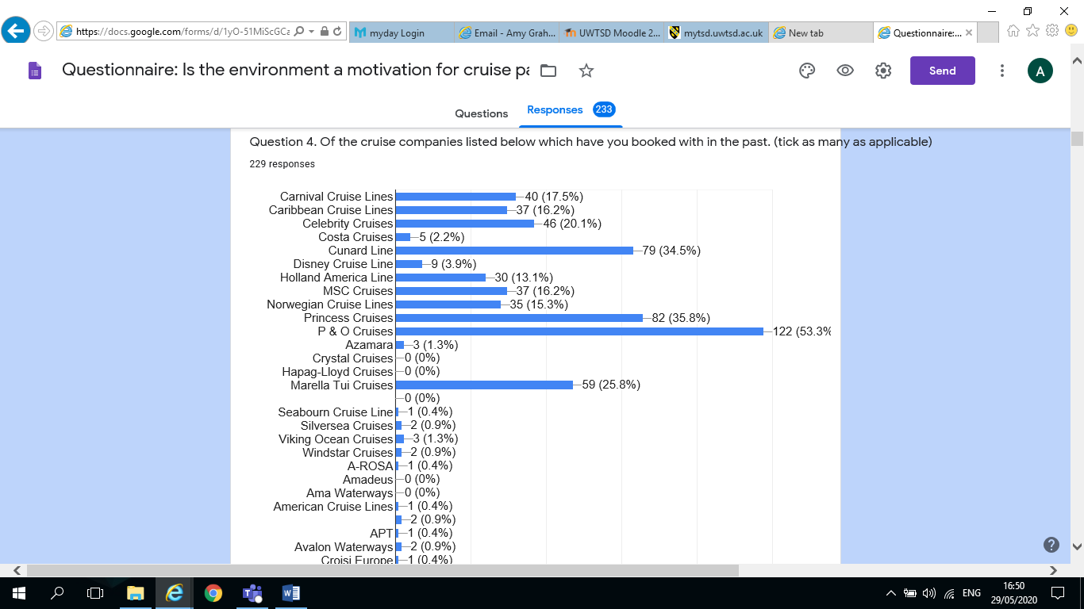
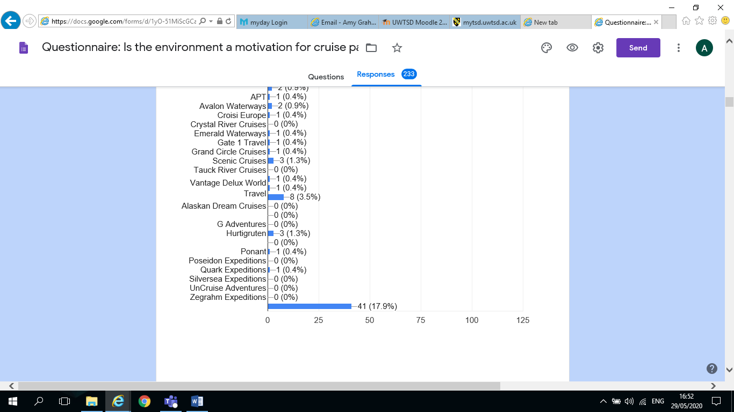

Q5. Name the Cruise Company that you last booked with – 221 responses
Cunard
P&O
Princess
Marella
MSC
P and O
Cunard
Royal Caribbean
P & O
Princess
Msc
P & o
NCL
P and o
Carnival
Marella
Marella Tui
Tui
Tui Marrella
Royal Caribbean
Royal Caribbean
P&O
P&O Cruises
P&o
P and o
P and o
P&O Cruises
PO
P and O
P&O Cruises
P&O Cruises
Celebrity
Carnival
French, Chandri
Last booking =Princess, last travel Carnival
Princess Cruises
Asmara
Celebrity
Msc
Marella cruises
Cruise and Maritime
Marrella Cruises Tui
DFDS
Marella Tui
MSc
Rcl
Marrella
Cunard
Cunard directly
Marella/Tui
Pullmantur
MSc though for later this year and possibly cancelled
Msc
Cruise Brothers in the US
AIDA
Cunard

Q6. Why did you choose to book with this company? (tick as many as applicable) – 228 responses

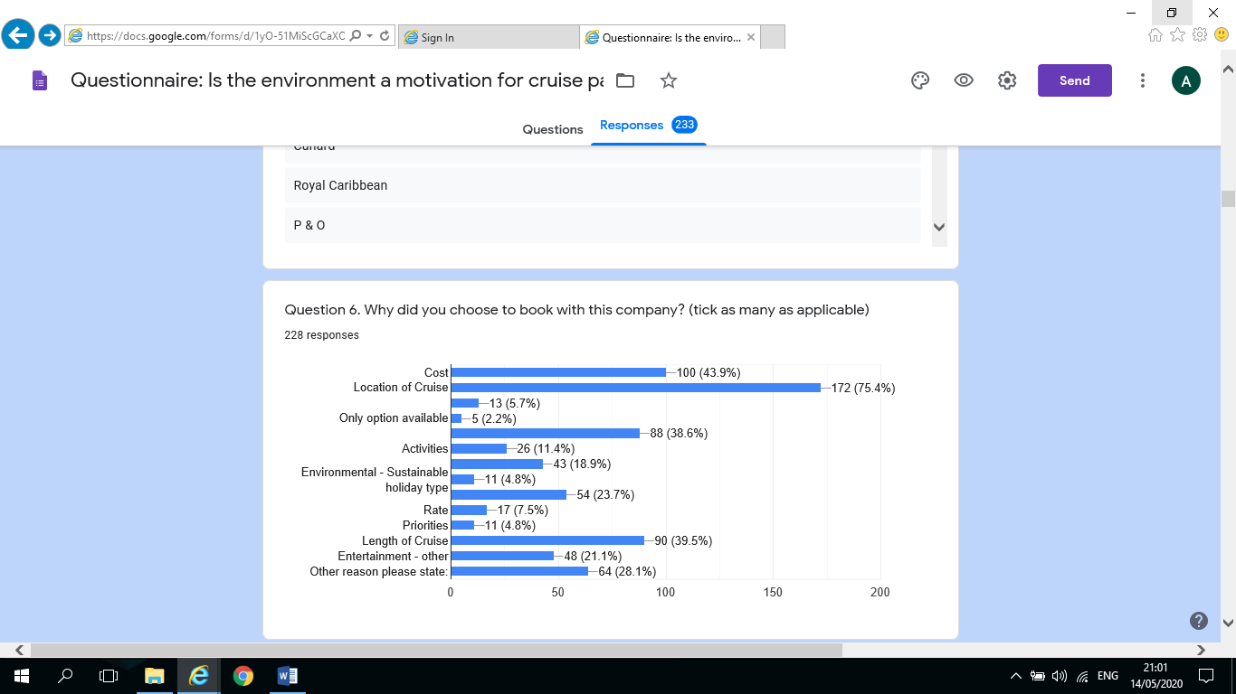

Q6a. Other reasons please state. – 116 responses
Cost
Itinerary
None
Loyalty benefits
Must sail out of British port
Excellent entertainment and all inclusive
Like that ship
Looking for Cruises from Southampton
Familiar and easy
Went to Santorini
GBP
Food
Cruise Caribbean. P&O charter flight from UK
The service we get is always impeccable
Mainly English speaking all British
Genera ambiance, old fashioned luxury
We are comfortable with P&O…lovely staff very nice passengers…right prices suit us
Itinerary
Only cruise available on the date we could travel
Elderly parent who won’t fly
They have a really good set of TV adverts which got my attention too
Sail from UK
Fits our available dates
Good friendly service
Very good kids club
We enjoy p and o
Excellent treatment
Food quality or family oriented
Itinerary
Free drink package, gratuities and Wi-Fi
Loyalty program
Caters for all ages travelling with a variety of ages from 1 to 50 years
Food, service and itinerary
Loyalty scheme
Perks Princess are our cruise line of choice
Value for money, good reviews
The destinations and the various ports of call are our sole motivation – based on History and local civilisation (cultural motivation!)
Timing
We have elite status on princess
I had a future cruise credit with this line
This cruise stays in Australian waters
Repositioning cruise across the Pacific
Visiting friends in Alaska
Correct dates
British cuisine and British passengers
Princess goes out of San Francisco which is wonderful for me
Charter cruise
Proper cruises, not like a holiday resort/Butlins
All inclusive, no hidden extras
Good balance of price, all-inclusive and not too up market.
Parents paid for it
It was a themed cruise. Only this company did this theme itinerary
Destinations
Tips are included in booking cost
Dress code, dining arrangements, friendliness of offices and crew. Friendly relaxed atmosphere on board
Local departure
The service staff are nearly always fantastic
They do the best Caribbean itinerary
Good value for money
Adult only
Lots of port stop offs in 2 weeks
Available in our country
The date of departure too as it had to fit in with my schedules
All inclusive
Do not have to fly as goes from Southampton
As mentioned, not a massive ship, more informal style
Value for money, itinerary, on board service
Dress code mostly forma
Could drive to port
Destination – wanted to go to Japan
Informal cruising
Dress code, staff standards, food, crew
Cabins
Fitted in with holidays
They look after solo travellers
Cost
Husband ex Merchant Navy Chief Engineer, now trains senior MN Officers including Cunard Officers
Not applicable
Local airport departure
We experienced Cunard last year and loved it so booked again with my mum and sister
It was a place I wanted to visit
Loyalty scheme
I like the informal days and the formality of the evenings, the food is always excellent
New ship. Looked great. Got good deal for balcony upgrade
Previous voyages with Cunard have been superb
Often to only way to get to see inaccessible places i.e. Fjord. Can sail and return from Southampton cruise port
Quality of on board talks and facilities (library, quiet spaces, not overcrowded)
Previous good experiences with the company and its ships
Ship
Left from Southampton
Size of ship (MSC Lirica)
Was interested in their ship
Dancing nightly to live band/orchestra
Luxury
Medium sized ships

Q7. In the main, what is your primary motivation when choosing a cruise holiday. (tick as many as applicable) – 227 responses

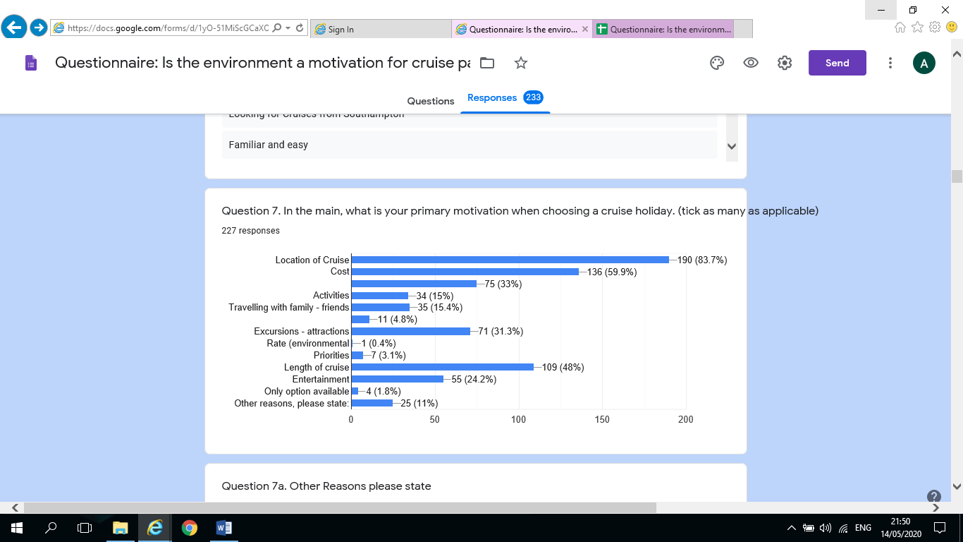

Q7a. Other reasons please state – 57 responses
All inclusive
Cost
Itinerary
None
No other
Itinerary and ship
I love being on the Ocean
Sailing out of British pot
Has to cruise only no fly
Food
Itineraries
Love the destinations… been to most over and over again
Waking up in a different place most days
School holidays
Its everything, the quality of the food and entertainment, on-board facilities, being somewhere new every day or every other day and on an environmental level the newer ships are more self-contained. We need to fly and don’t have the impact on the same local community for 14 days
No flying cruise from Southampton and back
Sailing from Southampton
Free perks
We just like cruising
Cost, entertainment
Destination + ports of call
Ports of call
For whatever I am planning
All inclusive, tips included
Drinks package
Departure airport location being near to us
I also like adult only if just going with my husband
Adult only
Love a cruise holiday, because it’s all inclusive
Only tend to go for 14 nights and we pick the cheapest last minute cruise
Quality of ship construction
To see as many destinations as I can
Great way to travel and value for money. Board, unpack and relax
No having to dress up and can eat informally too
Dress code, staff, standards, food, crew, loyalty level (we are diamond members)
Itinerary
Rate
Cabin
Certain cabins available
Likely calibre of other guests
Area of cruise
Like lots of sea days
Cost, needs to leave and return to UK port
Medium sized ships
Five-star service
Cunard satisfies a niche for us as described
Destinations/itinerary
Local airport
Company in combination with itinerary
Relaxation type of holiday
n/a
formal dining

Q8. Are there any cruise companies that you are considering booking with in the future and why? – 192 responses

No
P&O
Princess
Cunard
None at the moment
P and o
Not at the moment
Silversea
Cunard. They have a new ship in 2022 and we want to go on her
Top environmental companies
Environmental friendly ones
Disney cruises
Regent Seven Seas – friends booked
Will depend on where they offer cruises to and the price
Fred Olsen, Princess & P&O
Celebrity for food, NCL for entertainment
Not at present
It’s all about the itinerary for me
Cunard as recommended by a colleague
Any company that only sail from UK and back, other than Cunard
Princess – itinerary
Celebrity good reputation
Fred Olsen just to try smaller ship
Tui Princess
Open to all
Cruise and maritime our second favourite, Cunard, Princess
Have booked with Princess for itinerary and ship
P and o as above
?
Only p and o from now on
P&O, if we get to go we want to sail from Southampton to Norwegian Fjords.
Princess Cruises
Maybe princess or R C just to try a different company and recommendation
Only p and o
NO
No only P and O they are the best
Only P&O
Disney cruise line
We would book with carnival or Princess again.... and we would book with Celebrity…. if they had a deal that we liked to the right ports at the right times
Always P&O
Tui as it can give an All Inclusive holiday
I have booked p and o
P and O as they look after you
P&O and Cruise and Maritime. Quality and value
P & O and Cunard. Love their service
2 Already booked with P&O (Aug’20 & Mar ’21)
Royal Caribbean good reports
Cunard, Princess, Royal Caribbean. Be good to personally compare different cruise lines.
Fred Olsen – we only cruise from UK and they have a longer season than Princess
No, I prefer Princess
No
I have a credit with Royal Caribbean from a cruise we cancelled because of the hurricane last year so I should be looking to use that credit. I would like to book with Viking Oceans, we did one with them and it was the best
Yes, enjoy cruising
Just Princess
No, except Princess, the greatest!
No. The cruise industry needs to make some changes
Not really
Princess – good loyalty perks, insurance has some advantages
None
Saga. Ships and service look outstanding
Norwegian-we thought we would try these as curious that is the only reason we would probably do a short trip maybe 3 nights to get a feel
P and O. if the price and destination was applicable
P and O Baltic cruise….to celebrate family birthdays
Celebrity because they appear to offer a product that I would be interested in
Cunard. Simply because they are legendary so for the experience
The same 2, as previously mentioned!!!
P and O as like the atmosphere on board
Yes. I would like to do a river cruise
Royal Caribbean, P&O Australia
Princess (booked 2021) CMV (booked 2021)
No happy with P & O
Marella and P&O
Princess – they go where I want to travel
Princess
Would book with any which go where I want to go
Marella
Fred Olsen P & O good reviews, smaller ships
Maybe Royal Caribbean. We like the sound of their offering
RCI, would like to try a “megaship”
Disney Cruises. For a specifically Disney experience, and access to Disney-owned destinations.
A few-NCL and Royal Caribbean
Celebrity
Royal Caribbean
Just booked again with Marella
Fred Olsen, Hurtigruten. They cruise from UK to norther Europe.
We have already booked with Marella as they visit New York on my 60th birthday
Norwegian
No
Royal Caribbean
P and o. Booked for next year. Good food and entertainment and services
Never considered
Probably not
Marella, all-inclusive and where I want to go
Celebrity – very nice cruise line
Msc to test the last boat
Have two cruises booked one with P&O but has been cancelled and one with Marrella in August but might be cancelled due to Coronavirus
Any company as long as they are going somewhere that I have not yet visited
Marella… cost
P&O – destination
Princess cruises they are a bit more luxurious

Q9. How environmentally conscious are you on a scale of 1-5 with 1 being not very conscious and 5 being very conscious – 228 responses
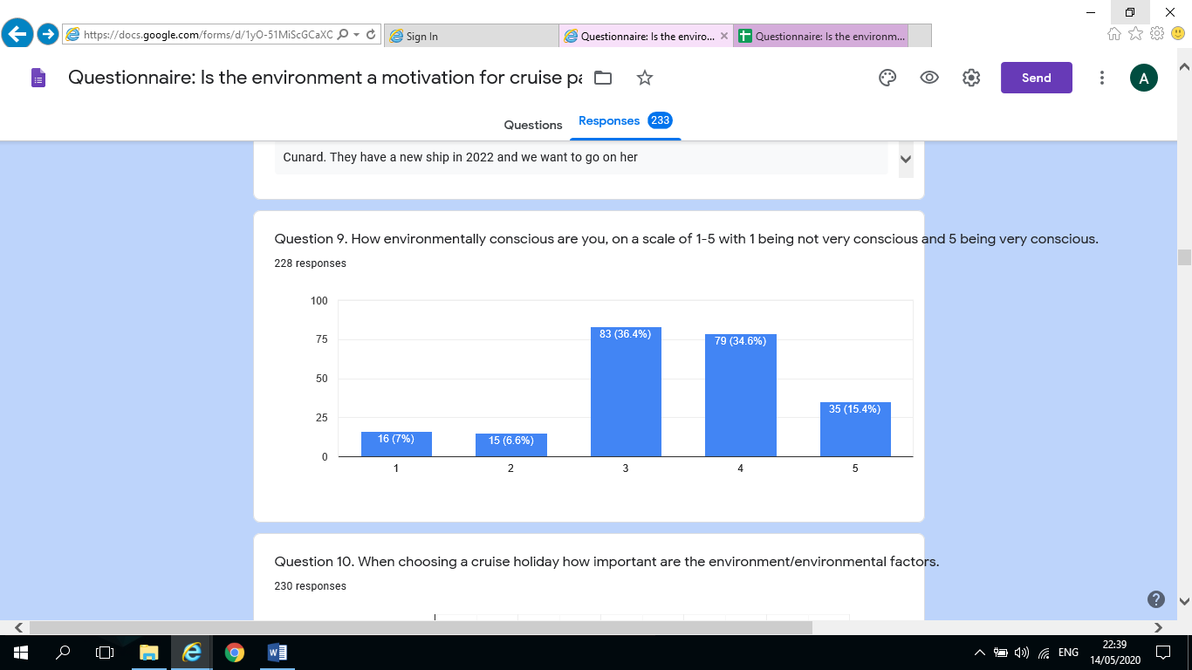

Q10. When choosing a cruise holiday how important are the environment/environmental factors.
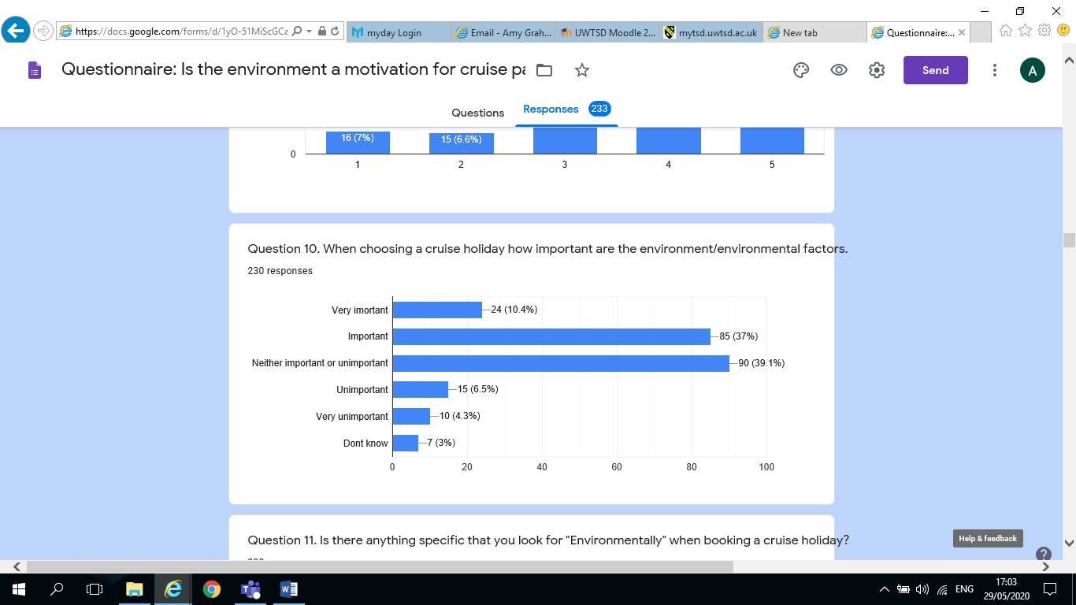

Q11. Is there anything specific that you look for “Environmentally” when booking a cruise holiday? – 230 responses
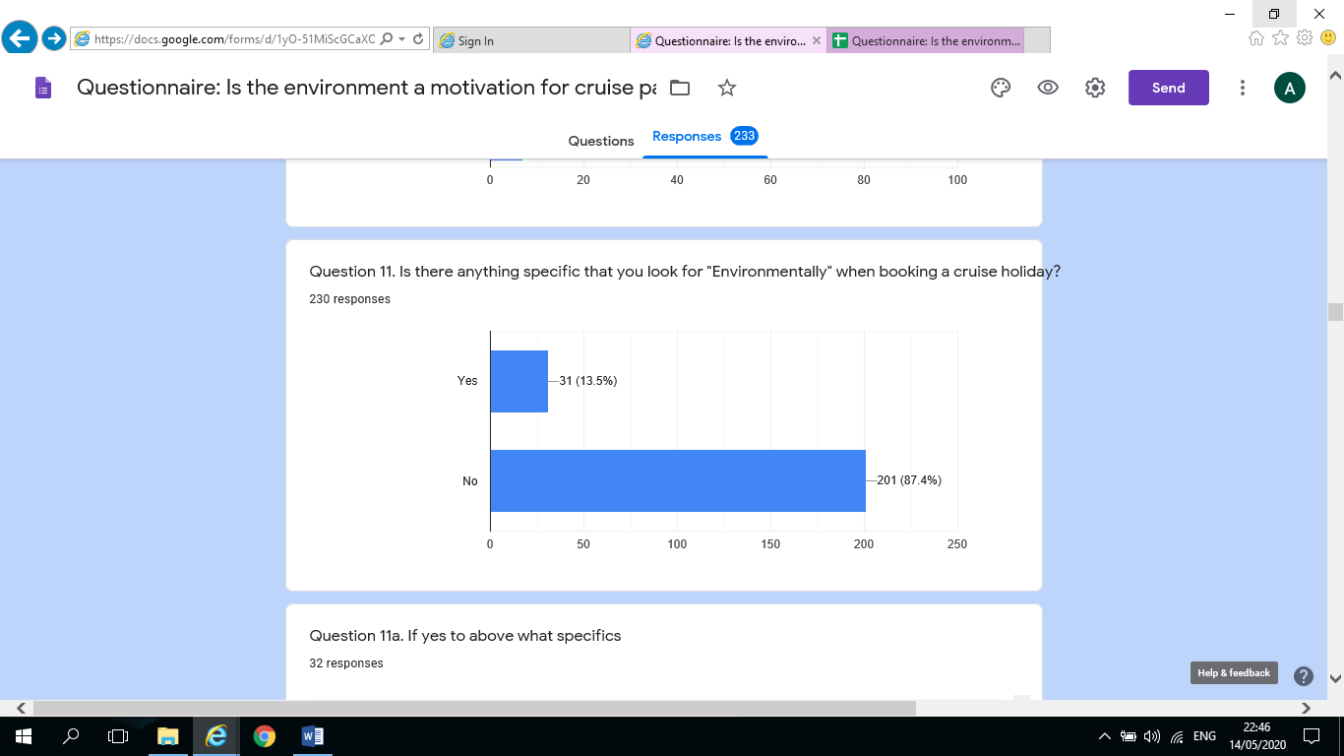

Q11a. If yes to above what specifics – 32 responses

If they recycle
Emissions and recycling
Low emissions and waste
Single waste plastic
Ports used
A clean and comfortable calming relaxing environment is very important
No plastic straws, flags, low emissions fuels, recycling
I like to have at least impact on location as is possible. We believe that cruise get a bad press about the environment yet flights and hotel based holidays don’t… this is because all the people who complain about cruises fly and holiday in other ways…that are equally as unfriendly to the environment if not worse…just look at Benidorm if you think that isn’t having a massive impact then its deluded. Compared to the huge hotel type resorts filling whole cities cruise ships are almost insignificant. And being self-contained are not trailing around leaving a trail of debris behind them as some would have you believe. I would rather not go to Venice on a cruise ship, it isn’t right
How the cruise ship handles everything?
I know princess is trying the best
I’ve heard about black water dumping and I don’t like that
Cleanliness and environmentally conscious
Following the Us regulations regarding pollution
Time on a cruise
Cruise line adhered to the environmental rules at the sea
Plastic pollution, carbon footprint
Their recycling policy and statistics
Pollution and engine carbon emissions
Scrubbers, plastic gestation
How green the company is and what efforts they are making to improve
Non=exploitation of local/natural wildlife, landscape, people
Small ships, no waste dumping
Type of passengers
Clean, efficient ships mindful of reducing laundry and not wasting food
Environmental policy of company both on board and in interaction with areas
visited.
Past information from the cruise company’s guides me
Good health and Hygienic conditions
Environmental friendly when possible
No flights involved
They explain what they are dong to support environment and if we agree we go with them
Environmental activities on board

Q12 Are you aware of the environmental impacts of cruise ships – 230 responses
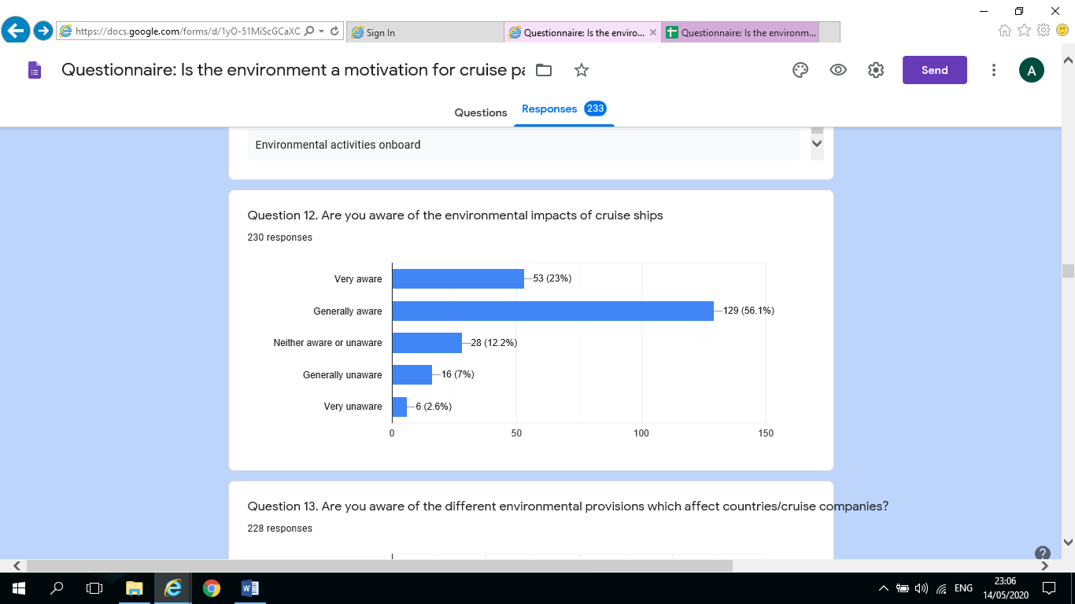

Q13. Are you aware of the different environmental provisions which affect countries/cruise companies? – 228 responses
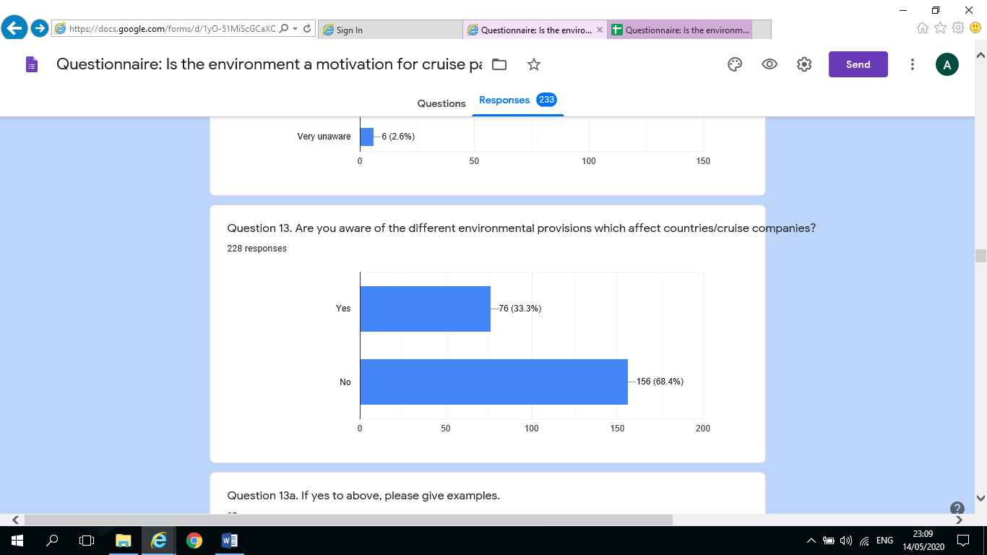

Q13a. If yes to above, please give examples – 62 responses
Waste management
Venice
Aware of damage to some destinations e.g. Viennese of wearing of the city due too many ships going there so would not go on a cruise to there for that reason
P&O have changed their policy on plastic waste
Port visitor numbers, size of cruise ships
P&o getting rid of many single use plastic and items such as butter packets in the buffet
Not dumping dirty water near the coast. Not dumping rubbish overboard
Fuel type and disposal of refuse and grey water. Also use of plastic
In Norway cruise ships are only allowed for a set amount of time
Over tourism
They are not allowed to dump brown water overboard without it being cleaned first, they are all designing new ships to be more environment. They have all banned plastic straws etc. and throwing anything overboard is not allowed. People also follow the rules because if caught they get thrown off the ship at next port
Flumes
Pollution
Don’t really care
Dumping raw water
No idea what you mean by environmental provision
Waste disposal
Use of certain types of bunkering oil which is more/less polluting. Waste streaming needs to be improved. My ideal would be that a ship leaves no trail after passing
Caribbean waste issues Venice erosion and footfall
Pollution and waste disposal
Discharge from ships…Australian waters very strict especially around our Great Barrier Reef…understand Alaska very strict too
Waste reduction. Effluent management
Norway banning oil burning cruise ships
Mooring arrangements
Impact on environment, impact on tourism, impact on the ocean (waste)
Fuel sulphur content, waste disposal
Water pollution. And carbon footprint
Effluent, disease control
Venice for example has banned cruise ships
Venice and the waterways, general crowding on shore
Disposal of waste, care of the reefs
New water treatment. Sea ballast on Meraviglia class decontaminated by uv.
The EU no longer allow the use of Shale oil in their waters, Canada they have to use electricity from the port. Norway is working towards banning all oil burning vessels from entering the fjords the local ferries are already all electric
Different fuel use in certain areas as one example. Limiting cruise ships size., e.g. Venice
Living in Southampton the pollution is higher when cruise ships are in
Erosion of seabed’s, dangers to marine life and conservation, effects of waste discharge
Waste disposal, use of plastics
Treatment of rubbish etc.
Venice is stopping large ships docking. Cruise ships treat their waste before disposing of in the sea.
Discharge of waste products, recycling, cleaner fuel
Norway no noise after 7pm
No dumping rules, emissions in certain ports
When in port and the funnelling of smoke
Waste produce of ship
Fuel requirements in some countries waters and cleaner fuel used by some newer ships
So many restrictions globally Alaska especially
Emission scrubbing engineering requirement and grey water regulations
Recycling, discharges from ship, requirement to be sympathetic to local environment
Only what I read in the media, especially regarding of plastic disposal
So many different countries must have different environmental provisions
Discharge, waste water treatment, fuel burn emissions
ISO 14001 discharge of waste
Fuel water and bio waste
Sea disposal of illegal waste, exhaust
Great barrier reef has speed restrictions for ships
Ships do their utmost to handle their waste and dirt waster in such a way the environment (sea and their animals) are not hurt
Keeping the oceans clean, not disposing rubbish or sewage into the sea, filtering exhausts
Burning different fuels in different regions with or without sulphur, proper waste disposal and recycling
Rubbish recycling, Food scrapping, Water recycling

Fuel
Cunard are very responsible, recycle where possible and meet all regulatory requirements
Have toured areas of ships where they recycle so nothing goes into the ocean

Q14. What measures are you aware of that have been introduced by cruise companies in recent years to address environmental factors. – 178 responses

None
None
Not aware
Don’t know
None
Less plastics
Recycling and energy saving
Recycling
N/A
Waste management
Use less plastic. Recycle as much as they can
Single use plastic reduction. Removing trays from buffet to discourage food waste
Reduce plastic n paper
Change of fuel used, water use, washing frequency
Fewer ships, smaller ships to some ports. Changing of fuel in newer built ships. Encouraging reuse of towels in cabins. Reducing wastage of food by banning trays in Buffett some people appear to be taking only what they can carry and eat now
Fuel usage
As above
Grey water
Less paper plastic
Info on board about looking after water quality
Asking to reduce laundry requirements
Getting rid of straws. No individual packaging of butter, coffee, preserves etc. generally cutting down on plastic. Trying to get passengers to cut down on towels being washed.
Fuel type, plastic. Less waste. Changing bathroom towels and bed linen less often
I believe the new P and O ship; Iona will be the best ships regards to the environment
No straws. Larger refill toiletries over travel size bottles
Reducing emissions
They have fit scrubbers to remove harmful toxins. Removed all single use plastics. P&O new ship Iona runs of natural gas
None as far as I am aware
Not really. Take them granted with P&O
Less washing of towels and more efficient fuel
Cut the use of plastic
Less plastic waste
No smoking
Recycling washing water, less plastic, new ship will have eco fuel
Got rid of plastic
Getting rid of plastic straws
For small islands they can be totally overwhelmed when two ships are in at the same time
New P&O ship is going to be running on ipg
Exhaust scrubbers
Trying to make new cruise ships non diesel
Non-use of plastic
Less plastic on board
Careful to remove waste in the correct way
P&O new ship powered by LNG
Using environmentally friendly fuel
New ships now run on natural gas I believe?
Wastage not dumped at sea
Changing the type of fuel to run the cruise, making them more environmentally friendly
Waste management
Using a better fuel
Water conservation, different soap
Not throwing trash overboard
Stopping the use of plastics
Using paper not plastics
Don’t now
Not dumping food and debris into the ocean
Less laundering using less paper products
Various sorts of garbage processing, attempts to recycle used bedding, changed of fuel depending on distance from land
Pollution and sustainability
Donating and building homes in Belize, assisting with sanitation projects / clean water
Better use of fuel, no mare plastic straws
Information is provided by our companies
Gas turbine. Total waste treatment. Very difficult to retro fit as many ships are old and most clients are totally unaware and don’t care
No skeet shooting modern propulsion systems
Grey waste water disposal
Nothing slid to overboard and anything approved for disposal at sea must be disposed of a the require distance offshore
No discharge inside our reefs … pilots on board
No
Nothing in particular
To reduce emissions and negate their carbon footprint
Paper straws. Reduction on single use products
LNG powered ships, recycling, water purification, marine pollution, education campaigns, shore excursions with focus on natural environment
Haven’t noticed any except sign to try to use your towels more than once
Unaware
Reducing plastic
Waste food pellet has to be produced to feed the marine life
Reduce fuel and waste
Not aware
Cleaner engineering
None. It’s not something I actively look into
No interest
LGP gas powered ships
Recycling targets/smaller ships sailing to certain ports/only certain ships/companies allowed in protected areas – Galapagos islands. Less paper used so more digital means of explaining daily activities
Vaccines
Engine emissions, disposal of waste
Cleaner cruising
I believe they have exhaust filters
Biodegradable straws
Recycling, engine design, waste disposal
Fuel how they dispose of waste
Only been going last three years so not using straws, not washing towels every day
Know that there are measures in place, not specifically what it is
Disposal of waste, care of the reefs
New scrubbers
Dumping waste at sea and does as much regarding plastic waste has supermarkets
Change of fuel when sailing in EU waters, the disconnection of the magic pipe from Princess cruise ships after a $40 million fine
Reduce/eradicate plastic use
Southampton are planning to plug cruise ships into the national grid
They are more aware of the importance of protecting the sea
Using sea water for drinking and cleaning on board

Q15. In your opinion, how well are environmental agendas addressed by cruise companies. – 228 responses

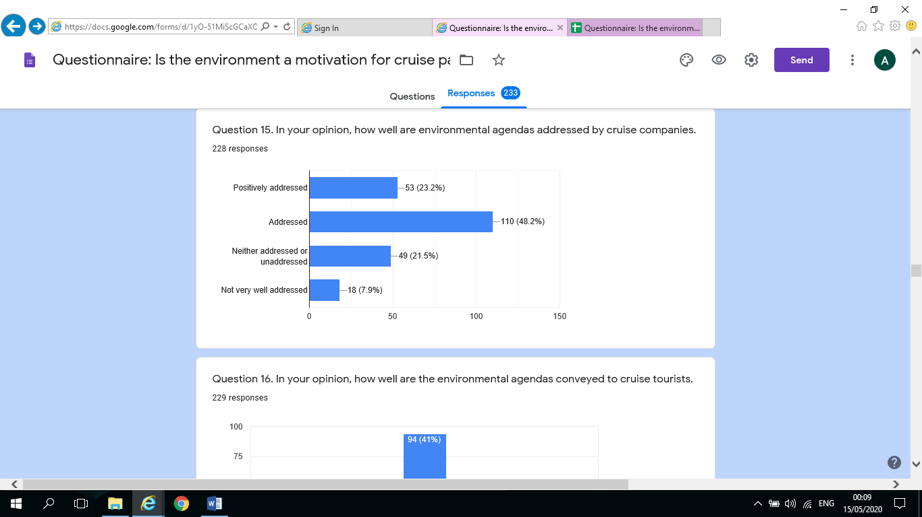

Q16. In your opinion, how well are the environmental agendas conveyed to cruise tourists. – 229 responses
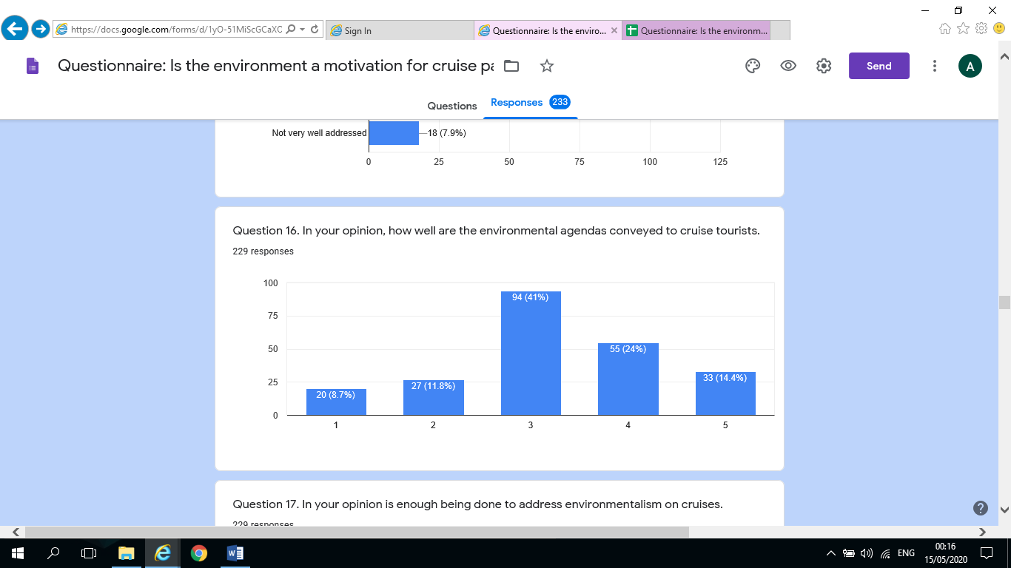

Q17 in your opinion is enough being done to address environmentalism on cruises? - 229 responses
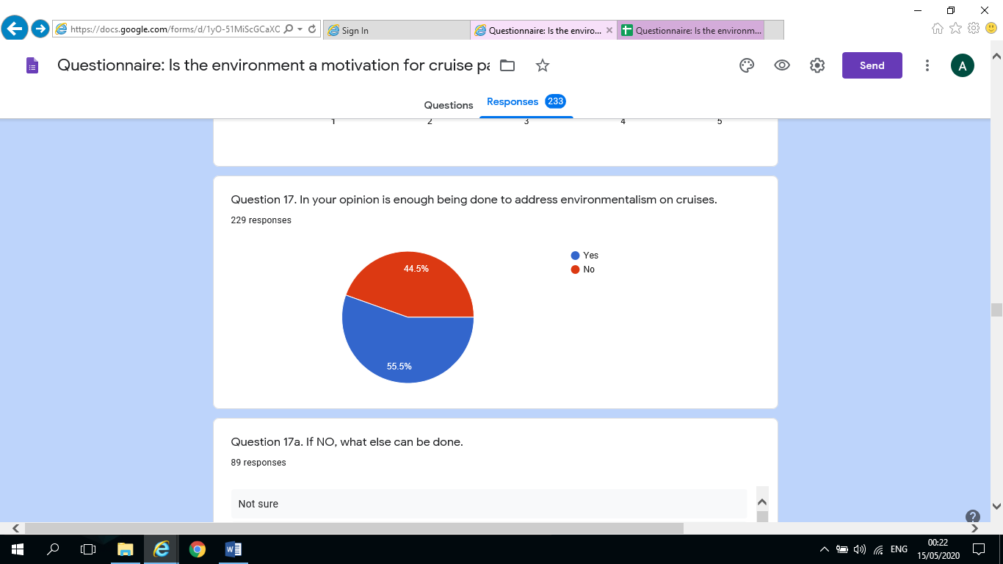

Q17a. If NO, what else can be done

Not sure
Don’t know
Make engine discharge better
Make their customers and staff more aware and abide by rules
Smaller ships, less food waste
More advertising about what cruise companies do to benefit the environment
Cleaner fuel options such as P&O Iona when she launches
X
Too many ships in some ports
It’s hard to answer when you don’t know what can and should be done, if cruise companies were doing enough, surely they’d be telling us and I don’t remember being told what they’d been doing
Enough will never be enough
More publicity
More information on board and before how we can behave or look after destinations
Sustainable fuel, prevent building of even bigger ships, less food waste
Use far less plastic
I don’t know as not an expert
More awareness and development of zero emissions cruising
Encourage guest to recycle
Improvements in fuel usage, choice of ports for some of these large ships, they shouldn’t go to tiny places
Make it part of the booking/sale process which you have to tick to say you have read and understood
All ships change fuel type, maybe plug in dock side when available to save burning fuel into the atmosphere
Use lighter fuel, i.e. not heavy oil
Education
I am not really sure because I don’t know what is being done or what environmentalism really actually means
Stop cruising ASAP at first sign of trouble
Should stop toxic discharges
I’m not sure but I’m all for regulating and keeping our earth safe and controlling pollution and protecting wildlife
I don’t know. I am not that well informed
Make people aware
As mentioned my ideal would be that apart from the fuel used the immediate environment is left as if the ship wasn’t there. No dumping of anything out at sea.
More info on web pages to enable people to make informed decisions
I go to environmental information talks by the Environmental Officers but not many other bother
More on energy conservation, better cleaning of engine exhaust gases
I really couldn’t say
Don’t know but there must be a huge impact on the environment. However so does all forms of tourism
Passengers need to be environmentally aware
Not really sure as not always aware of all that is being done
More inspection without pre warning
Better checks some lines lie about their rubbish/garbage disposal
Address waste issues, address impact of several cruise ships arriving at port together e.g. Venice
Fuel type waste needs looked at
Discuss it during Safety Drill specifically
It depends on the cruise line and the vessel
Look at different fuel source, adding solar power not using bottled water as ships have water fountains, not using plastic cups reducing paper making all excursions environmentally friendly
Let travellers know more about the important aspects of it
Disposable of waste
GPl
Not enough but that applies to all factions of life
The cruise companies could stop the illegal discharge of grey water when inside the limit, they could enforce hand hygiene no wash no eat. Cabin hygiene could be better and HVAC systems properly balanced and up graded
Should eradicate use of bunkering fuel, should utilise electric energy supply in port to reduce port pollution from running diesel engines
Too much plastic in cups, bottles etc.
Reduce waste paper and plastics
Checks on fuel being used
Consideration for small ports
Not sure
Stop going to Venice and possibly the fjords
Have no disposable items at all to cut down on waste
Not sure maybe make it more visible
Ban the building of any more really large ships. Phase out older more polluting ships
Less use of cotton napkins. Fewer changes of towels
Make passengers more aware
Towels and bed linen replaced less often
Use shore supply electric power in ports. Do not use dirty fuel when outside national waters
Reducing total on-board power consumption, and therefore emissions. Cleaner fuel.
Better regulation
Less plastic, food waste and fuel consumption
Maybe better client education and involvement? E.g. actively recycling on board by passengers
It’s a matter of speed to change, plus most cruise companies at USA owned and thus in general more money aware than environmentally aware
Reinforce environmental actions with customers as these are not always high on individual agendas
I’m not really sure but I’m sure a lot could be
Perhaps lectures
Fact sheets
Fuel type used
Reduce the number of cruises to threatened environmental areas such as the Artic
Maybe a health warning like cigarettes, maybe government legislation like cares with a time limit to comply? Ditto global
Unsure
I’m not sure. Maybe one day better fuels for ships
More information
Cleaner engines, less passenger per ship, less ships per harbour
Minimise food wastage and invest in better fuel technology even if dearer to use
N/a
Reduce waste
I hadn’t given this any thought

Q18. What do you know about the level of impact on marine wildlife on locations by cruise companies? – 179 responses

Nothing
Not much
Nothing
Very little
None
Not much
Not a lot
Little
Not aware
Not a lot
Not sure
Not much
None
It damages marine life and animals
There is a lot of impact on marine birds and animals
N/A
Limited management to reduce impact
Not sure
A little
Not much
Driving the animals further out to sea in some destinations possibly
Obviously from programmes like Blue Plant
Excess waste
Can be fatal
Nothing to be hones
Do not know
Only that rubbish especially plastics can impact on sea life
I don’t
No idea
Not a lot but tourism is sometimes the only income for some places visited
Little. Albright they do have educational talks now. And agencies such as ORCA are using the boats to track animals
Think differs with what location your happen to be in
Speed slowed down for whales
Not a lot but it must be significant
None
I can imagine Caribbean cruises disturb the marine wildlife and possibly destroy their habitat with pollution
The ships themselves are no worse than a regular ship. the keels are not hugely deep. The impact probably comes from the gests, snorkelling etc…. but tbf. What about the impact from all the shore based hotels and the flights to them… when is there a questionnaire addressing those issues? Compare a cruise ship to Benidorm, Malaga, Barbados, Florida, New York, London, Florence Rome, Athens… name anywhere you like where people fly to be there….and stay in hotels…how about Prague or Amsterdam… all those hen and stag parties flying abroad for a few days…far more impact than cruise ships…but no, no questionnaire having a dib at those options. Ban flying. Ban short haul holidays to the Costas they do far worse than cruise ships. And what about festivals…what impact does say Glastonbury have on the community and environment there? Who measures that…why don’t they move to ban that too.
P and O do a save the seas policy, it is in every cabin what you can do to help them look after the sea
A good cruise company always considers the environment
Nothing but I would imagine in certain areas it would affect as not usually a tourist area
It can be affected
Nothing, sorry!
There will always be an impact the same as land based holidays no matter what measures are in place but certain things can be done to minimise the risks and even help to enhance our marine life
It can pollute the air, hence having a diverse effect on wildlife
A lot
Not much but am against dredging to provide berthing
Definitely the cruise industry effects the marine wildlife
Pollution hurts the animals
Somewhat
I do not know anything specifically but anything that enters the ocean that does not belong there has to affect Marine life
Could learn more
Not enough
Not that much
Haven’t a clue
I don’t know…but this questionnaire is making me think about it!
What we read in the papers
Not read any studies
Mostly from locals when on tours
Not a great deal
Very little, but seemed very aware when we went to Australia and New Zealand
Very little
No
Lots
Not much apart from the type of Sun lotion allowed
I know nothing
Must affect marine life the same as cargo ships would. Pollutants may cause decrease in some species.
Not very much
Not aware
Nothings
Some
Sorry none
They do support the wildlife not sure it it’s enough
As far as I know, they have information sessions on board about protecting environment
I know that MSC is taking strides on marine life on their private.
Stop excursions with animals
Yes
They often hit whales and the discharge of grey water effects fish
Improving but some ships still guilty of dumping waste at sea
It’s not as bad as fishing vessel
Don’t know
Propeller damage to marine creatures, emissions into the sea, discarded waste materials
Not very aware
Disturbs wildlife
Not a lot
Varies. Like thousands of people walking over Coral, sunscreen in the ocean etc.
Believe Cunard is very conscious and does everything possible to limit impact
Not very much but aware of the general impact of west and plastics
Not a lot, but guessing it wouldn’t be good
Lots too much for a little line
Pollution from tender vessels to beach locations
Yea
Little other than plastic
A little bit
Probably not enough
Nothing
I am unsure
None, and black water holding not releasing
Marine wildlife is enjoyed by passengers. Local wildlife funded by cruise companies symbiotic
Generally, neutral
I have cruised with people from environmental companies searching for whales and other marine species which suggests they offer increased awareness of the animals.

Q19. In your opinion, how environmentally friendly are cruise excursions on a scales of 1-with 1 being not very friendly and 5 being very friendly. -225 responses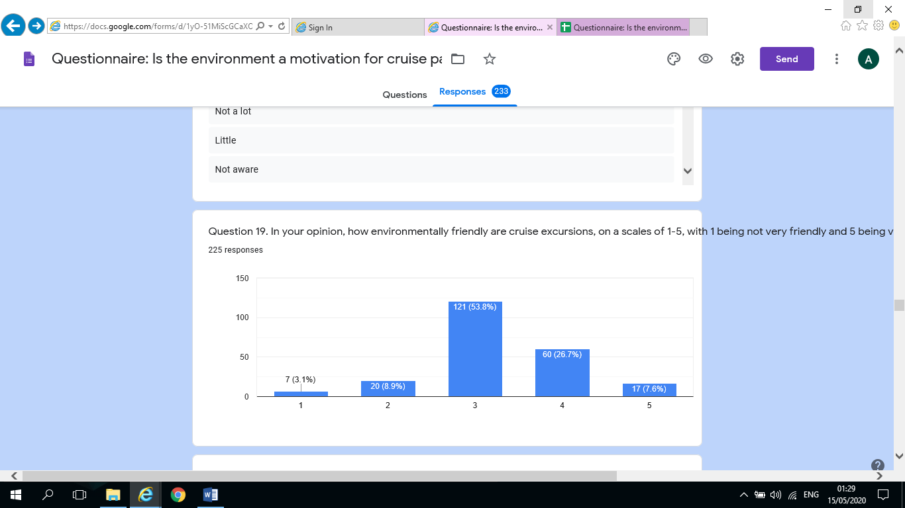Q20. Do you think cruises have more or less impact on the environment than other types of tourism holiday on a scale of 1-5 with 1 being more impact and 5 being less impact? – 225 responses
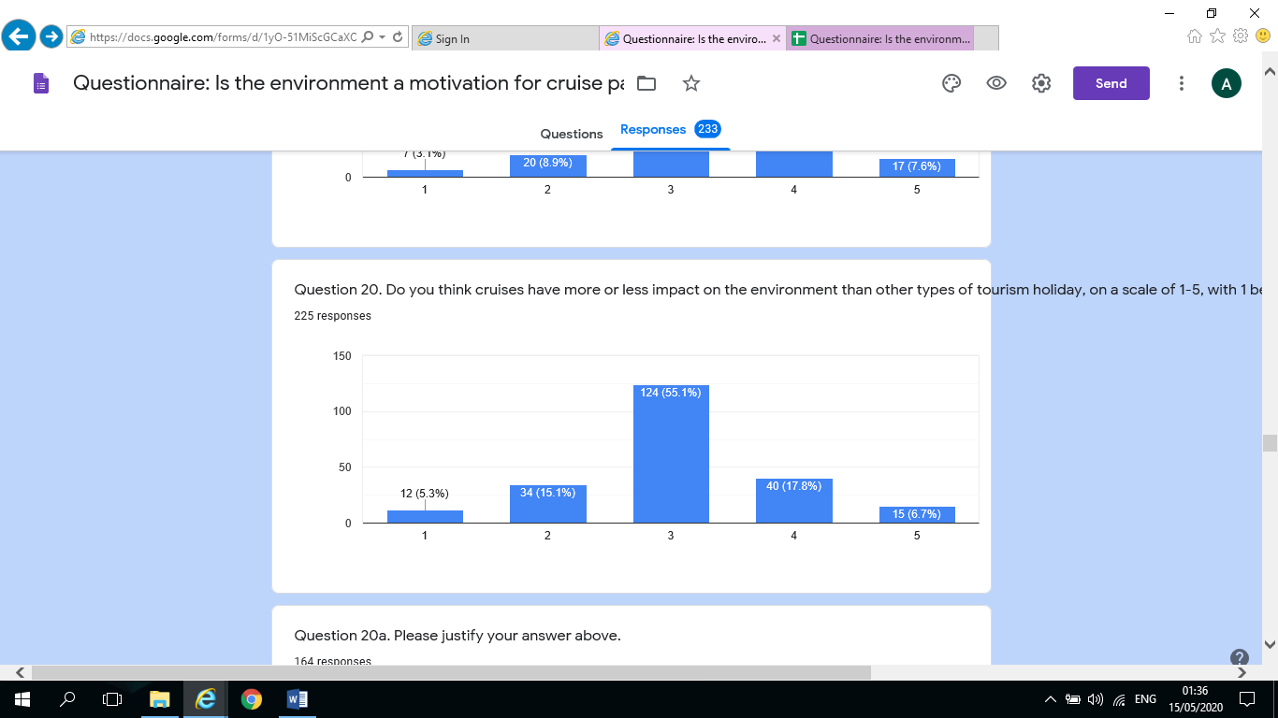
Q20a Please justify your answer above. – 164 responses
I don’t know
Not sure really
I also use a motorhome leaving a very small carbon footprint
More impact than train holiday but less impact I feel than aviation and car use. Emissions per person I imagine smaller
Ships produce a lot of carbon
A lot of waste is dumped into the waters
Not sure
Constantly active on the water. Long periods of time for holidays
The same
Fuel used/air pollution caused
They are very well planned unlike individual holidays
They all have impacts. Simply getting people to the location may have means many thousands of kilometres of travel regardless of by ship, air etc.
Planes, taxis, hire cars etc. for package holidays
Cruise ships with 6000 pax and crew have a huge environmental impacts.
The amount of people who travel at once
There is a negative to all types of travel but many economies rely on it
Cruise ships are no different than heavy traffic, trucks, coaches etc.
I don’t think cruisers would impact much because they don’t spend much time on land compared to people staying in resort’s or holiday destinations
I would think such a Venice would have more detrimental environmental problems. That most other destinations where cruise ships find themselves in
No flying
A lot of people on one vessel reducing additional travel emissions
Both must have an impact
Just seems that many more people descend on a port but if you added up all the people arriving in one day by lane this might balance
Pollution from fuels burnt. Size of ships
Polluting seas/oceans
They are doing their best to protect the environment
No worse than plane travel and litter impact of land holidays
Flights would be worse I think
Do more than hotel holidays to help the environment
Tourists in large numbers would impact the environment whether land based or cruise ship. Many countries depend on tourism for their livelihoods
I’m really not sure
I have above…it’s just folks who don’t go on cruises having a go at them because it doesn’t affect what they like to do…Ban flights…they do much more harm. In fact, if you follow the charts exampling global warming you will see that the number of flights closely mirrors the warming since 1979 to 2017…the figures after that time alter slightly and that is due to new aircraft being slightly more environmental… well cruise ships are also becoming more fuel economic too and that will show in the same manner

They all have an impact
Tourism and hotels have ruined places like Bali, but a day visit from a cruise ship does not leave a heavy footprint
Most holidays use flights so fuel usage is similar
Big ships have to create more hazardous conditions in the ocean
Same as standard holidays
If you have a large amount of tourists in one area being a cruise ship or a land holiday there will be an impact due to volume of people
Think cruise companies and their passengers are more aware of consequential damage
Shore based holidays create less carbon dioxide Nox/Tox than cruise holidays due to the fuel being used to travel
It varies depending whether they sail from the UK, or have additional flights too
I think they are trying their best to reduce their impact
All tourism has an environmental impact
Everyone trying nowadays to be environmentally aware – so expect all holiday companies must have a policy for this
I would think on the same level as other tourist holidays
Mass transportation means fewer individual journeys
I think they both have impacts
Different locations mean same problems repeated again and again
Cant “justify” a perception
Potential damage to marine life
It’s a personal thought, probably both types impact
A cruise ship is transport, catering, leisure entertainment and hotel. This has not been properly addressed when blaming the cruise lines. Some ships filled with passengers like sardine tins are evil, others aren’t, even if they are large
A lot of it is down to the behaviours of the tourists
In and out in one day some ships hold 6000 passengers this why we travel with Tui as they hold about 1800 passengers
Air traffic cause pollution as do cars and people create rubbish to
Amount of effluent into oceans is disturbing
The fuel is less polluting than air travel
Could not really answer the 2 previous questions as I don’t have any understanding on cruise environmental impact
When you are on shore in a tourist destination there are excursions organised via bus/boat, etc. just as there would be if you were land based in a hotel
The cruise lines try not to damage fragile environments
Unsure myself what they are or aren’t doing
Less air pollutant
Do not know the answer to this question
I’m ambivalent
No more or less than a beach holiday
Lack of in-depth knowledge prevents me from giving an honest answer
I thin flying and motoring are worse, we never fly to pick up a ship, if it doesn’t go from Southampton
Use dirty fuel and dump rubbish wherever is cheapest
More pressure has been put on cruise lines than other forms of travel
Not a very efficient way to travel
Potentially more impact because of nature of visits. However, if environmentally encompasses economic impacts cruise companies can enhance sustainability of local communities
Not sure
Unable to fully comment as never looked at impact of other holidays
We are encouraged to reuse towels, sheets changed less often, o ship food taken ashore
Big amount of passengers on ship might have impact on environment, but so does a lot of people on a beach
Huge amounts of people turning up at the same locations at the same time on mega-ships
Cruise ships size of increasing greater footfall in ports
Don’t know how impact compares to other holidays
No worse than aircraft
The ocean is the last un-spoilt place on earth. Cruise ship are in the ocean spreading bilge water and pol water from one area to another. This includes microorganisms. They also have barnacles, an and other sea life that gets migrated along with the ship. Other types of travel (e.g. trains busses) don’t move the environments or flora and fauna from one place to the next

Same as a hotel
Depends on the kind ship/cruise and excursion
We all have an impact wherever we go we have to be mindful at all times
They don’t leave any rubbish around
All tourism has an impact on the environment. Unfortunately, it’s part of the globalisation and provides positive economy to the locations visited.
Don’t actually know one way or the other
Less impact than flying
Less pollution that long haul flights
Personally no they don’t cruise companies are aware of the environmental issues
So many people visit at the same time
All tourism has an impact on the environment, especially flights, but cruise lines are managing the impact better with new technology
No data to compare
Huge number dumped on small community
Pollution
Airlines are less environmentally friendly than cruise ships for the same number of passengers over the same length of journey

Q21. How mindful are you in your behaviour when considering the environment when on a cruise holiday? – 227 responses

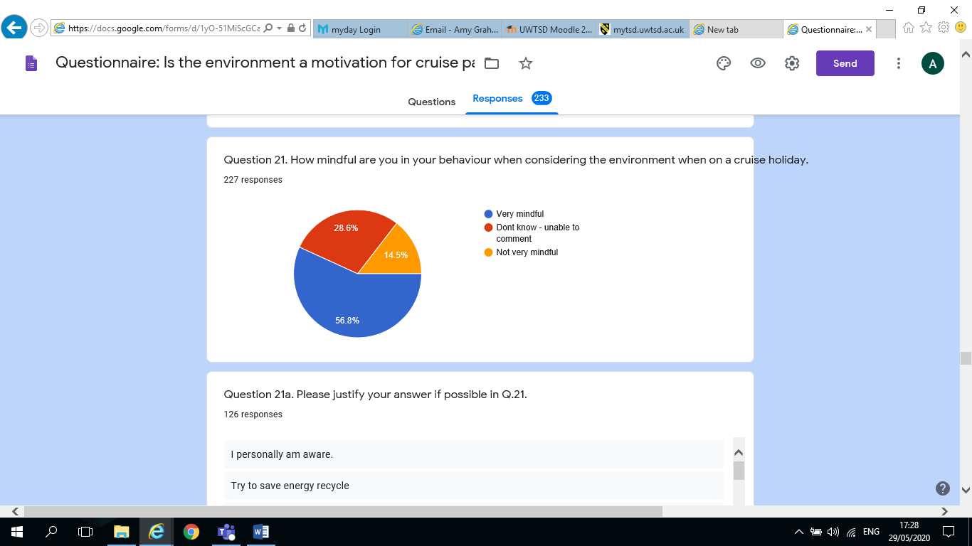

Q21a. Please justify your answer if possible in Q.21. – 126 responses

I personally aware
Try to avoid waste and reuse items
After checking the lines environment statement, I don’t really think about it
Try not to fly to cruise holiday
Don’t throw thing overboard
Unsure
I recycle when I can
Mindful about rubbish disposal and recycling
I am a consumer. I can’t personally do anything about the standards set. If I had another option at the same price I would choose it. Comes down to destination and price
Sounds terrible but I’m on holiday
We will use reusable bottles and dispose of litter effectively. Try and walk around ports as you see more
In terms of keeping my towels until they need a wash and using refillable bottles – I recycle if there is provision, I switch off lights and also try to be mindful of not over consuming
I think cruise companies are very aware on environmental issues, and do their best
Always dispose of rubbish in appropriate places or take it back to the ship for disposal. Try not to disturb the environment I visit
Price destination dates are our priority
Conscious of behaving correctly in living nothing but footprints and taking nothing but memories
Tour operators give guidance and I try to follow the requests
Leave no rubbish behind. Take no food off the ship. Only walk where allowed Mindful of where ship dock relative to area visiting
I do what I can but would not be a bore
Do not really consider the environment on a holiday
Try to be as conscious as possible about the effect of tourism on a country
I am very aware to take only pictures and leave only footprints. I look after everywhere I go, I never litter and do my best to reduce my own impact
Try to save energy recycle
I am afraid it is something I don’t think about in holiday
I am going on holiday, I have more important things to think about
I try and watch my carbon footprint, limiting water usage and definitely not throwing garbage anywhere except receptacle
Ensure I dispose of rubbish in re-cycle bins where possible
I am mindful of the environment wherever I am. Recycling everything possible at every opportunity and adjusting to the environment I am in
Important to respect local customs, procedure and flora/fauna
Is use the correct disposal systems provided on-board and don’t throw anything over the side
I don’t expect the towels to be changed every day. I do not drop rubbish overboard. If I go to a beach I pick up rubbish, in the same way as I do when I go to the beach in the UK
Definitely aware of not changing towels etc. so often. Don’t buy plastic bot
I’m on holiday
Throwing nothing overboard
Don’t drop litter or interfere with a country’s policies on the environment
Various age groups travelling together from very young to very old
If I see any paper napkins, straws paper etc. lying about or blowing about the decks I bin it
Requesting changes of towels and bedding a little as possible
Try to recycle and be energy efficient
I behave as if in my own home
Do my best within the constraints of the system
I sort my waste and avoid using plastics
Do not want this to affect my choice
I don’t take part in organised tours when they are not considering the locals and their environment
Ensure that we create minimum waste, reuse towels, etc.
Making sure any trips are in line with wildlife organisations
I want to leave it for my children the way if found it
Not to throw anything overboard. Use water sparing and reuse towels.
I try and recycle and reuse as much as possible
Don’t know enough about it
Never leave rubbish. Use less transport and walk more
I am on holiday
I reuse towels; avoid disposable
Reuse both towels
Use water stations and not bottled water
We tend not to go on excursions which are culturally enriching and environmentally friendly
Prefer to walk rather than take a bus
I try to stick to the rules, e.g. Dress code, etc.
Environmental conservation for me is very important
I worked for 40 years and plan to travel in my retirement
I am conscious of the environment whether I am away from home or not
Never deliberately pollute the sea or places I visit and treat both with respect
Don’t think of impact of travel, like to travel and explore new countries and don’t consider impact. Do what I can at home using less plastic, recycling, glass milk bottle delivery etc.
Leave it how we found it
All ships have a similar impact. My choice in company will not make a difference. They are all the same
No waste extra washing use of water
E.g. avoid leaving trash
Mindful of leaving the least environmental footprint
Choosing excursions that have minimal impact, picking up rubbish as at home
When on land if I see anyone leaving rubbish I ask them kindly to pick it up.
Wherever we go on holiday or business (cruising or flying) we try to offset our co2.
Don’t put rubbish into the sea or when on land walk rather than take transport etc.
You just don’t throw away anything overboard
Don’t change current habits
Read about it
Careful with rubbish
Look at the journey etc.
Trying not to have the towels changed, for instance
By being conscious of not dropping litter and try to walk around resorts
My holiday is my first concern
Unsure
I do not use any single use item. Bring my own reusable cup, straw etc.
We look at tours offer a positive effect something via funding, and other times simply not taking a bus and walking instead
I wouldn’t stray off the designated path. I listen to the excursion two about the rules
Don’t throw anything overboard
Try to recycle waste at home in the correct manner
I am ware to dispose of waste carefully, don’t buy plastic or cans
We live near the reef + are always mindful of doing the right thing as it also affects us.
Leave as we found.
I don’t really understand the question. I make sure I don’t leave litter. I would pick or destroy flowers. I recycle where I can.
Never considered this before.
Try to stay within the guidelines of the cruise company when it comes down to recycling & the environments we visit.
Towels and sheets not changed daily
Do as I’m told
When I think about it there is always an announcement over the PA
Our tour must consider the environment
I just don’t think of how to be more conscientious
My standards are always mindful of respecting the environment.

Q22. How important is the company’s environmental rating to you when booking a cruise holiday, on a scale of 1-5, with 1 being not very important and 5 being very important. – 244 responses
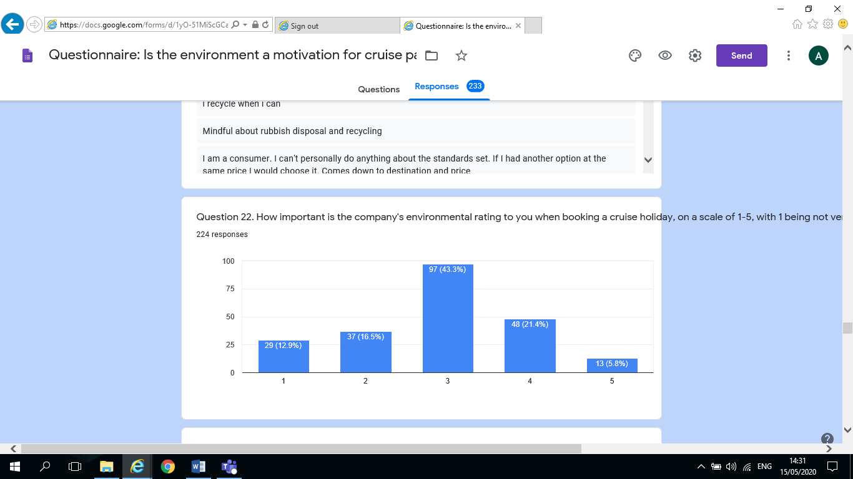
Q23. Would the environmental rating result in you changing your choice of cruise company?
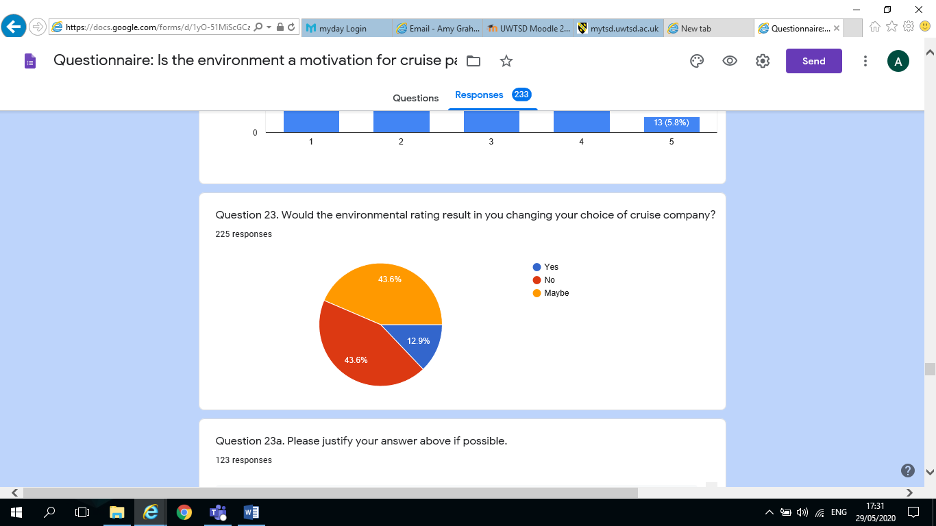

Q23a. Please justify your answer above if possible – 123 responses
Well I wouldn’t travel with a company that I know is not environment aware
It will travel whether I am on it or not
If it was low, I would consider avoiding that company entirely
They are all very much the same in my opinion.
There are other things more important to me when booking a cruise.
I would like to do more
Didn’t know there was one
If a ship wasn’t mindful of their surroundings, I probably wouldn’t cruise with them
I have to travel during half term times so that is my biggest consideration.
But only if the cruise was within budget
All cruise ships are very much like for like
If I thought that a cruise line didn’t care about the environment I wouldn’t use them. I don’t believe any cruise line would deliberately be destructive to the environment.
We would not cruise with any other company. Stay with the company we are comfortable with… wouldn’t risk a change in case we were disappointed…stick with P & O
Not a consideration
Would not want to associate with un environmentally conscious company
I would make sure the company was aware of my concerns and hope others did the same to try to make a change
Like cruise line to be responsible
I trust them to protect it
Depends on rating of other companies
I would need to understand more but I know P & O are doing more on environmental issues.
If a particular cruise company who were running a cruise that fitted with us were more environmental than another one to same fit, then I would definitely choose the environmental option
It would justify my choice
As I said previously it is something I don’t really think about when booking or going on holiday
It would put the subject on our “radar” and if a ship had a very poor rating I would certainly take that into consideration
I just want to go on the cruise I choose, environmental issues are not important to me
There needs to be more information available to cruisers. This would matter to me if I was made aware of environmental ratings of ships and cruise lines.
I would prefer to cruise with a company that is environmentally aware
I would cruise with a certain cruise line as they have been fined more than once illegal dumping at sea. This is a very well know cruise line
It would depend on the reason for the rating and which organisations applied the ratings.
The ratings cannot be trusted as was provided by the $40 million fine
If they had a very poor rating and I could see through their practices that they had little concern it may influence me to look at alternatives
I think all companies are now trying and a small difference between two companies wouldn’t affect me.
They all are pretty much following a policy so a rating would influence me.
Haven’t seen any environmental rating for cruise companies
Price is always a consideration too.
If I know I might change if they still offered everything I want.
Not sure there’s much difference, especially as my current 3 lines are part of the same group.
It would change anything the cruise would still go ahead
Do not want this to affect my choice
More facts could influence my thoughts
Because it has
I am able to judge by myself whether the cruise is appropriate or not. Most ratings are fake anyway.
I like the company ethos and smaller ships which is better for the environment
I feel It’s important I don’t want to sponsor a cruise company that doesn’t care.
If they have a negative reputation, I am likely to drop them
I donor like huge ships and I like the crew to be English speaking and trained
I am very passionate about animals and marine life; my decision would most definitely be affected if I was informed on the effect cruises have on marine life.
I would always go with a company with a good overall rating and also with friend’s recommendations
I think the company I use are fairly environmentally aware
If I thought what they were doing was harmful I probably wouldn’t book it
Don’t feel that any organisations are truthful with reporting of any type of environmental or financial information. They will only tell the customer what they think we wish to know/hear that will keep us interested in buying/consuming their products.
I need a good kids club for my grandson who lives with us full time, so we can get a break.
All ships pollute. Difference between best and worst is negligible.
Marella in my opinion are fulfilling all environmental requirements.
If a company was deliberately harming the environment I wouldn’t use it
Only if the company has had bad press reports
It might sway me
Would be a major influence especially if cruise company savvy enough to focus on that side of their operation.
I might consider another cruise company, if they are more considerate and open about strategies to conserve the environment
I’ve never come across this so I don’t really know the answer
Have never considered it as the information isn’t readily available and maybe it should be
Am not concerned re these issues
Not most important factor to me when booking holiday
If there was a cruise company that actually recycled or cleaned bilge water, pollsters, etc., instead of the current uptake/dumping process, then I’d consider it.
I haven’t got enough knowledge to judge.
Chose one that try more
Would not cruise if very poor rating
We simply love the Cunard experience. Remember man has never polluted the earth as one volcanic eruption
Would expect all cruise companies to follow same guidelines?
Depends if I could get some itinerary at a similar price with a company with better rating.
Not aware there was one.
How are you going to rate the cruise companies?
All cruises abide by current environmental standards and regulations
Always choose Cunard.
How the company handles the environmental is important?
I read and decide from there
If the rating was very bad I would probably not use that cruise line.
I believe ALL companies currently do their best
More info from cruise companies needs to be available recycling.
My holiday is my first concern
Itinerary is my factor
If the company was charged with something more than another line, I probably wouldn’t book with them
If one particular company was particularly bad then I would not use them, however, if it was being unfairly targeted it would have the reverse effect.
Limited choice
Cruising is our only source of holiday and adventure as wife can’s fly
If they were trying to improve
My choice of cruise line based on may factors. No one issue change that.
Don’t want to encourage things to get wrecked quicker.
In Australia there is no information on environmental ratings of cruises
It’s not something I would really consider when booking a holiday. if 2 cruises where similar and the price the same then yes I would go for the one that had a better environmental rating as long as the cruise company was not one that I would never consider e.g. Costa.
Not previously considered
Always use p&o and don’t like flying
Only cruise with Cunard
Depends what it was
The cruise company must have a good environmental record
I would need to know more to make this imaginary decision.
Would expect cruise c I monies to do as much as they can to protect f2f he environment
I’m not sure what that would involve
If it was advertised, it would sway me or discourage
It still depends on the itinerary

Q23a. Please justify your answer above if possible – 123 responses
Well I wouldn’t travel with a company that I know is not environment aware
It will travel whether I am on it or not
If it was low, I would consider avoiding that company entirely
They are all very much the same in my opinion.
There are other things more important to me when booking a cruise.
I would like to do more
Didn’t know there was one
If a ship wasn’t mindful of their surroundings, I probably wouldn’t cruise with them
I have to travel during half term times so that is my biggest consideration.
But only if the cruise was within budget
All cruise ships are very much like for like
If I thought that a cruise line didn’t care about the environment I wouldn’t use them. I don’t believe any cruise line would deliberately be destructive to the environment.
We would not cruise with any other company. Stay with the company we are comfortable with… wouldn’t risk a change in case we were disappointed…stick with P & O
Not a consideration
Would not want to associate with un environmentally conscious company
I would make sure the company was aware of my concerns and hope others did the same to try to make a change
Like cruise line to be responsible
I trust them to protect it
Depends on rating of other companies
I would need to understand more but I know P & O are doing more on environmental issues.
If a particular cruise company who were running a cruise that fitted with us were more environmental than another one to same fit, then I would definitely choose the environmental option
It would justify my choice
As I said previously it is something I don’t really think about when booking or going on holiday
It would put the subject on our “radar” and if a ship had a very poor rating I would certainly take that into consideration
I just want to go on the cruise I choose, environmental issues are not important to me
There needs to be more information available to cruisers. This would matter to me if I was made aware of environmental ratings of ships and cruise lines.
I would prefer to cruise with a company that is environmentally aware
I would cruise with a certain cruise line as they have been fined more than once illegal dumping at sea. This is a very well know cruise line
It would depend on the reason for the rating and which organisations applied the ratings.
The ratings cannot be trusted as was provided by the $40 million fine
If they had a very poor rating and I could see through their practices that they had little concern it may influence me to look at alternatives
I think all companies are now trying and a small difference between two companies wouldn’t affect me.
They all are pretty much following a policy so a rating would influence me.
Haven’t seen any environmental rating for cruise companies
Price is always a consideration too.
If I know I might change if they still offered everything I want.
Not sure there’s much difference, especially as my current 3 lines are part of the same group.
It would change anything the cruise would still go ahead
Do not want this to affect my choice
More facts could influence my thoughts
Because it has
I am able to judge by myself whether the cruise is appropriate or not. Most ratings are fake anyway.
I like the company ethos and smaller ships which is better for the environment
I feel It’s important I don’t want to sponsor a cruise company that doesn’t care.
If they have a negative reputation, I am likely to drop them
I donor like huge ships and I like the crew to be English speaking and trained
I am very passionate about animals and marine life; my decision would most definitely be affected if I was informed on the effect cruises have on marine life.
I would always go with a company with a good overall rating and also with friend’s recommendations
I think the company I use are fairly environmentally aware
If I thought what they were doing was harmful I probably wouldn’t book it
Don’t feel that any organisations are truthful with reporting of any type of environmental or financial information. They will only tell the customer what they think we wish to know/hear that will keep us interested in buying/consuming their products.
I need a good kids club for my grandson who lives with us full time, so we can get a break.
All ships pollute. Difference between best and worst is negligible.
Marella in my opinion are fulfilling all environmental requirements.
If a company was deliberately harming the environment I wouldn’t use it
Only if the company has had bad press reports
It might sway me
Would be a major influence especially if cruise company savvy enough to focus on that side of their operation.
I might consider another cruise company, if they are more considerate and open about strategies to conserve the environment
I’ve never come across this so I don’t really know the answer
Have never considered it as the information isn’t readily available and maybe it should be
Am not concerned re these issues
Not most important factor to me when booking holiday
If there was a cruise company that actually recycled or cleaned bilge water, pollsters, etc., instead of the current uptake/dumping process, then I’d consider it.
I haven’t got enough knowledge to judge.
Chose one that try more
Would not cruise if very poor rating
We simply love the Cunard experience. Remember man has never polluted the earth as one volcanic eruption
Would expect all cruise companies to follow same guidelines?
Depends if I could get some itinerary at a similar price with a company with better rating.
Not aware there was one.
How are you going to rate the cruise companies?
All cruises abide by current environmental standards and regulations
Always choose Cunard.
How the company handles the environmental is important?
I read and decide from there
If the rating was very bad I would probably not use that cruise line.
I believe ALL companies currently do their best
More info from cruise companies needs to be available recycling.
My holiday is my first concern
Itinerary is my factor
If the company was charged with something more than another line, I probably wouldn’t book with them
If one particular company was particularly bad then I would not use them, however, if it was being unfairly targeted it would have the reverse effect.
Limited choice
Cruising is our only source of holiday and adventure as wife can’s fly
If they were trying to improve
My choice of cruise line based on may factors. No one issue change that.
Don’t want to encourage things to get wrecked quicker.
In Australia there is no information on environmental ratings of cruises
It’s not something I would really consider when booking a holiday. if 2 cruises where similar and the price the same then yes I would go for the one that had a better environmental rating as long as the cruise company was not one that I would never consider e.g. Costa.
Not previously considered
Always use p&o and don’t like flying
Only cruise with Cunard
Depends what it was
The cruise company must have a good environmental record
I would need to know more to make this imaginary decision.
Would expect cruise c I monies to do as much as they can to protect f2f he environment
I’m not sure what that would involve
If it was advertised, it would sway me or discourage
It still depends on the itinerary
Q24. What changes have you noticed in recent years with respect to environmental provisions on cruise ships / cruise holidays?

None
None
Very little
Less Plastic
Only personal care
Do not know
Energy saving and recycling
No longer discharging waste into the sea
None
Less plastics
No plastic straws, no plastic flags at sail away, notices up asking you to consider whether you need to have your towels changed
Using technology for bar, dinner choices rather than paper. Only giving paper receipts to passengers on request. Less plastic being used
Cleaner fuels for new ships, less single use plastic use
To be aware of using towels more than once, reduce waste
Slow the ships down to use less fuel
Try not to use “one use” items also only change towels if requested
Less waste, encourage reusing towels, only small ships in certain ports, change of fuel in new built ships
Looking at new ways to power ships, recycling sea water
Changes on-board as to how thing are presented
Stopping the use of plastic straws
Less waste
Changing paper plastic products
More information and more TV programmes high lighting the environmental impacts of cruise lines
Cut down laundry and water usage
Less packaging, making passengers more aware of washing towels etc.
Some
Paper or no straws, water refill station
Less plastic and paper used
Don’t know slower speeds no dumping waste
More aware and actively reducing plastics etc.
Recycling on ships less plastic being used
None
Checking emissions on older ships
Stopped giving miniature toiletries, now use refills. No plastic straws. No plastic flags
No plastic straws, no balloons
Only the no smoking
Only cruised once so far but do have 2 more booked
Cleaning products they use and no more plastic
More rules about littering, more info on line about what they are doing to protect the environment
All plastic cut down on p and o plus they don’t give out plastic flags, small sauce sachets etc.
More recycling and new ship design
You don’t see the change but they done behind the scenes
I haven’t
More recycle bins, no plastic accompaniments in drinks
Less plastic, fuel on new ships
Recycling bins a lot more accessible on ever deck. Less disposable plastics e.g. no straws
Change in fuel type
Better waste management
More cognitive of the pollution
Different soap, water conservation
Not using plastic, some changing to aluminium cans for water instead of plastic
Less use of plastic
N/a
Less individual wrapped foods, less changing of bedding, no straws
Reduction of plastic, frequency of towel replacing etc.
Much more recycling and excursions re much more geared towards the environment
Straws
None, have only been on 2 cruises, last year and year before
Not noticed
Various changes, indicated here or there
They are becoming more sensitive to world attitudes
More info on board on the improvements made
Less paper usage
Environ notices in your staterooms
This depends on cruise lines as it varies, some ships no longer print photos until ordered after you have looked at them online
Unusable paper straws. (you need 4 or 5 for one drink) No lids available for drinks so we spill them everywhere. This has to cause more water and chemicals for clean-up.
Marine pollution and recycling are more important in recent years.
Nothing
No plastic bottles straws. Or disposable picnic items
Cleaner fuel etc.
I haven’t noticed anything recently
Waste disposal
Sanitizing facilitation have improved
Asking passengers using self service facilities to take what they are going to eat and try to avoid over filling plates with food they will not eat. Signs asking passengers not to throw cigarette butts and other rubbish into the sea. Using dream liner aircraft
Tell guests about how much fuel is used how waste is disposed of not putting anything in ocean
Plastic straws supporting local wildlife organisations
Ships have been made more environmentally friendly during recent years.
No plastic straws and notices about reducing the towel/bedding changes on board but I could find out on-line the company policy on reducing their impact if I wanted to
Paying more attention to marine life
New ships new cabins
Less plastics
No food waste is thrown over the side at least not during daylight hours
Plastic use reduced
Cruise ships not dumping waste at sea
They seem more focussed on environment
New ships more environmentally efficient i.e. type of tunnels and water consumption
No plastic straws less paper/plastic packaging, restrictions on discharging detergents etc. at sea. Less endorsement of local animal/marine businesses on excursions where there is direct participation of tourists and interaction with marine life, i.e. dolphins, turtles, stingrays
Paper straws, replacing plastic, tetrad packs of water instead of plastic bottles, ship notes in cabin to reduce laundry and use less towels
Princess were caught and fined for disposing untreated waste. They say they care for the environment but in practice don’t and continue to cost cut
Recycling
No change
More emphasis on reusing towels, sheets changed less often, less food wastage (small portions, no midnight buffet)
Huge difference since the 1980 when all waste was dumped at sea
Not experienced enough to say
Sorting of rubbish, no dumping at sea
None
Reuse towels, not use as much water, retain waste on ship until port and not dispose into sea
More awareness. Balloons no longer used.

Q25. In your opinion, what improvements should be made to the cruise industry in the future with respect to environmental agendas. – 150 responses

Not sure
Don’t know
None
Not sure
Don’t now
No idea
?
More information
Gas fuels and processed sewage disposal improvements and reduce food waste
Better fuel efficiency
More efforts to preserve marine life
Alternative fuels
I’m not sure
Convert all ships to bio fuel or lgp has
Educating their passengers regarding the reasons for changes
I think the newly built ships will be far more environmentally friendly with all the knowledge we have so I would be very surprised if they weren’t being implemented. There are many ways companies can reduce waste and expel it in a better way but of course that means investment and I hope companies are being mindful of this.
I think they do their best, new ships are obviously more environmentally friendly, more electrics than fuel used. Electric pods etc.
Maybe more fuel efficient engines
I can only speak for one company…and we are very happy with them… and NO we don’t work for P & O… just we have nothing to compare to
Dno
Refillable water bottles on trips low emission fuel
Fuel
Ships should run on gas or fuel that does not damage the environment
Be careful of where they dock and what emissions are left from the ship
Cutting down on plastic
Passengers need to be environmentally aware
More modern and less polluting ships, less fly cruises, more offsetting built in to the cost, big ships go to larger ports of call the smaller ships to the smaller ports of call
The emissions from engines should be tackled
None that will cost me money in my ticket price
No opinion
Make ratings and efforts as well as regulations common knowledge and readily available to travellers
More use of LNG fuel
Should always be looking at ways to help the environment / marine life and perhaps having a compulsory donation added on to booking price to help with the cause.
Hips are getting far too large, commercially more passengers equate to more revenue but it is a recipe for environmental disaster if a major incident with one of these juggernauts occurs.
All ships need to burn cleaner oil or be built with a nuclear reactor to drive the motors
More and honest answers
Not sure – perhaps look at the fuel used and food disposal
Selling less plastic i.e. water bottles
Not something I have really thought about.
There are too many mega ships being built.
There ship emissions when in dock and energy saving
Less laundry
Universal use of cleaner fuel
Reduction in exhaust emissions
I don’t know enough to comment
Smaller ships with less passenger, clean engines, keeping all waste on board, not going into sensible areas
Fuel being used
Be policed more and held responsible
Declare how sewage is disposed of
More information advertised to make customers a lot more aware. Statistics would also be beneficial.
Maybe less flying to pick up the ship, more cruise only holidays.
Don’t know
More can be done
No plastic cups, glasses
Type of fuel used to operate ships
More scrutiny
No idea
Control the amount of new ships bring built
Statements in their sales brochures
More awareness
Better regulation and whistle blowing encouraged
I am satisfied with how they are
Ports used
Forcing environmental agendas higher and recognise that these can also be positive selling points!
Tighter regulations as some companies are known to flaunt the rules
Limit number of ships allowed in sensitive areas, limit size of ships and number of passengers
Passengers must be informed and educated about ships impact on environment
Don’t know
Less ships in port
Cheap fuel causes a lot of air pollution and all cruise ships should be fitted with scrubbers
Reduce air pollution
Am not concerned about this
Less plastic, less waste
I don’t know enough about the industry or how it works, to be able to comment
More regular unannounced checks
Be more active
Ports to provide additional power so the ships do not have to keep their generators running.
Some are moving over to more environmentally friendly fuels but this takes time
Fuel
Cleaner fuels
If there are problems, all cruise companies and Government Environmentalists should get together and work on the problems
To continue the spread of more efficient ships, power generation etc.
To think through locations
Lighting
Keep up the good work
Improve the efficiency of ships
Why not use solar panels, for example? The enormous engines should be changed to use less fuel, and pollute less… trying to limit all the waste due to cruisers over piling their plates with food they won’t eat…and ordering drinks they will often leave almost full… all passengers should be reminded that must wash their hands thoroughly before going to the various eateries, and after using the toilets!
Alternative fuel
Environmentally friendly ships new ships
Only those that are essential
More publicity
I don’t know
Encourage passengers to walk into towns rather than take a bus
More of the same
See 17a
In time old vessels will be replaced by more environmentally friendly ships.
Id don’t know
Think about waste going into the ocean, oil spillages, less plane travel
IDK

Q26. In your opinion, what will the future most likely look like for the cruise industry. – 171 responses
Sanitation
Not sure
Given current issues with COVID 19 I think it will be bleak
Smaller than now but striving for cleaner and more environmentally friendly cruises.
Hard to say with Coronavirus but prior to that massive expansion
People will still cruise regardless of what is going on
Different fuel systems are a must
Good but not for the environment
Scrapping older ships quicker
Busy
Right now, with Corona virus, the future looks pretty bleak.
I’m unsure but I think as more people start going on them they will make more money and I hope that can be put into environmental factors
Unless government decide these liners have to meet tough regulations I believe they will continue to pollute the oceans as they do currently but I think there are improvements being made by the majority in terms of reduction of pollution
A shrinking due to Covid-19, with only the most financially secure surviving
Good, as ships are being built they will too become more environmentally friendly
I think it will be a long time before things get back to normal after the Covid-19 disaster. Cleanliness will have to be foremost on the agenda
More environmentally friendly
Better I hope
I think it will grow it is becoming more and more accessible with less formal environments to appeal to a wider demographic
At the moment because of the virus not good
More regulation
I hope it is good
Less passengers, no buffets, more cleaning. No going to some places PNG Venice Iceland Alaska
Less places to dock in future
Coronavirus!!
Doubt full after the virus
Dire after Corona Virus
No change
During and following this current crisis cruising would probably have reduced amount of passengers
Need to keep up with the impact of environmental issues and adapt themselves.
Continued growth shore based holidays are more damaging to the environment taking all the impacts into account…flying all the hotels, all the facilities that go along with shore based holidays, cafes bars restaurants, sewage systems, service provisions etc…all gigantic compared to the same serving cruise ships
It will grow but must become more environmentally friendly
At the moment I don’t know as we are in the middle of the Corona Virus Pandemic so there is a lot of uncertainty
Growing
Hopefully remain the same
It’s not looking good!
More environmentally aware
Difficult to answer in the current situation (re Covid-19) before this outbreak I believed they were going to become increasingly popular due to the many different variations you get with different cruise lines (adult only, formal, casual, family friendly, water parks on-board)
It is every growing industry the ability to have a moving 4/5-star hotel, with all amenities that visits 10 or 12 different places in the space of 2 weeks is a great attraction but my personal fear is that the industry will be the architect of its own demise. I worked for British Shipping for 20 years and have cruised regularly for over 25 years
Pretty poor since the virus
Not given it any thought to be hones
Think it looks very bleak with Corona virus
We get back to normal
Becoming more popular
Less venues available. The industry will continue to grow as it is so popular.
Will take some time to recover after Covid-19 problem
Continue to expand
Hopefully they will build smaller ships. Too many large ships
Probably become less popular
Good if they become environmentally friendly because everyone is aware now mostly
Challenging as competition is so fierce
Uncertain given the Coronavirus
It will continue much in the same way but I thing now we have massive ship we could start to see some smaller ship.
Good
Currently very worrying
Dire
Really difficult since the CORONA lockdown. They will have to intense the business, more passengers per ship and more sensible areas to go to attract attention
Don’t know
Cruise ships will be limited to the places that they can visit due to environmental impacts. For example, Venice.
Difficult after coved 19
It will increase again
Maybe smaller ships discharging less people into the ports
Dire
No different unless something was done to make customers more aware of the environmental impact
Fewer but larger ships so less pollution
I think it will be continuing to grow but destinations will have to have quotas
Less cruises but that’s due to COVID 19 rather than environmental factors. More should be done
At the moment, not good
Less ships and fewer cruises. Corona Virus
Dire
Cruise industry will suffer a major downturn. Corona virus relayed
Big
Very grim at the moment with coronavirus
I personally think people will not change their opinions on the way they want to travel
Could be over saturated
May become extinct
Fairly bleak – going out of favour. CV19 hasn’t helped
Now that we are dealing with COVID 19 I believe things will be very different and that hopefully the cruise industry will survive and thrive
In the present environment who knows!!!
Unsure due to Covid-19
With current ban on travel due to Covid-19, travel and cruise industry will be reducing
Younger people/families will be cruising meaning us older people will not be encouraged to cruise any more
I think the virus will destroy a lot of travel industries
Bleak after Covid-19
I don’t know
Hopefully less mega ships especially as many ports are tightening their visiting
Rules
Bleak, multiple problems, pollution, health and welfare, hygiene, reduced access to ports
Not sure after Covid-19
Unsure
More expensive, limited creation of new vessels
I think Coronavirus will be of bigger impact than environmental issues in the near future. I think ships will be healthier for passengers, but not necessarily for the ocean. I think environmental issues will make a back seat to the health and financial issues
Bright
Hard, but growing
Unfortunately, more cruise ships on the sea
Following Covid-19, I would increase my cruises as I do not believe Aeroplanes will have enough social distancing compared to Beautiful spacious cruise ships.
Bigger ships more resort style not going very far
It will decline

Q27. Gender – 227 responses
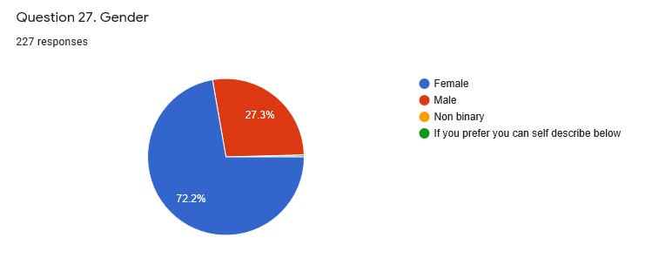

Q27a. Please self-describe below if you prefer. – 27 responses

Retired
I live in Australia. I’m putting it here as my country doesn’t come up below.
Female
NB. Question 21 my location is South Africa
I use cruise ship like a ferry as I don’t like to fly
Retired educator
I am 61 years old. Married. I don’t work now so live on my husband’s pension until I can claim my own pension in 6 years. We save a long time for holidays
Early retired, active, environmentally aware. Resident in France
Physician
Active
This is in relation to QUESTION 31 I LIVE IN TASMANIA, AUSTRALIA
Healthy, white male
Old man
Retired airline employee
Retired with a comfortable income
Retired language teacher
51 female
Mr
Q31 I live in Northern Ireland. As a travel student you should know the difference.
Environmentally conscious of the need to conserve our finite resources
Human male, would have answered male but you included non-binary in the choices, so ask a stupid question, get a stupid answer
Retired professional
N/a
Caucasian

Q28. Age – 227 responses
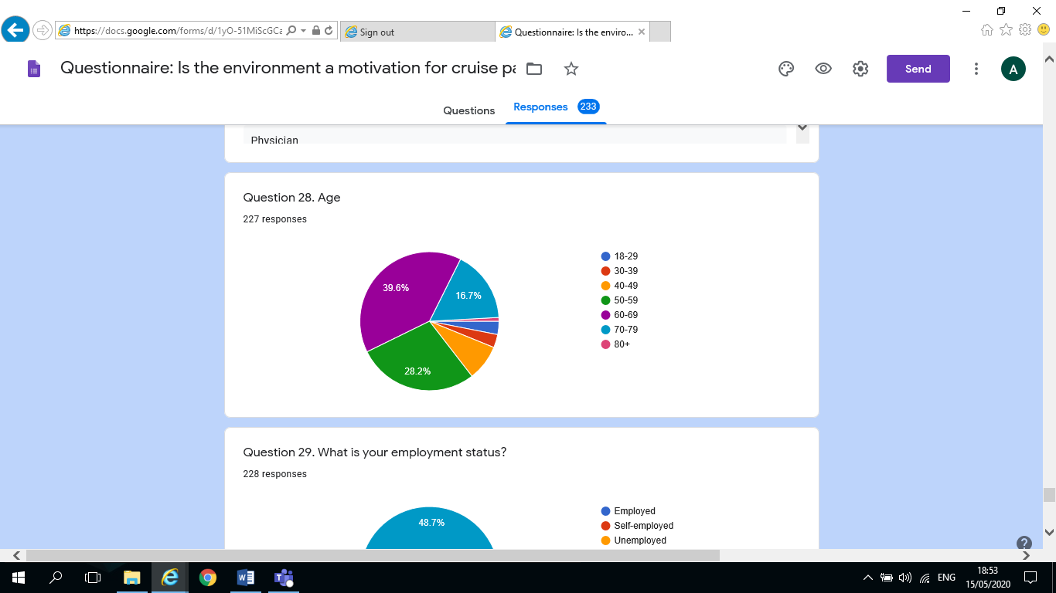

Q29. What is your employment status? – 228 responses
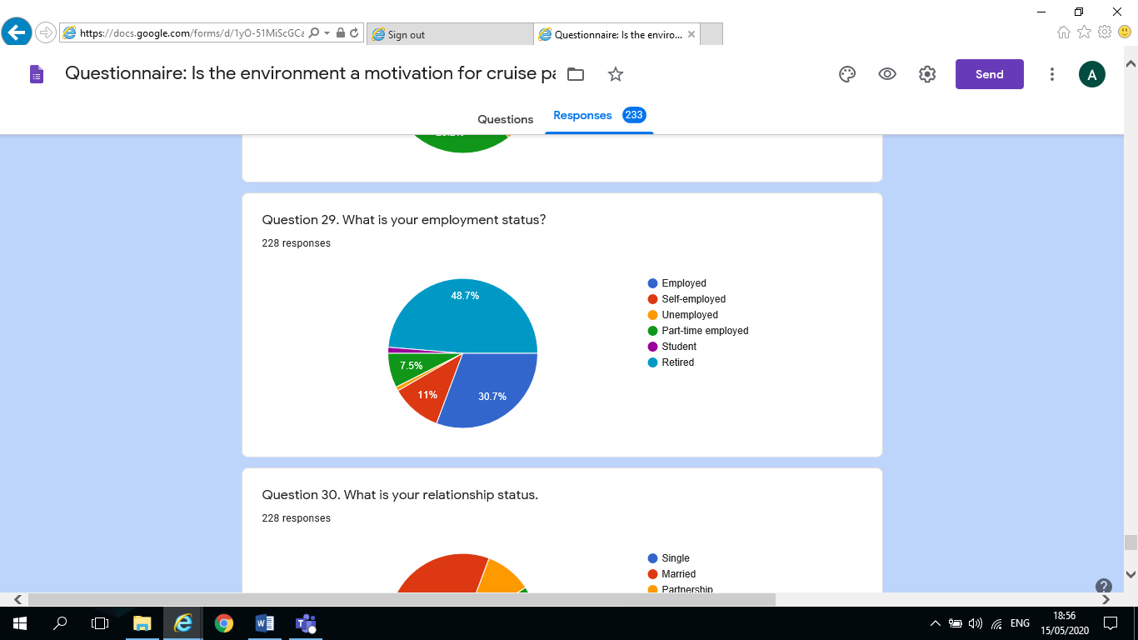

Q30. What is your relationship Status – 228 responses

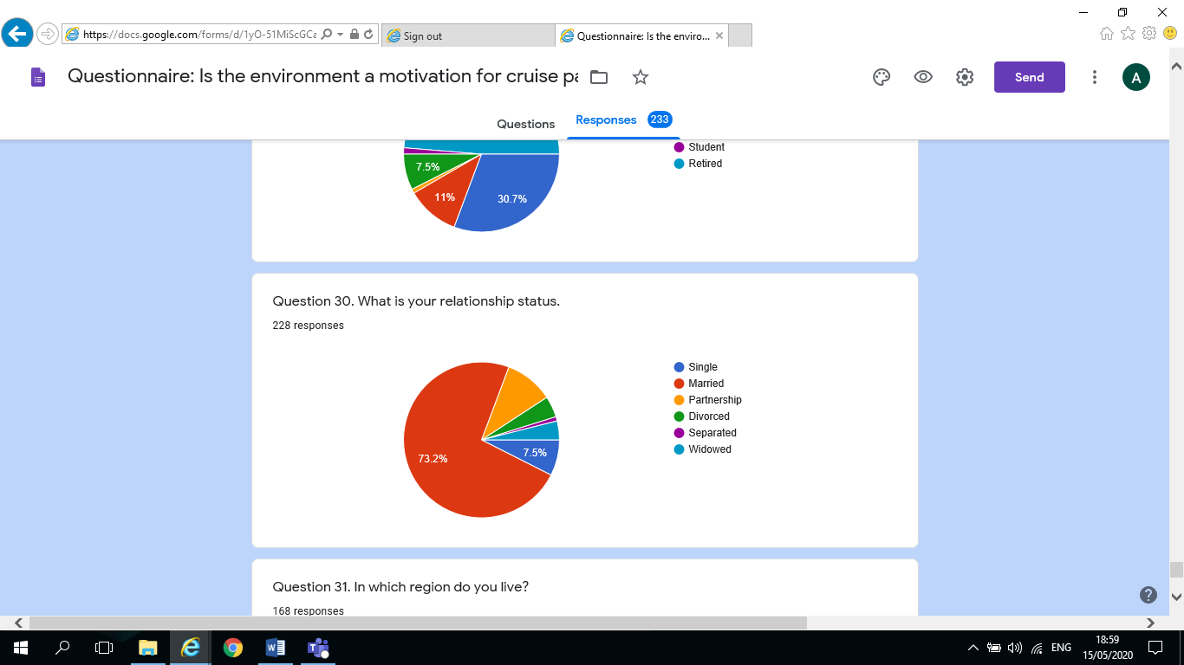
Q31. In which region do you live? – 168 responses

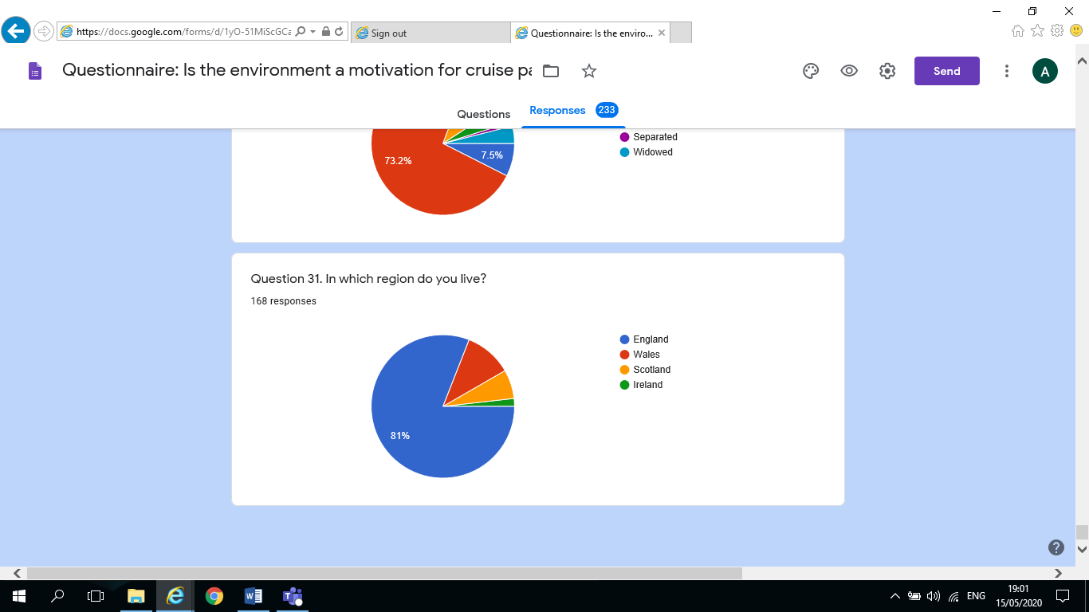

APPENDIX 4: BLANK INTERVIEW QUESTIONS
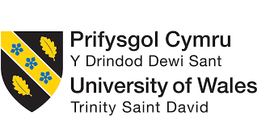

Hello,
My name is Amy Graham and as part of the final year of my degree, I am writing a dissertation the topic is centred on “Cruise Tourism” and specifically I aim to understand more about the Cruise Industry and whether the environment is a motivation for cruisers when choosing a cruise holiday.
The data collected from interviews will be kept by myself and the University of Wales Trinity St. David, Swansea, however, all the data collected will be kept anonymous and confidential and only used for the purpose of this dissertation. If you wish to retain a copy of this interview, please contact me and I will forward it on. My student email address is as follows: (1900375@student.uwtsd.ac.uk)
Thank you for your participation and help in this matter.

INTERVIEW QUESTIONS:
Please can you complete the following and email back.
Please state your agreement: (Tick the box);
I hereby understand and acknowledge that the data collected in this survey will remain anonymous and confidential and will be used by the University of Wales Trinity St. David for academic purposes only. I hereby agree to taking part.

Q1. What is your position in the Company?

Q2. How does your company comply with “Global Legislation” with respect to Cruise Holidays and the environment?

Q3. What level of emphasis is placed on Environmental aspects by your Company?

Q4. What is your company’s strategic positioning with regard to tourism and sustainability/environmentalism? (Particular policies/strategies Initiatives/measures)

Q5. What is your company’s strategic positioning regarding sustainability/environmentalism with regard to Cruise Ships? (Particular policies/strategies? Initiatives/measures)

Q6. Comment on your company’s levels of effectiveness carrying out/addressing such sustainability/environmentalism based policies/strategies.

Q7. How aware do you believe Cruise Tourists are of Environmental agendas? Do you feel it influences their choice of holiday/cruise?

Q8. To what extent does environmental issues/concerning impacts/influence the choice of cruise holidays?

Q9. At what point in your marketing strategy/campaign is your position/policies regarding how effective your initiatives/measures are being dealt with regarding environmentalism to your potential cruise passenger? (First point of sale/brochures/on-board ship)

Q10. How has your company’s approach changed in recent years with respect to environmental concerns? (How effective are these employed changes?)

Q11. What improvements, if any, do you feel your company could introduce to further address environmentalism?

Q12. What does the future hold for Cruise Tourism?

Q13. What does the future hold for Cruise Tourism with specific regard to Environmental Agendas?

Q14. What Moral/Social obligations do you feel the Cruise Industry has in informing/educating the Cruise Tourist on environmental matters?

Q15. Does your company carry out any action with respect to this?
(Informing/educating the cruiser)
(Adapting/encouraging behaviour changes in the Cruiser)

Q16. Should the Cruise Industry be doing more to encourage more Sensitive Minded Tourists re., Environment? (Not just profit driven?)

APPENDIX 5: INTERVIEW QUALITATIVE DATA – CONTENT ANALYSIS

INTERVIEW QUESTIONS - CONTENT ANLYSIS – ON-LINE WEBSITES

P & O CRUISES, Carnival Corporation plc., Sustainability Report 2018 [Online]
(https://www.pocruises.com/environment
[Accessed 20 April 2020]

All answers to the following questions were taken from P & O Cruises Sustainability 2018 Report:
Q1. What is your position in the Company?
N/A

Q2. How does your company comply with “Global Legislation” with respect to Cruise Holidays and the environment?

Our Environmental Commitment
P&O Cruises and our parent company Carnival Corporation and plc take our environmental responsibilities very seriously and are committed to reducing our environmental impact.
We are dedicated to preserving the marine environment in which we operate, and believe it is our duty to follow environmental practices which set a high standard of excellence and responsibility
These include abatement technologies and equipment to further reduce engine emissions such as:
• Advanced Air Quality Systems (AAQS) that use proprietary technology to remove sulphur oxides and particulate matter from engine exhaust.
• Cold ironing capabilities that allow us to plug into a port’s electrical grid while in port if the shore side Infrastructure is available.
• Air Lubrication Systems using air bubbles to reduce friction between ship’s hull and the water.
• A performance-based maintenance and engine efficiency monitoring agreement with Wärtsilä, our largest main engine manufacturer.
We quantify, monitor, report and verify our GHG emissions. We developed a GHG Inventory Management Plan (GHG IMP) in 2010 in accordance with the requirements of ISO 14064-1:2006 and The Greenhouse Gas Protocol. Our GHG emissions are independently verified by a third-party. Lloyd’s Register Quality Assurance Inc. (LRQA) certified our scope 1 and scope 2 GHG emissions inventory. For more information on our third-party verification visit our Assurance Statement in the Appendix. We continue to train and certify employees responsible for main engine, refrigeration and air-conditioning plants. We use recovery units certified to meet refrigerant recycling and recovery requirements and we implement programs to reduce Ozone Depleting Substance (ODS) releases

Q3. What level of emphasis is placed on Environmental aspects by your Company?
There is a high level of emphasis on environmental aspects in all areas, such as Exhaust Gas Cleaning Systems, Waste Water Purification, Shore Power, Water efficiency, Waste Reduction, Carbon Footprint, Recycling, Conservation, Responsible Sourcing, Energy efficiency, Clean Water, Singe use plastics.

Q4 What is your company’s strategic positioning with regard to tourism and sustainability/environmentalism? (Particular policies/strategies Initiatives/measures)
ENVIRONMENTAL COMPLIANCE
In 2013, an environmental crime was reported by an engineer on one of our ships. Following an investigation by the Department of Justice, we learned that the misconduct involved multiple ships over several years. We took responsibility and signed a plea agreement in 2016. Our probation includes
a five-year Environmental Compliance Plan (ECP) that began on April 19, 2017. The ECP requires independent audits as well as oversight by a Court Appointed Monitor. In 2019, the company agreed to revised terms of probation to resolve a petition for revocation of probation.

ENVIRONMENTAL OFFICER TRAINING
In 2018, the Environmental Officers (EO) training program was expanded to include a second course for continuous professional development.
IMO AND CLIMATE CHANGE
We remain active and interested in the worldwide strategies and frameworks being designed and developed to address climate change and air emissions. Specific to the maritime industry, the International Maritime Organization (IMO) is the specialized agency of the United Nations responsible for regulating shipping. We participate in IMO meetings and working groups through our trade association, the Cruise Lines International Association (CLIA). In 2018, the IMO established an
initial greenhouse gas (GHG) emissions from ships reduction strategy in line with the COP21 (Paris Agreement). The strategy includes likely implementation of further phases of the Energy Efficiency Design Index (EEDI) for new ships, reducing international shipping’s average unit CO2 emissions by at least 40% by 2030 and by 70% by 2050 (relative to 2008), and reducing absolute international shipping GHG emissions by at least 50% by 2050 compared to 2008 and pursuing efforts to phase them out.

UNESCO PARTNERSHIP – WORLD HERITAGE PROTECTION AND SUSTAINABLE TOURISM
Through our Seabourn brand we continue to partner with The United Nations Educational, Scientific and Cultural Organization (UNESCO) to foster wider support and understanding in the travel industry and among travellers for UNESCO’s mission of identifying, safeguarding and promoting World Heritage sites. The partnership consists of a $1 million financial commitment over a five-year period, which started in 2014.
WORLD TRAVEL & TOURISM COUNCIL (WTTC)
We are members of this organization, which promotes partnerships between the public and private sectors. Carnival’s President and CEO, e Arnold W. Donald, is a board member and in 2018 was a keynote
speaker at the Buenos Aires Conference. WTTC delivers results that match the needs of economies, local and regional authorities, and local communities, with those of business, based on governments recognizing travel & tourism as a top priority, business balancing economics with people, culture and environment, and a shared pursuit of long-term growth and prosperity.
YUMI PROJECT
Our Carnival Australia brand works in economically-challenged South Pacific Islands on YuMi projects, which translates literally to "you and me". Working with the Australian government, Carnival Australia
finds and develops locally-owned shore tour companies in Vanuatu and helps these small local companies overcome the significant hurdles to becoming part of our global supply chain.
4GOOD FOOD PROJECT
Our Costa brand has a unique partnership with the Food Bank Foundation, one of the biggest charitable organizations in Europe with a well-established distribution network. With this project, our on-board galley crew packages safe and ready-to-eat food and donates it to the food bank in the local port. This unique project has now been replicated in nine ports in Italy, France (including their Caribbean provinces of Martinique and Guadalupe) and in Spain. The project has become a source of pride for our crew and created a bond between our ships and the local community by giving a second life to healthy food and to the beneficiaries who receive it.

Q5. What is your company’s strategic positioning regarding sustainability/environmentalism with regard to Cruise Ships? (Particular policies/strategies? Initiatives/measures)

CARNIVAL CORPORATION ENVIRONMENTAL EXCELLENCE AWARD
In 2018 Carnival established the Environmental Excellence Award to honour the ships within the Carnival fleet with the best environmental performance. One ship from each cruise brand is selected and from those one ship is recognized as the best from the fleet.
WORLD OCEANS DAY
In 2018, Carnival's cruise brands celebrated World Oceans Day both on-board and shore side with events, activities and communications to promote ocean education and conservation.
ANIMAL WELFARE
• Farm Animals:
• We continue to expand our sourcing of cage free eggs. Our goal is to be 100% cage free by 2025.
• We continue to align welfare standards for broiler chicken, ensuring that 100% of chicken sourced will be certified by the Global Animal Partnership by 2024.
• Tour Operators:
• We continue our partnership with the Association of British Travel Agents (ABTA) to help us ensure we are responsibly managing excursions involving interactions with animals. We started to audit the dolphin in captivity tour encounters used by our cruise brands in 2018 and our goal is to complete the process in 2019.
CORAL REEFS
In 2018, we sponsored the Coral Restoration Foundation by donating a 7-day cruise. The Coral Restoration Foundation supports coral reef restoration. For details visit: https://www.coralrestoration.org/about.
REMOVING SINGLE-USE PLASTICS
In 2018, we started an initiative to evaluate our collective use of single-use plastic items and alternative options available in the market. As part of this initiative, we have identified items we can replace with reusable non-plastic alternatives or biodegradable options available for straws, take away cups and other items. Our goal is to remove single-use plastics within our operations whenever feasible.
2018 EUROPEAN UNION OUR OCEANS CONFERENCE – BALI
Carnival Corporation provided progress on our efforts to pioneer Liquefied Natural Gas in the cruise industry. This is part of Carnival’s approach to reduce greenhouse gas emissions. The Our Oceans conference seeks public commitments to actions that will reduce marine pollution, manage aquatic resources sustainably, mitigate climate change and establish marine sanctuaries.
PORT BIODIVERSITY
We continue to support conservation programs at the ports we own and operate. These ports include Puerta Maya, Cozumel, Mexico; Grand Turk Cruise Centre, Turks & Caicos Islands; Amber Cove Cruise Centre, Puerto Plata, Dominican Republic; and Mahogany Bay Cruise Centre, Roatán, Honduras. The following is a summary of our main port conservation accomplishments in 2018:

Q6. Comment on your company’s levels of effectiveness carrying out/addressing such sustainability/environmentalism based policies/strategies.

Also covered in Q.5 examples of effectiveness shown above.

Q7. How aware do you believe Cruise Tourists are of Environmental agendas? Do you feel it influences their choice of holiday/cruise?
Each ship in our fleet has a full-time Environmental Officer (EO), who oversees environmental compliance and correct implementation of procedures. Each EO reports directly to the ship’s Captain, and has a direct line of communication with the brand’s shore-side Environmental
Compliance Manager. Our brands also encourage our guests
To be aware of their own impact on the environment. We provide, for example, environmental awareness information to passengers across a range of media. Our EOs are glad to answer any environmental questions our guests may have and to provide in-depth insight into
maritime environmental management. For interested guests.

Q8. To what extent does environmental issues/concerning impacts/influence the choice of cruise holidays?
Cannot find information relating to this information.

Q9. At what point in your marketing strategy/campaign is your position/policies regarding how effective your initiatives/measures are being dealt with regarding environmentalism to your potential cruise passenger? (First point of sale/brochures/on-board ship)

Cannot find information relating to this question. Although there is a lot of on-line information. Although there is no mention of any information relating to the above question in the Sustainability from ship to shore Sustainability report 2018. However, does have environmental officer on board that cruisers can talk to and ask questions.
Q10. How has your company’s approach changed in recent years with respect to environmental concerns? (How effective are these employed changes?)
In the Carnival Corporation Sustainability Report there is a lot of facts and new developments. It discusses their environmental compliance Plan throughout the group in great detail. There would seem to be a lot of compliance in recent years since 2013 when the company committed an environmental crime which had been reoccurring over several years:
ENVIRONMENTAL COMPLIANCE
In 2013, an environmental crime was reported by an engineer on one of our ships. Following an investigation by the Department of Justice, we learned that the misconduct involved multiple ships over several years. We took responsibility and signed a plea agreement in 2016. Our probation includes a five-year Environmental Compliance Plan (ECP) that began on April 19, 2017. The ECP requires independent audits as well as oversight by a Court Appointed Monitor. In 2019, the company agreed to revised terms of probation to resolve a petition for revocation of probation.

Q11. What improvements, if any, do you feel your company could introduce to further address environmentalism?
The intention is to improve in all areas such as Exhaust Gas Cleaning Systems, Waste Water Purification, Shore Power, Water efficiency, Waste Reduction, Carbon Footprint, Recycling, Conservation, Responsible Sourcing, Energy efficiency, Clean Water, Singe use plastics.

Q12. What does the future hold for Cruise Tourism?
Based on the 2018 sustainability report it talked about continued growth, there were also supposed to be more ships in the pipeline, and further improvements in environmentalism. However, due to Covid-19 pandemic, the cruise industry has been suspended for the present.

Q13. What does the future hold for Cruise Tourism with specific regard to Environmental Agendas?
Relating this question to 2018 Sustainability report, it would suggest that there is more compliance and clarity with regard to their accountability.

Q14. What Moral/Social obligations do you feel the Cruise Industry has in informing/educating the Cruise Tourist on environmental matters?
This question was not specifically covered by the Sustainability report 2018. However, by previously stating that it provides Environmental Officer that passengers can talk to and the Brand encourages guests to be aware of their own impact on the environment through various forms of media.

Q15. Does your company carry out any action with respect to this?
(Informing/educating the cruiser)
(Adapting/encouraging behaviour changes in the Cruiser)

TUI GROUP CRUISES
All the answers to the following questions were found in the Tui Group Sustainability 2018 Report: [Online]
(https://www.tuigroup.com/damfiles/default/tuigroup-15/de/nachhaltigkeit/berichterstattung-downloads/2019/nachhaltigkeitsbericht-de-en/TUI_CSR18_EN.pdf-1e195dc4f0aff3763334c790e5417049.pdf)
[Accessed 20 April 2020]

Q1. What is your position in the Company?
N/A

Q2. How does your company comply with “Global Legislation” with respect to Cruise Holidays and the environment?
More energy efficient ships, improvements in Co2, smart energy managing systems, efficient air conditioning, innovative lighting controls, use of engine waste heat, hydrodynamic hull shape, comprehensive Led concepts, environmentally friendly underwater silicone painting. Energy efficient ships 40% less furl than ships of comparable size. New ships have up 99% lower sulphur emissions due to scrubber technology. Environmental KP’s lower Co2’s, fresh water per passenger, waste per passenger. Plastic reductions, recycling. All of Tui’s cruise ships have ISO 14001 certification
Q3. What level of emphasis is placed on Environmental aspects by your Company?
Tui’s sustainability 2018 report would seem to show they have a high emphasis on environmental aspects: Emissions purification – reduce sulphur emissions by up to 99%, support conservation, dedicated environmental officer on board every ship, Hapag-Lloyd cruises operate electric zodiac expedition ships in remote areas – reducing air and noise emissions. Industry research resulted in 17% less food waste – measures rolled out across Tui Cruises. Waste separated for processing and recycling for disposal.
Q4 What is your company’s strategic positioning with regard to tourism and sustainability/environmentalism? (Particular policies/strategies Initiatives/measures)
Tui measure and strategies are: Greener and fairer Tui holidays, 81% of Tui hotels have sustainability certification, 1,177,000 Tui excursions with sustainability at their heart. Destination management companies and excursions will meet sustainability standards. Communicate about sustainability throughout the customer journey. Animal welfare and compliance. Reducing plastic waste throughout business. Creating clean and go programme targeting waste in coastal areas. More carbon efficient aircraft, with a more modern fleet, reducing Co2 per customer on flights.

Q5. What is your company’s strategic positioning regarding sustainability/environmentalism with regard to Cruise Ships? (Particular policies/strategies? Initiatives/measures)
Tui’s sustainability report 2018 states: ongoing commitment, using sustainable materials on board, reducing Co2, won myclimate award 2018, also award econ Travel guide Green light category. Quarter of million donation programme to local environmental protection project such as SECORE coral protection, whale protection and whale watching in Dominica, Tui care foundation which is independent of Tui which supports sustainability programmes in destination including protecting the natural environment and endangered animal specifies.

Q6. Comment on your company’s levels of effectiveness carrying out/addressing such sustainability/environmentalism based policies/strategies.

According to the sustainability report Tui have had a lot of success in all the above policies and everything they are doing, and always striving to continue to improve and succeed.

Q7. How aware do you believe Cruise Tourists are of Environmental agendas? Do you feel it influences their choice of holiday/cruise?

According to Tui’s sustainable report 2018: This was not broken down into Tui land based tourists or cruise tourists. However, Nordic customers showed strong willingness to change current travel behaviour to adapt to sustainability priorities: 95% think sustainability is important, more than half say it is equally important to engage in sustainability measures at home and on holiday. 32% say they will change their travel base on sustainability concerns – less luggage, eat less, choose sustainable hotels, safe guarding animal and human rights and ensuring local people benefit from tourism. Giving back is big in UK: 50% say giving back to holiday destination is important. According to Opinion matters survey by Tui, (27%) eliminating hunger was important, (26%) animal welfare important (22%) cultural heritage conservation, (18%) education and lifelong learning opportunities. UK tourist agree travel companies’ commitment to support local communities impacts their booking decisions, according to survey. (62%) UK tourists say engagement with locals is important and makes them feel better when holiday organised with respect for nature and local communities.

Q8. To what extent does environmental issues/concerning impacts/influence the choice of cruise holidays?
Cannot find information relating to this information.

Q9. At what point in your marketing strategy/campaign is your position/policies regarding how effective your initiatives/measures are being dealt with regarding environmentalism to your potential cruise passenger? (First point of sale/brochures/on-board ship)

Q10. How has your company’s approach changed in recent years with respect to environmental concerns? (How effective are these employed changes?)
According to sustainability 2018 report Tui has realised that sustainability has become a primary ingredient in their customer’s tourism experience. Tui would seem to be more accountable for their environmental concerns and approaching it with open book policy.

Q11. What improvements, if any, do you feel your company could introduce to further address environmentalism?
According to sustainability 2018 report actively striving to improve on all of the above and more in the future.

Q12. What does the future hold for Cruise Tourism?

Based on the 2018 sustainability report it would have talked about continued growth, there were also supposed to be more ships in the pipeline, and further improvements in environmentalism. However, due to Covid-19 pandemic, the cruise industry has been suspended for the present.

Q13. What does the future hold for Cruise Tourism with specific regard to Environmental Agendas?
Following on from sustainability 2018 report, it would seem to be more progress in improving the environment however, the cruise companies have discontinued sailing at present due to Covid-19 Pandemic.
Q14. What Moral/Social obligations do you feel the Cruise Industry has in informing/educating the Cruise Tourist on environmental matters?
According to sustainability 2018 report this would be high in Tui’s obligations, concerned with educating next generation with regard to sustainable tourism, claims 60,000 pupils in UK have benefitted from Tui’s better world detective’s education programme. Empowering change agent’s universities. Tui say they will help customers to create positive change.
Q15. Does your company carry out any action with respect to this?
(Informing/educating the cruiser)
(Adapting/encouraging behaviour changes in the Cruiser)

Tui educate all customer they have on the Tui web site a sustainability responsibilities page. Encourage all tourists on cruise ships to be responsible and donate to good causes. Environmental officers aboard all ships to provide information to tourists.

VIKING CRUIISES
All responses to the following questions were found within the companies Sustainable 2018 Report: [Online]
(https://www.vikingline.com/globalassets/documents/market_specific/corporate/environment/hbr2018-vikingline-en.pdf)
[Accessed 20 April 2020)

Q1. What is your position in the Company?
N/A

Q2. How does your company comply with “Global Legislation” with respect to Cruise Holidays and the environment?
According to sustainability report 2018: International Marpol convention for prevention of pollution by cruise ships. ISO14001:2015 certification environmental standards. New ships using Norsepower Rotar Sail reduces fuel consumption and emissions by producing thrust from wind. Environmental measures Energy recovery, land based power supply, renewable diesel, Recycling bottle and glass and plastics, tins cardboard and food wastage. Carbon Dioxide emissions, processed bilge water. 14001:2015 ISO 14001:2015

Q3. What level of emphasis is placed on Environmental aspects by your Company?
According to sustainability 2018 report very environmentally aware and have been working since 1980’s to be leaders in their field.

Q4 What is your company’s strategic positioning with regard to tourism and sustainability/environmentalism? (Particular policies/strategies Initiatives/measures)
According to sustainability 2018 report they are the main sponsors for Turku’s city bikes programme to provide bicycles to tourists and people to use around city to make cities more environmentally friendly and minimise carbon dioxide. Could not find much else on tourism.

Q5. What is your company’s strategic positioning regarding sustainability/environmentalism with regard to Cruise Ships? (Particular policies/strategies? Initiatives/measures)
According to sustainability 2018 report the company is very environmentally aware of what they should do and reporting on it but do not put a lot of environmental schemes in the report apart from collaboration with Tvarminne Zoological Station went to station to hear marine biologists talk about the research centre, children can visit a learn about Baltic Sea welfare provided on Viking cruise ships.

Q6. Comment on your company’s levels of effectiveness carrying out/addressing such sustainability/environmentalism based policies/strategies.

According to sustainability 2018, they are getting message across at the Zoological station to both young and old, which they feel it their responsibility to do. Teach them about Baltic Sea welfare and learn how things are inter-connected and affect the environment with small creatures in the sea.

Q7. How aware do you believe Cruise Tourists are of Environmental agendas? Do you feel it influences their choice of holiday/cruise?

According to sustainability 2018 report – could not find any mention of this in the report.

Q8. To what extent does environmental issues/concerning impacts/influence the choice of cruise holidays?
According to sustainability 2018 report could not find information relating to this information.

Q9. At what point in your marketing strategy/campaign is your position/policies regarding how effective your initiatives/measures are being dealt with regarding environmentalism to your potential cruise passenger? (First point of sale/brochures/on-board ship)

Could not find anything on Vikings general booking on-line site about sustainability and environmentalism. A brochure could be ordered, therefore, may be inside this but due to Covid-19 pandemic unable to order brochure.

Q10. How has your company’s approach changed in recent years with respect to environmental concerns? (How effective are these employed changes?)
According to sustainability 2018 report have been making strives to improve their environmentalism since 1980 and continue to do so but not too much information available.

Q11. What improvements, if any, do you feel your company could introduce to further address environmentalism?
According to sustainability 2018 report constantly trying to improve their environmentalism with cutting edge innovation.

Q12. What does the future hold for Cruise Tourism?
According to sustainability 2018 report to continue to provide the best service as possible while being environmentally friendly, however, cannot discuss the future due to Covid-19 pandemic.

Q13. What does the future hold for Cruise Tourism with specific regard to Environmental Agendas?
Cannot comment on this question due to Covid-19 pandemic.

Q14. What Moral/Social obligations do you feel the Cruise Industry has in informing/educating the Cruise Tourist on environmental matters?
There is no information regarding this question.

Q15. Does your company carry out any action with respect to this?
(Informing/educating the cruiser)
(Adapting/encouraging behaviour changes in the Cruiser)

There is not no information regarding this question in the companies Sustainability 2018 report. The researcher also checked the Viking website but could not find any information.

APPENDIX 6: EXAMPLES OF EMAILS – TO RESPONDENTS AND REPLIES

Reservations <customerservices@pocruises.com>
Thu 07/05/2020 13:46





To:
- Amy Graham (1900375)
Interview Questions - dissertation.docx
34 KB
This mailbox is no longer in use. If you need to reach P&O Cruises, please contact po.guestsupport@carnivalukgroup.com.
In response to:
Dissertation Interview Questions

Amy Graham (1900375) | to: | customerservices@pocruises.com | 07/05/2020 14:46

To Whom it may concern
My name is Amy Graham, I am a student at University Wales Trinity St. David, and as part of the final year of my degree, I am writing a dissertation the topic is centred on “Cruise Tourism” and specifically I aim to understand more about the Cruise Industry and whether the environment is a motivation for cruisers when choosing a cruise holiday.
I know this is a very challenging and busy time for your company, but I was wondering if someone could spare the time to complete the interview questions I have attached. It should not take more than 10 minutes to complete. I would be happy to receive any information from you, even brief responses or I am happy to liaise with someone on the phone if you feel that it would be a more time efficient means for you. I am very keen to obtain this information as it is vital to complete and pass my degree.
Thanking you in anticipation of your help in this matter, and finds you all safe and well.
Kind Regards
Amy Graham
Student, UWTSD
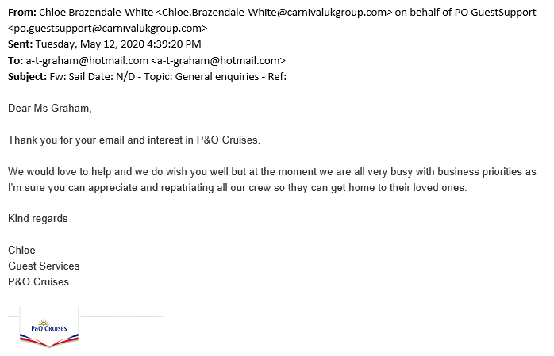

Call Centre Recruitment, TUI <contactcentre.recruitment@tui.co.uk>
Thu 07/05/2020 10:24





To:
- Amy Graham (1900375)
Hello

This mailbox is not currently monitored as we are out of office for the foreseeable future.

Kind regards
TUI Recruitment Team
TUI UK Limited, registered in England No 2830117, and TUI UK Retail Limited, registered in England No 1456086. VAT No: 233 3687 62
TUI Airways Limited, registered in England No 444359. VAT No 490 2120 79
TUI Ireland Limited, registered in England No 2220337. VAT No: IE4883835R
Registered Office: Wigmore House, Wigmore Lane, LUTON, LU2 9TN
Adehy Limited, registered in Ireland No 116977. VAT No IE4810799F. Registered Office: One Spencer Dock, North Wall Quay, Dublin 1, Ireland
The companies listed above are members of the TUI AG group of companies which is the world's number one integrated tourism business, operating in 180 countries with 31 major source markets and over 30 million customers.
TUI AG's Registered Office is Karl-Wiechert-Allee 4, 30625 Hanover, Germany. Registered in Germany (Berlin/Hanover), Company Number HRB 6580. For more information, visit www.tuigroup.com

icrosoft Outlook
Thu 07/05/2020 10:21





To:
- Microsoft Outlook
Dissertation Interview Questions
67 KB
Delivery has failed to these recipients or groups:
headoffice.recruitment@tui.co.ukk (headoffice.recruitment@tui.co.ukk)
Your message couldn't be delivered. The Domain Name System (DNS) reported that the recipient's domain does not exist.
Contact the recipient by some other means (by phone, for example) and ask them to tell their email admin that it appears that their domain isn't properly registered at their domain registrar. Give them the error details shown below. It's likely that the recipient's email admin is the only one who can fix this problem.
For more information and tips to fix this issue see this article: https://go.microsoft.com/fwlink/?LinkId=389361

Amy Graham (1900375)
Thu 07/05/2020 10:12





To:
- vikingpr@edelman.com
Interview Questions - dissertation.docx
34 KB
To Whom it may concern
My name is Amy Graham, I am a student at University Wales Trinity St. David, and as part of the final year of my degree, I am writing a dissertation the topic is centred on “Cruise Tourism” and specifically I aim to understand more about the Cruise Industry and whether the environment is a motivation for cruisers when choosing a cruise holiday.
I know this is a very challenging and busy time for your company, but I was wondering if someone could spare the time to complete the interview questions I have attached. It should not take more than 10 minutes to complete. I would be happy to receive any information from you, even brief responses or I am happy to liaise with someone on the phone if you feel that it would be a more time efficient means for you. I am very keen to obtain this information as it is vital to complete and pass my degree.
Thanking you in anticipation of your help in this matter, and finds you all safe and well.
Kind Regards
Amy Graham
Student, UWTSD

