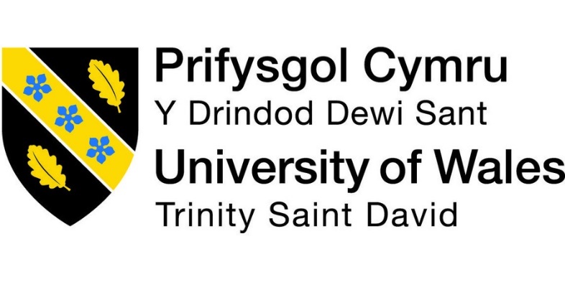

MASTER OF BUSINESS ADMINISTRATION
Module Title | : Entrepreneurship
Component 1 | : Essay
Essay Topic | : “ Sunlight Harvest” – The Solar Paint Revolution in California
Module Code | : LCMB7004
Student Name | : Nayankumar Bipinbhai Patel
Student ID | : 2243076
Lecturer Name | : Vasilios Tavlaridis And Masud Ibrahim

Table of Contents
Introduction 3
Overview of the Proposed Business Idea (Product) 4
Gap in the Market and Addressing the Gap 5
Proposed Location and Legal Entity 7
SWOT Analysis 9
Company targeting a diverse set of markets and strategies 11
Budgeting and Funding Requirements 14
Conclusion 16
Reference List 17

Business Plan: EnGreen’s Solar Paint

Introduction
In the face of increasingly devastating natural disasters, generally credited to global warming, EnGreen aims to present a progressive, sustainable energy solution to battle environmental change. EnGreen's business plan revolves around Solar Paint, an inventive solar-based energy product designed to saddle the force of the sun and transform it into a sustainable source of electricity (Khan and Rahman, 2019). This business plan will provide an overview of the proposed product, discuss how it addresses a gap in the market, identify the ideal location and legal entity, conduct a SWOT analysis, detail the target market and market strategies, and outline the budgeting and funding necessities.

Overview of the Proposed Business Idea (Product)
Solar Paint :
EnGreen Company is ready to change the renewable energy sector with a pioneering concept that combines urban sustainability and aesthetics. EnGreen's leading product, Solar Paint, is a historic photovoltaic paint that can be applied to different surfaces, like building facades, roofs, and streets. This creative business idea centres around the development and application of "Solar Paint" in urban settings across the United States. These innovations permit standard designs and foundations to employ solar energy, consequently revolutionising the manner in which we produce and consume power (Sharma and Baral, 2022). SolarPaint retains daylight and converts it into power, giving a perfect and environmentally friendly power source while mixing consistently into urban scenes. This eco-friendly innovation enables urban environments to function as clean energy generators, overcoming any issues between renewable energy production and urban feel.
The Solar Paint Concept :
Solar Paint is a groundbreaking innovation that incorporates advanced solar photovoltaic cells into a paint-like medium. This Paint can be applied to various surfaces, such as building facades, roads, and bridges, to capture sunlight and convert it into clean electricity (Padgaonkar, 2023). Unlike traditional solar panels, Solar Paint flawlessly mixes into urban environments, making it a sustainable energy and visually appealing solution.
Key Advantages of Solar Paint :
EnGreen's Solar Paint offers several benefits over traditional solar solutions,
Cost-Effective: Solar Paint reduces installation costs by dispensing with the requirement for traditional solar panel structures.
Sustainability: It contributes to reducing carbon emissions and reliance on fossil fuels, lining up with the worldwide shift towards sustainable power (Soomar et al., 2022).
Versatility: The product can be applied to various surfaces, from structures to streets, making it versatile in various urban environments (Irfeey et al., 2023).

Gap in the Market and Addressing the Gap:
Analysing the gap in the market: The energy sector is going through a critical transformation driven by the pressing need to lessen fossil fuel byproducts and battle the impacts of climate change. In this situation, renewable energy solutions have been acquired as a way to get a sustainable and environmentally friendly future. Traditional solar panels, although effective, face obstructions connected with style, space, and cost (Izam, Itam, Sing and Syamsir, 2022). Urban communities need sustainable power arrangements that are subtle, flexible, and savvy. Solar power, specifically, has arisen as a promising wellspring of clean energy.
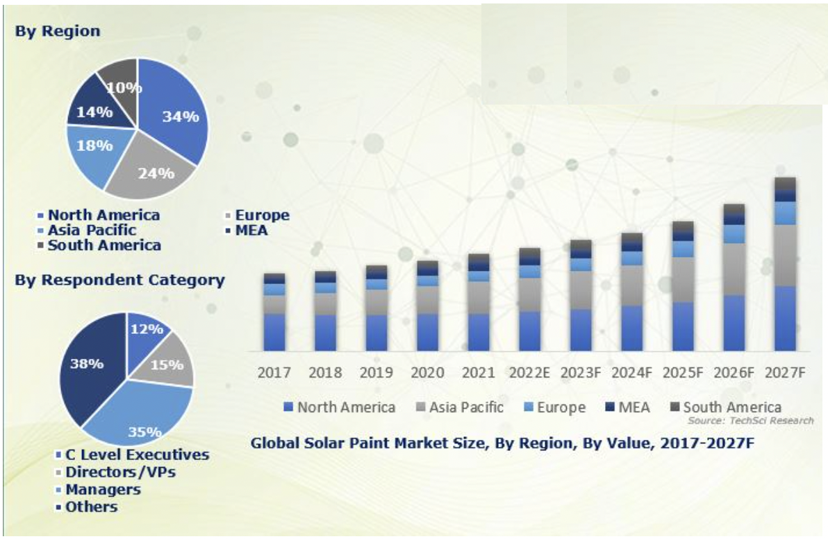
Figure 1: Solar Paint Market
(Source: TechSci Research, 2023)
Addressing the Gap: EnGreen's Solar Paint tends to these difficulties by offering an outwardly subtle arrangement. It can be applied to a wide range of surfaces, making the most of urban spaces. Solar Paint isn't just a manageable energy source but also an architectural element that upgrades the urban environment (Padgaonkar, 2023). Traditional solar panels represent a significant market gap. The advancement of SolarPaint intends to bring reasonable, open, and attractive solar energy to cities across the US and beyond. The company addresses these market gaps by offering creative and developed and space efficient arrangements such as,
Energy production efficiency: EnGreen Solar Paint is designed to optimise energy production. The power allows for applications in areas where the sun exposure is high and ensures efficient energy generation (Xu, 2020). By upgrading energy production, EnGreen company addresses the market gap in regard to energy efficiency.
Cost-effective installation: The instalment or establishment is cost-efficient and straightforward. Without any need for additional labour work, individuals can significantly reduce their installation costs (Singh, Kaur and Thakur, 2021). This cost factor addresses the high establishment cost gap, making solar energy accessible to a wider market.

Proposed Location and Legal Entity:
The selection of the proposed location for the business and the choice of the legal entity are essential contemplations in guaranteeing the achievement and suitability of this historic approach.
Proposed Location: The ideal location for EnGreen Solar Paint is Los Angeles, California. It is chosen as the primary location for EnGreen Solar Paint because of its abundant sunlight, innovative urban environment and commitment to sustainability. The city's progressive attitude towards renewable energy and its large urban foundation make it a perfect testing place for this creative and innovative product.
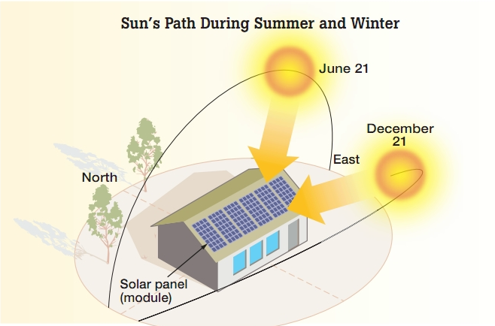
Figure 2: Solar Panel Installation Direction
(Source: Solartribe.com, 2023)

EnGreen's headquarters will be situated in Los Angeles, California. Los Angeles offers an ideal climate for development and supportability, with access to a skilled workforce, clean energy initiatives, and an educated and tech-savvy community. California's powerful solar industry and commitment to renewable energy align with the mission of EnGreen. Los Angeles, renowned for its plentiful daylight over time, gives a remarkable climate to solar energy production (Johra, Salonvaara and Desjarlais, 2023). The city's topographical area and environment make it an ideal area for a solar-based product like EnGreen's solar Paint. Los Angeles City is so into sustainable and clean energy solutions that they have set targeting goals to reduce its carbon footprint and transition to renewable energy sources (Kabeyi and Olanrewaju, 2022). Also, the diverse landscape of the city presents a large number of surfaces and designs that can be changed into solar energy generators by using solar Paint. This is significant as it offers a wide range of materials for the production application and creates more opportunities for revenue and market infiltration.

Legal Entity: EnGreen will work as a Limited Liability Company or LLC. This lawful design gives obligation security to the proprietors and an adaptable management framework, which is essential for an innovation-centred startup in the environmentally friendly and renewable energy sector. An LLC structure gives a layer of responsibility insurance for the entrepreneurs. This partition between private resources and the organisation's resources guarantees that the founders' personal finances are safeguarded from business-related liabilities. LLC offers management flexibility, taking into consideration a more casual functional design, ideal for new companies and inventive ventures like EnGreen. This adaptability works with fast, independent direction and variation to changing market dynamics. LLCs provide tax flexibility. The benefits and losses of the business go through to the owners' individual tax returns, avoiding double taxation (King III, 2022). Many investors, including financial capitalists and investors, find LLC as an attractive venture because of the capital contribution potential.

SWOT Analysis
According to Rahman, Farrok and Haque (2022), Solar Paint is an innovative business plan that aims to revolutionise the urban atmosphere by changing it into a source of renewable energy. This concept completely aligns with the EnGreen company's thoughts and mission.
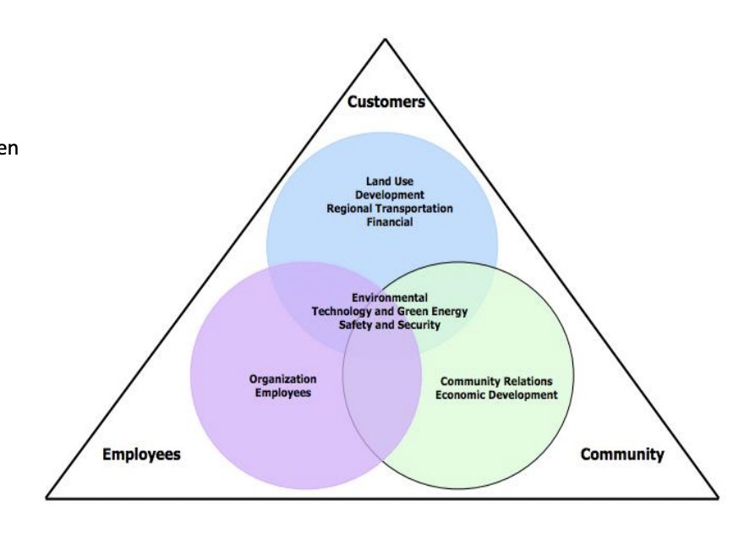
Figure 3: Environmental Technology and Green Energy Safety and Security Diagram
(Source: Simons and Zhuplev, 2014)
The SWOT analysis highlights the strengths, weaknesses, opportunities, and threats that this unique solar paint concept may encounter within Los Angeles City, California, USA.
Strengths | - Restrained and inventive solar technology.  - Strategic main location in Los Angeles.  - Strong partnerships with renewable energy organisations.  - Developing interest in clean energy solutions.
Weaknesses | - Rivalry with traditional solar panels.  - Uncertainty in the rising solar covering market.  - Initial capital requirements for research and development innovative work.  - Dependence on government policies and funding.
Opportunities | - Developing environmental awareness.  - Expanding interest in sustainable energy in urban places.  - Expansion into developing business sectors.  - Technological advancements in solar-based coatings.
Threats | - Price fluctuations in the solar industry.  - Competitive solar energy market.  - Financial downturns influence consumer spending on renewable energy.  - Administrative changes influencing solar incitements.

Company targeting a diverse set of markets and strategies
EnGreen Solar Paint is a leading renewable energy company with an extraordinary business concept, tackling the force of the sun through solar Paint to generate clean energy. This creative arrangement offers broad market appeal and spreads to diverse sectors in Los Angeles, California. By coordinating solar technology into urban foundations, EnGreen company tries to make reasonable, aesthetically pleasing cities while addressing environmental change.
Target Market: EnGreen Solar Paint's innovative solar-powered paint technology is prepared to revolutionise the renewable energy landscape and change urban environments into energy-producing substances. The target market for EnGreens differs and envelopes different partners, each assuming a significant part in advancing this excellent product. EnGreen Solar Paint's market capture strategies are intended to show the suitability and advantages of solar paint technology and create a sustainable market for this creative product (Harzallah et al., 2019). By engaging with diverse stakeholders and utilising training, motivations and customisation, the company aims for a greater future for the wider adoption of solar Paint in urban areas of the USA. The company market will focus on the following business and market sectors.
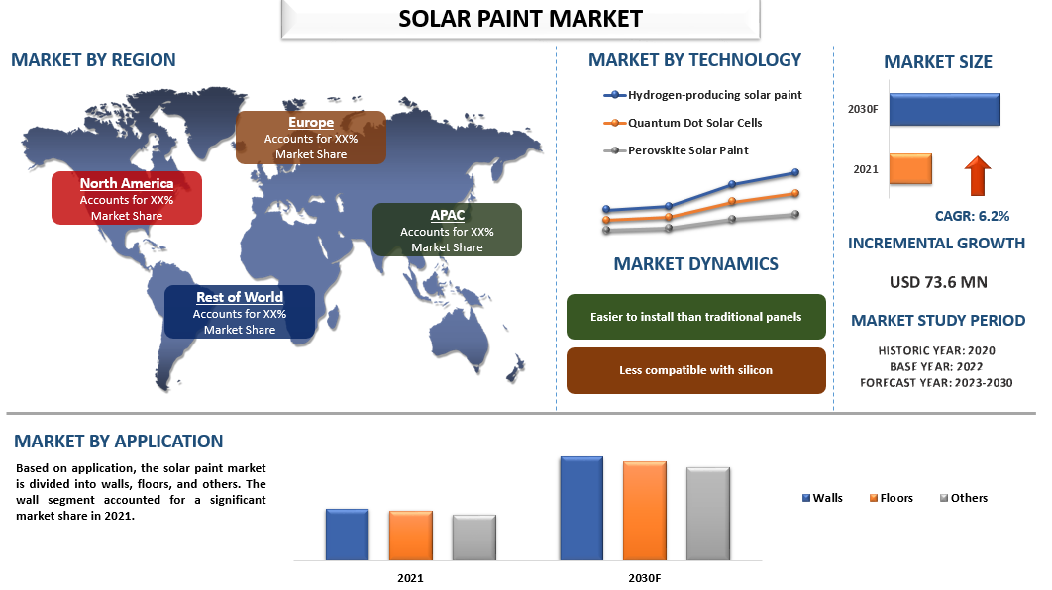
Figure 4: Solar Paint Market Current Analysis
(Source: univdatos.com, 2023)
Residential and Commercial: Offering Solar Paint for homeowners interested in integrating solar coatings into their homes, lessening energy bills and contributing to a sustainable lifestyle. Providing businesses with cost-effective, visually attractive, and engaging solar solutions, stressing energy effectiveness and sustainability.
Architects and Construction Companies: Cooperating with architecture firms, engineers, and developers to integrate Solar Paint into new and existing building plans. The goal is to establish solar Paint as a standard feature in urban architecture, guaranteeing its far and wide reception. Architects and construction firms play a critical part in coordinating EnGreen Solar Paint into new building designs and framework projects. The company will draw in engineers and development organisations by giving consultations and offerings to integrate solar Paint into their projects.
Municipal Governments: Collaborating with city government authorities to implement Solar Paint on public buildings, infrastructure and roads which will help in reducing the environmental impacts and municipal energy costs.
Community Initiatives: Engaging with community initiatives and local non-profit organisations is fundamental to advancing solar Paint's adoption in public spaces. By partaking in local area projects and teaming up with associations focused on sustainability and environmental drives, focused on sustainability and environmental initiatives, EnGreen can exhibit the advantages of solar Paint in parks, public buildings, and sporting areas or places.
Market Capture Strategies: To catch the target market effectively, EnGreen Solar Paint will execute the following strategies.
Collaborative Partnerships: EnGreen will effectively look for collaborative partnerships with key partners, including government offices, engineering affiliations, and real estate developer networks (Ilse et al., 2019). These partnerships will give a platform to advocate for solar paint adoption and create a network of supporters who can help drive its acknowledgement in the market.

Market Education and Awareness: EnGreen will put resources into educational drives to raise awareness regarding the advantages of solar Paint. This will include hosting webinars, seminars and various informational sessions for city authorities, developers and architects (Malhotra, Schmidt and Huenteler, 2019). The point is to guarantee that the target market comprehends the natural and financial benefits of embracing solar paint technology.
Sustainability Certifications: EnGreen will seek sustainability certifications and accreditations, guaranteeing that its products meet the most energy productivity and highest environmental principles. These certifications will give extra credibility and motivation for market adoption.

Budgeting and Funding Requirements
EnGreen Solar Paint's budgeting and financial plan frame the estimated costs, revenue projections, and funding requirements for launching and operating the inventive solar paint business (Peaucelle, Peñuelas and Verbeeck, 2022). The arrangement centres around the initial investment required, operational expenses, and potential outer money sources.
Budgeting: EnGreen will allocate a significant part of the initial investment to cover research and development, including further refinement of the solar paint technology, improvement of specific paint details, and testing (Parison et al., 2020). The assessed cost for Research and Development is $10 million.
To showcase the reasonability and advantages of solar Paint, EnGreen will start pilot projects in collaboration with regional authorities and city associations. The spending plan for these pilot projects is assessed at $900k.
EnGreen will invest in marketing campaigns showcasing efforts to bring issues to light about solar Paint's advantages and to educate the target market. This will incorporate workshops, online classes, and instructive meetings. The budget for marketing and education is estimated at around $600k.
The initial investment will cover the recruiting of essential staff, including researchers, project managers, and marketing professionals. Staff recruitment is assessed at $550k. EnGreen will allot assets for legitimate charges, grants, and regulatory costs. The assessed financial plan for legal and managerial expenses is $350k. The implementation of pilot projects will incorporate the purchase of necessary materials, equipment, and labour costs. The spending plan for pilot project execution is estimated at $1.5 million. The total Initial Investment Requirement is around $ 12 million.
Funding Sources: EnGreen will look for financing from the following sources,
Strategic Partnerships: Exploring collaborations with established solar companies to get to shared ventures and resources. By partnering with organisations that have a vested interest in sustainable building practices and urban development, EnGreen can get financial help, as well as industry skills and market reach.
Equity Financing: Drawing in investments from financial capitalists and effect investors with an emphasis on clean innovation and technology startups. Equity financing is a suitable option to secure the necessary capital for research and development, pilot projects, and initial marketing efforts (Forrester and Satchwell, 2023). The contribution of experienced financial investors can carry strategic guidance and industry associations with the business.
Bank Loans: Securing loans for working capital and extension.
Grants and Subsidies: Utilising government grants and incentives supporting renewable energy and sustainable urban drives.
Justification for Funding Choices: Equity financing is important for acquiring the necessary capital for research and development, marketing, testing and expansion while establishing key connections in the renewable energy sector (Lahiani et al., 2021). Impact investors and investors are attracted to organisations with the potential for huge positive natural and monetary effects. Grants and subsidies align with EnGreen's mission of advancing clean energy and sustainability. Government grants and incentives help reduce the weight of Research and development and pilot projects, making them an attractive choice for a startup focused on advancement. Strategic partnerships grow EnGreen's compass and abilities. Collaborations with architectural associations, real estate developers, and construction companies not only provide access to capital but also open doors to a broader market and valuable doors for development.

Conclusion
EnGreen's SolarPaint offers a unique and leading business plan for the challenges of renewable energy adoption in urban areas. It addresses the global warming crisis and contributes to the relief of natural disasters by reducing carbon emissions. EnGreen Company's Solar Paint concept addresses a dynamic and groundbreaking way to deal with renewable energy. The incorporation of Solar Paint into the urban scene tends to climate change as well as adds to stronger, eco-accommodating urban areas across the US and beyond. EnGreen's commitment to sustainability and development positions the company as an innovator in the rising solar painting market, contributing to a more sustainable and strong future for cities across the US and beyond. With a promise to develop ecological stewardship, EnGreen aims to pave the way for a cleaner, greener future in urban areas.

Reference List
Forrester, S. and Satchwell, A., (2023). Developing an Equity Framework for State Regulatory Decision-Making. Lawrence Berkeley National Laboratory (LBNL), Berkeley, CA (United States).
Harzallah, R., Larnicol, M., Leclercq, C., Herbein, A. and Campana, F., (2019), July. Development of high performances solar absorber coatings. In AIP Conference Proceedings (Vol. 2126, No. 1). AIP Publishing.
Ilse, K., Micheli, L., Figgis, B.W., Lange, K., Daßler, D., Hanifi, H., Wolfertstetter, F., Naumann, V., Hagendorf, C., Gottschalg, R. and Bagdahn, J., (2019). Techno-economic assessment of soiling losses and mitigation strategies for solar power generation. Joule, 3(10), pp.2303-2321.
Irfeey, A.M.M., Chau, H.W., Sumaiya, M.M.F., Wai, C.Y., Muttil, N. and Jamei, E., (2023). Sustainable mitigation strategies for urban heat island effects in urban areas. Sustainability, 15(14), p.10767.
Izam, N.S.M.N., Itam, Z., Sing, W.L. and Syamsir, A., (2022). Sustainable development perspectives of solar energy technologies with focus on solar Photovoltaic—A review. Energies, 15(8), p.2790.
Johra, H., Salonvaara, M. and Desjarlais, A., (2023), June. The impact of the solar absorption coefficient of roof and wall surfaces on energy use and peak demand. In NSB 2023: 13th Nordic Symposium on Building Physics (p. 350). Department of the Built Environment, Aalborg University.
Kabeyi, M.J.B. and Olanrewaju, O.A., (2022). Sustainable energy transition for renewable and low carbon grid electricity generation and supply. Frontiers in Energy research, 9, p.1032.
Khan, S.A. and Rahman, A., (2019). Efficiency of thin film photovoltaic paint: A brief review. Int. J. Recent Technol. Eng, 7, pp.163-169.
King III, A.W., (2022). Flexible Trusts to Deal With Future Uncertainties. Trusts & Estates.
Lahiani, A., Mefteh-Wali, S., Shahbaz, M. and Vo, X.V., (2021). Does financial development influence renewable energy consumption to achieve carbon neutrality in the USA?. Energy Policy, 158, p.112524.
Malhotra, A., Schmidt, T.S. and Huenteler, J., (2019). The role of inter-sectoral learning in knowledge development and diffusion: Case studies on three clean energy technologies. Technological Forecasting and Social Change, 146, pp.464-487.
Padgaonkar, A., (2023). The potential of solar Paint to harvest solar energy. Journal of High School Science, 7(1).
Parison, S., Hendel, M., Grados, A. and Royon, L., (2020). Analysis of the heat budget of standard, cool and watered pavements under lab heat-wave conditions. Energy and Buildings, 228, p.110455.
Peaucelle, M., Peñuelas, J. and Verbeeck, H., (2022). Accurate phenology analyses require bud traits and energy budgets. Nature Plants, 8(8), pp.915-922.
Rahman, A., Farrok, O. and Haque, M.M., (2022). Environmental impact of renewable energy source based electrical power plants: Solar, wind, hydroelectric, biomass, geothermal, tidal, ocean, and osmotic. Renewable and Sustainable Energy Reviews, 161, p.112279.
Sharma, S. and Baral, R., (2022). Solar Photovoltaic Paint for Future: A Technical Review. Advanced Journal of Engineering, 1, pp.18-23.
Singh, L., Kaur, M.J. and Thakur, D., (2021). Efficient fuelwood consumption with innovative solar water-heating system for forest conservation and mitigation of household carbon emission. Curr. Sci. India, 120, pp.835-840.

Solar Paint Market Current Analysis, Size and Forecast (2023-2030) (2023) Market Research Reporting & Analysis Agency in India. Available at: https://univdatos.com/report/solar-paint-market/ (Accessed: 22 October 2023).
Soomar, A.M., Hakeem, A., Messaoudi, M., Musznicki, P., Iqbal, A. and Czapp, S., (2022). Solar photovoltaic energy optimisation and challenges. Frontiers in Energy Research, 10, p.879985.

TechSci Research, https://www. techsciresearch. com/ (2023) Solar Paint Market - Global Industry Size, Share, Trends, Competition, Opportunity and Forecast, 2017-2027 Segmented By Technology (Solar Paint Hydrogen, Quantum Dot (Photovoltaic Paint), Perovskite Solar Paint), By End User (Solar Paint to Existing Solar Setups, Solar Painted Vehicles, Standalone Power-Generating Solar Setup), By Application (Rooftop, Wall, Door, Window), By Region, Solar Paint Market 2017-2027 By Size, Share, Trends, Growth, Forecast | TechSci Research. Available at: https://www.techsciresearch.com/report/solar-paint-market/8170.html (Accessed: 22 October 2023).

Which direction solar panels should be installed ? (no date) Solar Etribe. Available at: https://www.solaretribe.com/which-direction-solar-panels-should-be-installed/ (Accessed: 22 October 2023).
Xu, K., Du, M., Hao, L., Mi, J., Yu, Q. and Li, S., (2020). A review of high-temperature selective absorbing coatings for solar thermal applications. Journal of Materiomics, 6(1), pp.167-182.

