Generating Business database and analysis (BMSP4004)
Ishag Osman Ishag
Professor Roisin Mullins
Assignment 2
4th May 2018

Introduction
Prosumers form the key market drivers of today influencing Key marketing strategies and evolutionary research and development. Their importance lies in their influencing the overall brand perception and consumerist behaviour in nearly all of the spectrum. Any product strategy implies an underlying prosumers associated with them. This is so because prosumers form themselves to be the earliest adopters of any product coming into the market. Therefore, it becomes essential that consumer knowledge is very critical to know how to gauge any product that is being launched into the market and what kind of response it is going to elucidate amongst consumers. The further fact which is important here is that an original equipment manufacturer will be having a more direct response right form the customer himself (1)(2). This manifests a need to form a symbiotic need for a link between learning outcomes emanating in the form of customer feedback which will be aiding to the added value of the product in its development and evolution. The innovation factor associated with such kind of model ensures healthy participation of a pro-active consumer and an added focus towards organic innovation in a developer’s factory. Hence an overall upswing environment is created which reflects in the brand value of an enterprise (3).
This symbiotic relationship is important as it is leading to a greater participation of actual consumer, more so it is leading to an improved understanding about the customer’s point of view about the capability of the product. This framework relies on a voluntary basis from the consumer’s end (4). The desire to share information with others have actually enabled an enterprise to target such users through an incentive based program which can also be created into a research based focus group (15). The ability to know the consumer feedback before the actual launch of product will eventually shape up the product. The target consumers are normally identified on the basis of the social media review and responses correlating directly with the said consumer’s social media outreach and how much can they influence any decision making process(5) of other consumers. Such is the definition of a prosumer.

Knowledge sharing paradigm
Knowledge sharing is essentially voluntary in nature and prosumers sharing knowledge will directly imply that it lies solely on the incentive opportunity created by that firm. This fills the void where on one hand an enterprise wants to attain all the customer related feedback and their inputs and retain them at the same time. Awareness for prosumers directly translates to servicing any need which arises on the prosumer’s end by the enterprise (6). Therefore, there is a need to understand this framework, the motivating factors which feeds this symbiosis and a further need to tailor the product according to the feedback generated. Value creation is on both the sides, both prosumers and enterprises are getting their due worth (7).
The main emphasis is on the paradigm of the knowledge sharing exercise and the motivations behind it which are usually rewards or benefits which an enterprise bestows upon the prosumer, the benefits directly translates to the quality of feedback and efficacy of it. This is the eagerness of the prosumer which is being exploited to share the perspective of the prosumer and is being fed by any return favours. The rewards may be monetary fulfilment or some kind of goods or complementary service in return for feedback tendered (14). Although this is not the initial starting purpose and attitude of the said consumer in action, there is an inherent lack of reciprocity before the paradigm is established, said consumers do not start with the goal of being prosumer, they are merely eager to spread the awareness about the product in question so that if any shortcoming is associated with the product it can be dealt with by the original equipment manufacturer and a better product is launched in the shortest time frame as possible in the market framework. When prosumer’s willingness to enter a knowledge sharing relationship was explored, it was found that initial drive was rather furled by behavioural instinct triggered by a need of social validation and acceptance leading ultimately to a social fulfilment. Therefore, it is prudent that marketing strategies of enterprises aiming for such kinds of prosumers would be aimed at such kinds where the decision influencing quotient of prosumers is very wide and benchmark for same be established. This should also involve influencing prosumers to try a product and then promoting the product by their means to even a wider populace or social media outreach of that same prosumer. This comes under Knowledge management and consumer consumption behaviours. The usefulness of the product launched by the original equipment manufacturer and reward-reciprocity are directly related to each other. A product which has low feasibility would be less attractive than a product which has an ability to disrupt market. Tweaking marketing dynamics in case of product with low visibility and usefulness can be peddled easily by employing such prosumers, this prevents a large outflow of money and resources into the marketing of the product where the same kind of work can be done by having prosumers doing the bulk of the work under an incentive program (12). The key problem in this case of scenario would be the subsequent product reuse. In case of failure of such tactics the only key takeaway from this exercise would be the effective knowledge generated by prosumers helping the equipment manufacturer to generate a better product in the recurring cycles. Here the polish and UK based consumers helped to fill a knowledge based gap when a sustainable energy management solution was implemented. Therefore a question here arising is what kind of exact incentives are needed to keep the prosumers targeted and hooked-up in such knowledge based paradigm. A basic but a hypothetical framework for targeting such prosumers is made by use of a questionnaire having appropriate research questions and answers. This would form the core of the research methodology on which data points would be based on and then a sample case study of a prosumer involved in taking out the data for home energy monitoring in real life (8).
Incentives handed out are based on two forms which is either intrinsic or extrinsic. Intrinsic incentives are usually associated with products having high amount of usability and a certain ease of access and use associated with it. Hence, prosumer proactiveness is very low and penetration of the product is rather easy. Extrinsic incentives means that there is need to create a program for product (11). Products here are usually low on usefulness factor and would require careful market strategy and knowledgeable feedback. Incentives are further intangible or tangible in nature. Outcome based objectives would be monetary in nature. Intangible incentives are more of value based creations which may can be market value or monetary value more like community service and less towards wealth creation as is purported by the prosumers. This helps prosumers the more and they are able to carve out a brand for themselves and add to their retail brand value in the market (9).

Issues to be addressed
The main questions that need to addressed are-
- What kind of incentive needs to provide to encourage a prosumer response prosumers to engage in this knowledge sharing paradigm?
- Is prosumer behaviour different in different regions for a same product and having a similar useful quotient?
- Is choice of medium of incentive is going to play a major part in the process of knowledge sharing?
- How powerful is this knowledge sharing paradigm in general?
- Can a definitive framework be drawn out from this process?

Research Methodology
- First step would be a market research to find out the depth of penetration of the marketing strategy by a said prosumer. This process is termed as Presumption.
- Second step would be to plan a system which would be towards the encouragement of the system.
- Third step would be a deployment of a pilot plan of the same.
- Fourth step would be to determine the range of action of prosumer activity.
For an incentive program generated there should be system of scoring with weights assigned to the responses on a scale of 1-5 depending upon the state and degree of statements and should be directed towards prosumers alone.
There was a URL posted to about a sample user space of about 100 users both in UK and Poland. The people so selected were very different representing nearly all the demographic population of the regions having relevant ICT skills. This gave us a rough idea about all the response generated and accounting for all the outliers and anomalies a reliable data was collected and processed for further statistical processes and tools (10). The following data point were collected - Average, minimum, maximum, mean, median and mode. This was done in MS Excel.

Descriptive Analysis of the Problem
As we know that for analysing any given dataset before modelling and analysing we need to generate a descriptive statistics on a field. We have the data loaded in the MS Excel. Upon analysing this dataset we found that the appliance is being used as a function of frequency of use-
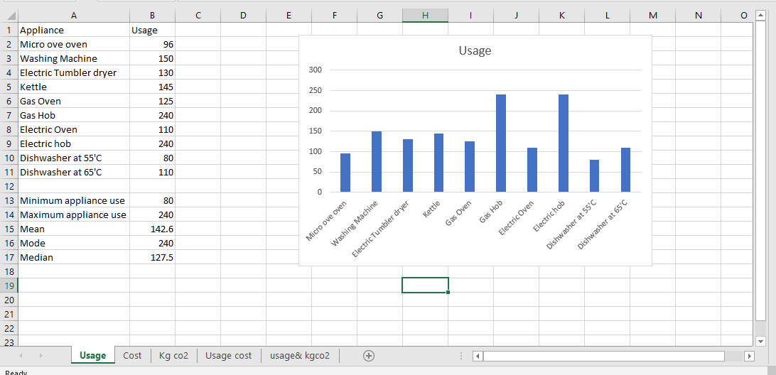

The above diagram shows and describes the data of different appliance on the basis of usage per year. This graph shows the data about appliance used on a frequency usage pattern as a function of how many times a said appliance was used in a year. The minimum number of times an appliance used is Dishwasher at 55’C which is used for about 80 times in a year and the maximum number of times an appliance is used in a year is an electric hob and a gas hob which is used to about 240 times as recorded.
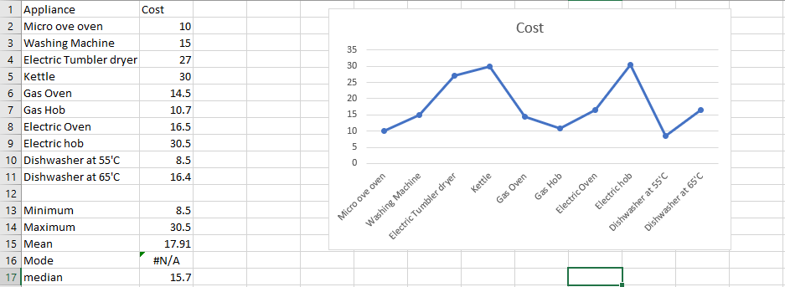

The above diagram shows that the relation between the appliance and the cost of the appliance. The main objective of this analysis is to predict the costs involved in the analysis. The minimum price in this set of different appliances is 8.5 and the maximum price for these appliances are 30.5 which is again an electric hob. The average price of these appliances is 17.91.

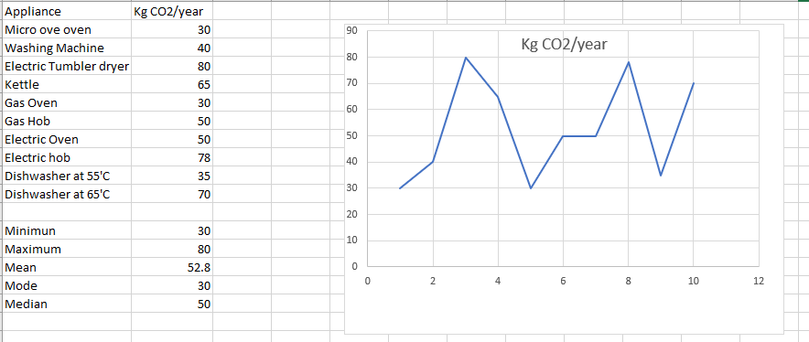

The above given diagram shows that the relation between the appliance and CO2 produce by the appliance in kg per year.
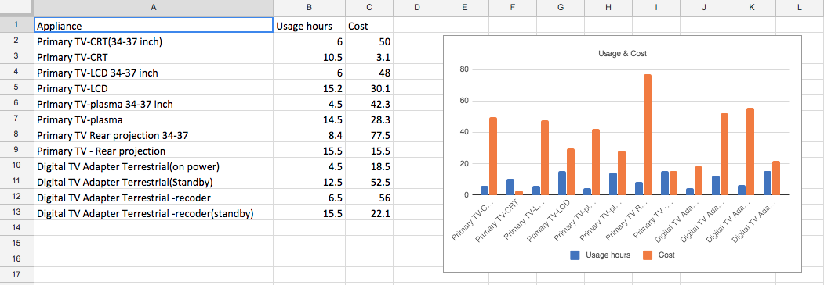
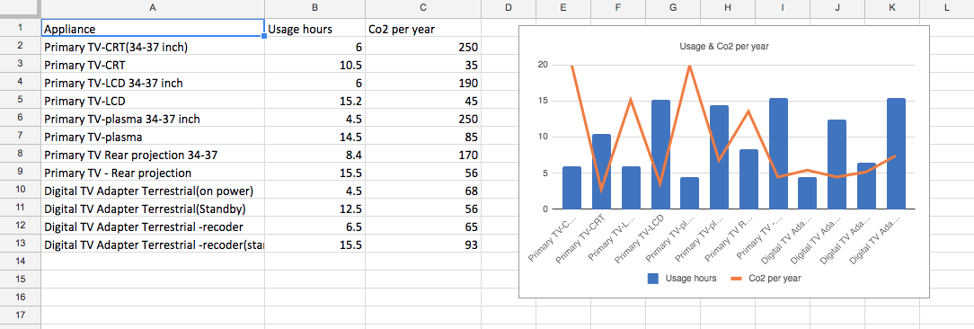
Analyzing the second part of the study, concerning the preferred engagement of electric appliances. On analysing a dataset, we found that how many electric appliances uses in a year. I have seen that most prosumers indicated that they would like and usage minimum electric appliances. They preferred and like such type of electric appliance which produces minimum CO2 gases per year.

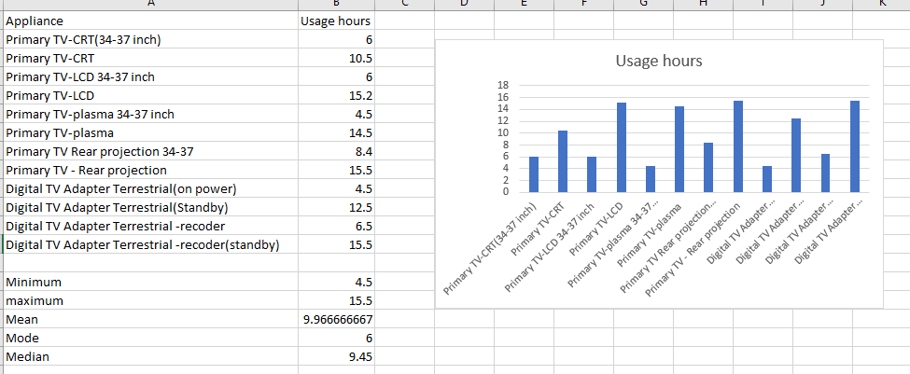

The above diagram shows and describes the engagement of different data of electric appliance usage per year. By engaging and sharing of knowledge about the electric appliance by prosumer. This graph shows the data about electric appliance uses how many times in a year. The minimum number of times appliances used digital TV adapter terrestrial which is used 4.5 times in a year and the maximum number of times appliances used in a year is digital TV adapter terrestrial adapter which is used 240 times.

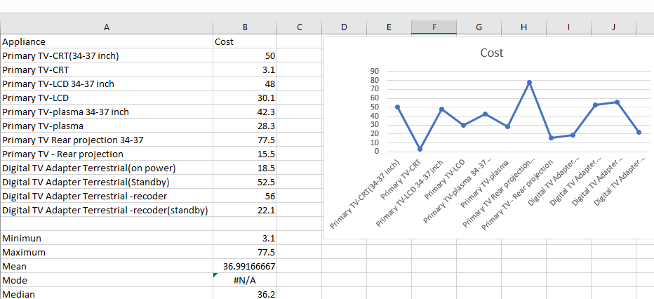

The above diagram shows the relation between the electric appliance and the cost of the appliance. The objective of this analysis is to predict the cost of the analysis and how the idea and knowledge of prosumer reduce the price of the appliance. The minimum cost of these different appliance is 3.1 and this minimum cost of electric appliance is a Primary TV-CRT and the maximum price for these appliances are 30.5 which is electric hob. The average price of these appliances is 17.91.

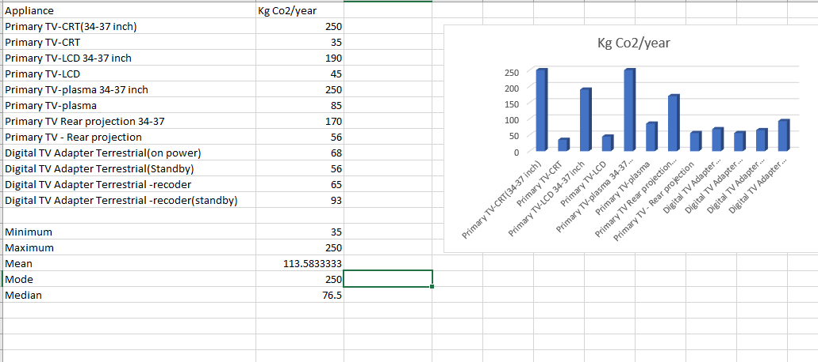

The above given diagram shows the relation between the electric appliance and CO2 produced by these electric appliances per year in kg. The majority of the appliances are producing more CO2 gases per year. The minimum CO2 gas is produced per year by Primary TV CRT which produce 30 kg CO2 per year and the maximum CO2 gas produce by Primary TV Plasma and the gas produced by this appliance is 80 kg per year.

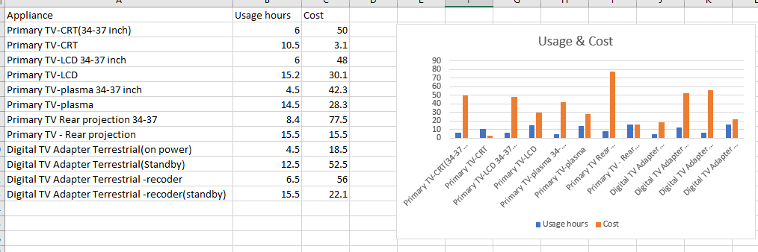

The above given diagram mentions here the relation between the appliance and the usage of these appliance. After analysing a dataset, we have seen and identified that the cost of appliance depends on the number of hours use. These conclusion are connected with the usage of appliance and the cost of the appliance

Conclusions
The above results show that enough incentives would create the right environment for a prosumer based environment. The tangible incentives so created would be essential and the behaviour exhibited by the prosumers over different regions would be roughly the same, but only when tangible incentives are concerned. The above analysis for a home appliance energy pattern usage will account for the pro-activity of the prosumer in gathering and analysing the data before sharing it as a feedback with the original equipment manufacturer. The data points so collected shows the intensive data collection process by the prosumer and also its validity.

References
(1) Siuda, P. (2012). Mechanizmy kultury prosumpcji, czyli fani i ich globalne zróżnicowanie [Mechanisms of prosumption culture, i.e., the fans and their global diversity]. Studia Socjologiczne, 4(207), 109-132.
(2) Reitz, A. (2012). Social media’s function in organizations: A functional analysis approach. Global Media Journal, 5(2), 41-56.
(3) Yuan, D., Lin, Z., & Zhuo, R. (2016). What drives consumer knowledge sharing in online travel communities? Computer in Human Behavior, 63(C), 68-74.
(4) Bylok, F. (2013). Konsumpcja, konsument i społeczeństwo konsumpcyjne we współczesnym świecie [Consumption, the consumer and the consumer society in the modern world]. Katowice: Śląsk.
(5) Dermol, V. (2011). Incentives for knowledge management and organisational performance. Proceedings of Management, Knowledge and Learning International Conference MakeLear, 22-24 June 2011, Celje, Slovenia, 345-353.
(6) Gafni, R., Geri, N., & Bengov, P. (2014). Investigating the effect of tangible and virtual rewards on knowledge contribution in online communities. Online Journal of Applied Knowledge Management, 2(2), 1-11.
(7) Grudzewski, W. M., Hejduk, I. K., Sankowska, A., & Wańtuchowicz, M. (2013). Sustainability w biznesie czyli przedsiębiorstwo przyszłości. Zmiany paradygmatów i koncepcji zarządzania (Sustainability in business i.e., enterprise of the future. Paradigms and management concepts changes). Warszawa: Poltex.
(8) Ho, L. A., & Kuo, T. H. (2013). How system quality and incentive affect knowledge sharing. Industrial Management & Data Systems, 113(7), 1048-1063.
(9) Gustafsson, A., Kristensson, P., Löfgren, M., & Witell, L. (2011). Idea generation: customer cocreation versus traditional market research techniques. Journal of Service Management, 22(2), 140-159.
(10) Löcker, A. K., Eraßme, D., Jakobs, E. M., Schaar, A. K., Valdez, A. C., & Ziefle. M. (2014). Yet another platform? Motivational factors for using online communities in business contexts. Proceedings of the 5th International Conference on Applied Human Factors and Ergonomics AHFE 2014, 19-23 July 2014, Krakow, Poland, 1145-1156.
(11) Lam, A., & Lambermont‐Ford, J. P. (2010). Knowledge sharing in organisational contexts: A motivation‐based perspective. Journal of Knowledge Management, 14(1), 51-66.
(12) Tong, C., Tak, W. I. W., & Wong, A. (2013). The impact of knowledge sharing on the relationship between organisational culture and job satisfaction: The perception of information communication and technology (ICT) practitioners in Hong Kong. International Journal of Human Resource Studies, 1(3), 9-37.
(13) Chouikha, M. B. (2016). Organisational design for knowledge management. London, UK: John Wiley & Sons.
(14) Hawkins, D. I., Best, R. J., & Coney, K. A. (2001). Consumer behavior: Building marketing strategy. Boston, MA: Irwin/McGraw Hill.
(15) Iyer, G. S., & Ravindran, S. (2009). Usefulness, incentives and knowledge management. Journal of Knowledge Management, 13(6), 410-430.

